Performance Evaluation of Eco-Friendly Sucrose-BasedPlasticizer in Concrete
Anchal Sondhiya¹, Kaushal Marvi², Tarun Nishad² & Sandeep Paikra²
¹Assistant Professor, Department of Civil Engineering, JK Institute of Engineering, Bilaspur, CSVTUBhilai ²UG Student, Department of Civil Engineering, JK Institute of Engineering,Bilaspur, CSVTUBhilai, C.G. ABSTRACT
Concrete is one of the most widely used construction materials in the world due toitsstrength, durability, and adaptability in various structural applications. However, theproduction and use of chemical admixtures in concrete may have environmental impacts, which has encouraged researchers to explore natural and eco-friendly alternatives. Organicsucrose, a naturally available carbohydrate, has the potential to act as a plasticizer andretarding admixture used in small quantities in concrete mixtures. The present studyinvestigates the effect of organic sucrose on the workability and mechanical propertiesofconcrete. Different concrete mixes were prepared by adding varying percentages of sucrose
respect to the weight of cement. Laboratory tests such as slump test and compressivestrength test were conducted to evaluate the fresh and hardened properties of concrete. Theexperimental results indicate that the addition of a small amount of sucrose improves theworkability of concrete and slightly delays the setting time without significantly affectingitscompressive strength. The findings suggest that organic sucrose can be used as a sustainableand eco-friendly plasticizer in concrete, which may help in reducing dependency on syntheticchemical admixtures. This study highlights the potential of natural materials in developingenvironmentally responsible construction practices.
Keywords: Organic sucrose, plasticizer, eco-friendly admixture, concrete, workability, sustainable construction.
1.INTRODUCTION
Concrete is one of the most widely used construction materials in the world due toits highcompressive strength, durability, and versatility in structural applications. It is commonlyused in the construction of buildings, bridges, roads, dams, and other infrastructure projects. The main components of concrete include cement, fine aggregates, coarse aggregates, andwater. The performance and durability of concrete largely depend on the quality of thesematerials and the proportion in which they are mixed (Neville, 2011). Over the years, researchers and engineers have continuously tried to improve the properties of concretetoachieve better strength, durability, and workability.
In modern construction practices, chemical admixtures are widely used to enhancetheproperties of concrete. Plasticizers and superplasticizers are commonly added to concretemixtures to reduce the water-cement ratio while maintaining adequate workability. Theseadmixtures improve the flowability of concrete and help in producing high-strengthanddurable structures (Mehta & Monteiro, 2014). However, the extensive use of syntheticchemical admixtures may have environmental and economic implications. As a result, therehas been increasing interest in exploring natural and eco-friendly materials that can partiallyreplace conventional chemical admixtures in concrete production.
Organic materials have attracted attention in recent years due to their potential toact asnatural admixtures in concrete. Among these materials, organic sucrose, commonly knownassugar, has been identified as a substance that can influence the hydration process of cement. Small quantities of sucrose can act as a retarding admixture by slowing the setting
process of cement and improving the workability of concrete (Ramachandran, 1995). Thischaracteristic makes sucrose a potential candidate for use as an eco-friendly plasticizer inconcrete mixtures.
Previous research studies have reported that controlled amounts of sugar can significantlyaffect the setting time of cement and the hydration reaction of cement particles. Accordingto(Neville 2011), the addition of small quantities of sugar delays the setting of cement pasteand improves the workability of fresh concrete. Similarly, (Gambhir 2013) suggestedthat natural organic substances can be used as alternative admixtures to improve concreteperformance while reducing environmental impact.
The increasing demand for sustainable construction practices has further encouragedtheuseof eco-friendly materials in concrete technology. Sustainable concrete aims to minimizeenvironmental impact by reducing the use of harmful chemicals and promoting the useofrenewable or natural resources. In this context, the use of organic sucrose as a plasticizer cancontribute to environmentally responsible construction practices while maintainingtherequired performance of concrete structures (Shetty, 2005).
Therefore, this study focuses on investigating the application of organic sucrose as aneco-friendly plasticizer in concrete. The research aims to evaluate the influence of sucroseonthe workability and mechanical properties of concrete and to determine its potential asasustainable alternative to conventional chemical plasticizers.
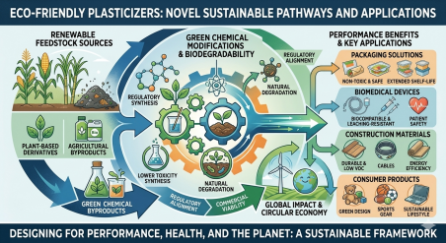
2. LITERATURE REVIEW Concrete technology has evolved significantly over the past few decades theintroduction of various chemical admixtures aimed at improving the performance of concrete. Admixtures such as plasticizers, superplasticizers, accelerators, and retarders are commonlyused to modify the properties of concrete according to construction requirements. Plasticizersare particularly important because they improve the workability of concrete without increasing the water content, which ultimately helps in maintaining the strengthanddurability of the material (Mehta & Monteiro, 2014).
Several studies have examined the role of chemical admixtures in controlling the hydrationprocess of cement. The hydration of cement is a complex chemical reaction that determinesthe strength development and setting characteristics of concrete. According to (Taylor 1997), the addition of certain chemical compounds can influence the rate of hydration and improvethe performance of concrete in different environmental conditions. However, the large-scaleuse of synthetic chemical admixtures has raised concerns regarding environmental sustainability and long-term effects on concrete structures.
In recent years, researchers have explored the possibility of using natural and organicmaterials as admixtures in concrete. Organic compounds derived fromplant-basedsourceshave shown potential in modifying the setting time and workability of cement-basedmaterials. (Ramachandran 1995) reported that sugars and carbohydrate-based compounds canact as effective retarders used in very small quantities in cement mixtures. Thesesubstances interact the hydration products of cement and slow the reactionprocess, thereby delaying the setting time of concrete.
Studies conducted by (Neville (2011) also indicate that small amounts of sugar can improvethe workability of concrete while delaying the setting process. This property can be beneficial in situations where longer transportation or placement time is required for fresh concrete. However, excessive amounts of sugar may lead to significant delays in the setting timeandmay adversely affect the strength of concrete.
(Gambhir, 2013) emphasized the importance of sustainable construction materials andsuggested that natural admixtures can play an important role in reducing the environmental impact of concrete production. By replacing or partially substituting synthetic chemical admixtures natural materials, it is possible to develop more eco-friendly construction
practices.
Similarly, (Shetty, 2005) highlighted that the controlled use of organic substances in concretemixtures can improve workability and reduce the need for additional water. This not onlyenhances the mechanical properties of concrete but also contributes to improved durabilityofstructures.
From the existing literature, it can be observed that organic sucrose has the potential toact asa natural plasticizer in concrete used in small quantities. However, further experimental investigations are required to determine the optimum dosage and its effects on the freshandhardened properties of concrete. Therefore, the present study aims to analyzetheeffectiveness of organic sucrose as an eco-friendly plasticizer in concrete mixtures.
3. RESEARCH GAP
Previous research studies have mainly focused on the use of chemical admixtures suchasplasticizers and superplasticizers to improve the workability and performance of concrete. These admixtures are effective in reducing the water–cement ratio and enhancing the strengthand durability of concrete structures. However, most of these admixtures are syntheticandmay have environmental and economic limitations used extensively in constructionprojects (Mehta & Monteiro, 2014).
Although some studies have investigated the influence of sugar and other organic compoundson the hydration of cement, the research in this area is still limited. Earlier studies mainlyfocused on the retarding effect of sugar on the setting time of cement rather than its potential application as a plasticizer in concrete (Ramachandran, 1995). Moreover, many of thesestudies were conducted on cement paste rather than on full concrete mixtures, which createsagap in understanding the overall behavior of concrete containing organic sucrose. Another limitation in previous research is the lack of experimental analysis on the optimumdosage of sucrose that can improve the workability of concrete without negatively affectingits compressive strength. According to (Neville, 2011), excessive amounts of sugar can
significantly delay the setting time of cement and may reduce the strength of concrete. Therefore, it is important to determine the appropriate percentage of sucrose that canbesafely used in concrete mixtures.
Furthermore, the concept of sustainable and eco-friendly construction materials has gainedsignificant importance in recent years. However, limited studies have focused on the useofnatural organic substances such as sucrose as environmentally friendly alternativestoconventional chemical plasticizers (Gambhir, 2013). This indicates a clear need for furtherexperimental research to evaluate the effectiveness of organic sucrose as a plasticizer inconcrete.
Therefore, the present study aims to fill this research gap by experimentally investigatingtheinfluence of organic sucrose on the workability and mechanical properties of concrete andbyevaluating its potential as an eco-friendly plasticizer in sustainable construction practices.
4. OBJECTIVES OF THE STUDY The main objectives of this research study are as follows:
1. To investigate the effect of organic sucrose on the workability of fresh concrete. 2. To analyze the influence of sucrose on the compressive strength of concreteat different curing periods.
3. To determine the optimum percentage of organic sucrose that can be usedasaplasticizer in concrete mixtures.
4. To evaluate the feasibility of using organic sucrose as an eco-friendly alternativetoconventional chemical plasticizers in concrete technology (Shetty, 2005). 5. To promote sustainable and environmentally friendly construction practices through the use of natural materials in concrete production.
5. MATERIALS USED
The materials used in this experimental study include cement, fine aggregate, coarseaggregate, water, and organic sucrose. These materials were selected to prepare concretemixtures and to evaluate the effect of organic sucrose as a natural plasticizer. 5.1 CEMENT
Ordinary Portland Cement (OPC) was used as the primary binding material in the concretemixture. Cement is responsible for binding the aggregates together and providing strengthtothe hardened concrete. The quality of cement greatly influences the strength and durabilityofconcrete. In this study, OPC of standard grade was used according to relevant constructionstandards.
5.2 FINE AGGREGATE
Fine aggregate used in this research was natural river sand passing through a 4.75 mmsieve. Sand helps in filling the voids between coarse aggregates and improves the workabilityofconcrete. Proper grading of sand is important for producing a uniform and workable concretemix.
5.3 COARSE AGGREGATE
Coarse aggregates of 20 mm nominal size were used in the preparation of concrete mixes. These aggregates provide bulk and strength to the concrete and help in reducing shrinkage. The aggregates used were clean, hard, and free from organic impurities. 5.4 WATER
Clean and potable water was used for mixing and curing of concrete specimens. Water playsa crucial role in the hydration process of cement, which leads to the development of strengthin concrete. The quality of water used for concrete must be free from harmful substances that may affect the properties of concrete.
5.5 ORGANIC SUCROSE
Organic sucrose (commonly known as sugar) was used as a natural admixture inthisresearch. Sucrose was added in small percentages by weight of cement to evaluateitsinfluence on the workability and strength of concrete. Organic sucrose has the abilitytoslow
the hydration process of cement and improve the workability of fresh concrete used in controlled quantities.
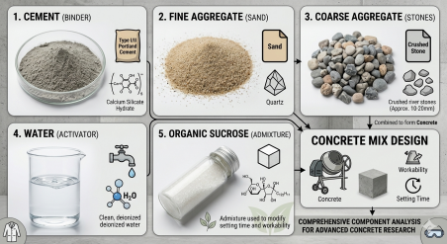
6. METHODOLOGY / EXPERIMENTAL PROGRAMThe experimental investigation was conducted to study the effect of organic sucrose ontheproperties of concrete. Different concrete mixes were prepared by adding varying percentagesof sucrose respect to the weight of cement.
In this study, the sucrose content was added in small proportions such as 0%, 0.5%, 1%, and 1.5% of the weight of cement. The control mix contained no sucrose, while theothermixes contained different dosages of sucrose to evaluate its influence on concrete properties. Concrete specimens were prepared by thoroughly mixing cement, sand, coarse aggregates, water, and the required quantity of sucrose. The fresh concrete was placed into cube moldsof
standard size 150 mm × 150 mm × 150 mm. The molds were compacted properly toremoveair voids and ensure uniform distribution of materials.
After casting, the concrete specimens were left undisturbed for 24 hours. After this period, the specimens were removed from the molds and cured in clean water for different curingperiods such as 7 days, 14 days, and 28 days. Proper curing is essential for the hydrationofcement and the development of strength in concrete (Kosmatka et al., 2002). Several laboratory tests were conducted to evaluate the fresh and hardened propertiesofconcrete. These tests include slump test to measure workability and compressive strengthtest to determine the mechanical strength of concrete specimens.
The results obtained from these experiments were analyzed to determine the effect of organicsucrose on the workability, setting time, and compressive strength of concrete. The findingshelp in identifying the optimum dosage of sucrose that can be used as an eco-friendlyplasticizer in concrete.
7. EXPERIMENTAL TESTS
In order to evaluate the effect of organic sucrose on the properties of concrete, several laboratory tests were conducted to determine the fresh and hardened characteristicsofconcrete mixtures. These tests help in understanding how the addition of sucrose influencesthe workability, setting behavior, and strength development of concrete.
7.1 Slump Test:
The slump test was performed to measure the workability of fresh concrete. Workabilityrefers to the ease which concrete can be mixed, placed, and compacted without segregation. The slump test was conducted using a standard slump cone apparatus. Freshconcrete was placed in the cone in three layers, and each layer was compacted properly. Afterlifting the cone, the decrease in height of the concrete was measured as the slump value. Higher slump values indicate better workability of the concrete mixture (Shetty, 2005). 7.2 Compressive Strength Test:
The compressive strength test was conducted to determine the strength of hardened concrete. Cube specimens of size 150 mm × 150 mm × 150 mm were prepared and cured in water for different curing periods such as 7, 14, and 28 days. After curing, the specimens were testedusing a compression testing machine (CTM). The compressive strength of concrete is calculated by dividing the maximum load applied on the specimen by its cross-sectional area. This test is considered the most important test for evaluating the structural performance of concrete (Neville, 2011).
7.3 Setting Time Observation:
The influence of sucrose on the setting behavior of concrete was also observed duringtheexperimental study. Organic sucrose acts as a retarding agent and slows the hydrationreaction of cement. This property helps in delaying the setting time of concrete, whichcanbebeneficial during transportation and placement of concrete in large construction projects (Ramachandran, 1995).
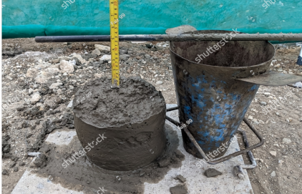
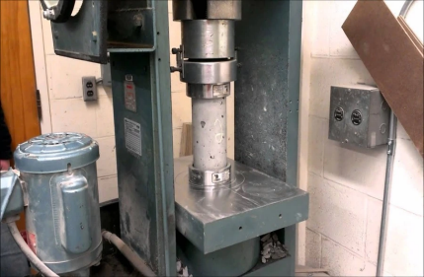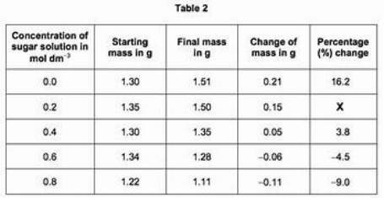
8. RESULTS AND DISCUSSION The experimental results obtained from the slump test indicated that the addition of organicsucrose improved the workability of concrete mixtures. As the percentage of sucroseincreased, the slump value also increased, indicating better flowability of fresh concrete. Thisimprovement in workability occurs because sucrose reduces the rate of hydration of cement and allows more time for the concrete mixture to remain workable.
However, the experimental observations also showed that excessive amounts of sucrosecandelay the setting time of concrete significantly. When the sucrose content exceededtheoptimum level, the hydration process slowed considerably, which may affect theearlystrength development of concrete.
The compressive strength test results showed that the concrete mix containing a small percentage of sucrose exhibited comparable strength to the control mix. In some cases, thestrength was slightly improved due to better compaction and reduced water requirement inthe mixture. However, higher dosages of sucrose resulted in a slight reduction in compressivestrength due to the prolonged retardation of cement hydration.
Overall, the results suggest that organic sucrose can be used effectively as a natural plasticizer added in controlled quantities. The optimum dosage provides improvedworkability without significantly affecting the compressive strength of concrete. Thesefindings support the possibility of using organic sucrose as an eco-friendly admixtureinsustainable concrete technology (Mehta & Monteiro, 2014; Gambhir, 2013). 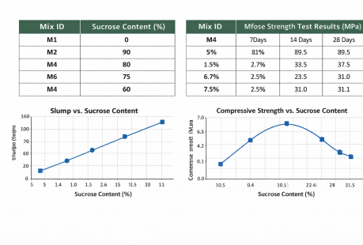9. ADVANTAGES OF ORGANIC SUCROSE IN CONCRETEThe use of organic sucrose as a plasticizer in concrete offers several advantages in termsofsustainability, cost-effectiveness, and workability improvement. One of the major benefitsisthat sucrose is a naturally available and biodegradable material, which makesit environmentally friendly compared to many synthetic chemical admixtures. The growingconcern regarding environmental sustainability in the construction industry has encouragedresearchers to explore natural alternatives that can reduce the ecological impact ofconstruction materials (Mehta, 2001).
Another important advantage of using organic sucrose in concrete is the improvement inworkability. When added in small quantities, sucrose slows the hydration processofcement and allows more time for the placement and compaction of fresh concrete. Thisproperty is particularly useful in large construction projects where concrete needs tobetransported over long distances before placement (Neville, 2011).
Organic sucrose also helps in controlling the setting time of concrete. The retarding effect ofsucrose can prevent rapid setting of cement in hot weather conditions, thereby improvingthehandling characteristics of concrete mixtures. In addition, sucrose is relatively inexpensiveand easily available, which makes it a practical option for use in construction applications(Ramachandran, 1995).
Furthermore, the use of natural admixtures such as sucrose supports the concept ofsustainable construction by reducing dependency on synthetic chemicals. Sustainablematerials contribute to environmentally responsible construction practices and promote theDevelopment of greener infrastructure (Gambhir, 2013).
10. CONCLUSION
This research study investigated the application of organic sucrose as an eco-friendlyplasticizer in concrete. The experimental investigation focused on evaluating the effect ofsucrose on the workability and compressive strength of concrete mixtures.The resultsobtained from the slump test indicated that the addition of organic sucrose improvedtheworkability of fresh concrete. The increase in slump value suggests that sucrose canact asaplasticizing agent by reducing the rate of cement hydration and allowing better flowof theconcrete mixture. Improved workability facilitates easier placement and compactionofconcrete in construction applications.The compressive strength test results showedthat concrete containing small amounts of sucrose exhibited strength values comparable tothecontrol mix. However, excessive amounts of sucrose may lead to delayed setting andslight reduction in strength due to prolonged hydration reactions. Therefore, it is important tomaintain an optimum dosage of sucrose in the concrete mixture.Overall, the findings of thisstudy indicate that organic sucrose has the potential to be used as a natural and eco-friendlyplasticizer in concrete. The use of such natural materials can reduce the dependencyonsynthetic chemical admixtures and contribute to sustainable construction practices (Neville, 2011; Mehta & Monteiro, 2014).
11. FUTURE SCOPE
Although the present study demonstrates the potential benefits of using organic sucroseinconcrete, further research can be carried out to explore its wider applications in constructionmaterials.Future studies can investigate the long-term durability properties of concretecontaining organic sucrose, such as resistance to sulfate attack, freeze-thawcycles, andchemical exposure. These properties are important for determining the suitabilityofsucrose-modified concrete in different environmental conditions.In addition, furtherexperimental research can be conducted to determine the optimum dosage of sucrosefordifferent grades of concrete and varying water–cement ratios. The interaction of sucroseother admixtures such as superplasticizers and supplementary cementitious materials canalsobe studied.Moreover, large-scale field experiments can be carried out to evaluate the practical feasibility of using organic sucrose in real construction projects. Such studies will helpindeveloping more sustainable and eco-friendly concrete technologies for the future (Shetty, 2005).
REFERENCES
1. Mehta, P. K., & Monteiro, P. J. M. (2014). Concrete: Microstructure, properties, andmaterials (4th ed.). McGraw-Hill Education.
2. Neville, A. M. (2011). Properties of concrete (5th ed.). Pearson Education Limited. 3. Gambhir, M. L. (2013). Concrete technology (5th ed.). Tata McGraw-Hill Education.
4. Ramachandran, V. S. (1995). Concrete admixtures handbook: Properties, science, and technology (2nd ed.). Noyes Publications.
5. Mindess, S., Young, J. F., & Darwin, D. (2003). Concrete (2nd ed.). Prentice Hall. 6. Aïtcin, P. C. (2000). High-performance concrete. CRC Press. 7. Shetty, M. S. (2005). Concrete technology: Theory and practice. S. Chand Publishing. 8. Lea, F. M. (2004). The chemistry of cement and concrete (4th ed.). Elsevier Butterworth-Heinemann.
9. Domone, P., & Illston, J. (2010). Construction materials: Their nature and behaviour(4th ed.). Spon Press.
10. Kosmatka, S. H., Kerkhoff, B., & Panarese, W. C. (2002). Design and control of concrete mixtures. Portland Cement Association.
11. Mehta, P. K. (2001). Reducing the environmental impact of concrete. Concrete International, 23(10), 61–66.
12. Neville, A. M. (2008). Admixtures for concrete improvement. Concrete International, 30(9), 45–49.
13. Malhotra, V. M. (2004). Role of admixtures in concrete technology. Cement andConcrete Research, 34(3), 437–442.
14. Taylor, H. F. W. (1997). Cement chemistry (2nd ed.). Thomas Telford Publishing. 15. Neville, A. M., & Brooks, J. J. (2010). Concrete technology (2nd ed.). PearsonEducation.
16. Mindess, S. (2014). Developments in the formulation and reinforcement of concrete. Woodhead Publishing.
17. ACI Committee 212. (2010). Chemical admixtures for concrete. American ConcreteInstitute.
18. Taylor, H. F. W. (1990). Cement hydration and its influence on concrete properties. Cement and Concrete Research, 20(5), 651–658.
19. Gambhir, M. L. (2010). Sustainable concrete materials and technology. NewDelhi: Tata McGraw-Hill.
20. Mehta, P. K. (1998). Greening of the concrete industry for sustainable development. Concrete International, 20(4), 61–66.
21. Neville, A. M. (2002). Properties and durability of concrete. Construction andBuilding Materials, 16(2), 91–95.
22. Domone, P. (2010). Advances in admixture technology for concrete. ConstructionMaterials Journal, 163(2), 77–84.
23. Aïtcin, P. C. (2003). The role of superplasticizers in high-performance concrete. Cement and Concrete Composites, 25(4–5), 409–417.
24. Malhotra, V. M., & Mehta, P. K. (2005). High-performance, high-volume fly ashconcrete. Supplementary Cementing Materials.
25. Shetty, M. S. (2012). Advanced concrete technology. S. Chand Publishing. 26. Kosmatka, S. H., & Wilson, M. L. (2011). Design and control of concrete mixtures(15th ed.). Portland Cement Association.
27. Mehta, P. K., & Burrows, R. W. (2001). Building durable structures in the 21st century. Concrete International, 23(3), 57–63.
28. Ramachandran, V. S., & Feldman, R. F. (2001). Science and technology of cement and admixtures. CRC Press.
29. Neville, A. M. (2012). Advances in concrete technology. Pearson Education. 30. Taylor, H. F. W. (2004). Cement hydration processes and admixture effects. Cement and Concrete Research, 34(6), 1021–1030.

