TomLeafVision: Real-Time Detection of Tomato Leaf Diseases Using Deep Learning for Early and Late Blight Classification
Authors: Urvashi¹, Saumya Agrawal², Ritu Arya³, Riya⁴, Nitin Goyal⁵
urvashi022cs0109@rdec.in
saumya022cs0088@rdec.in
ritu022cs0082@rdec.in
riya022cs0083@rdec.in
nitin.cs@rdec.in
IT Professor at RD Engineering College
Department of Computer Science & Engineering,
RD Engineering College, Ghaziabad, India
ABSTRACT
Tomato cultivation contributes significantly to agricultural production, but it is highly prone to diseases such as Early Blight and Late Blight, which can severely affect crop yield if not identified at an early stage. These diseases spread quickly under favorable environmental conditions and can cause major losses to farmers.
Traditional methods of disease identification depend on manual inspection, which is time-consuming, labor-intensive, and often unreliable, especially during the initial stages of infection. As a result, early symptoms are frequently overlooked, leading to reduced productivity.
To address this problem, this paper presents TomLeafVision, a deep learning-based system designed for automated detection of tomato leaf diseases. The proposed approach classifies leaf images into three categories: Healthy, Early Blight, and Late Blight using a Convolutional Neural Network (CNN). To improve model performance, input images captured through mobile devices undergo preprocessing steps such as resizing, normalization, and data augmentation.
Furthermore, transfer learning using the MobileNetV2 architecture is applied to enhance classification accuracy while reducing training time. The model is trained using the Adam optimizer with categorical cross-entropy as the loss function. Experimental results indicate that the system performs effectively on unseen data and achieves high accuracy. The proposed solution is user-friendly, cost-effective, and suitable for real-time deployment in agricultural environments.
Keywords: Plant disease detection, smartphone-based diagnosis, image-based classification, transfer learning techniques, deep learning approaches, convolutional neural networks (CNN), tomato leaf disease identification, early blight, late blight
- INTRODUCTION
Agriculture plays an essential role in supporting the economy of many countries, particularly in developing regions where a significant portion of the population depends on farming as their primary source of income. Among the various crops cultivated worldwide, tomato is one of the most widely grown and consumed vegetables due to its nutritional benefits and commercial value.
However, tomato plants are highly susceptible to a range of diseases caused by fungi, bacteria, and viruses. These diseases can lead to substantial reductions in crop yield and quality if not detected and managed at an early stage. Among them, Early Blight and Late Blight are considered the most harmful, as they spread rapidly and can cause severe damage within a short period.
Early Blight is typically characterized by the appearance of dark, circular lesions on older leaves, whereas Late Blight spreads quickly under humid conditions and can destroy entire crops if left untreated. Therefore, early and accurate detection of these diseases is critical for effective crop management and minimizing losses.
In conventional agricultural practices, disease detection is usually performed through visual inspection by farmers or experts. However, this method is often slow, subjective, and less effective in identifying diseases during their initial stages. Moreover, manual inspection becomes impractical when dealing with large-scale farming.
Recent advancements in artificial intelligence and computer vision have opened new opportunities for automated plant disease detection. Deep learning models, especially Convolutional Neural Networks (CNNs), have shown remarkable performance in image classification tasks. These models are capable of learning important features such as color variations, textures, and patterns directly from images, eliminating the need for manual feature extraction.
Despite their effectiveness, many existing approaches rely on datasets collected under controlled laboratory conditions. Such datasets often lack variations in lighting, background, and environmental conditions, which limits their applicability in real-world scenarios.
To overcome these limitations, this work proposes TomLeafVision, a practical and scalable system designed for real-time tomato leaf disease detection under field conditions. The system allows users to capture leaf images using a mobile device and receive instant classification results.
Additionally, the system provides basic recommendations to farmers regarding disease prevention and management. This not only helps in reducing crop losses but also promotes sustainable farming by minimizing excessive use of pesticides.
The main objectives of the proposed system include:
- Developing an automated system for early detection of tomato leaf diseases
- Designing a deep learning model that performs reliably in real-world conditions
- Providing a simple and accessible interface for farmers
By achieving these goals, the proposed system aims to bridge the gap between advanced technological solutions and practical agricultural applications.
- LITERATURE REVIEW
A number of research studies have explored the use of image processing and deep learning techniques for plant disease detection. These approaches focus on improving the accuracy and efficiency of identifying diseases in crops.
Several works have utilized deep learning models that combine different feature extraction strategies to enhance classification performance. Such approaches aim to capture both global and local features from images, leading to improved accuracy.
Object detection-based techniques have also been proposed to identify diseased regions in plant leaves. These methods are capable of providing real-time detection, making them suitable for practical applications.
Some researchers have introduced context-aware models that incorporate additional information such as environmental conditions to improve prediction accuracy. These approaches highlight the importance of combining multiple data sources for better performance.
Sensor-based methods have also been explored, where specialized hardware is used to monitor plant health and detect diseases. Although these techniques can provide accurate results, they often involve high costs and complex setups.
Convolutional Neural Networks have been widely adopted in many studies due to their strong performance in image-based tasks. Various CNN-based models have been developed to classify plant diseases with high accuracy. Some systems also integrate real-time applications for practical usage.
Despite these advancements, certain challenges still remain. Many existing models are trained on limited datasets, which affects their ability to generalize in real-world conditions. Additionally, some models require high computational resources, making them unsuitable for mobile deployment.
To address these issues, the proposed work utilizes a combination of CNN and MobileNetV2 architectures. This approach ensures a balance between accuracy, efficiency, and real-time performance, making it suitable for practical agricultural applications.
Table I. Comparison of Existing Models for Tomato Leaf Disease Detection

Research Paper Title | Model Used | Performance Level | Limitations
Efficient deep learning-based tomato leaf disease detection through global and local feature fusion | Feature fusion CNN | High Accuracy | Complex model design
TomatoGuard-YOLO: A novel efficient tomato disease detection method | YOLO (Object Detection) | Very High Accuracy | High computational cost
Context-aware tomato leaf disease detection using deep learning | CNN | High Accuracy | Dataset dependency
Spectral sensors-based device for real-time detection | Sensors + ML | Moderate Accuracy | Expensive hardware
Tomato leaf disease detection using CNN | CNN | High Accuracy | Limited Dataset
Real-time CNN-based tomato leaf disease classification | CNN | Good Accuracy | Less robust in real conditions
A study on tomato disease and pest detection method | Machine Learning | Moderate Accuracy | Lower accuracy
Early detection and classification using deep neural network | Deep Neural Network | High Accuracy | High training time

- PROPOSED METHODOLOGY
The proposed system follows a systematic approach for detecting tomato leaf diseases using deep learning techniques. The process begins with collecting images of tomato leaves using mobile devices in real-field environments. The dataset consists of images belonging to three categories: Healthy, Early Blight, and Late Blight.
During preprocessing, all images are resized to a fixed dimension to maintain consistency. Pixel values are normalized to improve model stability, and data augmentation techniques such as rotation and flipping are applied to increase dataset diversity and reduce overfitting.
The classification process is carried out using a Convolutional Neural Network (CNN), which automatically extracts relevant features from input images. The model is trained using the Adam optimizer, and categorical cross-entropy is used as the loss function for multi-class classification.
To enhance performance, transfer learning is implemented using the MobileNetV2 architecture. This model is chosen due to its lightweight design and efficiency, making it suitable for real-time applications. Fine-tuning the pre-trained model allows it to adapt effectively to the tomato leaf dataset.
After training, the model is evaluated using unseen data to assess its performance. The results demonstrate that the system is capable of accurately detecting diseases at an early stage, making it useful for practical deployment.
- Dataset Description
The dataset utilized in this research consists of tomato leaf images obtained from real-world conditions, specifically collected from nearby agricultural fields. It is categorized into three groups: healthy leaves, leaves affected by early blight, and those impacted by late blight. Efforts were made to ensure a balanced representation of each category within the dataset.
To enhance the diversity and volume of the data, various augmentation methods were implemented. The complete dataset was then partitioned into training, validation, and testing subsets using an 80:10:10 split, allowing for a fair and reliable assessment of the model’s performance.
The dataset also includes representative examples of tomato leaf images, covering healthy samples as well as those exhibiting symptoms of early blight and late blight.
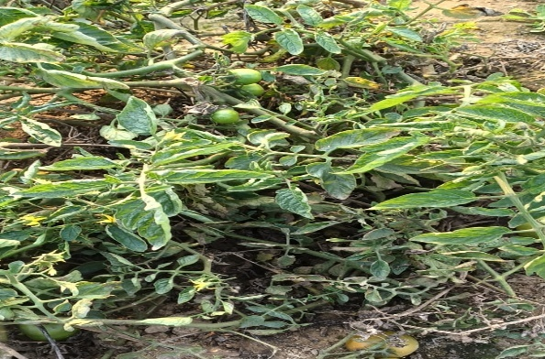
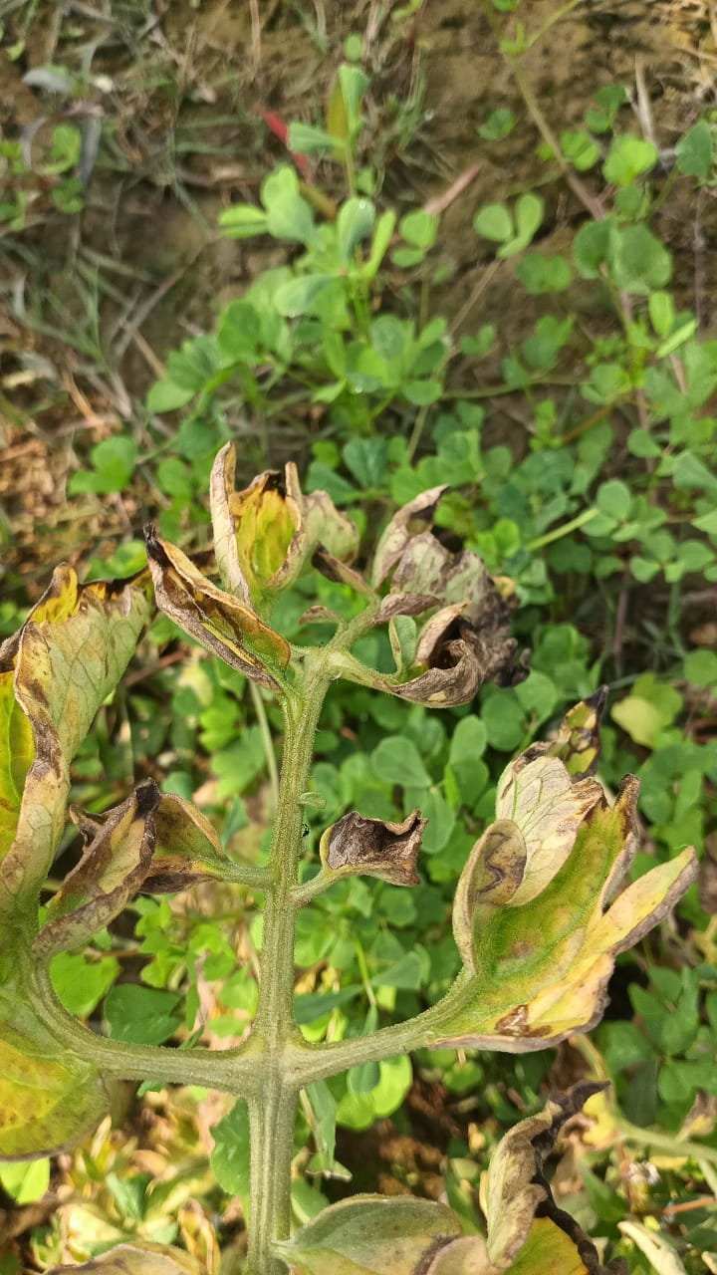

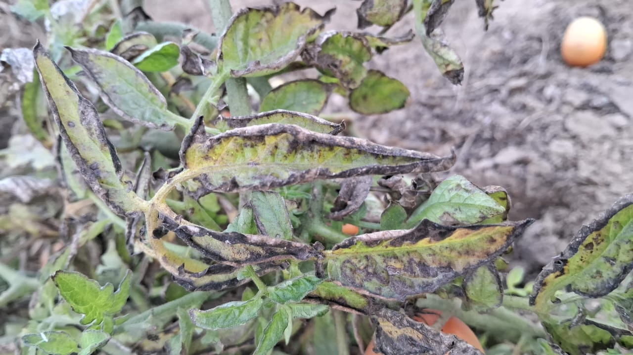

Figure 1: Sample tomato leaf images from the TomLeafVision Dataset representing respectively Healthy, Early Blight, and Late Blight.

- CNN Model Architecture
The TomLeafVision model is developed using a deep Convolutional Neural Network (CNN) framework that is capable of automatically identifying and classifying disease patterns in tomato leaf images. In this architecture, a tomato leaf image is provided as input and processed through several layers of convolution and pooling to extract meaningful features.
The convolutional layers utilize multiple trainable filters to identify key visual characteristics such as edges, color differences, textures, and patterns associated with specific diseases on the leaf surface. Each convolution step is followed by a non-linear activation function, which helps the model capture complex patterns within the data. Pooling layers are incorporated after these operations to reduce the size of feature maps while preserving important information, which also helps in lowering computational cost and minimizing overfitting.

Figure 2: CNN Model Architecture of the Proposed
At the final stage, a Softmax activation function is applied to produce probability values for each class, including healthy, early blight, and late blight. The class with the highest probability is selected as the final prediction. During the training phase, the predicted output is compared with the actual label to calculate the loss, indicating the difference between prediction and ground truth.
To enhance the model’s performance, backpropagation is used to adjust the weights of both convolutional and fully connected layers. Through continuous iterations, the network reduces the loss and improves its prediction capability. Overall, this CNN-based architecture integrates feature extraction, classification, and optimization processes to deliver accurate and reliable detection of tomato leaf diseases.

- Workflow Description
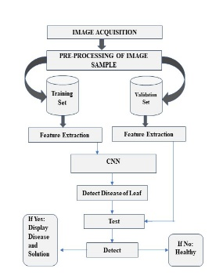
Figure3: Workflow of the Proposed TomLeafVision System
The proposed TomLeafVision system begins with the farmer capturing an image of a tomato leaf using a mobile device. This image is then forwarded to the image acquisition module for further processing. During the preprocessing stage, the image is resized and normalized to ensure consistency and to improve the overall performance of the model.
Once preprocessing is complete, the image is passed to the trained CNN model, which analyzes it and classifies the leaf based on the features it has learned. The model determines whether the leaf is healthy or affected by early blight or late blight. Finally, the prediction results are displayed to the farmer in a clear and user-friendly manner, enabling quick and informed decisions for effective disease management.
- RESULTSAND ANALYSIS

- Model Comparison

The table below presents a comparison between the proposed MobileNetV2 model and several widely used deep learning architectures, such as ResNet50, VGG16, InceptionV3, and a custom CNN model. The analysis shows that MobileNetV2 requires significantly fewer parameters while still maintaining a good trade-off between computational efficiency and predictive performance, making it suitable for real-time applications.

Table II. Comparison of proposed MobileNetV2 Model with Existing Deep Learning Models

Model | Parameters | Accuracy | Speed | Mobile Ready
MobileNetV2 (Ours) | 2.5M | 94% | Fast | Yes
ResNet50 | 25.6M | 95.1% | Slow | No
VGG16 | 138M | 93.5% | Very Slow | No
InceptionV3 | 23.9M | 94.8% | Medium | Limited
Custom CNN | ~1M | 88.2% | Fast | Yes

- Model Performance Analysis

Table III. Performance Evaluation Metricsof the Proposed TomLeafVision System

Metrics | Value
Training Accuracy | 96%
Validation Accuracy | 94%
Field Test Accuracy | 92%
Precision | 93%
Recall | 92%
F1-Score | 92%
A slight drop in performance during field testing can be attributed to environmental factors such as lighting conditions, background variations, and image quality. However, the overall results demonstrate that the model performs reliably under real-world conditions.
- System Interface and Prediction Result

The proposed model effectively captured patterns from the training data, achieving a training accuracy of 96%. It also demonstrated strong performance on unseen samples, with a validation accuracy of 94%, indicating good generalization and minimal overfitting.
The slight decrease in accuracy from training to validation can be attributed to variations in environmental conditions, such as lighting differences, background complexity, and image quality. Overall, the results suggest that the CNN-based approach provides a reliable and accurate solution for detecting diseases in tomato leaves.
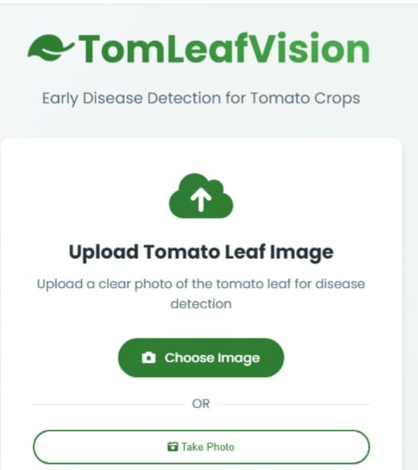

Input interface (Upload Page)

Figure 4: Interface for Uploading Images of Tomato Leaves

The interface allows users to either upload an image or capture a photo of a tomato leaf for disease detection. Once the image is provided through file upload or camera input, it is forwarded to the trained CNN model for further analysis and classification..

Prediction Result Page

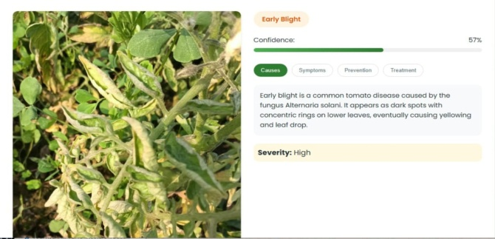

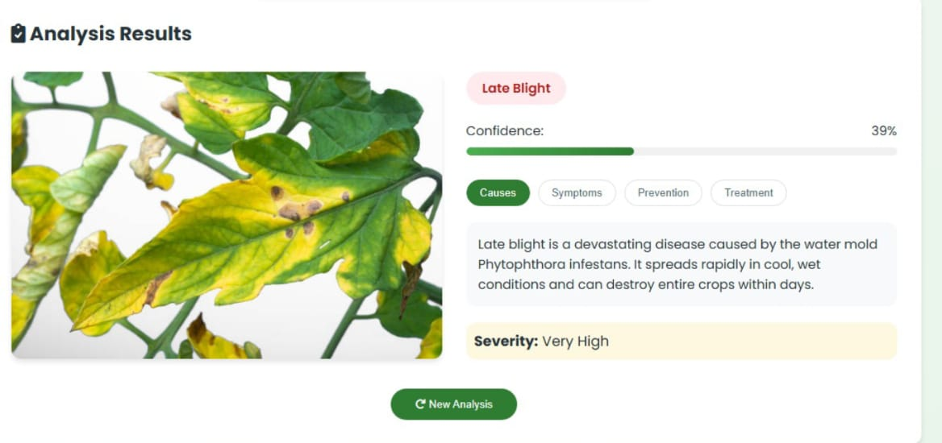

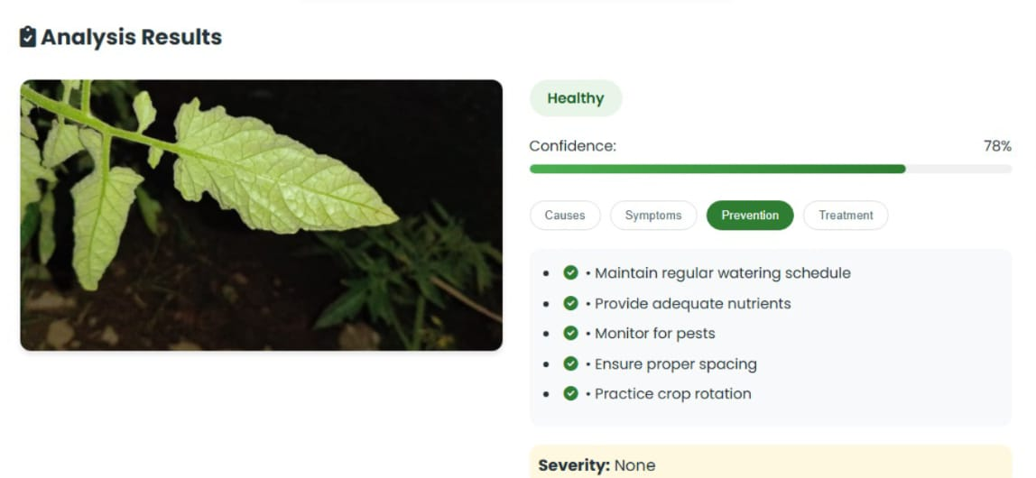

Figure 5: Results of Real-Time Disease Detection for Various Tomato Leaf Conditions

The proposed system was evaluated using a variety of tomato leaf images, including samples affected by early blight, late blight, as well as healthy leaves.

In addition to classification, the system presented detailed insights for diseased leaves, such as possible causes, visible symptoms, preventive strategies, and suggested treatments. For healthy leaves, it offered precautionary recommendations to help maintain plant health.
These results highlight the effectiveness of the CNN-based approach in accurately distinguishing between healthy and diseased tomato leaves in real-time conditions.

Furthermore, each convolutional layer is followed by a non-linear activation function, enabling the network to capture complex patterns within the data. Pooling layers are incorporated after convolution stages to decrease the spatial size of feature maps while preserving essential information, which enhances computational efficiency and helps prevent overfitting.

- Model Training Performance (Loss Curve)

Figure 6: Training and Validation Loss Curve showing model convergence over epochs
The loss curve illustrates the training and validation losses over 15 epochs. Initially, the training loss is relatively high, but it steadily decreases as the model learns important features from the dataset. Similarly, the validation loss also shows a downward trend, indicating improved performance on unseen data. This behavior suggests that the model is learning effectively with minimal overfitting, demonstrating the efficiency of the CNN approach.
- Performance Evaluation using F1-Score, Recall, Precision

Figure 7: Performance Metrics Bar Chart of the Proposed CNN Model

The bar chart presents the performance metrics of the proposed CNN model for detecting diseases in tomato leaves. The model achieves high values in terms of precision, recall, F1-score, and overall accuracy, indicating strong classification capability. The balanced nature of these metrics suggests that the model effectively distinguishes between healthy and diseased leaves while keeping misclassification to a minimum.
- CONCLUSION
This paper presents a deep learning-based system for early detection of tomato leaf diseases, focusing on Early Blight and Late Blight. The proposed approach combines CNN with MobileNetV2 to achieve high accuracy while maintaining computational efficiency.
Experimental results show that the model performs effectively in terms of accuracy, precision, recall, and F1-score. The system demonstrates good generalization ability and is capable of handling real-world variations.
The mobile-based implementation makes the system accessible and easy to use for farmers, enabling timely decision-making and reducing crop losses. Overall, the proposed work contributes to the advancement of smart agriculture by integrating modern technology with practical farming needs.
Future work may include expanding the dataset, improving robustness under varying environmental conditions, and extending the system to detect additional plant diseases.
- REFERENCES
[1] Hao Sun, Rui Fu, “Efficient deep Learning-based tomato leaf disease detection through global and local feature fusion,” BMC Plant Biology, ISSN: 1471-2229, 2025.
[2] X. Wang, J. Liu, “ToamtoGuard-YOLO: a novel efficient tomato disease detection method,” Frontiers in plant Science, ISSN:1664-462X, 2025.
[3] D. Karimanizira, “Context-aware tomato leaf disease detection using deep learning in an operational framework,” Electronics, ISSN: 2079-9292, 2025.
[4] K. Kumari, R. Parray, Y.B. Basavaraj, “Spectral sensor-based device for real-time detection and severity estimation of groundnut bud necrosis virus in tomato,” Journal of Field Robotics, ISSN:1556-4959, 2025.
[5] D.L. Shanhi, K. Vinutha, N. Ashwini, “Tomato Leaf Disease Detection Using CNN,” Procedia Computer Science (Elsevier), ISSN:1877-0509, 2024.
[6] S.G. Paul, A.A. Biswas, A. Saha, “A real-time application-based convolutional neural network approach for tomato leaf disease classification,” Array (Elsevier Journal), ISSN: 2590-0056, 2023.
[7] W. Hu, W. Hong, H. Wang, “A study on tomato disease and pest detection method,” Applied Sciences, 2076-3417, 2023.
[8] N.K. Trivedi, V. Gautam, A. Anand, “Early Detection and Classification of Tomato Leaf Disease Using High-Performance Deep Neural Network,” Sensors, ISSN:1424-8220, 2021.
[9] X. Wang, J. Liu, Z. Zhu, “Early real-time detection algorithm of tomato diseases and pests in the natural environment,” Plant Methods, ISSN:1746-4811, 2021.
[10] M. Agarwal, S.K. Gupta, K.K. Biswas, “Development of Efficient CNN Model for Tomato Crop Disease Identification,” Sustainable Computing: Informatics and Systems (Elsevier Journal), ISSN: 2210-5379, 2020.
[11] M. Agarwal, A. Singh, S. Arjaria, “Tomato Leaf Disease Detection using convolution neural network,” Procedia Computer Science, ISSN:1877-0509, 2020.
[12] J. Abdulridha, Y. Ampatzidis, “Detection of target spot and bacterial spot diseases in tomato usingUAV-based and benchtop-based hyperspectral,” Agriculture, 1385-2256, 2020.
[13] A. Kumar, M. Vani, “Image Based Tomato Leaf Disease Detection,” International Conference on Computing, Communication and Networking Technologies, ISSN: 2150-6864, 2019.
[14] Q. Wang, F.Qi, M. Sun, “Identification of tomato disease types and detection of infected areas based on deep convolutional neural networks and object detection technologies,” Computational Intelligence,ISSN: 0824-7935, 2019.
[15] Robert G. de Luna, Elmer P. Dadios, Argel A. Bandala, “Automated image capturing system for deep learning-based tomato plant leaf disease detection and recognition,” IEEE Region 10 Annual International Conference, ISSN: 2018.

