THE BIYA ERA: STATECRAFT, POLITICAL CONTINUITY, AND THE CHALLENGES OF GOVERNANCE IN CAMEROON, 1982–2025. A HISTORICAL ANALYSIS

ABSTRACT
Since 1982, the presidency of Paul Biya has represented one of the longest political eras in contemporary Africa, shaping Cameroon’s state institutions, governance structures, development strategies, and international relations. This article examines the Biya era (1982–2025) by exploring the central question of how his statecraft influenced political continuity, national stability, and governance outcomes in Cameroon. Using a qualitative historical methodology based on constitutional texts, legal instruments, presidential speeches and decrees, policy documents, administrative reforms, and scholarly literature, the study analyzes major political transitions, development policies, diplomatic strategies, and security challenges. The findings reveal a complex legacy: the Biya administration contributed to institutional continuity, infrastructure expansion, regional diplomatic engagement, and state resilience, while also facing persistent challenges related to democratic consolidation, decentralization, corruption, socioeconomic inequalities, youth unemployment, and internal conflicts. The article concludes that the Biya era represents a paradox of relative political stability and economic transformation, where effective state preservation has coexisted with demands for deeper political and institutional reforms. It recommends strengthening democratic institutions, improving governance accountability, accelerating decentralization, promoting inclusive development, and establishing credible mechanisms for political renewal.
KEYWORDS: Political Continuity, Statecraft, Governance, Paul Biya, Cameroon
- INTRODUCTION
The presidency of Paul Biya constitutes one of the most significant political periods in Cameroon’s post-independence history. Since assuming office on 6 November, 1982 following the resignation of President Ahmadou Ahidjo, Biya has remained the central figure in Cameroon’s political system for more than four decades. His leadership has been characterized by institutional continuity, political adaptation, diplomatic pragmatism, economic policy adjustments, and persistent debates regarding governance, democratic consolidation, and national transformation (Konings & Nyamnjoh, 2003).
When Biya inherited power in 1982, Cameroon operated within a highly centralized presidential system created during the Ahidjo era. The political order was built around a strong executive presidency, a dominant ruling party, and an extensive administrative bureaucracy. Although the constitutional transfer of power from Ahidjo to Biya represented an important moment of institutional continuity, the early years of Biya’s rule were marked by internal struggles over political authority, particularly the rivalry between the former president and his successor (Bayart, 1986).
The consolidation of Biya’s authority following the failed military coup attempt of April 1984 marked a decisive moment in the evolution of Cameroon’s political system. The subsequent transformation of the Cameroon National Union (CNU) into the Cameroon People’s Democratic Movement (CPDM) in 1985 strengthened the ruling party’s role as the central instrument of political mobilization and state management (Konings & Nyamnjoh, 2003). The end of the Cold War and the emergence of democratic pressures across Africa forced significant political adjustments. In 1990, Cameroon introduced political liberalization measures that ended the single-party monopoly and permitted the creation of opposition parties. However, scholars have described this transition as a form of “democratic opening” that expanded political competition while preserving significant elements of presidential dominance and administrative control (Bratton & van de Walle, 1997).
The constitutional reform of 1996 introduced important institutional changes, including provisions for decentralization, the creation of the Senate, and the strengthening of constitutional institutions. However, the implementation of these reforms remained gradual, creating tensions between constitutional commitments and practical realities of governance (Fombad, 2017). Beyond political institutions, the Biya era has been shaped by economic transformation efforts, including structural adjustment reforms during the economic crisis of the 1980s and 1990s, the pursuit of infrastructure development, and long-term development frameworks such as the Growth and Employment Strategy Paper and Cameroon Vision 2035 (International Monetary Fund, 2010). These policies contributed to economic recovery and modernization efforts but also revealed persistent challenges relating to poverty reduction, employment creation, inequality, and governance efficiency (World Bank, 2022).
The administration’s foreign policy has emphasized diplomatic continuity, regional security cooperation, and strategic partnerships with traditional and emerging international actors. Cameroon has maintained an active role within regional organizations such as the Economic and Monetary Community of Central Africa (CEMAC), and the African Union, while engaging international partners on security and development issues (Awasom, 2004). However, the Biya era has also faced major governance challenges. The rise of Boko Haram in the Far North region and the Anglophone crisis beginning in 2016 exposed limitations in state capacity, conflict management, and inclusive governance. These crises have renewed debates about decentralization, national identity, citizenship, and the relationship between the central state and peripheral communities (International Crisis Group, 2017).
This article argues that the Biya presidency represents a complex model of African statecraft: a system that has demonstrated remarkable political endurance and institutional survival while simultaneously confronting demands for democratic renewal, stronger accountability, and broader inclusion. The study addresses three major questions:
- How has Paul Biya’s statecraft shaped Cameroon’s political institutions and governance system between 1982 and 2025?
- What achievements and policy outcomes define the Biya era?
- What challenges continue to influence assessments of his political legacy?
2. METHODOLOGY AND THEORETICAL APPROACH
This study adopts a qualitative historical-institutional methodology, which emphasizes the role of political institutions, historical trajectories, and leadership decisions in shaping long-term governance outcomes (Thelen, 1999; Pierson, 2004). This approach is appropriate because Cameroon’s political system has evolved through gradual institutional layering rather than abrupt systemic change.
The research relies on primary and secondary documentary sources. Primary sources include the Constitution of Cameroon (1972, revised 1996), major legislative instruments such as Law No. 90/053 of 1990 on political freedoms, Law No. 96/06 of 1996 revising the Constitution, Law No. 2004/017 on decentralization, and Law No. 2008/001 removing presidential term limits. Additional sources include presidential speeches, policy documents such as Vision 2035 and the Growth and Employment Strategy Paper (2009), and official government reports (Republic of Cameroon, 2009). Secondary sources include peer-reviewed academic works, World Bank and IMF reports, and analyses of Cameroon’s political economy and governance structure (Fombad, 2017; Konings & Nyamnjoh, 2003). The study uses thematic analysis to identify patterns of political continuity, institutional reform, economic governance, diplomacy, and conflict management.
3. HISTORICAL FOUNDATIONS OF THE BIYA ERA (1982–1990)
The historical foundations of the Biya era (1982–1990) represent a decisive phase in Cameroon’s post-independence political development, during which the transition from Ahmadou Ahidjo to Paul Biya evolved into a process of elite restructuring, institutional consolidation, and gradual redefinition of executive authority. Although the succession occurred within a constitutional framework, the political environment surrounding it was characterized by internal tensions, competing loyalties within the ruling elite, and uncertainty over the direction of the state (Takougang & Krieger, 1998).
Paul Biya assumed office on 6 November 1982, following the resignation of President Ahmadou Ahidjo on 4 November 1982.
Plate 1: His Excellency President Paul Biya Taking his first Oath of office on the 6th November, 1982
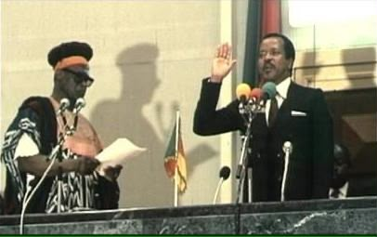
Source: Authors collection March 2026
At the time, Biya occupied the position of Prime Minister, a role that had been institutionalized as part of the constitutional succession architecture under the 1972 unitary constitution. While the transfer of power was formally legal, it marked the beginning of a politically sensitive transition, as Ahidjo initially retained leadership of the ruling Cameroon National Union (CNU), thereby sustaining influence over party structures and segments of the administration (Bayart, 1986).
The early presidency was therefore defined by a dual legitimacy problem, where the new president possessed constitutional authority but faced residual political influence from his predecessor. This situation generated tensions within the ruling elite, particularly between pro-Ahidjo and pro-Biya factions embedded in the bureaucracy, security services, and party apparatus (Joseph, 1986).
3.1 Elite Rivalry and the Breakdown of the Ahidjo–Biya Political Alliance
The relationship between Ahidjo and Biya deteriorated rapidly between 1983 and 1984, largely due to disagreements over the distribution of political authority and the future leadership of the state. Ahidjo’s continued role as party leader created a parallel power structure that conflicted with Biya’s presidential authority. This tension escalated into an open political crisis, culminating in Ahidjo’s resignation from party leadership and subsequent exile (Ngoh, 2023).
The most significant rupture occurred in April 1984, when a faction within the Presidential Guard attempted a coup d’état against Biya’s government. The coup attempt, widely interpreted as linked to pro-Ahidjo elements within the security establishment, was forcefully suppressed. Following this event, the Biya administration undertook a comprehensive restructuring of the military and intelligence apparatus to ensure loyalty to the presidency (Bayart, 1986). This episode marked a foundational turning point in the consolidation of executive power. It reinforced the centralization of authority within the presidency and reshaped civil–military relations in Cameroon, establishing a pattern in which regime security became closely tied to presidential control over coercive institutions.
3.2 Reconfiguration of the Party State System (1985)
A key institutional transformation occurred in 1985, when the Cameroon National Union (CNU) was replaced by the Cameroon People’s Democratic Movement (CPDM/RDPC) during a party congress held in Bamenda. This rebranding was not merely symbolic but reflected a strategic effort to reorganize the ruling party under the direct leadership of President Biya. The transformation of the CNU into the CPDM served several political functions. First, it consolidated presidential authority over party structures, ensuring that the ruling party became an instrument of executive coordination rather than a semi-autonomous political actor. Second, it reinforced the integration of party and state institutions, embedding political loyalty within administrative hierarchies. Third, it contributed to the construction of a national unity discourse, which was central to legitimizing the regime in a linguistically and culturally diverse country (Konings & Nyamnjoh, 2003). By the late 1980s, the CPDM had become deeply entrenched within the state apparatus, with party elites occupying key administrative and governmental positions. This fusion of party and state is widely interpreted as a defining feature of Cameroon’s political system during the Biya era.
3.3 Administrative Centralization and State Control
Between 1982 and 1990, the Cameroonian state experienced a marked intensification of administrative centralization. Although Cameroon formally retained a unitary structure inherited from the Ahidjo period, the Biya administration strengthened executive control over territorial administration through the expansion of presidential decrees and ministerial oversight. Regional governors, prefects, and sub-prefects appointed directly by the presidency, played a crucial role in enforcing state authority at the local level. This administrative structure ensured vertical control from Yaounde to regional and local institutions, limiting the autonomy of local political actors (Ngoh, 2023).
The presidency increasingly relied on decree-based governance, reinforcing the constitutional dominance of the executive branch. This pattern contributed to a political system in which formal institutions existed but were heavily dependent on presidential authority for operational effectiveness (Fombad, 2017).
3.4 The Doctrine of “Rigour and Moralization” (1987)
In 1987, President Biya introduced the political doctrine of “Rigour and Moralization”, articulated in a national address aimed at improving governance standards and combating corruption. The doctrine emphasized administrative discipline, ethical governance, and public sector efficiency as core principles of state reform. While the policy was widely publicized and became a central ideological reference point of the administration, its practical impact was limited. Corruption networks, patronage systems, and informal political practices remained deeply embedded within administrative structures. Scholars argue that the doctrine functioned more as a normative framework for governance legitimacy than as a fully implemented reform agenda (Fombad, 2017). Nevertheless, it contributed to shaping the official discourse of governance and remains a recurring reference point in subsequent anti-corruption campaigns in Cameroon.
3.5 Economic Conditions and Early Structural Pressures
The late 1980s marked the beginning of significant economic difficulties in Cameroon. The economy, heavily dependent on agricultural exports such as cocoa and coffee, as well as oil revenues, was affected by declining global commodity prices. These external shocks, combined with internal fiscal imbalances, led to rising budget deficits and increasing public debt. By the end of the decade, Cameroon was experiencing early signs of economic crisis, prompting discussions with international financial institutions regarding Structural Adjustment Programs. These discussions laid the groundwork for the economic reforms that would dominate the 1990s (World Bank, 1990). The emerging economic constraints highlighted structural vulnerabilities within the Cameroonian economy and underscored the need for diversification and fiscal reform.
3.6 Controlled Political Stability and Emerging Pressures for Change
Despite internal elite conflicts and economic pressures, the 1982–1990 period was characterized by relative political stability in terms of regime continuity. Opposition activity remained limited, and Cameroon continued to operate under a single-party system dominated by the CPDM. However, by the late 1980s, growing internal and external pressures for political liberalization began to emerge. The global wave of democratization following the end of the Cold War combined with domestic demands for political participation, increased pressure on the regime to introduce reforms. Student movements, civil society actors, and intellectual debates signaled the beginning of a transition toward multiparty politics (Bratton & van de Walle, 1997). These pressures set the stage for the major political reforms of the early 1990s, marking the end of the foundational phase of the Biya era and the beginning of a new era of controlled political liberalization.
4. POLITICAL LIBERALIZATION, REFORMS, AND INSTITUTIONAL CHANGE (1990–2008).
The period between 1990 and 2008 represents a critical phase of political transformation in Cameroon under President Paul Biya, characterized by controlled liberalization, constitutional engineering, and gradual institutional restructuring. This era marked the transition from a de facto single party system to a formally multiparty political environment, while maintaining strong executive dominance over the state apparatus. The reforms introduced during this period were largely responses to both internal political pressures and external democratization trends following the end of the Cold War (Bratton & van de Walle, 1997).
The first major political opening occurred in 1990 with the promulgation of Law No. 90/053, which legalized political associations and effectively ended the monopoly of the Cameroon People’s Democratic Movement (CPDM). This reform allowed the emergence of opposition parties such as the Social Democratic Front (SDF), which rapidly became a major political force, particularly in the Anglophone regions. The legalization of multiparty politics was accompanied by growing political mobilization, civil society activism, and public protests demanding deeper democratic reforms (Konings, 1996).
Despite this political opening, the transition did not result in full democratization. The 1992 presidential election, the first multiparty presidential contest, was characterized by intense competition but also widespread allegations of irregularities. President Biya was declared the winner, but opposition claims of electoral manipulation led to political tensions and a legitimacy crisis. Scholars describe this period as the emergence of “managed pluralism,” where political competition existed but remained structurally constrained by state control over electoral processes and security institutions (Bratton & van de Walle, 1997).
A major constitutional milestone occurred in 1996 with Law No. 96/06, which revised the 1972 Constitution. This reform introduced significant institutional innovations, including the establishment of a bicameral parliament composed of the National Assembly and a proposed Senate, as well as provisions for decentralization and the strengthening of regional governance structures. The constitution also reaffirmed the unitary nature of the state while introducing mechanisms intended to enhance local governance and political representation. However, implementation of these reforms was slow and selective, with key institutions such as the Senate only becoming operational many years later, illustrating the gap between constitutional design and political practice (Fombad, 2017).
The decentralization framework was further reinforced through subsequent legal instruments, particularly Law No. 2004/017, which outlined the organization and functioning of decentralized territorial collectivities. This law aimed to transfer certain administrative and fiscal responsibilities to local governments. However, in practice, decentralization remained limited due to continued dominance of centrally appointed administrative officials such as governors and prefects, who retained significant authority over regional governance structures.
Another major institutional development occurred in 2008 with Law No. 2008/001, which removed presidential term limits. This constitutional amendment marked a significant turning point in Cameroon’s political trajectory, as it eliminated constraints on presidential tenure and reinforced the continuity of executive power. Critics argued that this reform significantly weakened prospects for political alternation and consolidated long-term incumbency within the presidency (Freedom House, 2009). Throughout this period, governance reforms were also introduced under broader administrative modernization efforts, including anti-corruption campaigns such as the “Operation Sparrow Hawk” launched in the mid-2000s. These initiatives targeted high-level corruption cases within the public administration, although their effectiveness has been debated in scholarly literature due to concerns about selective enforcement and politicization (Fombad, 2017).
Overall, the period 1990–2008 reflects a dual dynamic of political liberalization and institutional consolidation. While multiparty politics and constitutional reforms expanded the formal framework of democracy, the persistence of centralized executive control and limited institutional independence constrained the depth of political transformation.

5. ECONOMIC GOVERNANCE, DEVELOPMENT POLICIES, AND INFRASTRUCTURE TRANSFORMATION.
Economic governance under the Biya administration has evolved through distinct phases shaped by crisis management, structural adjustment, and long-term development planning. The trajectory of Cameroon’s economy from the 1980s to 2025 reflects both external shocks and domestic policy responses aimed at restoring macroeconomic stability and promoting structural transformation (World Bank, 2006). The initial phase of economic governance in the mid-1980s was marked by severe fiscal crisis triggered by declining global prices of Cameroon’s primary export commodities, particularly oil, cocoa, and coffee. This economic downturn resulted in reduced public revenues, rising external debt, and growing budget deficits. In response, Cameroon engaged with the International Monetary Fund and the World Bank, leading to the adoption of structural adjustment programs in the early 1990s (IMF, 1999).
These structural adjustment policies emphasized fiscal austerity, privatization of state-owned enterprises, liberalization of trade, and reduction of public expenditure. Key public institutions were restructured or privatized, including utilities and agricultural marketing boards. While these reforms stabilized macroeconomic indicators over time, they also generated significant social costs, including unemployment, reduced public sector employment, and declining access to basic services. The social impact of these reforms remains a central point of academic debate (World Bank, 2002). From the early 2000s, Cameroon shifted toward a development-oriented governance framework focused on poverty reduction and long-term economic transformation. The introduction of the Poverty Reduction Strategy Paper (PRSP) marked a new phase of policy alignment with international development frameworks. This strategy emphasized macroeconomic stability, social development, and institutional reform aimed at improving governance efficiency (IMF, 2003).
This framework was later expanded through the Growth and Employment Strategy Paper (GESP) adopted in 2009, which became the central national development blueprint. The GESP outlined a long-term vision of transforming Cameroon into an emerging economy by 2035, with emphasis on industrialization, infrastructure development, private sector expansion, and agricultural modernization (Republic of Cameroon, 2009). This strategy is closely linked to the broader national development vision known as Vision 2035, which sets long-term objectives for economic transformation and structural diversification. Infrastructure development has been one of the most visible and politically significant dimensions of economic governance under the Biya administration. Major investments have been directed toward energy, transport, and logistics infrastructure, reflecting the state’s strategy of using infrastructure as a driver of economic growth and national integration.
In the energy sector, significant projects include the Lom Pangar Hydropower Dam, completed in 2017, which regulates water flow and enhances electricity generation capacity in the Sanaga River basin.
Plate 2: The Lom Pangar Hydropower Dam
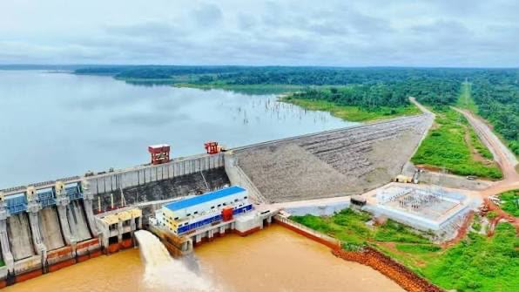Source: Authors collection March 2026
The Nachtigal Hydropower Plant, commissioned in 2024, represents one of the largest electricity infrastructure projects in Cameroon, significantly increasing national power supply capacity. The Kribi Gas Power Plant, operational since 2013, also contributes to energy stabilization and industrial supply (World Bank, 2012; BESIX, 2024).
Plate 3: The Kribi Gas Power Plant
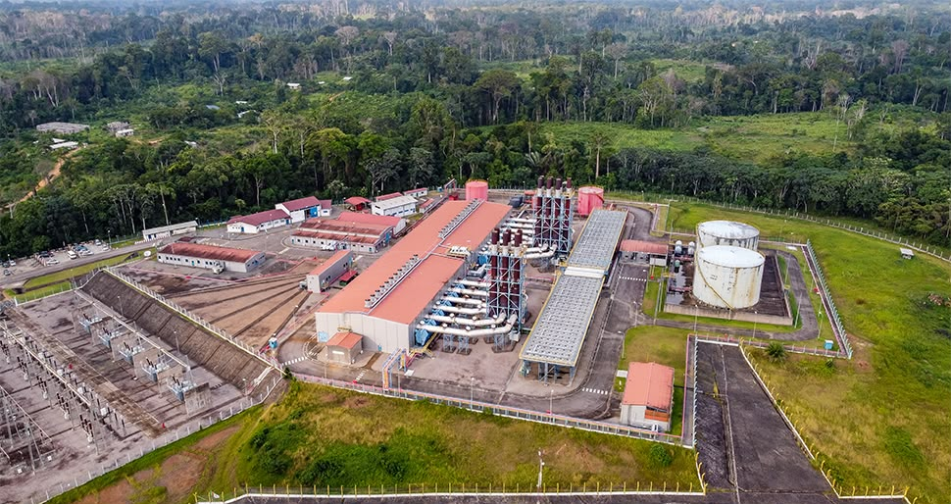
Source: Authors collection March 2026
In transport infrastructure, the development of the Yaounde–Douala motorway represents a major effort to improve connectivity between the political and economic capitals. Urban infrastructure projects in cities such as Douala have included road expansion, bridge construction, and modernization of transport corridors. These projects aim to reduce congestion, improve logistics efficiency, and support economic productivity.
A particularly strategic project is the Kribi Deep Sea Port, which has become a key logistics hub for Cameroon and the Central African region. Designed to accommodate large cargo vessels, the port is intended to reduce pressure on the Port of Douala and facilitate export-oriented industrial development. It is linked to broader industrial corridor projects, including mining and transport infrastructure aimed at enhancing regional trade competitiveness (Kribi Port Authority, 2024).
Plate 4: The Kribi Deep Sea Port
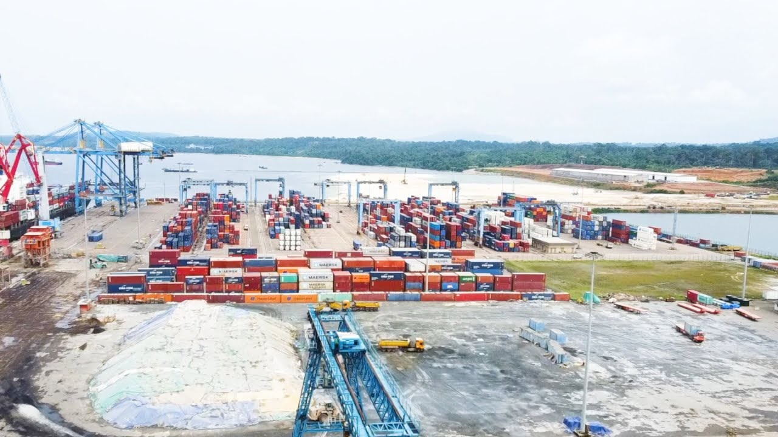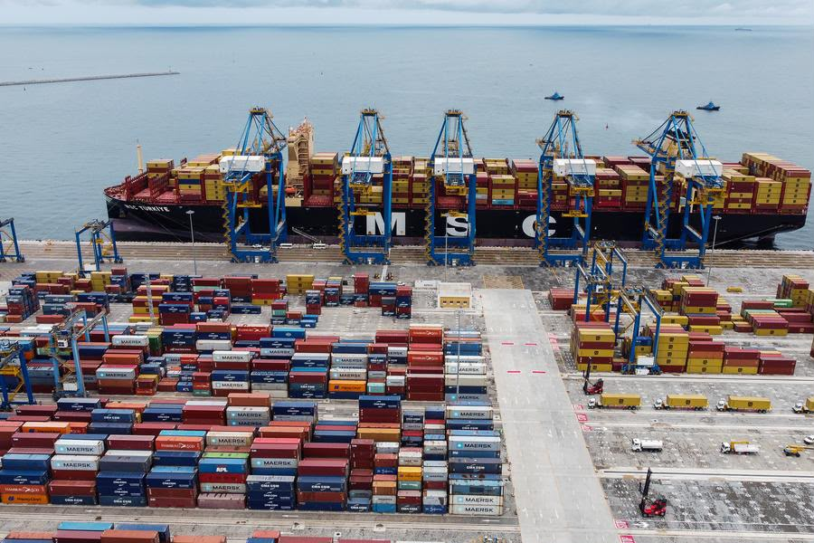
Source: Authors collection March 2026
Despite these infrastructure achievements, Cameroon continues to face structural economic challenges. The economy remains heavily dependent on primary commodities, with limited industrial diversification and persistent vulnerability to external shocks. Youth unemployment remains high, and regional inequalities in development persist. Governance inefficiencies and institutional constraints continue to affect the efficiency of public investment and the overall impact of development policies (World Bank, 2006).
In summary, economic governance under the Biya administration reflects a dual reality. On one hand, it demonstrates significant progress in macroeconomic stabilization, infrastructure expansion, and long-term development planning. On the other hand, structural constraints related to governance, inequality, and economic diversification continue to limit the full realization of development objectives.
6. CAMEROON’S DIPLOMACY AND INTERNATIONAL RELATIONS UNDER PAUL BIYA
Cameroon’s diplomacy under President Paul Biya has been characterized by continuity, pragmatism, and strategic diversification in response to shifting global and regional dynamics. From 1982 to 2025, foreign policy has been guided by the need to preserve national sovereignty, maintain regional stability, and expand international partnerships beyond traditional post-colonial alignments. This diplomatic orientation reflects a broader strategy of balancing inherited Franco-Cameroonian relations with emerging multipolar engagements involving China, the United States, and other global actors (Awasom, 2004).
A central pillar of Cameroon’s foreign policy has been its historically close relationship with France. This relationship, rooted in colonial history, has remained stable throughout the Biya era, encompassing military cooperation, economic assistance, and diplomatic alignment on various international issues. France has continued to play a significant role in Cameroon’s security architecture and development financing, particularly in infrastructure and governance programs. However, over time, Cameroon has increasingly sought to diversify its external partnerships in order to reduce dependency and assert greater diplomatic autonomy.
From the early 2000s, Cameroon pursued a deliberate policy of diplomatic diversification, with China emerging as one of its most significant development partners. Chinese engagement has been particularly prominent in infrastructure development, including roads, ports, energy projects, and construction of public facilities. This shift reflects Cameroon’s broader strategy of engaging multiple global powers in a competitive development financing environment. The expansion of Chinese investment has been accompanied by partnerships with other emerging actors such as India, Turkey, and Gulf states, reinforcing Cameroon’s position within a multipolar global system.
Cameroon’s regional diplomacy has been equally significant, particularly within Central Africa. As a member of the Economic and Monetary Community of Central Africa (CEMAC) and the African Union, Cameroon has consistently positioned itself as a stabilizing force in a region often affected by political instability and armed conflict. The country has participated in mediation efforts in the Central African Republic and has contributed to regional peacekeeping and stabilization initiatives. These diplomatic engagements reflect Cameroon’s ambition to maintain regional leadership and reinforce its geopolitical relevance in Central Africa (Awasom, 2004).
Security diplomacy has become increasingly important in the Biya era, particularly in response to transnational threats such as Boko Haram. Also, following the historic Green Tree Agreement between Cameroon and Nigeria on the 14 August 2013, the Bakassi peninsula became an integral part of Cameroons territory, with Cameroon exercising full sovereignty over the territory. The landmark resolution of the territorial conflict between Cameroon and Nigeria was taken on 12 June 2006 in Green Tree, a suburb of New York in the United States of America, by the President of the Republic His Excellency Paul BIYA and his Nigerian counterpart, His Excellency Olusegun Obasanjo.

Plate 5: His Excellency, President of the Republic of Cameroon, Paul Biya and his Nigerian counterpart, His Excellency Olusegun Obasanjo signing the Green Tree Agreement
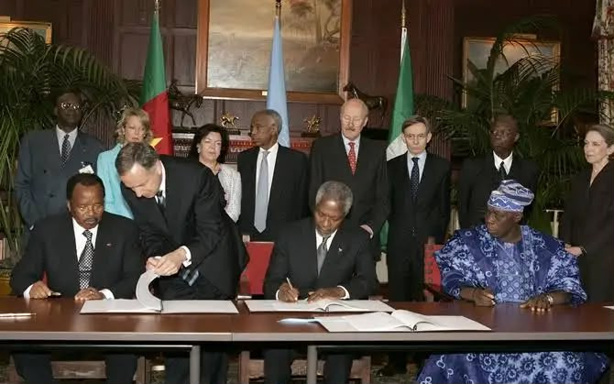
Source: Authors collection March 2026
Cameroon has also engaged in multilateral military cooperation with neighboring states including Nigeria, Chad, and Niger through joint operations under regional security frameworks. These collaborations have involved intelligence sharing, coordinated military operations, and border security management, demonstrating Cameroon’s integration into regional security governance structures (Konings, 2011).
At the multilateral level, Cameroon has maintained active participation in international organizations including the United Nations, the Commonwealth, and La Francophonie. Since joining the Commonwealth in 1995, Cameroon has expanded its diplomatic reach beyond Francophone networks, allowing it to engage more broadly with Anglophone countries and global governance institutions. This dual linguistic and diplomatic orientation has enabled Cameroon to maintain flexibility in international relations while preserving its historical alliances. Overall, Cameroon’s diplomacy under Paul Biya reflects a consistent strategy of pragmatic engagement, strategic balancing, and regional leadership. While the country has successfully maintained diplomatic stability and diversified its international partnerships, its foreign policy remains closely tied to internal political and security considerations, particularly the need to manage regional instability and domestic conflict dynamics.
7. SECURITY CHALLENGES AND GOVERNANCE CRISIS: BOKO HARAM, THE ANGLOPHONE CONFLICT, AND STATE RESPONSE
The security landscape of Cameroon under the Biya administration has been shaped by two major and interconnected crises: the Boko Haram insurgency in the Far North region and the Anglophone conflict in the North-West and South-West regions. These crises have significantly tested the capacity of the state, reshaped governance priorities, and exposed structural limitations in conflict management and institutional responsiveness. The Boko Haram insurgency emerged in the early 2010s as an extension of the extremist violence originating in northeastern Nigeria. The group expanded its operations into Cameroon’s Far North region, launching attacks on civilian populations, security forces, and public infrastructure (Mark Bolak, 2018).
In response, the Cameroonian government deployed military forces and established coordinated operations with neighboring countries under the Multinational Joint Task Force framework. These operations involved joint military patrols, intelligence sharing, and cross-border coordination aimed at containing insurgent activities (International Crisis Group, 2017). The state’s response included increased militarization of the Far North region, reinforcement of border security, and expansion of counterterrorism measures. While these efforts succeeded in reducing the territorial control of Boko Haram, the insurgency persisted in the form of sporadic attacks, suicide bombings, and asymmetric warfare, highlighting the enduring nature of the threat.
The second major security crisis, the Anglophone conflict, represents one of the most serious internal governance challenges in Cameroon’s contemporary history. The origins of the crisis can be traced to longstanding grievances related to the perceived marginalization of English-speaking regions and the centralization of political and administrative authority. Tensions escalated significantly in 2016 following protests by lawyers and teachers concerning the imposition of Francophone legal and educational systems in Anglophone regions (Confidence Chia etal, 2020). The government’s response initially involved negotiations and limited administrative measures, including the creation of a National Commission for the Promotion of Bilingualism and Multiculturalism in 2017. However, the situation deteriorated into armed conflict following the emergence of separatist armed groups and the militarization of the crisis. The state responded through military deployments, security operations, and legal measures aimed at restoring order.
Key legislative and policy responses included the acceleration of decentralization reforms under the 2019 General Code of Regional and Local Authorities (Law No. 2019/024), which sought to grant greater autonomy to local governments. However, implementation has remained limited, and the conflict continues to affect governance, education, economic activity, and civilian security in affected regions (International Crisis Group, 2017). The persistence of these crises has had significant implications for governance in Cameroon. It has led to increased centralization of security authority, expanded military influence in internal administration, and growing pressures on public finances. It has also intensified debates about national identity, state legitimacy, and the effectiveness of decentralization policies.
From a governance perspective, these crises reveal structural challenges in Cameroon’s political system, particularly in relation to conflict prevention, institutional responsiveness, and inclusive governance. While the state has demonstrated resilience in maintaining territorial integrity, the prolonged nature of these conflicts highlights limitations in achieving sustainable peace and political reconciliation. In summary, Cameroon’s security challenges under Paul Biya illustrate the complexity of governing a diverse and politically plural society facing both transnational insurgency and internal identity-based conflict. These crises have reshaped state priorities, reinforced the centrality of security governance, and exposed the need for deeper institutional reforms to address underlying political and social grievances.
8. ACHIEVEMENTS, USEFUL CRITICISMS, AND LEGACY OF THE BIYA ERA
The evaluation of the Biya era (1982–2025) requires a balanced analytical approach that considers both the achievements of long-term governance and the persistent structural challenges that have shaped Cameroon’s political and socioeconomic trajectory. Over more than four decades, the administration has presided over significant state continuity, institutional survival, infrastructure expansion, and diplomatic engagement, while simultaneously facing criticisms related to governance centralization, democratic deficits, and unresolved internal conflicts (Fombad, 2017; Konings & Nyamnjoh, 2003).
One of the most widely acknowledged achievements of the Biya era is the preservation of state stability in a region often characterized by political volatility. Despite internal tensions and external pressures, Cameroon has maintained territorial integrity and institutional continuity since independence. The state has avoided large-scale breakdowns of central authority, even during periods of economic crisis, political liberalization, and armed conflict. This continuity is often attributed to the strong presidential system and centralized administrative structure that have defined governance under Biya (Bayart, 1986).
Another key achievement is the expansion of national infrastructure, particularly in the areas of energy, transport, and ports. Major investments in hydropower projects such as Lom Pangar and Nachtigal, as well as the development of the Kribi deep-sea port and the Yaoundé–Douala motorway, reflect a long-term strategy of infrastructure-led development. These projects have contributed to improving electricity generation capacity, enhancing national connectivity, and strengthening Cameroon’s position as a regional logistics hub (World Bank, 2006; Republic of Cameroon, 2009).
On the diplomatic front, Cameroon has maintained a relatively stable and pragmatic foreign policy, balancing traditional partnerships with France while expanding relations with China and other emerging global actors. One of the earliest significant infrastructure projects linked to Chinese cooperation was the Lagdo Hydroelectric Dam, developed during the 1980s with Chinese financial and technical support. Completed during this period of consolidation, the project symbolized the growing willingness of China to participate in Cameroon’s energy sector and laid the groundwork for later large-scale hydroelectric investments (Zoubir, 2014).
The Lagdo dam was built between 1977 and 1982 by the CWE. The reservoir is located on the Benue River, in a locality 50 km from Garoua, the capital of the Northern Region in Cameroon. The project increased the plant’s capacity to 80 MW and represented an early demonstration of how Chinese involvement could combine financing and technical expertise in critical public infrastructure.
Plate 6: The Lagdo Hydroelectric Dam Project on the Benue River

Source: Authors collection, March, 2026
Cameroons’ active participation in regional organizations such as CEMAC and the African Union, as well as its involvement in peacekeeping and mediation efforts in Central Africa, demonstrates its role as a regional diplomatic actor (Awasom, 2004). Cameroon has also contributed to regional security operations against Boko Haram, reinforcing its relevance in Central African security governance (Konings, 2011).
However, these achievements are accompanied by significant criticisms. One of the most persistent concerns relates to democratic governance and political alternation. The concentration of executive power, particularly following the 2008 constitutional amendment removing presidential term limits, has been widely criticized as reinforcing long-term incumbency and limiting political competition (Freedom House, 2009). Scholars have described Cameroon’s political system as a form of “electoral authoritarianism,” where formal multiparty institutions exist but are constrained by structural imbalances favoring the ruling party (Bratton & van de Walle, 1997). Governance challenges also include issues of corruption, administrative inefficiency, and weak institutional accountability. Despite repeated policy initiatives such as the “Rigour and Moralization” doctrine and subsequent anti-corruption campaigns, corruption remains a significant concern in public administration and service delivery (Fombad, 2017). These governance constraints have affected the efficiency of public investment and reduced the impact of development policies.
Socioeconomic inequalities and youth unemployment represent additional structural challenges. While macroeconomic stability has improved over time, economic transformation has been uneven, with limited industrial diversification and continued dependence on primary commodity exports. Regional disparities between urban and rural areas also persist, reflecting unequal distribution of infrastructure and public services (World Bank, 2006). The most serious governance challenges of the Biya era are reflected in the emergence and persistence of armed conflicts, particularly the Boko Haram insurgency. (Mark Bolak, 2018). These conflicts have exposed limitations in conflict prevention, institutional responsiveness, and inclusive governance, while placing significant pressure on national unity and state capacity (International Crisis Group, 2017).
The legacy of Paul Biya’s presidency is therefore deeply ambivalent. On one hand, it is associated with political stability, institutional endurance, infrastructure development, and diplomatic continuity. On the other hand, it is marked by unresolved questions regarding democratic consolidation, governance reform, and national cohesion. This duality reflects a broader paradox in African statecraft, where long-term incumbency can simultaneously produce stability and institutional stagnation. Ultimately, the Biya legacy is likely to be interpreted through competing historical narratives. One narrative emphasizes state preservation, continuity, and modernization efforts. The other highlights missed opportunities for political reform, inclusive governance, and structural transformation. The tension between these interpretations defines the enduring complexity of Cameroon’s contemporary political history.
9. CONCLUSION AND POLICY RECOMMENDATIONS
The Biya era (1982–2025) represents one of the longest and most consequential political trajectories in contemporary African governance. Across more than four decades, Cameroon has experienced significant transformations in political institutions, economic policy frameworks, diplomatic orientation, and security governance. The analysis presented in this study demonstrates that the Biya presidency is characterized by a dual dynamic of continuity and constraint, where institutional stability coexists with persistent governance challenges.
From a historical perspective, the Biya administration successfully consolidated executive authority in the early years, particularly following the political crisis of the 1980s and the attempted coup of 1984. This consolidation provided the foundation for long-term political continuity and state stability. Subsequent phases of governance introduced controlled political liberalization in the 1990s, constitutional reforms in 1996, and development-oriented planning frameworks such as Vision 2035 and the Growth and Employment Strategy Paper (Republic of Cameroon, 2009).
Economically, Cameroon achieved periods of macroeconomic stabilization, particularly following structural adjustment reforms supported by international financial institutions. Infrastructure development has been one of the most visible achievements of the era, with major investments in energy production, transport networks, and port infrastructure contributing to national integration and regional competitiveness (World Bank, 2006). Diplomatically, Cameroon maintained stable relations with traditional partners while expanding its global partnerships and strengthening its role in regional security and multilateral cooperation (Awasom, 2004).
However, these achievements are accompanied by persistent structural challenges. Democratic consolidation remains limited due to centralized executive power and constrained political competition. Governance inefficiencies and corruption continue to affect public administration and development outcomes. Economic transformation has been uneven, with limited industrial diversification and persistent unemployment. Most significantly, internal conflicts such as the Anglophone crisis and Boko Haram insurgency have exposed limitations in conflict management and inclusive governance (International Crisis Group, 2017).
In light of these findings, several policy recommendations emerge.
First, there is a need to strengthen institutional independence, particularly within the judiciary, electoral bodies, and oversight institutions, to enhance accountability and democratic credibility. Second, the decentralization process should be fully implemented to ensure meaningful transfer of authority and resources to regional and local governments. Third, economic policy should prioritize industrial diversification and youth employment to reduce structural dependence on primary commodities. Fourth, governance reforms must intensify anti-corruption measures and improve public financial management systems to enhance efficiency and trust in public institutions. Finally, sustained national dialogue and inclusive political frameworks are essential for addressing long-standing conflicts and reinforcing national cohesion.
Finally, the Biya era reflects a complex historical experience in which state survival, institutional continuity, and development ambitions coexist with unresolved governance challenges. Its legacy will continue to shape Cameroon’s political trajectory, particularly in relation to questions of democratic transition, institutional reform, and national unity in the post-Biya period.
SOURCES CONSULTED
- Books
Bayart, J.-F. L’État au Cameroun. Cameroon: Presses de la Fondation Nationale des Sciences Politiques, 1986.
Bratton, M., & van de Walle, N. Democratic experiments in Africa: Regime transitions in comparative perspective. UK: Cambridge University Press, 1997.
Danga, M. J. “Dynamics, contours and foundations of Sino-Cameroonian military cooperation”. Journal of Sino-African Studies (2025): 1971–2021
Fanso, Verkijika Godfrey., Cameroon History for Secondary Schools and Colleges. The Colonial and Post-Colonial Periods. Limbe: Macmillan Publishers Limited, 1989.
Fombad, C. M. Constitutional democracy in Africa: Progress and problems. UK: Oxford University Press, 2017.
Joseph, R. Gaullist Africa: Cameroon under Ahmadou Ahidjo. London: Macmillan, 1986.
Ngoh, VJ. Former Southern Cameroons. The “Third Option” and the Anglophone problem, 1959 2022: A Historico-conflict study. Limbe: Press Print 2023: 165-200.
Pierson, P. Politics in Time: History, Institutions, and Social Analysis. Princeton: University Press, 2004.
Takougang, J., & Krieger, M. African state and society in the 1990s: Cameroon’s political crossroads. Westview Press, 1998.

- Articles in Journals
Awasom, F. (2004). Cameroon’s diplomatic positioning in Central Africa. African Studies Review, 47(3), 1–22.
Awasom, F. “The history of the Cameroon-Nigeria borderlands: Theoretical perspectives and political challenges.” African Studies Review, 47(3), (2004): 1–22.
Confidence Chia Ngam and Reymond Njingti Budi. “The Anglophone question in Cameroon: History Context and Evolution from ‘Everyday’ Resistance to Armed Conflict, 1961-2017.” AFRICANA STUDIA, no. 33 (2020): 3-6.
Fombad, C. M. “Constitutional Reforms and Governance in Cameroon”. Journal of African Law, 61(2), 20(17): 1–25.
Konings, P. “Cameroon and regional security cooperation in Central Africa”. African Security Review, 20(2), (2011): 1–15.
Konings, P. “Political liberalization in Cameroon”. African Studies Review, 39(2), (1996): 1–22.
Konings, P. “The Anglophone Cameroon crisis: A story of failed democratization”. African Studies Quarterly, 12(3), (2011): 23–45.
Mark Bolak Funteh, “stretching the hypothetically “Unstretchable” Checks against Boko Haram Terrorist Recalcitrance around the Lake Chad Basin Area: A Direct Payoff for Staking the state and state Interest on the Platter of personal Attention.”International journal of history and cultural studies 4, no. 1 (2018): 37-55.
Thelen, K. “Historical institutionalism in comparative politics”. Annual Review of Political Science, 2, (1999): 369–404.
- Decrees/Laws/ Presidential Circulars /Reports
Freedom House. Freedom in the world report: Cameroon: Freedom House, 2009.
International Crisis Group. Cameroon’s Anglophone crisis at the crossroads. International Crisis Group, 2017.
International Monetary Fund. Cameroon Structural Adjustment Program Review. IMF, 1999.
Kribi Port Authority. Kribi deep sea port development report. Government of Cameroon, 2024.
Law No. 2004/017 of 22 July 2004 on the Orientation of Decentralization;
Law No. 2019/024 of 24 December 2019 instituting the General Code of Regional and Local Authorities;
Law No. 90/053 of 19 December 1990 on Public Freedoms, which introduced political pluralism;
Law No. 96/06 of 18 January 1996 revising the Constitution of Cameroon;
Republic of Cameroon. Cameroon Vision 2035. Government of Cameroon, 2009.
Republic of Cameroon. Growth and Employment Strategy Paper (GESP). Government of Cameroon, 2009.
Republic of Cameroon. Law No. 2019/024 instituting the General Code of Regional and Local Authorities. Cameroon: Journal Officiel, 2019.
Republic of Cameroon. National Commission for the Promotion of Bilingualism and Multiculturalism Report. Government of Cameroon, 2017.
World Bank. Cameroon Country Economic Memorandum. World Bank Group, 2006.
World Bank. Cameroon Economic Memorandum. World Bank Group, 1990.
World Bank. Cameroon Economic Update: Revisiting Reforms for Inclusive Growth. World Bank Group. 2022.
World Bank. Cameroon Public Expenditure Review. World Bank Group, 2002.
World Bank. Lom Pangar Hydropower Project Appraisal Report. World Bank Group, 2012.
AUTHOR’S BIOGRAPHY

Dr. Shey Fonjoh Ivo (PhD) is a Cameroonian scholar working as a secondary school teacher with MINESEC and affiliated to the University of Bamenda, Cameroon. He is a holder of CAPIEMP, DIPES I, BA and MA in history and Archeology. He holds a PhD in Political History from the University of Bamenda since 2025. His research interest includes politics and nation building, conflict management, humanitarian studies and environmental governance, with particular focus on the evolution of conflict in Cameroon, Africa and the world. His works explores the intersections of conflict, gender related issues, climate vulnerability, governance and state reconstruction in fragile contexts. He is actively engaged in academic research and writing most especially curriculum development and restructuring, contributing to scholarly and policy discussions aimed at ameliorating educational standards in Cameroon, and also addressing complex sociopolitical challenges in Africa and beyond.

