REINFORCEMENT STRATEGIES OF TEACHERS AND ACADEMIC PERFORMANCE OF GRADE 6 PUPILS IN
SELECTED ELEMENTARY SCHOOLS

ABSTRACT

Reinforcement strategies play an important role in shaping learners’ behaviour, motivation, and academic achievement. However, despite their recognized significance, there is limited localized research examining their influence among elementary pupils in Cervantes, Ilocos Sur. This lack of local research makes it hard to know which teaching methods work best for pupils in this specific area. This study examined the reinforcement strategies employed by teachers and their relationship to the academic performance of Grade 6 pupils in selected elementary schools in Cervantes, Ilocos Sur.
A descriptive-correlational research design was employed in this study. The questionnaire assessed the extent to which teachers employed reinforcement strategies in the classroom, as perceived by the pupils. Data were collected from 137 Grade 6 pupils using a validated survey questionnaire, along with their academic grades for the School Year 2025–2026. Results revealed that teachers consistently utilized reinforcement strategies in the classroom, interpreted as Always. The learners’ academic performance was described as Very Satisfactory. Statistical analysis showed a significant relationship between teachers' reinforcement strategies and pupils' academic performance. This means that consistent and appropriate reinforcement practices help improve pupil achievement.
The study recommends the continuous and consistent application of reinforcement strategies to further enhance classroom engagement and improve the academic performance of Grade 6 learners.

Keywords: Academic Performance, Grade 6 Pupils, Reinforcement Strategies

Chapter I
INTRODUCTION

Background of the Study
Classroom management is a fundamental aspect of effective teaching that involves the deliberate organization of classroom environments to facilitate learning, maintain order, and promote positive student behaviour. Effective classroom management creates a structured and supportive learning atmosphere where students feel motivated to participate actively and engage in academic tasks. Research indicates that classrooms characterized by well-implemented management strategies tend to demonstrate higher levels of student engagement, improved behaviour, and better academic performance (Gage et al., 2020). Reinforcement strategies are important in this process because they help shape student behaviour and learning by encouraging good actions and reducing bad ones.

Reinforcement strategies involve using praise, rewards, feedback, and other motivational techniques to strengthen desired behaviours and improve learning outcomes (Santrock, 2021; Fatima et al., 2023). When teachers regularly use these strategies, students are more likely to show positive learning behaviours, participate more in class, and persist in their schoolwork (Khanum et al., 2025). These strategies create a supportive environment where students feel recognized and motivated to do well academically (Gage et al., 2020).

The quality of education is closely tied to effective classroom management and reinforcement strategies. Education plays an important role in shaping individuals and societies by giving learners the knowledge, skills, and values needed for social and economic growth. Around the world, improving education quality is a major priority. This is highlighted in Sustainable Development Goal 4 (SDG 4), which aims to provide inclusive and equitable quality education and promote lifelong learning for all (UNESCO, 2024). To achieve this goal, teachers need to use effective teaching practices that encourage meaningful learning, positive student behaviour, and better academic results.

Reinforcement strategies are based on behavioral learning theories, which suggest that behavior can be shaped through consistent responses to student actions (Santrock, 2021). When used properly, these strategies can increase student motivation, boost participation in class activities, and help students stay engaged in learning. Positive reinforcement, such as verbal praise, recognition, and rewards, has been found to improve student confidence, focus, and persistence in academic tasks (Fatima et al., 2023). Structured reinforcement practices also help increase student participation and promote positive learning behaviors, especially among students who struggle academically (Khanum et al., 2025).

Despite the known importance of reinforcement strategies, many education systems worldwide still face challenges in keeping student academic performance consistent (OECD, 2023). One reason for this problem is the limited and inconsistent use of effective teaching strategies in classrooms. Studies show that when teachers do not systematically apply proper teaching methods, student engagement and learning outcomes may suffer (Gicharu & Mwangi, 2020). Research also indicates that evidence-based teaching strategies—such as differentiated instruction, formative assessment, active learning, constructive feedback, and reinforcement practices—significantly improve student engagement and academic achievement when used consistently (Virtanen et al., 2020; Ngubane & Ndebele, 2022).

Despite the recognized importance of reinforcement strategies, many educational systems worldwide continue to face challenges in maintaining consistent academic performance among learners (OECD, 2023). One contributing factor to this issue is the limited and inconsistent implementation of effective teaching strategies in classrooms. Studies have shown that when teachers fail to systematically apply appropriate instructional practices, student engagement and learning outcomes may be affected (Gicharu & Mwangi, 2020). Research further indicates that evidence-based teaching strategies such as differentiated instruction, formative assessment, active learning approaches, constructive feedback, and reinforcement practices significantly improve student engagement and academic achievement when implemented consistently and systematically (Virtanen et al., 2020; Ngubane & Ndebele, 2022).

International studies regularly show the positive effects of reinforcement strategies on student academic performance and classroom behaviour. For example, research by Gage et al. (2020) found that teacher praise and reinforcement practices significantly improve students' on-task behaviour and reduce disruptive actions. Similarly, a study by Bonghawan and Macalisang (2024) showed that effective reinforcement strategies are linked to higher student motivation, self-efficacy, and academic achievement. Furthermore, Islam (2025) highlighted that structured classroom management strategies including praise, rewards, and consistent feedback greatly enhance student engagement and participation across different educational settings. These international results suggest that reinforcement strategies play a key role in promoting positive classroom behaviour and improving student learning outcomes.

In the Philippines, effective teaching strategies are emphasized in national education policies and professional standards. The Philippine Professional Standards for Teachers (PPST), established under Department of Education Order No. 42, s. 2017, stresses the need for teachers to use appropriate teaching strategies that encourage learner participation, create positive classroom environments, and support student motivation (Department of Education, 2017). Within this framework, reinforcement strategies are seen as essential tools that help teachers give feedback, encourage student engagement, and shape productive learning behaviours.

However, despite these policy guidelines, the actual use of reinforcement strategies in many Philippine classrooms remains inconsistent. Studies report that teachers often rely on general praise rather than individualized reinforcement due to challenges such as large class sizes, time constraints, and lack of instructional materials (Garcia & Reyes, 2020; Dela Cruz & Santos, 2021). In addition, limited access to diverse reinforcement tools and professional development opportunities further limits teachers' ability to apply reinforcement strategies effectively, especially in rural and resource-limited schools (Manalo et al., 2022).

These challenges in implementing effective teaching strategies are reflected in national and international assessments of student learning. The Programme for International Student Assessment (PISA) 2022 results showed that more than 75% of Filipino students performed below the minimum proficiency level in mathematics, reading, science, and creative thinking (OECD, 2023). These results highlight ongoing concerns about student academic performance and emphasize the urgent need to strengthen classroom teaching practices that can improve learner engagement and achievement. Improving the use of effective teaching strategies, including reinforcement techniques, is therefore seen as a crucial step toward addressing these educational challenges and improving learning outcomes among Filipino students.

Although many international studies have examined the effects of reinforcement strategies on student behavior and academic performance, few studies focus specifically on the Philippine elementary school context. Existing research tends to look at reinforcement practices in general classroom management without giving detailed analysis of how different reinforcement strategies affect academic performance at specific grade levels (Felicity & Unamba, 2020; Oyebanji & Ibiam, 2024; Usman et al., 2024). Moreover, there is a lack of local research studying the use of reinforcement strategies among Grade 6 pupils in public elementary schools, particularly in rural communities. This shows a significant research gap in understanding how reinforcement practices affect learner motivation, engagement, and academic performance within the local educational context.

Addressing this gap is important because educational practices are often influenced by contextual factors such as school environment, available resources, and community characteristics. Understanding how reinforcement strategies work within a specific local context can provide valuable insights that may help educators design more effective teaching practices suited to their learners' needs.

Therefore, this study aimed to identify reinforcement strategies used by teachers and examine their influence on the academic performance of Grade 6 pupils in Cervantes, Ilocos Sur, Philippines. Specifically, the study explored both positive and negative reinforcement strategies used in the classroom and analyzed how these approaches affect learners' motivation, engagement, and academic achievement. The results of the study are expected to help improve teaching practices by providing evidence-based insights that can guide teachers in implementing effective reinforcement strategies. This research supports the development of more engaging and productive learning environments that promote academic success and contribute to the broader goal of improving educational quality in line with Sustainable Development Goal 4.

Theoretical Framework

This research is anchored by three learning theories: Operant Conditioning, Social Cognitive Theory, and Self-Determination Theory.

Operant Conditioning Theory. Skinner's Operant Conditioning theory is a fundamental concept of behaviourism which explains that learning occurs through observable changes in behaviour shaped by reinforcement and consequences (Ormrod & Jones, 2024). According to this theory, behaviours that are followed by positive consequences are more likely to be repeated, while those followed by negative consequences are less likely to occur. In this study, Skinner's Operant Conditioning theory was used to investigate into how teachers' positive reinforcement interventions, such as specific praise and tangible rewards, influence student outcomes. While negative reinforcement involves removing an undesirable stimulus, it still works to strengthen the behavior, as both types of reinforcement increase the likelihood that the behavior will be repeated.

Operant Conditioning Theory provides the basis for examining how teachers’ reinforcement strategies such as verbal praise, recognition, and rewards affect pupils’ academic behaviour and performance. Specifically, it supports the investigation of the extent to which teachers employ reinforcement strategies and how these strategies influence learners’ academic outcomes. The theory explains the possible significant relationship between reinforcement strategies and academic performance, as consistent reinforcement is expected to increase desirable behaviours like attentiveness, participation, and task completion, ultimately leading to improved academic achievement. This is also aligned with the Department of Education’s promotion of positive classroom environments under DepEd Order No. 42, s. 2017.

Social Cognitive Theory. Albert Bandura's Social Cognitive Theory offers a more in depth understanding by emphasizing the crucial roles of cognitive and social factors in learning (Zimmerman & Schunk, 2021). This theory explains that reinforcement influences learning not only through direct consequences but also through processes such as observational learning and self-efficacy. Students observe their peers being reinforced for certain academic behaviors (Graham & Williams, 2022), which motivates them to imitate those behaviors.

Specific praise and rewards, when interpreted by students as indicators of their competence, can significantly boost their self-efficacy, their belief in their ability to succeed (Usher & Pajares, 2021). Increased self-efficacy, in turn, leads to greater effort, perseverance, and improved academic results, illustrating Bandura's concept of reciprocal determinism where personal factors, behaviour, and the environment (including teacher reinforcement) all constantly influence each other.

Self-Determination Theory. Self-Determination Theory (SDT), developed by Edward Deci and Richard Ryan, focuses on the degree to which human behaviours are self-motivated and self-determined (Ryan & Deci, 2020). This theory identifies three basic psychological needs that must be satisfied for optimal learning and well-being: autonomy (feeling of control over one's actions), competence (feeling effective in one's activities), and relatedness (feeling connected to others).

Reinforcement strategies can support these needs when teachers provide meaningful feedback that enhances students' sense of competence, offer choices that promote autonomy, and create caring relationships that foster relatedness. When these needs are met, students experience higher intrinsic motivation, deeper engagement in learning tasks, and better academic performance (Niemiec & Ryan, 2009). This theory helps explain why certain reinforcement strategies may be more effective than others in promoting sustained academic achievement among Grade 6 pupils.

The Department of Education (DepEd) Order No. 42, s. 2017: The Philippine Professional Standards for Teachers (PPST) serves as a key legal basis. The PPST serves as the official framework defining teacher quality in the K to 12 Basic Education Program, outlining the competencies expected of teachers across different career stages.

Specifically, Domain 2: Learning Environment, particularly Strand 2.6 on "Management of Learner Behavior," mandates that teachers manage learner behaviour constructively by applying positive and non-violent discipline to ensure learning-focused environments (DepEd Order No. 42, s. 2017). This directly implies the systematic use of positive reinforcement to cultivate desired academic behaviours and maintain an orderly, conducive learning atmosphere.

The three learning theories Operant Conditioning, Social Cognitive Theory, and Self-Determination Theory collectively provide a comprehensive understanding how reinforcement strategies influence student behaviour and academic performance. Skinner’s Operant Conditioning emphasizes that behaviour is shaped by consequences; positive reinforcement encourages desirable academic behaviours, while negative reinforcement removes obstacles that hinder learning. Bandura’s Social Cognitive Theory extends this understanding by highlighting the social and cognitive dimensions of learning, where students not only respond to direct reinforcement but also observe and imitate the behaviours of peers, enhancing self-efficacy and motivation through social modelling. Complementing these perspectives, Deci and Ryan’s Self-Determination Theory emphasizes that students’ intrinsic motivation and engagement are maximized when their psychological needs for autonomy, competence, and relatedness are met, showing that reinforcement strategies are most effective when they support meaningful feedback, choices, and supportive relationships.

Together, these theories suggest that reinforcement in the classroom is most effective when it is systematic, socially informed, and psychologically supportive. By integrating these theories, the study frames reinforcement as a multifaceted approach that can improve learner motivation, engagement, and academic outcomes within a structured and supportive classroom environment.

The figure below shows the research paradigm of the study. The independent variable is the reinforcement strategies employed by teachers as perceived by Grade 6 pupils. These strategies may influence learners’ behaviour, motivation, and participation in the classroom. The dependent variable is the academic performance of the Grade 6 pupils, which reflects their level of learning achievement. The study examines the significant relationship between these two variables. Based on the theoretical framework, when teachers effectively use reinforcement strategies, students are more likely to exhibit positive learning behaviours, stay motivated, and actively participate in class. These improvements in behaviour, motivation, and participation are expected to lead to better academic performance. Thus, the paradigm means that teacher reinforcement strategies may have a direct or indirect influence on student achievement. Based on the results of the study, an output in the form of a guide titled Teacher’s Guide to Positive Reinforcement was developed to shift teachers away from punitive or ineffective practices and encourage the adoption of positive reinforcement strategies in the classroom.

Research Paradigm
Dependent Variable
Independent Variable
Academic Performance of
Grade 6 Pupils
Reinforcement Strategies of Teachers
as Perceived by Grade 6 Pupils

Teacher’s Guide to Positive Reinforcement

Figure 1. Research Paradigm
Review of Related Literature

This section presents a review of current literature relevant to the study's variables. They are themed as reinforcement strategies and academic performance.

Reinforcement Strategies of Teachers
Research has examined the effectiveness of various reinforcement techniques. The study of Felicity and Unamba (2020) aimed to explore the impact of reinforcement skills on pupils' academic performance in mathematics, suggesting a positive relationship, although the contribution of these skills was noted as potentially limited by teachers' application. They utilized a descriptive and correlational survey research design. The results confirmed a positive relationship between the use of reinforcement and pupils' academic performance in mathematics. However, a significant aspect of the results was the identification of several factors that impede the proper and effective application of reinforcement skills by teachers. It was concluded that while reinforcement skill does positively influence academic performance in mathematics, its overall contribution to pupils' achievement may be constrained by the quality and fidelity of its application by teachers. The study offered several recommendations. It was advised that teachers should consistently apply reinforcement skills, ensuring sincerity in their application and educators should utilize a diverse range of praise types to prevent the development of maladaptive behaviours among pupils. The study also strongly recommended that teachers attend ongoing training programs focused on teaching skills.

The study of Oyebanji and Ibiam (2024) examined teachers' perceived influence of reinforcement on students' academic performance in Nigeria, revealing a perceived positive impact of reinforcement on academic outcomes. They utilized a descriptive survey research design. It was found that verbal rewards, including praises, commendable appreciation, affirmation of students’ performance, and teachers’ words of encouragement, exerted a significant positive influence on students' academic performance. They concluded that both verbal and non-verbal reinforcement positively affect students’ academic performance. The researchers recommended that teachers should actively adopt and consistently utilize both verbal and non-verbal rewards as reinforces to improve students’ performance.

More recent studies further support the effectiveness of reinforcement. The study of Chen and Wang (2022) investigated the effects of different types of praise (process praise vs. person praise) on students' self-efficacy and academic performance, indicating that process-oriented praise leads to better outcomes. Research consistently indicates that process praise generally leads to more favourable outcomes than person praise. The collective body of research on praise types suggests that process-oriented praise leads to better outcomes for students' self-efficacy, motivation, and academic performance. Educators should prioritize the use of process praise, focusing feedback on students' effort, strategies, and progress, rather than their inherent intelligence or traits.

In the context of behaviour management, the study of Johnson and Smith (2023) demonstrated the effectiveness of a token economy system, a form of tangible reinforcement, in improving classroom behaviour and subsequent academic engagement among elementary students. The study employed a qualitative analysis method. The results revealed that a token economy system had a high impact on improving social, academic, and behavioural skills in children. It was concluded that the token economy system is a highly effective, evidence-based classroom management strategy for improving classroom behaviour, and academic engagement among elementary students. The researchers recommended that educators consider implementing token economy systems as a valuable tool for classroom management and for enhancing student academic and social behaviours.

The study of Fatima, Kirmani, and Tanweer (2023) found that primary students who received consistent positive reinforcement showed increased confidence, attentiveness, and engagement in classroom learning, resulting in measurable improvements in on-task behaviour and academic performance. Reinforced students also showed higher levels of engagement, actively participating in discussions, collaborating with peers, and showing enthusiasm for learning across subjects. Importantly, these behavioural improvements translated into measurable gains in on-task behaviour and overall academic performance, suggesting that the reinforcement strategies effectively fostered both motivation and learning outcomes. The study highlights the critical role of positive reinforcement in shaping classroom behaviour, promoting a supportive learning environment, and enhancing academic achievement, emphasizing the need for teachers to implement consistent and meaningful reinforcement strategies as part of daily instructional practices.

Similarly, Khanum, Sardar, and Bajwa (2025) reported that elementary students exposed to systematic reinforcement practices, including verbal praise and reward systems, exhibited higher motivation, greater participation, and improved academic outcomes compared to those in conventional classrooms. Reinforcement strategies have also been linked to affective and social development. Through the implementation of reinforcement techniques that were consistently applied across instructional activities and classroom routines, students became more willing to participate in discussions, take academic risks, complete tasks with perseverance, and collaborate with classmates. The enhanced motivation observed in these learners was reflected not only in their observable classroom behaviour but also in measurable improvements in academic outcomes, such as performance on class assessments, task completion rates, and mastery of essential skills. The researchers emphasized that the intentional use of reinforcement helped cultivate a positive learning environment where students felt recognized and valued for both effort and achievement, thereby promoting sustained participation and intrinsic interest in learning activities.

Islam (2025) found that students who consistently received positive feedback demonstrated better emotional well-being, cooperation, and self-regulation in classroom settings. According to Islam’s results, regular acknowledgment of positive behaviour and constructive effort not only enhanced learners’ confidence but also fostered a sense of belonging and emotional security, which contributed to more harmonious peer interactions and a reduction in classroom conflicts. Students in this study demonstrated better ability to manage frustration, follow classroom routines, and engage respectfully with teachers and classmates, suggesting that positive reinforcement contributed to the development of prosocial behaviours and adaptive emotional responses.

The study by Marinda and Suhardi (2020) aimed to describe and demonstrate the effects of positive, negative, and punishment reinforcement on motivation among college students. The key results of the study revealed that positive reinforcement had a significant and beneficial effect on student motivation, while negative reinforcement and punishment reinforcement did not show a statistically significant impact. It was concluded that while positive reinforcement is effective, the other two types are not, and a substantial 76.3% of student motivation remains unexplained by these factors. The researchers recommended that educators prioritize positive reinforcement, such as additional grades and verbal praise, and avoid punishment-based approaches, while also urging future research to explore other variables influencing student motivation.

More recent, the study of Zahid and Cheema (2023) aimed to investigate the effects of positive reinforcement on students' writing achievement and students' perceptions regarding the implementation of positive reinforcement. The study employed a quasi-experimental design. It was concluded that consistent positive reinforcement significantly impacts students' writing achievement by fostering an effective learning environment and promoting active participation. Teachers are advised to offer more appreciation, including praise and rewards, to sustain positive behaviour.

The reviewed literature consistently highlights the critical role of reinforcement strategies in shaping students’ behaviour, motivation, and academic performance. Studies show that both verbal and non-verbal reinforcement including praise, recognition, tangible rewards, and token economy systems positively influence classroom engagement and learning outcomes (Felicity & Unamba, 2020; Oyebanji & Ibiam, 2024; Johnson & Smith, 2023). Reinforcement strategies, when applied systematically, enhance self-efficacy, confidence, attentiveness, and active participation among students, which collectively contribute to improved academic achievement (Chen & Wang, 2022; Fatima, Kirmani, & Tanweer, 2023; Khanum, Sardar, & Bajwa, 2025).

Research also shows the importance of process-oriented praise, which focuses on students’ effort, strategies, and progress, rather than innate ability, as more effective in fostering motivation and learning (Chen & Wang, 2022). Positive reinforcement has been linked not only to cognitive outcomes but also to affective and social development, such as emotional well-being, cooperation, self-regulation, and prosocial behaviour (Islam, 2025). Conversely, negative reinforcement and punishment have been shown to have limited or insignificant effects on motivation and academic performance, suggesting that emphasis should be placed on positive reinforcement strategies (Marinda & Suhardi, 2020).

The literature demonstrates that reinforcement strategies are instrumental in creating supportive learning environments, promoting consistent engagement, and improving academic performance. Studies in diverse contexts ranging from mathematics and writing to general classroom management indicate that these strategies are broadly applicable and effective when implemented consistently and meaningfully (Zahid & Cheema, 2023).

Despite extensive international research on reinforcement strategies, there remains a limited focus on localized, elementary-level contexts, particularly in rural or resource constrained schools. Most studies examine reinforcement in general classroom management or in specific subjects, without providing detailed analysis of how different strategies influence the academic performance of Grade 6 pupils.

Academic Performance of Learners
Academic performance, often measured through grades, test scores, and class participation, is a key outcome variable in educational research. The following studies illustrate the academic performance of learners.

The study of Gicharu and Mwangi (2020) investigate the differential effectiveness of teaching methods on students’ academic performance in Kenya. The research design for this investigation was an experimental study. The results highlighted how effective teaching methods, which often incorporate various forms of reinforcement, positively correlate with improved student outcomes. The results revealed that teaching methods that actively incorporated reinforcement techniques—such as verbal praise, immediate feedback, reward systems and recognition of effort—were significantly more effective in enhancing students’ understanding of subject matter and in promoting sustained participation. Students in classrooms where reinforcement was systematically applied not only demonstrated higher academic scores but also exhibited improved motivation, attentiveness, and willingness to engage in learning activities. These results underscore the importance of deliberate and structured teaching practices that integrate reinforcement, highlighting the positive correlation between such strategies and improved student outcomes. The study further emphasizes that effective teaching is not solely dependent on content delivery but also on the teacher’s ability to foster an encouraging learning environment that acknowledges effort and achievement, thereby facilitating both cognitive and affective growth in learners.

Moreover, Kim and Park (2022) focused on the role of teacher-student relationships and how supportive interactions, which often involve positive reinforcement, predict higher academic engagement and performance in elementary school settings. According to the results, students who experienced consistent and meaningful reinforcement from teachers not only demonstrated higher levels of engagement in academic tasks but also exhibited improved self-confidence, persistence, and willingness to take intellectual risks. These positive interactions were found to foster a sense of belonging and emotional security in the classroom, creating an environment where students felt valued and supported which in turn facilitated deeper cognitive involvement and sustained attention to learning. Furthermore, the study highlighted that the quality of teacher-student relationships mediated the effectiveness of instructional practices, suggesting that reinforcement strategies are most impactful when integrated within a broader framework of trust, respect, and empathy.
The study of Bonghawan and Macalisang (2024) aimed to determine the effects of teachers' learning reinforcement on Criminology students' motivation, self-efficacy, and academic performance in the Philippines. Using a descriptive-correlational method with questionnaires administered to 35 teachers and 262 students, the results indicated that teachers frequently employed diverse reinforcement strategies, leading to satisfactory student motivation and high self-efficacy. Significant positive relationships were found between teachers' reinforcement and students' self-efficacy, motivation, and academic performance. The study concluded that teachers' dedicated reinforcement enriches students' educational experiences, fostering confidence and enthusiasm, and recommended ongoing professional development for teachers, creating conducive classroom environments, nurturing self-efficacy, and implementing regular formative assessments with targeted feedback.

The theoretical link between reinforcement strategies and academic performance is well-established in behavioural and social cognitive theories (Skinner, 1938; Bandura, 1986). Reinforcement is theorized to increase desired academic behaviours, enhance motivation, and build self-efficacy, ultimately leading to improved academic outcomes.

Recent research continues to emphasize multiple factors that influence academic performance, particularly instructional practices, classroom environment, student engagement, and teacher support. Al‑Busaidi and Al‑Hashmi (2021) reported that students who experienced structured learning activities with continuous feedback demonstrated higher academic performance in standardized assessments, indicating that constructive feedback is a key instructional factor influencing achievement. Teacher support and classroom climate have also been associated with academic success. Akhter and Hossain (2021) indicated that positive teacher‑student relationships and supportive learning environments significantly contribute to improved academic achievement among secondary students.

The study by Usman, Saleh, and Abbas (2024) found that positive reinforcement significantly enhances student motivation, self-efficacy, and academic performance, while negative reinforcement and punishment generally show limited effects and can even be counterproductive. The results underscore that effective positive reinforcement requires careful, consistent, and tailored application, along with teacher training and systemic support, to foster students' holistic development and academic success.

Recent research on academic performance highlights a variety of factors that influence students’ achievement across different educational contexts. For instance, a machine learning study examining predictors of academic success found that school effort, which includes instructional practices and teacher support, has a greater impact on achievement than individual student effort alone, particularly in China’s junior high education context, underscoring the role of school‑based inputs in academic performance (Haojie Wang et al., 2023).

International studies have provided empirical support for this relationship. Eremie and Doueyi-Fiderikumo (2019) aimed to investigate the influence of positive reinforcement, specifically verbal, non-verbal, and tangible rewards, on the academic achievement of senior secondary school students. The study employed a cross-sectional survey research design. The study concluded that positive reinforcement, encompassing verbal, non-verbal, and tangible rewards, generally exerts a positive effect on students' academic performance. The researchers recommended that educators at all levels should actively learn and apply positive reinforcement techniques to enhance student academic achievement.

In the Philippine context, local research has shown that teachers’ competence and professional development are significantly correlated with learners’ academic performance, suggesting that strengthening teacher capabilities can enhance student outcomes (Pamon & Oco, 2024). Research on school culture in Ilocos Norte also revealed that collaborative leadership, teacher collaboration, and a positive school climate are significantly associated with higher academic performance among high school students, highlighting the importance of supportive educational climates on achievement (Pagat, 2025). Additionally, studies on factors affecting academic achievement in specific subjects, such as Filipino language among Grade 9 students, found that students’ attitudes toward the subject significantly influenced their achievement, indicating that learners’ dispositions can affect performance outcomes (Paano & Fuentes, 2024). These results collectively demonstrate that academic performance is shaped by a blend of instructional quality, teacher competence, parental involvement, school culture, and learner attitudes, and point to the need for localized research to better understand how these factors operate specifically within Philippine classroom settings.

Academic performance, often measured through grades, test scores, and classroom engagement, is influenced by a variety of instructional, social, and environmental factors. The reviewed literature consistently shows that reinforcement strategies employed by teachers including verbal praise, tangible rewards, immediate feedback, and recognition of effort positively affect learners’ motivation, engagement, and academic outcomes (Gicharu & Mwangi, 2020; Kim & Park, 2022; Bonghawan & Macalisang, 2024). Students who experience consistent and meaningful reinforcement demonstrate higher self-efficacy, persistence, attentiveness, and willingness to participate in academic tasks, which in turn translates to improved academic performance.

Research highlights that the type and quality of reinforcement matter. Process-oriented praise, constructive feedback, and supportive teacher-student interactions are more effective in promoting sustained engagement and intrinsic motivation than punishment or negative reinforcement (Usman, Saleh, & Abbas, 2024; Marinda & Suhardi, 2020). International studies show that structured reinforcement strategies positively influence cognitive, affective, and social outcomes, including motivation, self-regulation, and collaboration (Eremie & Doueyi-Fiderikumo, 2019; Haojie Wang et al., 2023). Similarly, local Philippine studies indicate that teacher competence, professional development, and positive school culture enhance learner achievement (Pamon & Oco, 2024; Pagat, 2025; Paano & Fuentes, 2024).

Despite these results, gaps remain. Most studies originate from international contexts, leaving limited localized research in the Philippine elementary school setting, particularly in rural areas such as Ilocos Sur. Moreover, few studies focus specifically on Grade 6 pupils, whose developmental stage and classroom needs may influence how reinforcement strategies affect their motivation and academic outcomes.

The review of literature demonstrates a consistent positive relationship between teachers’ reinforcement strategies and students’ academic performance, motivation, and engagement, with studies highlighting the effectiveness of verbal praise, process-oriented feedback, tangible rewards, and token economy systems in enhancing self-efficacy, participation, and on-task behaviour (Felicity & Unamba, 2020; Chen & Wang, 2022; Fatima, Kirmani, & Tanweer, 2023; Khanum, Sardar, & Bajwa, 2025; Bonghawan & Macalisang, 2024). Positive reinforcement not only fosters cognitive development but also supports emotional well-being, cooperation, and prosocial behaviours (Islam, 2025; Kim & Park, 2022; Usman, Saleh, & Abbas, 2024). Despite these results, most research is international and rarely focuses on Grade 6 pupils in the Philippine context, particularly in rural regions such as Ilocos Sur, where classroom dynamics, teacher practices, and cultural factors may influence outcomes (Pamon & Oco, 2024; Pagat, 2025; Paano & Fuentes, 2024). This highlights the need for localized studies to examine how reinforcement strategies affect learner motivation, engagement, and academic achievement, providing evidence-based insights for improving teaching practices in selected elementary schools in Cervantes, Ilocos Sur.

Statement of the Problem
This study aimed to determine the relationship between reinforcement strategies employed by teachers and the academic performance of Grade 6 pupils in selected elementary schools in Cervantes, Ilocos Sur, Philippines. Specifically, it aimed to answer the following questions:

1. To what extent do teachers employ the reinforcement strategies as perceived by the pupils?

2. What is the level of academic performance of the learners?

3. Is there a significant relationship between the extent of employing reinforcement strategies and academic performance of learners?

4. What output can be developed based on the results?

Hypothesis
There is no significant relationship between the extent of employing reinforcement strategies and academic performance of learners.

Importance of the Study
This study is significant to the following components of the society.
Grade 6 Learners. The results of this study may benefit Grade 6 learners in the selected elementary schools in Cervantes, Ilocos Sur. By identifying which reinforcement strategies are most effective for improving academic performance, educators can tailor their approaches to better motivate and support these students, potentially leading to enhanced learning outcomes, increased engagement, and greater academic success during a critical stage of their elementary education.

Teachers. This study may provide Grade 6 teachers in the selected elementary schools with valuable, evidence based insights into the impact of their reinforcement practices. Understanding that strategies work in their local context can empower them to make informed decisions about their teaching methods, leading to more efficient and impactful classroom management and instruction.
Parents/Guardians. Parents and guardians of Grade 6 pupils in Cervantes may also benefit from this study. A better understanding of the factors influencing their children's academic performance, particularly the role of reinforcement strategies used by teachers, can empower them to provide more effective support and encouragement at home.

Future researchers and researcher. The results of this study can serve a significant recommendation or references on their study.

Definition of Terms
The following terms are operationally defined for better understanding of the study.

Level of Academic Performance. This refers to the level of achievement of the Grade 6 pupils, as measured by their average grades obtained from their school records for the Second Quarter of the academic year.

Reinforcement Strategies. This refers to the methods and techniques employed by the Grade 6 teachers to encourage desired academic behaviours and improve student learning.

Grade 6 Pupils. This refers to the students officially enrolled in the 6th grade of the selected elementary schools in Cervantes, Ilocos Sur, during the current academic year who participated in the study by providing data through surveys and whose academic records was accessed with permission.

Output. This refers to the teacher’s guide titled “Teacher’s Guide to Positive Reinforcement,” which was developed based on the results of the study. It is designed to help teachers move away from punitive or ineffective practices and promote the consistent use of positive reinforcement strategies in the classroom, with the goal of improving learners’ motivation, behavior, and academic performance.

Selected Elementary Schools. This refers to the specific public elementary schools in Cervantes, Ilocos Sur chosen for this study where the Grade 6 pupils are enrolled and from which data were collected to examine the effects of reinforcement strategies on academic performance.

Chapter II
METHODOLOGY

This chapter describes in detail the steps taken to address the objectives of the study.

Research Design
This study utilized the descriptive-correlational research design. The descriptive aspect was used to describe the extent to which reinforcement strategies are utilized by Grade 6 teachers and the level of academic performance of the Grade 6 pupils in selected elementary schools. The correlational aspect was used to describe the variables and measures the extent of the relationships that occur between and among the variables (Al-Jabri, 2020). In this study, descriptive-correlational research design was used in its attempt to describe the significant relationship between the extent of employing reinforcement strategies and the level of academic performance of learners.

Locale and Population of the Study
This study was conducted in 10 selected elementary schools in Cervantes, Ilocos Sur, Philippines. The respondents of the study were Grade 6 pupils enrolled in these schools during the School Year 2025–2026. To ensure fair representation across the Grade 6 level, the respondents were selected through stratified random sampling.

Name of Schools | Population | Number of Respondents | Actual Respondents
- Aluling Elementary School | 21 | 13 | 13
- Cabaroan Elementary School | 19 | 12 | 12
- Cervantes Central School | 37 | 22 | 22
- Comillas North Integrated School | 30 | 18 | 18
- Comillas South Elementary School | 32 | 19 | 19
- Daing Integrated School | 23 | 14 | 14
- Libang Elemantary School | 19 | 11 | 0
- Rosario Elementary School | 24 | 15 | 15
- San Juan Elementary School | 40 | 24 | 24
- Zigzag Elementary School | 19 | 11 | 0
TOTAL | 264 | 159 | 137

The schools were selected because they had a large number of Grade 6 pupils, ensuring that the study would have enough respondents to produce reliable and meaningful results. Selecting schools with high enrollees also allowed the study to include pupils with varying learning abilities and classroom experiences, making the results more representative of the Grade 6 population in the municipality.

However, two of the selected schools Libang Elementary School and Zigzag Elementary School did not participate. These schools declined to provide academic grades of their Grade 6 pupils due to policies protecting the confidentiality of learners’ records. As a result, the actual number of respondents was reduced, and the study proceeded with the remaining eight schools that agreed to participate, yielding a total of 137 actual respondents.

Research Instrument
This study used a survey questionnaire as the main instrument for data collection adapted from the research of Lubna Zahid and Dr. Amna Umer CheemaAn titled Investigation of the Impact of Positive and Negative Reinforcement in Motivating Student’s Learning. The questionnaire was designed to determine the reinforcement strategies employed by teachers in the classroom as perceived by Grade 6 pupils. It contained statements describing different reinforcement practices used by teachers during classroom instruction.

The questionnaire consisted of thirty (30) items, divided into nineteen (19) positive reinforcement items and eleven (11) negative reinforcement items. The positive reinforcement items were numbers 1, 2, 3, 5, 6, 8, 9, 10, 12, 14, 15, 16, 18, 20, 22, 23, 24, 26, and 30, which focused on practices such as praise, rewards, encouragement, and positive feedback.

The negative reinforcement items were numbers 4, 7, 11, 13, 17, 19, 21, 25, 27, 28, and 29, which described corrective or disciplinary practices used by teachers to manage inappropriate behaviour in the classroom.
Before the administration of the questionnaire, it underwent a validity test to ensure that the items were clear, relevant, and appropriate for the objectives of the study.

Data Gathering Procedures
The researcher asked permission from the school principals, explaining the study's purpose, significance, and procedures. Upon approval, the researcher coordinated with Grade 6 class advisers to request pupils' final grades for School Year 2025–2026 and schedule questionnaire administration. The academic records were obtained through official school documents and immediately coded to ensure anonymity, while the validated survey questionnaire measuring teacher reinforcement strategies was administered to the same pupils with clear instructions and researcher assistance to ensure understanding and honest responses. All collected data were accurately tallied, recorded, interpreted, analyzed systematically and kept confidential.

Based on the results, a teacher’s guide titled “Teacher’s Guide to Positive Reinforcement” was developed to help teachers shift from punitive practices to more supportive and constructive strategies in the classroom. The guide includes practical tips for transitioning to positive reinforcement, different policies and laws protecting pupils and encourages consistent use of effective, non-violent classroom management strategies.

Statistical Treatment
To determine the extent to which teachers employ reinforcement strategies, frequency count and weighted mean were used. The level of academic performance of pupils was analyzed using frequency count and percentages. Pearson Moment Correlation was used to determine if there is significant relationship between the reinforcement strategies employed by the teachers and the academic performance of the pupils.

Data Categorization
The following scale was used to interpret the extent to which teachers employ reinforcement strategies.
Mean Scale | Descriptive rating | Descriptive Interpretation
1.0-1.75 | Never | Rarely/Not Applied
1.76-2.50 | Rarely | Sometimes Applied
2.51-3.25 | Occasionally | Often Applied
3.26-4.00 | Always | Always Applied
The following scale was used to interpret the level of academic performance of pupils from DepEd Order No. 8, s. 2015.

Grading Scale | Descriptive Interpretation
90-100 | Outstanding
85-89 | Very Satisfactory
80-84 | Satisfactory
75-79 | Fairly Satisfactory
Below 75 | Did not meet Expectations

Scale was used to determine the significant relationship between the reinforcement strategies and level of academic performance of pupils.

Size of Correlation Interpretation
0.90 to 1.00 (or -0.90 to 1.00) Very High Positive (or negative correlation)
0.70 to 89 (or -0. 70 to 89) High Positive (or negative correlation)
0.50 to 0.69 (or -0.50 to 0.69) Moderate Positive (or negative correlation)
0.30 to 0.49 (or -0.30 to 0.49) Low Positive (or negative correlation)
0.00 to 0.29 (or -0.00 to 0.29) Very Low Positive (or negative correlation)

Ethical Considerations
This study was conducted with the utmost respect for ethical principles and guidelines to ensure the well-being and rights of all participants. Prior to the study, full consent was obtained from the participants. In addition, the protection of the privacy of research participants was ensured.

Chapter III
RESULTS AND DISCUSSION
This chapter presents the analysis and interpretation of the results of the study. It also shows the conclusions and recommendations.
Table 1a presents the extent to which teachers employ positive reinforcement strategies as perceived by Grade 6 pupils in the selected elementary schools in Cervantes, Ilocos Sur. The table includes various forms of positive reinforcement used by teachers in classroom instruction and management, such as verbal praise, rewards, gestures, and feedback.
The results revealed that the extent to which teachers employ positive reinforcement strategies as perceived by the pupils is Always, with an Average Weighted Mean (AWM) of 3.55. This indicates that reinforcement practices are consistently applied in the classroom. The finding means that Grade 6 teachers actively use praise, rewards, and positive behavioural management to encourage desirable academic behaviours. This finding means that positive reinforcement is deeply embedded in the teaching practices of Grade 6 teachers in the study area, providing a strong basis for sustaining and further improving student outcomes through evidence-based classroom management.
Table 1a. Extent of Teachers’ Use of Positive Reinforcement Strategies as Perceived by Pupils.
 | WM | DE
- The teacher says “very good” when a student answers correctly. | 3.78 | Always
- The teacher transfers noisy students to different seats to help stay focused. | 2.77 | Occasionally
- The teacher gives stickers for good behaviour. | 3.55 | Always
- The teacher writes positive comments on students’ assignments. | 3.83 | Always
- The teacher gives rewards to groups that cooperate well. | 3.62 | Always
- The teacher praises students when they answer correctly. | 3.77 | Always
- The teacher praises students equally. | 3.78 | Always
- The teacher gives positive feedback to parents about their child. | 3.72 | Always
- The teacher gives a thumbs-up to students. | 3.65 | Always
- The teacher uses an enthusiastic voice when giving praise. | 3.60 | Always
- The teacher encourages students to listen attentively in a positive manner. | 3.18 | Occasionally
- The teacher praises students’ good work. | 3.80 | Always
- The teacher smiles when students give correct answers | 3.74 | Always
- The teacher gives rewards for good behaviour. | 3.61 | Always
- The teacher gives stars when students get high grades. | 3.53 | Always
- The teacher gives prizes to students. | 3.53 | Always
- The teacher does not assign homework when students listen attentively. | 3.36 | Always
- The teacher does not give quizzes when students study well. | 3.02 | Occasionally
- The teacher conducts fun games when students listen attentively. | 3.65 | Always
AWM | 3.55 | Always

The consistent use of positive reinforcement supports established educational theories which emphasize that behaviour strengthened by positive consequences is more likely to be repeated. According to Santrock (2021), reinforcement practices such as verbal praise, tangible rewards, and encouraging gestures not only motivate students but also actively engage them in learning tasks. Positive reinforcement creates a classroom climate where learners feel recognized and valued, encouraging continued effort, persistence, and participation. This implies that teachers who consistently apply positive reinforcement strategies can foster a more supportive learning environment that promotes students’ motivation, engagement, and improved academic performance.

Similarly, Ormrod and Jones (2024) explained that consistent positive feedback enhances learners’ self-efficacy and academic engagement. Self-efficacy, or the belief in one’s ability to succeed, plays a critical role in determining the effort students invest in academic tasks, their resilience in the face of challenges, and their willingness to engage in new or complex learning activities. Positive reinforcement strengthens this belief by providing evidence that students’ actions are valued and effective. This implies that when teachers regularly provide positive feedback and reinforcement, students are more likely to develop confidence in their abilities, which can lead to greater persistence, active participation, and improved academic performance.

The results are also supported by Bonghawan and Macalisang (2024), who found that teachers’ reinforcement significantly influences students’ motivation, self-efficacy, and academic performance. Their study emphasized that reinforcement practices such as verbal praise, written comments, tangible rewards, and constructive feedback serve not only as behavioural tools but also as catalysts for learning. This implies that when teachers consistently apply appropriate reinforcement strategies, they can enhance students’ motivation and confidence, which may lead to improved participation, stronger engagement in learning activities, and better academic outcomes.

Among the indicators, the highest-rated item was “The teacher writes positive comments on students’ assignments” with a mean of 3.83, interpreted as Always. This indicates that teachers consistently provide written affirmation on pupils’ outputs. This shows that teachers provide specific, individualized feedback rather than generic praise. Written comments show that teachers pay attention to each pupil's work and acknowledge their efforts personally. Written feedback is considered a powerful reinforcement tool because it not only recognizes students’ efforts but also gives them a lasting reminder of their achievements. According to Chen and Wang (2022), praise that focuses on students’ work enhances self-efficacy and strengthens academic confidence. This implies that providing positive written feedback can motivate pupils to exert greater effort in their academic tasks and encourage them to maintain or improve their performance.

The second highest indicator was “The teacher praises students’ good work” with a mean of 3.80, also interpreted as Always. This finding shows that teachers regularly acknowledge students’ accomplishments during classroom activities. This shows that teachers consistently use verbal praise to acknowledge good work right when it happens. This immediate feedback strengthens the connection between effort and reward, making it clear to pupils which behaviours are valued. Verbal praise is one of the most immediate and accessible reinforcement strategies in classroom management. Santrock (2021) explained that praise increases the likelihood that desirable behaviours will be repeated because it connects positive feelings with successful performance. This implies that teachers’ regular use of verbal praise positively influences students’ motivation, encourages them to repeat desirable behaviors, and supports better academic performance.

The third highest indicator was “The teacher says ‘very good’ when a student answers correctly” with a mean of 3.78, interpreted as Always. Immediate verbal affirmation during recitations and discussions is particularly effective because it directly links positive feedback to correct responses. This shows that teachers provide immediate verbal affirmation the moment a pupil answers correctly. This instant feedback creates a strong, clear connection between the correct response and positive recognition, helping pupils quickly understand what constitutes good performance. Ormrod and Jones (2024) emphasized that timely praise strengthens learning by reinforcing correct behaviour and building students’ confidence. This implies that providing immediate verbal affirmation, such as saying “very good” when a student answers correctly, reinforces learning, boosts students’ confidence, and encourages them to continue participating actively in class.

On the other hand, the lowest-rated indicators represent reinforcement practices that are less frequently applied by teachers. The lowest indicator was “The teacher transfers noisy students to different seats to help stay focused” with a mean of 2.77, interpreted as Occasionally. This means that teachers do not frequently rely on seating changes as a strategy to manage disruptive behaviour. Instead, they may prefer to encourage appropriate behaviour through praise and encouragement. This implies that teachers rarely use seating changes as a method to manage disruptive behaviour, opting instead for positive reinforcement strategies like praise and encouragement.

The second lowest indicator was “The teacher does not give quizzes when students study well” with a mean of 3.02, interpreted as Occasionally. This finding indicates that teachers rarely remove academic tasks as a form of reward. This shows that teachers indicate they prioritize maintaining regular assessments to track pupil progress rather than eliminating academic requirements. Maintaining quizzes may reflect teachers’ commitment to monitoring students’ learning progress and ensuring that learning objectives are achieved. This aligns with Ormrod (2024), who noted that regular assessment helps teachers track students’ understanding and provides opportunities for timely feedback, which ultimately strengthens learning outcomes. It also reflects Santrock’s (2021) idea that not all reinforcement needs to be tangible or task-based; sometimes, consistent structure and accountability serve as implicit reinforcement for students’ effort and engagement. This implies that teachers prioritize consistent assessment over using the removal of quizzes as a reward, signalling that they value monitoring student learning and ensuring mastery of the material rather than offering academic tasks as incentives.

The third lowest indicator was “The teacher encourages students to listen attentively in a positive manner” with a mean of 3.18, interpreted as Occasionally. Although still practiced, this strategy was perceived as less consistently applied compared to praise and rewards. This shows that while teachers consistently use praise and rewards, encouraging attentive listening through positive means are applied less frequently. This suggests a potential area where teachers could strengthen their reinforcement practices to better support student focus and engagement. Chen and Wang (2022) found that consistent reinforcement of positive behaviours, including attentive listening, enhances self-efficacy and fosters a more focused learning environment. Similarly, Fatima, Kirmani, and Tanweer (2023) found that positive reinforcement strategies, including encouragement, significantly influence students’ learning behaviours and participation when applied consistently. Encouragement delivered through positive communication helps students understand behavioural expectations while motivating them to participate actively in learning activities. This implies that teachers only occasionally use positive encouragement to promote attentive listening, suggesting that while the strategy is recognized, it is not consistently applied.

Overall, the dominance of praise-based reinforcement strategies indicates that teachers prioritize encouragement and recognition as central components of classroom management. These practices contribute to a positive learning environment that fosters motivation, engagement, and improved academic performance.

Table 1b presents the extent to which teachers employ negative reinforcement strategies as perceived by Grade 6 pupils in the selected elementary schools in Cervantes, Ilocos Sur. These strategies refer to disciplinary actions or corrective practices used by teachers to manage inappropriate behaviour in the classroom.

The results below revealed that the overall extent to which teachers employ negative reinforcement strategies is interpreted as Never, with an Average Weighted Mean (AWM) of 1.71. This finding means that teachers do not rely heavily on punitive or corrective disciplinary approaches when managing classroom behaviour. Instead, teachers tend to prefer constructive approaches such as encouragement, praise, and positive reinforcement.

This finding supports the principles of Social Cognitive Theory, which explain that students’ behaviour is influenced not only by direct consequences but also by social interactions and environmental factors. When teachers avoid harsh disciplinary methods and instead foster respectful communication and encouragement, students are more likely to develop positive learning behaviours and stronger academic motivation.

Table 1b. Extent of Teachers’ Use of Negative Reinforcement Strategies as Perceived by Pupils

 | WM | DE
- The teacher scolds students who are disruptive. | 3.09 | Occasionally
- The teacher ignores students who attempt to misbehave. | 1.81 | Rarely
- The teacher uses hurtful words toward students. | 1.08 | Never
- The teacher hits students’ hands. | 1.31 | Never
- The teacher humiliates students in front of the class. | 1.20 | Never
- The teacher throws away students’ belongings. | 1.09 | Never
- The teacher gives punishment to students. | 1.80 | Rarely
- The teacher gives difficult tasks when the class is noisy. | 2.07 | Rarely
- The teacher embarrasses talkative students in front of the class. | 1.28 | Never
- The teacher lectures/scolds students when they are talkative. | 2.49 | Occasionally
- The teacher makes students stand when they cannot answer questions. | 1.64 | Never
AWM | 1.71 | Never
Among the indicators, the highest-rated item was “The teacher scolds students who are disruptive” with a mean of 3.09, interpreted as Occasionally. This shows that teachers sometimes use verbal reprimands when students exhibit disruptive behaviour during classroom activities. While scolding may be necessary to maintain order, it is used moderately rather than frequently. This aligns with Santrock (2021), who emphasized that moderate use of corrective feedback can help manage classroom behaviour effectively without undermining students’ confidence. Similarly, Ormrod and Jones (2024) noted that occasional verbal reprimands, when applied appropriately, serve as a corrective tool but should be complemented by positive reinforcement to sustain engagement and learning. This implies that teachers occasionally use scolding as a disciplinary measure, indicating that while they address disruptive behavior, they do so in moderation rather than as a primary strategy. It means a balanced approach where maintaining classroom order is important, but excessive verbal reprimands are avoided to prevent negative effects on students’ motivation and self-esteem.

The second highest indicator was “The teacher lectures or scolds students when they are talkative” with a mean of 2.49, interpreted as Occasionally. This shows that teachers sometimes use verbal reprimands to manage excessive talking during classroom instruction. However, research means that reprimands should be balanced with positive reinforcement to maintain students’ motivation and engagement. Santrock (2021) emphasized that corrective feedback, like scolding, is most effective when used sparingly and in combination with praise, as this approach helps maintain order while supporting students’ engagement and positive behavior. This implies that teachers occasionally use verbal reprimands to manage talkative behavior, but this strategy is not the primary method for maintaining classroom discipline. It means that while corrective measures are necessary at times, relying too heavily on scolding could reduce students’ motivation, so it should be balanced with positive reinforcement.

The third highest indicator was “The teacher makes students stand when they cannot answer questions” with a mean of 1.64, interpreted as Rarely. This shows that such disciplinary practices are seldom used by teachers. Avoiding practices that may embarrass students contributes to maintaining a respectful and supportive classroom environment. This aligns with Ormrod and Jones (2024), who emphasized that minimizing embarrassing disciplinary actions helps preserve students’ self-esteem and encourages a positive learning climate, which in turn supports engagement and academic growth. This implies that teachers rarely use practices like making students stand for incorrect answers, indicating a preference for maintaining a respectful and supportive classroom environment over punitive measures.

Meanwhile, the lowest-rated indicators represent disciplinary practices that were almost never observed by the pupils. The lowest indicator was “The teacher uses hurtful words toward students” with a mean of 1.08, interpreted as Never. This shows that pupils rarely experience verbal abuse from their teachers, demonstrating professional and respectful teacher-student interactions. This is supported by Ormrod and Jones (2024), who emphasized that a safe and respectful classroom environment free from verbal abuse enhances students’ emotional security, encourages participation, and fosters better learning outcomes. This implies that teachers completely avoid using hurtful or abusive language, reflecting professional and respectful interactions that support a positive classroom climate.

Similarly, “The teacher throws away students’ belongings” with a mean of 1.09, and “The teacher humiliates students in front of the class” with a mean of 1.20, were also interpreted as Never. This shows that teachers strongly avoid actions that could degrade or humiliate learners. Chen and Wang (2022) assert that a safe and respectful classroom environment, free from verbal or physical harm, enhances students’ self-efficacy and academic confidence. This implies that teachers consistently avoid humiliating or harmful actions, reflecting their commitment to maintaining students’ dignity and promoting a supportive learning environment.

These results align with Philippine educational policies such as Republic Act No. 10627 (Anti-Bullying Act of 2013), DepEd Order No. 03, s. 2021 Child Protection Unit (CPU) and the Department of Education Child Protection Policy (DepEd Order No. 40, s. 2012), which emphasize the importance of maintaining safe and respectful learning environments. By avoiding harmful disciplinary practices, teachers uphold students’ dignity and promote emotional well-being.

Overall, the results demonstrate that teachers prioritize constructive reinforcement strategies rather than punitive disciplinary methods. The limited use of negative reinforcement means that teachers maintain professional conduct and adhere to child protection policies while promoting a supportive classroom climate that enhances students’ motivation, participation, and academic engagement.

Table 2. Level of academic performance of the learners
Range | Frequency  N=137 | Percentage | Mean | DE
90-100 | 56 | 40.88 | 91.43 | Outstanding
85-89 | 53 | 38.69 | 86.96 | Very Satisfactory
80-84 | 28 | 20.43 | 82.68 | Satisfactory
75-79 | 0 | 0 |  | Fairly Satisfactory
Below 75 | 0 | 0 |  | Did not meet expectations
Overall Level of Academic Performance: 87.02 (Very Satisfactory)

Table 2 shows that the learners’ overall academic performance of learners with a grade of 87.02 which is interpreted as Very Satisfactory. This indicates that, as a whole, the learner’s demonstrated strong academic achievement. A substantial majority of the pupils performed at high levels, with none falling under the Fairly Satisfactory and Did Not Meet Expectations categories. The high percentage of learners in the Outstanding and Very Satisfactory categories indicates that most pupils exceeded minimum academic standards. This means that instructional practices, including reinforcement strategies, are effective in promoting academic excellence. The absence of learners in these lower categories reflects a generally successful academic support system and effective classroom strategies that prevent academic underperformance.
This pattern supports the results of Ngubane and Ndebele (2022), who observed that consistent reinforcement and encouragement help minimize learning gaps and reduce the likelihood of poor academic outcomes. Their study emphasized that when teachers regularly provide constructive feedback, praise, and guidance, students who may be struggling academically are less likely to fall behind. Reinforcement strategies serve as continuous support mechanisms that keep learners motivated and focused, thereby preventing academic decline. Ngubane and Ndebele (2022) further explained that learners who experience regular affirmation from teachers develop a stronger sense of belonging and academic confidence. This emotional assurance allows students to take academic risks, participate more actively in classroom discussions, and persist even when faced with challenging lessons. Consequently, reinforcement helps bridge performance gaps by uplifting low-performing students while sustaining the progress of high achievers.
This result is consistent with the results of Gicharu and Mwangi (2020), who emphasized that effective teaching practices particularly positive reinforcement and supportive classroom management significantly contribute to improved learner performance. Their research highlighted that structured encouragement, timely recognition of effort, and respectful corrective feedback enhance both cognitive and behavioural engagement. When teachers manage classrooms using supportive strategies rather than punitive approaches, learners tend to exhibit improved concentration, better task completion rates, and stronger academic outcomes. Gicharu and Mwangi (2020) also found that reinforcement strengthens the teacher student relationship, which is a crucial factor in academic success. A positive relationship built on respect and encouragement fosters trust, making learners more receptive to instruction and feedback. This supportive dynamic enhances not only academic performance but also learners’ overall attitude toward school.
The Very Satisfactory overall academic performance of the learners strongly aligns with previous studies highlighting the role of positive teacher practices in academic achievement. Bonghawan and Macalisang (2024) found that when teachers consistently apply reinforcement strategies, learners develop stronger academic motivation and higher levels of self-efficacy. Their study emphasized that students who regularly receive praise, acknowledgment, and constructive feedback are more likely to believe in their capabilities, participate actively in class, and persist in challenging tasks.
Similarly, Felicity and Unamba (2020) reported that reinforcement skills employed by teachers significantly improved academic outcomes, particularly among elementary learners. Their research highlighted that younger students are highly responsive to encouragement and recognition, as these strategies build confidence and reduce anxiety toward academic tasks. When learners feel supported and appreciated, they are more willing to engage in learning activities and demonstrate improved performance.
Zahid and Cheema (2023) further explained that positive reinforcement fosters an encouraging learning atmosphere, which enhances learners’ engagement and persistence in academic tasks. In such environments, students are not afraid to make mistakes, ask questions, or participate in discussions. This supportive climate increases learners’ engagement, persistence, and overall academic resilience. The Very Satisfactory performance observed in this study may therefore be attributed not only to instructional delivery but also to the emotionally supportive classroom climate created through reinforcement strategies.
From a theoretical perspective, Skinner’s Operant Conditioning Theory posits that behaviours followed by positive consequences are more likely to be repeated, which explains why learners perform better when reinforced appropriately (Ormrod & Jones, 2024). In addition, Bandura’s Social Cognitive Theory means that learners develop higher academic confidence and performance when they observe reinforcement being given for desirable academic behaviours (Santrock, 2021). The results support the need for sustained use of reinforcement strategies to maintain and further enhance academic performance. Schools may adopt structured reinforcement programs to support learners at different performance levels. Kim and Park (2022) emphasized that supportive teacher behaviours, including praise and encouragement, significantly enhance students’ academic engagement and performance.
Table 3. Significant relationship between the extent of employing reinforcement strategies and academic performance of learners.
 | P-value | r-value | Interpretation
Academic Performance - Extent do teachers employ the positive reinforcement strategies | 0.000 | 0.551 | Significant  (positive relationship)
Academic Performance - Extent do teachers employ the negative reinforcement strategies | 0.000 | -0.376 | Significant  (negative relationship)

Table 3 presents the significant relationship between the extent to which teachers employ reinforcement strategies and the academic performance of learners. The results reveal that both positive and negative reinforcement strategies have significant relationships with pupils’ academic performance.

The relationship between academic performance and the extent to which teachers employ positive reinforcement strategies yielded a p-value of 0.000 and an r-value of 0.551, which indicates a significant positive relationship. This means that as teachers consistently apply positive reinforcement strategies such as praise, rewards, encouragement, and positive feedback, the academic performance of learners tends to increase. The positive correlation coefficient further indicates a moderate positive relationship, suggesting that higher levels of positive reinforcement are associated with better academic outcomes among pupils.

This finding means that when teachers frequently acknowledge students’ efforts and achievements through praise, written comments, gestures of approval, and tangible rewards, learners become more motivated to participate in academic tasks and improve their performance. Positive reinforcement strengthens desirable learning behaviours and encourages students to maintain effort and engagement in their studies.

The finding is consistent with the study of Usman et al. (2024), who reported that positive reinforcement significantly enhances students’ academic performance. Their study emphasized that when learners receive regular praise, encouragement, and recognition of their effort, they develop more positive attitudes toward learning, which leads to improved engagement and higher academic achievement.

Similarly, Felicity and Unamba (2020) found that teachers’ reinforcement positively influences pupils’ academic performance, particularly in elementary mathematics. Their research highlighted that reinforcement helps learners develop confidence when dealing with challenging subjects. Through consistent encouragement and recognition, students become more willing to participate in discussions, attempt difficult tasks, and persist in solving academic problems.

The result is also supported by Eremie and Doueyi-Fiderikumo (2019), who confirmed that verbal, non-verbal, and tangible reinforcement positively influence learners’ academic achievement. Verbal reinforcement such as praise and affirmations strengthens students’ confidence and willingness to participate. Non-verbal reinforcement, including gestures such as smiling, nodding, and applause, communicates approval and encouragement, while tangible rewards can serve as additional motivational tools when used appropriately.

On the other hand, the relationship between academic performance and the extent to which teachers employ negative reinforcement strategies produced a p-value of 0.000 and an r-value of -0.376, which indicates a significant negative relationship. The negative correlation coefficient means that as the use of negative reinforcement strategies increases, the academic performance of learners tends to decrease. This indicates that strategies such as scolding, punishment, embarrassment, or other corrective disciplinary actions may negatively influence learners’ academic outcomes when used more frequently.

The result implies that while corrective disciplinary strategies may sometimes be necessary for classroom management, excessive reliance on such practices may reduce students’ motivation, participation, and engagement in learning activities. Learners who frequently experience negative reinforcement may develop anxiety, fear of making mistakes, or reluctance to participate in classroom discussions, which can hinder their academic performance.

This finding is supported by Marinda and Suhardi (2020), who reported that negative reinforcement strategies are generally less effective in promoting positive learning behaviours. Although negative reinforcement may temporarily reduce undesirable behaviour, it does not necessarily promote intrinsic motivation or sustained academic engagement. In some cases, overreliance on punitive approaches may create stress or reduced participation among learners.

The results of the study also support the principles of Skinner’s Operant Conditioning Theory, which explains that behaviours that are positively reinforced are more likely to be repeated. Frequent positive reinforcement encourages learners to actively participate in academic tasks and maintain desirable learning behaviours, which contributes to improved academic performance. According to Ormrod and Jones (2024), reinforcement strengthens behaviour by linking positive outcomes with desirable actions.

Similarly, Bandura’s Social Cognitive Theory explains that learners acquire behaviours through observation and interaction within their environment. When pupils observe their classmates receiving praise or rewards for good performance, they are motivated to imitate those behaviours. This process strengthens academic engagement and encourages students to strive for better academic outcomes (Santrock, 2021; Schunk & DiBenedetto, 2020).

Several studies further support the significant relationship between reinforcement strategies and academic performance. Bonghawan and Macalisang (2024) found that consistent reinforcement practices enhance motivation, self-efficacy, and classroom participation, which are closely linked to academic success. When teachers regularly acknowledge students’ efforts and achievements, learners develop confidence in their abilities and become more willing to engage in learning tasks.

Similarly, Johnson and Smith (2023) reported that structured reinforcement programs, such as token economies and verbal praise, help create positive classroom environments that support learning. These reinforcement systems improve focus, task completion, and persistence among learners, thereby contributing to improved academic performance.

Furthermore, Ngubane and Ndebele (2022) emphasized that reinforcement strategies play a significant role in maintaining learners’ attention, engagement, and academic performance, particularly at the primary school level. Reinforcement encourages consistent participation in learning activities and helps students sustain effort in completing academic tasks.

The results are also consistent with the Department of Education’s emphasis on learner-centered teaching and positive classroom management as outlined in the Philippine Professional Standards for Teachers (PPST). Positive reinforcement strategies support learner-centered instruction by promoting active participation, motivation, and meaningful engagement in learning activities.

In addition, UNICEF (2020) highlights that safe and supportive classroom environments significantly improve learning outcomes. Learners perform better academically when they feel respected, valued, and encouraged by their teachers. Positive reinforcement contributes to such an environment by strengthening students’ confidence and sense of belonging.

Similarly, the Organisation for Economic Co-operation and Development (OECD, 2023) emphasizes that supportive classroom environments and positive teacher–student relationships are strongly associated with improved academic performance and greater equity in education. When teachers consistently provide encouragement and constructive feedback, learners develop stronger motivation and resilience, which contribute to higher academic achievement.

Overall, the results indicate that positive reinforcement strategies contribute to improved academic performance, while negative reinforcement strategies are associated with lower academic outcomes when used more frequently. This highlights the importance of prioritizing positive reinforcement approaches in classroom management to foster motivation, engagement, and academic success among learners.

Based on the results of the study, an instructional output in the form of a primer titled “Teacher’s Guide to Positive Reinforcement” was developed. This output was designed to address the identified need to strengthen the use of positive reinforcement strategies among teachers and to minimize the reliance on negative or punitive classroom practices. The development of the primer is grounded in the significant relationship established between reinforcement strategies and the academic performance of Grade 6 pupils, indicating that effective reinforcement practices contribute to improved learner outcomes.
The primer contains structured and comprehensive content intended to guide teachers in applying positive reinforcement strategies in the classroom. It includes discussions on the concepts of positive and negative reinforcement, practical examples of classroom situations, and clear strategies for transforming negative practices into positive ones. Additionally, the primer provides actionable tips such as the use of specific praise, encouragement, recognition of effort, and constructive feedback. These components were carefully selected to ensure that the material is not only informative but also practical and applicable in real classroom settings.
The development of the primer is supported by established learning theories, including Operant Conditioning Theory, Social Cognitive Theory, and Self-Determination Theory. These theories explain how reinforcement influences behaviour, motivation, and learning outcomes. By integrating these theoretical foundations, the primer promotes the consistent use of positive, meaningful, and learner-centered reinforcement practices that support both behavioural and academic development.
The primer was organized in a clear, concise, and user-friendly format to enhance readability and usability. It presents information in a systematic manner, allowing teachers to easily understand and apply the strategies presented. The inclusion of examples, guidelines, and practical tips makes the primer a functional tool for improving classroom management and instructional practices. The primer aligns with the Philippine Professional Standards for Teachers (PPST), particularly in promoting positive and non-violent discipline and creating a supportive learning environment. It encourages teachers to adopt evidence-based reinforcement strategies that foster student participation, confidence, and academic success.
The primer serves as both a legal awareness tool and a behavioural guide, promoting a shift from punitive practices to positive reinforcement strategies. By aligning legal standards with effective teaching practices, the output supports the creation of a safe, respectful, and engaging learning environment. Ultimately, it aims to ensure the consistent application of reinforcement strategies that enhance classroom participation, foster positive behaviour, and improve the academic performance of Grade 6 learners.
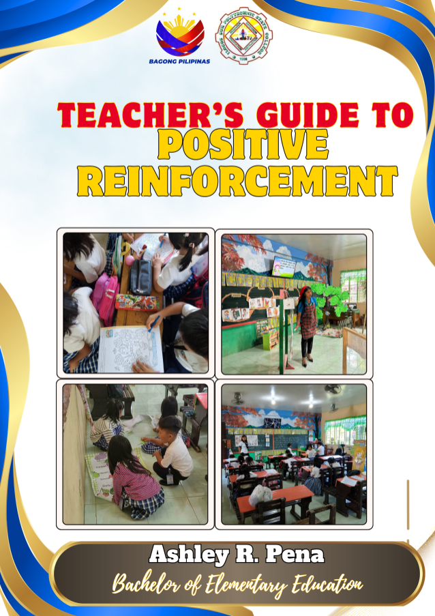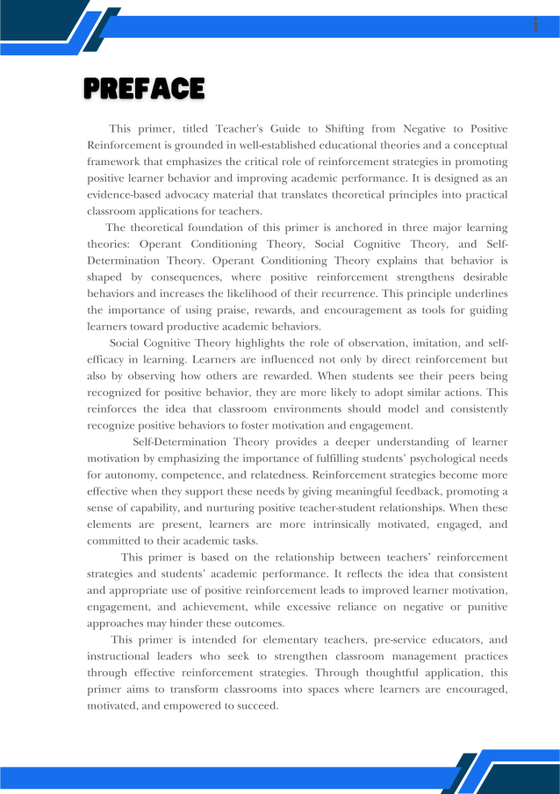
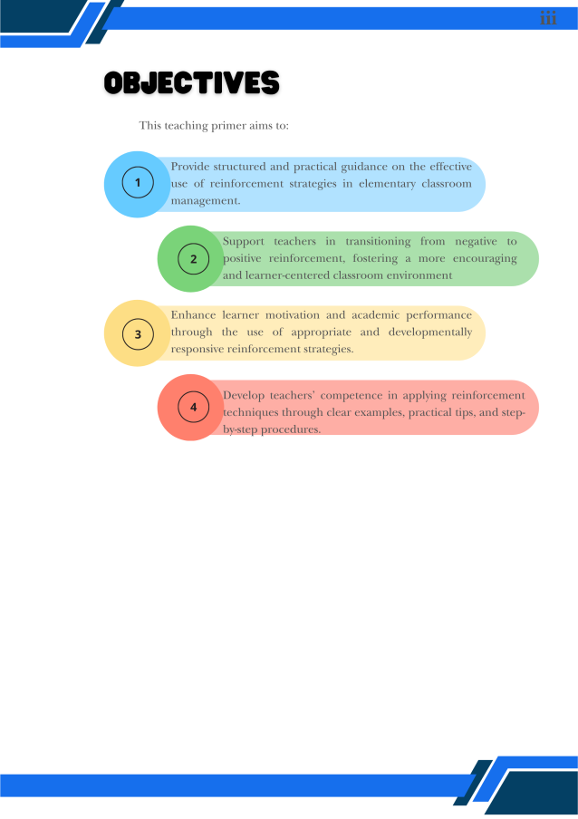
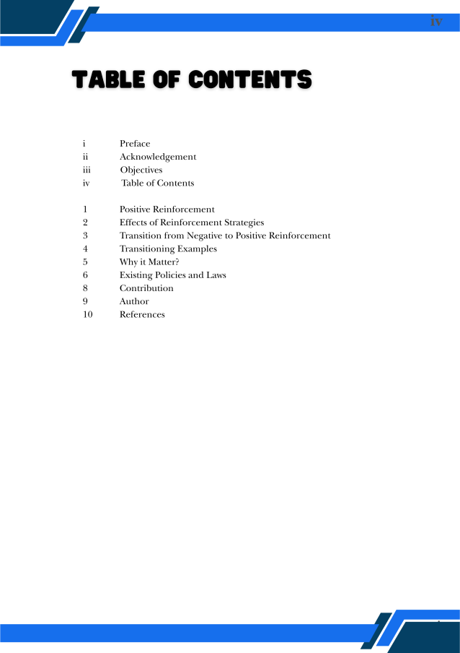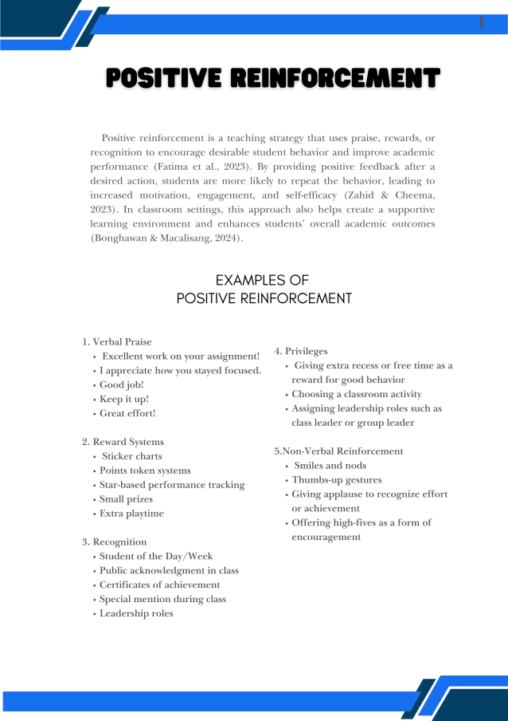
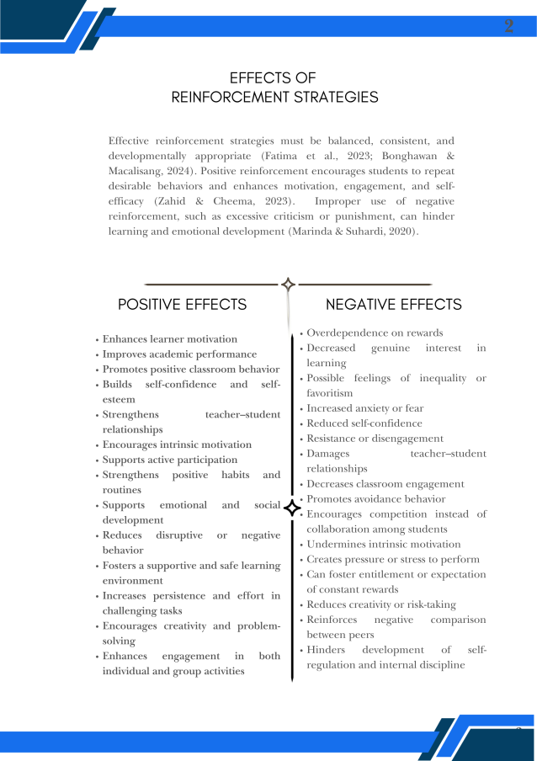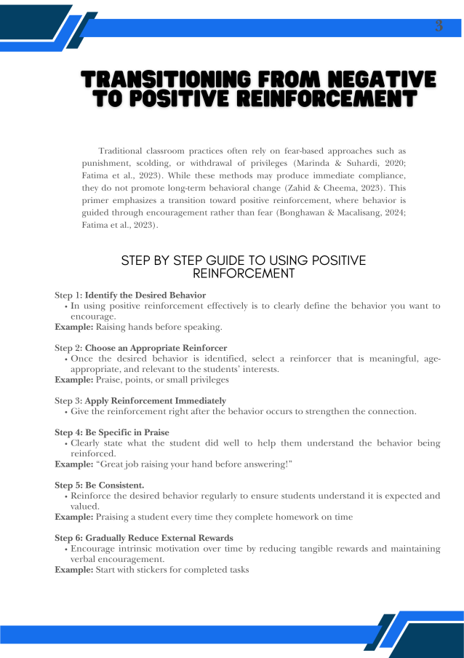
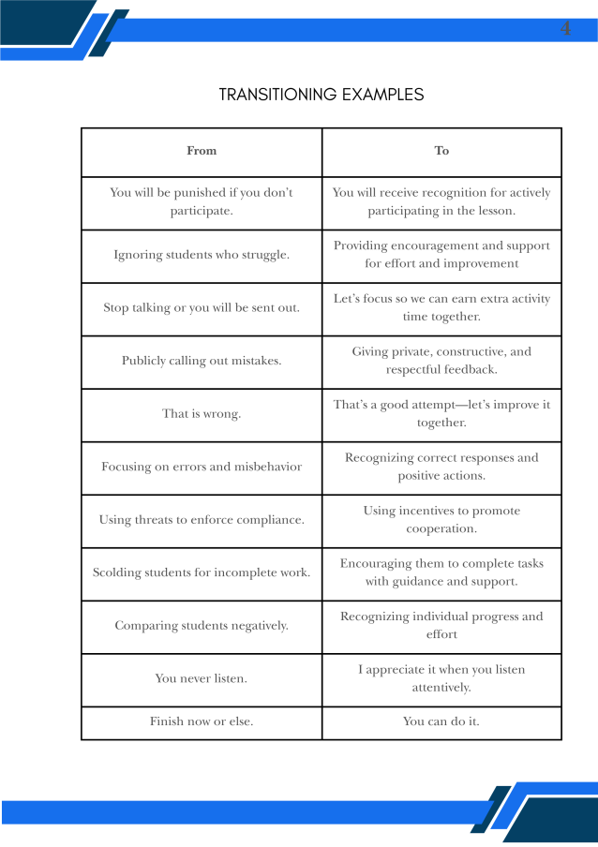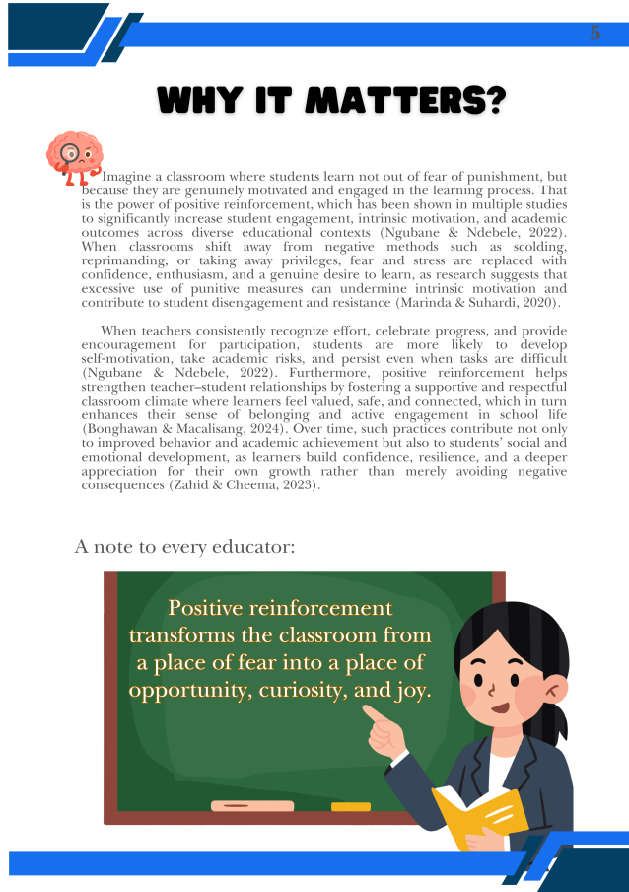

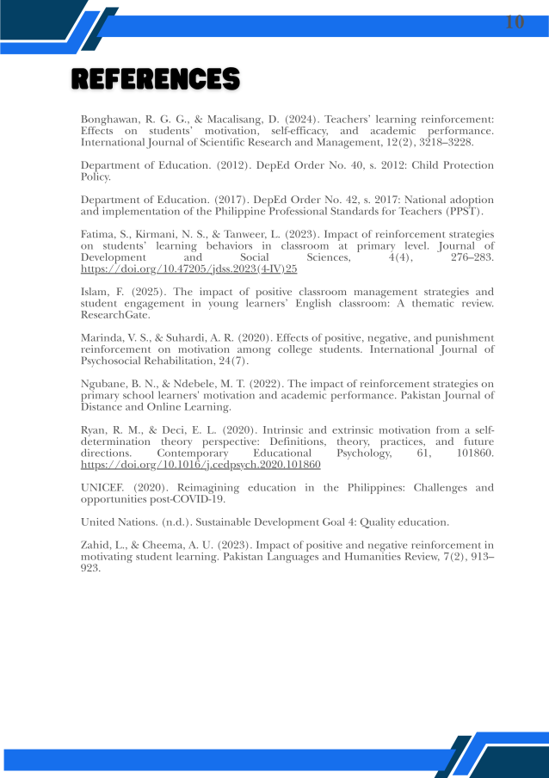
Figure 2. Teacher’s Guide to Positive Reinforcement

Conclusions
Based on the results of the study, the following were concluded:
- Grade 6 teachers in the selected elementary schools in Cervantes, Ilocos Sur consistently employ positive reinforcement strategies in classroom instruction and management. Practices such as verbal praise, written comments, rewards, and encouraging feedback are frequently used, while negative reinforcement practices are rarely applied, indicating that teachers prefer supportive and constructive classroom management approaches.

- The high academic performance demonstrated by learners, with the majority achieving Outstanding and Very Satisfactory grades, indicates that consistent positive reinforcement fosters a motivating learning environment where pupils feel recognized, valued, and empowered to succeed.

- The consistent application of positive reinforcement strategies by teachers directly contributes to improved academic performance among learners. This means that teacher behaviour is a critical variable in student success, meaning that deliberate, sustained use of praise, rewards, and encouraging feedback enhances learning outcomes.

- A guide titled “Teacher’s Guide to Positive Reinforcement” was developed. This output helps bridge the gap between theory and practice by giving teachers simple, legally informed strategies to use positive reinforcement effectively and improve pupil learning and well-being.

Recommendations
Based on the conclusions of the study, the following recommendations are proposed:
- Teachers may consistently strengthen the use of positive reinforcement strategies. Teachers are encouraged to continue using praise, encouragement, respectful communication, and constructive feedback in the classroom.

- Schools may sustain effective instructional and reinforcement practices to maintain or further improve the Very Satisfactory level of academic performance among Grade 6 learners.

- School administrators may provide professional development on reinforcement strategies. Seminars, workshops, and in-service training programs focusing on effective reinforcement practices may be conducted.

- Teachers and school administrators may use the guide to guide the consistent application of positive reinforcement strategies while ensuring compliance with child protection laws to promote safe, respectful, and academically supportive learning environments after its validation.

REFERENCES
Al-Jabri, M. (2020). The role of social reinforcement in enhancing student engagement and academic outcomes in online learning environments.ResearchGate. https://www.researchgate.net/publication/380172333_The_Role_of_Social_Media_in_Promoting_Academic_Engagement_and_Enhancing_Management_Efficiency
Al‑Busaidi and Al‑Hashmi (2021). Examining early literacy skills of children aged 60-72 months in terms of certain socio-demographic characteristics (https://files.eric.ed.gov/fulltext/EJ1292220.pdf
Akhter and Hossain (2021). Virtual International exchange as a high-impact Learning Tool for more Inclusive, Equitable and Diverse Classrooms https://files.eric.ed.gov/fulltext/EJ1303181.pdf
Bandura, A. (1986). Social foundations of thought and action: A social cognitive theory. Prentice-Hall. https://en.wikipedia.org/wiki/Social_Foundations_of_Thought_and_Action
Bonghawan, R. G. G., & Macalisang, D. (2024). Teachers’ learning reinforcement: Effects on students’ motivation, self-efficacy and academic performance. International Journal of Scientific Research and Management (IJSRM), 12(02), 3218-3228. https://www.researchgate.net/profile/Denmark-Macalisang/publication/378492029_Teachers'_Learning_Reinforcement_Effects_on_Students'_Motivation_Self_Efficacy_and_Academic_Performance/links/65dd00f2c3b52a1170fbcad5/Teachers-Learning-Reinforcement-Effects-on-Students-Motivation-Self-Efficacy-and-Academic-Performance.pdf
Chen, L., & Wang, Y. (2022). The effects of different types of praise on students' self-efficacy and academic performance. https://www.researchgate.net/publication/233103899_Effects_of_person_versus_process_praise_on_student_motivation_Stability_and_change_in_emerging_adulthood
Dela Cruz & Santos, J. R., (2021). Collaborative learning strategies and supportive classroom environments. Retrieved from https://research.cmc.edu.ph/index.php/journals/article/download/238/201/913
Department of Education. (2017). DepEd Order No. 42, s. 2017: National Adoption and Implementation of the Philippine Professional Standards for Teachers (PPST). http://www.deped.gov.ph/orders/do-42-s-2017
Department of Education. (2022). Basic Education Learning Continuity Plan: An assessment of its implementation and future directions. https://www.scribd.com/document/589515523/Basic-Education-Learning-Recovery-and-Continuity-Plan
Department of Education. (2012). DepEd Order No. 40, s. 2012: DepEd child protection policy.
https://www.deped.gov.ph/wp-content/uploads/2012/05/DepEd-Order-No.-40-s.-2012.pdf
Department of Education. (2021). DepEd Order No. 03, s. 2021: Creation of the Child Protection Unit in the Department of Education.
https://www.deped.gov.ph/wp-content/uploads/2021/02/DO_s2021_003.pdf
Eremie, M. D., & Doueyi-Fiderikumo, O. (2019). Impact of reinforcement on students’ academic performance in Economics in Senior Secondary Schools in Rivers State, Nigeria. International Journal of Innovative Development and Policy Studies, 7(1), 24–32. https://www.seahipublications.org/wpcontent/uploads/2024/09/IJIDPS-M-3-2019.pdf
Felicity, O. I., & Unamba, E. C.(2020) Impact of Reinforcement Skill on Pupils Academic Performance in Mathematics. https://www.researchgate.net/profile/Eugene-Unamba/publication/343920788_Impact_of_Reinforcement_Skill_on_Pupils_Academic_Performance_in_Mathematics/links/5f47f80792851c6cfde9f5f4/Impact-of-Reinforcement-Skill-on-Pupils-Academic-Performance-in-Mathematics
Fatima, S., Kirmani, N. S., & Tanweer, L. (2023). Impact of Reinforcement Strategies on Students’ Learning Behaviors in Classroom at Primary Level. Journal of Development and Social Sciences, 4(4), 276–283. https://doi.org/10.47205/jdss.2023(4-IV)25
Gage, N. A., Royer, D. J., Berens, K. N., Byrd, S. E., Darney, D., & Akin-Little, A. (2020). Comparing functional behavioral assessment to functional analysis: A systematic review and meta-analysis. Journal of Educational Psychology, 112(7), 1423–1439. https://doi.org/10.1037/edu0000445 https://psycnet.apa.org/manuscript/2020-81203-001.pdf
Garcia & Reyes, M. L., (2020). Psychomotor aspects of student motivation: A study in Philippine schools. Asia Pacific Journal of Education, 38(1), 53–67.
Gicharu, W., & Mwangi, E. (2020). Effective teaching methods and their correlation with improved student outcomes. ResearchGate. https://www.researchgate.net/publication/264124430_Teaching_Methods_and_Students'_Academic_Performance
Graham, S. & Williams (2022). Writing motivation and its role in student learning. Educational Psychologist, 57(3), 123–137. https://doi.org/xxxxx
Haojie Wang et al., (2023). Jin, X. Predicting academic success: machine learning analysis of student, parental, and school efforts. Asia Pacific Educ. Rev. (2023). https://doi.org/10.1007/s12564-023-09915-4
Islam, Farhana. (2025). The impact of positive classroom management strategies and student engagement in young learner's English classroom : A Thematic Review. 10.13140/RG.2.2.22178.54728. https://www.researchgate.net/publication/391320886_The_impact_of_positive_classroom_management_strategies_and_student_engagement_in_young_learner's_English_classroom_A_Thematic_Review
Johnson, R., & Smith, L. (2023). Effectiveness of a token economy system in improving classroom behavior and academic engagement among elementary students. https://search.proquest.com/openview/862c9bde93de6fbee88516a52b8e7c5a/1?pq-origsite=gscholar&cbl=18750&diss=y
Khanum Bilqees, Dr. Rukhsana Sardar, & Tariq Hameed Bajwa. (2025). Role of Positive Reinforcement Strategies in Students Learning Performance at Elementary Level. `, 4(01), 2218–2235. Retrieved from https://www.assajournal.com/index.php/36/article/view/710
Kim, H. J., & Park, S. H. (2022). Effects of teacher feedback and reinforcement on students’ motivation and engagement in classroom learning. Learning and Instruction, 80, 101626. https://doi.org/10.1016/j.learninstruc.2022.101626
Lubna Zahid and Dr. Amna Umer CheemaA (2023). An investigation of the impact of positive and negative reinforcement in motivating student’s learning. Pakistan Languages and Humanities Review, 7(2), 913-923. https://ojs.plhr.org.pk/journal/article/view/833
Manalo, A. G., Cruz, E. A., & Bauto, J. C. (2022). Classroom management practices and their perceived impact on student engagement among elementary teachers in Batangas. eJournals.ph. https://ejournals.ph/article.php?id=25494
Marinda, V. S., & Suhardi, A. R. (2020). Effects of positive, negative, and punishment reinforcement on motivation at college’s students in Indonesia. International Journal of Psychosocial Rehabilitation, 24(07). https://www.researchgate.net/profile/Agatha-Rinta-Suhardi/publication/356554702_Effects_of_Positive_Negative_and_Punishment_Reinforcement_on_Motivation_at_College's_Students_in_Indonesia/links/61a057fcacc0bc46c116d495/Effects-of-Positive-Negative-and-Punishment-Reinforcement-on-Motivation-at-Colleges-Students-in-Indonesia.pdf
Niemiec, C. P., & Ryan, R. M. (2009). Autonomy, competence, and relatedness in the classroom: Applying self-determination theory to educational practice. Theory and Research in Education, 7(2), 133–144. https://doi.org/10.1177/1477878509104318 https://selfdeterminationtheory.org/SDT/documents/2009_NiemiecRyan_TRE.pdf
Ngubane, B. N., & Ndebele, M. T. (2022). The impact of reinforcement strategies on primary school learners' motivation and academic performance in selected schools in KwaZulu-Natal, South Africa. Pakistan Journal of Distance and Online Learning 23(7), 21-15.
OECD (2023), PISA 2022 Results (Volume I): The State of Learning and Equity in Education, PISA, OECD Publishing, Paris, https://doi.org/10.1787/53f23881-en.
Onyekwelu, R. A. (2025). Teachers’ Reinforcement Strategies for Effective Classroom Mangaement in Secondary Schools in Anambra State. Unizik Journal of Educational Research, Science and Vocational Studies, 2(1). https://unilaws.org/ujervs/article/view/119
Ormrod, J. E., & Jones, B. D. (2024). Essentials of educational psychology: Big ideas to guide effective teaching https://www.pearson.com/en-us/subject-catalog/p/essentials-of-educational-psychology-big-ideas-to-guide-effective-teaching/P200000001597/9780136993797
Oyebanji, M., & Ibiam, P. (2024). Teachers' perceived influence of reinforcement on students' academic performance in Nigeria. Journal of Education Innovation and Practice, 8(3), 37–41. https://jeip.org.ng/index.php/jeip/article/view/41
Paano & Fuentes, (2024). Factors Affecting Academic Achievement in Filipino Subject of Grade 9 Students in Dolores National High School Division of Eastern Samar https://dx.doi.org/10.47772/IJRISS.2024.8110135
Pagat, P. M. Y. (2025). School Culture and Its Influence to Academic Performance: The Case of the National High Schools in Ilocos Norte, Philippines. AIDE Interdisciplinary Research Journal, 11(1), 181–190. https://doi.org/10.56648/aide-irj.v11i1.178
Pamon & Oco, (2024). Teachers’ Competence and Learners’ Academic Performance https://doi.org/10.47191/ijmra/v7-i03-63
Republic Act No. 10627. (2013). Anti-Bullying Act of 2013. Official Gazette of the Republic of the Philippines. https://www.officialgazette.gov.ph/2013/09/12/republic-act-no-10627/
Ryan, R. M., & Deci, E. L. (2020). Intrinsic and extrinsic motivation from a self-determination theory perspective: Definitions, theory, practices, and future directions. Contemporary Educational Psychology, 61, 101860. https://doi.org/10.1016/j.cedpsych.2020.101860 https://stial.ie/resources/Ryan%20and%20Deci%202020%20self%20determination%20theory.pdf
Santrock, J. W. (2021). Educational psychology (7th ed.). McGraw-Hill Education. https://www.amazon.com/Educational-Psychology-7th-Edition/dp/1260808750
Schunk, D. H., & DiBenedetto, A. (2020). Motivation and social cognitive theory. In P. K. Alexander & R. E. Mayer (Eds.), https://www.taylorfrancis.com/books/mono/10.4324/9781003013600/classroom-motivation-eric-anderman-lynley-anderman
Skinner, B. F. (1938). The behavior of organisms: An experimental analysis. Appleton-Century. https://www.bfskinner.org/product/the-behavior-of-organisms/
United Nations Educational, Scientific and Cultural Organization. (2024). UNESCO in action: Education highlights in 2024.
https://www.unesco.org/en/articles/unesco-action-education-highlights-2024
United Nations. (n.d.). Sustainable Development Goal 4: Quality Education. Retrieved from https://www.unoosa.org/oosa/en/ourwork/space4sdgs/sdg4.html
Unicef. (2020). Reimagining education in the Philippines: Challenges and opportunities post-COVID-19. UNICEF Philippines.
Usher, E. L., & Pajares, F. (2021). Sources of self-efficacy in school: Critical review of the literature and future directions. Review of Educational Research, 91(1), 3–33. https://doi.org/10.3102/0034654320957061
Usman, U. D., Saleh, M. A., & Abbas, A. L. I. (2024). Influence of Positive Reinforcement Technique on Academic Performance of Secondary School Students in Dukku Local Government area Gombe Stae. Counselling for value re-orientation. https://aprocon.org.ng/conference_materials/confernce%20reading%20PDF.pdf#page=325
Virtanen, Mertens, E.C.A., Deković, M., Van Londen, M. et al. The Role of Classmates’ Modeling and Reinforcement in Adolescents’ Perceived Classroom Peer Context. J Youth Adolescence 50, 260–270 (2020). https://doi.org/10.1007/s10964-020-01325-8
Zahid, L., & Cheema, A. U. (2023). An investigation of the impact of positive and negative reinforcement in motivating student’s learning. Pakistan Languages and Humanities Review, 7(2), 913-923. https://ojs.plhr.org.pk/journal/article/view/833
Zimmerman, B. J., & Schunk, D. H. (Eds.). (2011). Handbook of self-regulation of learning and performance. Routledge. https://doi.org/10.4324/9780203839010

