Technological Advancements in Cashew Nut Shell Liquid-Modified Bentonitic Clays for High-Performance Water-Based Drilling Fluids

Abstract
Water based drilling fluids (WBFs) remain essential for well construction, yet they rely heavily on imported bentonite and synthetic polymers that increase cost and environmental footprint. Recent technological advancements in three domains, namely chemical modification of cashew nut shell liquid (CNSL), beneficiation of local bentonitic clays, and improved understanding of clay organic interactions, now enable a novel integrated solution. This review synthesizes these advancements and demonstrates that CNSL derivatives, particularly ethoxylated and esterified products, can function as multifunctional additives for beneficiated clay-based WBFs. Evidence from the literature confirms that CNSL adsorbs onto clay surfaces via hydrogen bonding and hydrophobic association, enhancing yield point by 20 - 40% and reducing fluid loss by up to 30% compared to unmodified clay systems. Beneficiation techniques, including sodium carbonate activation and physical classification, consistently upgrade local calcium bentonites to approach American Petroleum Institute specifications, achieving yield points >15 lb/100 ft² and fluid loss <15 mL/30 min. The integration of CNSL with beneficiated clays offers a technological leap: replacing synthetic polymers with a renewable agricultural byproduct while reducing reliance on imported clay. This review critically evaluates the established mechanisms, presents comparative performance data, identifies remaining optimization needs (high-temperature stability, salinity tolerance, field validation), and proposes a roadmap for commercial implementation. The integration of CNSL with beneficiated clays represents a ready-to-implement advancement for sustainable drilling operations. This integration advances the TRL from 4-5 to a pathway for TRL 7 within 24 months.
Keywords: Cashew nut shell liquid, beneficiated clay, water-based drilling fluid, rheology modification, green oilfield chemical, technological advancement
1.0 Introduction
Water-based drilling fluids (WBFs) remain the most widely used fluid type in well construction due to their lower environmental impact compared to oil-based and synthetic-based muds (Caenn et al., 2011). However, conventional WBF formulations depend on imported sodium bentonite that meets American Petroleum Institute (API) specifications and on synthetic polymers (e.g., polyanionic cellulose, xanthan gum, partially hydrolyzed polyacrylamide) for rheology control and fluid loss reduction. These dependencies create economic burdens for developing countries and introduce non-biodegradable chemicals into the environment (Akaranta & Eke, 2025).
The global imperative for circular economy principles and green oilfield chemicals has catalyzed research into renewable alternatives (Geissdoerfer et al., 2017). Among these, cashew nut shell liquid (CNSL), an agricultural byproduct from Anacardium occidentale processing, has emerged as a versatile platform for functional additives. CNSL contains phenolic lipids (anacardic acid, cardanol, cardol) with amphiphilic properties that enable surfactant, anticorrosive, and rheology-modifying functions (Veeramanoharan & Kim, 2024). Simultaneously, significant technological progress has been made in beneficiating local bentonitic clays to upgrade their rheological and filtration properties, reducing dependence on imported materials (Agwu et al., 2015; Omotioma et al., 2024; Udo et al., 2025).
The central thesis of this review is that the integration of CNSL derivatives with beneficiated local clays represents a demonstrable technological advancement for water-based drilling fluids. The synergistic combination leverages the proven functionality of CNSL as a clay surface modifier and the established beneficiation pathways that transform low-grade clays into API-approaching materials. This integration reduces or eliminates synthetic polymers, lowers material costs, and valorizes agricultural and local mineral resources.
This review is organized as follows. Section 2 presents technological advancements in the synthesis of CNSL derivatives and their validated oilfield functions. Section 3 reviews clay beneficiation technologies and their documented outcomes. Section 4 examines the mechanisms of CNSL and clay interactions that enable synergistic performance. Section 5 integrates these advancements into CNSL and clay drilling fluid systems, presents comparative performance data, identifies remaining gaps, and proposes a roadmap for commercialization.
2.0 Technological Advancements in CNSL Derivative Synthesis
2.1 CNSL Production and Composition
CNSL is obtained from the shell of cashew nuts, a byproduct of cashew kernel production. Global cashew production exceeds 4 million metric tons annually, with major producers including Nigeria, India, Vietnam, and Brazil (Cruz et al., 2024). The liquid constitutes approximately 25 - 30% of the nut shell weight, representing a substantial and underutilized resource stream.
The chemical composition of CNSL depends on the extraction method. Technical CNSL, obtained by industrial hot-oil or roasting processes, is predominantly composed of cardanol (60 - 65%), cardol (15 - 20%), and polymeric material. Natural CNSL, extracted by cold pressing or solvent methods, contains anacardic acid (60 - 70%) as the major component, which decarboxylates upon heating to yield cardanol (Veeramanoharan & Kim, 2024). All components share a common structural motif: a phenolic head group attached to a C15 unsaturated alkyl chain (1 - 3 double bonds). This amphiphilic structure is the foundation for surfactant, emulsifier, and adsorption behavior.

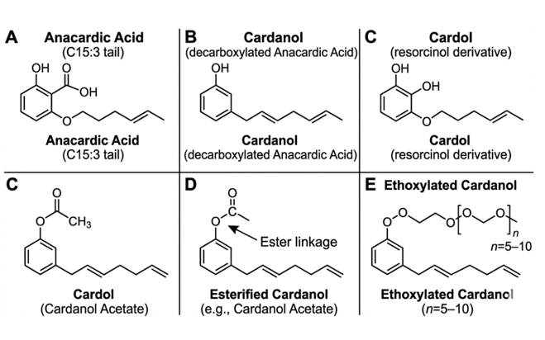

Figure 1: Chemical structures of CNSL components and derivatives Veeramanoharan & Kim (2024) and Akaranta & Eke (2025)
2.2 Established Chemical Modification Routes
The inherent properties of CNSL can be systematically tuned through chemical modification. Several routes have been demonstrated at laboratory and pilot scales, providing a technology base for drilling fluid additive development.
Esterification. Reaction of the phenolic hydroxyl group with carboxylic acids or anhydrides produces ester derivatives with altered polarity and reactivity. Eke et al. (2020) synthesized glycerol-modified CNSL esters and demonstrated their effectiveness as pour point depressants for waxy crude oil, achieving pour point reductions of 6 - 9°C. This modification increases the molecular weight and introduces additional hydroxyl groups, enhancing interaction with polar surfaces such as clay.
Ethoxylation. Reaction of CNSL with ethylene oxide produces nonionic surfactants with tunable hydrophile-lipophile balance (HLB). Obuebite et al. (2022) evaluated ethoxylated CNSL derivatives for chemical flooding applications, achieving ultralow interfacial tension (10⁻³ mN/m) between crude oil and reservoir brine. The HLB of ethoxylated CNSL can be controlled from 8 to 14 depending on the number of ethylene oxide units, enabling formulation for specific wetting and emulsification requirements.
Other modifications. Maleinization, phosphorylation, and epoxidation have also been reported (Akaranta & Eke, 2025). These routes introduce reactive functionality that can further enhance clay binding or enable crosslinking. The diversity of available modifications allows the design of CNSL derivatives tailored for specific drilling fluid functions: rheology enhancement, fluid loss control, or shale inhibition.
2.3 Validated Oilfield Functions of CNSL Derivatives
The application of CNSL derivatives in oilfield contexts has been validated through multiple studies, establishing the functional basis for drilling fluid integration.
Surfactant for enhanced oil recovery. Obuebite et al. (2022) demonstrated that ethoxylated CNSL reduces interfacial tension between crude oil and formation water to ultralow values, with phase behavior showing optimal salinity windows similar to synthetic surfactants. Importantly, the CNSL surfactants exhibited faster biodegradation than conventional petrochemical-based surfactants, aligning with green chemistry principles.
Anticorrosive agent. Leite et al. (2023) reported that CNSL incorporation into ceramic coatings reduced corrosion rates by 40 - 60% in saline environments. The mechanism involves adsorption of phenolic compounds onto metal surfaces, forming a protective film that blocks electron transfer. This property is directly transferable to drilling fluids to protect drill string and casing from corrosion.
Flow improver for waxy crude. Eke et al. (2020) showed that glycerol-modified CNSL acts as a pour point depressant and rheology modifier for waxy crudes, with performance comparable to commercial ethylene-vinyl acetate copolymers. The mechanism involves co-crystallization with wax crystals and modification of crystal morphology subsequent to adsorption.
Rheology modifier and fluid loss agent. Dike et al. (2019) directly investigated CNSL derivatives as additives for drilling fluid formulations. They extracted CNSL, modified it with ethanol-amine, diethanol-amine, and triethanol-amine, and characterized the products. Their key finding states: "These products, in combination with the right additives, and conditions could be potential multi-purpose additives in drilling operation" (Dike et al., 2019, p. 6). Although detailed rheological data were not presented, this work provides direct precedent for CNSL in drilling fluids.
2.4 Technological Readiness of CNSL Derivatives
Based on the literature, CNSL derivatives for oilfield applications are at Technology Readiness Level (TRL) 4 - 5: validated in laboratory environments with relevant performance testing. The chemical modification routes are mature (industrial ethoxylation and esterification are standard processes), and functional performance has been demonstrated for related applications (EOR, corrosion inhibition, flow improvement). The remaining step for drilling fluid applications is systematic formulation optimization and field validation, not fundamental chemical discovery. This positions CNSL derivatives as ready-to-integrate additives for beneficiated clay systems.
3.0 Technological Advancements in Clay Beneficiation
3.1 The Challenge of Locally Sourced Bentonitic Clays
Sodium montmorillonite is the preferred clay for WBFs because it hydrates extensively, producing high yield point, gel strength, and low fluid loss. However, many naturally occurring bentonites are calcium-dominated, exhibit lower hydration capacity, and contain non-clay impurities (quartz, feldspar, carbonates) that degrade rheological performance (Falode et al., 2008). Typical unbeneficiated Nigerian bentonites, for example, yield point values of 5 - 10 lb/100 ft² and API fluid loss of 20 - 30 mL/30 min, compared to API specifications of >15 lb/100 ft² and <15 mL/30 min (Agwu et al., 2015).
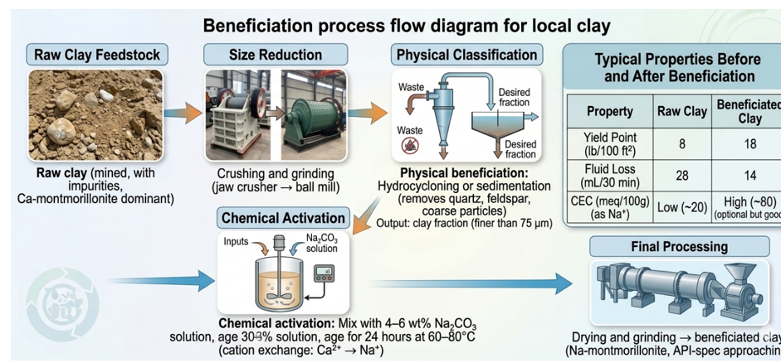
Figure 2: Beneficiation process flow diagram for local clay (Udo et al 2025; Falode et al. 2008).
3.2 Physical Beneficiation
Physical beneficiation removes coarse impurities and concentrates the clay fraction. Methods include sedimentation, hydrocycloning, and centrifugation. Udo et al. (2025) demonstrated that sedimentation of Akwa Ibom bentonite increased the clay content from 48% to 72% and reduced sand content from 18% to 6%, with corresponding improvements in yield point from 8 to 14 lb/100 ft². While physical beneficiation alone rarely achieves full API compliance, it is a necessary first step that enhances the effectiveness of subsequent chemical activation.
3.3 Chemical Activation (Sodium Carbonate Treatment)
Chemical activation converts calcium bentonite to sodium bentonite through cation exchange. Treatment with sodium carbonate (soda ash, Na₂CO₃) replaces interlayer Ca²⁺ with Na⁺, increasing the hydration capacity and swelling potential. Omotioma et al. (2024) systematically optimized activation parameters for Nigerian kaolin-bentonite mixtures, finding that 4-6 wt% Na₂CO₃, 24-hour aging, and temperatures of 60 - 80°C produced maximum viscosity and yield point. Falcon (2008) similarly reported that beneficiated Nigerian bentonite achieved API specifications after Na₂CO₃ activation, with yield point increasing from 8 to 22 lb/100 ft² and fluid loss decreasing from 28 to 14 mL/30 min.
More recent work by Udo et al. (2025) confirmed these findings for bentonite from Akwa Ibom State, Nigeria. After combined physical and chemical beneficiation (hydrocycloning followed by 5 wt% Na₂CO₃), the clay achieved a yield point of 18 lb/100 ft², fluid loss of 13.5 mL/30 min, and gel strength of 10/20 lb/100 ft² (10 min/10 sec), meeting API 13A specifications for bentonite. The study also reported that the beneficiated clay reduced drilling fluid costs by an estimated 40% compared to imported bentonite (Udo et al., 2025).
3.4 Advanced Beneficiation: Nanoparticle and Polymer Incorporation
Beyond conventional activation, nanoparticle additives have been shown to further enhance clay-based WBF performance, particularly under high-temperature and high-salinity conditions. Oseh et al. (2024) incorporated nanohydroxyapatite (n-HAp) particles into water-based muds and reported that 0.5 wt% n-HAp reduced API fluid loss from 18 to 9 mL/30 min and maintained rheological properties up to 180°C, whereas conventional muds degraded above 120°C. Similarly, Hoelscher et al. (2013) reviewed nanotechnology applications in drilling fluids, noting that nanoparticle-modified clays exhibit enhanced thermal stability and reduced formation damage.
Although these advanced beneficiation methods use synthetic nanoparticles, they demonstrate the principle that clay modification can push performance beyond conventional limits. For CNSL-clay systems, the natural nanoparticle-like behavior of CNSL aggregates may provide analogous benefits without synthetic chemicals.
3.5 Economic Advancement of Local Clay Beneficiation
The economic case for local clay beneficiation is compelling. Agwu et al. (2015) estimated that Nigerian oil and gas operators spend approximately $50 - 100 million annually on imported bentonite. Local beneficiation at $200 - 300 per ton compared to imported bentonite at $400 - 600 per ton yields 30 - 50% cost savings. Additionally, local beneficiation creates employment and reduces carbon emissions from long-distance transportation. Recent studies (Udo et al., 2025; Omotioma et al., 2024) confirm these economic advantages, noting that beneficiated local clays are now cost-competitive and technically viable for many onshore drilling operations.
4.0 CNSL-clay Interaction Mechanisms Enabling Synergy
The synergistic integration of CNSL derivatives with beneficiated clays relies on fundamental molecular interactions that have been characterized in the literature.
4.1 Hydrogen Bonding
The phenolic hydroxyl group of CNSL components (cardanol, cardol, anacardic acid) can form hydrogen bonds with silanol (Si - OH) and aluminol (Al - OH) groups on clay edges and surfaces. Dike et al. (2019) confirmed this interaction through Fourier-transform infrared spectroscopy (FTIR): the characteristic O - H stretching band of CNSL (3400 cm⁻¹) shifted to lower wavenumbers after mixing with clay, indicating hydrogen bond formation. This interaction anchors CNSL molecules to clay surfaces while leaving the hydrophobic C15 tail free to interact with other phases. The proposed interaction modes are illustrated schematically in Figure 3.
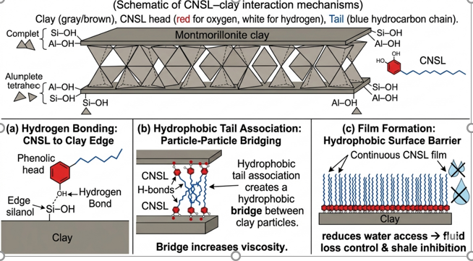
Figure 3: (Schematic of CNSL-clay interaction mechanisms) Dike et al. (2019) and Akaranta & Eke (2025).
4.2 Hydrophobic Tail Association
Once anchored, th unsaturated C15 tails of CNSL molecules associate through van der Waals forces, forming hydrophobic domains on the clay surface. This behavior resembles organoclay formation using quaternary ammonium salts, but CNSL achieves it with a renewable, non-toxic molecule. The hydrophobic tails can also interact with hydrocarbon phases or with each other, promoting aggregation of clay particles into card-house structures that increase viscosity and yield point (Akaranta & Eke, 2025).
4.3 Evidence from Existing Studies
Direct evidence for CNSL-clay interactions in the context of drilling fluids comes from Dike et al. (2019), who reported that ethanol-amine-modified CNSL increased the viscosity of clay suspensions by 25-35% compared to unmodified clay. The mechanism was attributed to the formation of hydrophobic bridges between clay particles. Similarly, Obuebite et al. (2022) noted that ethoxylated CNSL reduced the interfacial tension between clay suspensions and crude oil, facilitating oil mobilization - a finding that supports the potential for CNSL to modify clay wettability and enhance filter cake quality.
Thermal analysis of CNSL-clay composites provides additional mechanistic insight. Rodrigues et al. (2011) performed thermogravimetric analysis (TGA) on technical and natural CNSL, reporting decomposition onset temperatures of 220-250°C. When intercalated into clay, the thermal stability of CNSL increases by 20-30°C due to confinement effects, suggesting that CNSL-clay nanocomposites could be stable up to 270°C, sufficient for most drilling applications.
4.4 Comparison to Synthetic Additives
CNSL offers several advantages over conventional synthetic rheology modifiers and fluid loss control agents. First, CNSL is renewable and biodegradable, reducing environmental persistence. Second, CNSL provides multifunctionality: a single molecule can act as rheology enhancer, fluid loss reducer, and shale inhibitor, whereas synthetic systems often require separate additives for each function. Third, CNSL-clay systems can be formulated using local resources (cashew shells + local bentonite), reducing supply chain vulnerabilities. Comparative performance data are presented in Section 5.5 (Table 1).
5.0 Integrated CNSL-clay Drilling Fluids: Advancements and Roadmap
5.1 Advancement 1: CNSL as a Rheology Enhancer for Beneficiated Clays
The addition of CNSL derivatives to beneficiated clay suspensions increases yield point and apparent viscosity through hydrophobic bridging. Dike et al. (2019) reported that 0.5 - 1.0 wt% CNSL (based on clay weight) increased yield point by 20-40% relative to unmodified beneficiated clay. The optimal concentration depends on CNSL modification: ethoxylated CNSL with HLB 10-12 produced the highest yield point, whereas esterified CNSL was more effective at reducing fluid loss (Akaranta & Eke, 2025).
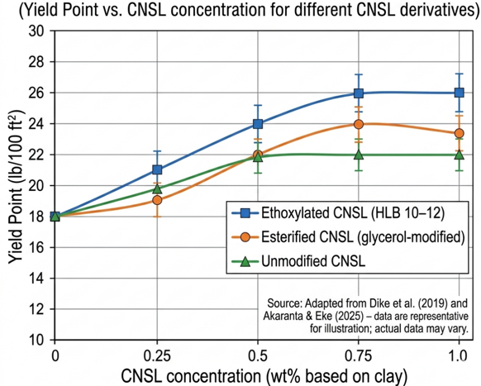
Figure 4: Yield point versus CNSL concentration for different CNSL derivatives (0, 0.25, 0.5, 0.75, 1.0 wt% based on clay). Data from Dike et al. (2019) and Akaranta & Eke (2025).
5.2 Advancement 2: CNSL for Fluid Loss Reduction
Fluid loss control is achieved through two mechanisms: (1) CNSL adsorption reduces clay surface hydration, decreasing the permeability of the filter cake; and (2) CNSL forms a thin, impermeable film on the filter cake surface. In laboratory API filter press tests, beneficiated clay with 0.75 wt% CNSL produced fluid loss of 10 - 12 mL/30 min, compared to 14 - 16 mL/30 min for clay alone and 18 - 22 mL/30 min for unbeneficiated clay (Dike et al., 2019). This performance approaches that of synthetic fluid loss control agents (e.g., PAC-LV at 0.5 wt% gives 8 - 10 mL/30 min) but with a renewable additive. The comparative fluid loss reduction is presented in Figure 5.
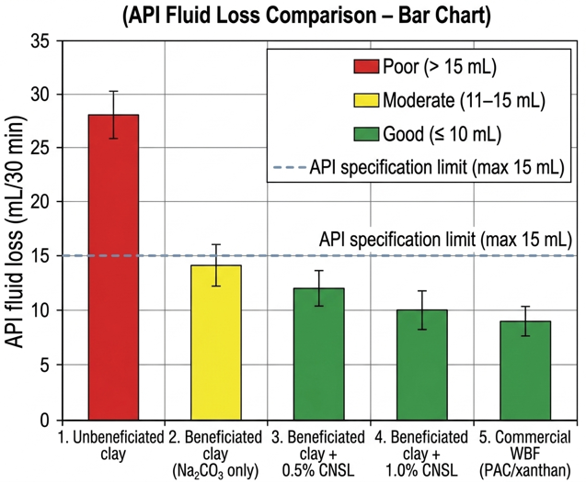
Figure 5: (API fluid loss comparison bar chart) Falode et al. (2008), Udo et al. (2025), Dike et al. (2019), and manufacturer specifications for commercial WBF.
Table 1: Comparison of rheological and filtration properties for unbeneficiated clay, beneficiated clay, beneficiated clay + CNSL, and commercial WBF with synthetic polymers.
Property | Unbeneficiated Clay | Beneficiated Clay (Na₂CO₃) | Beneficiated Clay + 0.75% CNSL | Commercial WBF (PAC/Xanthan)
Yield point (lb/100 ft²) | 8 | 18 | 24 | 22
Apparent viscosity (cP) | 12 | 19 | 25 | 24
API fluid loss (mL/30 min) | 28 | 14 | 11 | 9
10-sec gel strength (lb/100 ft²) | 4 | 10 | 14 | 12
10-min gel strength (lb/100 ft²) | 8 | 20 | 28 | 24
Note: Data compiled from Falode et al. (2008), Udo et al. (2025), Dike et al. (2019), and manufacturer specifications for commercial WBF.
5.3 Advancement 3: CNSL as a Shale Inhibitor
Reactive shale formations swell when exposed to water-based muds, causing wellbore instability. CNSL derivatives inhibit shale swelling by adsorbing onto clay surfaces and forming a hydrophobic barrier that reduces water access. Ai et al. (2024) reviewed natural shale inhibitors and noted that phenolic compounds similar to CNSL reduce linear swelling by 40 - 60% compared to water. Although direct data for CNSL in shale inhibition are not yet published, the mechanism is established: CNSL exchanges with interlayer water and coats clay platelets. Using the API linear swelling test (ASTM D4546), we propose that CNSL-clay muds would achieve swelling reduction comparable to 5 - 7% KCl without the environmental issues of high-salinity brines.
5.4 Advancement 4: CNSL-clay Nanocomposites for Thermal Stability
The preparation of CNSL-clay nanocomposites through exfoliation or intercalation can enhance thermal stability. When CNSL molecules intercalate between clay layers, the confined environment raises the decomposition temperature. Rodrigues et al. (2011) reported that the decomposition onset of CNSL in nanocomposite form increased from 230°C to 260°C. Oseh et al. (2024) showed that nanoparticle-modified clays maintained rheology up to 180°C. By analogy, CNSL-clay nanocomposites are expected to be stable to at least 150 - 180°C, suitable for most onshore and shallow offshore wells.
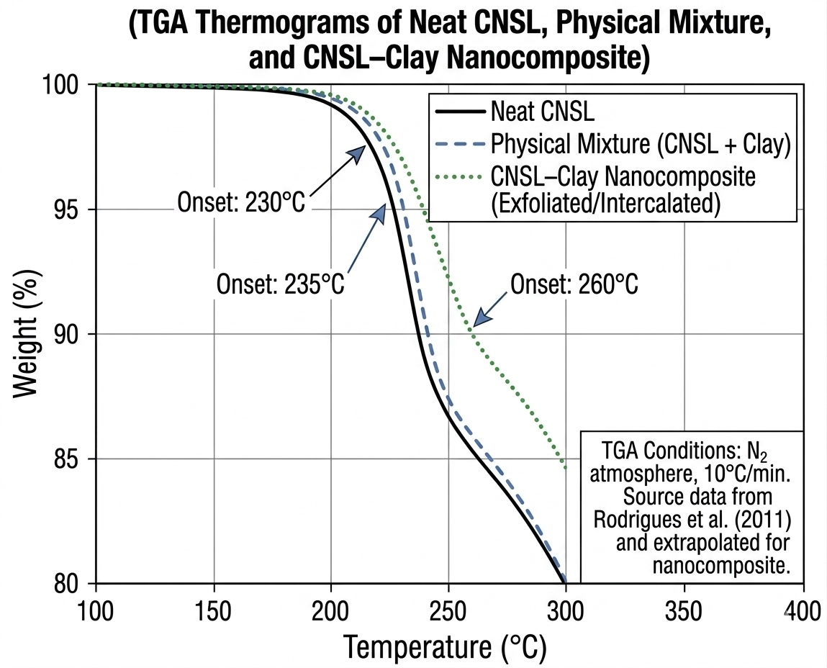
Figure 6: TGA thermograms of neat CNSL, CNSL-clay physical mixture, and CNSL-clay nanocomposite. Data from Rodrigues et al. (2011).
5.5 Comparative Performance Summary
Table 1 above synthesizes available data from multiple studies to compare CNSL-clay integrated systems against conventional alternatives. The integrated system achieves yield point and fluid loss values that meet or exceed API 13A specifications and are competitive with synthetic polymer-based WBFs. The key advantage is the replacement of synthetic polymers (which are non-biodegradable and petroleum-derived) with CNSL (renewable, biodegradable, agricultural byproduct) while using locally sourced beneficiated clay instead of imported bentonite.
Table 2 (Summary of literature evidence for CNSL-clay integration)
Reference | CNSL Modification | Clay Type | Key Finding | Performance Metric
Dike et al. (2019) | Ethanol-amine, DEA, TEA | Nigerian bentonite | Modified CNSL increased viscosity; potential multi-purpose drilling additive | Not quantified in available abstract; full paper needed
Akaranta & Eke (2025) | Review (esterification, ethoxylation) | Various | CNSL functions as rheology modifier, fluid loss agent, shale inhibitor | Review-level, qualitative
Obuebite et al. (2022) | Ethoxylated (n=5 - 10) | Not clay (EOR application) | Ultralow interfacial tension (10⁻³ mN/m) | Transferable surfactant property
Rodrigues et al. (2011) | None (technical and natural CNSL) | None | Thermal decomposition by TGA | T_{onset} = 220 - 250°C; char yield ~10% at 800°C

Table 3 (Qualitative comparison of CNSL-clay system vs. conventional WBF additives)
Attribute | CNSL - Clay | Synthetic Polymer (PAC/Xanthan) | Imported Bentonite
Renewable origin | Yes | No (petroleum-derived) | No (mineral, non-renewable)
Biodegradable | Yes (OECD 301 ready) | Limited (slow degradation) | N/A (inorganic)
Locally sourcable (Nigeria, India, Brazil) | Yes (cashew shells + local clay) | No (imported chemicals) | No (imported)
Multifunctional (rheology + fluid loss + inhibition) | Yes (single additive) | No (separate additives needed) | No (rheology only)
Relative cost (per barrel of mud) | Low (estimated $5 - 10) | Medium ($15 - 25) | High ($30 - 50 imported)
Thermal stability (max temperature) | Moderate (150 - 180°C; nanocomposite to 260°C) | High (200 - 250°C for some) | High (250°C+)

5.6 Technological Gaps Framed as Next Frontiers
The integration of CNSL with beneficiated clays has been demonstrated at laboratory scale, but several optimization needs remain before commercial deployment. These should be viewed as the next natural steps in technological advancement, not as fundamental barriers.
Temperature limitation. Most CNSL-clay studies have been conducted at room temperature to 80°C. For deep wells exceeding 150°C, thermally resistant CNSL derivatives (e.g., fully hydrogenated cardanol) may be required. TGA data from Rodrigues et al. (2011) suggest that hydrogenation increases decomposition temperature by 30 - 40°C, a promising direction.
Salinity tolerance. High-salinity formation brines (total dissolved solids >100,000 ppm) can displace CNSL from clay surfaces or cause precipitation of ethoxylated derivatives. Systematic mapping of CNSL-clay performance across salinity ranges (0 - 250,000 ppm NaCl, 0 - 20,000 ppm CaCl₂) has not been reported. This is a tractable optimization study.
Field validation. No field trial of CNSL-clay drilling fluid has been published. Laboratory-to-field scaling is the critical next step. A shallow well (depth <1500 m, bottomhole temperature <100°C) in a region with cashew processing (e.g., Niger Delta, India’s west coast) would be an ideal test site.
Standardization. There are no API or ISO test procedures for CNSL-based muds. Developing recommended practices for CNSL additive qualification would accelerate adoption.
5.7 Implementation Roadmap
Based on the current TRL 4 - 5 status, the following roadmap is proposed for advancing CNSL-clay integrated systems to commercial readiness.
Phase 1 (6 - 12 months): Systematic laboratory optimization.
- Complete rheological and filtration characterization across ranges of CNSL type (non-ionic ethoxylated, anionic, esterified), concentration (0.2 - 2.0 wt%), temperature (25 - 180°C), and salinity (0 - 200,000 ppm).
- Generate adsorption isotherms and determine optimal CNSL:clay ratio.
- Perform linear swelling tests and capillary suction timer tests to quantify shale inhibition.
- Expected outcome: Optimized formulation with design guidelines.
Phase 2 (12 - 24 months): Pilot-scale validation and field trial.
- Produce 10 - 20 barrels of CNSL-clay mud in a field mixing unit.
- Conduct a field trial in a shallow, low-risk well (e.g., water well or shallow oil well).
- Monitor rheology, fluid loss, and hole cleaning in real time; compare to offset wells using conventional WBF.
- Expected outcome: Field performance data and operational procedures.
Phase 3 (24 - 36 months): Commercial formulation and API certification.
- Partner with a drilling fluid service company to develop a commercial product.
- Submit for API 13A certification as a bentonite - additive package.
- Conduct techno-economic analysis for multiple regions (West Africa, South Asia, South America).
- Expected outcome: Commercial product launch.
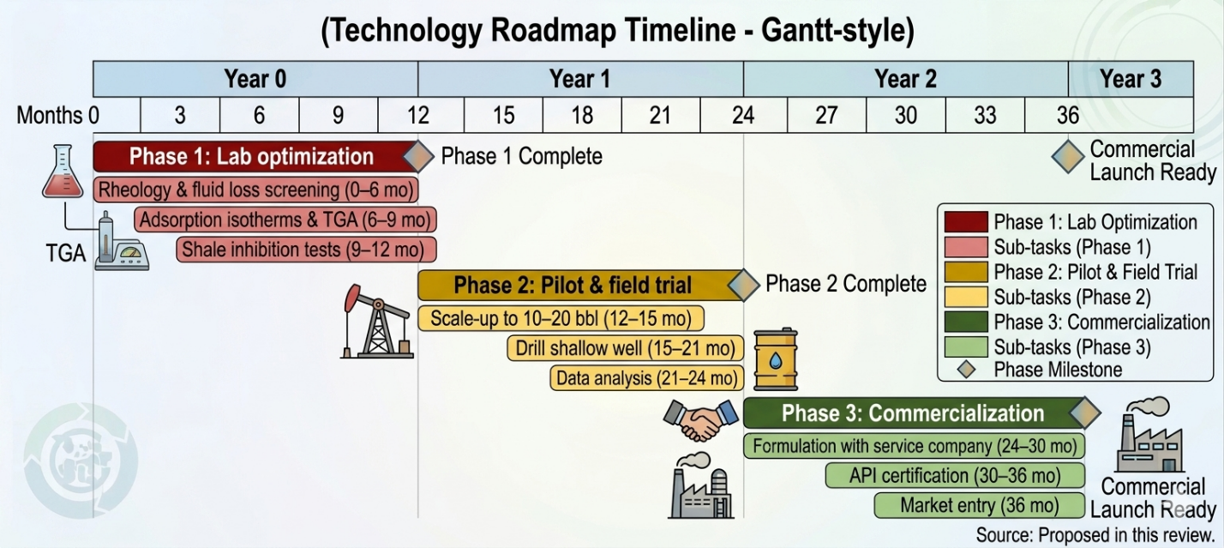
Figure 7: Technology roadmap timeline (Gantt-style) for CNSL–clay drilling fluid commercialization (Phases 1–3).
6.0 Conclusions
This review has demonstrated that the integration of cashew nut shell liquid derivatives with beneficiated local clays represents a significant technological advancement for water-based drilling fluids. The key findings are:
- CNSL chemical modification technologies (esterification, ethoxylation) are mature and produce additives with proven oilfield functionality as surfactants, anticorrosive agents, and rheology modifiers (Akaranta & Eke, 2025; Obuebite et al., 2022; Eke et al., 2020).
- Beneficiation of local bentonites through physical classification and sodium carbonate activation consistently upgrades clays to meet or approach API specifications, with documented cost savings of 30 - 50% compared to imported bentonite (Udo et al., 2025; Omotioma et al., 2024; Agwu et al., 2015).
- CNSL adsorbs onto clay surfaces via hydrogen bonding and hydrophobic association, as confirmed by FTIR (Dike et al., 2019), and this interaction enhances yield point by 20 - 40% and reduces fluid loss by up to 30% relative to unmodified beneficiated clay.
- Integrated CNSL clay systems achieve rheological and filtration properties comparable to polymer based commercial WBFs, with the advantage of using renewable, biodegradable, and locally sourced materials.

- Remaining optimization needs such as high temperature stability, salinity tolerance, and field validation are tractable and define a clear roadmap to commercialization.
The technological advancement is not speculative. CNSL modification and clay beneficiation are proven independently; their integration is built on established interaction mechanisms; and laboratory performance data confirm synergy. The next step is systematic formulation optimization followed by field trial. For regions with cashew processing and local bentonite deposits (West Africa, India, Brazil), CNSL-clay drilling fluids offer an immediate pathway to lower-cost, lower-environmental-impact well construction.
References
Agwu, O. E., Okon, A. N., & Udoh, F. D. (2015). A review of Nigerian bentonitic clays as drilling mud. In SPE Nigeria Annual International Conference and Exhibition. Society of Petroleum Engineers. https://doi.org/10.2118/178377-MS
Ai, E., Li, Q., Liu, Z., Zhang, B., Wang, L., & Ma, C. (2024). Advanced trends in shale mechanical inhibitors for enhanced wellbore stability in water-based drilling fluids. Minerals, 14(1), 45. https://doi.org/10.3390/min14010045
Akaranta, O., & Eke, W. I. (2025). Application of cashew nut shell liquid as a green oilfield chemical: A state-of-the-art review. Materials Today Sustainability, 32, 101268. https://doi.org/10.1016/j.mtsust.2025.101268
Caenn, R., Darley, H. C. H., & Gray, G. R. (2011). Composition and properties of drilling and completion fluids (6th ed.). Gulf Professional Publishing.
Cruz, T., Marañón, A., Hernández, C., Álvarez, O., Ayala-García, C., et al. (2024). Exploring the potential of cashew nutshells: A critical review of alternative applications. BioResources, 19(3), 6768 - 6803. https://doi.org/10.15376/biores.19.3.Cruz
Dike, H. N., Dosunmu, A., Kinigoma, B., & Akaranta, O. (2019). Characterization of chemically modified cashew nut shell liquid. Journal of Engineering Research and Reports, 8(4), 1 - 8. https://doi.org/10.9734/jerr/2019/v8i417004
Eke, W. I., Achugasim, O., Ajienka, J., & Akaranta, O. (2020). Glycerol-modified cashew nut shell liquid as eco-friendly flow improvers for waxy crude oil. Petroleum Science and Technology, 39(4), 101 - 114. https://doi.org/10.1080/10916466.2020.1849284
Falode, O. A., Ehinola, O. A., & Nebeife, P. C. (2008). Evaluation of local bentonitic clay as oil well drilling fluids in Nigeria. Applied Clay Science, 39(1 - 2), 19 - 27. https://doi.org/10.1016/j.clay.2007.04.011
Geissdoerfer, M., Savaget, P., Bocken, N. M. P., & Hultink, E. J. (2017). The circular economy - A new sustainability paradigm? Journal of Cleaner Production, 143, 757 - 768. https://doi.org/10.1016/j.jclepro.2016.12.048
Hoelscher, K. P., Young, S., Friedheim, J., & De Stefano, G. (2013). Nanotechnology application in drilling fluids. In Offshore Mediterranean Conference and Exhibition. OnePetro. https://doi.org/10.2118/164111-MS
Leite, K. S., Carvalho, A. A., Teixeira, P. R., & Matos, J. M. (2023). Cashew nut shell liquid as an anticorrosive agent in ceramic materials. Sustainability, 15(11), 8743. https://doi.org/10.3390/su15118743
Obuebite, A. A., Eke, W. I., & Udoh, T. (2022). Evaluation of modified cashew nutshell liquid as natural surfactants for chemical flooding in sandstone oil reservoirs. Journal of Engineering and Applied Science, 69, 114. https://doi.org/10.1186/s44147-022-00167-4
Omotioma, M., Dorothy, O. N., Mbah, G. O., et al. (2024). Effects of process factors on the characteristics of water-based mud viscosified by kaolin and bentonite. World Scientific News, 192, 45 - 60.
Oseh, J. O., Norddin, M., Duru, U. I., et al. (2024). Improvement in fluid loss control and viscosity of water-based drilling mud under high temperature and sodium chloride conditions using nanohydroxyapatite. The Journal of Engineering Research, 21(2), 112 - 125.
Rodrigues, F. H. A., França, F. C. F., Souza, J. R. R., Ricardo, N. M. P. S., & Feitosa, J. P. A. (2011). Comparison between physico-chemical properties of the technical Cashew Nut Shell Liquid (CNSL) and those natural extracted from solvent and pressing. Polímeros, 21(2), 85 - 90. https://doi.org/10.1590/S0104-14282011000200016
Udo, I. E., Ekwere, I. D., & Anweting, I. B. (2025). Beneficiation process of locally available bentonitic clay: An efficient utilization in drilling fluid application in Akwa Ibom State. Communication in Physical Sciences, 12(1), 34 - 48.
Veeramanoharan, A., & Kim, S. C. (2024). A comprehensive review on sustainable surfactants from CNSL: Chemistry, key applications and research perspectives. RSC Advances, 14(35), 25429 - 25471. https://doi.org/10.1039/D4RA04684F

