Book review

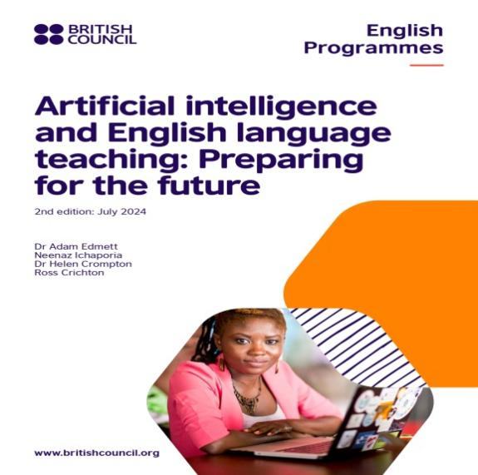

Authors: Adam Edmett, Neenaz Ichaporia, Helen Crompton, & Ross Crichton
Title of book: "Artificial intelligence and English language teaching: Preparing for the future."
Year of publication: 2024
Place of publication: 1 Redman Place, London E20 1JQ, United Kingdom
Publisher: British Council, UK
Pages: 82
Reviewer: Hassan Naqeeb
Heated debates are ongoing regarding the challenges being confronted through integrating AI into English Language Teaching (ELT). Such an integration has well-documented benefits such as the observable improvement in English receptive and productive skills, individualized learning , immediate feedback and assessment and autonomous learning. However, the challenge is in the implementation regarding the availability of the effective AI powered environment, ethics and pedagogical constraints (Edmett et al. 2024; Syuhra et al. 2025; Özçelik, 2025 ). Other issues were raised concerning student's readiness towards learning since AI reduces student's enthusiasm for practice and engagement, AI's inefficiency in processing idiomatic expressions and responding emotionally and the concern of AI's replacement of human intervention ( Kohnke et al., 2023; Barrett & Pack, 2023; Gayed et al (2022).
Written by Edmett and his colleagues in 2024 and published by the British Council, Artificial intelligence and English language teaching: Preparing for the future continues to be an indispensable resource for scholars and teachers who address artificial intelligence (AI) in their EFL classes. This 82 page and three-chapter book opens a new horizon of clear-cut knowledge and practice.

The authors skillfully explore and design the seamless relationship between artificial intelligence and English language learning and teaching. This professional inclusion of AI into English language learning and teaching has been professionally addressed through an intricate survey, analysis and review of 10- year empirical studies, views of 1,348 teachers from 118 countries and the views of key stakeholders from different corners of the universe. All these experiences provided their own feedback on how AI is being used to teach English and the related present and the future issues, opportunities and challenges for English language teaching and learning.

Consequently, the strengths of this book arise from the new trends offered by AI to English language learning and teaching. More specifically, the 10-year empirical studies have underlined the improvement in the different English language skills and sub-skills due to the use of AI in teaching. For example, many speaking sub-skills have improved like pronunciation, fluency, retention of vocabulary, reducing the flatness of pitch and intonation patterns, learning consonants and vowels. AI was used as a conversational partner through different AI powered programs like Alexa and AI coach. In addition, tangible and observable progress was achieved in the writing skill, especially vocabulary and grammar due to the use of AI programs and apps like Grammarly, grammar checkers and Google Translate. Similarly, the vocabulary in reading has improved through using AI powered program World of Warcraft (WoW). Likewise, the pedagogy has improved. Using ChatGPT has enhanced personalized learning experiences and supported assessment techniques. AI has also promoted self-regulation and enhanced autonomous learning. Chatbots have significantly promoted the listening skill in which the learners had the opportunity to listen in supportive environments.

Another point of strength of this book is its varied, diverse and innovative style of demystifying the concerns and fears of the inclusion of AI in English language teaching and learning. This was professionally presented through surveying the views of 1,348 teachers from 118 countries. The vast majority of respondents agreed that both the receptive and productive skills had improved due to the implementation of the AI powered tools. However, they stressed the necessity to have “ A shared belief that the integration of AI powered tools and content should complement, rather than replace the existing methods” ( p. 33). Additionally, although some concerns were highlighted regarding plagiarism, cheating and over-dependence on AI in learning English skills, several educators and ELT scholars accentuated that each teaching method has its own “beneficial and detrimental effects” (p.33), but that basically depends on how to use those tools. Therefore, the concerns are not exclusive to AI. Moreover, despite the trend is autonomous and innovative learning, the respondents valued AI powered tools in writing English and preparing lesson plans. That is, since native speakers themselves use AI tools in writing and lesson plans are formulaic, why do not the EFL learners follow the suit? The vast majority of the respondents agreed that they do not have training in AI, “but the overarching theme is a call for
more structured and comprehensive training opportunities” ( p.36). The fear that AI may replace human teachers has also been refuted since human experience is unique and learning language means learning cultures.

The writers of the this book have also refuted some fallacies about AI. Some views of writers,
academics, ministry of education representatives, (CEOs) of EdTech companies were
Surveyed as well. Consequently, almost all participants highlighted the issue of which AI people use: the generative AI or the AI in general. Therefore, before the inclusion of AI in ELT, educators should be familiar with credible AI powered products. If used and developed properly, AI would dismiss the fallacy of AI’s individual learning and transcends it to individualized learning. The stakeholders have also underlined the immediate feedback and help provided promptly by the AI. Thus, it will become like the snowball. More help and more feedback brings about learning. Additionally, although AI simulates human verbal and nonverbal interactions, it is impossible to replicate the “authenticity o human interactions” (p. 50). Unlike some misconceptions, AI is still attractive and under massive demand by many teaching methods due to its efficiency and cost efficiency.

The writers of the book have also provided an insightful look for the future of AI in ELT. They suggested a lifelong training program which focuses on AI literacy alongside drafting “ an accessible and unanimous ethics statements for AI in ELT. The authors have also suggested some areas for future research, especially challenges of using AI in ELT, using AI in English receptive skills, long-term impact of some AI tools and AI assessment applications.

I would strongly recommend this amazing book since it is worthwhile reading for its succinct, innovative obvious ideas and rich sources. It is based on theoretical and empirical studies. It is also supported by testimonies and experiences of educators and stakeholders from all over the world.

References
Barrett, A., & Pack, A. (2023). Not quite eye to A.I.: student and teacher perspectives on using generative artificial intelligence in writing. International Journal of Educational Technology in Higher Education, 20(1). https://doi.org/10.1186/s41239-023-00427-0
Edmett, A., Ichaporia, N., Crompton, & H., Crichton, R. (2024). Artificial intelligence and English language teaching: Preparing for the future. 1 Redman Place, London E20 1JQ, United Kingdom.
Gayed, J. M., Carlon, M. K. J., Oriola, A. M., & Cross, J. S. (2022). Exploring an AI-based writing Assistant’s impact on English language learners. Computers and Education Artificial Intelligence, 3, 100055. https://doi.org/10.1016/j.caeai.2022.100055
Kohnke, L. (2024). Exploring EAP students’ perceptions of GenAI and traditional grammar checking tools for language learning. Computers and Education Artificial Intelligence, 7, https://doi.org/10.1016/j.caeai.2024.100279
Özçelik, N. P. (2025). Artificial Intelligence in English Language Teaching: A Systematic Analysis
of Global Trends. International Journal of Curriculum and Instruction 17 (2), 612-626.
Syuhra, M., Chandra, N., & Rosalina (2025). Artificial Intelligence in English Language Teaching: A Systematic Literature Review of Tools, Impact, and Challenges. Voices of English Language Education Society 9 (1), 193-205.

Reviewer
Hassan Naqeeb
PhD. Assistant professor at Department of the English Language Center at the Arab American University, Palestine (AAUP). He lectures on general linguistics, ELT methodology and intercultural communicative competence. He is publishing and dealing with methodological, cultural literacy, learning styles and methods of teaching English as a second language issues. He is now Elsevier Journals Reviewer and AAUP Journal & Stem Journal Copy editor.

