EVALUATING PERFORMANCE LIMITATIONS OF MOVABLE PARTITION SYSTEMS TO ACHIEVE SPATIAL FLEXIBILITY IN CONVENTION CENTRES IN UYO.
OBASI-IKEKWE, Deborah Uchechi¹; OKEY-EJIOWHOR, Caleb²; ESAU, James Esau³
Department of Architecture, Rivers State University, Port Harcourt, Nigeria
OBASI-IKEKWE, Deborah Uchechi*;
deborah.obasi-ikekwe@rsu.edu.ng

ABSTRACT
The growing demand for multifunctional convention centres has increased the need for interior spaces that can be reconfigured efficiently without compromising user comfort or operational performance. Movable partition systems is become an important architectural solution for achieving spatial flexibility by allowing large halls to accommodate multiple events simultaneously. However, their effectiveness is often constrained by acoustic deficiencies, operational inefficiencies, maintenance challenges, and inadequate integration within the building design. This study evaluates the performance limitations of movable partition systems in achieving spatial flexibility in convention centres, with particular reference to Uyo, Akwa Ibom State, Nigeria and is pursued by two objectives, identifying the types of partition system, acoustic, operational, and material constraints that limit the performance, and to propose architectural improvements for convention centre in uyo. A mixed-method research approach was adopted for this study, combining a systematic review of existing literature with comparative case studies of ExCeL London and Convene 155 Bishopsgate, both internationally recognised for their implementation of movable partition. The findings reveal that acoustic performance remains the most critical determinant of partition effectiveness, with sound leakage through joints, seals, and adjacent building elements reducing spatial functionality. Operational factors such as inadequate storage, mechanical wear, inefficient circulation planning, and material selection also influence long-term performance and adaptability. Based on the the literature and case study evidence, the study proposes a Performance-Based Movable Partition Design Framework (PMPDF), which integrates acoustic performance, operational efficiency, material and structural integration, and space planning as interconnected design considerations. The study concludes that movable partition systems should be treated as integral architectural components from the conceptual design stage rather than secondary building elements. Integrating these criteria early in the design process will enhance spatial flexibility, improve user satisfaction, increase operational efficiency, and support the long-term sustainability of convention centres in developing urban contexts as Uyo.
Keywords: movable partition, convention centre, spatial flexibility, acoustic performance, Uyo

INTRODUCTION
Some building types are increasingly expected to hold more than one event simultaneously so as to keep the facility in use and not dormant. Convention centres sit at the extreme end of this demand: they are designed to host conferences, exhibitions, banquets, and performances, sometimes concurrently, while adapting smoothly to different occupancy patterns and event scales. The movable partition is the primary architectural tool for making this work.
Spatial flexibility, as defined by Geldermans et al. (2019), is a building's capacity to adapt its internal configuration to changing functions and needs with minimal intervention, time, and disruption. Convention centres exemplify this need. Luster (2017) describes them as large facilities where groups of individuals gather around shared interests, noting that they also serve as civic icons and economic anchors for their surrounding communities.
Movable partitions, operable walls, folding panels, sliding screens, allow large halls to be subdivided into smaller, functional zones. In theory, this enables concurrent events with quite different spatial requirements. In practice, the systems are regularly compromised by acoustic deficiencies, mechanical wear, inadequate storage, and a failure to coordinate with circulation planning (Chen et al., 2009; Eze et al., 2026). When these issues go unresolved, they undermine the flexibility the systems were installed to deliver. In Uyo, Akwa Ibom State, convention centres play a meaningful role in the region's events and tourism economy. Yet movable partition design in these facilities is rarely treated as a priority at the conceptual stage. This paper addresses that gap, offering architects and designers an evidence-based account of partition performance limitations and practical guidance for improving design outcomes.

AIM AND OBJECTIVES
The aim of this study is to evaluate the performance limitations of movable partition systems in achieving spatial flexibility in convention centre design, with specific reference to facilities in Uyo. This is pursued through two objectives:
- identifying the types of partition system, acoustic, operational, and material constraints that limit the performance.
- To propose architectural improvements for convention centre in uyo.

STATEMENT OF THE PROBLEM
Convention centres generate substantial noise across concurrent events, making effective spatial separation a functional necessity. One of the primary concerns associated with movable partitions is their inability to consistently achieve adequate acoustic separation between adjacent event spaces. This multifunctional nature requires interior spaces that can be reconfigured quickly and efficiently to meet varying occupancy levels and event requirements (Long, 2014). Movable partition systems have therefore become an essential component of contemporary convention centre design because they enable large halls to be divided into smaller functional spaces while maximizing flexibility and space utilization (Schmidt III et al., 2010). However, despite their widespread adoption, the performance of movable partition systems remains a significant challenge in many convention centres worldwide. Beyond acoustic performance, operational challenges also affect the efficiency of movable partition systems. Frequent opening, closing, and reconfiguration expose tracks, rollers, seals, and suspension mechanisms to continuous mechanical wear, leading to increased maintenance requirements and operational downtime. In Nigeria, and particularly in Uyo, there is limited empirical research examining the integration of movable partition systems within convention centre design. Existing studies on public buildings have largely focused on architectural aesthetics, structural performance, or general space planning, while relatively little attention has been given to flexible spatial design and the operational effectiveness of movable partitions. As convention facilities continue to play an increasingly important role in supporting conferences, tourism, business events, and economic development, understanding the design factors that influence partition performance becomes essential for improving building functionality and long-term sustainability. this study seeks to examine the documented limitations associated with movable partition systems including acoustic performance, operational efficiency, maintenance requirements, and spatial adaptability and assess their implications for the planning and design of a convention centre in Uyo.
LITERATURE REVIEW

Convention Centres
Convention centres are commercial facilities capable of hosting large gatherings for a wide variety of events, concerts, trade exhibitions, banquets, and conferences. Adewale and Ewuoso (2023) noted that these facilities have become significant structures in the events and tourism industry, contributing meaningfully to the economic and social character of their host cities. Their value depends entirely on their ability to respond to a wide variety of event configurations and occupancy densities, which requires a high degree of spatial flexibility. A study conducted by Allen and Abbey's study on cultural centre design in Rivers State, Nigeria, found that the integration of flexible spatial approaches directly determines a facility's capacity to meet diverse user requirements while maximising operational efficiency, an observation directly applicable to convention centres in Uyo.

Sound Transmission Class (STC)
Sound Transmission Class (STC) is the standard single-number rating for quantifying how well a building element attenuates airborne sound, The higher the rating, the more effective the acoustic isolation (Andrea et al., 2020). In convention centres, where large-scale events may occur simultaneously in adjacent halls, STC ratings of 60 and above are typically necessary to prevent disruptive sound transfer between spaces (Borzym, 2021). For context, STC 25–30 means speech is easily understood through the partition, STC 60–65 reduces loud sounds to barely audible, STC 65+ approaches near-total isolation. The gap between what many installed partitions deliver and what convention centres actually need is considerable.

Types and Configurations of Movable Partition Systems
Movable partition systems fall into five main categories, each with different operational characteristics, acoustic profiles, and spatial requirements.
- Accordion Partitions: Panels fold against one another when retracted, making them economical and compact. However, the continuous hinge gaps in their construction allow both sound and light to pass through. Field testing by Borzym, (2021) found that accordion units performed from satisfactory to inferior compared to rigid panel systems, making them poorly suited to environments where acoustic separation is critical.
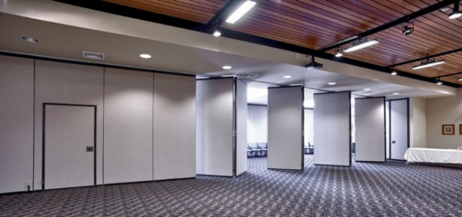
Figure 1. operable and foldable wall systems (source: OKInteriors corp, 2015)

- Sliding Panel Systems: Individual or paired panels suspended from overhead tracks, capable of omnidirectional movement. These offer the greatest layout flexibility and the widest range of stacking configurations, including remote stacking, which allows panels to be stored away from the primary track run, preserving clear floor area (Huang, J. (2011). These are the most appropriate system type for convention centres.
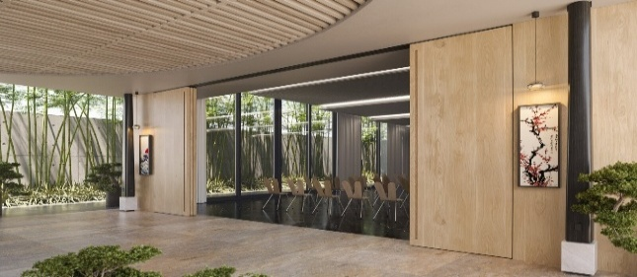
Figure 2. sliding panel systems (source: LINVISIBILE Nigeria Ltd, 2005-2026)
)

- Demountable Partitions: Modular, semi-permanent wall systems that can be assembled and disassembled relatively quickly, but are intended to remain in place for longer periods. They offer better acoustic performance than accordion systems, but their limited reconfigurability reduces their usefulness in venues requiring frequent layout changes.
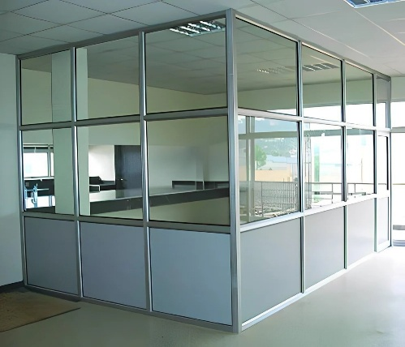
Figure 3. demountable partition systems (source: Aluminium Office Partition Service, 2026)
)

- Vertical Lift Systems: Panels retract upward into a ceiling cavity, eliminating floor-level storage. Multi-layer construction typically delivers the highest acoustic performance of all partition types. However, substantial plenum depth is required, and installation costs are the highest in the category, limiting adoption in cost-sensitive projects (Geldermans et al., 2019).
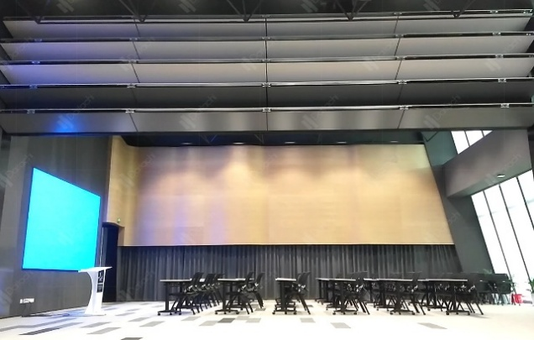
Figure 4 vertical partition walls retracting. (source: daitachi partition wall, 2025)
e. Manual and Electrically Operated Systems: Manually operated systems are the most affordable option for straightforward linear divisions, but require considerable physical effort and impose height limitations. Electrically operated systems move panels via motorised controls, reducing manual effort and making them suitable for venues requiring frequent reconfiguration. They depend on reliable electrical infrastructure and qualified operators (Jurdy & Gray, 2016).

Performance Limitations
a. Acoustic Constraints: Acoustic isolation is the most demanding performance criterion for movable partitions in multifunctional facilities, and the evidence on where systems fail is precise. Huang (2011) provides empirical data that should give pause to any designer relying on partition materials alone: under normal operating conditions with unsealed joints, a steel-framed movable partition achieved an STC rating of only 31, compared to STC 41 when fully sealed. The difference of 10 rating points is primarily caused by joint gaps, not by the panel material itself. The effect is most pronounced at higher frequencies, with a 28.2 dB differential at 5 kHz between sealed and unsealed conditions.
Acoustic leakage occurs at three interface types: panel-to-panel joints, the telescopic extension mechanism, and floor and head seals. Steel-framed systems with aluminium extrusion joinery consistently outperform timber-framed equivalents, which lack vertical joining mechanisms and allow direct sound transmission (Huang, 2011). David and Fergus (2011) add a further important point: partitions alone cannot guarantee acoustic separation in large spaces. Effective sound isolation requires the combination of partition systems with ceiling sound absorption and floor treatment. Sentagi et al. (2019) confirm this, finding that even double gypsum board panels with rockwool infill, a well-specified assembly, achieved an STC of only 45, with flanking noise through the surrounding structure identified as the primary limitation.
b. Operational Shortcomings. Debris accumulation on overhead tracks causes misalignment and mechanical failure, disrupting smooth operation and increasing maintenance demands. Where storage bays or parking pockets are absent or inadequate, operational flexibility is reduced. Manual operation of large partition panels demands significant physical effort, slowing reconfiguration and increasing the risk of improper installation. Barnaby et al. (2023) note that spatial efficiency and flexibility are compromised when partition systems are not properly coordinated with circulation and functional planning, a problem particularly acute in convention centres, where rapid turnaround between event configurations is a core operational requirement.
c. Material and Integration Considerations. Material choice and joinery design directly determine long-term partition performance. Bob G. et al. (2019) emphasise the value of reversible and adaptable materials that support quick reconfiguration, reduce wear, and improve user experience. Steel-framed systems with precision aluminium extrusion joinery are the current performance benchmark, but carry a higher initial cost than timber alternatives. The long-term costs of underperforming timber systems, through increased maintenance, acoustic remediation, and reduced operational efficiency, must be weighed against that upfront investment.

METHODOLOGY
This study adopts a mixed-method research design combining a systematic literature review and case study review. Two academic databases were used as primary sources for the literature include ResearchGate and ScienceDirect. These platforms were selected for their extensive coverage of peer-reviewed material in architecture, building science, and acoustic engineering. The search focused on articles addressing spatial flexibility, movable partition systems, acoustic performance in multifunctional buildings, and convention centre design. Materials were selected based on their relevance to the study's objectives, their methodological rigour, and their empirical contribution to understanding the performance limitations under investigation. The review process involved reading and critically analysing selected articles, identifying recurring themes and findings, and synthesising these into the framework presented in this paper.
DISCUSSION
Excel London exhibition centre (phase 3)
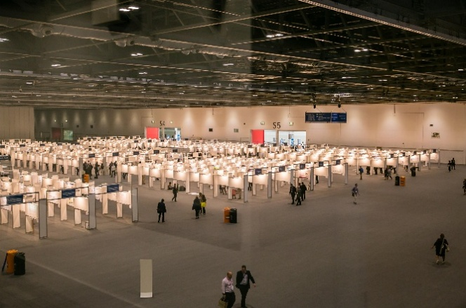
Figure 5. image showing the interior view of the hall. (source: excel-london, 2025)
The ExCeL London is one of Europe's largest purpose-built exhibition and convention venues. Located at the Royal Victoria Dock in East London, the centre was opened in 2000 and expanded in 2010 with the addition of the International Convention Centre (ICC). The Phase 3 expansion, completed in 2024 and officially brought into operation in 2025, represents the largest development of the venue since its inception. The expansion was undertaken to accommodate increasing international demand for conferences, exhibitions, corporate meetings, and large-scale events while strengthening London's position as a global business tourism destination.
a. System specification: the partition system uses a manual, top-hung Dorma Huppe Variflex system. The total installation include 1.2km of overhead track, 548 individual panel elements. The panel finish; high-pressure durable laminate. Acoustic rating: Rw 55db. The partition system enables simultaneous multiple-event operation with documented speech privacy between adjacent halls.
Etc. Venues, 155 Bishopsgate, London
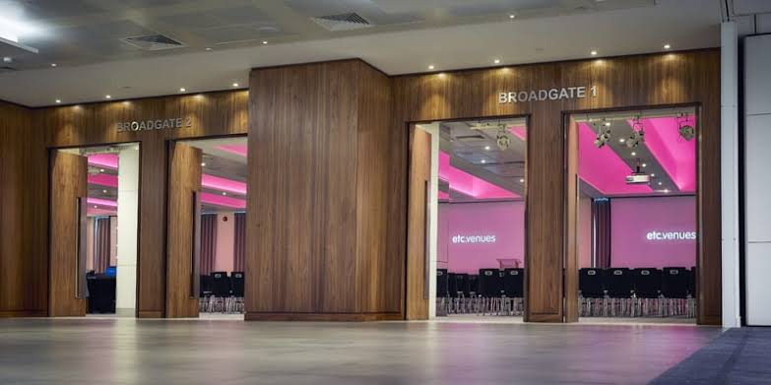
Figure 6. image showing the partition system in the hall. (source: Convene – 155 Bishopsgate, 2026)
Etc. Venues, 155 Bishopsgate (now operating as Convene 155 Bishopsgate) is a purpose-built conference and exhibition venue located within the Broadgate commercial district in the City of London. Situated adjacent to Liverpool Street Station, the facility was developed to provide a flexible environment for conferences, corporate meetings, exhibitions, product launches, training sessions, and networking events. Following its expansion and integration into the Convene portfolio, the venue now occupies approximately 3,749 m² (about 40,000 sq. ft.) across two floors and accommodates more than 1,000 delegates.
a. System specification: This event space, installed a 21-metre high Dorma Huppe Variflex wall dividing the main space, supplemented by five additional walls creating individual meeting rooms. The partition system operates a semi-automatic manual. It achieved a 52 bd Rw acoustic rating. Pass doors and adjacent panels are fully glazed to maintain natural light transmission throughout the subdivided space. The solid panels feature custom graphics for branding.
Analysis Of Case Study
Performance parameter | Excel london | Etc venues | Critical threshold
Acoustic ratings | Rw 55db | 52db Rw | STC 45 minimum
Operation type | manual | Semi-automatic | Field performance
scale | 1.2km track, 548 panels | - | -
Glazed elements | Pass doors only | Full height glazing | Glazing requires acoustic elements

INTERPRETATION OF RESULT

The primary objective of this study was to evaluate the performance limitations of movable partition systems in achieving spatial flexibility in convention centre design and to identify architectural strategies capable of improving their effectiveness, particularly for the proposed convention centre in Uyo. The findings indicate that while movable partition systems remain one of the most practical solutions for creating adaptable interior spaces, their effectiveness depends largely on how they are considered during the architectural design process. Rather than functioning as isolated building components, movable partitions should be viewed as integral elements of a coordinated design strategy that combines acoustics, structural integration, operational efficiency, and space planning.

One of the most significant findings of this study is that acoustic performance remains the greatest determinant of partition effectiveness. The literature consistently identifies sound transmission through panel joints, floor seals, ceiling interfaces, and adjacent building elements as the major causes of performance failure. This finding supports the studies of Huang (2011), Borzym (2021), and Sentagi et al. (2019), who concluded that achieving satisfactory sound insulation depends not only on the partition panels themselves but also on the quality of sealing mechanisms and the integration of complementary acoustic treatments within the surrounding building envelope. The two case studies reinforce this conclusion. ExCeL London achieved an acoustic rating of Rw 55 dB, while Etc. Venues achieved Rw 52 dB, both exceeding the minimum level generally considered acceptable for speech privacy in multifunctional facilities. These examples demonstrate that high acoustic performance is attainable when acoustic requirements are established during the early design stages.

The study also noted the importance of operational efficiency in achieving true spatial flexibility. Although movable partitions are intended to facilitate rapid space reconfiguration, their effectiveness is frequently reduced by inadequate storage provisions, poorly coordinated circulation routes, mechanical wear, and labour-intensive operation. These observations agree with the Adaptable Building Design (ABD) Framework proposed by Schmidt III et al. (2010), which argues that adaptability must be deliberately incorporated into the design process rather than introduced after construction. Both ExCeL London and Etc. Venues illustrate this principle by integrating partition storage areas, circulation paths, and building services into the overall architectural layout, thereby enabling efficient room conversion with minimal disruption to ongoing activities.

Material selection emerged as another important determinant of system performance. Steel-framed movable partition systems with precision aluminium extrusion joinery consistently outperformed timber-framed alternatives in terms of acoustic insulation, durability, and operational reliability. These findings corroborate Huang's (2011) assertion that the quality of panel connections and sealing mechanisms contributes more to acoustic performance than panel materials alone. Although steel-framed systems involve higher initial construction costs, their improved durability and reduced maintenance requirements provide greater long-term value throughout the building's operational life.

Beyond these individual findings, this study demonstrates that the performance of movable partition systems cannot be attributed to a single design factor. Instead, successful spatial flexibility results from the interaction of several interdependent architectural considerations. Based on the synthesis of the literature, the comparative case studies, and the findings of this research, a conceptual model referred to as the Performance-Based Movable Partition Design Framework (PMPDF) is proposed.

The proposed framework argues that effective use of this architectural element to improve spatial flexibility in convention centres is achieved through four interconnected design variables that should be addressed during the conceptual design stage:

Acoustic Performance, which includes sound insulation ratings, joint sealing, floor and ceiling interfaces, and control of flanking sound transmission.

Operational Efficiency, which encompasses ease of operation, maintenance requirements, track systems, and speed of space reconfiguration.

Material and Structural Integration, involving appropriate material selection, structural coordination, durability, and compatibility with building systems.

Space Planning Integration, which incorporates dedicated partition storage, circulation planning, emergency egress, and coordination with mechanical and electrical services.

These four variables collectively determine the overall performance of the movable partition system. When properly integrated, they produce improved acoustic separation, reliable operation, reduced maintenance requirements, and efficient room reconfiguration. Enhanced partition performance subsequently leads to greater spatial flexibility by enabling convention centres to accommodate multiple simultaneous events, respond to changing user requirements, maximize space utilization, and adapt to future operational demands. Ultimately, these improvements contribute to higher user satisfaction, increased operational efficiency, greater economic viability, and enhanced long-term sustainability of the facility.

CONCLUSION
Movable partition systems are an essential tool for achieving spatial flexibility in convention centres, but the evidence reviewed in this paper demonstrates that their performance in practice frequently falls short of what is required. Acoustic inadequacy is the most critical limitation, unsealed steel-framed partitions achieve STC ratings as low as 31 under operating conditions, well below the minimum needed for meaningful sound separation in large multifunctional halls. Operational wear, storage deficiencies, and poor integration with circulation and acoustic strategy compound the problem.
The central argument of this paper is that these limitations are not inevitable. They arise primarily from a failure to treat movable partition performance as a design priority at the conceptual stage. When partition systems are designed as components of a coherent architectural strategy, with acoustic targets, storage provisions, and maintenance requirements established from the outset, their performance is substantially better.
For convention centres in Uyo, where the demand for flexible, high-performance event spaces is growing, this design approach is not a luxury but a functional necessity. Architects and designers working on these facilities should engage with the technical evidence presented and apply it to produce buildings that deliver the spatial flexibility and acoustic separation their users require.

RECOMMENDATIONS
- Integrate acoustic strategy at the conceptual stage: As David and Fergus (2011) make clear, partitions alone cannot achieve adequate sound isolation; the surrounding surfaces must be treated as part of a holistic acoustic system. Upgrade the STC class to STC of 55-59db as used in Excel convention centre and proper insulation material in the layers of the partition panel is recommended.
- Specify steel-framed systems with precision joinery: For convention centre applications, steel-framed systems with aluminium extrusion joinery should be used over timber alternatives. The acoustic performance differential is significant and well-documented (Huang, 2011).
- Design dedicated storage and circulation provision: Remote stacking configurations are particularly valuable in convention halls where floor area is at a premium. Partition storage and movement must be coordinated with circulation routes to ensure that reconfiguration does not conflict with occupant movement or emergency egress (Barnaby et al., 2023).
- Establish preventive maintenance protocols: These protocols should be agreed and documented at the design stage, with access provisions for maintenance personnel incorporated into the building design from the outset (Barnaby et al., 2023).
- Adopt adaptable materials for long-term performance: The selection of reversible and adaptable materials, as emphasised by Bob G. et al. (2019), should be a stated requirement in partition specifications.

REFERENCES
1. Adewale, B. A., & Ewuoso, E. A. (2023). Assessment of daylighting strategies in convention centres: A review from 1990 to 2023. Journal of Environment Sciences (JOES), 22(1). ISSN 1118-8936.
2. Andrea, S., John, L. D., & Paolo, B. (2020). A review of the different approaches to predict sound transmission loss of building partitions. Sage Journals, 27(3), 253–279. https://doi.org/10.1177/1351010X20911599

3. Barnaby, C. S., et al. (2023). Spatial efficiency and flexible indoor partitioning: Integration with circulation and functional planning. Journal of Architectural Science

4. Bob G., et al. (2019). Reversible and adaptable materials in flexible partition design. Building Science Review

5. Borzym, J. (2021). Acoustical performance of horizontal-sliding-panel operable partition walls. INTER-NOISE and NOISE-CON Congress and Conference Proceedings, 263(1), 5125–5130. https://doi.org/10.3397/IN-2021-2974
6. Building Centre. (2024a). Style creates flexible conference facilities at Center Parcs. Retrieved from https://www.buildingcentre.co.uk
7. Building Centre. (2024b). Style divides space again for prestigious London etc.venues facility. https://www.buildingcentre.co.uk
8. Building Centre. (2026). Style returns to deliver ExCeL's Phase 3 movable wall solution. https://www.buildingcentre.co.uk
9. David, E., & Fergus, F. (2011). The identification of flanking paths in buildings. Architectural Science Review, 25(4), 106–111. https://doi.org/10.1080/00038628.1982.9696507
10. Huang, J. (2011). Acoustic performance of movable partition systems: The effect of joint sealing on sound transmission class. Building Acoustics

11. Jurdy, B., & Gray, K. (2016). A case for modular partitions in healthcare facilities. The Journal of the Acoustical Society of America, 140(4), 3237. https://doi.org/10.1121/1.4970236
12. Lilly, J. G. (1991). Field testing of operable walls. The Journal of the Acoustical Society of America, 90(4), 2239. https://doi.org/10.1121/1.401571
13. Luster, A. (2017). Analysis of lighting schemes in public assembly rooms for improved energy performance [Master's thesis]. University of Arizona. https://repository.arizona.edu/handle/10150/624134
14. Sentagi, S. U., Randy, F. F., Joko, S., & Kristina, W. (2019). Study of partition walls to minimise leaking sound in counselling rooms. AIP Publishing, 2088(1). https://doi.org/10.1063/1.5095342

15. Wu, A., & Weber, K. (2005). Convention centre facilities, attributes and services: The delegates' perspective. Asia Pacific Journal of Tourism Research, 10(4), 399–410. https://doi.org/10.1080/10941660500363736

