Development and Characterization of a Sustainable Pectin-Based Zeolite–ZnO Hybrid Nanocomposite for Antibacterial Biomedical Applications

ABSTRACT
A novel nanocomposite comprising pectin, zeolite, and zinc oxide (ZnO) nanoparticles (NPs) was hypothesised to enhance antibacterial activity through synergistic effects. Consequently, the material was investigated as a green antibacterial agent for biomedical applications. Pectin was extracted from green apples using ethanol precipitation and dried at 50°C. The nanocomposite was prepared by mixing 1% (w/v) pectin, 2% (w/v) zeolite, and 0.5% (w/v) ZnO nanoparticles in water, followed by stirring for 2 hours at room temperature. For antibacterial testing, 100 µL of a 10^6 CFU/mL bacterial suspension was spread on Mueller-Hinton agar. Composite discs (6 mm diameter, 20 mg) were placed on the plates. After 24 hours of incubation at 37°C, inhibition zones were measured. Minimum inhibitory concentrations were determined by broth microdilution (10–200 µg/mL) in 96-well plates. FTIR analysis confirmed functional group interactions within the materials. The pectin-zeolite-ZnO nanocomposite had strong antibacterial activity against both bacteria. For Staphylococcus aureus, the nanocomposite produced an inhibition zone of 18.2 ± 0.5 mm and for Escherichia coli, 15.7 ± 0.6 mm. These values were significantly greater than those observed for the pectin (9.3 ± 0.3 mm), zeolite (10.1 ± 0.4 mm), or ZnO nanoparticles alone (13.5 ± 0.5 mm). The minimum inhibitory concentration (MIC) for the nanocomposite was 40 µg/mL against S. aureus and 50 µg/mL against E. coli. This increase in antibacterial efficacy results from the synergy among zeolite, pectin, and ZnO nanoparticles, which enhances bacterial cell disruption and inhibition. The developed nanocomposite is a promising antibacterial agent. Its strong antibacterial activity suggests potential use in biomedical applications such as wound dressings, implant coatings, or antibacterial surfaces, where effective inhibition of bacterial growth is essential. These results highlight the nanocomposite's translational potential for preventing infections and supporting the development of safe biomedical devices.
Keywords: Pectin, Zeolite, Zinc oxide nanoparticles (ZnO), nanocomposite, green antibacterial agent.

INTRODUCTION
The term “zeolite” is derived from the Greek words “zeo” (to boil) and “litos” (stone). Zeolites are porous, inorganic crystalline aluminosilicate minerals. They have cavities that can encapsulate pectin and other molecules (see Figure 1). Their hybrid structure facilitates controlled release and adsorption by using their porous architecture. Zeolites possess negatively charged channels and cavities. These are occupied by positively charged alkali and alkaline-earth ions, such as Na+, K+, and Ca2+, as well as by OH– groups or H2O molecules. Ions and molecules can readily exchange with those from the surrounding environment [1]. This distinctive structure enables a broad spectrum of applications. Zeolites are used in medicine, agriculture, food production, environmental protection, water vapour adsorption, the construction industry, and biomedical fields [2,3]. Owing to their ion-exchange and adsorption properties, as well as their biocompatibility, zeolites have significant potential as pharmaceutical agents. They are increasingly used in food science, as shown in Figures 2a and 2b [4,5]. Zeolites are used as drug carriers for the controlled release of pharmaceuticals such as ibuprofen and 5-fluorouracil. They contribute to detoxification, wound healing, antibacterial treatments, dental fillers, gastrointestinal therapies, advanced wound care, and tissue engineering by promoting cell adhesion [2-5]. Furthermore, zeolites are valuable in animal feed for enhancing immunity, detoxifying mycotoxins, and binding ammonia [4-6].
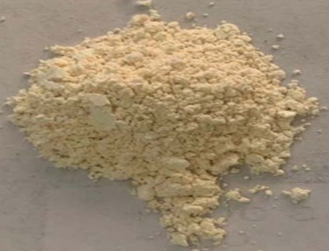
Figure 1: Zeolite crystallized at 105°C with a particle size of 60-80nm

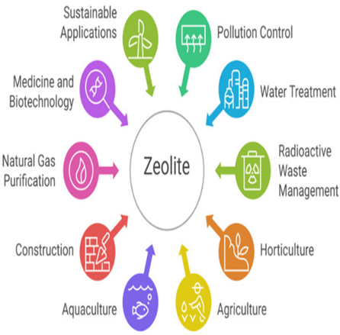
Figure 2a: Various Industrial Applications of Zeolite [5]
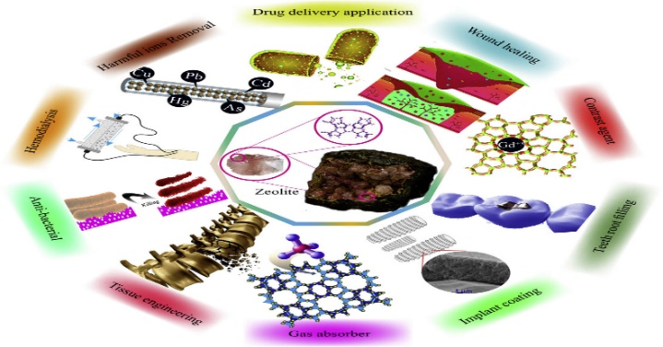
Figure 2b: Various Biomedical applications of zeolite-based materials [3]
Zeolite as a Binding or Adsorption Agent
Combining pectin, a natural polysaccharide, with zinc oxide nanoparticles (ZnO-NPs) yields a hybrid, biocompatible adsorbent. This hybrid mimics several zeolite-like properties. It has a high surface area, a porous structure, and strong contaminant-binding properties, especially for water treatment. While zeolites are inorganic crystalline aluminosilicates, the pectin-ZnO nanocomposite is an organic-inorganic hybrid adsorbent [7]. The synergy between zeolite and pectin forms a matrix with multiple functional groups. These groups bind heavy metals through ion exchange and chelation [8]. This structure offers a high surface area-to-volume ratio. It contains active adsorption sites due to ZnO-NPs. The composite shows a higher adsorption capacity than pure pectin. ZnO-NPs prevent pectin dissolution and increase its surface reactivity [9,10]. Binding mechanisms include hydrogen bonding between pectin hydroxyl groups and polar contaminants. They also include the complexation of pectin carboxylate groups with zinc oxide ions and electrostatic attraction. Pectin is negatively charged at moderate pH [10], while ZnO-NPs are amphoteric, resulting in stable nanocomposites [11]. These interactions enhance the mechanical strength, barrier properties, and antimicrobial activity of pectin-based films. The gel networks of pectin-ZnO nanocomposites also form zeolite-like porous structures. These porous structures trap molecules within crystalline cages, similar to zeolites [11]. The adsorption properties of the zeolite-pectin-ZnO composite depend strongly on pH. At low pH, protonation of pectin reduces metal-binding affinity but may promote the release of adsorbed materials. ZnO nanoparticles can also be immobilised on zeolite surfaces. This further improves stability and adsorption efficiency by combining zeolite porosity with the antimicrobial properties of ZnO-NPs [12].
Pectin: Structure, Sources, and Applications
Pectin is a natural, heterogeneous polysaccharide found in plant cell walls, mainly composed of α-1-4 d-galacturonic acid units. It is abundant in fruit peels and valued for its water solubility, biodegradability, non-toxicity, and natural availability. Pectin can be methyl esterified or non-methyl esterified [13] and is classified as high-methoxyl or low-methoxyl. Its key physicochemical properties include sensitivity to pH, ion concentration, and temperature [9,11,13]. Commonly extracted from fruits and vegetables like apples and citrus, pectin contributes to dietary soluble fibre. It accounts for 2% to 35% of the cell wall weight in higher plants. Pectin supports plant growth, development, and defence, and regulates ion and water exchange. Its applications include edible and biodegradable films, adhesives, paper substitutes, gelling agents, stabilisers [11,13], pharmaceuticals [14,15], surface modifiers for clinical devices, drug delivery systems, and implantable materials [16,17]. In sub-Saharan Africa, including Ghana, pectin is traditionally used to reduce cholesterol absorption, prevent heartburn and diarrhoea, and treat various conditions, though no scientific evidence supports these uses [11]. Extraction methods include ultrasound, microwave-assisted, enzyme-based, steam-injection heating, and subcritical water extraction, the latter of which is applied to apple pectin [18]. Research has also examined pectin extraction from ripe and unripe mango peels to evaluate the effects of ripeness on yield and quality [19]. Extraction variables such as temperature, time, pH (using 0.1 N HCl), plant species, tissue type, and method influence pectin characteristics and applications. Findings indicate ripe mango peel may be more suitable for pectin production. Due to its hydrophilic nature, pectin is biocompatible, low-toxicity, and biodegradable, making it suitable for drug delivery, tissue scaffolds, prebiotics, wound healing, and biosensors [20]. These properties support its broad functionality and applications in food, biotechnology, and biomedical fields.
Pectin as a Natural Polymer: Properties and Applications
Pectin is typically extracted from various plant species and by-products using acidic solutions [13, 17, 20]. As a natural polymer, it is well-suited for hydrocolloid applications in food systems. Recent studies suggest pectin may help prevent and reduce carcinogenesis [12]. Its polymeric structure allows it to function as a fat replacer, gelling agent, thickener, emulsifier, stabiliser, and glazing agent in food and pharmaceutical products [12, 20]. Its bioactive, soluble dietary fibre properties support lower blood lipid levels and may help combat certain cancers, contributing to its use in the pharmaceutical and nutraceutical industries [12, 17]. Pectin’s biodegradability, biocompatibility, edibility, and versatile properties make it an effective matrix for edible films in active food packaging. These packaging systems incorporate functional ingredients or polymers to deliver benefits beyond basic barrier performance. Their antimicrobial activity inhibits microbial growth, extending shelf life and reducing spoilage [12, 17, 21].
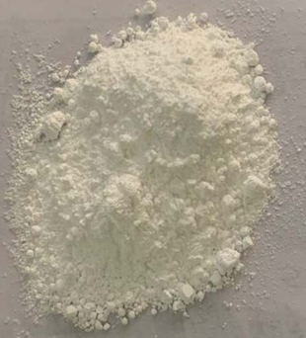
Figure 3: A synthesized Zinc Oxide Nanoparticle (ZnO)

The zinc oxide nanoparticles (NPs)
This study examines zinc oxide nanoparticles (ZnO), which naturally occur in the Earth's crust and are classified as Generally Recognised as Safe by the FDA, as shown in Figure 3. ZnO nanoparticles range in size from 1 to 100 nanometers. As the second-most-abundant metal oxide after iron, ZnO is valued for its low cost, safety, and ease of preparation. The physical and chemical properties of ZnO nanoparticles can be adjusted by altering their morphology through different synthesis methods, precursors, or production materials [22, 23]. In this study, ZnO nanoparticles were synthesised via a green method that combined pectin extracts with zeolite, yielding the desired nanocomposite, which was subsequently characterised.
ZnO nanoparticles possess unique properties that make them widely used in analytical sensing and biomedical applications [23]. These group II–IV semiconductor inorganic compounds appear as white powders, are insoluble in water, and have an energy band gap of 3.37 eV and a bonding energy of 60 meV, which together provide excellent chemical, electrical, and thermal stability [22]. Furthermore, ZnO's low toxicity and high ultraviolet absorption enhance its suitability for biomedical applications, including drug delivery, wound healing, biosensing, bioimaging, tissue engineering, and the use of luminescent semiconductors for visualising tissue cells [22-25]. In particular, in biomedical settings, ZnO nanoparticles serve as effective surface materials with strong antimicrobial activity [25]. The versatility of zinc oxide nanoparticles underlies their widespread use in biological labelling, biosensing, drug delivery, gene delivery, and nanomedicine. Furthermore, zinc oxide can be solubilised in acidic environments, allowing its use as a multifunctional nanocarrier for drug delivery and release [23, 24].
Synergistic Functional Potential of the Hybrid Nanocomposite
A novel combination of zeolite, pectin, and zinc oxide nanoparticles creates a functional antimicrobial nanocomposite. Each component enhances the others’ performance through synergistic action. This interaction increases resistance to nanoparticle aggregation and improves durability. Within the composite, zeolite provides porous channels that help sustain particle delivery. Pectin encapsulates the structures, promoting biocompatibility and preserving film integrity. On contact with microbes, zinc oxide forms reactive species such as hydroxyl radicals and superoxide. These disrupt microbial cell walls. Zeolite’s ion-exchange sites gradually release zinc ions, extending antimicrobial activity. Together, these actions cause membrane destabilisation, protein dysfunction, and genetic material degradation through coordinated interactions among materials [20,21,26]. The pectin matrix also allows moisture-driven expansion. This increases nanoparticle-microbe interactions [27,28]. The primary strength of this system lies in its composite action, not just in the effects of its individual components. The zeolite-ZnO composite disrupts gram-positive cell walls more efficiently owing to their less dense peptidoglycan layer [29]. The antibacterial efficacy of the ZnO-NPs nanocomposite is likely linked to Zn2+ ion release and the generation of reactive oxygen species (ROS), such as hydrogen peroxide. These penetrate and disrupt bacterial cell walls. Table 1 summarises the antibacterial efficacy of various nanocomposites and their antibiotic studies, including zones of inhibition against Gram-positive bacteria.
Additionally, gram-positive bacteria have a thick cell wall. This structure helps ZnO-NPs bind, making them more susceptible to antibacterial effects and leading to membrane damage [29]. The chemical stability and molecular-trapping capabilities of nanocomposites make them suitable for many applications, including medicine, skincare, and manufacturing [25]. Their structure remains intact during use. This prevents microbial growth and helps remove contaminants, pathogens, and unwanted substances in diverse environments.

Table 1: Antibacterial Efficacy studies report on zones of inhibition (ZOI) comparable to antibiotics.
Nanocomposite | Bacteria | ZOI (mm at 10-20 µL) | Control (Chloramphenicol) | Source
Zeolite-Ag/ZnO | S. aureus | 15.5-16.2 | 15.6-23.6 | Wakweya and Jifar, [21]
Zeolite-Ag/ZnO | E. coli | 15.5 | 23.6 | Wakweya and Jifar, [21]
Pectin-ZnO (1-1.5%) | S. aureus, E. coli | Enhanced vs. pectin alone | N/A | Hari et al., [29]
ZnO NP hybrids | S. aureus | MIC reduced 4-8x with antibiotics | Antibiotics alone | Hao et al.,​ [26]
This study investigates the combined effects of a zeolite-pectin-ZnO nanoparticle composite. The antibacterial properties of the nanocomposite are evaluated. Initially, pectin is extracted and characterised from green apples. Subsequently, the zeolite-pectin-ZnO nanocomposite is biosynthesised. Its antimicrobial activity is then assessed against Escherichia coli and Staphylococcus aureus.
MATERIALS AND METHODS
Chemicals and Reagents
The experiment used 200 mg of zeolite, 300 mg of ZnO nanoparticles, 100 mg of pectin extracted from green apples, and a suitable concentration of ethanol.
Extraction of Pectin from Green Apple
Pectin was extracted following the method described by Chandel et al. [30] without modification, as shown in Figure 4. The protocol was followed precisely. Apples, including skin and seeds, were selected, washed, and cut. They were placed in a preserving pot and covered with just enough water to float, avoiding excess water that could dilute them. The pot was covered and brought to a boil over medium-high heat, then simmered gently for 2 to 2.5 hours. Stirring was avoided to keep the pectin extract clear. After cooking, the apples were thoroughly softened to a consistency similar to chunky applesauce.
A colander lined with cheesecloth, coffee filters, or a tea towel was placed over a large pot. The apple mixture was strained and left to drip for several hours or overnight at room temperature. No pressure was applied to preserve clarity. The pectin extract was simmered over moderate heat until its volume was reduced by half. Its gelling ability was evaluated before storage. One teaspoon of pectin extract was cooled and mixed with one tablespoon of rubbing alcohol. A gelatinous mass, retrievable with a fork, indicated a high pectin content. If only a few particles formed, the liquid was further reduced by boiling. The test batch was discarded. The hot pectin extract was transferred into sterilised half-pint Mason jars, leaving a ¼-inch headspace. Jar rims were wiped clean, new lids applied, and screw bands secured. The jars were processed in a boiling water bath for 10 minutes, then left undisturbed for 8 to 12 hours.
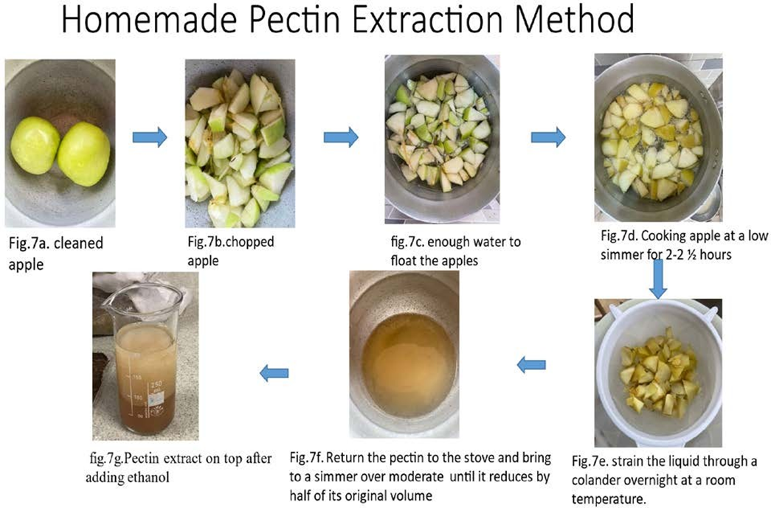
Figure 4: Homemade Extraction of Pectin (Chandel et al., (30)

Green synthesis of zeolite-pectin-ZnO nanocomposite

The zeolite-pectin-ZnO nanocomposite was synthesised using a stepwise solvent-free mechanochemical method to ensure uniform dispersion and preserve structural integrity. Zeolite (particle size under 5 µm, cation exchange capacity 2.0–2.5 meq/g), pectin (degree of esterification 30–40%, molecular weight about 80 kDa), and ZnO nanoparticles (20–60 nm) were kept dry to prevent hydrolytic degradation. Zeolite and pectin were mixed for 1 hour. Then ZnO nanoparticles were added and stirred for another hour at 50°C. The final product was dried in a vacuum oven at 70°C for 2 hours, yielding the nanocomposite powder.

Table 2: The ratio of zeolite-pectin-ZnO NPs nanocomposite
Nanocomposite | Zeolite ratio (%) E | Zinc oxide (ZnO)  ratio (%)  D | Pectin ratio (%)  F | Weighed composite(mg)
Sample A | 10 | 20 | 70 | 31.8
Sample B | 20 | 40 | 40 | 58.3
Sample C | 20 | 30 | 50 | 42.5
Table 2 lists the sample ratios used in this study. Samples A, B, and C contain specific proportions of zeolite, zinc oxide nanoparticles (ZnO NP), and pectin. The following protocol outlines the preparation of zeolite-pectin-zinc oxide nanocomposite materials:
- A 10 mL aqueous dispersion of zeolite and pectin was prepared in distilled water (H₂O) using a borosilicate glass beaker.
- The mixture was stirred continuously for 1 hour using a magnetic stirrer to ensure complete homogenization.
- Zinc oxide nanoparticles were added, and the mixture was stirred for another hour.
- The mixture was transferred to a sterile Petri dish and dried in a vacuum oven at 70°C for 48 hours.
- This process removed moisture and produced a uniform, dry film.
Assessment of Antimicrobial Inhibition Zones
Antimicrobial susceptibility was assessed using the agar well diffusion method on Mueller-Hinton agar (MHA) prepared in accordance with pharmacopoeial guidelines. Dehydrated MHA powder (21 g/L) was dissolved in distilled water, and the pH was adjusted to 7.3 ± 0.1. The medium was sterilised by autoclaving at 121°C and 15 psi for 15 minutes. It was then cooled to 45–50°C and aseptically poured into sterile 90-mm Petri dishes within a Class II biosafety cabinet. Each dish received 20–25 mL of medium to achieve a uniform depth of 4 mm. After solidification at room temperature, a sterile 6 mm cork borer was used to create a central well in the agar. Standardised inocula of Escherichia coli and Staphylococcus aureus were prepared from overnight cultures and evenly spread on the MHA surface using a sterile cotton swab. Plates were pre-dried for 5 minutes under biosafety cabinet conditions. Test agents, including zeolite (Sample E), zinc oxide nanoparticles (ZnO NPs, Sample D), and zeolite-ZnO nanocomposites (Samples A, B, C), were added to the wells in 50 µL volumes using a calibrated micropipette. Plates were sealed with Parafilm and incubated inverted at 37°C for 24 hours. Inhibition zones were measured by recording the zone diameters [31].
RESULTS
Extraction of pectin
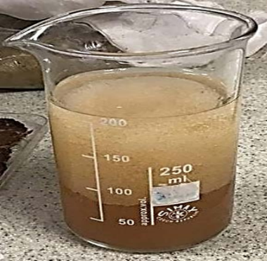

Figure 5: Extracted pectin from apple (Homemade method)

Fourier Transform Infrared Spectroscopy (FTIR) Analysis

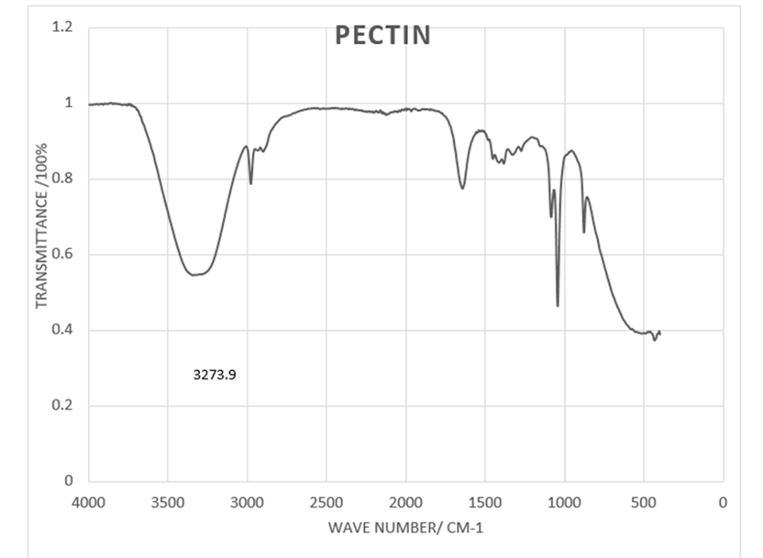

Figure 6: FTIR spectra of pectin extracted from apple
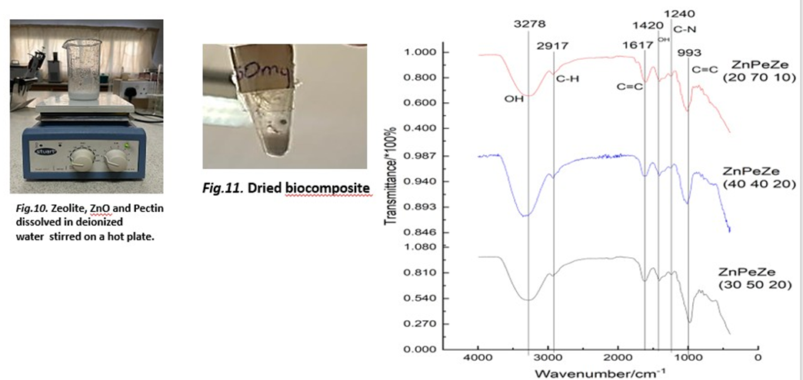
Figure 7: FTIR analysis results for nanocomposites with varying compositions
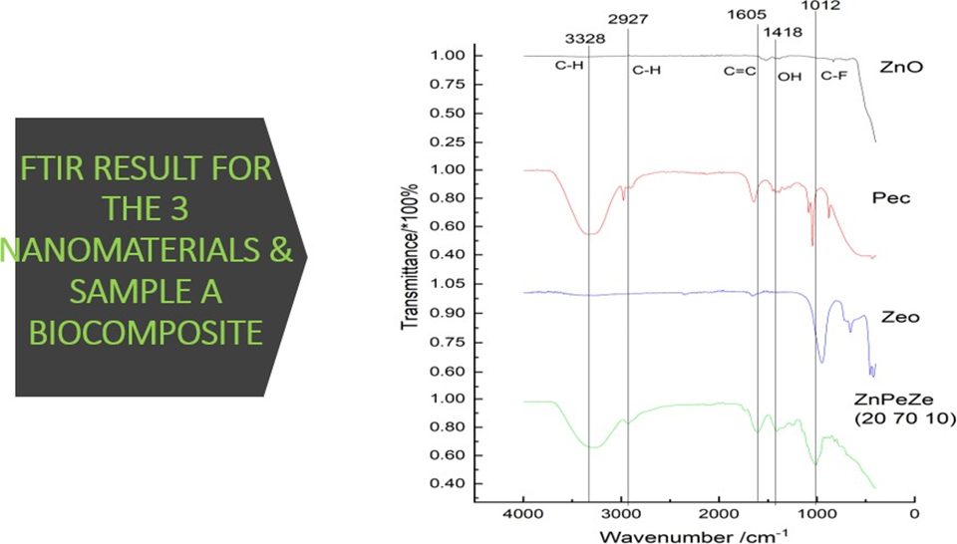
Figure 8: FTIR Results for the Three Nanomaterials and Sample A Nanocomposite
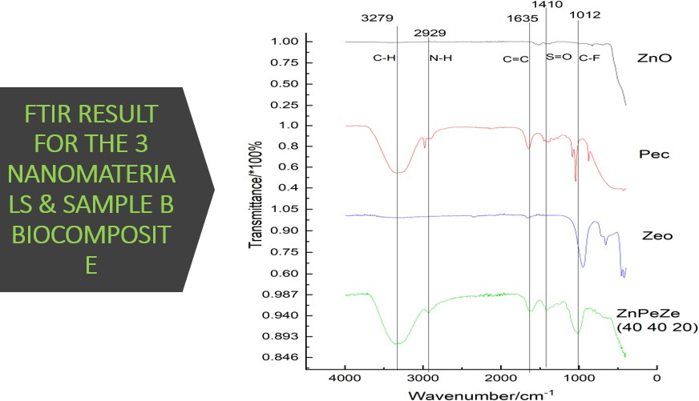
Figure 9: FTIR result for the 3 nanomaterials & sample B nanocomposite
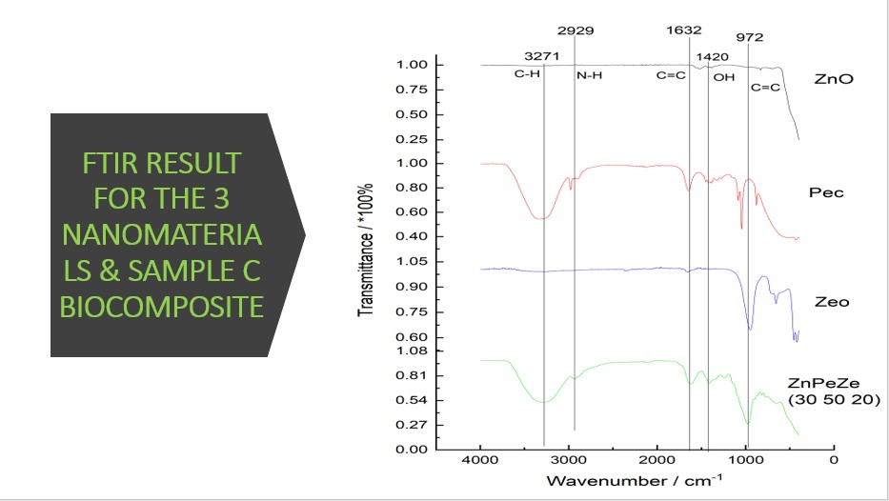
Figure 10: FTIR results for the Three Nanomaterials and Sample C Nanocomposite
Antibacterial potency study of the synergistic nanocomposite material
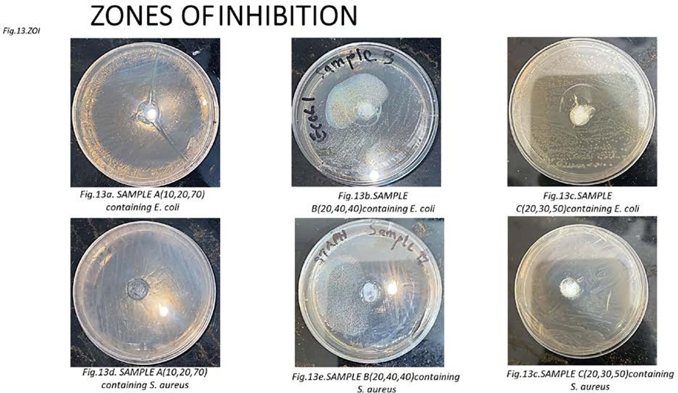
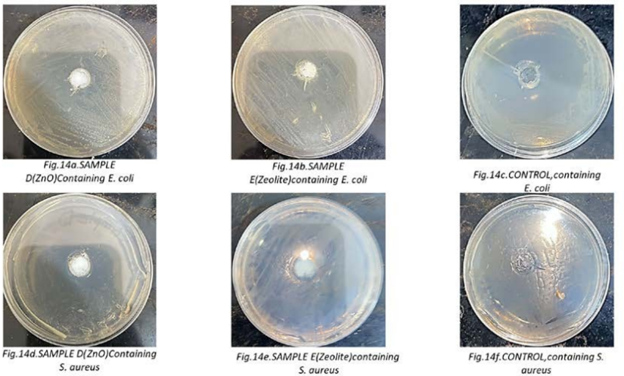
Figure 11: Cultured plates showing the zone of inhibition of the E. coli and S. aureus bacteria
Table 3: MIC/Zone of Inhibition Measurement
BACTERIA  STRAINS | SAMPLE A  (mm)  (10:20:70) | SAMPLE B  (mm)  (20:40:40) | SAMPLE C  (mm)  (20:30:50) | SAMPLE D  (mm)  (ZnO) | SAMPLE E  (mm)  (Zeolite) | CONTROL  (Amoxicilin)
E. coli | 16 | 13 | 6 | 5 | 6 | 0
S. aureus | 16 | 16 | 18 | 15 | 6 | 0

DISCUSSION
Pectin Extraction
Figure 5 shows the homemade pectin extracted from green apples. The extracted pectin was characterised and compared to the standard characterisation results.
Fourier Transform Infrared Spectroscopy Analysis (FTIR)

Fourier Transform Infrared Spectroscopy (FTIR) was used to analyse the molecular composition of the nanocomposite. This technique identifies functional groups through infrared absorption. FTIR analysis of zeolite, zinc oxide nanoparticles (NPs), and pectin revealed distinct peaks and bands, indicating active components and specific bond-stretching modes in both individual substances and their mixtures. In the spectra, the horizontal axis shows wavenumber in cm⁻¹, while the vertical axis displays transmittance as a percentage of incident light. These findings clarify the chemical composition of each tested sample [32].
The FTIR spectrum of pectin in Figure 6 confirms the presence of functional groups typical of polysaccharides, as previously reported [33]. The broad O-H peak at 3273.9 cm⁻¹ indicates hydroxyl groups, which support pectin’s gel-forming ability. The C=O peak at 1638 cm⁻¹ suggests ester groups in the backbone, while C-O peaks between 1020 and 1200 cm⁻¹ are characteristic of glycosidic linkages. C-H peaks between 840 and 900 cm⁻¹ reflect aliphatic groups that influence pectin's physical properties.
Figure 7 shows the FTIR analysis of ZnO, pectin (Pec), and zeolite (Zeo) composites. Zinc oxide exhibits minimal absorption across the spectrum, consistent with the absence of strong IR-active vibrations. Pectin exhibits a broad O-H stretching peak in all spectra with slight shifts across the composites, indicating changes in hydrogen bonding. The C-H stretching vibrations appear at different positions, suggesting stronger interactions or altered structures. The C=O stretching band (1620–1650 cm⁻¹), linked to pectin's carboxyl groups, is present in all spectra. Shifts in this peak indicate varying interactions between pectin and the other components. The peak at 1605 cm⁻¹ in ZnPeZe (20 70 10) suggests stronger interactions, possibly due to greater involvement of pectin in complex formation or bonding. Zeolite shows broad O-H stretching peaks in all spectra, indicating adsorbed water or surface hydroxyl groups. Framework vibrations in the 1000–1100 cm⁻¹ region reveal varying interactions and structural modifications within the zeolite framework. The lower frequency at 757 cm⁻¹ in ZnPeZe (40 40 20) suggests structural changes in the zeolite, likely due to new bond formation, which shifts the vibrational frequency. The ZnPeZe composites show broad O-H stretching, confirming the presence of both pectin and zeolite. The shift to lower wavenumbers in ZnPeZe (40 40 20) indicates stronger hydrogen bonding or different interactions compared to other composites. Shifts in C=O stretching vibrations reflect changes in interactions between pectin and inorganic components. The change in Si-O/Al-O stretching from 972 cm⁻¹ in ZnPeZe (30 50 20) to 757 cm⁻¹ in ZnPeZe (40 40 20) suggests structural modifications in the zeolite framework, likely due to differences in component ratios or interactions.
The Fourier-transform infrared (FTIR) spectra of ZnO (20 70 10), pectin, zeolite, and their composite in Figure 8 confirm the presence and interaction of these materials. ZnO exhibits weak absorption across the infrared range, consistent with its inorganic nature and the absence of IR-active organic groups. Pectin exhibits a broad absorption at 3328 cm⁻¹ from O-H stretching of hydroxyl groups, with overlapping C-H stretching from methyl and methylene groups. The 1045 cm⁻¹ peak in pectin is due to C-O-C stretching, indicating glycosidic bonds. Zeolite shows a broad absorption at 3328 cm⁻¹, assigned to O-H stretching from surface hydroxyl groups or adsorbed water. The 1418 cm⁻¹ peak is observed in both zeolite and pectin, suggesting an interaction between them. The pronounced composite peak at 1045 cm⁻¹ results from combined C-O-C stretching of pectin and Si-O stretching of zeolite, confirming their integration. In summary, the FTIR spectra in Figure 8 confirm the presence and interaction of pectin, zeolite, and ZnO in the ZnPeZe (20 70 10) composite. The peak shifts and overlaps indicate effective integration of the organic and inorganic components, potentially imparting novel material properties.
The FTIR spectrum of ZnPeZe (40 40 20) in Figure 9 confirms the incorporation of both pectin and zeolite, with clear interactions between organic and inorganic components. The spectrum shows minimal absorption in the infrared region, indicating few organic functional groups. Pectin exhibits broad O-H stretching at 3279 cm⁻¹, 3000 cm⁻¹, 1635 cm⁻¹, and 757 cm⁻¹, corresponding to O-H, C-H, and C=O stretching vibrations. Zeolite displays broad O-H stretching at 3279 cm⁻¹, 3000 cm⁻¹, and 757 cm⁻¹, indicating O-H, C=O stretching, and T-O-T (T=Si, Al) bending vibrations. The composite displays characteristic features of both pectin and zeolite, confirming their presence and integration. Interactions in the O-H and C=O regions may indicate bonding or structural changes due to composite formation. The T-O-T bending vibration at 757 cm⁻¹ suggests the zeolite structure remains intact, which is important for preserving the material's porous framework and properties. In conclusion, the FTIR spectrum of ZnPeZe (40 40 20) in Figure 9 demonstrates successful incorporation of pectin and zeolite, with clear interactions between organic and inorganic components. The persistence and slight shifts in characteristic peaks indicate strong integration, which may yield a unique composite material.
FTIR analysis of ZnO, Pec, Zeo, and ZnPeZe in Figure 10 shows that ZnO lacks significant organic functional groups because it is inorganic. The absence of characteristic peaks indicates that ZnO mainly contains Zn-O bonds, which do not strongly absorb infrared radiation in the measured range. Pec and Zeo contain hydroxyl, aliphatic, and carbonyl groups. Their FTIR spectra show a broad peak at 3344 cm⁻¹ for O-H stretching, a peak at 2948 cm⁻¹ for C-H stretching, and a peak at 1632 cm⁻¹ for C=O stretching. The 972 cm⁻¹ peak corresponds to Si-O-Si stretching in silicates. The ZnPeZe (30:50:20) composite contains both organic groups and inorganic components, including zinc and silicate. Comparing peak intensities reveals the relative amounts of these functional groups in the samples. In summary, FTIR analysis confirms that ZnO is inorganic and lacks organic functional groups, whereas pectin (Pec) and zeolite (Zeo) exhibit hydroxyl, aliphatic, and carbonyl groups, with Zeo also containing silicate groups. The ZnPeZe composite incorporates both organic and inorganic components, demonstrating functional diversity in the nanocomposite.
Antibacterial Potency Study of the Synergistic Nanocomposite Material
An effective antimicrobial agent produces a clear area, known as the zone of inhibition, where bacteria do not grow. This zone, sometimes called the clearing zone or halo assay, appears on a surface covered with bacteria. The lack of growth can be due to bacteriostatic effects, in which bacteria are alive but cannot multiply [34], or to bactericidal effects, in which bacteria are killed [35]. Figure 10 shows Petri dishes with clear rings indicating where bacterial growth was stopped, illustrating the effectiveness of different materials in inhibiting E. coli and S. aureus. Each sample is compared to Amoxicillin as a standard. The size of the inhibition zone, measured in millimetres and shown in Table 2, indicates how well each substance prevents bacterial spread and helps evaluate the nanocomposite's antimicrobial activity [36].

Table 3 presents the measured E. coli inhibition zones for the various samples. The sample A (10:20:70) shows a 16 mm inhibition zone, indicating strong antibacterial activity. Sample B (20:40:40) has a 13 mm zone, indicating good activity. Samples C (20:30:50) and E (Zeolite) each display a 6 mm zone, indicating moderate activity. Sample D (ZnO) presents a 5 mm zone, indicating weak activity. The control (Amoxicillin) shows no inhibition zone, indicating no antibacterial activity. For Staphylococcus aureus, Samples A (10:20:70) and B (20:40:40) each show a 16 mm inhibition zone, indicating good antibacterial activity. Sample C (20:30:50) presents an 18 mm zone, reflecting strong activity. Sample D (ZnO) has a 15 mm zone, indicating moderate activity. Sample E (Zeolite) displays a 6 mm zone, indicating weak activity. The control (Amoxicillin) shows no inhibition zone, indicating no antibacterial activity.
CONCLUSION
A comprehensive antimicrobial susceptibility assay evaluated nanocomposite formulations A, B, C, D, and E against two clinically significant bacterial pathogens: Gram-negative Escherichia coli (E. coli) and Gram-positive Staphylococcus aureus (S. aureus). The disk diffusion method, following Clinical and Laboratory Standards Institute (CLSI) guidelines, quantified zones of inhibition (ZOI) to provide a standardised measure of antibacterial efficacy. Sample C demonstrated the strongest bactericidal effect, consisting of 10 mg zeolite, 20 mg zinc oxide (ZnO) nanoparticles, and 70 mg pectin as the polymeric matrix. Its ZOI diameter was 18 mm against both E. coli and S. aureus. Samples A, B, D, and E produced smaller inhibitory zones, indicating lower antibacterial efficacy. ZOI diameters over 15 mm indicate strong antimicrobial activity in agar diffusion assays. Sample C, the zeolite-pectin-ZnO biocomposite, showed strong bacteriostatic and bactericidal effects against both bacterial strains through multiple mechanisms. Zeolites exchange ions and adsorb nutrients essential for bacterial survival, causing nutritional deprivation. ZnO nanoparticles generate reactive oxygen species (ROS) under ambient conditions, including hydroxyl radicals, superoxide anions, and hydrogen peroxide, which induce oxidative stress and damage bacterial cells. Pectin acts as a stabiliser and dispersant, ensuring uniformity in the nanocomposite and preventing ZnO aggregation. The 70:20:10 mass ratio of pectin, ZnO, and zeolite optimises these effects. Carboxyl and hydroxyl groups in pectin bind Zn²⁺ ions, regulating their release and increasing toxicity over time. This synergy enhances antibacterial efficacy, as shown by the larger ZOI, and may also result from increased surface area, improved biofilm penetration, and sustained ion release.
Fourier transform infrared (FTIR) spectroscopy was performed on ZnO, Pec, Zeo, and ZnPeZe. ZnO, an inorganic compound mainly composed of Zn-O bonds, lacks significant organic functional groups and does not strongly absorb infrared radiation in the measured range. In contrast, Pec and Zeo are organic materials containing hydroxyl, aliphatic, and carbonyl groups, which produce characteristic peaks at approximately 3344 cm⁻¹, 2948 cm⁻¹, 1632 cm⁻¹, and 972 cm⁻¹. The broad peak near 3344 cm⁻¹ corresponds to O-H stretching, while peaks at 2948 and 1632 cm⁻¹ are due to C-H and C=O stretching. The peak near 972 cm⁻¹ is associated with Si-O-Si stretching, indicating vibrations between silicon and oxygen atoms in silicates.
The zeolite-pectin-ZnO nanocomposite is a promising scaffold for next-generation antibacterial agents and is well-suited for biomedical applications, including wound dressings, implantable devices, and antimicrobial coatings. Its environmentally sustainable synthesis, enabled by biopolymer stabilisation, reduces the ecological impact compared to synthetic nanomaterials. This nanocomposite may serve as an alternative to conventional antibiotics, especially given the rise of antimicrobial resistance (AMR). Future research should map dose-response relationships, evaluate in vivo biocompatibility, and assess scalability. Techniques like spray drying or electrospinning could support large-scale production.

ACKNOWLEDGEMENT
The author is very thankful to Prof. Elvis Tiburi, Department of Biomedical Engineering, School of Engineering Sciences, University of Ghana, for his laboratory facility, supervision, and advice during the experimental session.

REFERENCES
- Oggiano, G., Pokimica, B., Popović, T., & Taki, M. (2023). Beneficial properties of zeolite. Italian Journal of Food Science, 35(1). https://doi.org/10.15586/ijfs.v35i1.2325
- Canli, M., Abali, Y. S., & Bayca, U. (2013). Removal of methylene blue by natural and Ca- and K-exchanged zeolite treated with hydrogen peroxide. Physicochemical Problems of Mineral Processing, 49, 481–496.
- Alotaibi, A. M. (2025). An overview of zeolites from historical background to diverse applications. Molecules, 30(20), 4036. https://doi.org/10.3390/molecules30204036
- Kordala, N., & Wyszkowski, M. (2024). Zeolite properties, methods of synthesis, and selected applications. Molecules, 29(5), 1069. https://doi.org/10.3390/molecules29051069
- Hao, J., Milain, I. S., Eken, Z. B., Mravak-Stipetic, M., Pavelić, K., & Ozer, F. (2021). Effects of zeolite as a drug delivery system on cancer therapy: A systematic review. Molecules, 26(20), 6196. https://doi.org/10.3390/molecules26206196
- Serati, N. H., Jafari, A., Roshangar, L., Dadashpour, M., Pilehvar-Soltanahmadi, Y., & Zarghami, N. (2020). Biomedical applications of zeolite-based materials: A review. Materials Science and Engineering: C, 116, 111225. https://doi.org/10.1016/j.msec.2020.111225
- Shi, L., & Gunasekaran, S. (2008). Preparation of pectin-ZnO nanocomposite. Nanoscale Research Letters, 3, 12491–12495. https://doi.org/10.1007/s11671-008-9185-6
- Taher Sih, R., Hsu, C. Y. B., Almajidi, Y. Q., Ahmad, I., Ali, I. R., Menon, S. V., et al. (2025). Magnetic agar-cellulose hydrogel-g-C3N4-ZnAl LDH-Fe3O4 nanocomposite for efficient pirimicarb removal and antibacterial water purification. International Journal of Biological Macromolecules, 324(Pt 1), 147076.
- Kodoth, A. K., Ghate, V. M., Lewis, S. A., & Badalamoole, V. (2018). Application of pectin zinc oxide hybrid nanocomposite in the delivery of a hydrophilic drug and a study of its isotherm, kinetics and release mechanism. International Journal of Biological Macromolecules, 115, 1024–1033. https://doi.org/10.1016/j.ijbiomac.2018.04.069
- Wang, R., Li, Y., Shuai, X., Chen, J., Liang, R., & Liu, C. (2021). Development of pectin-based aerogels with several excellent properties for the adsorption of Pb2+. Foods, 10(12), 3127. https://doi.org/10.3390/foods10123127
- Li, J., Yang, Z. L., Ding, T., Song, Y. J., Li, H. C., Li, D. Q., et al. (2022). The role of surface functional groups of pectin and pectin-based materials on the adsorption of heavy metal ions and dyes. Carbohydrate Polymers, 276, 118789.
- Trentini, J. D., Jaerger, S., Balaba, N., Alves, H. J., Wypych, F., & Anaiss, F. J. A. (2023). Adsorptive removal of Congo red by macroporous ZnO obtained from citrus pectin gelation and reuse as a hybrid pigment. Particulate Science and Technology, 41, 1120–1130. https://doi.org/10.1080/02726351.2022.2064786
- Lara-Espinoza, C., Carvajal-Millán, E., Balandrán-Quintana, R., López-Franco, Y., & Rascón-Chu, A. (2018). Pectin and pectin-based composite materials beyond food texture. Molecules, 23(4), 942. https://doi.org/10.3390/molecules23040942
- Maxwell, E. G., Belshaw, N. J., Waldron, K. W., & Morris, V. J. (2012). Pectin: An emerging new bioactive food polysaccharide. Trends in Food Science & Technology, 24, 264–273.
- Belkheiri, A., Forouhar, A., Ursu, A. V., Dubessay, P., Pierre, G., Delattre, C., et al. (2021). Extraction, characterization, and applications of pectins from plant by-products. Applied Sciences, 11(14), 6596. https://doi.org/10.3390/app11146596
- Kedir, W. M., Deresa, E. M., & Diriba, T. F. (2022). Pharmaceutical and drug delivery applications of pectin and its modified nanocomposites. Heliyon, 8(9), e10654. https://doi.org/10.1016/j.heliyon.2022.e10654
- Sontakke, P. B., Swami, S. B., Zambre, S., Venkatesh, K. V., Patange, S. B., & Pardeshi, I. L. (2023). Pectin, sources and its food and pharmaceutical applications: An overall review. International Journal of Food Fermentation Technology, 13(2), 229–238.
- Mahdy, S. A. Z., Amin, A. S., Abouzeid, R., Moustafa, I. M. I., Youssef, A. M., & El Habbasha, E. S. (2024). Pectin methods of extraction and biomedical application. Egyptian Journal of Chemistry, 67(4), 461–483.
- Shaibu, C., Dinshiya, J., & Shaibu, V. E. (2022). Extraction and characterization of pectin from ripe and unripe mango (Mangifera indica) peel. Asian Journal of Natural Products and Biochemistry. https://doi.org/10.13057/biofarf200104
- Roman-Benn, A., Contador, C. A., Li, M. W., Lam, H. M., Ah-Hen, K., Ulloa, P. E., et al. (2023). Pectin: An overview of sources, extraction and applications in food products, biomedical, pharmaceutical and environmental issues. Food Chemistry Advances, 1, 100192. https://doi.org/10.1016/j.focha.2023.100192
- Wakweya, B., & Jifar, W. W. (2023). In vitro evaluation of antibacterial activity of synthetic zeolite supported Ag-ZnO nanoparticle against a selected group of bacteria. Journal of Experimental Pharmacology, 15, 139–147. https://doi.org/10.2147/JEP.S396118
- Joshi, S. S. (2025). Effect of synthetic routes on physicochemical properties and biomedical applications of zinc oxide nanomaterials and quaternary ammonium compounds. Medical Research Archives, 13(3). https://doi.org/10.18103/mra.v13i3.6439
- Raha, S., & Ahmaruzzaman, M. (2022). ZnO nanostructured materials and their potential applications, progress, challenges and perspectives. Nanoscale Advances, 4, 1868–1925.
- Matinise, N., Fuku, X. G., Kaviyarasu, K., Mayedwa, N., & Maaza, M. (2017). ZnO nanoparticles via Moringa oleifera green synthesis: Physical properties, mechanism of formation. Applied Surface Science, 406, 339–347.
- Okaiyeto, K., Gigliobianco, M. R., & Di Martino, P. (2024). Biogenic zinc oxide nanoparticles as a promising antibacterial agent: Synthesis and characterization. International Journal of Molecular Sciences, 25(17), 9500. https://doi.org/10.3390/ijms25179500
- Hao, Y., Wang, Y., Zhang, L., Liu, F., Jin, Y., Long, J., et al. (2024). Advances in antibacterial activity of zinc oxide nanoparticles against Staphylococcus aureus: Review. Biomedical Reports, 16(1), 1. https://doi.org/10.3892/br.2024.1849
- Huang, R., Huang, X., Zhang, Q., Fan, J., Zhang, Z., & Huang, J. (2024). Humidity-responsive pectin-AgNPs-ZnO composite films with high antimicrobial and UV-proof functions. International Journal of Biological Macromolecules, 279(Pt 1), 135075.
- Azizi-Lalabadi, M., Ehsani, A., Divband, B., & Alizadeh-Sani, M. (2019). Antimicrobial activity of titanium dioxide and zinc oxide nanoparticles supported in 4A zeolite and evaluation of the morphological characteristic. Scientific Reports, 9, 17439. https://doi.org/10.1038/s41598-019-54025-0
- Hari, K. D., Garcia, C. V., Shin, G. H., & Kim, J. T. (2021). Improvement of the UV barrier and antibacterial properties of crosslinked pectin-zinc oxide bionanocomposite films. Polymers, 13(15), 2403. https://doi.org/10.3390/polym13152403
- Chandel, V., Biswas, D., Roy, S., Vaidya, D., Verma, A., & Gupta, A. (2022). Current advancements in pectin extraction, properties and multifunctional applications. Foods, 11(17), 2683. https://doi.org/10.3390/foods11172683
- Zhang, L., Gadd, G. M., & Li, Z. (2021). Microbial biomodification of clay minerals. Advances in Applied Microbiology, 111, 1–39.
- Liu, X., Renard, C. M., Bureau, S., & Le Bourvellec, C. (2021). Revisiting the contribution of ATR-FTIR spectroscopy to characterize plant cell wall polysaccharides. Carbohydrate Polymers, 262, 117935.
- Didem, D., Seda, C., Dilek, G., & Nimet, B. (2021). Extraction of pectin from albedo of lemon peels for preparation of tissue engineering scaffolds. Polymer Bulletin, 78(4), 2211–2226. https://doi.org/10.1007/s00289-020-03208-1
- Tenover, F. C. (2019). Antimicrobial susceptibility testing. In Encyclopedia of Microbiology.
- Pankey, G. A., & Sabath, L. D. (2004). Clinical relevance of bacteriostatic versus bactericidal mechanisms of action in the treatment of gram-positive bacterial infections. Clinical Infectious Diseases, 38, 864–872.
- Kumar, S., Ahmad, R., Jalal, M., Tayyaba, U., Singh, A., Shahid, M., & Lee, B. I. (2023). Antibacterial and antibiofilm activity of Abroma augusta stabilized silver (Ag) nanoparticles against drug-resistant clinical pathogens. Frontiers in Molecular Biosciences. https://doi.org/10.3389/fmolb.2023.1292509

