ULTRASONIC SHIELD SYSTEM

Nancy S. Tajale, Joselito Y. Bulabos, Jamaica Dee C. Dominguez, Althea Faye Fernandez, Trisha Eve R. Lapuja, Marjun Noah P. Polinar, Saiha Mae B. Repana, Fritz Leanne T. Requierme, and Frederick A. Soreño

Student Researchers, San Agustin National High School, Philippines

ABSTRACT

This study aimed to develop and evaluate the Ultrasonic Shield System, a non-chemical pest control device designed to repel rice ear bugs through ultrasonic sound exposure under controlled laboratory conditions. A research and development (R&D) design combined with a one-shot case study approach was employed to establish baseline performance prior to field deployment. The system utilized a microcontroller-based ultrasonic transducer operating at calibrated frequencies and was tested in an isolated setup to minimize environmental interference. Experimental trials were conducted by exposing rice ear bugs to programmed ultrasonic sound cycles, and pest response was measured through direct observation and video verification, focusing on behavioral disturbance and positional movement as indicators of repellency. Descriptive statistical tools were used to analyze pest reduction and consistency of system performance across trials. The findings revealed a measurable and consistent reduction in rice ear bug presence, indicating a moderate level of pest-control efficacy under controlled conditions. Ultrasonic exposure induced observable changes in pest behavior, including movement away from the sound source, demonstrating that the system was capable of influencing rice ear bug activity without the use of chemical agents. Although complete pest elimination was not achieved, the results suggest that the Ultrasonic Shield System has potential as an eco-friendly alternative to conventional chemical pesticides. The controlled testing environment strengthened internal validity by isolating the effects of ultrasonic sound, providing reliable baseline data to support further system optimization, longer testing periods, and real-field validation for sustainable rice pest management.

Keywords: Ultrasonic Shield System, rice ear bugs, pest-control efficacy

INTRODUCTION

Rice is one of the most important crops in the Philippines and in many other parts of Asia. However, pests in rice fields, especially rice ear bug attacks during the important flowering stage, continue to threaten the crop production and lead to losses of crops. Farmers often use chemical pesticides to repel pests, but this can be harmful to the environment and people's health (Ahmad et al., 2024). Studies report that 10–30% of rice grains may become unfilled or discoloured due to rice ear bug infestation, leading to reduced market value and compromised seed viability (Poudel et al., 2025). This is a developing issue that threatens food security and farmer livelihoods, as well as economic instability, as the effects of insect-related crop losses and dangerous pest control practices spread across national borders.
Despite the use of chemical pesticides to repel rice ear bugs, these approaches have several limitations, including harm to the environment and health hazards for farmers. According to a review of the existing literature, there have been no studies that use ultrasonic repellent devices for controlling rice ear bugs. Reviews and experiments also yield different results—some insects are repelled in controlled tests, while others exhibit no effect or become habituated to the sound—so effectiveness remains debatable (Yanagisawa et al., 2023). Additionally, several strong studies target different pests rather than rice-field pests, as they cannot safely assume the same results hold for the rice ear bug in open paddy fields (Nakano et al., 2022). From the findings of the ultrasonic devices used, the highest percentage of pests that were repelled was only 19.5%, which is insufficient to use in pest management and provides inadequate protection (Panthawong, 2021).
The purpose of this study is to design and test an Ultrasonic Shield System, a pest control method that does not use chemicals to repel rice ear bugs. The system works by producing ultrasonic sound waves that disturb the bugs and cause them to leave the area. This study aims to control rice ear bugs without harming the environment or using chemical pesticides. The findings of this research will help determine if the system is an effective and environmentally friendly alternative for controlling rice pests.
This study is important because it teaches farmers to use ultrasonic technology to get rid of rice ear bugs instead of using chemical pesticides. This way of farming is safer and can save money on chemicals. It also helps protect the environment by lowering pollution in the soil, water, and air. The results can help local government units (LGUs) support farmers with safer and eco-friendly pest control programs. And this research can guide innovators and future researchers who want to improve ultrasonic pest control systems or test how well they work in real farming situations.

Research Questions

This study aimed to develop and assess the effectiveness of the Ultrasonic Shield System in repelling rice ear bugs during the school year 2025-2026.
Specifically, this study sought to answer the following questions:
1. What is the technical profile of the Ultrasonic Shield System in terms of:
1.1. circuit schematic;
1.2. prototype design; and
1.3. system flow?
2. How effective is the Ultrasonic Shield System in repelling rice ear bugs in terms of pest-control efficacy?
3. What recommendations can be proposed based from the findings of the study?

Review of Related Literature

Many studies show that sustainable pest control is important to protect crops while also keeping the environment and people safe. Farmers often depend too much on chemical pesticides, which can cause pest resistance, harm ecosystems, and affect food safety. Because of this, researchers are now focusing on technology-based solutions that are safer and more affordable. Chamara et al. (2022) explained that agricultural IoT and automated systems make pest control more precise and reduce the need for manual labor. Similarly, Shah and Razaq (2021) and Rahman and Ravi (2023) showed that smart technologies such as AI, sensors, and mobile applications improve pest monitoring and help lessen the use of chemical pesticides.
Ultrasonic technology is also being studied as an alternative method for pest control. Awal et al. (2025) tested a frequency-based ultrasonic system against Sitophilus oryzae and found that repellency increased over time. This shows that the right ultrasonic frequency can reduce pest presence. Agah-Manesh et al. (2021) also found that certain ultrasonic frequencies reduced the survival and reproduction of the pink stalk borer. In addition, Ammar et al. (2024) found that specific ultrasonic frequencies reduced the egg hatchability and feeding activity of Spodoptera frugiperda. These findings show that choosing the correct frequency is very important for ultrasonic pest control to be effective.
However, not all studies show strong results. Panthawong et al. (2021) reported that some commercial ultrasonic devices did not work against Australian paralysis ticks. Sedlock et al. (2025) also found that natural ultrasonic sounds did not significantly affect arthropods in rice paddies in the Philippines. These studies suggest that ultrasonic systems must be carefully tested and adjusted for specific pests and environments. On the positive side, Balingbing et al. (2024) identified unique sound patterns of stored rice pests using low-cost acoustic sensors, which shows that sound technology can also help in detecting pests more accurately.
Energy efficiency is another important factor. Puryono and Pangestu (2023) developed an IoT-based ultrasonic device that worked within a short range and could be controlled through smartphones. Nurmalasari et al. (2023) created a solar-powered ultrasonic tool that reduced pest attacks and increased rice yield. Ramadhan et al. (2022) and Ali et al. (2024) also showed that combining renewable energy, AI, and automation can make pest control more efficient and environmentally friendly. Even though many of these studies focus on field pests, their ideas can also be applied to rice pest management.
Despite all these advancements, there is still a gap in research. Most studies focus on stored grain pests or general rice pests, but very few focus specifically on the rice ear bug using ultrasonic technology. Some of the current systems cost too much and are not really made for small farmers. Because of this, the present study aims to develop a frequency-calibrated and energy-efficient ultrasonic repellent that is affordable and suitable for local rice farmers. This study aims to reduce the use of chemical pesticides and promote more sustainable rice farming practices.

RESEARCH METHODOLOGY

Research Design

This study used a combination of Research and Development (R&D) design and experimental research through a One-Shot Case Study to develop and evaluate the proposed intervention. The R&D approach guided the systematic creation of the system by following stages such as analysis, design, development, implementation, and evaluation to ensure its functionality and relevance to user needs (Rahman et al., 2022). Previous research studies indicate that the R&D design is effective in innovation-based, technological, and educational research because it allows a continuous improvement and validation before broader application (Rahman et al., 2022). To evaluate the effectiveness of the developed system, One-Shot Case Study experimental design was applied. In this design, the intervention was implemented with a single group, and the results were gathered afterward to obtained initial feedback on its performance and impact (DocMcKee, 2020).

System Description

The Ultrasonic Shield System is a solar-powered device created to help reduce rice ear bug infestation using ultrasonic sound frequencies. Power is supplied through a solar panel connected to rechargeable batteries, allowing the unit to run even in areas without access to electricity. The ultrasonic output is controlled by a microcontroller that sets the frequency needed to disturb pests while keeping energy use minimal. The system runs automatically on a 30- minute timed cycle, releasing ultrasonic frequencies for a 5- minute period followed by a brief pause of 3- minute to prevent overheating and extend the life of the device. Before being used in actual farms, the prototype was tested in controlled conditions to check its operation, energy consumption, timing consistency, and physical durability, confirming its suitability for remote agricultural settings.

Experimental Setup

The research was conducted in the laboratory to help the researchers observe the behavior of the pest closely without interfering them. Each trial consisted of ten pest place inside the transparent container with the Ultrasonic Shield. The duration of the of each trial was 30 minutes, during which the pest were exposed to the ultrasonic pulses in short burst to prevent them from being used to the sound. The exposure condition were kept consistent in all trials to ensure accurate and reliable results. Observations were recorded at regular intervals to monitor the effects of the treatment on the pests.

Data Collection Procedures

Data were collected through direct observation and video recording of pest activity before and during system activation. The cameras were positioned to monitor pest movement within the testing area, specifically tracking the number of rice ear bugs that moved away from their original positions after exposure to ultrasonic sound. This minimized human interference during the experiment. All observations were written on prepared data sheets, and the video recordings were reviewed to double-check the pest counts for accuracy. Any decrease in the number of pests or changes in their movement were used as the main signs that the system was effective in repelling them.

Data Analysis

The gathered data were analyzed using simple descriptive statistics. The mean was computed to find the average number of pests affected in the three trials, while the standard deviation was used to measure the consistency of pest responses. An effectiveness scale was also used to assess how well the Ultrasonic Shield System worked based on the average decrease in pests observed. These methods helped give an objective assessment of how well the system repelled rice ear bugs.

Mean:
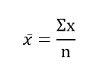

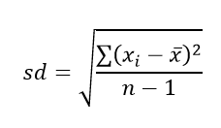
Standard Deviation:

Table 1. Scale for Interpreting Pest-Control Effectiveness
Mean Pest Reduction | Level of Effectiveness | Interpretation
8 – 10 pests | Very Effective | The system shows a high level of pest-control efficacy and is highly effective in repelling rice ear bugs.
6 – 7 pests | Effective | The system shows a moderate to high level of effectiveness in reducing pest presence.
4 – 5 pests | Slightly Effective | The system shows a limited but noticeable effect in pest reduction.
2 – 3 pests | Less Effective | The system has minimal impact on pest control.
0 – 1 pest | Not Effective | The system shows no significant pest-control effect.

RESULTS AND DISCUSSION

Figure 2 illustrates the schematic diagram of the Ultrasonic Shield System, an Arduino based pest repellent system. The system is supplied by a solar panel that charges a rechargeable lithium battery through a TP4056 battery charging module. This power configuration enables autonomous and sustainable operation, ensuring continuous system functionality in outdoor agricultural environments. The regulated battery output provides stable power to the Arduino Uno, ultrasonic transducers, and LCD display. ‎
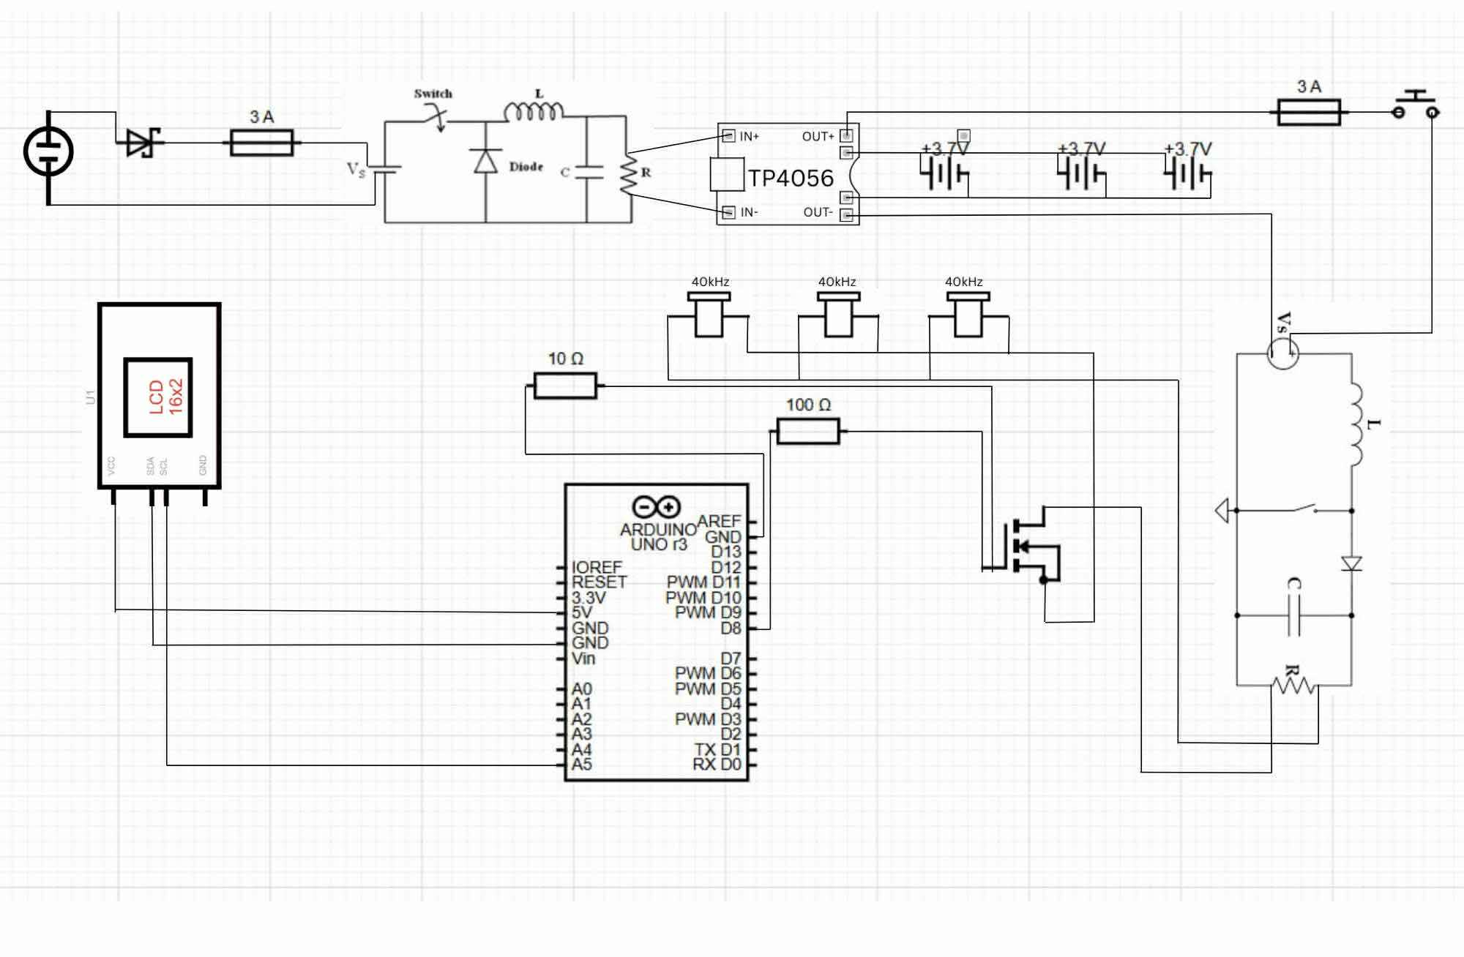

Figure 1. Circuit schematic of the Ultrasonic Shield System
In this simplified setup, the Arduino Uno directly controls the ultrasonic transducers according to the programmed operational sequence. The transducers emit high-frequency ultrasonic waves in controlled burst cycles, consisting of alternating ON and OFF intervals over a predefined period. Burst-based ultrasonic emission has been shown to improve pest deterrence efficiency while minimizing power consumption and reducing thermal stress on electronic components. The LCD display provides real-time updates on system status, including the activation cycles of the ultrasonic transducers. After completing the programmed number of burst cycles, the ultrasonic system is automatically deactivated. This configuration allows for isolated data collection on the performance and efficiency of the ultrasonic deterrence mechanism.

Figure 3 presents the prototype design of the Ultrasonic Shield System. The system is a solar-powered, automated device developed to repel rice ear bugs through the emission of ultrasonic sound waves. Solar energy harvested by the integrated panel charges onboard batteries, allowing the device to function independently of external power sources. A microcontroller manages signals from the ultrasonic transducers and controls the emission of specific ultrasonic frequencies aimed at disturbing and repelling rice ear bugs from the rice crops. This design prioritizes sustainability, self-sufficiency, and low operational cost, making it particularly suitable for agricultural areas, including remote or off-grid rice fields.

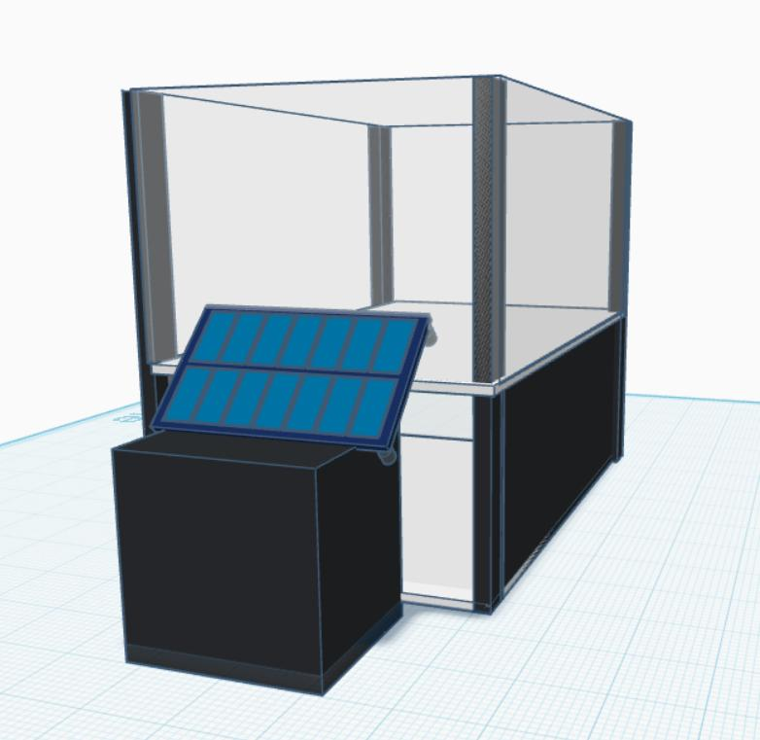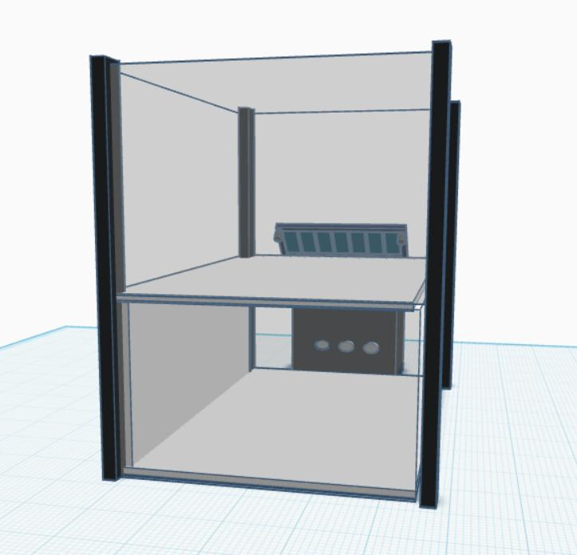

Figure 2. Prototype Design of the Ultrasonic Shield System

The system operates on a 30-minute monitoring cycle to balance effectiveness and energy efficiency. Within this cycle, the ultrasonic emitters are activated for 5 minutes and then 3-minute cooldown phase, pausing emission to prevent excessive power consumption and allow the components to reset. This cycle repeats automatically throughout the 30-minute duration, ensuring periodic monitoring, targeted pest deterrence, and prolonged operational life.

Moreover, the prototype design was developed and evaluated under controlled conditions to assess its functional performance and system reliability prior to field implementation. The enclosed structure serves as a protective housing for the electronic components while allowing proper placement and alignment of the ultrasonic transducers and solar panel for efficient operation. Testing in an isolated setup enabled consistent monitoring of power consumption, signal emission patterns, and timing accuracy of the monitoring cycle. These controlled evaluations are essential for identifying design limitations and optimizing system parameters before future deployment in rice field environments.

Figure 4 presents the system flow of the Ultrasonic Shield System. This flow illustrates how the system operates and how the program written in the Arduino microcontroller functions during actual use. The system starts at the Start point, where the device is powered on. Once power is supplied, the system proceeds to Initialize System, during which the microcontroller activates and prepares all connected components, including the LCD display and the three ultrasonic transducers. System initialization is a critical step in embedded systems, as it configures hardware peripherals, prepares memory, and ensures that all components are synchronized before normal operation begins.

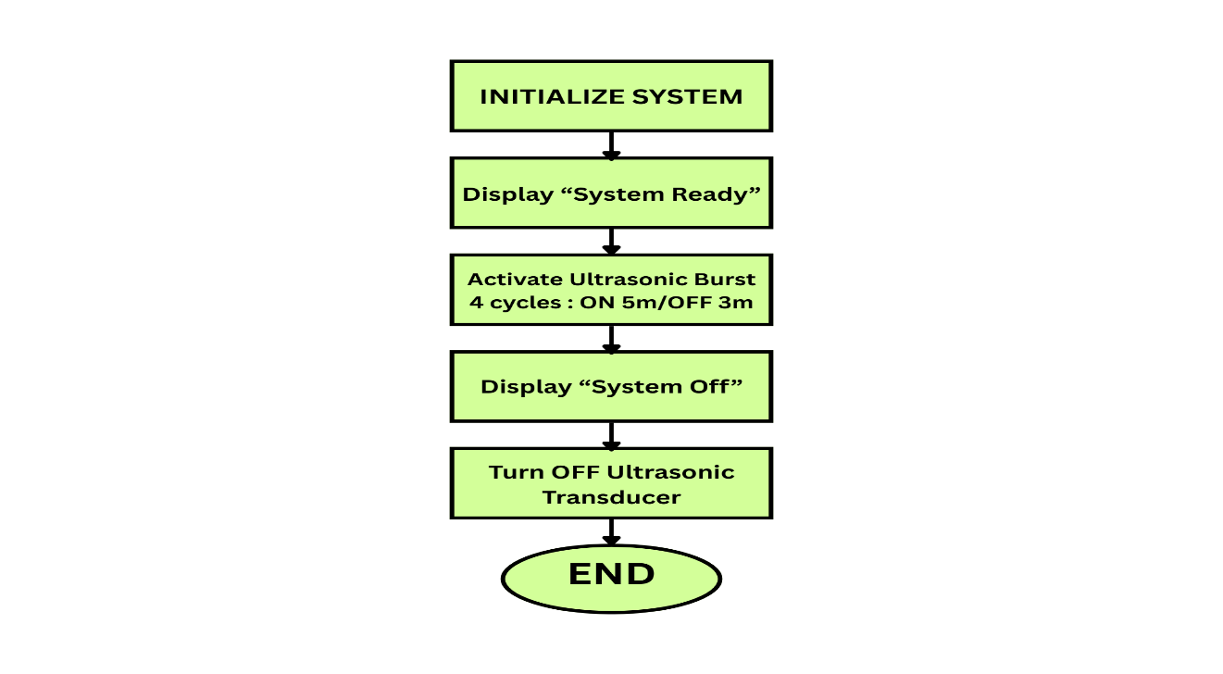
Figure 3. System Flow of the Ultrasonic Shield System

After initialization, the system displays “System Ready” on the LCD, indicating that the device is active and ready to begin operation. The system then activates the ultrasonic repellent mechanism based on a predefined time-controlled sequence. The ultrasonic transducers operate in controlled bursts consisting of four cycles with a five-minute ON and three-minute OFF pattern, as shown in the system flow. Time-based control is commonly used in automated systems to limit continuous operation, reduce power consumption, and prevent excessive stress on electronic components.

Once the ultrasonic burst cycles are completed, the system displays “System Off” and automatically disables the ultrasonic transducers, ending the operation. This automated shutdown mechanism helps conserve energy and prolong the lifespan of the system components. The system then reaches the End state, completing one full operational cycle. Through this simplified, time-based control flow, the Sonic Shield System ensures consistent ultrasonic emission for pest deterrence while maintaining energy efficiency and operational reliability.

Table 2 presents the statistical analysis of the performance of the Sonic Shield System based on the observed pest reduction across three test runs. The analysis focuses on the mean pest reduction and the standard deviation, which determine the system’s overall effectiveness and the consistency of its results.

Table 2. Performance of the Ultrasonic Shield System
Test Run | Pest Count Before | Pest Count After | Reduction | Mean | Standard Deviation | Interpretation
1 | 10 | 5 | 5 | 6.33 | 1.53 | Effective
2 | 10 | 2 | 8 | 6.33 | 1.53 | Effective
3 | 10 | 4 | 6 | 6.33 | 1.53 | Effective

The mean pest reduction was computed by dividing the total reduction across the three test runs by the number of trials. A mean value of 6.33 indicates that, on average, the Sonic Shield System was able to reduce approximately six pests per test run. This demonstrates that the system achieved a measurable reduction in pest population during each activation period.

To assess the stability of the system’s performance, the standard deviation was calculated. The obtained value of 1.53 indicates that the reduction results were relatively close to the mean, showing that the system produced consistent outcomes across the three test runs. A lower standard deviation suggests minimal variation in performance, which implies that the ultrasonic repellent mechanism operated reliably under the same testing conditions.

Overall, the results show that the Sonic Shield System demonstrated a consistent and observable pest reduction effect across all test runs. With a mean reduction of 6.33 pests and a standard deviation of 1.53, the system exhibited stable performance under controlled conditions. These findings suggest that the Sonic Shield System shows a moderate to high level of effectiveness in repelling rice ear bug in a controlled set-up.

From an agricultural perspective, the findings imply that ultrasonic-based pest control may help reduce farmers’ dependence on synthetic pesticides. Although this study no longer includes a control group, the measurable reduction in pest presence demonstrates that the system produces tangible effects under controlled conditions. This is especially important for small-scale farmers who seek safer and more affordable pest management options. By minimizing chemical exposure, the Ultrasonic Shield System supports healthier working conditions for farmers and helps reduce potential contamination of crops and surrounding ecosystems.

Conclusion and Recommendations

The study aimed to determine the effectiveness of the Ultrasonic Shield System in repelling the rice ear bugs. Based on the results of the study, the system found to be moderately effective during the controlled laboratory testing. The ultrasonic frequency caused a visible movements or disturbance to the rice ear bugs during the trials. In the result, the system get an average reduction of 6.33 pests across the three trials, it shows that the system is able to repel the rice ear bugs in controlled conditions.

The result of the study suggest that the Ultrasonic Shield System has potential as eco-friendly and non-chemical pest control option for rice farming. The system may help to reduce the use of pesticides of the farmers, which can be very harmful to the environment and the human health. Although the study is only limited to controlled setup, the findings still provides good basis for future researcher. Further studies are recommended to improve the system design and to test the system in actual rice fields to know its effectiveness and to support pest management practices.

REFERENCES

Agah‑Manesh, H., Rajabpour, A., Yarahmadi, F., & Farsi, A. (2021). Potential of ultrasound to control Sesamia cretica (Lepidoptera: Noctuidae). Environmental Entomology, 50(6), 1393–1399. https://doi.org/10.1093/ee/nvab103
Ahmad, M. F., Ahmad, F. A., Alsayegh, A. A., Zeyaullah, M., AlShahrani, A. M., Muzammil, K., Saati, A. A., Wahab, S., Elbendary, E. Y., Kambal, N., Abdelrahman, M. H., & Hussain, S. (2024). Pesticides impacts on human health and the environment with their mechanisms of action and possible countermeasures. Heliyon, 10, e29128. https://doi.org/10.1016/j.heliyon.2024.e29128
Ali, M. A., Dhanaraj, R. K., & Kadry, S. (2024). AI-enabled IoT-based pest prevention and controlling system using sound analytics in large agricultural field. Computers and Electronics in Agriculture, 220, 108844. https://doi.org/10.1016/j.compag.2024.108844
Ammar, R., Khalil, D. H., Kandil, R., & Atwa, A. (2024). Disrupting Spodoptera frugiperda (Smith): Ultrasonic waves as a novel pest control strategy. Journal of Biopesticides, 17(1), 65–71. https://doi.org/10.57182/jbiopestic.17.1.65-71
Awal, M. A., Zune, I. J., & Partha, P. K. P. (2025). Repelling of stored pest (rice weevil) through near‑far ultrasound. Smart Agricultural Technology, 11(1), 100961. https://doi.org/10.1016/j.atech.2025.100961
Balingbing, C., Kirchner, S., Siebald, H., Van Hung, N., & Hensel, O. (2024). Determining the sound signatures of insect pests in stored rice grain using an inexpensive acoustic system. Food Security, 16, 1529-1538 https://doi.org/10.1007/s12571-024-01493-6
Chamara, N., Islam, M. D., Bai, G. F., Shi, Y., & Ge, Y. (2022). Ag-IoT for crop and environment monitoring: Past, present, and future. Agricultural Systems, 203, 103497. https://doi.org/10.1016/j.agsy.2022.103497
DocMcKee. (2020). One-shot case study: Definition and explanation. DocMcKee Research Methods. https://docmckee.com/cj/docs-research-glossary/one-shot-case-study-definition/
Nakano, R., Ito, A., & Tokumaru, S. (2022). Sustainable pest control inspired by prey–predator ultrasound interactions. Proceedings of the National Academy of Sciences, 119(43), e2211007119. https://doi.org/10.1073/pnas.2211007119
Nurmalasari, R., Puspitasari, P., Marsono, & Suyetno, A. (2023). Development of a smart pest repellent machine using solar power and ultrasonic sensors for agricultural productivity. In Proceedings of the 2nd International Conference on Renewable Energy (I-CoRE 2021). AIP Publishing. https://doi.org/10.1063/5.0121141
Panthawong, A., Doggett, S. L., & Chareonviriyaphap, T. (2021). The efficacy of ultrasonic pest repellent devices against the Australian paralysis tick, Ixodes holocyclus (Acari: Ixodidae). Insects, 12(5), 400. https://doi.org/10.3390/insects12050400
Poudel, J., Neupane, B., & Poudel, S. (2025). Efficacy of different chemical and botanical pesticides against rice ear head bug (Leptocorisa acuta Thunberg, Hemiptera: Alydidae) in rice Superzone, Nepal. Turkish Journal of Food and Agriculture Sciences, 7(1), 44–55. https://doi.org/10.53663/turjfas.1586952
Puryono, H., & Pangestu, Y. (2023). Design and implementation of an ESP32-based ultrasonic pest repellent system for rice fields. International Journal of Agricultural Technology, 19(6), 1021–1034. https://doi.org/10.52436/1.jutif.2025.6.4.5198
Rahman, S. M., & Ravi, G. (2022). Role of artificial intelligence in pest management. In Current topics in agricultural sciences (Vol. 7, pp. 65–81). B P International. https://doi.org/10.9734/bpi/ctas/v7/2141B
Ramadhan, G. T., Sutopo, W., & Hisjam, M. (2022). A sustainable location-allocation model for solar-powered pest control to increase rice productivity. Applied System Innovation, 5(2), 39. https://doi.org/10.3390/asi5020039
Sedlock, J. L., Almazan, M. L. P., Hadi, B. A. R., Gomes, D. G. E., & Barber, J. R. (2025). Dispersing rice-associated arthropods ignore a phantom ultrasonic insect chorus. The Open Agriculture Journal, 19, e18743315389873. https://doi.org/10.2174/0118743315389873250624220003
Shah, F. M., & Razaq, M. (2021). From agriculture to sustainable agriculture: Prospects for improving pest management in Industrial Revolution 4.0. In Handbook of smart materials, technologies, and devices (pp. 1–18). Springer. https://doi.org/10.1007/978-3-030-58675-1_76-1
Yanagisawa, R., Tatsuta, H., Sekine, T., Oe, T., Mukai, H., Uechi, N., Koike, T., Onodera, R., Suwa, R., & Takanashi, T. (2024). Vibrations as a new tool for pest management – A review. Entomologia Experimentalis et Applicata, 172(12), 1116–1127. https://doi.org/10.1111/eea.13458

APPENDICES

Appendix A. Computation

Test Run | Pest Count Before | Pest Count After | Reduction | Mean | Standard Deviation | Interpretation
1 | 10 | 5 | 5 | 6.33 | 1.53 | Effective
2 | 10 | 2 | 8 | 6.33 | 1.53 | Effective
3 | 10 | 4 | 6 | 6.33 | 1.53 | Effective

Computation Guide:

Reduction = Pest Count Before – Pest Count After
Mean =
Standard Deviation =

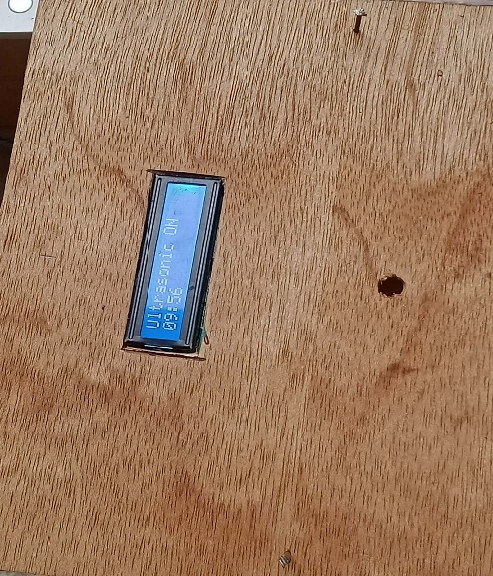
Appendix B. Design/Features of the System
