Isolation and Identification of Microbial Flora From Fresh Vegetable (Brinjal and Tomato) and fruit(Apple and Mango) samples

Abstract
Fresh fruits and vegetables are a significant part of the human diet worldwide. However, since they are characteristically consumed raw in many parts of the world and often without suitable thermal treatment or rigorous washing, they are prone to serve as vectors for the transmission of pathogenic microorganisms which are often associated with severe human diseases , affecting majority of population .The current study aimed at isolating and identifying the microbial flora found in fresh fruits (Mango and Apple) and vegetable (Tomato and Brinjal)samples sold in the local open markets of Bilaspur city, Chhattisgarh. The samples were collected under strict aseptic conditions from different retail vendors. Specific selective and non-selective culture media, including Nutrient Agar, Potato Dextrose Agar, MacConkey Agar, and Eosin Methylene Blue Agar, were used to isolate and enumerate the microbial load. All the isolated species were further identified on the basis of their morphological characteristics, selective differential culture media, and biochemical tests (IMViC). The findings specified that the fresh produce was severely contaminated with numerous bacterial and fungal strains. This high microbial load suggested unhygienic handling practices and environmental contamination in the local markets. These findings highlight a serious public health concern for the people of the Bilaspur region and emphasize the need to create an extensive awareness regarding proper hygienic practices during the harvesting, distribution, selling, and consumption of fresh produce.
Keywords: Microbial flora, Pathogenic bacteria, Fruits, Vegetables, Bilaspur.

Introduction
Fresh fruits and vegetables are globally recognized as critical components of a balanced human diet. It is prerequisite to include them in the diet as they are an excellent source essential nutrients which are required to maintain a healthy lifestyle. Fruits and vegetables are consumed in huge amounts worldwide They deliver a rich source of vital vitamins, dietary minerals, fibres, and antioxidants, which are highly advantageous for the maintenance of finest health and the deterrence of chronic diseases, (Slavin, J. L., & Lloyd, B. ,2012). However, in recent times, the rising consumption of raw and minimally processed produce has been directly linked to an amplified occurrence of foodborne human infections. Fresh fruits and vegetables if not washed properly can harbour a great number of germs that can further become the cause many fatal diseases, (Hedberg C.W. etal. 1994). Because commodities like apples, mangoes, carrots, radish, and tomatoes etc. are frequently consumed raw without any heat treatment as a consequence microbial contamination present on their surfaces can directly lead to the gastrointestinal diseases, (Schuenzel, K. M., & Harrison, M. A. ,2002).
The microbial profile of fresh produce is highly variable and depends on a multitude of environmental and human factors. Cultivation in open fields directly exposes the yields to a varied range of microorganisms instigating from soil microflora, the application of raw animal manure as fertilizer, and the use of untreated irrigation water can also lead to increased enhancements (Beuchat, L. R.,2002). Furthermore, post-harvest handling drastically increases the microbial load. During harvesting, transportation and demonstration of such produce in open markets, often exposes them to airborne spores, dust, and insensible handling by agricultural workers and retail vendors further deteriorates the condition, (Nguyen-the, C., & Carlin, F.,1994). The physical characteristics of the produce also play a crucial role; for instance, the delicate skin of tomatoes and apples is prone to microscopic abrasions, while the rough calyx of brinjals easily traps dirt and moisture, providing an ideal microenvironment for pathogenic survival (Kumar, S., Singh, R., & Maurya, V. K. ,2019).
In developing regions, the deficiency of strict microbiological investigations and insufficient sanitary practices in local markets further complicates the risk of contamination, (Eni, A. O.,etal., 2010). Open-air markets often lack proper cold-chain infrastructure, creating a highly favourable environment for the speedy multiplication of both spoilage and pathogenic microorganisms on the surface of the produce, (Garg, N., Churey, J., & Splittstoesser, D. F.,1990). Consequently, raw vegetables and fruits host a variety of pathogenic bacteria and fungi that may spread over the plant exterior or form micro-colonies within

the plant tissues, (Nipa, M. N., et al. ,2011). Despite the high consumption rate of fresh produce in the rapidly growing urban districts like Bilaspur, Chhattisgarh, most foodborne outbreaks remain undetected due to limited localized research, (Amoah, P., et al. ,2006).
A major conducive factor to the perseverance of these pathogens is the high moisture content and nutrient-rich content of these crops, which act as an excellent growth medium for microbes, (Singh, A., & Singh, B.,2021). Identifying the specific initial microbial population and its species composition is highly valuable for determining appropriate sanitizing practices and protecting human health (Fan, L., & Song, J. , 2008). Therefore, this present study was undertaken to assess the microbiological safety of highly consumed local produce. Specifically, the objective is to isolate and identify the microbial flora from fresh fruits (Mango and Apple) and vegetables (Tomato and Brinjal) sourced from the open markets of Bilaspur, Chhattisgarh (Boeing, H., et al. 2012).

Materials and Methods

Sample Collection
A total of four distinct types of fresh produce, comprising two fruits—Mango (Mangifera indica) and Apple (Malus domestica)—and two vegetables— Tomato (Solanum lycopersicum) and Brinjal (Solanum melongena)—were collected from the major open markets of Bilaspur city, Chhattisgarh. To avert any external cross-contamination during transport, all samples were carefully collected in sterile, polythene bags. The collected samples were immediately placed in an insulated icebox to maintain a low-temperature environment ranging from 4°C to 6°C and were transported to the Microbiology Laboratory for analysis within one hour of collection (Viswanathan, P., & Kaur, R. 2001).

Preparation of Samples
Within an hour of reaching the laboratory, the samples were individually processed. Each fruit and vegetable sample were methodically rinsed with 100 ml of sterile distilled water to extract the surface microflora. Following this, a 5
-fold serial dilution was performed. To supplement the bacterial population, 10 ml of the washed aqueous suspension from each sample was inoculated into 90 ml of Luria Bertani (LB) broth. These inoculated broth cultures were then incubated for 24 hours at 37°C. This overnight enriched culture in LB broth aided primary source for the succeeding isolation and identification of microbial strains using the streak plate technique Kuroya, M., Ouchi, N., & Katsuno, M. (1952).

Isolation and Identification of Microorganisms
The microorganisms were isolated and enumerated by growing them on specific selective and non-selective culture media. Nutrient Agar (NA) was utilized to determine the Total Viable Bacterial Count (TVBC), while Potato Dextrose Agar (PDA) was employed specifically for the isolation and enumeration of fungal species. For the detection of specific enteric bacteria, MacConkey Agar was used to isolate total coliforms, and Eosin Methylene Blue (EMB) agar was used for the selective isolation of Escherichia coli (Pandey AR, &Ankita B 2024).
One loopful of the overnight LB broth culture (and aqueous suspension for fungi) was streaked over these respective media plates. The NA, MacConkey, and EMB plates were incubated at 37°C for 24-48 hours, whereas PDA plates were incubated at 25°C for 3-5 days. Following incubation, distinct colonies were examined for their cultural and morphological characteristics. For definitive confirmation of the isolated bacterial species, standard biochemical assessments, specifically the IMViC (Indole, Methyl Red, Voges-Proskauer, and Citrate) tests, were performed for every distinct bacterial isolate( Powers, E. M., & Latt, T. G. 1977).
Table 1. Showing total bacterial count in cfu/ml found in fresh vegetable(brinjal) on different culture media .

Name of Sample and Media | No. of Colonies(cfu/ml)
Name of Sample and Media | 10-1 | 10-2 | 10-3 | 10-4 | 10-5
Brinjal in PDA | + | + | + | + | +
Brinjal in NAM | 300 | 245 | 180 | 180 | 100
Brinjal in EMB | 400 | 325 | 170 | 170 | 150
Brinjal in Macckonkey | 400 | 350 | 195 | 190 | 190

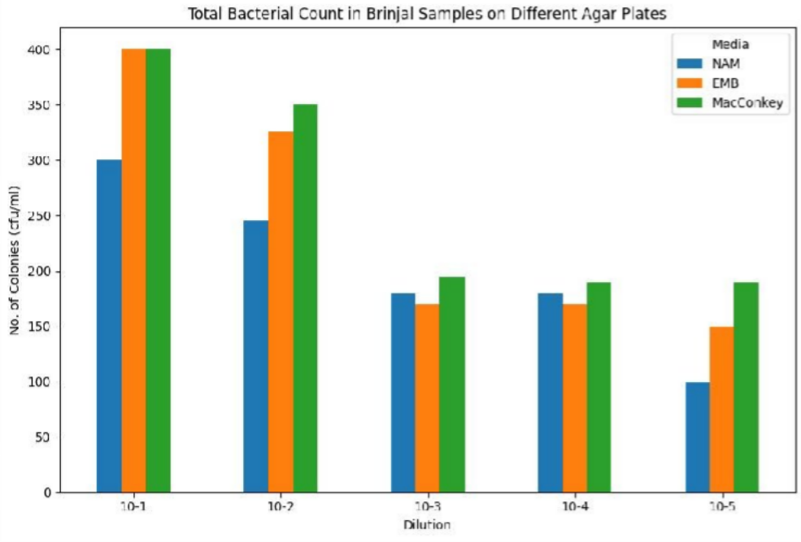
Table 2. Showing total bacterial count in cfu/ml found in fresh vegetable (Tomato) on different culture media.

Name of Sample and Media | No. of Colonies(cfu/ml)
Name of Sample and Media | 10-1 | 10-2 | 10-3 | 10-4 | 10-5
Tomato in PDA | + | + | + | + | +
Tomato in NAM | 500 | 450 | 400 | 350 | 300
Tomato in EMB | 440 | 350 | 350 | 230 | 220
Tomato in Macckonkey | 550 | 455 | 400 | 350 | 300

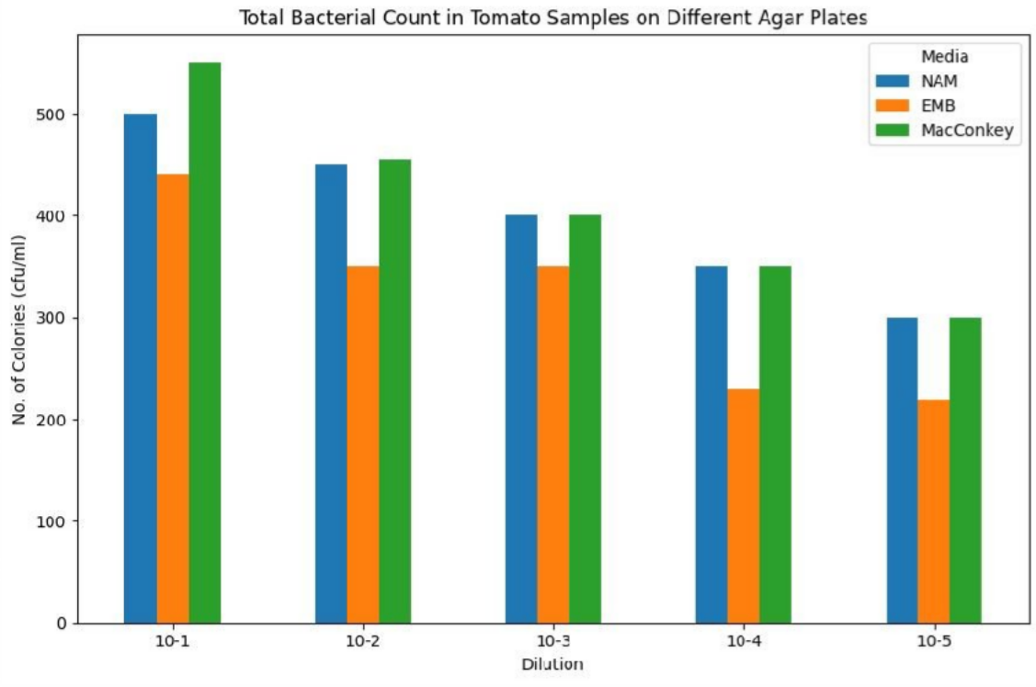

Table 3. Showing total bacterial count in cfu/ml found in fresh fruit(apple) on different culture media.

Name of Sample and Media | No. of Colonies(cfu/ml)
Name of Sample and Media | 10-1 | 10-2 | 10-3 | 10-4 | 10-5
Apple in PDA | + | + | + | + | +
Apple in NAM | 400 | 400 | 355 | 325 | 200
Apple in EMB | 360 | 300 | 250 | 250 | 180
Apple in Macckonkey | 430 | 315 | 230 | 200 | 170

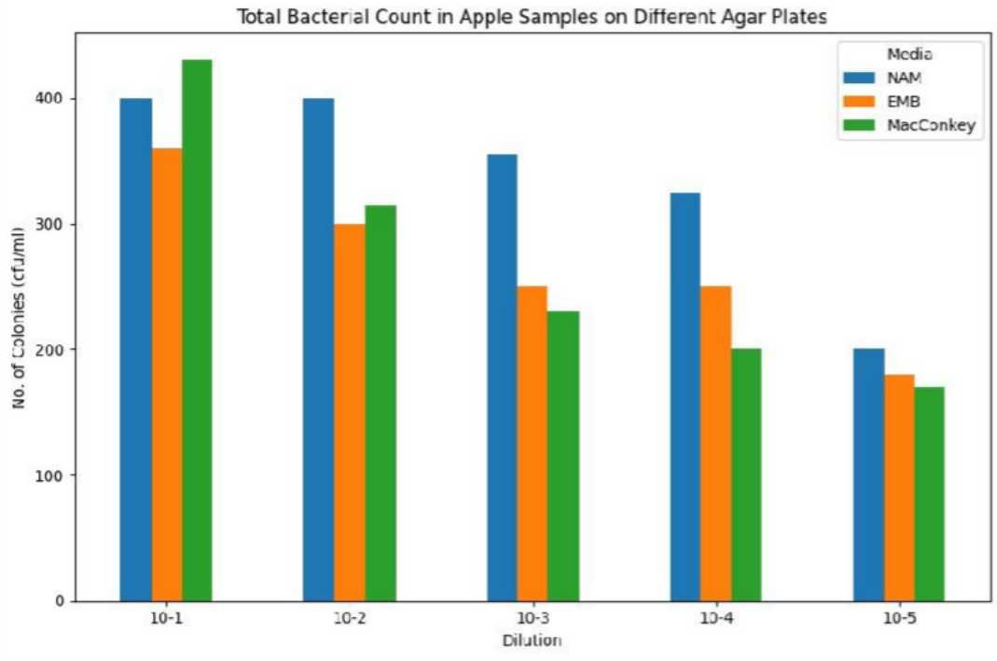

Table 4. Showing total bacterial count in cfu/ml found in fresh fruit(mango) on different culture media.

Name of Sample and Media | No. of Colonies(cfu/ml)
Name of Sample and Media | 10-1 | 10-2 | 10-3 | 10-4 | 10-5
Mango in PDA | + | + | + | + | +
Mango in NAM | 420 | 335 | 230 | 200 | 180
Mango in EMB | 550 | 430 | 340 | 300 | 200
Mango in Macckonkey | 450 | 415 | 360 | 315 | 280

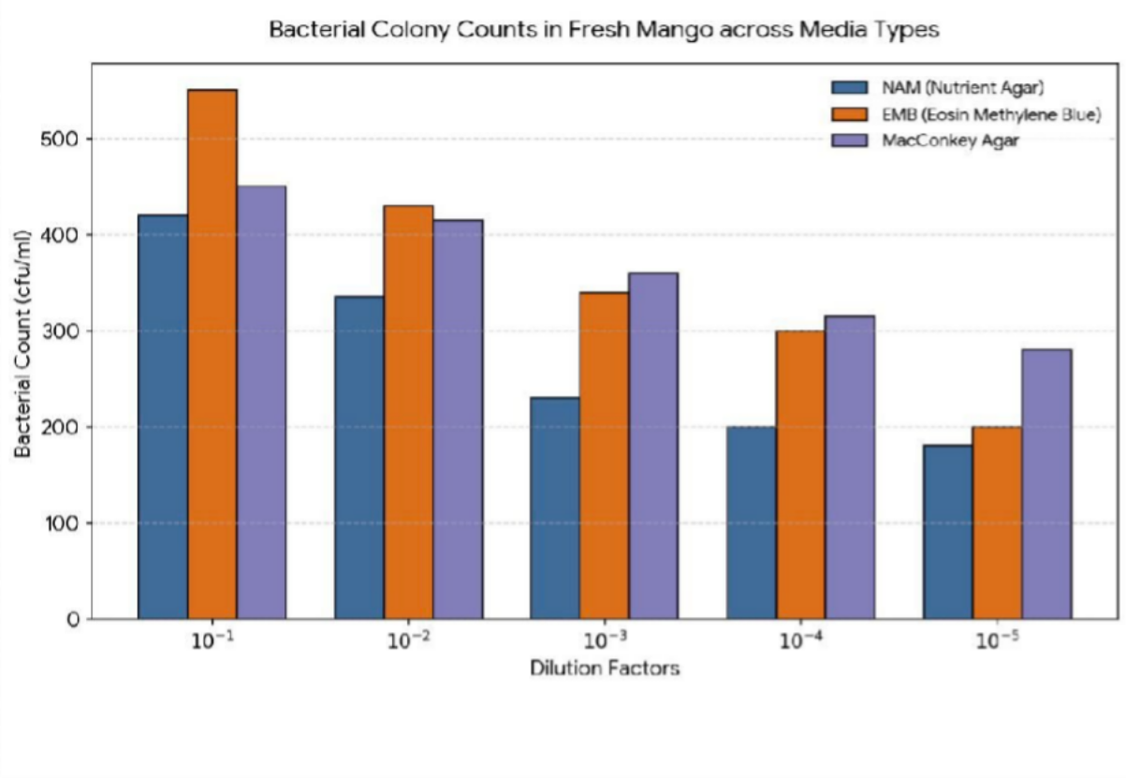

Result and Discussion:

Total Viable Count
In this study, all sampled fruits and vegetables collected from the local markets of Bilaspur were found to be contaminated. The microbial load varied significantly depending on the type of produce.
- The total viable count(cfu/ml) for brinjal on Nutrient Agar, EMB and Macconkey are shown in Table no.1
- The total viable count(cfu/ml) for tomato on Nutrient Agar, EMB and Macconkey are shown in Table no.2
- The total viable count(cfu/ml) for apple on Nutrient Agar, EMB and Macconkey are shown in Table no.3
- The total viable count(cfu/ml) for mango on Nutrient Agar, EMB and Macconkey are shown in Table no.4
Furthermore, significant fungal growth was observed on Potato Dextrose Agar for all samples. The fresh fruits and vegetables were heavily contaminated with coliforms, indicating severe unhygienic exposure.
Fig1. Showing colonies on PDA plates of vegetable and fruit samples.

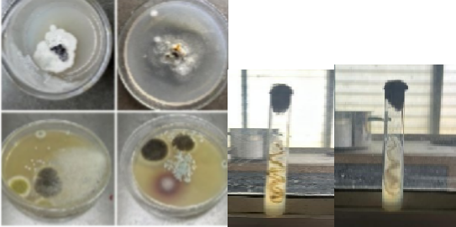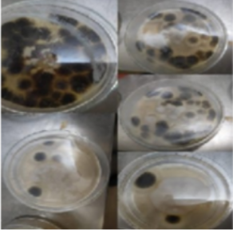
(Brinjal and Tomato) (Apple and Mango)
Fig2. Showing colonies on Nutrient agar plate of vegetable and fruit samples
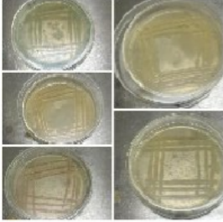
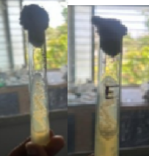
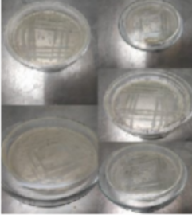
(Brinjal and Tomato) (Apple and Mango)
Fig3.Showing colonies on EMB agar plate of vegetable and fruit samples.
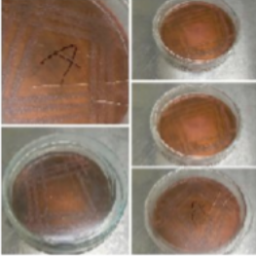
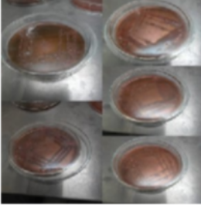
(Brinjal and Tomato) (Apple and Mango)
Fig4. Showing colonies on Macconkey agar plate of vegetable and fruit samples.
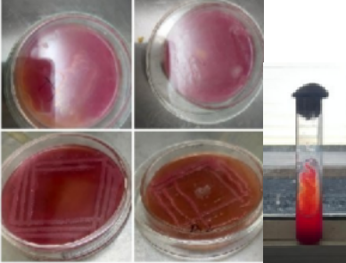

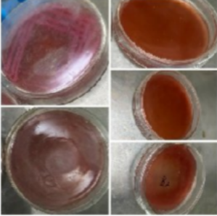
(Brinjal and Tomato) (Apple and Mango)

Distinct microbial colonies were isolated from the samples and identified based on their cultural, morphological, and biochemical characteristics. On the specific selective media, E. coli produced colonies with a distinct metallic sheen on EMB agar. MacConkey agar yielded pink, mucoid colonies characteristic of Klebsiella spp. and Enterobacter spp., confirming coliform contamination. PDA plates supported the growth of prominent fungal flora, morphologically identified as Aspergillus spp. and Saccharomyces spp.

Table 5: Biochemical characterization (IMViC) of isolated bacterial strains

Isolate No. | Isolated strain | Indole test | Methyl red test | Voges-Proskauer test | Citrate test
01 | B1(Brinjal sample in NAM) | +ve | +ve | -ve | -ve
02 | B2 (Brinjal sample in EMB) | -ve | -ve | +ve | +ve
03 | B3(Brinjal sample in Macconkey) | -ve | -ve | +ve | +ve
(Note: Fungal isolates from PDA were identified morphologically and thus are not included in the bacterial biochemical test table).
Table 6: Biochemical characterization (IMViC) of isolated bacterial strains

Isolate No. | Isolated strain | Indole test | Methyl red test | Voges-Proskauer test | Citrate test
01 | T1(Tomato sample in NAM) | -ve | +ve | +ve | -ve
02 | T2 (Tomato sample in EMB) | -ve | -ve | +ve | +ve
03 | T3(Tomato sample in Macconkey) | -ve | +ve | +ve | +ve

Discussion
During cultivation in fields, harvesting, post-harvest handling, and distribution, vegetables and fruits are highly prone to infection by pathogenic microorganisms (Chai, L. C., et al. 2007). The presence of diverse bacterial and fungal types in the fruit and vegetable samples evaluated in this study is a direct reflection of the prevailing sanitary conditions in the retail outlets of Bilaspur. This result highlights the critical fact that fresh, raw produce can act as a direct transmission vehicle for many foodborne diseases (Tunung, R., et al. 2010).
The prevalence of high microbial counts in daily consumed items like tomatoes and mangoes clearly indicates the unhygienic state of the open markets. The detection of coliforms such as E. coli and Klebsiella spp. on EMB and MacConkey agar is of particular concern, as these are primary indicators of fecal contamination and poor sanitation. Furthermore, the isolation of fungal species on PDA signifies potential post-harvest spoilage risks. It is evident that samples from these local wet markets yielded a higher proportion of microbes because the vegetables and fruits are openly displayed, allowing dust and airborne contaminants to settle on them. The handlers rarely use protective gloves, and the produce is often sprinkled with untreated water to maintain a fresh appearance, which exacerbates microbial accumulation (Olayemi, A. J. 1997).

Conclusion

This study demonstrated an alarming presence of microbial flora, including coliforms and spoilage fungi, among the most popular fresh fruits (Mango, Apple) and vegetables (Tomato, Brinjal) sold in Bilaspur, Chhattisgarh. The results serve as a clear indicator of the compromised hygiene conditions in the local selling and buying zones. Identifying these microbial strains provides a necessary baseline overview of the microbiological quality of fresh produce in this region. The findings strongly suggest that immediate steps must be taken to create public awareness and enforce better hygienic practices among vendors and consumers to prevent potential outbreaks of foodborne pathogens and reduce post-harvest spoilage.

References
- Amoah, P., et al. (2006). Pathogen contamination of vegetables in urban markets. Archives of Environmental Contamination, 50(1), 1-6.
- Beuchat, L. R. (2002). Ecological factors influencing survival of human pathogens on raw fruits. Microbes and Infection, 4(4), 413-423.
- Boeing, H., et al. (2012). Vegetables and fruit in the prevention of chronic diseases. European Journal of Nutrition, 51(6), 637-663.
- Chai, L. C., et al. (2007). Thermophilic Campylobacter spp. in salad vegetables in Malaysia. International Journal of Food Microbiology, 117(1), 106-111.
- Eni, A. O., Oluwawemitan, I. A., & Solomon, O. U. (2010). Microbial quality of fruits and vegetables sold in Nigeria. African Journal of Food Science, 4(5), 291-296.
- Fan, L., & Song, J. (2008). Microbial quality assessment methods for fresh-cut fruits. Stewart Postharvest Review, 4(3), 1-9.
- Garg, N., Churey, J., & Splittstoesser, D. F. (1990). Effect of processing conditions on the microflora of fresh vegetables. Journal of Food Protection, 53(8), 701-703.
- Hedberg, C. W., MacDonald, K. L., & Osterholm, M. T. (1994). Changing epidemiology of food-borne disease. Clinical Infectious Diseases, 18(5), 671-680.
- Kumar, S., Singh, R., & Maurya, V. K. (2019). Post-harvest microbial pathogens in fresh tomatoes. Journal of Applied Microbiology, 5(2), 45-52.

- Kuroya, M., Ouchi, N., & Katsuno, M. (1952). Classification of antibiotic actinomyces by streak plate method. Tohoku Journal of Experimental Medicine, 55(2), 203-207.
- Leff, J. W., & Fierer, N. (2013). Bacterial communities associated with the surfaces of fresh fruits and vegetables. PLoS One, 8(3), e59310.
- Nguyen-the, C., & Carlin, F. (1994). Microbiology of minimally processed fresh fruits and vegetables. Critical Reviews in Food Science, 34(4), 371-401.
- Nipa, M. N., et al. (2011). Prevalence of multi-drug resistant bacteria on raw salad vegetables. Middle-East Journal of Scientific Research, 10(1), 70-77.
- Olayemi, A. J. (1997). Microbiological hazards associated with agricultural utilization of urban polluted river water. International Journal of Environmental Health, 7(2), 149-154.
- Pandey AR, Ankita B. (2024). A Comparative Investigation on the Assessment of Microbial Count Present in Commercially Packed Fruit Juices and Fresh Street Fruit Juices Available in Bilaspur City. Indian Journal of Nutrition, 11(2): 300-304.
- Powers, E. M., & Latt, T. G. (1977). Simplified 48-hour IMViC test: an agar plate method. Applied and Environmental Microbiology, 34(3), 274-279.
- Schuenzel, K. M., & Harrison, M. A. (2002). Microbial antagonists of foodborne pathogens on minimally processed vegetables. Journal of Food Protection, 65(12), 1909-1915.
- Singh, A., & Singh, B. (2021). Microbial ecology of the calyx and surface flora of brinjal. Horticultural Microbiology Reports, 7(1), 33-41.
- Slavin, J. L., & Lloyd, B. (2012). Health benefits of fruits and vegetables. Advances in Nutrition, 3(4), 506-516.
- Tunung, R., et al. (2010). Prevalence of pathogenic bacteria in raw salad vegetables at retail level. Food Control, 20(2), 391-396.
- Viswanathan, P., & Kaur, R. (2001). Prevalence and growth of pathogens on salad vegetables and fruits. International Journal of Hygiene, 203(3), 205-213.

