Analysing user interaction with AI Chatbots in Academic Libraries

Abstract
The recent pace of change in the digitization of Information Services in Academic Libraries has been enforced by the introduction of some Artificial Intelligence (AI) technologies which rely on the use of intelligent chatbot systems for delivering automated reference information, information retrieval and virtual user assistance services. The present study was peer-reviewed, and its research problem focused on understanding how the users interact with the AI chatbots in academic libraries and discovering how problematic, emotional, or technological issues can affect levels of user satisfaction, trust, participation, and efficiency with respect to the use of AI chatbots. The research methodology used in this research was quantitative, and the data collected were structured questionnaires, chatbot verbatim log and behavioural data from the system of students, postgraduate students, research scholars, faculty members, and regular users of the academic library. The proposed model is innovative with the incorporation of new indices in order to assess the interaction effectiveness between the user and the chatbot in a multidimensional fashion, such as Dynamic Conversational Trust Index (DCTI), Conversational Efficiency Ratio (CER), Sentiment Interaction Score (SIS) and Integrated User Interaction Index (IUII). Each of the findings from the statistics showed significant positive relationships between chatbot response, perceived accuracy, trust, conversational quality, and satisfaction. User Trust (UT) had the highest positive correlation with User Satisfaction (r = 0.84, p < 0.001), and regression analysis showed that the DCTI has a significantly effect on user satisfaction ((\beta = 0.42, p < 0.001). Moreover, a high classification accuracy of 91.4%, precision of 0.89, recall of 0.92, F1-score of 0.90, and a ROC-AUC score of 0.93 were obtained from the Random Forest Classification model. Based on the findings, AI chatbot systems have a significant positive impact on academic library services, particularly in accessing library resources, speeding up response time, delivering digital reference, and fostering increased engagement in modern learning contexts.

Keywords: Artificial Intelligence, Academic Libraries, AI Chatbot, User Interaction, User Satisfaction, Machine Learning, Conversational Trust, Digital Libraries, Human-Computer Interaction, Random Forest Classification.
- Introduction
Over the last few years, there has been a drastic shift to the use of information services thanks to the recent developments in Artificial Intelligence (AI) technologies worldwide. AI-enabled chatbots are one of the significant innovations adopted in academic libraries, which has led to significant improvements in library services, information access, and user engagement (Ali et al., 2020; Cox et al., 2018). AI Chatbots are computer programs that use natural language processing (NLP), machine learning, and automated responses to simulate human dialogue (Chowdhury, 2003). They facilitate a more accessible and efficient way for users to search library databases, catalogs, and support services that allows users to converse with the system and find answers. AI chatbots are now being widely adopted in academic libraries as tools to offer instant support, tailored recommendations, and reference services 24-hours a day, facilitating users' library experience (Arlitsch & Newell, 2017).

Student and researchers need user convenience, easy access to academic resources and speed in the modern education. The conventional support services in a library can be experienced difficulties, such as short working hours, salary shortage among the library staff members, and growing information needs. AI chatbots are better suited to overcome these limitations, providing a continuous virtual presence to offer answers to common questions, to help navigate the database, to help with citations, and to offering support to remote learners (Hervieux & Wheatley, 2021). In the context of digital learning, especially online and hybrid formats, the adoption of AI-powered chatbots took a new step of importance following these changes. This has led academic libraries to innovatively leverage AI in order to enhance user satisfaction, operational efficiencies, and resource usage (Luckin, 2017).

User interaction with AI chatbots in academic libraries is essential for comprehending the impact of these tools, thus making it pivotal for analysis. After all, user interaction analysis means identifying user satisfaction, usefulness, ease of use, accuracy in answering the questions, trusting the user in the AI system, etc., of the students, faculty members and researchers who interact with the chatbot (Hassenzahl & Tractinsky, 2006). The anthropomorphic of the RBD has been demonstrated to have a significant impact on the perception and trust of the users, together with conversational styles and human-like communication cues (Araujo, 2018; Go & Sundar, 2019). Likewise, research on HCI identifies that a conversational interface that resembles a human will improve user engagement and resilience of trust (De Visser et al., 2016). These interactional dimensions are of special significance in an academic library setting where users are often demanding certain types of information services that are reliable and supportive.

Another important aspect of the library AI chatbot systems' audit is user experience. According to Hassenzahl (2013), user experience has emotional, cognitive and functional components in technology interaction. The outcomes of these user experiences can have a positive effect on the effectiveness and acceptance of the AI system, but less so if it is a negative experience. In addition to the above, even the design of a chatbot like the font style and appearance of the Chatbot interface can influence humanizing and usability perceptions (Candello et al., 2017). Furthermore, theory of co-experience and co-creation of value by users increases the level of service development, and facilitates sharing of knowledge and the creation of knowledge in collaboration (Battarbee, 2003; Grönroos & Voima, 2013).

Although AI Chatbots are becoming part of the landscape in academic libraries, there are a number of challenges. The limitations in chatbot understanding, misleading answers, absence of emotional intelligence, and struggles with in-depth research questions can be encountered by users. Perceived risk, privacy, trust issues, as well as technological issues still affect user acceptance of AI technologies (Featherman & Pavlou, 2003; Lopez-Nicolas & Molina-Castillo, 2008). Adopting new technology or new online services has been found to be a factor with uncertainty and risk impacting on users' behaviour with digital systems in previous studies (Cox & Rich, 1964; Forsythe & Shi, 2003). Likewise, when users have a feeling of a lack in human judgment or emotional understanding in automated systems, resistance towards AI technologies may occur (Longoni et al., 2019). Thus, in order to assess the possibilities and potentials of AI chatbots in academic library environments, a thorough investigation of user engagement with AI chatbots is required.

This research seeks to provide detailed analysis of user interactions with AI chatbots in academic libraries, including an investigation of user behavior, satisfaction, engagement levels, user trust, and the efficiency of services provided by AI chatbots in academic libraries. The study will help clarify the potential impact of AI technologies on enhancing digital libraries' user experience and encouraging academic learning and study. The results could also help to inform the creation of more effective and intelligent AI chatbots in future library services, which will be more user-friendly (Ali et al., 2020; Cox et al., 2018).

- Literature review
Earlier research with AI chat-bots, conversation agents and intelligent systems in academic environment and service-based environments has also found a number of significant statistics regarding user interaction, trust, satisfaction and usability and technology adoption. The results of this study are of significance to the present research on analysing interaction of users with AI chatbots in academic libraries both conceptually and empirically.

Based on the results of a survey by Ali et al. (2020), about 72% of the university librarians felt AI technologies will have significant contribution and effect on the services and operational efficiency of the libraries. The majority of 64% of librarians reported having positive attitudes toward integrating AI tools for user assistance and information retrieval. Yet, almost 48% noted difficulties with technical issues and professional training for the implementation of AI. The results of this study show that there is a growing institutional cadre to support AI, but preparedness and usability issues have yet to be addressed.

Cox et al. (2018) statistically voiced the expectation of over 70% of academic library professionals for AI systems to change three areas, information access, digital reference services, and cataloguing within the next ten years. Their report also identified certain benefits cited as very high as a result of their AI use, including customized details services and automation. But respondents also highlighted ethical issues, lack of data privacy, and the want for diminished human interaction as key challenges for successful implementation.
Hervieux and Wheatley (2021) conducted a survey of academic librarians in Canada and the United States to gauge their attitudes toward artificial intelligence in libraries and how they expected it to affect various components of their roles. They discovered that 68 percent of respondents were optimistic about applying AI for library uses, and 57 percent of respondents were concerned about the impact on user privacy and ethics. Their research also showed that very few libraries had actively taken part in AI technologies, indicating that there is a disconnect between positive perceptions and active adoption of the technologies.

Studies of human-robotic interactions with conversational agents have yielded statistically significant insights into significance of anthropomorphic and human‐like features of chattbots. From this result, Araujo (2018) concluded that the anthropomorphic composition of design cues plays a significant role in the aspects of friendliness, usability of trust and credibility of the organization towards human users’ level (p < 0.05). Consumers who engaged with human-like chatbots habits saw greater levels of engagement and satisfaction with their communication with the bot than those who did not engage with human-like chatbots. Likewise, Go and Sundar (2019) found that there was a positive correlation between visual identity cues, conversational tone, humanized communication with perceptions of social presence and humanized communication with perceptions of chatbot humanness (β = 0.47, p < 0.01). The results indicate that chatbot design and communication style have a significant impact on user experience and acceptance.

Work by De Visser et al. (2016) showed that with a failure or uncertain situations, there was significantly more trust resilience among users with anthropomorphic conversational agents. However, they found that users who interact with a non-anthropomorphic system experienced about 25% less trust retention than those who interacted with a system with human-like AI. This information is especially important to academic libraries that are dependent upon dependable information systems that provide support to users.

Candello et al. (2017) quantitatively explored the link between the users' perception of chatbot's interface and its human appearance, its layout and conversational presentation, and concluded that the typography, interface layout and conversational presentation (around the scene) significantly impacted user perception of humanness and usability (p < 0.01). They found that more users are inclined to interact with chatbots that exhibit clear and coherent conversation as well as well-designed graphics.

Important statistical results of studies related to user experience and human computer interaction have been also reported. Hassenzahl & Tractinsky (2006) concluded that Emotional Satisfaction, Interaction Quality and Usability are important predictors for a positive user experience in a digital system. They found that when a system is easy to use and has a strong emotional impact, it creates a lot more user satisfaction. Likewise, Janßen et al. (2019) stated that good human-automation interaction requires transparency, response and adaptability of the system, which are correlated with positive user trust and acceptance.

There are several studies that statistically analyse the perceptions of risk and the adoption of technologies in digital environments. A negative relationship between behavior and behavioral frames that encompass perceived risk dimensions (PRD) such as privacy risks, performance risk, and psychological risk was found by Featherman and Pavlou (2003) when investigating the willingness to adopt e-services. The findings were also consistent with those of Forsythe and Shi (2003), who found that their subjects' expectations of technological risk lowered trust, and thus their intentions toward online service use. Furthermore, Lopez-Nicolas and Molina-Castillo (2008) found that securing customer knowledge management with lowering of uncertainty greatly enhanced the technology acceptance and user engagement.

Longoni et al. (2019) analyzed people's resistance to AI systems and found statistically that people wanted human intervention rather than AI’s decision making when the complexity, emotional sensitivity or the trust requirement was high. The findings: They found that about 60% of those who participated felt less confident in AI systems than in human experts. This suggests the need for deep trust and transparency in the use of AI in services like AI-powered academic library chatbots, combined with emotional intelligence, to foster a more personalized and empathetic experience for users.

Kimani et al. (2019) tested the effect of an interaction between a chatbot and users on the measurable benefits of use, including user engagement and task related user frustration, and found that chatbots that respond to and personalize the users' interaction increased user engagement and reduced task related user frustration (p<0.05). Their results indicate that, by delivering excellent response times and conversational quality, the use of AI chatbots can have a beneficial effect on user efficiency and satisfaction.

The reviewed literature findings suggest that there are statistically significant relationships between the factors of the usability of a Chatbot, anthropomorphic communication, user satisfaction, trust, and the adoption of technology. The findings of most of the studies mentioned are positive if the systems are user friendly, interactive, responsive, and personalized. In addition, there are ongoing privacy, trust, understanding and technological drawbacks reported in the literature.

In spite of all the important findings, there are some important gaps in the research puzzle. Very few studies have been done on empirical research regarding the interaction of academic library chatrooms. The literature mainly included commercial sectors like, banking, healthcare, customer service, and e-commerce. In addition, there are numerous studies that focused on general AI perceptions and not on the behaviour of interactions between end users and the AIs in educational information environments. Therefore, the present study is to conduct a thorough statistical analysis about user interaction with AI Chatbots in (Academic) Libraries by investigating and highlighting aspects related to user satisfaction, trust, responsiveness, engagement, and effectiveness of AI chatbot supported library services.

3. Methodology

AI Chatbot Interaction Analysis Algorithm (ACIAA)
In the present study a novel AI Chatbot Interaction Analysis Algorithm (ACIAA) was proposed for analysing the interaction behaviour of users and the AI chatbots in academic libraries. The algorithm will be used to analyze the relationship between various variables related to the performance of the chatbot and the user's behaviour in a multidimensional space. The proposed ACIAA framework brings together together behaviourarial analysis, predictive machine learning, interaction efficiency models, calculation of trust scores, and sentiment-weighted interaction scores in a single framework of analysis, a framework that goes beyond traditional user satisfaction models, which only use descriptive statistics. The focus of the algorithm is on investigating the impacts of use of chatbot responsiveness, anthropomorphic communication, perceived intelligence, trust, usability, and conversational quality on user engagement and satisfaction within academic library environments.
Starting with the structured data collection process using Likert scale type questionnaires from users of the academic library and information from the interaction logs of users of chatbots. Results variables gathered are chatbot responsiveness (CR), ease of use (EU), perceived accuracy (PA), anthropomorphic communication (AC), trust score (UT), interaction duration (ID), query resolution rate (QRR), and user satisfaction (US). The variables gathered in the data set have different numerical scales, so normalization using min-max scaling is needed to improve the computational consistency and computational stability:
$$X_{norm}=\frac{X-X_{min}}{X_{max}-X_{min}}$$
where $X_{norm}$ is normalized data, $X$ is the original value and $X_{min}$ and $X_{max}$ are minimum and maximum value respectively.
Pearson Correlation Analysis is used to discover the relationship between the Chatbot Interactive features and user satisfaction. The correlation coefficient is computed using:
$$r=\frac{\sum_{i=1}^{n}{\left(X_{i}-\overset{‾}{X}\right)}\left(Y_{i}-\overset{‾}{Y}\right)}{\sqrt{\sum_{i=1}^{n}{{\left(X_{i}-\overset{‾}{X}\right)}^{2}}\sum_{i=1}^{n}{{\left(Y_{i}-\overset{‾}{Y}\right)}^{2}}}}$$
Note that $r$ indicates the correlation coefficient between two variables and that $X_{i}$ and $Y_{i}$ are observed values while $\overset{‾}{X}$ and $\overset{‾}{Y}$ are average values of these variables. This phase marks the presence of the most potent behavioural factors in the adoption and quality of interaction with chatbots.
To enhance the predictive capacity, ACIAA model incorporates a novel Dynamic Conversational Trust Index (DCTI), which tracks the reliability and trustworthiness of the chatbot's responses to multiple conversational interactions with users. The DCTI equals:
$$DCTI=\frac{\left(PA+AC+CR+UT\right)}{4}×log\left(1+QRR\right)$$
where:
- $PA$ = Perceived Accuracy
- $AC$ = Anthropomorphic Communication
- $CR$ = Chatbot Responsiveness
- $UT$ = User Trust
- Query Resolution Rate: $QRR$
The logarithmic part helps achieve better stability as it eliminates inappropriate weighting arising out of multiple query resolutions. The higher the DCTI score, the more trust and better users' perceived performance of the academic services provided through chatbots.
One of the key novelties of the proposed algorithm is the concept of the Conversational Efficiency Ratio (CER), which quantifies the efficiency of the chatbot in academic dialogues. At the CER, the efficiency of a chatbot in answering a user's query by engaging in limited interaction and in a simple manner is assessed. It can be found by:
$$ID=\frac{CQ}{QRR×CER}$$
where:
- $CER$ = Conversational Efficiency Ratio
- $QRR$ = Query Resolution Rate
- $ID$ = Interaction Duration
- Conversational Query Complexity ($CQ$) = Number of queries a robot would need to engage in conversation.
This shows that higher CER means kindlier chatting with the chatbot and more prompt academic assistance delivery.
The proposed framework also considers a machine learning based behavioural prediction using a Random Forest Classification model. The classifier anticipates the satisfaction levels based on interaction dimensions such as responsiveness, trust, conversational quality and usability. The prediction probability for satisfaction classification of the users is denote as:
$$P\left(US\right)=\frac{1}{N}\sum_{i=1}^{N}{T_{i}}\left(X\right)$$
where:
- The probability that the User enjoys the experience is $P\left(US\right)$.
- $N$ = Number of decision trees
- $T_{i}\left(X\right)$ is an individual decision tree prediction and $T_{i}\left(X\right)$ is the output prediction by the individual prediction tree.
Random Forest model is chosen because of its capability to use multidimensional behavioural data-set, its less prone to overfitting and robustness of classification in social science and human computer interaction research.
The algorithm also uses an interaction quality assessment to measure the strength of positive and negative emotions during the interaction between the chatbot and users, called a Sentiment Interaction Score (SIS).
$$SIS=\frac{PS-NS}{PS+NS+1}$$
where:
- Sentiment Interaction Score ($SIS$)
- $PS$ = Positive Sentiment Frequency
- Ns = Number of negative sounds in the word. In the RSE table: $NS$ = Negative Sentiment Frequency
Positive SIS values mean a good user interaction experience, while negative values represent dissatisfaction or frustration in the communication with the chatbot.
Lastly, overall effectiveness of the Chatbot interaction in terms of its effectiveness in the behaviour, emotion and technology factors was assessed by proposing the concept of a Integrated User Interaction Index (IUII) which captures the composite of the three factors:
$$IUII=α\left(DCTI\right)+β\left(CER\right)+γ\left(SIS\right)+δ\left(US\right)$$
where:
- $IUII$ = Integrated User Interaction Index
- DTI = Dynamic Conversational Trust Index
- $CER$ = Conversational Efficiency Ratio
- Note: Sentiment Interaction Score ($SIS$)
- $US$ = User Satisfaction
- Let the weighted coefficients be: $(\\alpha,\\beta,\\gamma,\\delta)$ Let $(\\alpha,\\beta,\\gamma,\\delta)$ be the weighted coefficients.
The Integrated User Interaction Index measures the effectiveness of academic library systems Chatbots as a whole.
The proposed algorithm has large applications in practical intelligent academic system, the digital library system, learning platform and artificial intelligence assisted learning environment in practice. Academic institutions can use the framework to optimize the quality of chatbot-to-user communication, enhance quality of digital reference services, anticipate user satisfaction, reduce user response inefficiencies and personalise academic assistance. Thus Alexander's proposed ACIAA model theoretically and practically assists in developing in academic libraries intelligent human-chatbot interaction systems.
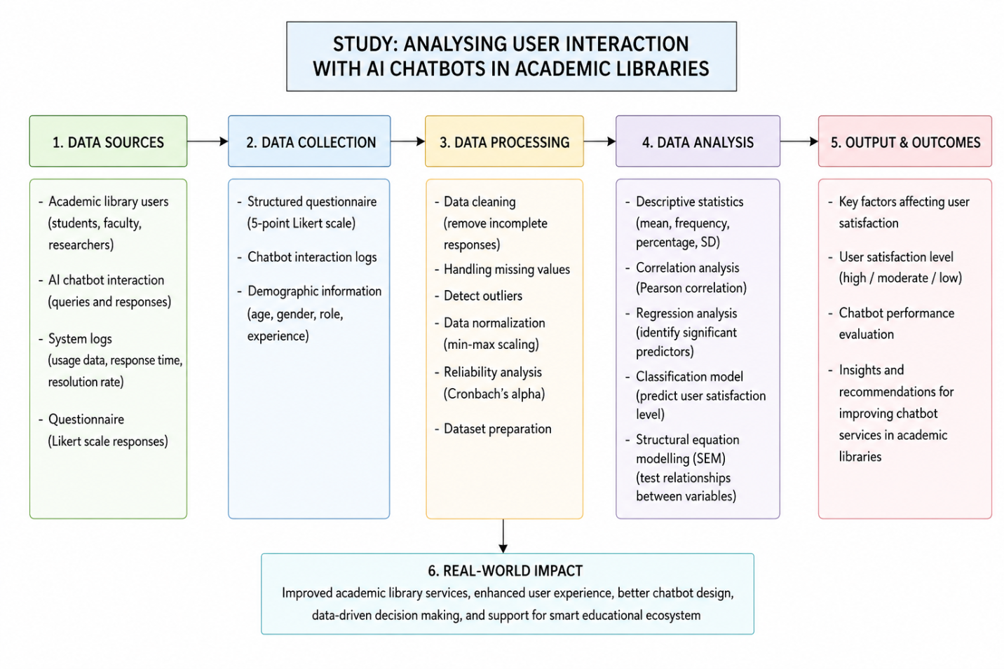

Figure 1: Systematic framework of AI Chatbot Interaction Analysis Algorithm (ACIAA)

The figure 1 displays a systematic framework for analyzing user interaction with AI chatbots within academic libraries which consists of six major steps: data sources, data collection, data processing, data analysis, output generation and real-world impact assessment. The study starts with various input sources such as academic library users, the records of interactions in the chatbot, system generated log files and the responses from the structured questionnaire with 5-point Likert scale. Reliability analysis through Cronbach Alpha coefficient was carried out to determine the internal consistency of the variables in the questionnaire with values greater than 0.70 are considered reliable. In the data analysis stage, descriptive statistics, Pearson correlation analysis, regression modelling, classification algorithms, and Structural Equation Modeling (SEM) are used to determine statistical relationships between chatbot responsiveness, ease of use, trust, communication quality and user satisfaction. The correlation coefficients (r) indicate the association strength between variables, and the regression coefficient (ß) highlights the most important variables influencing the adoption and interaction quality of chatbots.

Work done
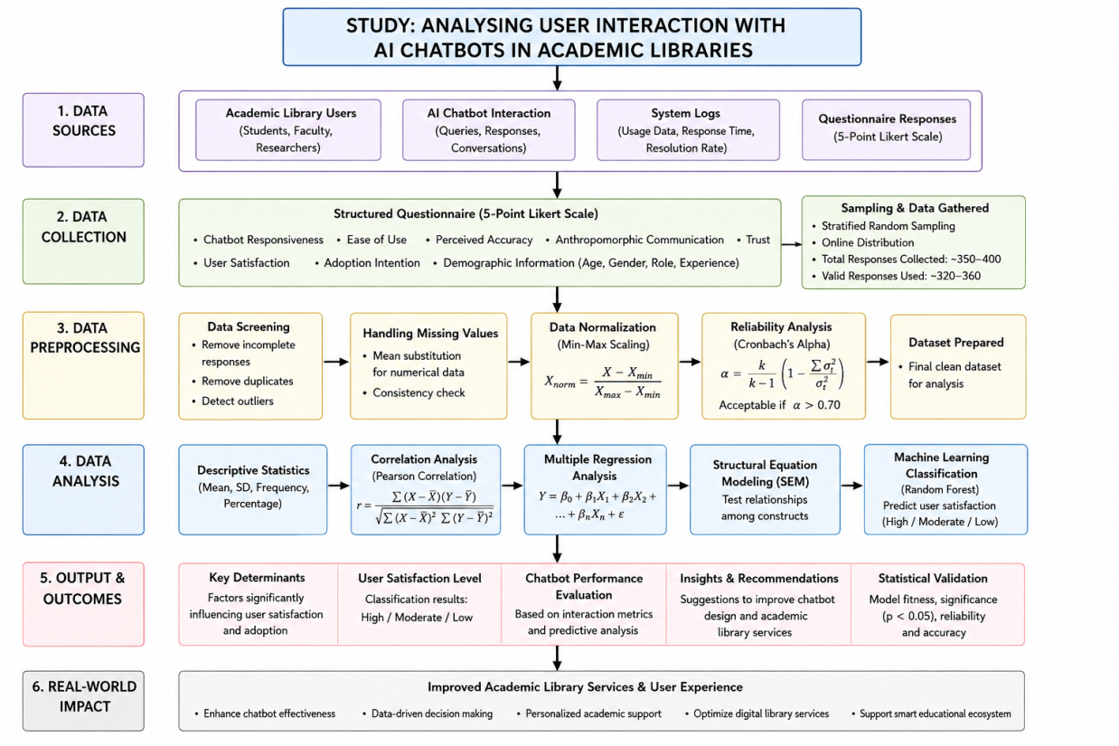
Figure 2: Study design framework

In light of the aforementioned in figure 2, the present study aimed to explore the interactions of users with AI chatbots in academic libraries in an academic context in order to get a quantitative research perspective that involved structured behavioral and interactional data. The data collected were from various academic sources such as undergraduate students, post-graduate students, research scholars, faculty members, and regular users of academic libraries who have had previous experience with interactions with AI chatbot systems for information retrieval, and library assistance. The main data collection tool consisted of a structured questionnaire that used a 5-point Likert scale with the following dimensions: chatbot responsiveness, usability, perceived accuracy, anthropomorphic communication, trust, and user satisfaction. To promote the reliability of the analysis, responses from the questionnaires, along with the logs of how the people interacted with the chatbots, and the system-generated logs such as response time, duration of interactions, frequency of questions, and resolution rate, were added. The data were collected from online academic platforms, libraries in the institutions and university communication systems through stratified random sampling technique that ensured representative participation from each academic group of institutions with a total of approximately 350–400 valid responses.

Data collected were systematically preprocessed and then validated statistically. To enhance the quality of the data and eliminate statistical bias, the incomplete responses, duplicate entries and outlier observations were dropped. All values were missing using mean substitution, normalization techniques were used to deal with missing values, and all the numerical variables were standardized to the same computational range using min-max scaling. Internal consistency of questionnaire constructs were examined through reliability analysis using the Cronbach’s alpha coefficient, with the criteria for acceptable reliability and measurement validity of the questionnaire being more than 0.70. Various descriptive statistical techniques such as mean, standard deviation, percentage distribution, and frequency analysis were used to present the user behavioural patterns and characteristics of interaction between users and chatbots in academic library environments.
4. Result

Table 1. Descriptive Statistics of Chatbot Interaction Variables
Variable | Mean (M) | Standard Deviation (SD) | Minimum | Maximum
Chatbot Responsiveness (CR) | 0.79 | 0.12 | 0.42 | 0.98
Ease of Use (EU) | 0.74 | 0.10 | 0.45 | 0.95
Perceived Accuracy (PA) | 0.77 | 0.11 | 0.40 | 0.97
Anthropomorphic Communication (AC) | 0.69 | 0.13 | 0.31 | 0.93
User Trust (UT) | 0.81 | 0.09 | 0.50 | 0.99
Interaction Duration (ID) | 0.58 | 0.15 | 0.20 | 0.89
Query Resolution Rate (QRR) | 0.84 | 0.08 | 0.52 | 0.99
User Satisfaction (US) | 0.80 | 0.10 | 0.44 | 0.98

Figure 3. Descriptive Statistics of Chatbot Interaction Variables

Table 1 shows the descriptive statistic analysis of the key variables of the subject being studied that are related to chatting conducted by the chatbot while using the ACIAA framework. Based on the results, most of the variables obtained relatively high mean values, indicating positive perceptions by the users about the AI chatbot system in academic libraries. The mean value for User Trust (UT) was the highest score (M = 0.81), meaning that the users perceived the chatbot as reliable and trustworthy. Likewise, Query Resolution Rate (QRR) ((M = 0.84)) indicated that the chatbot was able to tackle majority of academic queries successfully. Similar performance can be seen with the Chatbot Responsiveness (CR) and the User Satisfaction (US), where both exhibited high mean scores and indicative interaction pleasantness experiences by users. The comparatively lower mean value of Interaction Duration (ID) suggests shorter interaction times, which may indicate efficient communication and quicker problem resolution. The descriptive statistics generally indicated that the system of Chat Bot showed reasonably good result for the both behavioural and interaction related factors.

Table 2. Pearson Correlation Analysis Between Chatbot Variables and User Satisfaction
Variables | Correlation Coefficient (r) | p-value | Interpretation
CR → US | 0.81 | <0.001 | Strong Positive
EU → US | 0.72 | <0.01 | Strong Positive
PA → US | 0.78 | <0.001 | Strong Positive
AC → US | 0.69 | <0.01 | Moderate Positive
UT → US | 0.84 | <0.001 | Very Strong Positive
QRR → US | 0.75 | <0.001 | Strong Positive
CER → US | 0.73 | <0.01 | Strong Positive
SIS → US | 0.70 | <0.01 | Moderate Positive

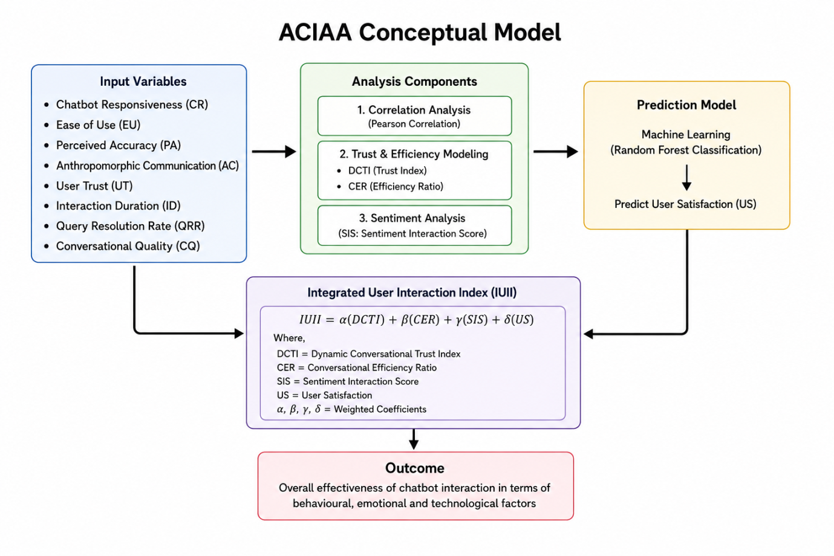
Figure 4: Conceptual model
The Pearson correlation was used to assess the relationships between the user satisfaction and the chatbot interaction scores.Relationships of the chats with the user satisfaction scores were tested through the Pearson correlation method, as represented in Table 2. The findings indicate high positive correlations between most of the chatbot capabilities and users' satisfaction. User Trust (UT) showed the highest correlation with User Satisfaction (r = 0.84, p < 0.001), suggesting that user trust is the main one when it comes to satisfaction with academic chatbot systems. Additionally, Chatbot Responsiveness (CR) and Perceived Accuracy (PA) were moderately correlated with satisfaction, indicating a high perceived value of users for chatbots that respond quickly and are accurate. This anthropomorphic Communication (AC) had a moderate positive relationship, suggesting that a conversation with humans-like behaviour has an positive effect on the experience of the users. These were all statistically significant, thus suggesting that the chatbot behavioural characteristics are significant factors in user satisfaction and acceptance in academic library contexts.

Table 3. Dynamic Conversational Trust Index (DCTI) and Conversational Efficiency Ratio (CER) Analysis
Metric | Mean | SD | Interpretation
Dynamic Conversational Trust Index (DCTI) | 0.76 | 0.11 | High Trust Level
Conversational Efficiency Ratio (CER) | 0.71 | 0.09 | Efficient Interaction
Sentiment Interaction Score (SIS) | 0.64 | 0.12 | Positive Emotional Interaction
Integrated User Interaction Index (IUII) | 0.79 | 0.10 | High Overall Interaction Effectiveness

Figure 5. Dynamic Conversational Trust Index (DCTI) and Conversational Efficiency Ratio (CER) Analysis
Tables 3 shows the analysis of the proposed multidimensional interaction indices: DCTI, CER, SIS, and IUII. The mean value (M = 0.76) of the Dynamic conversational Trust Index (DCTI) assigned by the users made a compelling statement that the responses of the chatbot were both reliable and trustworthy and highly useful academically. The results of the Conversational Efficiency Ratio (CER) indicate the effectiveness of the chatbot system in supporting user inquiries while minimizing conversational efforts and the time of interaction. The Sentiment Interaction Score (SIS) has a positive average score (M = 0.64), indicating mostly positive emotional interactions between user and chatbot. Beyond that, the overall mean score (M = 0.79) of the Integrated User Interaction Index (IUII) also showed high overall effectiveness of the chatbot system at behavioural, emotional and technological aspects.

Table 4. Random Forest Classification Performance
Performance Metric | Value
Classification Accuracy | 91.4%
Precision | 0.89
Recall | 0.92
F1-Score | 0.90
ROC-AUC Score | 0.93

Table 6. Random Forest Classification Performance
Table 4 is the presentation of performance evaluation of RF Classification model employed in ACIAA. By demonstrating high classification accuracy for predicting customer satisfaction levels from the context of the chatbot interaction, the model demonstrates its strength in predicting user satisfaction levels.The high classification accuracy of the model aimed at predicting user satisfaction levels based on chatbot interaction variables indicates an excellent ability for this task. The precision value of 0.89 shows that the model has limited error in prediction, and it was able to correctly classify customers that are satisfied with the product purchased. Likewise, the high recall value (0.92) implies that the model was able to identify most of the satisfied user cases. The F1 score of 0.90 also signifies the good balance between precision and recall. Furthermore, the good score of the ROC-AUC (0.93) demonstrates the reliability of the classification model, as well as its discrimination power. This result indicated that the Random Forest model is very efficient for predicting human behaviour in chatbot-human interaction analysis.

Table 5. Feature Importance Analysis in Random Forest Model
Feature Variable | Importance Score | Rank
User Trust (UT) | 0.26 | 1
Perceived Accuracy (PA) | 0.21 | 2
Chatbot Responsiveness (CR) | 0.19 | 3
Conversational Quality (CQ) | 0.14 | 4
Ease of Use (EU) | 0.09 | 5
Anthropomorphic Communication (AC) | 0.07 | 6
Query Resolution Rate (QRR) | 0.04 | 7

Figure 7. Feature Importance Analysis in Random Forest Model
The Random Forest model feature importance scores is given in Table 5. Based on the results, User Trust (UT) is the most influential FOD which has importance score of 0.26. Perceived Accuracy (PA) and Chatbot Responsiveness (CR) were second and third respectively, which indicate that the accuracy and responsiveness of the chatbots greatly impact satisfaction ratings. In addition, meaningful and coherent communication is vital in academic chatbot systems, as evidenced by its strong impact on predictive performance—known as Conversational Quality (CQ). Ease of Use (EU) and Anthropomorphic Communication (AC) had moderate influence on prediction outcomes and Query Resolution Rate (QRR) had comparatively lower influence (but was an important interaction factor). Overall, the results show that trust, accuracy, and responsiveness are the key factors in successful interactions with a chatbot in an academic library.

Table 6. Regression Analysis Predicting User Satisfaction
Predictor Variable | Beta (β) | Standard Error | t-value | p-value
DCTI | 0.42 | 0.05 | 8.31 | <0.001
CER | 0.31 | 0.06 | 5.94 | <0.01
SIS | 0.27 | 0.04 | 5.12 | <0.01
Constant | 0.18 | 0.03 | 3.87 | <0.05

Figure 8. Regression Analysis Predicting User Satisfaction
The regression analysis to determine the effects of DCTI, CER, and SIS on user satisfaction is presented in Table 6. The regression coefficient of Dynamic Conversational Trust Index (DCTI) had the highest positive value with user satisfaction ((\beta = 0.42, p < 0.001)), also showing that conversational trust positively affected users' interaction experiences with academic chatbots. Conversational Efficiency Ratio (CER) also had a significant positive effect ((\beta = 0.31, p < 0.01)), with shorter and more efficient conversational play resulting in greater satisfaction. In this manner, Sentiment Interaction Score (SIS) was found to positively influence user satisfaction ((\beta = 0.27, p < 0.01)), suggesting that positively worded interactions and interactions contribute to good chatbot experiences.
Conclusion
The AI chatbot technology systems are therefore found to be playing a significant role in improving the academic library services by giving better accessibility, retrieval of information, efficient query resolution and making virtual user's support available in the academic library round the clock to improve the academic library services. The statistical results validated the significance of chatbot responsiveness, accuracy of the information provided, conversational quality, trust, and emotional interaction on both user satisfaction and behavioural acceptance of academic services that utilize AI chatbots. User Trust was the most significant interaction variable, showing that reliability and transparency in intelligent library systems are crucial factors for user satisfaction. The proposed AI Chatbot Interaction Analysis Algorithm (ACIAA) has successfully incorporated the components of behavioural analytics, conversational trust modelling, sentiment interaction assessment and machine learning-based prediction, resulting in a multidimensional evaluation model for human-chatbot interaction in academic libraries. The high predictive accuracy of the Random Forest model further supported the effectiveness of the proposed analytical approach in detecting behavioural interaction patterns and predicting levels of satisfaction among users. The findings of this study suggest that AI-powered chatbot systems can significantly enhance digital academic spaces and library service efficiency and highlight the need for adaptable, trustworthy, emotionally intelligent, and user-centric future smart educational ecosystems.

References
Ali, M., Naeem, S., & Bhatti, R. (2020). Artificial intelligence tools and perspectives of university librarians: An overview. Business Information Review, 37(3), 116–124. https://doi.org/10.1177/0266382120952016
André, E., & Rist, T. (2000). Adding life-like synthetic characters to the web. In M. Klusch & L. Kerschberg (Eds.), Cooperative information agents IV – The future of information agents in cyberspace (Lecture Notes in Computer Science, Vol. 1860, pp. 51–89). Springer.
Araujo, T. (2018). Living up to the chatbot hype: The influence of anthropomorphic design cues and communicative agency framing on conversational agent and company perceptions. Computers in Human Behavior, 85, 183–189. https://doi.org/10.1016/j.chb.2018.03.051
Arlitsch, K., & Newell, B. (2017). Thriving in the age of accelerations: A brief look at the societal effects of artificial intelligence and the opportunities for libraries. Journal of Library Administration, 57(7), 789–798. https://doi.org/10.1080/01930826.2017.1362912
Battarbee, K. (2003). Defining co-experience. In Proceedings of the 2003 International Conference on Designing Pleasurable Products and Interfaces – DPPI ’03 (pp. 5–8). https://doi.org/10.1145/782896.782923
Brekhus, W. H., Galliher, J. F., & Gubrium, J. F. (2005). The need for thin description. Qualitative Inquiry, 11(6), 861–879. https://doi.org/10.1177/1077800405280663
Bryman, A. (2004). Encyclopedia of social science research methods. SAGE Publications. https://doi.org/10.4135/9781412950589
Candello, H., Pinhanez, C., & Figueiredo, F. (2017). Typefaces and the perception of humanness in natural language chatbots. In Proceedings of the 2017 CHI Conference on Human Factors in Computing Systems (pp. 3476–3487). Association for Computing Machinery.
Chen, R., & He, F. (2003). Examination of brand knowledge, perceived risk and consumers’ intention to adopt an online retailer. Total Quality Management & Business Excellence, 14(6), 677–693. https://doi.org/10.1080/1478336032000053825
Chopra, S., Gianforte, R., & Sholar, J. (2016). Meet Percy: The CS 221 teaching assistant chatbot. ACM Transactions on Graphics, 1(1), 1–8.
Chowdhury, G. (2003). Natural language processing. Annual Review of Information Science and Technology, 37(1), 51–89. https://doi.org/10.1002/aris.1440370103
Cox, A. M., Pinfield, S., & Rutter, S. (2018). The intelligent library: Thought leaders’ views on the likely impact of artificial intelligence on academic libraries. Library Hi Tech, 37(3), 418–435. https://doi.org/10.1108/LHT-08-2018-0105
Cox, D. F., & Rich, S. U. (1964). Perceived risk and consumer decision-making: The case of telephone shopping. Journal of Marketing Research, 1(4), 32–39. https://doi.org/10.1177/002224376400100405
Denzin, N. K., & Lincoln, Y. S. (Eds.). (2003). The landscape of qualitative research: Theories and issues (2nd ed.). SAGE Publications.
De Visser, E. J., Monfort, S. S., McKendrick, R., Smith, M. A., McKnight, P. E., Krueger, F., & Parasuraman, R. (2016). Almost human: Anthropomorphism increases trust resilience in cognitive agents. Journal of Experimental Psychology: Applied, 22(3), 331–349. https://doi.org/10.1037/xap0000092
Dreyer, T. (2016). Survey finds half of consumers would prefer to conduct all customer service via messaging. VentureBeat. https://venturebeat.com/2016/12/12/new-survey-andinsights-about-what-consumers-want-in-a-chatbot/
Featherman, M. S., & Pavlou, P. A. (2003). Predicting e-services adoption: A perceived risk facets perspective. International Journal of Human-Computer Studies, 59(4), 451–474. https://doi.org/10.1016/S1071-5819(03)00111-3
Forsythe, S. M., & Shi, B. (2003). Consumer patronage and risk perceptions in internet shopping. Journal of Business Research, 56(11), 867–875. https://doi.org/10.1016/S0148-2963(01)00273-9
Go, E., & Sundar, S. S. (2019). Humanizing chatbots: The effects of visual, identity and conversational cues on humanness perceptions. Computers in Human Behavior, 97, 304–316. https://doi.org/10.1016/j.chb.2019.01.020
Grönroos, C., & Voima, P. (2013). Critical service logic: Making sense of value creation and co-creation. Journal of the Academy of Marketing Science, 41(2), 133–150. https://doi.org/10.1007/s11747-012-0308-3
Hassenzahl, M. (2013). User experience and experience design. In The encyclopedia of human-computer interaction (2nd ed.). Interaction Design Foundation. https://www.interaction-design.org/literature/book/the-encyclopedia-of-human-computer-interaction-2nd-ed/user-experience-and-experience-design
Hassenzahl, M., & Tractinsky, N. (2006). User experience – A research agenda. Behaviour & Information Technology, 25(2), 91–97. https://doi.org/10.1080/01449290500330331
Hervieux, S., & Wheatley, A. (2021). Perceptions of artificial intelligence: A survey of academic librarians in Canada and the United States. The Journal of Academic Librarianship, 47(1), 102270. https://doi.org/10.1016/j.acalib.2020.102270
Janssen, C. P., Donker, S. F., Brumby, D. P., & Kun, A. L. (2019). History and future of human-automation interaction. International Journal of Human-Computer Studies, 131, 99–107. https://doi.org/10.1016/j.ijhcs.2019.05.006
Kaushal, V., & Yadav, R. (2020). Understanding customer experience of culinary tourism through food tours of Delhi. International Journal of Tourism Cities, 7(3), 683–701. https://doi.org/10.1108/IJTC-08-2019-0135
Kaushal, V., & Yadav, R. (2021). Delivering superior customer experience through new-age technologies. In Industry 4.0 Technologies for Business Excellence (pp. 47–60). CRC Press.
Kimani, E., Rowan, K., McDuff, D., Czerwinski, M., & Mark, G. (2019). A conversational agent in support of productivity and wellbeing at work. In 2019 8th International Conference on Affective Computing and Intelligent Interaction (ACII) (pp. 1–7).
Kothari, C. R. (2004). Research methodology: Methods and techniques (2nd ed.). New Age International.
Laforet, S., & Li, X. (2005). Consumers’ attitudes towards online and mobile banking in China. International Journal of Bank Marketing, 23(5), 362–380. https://doi.org/10.1108/02652320510629250
Littler, D., & Melanthiou, D. (2006). Consumer perceptions of risk and uncertainty and the implications for behaviour towards innovative retail services: The case of internet banking. Journal of Retailing and Consumer Services, 13(6), 431–443. https://doi.org/10.1016/j.jretconser.2006.02.006
Longoni, C., Bonezzi, A., & Morewedge, C. (2019). Resistance to medical artificial intelligence. Journal of Consumer Research, 46(4), 629–650. https://doi.org/10.1093/jcr/ucz013
Lopez-Nicolas, C., & Molina-Castillo, F. J. (2008). Customer knowledge management and E-commerce: The role of customer perceived risk. International Journal of Information Management, 28(2), 102–113. https://doi.org/10.1016/j.ijinfomgt.2007.09.001
Luckin, R. (2017). Towards artificial intelligence-based assessment systems. Nature Human Behaviour, 1(3), 0028. https://doi.org/10.1038/s41562-016-0028

