Human Intelligence Beyond the brain: AI and the Extended Mind Perspective.

Abstract
Artificial Intelligence (AI) has significantly transformed human cognition, learning, and assessment practices in the modern digital era. The emergence of the AI age challenges traditional views that human intelligence exists solely within the brain. Drawing upon the Extended Mind Perspective, this paper explores how AI technologies function as cognitive extensions that support and enhance human thinking, memory, problem-solving, and decision-making processes. Rather than viewing AI as a replacement for humans, the study emphasizes the growing collaboration between humans and intelligent machines in educational, professional, and social contexts.
The paper further examines the implications of AI-assisted cognition for enhancement and assessment. As humans increasingly operate alongside AI systems, conventional assessment methods focused on individual and autonomous performance become insufficient. New approaches to assessment must evaluate critical thinking, creativity, ethical reasoning, and the ability to effectively collaborate with AI technologies. The study highlights the need to redesign educational goals and assessment strategies to align with integrated human-AI environments.
Additionally, the paper discusses ethical concerns such as technological dependency, data privacy, algorithmic bias, and unequal access to AI resources. It concludes that the future of education and human development depends on balancing technological enhancement with meaningful human understanding, autonomy, and responsible AI usage. Through the extended mind perspective, AI is ultimately understood as an important partner in expanding human intelligence beyond the boundaries of the biological brain.

Keywords
Artificial Intelligence, Extended Mind Theory, Cognitive Enhancement, Human–AI Collaboration, Educational Assessment, Human Cognition, AI-Assisted Learning, Human–Machine Interaction.

Introduction
The rapid advancement of Artificial Intelligence (AI) has significantly transformed human life, education, communication, and professional practices. In the emerging AI era, intelligent systems are increasingly capable of performing tasks once considered exclusive to human intelligence, including reasoning, problem-solving, language generation, decision-making, and creative production. These developments have raised important questions regarding the future of human cognition, learning, and assessment. As AI technologies continue to evolve, educators and researchers are challenged to identify the knowledge and skills those future generations require to effectively functioning in an AI-driven society¹.
Traditionally, education has focused on developing independent cognitive abilities and assessing individual performance. However, the widespread use of AI tools in learning environments has blurred the distinction between human intelligence and machine-assisted cognition. Students and professionals now rely on AI systems for information retrieval, writing assistance, data analysis, and problem-solving, making human thinking increasingly interconnected with digital technologies. This shift has generated concerns regarding overdependence on AI, authenticity in assessment, and the preservation of critical and reflective thinking skills².
The concept of the Extended Mind Theory, proposed by Clark and Chalmers, offers a valuable framework for understanding this transformation. According to this perspective, cognition is not limited to the biological brain alone; rather, external tools and technologies can function as integral parts of human cognitive processes when closely connected to human activity. In the AI age, intelligent systems can therefore be understood as cognitive extensions that enhance memory, reasoning, creativity, and decision-making abilities. Instead of viewing AI merely as a replacement for human intelligence, the extended mind perspective emphasizes collaboration between humans and intelligent technologies³.
This perspective has important implications for enhancement and assessment in education. As humans increasingly operate within human–AI partnerships, conventional assessment methods based solely on autonomous individual performance may no longer adequately measure meaningful learning outcomes. Educational systems must therefore reconsider how knowledge, understanding, creativity, and problem-solving abilities are evaluated in environments where AI support is continuously available. The focus of education may gradually shift from memorization and isolated performance toward critical thinking, ethical reasoning, adaptability, and effective collaboration with AI technologies⁴.
Furthermore, the integration of AI into human cognition raises ethical and social concerns related to privacy, technological dependency, inequality of access, and algorithmic bias. While AI offers substantial opportunities for cognitive enhancement and educational innovation, responsible use and human oversight remain essential to ensure that technology supports rather than diminishes human autonomy and understanding⁵.
Therefore, this paper explores enhancement and assessment in the AI age through the lens of the extended mind perspective. It examines how AI functions as an extension of human cognition, the implications of human–AI collaboration for education and assessment, and the challenges associated with evaluating learning and intelligence in increasingly integrated human–machine environments⁶.
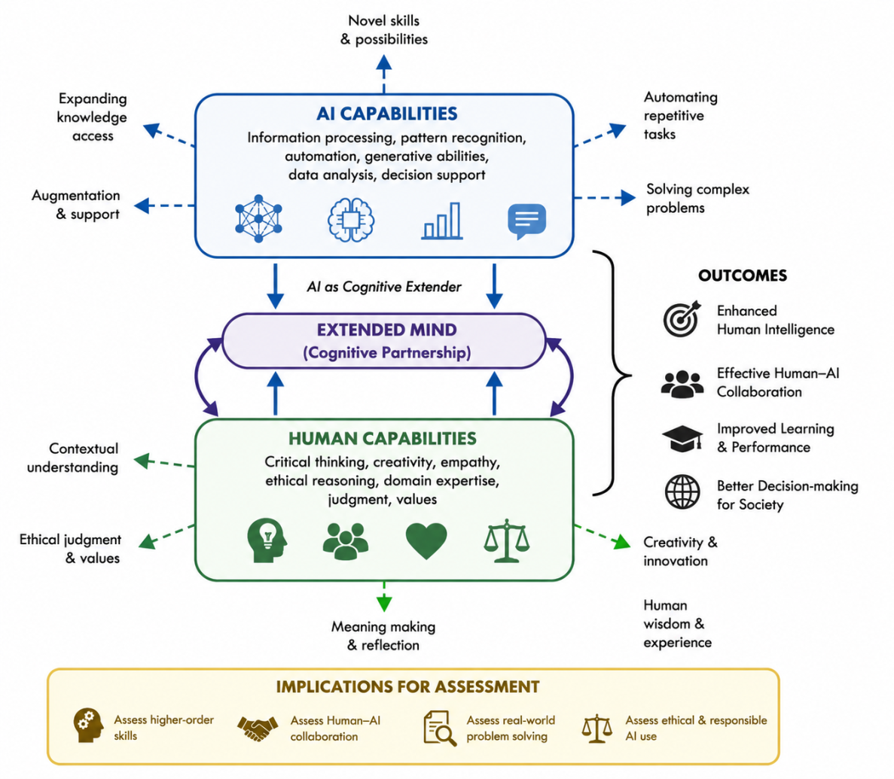
Figure 1 : The figure illustrates the concept of the Extended Mind Perspective, showing the integration of Artificial Intelligence (AI) and human intelligence. AI contributes capabilities such as automation, information processing, data analysis, and problem-solving, while humans provide critical thinking, creativity, ethical reasoning, and contextual understanding. The interaction between AI and human capabilities forms a cognitive partnership known as the “extended mind,” where AI functions as a cognitive extender that enhances human intelligence and learning. The figure further highlights the implications for education and assessment, emphasizing the need to evaluate higher-order thinking, ethical AI use, real-world problem-solving, and effective human–AI collaboration in the AI age.

AI as Cognitive Extension in the Extended Mind Framework
The rapid advancement of Artificial Intelligence (AI) has transformed the relationship between humans and technology, particularly in the context of cognition and learning. The Extended Mind Theory explains that external technologies can become integrated with human thinking processes when strong interaction and dependency exist between humans and technological systems. In this framework, AI systems are not merely external tools but can function as cognitive extenders that enhance human intelligence, reasoning, creativity, and decision-making⁷.
Researchers have described different forms of interaction between humans and AI, ranging from fully autonomous systems to deeply integrated cognitive partnerships. Autonomous AI refers to systems that independently perform tasks with minimal human involvement, whereas externalised AI involves outsourcing specific cognitive tasks to AI systems. In contrast, extended cognition represents a closer human–AI partnership in which AI actively supports and enhances human thinking processes. Internalised cognition occurs when humans learn from AI-generated outputs and gradually integrate that knowledge into their own cognitive abilities⁸.
Among these approaches, extended cognition is particularly significant for education and human enhancement because it emphasizes collaboration rather than replacement. Through continuous interaction with AI systems, humans can improve problem-solving, critical thinking, and knowledge generation while maintaining meaningful engagement in the learning process. The effectiveness of cognitive extension depends on the degree of coupling between humans and AI technologies, where the absence of the AI system would substantially reduce cognitive performance⁹ .
This perspective has important implications for educational practices and assessment in the AI age. As human cognition becomes increasingly interconnected with AI systems, education must focus not only on independent knowledge acquisition but also on developing the ability to effectively collaborate with intelligent technologies. Consequently, assessment methods should evolve to evaluate higher-order thinking, ethical reasoning, adaptability, and productive human–AI interaction within real-world contexts¹⁰.

Transformative AI and Human Cognitive Evolution
The rapid advancement of Artificial Intelligence (AI) is reshaping human cognition, education, and social interaction. Rather than simply replacing human tasks, AI increasingly transforms the ways in which tasks are performed, creating new forms of collaboration between humans and intelligent systems. In this context, AI should not be viewed only as a tool for automation but as a transformative technology capable of enhancing and extending human cognitive abilities¹¹.
The future of AI raises important questions regarding the skills humans will need in an environment where intelligent systems may eventually perform most cognitive activities currently carried out by humans. Traditional approaches often focus on identifying occupations or skills that are less vulnerable to automation. However, the rapid evolution of AI technologies makes such predictions uncertain, as tasks once considered uniquely human are increasingly being supported or automated by advanced AI systems¹².
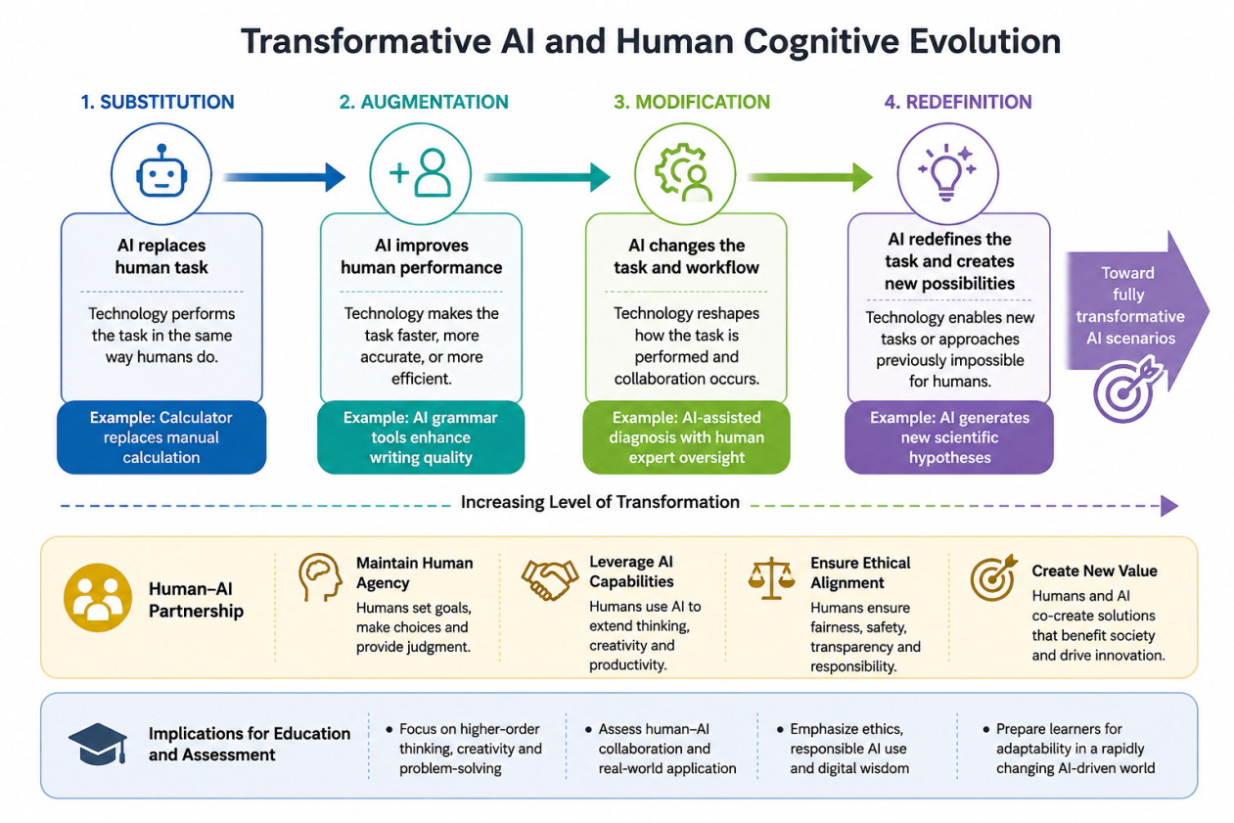
Figure 2: The figure demonstrates the evolving role of Artificial Intelligence (AI) in human cognition through four stages: substitution, augmentation, modification, and redefinition. Initially, AI replaces simple human tasks, then enhances human performance, modifies workflows through collaboration, and ultimately redefines tasks by creating new possibilities. The diagram emphasizes that AI functions as a cognitive partner that extends human intelligence rather than merely replacing it. It also highlights the importance of human–AI collaboration, ethical responsibility, creativity, and higher-order thinking in education and assessment within AI-driven environments.
The concept of Transformative AI emphasizes that technological progress does not merely substitute human labor but continuously modifies and redefines human activities. AI systems alter workflows, learning methods, communication processes, and decision-making practices, leading to the redesign of educational, professional, and social environments. This transformation creates opportunities for enhanced productivity, creativity, and problem-solving through human–AI collaboration¹³.
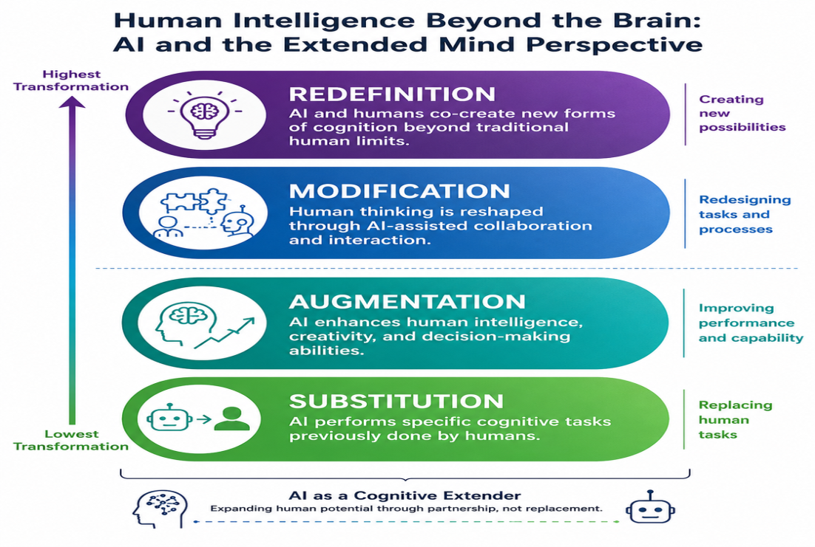
Figure 3: The figure illustrates the progressive integration of Artificial Intelligence (AI) with human cognition through four stages: substitution, augmentation, modification, and redefinition. AI initially replaces specific human tasks, then enhances cognitive performance, reshapes human–AI collaboration, and ultimately enables new forms of thinking and innovation. The diagram emphasizes AI as a cognitive extender that expands human intelligence through partnership rather than replacement, reflecting the principles of the Extended Mind Perspective.
The Substitution–Augmentation–Modification–Redefinition (SAMR) framework explains how AI influences human activities at different levels. AI may replace tasks directly, enhance existing processes, modify workflows, or completely redefine how tasks are performed. In many real-world contexts, AI-driven transformation extends beyond simple automation, resulting in new forms of interaction between humans and intelligent systems¹⁴.
From the extended mind perspective, these transformations suggest that cognition increasingly occurs through integrated human–AI systems rather than isolated individual thinking. Consequently, education and assessment must evolve to prepare individuals not only for independent performance but also for effective participation within technologically enhanced cognitive environments. Skills such as critical thinking, adaptability, ethical reasoning, creativity, and collaborative problem-solving become increasingly important in this AI-driven world¹⁵.

Human Enhancement through AI and the Extended Mind Perspective
The rapid advancement of Artificial Intelligence (AI) has profoundly transformed the way humans think, learn, communicate, and make decisions. In the contemporary digital era, intelligent technologies such as smartphones, virtual assistants, generative AI systems, automated recommendation platforms, and machine learning applications have become deeply integrated into everyday human activities. These technologies are no longer viewed merely as external tools but increasingly function as cognitive partners that support human intelligence. From the perspective of the Extended Mind Theory, human cognition extends beyond the biological brain and includes technological systems that assist memory, reasoning, problem-solving, and decision-making processes¹⁶.
Human enhancement through AI does not necessarily involve biological interventions such as neural implants or genetic modifications. Instead, enhancement occurs through continuous interaction and strong coupling between humans and AI systems. AI technologies enable individuals to process information more efficiently, solve complex problems rapidly, generate creative ideas, and access vast amounts of knowledge instantly. As a result, humans can perform tasks with greater speed, accuracy, and productivity than would be possible through unaided cognition alone¹⁷.
In educational environments, the role of AI as a cognitive enhancer is becoming increasingly visible. Students now use AI-powered tools for grammar correction, language translation, academic writing assistance, research support, multimedia creation, personalized tutoring, and adaptive learning. These technologies assist learners in understanding concepts, organizing information, and improving academic performance. Rather than simply replacing human learning, AI has the potential to enhance critical thinking and reflective learning when used responsibly and effectively¹⁸.
The concept of extended cognition explains that human intelligence becomes more powerful when technological systems are integrated into cognitive activities. AI functions as a “cognitive extender” that augments human memory, creativity, reasoning, and analytical capabilities. In this human–AI partnership, humans continue to contribute contextual understanding, emotional intelligence, ethical reasoning, judgment, and decision-making, while AI contributes computational efficiency, pattern recognition, and information-processing abilities. This collaborative relationship demonstrates that AI should not be understood solely as a substitute for human intelligence but as a system that can expand and strengthen human cognitive capacity¹⁹.
Furthermore, AI-driven enhancement can support individuals across diverse professional and social contexts. Healthcare professionals use AI-assisted diagnostic systems to improve clinical decision-making and patient care. Researchers employ AI to analyze large datasets, identify patterns, and accelerate scientific discoveries. Businesses utilize AI for forecasting, automation, and strategic planning, while creative professionals increasingly collaborate with generative AI tools for design, writing, music production, and innovation. These examples illustrate how AI contributes to enhanced human performance and productivity in multiple domains²⁰. 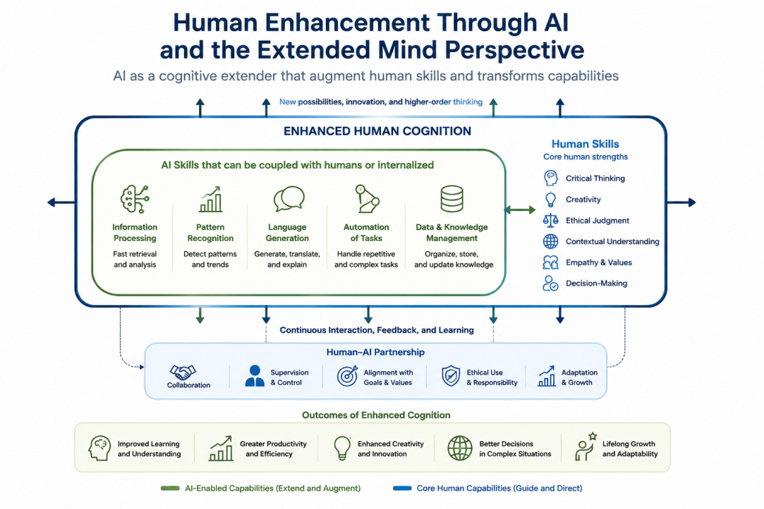
Figure 4: The figure illustrates how Artificial Intelligence (AI) functions as a cognitive extender within the Extended Mind Perspective. It demonstrates the integration of AI capabilities—such as information processing, automation, and knowledge management—with human skills including critical thinking, creativity, ethical judgment, and decision-making. Through continuous human–AI interaction and collaboration, cognition is enhanced, leading to improved learning, innovation, productivity, adaptability, and effective problem-solving in the AI age.
However, despite these advantages, the increasing integration of AI into human cognition also introduces significant challenges and ethical concerns. Excessive dependence on AI systems may reduce independent cognitive functioning and create overreliance on technological support. Individuals may gradually lose certain problem-solving or memory skills if cognitive tasks are consistently delegated to AI systems. This phenomenon raises concerns regarding cognitive atrophy and the preservation of human intellectual autonomy²¹.
Another important issue involves the “illusion of understanding,” where individuals may believe they fully comprehend a process simply because AI systems provide accurate outputs or explanations. In reality, users may rely on AI-generated information without critically evaluating its validity, accuracy, or ethical implications. This challenge is particularly relevant in educational settings, where students may use AI-generated responses without developing deep conceptual understanding or reflective thinking skills²².
The integration of AI also raises concerns related to privacy, surveillance, data security, algorithmic bias, reliability, and accountability. AI systems may reflect biases present in training data, leading to unfair or discriminatory outcomes. Additionally, determining responsibility becomes complex when decisions are influenced by AI-assisted systems. Questions regarding trust, transparency, and ethical AI governance therefore become increasingly important in technologically enhanced societies²³
These developments have major implications for education and assessment in the AI age. Traditional assessment models primarily focus on memorization, individual performance, and independent task completion. However, in environments where AI tools are continuously available, such approaches may no longer accurately measure genuine understanding or cognitive ability. Educational institutions must therefore redesign assessment strategies to evaluate higher-order thinking skills, creativity, ethical reasoning, metacognitive awareness, adaptability, and effective human–AI collaboration²⁴.
Future educational systems should emphasize responsible AI usage, critical evaluation of AI-generated information, problem-solving in real-world contexts, and the ability to work collaboratively with intelligent technologies. Rather than resisting AI integration, education should aim to prepare learners for a future where human intelligence and artificial intelligence function together in increasingly interconnected cognitive environments²⁵.
Overall, the Extended Mind Perspective provides a valuable framework for understanding human enhancement in the AI era. It highlights that human cognition is no longer confined solely to the brain but is increasingly distributed across human–technology interactions. When used ethically and responsibly, AI can function as a powerful cognitive extender that enhances human understanding, creativity, learning, and decision-making while supporting the continued evolution of human intelligence in the digital age²⁶.

AI-Integrated Assessment and Human Cognition beyond the Brain
The rapid advancement of Artificial Intelligence (AI) has created a major transformation in education, learning, and assessment practices across the world. Intelligent technologies such as generative AI, virtual assistants, adaptive learning systems, automated writing tools, and machine-learning platforms are increasingly becoming part of everyday academic and professional activities. In this evolving digital environment, human cognition is no longer confined solely to the biological brain. According to the Extended Mind Theory, technological systems can become integrated components of human cognitive processes when humans interact closely and continuously with them. From this perspective, AI functions as a cognitive extender that enhances memory, reasoning, creativity, communication, and problem-solving abilities²⁷.
Traditionally, educational assessment has focused on evaluating individual performance without technological assistance. Written examinations, memorization-based testing, and restricted assessment environments were designed to measure autonomous human knowledge and cognitive ability. However, the increasing integration of AI into educational contexts challenges these traditional assumptions. Students today frequently use AI-powered tools for academic writing, grammar correction, language translation, coding assistance, research support, multimedia generation, and personalized tutoring. These technologies support learning and improve efficiency, making AI-assisted cognition a common feature of modern education²⁸.
The Extended Mind Perspective suggests that learning should not be understood as an entirely isolated mental process occurring solely within the individual mind. Instead, cognition increasingly emerges through interactions between humans and intelligent technologies. In this context, AI becomes part of the broader cognitive system that supports understanding, reasoning, and knowledge construction. Students using AI tools are not simply outsourcing tasks; rather, they are engaging in a form of cognitive partnership where AI contributes computational power and information processing while humans provide contextual understanding, ethical reasoning, reflective judgment, and decision-making²⁹.
Dimension | Human Capabilities | AI Capabilities | Human–AI Integration (Extended Mind) | Educational Implications
Cognition | Critical thinking, reasoning, judgment | Fast data processing and pattern recognition | AI supports and enhances human thinking | Focus on analytical and reflective learning
Creativity | Imagination, innovation, emotional expression | Content generation and idea assistance | Humans and AI co-create knowledge and solutions | Encourage creative and collaborative tasks
Decision-Making | Ethical reasoning and contextual understanding | Predictive analytics and recommendations | AI assists humans in informed decision-making | Assess ethical and responsible AI use
Learning | Conceptual understanding and adaptability | Personalized tutoring and adaptive feedback | AI enables continuous and personalized learning | Shift from memorization to problem-solving
Communication | Human interaction and empathy | Language translation and automated communication | AI enhances global communication and accessibility | Develop digital communication literacy
Assessment | Human evaluation and reflective judgment | Automated grading and performance analytics | AI-assisted assessment supports personalized evaluation | Emphasize higher-order cognitive skills
Collaboration | Teamwork and social intelligence | Intelligent assistance and task automation | Human–AI partnership improves productivity | Evaluate effective human–AI collaboration
Future Skills | Metacognition, adaptability, ethical awareness | Computational efficiency and scalability | Integrated human–AI cognition shapes future competencies | Prepare learners for AI-driven environments

Table 1: The table illustrates the relationship between human intelligence and Artificial Intelligence (AI) within the framework of the Extended Mind Perspective. Human cognition is complemented by AI capabilities such as data processing, automation, and adaptive learning, creating an integrated human–AI cognitive system. Rather than replacing humans, AI acts as a cognitive extender that enhances creativity, learning, communication, and decision-making. The table further highlights the implications for education and assessment, emphasizing the importance of critical thinking, ethical reasoning, adaptability, and effective human–AI collaboration in the AI age.
This transformation has important implications for educational assessment. Traditional examinations that prohibit technological tools may no longer reflect authentic real-world environments where AI systems are continuously available and widely used. Similar debates occurred previously with calculators, computers, and internet access in education. Initially, these technologies were often restricted because they were perceived as threats to independent learning. Over time, however, educational systems recognized that such tools could support higher-order thinking when appropriately integrated into learning environments. AI now presents a similar challenge, but on a much larger scale because of its ability to generate content, solve problems, and simulate human-like reasoning³⁰.
Consequently, assessment practices in the AI age must move beyond simple memorization and isolated task completion. Educational institutions increasingly need to evaluate higher-order cognitive skills such as critical thinking, creativity, problem-solving, ethical reasoning, metacognition, adaptability, and effective human–AI collaboration. In AI-assisted environments, the ability to evaluate information critically, supervise AI outputs, identify errors, and apply knowledge responsibly becomes more important than merely recalling factual information³¹.
Project-based learning, collaborative assignments, reflective portfolios, oral examinations, live demonstrations, and practical problem-solving tasks may therefore become more relevant forms of assessment. These approaches allow educators to observe how students interact with AI systems, apply knowledge in authentic situations, and demonstrate understanding beyond AI-generated outputs. Such assessment methods are more ecologically valid because they reflect the actual ways individuals will work and learn in AI-driven professional environments³².
Another important issue concerns academic integrity and fairness. AI-assisted systems blur the boundaries between independent work and technological collaboration, making it increasingly difficult to determine the extent of human contribution in academic tasks. Some students may have access to more advanced AI tools than others, potentially creating inequalities in educational opportunities. Therefore, institutions must establish transparent policies regarding acceptable AI use, ethical guidelines, and fair evaluation practices. Responsible AI usage should become an essential component of digital literacy education³³.
The integration of AI into assessment also raises concerns regarding overreliance on technology. Excessive dependence on AI systems may reduce independent cognitive engagement and create an “illusion of understanding,” where learners appear knowledgeable without developing deep conceptual comprehension. Students may rely on AI-generated answers without critically analyzing the information or understanding the reasoning behind it. This challenge highlights the importance of maintaining human reflection, supervision, and metacognitive awareness in AI-assisted learning environments³⁴.
In addition, AI itself may increasingly participate in assessment processes. Intelligent systems can support automated feedback generation, personalized evaluation, adaptive testing, plagiarism detection, and learning analytics. AI-assisted assessment may help address challenges related to scalability, efficiency, and continuous monitoring of student progress. However, relying entirely on automated evaluation may introduce risks such as algorithmic bias, lack of transparency, and inaccurate judgments. Human oversight therefore remains essential to ensure fairness, ethical accountability, and contextual understanding in assessment practices³⁵.
The concept of human–AI collaboration is central to the future of education. In many professional settings, individuals will work alongside intelligent systems rather than independently from them. Consequently, educational assessment should evaluate not only what students know individually but also how effectively they collaborate with AI technologies to solve complex problems, generate innovative ideas, and make responsible decisions. This represents a significant shift from the traditional emphasis on isolated individual performance toward integrated cognitive interaction between humans and machines³⁶.
Furthermore, AI-integrated assessment reflects broader societal changes in how knowledge is produced, shared, and applied. The growing presence of intelligent technologies requires educational systems to prepare learners for dynamic environments characterized by rapid technological change, continuous learning, and digital interdependence. Skills such as adaptability, ethical judgment, communication, creativity, emotional intelligence, and interdisciplinary thinking become increasingly valuable because they complement rather than compete with AI capabilities³⁷.
Overall, the Extended Mind Perspective provides a powerful framework for understanding assessment in the AI age. It emphasizes that human cognition is increasingly distributed across interactions with intelligent technologies, transforming both learning and evaluation processes. Rather than resisting technological advancement, educational systems should aim to develop balanced approaches that combine human intellectual growth with responsible AI integration. Through meaningful human–AI collaboration, assessment can evolve to support deeper understanding, innovation, and the continued development of human intelligence beyond the boundaries of the biological brain³⁸.

Conclusion
The rapid advancement of Artificial Intelligence (AI) has transformed the relationship between humans and technology, leading to a new era in which cognition increasingly extends beyond the biological brain. From the perspective of the Extended Mind Theory, AI systems function not merely as external tools but as cognitive extenders that enhance human thinking, creativity, learning, communication, and decision-making. In this AI-driven age, human intelligence is becoming deeply interconnected with intelligent technologies, creating new forms of human–AI collaboration and cognitive integration.
This paper has explored how AI contributes to human enhancement through continuous interaction and close coupling between humans and intelligent systems. Rather than viewing AI solely as a replacement for human abilities, the study emphasizes the role of AI in augmenting human cognition and supporting more effective problem-solving and knowledge generation. The integration of AI into education, professional practice, and daily life demonstrates that cognition increasingly occurs within human–technology partnerships³⁹.
At the same time, the growing dependence on AI introduces important ethical, educational, and social challenges. Issues related to overreliance on technology, privacy, algorithmic bias, responsibility, transparency, and the illusion of understanding require careful consideration. These concerns highlight the need for responsible AI use and continued human oversight in technologically enhanced environments.
The study also emphasizes that traditional educational assessment methods are becoming insufficient in contexts where AI tools are continuously available and integrated into learning processes. Educational systems must therefore shift toward assessment approaches that evaluate critical thinking, creativity, ethical reasoning, metacognitive awareness, adaptability, and effective human–AI collaboration. Future learning environments should prepare individuals not only to use AI technologies but also to critically supervise, evaluate, and interact responsibly with them.
Ultimately, the AI age represents a significant transformation in human cognition and society. As intelligent technologies continue to evolve, the future of education and human development will depend on balancing technological enhancement with meaningful human understanding, autonomy, and ethical responsibility. Through the Extended Mind Perspective, AI can be understood as a powerful partner in expanding human intelligence beyond the boundaries of the brain, shaping new possibilities for learning, innovation, and human progress.
References.
- Clark A, Chalmers DJ. The extended mind. Analysis. 1998;58(1):7–19.
- Hernández-Orallo J, Vold K. AI extenders: The ethical and societal implications of humans cognitively extended by AI. In: Proceedings of the 2019 AAAI/ACM Conference on AI, Ethics, and Society; 2019. p. 507–513.
- Carter S, Nielsen M. Using artificial intelligence to augment human intelligence. Distill. 2017;2(12):e9.
- Daugherty PR, Wilson HJ. Human + Machine: Reimagining Work in the Age of AI. Boston: Harvard Business Press; 2018.
- Yan L, Greiff S, Teuber Z, Gašević D. Promises and challenges of generative artificial intelligence for human learning. Nat Hum Behav. 2024;8(10):1839–1850.
- Collins KM, Sucholutsky I, Bhatt U, Chandra K, Wong L, Lee M, et al. Building machines that learn and think with people. Nat Hum Behav. 2024;8(10):1851–1863.
- Gruetzemacher R, Whittlestone J. The transformative potential of artificial intelligence. Futures. 2022;135:102884.
- Bostrom N, Sandberg A. Cognitive enhancement: Methods, ethics, regulatory challenges. Sci Eng Ethics. 2009;15:311–341.
- Risko EF, Gilbert SJ. Cognitive offloading. Trends Cogn Sci. 2016;20(9):676–688.
- Sparrow B, Liu J, Wegner DM. Google effects on memory: Cognitive consequences of having information at our fingertips. Science. 2011;333(6043):776–778.
- Wiles E, Krayer L, Abbadi M, Awasthi U, Kennedy R, Mishkin P, et al. GenAI as an exoskeleton: Experimental evidence on knowledge workers using GenAI on new skills. SSRN Electron J. 2024.
- Dell’Acqua F, McFowland E III, Mollick ER, Lifshitz-Assaf H, Kellogg K, Rajendran S, et al. Navigating the jagged technological frontier: Field experimental evidence of the effects of AI on knowledge worker productivity and quality. Harvard Bus Sch Technol Oper Mgt Unit Work Pap. 2023;(24-013).
- OECD. OECD Digital Education Outlook 2023: Towards an Effective Digital Education Ecosystem. Paris: OECD Publishing; 2023.
- Hamilton ER, Rosenberg JM, Akcaoglu M. The substitution augmentation modification redefinition (SAMR) model: A critical review and suggestions for its use. TechTrends. 2016;60:433–441.
- Martínez-Plumed F, Hernández-Orallo J. Training data scientists through project-based learning. IEEE Rev Iberoam Tecnol Aprendiz. 2023;18(3):295–304.
- Aloisi C. The future of standardised assessment: Validity and trust in algorithms for assessment and scoring. Eur J Educ. 2023;58(1):98–110.
- Von Davier AA, Halpin PF. Collaborative problem solving and the assessment of cognitive skills: Psychometric considerations. ETS Res Rep Ser. 2013;2013(2):1–36.
- Frey CB, Osborne MA. The future of employment: How susceptible are jobs to computerisation? Technol Forecast Soc Change. 2017;114:254–280.
- Eloundou T, Manning S, Mishkin P, Rock D. GPTs are GPTs: Labor market impact potential of LLMs. Science. 2024;384(6702):1306–1308.
- Zhou L, Schellaert W, Martínez-Plumed F, Moros-Daval Y, Ferri C, Hernández-Orallo J. Larger and more instructable language models become less reliable. Nature. 2024;1–8.
- Brynjolfsson E, Li D, Raymond LR. Generative AI at work. Natl Bur Econ Res Work Pap. 2023;(31161).
- Noy S, Zhang W. Experimental evidence on the productivity effects of generative artificial intelligence. Science. 2023;381(6654):187–192. Clos J, Chen YY. Investigating the impact of generative AI on students and educators: Evidence and insights from the literature. In: Proceedings of the Second International Symposium on Trustworthy Autonomous Systems; 2024. p. 1–6.
- Dergaa I, Ben Saad H, Glenn JM, Amamou B, Ben Aissa M, Guelmami N, et al. From tools to threats: A reflection on the impact of artificial-intelligence chatbots on cognitive health. Front Psychol. 2024;15:1259845.
- Messeri L, Crockett MJ. Artificial intelligence and illusions of understanding in scientific research. Nature. 2024;627(8002):49–58.
- Racine E, Sattler S, Boehlen W. Cognitive enhancement: Unanswered questions about human psychology and social behavior. Sci Eng Ethics. 2021;27(2):19.
- Tolan S, Pesole A, Martínez-Plumed F, Fernández-Macías E, Hernández-Orallo J, Gómez E. Measuring the occupational impact of AI: Tasks, cognitive abilities and AI benchmarks. J Artif Intell Res. 2021;71:191–236.
- Frey CB, Osborne M. Generative AI and the future of work: A reappraisal. Brown J World Aff. 2023;30:161.
- OECD. What should teachers teach and students learn in a future of powerful AI? Paris: OECD Publishing; 2024.
- Wilson HJ, Daugherty PR. Embracing Gen AI at work. Harv Bus Rev. 2024;Sep–Oct:151–155.
- Shavit Y, Agarwal S, Brundage M, Adler S, O’Keefe C, Campbell R, et al. Practices for governing agentic AI systems. OpenAI Research Paper; 2023.
- Swanson B, Mathewson K, Pietrzak B, Chen S, Dinalescu M. Story centaur: Large language model few shot learning as a creative writing tool. In: Proceedings of the 16th Conference of the European Chapter of the Association for Computational Linguistics: System Demonstrations; 2021. p. 244–256.
- Choi JH, Monahan A, Schwarcz D. Lawyering in the age of artificial intelligence. SSRN Electron J. 2023.
- Ziegler DA, Anguera JA, Gallen CL, Hsu WY, Wais PE, Gazzaley A. Leveraging technology to personalize cognitive enhancement methods in aging. Nat Aging. 2022;2(6):475–483.
- Cazzaniga M, Jaumotte MF, Li L, Melina GG, Panton AJ, Pizzinelli C, et al. Gen-AI: Artificial intelligence and the future of work. Washington, DC: International Monetary Fund; 2024.
- OECD. OECD digital education outlook: Digital examinations in upper secondary certification. Paris: OECD Publishing; 2024.
- Puentedura R. As we may teach: Educational technology, from theory into practice. Apple; 2009.
- Puentedura R. Learning, technology, and the SAMR model: Goals, processes, and practice [Internet]. 2014 [cited 2026 May 20]. Available from: http://www.hippasus.com/rrpweblog/archives/2014/06/29/LearningTechnologySAMRModel.pdf
- Pinker S. The Language Instinct: The New Science of Language and Mind. New York: Penguin Books; 1995.
- Brabazon T. The Google effect: Googling, blogging, wikis and the flattening of expertise. Libri. 2006;56(3):157–167.

