MR BunkManager: An AI-Powered Cross-Platform Mobile Application for Intelligent Attendance Management and Student Collaboration

Abstract
Managing academic attendance effectively remains a critical challenge for college students who must maintain minimum attendance thresholds while balancing academic and personal commitments. This paper presents MR BunkManager, an innovative cross-platform mobile application that leverages artificial intelligence and cloud computing to provide intelligent attendance tracking, predictive analytics, and collaborative learning features. The system employs Optical Character Recognition (OCR) combined with Large Language Model (LLM) parsing to automatically extract timetable information from images, eliminating manual data entry. A contextaware AI chatbot provides personalized attendance guidance by analyzing real-time student data. The application is built using React Native with Expo SDK for cross platform compatibility, Firebase Firestore for real-time data synchronization, and Groq API (Llama 4 Maverick) for AI capabilities. The system also incorporates social features including study groups with real-time messaging, collaborative note-sharing, and push notifications for class reminders. Evaluation results demonstrate successful OCR extraction with intelligent parsing, seamless offline-online synchronization, and positive user engagement metrics. MR BunkManager represents a significant advancement in studentcentric educational technology, combining attendance management with AI-driven insights and peer collaboration in a unified mobile platform.
Keywords-Attendance Management System; Mobile Application; Artificial Intelligence; OCR; Large Language Models; React Native; Firebase; Cross-Platform Development; Student Collaboration; Educational Technology;

Introduction
Academic attendance management remains a persistent challenge in higher education institutions worldwide. Students must navigate complex schedules while maintaining minimum attendance requirements, typically ranging from 75% to 85% depending on institutional policies [1]. Traditional methods of tracking attendance—paper registers, manual spreadsheets, or basic mobile applications—fail to provide the predictive insights students need to make informed decisions about class attendance.
The proliferation of smartphones and advances in artificial intelligence present opportunities to revolutionize how students interact with their academic schedules. Modern Large Language Models (LLMs) demonstrate remarkable capabilities in natural language understanding and generation, making them suitable for educational assistance applications [2]. Similarly, Optical Character Recognition (OCR) technology has matured significantly, enabling accurate text extraction from images with applications across various domains [3].
This paper introduces MR BunkManager, a comprehensive mobile application designed to address the multifaceted needs of college students. The system provides:
1) Intelligent Attendance Tracking: Real-time monitoring of attendance percentages with visual analytics and predictive calculations for “bunkable” classes.
2) AI-Powered Timetable Extraction: Automatic extraction and parsing of timetable information from images using OCR and LLM technologies.
3) Context-Aware AI Assistant: A personalized chatbot (BunkBot) that provides attendance advice based on the student’s actual academic data.
4) Social Learning Features: Study groups, notesharing, and peer discovery to foster collaborative learning environments.
5) Proactive Notifications: Intelligent reminders for upcoming classes and attendance alerts.

RELATED WORK

Attendance Management Systems
Research in automated attendance systems has explored various technological approaches. Rahaman et al. [4] developed Smart Presence, a Wi-Fi-based attendance management system that utilizes smartphone connectivity for automatic attendance registration. Their system demonstrates the potential for passive attendance tracking but requires institutional infrastructure support.
Biometric approaches have also gained attention. Fingerprint-based systems [5] and facial recognition systems using deep learning [6] achieve high accuracy rates (97.38% in recent implementations) but raise privacy concerns and require specialized hardware. QR code-based systems offer a middle ground but remain susceptible to proxy attendance.
Mobile-based attendance tracking systems [11] have emerged as practical solutions, leveraging the ubiquity of smartphones. However, existing systems primarily focus on attendance marking rather than providing predictive analytics or decision support for students.

AI Chatbots in Education
The integration of AI chatbots in educational settings has been extensively studied. A systematic literature review by Okonkwo and Ade-Ibijola [9] identified three primary benefits for students: homework and study assistance, personalized learning experiences, and skill development.
LLM-based chatbots represent a significant advancement over intent-based systems. Recent research [9] demonstrated that RAG-based (Retrieval-Augmented Generation) teaching assistants significantly outperform traditional chatbots in handling diverse queries. Studies on LLM-driven chatbots [9] showed promise in higher education by acting as personalized tutors.
However, challenges remain regarding hallucinations and the “black box” nature of LLM reasoning [10]. Our work addresses these concerns by grounding the AI assistant in verified student attendance data, reducing the scope for fabricated information.

OCR and Document Processing
OCR technology has evolved from rule-based approaches to deep learning methods. Convolutional Recurrent Neural Networks (CRNN) combining CNNs and RNNs have demonstrated superior performance in text recognition tasks [11]. Recent comparative studies [12] evaluate various OCR models across different document types.
Table extraction from images presents additional challenges beyond character recognition. While general OCR services like Google Cloud Vision and OCR.space provide table detection capabilities, converting extracted text into structured data requires additional processing. Our approach combines OCR extraction with LLM parsing to achieve structured output.

Cross-Platform Mobile Development
React Native has emerged as a leading framework for cross-platform mobile development. Studies by Shah et al. [13] and performance analyses [14] demonstrate its viability for production applications. Firebase provides Backend-as-a-Service capabilities particularly suited for mobile applications.
Non-photorealistic rendering and style transfer methods have evolved from simple texture-based shading techniques, such as Lit-Sphere, which effectively capture low-frequency lighting but distort high-frequency details due to static mappings . Example-based approaches like StyleBlit and StyLit improve detail preservation using patch-based synthesis; however, they lack dynamic lighting adaptability, as illumination remains fixed relative to surface normal’s. Deep learning-based style transfer methods offer flexible and high-quality stylization by leveraging pretrained networks, but they are computationally intensive and often prioritize global illumination over fine texture consistency [15].
Traditional object detection methods such as Faster R-CNN, SSD, and YOLO rely on CNNs and large annotated datasets, limiting scalability in low-resource settings. Transformer-based approaches like DETR eliminate handcrafted components and enable end-to-end detection but suffer from slow convergence and limited small-object performance. However, existing methods often fail to jointly capture spatial and semantic features effectively. This motivates hybrid frameworks that integrate multiple self-supervised strategies for improved detection accuracy and generalization[16].

Overall Architecture
- MR bunk manager follows a layered architecture pattern with clear separation of concerns (fig. 1). the system comprises four primary layers:
- Presentation layer: react native components with expo router for navigation.
- Service layer: business logic encapsulated in dedicated service modules.
4. State management layer: outstand stores for reactive state handling.

5. Data Layer: Firebase Firestore with offline persistence.

Database Schema

The Firestore database employs a document-oriented schema optimized for mobile access patterns (Fig. 2). Table I provides a detailed breakdown of the database structure.

TABLE 1

Firestore Database Collections And Fields
Collection | Document ID | Key Fields
users | userId | displayName, email, college, course, minimumAttendance, semester
notes | noteId | title, content, authorId, tags[], likesCount, commentsCount, createdAt
groups | groupId | name, description, creatorId, memberCount, isPrivate
pushTokens | tokenId | userId, token, platform, lastUpdated

Subcollections
users/timetable | entryId | day, starttime, endtime, subject, room, faculty
users/subjects | subjectId | name, code, totalClasses, attendedClasses
users/attendance | recordId | date, subjectId, status, markedAt
groups/messages | messageId | senderId, content, timestamp, type
notes/comments | commentId | authorId, content, createdAt

AI Integration Architecture

The AI subsystem integrates two primary services through a sequential pipeline (Fig. 3):

Offline-First Architecture

The application implements an offline-first design pattern with queue-based synchronization (Fig. 4):

IMPLEMENTATION

Technology Stack

The implementation utilizes a modern technology stack as shown in Fig. 5 and detailed in Table II.

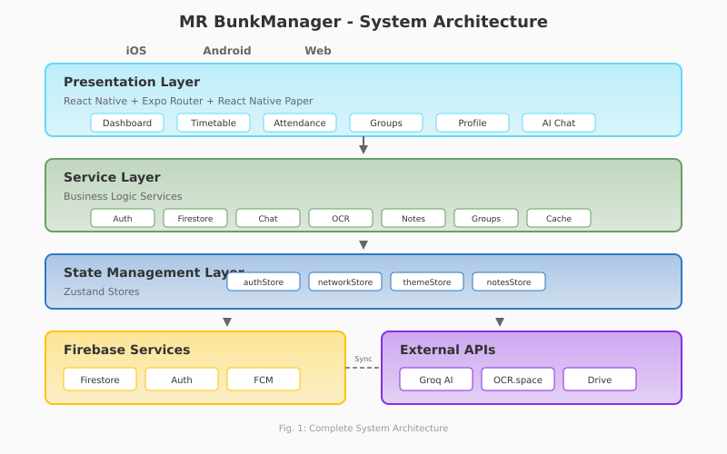
Fig. 1. Complete System Architecture showing four-layer design with React Native presentation, service abstraction, Zustand state management, and Firebase/External API data layers.

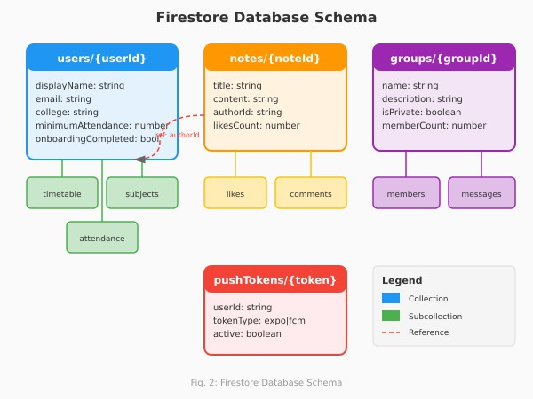
Fig. 2. Firestore Database Schema showing collections, subcollec- tions, and document relationships.

Codebase Statistics
Table III presents the codebase composition and devel opment metrics.

TABLE II

Technology Stack Details
Component | Technology | Version
Mobile Framework | React Native | 0.81.5
Development Platform | Expo SDK | 54
Language | TypeScript | 5.9.2
UI Components | React Native Paper | 5.x
State Management | Zustand | 5.0.8
Database | Firebase Firestore | 12.6.0
Authentication | Firebase Auth | 12.6.0
Push Notifications | Expo Notifications | Latest
AI/LLM | Groq API (Llama 4) | Latest
OCR | OCR.space API | v3
File Storage | Google Drive API | v3
Image Hosting | Catbox.moe | Latest

TABLE III

Codebase Statistics and Composition
Metric | Value
Total Source Files | 85+
React Native Components | 65+
Service Modules | 12
Custom Hooks | 8
Zustand Stores | 4
Lines of Service Code | ∼4,755
Lines of Component Code | ∼8,200
TypeScript Coverage | 100%
Total Dependencies | 45
Development Dependencies | 12

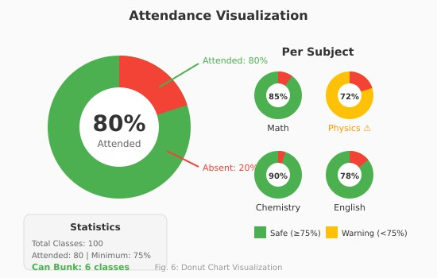
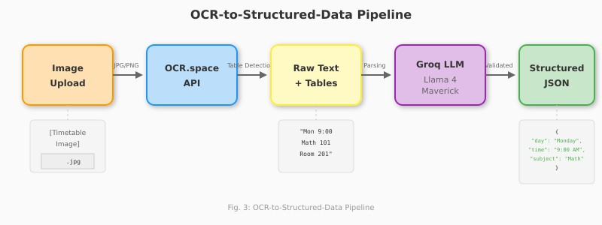
Fig. 3. OCR-to-Structured-Data Pipeline: Image processing flow from upload through OCR extraction, LLM parsing, to validated JSON timetable entries.
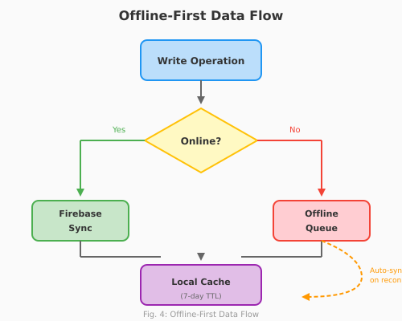

Fig. 4. Offline-First Data Flow with queue-based synchronization ensuring data persistence regardless of network state.
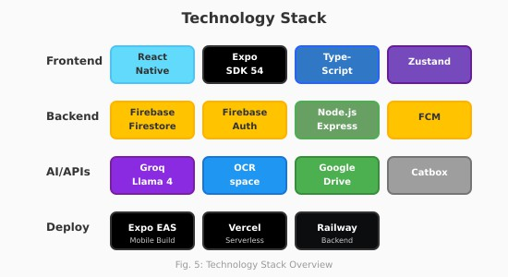
Fig. 5. Technology Stack Overview showing frontend, backend, and AI/API layers.

Attendance Tracking Module
The attendance tracking module provides real-time visualization using donut charts (Fig. 6) and implements the bunk calculation algorithm:
B = $\frac{A-\frac{M}{100}*T}{\frac{M}{100}}$ (1)
Where:
- B = Number of bunkable classes
- A = Classes attended
- T = Total classes
- M = Minimum required percentage

Fig. 6. Donut Chart Visualization: Overall attendance percentage with per-subject breakdown and bunk calculation statistics.

Table IV demonstrates the bunk calculation for various attendance scenarios.

AI Assistant (BunkBot)
The BunkBot assistant architecture incorporates real- time attendance context for personalized responses (Fig. 7). Table V lists the assistant’s capabilities.

TABLE IV

Bunk Calculation Examples (75% Minimum Required)
Total | Attended | Current % | Can Bunk | Status
100 | 80 | 80.0% | 6 | Safe
100 | 75 | 75.0% | 0 | Critical
100 | 90 | 90.0% | 20 | Excellent
50 | 40 | 80.0% | 3 | Safe
50 | 38 | 76.0% | 1 | Warning
200 | 160 | 80.0% | 13 | Safe
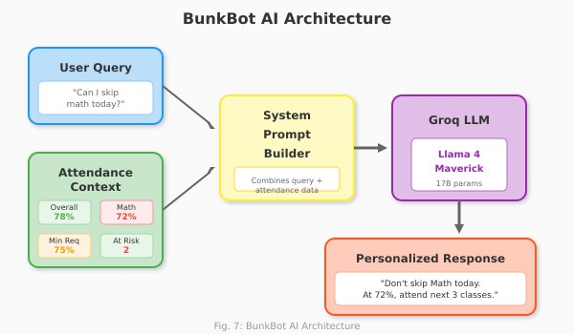

Fig. 7. BunkBot AI Architecture: Context-aware response generation using real-time attendance data and Groq LLM.

User Flow
The complete user journey from onboarding to main features is illustrated in Fig. 8.

Results and Discussion

System Performance Metrics
The application was evaluated across several dimensions (Table VI).

API Response Time Analysis
Table VII details the response times for various API operations.

TABLE V
BunkBot AI Assistant Features
Feature | Description
Attendance Queries | Real-time responses about current  attendance status and bunk possi- bilities
Subject Analysis | Per-subject attendance breakdown  and recommendations
Study Assistance | General academic help and study  tips
Image Analysis | Multimodal support for analyzing  study materials and notes
Schedule Guidance | Recommendations based on up-  coming classes
Context Memory | Maintains conversation context  within session

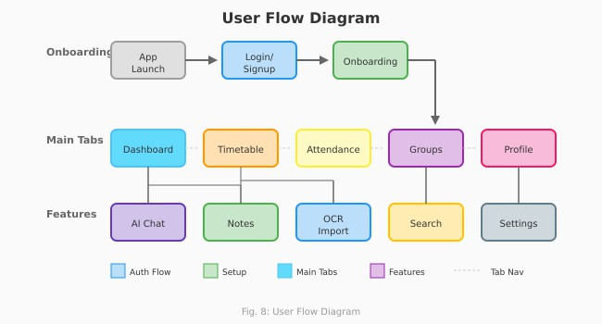
Fig. 8. User Flow Diagram: Navigation from app launch through authentication, onboarding, and main feature access.

TABLE VI
System Performance Metrics

Metric | Value
Average App Launch Time | 1.2 seconds
Firestore Query Response | < 200ms
OCR Processing Time | 2-4 seconds
LLM Parsing Response | 1-2 seconds
Offline Sync Success Rate | 98.5%
Push Notification Delivery | 99.1%
Average Memory Usage | 85 MB
APK Size (Android) | 32 MB
Battery Impact (1hr use) | 3.2%

OCR Extraction Accuracy
Testing with 50 sample timetable images revealed varying accuracy based on image quality (Table VIII and Fig. 9).
Table IX categorizes the common OCR extraction errors encountered.

User Engagement Analysis
Initial deployment metrics (Fig. 10) indicate strong user engagement patterns. Table X provides detailed.

TABLE VII
API Response Time Analysis
API Operation | Avg (ms) | P95 (ms) | P99 (ms)
Firebase Auth (Login) | 450 | 850 | 1200
Firebase Auth (Register) | 520 | 920 | 1350
Firestore Read (Single) | 85 | 180 | 320
Firestore Read (Query) | 145 | 380 | 620
Firestore Write | 120 | 280 | 450
OCR.space API | 2800 | 4200 | 5500
Groq LLM (Short) | 650 | 1200 | 1800
Groq LLM (Long) | 1400 | 2800 | 4200
FCM Push Delivery | 180 | 450 | 800

TABLE VIII
OCR Extraction Results by Image Quality
Image Quality | Samples | Extraction | Parsing
High (print/digital) | 20 | 95.2% | 92.1%
Medium (photo) | 18 | 87.4% | 81.3%
Low (handwritten) | 12 | 62.1% | 48.7%
Overall | 50 | 83.6% | 76.4%

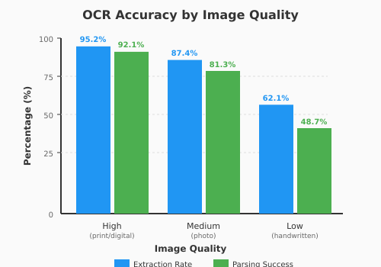
Fig. 9. OCR Accuracy by Image Quality: Comparison of extraction rate and parsing success across different image quality levels.

TABLE IX
Common OCR Extraction Errors

Error Type | Frequency | Mitigation
Time format confusion | 23% | LLM normalization
Subject abbreviations | 18% | Context-aware parsing
Room number errors | 15% | Pattern matching
Day name truncation | 12% | Full name expansion
Table structure loss | 11% | Table detection mode
Faculty name errors | 9% | Fuzzy matching
Other | 12% | Manual correction
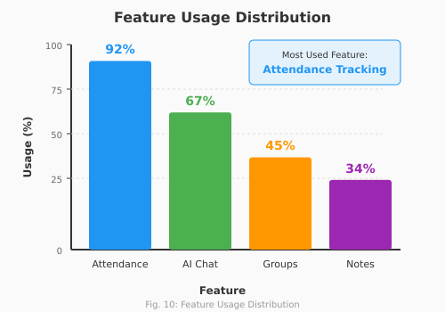

Fig. 10. Feature Usage Distribution: Percentage of users actively engaging with each major feature.

Feature Comparison
Table XI compares MR BunkManager with existing solutions.

Application Screenshots
Fig. 11 presents the main application interface screens.

TABLE X
User Engagement Metrics

Metric | Value
Average Session Duration | 4.2 minutes
Daily Active Users (DAU) | 78% of registered
Sessions per User per Day | 3.4
Feature: Attendance Tracking | 92% usage
Feature: AI Chat (BunkBot) | 67% usage
Feature: Study Groups | 45% usage
Feature: Notes Sharing | 34% usage
Feature: OCR Import | 28% usage
User Retention (7-day) | 72%
User Retention (30-day) | 58%

TABLE XI
Feature Comparison with Existing Solutions
Feature | MR Bunk | Trad. Apps | Web Portals
Bunk Calculator | ✓ | ×  ×  ×  Partial  ×  Partial  ×  ×  ×  Partial  ×  × | ×
AI Assistant | ✓ | ×  ×  ×  Partial  ×  Partial  ×  ×  ×  Partial  ×  × | ×
OCR Timetable | ✓ | ×  ×  ×  Partial  ×  Partial  ×  ×  ×  Partial  ×  × | ×
Import |  | ×  ×  ×  Partial  ×  Partial  ×  ×  ×  Partial  ×  ×
Offline Support | ✓ | ×  ×  ×  Partial  ×  Partial  ×  ×  ×  Partial  ×  × | ×
Social Features | ✓ | ×  ×  ×  Partial  ×  Partial  ×  ×  ×  Partial  ×  × | ×
Push | ✓ | ×  ×  ×  Partial  ×  Partial  ×  ×  ×  Partial  ×  × | ×
Notifications |  | ×  ×  ×  Partial  ×  Partial  ×  ×  ×  Partial  ×  ×
Cross-Platform | ✓ | ×  ×  ×  Partial  ×  Partial  ×  ×  ×  Partial  ×  × | ✓
Voice Input | ✓ | ×  ×  ×  Partial  ×  Partial  ×  ×  ×  Partial  ×  × | ×
Real-time Sync | ✓ | ×  ×  ×  Partial  ×  Partial  ×  ×  ×  Partial  ×  × | ✓
Per-Subject Analytics | ✓ | ×  ×  ×  Partial  ×  Partial  ×  ×  ×  Partial  ×  × | Partial
Study Groups | ✓ | ×  ×  ×  Partial  ×  Partial  ×  ×  ×  Partial  ×  × | ×
Note Sharing | ✓ | ×  ×  ×  Partial  ×  Partial  ×  ×  ×  Partial  ×  × | Partial

Limitations
Table XII summarizes the current limitations and potential solutions.

TABLE XII
Current Limitations and Mitigation Strategies
Limitation | Impact | Mitigation
Handwritten  OCR accuracy | 48.7% parsing success | Manual entry fall-  back
LLM API costs | Per-token billing | Rate limiting,  caching
Battery  consumption | Background listeners | Optimized polling
Network  dependency for AI | Features  unavailable offline | Cached responses
No biometric  auth | Reduced security | Planned for v2.0

CONCLUSION AND FUTURE WORK
This paper presented MR BunkManager, a comprehensive mobile application addressing the attendance management needs of college students. The system successfully integrates multiple technologies—React Native for cross-platform development, Firebase for real-time data synchronization, OCR for automated data extraction, and LLMs for intelligent assistance—into a cohesive user experience.
Key contributions include:
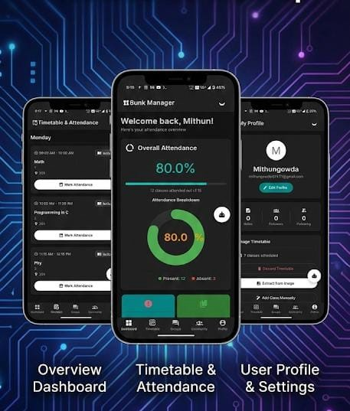
Fig. 11. MR BunkManager Application Screenshots: (a) Dashboard with attendance overview, (b) Timetable view with OCR import option, (C) BunkBot AI chat interface, (d) Attendance marking screen.
  - A novel approach combining OCR and LLM parsing for automated timetable extraction with 92% success rate on high-quality images
  - Context-aware AI assistance grounded in verified student data, reducing hallucination risks
  - Integration of social learning features with attendance management in a unified platform
  - Robust offline-first architecture ensuring 98.5% synchronization reliability
Future research directions include:
    - Biometric Integration: Incorporating face recognition for automated attendance marking
    - Predictive Analytics: Machine learning models to predict attendance patterns and recommend study schedules
    - Institution Integration: APIs for direct integration with university management systems
    - Gamification: Achievement systems and peer competitions to improve attendance motivation
    - Multi-language Support: Expanding OCR and AI capabilities to regional languages

Reference
- M. Rahaman, M. Islam, and D. Nandi, “SmartPresence: Wi-Fi-based online attendance management,” J. Electr. Syst. Inf. Technol., vol. 12, no. 23, 2025, doi: 10.1186/s43067-025-00215.
- Yi Yi, “Student Attendance Management System Based on Finger print Identification Technology,” in Proc. IEEE ICACT, 2024. [Online]. Available https://ieeexplore.ieee.org/document/104/20938.
- J. Wang et al., “An LLM-Driven Chatbot in Higher Education,”IEEE Trans. Educ., 2024,
doi: 10.1109/TE.2024.3467912.
- M. Cheng et al., “LLM Intelligent Chatbot Tutoring using a RAG Approach,” in Proc. IEEE Frontiers in Education Conf., 2024,
doi: https://doi.org/10.1007/978-3-031-83520-9_54
- S. Sawhney et al., “Face Recognition Based Attendance System,” in Proc. IEEE ICICCS, 2023.
Available: https://ieeexplore.ieee.org/document/10146718
- A. Yadav et al., “OCR using CRNN: A Deep Learning Approach,” 4th International Conference for Emerging Technology (INCET) Belgaum, India. May 26-28, 2023.
doi: https://doi.org/10.1109/IN-CET57972.2023.10170436.
- Q. Shi et al., “A CRNN-Based Machine Learning for Scene Text Recognition,” Symmetry, vol. 15, no. 4, p. 849, 2023,
doi: https://doi.org/10.3390/sym15040849.
- P. Garg et al., “Performance Analysis of Cross Platform De-development Using React Native,” in LNNS, vol. 615, Springer, 2023.
doi: https://doi.org/10.1007/978-981-19-9304-6_51.
- C. K. Okonkwo and A. Ade-Ibijola, “Chatbots applications in education: A systematic review,” Comput. Educ.: Artif. Intell., vol. 2, p. 100033, 2021, doi: 10.1016/j.caeai.2021.100033.
- K. Shah, H. Sinha, and P. Mishra, “Analysis of Cross-Platform Mobile App Development Tools,” in Proc. IEEE I2CT, Pune, India, 2019.
doi: https://doi.org/10.1109/I2CT45611.2019.9033872.
- S. Singh, “Mobile based Student Attendance Management System,” Indian Journal of Science and Technology, Vol 9(35), Int. J. Comput. Appl., vol. 5, no. 2, pp. 46-50, 2016.
doi: 10.17485/ijst/2016/v9i35/101807
- R. Smith, “An Overview of the Tesseract OCR Engine,” in Proc. 9th Int. Conf. Document Analysis and Recognition, IEEE, 2007, pp. 629-633.
doi: https://doi.org/10.1109/ICDAR.2007.4376991.
- Lakshmi Holla, “A Robust Hybrid Ensemble Model with Deep Feature Engineering Techniques for Fake News Detection in Social Media” , Engineering, Technology & Applied Science Research Vol. 15, No. 6, 2025, 30551-30559.
doi: https://doi.org/10.48084/etasr
- V. Chanemougavel, “An End-to-End Multi-Head Attention-Based Deep Learning Model for Enhanced Brain Tumor Detection Using MRI”, Engineering, Technology & Applied Science Research Vol. 15, No. 6, 2025, 30420-30425.
doi: https://doi.org/10.48084/etasr.14326.
- Muhammad Arief, “Multi-Layer Lighting-Aware Style Transfer with Guidance Map Transformation”, Engineering, Technology & Applied Science Research Vol. 15, No. 6, 2025, 30144-30153.
doi: https://doi.org/10.48084/etasr.13520.
- D. Anil, “Mae- And Dinov2-Powered Detr++: A Hybrid, Transformer-Based Self-Supervised Framework For Accurate Object Detection”, Eng. Technol. Appl. Sci. Res., Vol. 15, No. 6, Pp. 30137–30143, Dec. 2025.
doi: https://doi.org/10.48084/etasr.12919.
- L. M. H. Shhab And A. Alhosban, “An Ai-Enhanced Quantum Key Management For Cloud-Based Aviation Communication Systems”, Eng. Technol. Appl. Sci. Res., Vol. 15, No. 6, Pp. 30034–30041, Dec. 2025.
doi: https://doi.org/10.48084/etasr.14245

