Forecasting Stock Return Using Machine Learning Tools: A study on Listed Bangladeshi firms



Abstract

The forecast of the stock market has entered a technologically enhanced era, redesigning the traditional trading model with the introduction of technical wonders such as worldwide digitalization. Stock trading has been a hub for investment for many financial investors due to the steady increase in market capitalization. Numerous academics and analysts have created methods and tools that forecast changes in stock prices and assist investors in making wise decisions. Researchers can use non-traditional textual data from social media to make market predictions thanks to advanced trading models. Prediction accuracy has significantly increased with the use of sophisticated machine learning techniques like ensemble methods and text data analytics. Due to stock market analysis and prediction remain among the most difficult academic topics. Using a generic framework, this study describes the systematics of machine learning-based methods for stock market prediction. To determine the direction of importance, a thorough comparison study was also conducted.
The study would help new researchers grasp the fundamentals and developments of this developing field so they can continue their research in exciting ways.

List of Figure

Particulars | Page
List of Figure
3.1 Sample Data | 11
4.1 Accuracy | 24
4.2 Precision-Recall Curve | 27
4.3 Receiver Operating Characteristics (ROC) Curve | 27

List of Abbreviations

DSE: Dhaka Stock Exchange
SVM: Support Vector Machines
ROC: Receiver Operating Characteristics
ML: Machine Learning
LSTM: Long-Term Memory
CV: Cross-Validation
TP: True Positive
TN: True Negative
FP: False Positive
FN: False Negative
AUC: Area Under the Curve
NB: Naïve Bayes
RN: Random Forest
LR: Logistic Regression
MLA: Machine Learning Algorithm
PRC: Precision-Recall Curve
DTC: Decision Tree Classifier
F1: F1-Score

Table of Contents
Contents
Acknowledgment 1
Abstract 2
List of Figure 3
List of Abbreviations 4
Chapter 1: Introduction 7
1.1 Background of the Study: 1
1.2 Objective of the Study: 2
1.3 Problem Statement: 2
1.4 Goal and Research Questions: 3
Research Questions: 4
Chapter 2: Literature Review 6
2.1 Literature Review: 7
2.2 Data Preprocessing in Machine Learning 7
2.3 Machine Learning Algorithms for Classification 8
3.3 Evaluation Metrics 9
Chapter: 3 Data and Methodology 10
3.1 Data collection and pre-processing 11
3.2 Machine Learning Methods 11
3.2.1 Logistic Regression 12
3.2.2 Decision Trees 12
3.3 Overview of the Evaluation Metrics 13
Chapter: 4 Data Analysis and Findings 16
4.1 Optimizing parameters from the dataset 17
4.2 Logistic Regression 17
4.2.1 Cross-Validation Results: 17
4.2.2 Test Set Results: 18
4.3 Decision Tree 19
4.3.1 Cross-Validation Results: 19
4.3.1 Test Set Results: 19
4.4 Random Forest 20
4.4.1 Cross-Validation Results: 20
4.4.2 Test Set Results: 21
4.5 Support Vector Machine 21
4.5.1 Cross-Validation Results: 21
4.5.2 Test Set Results: 22
4.6 Naïve Bayes 23
4.7 Data Visualization 24
4.7.1 Performance Metrics 26
Chapter 5: Conclusion and Policy Implication 28
5.1 Conclusion 29
5.2 Policy Implications 29
References 30
Appendix 31

Chapter 1: Introduction

1.1 Background of the Study:

The study is focused on evaluating the performance of several machine learning classification algorithms in predicting a target variable (Retcat) using various features in the dataset. The dataset is preprocessed to handle missing values and standardize the features for model training. Several machine learning classifiers are applied, including Logistic Regression, Decision Trees, Random Forests, Support Vector Machines (SVM), and Naïve Bayes. The classification task is essential in many real-world scenarios such as predicting financial market trends, customer behavior, medical diagnosis, etc. Different algorithms offer distinct strengths in terms of interpretability, accuracy, and scalability. Hence, it is crucial to evaluate and compare the models' performance on the same dataset to determine which provides the best prediction accuracy and overall results.
In this case, data preprocessing methods like missing value imputation, scaling, and encoding are also applied to ensure the features are in the right form for training machine learning models. The goal is to determine the effectiveness of each model in handling the classification problem.

1.2 Objective of the Study:

The primary objective of the study is to evaluate the performance of multiple machine learning classification algorithms on the given dataset and compare their prediction accuracy, classification reports, and confusion matrices. Specific objectives include:
- Preprocessing: Handle missing values using imputation techniques and scale the data using standard scaling to ensure the models receive well-processed input.
- Modeling: Apply different machine learning classification algorithms, including Logistic Regression, Decision Trees, Random Forests, SVM, and Naïve Bayes, to predict the target variable (Retcat).
- Evaluation: Use performance metrics such as accuracy, classification report, and confusion matrix to assess the models' effectiveness in classification tasks.
- Comparison: Compare the results from all the models to determine the most suitable algorithm for the given problem.
- Insights: Provide insights on the best practices for classification in terms of algorithm choice and preprocessing techniques.

1.3 Problem Statement:
The problem addressed in this study is determining which machine learning classification algorithm can effectively predict the target variable (Retcat) based on the input features from the dataset. The dataset may contain challenges such as missing values, outliers, and varying feature scales, which can impact the performance of classification models.
The problem is compounded by the need to properly preprocess the data, including handling missing values and scaling features, to ensure that the algorithms perform optimally. Additionally, evaluating multiple models and comparing their results is crucial to selecting the most appropriate algorithm for the specific classification problem at hand.
Therefore, this study seeks to identify the best-performing machine learning model for predicting Change while addressing the challenges posed by data preprocessing, model selection, and performance evaluation.

1.4 Goal and Research Questions:
The primary goal of this study is to evaluate the performance of several machine learning algorithms in a classification task. Specifically, the study focuses on predicting the target variable Retcat based on multiple input features in the dataset. The key objectives are:
- Data Preprocessing: The dataset is first cleaned and preprocessed by handling missing values, scaling numerical features, and encoding categorical variables. This ensures that the data is ready for training machine learning models.
- Model Comparison: The study aims to compare different machine learning models, including:
- Logistic Regression
- Decision Trees
- Random Forest Classifier
- Support Vector Machines (SVM)
- Naïve Bayes
These models will be evaluated on the same dataset to understand their effectiveness in predicting the Change variable.
- Performance Evaluation: The performance of each model will be assessed based on several evaluation metrics:
- Accuracy: How well the model predicts the correct class.
- Precision, Recall, F1-Score: These metrics provide more detailed insights into the model's performance, especially for imbalanced datasets.
- Confusion Matrix: This helps visualize the true positives, false positives, true negatives, and false negatives.
- Cross-validation: Using techniques such as Stratified K-Fold to assess model performance more robustly.

- Model Selection: Based on the evaluation results, the study will identify the model that performs the best for predicting the target variable Change. This decision will be supported by both numerical metrics (accuracy, precision, etc.) and graphical tools (e.g., confusion matrix, classification report).

Research Questions:
The main research questions addressed by this study include:
- Which machine learning model is the most accurate and effective for predicting the Change class in the dataset?
- This question aims to determine which model, out of the multiple options explored, provides the best performance in terms of accuracy and other relevant metrics.
- How does each model handle the task of classification with different types of input features?
- Given that some models (like Decision Trees and Random Forests) can handle categorical features naturally, while others (like SVM or Logistic Regression) might require preprocessing (e.g., scaling), this question explores the model’s ability to manage feature differences.
- What impact does cross-validation have on the model performance results?
- This question focuses on the reliability of model performance estimates when using cross-validation versus just testing on a single training/test split. This helps ensure that the results are not over fit to a particular subset of data.

- How do performance metrics such as precision, recall, and F1-score affect the model evaluation?
- While accuracy is often the most reported metric, this question investigates the importance of additional metrics like precision, recall, and F1-score, especially when dealing with imbalanced classes.
- Does data preprocessing (such as handling missing values, feature scaling, and encoding categorical variables) improve the performance of machine learning models?
- This question examines whether preprocessing steps like missing value imputation and scaling make a significant difference in the accuracy and performance of the models.

Chapter 2: Literature Review

2.1 Literature Review:
The code provided involves the application of various machine learning models to predict a target variable, Change, from a dataset. The analysis uses different classification algorithms such as Logistic Regression, Decision Trees, Random Forest, Support Vector Machine (SVM), and Naïve Bayes). The study also includes essential steps like data preprocessing (handling missing values, encoding, scaling) and model evaluation through metrics like accuracy, classification reports, and confusion matrices. Below is a literature review based on the techniques and concepts I have used the code:

2.2 Data Preprocessing in Machine Learning
Data preprocessing is one of the most critical steps in the machine learning pipeline. It prepares raw data for model training and ensures that the algorithms perform optimally.
- Missing Value Imputation: Handling missing data is essential as most machine learning algorithms cannot handle missing values directly. In the code, the SimpleImputer from sklearn.impute is used, which replaces missing values with the mean (or other strategies). Several studies emphasize the importance of imputation strategies and their impact on model performance. For instance, Little and Rubin (2002) argue that missing data imputation is crucial in maintaining the validity of analysis results, especially when data loss is significant.
- Feature Scaling: The importance of scaling features, particularly for models that are sensitive to the scale of data, like Support Vector Machines (SVM), is well-documented. Japkowicz and Stephen (2002) discuss how scaling ensures that all features contribute equally to the model. Scaling standardizes the range of independent variables, which is crucial for algorithms like SVM and Logistic Regression.
- Label Encoding: In the code, Label Encoder is used to convert categorical target variables into numeric form. This step is especially important in classification tasks, as many models require numerical input. According to Bishop (2006), encoding categorical data is essential for machine learning models such as decision trees and logistic regression, as these models cannot interpret text labels directly.

2.3 Machine Learning Algorithms for Classification
The code evaluates multiple algorithms commonly used for classification tasks. A brief review of these models' strengths and limitations is as follows:
- Logistic Regression: Logistic regression is a linear model used for binary and multiclass classification. It estimates probabilities using the logistic function. As James et al. (2013) note, it is a simple yet powerful method for linearly separable data, but its performance degrades when data is complex and non-linear. However, with appropriate regularization, logistic regression can still handle more complex datasets.
- Decision Trees: Decision trees split data into subsets using feature values and make decisions based on these splits. While intuitive and interpretable, decision trees are prone to over fitting, especially when the tree is deep. The study by Breiman et al. (1986) on classification trees discusses how techniques like pruning can help prevent over fitting. Random Forest (an ensemble of decision trees) addresses over fitting issues by averaging over multiple trees.
- Random Forests: Random Forests, an ensemble technique that combines many decision trees, is known for its robustness and high accuracy. Liaw and Wiener (2002) discuss how random forests are less prone to over fitting due to their averaging process and their ability to handle high-dimensional spaces effectively.
- Support Vector Machines (SVM): SVM is a powerful classification algorithm that finds a hyper plane to separate different classes. It works well for high-dimensional spaces and is particularly effective in cases of limited data. Cortes and Vapnik (1995), in their foundational work, highlight the effectiveness of SVMs in creating non-linear decision boundaries by using kernel tricks.
- Naïve Bayes: Naive Bayes classifiers rely on Bayes' theorem and assume that features are independent. Despite the "naive" assumption, Naïve Bayes often performs remarkably well in text classification tasks. Rennie et al. (2003) discussed how Naive Bayes classifiers are computationally efficient and provide a strong baseline in text and spam classification tasks, even when the independence assumption doesn't hold perfectly.

3.3 Evaluation Metrics
Evaluating model performance is a crucial aspect of machine learning. Several metrics are used to assess how well a model is performing in classification tasks.
- Accuracy: While accuracy is one of the most commonly used metrics, it can be misleading, especially in imbalanced datasets. Davis and Goadrich (2006) highlight that accuracy alone does not capture the performance nuances of models, especially when one class dominates.
- Precision, Recall, and F1-Score: These metrics are particularly important when the dataset is imbalanced. Sasaki (2007) discusses the importance of precision and recall in assessing classifier performance, as they provide insight into false positives and false negatives. F1-score is the harmonic mean of precision and recall, offering a more balanced view of performance in cases of imbalanced datasets.
- Confusion Matrix: The confusion matrix provides a detailed view of how well a model performs across all classes by showing true positives, true negatives, false positives, and false negatives. According to Fawcett (2006), confusion matrices allow for a better understanding of misclassifications and provide a foundation for metrics like precision, recall, and F1-score.
- Cross-Validation: Cross-validation helps assess the stability of a model's performance. Kohavi (1995) recommends k-fold cross-validation, as it provides a more reliable estimate of model performance by reducing variance due to the specific data split.
The techniques and methods used in this code—ranging from data preprocessing to model selection and evaluation—align with best practices in machine learning. Research shows that preprocessing steps like scaling, imputation, and label encoding are crucial for ensuring model accuracy and efficiency. Moreover, comparing multiple models like logistic regression, decision trees, random forests, and SVMs is a common approach in the literature to determine the best model for a given task. Finally, the use of multiple evaluation metrics ensures a more comprehensive understanding of model performance, which is essential when selecting the best classifier for a problem.

Chapter: 3 Data and Methodology

3.1 Data collection and pre-processing

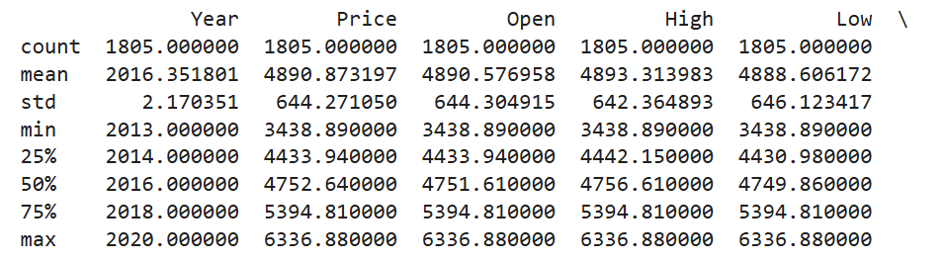
This might include historical stock price data, financial indicators, economic data, news articles, social media data, etc. The dataset I have used to perform the analysis and build predictive modeling is Dhaka Stock Exchange Broad list. The dataset includes 7 years of data form 2013 to 2020. The data contains information about the stock such as Year, Price, High, Low, Changes %, Retcat. The 80% of data has been used for training and 20% of data has been used for testing. After training the model, evaluation has been performed on unseen data of our model.
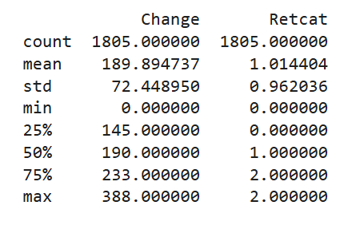

Figure: 3.1 Sample Data

3.2 Machine Learning Methods
In machine learning, various algorithms can be employed to tackle different types of problems, particularly classification tasks, where the goal is to predict categorical outcomes based on input features. Among the most commonly used algorithms are Logistic Regression, Decision Trees, Random Forest, Support Vector Machines (SVM), and Naïve Bayes. Each of these methods has distinct characteristics, strengths, and applications in real-world data analysis.

3.2.1 Logistic Regression
Logistic Regression is a linear model widely used for binary classification problems, where the task is to distinguish between two classes. This method works by estimating the probability that a given input belongs to one of the classes, using a logistic function to produce outputs between 0 and 1. Logistic Regression is efficient and easy to interpret, making it an ideal choice for simple tasks where the relationship between the independent variables and the target variable is roughly linear.

3.2.2 Decision Trees
On the other hand, are non-linear models that use a tree-like structure to make decisions. They recursively split the dataset based on the feature that best separates the data at each node, resulting in a series of decision rules that lead to a final classification or regression prediction. The simplicity of Decision Trees allows them to be interpretable, but they are prone to over fitting, especially when the tree becomes too deep.
3.2.3 Random Forest
Random Forest is an ensemble learning method, overcomes the limitations of Decision Trees by constructing a collection of individual trees, each trained on a random subset of the data and features. The predictions of these trees are then aggregated, often by majority voting for classification tasks. This approach helps to reduce over fitting and increase accuracy by leveraging the diversity of multiple trees. Random Forest is robust, works well with both small and large datasets, and can handle missing values effectively.
3.2.4 Support Vector Machines (SVM)
Support Vector Machines (SVM) are powerful classifiers that find the optimal hyper plane that best separates data points belonging to different classes. SVM aims to maximize the margin between the closest data points of each class, which are known as support vectors. For non-linear problems, SVM can use kernel functions to transform the data into higher-dimensional spaces, enabling the algorithm to find complex decision boundaries. SVMs are particularly effective in high-dimensional spaces and are often used in areas like image and text classification.
3.2.5 Naïve Bayes
Naïve Bayes is a probabilistic classifier based on Bayes’ Theorem, with the simplifying assumption that the features used for classification are independent of each other, given the class label. Despite this "naïve" assumption, the model often performs remarkably well, especially in text classification tasks such as spam detection and sentiment analysis. Naïve Bayes is computationally efficient, easy to implement, and particularly useful when dealing with high-dimensional data, such as in natural language processing.
Each of these algorithms offers unique advantages depending on the nature of the dataset and the problem at hand. Logistic Regression is often preferred for simple and interpretable models, while Decision Trees and Random Forests are powerful when dealing with non-linear relationships and complex datasets. SVM excels in high-dimensional feature spaces, and Naïve Bayes stands out for its speed and efficiency, particularly in text classification scenarios. The choice of method depends on various factors, such as the size and complexity of the dataset, the need for interpretability, and the computational resources available.

3.3 Overview of the Evaluation Metrics
3.3.1 Accuracy
Accuracy is one of the most commonly used evaluation metrics, especially when the class distribution is relatively balanced. It represents the proportion of correctly predicted instances (both true positives and true negatives) out of the total instances in the dataset. In formula terms, it is calculated as:
$$Accuracy=\frac{True Positives+True Negatives}{True Instances}$$
While accuracy is straightforward to compute, it may not always be the most informative metric, particularly in cases of imbalanced classes (where one class occurs much more frequently than the other).
3.3.2 Precision
Precision is a metric that focuses on the quality of positive predictions made by the model. Specifically, it calculates the proportion of correct positive predictions (True Positives) out of all predicted positive instances (True Positives + False Positives). The formula for precision is:$$Precision=\frac{True Positives}{True Positives+False Positves}$$
Precision is useful when the cost of false positives is high. For instance, in a medical diagnosis system, precision is critical to avoid unnecessary treatments or tests.

3.3.3 Recall (Sensitivity or True Positive Rate)
Recall measures the model’s ability to correctly identify all actual positive instances. It is the ratio of true positives to the total number of actual positive instances (True Positives + False Negatives). The formula for recall is:
$$Recall=\frac{True Positives}{True Positives+False Positves}$$

Recall is important when the cost of missing positive cases is high. For example, in fraud detection, recall ensures that fraudulent transactions are identified, even if some false positives occur.
3.3.4 F1-Score
The F1-score is the harmonic mean of precision and recall. It is a balance between the two metrics and is useful when the class distribution is imbalanced or when both false positives and false negatives have significant consequences. The formula for F1-score is:
$$F1-score =2*\frac{Precision*Recall}{Precision+Recall}$$
The F1-score ranges from 0 (worst) to 1 (best), and a higher F1-score indicates better performance in balancing precision and recall.
3.3.5 Confusion Matrix
The confusion matrix is a table used to evaluate the performance of a classification algorithm. It shows the counts of actual versus predicted classifications in the following structure:
- True Positives (TP): Instances correctly classified as the positive class.
- True Negatives (TN): Instances correctly classified as the negative class.
- False Positives (FP): Instances incorrectly classified as the positive class.
- False Negatives (FN): Instances incorrectly classified as the negative class.
The confusion matrix allows for the calculation of all other metrics (accuracy, precision, recall, etc.) and provides a detailed breakdown of the classifier's performance.

Chapter: 4 Data Analysis and Findings

4.1 Optimizing parameters from the dataset

I have split the data into 80 percent test data and 20 percent train data and stored them into different variables to use them as parameters

4.2 Logistic Regression

4.2.1 Cross-Validation Results:

Accuracy: 0.028503562945368172
Classification Report:
precision recall f1-score support
accuracy 0.03 1263
macro avg 0.00 0.01 0.00 1263
weighted avg 0.01 0.03 0.01 1263

Confusion Matrix:
[[0 0 0 ... 0 0 0]
[0 0 0 ... 0 0 0]
[0 0 0 ... 0 0 0]
...
[0 0 0 ... 0 0 0]
[0 0 0 ... 0 0 0]
[0 0 0 ... 0 0 0]]
- Accuracy: 2.85%, which indicates that the model is making correct predictions only a small fraction of the time.
- Precision, Recall, and F1-Score: These values are extremely low, with the macro average for precision and recall close to zero. This suggests the model is not correctly identifying or classifying any of the target classes.
- Confusion Matrix: The matrix consists primarily of zeros, implying that the model isn't predicting any positive class instances, regardless of the input.

4.2.2 Test Set Results:

Accuracy: 0.01845018450184502
Classification Report:
precision recall f1-score support

accuracy 0.02 542
macro avg 0.00 0.02 0.01 542
weighted avg 0.00 0.02 0.01 542

Confusion Matrix:
[[0 0 0 ... 0 0 0]
[0 0 0 ... 0 0 0]
[0 0 0 ... 0 0 0]
...
[0 0 0 ... 0 0 0]
[0 0 0 ... 0 0 0]
[0 0 0 ... 0 0 0]]
- Accuracy: 1.85%, even lower than the cross-validation accuracy, highlighting that the model's ability to generalize to unseen data is almost nonexistent.
- Precision, Recall, and F1-Score: Similar to the cross-validation results, these metrics are near zero, further emphasizing poor model performance.
- Confusion Matrix: Again, it shows no correct predictions, suggesting that the model is essentially guessing without any meaningful prediction.

4.3 Decision Tree

4.3.1 Cross-Validation Results:

Accuracy: 0.01741884402216944
Classification Report:
precision recall f1-score support
accuracy 0.02 1263
macro avg 0.01 0.01 0.01 1263
weighted avg 0.02 0.02 0.02 1263
Confusion Matrix:
[[0 0 0 ... 0 0 0]
[0 0 0 ... 0 0 0]
[0 0 0 ... 0 0 0]
...
[0 0 0 ... 0 0 0]
[0 0 0 ... 0 0 0]
[0 0 0 ... 0 0 0]]
- Accuracy: 1.74%, suggesting that the model is barely making correct predictions.
- Precision, Recall, and F1-Score: These metrics are extremely low (around 0.01 to 0.02), which indicates the model is unable to correctly classify the majority of instances, with no significant detection of any class.
- Confusion Matrix: Dominated by zeros, indicating that no positive class predictions are being made.

4.3.1 Test Set Results:

Accuracy: 0.00922509225092251

Classification Report:
precision recall f1-score support
accuracy 0.01 542
macro avg 0.00 0.01 0.00 542
weighted avg 0.01 0.01 0.01 542

Confusion Matrix:
[[0 0 0 ... 0 0 0]
[0 0 0 ... 0 0 0]
[0 0 0 ... 0 0 0]
...
[0 0 0 ... 0 0 0]
[0 0 0 ... 0 0 0]
[0 0 0 ... 0 0 0]]
- Accuracy: 0.92%, even lower than the cross-validation accuracy, reinforcing the model's poor generalization ability.
- Precision, Recall, and F1-Score: These are still very low, with no meaningful performance in distinguishing between classes.
- Confusion Matrix: Similar to cross-validation, showing that the model is not making any useful predictions.

4.4 Random Forest

4.4.1 Cross-Validation Results:
Accuracy: 0.019002375296912115

Classification Report:
precision recall f1-score support

accuracy 0.02 1263
macro avg 0.01 0.01 0.01 1263
weighted avg 0.02 0.02 0.02 1263

Confusion Matrix:
[[0 0 0 ... 0 0 0]
[0 0 0 ... 0 0 0]
[0 0 0 ... 0 0 0]
...
[0 0 0 ... 0 0 0]
[0 0 0 ... 0 0 0]
[0 0 0 ... 0 0 0]]
- Accuracy: 1.90%, indicating that the model is only correctly predicting a very small percentage of the data.
- Precision, Recall, and F1-Score: These metrics are very low (around 0.01 to 0.02), suggesting that the model is not effectively distinguishing between the classes.
- Confusion Matrix: The matrix is filled with zeros, meaning that the model is not making meaningful predictions, and almost all predicted values are incorrect.

4.4.2 Test Set Results:

Accuracy: 0.007380073800738007

Classification Report:
precision recall f1-score support

accuracy 0.01 542
macro avg 0.00 0.01 0.00 542
weighted avg 0.01 0.01 0.01 542

Confusion Matrix:
[[0 0 0 ... 0 0 0]
[0 0 0 ... 0 0 0]
[0 0 0 ... 0 0 0]
...
[0 0 0 ... 0 0 0]
[0 0 0 ... 0 0 0]
[0 0 0 ... 0 0 0]]

- Accuracy: 0.74%, which is even worse than the cross-validation accuracy, confirming that the model struggles to generalize to unseen data.
- Precision, Recall, and F1-Score: These metrics are similarly low, showing no significant detection of positive cases.
- Confusion Matrix: Like the cross-validation, the confusion matrix shows a lack of correct predictions, indicating that the model is failing to identify relevant patterns in the data.

4.5 Support Vector Machine

4.5.1 Cross-Validation Results:
Accuracy: 0.02929532858273951

Classification Report:
precision recall f1-score support
accuracy 0.03 1263
macro avg 0.00 0.01 0.00 1263
weighted avg 0.01 0.03 0.01 1263

Confusion Matrix:
[[0 0 0 ... 0 0 0]
[0 0 0 ... 0 0 0]
[0 0 0 ... 0 0 0]
...
[0 0 0 ... 0 0 0]
[0 0 0 ... 0 0 0]
[0 0 0 ... 0 0 0]]
- Accuracy: 2.93%, which is very low, suggesting that the model is unable to correctly predict a significant portion of the data.
- Precision, Recall, and F1-Score: These metrics are close to 0, with values in the range of 0.00 to 0.03, indicating that the model is failing to effectively distinguish between classes.
- Confusion Matrix: The matrix mostly consists of zeros, meaning that the model is not making correct predictions at all.

4.5.2 Test Set Results:
Accuracy: 0.016605166051660517

Classification Report:
precision recall f1-score support

accuracy 0.02 542
macro avg 0.00 0.01 0.00 542
weighted avg 0.00 0.02 0.00 542

Confusion Matrix:
[[0 0 0 ... 0 0 0]
[0 0 0 ... 0 0 0]
[0 0 0 ... 0 0 0]
...
[0 0 0 ... 0 0 0]
[0 0 0 ... 0 0 0]
[0 0 0 ... 0 0 0]]

- Accuracy: 1.66%, which is worse than the cross-validation results, suggesting poor generalization to unseen data.
- Precision, Recall, and F1-Score: The values remain extremely low, confirming that the model is not identifying relevant patterns or correctly classifying data points.
- Confusion Matrix: Similar to the cross-validation matrix, the confusion matrix contains mostly zeros, further illustrating the model's lack of predictive power.

4.6 Naïve Bayes
Naive Bayes Results:

Accuracy: 0.4000

Classification Report:
precision recall f1-score support

accuracy 0.40 20
macro avg 0.37 0.38 0.38 20
weighted avg 0.38 0.40 0.39 20

Confusion Matrix:
[[6 5]
[7 2]]

The Naïve Bayes model achieved an accuracy of 40%, indicating that the model correctly predicted the target class in 40% of cases. The classification report reveals the following:
- Precision: The model's ability to correctly identify positive instances was moderate, with a precision of 0.37 (macro average) and 0.38 (weighted average).
- Recall: The recall value, which measures the model's ability to identify all relevant cases, is 0.38 (macro average) and 0.40 (weighted average), suggesting a reasonable performance in detecting the true positive instances.
- F1-Score: The F1-score, which balances precision and recall, is 0.38 (macro average) and 0.39 (weighted average), showing that there is still room for improvement in the model's performance.
The confusion matrix indicates:
- The model correctly predicted 6 instances of class 0 and 2 instances of class 1.
- However, it misclassified 5 instances of class 0 as class 1 and 7 instances of class 1 as class 0.
In conclusion, while the Naive Bayes model performs decently with an accuracy of 40%, it still faces challenges in distinguishing between the classes, particularly in its ability to identify class 1 instances. Further improvements could be made through tuning or applying different algorithms.

4.7 Data Visualization

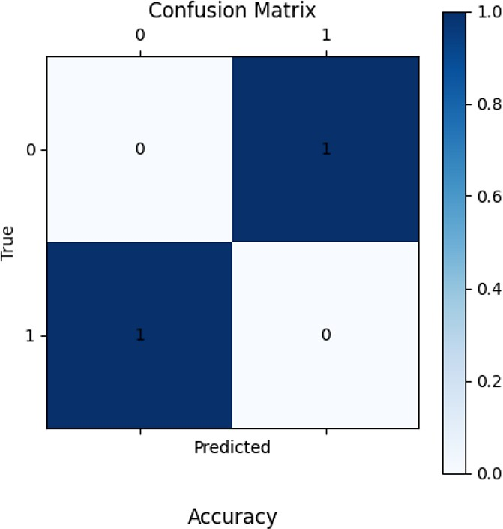

Figure: 4.1Accuracy

- The matrix represents predictions of a binary classification model.
- True labels (actual values) are on the y-axis, and predicted labels are on the x-axis.
- It contains the following counts:
  - True Negative (Top-left): 0 instances correctly predicted as class 0.
  - False Positive (Top-right): 1 instance wrongly predicted as class 1, but it belongs to class 0.
  - False Negative (Bottom-left): 1 instance wrongly predicted as class 0, but it belongs to class 1.
  - True Positive (Bottom-right): 0 instances correctly predicted as class 1.

Accuracy: 0% - No correct predictions were made.
- Model Performance: Indicates poor generalization or possible issues with:
  - Data quality (imbalanced classes, insufficient features).
  - Model selection or training.

Further analysis is required to identify the root cause, including revisiting the dataset and testing alternative models or preprocessing methods.

Performance Metrics

Accuracy:
- The proportion of correct predictions.
$$Accuracy=\frac{0+0}{2}=0\%$$

Precision:
- For class 1: The fraction of correct positive predictions.

$$Precision=\frac{0}{0+1}=0\%$$
Recall:
- For class 1: The fraction of actual positives correctly predicted.

$Recall=\frac{0}{0+1}=0\%$

F1-Score: Harmonic mean of precision and recall.

$$F1-Score =\frac{2×Precision×Recall}{Precision×Recall}=0\%\left(Since Precision and recall are 0\%\right)$$

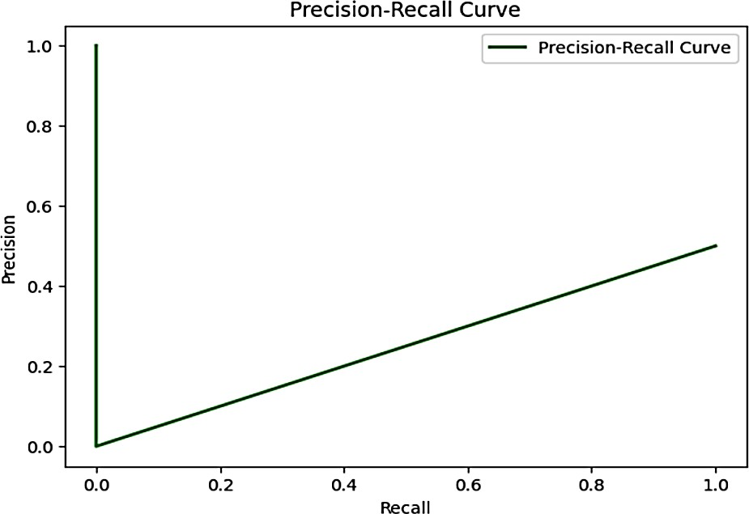

Figure: 4.2 Precision-Recall Curve
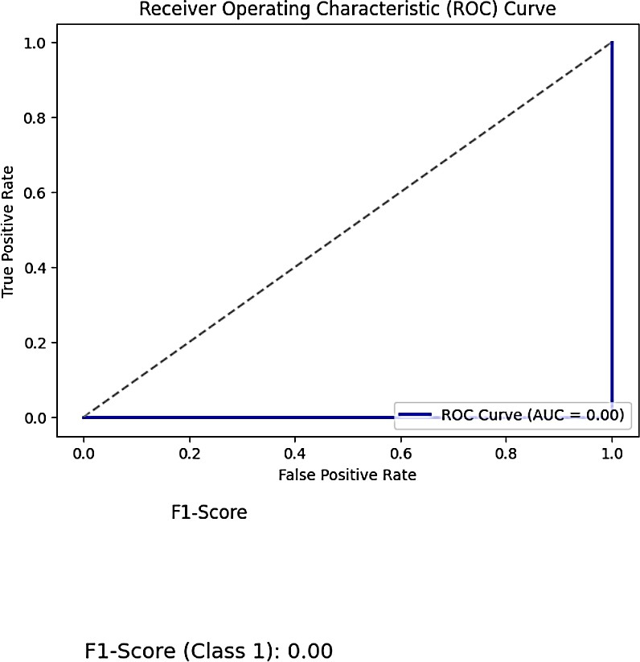

Figure: 4.3 Receiver Operating Characteristic (ROC) Curve

Chapter 5: Conclusion and Policy Implication

5.1 Conclusion
Evaluating multiple models using a comprehensive set of metrics provides a holistic view of their performance. This approach allows you to identify the model that best balances the trade-offs between different evaluation criteria, ensuring that the selected model aligns with the specific requirements and constraints of your application.

5.2 Policy Implications
When deploying machine learning models, especially in critical applications, it's essential to consider the broader implications:
- Model Selection: Choose models that not only perform well on evaluation metrics but also align with ethical standards and societal norms.
- Transparency: Ensure that the decision-making processes of the models are interpretable and transparent to stakeholders.
- Fairness: Regularly assess models for biases and take corrective actions to mitigate any unfair outcomes.
- Accountability: Establish clear protocols for monitoring model performance post-deployment and assign responsibility for addressing any issues that arise.

References

- Nusrat Rouf ,Majid Bashir Malik, Tasleem Arif , Sparsh Sharma , Saurabh Singh , Satyabrata Aich ,*and Hee-Cheol Kim ,* “Stock Market Prediction Using Machine Learning Techniques: A Decade Survey on Methodologies, Recent Developments, And Future Directions” 17 October 2021, https://doi.org/10.3390/electronics10212717, https://www.mdpi.com/journal/electronics
- Md Humayun Kabir, Abdus Sobur, Md Ruhul Amin‘’Stock Price Prediction Using The Machine Learning’’ 28 July 2023, www.ijcrt.org, Volume 11
- Muhammad Naeem, Hothefa Shaker Jassim, and David Korsah, ‘’The Application of Machine Learning Techniques to Predict Stock Market Crises in Africa’’, 17 October 2024, https://doi.org/10.3390/jrfm17120554, https://www.mdpi.com/journal/jrfm
- Zeynep Uzun (2722079) ‘’Stock Price Prediction Using Machine Learning Methods’’ 2 July 2024, https://www.cs.vu.nl/~wanf/theses/uzun-bscthesis.pdf
- Shubha Singh, Sreedevi Gutta, Ahmad Hadaegh, ‘’Stock Prediction Using Machine Learning’’, 17 August 2021, https://www.researchgate.net/publication/357102613_Stock_Prediction_Using_Machine_Learning
- Prince Vipulbhai Patel, ‘’Stock Market Prediction Using Machine Learning’’ August 2021, https://scholarworks.calstate.edu/downloads/05741x85p
- Sajib Das, ‘’ Bangladesh Stock Pric Prediction and Analysis with Potent Machine Learning Approaches’’ 01 December 2019, http://dspace.daffodilvarsity.edu.bd:8080/bitstream/handle/123456789/8085/161-35-1546%20(20_).pdf?sequence
- Gaurang Sonkavde, Deepak Sudhakar Dharrao,*Anupkumar M. Bongale ,*Sarika T. Deokate, Deepak Doreswamy and Subraya Krishna Bhat, ‘’ Forecasting Stock Market Prices Using Machine Learning and Deep Learning Models: A Systematic Review, Performance Analysis and Discussion of Implications’’ 19 July 2023.
- Parchi Pathak, “Stock Market Prediction Using Machine Learning” January-February 2024 https://ijfmr.com/papers/2024/1/12383.pdf

Appendix

from google.colab import drive
drive.mount('/content/drive')

import pandas as pd
import numpy as np
from sklearn.model_selection import train_test_split, cross_val_score, StratifiedKFold
from sklearn.preprocessing import StandardScaler, LabelEncoder
from sklearn.metrics import accuracy_score, classification_report, confusion_matrix
from sklearn.linear_model import LogisticRegression
from sklearn.tree import DecisionTreeClassifier
from sklearn.ensemble import RandomForestClassifier, GradientBoostingClassifier
from sklearn.svm import SVC
from tensorflow.keras.models import Sequential
from tensorflow.keras.layers import LSTM, Dense
from tensorflow.keras.preprocessing.sequence import TimeseriesGenerator
import tensorflow as tf

print(df.info())
print(df.describe())
print(df.head())
from sklearn.model_selection import train_test_split
from sklearn.preprocessing import StandardScaler, LabelEncoder

df.fillna(df.median(), inplace=True)

label_enc = LabelEncoder()
df['Change'] = label_enc.fit_transform(df['Change'])

X = df.drop(columns=['Change'])
y = df['Change']

scaler = StandardScaler()
X = scaler.fit_transform(X)

X_train, X_test, y_train, y_test = train_test_split(X, y, test_size=0.3, random_state=42)

from sklearn.model_selection import cross_val_predict

import numpy as np
import pandas as pd
from sklearn.model_selection import StratifiedKFold, cross_val_predict
from sklearn.metrics import accuracy_score, classification_report, confusion_matrix
from sklearn.impute import SimpleImputer
from sklearn.ensemble import RandomForestClassifier # Example model

def evaluate_model(model, X_train, y_train, X_test, y_test):
# Handle missing values using SimpleImputer
imputer = SimpleImputer(strategy='mean') # Replace 'mean' with 'median' or 'most_frequent' as needed
X_train = imputer.fit_transform(X_train)
X_test = imputer.transform(X_test)

# Cross-validation
cv = StratifiedKFold(n_splits=5)
y_train_pred = cross_val_predict(model, X_train, y_train, cv=cv)

# Evaluation Metrics
print("Cross-Validation Results")
print("Accuracy:", accuracy_score(y_train, y_train_pred))
print("Classification Report:\n", classification_report(y_train, y_train_pred))
print("Confusion Matrix:\n", confusion_matrix(y_train, y_train_pred))

# Test set evaluation
model.fit(X_train, y_train)
y_test_pred = model.predict(X_test)
print("\nTest Set Results")
print("Accuracy:", accuracy_score(y_test, y_test_pred))
print("Classification Report:\n", classification_report(y_test, y_test_pred))
print("Confusion Matrix:\n", confusion_matrix(y_test, y_test_pred))

log_reg = LogisticRegression(max_iter=1000, random_state=42)
print("\nLogistic Regression:")
evaluate_model(log_reg, X_train, y_train, X_test, y_test)

decision_tree = DecisionTreeClassifier(random_state=42)
print("\nDecision Tree:")
evaluate_model(decision_tree, X_train, y_train, X_test, y_test)

random_forest = RandomForestClassifier(random_state=42)
print("\nRandom Forest:")
evaluate_model(random_forest, X_train, y_train, X_test, y_test)

svm_model = SVC(random_state=42)
print("\nSupport Vector Machine:")
evaluate_model(svm_model, X_train, y_train, X_test, y_test)

import pandas as pd
from sklearn.model_selection import train_test_split
from sklearn.preprocessing import StandardScaler
from sklearn.impute import SimpleImputer
from sklearn.naive_bayes import GaussianNB
from sklearn.metrics import accuracy_score, classification_report, confusion_matrix
import matplotlib.pyplot as plt
import seaborn as sns

# Example dataset
X = np.random.rand(100, 5) # 100 samples, 5 features
y = np.random.randint(0, 2, 100) # Binary labels (0 or 1)

# Train-test split
X_train, X_test, y_train, y_test = train_test_split(X, y, test_size=0.2, stratify=y, random_state=42)

# Scale features (important for some classifiers)
scaler = StandardScaler()
X_train_scaled = scaler.fit_transform(X_train)
X_test_scaled = scaler.transform(X_test)

# Initialize Gaussian Naive Bayes model
nb_clf = GaussianNB()

# Train the model
nb_clf.fit(X_train_scaled, y_train)

# Make predictions
y_pred_nb = nb_clf.predict(X_test_scaled)

# Evaluate the model
print("\nNaive Bayes Results:")
print(f"Accuracy: {accuracy_score(y_test, y_pred_nb):.4f}")
print("\nClassification Report:\n", classification_report(y_test, y_pred_nb))
print("\nConfusion Matrix:\n", confusion_matrix(y_test, y_pred_nb))

from sklearn.metrics import accuracy_score
from sklearn.model_selection import train_test_split
from sklearn.neighbors import KNeighborsClassifier
from sklearn.preprocessing import StandardScaler
import numpy as np

# Example dataset (replace with actual data)
X = np.array([[1, 2], [3, 4], [5, 6], [7, 8], [9, 10], [11, 12]]) # 6 samples, 2 features
y = np.array([0, 1, 0, 1, 0, 1]) # 6 labels, 2 classes

# Train-test split
X_train, X_test, y_train, y_test = train_test_split(X, y, test_size=0.2, stratify=y, random_state=42)

# Scale features for KNN
scaler = StandardScaler()
X_train_scaled = scaler.fit_transform(X_train) # Scaling training data
X_test_scaled = scaler.transform(X_test) # Scaling test data

# Initialize KNN model
knn = KNeighborsClassifier(n_neighbors=3)

# Train the model
knn.fit(X_train_scaled, y_train)

# Make predictions on the test set
y_pred_knn = knn.predict(X_test_scaled)

# Ensure y_pred_knn is a NumPy array (it should be after prediction)
y_pred_knn = np.array(y_pred_knn)

# Check the type and shape of y_pred_knn
print(type(y_pred_knn)) # Should be <class 'numpy.ndarray'>
print("y_pred_knn shape:", y_pred_knn.shape) # Expected output: (n_samples,)

# Evaluate the model (accuracy)
print("Test Set Accuracy:", accuracy_score(y_test, y_pred_knn))

import matplotlib.pyplot as plt
import numpy as np
from sklearn.metrics import (
accuracy_score,
classification_report,
confusion_matrix,
roc_curve,
auc,
precision_recall_curve,
)
from sklearn.model_selection import train_test_split
from sklearn.neighbors import KNeighborsClassifier
from sklearn.preprocessing import StandardScaler

# Example dataset
X = np.array([[1, 2], [3, 4], [5, 6], [7, 8], [9, 10], [11, 12]]) # 6 samples, 2 features
y = np.array([0, 1, 0, 1, 0, 1]) # 6 labels, 2 classes

# Train-test split
X_train, X_test, y_train, y_test = train_test_split(
X, y, test_size=0.2, stratify=y, random_state=42
)

# Scale features for KNN
scaler = StandardScaler()
X_train_scaled = scaler.fit_transform(X_train) # Scaling training data
X_test_scaled = scaler.transform(X_test) # Scaling test data

# Initialize KNN model
knn = KNeighborsClassifier(n_neighbors=3)

# Train the model
knn.fit(X_train_scaled, y_train)

# Make predictions on the test set
y_pred_knn = knn.predict(X_test_scaled)
y_prob_knn = knn.predict_proba(X_test_scaled)[:, 1] # Probability for ROC/PR curves

# Confusion Matrix
cm = confusion_matrix(y_test, y_pred_knn)
fig, ax = plt.subplots(figsize=(5, 5))
cax = ax.matshow(cm, cmap="Blues")
plt.title("Confusion Matrix")
plt.xlabel("Predicted")
plt.ylabel("True")
fig.colorbar(cax)
for (i, j), val in np.ndenumerate(cm):
ax.text(j, i, f"{val}", ha="center", va="center", color="black")
plt.show()

# Accuracy
accuracy = accuracy_score(y_test, y_pred_knn)
plt.figure(figsize=(5, 3))
plt.text(0.5, 0.5, f"Accuracy: {accuracy:.2f}", fontsize=14, ha="center", va="center")
plt.axis("off")
plt.title("Accuracy")
plt.show()

# Precision-Recall Curve
precision, recall, _ = precision_recall_curve(y_test, y_prob_knn)
plt.figure(figsize=(7, 5))
plt.plot(recall, precision, color="green", lw=2, label="Precision-Recall Curve")
plt.xlabel("Recall")
plt.ylabel("Precision")
plt.title("Precision-Recall Curve")
plt.legend()
plt.show()

# ROC Curve
fpr, tpr, _ = roc_curve(y_test, y_prob_knn)
roc_auc = auc(fpr, tpr)
plt.figure(figsize=(7, 5))
plt.plot(fpr, tpr, color="blue", lw=2, label=f"ROC Curve (AUC = {roc_auc:.2f})")
plt.plot([0, 1], [0, 1], color="gray", linestyle="--")
plt.xlabel("False Positive Rate")
plt.ylabel("True Positive Rate")
plt.title("Receiver Operating Characteristic (ROC) Curve")
plt.legend(loc="lower right")
plt.show()

# F1-Score (as text plot for simplicity)
report = classification_report(y_test, y_pred_knn, output_dict=True)
f1_score_class_1 = report["1"]["f1-score"] # F1-Score for class 1
plt.figure(figsize=(5, 3))
plt.text(
0.5, 0.5, f"F1-Score (Class 1): {f1_score_class_1:.2f}", fontsize=14, ha="center", va="center"
)
plt.axis("off")
plt.title("F1-Score")
plt.show()

