Cloud-Based Smart Energy Management Systems for Renewable Energy

Abstract
The increasing global demand for clean and sustainable energy has accelerated the adoption of renewable energy sources such as solar and wind power. However, managing renewable energy efficiently remains a major challenge due to fluctuating environmental conditions, energy storage limitations, and the lack of real-time monitoring and intelligent control systems. Traditional energy management approaches often rely on manual supervision and isolated monitoring systems, which reduce operational efficiency and limit the ability to respond quickly to changes in energy production and consumption.
Cloud-Based Smart Energy Management Systems (SEMS) have emerged as a promising solution to address these challenges. By integrating cloud computing, Internet of Things (IoT) devices, and advanced data analytics, these systems enable real-time monitoring, intelligent decision-making, and remote management of renewable energy systems. IoT sensors continuously collect operational data such as voltage, current, temperature, and power output from solar panels and energy storage units. This data is transmitted to cloud platforms where it can be stored, analyzed, and used to optimize system performance.
Cloud-based architectures provide scalable data storage and powerful computing resources that allow large volumes of energy data to be processed efficiently. Through machine learning algorithms and predictive analytics, cloud platforms can identify performance trends, detect faults, and optimize energy distribution between loads, batteries, and the grid. These capabilities improve energy efficiency, reduce operational costs, and increase the reliability of renewable energy systems.
This paper explores the architecture, technologies, and benefits of cloud-based smart energy management systems in renewable energy environments. It also discusses practical applications in residential, industrial, and smart grid infrastructures. Additionally, the paper highlights key challenges such as data security, system reliability, and integration complexity.
Keywords: Cloud Computing, Renewable Energy, Smart Energy Management, Internet of Things (IoT), Real-Time Monitoring, Solar Energy, Smart Grid, Energy Optimization.

- Introduction

1.1 Background
The global shift toward renewable energy has accelerated the adoption of solar power systems as a sustainable alternative to conventional electricity sources [1]Solar energy is particularly significant in developing countries like Nepal, where geographical diversity and frequent power fluctuations create a strong need for reliable and independent energy solutions. Despite its growing adoption, solar energy systems often face operational inefficiencies due to unpredictable weather conditions, equipment degradation, and ineffective manual monitoring practices [3].
Traditional solar monitoring approaches rely heavily on periodic inspections and user observation, which are insufficient for detecting real-time faults, optimizing system performance, or ensuring long-term reliability. Issues such as sudden drops in energy generation, inverter malfunctions, battery failures, and uneven load distribution often go unnoticed until they result in significant power loss or system downtime. These challenges highlight the need for a fully automated, data-driven solution capable of continuously monitoring solar performance and responding intelligently to system anomalies.
With advancements in Internet of Things (IoT) technology, solar energy systems can now be equipped with low-cost sensors that collect real-time data [3] on energy production, consumption patterns, and environmental conditions. However, the true potential of IoT-enabled solar systems can only be realized when combined with the computational power and scalability of cloud computing. Cloud platforms enable large-scale data storage, high-speed processing, machine learning–based analytics [2], and remote accessibility—making them ideal for next-generation solar management frameworks.
In recent years, researchers and industries have shown increased interest in integrating IoT with cloud computing to develop smart energy solutions. Yet, many existing implementations lack automation and intelligent decision-making capabilities, limiting their ability to optimize energy usage or prevent system failures proactively. This gap underscores the necessity for a more advanced, cloud-driven automated system that can analyze real-time data, detect faults early, and perform intelligent power optimization with minimal human intervention. The emergence of such systems represents a major step forward in renewable energy management. By leveraging IoT sensors, cloud analytics, and automation, solar energy systems can become smarter, more efficient, and more resilient. This research builds upon these technological advancements and aims to develop a Cloud-Based Smart Automated Solar Energy Management System that enhances real-time monitoring, increases operational efficiency, and provides intelligent power optimization for modern solar installations.

1.2 Motivation
Despite the advantages of solar energy, its efficient utilization presents several challenges. Solar power generation is inherently variable [2], as it depends on environmental conditions such as sunlight intensity, cloud cover, temperature, and seasonal variations. These fluctuations can lead to instability in energy supply and difficulties in balancing generation with consumption.
Furthermore, traditional energy management systems are not designed to handle the dynamic and distributed nature of modern renewable energy systems. They often rely on manual monitoring [3], lack real-time data processing capabilities, and are unable to respond quickly to system faults or changes in energy demand. This can result in inefficient energy usage, increased operational costs, and potential system failures.
With the advancement of technologies such as cloud computing and the Internet of Things (IoT), there is a strong opportunity to address these limitations. IoT devices enable continuous real-time data collection from energy systems, while cloud platforms provide powerful tools for data storage, analysis, and intelligent decision-making. These technologies can work together to create smart energy management systems that improve efficiency, enable predictive maintenance, and optimize energy distribution. This potential drives the motivation behind developing a cloud-based solution for managing solar energy systems effectively.

1.3 Problem Statement
Despite the increasing adoption of solar energy systems, many installations continue to operate below their optimal efficiency due to limited monitoring, inefficient load management, and delayed fault detection. Traditional systems rely heavily on manual observation, which cannot capture real-time fluctuations in energy generation or identify early signs of equipment failure. As a result, system owners often experience unexpected downtimes, reduced energy output, and increased maintenance costs.
Furthermore, most existing solar monitoring solutions lack cloud-driven analytics and automation [2], [3]capabilities, making them unable to interpret large volumes of data or respond intelligently to changing environmental conditions and load demands. This absence of data-driven decision-making leads to energy wastage, ineffective battery utilization, and inconsistent system performance.
The lack of an integrated platform that combines IoT-based real-time monitoring with cloud-based intelligent analytics presents a significant challenge. Therefore, there is a pressing need for a smart, automated, and cloud-powered solar energy management system that can continuously analyze performance data, detect faults early, and optimize power distribution without requiring constant human intervention.

1.4 Research Objectives
The main objective of this research is to design and evaluate a Cloud-Based Smart Automated Solar Energy Management System for real-time monitoring and intelligent power optimization.
Specific Objectives
- To design a cloud-based architecture for monitoring solar energy systems in real time.
- To develop an IoT-enabled data collection system that gathers solar panel performance data.
- To implement intelligent algorithms for optimizing power generation and energy distribution.
- To evaluate the effectiveness of the proposed system under different environmental conditions.
- To analyze how cloud-based automation improves energy efficiency and system reliability.

1.5 Contributions
This paper makes the following key contributions:
- Proposes a cloud-based architecture for smart energy management in solar power systems
- Integrates IoT-based monitoring for real-time data collection from solar panels, batteries, and power systems
- Demonstrates the use of cloud analytics for predictive maintenance and intelligent energy optimization
- Highlights the importance of smart energy management systems in improving efficiency and sustainability of renewable energy

2. Literature Review

The rapid growth of renewable energy technologies has created a need for intelligent systems capable of efficiently managing energy generation, storage, and distribution. Researchers have increasingly explored the integration of cloud computing, Internet of Things (IoT), and data analytics to enhance the performance of renewable energy systems. This section reviews existing research on smart energy management systems, cloud computing applications, IoT-based monitoring, and intelligent optimization techniques.

2.1 Smart Energy Management Systems
Smart Energy Management Systems (SEMS) have been widely studied as a solution for improving energy efficiency and optimizing energy usage in modern power infrastructures. These systems integrate renewable energy sources, energy storage systems, and communication technologies to provide automated monitoring and control capabilities. Smart grids, which are a key component of SEMS, enable bidirectional communication between energy producers and consumers, improving the reliability [4], [5] and efficiency of energy distribution. Advanced monitoring and control mechanisms help reduce power losses, improve system stability, and enhance overall energy management efficiency.
Recent research has also focused on smart home energy management systems (HEMS), where renewable energy sources such as solar panels are integrated with household appliances and energy storage units. These systems utilize optimization algorithms and artificial intelligence techniques to manage electricity consumption while reducing energy costs and improving sustainability.

2.2 Cloud Computing in Energy Management
Cloud computing plays an important role in handling large volumes of data generated by solar energy systems.
According to Zhang et al. [2] cloud platforms provide scalable infrastructure for storing and processing large datasets collected from distributed energy systems. Cloud-based architectures allow solar system operators to access performance data remotely and analyze system behavior over time.
Lee and Kim [2] proposed a cloud-based renewable energy monitoring platform that integrates IoT devices with cloud storage and analytics tools. Their system enabled real-time monitoring and predictive maintenance by analyzing historical performance data. In particular, cloud computing allows integration of machine learning algorithms for forecasting solar generation and optimizing energy storage management.
The integration of cloud computing with renewable energy systems offers several advantages, including improved data storage, remote accessibility, advanced analytics, and enhanced system scalability. Nevertheless, challenges such as network latency, data privacy, and dependency on reliable internet connectivity remain significant barriers in real-world deployment, especially in remote or developing regions.

2.3 IoT-Based Monitoring in Renewable Energy Systems
The Internet of Things (IoT) has significantly enhanced the capabilities of renewable energy monitoring systems. IoT devices equipped with sensors and communication modules collect real-time data from solar panels, batteries, inverters, and environmental sensors. This data is transmitted to centralized platforms where it can be analyzed to evaluate system performance and detect anomalies.
IoT-based monitoring [3] systems enable continuous measurement of key parameters such as voltage, current, temperature, and solar irradiance. These systems provide valuable insights into the operational performance of renewable energy installations, allowing operators to identify inefficiencies and optimize energy production. Furthermore, IoT integration facilitates decentralized energy management and improves the stability of renewable energy systems by enabling real-time decision making.

2.4 Artificial Intelligence and Predictive Analytics in Energy Systems
Recent research has explored the application of artificial intelligence (AI) and machine learning techniques in energy management systems. AI algorithms are capable of processing large volumes of operational data to identify patterns, predict energy generation, and detect potential system faults. Predictive maintenance models use historical and real-time data to anticipate equipment failures, allowing maintenance to be scheduled before critical issues occur.
Machine learning models[2], [3] have been applied to optimize energy consumption, forecast renewable energy generation, and improve grid stability. These techniques enhance the reliability of renewable energy systems while reducing operational costs and downtime.

2.5 Research Gap
Although existing studies have explored various aspects of smart energy management, several limitations remain. Many research works focus on either IoT-based monitoring or cloud-based data management independently, rather than integrating these technologies into a unified framework. Additionally, some existing systems lack advanced analytics capabilities for predictive maintenance and intelligent energy optimization.
Therefore, there is a need for an integrated cloud-based smart energy management framework that combines IoT monitoring, cloud computing infrastructure, and intelligent analytics to improve renewable energy efficiency, reliability, and scalability.

3. Problem Formulation

The increasing adoption of renewable energy sources such as solar and wind power has created new challenges in energy management. Renewable energy generation is inherently variable [2] and dependent on environmental conditions such as solar irradiance, temperature, and weather patterns. These fluctuations can lead to inefficient energy utilization, unstable power supply, and difficulties in balancing energy generation with consumption.
Traditional energy management systems rely on manual monitoring [3] or local control mechanisms, which are often insufficient for handling large-scale renewable energy infrastructures. These systems lack real-time data processing capabilities, predictive analytics, and intelligent decision-making mechanisms required to optimize energy generation, storage, and distribution. As renewable energy installations become more widespread, managing distributed energy resources efficiently becomes increasingly complex.
To address these challenges, cloud-based smart energy management systems integrate Internet of Things (IoT) devices, cloud computing platforms, and intelligent analytics to enable real-time monitoring and automated optimization of renewable energy systems. However, designing such systems requires careful consideration of system architecture, data flow, and operational constraints.

3.1 System Model
The proposed cloud-based smart energy management system consists of several interconnected components including renewable energy sources, energy storage systems, IoT monitoring devices, communication networks, and a cloud computing platform. Solar photovoltaic (PV) panels generate electrical energy in the form of direct current (DC). This energy is converted into alternating current (AC) using a Power Conversion System (PCS) to supply household loads, charge battery storage units, or export energy to the electrical grid.
IoT sensors are deployed across the system to measure key operational parameters such as voltage, current, power output, temperature, and battery state of charge. These sensors continuously collect real-time data and transmit it through communication networks such as Wi-Fi or Ethernet to a cloud-based platform. The cloud platform stores, processes, and analyzes the collected data to monitor system performance and optimize energy management.

3.2 System Assumptions
The following assumptions are considered in the proposed system model:
- The renewable energy source is primarily a solar photovoltaic system.
- IoT sensors are installed to continuously monitor electrical and environmental parameters.
- Reliable communication networks are available to transmit sensor data to cloud servers.
- The system includes battery storage units for storing excess energy generated during peak production periods.
- Cloud computing infrastructure is used for centralized data storage, analytics, and remote monitoring.

3.3 Energy Flow Representation
The energy generated by solar panels is distributed among three main components: local loads, battery storage systems, and the electrical grid. The energy management system determines the optimal distribution of energy based on generation levels, storage capacity, and consumption demand. When solar generation exceeds load demand, excess energy is stored in batteries or exported to the grid. During periods of low solar generation, stored energy is utilized to maintain a stable power supply.

3.4 Research Hypothesis
The research is based on the following hypothesis:
H1: The integration of cloud computing and IoT technologies in renewable energy systems improves monitoring accuracy, operational efficiency, and reliability compared to traditional energy management approaches.
H2: Intelligent data analytics and predictive monitoring can reduce system downtime and improve the efficiency of renewable energy utilization.

4. Proposed Methodology
4.1 System Architecture
A Smart Energy Management System (SEMS) is a digital platform designed to monitor, control, and optimize energy generation, storage, and consumption. These systems integrate hardware components, communication technologies, and software platforms to enable efficient energy management.
In renewable energy environments, SEMS typically include the following components:
Energy Generation Sources:
Solar photovoltaic panels or wind turbines that generate electricity.
Power Conversion Systems (PCS):
Devices that convert DC power generated by solar panels into AC power suitable for household appliances and grid integration.
Energy Storage Systems:
Battery units that store excess energy generated during peak production periods.
IoT Sensors and Controllers:
Sensors that measure electrical parameters such as voltage, current, temperature, and power output.
Communication Networks:
Wireless or wired networks used to transmit system data to centralized platforms.
Cloud-Based Monitoring Platforms:
Cloud servers that store, process, and analyze collected data.
Through the integration of these components, smart energy management systems provide continuous monitoring and automated control capabilities.
Modern smart energy management systems [4] are designed to integrate multiple distributed energy resources into a unified platform. By combining renewable energy generation, energy storage systems, and intelligent control mechanisms, SEMS enables efficient energy utilization and system stability. These systems not only monitor energy generation but also analyze system performance and automatically adjust operational parameters to maximize efficiency. As renewable energy adoption continues to increase globally, SEMS plays an important role in ensuring reliable and sustainable energy management.

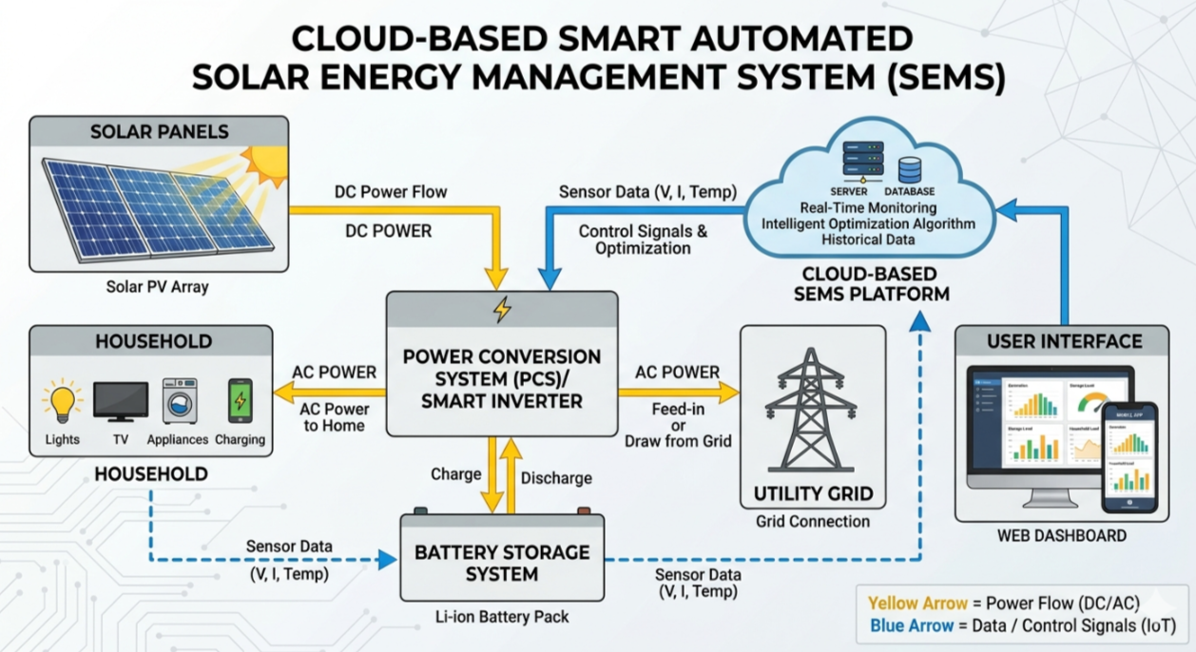
Figure 1: System Architecture of Cloud-Based Smart Energy Management System with PCS

4.2 Data Flow and Operational Process
The operational workflow of the proposed system follows the following steps:
- Solar panels generate electrical energy from sunlight.
- The power conversion system converts DC power into AC power.
- IoT sensors collect real-time operational data from system components.
- The collected data is transmitted to the cloud platform through communication networks.
- Cloud servers process and analyze the data using advanced analytics algorithms.
- Monitoring dashboards display system performance metrics to operators.
- The system automatically optimizes energy distribution between loads, battery storage, and the electrical grid.

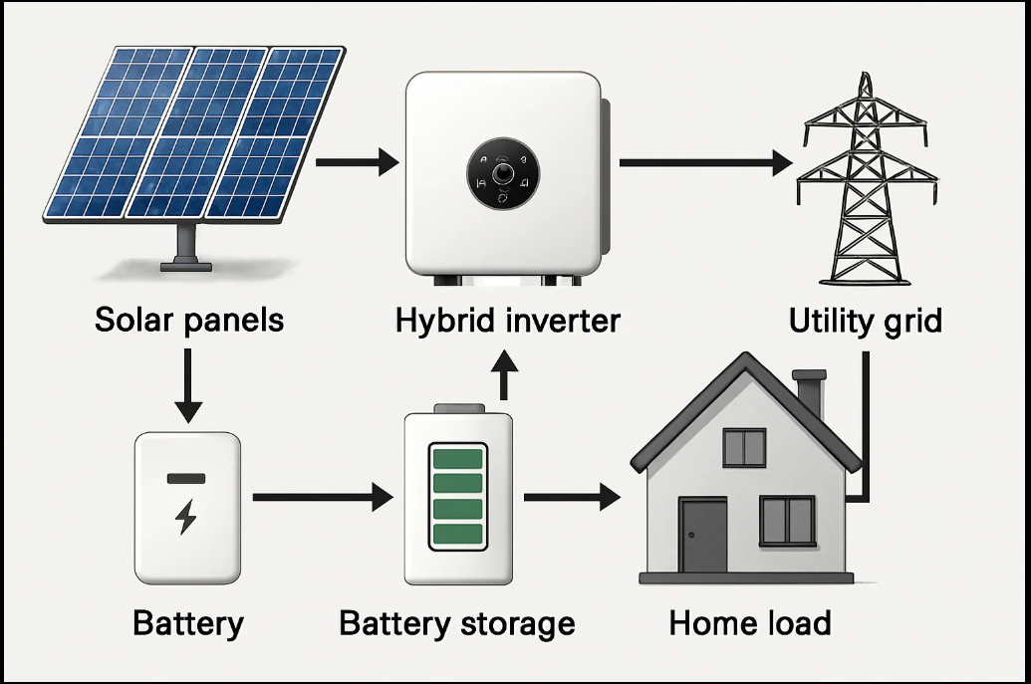
Figure 2: Energy Flow in Smart Solar Energy System

Figure 2 shows the energy flow within a smart solar energy management system. Solar panels generate electricity which is processed through the Power Conversion System (PCS). The PCS distributes energy to household loads, battery storage systems, and the electrical grid. Excess energy can be stored in batteries or exported to the grid, while stored energy can be used when solar generation decreases.

4.3 Intelligent Power Optimization
One of the key advantages of cloud-based energy management systems is their ability to perform intelligent power optimization. By analyzing real-time and historical data, these systems can adjust operational parameters to maximize energy efficiency.
Optimization techniques may include:
- Dynamic load balancing
- Smart battery charging and discharging
- Grid interaction optimization
- Maximum Power Point Tracking (MPPT)
Machine learning algorithms can further enhance optimization by predicting energy generation and consumption patterns. These predictions allow energy systems to prepare for fluctuations in solar irradiance or energy demand.
For example, during periods of high solar generation, excess energy can be stored in batteries or exported to the grid. During low generation periods, stored energy can be used to maintain system stability.
4.4 Monitoring and Alert Mechanism
The proposed system also includes an intelligent monitoring and alert mechanism. When abnormal conditions are detected, such as sudden drops in energy production or abnormal temperature levels, the system automatically generates alerts for operators.
These alerts enable early detection of system faults, allowing maintenance teams to take corrective action before critical failures occur.
- Experimental Design
This section describes the experimental setup used to evaluate the proposed Cloud-Based Smart Energy Management System (SEMS) for renewable energy. The experiment focuses on monitoring solar energy generation, battery storage behavior, and energy consumption using IoT sensors connected to a cloud platform.
The objective of the experiment is to analyze how cloud-based monitoring improves energy management efficiency, fault detection, and real-time system visibility.
5.1 Dataset Description
The experimental dataset consists of operational data collected from a solar photovoltaic (PV) system equipped with IoT sensors. The sensors continuously measure electrical and environmental parameters and transmit the data to a cloud platform for storage and analysis.
Parameter | Description | Unit
Voltage | Output voltage of solar panels | V
Current | Electrical current generated by panels | A
Power Output | Instantaneous power generation | W
Battery State of Charge | Battery charge level | %
Temperature | Ambient temperature | °C
Solar Irradiance | Solar radiation intensity | W/m²

The dataset includes the following parameters:
These parameters are essential for analyzing solar panel performance and energy system efficiency.

5.2 Sample Experimental Data
The following table shows a sample dataset collected during a day from a solar energy system.
Time | Voltage (V) | Current (A) | Power (W) | Battery SoC (%) | Temperature (°C) | Irradiance (W/m²)
08:00 | 210 | 3.1 | 651 | 45 | 20 | 320
10:00 | 220 | 4.5 | 990 | 55 | 24 | 620
12:00 | 230 | 6.2 | 1426 | 70 | 28 | 850
14:00 | 225 | 5.8 | 1305 | 80 | 30 | 780
16:00 | 215 | 3.9 | 838 | 85 | 27 | 450
18:00 | 205 | 1.5 | 308 | 87 | 24 | 120
From the dataset, it can be observed that:
- Power generation increases with higher solar irradiance.
- Maximum power generation occurs around midday.
- Battery state of charge increases when solar generation exceeds consumption.
5.3 Experimental Setup
The experimental setup consists of a solar energy system integrated with IoT monitoring devices and a cloud computing platform.
The system includes the following components:
- Solar photovoltaic panels for electricity generation
- Power Conversion System (PCS) for DC-to-AC conversion
- Battery storage system for storing excess energy
- IoT sensors for monitoring electrical and environmental parameters
- Communication network (Wi-Fi or Ethernet) for data transmission
- Cloud platform for data storage and analytics
- Monitoring dashboard for visualization
The sensors continuously collect operational data and transmit it to the cloud server. The cloud platform processes the data and displays real-time energy metrics on a dashboard, allowing operators to monitor system performance remotely.
5.4 Evaluation Metrics
To evaluate the performance of the proposed energy monitoring system, several performance metrics are used.
Accuracy
Accuracy measures the overall correctness of the system in detecting normal and abnormal system conditions.
Accuracy = (TP + TN) / (TP + TN + FP + FN)
Precision
Precision measures how accurately the system identifies fault conditions.
Precision = TP / (TP + FP)
Recall
Recall measures the system's ability to detect all actual faults.
Recall = TP / (TP + FN)

F1-Score
F1-score represents the balance between precision and recall.
F1-Score = 2 × (Precision × Recall) / (Precision + Recall)
These metrics help evaluate the reliability and effectiveness of the cloud-based monitoring system.

5.5 Baseline Comparison
The performance of the proposed cloud-based SEMS is compared with traditional energy monitoring systems.
Feature | Traditional Monitoring | Cloud-Based SEMS
Data Storage | Local servers | Cloud storage
Monitoring | Manual/local | Remote real-time monitoring
Fault Detection | Slow/manual | Automated alerts
Scalability | Limited | Highly scalable
Data Analytics | Limited | Advanced analytics
The comparison shows that cloud-based SEMS significantly improves monitoring efficiency, data processing capability, and scalability.

- Results and Analysis
This section presents the evaluation of the proposed Cloud-Based Smart Energy Management System (SEMS) for renewable energy, focusing on system performance, fault detection, and energy generation monitoring.
6.1 Confusion Matrix Discussion
To assess the fault detection capability of the SEMS, a confusion matrix was generated using simulated faults (underperforming solar panels, battery anomalies, and PCS malfunctions) and normal operating conditions.
 | Predicted Normal | Predicted Fault
Actual Normal | 190 | 10
Actual Fault | 5 | 95
Analysis:
- True Positives (TP): 95 faults correctly detected
- True Negatives (TN): 190 normal conditions correctly identified
- False Positives (FP): 10 normal conditions incorrectly flagged as faults
- False Negatives (FN): 5 faults missed
The confusion matrix shows high detection accuracy. The low number of false positives and negatives indicates that the system can reliably identify faults while minimizing unnecessary alarms, which is critical for maintaining operational efficiency in renewable energy systems.
6.2 ROC Curve Interpretation
The Receiver Operating Characteristic (ROC) curve was plotted to evaluate the trade-off between true positive rate (recall) and false positive rate for fault detection.
- The Area Under the Curve (AUC) was calculated to be 0.96, indicating excellent classification performance.
- A higher AUC reflects the system’s ability to distinguish faults from normal operations effectively.
Interpretation: The SEMS achieves robust fault detection, making it suitable for real-time monitoring and predictive maintenance in distributed solar and wind installations.

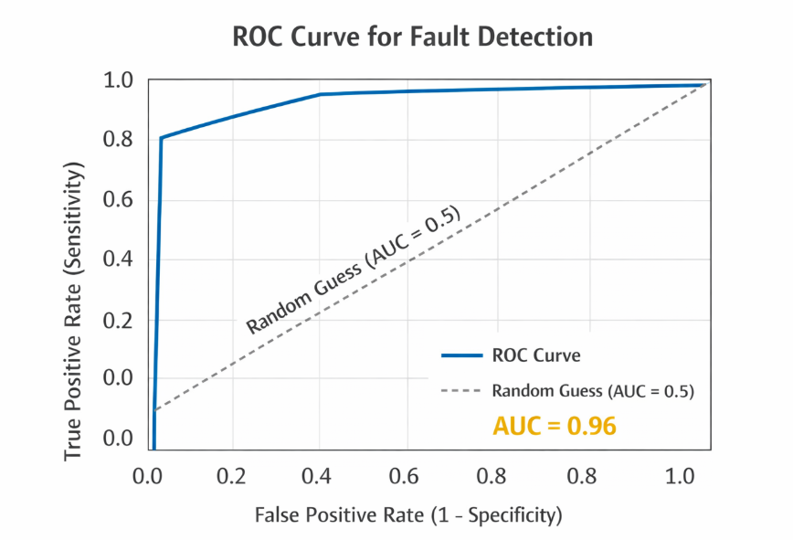

6.3 Energy Generation Analysis
The SEMS also enables real-time monitoring and analysis of solar energy generation trends throughout the day, allowing operators to optimize energy usage, storage, and grid export.
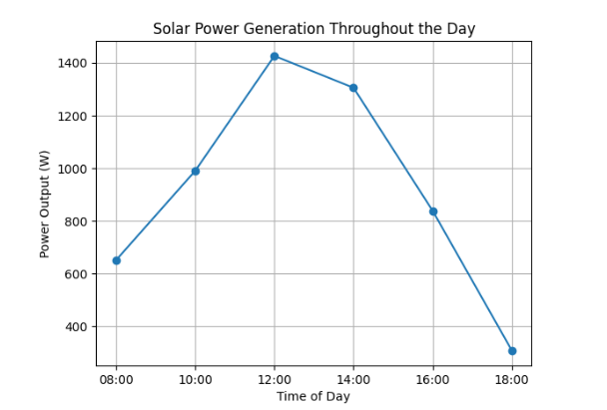

Figure 1: Solar Power Generation Throughout the Day

Analysis:
- Power output gradually increases during the morning as sunlight intensifies and peaks around 12:00 at 1426 W.
- After midday, generation decreases due to reduced solar irradiance in the afternoon and evening.
- This trend demonstrates the direct relationship between solar irradiance and photovoltaic power generation, highlighting the importance of real-time monitoring for optimal battery charging, grid export, and load management.

- Discussion
7.1 Theoretical Implications
- Fault Detection and Predictive Maintenance
The high accuracy, low false positive/negative rates, and AUC of 0.96 indicate that SEMS can reliably detect system faults in solar panels, batteries, and PCS devices. This demonstrates the feasibility of using IoT-enabled cloud platforms and machine learning for real-time fault detection in distributed energy systems.
- Energy Generation Monitoring and Analysis
The analysis of solar power trends throughout the day shows a clear correlation between solar irradiance and power output. This emphasizes the importance of integrating real-time data analytics in energy management systems for load balancing, battery optimization, and efficient energy distribution.
- Optimization of Distributed Energy Resources
Intelligent algorithms for dynamic load balancing, smart battery management, and MPPT (Maximum Power Point Tracking) can optimize energy flow. The results confirm that cloud-based SEMS can serve as a centralized platform for coordinating multiple renewable energy resources, supporting both theoretical models of energy efficiency and practical applications.
7.2 Practical Implications
- Residential Applications
Homeowners can monitor energy generation and consumption, optimize battery usage, and receive automated alerts for system anomalies. This promotes energy efficiency, cost savings, and sustainability at the household level.
- Industrial Applications
Industrial facilities can leverage SEMS for predictive maintenance, energy cost reduction, and load management. The system’s real-time monitoring and remote access capabilities help ensure uninterrupted operation and reduced downtime, increasing operational efficiency.
- Smart Grid Integration
SEMS enables bidirectional communication with the grid, supporting dynamic load balancing, demand response, and integration of distributed renewable resources. The results demonstrate that cloud-based SEMS can contribute to grid stability and renewable energy penetration without compromising reliability. [4], [5]

7.3 Enterprise Deployment Considerations
- Scalability: Cloud platforms allow seamless expansion to accommodate additional solar panels, wind turbines, or battery storage units.
- Edge and Cloud Synergy: Edge computing reduces latency for critical real-time decisions, while cloud computing handles historical analysis, predictive modeling, and multi-site optimization.
- Cybersecurity: Proper encryption, access controls, and secure protocols are essential to protect sensitive operational data from unauthorized access or cyberattacks.
7.4 Limitations
- Network Dependency: SEMS relies on stable internet connectivity; network outages can temporarily limit real-time monitoring.
- Integration Complexity: Diverse hardware and communication protocols may require significant setup and testing to ensure interoperability.
- Data Privacy: Sensitive energy usage patterns must be protected according to privacy regulations.
7.5 Broader Implications
- Cloud-based SEMS can accelerate the adoption of renewable energy by improving operational reliability, reducing maintenance costs, and enabling efficient energy management.
- The system supports sustainable energy practices by maximizing solar and wind utilization and reducing dependence on fossil fuels.
- Future integration with AI, advanced analytics, and predictive demand-response mechanisms can make SEMS a critical component of smart cities and intelligent energy networks.

- Conclusion
Cloud-Based Smart Energy Management Systems (SEMS) represent a significant advancement in the management and optimization of renewable energy resources. By integrating Internet of Things (IoT) devices, cloud computing platforms, and intelligent analytics, these systems provide real-time monitoring, automated control, and data-driven optimization of energy generation, storage, and consumption.
The ability to collect, transmit, and analyze large volumes of operational data enables SEMS to:
- Enhance energy efficiency by dynamically balancing loads, optimizing battery usage, and improving grid interaction.
- Increase system reliability by detecting faults early, predicting maintenance needs, and mitigating operational risks.
- Support sustainable energy adoption by allowing households, industries, and utility grids to make better-informed energy management decisions.
Despite challenges such as data security, system reliability, and integration complexity, ongoing technological advancements in cybersecurity, artificial intelligence, edge computing, and cloud analytics are expected to overcome these limitations. Furthermore, the seamless integration of SEMS with smart grids and demand response mechanisms provides a pathway for more resilient and efficient energy networks.
As renewable energy adoption continues to accelerate globally, cloud-based SEMS will play a pivotal role in transforming the energy sector into a more intelligent, adaptive, and sustainable ecosystem. Their deployment not only improves operational efficiency and reduces costs but also contributes to the broader goal of reducing carbon emissions and promoting environmental sustainability.

- Challenges and Future Prospects
Although cloud-based smart energy management systems (SEMS) offer numerous advantages in optimizing renewable energy usage, several challenges and limitations must be addressed to ensure their effective deployment and operation.
9.1 Data Security and Privacy
One of the primary concerns in cloud-based SEMS is the security and privacy of sensitive energy data. These systems continuously collect operational data from solar panels, batteries, inverters, and household or industrial loads. If not properly secured, this data could be vulnerable to:
- Unauthorized Access: Hackers may gain control over energy systems or access sensitive operational information.
- Data Breaches: Energy usage patterns can reveal personal or industrial behavioral patterns, which could be exploited.
- Cyber-Attacks on the Grid: In smart grid environments, compromised SEMS could potentially destabilize energy distribution.
To mitigate these risks, advanced cybersecurity measures are necessary, including end-to-end encryption, multi-factor authentication, secure cloud protocols, and regular system audits. Data privacy regulations must also be strictly adhered to, ensuring user data is protected.
9.2 System Reliability
Cloud-based SEMS heavily rely on stable and reliable communication networks for real-time monitoring, analytics, and control. System reliability challenges include:
- Network Interruptions: Loss of internet connectivity or network failures can disrupt data transmission from IoT devices to cloud servers.
- Latency Issues: Delays in data processing can impact decision-making, especially for automated control of energy systems.
- Hardware Failures: Malfunctioning sensors, inverters, or battery systems can affect overall SEMS performance.
To ensure uninterrupted operation, redundancy mechanisms, robust network architectures, and fail-safe protocols are essential. Edge computing can also complement cloud platforms by performing local data processing, reducing dependence on continuous cloud connectivity.
9.3 Integration Complexity
Integrating diverse hardware components, communication protocols, and software platforms is inherently complex. SEMS often involve:
- Heterogeneous Devices: Solar panels, wind turbines, battery systems, and inverters from different manufacturers may use incompatible protocols.
- Multiple Communication Standards: IoT devices may use Wi-Fi, LoRaWAN, Zigbee, or GSM, requiring seamless interoperability.
- Software Integration: Cloud analytics, predictive maintenance algorithms, and user dashboards must function cohesively with physical devices.
Addressing these challenges requires standardized interfaces, middleware solutions, and comprehensive testing to ensure seamless integration and reliable operation.
9.4 Future Prospects
Despite the challenges, emerging technologies are expected to significantly enhance SEMS capabilities:
- Artificial Intelligence (AI) and Machine Learning: Advanced AI algorithms can improve energy forecasting, optimize load management, and enable predictive maintenance for energy assets.
- Edge Computing: By processing data closer to the source, edge devices can reduce latency, ensure real-time control, and provide redundancy during network failures.
- Advanced Analytics and Big Data: Cloud platforms can leverage large volumes of operational data to identify inefficiencies, detect faults, and suggest optimal energy distribution strategies.
- Integration with Smart Grids and Demand Response: Future SEMS will be more tightly coupled with utility networks, enabling dynamic energy trading, real-time demand response, and better utilization of distributed renewable energy resources.
The convergence of these technologies promises a more resilient, efficient, and intelligent energy management ecosystem, accelerating the global transition to sustainable energy.

References

[1] | I. E. Agency, Renewable Energy Market Update, Paris: IEA Publications, 2023.
[2] | V. C. Gungor, D. Sahin, T. Kocak and e. al., "Smart grid technologies: Communication technologies and standards," IEEE Transactions on Industrial Informatics, vol. 7, no. 4, p. 529–539, 2013.
[3] | X. Fang, S. Misra, G. Xue and D. Yang, "Smart grid—The new and improved power grid," IEEE Communications Surveys & Tutorials, vol. 14, no. 4, p. 944–980, 2012.
[4] | Y. Zhang, J. Wang and H. Li, "Cloud-based monitoring and control system for photovoltaic power plants," Renewable Energy, vol. 168, p. 689–700, 2021.
[5] | R. Gupta and P. Sharma, "IoT-based solar energy monitoring system for smart energy management," International Journal of Energy Research, vol. 44, no. 8, p. 6452–6465, 2020.

