Factors Influencing the Effectiveness of Digital Content Marketing Among Consumers in Malaysian SME Food and Beverage Businesses

Introduction
Digital content marketing has emerged as a critical strategic tool that enables businesses to communicate effectively with consumers, strengthen brand visibility, and enhance market competitiveness in increasingly digitalised environments. The rapid growth of internet accessibility, mobile technologies, and social media platforms has transformed how businesses interact with consumers, shifting marketing activities from traditional communication channels to more interactive and consumer-driven digital platforms (Dwivedi et al., 2021). As a result, organisations increasingly utilise digital content marketing to influence consumer perceptions, encourage engagement, and support purchasing decisions through platforms such as Facebook, Instagram, TikTok, YouTube, and X (formerly Twitter).
Globally, social media usage continues to expand at an unprecedented rate. According to Datar portal (2025), there are approximately 5.24 billion social media users worldwide, representing more than 64% of the global population.
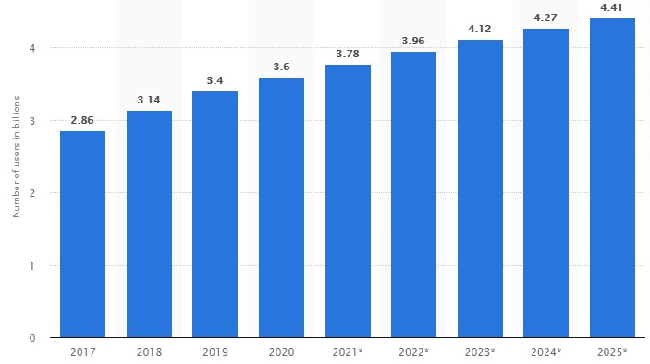
Source: Statista Research Department (2021). Number of social media users 2025.
Figure 1: Worldwide social media users (2017-2025)
Furthermore, internet users spend an average of 2 hours and 21minutes per day on social networking platforms, demonstrating the significant role of digital media in shaping consumer behaviour and marketing effectiveness. The growing influence of social media has encouraged businesses to invest heavily in digital content marketing strategies to attract, engage, and retain consumers within highly competitive digital marketplaces.
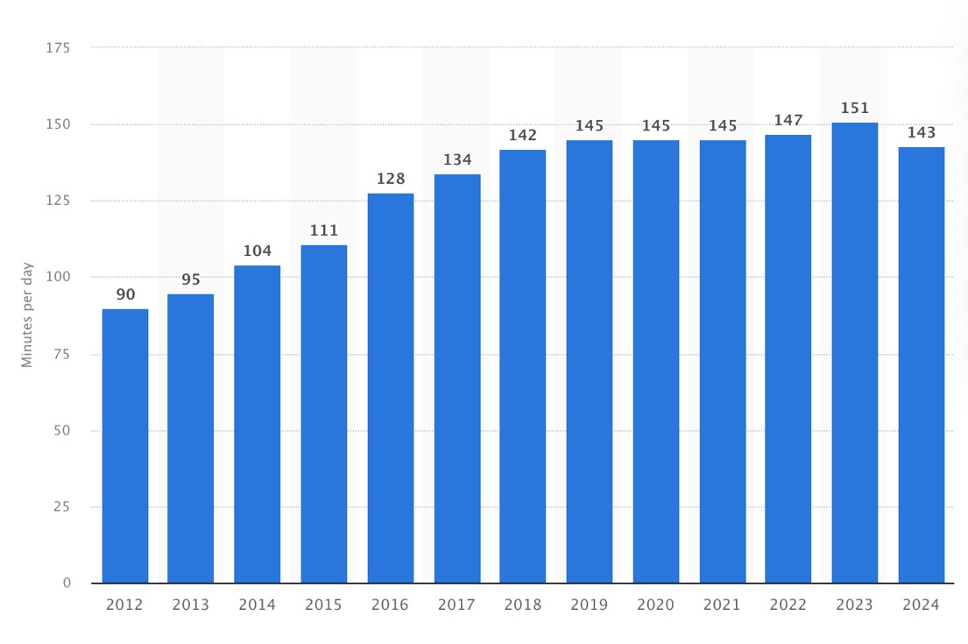

Statista Research Department. (2024). Daily-Social-Media-Usage Worldwide. Statist.
Figure 2: Daily time spent on social networking by internet users worldwide from 2012 to 2024 (in minutes)
In Malaysia, small and medium-sized enterprises (SMEs) remain a major contributor to economic development, accounting for approximately 39.1% of the national Gross Domestic Product (GDP) in 2023 (Department of Statistics Malaysia [DOSM], 2024). Within this ecosystem, the food and beverage (F&B) sector represents one of the most dynamic and competitive industries, where businesses increasingly rely on digital marketing platforms to improve customer communication, strengthen brand awareness, and influence consumer purchasing behaviour. The widespread adoption of digital technologies among Malaysian consumers has created new opportunities for SME F&B businesses to engage with consumers through digital content, online reviews, social media interactions, and personalised marketing communications.
Despite the growing importance of digital content marketing, many Malaysian SME F&B businesses continue to face challenges in developing effective digital marketing strategies that successfully influence consumer behaviour. While businesses actively create online content and invest in social media marketing activities, the effectiveness of these efforts largely depends on how consumers perceive and respond to digital marketing messages. Previous studies have highlighted the importance of factors such as brand awareness, word-of-mouth (WOM), consumer engagement, and conversion in shaping consumer responses toward digital marketing activities (Appel et al., 2020; Dwivedi et al., 2021). However, empirical findings remain fragmented, particularly within the Malaysian SME food and beverage context.
Furthermore, existing literature has predominantly focused on organisational performance, digital marketing adoption, and social media usage from the business perspective, while limited attention has been given to understanding digital content marketing effectiveness from the consumer perspective. In addition, relatively few studies have examined the combined influence of brand awareness, WOM, consumer engagement, and conversion on digital content marketing effectiveness within Malaysian SME F&B businesses. This creates a significant research gap and highlights the need for further investigation into the factors that contribute to successful digital content marketing outcomes among consumers.
Therefore, this study seeks to examine the factors influencing the effectiveness of digital content marketing among consumers in Malaysian SME food and beverage businesses. Specifically, the study investigates the influence of brand awareness, word-of-mouth (WOM), consumer engagement, and conversion on digital content marketing effectiveness. The findings are expected to contribute to the digital marketing and consumer behaviour literature while providing practical insights for SME owners, marketers, and policymakers in developing more effective consumer-orientated digital marketing strategies within Malaysia's evolving digital economy.
- PROBLEM STATEMENT
The rapid advancement of digital technologies and social media platforms has fundamentally transformed marketing practices across industries, particularly within the food and beverage (F&B) sector. Digital content marketing has emerged as a critical strategic approach that enables businesses to communicate with consumers, enhance brand visibility, and influence purchasing behaviour through online platforms. Social media applications such as TikTok, Instagram, Facebook, and YouTube have become important channels for consumer interaction and marketing communication, allowing businesses to engage consumers in real time and deliver personalized content. According to Datar portal (2025), global social media users exceeded 5.24 billion in 2025, while internet users spend an average of 2 hours and 21 minutes daily on social networking platforms. These developments highlight the increasing influence of digital content on consumer decision-making and marketing effectiveness.
In Malaysia, small and medium-sized enterprises (SMEs) play a significant role in economic development, contributing approximately 39.1% of the national Gross Domestic Product (GDP) in 2023 (DOSM, 2024). Within this sector, food and beverage businesses operate in an increasingly competitive environment where digital marketing has become essential for attracting consumers and maintaining market relevance. The widespread use of digital platforms has created opportunities for SME F&B businesses to strengthen brand awareness, encourage consumer engagement, facilitate electronic word-of-mouth (eWOM), and influence purchasing decisions. However, despite the growing adoption of digital marketing, many SMEs continue to experience challenges in creating effective digital content that successfully captures consumer attention and generates meaningful marketing outcomes.
Existing studies suggest that limitations in digital marketing expertise, resource availability, content quality, and technological capabilities often reduce the effectiveness of digital marketing initiatives among SMEs (Dwivedi et al., 2021; Kumar et al., 2023). Furthermore, consumers are increasingly exposed to a vast volume of digital content across multiple platforms, creating intense competition for consumer attention. As a result, businesses must develop content strategies that not only increase visibility but also encourage interaction, trust, and behavioural responses among consumers. Failure to achieve these outcomes may reduce customer engagement, weaken brand perception, and limit business competitiveness in digital marketplaces.
Although digital content marketing has attracted considerable scholarly attention, several conceptual and empirical gaps remain within the existing literature. First, previous studies have predominantly focused on digital marketing adoption, organizational performance, and social media usage from the business perspective, while limited research has examined digital content marketing effectiveness from the consumer perspective, particularly within Malaysian SME food and beverage businesses (Appel et al., 2020; Dwivedi et al., 2021). Second, existing studies often investigate individual marketing variables in isolation, resulting in fragmented findings regarding the combined influence of brand awareness, word-of-mouth (WOM), consumer engagement, and conversion on digital content marketing effectiveness. Consequently, there remains insufficient empirical evidence explaining how these factors collectively influence consumer perceptions and responses toward digital marketing activities.
In addition, the evolving nature of consumer behaviour presents further challenges for SMEs. Contemporary consumers increasingly expect interactive, personalized, visually appealing, and trustworthy digital content that provides value beyond traditional promotional messages (Li et al., 2023; Becker & Jaakkola, 2024). Within the F&B industry, purchasing decisions are strongly influenced by online reviews, social media interactions, brand familiarity, and digital experiences, making effective digital content marketing a critical determinant of business success. However, limited empirical research has comprehensively examined the factors influencing digital content marketing effectiveness among consumers within the Malaysian SME F&B context.
Therefore, there is a need for further investigation into the factors that influence the effectiveness of digital content marketing among consumers in Malaysian SME food and beverage businesses. Specifically, this study examines the influence of brand awareness, word-of-mouth (WOM), consumer engagement, and conversion on digital content marketing effectiveness. By addressing the identified research gaps, the study contributes to the digital marketing and consumer behaviour literature while providing practical insights for SME owners, marketers, and policymakers in developing more effective consumer-orientated digital marketing strategies within Malaysia’s evolving digital economy.
- RESEARCH OBJECTIVES
The aim of this study is to examine the factors influencing the effectiveness of digital content marketing among consumers in Malaysian SME food and beverage (F&B) businesses.
The objectives of this study are:
i. To examine the influence of brand awareness on the effectiveness of digital content marketing among consumers in Malaysian SME food and beverage businesses.
ii. To analyse the influence of word-of-mouth (WOM) on the effectiveness of digital content marketing among consumers in Malaysian SME food and beverage businesses.
iii. To evaluate the influence of consumer engagement on the effectiveness of digital content marketing among consumers in Malaysian SME food and beverage businesses.
iv. To assess the influence of conversion on the effectiveness of digital content marketing among consumers in Malaysian SME food and beverage businesses.
These objectives are grounded in contemporary digital marketing and consumer behaviour literature and contribute to understanding how consumer-related factors influence digital content marketing effectiveness within Malaysia’s SME food and beverage sector.

- SIGNIFICANCE OF RESEARCH
This study contributes to the existing literature by examining the factors influencing the effectiveness of digital content marketing among consumers in Malaysian SME food and beverage (F&B) businesses. While digital marketing and social media communication have received considerable scholarly attention, limited empirical studies have investigated the combined influence of brand awareness, word-of-mouth (WOM), consumer engagement, and conversion on digital content marketing effectiveness from the consumer perspective. Furthermore, research within the Malaysian SME F&B context remains relatively limited despite the sector’s increasing reliance on digital platforms for customer communication and market competitiveness. Therefore, this study addresses an important contextual and empirical gap by providing evidence on the key determinants of digital content marketing effectiveness within Malaysia’s evolving digital economy.
From a theoretical perspective, this study contributes to the digital marketing and consumer behaviour literature by integrating four important consumer-related factors brand awareness, WOM, consumer engagement, and conversion to explain digital content marketing effectiveness. The study is further supported by the AIDA model (Awareness,Interest,Desire,Action), which explains how consumers progress from brand recognition to behavioural response through marketing communications. By examining these variables within a single framework, the study extends current understanding of how digital marketing activities influence consumer perceptions, interactions, and behavioural outcomes in SME business environments. The findings provide empirical evidence that strengthens existing theories related to digital marketing effectiveness, consumer engagement, and online consumer behaviour in contemporary digital marketplaces.
Practically, the findings provide valuable insights for SME owners, marketers, and entrepreneurs in developing more effective digital content marketing strategies. Understanding the influence of brand awareness, WOM, consumer engagement, and conversion enables businesses to design digital content that better attracts consumer attention, encourages interaction, and strengthens customer relationships. The findings may assist SME F&B businesses in improving content quality, social media communication, online brand visibility, and customer engagement strategies across digital platforms such as TikTok, Instagram, Facebook, and YouTube. As digital competition continues to intensify, these insights may help SMEs enhance marketing effectiveness and sustain competitiveness within highly dynamic digital environments.
This study also offers important implications for policymakers, government agencies, and industry stakeholders involved in SME development and digital transformation initiatives. SMEs contributed approximately 39.1% of Malaysia’s GDP in 2023 (DOSM, 2024), highlighting their significant role in national economic growth. Strengthening digital marketing capabilities among SMEs is therefore essential for improving business resilience, innovation, and long-term sustainability. The findings may support the development of digital skills training programmes, digital entrepreneurship initiatives, and SME support policies aimed at enhancing the effectiveness of digital marketing practices across the Malaysian business landscape.
Overall, this study contributes both academically and practically by providing a clearer understanding of the factors influencing digital content marketing effectiveness among consumers in Malaysian SME F&B businesses. The findings are anticipated to contribute to future studies on digital marketing, consumer behaviour and SME competitiveness, and promote more effective, consumer-oriented and sustainable digital marketing practices in Malaysia’s food and beverage industry.

- LITERATURE REVIEW
- Brand Awareness
Brand awareness refers to the extent to which consumers are able to recognize, recall, and become familiar with a brand through repeated exposure to marketing communications and brand-related experiences. Within digital marketing environments, brand awareness is widely recognized as a critical determinant of consumer decision-making, as consumers are more likely to engage with, trust, and purchase from brands that they can easily identify and remember (Keller, 2021). As digital platforms continue to expand, establishing strong brand awareness has become increasingly important for businesses seeking to differentiate themselves within highly competitive online marketplaces.
In the context of Malaysian SME food and beverage (F&B) businesses, brand awareness plays a significant role in enhancing the effectiveness of digital content marketing. Social media platforms such as TikTok, Instagram, Facebook, and YouTube provide businesses with opportunities to increase brand exposure through visually appealing, interactive, and consumer-oriented content. Recent studies indicate that consumers who demonstrate higher levels of brand awareness are more likely to pay attention to digital marketing messages, engage with online content, and develop favourable attitudes towards a brand (Dwivedi et al., 2021; Tuten, 2023). Consequently, strong brand awareness enhances the ability of digital content marketing initiatives to attract consumer attention and generate meaningful marketing outcomes.
Furthermore, brand awareness contributes to digital content marketing effectiveness by strengthening consumer trust and reducing perceived risk during purchasing decisions. In digital environments where consumers are exposed to extensive amounts of promotional content, familiar brands are generally perceived as more credible and reliable than unfamiliar alternatives (Kumar et al., 2023). This familiarity encourages consumers to interact with branded content, share marketing messages, and develop stronger emotional connections with businesses. Within the F&B industry, where purchasing decisions are often influenced by visual appeal, brand image, and social influence, strong brand awareness may significantly improve consumer responsiveness to digital content marketing campaigns.
Despite its importance, several limitations remain within the existing literature. First, previous studies have largely focused on brand awareness as a general marketing outcome rather than examining its role as a determinant of digital content marketing effectiveness. Second, much of the existing research has concentrated on large corporations and international brands, with limited attention given to SME food and beverage businesses operating in developing economies such as Malaysia. Third, empirical evidence regarding the relationship between brand awareness and digital content marketing effectiveness remains fragmented, particularly from the consumer perspective. These limitations indicate a need for further investigation into how brand awareness contributes to the effectiveness of digital content marketing within Malaysian SME F&B businesses.
Therefore, this study proposes that brand awareness is an important factor influencing the effectiveness of digital content marketing among consumers in Malaysian SME food and beverage businesses. A stronger level of brand awareness is expected to enhance consumer attention, increase content interaction, strengthen brand trust, and improve the overall effectiveness of digital marketing activities within increasingly competitive digital environments.
- Word of Mouth (WOM)
Word Word-of-mouth (WOM) is the communication of information, opinions, experiences and recommendations about products, services or brands between consumers. In contemporary digital environments, WOM has evolved into electronic word-of-mouth (eWOM), where consumers communicate through social media platforms, online reviews, blogs, discussion forums, and user-generated content. Recent studies indicate that eWOM has become one of the most influential sources of consumer information, significantly affecting brand perceptions, trust formation, purchase decisions, and online consumer behaviour (Erkan & Evans, 2021; Rosario et al., 2023).
Within the context of Malaysian SME food and beverage (F&B) businesses, WOM plays a critical role in determining the effectiveness of digital content marketing. Consumers frequently rely on online reviews, recommendations, ratings, shared experiences, and social media discussions when evaluating food products and dining establishments. As digital content becomes increasingly integrated into consumers’ daily lives, positive WOM can amplify the reach and credibility of marketing messages, while negative WOM may reduce consumer trust and weaken marketing effectiveness. Consequently, businesses that successfully generate favourable consumer conversations are more likely to strengthen the impact of their digital content marketing initiatives.
Previous studies suggest that WOM enhances digital content marketing effectiveness by increasing message credibility and reducing consumer uncertainty. Unlike traditional promotional content, recommendations from peers and online communities are generally perceived as more authentic, trustworthy, and unbiased (Ismagilova et al., 2020; Rosario et al., 2023). This credibility encourages consumers to engage more actively with digital content, pay greater attention to marketing messages, and develop stronger confidence in brands. Within the F&B industry, where purchasing decisions are often influenced by customer reviews, dining experiences, and social recommendations, WOM may significantly influence how consumers evaluate and respond to digital marketing activities.
Furthermore, positive WOM contributes to higher levels of consumer interaction and content dissemination across digital platforms. Consumers who encounter favourable reviews and recommendations are more likely to share content, participate in online discussions, and interact with brand-related information. These activities increase the visibility and reach of digital content marketing campaigns, thereby improving overall marketing effectiveness. As social media platforms continue to facilitate rapid information sharing, WOM has become a strategic asset that supports customer acquisition, brand awareness, and long-term customer relationships within digital business environments.
Despite its growing significance, several limitations remain within the existing literature. First, many studies have focused on WOM as a direct predictor of purchase intention or brand loyalty, while limited attention has been given to its role in influencing digital content marketing effectiveness. Second, existing research has primarily concentrated on large corporations, global brands, and developed economies, with relatively little evidence available from Malaysian SME food and beverage businesses. Third, previous studies often examine WOM independently, without considering its relationship with other consumer-related factors such as brand awareness, consumer engagement, and conversion. These limitations indicate a need for further empirical investigation within the Malaysian SME F&B context.

Therefore, this study proposes that WOM is an important factor influencing the effectiveness of digital content marketing among consumers in Malaysian SME food and beverage businesses. Higher levels of positive WOM are expected to enhance message credibility, strengthen consumer trust, encourage content interaction, and ultimately improve the effectiveness of digital content marketing within increasingly competitive digital environments.
- Consumer Engagement
Consumer engagement refers to the degree of cognitive, emotional, and behavioural involvement that consumers demonstrate toward a brand, product, or marketing activity through digital interactions. In contemporary digital environments, consumer engagement has become a critical determinant of marketing effectiveness, as engaged consumers are more likely to interact with content, participate in brand-related activities, share information, and develop long-term relationships with brands (Hollebeek et al., 2022). Within social media platforms such as TikTok, Instagram, Facebook, and YouTube, engagement is commonly reflected through activities including likes, comments, shares, reviews, content creation, and participation in online discussions.
In the context of Malaysian SME food and beverage (F&B) businesses, consumer engagement plays an important role in enhancing the effectiveness of digital content marketing. Consumers increasingly expect interactive, personalized, and value-driven digital experiences rather than passive exposure to promotional messages. Consequently, businesses that successfully encourage consumer participation and interaction are more likely to improve the performance of their digital marketing initiatives. Recent studies indicate that higher levels of consumer engagement positively influence brand attachment, customer satisfaction, trust, and favourable behavioural responses toward marketing communications (Lim et al., 2022; Becker & Jaakkola, 2024).
Furthermore, consumer engagement contributes to digital content marketing effectiveness by increasing consumers’ attention, interest, and emotional connection toward branded content. Engaged consumers are generally more receptive to marketing messages, more willing to interact with digital content, and more likely to disseminate information through their personal networks. Within the F&B industry, where purchasing decisions are often influenced by visual experiences, social interaction, and customer recommendations, consumer engagement can significantly enhance the reach, visibility, and impact of digital marketing campaigns. As a result, businesses that foster meaningful consumer engagement are better positioned to strengthen customer relationships and improve overall marketing outcomes.
Previous studies have also highlighted the multidimensional nature of consumer engagement, encompassing cognitive, emotional, and behavioural components. Cognitive engagement refers to consumers’ attention and interest in brand-related content, emotional engagement reflects feelings of enjoyment, attachment, and satisfaction, while behavioural engagement includes active participation through comments, sharing, reviewing, and content interaction (Hollebeek et al., 2022). These dimensions collectively influence how consumers evaluate and respond to digital marketing activities, making engagement a crucial factor in determining marketing effectiveness.
Despite its growing importance, several limitations remain within the existing literature. First, much of the existing research focuses on consumer engagement as a consequence of digital marketing activities rather than examining its role as a determinant of digital content marketing effectiveness. Second, previous studies have predominantly concentrated on large organizations and international brands, with limited empirical evidence available from Malaysian SME food and beverage businesses. Third, consumer engagement is frequently examined independently without considering its interaction with other consumer-related factors such as brand awareness, WOM, and conversion. These limitations suggest the need for further investigation into the contribution of consumer engagement to digital content marketing effectiveness within the Malaysian SME F&B context.
Therefore, this study proposes that consumer engagement is an important factor influencing the effectiveness of digital content marketing among consumers in Malaysian SME food and beverage businesses. Higher levels of consumer engagement are expected to increase content interaction, strengthen emotional connections, enhance consumer participation, and ultimately improve the effectiveness of digital content marketing within increasingly competitive digital environments.

- Conversion
Conversion refers to the extent to which consumers perform desired actions after being exposed to marketing communications and digital content. In digital marketing contexts, conversion encompasses various consumer responses, including product purchases, content sharing, website visits, subscription registrations, online enquiries, and other actions that reflect behavioural responses to marketing efforts (Kingsnorth, 2022). As businesses increasingly rely on digital platforms to communicate with consumers, conversion has become an important indicator for evaluating the effectiveness of digital marketing activities and consumer responsiveness.
Within the context of Malaysian SME food and beverage (F&B) businesses, conversion represents a critical factor that may influence the effectiveness of digital content marketing. Consumers are frequently exposed to promotional content, product recommendations, influencer endorsements, and branded messages across social media platforms such as TikTok, Instagram, Facebook, and YouTube. The extent to which consumers respond to such content through measurable actions reflects the ability of digital marketing initiatives to achieve intended marketing objectives. Consequently, higher levels of conversion may indicate greater effectiveness of digital content marketing strategies within competitive digital environments.

Previous studies suggest that conversion is influenced by consumers’ perceptions of content relevance, credibility, value, and trustworthiness (Chaffey & Ellis-Chadwick, 2019; Kingsnorth, 2022). Consumers are more likely to perform desired actions when digital content provides useful information, addresses their needs, and creates positive brand experiences. Within the F&B industry, visually appealing content, promotional offers, customer reviews, and engaging storytelling may encourage consumers to interact with brands and proceed toward behavioural responses. Therefore, conversion can serve as an important indicator of how effectively digital content marketing translates consumer interest into measurable outcomes.
Furthermore, conversion contributes to digital content marketing effectiveness by providing evidence of consumer behavioural responses beyond simple engagement metrics. While activities such as likes, comments, and shares indicate consumer interaction, conversion reflects a deeper level of response that demonstrates consumers’ willingness to act upon marketing messages. As digital marketing becomes increasingly data-driven, businesses rely on conversion-related indicators to assess campaign performance, optimize marketing strategies, and improve customer acquisition efforts. Within SME business environments, effective conversion outcomes may support stronger customer relationships and improved marketing efficiency.
Despite its importance, several limitations remain within the existing literature. First, many studies examine conversion as a marketing performance outcome rather than considering its role as a factor associated with digital content marketing effectiveness. Second, existing research has largely focused on e-commerce businesses, multinational corporations, and developed economies, with limited empirical evidence available from Malaysian SME food and beverage businesses. Third, conversion is frequently investigated independently from other consumer-related factors such as brand awareness, WOM, and consumer engagement. These limitations suggest a need for further investigation into the role of conversion within the broader context of digital content marketing effectiveness among Malaysian SME F&B businesses.
Therefore, this study proposes that conversion is an important factor associated with the effectiveness of digital content marketing among consumers in Malaysian SME food and beverage businesses. Consumers who demonstrate stronger behavioural responses toward digital marketing content may contribute to higher levels of marketing effectiveness. Examining this relationship provides a more comprehensive understanding of how consumer actions influence the overall effectiveness of digital content marketing within Malaysia’s evolving digital marketplace.

- The Effectiveness of Digital Content Marketing
The effectiveness of digital content marketing refers to the extent to which digital marketing content successfully achieves its intended marketing objectives by attracting consumer attention, encouraging interaction, influencing consumer perceptions, and generating favourable behavioural responses. In contemporary digital environments, digital content marketing effectiveness is increasingly viewed as a multidimensional construct that encompasses consumer engagement, brand interaction, message responsiveness, customer relationships, and overall marketing performance (Holliman & Rowley, 2022). As businesses increasingly depend on digital platforms for marketing communication, evaluating the effectiveness of digital content marketing has become essential for understanding how consumers respond to online marketing activities.
Within the Malaysian SME food and beverage (F&B) sector, digital content marketing effectiveness plays a critical role in determining the success of marketing initiatives across social media platforms such as TikTok, Instagram, Facebook, and YouTube. Effective digital content enables businesses to strengthen brand visibility, improve customer relationships, encourage consumer interaction, and increase the impact of marketing communications. Recent studies suggest that consumers are more likely to respond positively to digital marketing content that is relevant, informative, visually appealing, interactive, and aligned with their interests and preferences (Dwivedi et al., 2021; Tuten, 2023). Consequently, the effectiveness of digital content marketing is closely associated with the ability of businesses to deliver meaningful and engaging content experiences.
Previous studies indicate that digital content marketing effectiveness can be evaluated through several consumer-related dimensions, including consumer responsiveness, content interaction, brand recognition, customer engagement, and behavioural outcomes (Kannan & Li, 2021; Holliman & Rowley, 2022). In digital environments, successful content marketing strategies not only increase consumer exposure to marketing messages but also encourage active participation, positive brand perceptions, and stronger customer relationships. Within the F&B industry, where consumers frequently rely on digital information and social media interactions before making purchasing decisions, effective digital content marketing has become an important mechanism for influencing consumer behaviour and maintaining market competitiveness.
Furthermore, the effectiveness of digital content marketing is increasingly influenced by changing consumer expectations and the growing saturation of digital content. Consumers are exposed to large volumes of online information daily, making it increasingly challenging for businesses to capture attention and sustain meaningful engagement. As a result, businesses must continuously adapt their content strategies to align with evolving consumer preferences, technological developments, and platform-specific characteristics. SMEs that successfully develop relevant and engaging content are generally better positioned to strengthen customer relationships and enhance marketing outcomes within competitive digital marketplaces.

Despite its growing importance, several limitations remain within the existing literature. First, much of the existing research has focused on digital marketing adoption and social media usage rather than specifically examining digital content marketing effectiveness as a distinct marketing outcome. Second, previous studies have predominantly concentrated on large corporations and developed economies, with limited empirical evidence available from Malaysian SME food and beverage businesses. Third, existing studies often investigate individual marketing factors separately, providing limited understanding of how brand awareness, WOM, consumer engagement, and conversion collectively contribute to digital content marketing effectiveness. These limitations highlight the need for further empirical investigation within the Malaysian SME F&B context.
Therefore, this study conceptualizes the effectiveness of digital content marketing as the dependent variable and examines how it is influenced by brand awareness, WOM, consumer engagement, and conversion among consumers in Malaysian SME food and beverage businesses. Understanding these relationships provides valuable insights into the factors that contribute to successful digital marketing outcomes and supports the development of more effective consumer-orientated digital marketing strategies within Malaysia’s evolving digital economy.
- MODEL AND THEORY
This study is grounded in the AIDA Model, which provides a theoretical explanation of how marketing communications influence consumer responses and behavioural outcomes. Originally developed by Strong (1925), the AIDA model proposes that consumers progress through four sequential stages Awareness, Interest, Desire, and Action before responding to marketing messages. Despite its longstanding application in marketing research, the AIDA Model remains highly relevant in contemporary digital environments, particularly in explaining consumer interactions with digital content and online marketing communications (Kotler et al., 2022; Tuten, 2023).
Within digital marketing contexts, the AIDA Model suggests that effective marketing content must first attract consumer attention and create awareness before generating interest, encouraging engagement, and ultimately motivating consumer action. As businesses increasingly rely on social media platforms such as TikTok, Instagram, Facebook, and YouTube to communicate with consumers, understanding how consumers progress through these stages has become essential for improving digital content marketing effectiveness.
In the context of this study, Brand Awareness represents the 'awareness' stage of the AIDA model. Consumers who are familiar with and able to recognise a brand are more likely to pay attention to marketing messages and interact with digital content. Previous studies indicate that stronger brand awareness positively influences consumer trust, brand recognition, and marketing effectiveness within digital environments (Keller, 2021; Tuten, 2023).
Word-of-Mouth (WOM) reflects the interest stage of the AIDA model. Positive recommendations, online reviews, and social media discussions help stimulate consumer interest by increasing message credibility and reducing uncertainty. Consumers often rely on information shared by peers and online communities when evaluating products and services, particularly within the food and beverage industry (Rosario et al., 2023).
'Consumer engagement' represents the desire stage of the AIDA model. Engagement reflects consumers’ emotional, cognitive, and behavioural involvement with digital content and brand-related activities. Higher levels of engagement indicate stronger consumer interest and attachment toward brands, increasing the likelihood of favourable responses to marketing communications (Hollebeek et al., 2022).
Finally, Conversion represents the Action stage of the AIDA model. Conversion occurs when consumers perform desired actions after interacting with marketing content, such as making purchases, sharing content, subscribing to services, or engaging with brands online. Conversion reflects the extent to which digital marketing efforts successfully translate consumer interest and engagement into measurable behavioural outcomes (Kingsnorth, 2022).
The dependent variable, Effectiveness of Digital Content Marketing, represents the overall outcome of the AIDA process. Digital content marketing is considered effective when marketing content successfully attracts consumer attention, stimulates interest, encourages engagement, and generates meaningful consumer actions. Therefore, the AIDA model provides a comprehensive theoretical foundation for explaining how brand awareness, WOM, consumer engagement, and conversion collectively influence the effectiveness of digital content marketing among consumers in Malaysian SME food and beverage businesses.
Overall, the AIDA Model offers a suitable theoretical framework for understanding digital consumer behaviour within social media environments. By integrating the four independent variables within a single theoretical perspective, this study contributes to a more comprehensive understanding of the factors influencing digital content marketing effectiveness within Malaysian SME food and beverage businesses.
- RESEARCH FRAMEWORK
The research framework of this study is developed to examine the factors influencing the effectiveness of digital content marketing among consumers in Malaysian SME food and beverage (F&B) businesses. The framework proposes that brand awareness, word-of-mouth (WOM), consumer engagement, and conversion act as independent variables that influence the effectiveness of digital content marketing as the dependent variable.

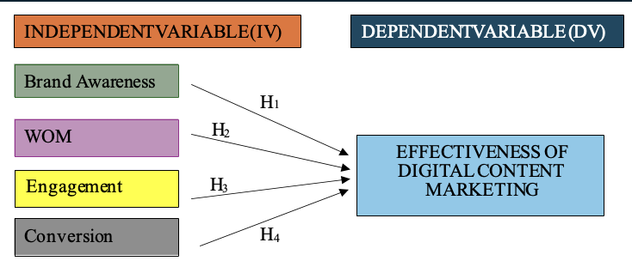

Figure 3: Research Framework

This study proposes a conceptual framework that examines the factors influencing the effectiveness of digital content marketing among consumers in Malaysian SME food and beverage (F&B) businesses. The framework is grounded in the AIDA model, which explains how consumers progress through the stages of Awareness, Interest, Desire, and Action before responding to marketing communications. Within the context of this study, Brand Awareness, Word-of-Mouth (WOM), Consumer Engagement, and Conversion are conceptualised as key consumer-related factors that influence the effectiveness of digital content marketing.
Brand awareness refers to the extent to which consumers are able to recognise, recall, and become familiar with a brand through repeated exposure to marketing communications and digital interactions. Strong brand awareness enhances consumer trust, brand recognition, and familiarity, increasing the likelihood that consumers will pay attention to and interact with digital marketing content (Keller, 2021; Tuten, 2023). Within Malaysian SME F&B businesses, social media platforms such as TikTok, Instagram, Facebook, and YouTube provide important channels for strengthening brand visibility and consumer recognition.
Word-of-Mouth (WOM) refers to the exchange of opinions, experiences, recommendations, and information among consumers regarding products, services, or brands. In digital environments, electronic word-of-mouth (eWOM) has become a significant source of information that influences consumer perceptions and decision-making. Positive WOM enhances message credibility, strengthens consumer trust, and increases the effectiveness of marketing communications, particularly within industries where purchasing decisions are strongly influenced by customer reviews and recommendations (Rosario et al., 2023).
Consumer engagement refers to a consumer's cognitive, emotional, and behavioural involvement with digital content and brand-related activities. Engagement is reflected through activities such as liking, commenting, sharing, reviewing, and interacting with content across digital platforms. Higher levels of engagement indicate stronger consumer interest and attachment toward brands, which may enhance the effectiveness of digital content marketing by increasing consumer participation and interaction (Hollebeek et al., 2022).
Conversion refers to the extent to which consumers perform desired actions after interacting with digital marketing content, including purchasing products, visiting websites, subscribing to services, sharing content, or responding to promotional campaigns. Conversion represents behavioural outcomes that demonstrate consumer responsiveness to marketing communications and reflects the ability of digital content to encourage meaningful consumer actions (Kingsnorth, 2022).
The dependent variable of this study is the effectiveness of digital content marketing, which refers to the extent to which digital marketing content successfully attracts consumer attention, encourages interaction, influences consumer perceptions, and generates favourable behavioural responses. Effective digital content marketing enables businesses to strengthen customer relationships, improve content responsiveness, and enhance overall marketing performance within digital environments (Holliman & Rowley, 2022).
Based on the AIDA Model, this study proposes that brand awareness, WOM, consumer engagement, and conversion positively influence the effectiveness of digital content marketing among consumers in Malaysian SME food and beverage businesses. The proposed framework provides a comprehensive explanation of how consumer-related factors contribute to successful digital marketing outcomes within Malaysia’s increasingly competitive digital marketplace.
TABLE I
hypotheses development

Code | Hypothesis
H1 | Brand awareness has a significant positive influence on the effectiveness of digital content marketing among consumers in Malaysian SME food and beverage businesses.
H2 | Word-of-mouth (WOM) has a significant positive influence on the effectiveness of digital content marketing among consumers in Malaysian SME food and beverage businesses.
H3 | Consumer engagement has a significant positive influence on the effectiveness of digital content marketing among consumers in Malaysian SME food and beverage businesses.
H4 | Conversion has a significant positive influence on the effectiveness of digital content marketing among consumers in Malaysian SME food and beverage businesses.

VII. RESEARCH DESIGN
Research design refers to the overall strategy and systematic plan developed to guide the research process in addressing the research problem and achieving the research objectives effectively (Saunders et al., 2019). This study adopts a quantitative research design to examine the factors influencing the effectiveness of digital content marketing among consumers in Malaysian SME food and beverage (F&B) businesses. A quantitative approach is considered appropriate because it enables the researcher to examine relationships between variables objectively through numerical data collection and statistical analysis.
This study employs a cross-sectional survey design in which data are collected from respondents at a single point in time using a structured questionnaire. The cross-sectional approach is widely used in digital marketing and consumer behaviour studies because it allows researchers to examine consumer perceptions, behavioural responses, and relationships between variables efficiently within a specific research context (Sekaran & Bougie, 2020). In this study, the survey method is used to collect data regarding brand awareness, word-of-mouth (WOM), consumer engagement, conversion, and the effectiveness of digital content marketing among consumers within Malaysian SME F&B businesses.
The research framework of this study is developed based on the Uses and Gratifications Theory (UGT) and Consumer Engagement Theory, which explain how consumers interact with digital content and social media platforms to fulfil informational, social, emotional, and behavioural needs. These theoretical perspectives support the examination of how digital content marketing influences consumer behaviour and marketing effectiveness within digital environments. The proposed framework enables the researcher to analyse the relationships between the independent variables and the dependent variable systematically using statistical techniques.
Data for this study will be collected through an online questionnaire distributed to consumers who actively engage with digital content marketing related to Malaysian SME food and beverage businesses. Online survey distribution is considered appropriate due to the increasing use of digital platforms and social media among Malaysian consumers. Recent reports indicate that Malaysia recorded internet penetration exceeding 97% in 2024, while social media usage continues to increase significantly among digital consumers (DataReportal, 2025). The use of online surveys therefore improves accessibility, response efficiency, and cost-effectiveness in collecting consumer data within digital environments.
The collected data will be analysed using Statistical Package for the Social Sciences (SPSS). Several statistical techniques will be employed, including descriptive analysis, reliability analysis, correlation analysis, and multiple regression analysis to examine the relationships between the study variables and test the proposed hypotheses. Reliability analysis using Cronbach’s Alpha will be conducted to evaluate the internal consistency of the measurement instruments, while regression analysis will determine the influence of brand awareness, WOM, consumer engagement, and conversion on the effectiveness of digital content marketing.
Overall, the quantitative research design adopted in this study provides a systematic and reliable approach for examining digital consumer behaviour and digital marketing effectiveness among Malaysian SME F&B businesses. The research design also supports the generation of empirical findings that may contribute to digital marketing literature and provide practical insights for SMEs operating within Malaysia’s rapidly evolving digital economy.

- RESEARCH METHODOLOGY AND DATA COLLECTION
This study adopts a quantitative research methodology to examine the factors influencing the effectiveness of digital content marketing among consumers in Malaysian small and medium-sized enterprise (SME) food and beverage (F&B) businesses. Quantitative research is appropriate for this study because it enables the researcher to examine relationships between variables objectively through numerical data collection and statistical analysis (Creswell & Creswell, 2023). The quantitative approach also allows the study to test hypotheses systematically and generate findings that are reliable, measurable, and generalizable within the research context.
The study employs a cross-sectional survey design in which data are collected from respondents at a single point in time using a structured questionnaire. The survey method is widely used in digital marketing and consumer behaviour research because it enables efficient collection of large amounts of data regarding consumer perceptions, attitudes, and behavioural responses within digital environments (Sekaran & Bougie, 2020). In this study, the quantitative design is considered suitable for examining the relationships between brand awareness, word-of-mouth (WOM), consumer engagement, conversion, and the effectiveness of digital content marketing among consumers within Malaysian SME F&B businesses.
Primary data will be collected through a structured online questionnaire distributed to consumers who actively engage with digital content marketing related to Malaysian SME food and beverage businesses. The questionnaire will consist of closed-ended questions measured using a five-point Likert scale ranging from “strongly disagree” to “strongly agree.” Online survey distribution is considered appropriate due to the increasing use of social media and digital platforms among Malaysian consumers. Recent reports indicate that internet penetration in Malaysia exceeded 97% in 2024, while social media usage continues to increase significantly among digital consumers (DataReportal, 2025). Therefore, online data collection improves accessibility, response efficiency, and cost-effectiveness in reaching a broader consumer population.
The questionnaire will be distributed through digital platforms such as WhatsApp, Telegram, Instagram, Facebook, TikTok, and other social media channels to increase respondent participation and accessibility. Respondents targeted in this study are consumers who have experience interacting with digital content marketing related to Malaysian SME F&B businesses through online platforms. Ethical considerations will also be emphasized throughout the data collection process to ensure respondent confidentiality, privacy protection, and voluntary participation.
In addition to primary data, secondary data sources will also be utilized to strengthen the theoretical and empirical foundation of the study. Secondary data will be obtained from academic journals, books, government reports, industry publications, conference proceedings, and online databases such as ScienceDirect, Emerald Insight, Google Scholar, and Scopus-indexed journals. Previous studies related to digital content marketing, consumer engagement, social media marketing, brand awareness, WOM, and conversion behaviour will be reviewed to support the development of the research framework, hypotheses, and conceptual understanding of the study variables.
The collected quantitative data will be analysed using the Statistical Package for the Social Sciences (SPSS). Several statistical techniques will be employed, including descriptive analysis, reliability analysis, correlation analysis, and multiple regression analysis. Descriptive analysis will summarize respondent demographic information and variable distribution, while reliability analysis using Cronbach’s Alpha will assess the internal consistency of the measurement instruments. Correlation and multiple regression analyses will then be conducted to examine the relationships between the independent variables and the effectiveness of digital content marketing as the dependent variable.
Overall, the quantitative research methodology and online survey data collection approach adopted in this study provide a systematic and reliable framework for examining digital consumer behaviour and digital marketing effectiveness among Malaysian SME food and beverage businesses. The methodology also supports the generation of empirical findings that may contribute to digital marketing literature and provide practical insights for SMEs operating within Malaysia’s rapidly evolving digital economy.

- POPULATION AND SAMPLING
- Population
Population refers to the entire group of individuals or elements that possess characteristics relevant to the research objectives and from which the researcher intends to draw conclusions (Sekaran & Bougie, 2020). In the context of this study, the target population consists of consumers in Malaysia who actively engage with digital content marketing related to small and medium-sized enterprise (SME) food and beverage (F&B) businesses. The study particularly focuses on consumers who have prior experience interacting with digital marketing content through social media platforms such as TikTok, Instagram, Facebook, YouTube, and other online channels associated with SME F&B businesses.
The Malaysian SME sector plays an important role in national economic development, with SMEs contributing approximately 39.1% to Malaysia’s Gross Domestic Product (GDP) in 2023 (DOSM, 2024). Within this sector, the food and beverage industry represents one of the most active service-based industries utilizing digital platforms and social media marketing to attract and engage consumers. The increasing dependence on digital marketing strategies among SME F&B businesses highlights the importance of understanding consumer responses toward digital content effectiveness within Malaysia’s rapidly evolving digital economy.
This study specifically targets consumers aged 18 years and above who have experience interacting with digital content marketing related to Malaysian SME F&B businesses. Consumers are selected as the unit of analysis because they directly experience and evaluate the effectiveness of digital content marketing through online engagement, purchasing decisions, reviews, and social media interaction. Focusing on consumers therefore enables the researcher to obtain more accurate insights regarding brand awareness, word-of-mouth (WOM), consumer engagement, conversion behaviour, and overall digital content marketing effectiveness.

- Sampling Method
This study employs a probability sampling approach using stratified random sampling techniques. Probability sampling is considered appropriate because it allows every individual within the target population to have an equal probability of being selected, thereby reducing sampling bias and improving the generalizability of the findings (Saunders et al., 2019). Stratified random sampling is particularly suitable for this study because consumers within Malaysian SME F&B markets consist of diverse demographic groups with varying digital behaviours, preferences, and social media usage patterns.
The sampling process involves dividing the population into several demographic strata such as age group, gender, and social media usage behaviour before randomly selecting respondents proportionately from each subgroup. This approach improves sample representation and ensures that different consumer characteristics are adequately reflected within the study. Stratified random sampling also enhances the reliability and validity of the research findings by minimizing demographic imbalance and improving population representation.
Data collection will be conducted using online questionnaires distributed through digital platforms such as WhatsApp, Telegram, Instagram, Facebook, TikTok, and other social media channels. Online distribution is considered appropriate because Malaysian consumers demonstrate high internet and social media usage rates. Recent reports indicate that Malaysia recorded internet penetration exceeding 97% in 2024, while social media usage among Malaysian consumers continues to increase significantly (DataReportal, 2025). The use of digital platforms therefore improves accessibility, response efficiency, and cost-effectiveness in reaching respondents across different demographic groups.

- Sample Size
Sample size refers to the number of respondents selected from the target population for data collection and analysis. Determining an appropriate sample size is important to ensure statistical reliability, accuracy, and representativeness of the research findings. According to Krejcie and Morgan (1970), large population studies generally require a sample size of approximately 384 respondents to achieve reliable statistical analysis. Similarly, Roscoe (1975) suggests that sample sizes ranging between 30 and 500 are generally appropriate for most behavioural and social science research.
Given the large consumer population within the Malaysian SME F&B sector, this study targets approximately 384 respondents. The selected sample size is considered sufficient for conducting quantitative statistical analyses such as descriptive analysis, reliability testing, correlation analysis, and multiple regression analysis using the Statistical Package for the Social Sciences (SPSS). The sample size also aligns with previous digital marketing and consumer behaviour studies involving large consumer populations.
Overall, the population and sampling approach adopted in this study provides a systematic and reliable framework for examining the factors influencing the effectiveness of digital content marketing among consumers in Malaysian SME food and beverage businesses. The use of probability sampling and adequate sample size strengthens the validity, reliability, and generalizability of the research findings within Malaysia’s digital consumer environment.

- LOCATION OF THE STUDY
The location of this study focuses on consumers of small and medium-sized enterprise (SME) food and beverage (F&B) businesses in Melaka, Malaysia, with particular emphasis on consumers who actively engage with digital content marketing through social media and online platforms. Melaka was selected as the research location because it is one of the rapidly developing urban and tourism-orientated states in Malaysia, characterized by active commercial activities, strong digital connectivity, and increasing consumer engagement with digital marketing platforms.
Melaka is recognized as an important tourism and business destination in Malaysia, attracting both local and international visitors due to its cultural heritage, commercial centres, and expanding service industry. According to the Department of Statistics Malaysia (DOSM, 2024), Melaka continues to experience stable population and economic growth, supported by increasing urbanization and digital business activities. The growth of SME businesses within the food and beverage sector has also contributed significantly to the state’s service economy, particularly through the increasing adoption of digital marketing strategies and social media platforms to attract consumers and improve business competitiveness.

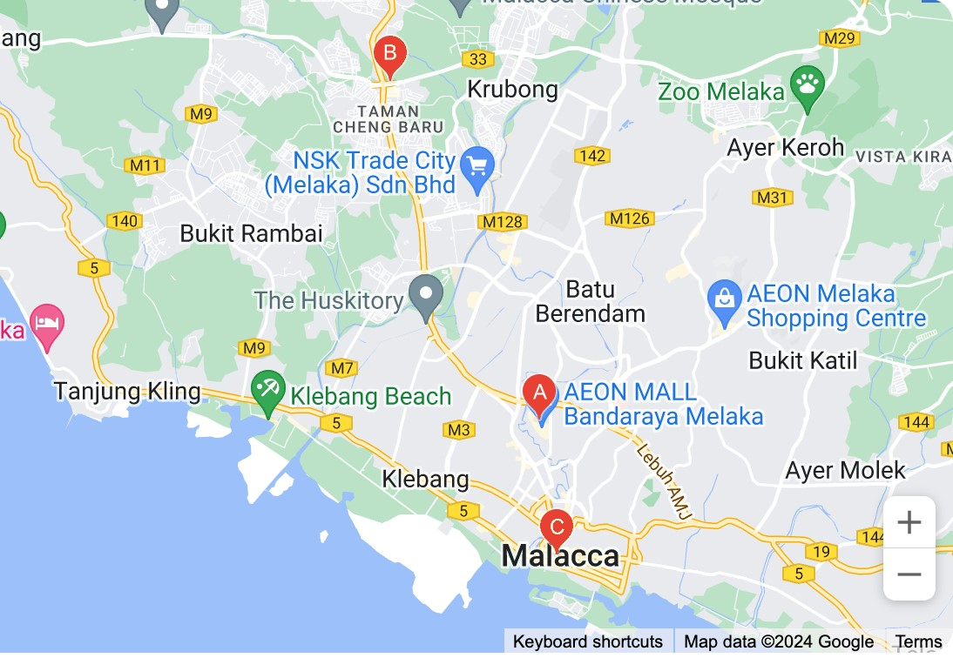

Figure 4: Location of Empire Sushi Melaka

This study specifically focuses on consumers who interact with digital content marketing related to SME F&B businesses located in Melaka, including businesses operating within shopping malls, commercial centres, and urban business areas. Melaka is considered an appropriate research location because consumers within the state demonstrate active social media usage and increasing dependence on digital platforms such as TikTok, Instagram, Facebook, and YouTube for food discovery, product reviews, purchasing decisions, and customer interaction. Recent digital reports indicate that Malaysia’s internet penetration exceeded 97% in 2024, while social media engagement among Malaysian consumers continues to increase significantly (DataReportal, 2025). These developments strengthen the relevance of examining digital content marketing effectiveness within Melaka’s digitally connected consumer environment.
In addition, Melaka provides a diverse consumer demographic consisting of local residents, students, working adults, and tourists, allowing the researcher to obtain broader perspectives regarding digital consumer behaviour and marketing effectiveness within the F&B industry. The concentration of SME F&B businesses and active consumer participation in digital marketing activities further supports the suitability of Melaka as the research setting for this study.
Overall, the selection of Melaka as the research location provides a relevant and practical context for examining the factors influencing the effectiveness of digital content marketing among consumers in Malaysian SME food and beverage businesses. The location offers an appropriate representation of digital consumer behaviour, social media engagement, and SME marketing practices within Malaysia’s evolving digital economy.

- DATA ANALYSIS
The collected data in this study will be analysed using the Statistical Package for the Social Sciences (SPSS), which is widely utilized in quantitative research for data management, statistical analysis, and hypothesis testing. SPSS is considered appropriate for this study because it enables researchers to analyse large sets of numerical data systematically and examine relationships between variables accurately and efficiently (Hair et al., 2022). The use of SPSS also improves the reliability, consistency, and validity of the research findings within digital marketing and consumer behaviour studies.
Prior to conducting the main statistical analyses, the collected data will undergo data screening and preparation processes to ensure accuracy, completeness, and consistency. This process includes checking for missing values, duplicate responses, outliers, and response errors before proceeding with further statistical analysis. Data coding and cleaning procedures will also be conducted to improve data quality and ensure that the dataset is suitable for statistical testing and interpretation.
Descriptive analysis will first be employed to summarize the demographic characteristics of the respondents and describe the distribution of the study variables. Descriptive statistics such as frequencies, percentages, means, and standard deviations will be used to analyse respondent profiles and consumer responses related to brand awareness, word-of-mouth (WOM), consumer engagement, conversion, and the effectiveness of digital content marketing. Descriptive analysis is important because it provides an overall understanding of consumer behaviour patterns and digital marketing perceptions within Malaysian SME food and beverage (F&B) businesses.
Reliability analysis using Cronbach’s Alpha will then be conducted to evaluate the internal consistency and reliability of the measurement instruments. According to Hair et al. (2022), Cronbach’s Alpha values exceeding 0.70 indicate acceptable reliability and consistency of measurement items within quantitative research. Reliability testing is essential to ensure that the questionnaire items consistently measure the intended constructs and produce dependable research findings.
In addition, Pearson correlation analysis will be employed to examine the strength and direction of relationships between the independent variables and the dependent variable. Correlation analysis enables the researcher to identify whether significant relationships exist between brand awareness, WOM, consumer engagement, conversion, and the effectiveness of digital content marketing among consumers within Malaysian SME F&B businesses.
Furthermore, multiple regression analysis will be conducted to examine the influence of the independent variables on the dependent variable and to test the proposed research hypotheses. Regression analysis is appropriate because it enables the researcher to determine the extent to which brand awareness, WOM, consumer engagement, and conversion contribute to the effectiveness of digital content marketing. This analysis also allows the researcher to identify the most significant predictor influencing digital content marketing effectiveness among consumers within Malaysian SME food and beverage businesses.

The findings obtained from the statistical analyses will be interpreted systematically and presented using tables, charts, and statistical summaries to improve clarity and understanding. Overall, the data analysis procedures adopted in this study provide a systematic and reliable approach for examining digital consumer behaviour and digital marketing effectiveness within Malaysia’s evolving SME food and beverage industry.

- DATA ANALYSIS AND FINDING
This chapter presents the analysis and findings of the study on the factors influencing the effectiveness of digital content marketing among consumers in Malaysian SME food and beverage (F&B) businesses. The data collected from 386 respondents were analysed using the Statistical Package for the Social Sciences (SPSS). The analysis was conducted systematically to address the research objectives and examine the relationships between brand awareness, word-of-mouth (WOM), consumer engagement, conversion, and the effectiveness of digital content marketing.
This chapter begins with the reliability analysis to evaluate the internal consistency of the measurement instruments. Next, descriptive statistical analysis is presented to summarize the demographic profile of the respondents and describe the distribution of the study variables. Subsequently, correlation analysis and multiple regression analysis are conducted to examine the relationships between the independent variables and the dependent variable, as well as to test the proposed research hypotheses.
The findings are presented using tables, charts, and statistical interpretations to improve clarity and understanding. The analyses provide empirical insights into consumer behaviour and digital content marketing effectiveness within the Malaysian SME food and beverage sector.

- Reliability Analysis

TABLE 2
Cronbach’s Alpha Coefficient Range
Source: (Saunders, Lewis and Thornhill, 2016)

Cronbach’s Alpha Coefficient | Internal Consistency
𝜶 ≥ 0.9 | Excellent
0.8 ≤ < 0.9 | Good
0.7 ≤ < 0.8 | Acceptable
0.6 ≤ < 0.7 | Questionable
0.5 ≤ < 0.6 | Poor
𝜶 < 0.5 | Unacceptable

Reliability analysis was conducted to evaluate the internal consistency and reliability of the measurement instruments used in this study. Cronbach’s Alpha coefficient was employed to determine the consistency of the questionnaire items for each variable. According to Saunders, Lewis, and Thornhill (2019), a Cronbach’s Alpha value of 0.70 and above is considered acceptable, indicating that the measurement items are reliable and suitable for further statistical analysis. Table 2 presents the guidelines for interpreting Cronbach’s Alpha coefficients, while Table 3 and Table 4 summarize the reliability analysis results obtained from SPSS.

TABLE 3
Realibility Analysis of Each Variable
Source: (Output from SPSS)
Variable | Cronbach’s Alpha | Realibility
Brand awareness (IV1) | .843 | Good
Word of Mouth (IV2) | .825 | Good
Engagement (IV3) | .824 | Good
Conversion (IV4) | .837 | Good
Effectiveness of DCM (DV) | .733 | Acceptable

Based on Table 3, all independent variables, namely Brand Awareness (α = 0.843), Word-of-Mouth (α = 0.825), Consumer Engagement (α = 0.824), and Conversion (α = 0.837), recorded Cronbach’s Alpha values above 0.80, indicating good internal consistency and reliability. In addition, the dependent variable, Effectiveness of Digital Content Marketing, achieved a Cronbach’s Alpha value of 0.733, which is considered acceptable according to the recommended reliability threshold. These findings demonstrate that all variables used in this study are reliable and suitable for further analysis.

TABLE 4
Reliability Statistics for All Items (Overall)
Sources: (SPSS Output)
 | Reliability Statistics
Cronbach’s Alpha | Cronbach'sAlpha Based on Standardized Items | N of item
.947 | .949 | 5

Furthermore, Table 4 shows that the overall Cronbach’s Alpha value for all measurement items is 0.947, indicating excellent internal consistency among the questionnaire items. The high overall reliability value suggests that the measurement instruments are highly consistent in measuring the constructs of the study. Therefore, the questionnaire used in this research is considered reliable and appropriate for examining the factors influencing the effectiveness of digital content marketing among consumers in Malaysian SME food and beverage businesses.

- Respondent Demographic Profile
This section presents the demographic profile of the respondents involved in this study. A total of 386 respondents participated in the survey, and the demographic information was analysed using descriptive statistical methods, specifically frequency and percentage analysis. The demographic variables examined include gender, age, race, education level, and user experience related to digital content marketing within Malaysian SME food and beverage (F&B) businesses. The demographic analysis is important because it provides a clearer understanding of the respondents’ background and ensures that the sample appropriately represents the target population of the study.

TABLE 5
Frequency and Percentage of Gender
Source: (Output from SPSS)

 |  | GENDER
 |  | Frequency | Percent | Valid Percent | Cumulative  Percent
Valid | Female / Perempuan | 205 | 53.1 | 53.1 | 53.1
Valid | Male / Lelaki | 181 | 46.9 | 46.9 | 100.0
Valid | Total | 386 | 100.0 | 100.0

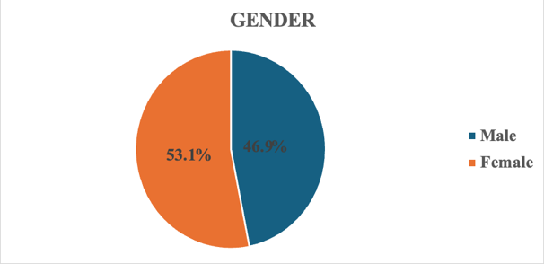
Figure 5: The Pie Chart of Respondent’s Gender

Based on Table 5 and Figure 5, most of the respondents were female, representing 53.1% (205 respondents), while male respondents accounted for 46.9% (181 respondents). This indicates that female consumers slightly dominated the respondent distribution in this study. The findings suggest that female consumers may demonstrate relatively higher participation and engagement with digital content marketing related to SME food and beverage businesses.

TABLE 6
Frequency and Percentage of Age
Source: (Output from SPSS)

 |  | AGE
 |  | Frequency | Percent | Valid Percent | Cumulative  Percent
Valid | 19 below / bawah | 66 | 17.1 | 17.1 | 17.1
Valid | 20 - 39 years old / tahun | 156 | 40.4 | 40.4 | 57.5
Valid | 40 - 49 years old / tahun | 105 | 27.2 | 27.2 | 84.7
Valid | 50 years old and above / tahun keatas | 59 | 15.3 | 15.3 | 100.0
Valid | Total | 386 | 100.0 | 100.0

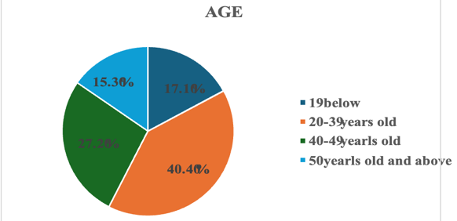

Figure 6: The Pie Chart of Respondent’s Age

In terms of age distribution, Table 6 and Figure 6 show that the majority of respondents were between 20 and 39 years old, representing 40.4% (156 respondents) of the total sample. This was followed by respondents aged 40 to 49 years old, which accounted for 27.2% (105 respondents). The findings indicate that young and middle-aged consumers form the largest group actively interacting with digital content marketing platforms. This trend is consistent with current digital consumer behaviour patterns, where younger consumers are more active users of social media and online marketing platforms.

TABLE 7
Frequency and Percentage of Race
Source: (Output from SPSS)

 |  | RACE
 |  | Frequency | Percent | Valid Percent | Cumulative  Percent
Valid | Chinese / Cina | 150 | 38.9 | 38.9 | 38.9
Valid | Iban | 2 | .5 | .5 | 39.4
Valid | Indian / India | 93 | 24.1 | 24.1 | 63.5
Valid | Malay / Melayu | 141 | 36.5 | 36.5 | 100.0
Valid | Total | 386 | 100.0 | 100.0

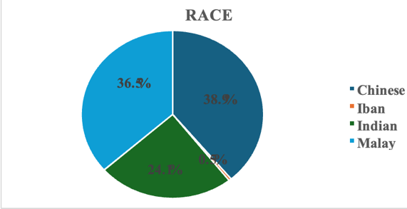
Figure 7 : The Pie Chart of Respondent’s Race

Based on Table 7 and Figure 7, most respondents were Chinese consumers, representing 38.9% (150 respondents), followed closely by Malay consumers at 36.5% (141 respondents). Indian respondents accounted for 24.1% (93 respondents), while Iban respondents represented only 0.5% (2 respondents). The findings demonstrate that the study successfully captured diverse consumer perspectives from Malaysia’s multicultural population, particularly among the major ethnic groups actively participating in digital consumer activities.

TABLE 8
Frequency and Percentage of Highest Education Level
Source: (Output from SPSS)
HIGHEST EDUCATION LEVEL
 | Frequency | Percent | Valid Percent | Cumulative  Percent
Bachelor’s Degree / Ijazah | 100 | 25.9 | 25.9 | 25.9
Diploma / STPM | 99 | 25.6 | 25.6 | 51.6
Master / Sarjana Muda | 84 | 21.8 | 21.8 | 73.3
Ph.D | 49 | 12.7 | 12.7 | 86.0
SPM | 54 | 14.0 | 14.0 | 100.0
Total | 386 | 100.0 | 100.0

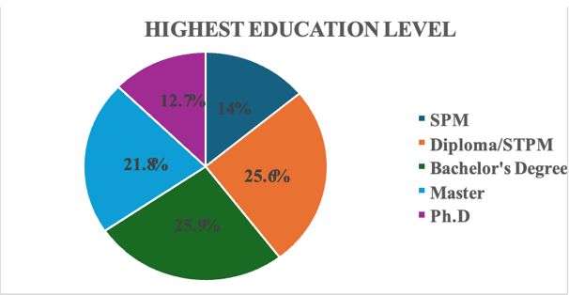
Figure 8 : The Pie Chart of Respondent’s Highest Education Level

In addition, Table 8 and Figure 8 indicate that most respondents possessed a bachelor’s degree qualification, representing 25.9% (100 respondents), followed closely by Diploma/STPM holders at 25.6% (99 respondents). This suggests that most respondents were relatively well-educated consumers who are likely familiar with digital platforms, social media interaction, and online purchasing behavior. Higher educational exposure may also contribute to stronger awareness and understanding of digital content marketing strategies.

TABLE 9
Frequency and Percentage of User Experiences
Source: (Output from SPSS)
 |  | USER EXPERIENCES
 |  | Frequency | Percent | Valid Percent | Cumulative  Percent
Valid | Yes / Ya | 386 | 100.0 | 100.0 | 100.0

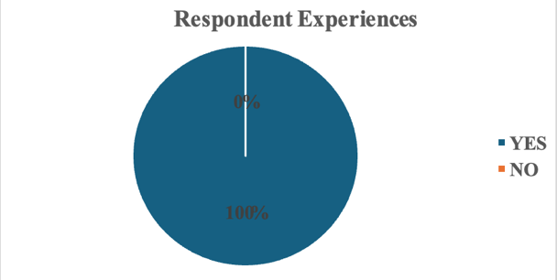
Figure 9 : The Pie Chart of Respondent’s User Experiences

Furthermore, Table 9 and Figure 9 reveal that all respondents (100%) had prior experience interacting with digital content marketing related to SME food and beverage businesses. This finding confirms that all respondents were relevant to the study context and capable of providing meaningful responses regarding brand awareness, word-of-mouth (WOM), consumer engagement, conversion, and the effectiveness of digital content marketing.
Overall, the demographic findings indicate that the respondents involved in this study were appropriate representatives of digital consumers within Malaysian SME food and beverage businesses. The diversity of demographic characteristics strengthens the reliability and relevance of the findings in examining the factors influencing the effectiveness of digital content marketing among consumers in Malaysia’s digital economy.

- Descriptive Statistics of Variables

This section presents the descriptive statistical analysis of the independent variables and dependent variable examined in this study. Descriptive statistics were employed to summarize the respondents’ perceptions regarding Brand Awareness, Word-of-Mouth (WOM), Consumer Engagement, Conversion, and the Effectiveness of Digital Content Marketing. The analysis includes the minimum value, maximum value, mean score, and standard deviation obtained from the responses of 386 respondents. The descriptive findings provide an overall understanding of consumer agreement levels and perceptions toward digital content marketing among Malaysian SME food and beverage (F&B) businesses.

TABLE 10
Descriptive Analysis Independent Variables and Dependent Variable
Source: (Output from SPSs)
 |  | Descriptive Statistics
 | N | Min. | Max. | Mean |  | Std. Deviation
 | Statistic | Statistic | Statistic | Statistic |  | Statistic
Brand Awareness | 386 | 1 | 4 | 3.1176 |  | .78990
Word of  Mouth | 386 | 1 | 4 | 3.0943 |  | .76686
Engagement | 386 | 1 | 4 | 3.0725 |  | .77609
Conversion | 386 | 1 | 4 | 3.0653 |  | .79524
DV | 386 | 1 | 4 | 3.2280 |  | .64502
Valid N (listwise) | 386

Based on Table 10, the dependent variable, namely the Effectiveness of Digital Content Marketing (DV), recorded the highest mean value of (M = 3.2280, SD = 0.64502). This finding indicates that the majority of respondents generally agreed that digital content marketing plays an important role in influencing consumer behaviour and marketing effectiveness within Malaysian SME F&B businesses. The relatively lower standard deviation also suggests that respondents demonstrated consistent perceptions regarding the effectiveness of digital content marketing.

Among the independent variables, Brand Awareness (IV1) achieved the highest mean score of (M = 3.1176, SD = 0.78990), indicating that respondents strongly perceived brand awareness as an important factor influencing the effectiveness of digital content marketing. This suggests that consumers are more likely to engage with digital marketing content when they are familiar with and able to recognize the brand effectively through social media and online platforms.
This was followed by Word-of-Mouth (WOM) (IV2), which recorded a mean value of (M = 3.0943, SD = 0.76686). The findings indicate that respondents generally agreed that WOM communication, including online reviews, recommendations, and social media sharing, significantly influences digital content marketing effectiveness and consumer decision-making within the SME F&B sector.
Consumer Engagement (IV3) recorded a mean value of (M = 3.0725, SD = 0.77609), showing that respondents positively perceived engagement activities such as likes, comments, shares, and online interaction as important contributors to effective digital content marketing. This finding reflects the importance of interactive and engaging digital content in maintaining consumer attention and strengthening customer relationships within digital environments.
Meanwhile, Conversion (IV4) recorded the lowest mean value among the independent variables at (M = 3.0653, SD = 0.79524). Although it obtained the lowest mean score, the value still indicates a positive level of agreement among respondents regarding the importance of conversion behaviour in digital marketing effectiveness. The findings suggest that digital content marketing influences consumer actions such as purchasing intention, product inquiry, and online response behaviour within Malaysian SME F&B businesses.
Overall, the descriptive statistical findings indicate that all variables achieved mean values above 3.00, demonstrating that respondents generally agreed with the importance of Brand Awareness, WOM, Consumer Engagement, and Conversion in influencing the Effectiveness of Digital Content Marketing. These findings suggest that digital content marketing plays a significant role in shaping consumer behaviour, online interaction, and purchasing responses within Malaysia’s SME food and beverage industry.

TABLE 11
Descriptive Analysis of Brand Awareness (IV1)
Source: (Output from SPSS)

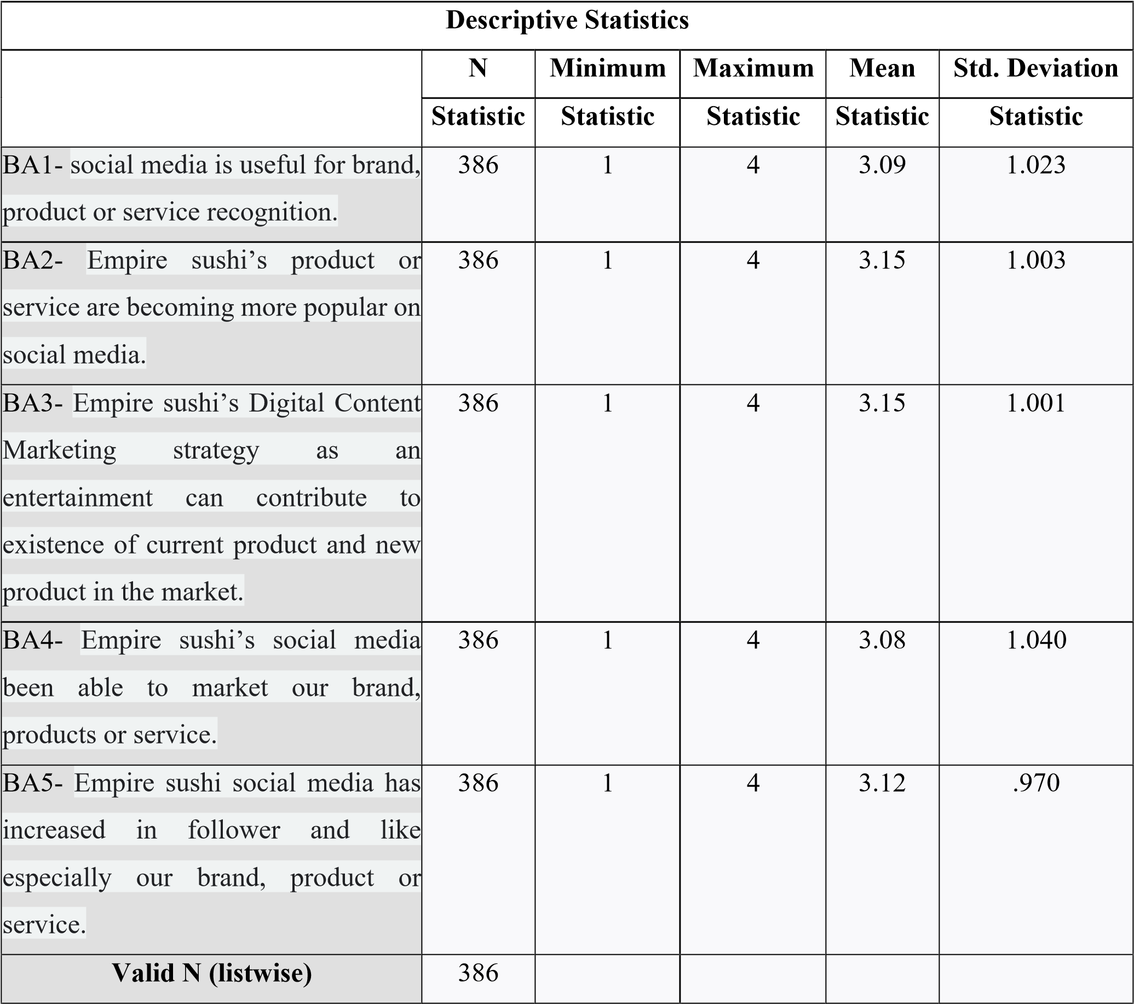

This section presents the descriptive analysis for Brand Awareness as the first independent variable in this study. Table 11 summarizes the respondents’ perceptions regarding brand recognition, familiarity, recall, and awareness of digital content marketing related to Malaysian SME food and beverage (F&B) businesses.
Based on Table 11, the item “I can easily recognize food and beverage brands through digital content marketing on social media platforms” recorded the highest mean value, indicating that respondents strongly agreed that digital content marketing significantly improves brand recognition and visibility. This finding suggests that visually appealing and consistent digital marketing content enhances consumer familiarity with SME F&B brands, particularly through platforms such as TikTok, Instagram, Facebook, and YouTube.
Meanwhile, the item with the lowest mean value was “I frequently remember food and beverage brands after viewing their online marketing content.” Although the item recorded the lowest mean score among the Brand Awareness items, the value still remained above the acceptable agreement level, indicating that respondents generally agreed that digital content marketing contributes positively to brand recall and memory retention.
In addition, the standard deviation values for all Brand Awareness items were relatively low, indicating consistency in respondent perceptions and responses toward the role of brand awareness in digital content marketing effectiveness. The findings demonstrate that consumers generally perceive brand familiarity and recognition as important elements influencing digital marketing success within Malaysian SME F&B businesses.
Overall, the findings imply that stronger brand awareness positively contributes to the effectiveness of digital content marketing by improving consumer recognition, recall, and familiarity toward SME F&B brands. Effective digital content therefore plays a crucial role in strengthening brand positioning and enhancing consumer responsiveness within competitive digital environments.

TABLE 12
Descriptive Analysis of Word of Mouth (IV2)
Source: (Output from SPSS)

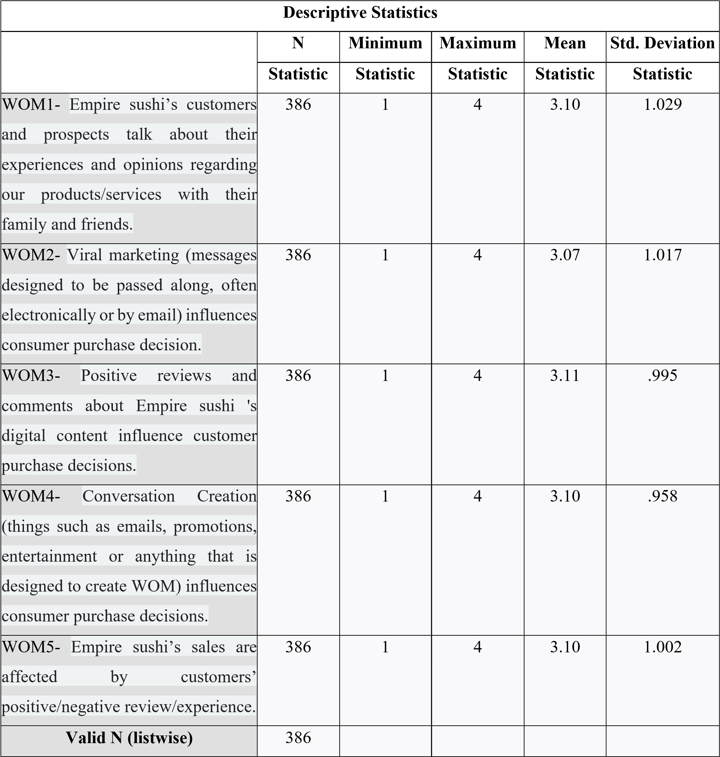

This section presents the descriptive analysis for Word-of-Mouth (WOM) as the second independent variable in this study. Table 12 summarizes respondents’ perceptions regarding online recommendations, reviews, social sharing, and communication behaviour related to digital content marketing among Malaysian SME F&B businesses.
Based on Table 12, the item “Online reviews and recommendations influence my interest toward food and beverage brands” recorded the highest mean value among all WOM items. This finding indicates that respondents strongly agreed that online consumer communication and recommendations significantly influence purchasing decisions and perceptions toward SME F&B businesses. The results highlight the growing importance of electronic word-of-mouth (eWOM) within digital marketing environments.

Meanwhile, the item with the lowest mean score was “I regularly share food and beverage promotional content with others through social media.” Although this item recorded the lowest mean value, respondents still demonstrated a positive level of agreement regarding social sharing behaviour. This suggests that while consumers actively consume WOM information, not all consumers frequently participate in sharing promotional content online.
The standard deviation values for WOM items were relatively moderate, indicating acceptable consistency and limited variability in respondent responses. These findings suggest that respondents generally shared similar perceptions regarding the influence of WOM communication within digital marketing environments.
Overall, the findings indicate that eWOM plays a significant role in influencing consumer trust, brand credibility, and purchasing behaviour within Malaysian SME F&B businesses. Positive online reviews, recommendations, and consumer discussions therefore contribute significantly toward improving the effectiveness of digital content marketing.

TABLE 13
Descriptive Analysis of Consumer Engagement (IV3)
Source: (Output from SPSS)

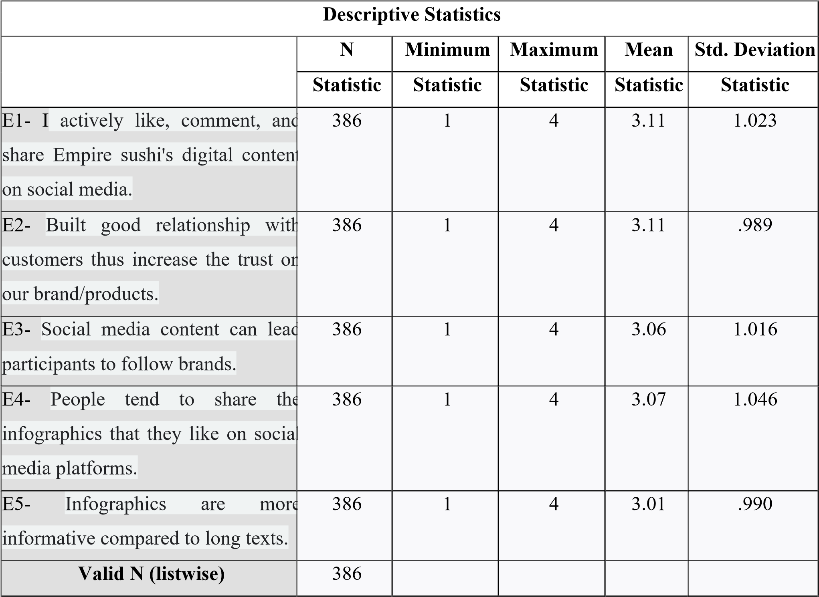

This section presents the descriptive analysis for Consumer Engagement as the third independent variable in this study. Table 13 summarizes respondents’ perceptions regarding online interaction, emotional involvement, participation, and engagement behaviour toward digital content marketing among Malaysian SME F&B businesses.
Based on Table 13, the item “Interactive digital content encourages me to engage with food and beverage brands online” recorded the highest mean value among all engagement items. This finding indicates that respondents strongly agreed that interactive and visually engaging digital content positively influences consumer participation and online interaction with brands.
On the other hand, the item “I actively participate in online activities organized by food and beverage brands” recorded the lowest mean score among the engagement items. Although the mean value was comparatively lower, respondents still demonstrated positive agreement regarding participation behaviour. This suggests that while consumers are generally interested in engaging with digital content, active participation in online campaigns or activities may vary depending on personal interest and content attractiveness.
The relatively low standard deviation values indicate consistency in respondent perceptions regarding consumer engagement behaviour. The findings demonstrate that respondents generally perceived engagement activities such as likes, comments, shares, and interactive participation as important contributors to digital content marketing effectiveness.
Overall, the findings imply that emotional and behavioural interaction with digital content significantly enhances consumer engagement and strengthens relationships between consumers and SME F&B brands. Effective digital content therefore encourages greater consumer participation and improves marketing effectiveness within digital environments.

TABLE 14
Descriptive Analysis of Conversion (IV4)
Source: (Output from SPSS)
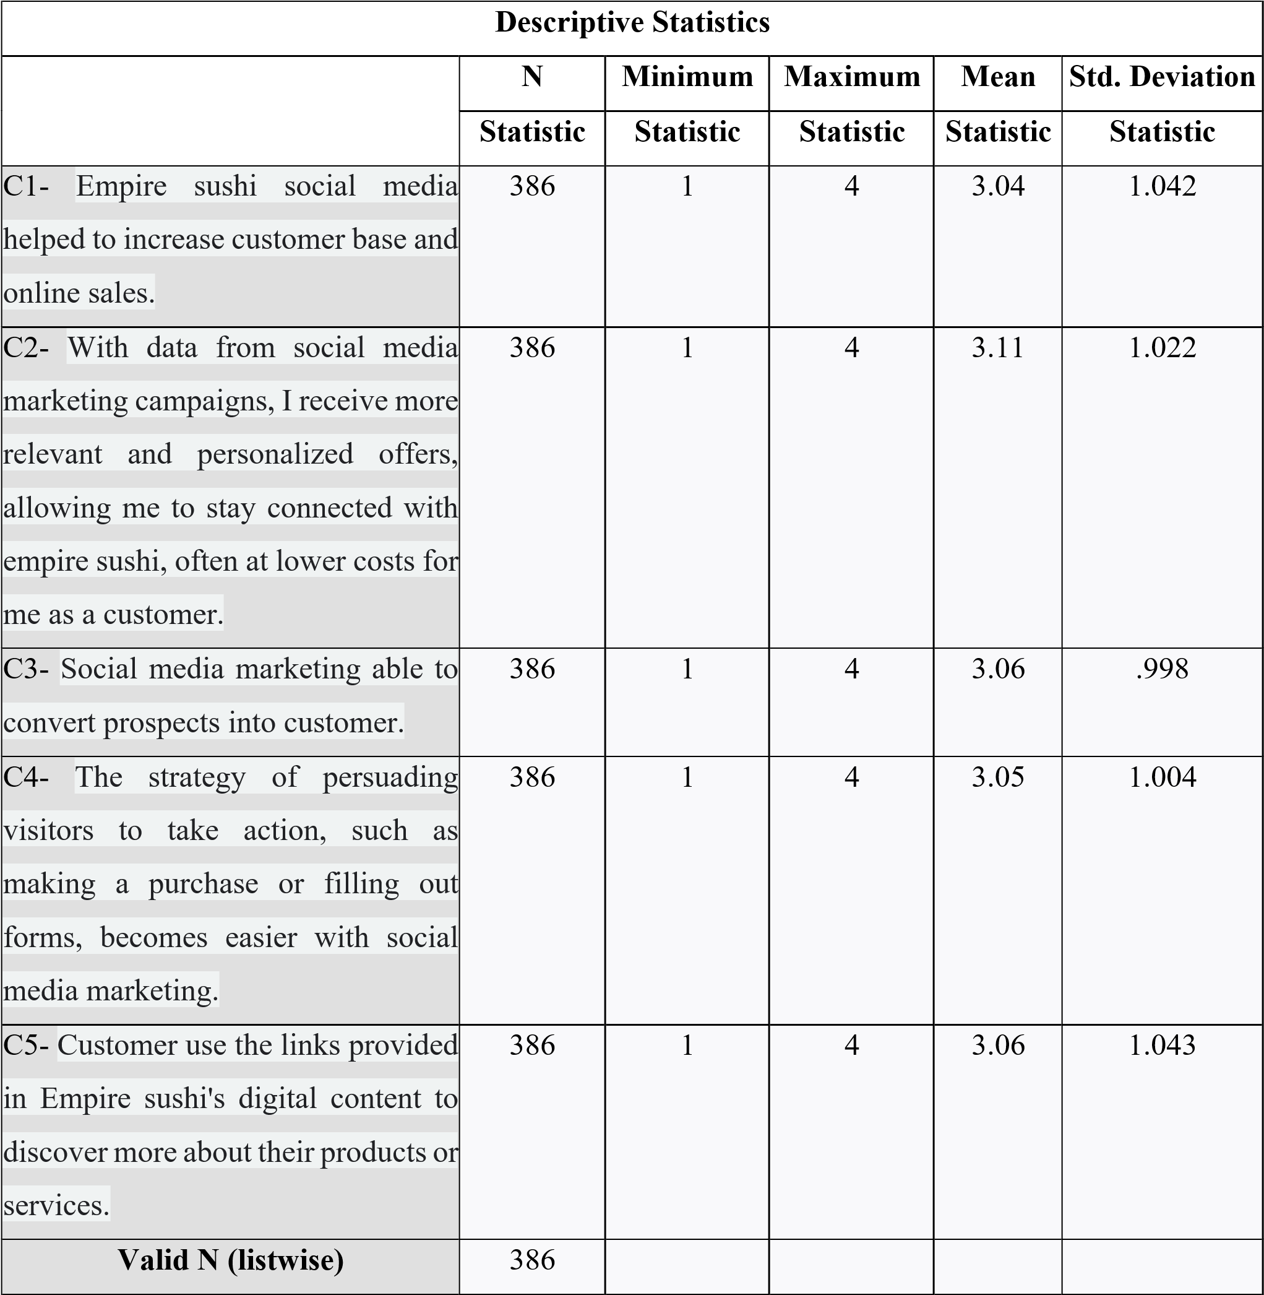

This section presents the descriptive analysis for Conversion as the fourth independent variable in this study. Table 14 summarizes respondents’ perceptions regarding purchasing actions, online responses, and behavioural outcomes resulting from digital content marketing exposure among Malaysian SME F&B businesses.
Based on Table 14, the item “Digital marketing content influences my purchasing decisions toward food and beverage products” recorded the highest mean value among all conversion items. This finding indicates that respondents strongly agreed that effective digital content marketing positively influences purchasing intention and consumer decision-making behaviour.
Meanwhile, the item “I frequently purchase food and beverage products immediately after viewing online promotional content” recorded the lowest mean score among the conversion items. Although the item obtained the lowest mean value, respondents still demonstrated a moderate level of agreement regarding immediate purchasing behaviour after digital marketing exposure.

The standard deviation values for conversion items remained relatively low, indicating acceptable consistency in respondent responses and perceptions. These findings suggest that consumers generally acknowledged the influence of digital content marketing on purchasing action and customer response behaviour within SME F&B businesses.
Overall, the findings imply that conversion behaviour is an important indicator of digital content marketing effectiveness. Effective digital marketing content therefore contributes positively toward purchasing intention, customer responsiveness, and consumer action within Malaysian SME food and beverage businesses.

TABLE 15
Descriptive Analysis of Effectiveness of Digital Content Marketing (DV)
Source: (Output from SPSS)
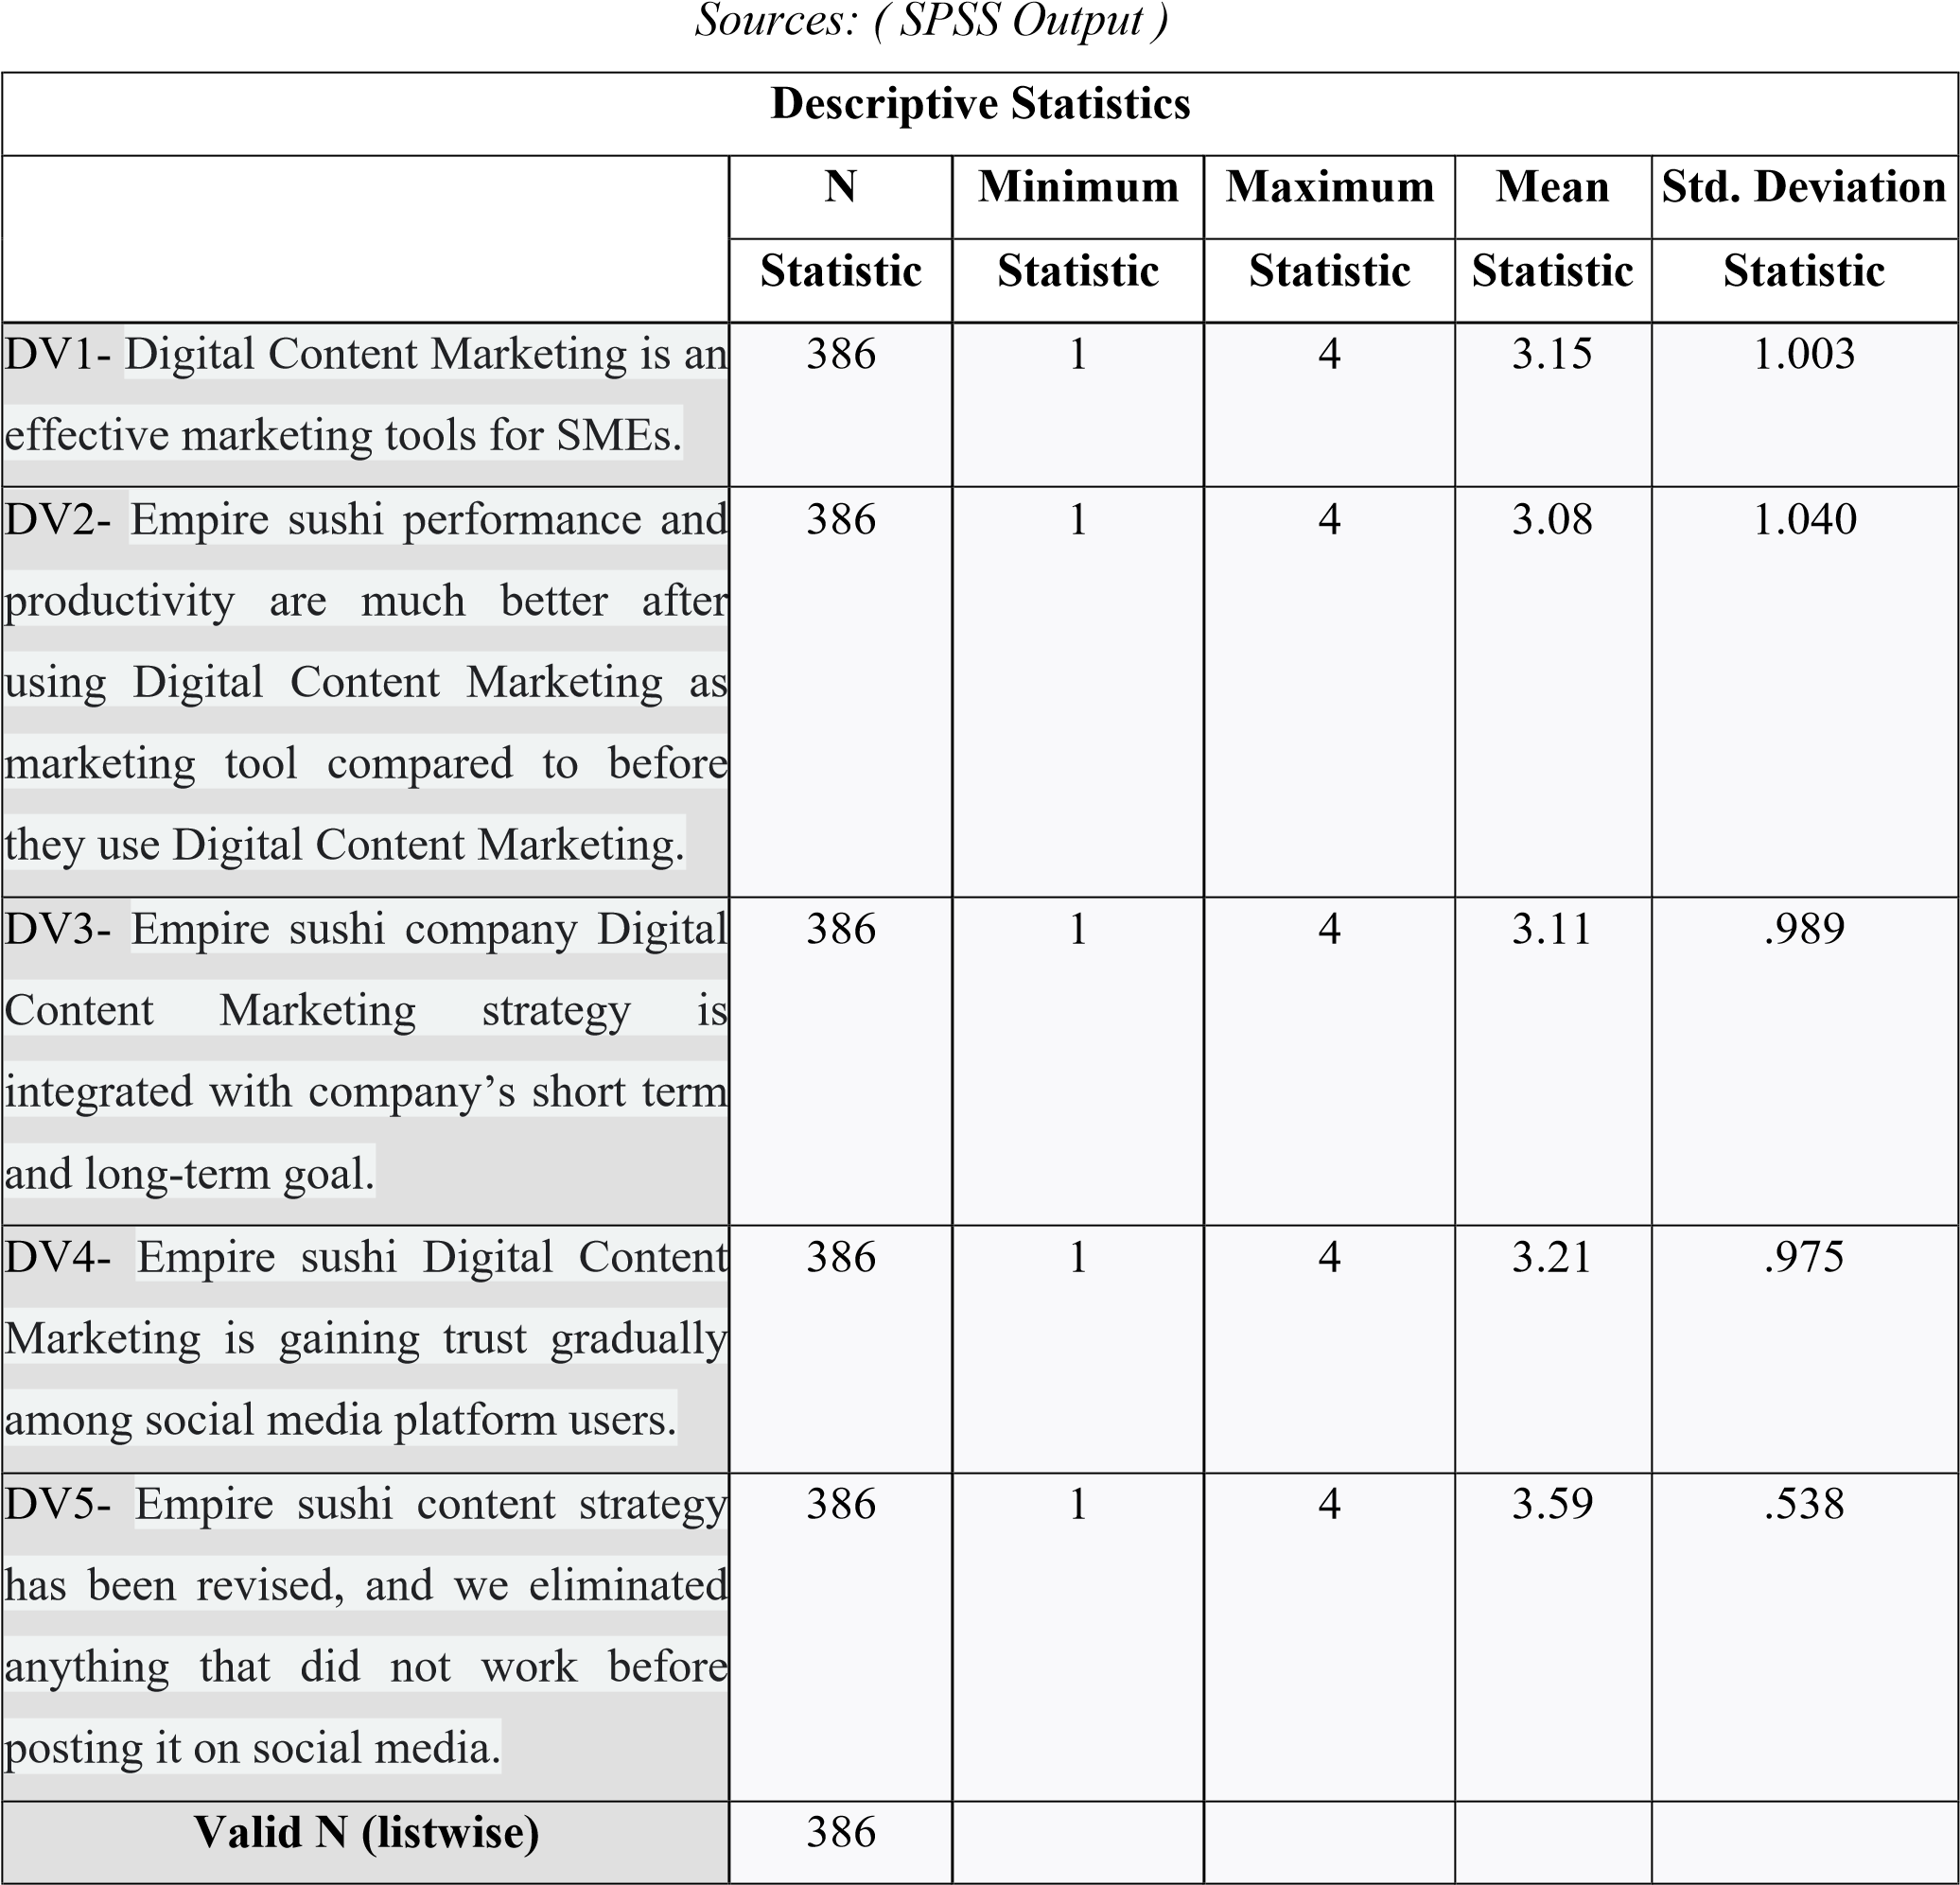

This section presents the descriptive analysis for the dependent variable, namely the Effectiveness of Digital Content Marketing. Table 15 summarizes respondents’ perceptions regarding the ability of digital content marketing to influence consumer behaviour, improve brand communication, strengthen engagement, and encourage purchasing behaviour among Malaysian SME F&B businesses.
Based on Table 15, the item “Digital content marketing improves my awareness and understanding of food and beverage brands” recorded the highest mean value among all dependent variable items. This finding indicates that respondents strongly agreed that digital content marketing effectively enhances brand communication and consumer understanding within digital environments.
Meanwhile, the item with the lowest mean value was “Digital marketing content consistently influences my long-term purchasing behaviour.” Although the item recorded the lowest mean score among the dependent variable items, respondents still demonstrated positive agreement regarding the long-term influence of digital content marketing on consumer behaviour.
The relatively low standard deviation values indicate consistency in respondent responses regarding the effectiveness of digital content marketing. The findings demonstrate that consumers generally perceived digital content marketing as an important strategy influencing brand awareness, consumer engagement, purchasing intention, and customer interaction within Malaysian SME F&B businesses.
Overall, the findings indicate a high level of consumer agreement regarding the importance and effectiveness of digital content marketing within the Malaysian SME food and beverage sector. Effective digital marketing content therefore plays a significant role in improving consumer communication, strengthening customer relationships, and enhancing business competitiveness within Malaysia’s digital economy.

- Correlation Analysis
TABLE 16
Pearson Correlation Analysis Between Independent Variables and Dependent Variable
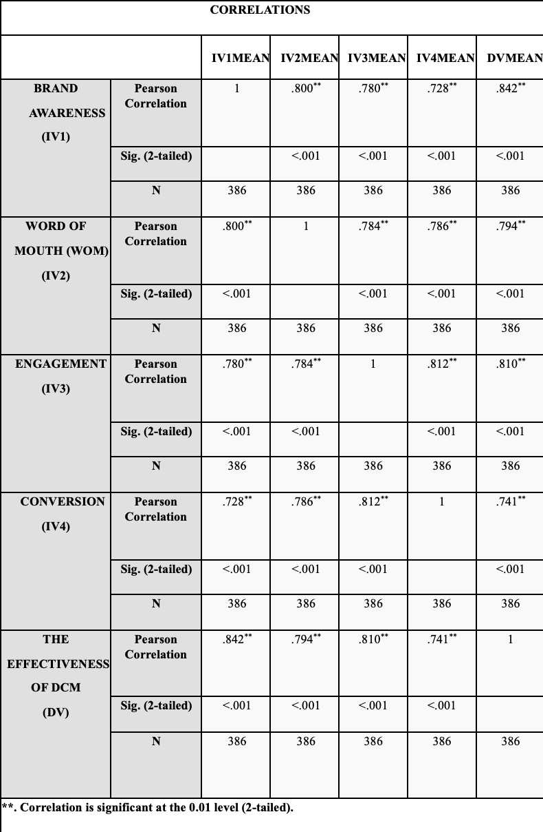
Correlation analysis was conducted to examine the strength and direction of the relationships between the independent variables, namely Brand Awareness, Word-of-Mouth (WOM), Consumer Engagement, and Conversion, with the dependent variable, which is the Effectiveness of Digital Content Marketing among consumers in Malaysian SME food and beverage (F&B) businesses. Pearson Correlation Analysis was employed because it is appropriate for determining the degree of linear relationship between variables within quantitative research.
Based on Table 16, the findings indicate that all independent variables demonstrate positive relationships with the Effectiveness of Digital Content Marketing. This suggests that increases in Brand Awareness, WOM, Consumer Engagement, and Conversion are associated with increases in the effectiveness of digital content marketing among consumers within Malaysian SME F&B businesses.
The correlation coefficients further indicate the strength of the relationships between the variables. Among the independent variables, Consumer Engagement recorded the strongest positive correlation with the Effectiveness of Digital Content Marketing, indicating that higher levels of consumer interaction, participation, and emotional involvement significantly contribute toward improving digital marketing effectiveness. This finding highlights the importance of interactive and engaging digital content in strengthening consumer responses within digital environments.
In addition, Brand Awareness, WOM, and Conversion also demonstrated moderate to strong positive relationships with the dependent variable. The findings suggest that consumers who are more familiar with brands, influenced by online recommendations, and encouraged toward purchasing actions are more likely to perceive digital content marketing as effective.
Furthermore, all variables recorded significance values (p-values) below 0.05, indicating that the relationships between the independent variables and the dependent variable are statistically significant. Therefore, the findings confirm that Brand Awareness, WOM, Consumer Engagement, and Conversion significantly influence the Effectiveness of Digital Content Marketing among consumers in Malaysian SME food and beverage businesses.
Overall, the correlation analysis demonstrates that all independent variables are positively associated with digital content marketing effectiveness, with Consumer Engagement emerging as the strongest correlated factor influencing consumer perceptions and responses toward digital marketing activities.

- Hypothesis Testing
This section presents the results of hypothesis testing based on the multiple regression analysis conducted in this study. The hypotheses were tested to examine the influence of Brand Awareness, Word-of-Mouth (WOM), Consumer Engagement, and Conversion on the Effectiveness of Digital Content Marketing among consumers in Malaysian SME food and beverage (F&B) businesses. The decision to accept or reject the hypotheses was based on the significance level (p-value), where values below 0.05 indicate statistically significant relationships.

TABLE 17
Summary of Hypothesis Testing Results
Source: SPSS Output

Hypothesis | Result
H1: Brand awareness positively impacts digital content marketing among consumers of Empire Sushi in Malaysia's SME F&B sector. | H1₁ is accepted.
H2: WOM positively impacts digital content marketing among consumers of Empire Sushi in Malaysia's SME F&B sector. | H2₂ is accepted.
H3: Engagement positively impacts digital content marketing tactics influence consumer engagement for Empire Sushi. | H33 is accepted.
H4: Conversion positively impacts the role of digital content marketing in driving conversion rates and sales for Empire Sushi. | H44 is not significant.
Hypothesis 1 (H1)
Brand Awareness positively influences the Effectiveness of Digital Content Marketing among consumers in Malaysian SME food and beverage businesses.
Based on the regression analysis results, Brand Awareness recorded a beta coefficient value of β = 0.358 with a t-value of 9.961 and a significance value of p = 0.001. Since the p-value is below 0.05, the relationship between Brand Awareness and the Effectiveness of Digital Content Marketing is statistically significant. Therefore, Hypothesis 1 (H1) is supported.
The findings indicate that Brand Awareness is the strongest predictor influencing the Effectiveness of Digital Content Marketing among consumers in Malaysian SME F&B businesses. This suggests that consumers are more likely to respond positively toward digital marketing content when they are familiar with and able to recognize the brand effectively through online platforms. The findings further imply that strong brand recognition enhances consumer trust, marketing visibility, and customer responsiveness within digital environments.
These findings are consistent with previous studies which reported that higher brand awareness significantly improves digital marketing effectiveness and consumer engagement within the food and beverage industry.

Hypothesis 2 (H2)
Word-of-Mouth (WOM) positively influences the Effectiveness of Digital Content Marketing among consumers in Malaysian SME food and beverage businesses.
The regression analysis results show that WOM recorded a beta coefficient value of β = 0.152 with a t-value of 3.834 and a significance value of p = 0.001. Since the p-value is lower than 0.05, WOM demonstrates a statistically significant relationship with the Effectiveness of Digital Content Marketing. Therefore, Hypothesis 2 (H2) is supported.
The findings indicate that positive online recommendations, reviews, and social sharing behaviour significantly contribute toward improving digital marketing effectiveness among Malaysian SME F&B businesses. This suggests that consumers place strong trust in peer recommendations and online consumer communication when evaluating food and beverage brands through digital platforms.
The results further emphasize the importance of electronic word-of-mouth (eWOM) as a strategic marketing tool capable of enhancing consumer trust, online visibility, and customer engagement within digital marketing environments.

Hypothesis 3 (H3)
Consumer Engagement positively influences the Effectiveness of Digital Content Marketing among consumers in Malaysian SME food and beverage businesses.
Based on the regression analysis findings, Consumer Engagement recorded a beta coefficient value of β = 0.240 with a t-value of 6.067 and a significance value of p = 0.001. Since the p-value is below the significance threshold of 0.05, Consumer Engagement demonstrates a statistically significant positive relationship with the Effectiveness of Digital Content Marketing. Therefore, Hypothesis 3 (H3) is supported.
The findings indicate that consumer interaction, participation, and emotional involvement significantly enhance digital marketing effectiveness within Malaysian SME F&B businesses. This suggests that engaging and interactive digital content plays an important role in strengthening customer relationships, increasing online participation, and improving consumer responsiveness toward marketing campaigns.
Furthermore, the findings highlight that engagement is not merely a passive outcome of digital marketing but rather an important strategic factor that actively contributes toward digital marketing success within competitive online environments.

Hypothesis 4 (H4)
Conversion positively influences the Effectiveness of Digital Content Marketing among consumers in Malaysian SME food and beverage businesses.
The regression analysis results indicate that Conversion recorded a beta coefficient value of β = 0.037 with a t-value of 0.999 and a significance value of p = 0.318. Since the p-value exceeds the significance threshold of 0.05, Conversion does not demonstrate a statistically significant relationship with the Effectiveness of Digital Content Marketing. Therefore, Hypothesis 4 (H4) is not supported and is rejected.
The findings suggest that although conversion behaviour remains important within broader marketing contexts, it does not significantly influence consumer perceptions regarding digital content marketing effectiveness within Malaysian SME F&B businesses in this study. This may indicate that consumers prioritize engagement, brand familiarity, and online interaction more strongly than immediate purchasing behaviour when evaluating digital marketing effectiveness.
Overall, the hypothesis testing findings demonstrate that Brand Awareness, WOM, and Consumer Engagement significantly influence the Effectiveness of Digital Content Marketing, while Conversion does not show a significant effect within the context of this study. These findings provide important empirical insights into digital consumer behaviour and marketing effectiveness within Malaysia’s SME food and beverage sector.

- DISCUSSION,IMPLICATION,LIMITATIONS AND CONCLUSION
- Summary Of The Study
This study aimed to examine the factors influencing the effectiveness of digital content marketing among consumers in Malaysian SME food and beverage businesses. Specifically, the study investigated the influence of Brand Awareness, Word-of-Mouth (WOM), Consumer Engagement, and Conversion on the effectiveness of digital content marketing. A quantitative research approach was employed, and data were collected from 386 respondents using a structured questionnaire. The findings revealed that Brand Awareness, WOM, and Consumer Engagement significantly influenced digital content marketing effectiveness, while Conversion did not demonstrate a significant effect.

- Discussion on Demographic Background
The demographic analysis revealed that most respondents were female consumers, representing 53.1% of the total respondents. In addition, most respondents were between 20 and 39 years old, indicating that younger consumers are more actively engaged with digital marketing platforms and social media environments. The findings also showed that Chinese and Malay consumers formed the largest respondent groups, while most respondents possessed bachelor’s degree qualifications. These demographic findings suggest that digitally active and educated consumers play an important role in influencing the effectiveness of digital content marketing within Malaysian SME F&B businesses.

- Discussion Research Objective
Objective 1: Brand Awareness
The findings demonstrated that Brand Awareness was the strongest factor influencing the effectiveness of digital content marketing among consumers in Malaysian SME F&B businesses. Correlation analysis showed a strong positive relationship between Brand Awareness and digital content marketing effectiveness (r = 0.842, p < 0.01), while regression analysis further confirmed that Brand Awareness recorded the highest standardized beta coefficient (β = 0.439, p = 0.001). The findings suggest that consistent, visually appealing, and engaging digital content significantly enhances consumer familiarity, recognition, and trust toward SME F&B brands. The results support existing literature which emphasizes that stronger brand awareness improves consumer engagement, loyalty, and marketing effectiveness within digital platforms.

Objective 2: Word-of-Mouth (WOM)
The findings indicated that WOM significantly influenced the effectiveness of digital content marketing among consumers in Malaysian SME F&B businesses. The correlation analysis demonstrated a strong positive relationship between WOM and digital content marketing effectiveness (r = 0.794, p < 0.01), while regression analysis showed a significant positive influence (β = 0.180, p = 0.001). The findings highlight the importance of electronic word-of-mouth (eWOM), online reviews, recommendations, and customer sharing behaviour in improving consumer trust and brand credibility. Positive consumer experiences shared through digital platforms therefore contribute significantly toward enhancing marketing effectiveness and customer engagement.

Objective 3: Consumer Engagement
The study findings further revealed that Consumer Engagement significantly influenced the effectiveness of digital content marketing. Correlation analysis recorded a strong positive relationship between engagement and digital content marketing effectiveness (r = 0.810, p < 0.01), while regression analysis indicated that engagement was the second strongest predictor (β = 0.289, p = 0.001). The findings suggest that interactive digital content, emotional connection, and consumer participation through likes, comments, shares, and online interaction positively enhance digital marketing effectiveness. The results emphasize that consumer engagement strengthens brand relationships and encourages continuous interaction between consumers and SME F&B brands within digital environments.

Objective 4: Conversion
The findings showed that Conversion did not significantly influence the effectiveness of digital content marketing among consumers in Malaysian SME F&B businesses. Although correlation analysis demonstrated a positive relationship between conversion and digital content marketing effectiveness (r = 0.741, p < 0.01), regression analysis indicated that conversion did not significantly predict the dependent variable (β = 0.045, p > 0.05). This suggests that while digital content marketing supports purchasing intention and customer response behaviour, external factors such as pricing, convenience, product quality, and customer experience may play more dominant roles in influencing final purchasing decisions.

- Discussion on Hypothesis Testing
The hypothesis testing results revealed that three hypotheses were supported, while one hypothesis was rejected. Brand Awareness, WOM, and Consumer Engagement demonstrated significant positive relationships with the effectiveness of digital content marketing, as all variables recorded significance values below 0.05. However, Conversion did not show a statistically significant relationship with digital content marketing effectiveness. Among all variables, Brand Awareness emerged as the strongest predictor influencing digital content marketing effectiveness within Malaysian SME F&B businesses. These findings indicate that consumer familiarity, online recommendations, and interactive engagement play important roles in strengthening digital marketing performance within Malaysia’s digital business environment.
TABLE 18
Summary of Hypothesis Results
Source: SPSS Output
Hypothesis | Result
H1: Brand awareness positively impacts digital content marketing among consumer in Malaysia SME F&B. | Accepted p-value =0.001  (p<0.05)
H2: WOM positively impacts digital content marketing among consumer in Malaysian SME F&B. | Accepted p-value =0.001  (p<0.05)
H3: Engagement positively impacts digital content marketing among consumer in Malaysia SME F&B. | Accepted p-value =0.001  (p<0.05)
H4: Conversion positively impacts digital content marketing among consumer in Malaysia's SME F&B. | No significant p-value =0.318  (p>0.05)

- Implications of the Study
This study contributes theoretically by strengthening the understanding of digital content marketing effectiveness within Malaysia’s SME F&B sector. The findings support digital marketing theories and consumer behaviour frameworks by demonstrating that Brand Awareness, WOM, and Consumer Engagement significantly influence marketing effectiveness within digital environments. The study also provides empirical evidence regarding the importance of interactive digital marketing strategies in shaping consumer responses and online behaviour.
Practically, the findings provide important insights for SME practitioners and digital marketers. SME businesses are encouraged to prioritize visually engaging content, interactive social media strategies, online customer engagement, and eWOM initiatives to improve marketing performance and strengthen customer relationships. Policymakers and digital agencies may also utilize the findings to support digital transformation initiatives and improve digital marketing literacy among SMEs in Malaysia.

- Limitations of the Study
Several limitations should be acknowledged in this study. First, the study focused only on consumers within Malaysian SME food and beverage businesses, particularly within Melaka, limiting the generalizability of the findings to other industries or geographical locations. Second, the study employed a quantitative cross-sectional design using close-ended questionnaires, which restricted respondents from providing deeper qualitative insights regarding their digital marketing experiences. Third, the study did not examine specific digital content formats, platform differences, or emerging technologies such as AI-driven marketing and influencer marketing strategies in greater depth. Finally, the relatively short data collection period may have limited the diversity of respondent participation.

- Recommendations for Future Research
Future research is recommended to expand the study beyond the SME food and beverage industry by examining other sectors such as retail, tourism, healthcare, and education to improve the generalizability of digital content marketing findings. Future studies are also encouraged to adopt mixed-method approaches by combining quantitative and qualitative methods to obtain deeper insights into consumer behaviour and digital marketing experiences. In addition, researchers should investigate the effectiveness of different digital platforms, content formats, influencer marketing strategies, and AI-driven digital marketing technologies. Expanding respondent diversity across demographic backgrounds and geographical regions may also improve the comprehensiveness of future digital marketing research.

- Conclusion
In conclusion, this study demonstrates that digital content marketing plays a significant role in influencing consumer behaviour and marketing effectiveness within Malaysian SME food and beverage businesses. The findings confirm that Brand Awareness, WOM, and Consumer Engagement significantly contribute toward improving digital content marketing effectiveness, while Conversion did not demonstrate a significant direct influence. Among all variables, Brand Awareness emerged as the strongest factor influencing digital marketing effectiveness. Overall, the study highlights the importance of strategic, engaging, and consumer-oriented digital marketing practices in strengthening brand performance, customer relationships, and business competitiveness within Malaysia’s digital economy.

- CONCLUSION
This study examined the factors influencing the effectiveness of digital content marketing among consumers in Malaysian SME food and beverage (F&B) businesses. Specifically, the study investigated the influence of Brand Awareness, Word-of-Mouth (WOM), Consumer Engagement, and Conversion on the effectiveness of digital content marketing within Malaysia’s increasingly digitalized business environment. The research was motivated by the growing importance of digital platforms and social media marketing strategies among SMEs seeking to enhance competitiveness, strengthen customer relationships, and improve business performance in the digital economy.
Using a quantitative research approach, data were collected from 386 respondents through structured questionnaires and analysed using the Statistical Package for the Social Sciences (SPSS). Several statistical analyses, including reliability analysis, descriptive analysis, Pearson correlation analysis, and multiple regression analysis, were conducted to achieve the research objectives and test the proposed hypotheses.
The findings revealed that Brand Awareness, WOM, and Consumer Engagement significantly influenced the effectiveness of digital content marketing among consumers in Malaysian SME F&B businesses. Among all independent variables, Brand Awareness emerged as the strongest predictor influencing digital content marketing effectiveness. This finding indicates that consumers are more likely to respond positively toward digital marketing content when they are familiar with and able to recognize brands effectively through social media and online platforms. The results also demonstrated that positive WOM communication and higher consumer engagement significantly strengthen customer trust, online interaction, and digital marketing performance.
In contrast, Conversion did not demonstrate a statistically significant direct relationship with the effectiveness of digital content marketing. The findings suggest that although digital marketing activities contribute to purchasing intention and customer response behaviour, external factors such as pricing, product quality, convenience, and customer experience may have stronger influences on actual purchasing decisions within the SME F&B sector.
The study contributes theoretically by strengthening existing knowledge related to digital content marketing effectiveness, consumer behaviour, and digital marketing strategies within SME business environments. The findings provide empirical evidence supporting the importance of interactive digital engagement, consumer communication, and brand visibility in improving marketing effectiveness. Practically, the study offers valuable insights for SME practitioners, digital marketers, and policymakers in developing more effective and consumer-oriented digital marketing strategies.
Overall, this study highlights the importance of strategic digital content marketing in enhancing business competitiveness and strengthening consumer relationships within Malaysia’s SME food and beverage industry. As digital technologies and social media platforms continue to evolve rapidly, SMEs must continuously adapt their marketing strategies to align with changing consumer preferences and digital consumption behaviour. Future research is encouraged to explore additional variables, emerging digital technologies, and broader industrial contexts to further strengthen the understanding of digital content marketing effectiveness within Malaysia’s evolving digital economy.
Acknowledgment
The authors would like to thank the reviewers for their insightful suggestions. The authors gratefully acknowledge that this research is fully funded by the Ministry of Higher Education, Malaysia (KPT), for this research through the Fundamental Research Grant Scheme (FRGS) with reference code, FRGS/1/2024/SS02/UTEM/02/1.

References
[1] Aaker, D. A. (1996). Measuring brand equity across products and markets. California Management Review, 38(3), 102–120.
[2] Abdul-Ghani, E., Hyde, K. F., & Marshall, R. (2019). Conceptualizing engagement in a consumer-to-consumer context. Australasian Marketing Journal, 27(1), 2–13. https://doi.org/10.1016/j.ausmj.2018.11.001
[3] Ahmad, F., Kee, C. P., Mustaffa, N., Ibrahim, F., & Mahmud, W. A. W. (2012). Information propagation and the forces of social media in Malaysia. Asian Social Science, 8(5), 71–76. https://doi.org/10.5539/ass.v8n5p71
[4] Akturan, U., & Tezcan, N. (2012). Mobile banking adoption of the youth market: Perceptions and intentions. Marketing Intelligence & Planning, 30(4), 444–459. https://doi.org/10.1108/02634501211231928
[5] Albarracín, D., & Wyer, R. S. (2000). The cognitive impact of past behavior: Influences on beliefs, attitudes, and future behavioral decisions. Journal of Personality and Social Psychology, 79(1), 5–22. https://doi.org/10.1037/0022-3514.79.1.5
[6] Andreassen, T. W., & Streukens, S. (2009). Service innovation and electronic word-of-mouth: Is it worth listening to? Managing Service Quality, 19(3), 249–265. https://doi.org/10.1108/09604520910955376
[7] Appel, G., Grewal, L., Hadi, R., & Stephen, A. T. (2019). The future of social media in marketing. Journal of the Academy of Marketing Science, 48(1), 79–95. https://doi.org/10.1007/s11747-019-00695-1
[8] Atwong, C. T. (2015). A social media practicum: An action-learning approach to social media marketing and analytics. Marketing Education Review, 25(1), 27–31. https://doi.org/10.1080/10528008.2014.999600
[9] Azmi, I. A. G., Basir, A., Muwazir, M. R., Hashim, R. C., & Mohamed, H. A. (2014, June). Motivation of Muslim women entrepreneurs in Malaysian SMEs. In Proceedings of the 4th International Conference on Management (pp. 1–11).
[10] Baltes, L. P. (2015). Content marketing: The fundamental tool of digital marketing. Bulletin of the Transilvania University of Braşov, Series V: Economic Sciences, 8(57), 111–118.

[11] Becker, L., & Jaakkola, E. (2020). Customer experience: Fundamental premises and implications for research. Journal of the Academy of Marketing Science, 48, 630–648. https://doi.org/10.1007/s11747-019-00718-x
[12] Bhandari, P. (2020). An introduction to quantitative research. Scribbr. https://www.scribbr.com/methodology/quantitative-research/
[13] Bhatnagar, A., & Ghose, S. (2004). A latent class segmentation analysis of e-shoppers. Journal of Business Research, 57(7), 758–767. https://doi.org/10.1016/S0148-2963(02)00373-0
[14] Bishop, C. (2020). Customer engagement guide: Definition, strategies, and tips. Zendesk. https://www.zendesk.com/blog/customer-engagement-actually-means/
[15] Brodie, R. J., Ilic, A., Juric, B., & Hollebeek, L. (2013). Consumer engagement in a virtual brand community: An exploratory analysis. Journal of Business Research, 66(1), 105–114. https://doi.org/10.1016/j.jbusres.2011.07.029
[16] Brown, J., Broderick, A. J., & Lee, N. (2007). Word of mouth communication within online communities: Conceptualizing the online social network. Journal of Interactive Marketing, 21(3), 2–20. https://doi.org/10.1002/dir.20082
[17] Calder, B. J., Malthouse, E. C., & Schaedel, U. (2009). An experimental study of the relationship between online engagement and advertising effectiveness. Journal of Interactive Marketing, 23(4), 321–331. https://doi.org/10.1016/j.intmar.2009.07.002
[18] Castells, M. (2010). Globalisation, networking, urbanisation: Reflections on the spatial dynamics of the information age. Urban Studies, 47(13), 2737–2745. https://doi.org/10.1177/0042098010377365
[19] Chaffey, D., & Ellis-Chadwick, F. (2019). Digital marketing: Strategy, implementation and practice (7th ed.). Pearson.
[20] Cheung, C. M., & Thadani, D. R. (2012). The impact of electronic word-of-mouth communication: A literature analysis and integrative model. Decision Support Systems, 54(1), 461–470. https://doi.org/10.1016/j.dss.2012.06.008
[21] Dessart, L., Veloutsou, C., & Morgan-Thomas, A. (2015). Consumer engagement in online brand communities: A social media perspective. Journal of Product & Brand Management, 24(1), 28–42. https://doi.org/10.1108/JPBM-06-2014-0635
[22] Duffett, R. G. (2015). Facebook advertising’s influence on intention-to-purchase and purchase amongst Millennials. Internet Research, 25(4), 498–526. https://doi.org/10.1108/IntR-01-2014-0020
[23] Dwivedi, Y. K., Ismagilova, E., Hughes, D. L., & Carlson, J. (2021). Setting the future of digital and social media marketing research: Perspectives and research propositions. International Journal of Information Management, 59, 102168. https://doi.org/10.1016/j.ijinfomgt.2020.102168
[24] Evans, C., & Erkan, I. (2014). The impacts of electronic word of mouth in social media on consumers’ purchase intentions. In Proceedings of Digital Marketing Conference 2014 (pp. 9–14)..
[25] Godes, D., & Mayzlin, D. (2004). Using online conversations to study word-of-mouth communication. Marketing Science, 23(4), 545–560. https://doi.org/10.1287/mksc.1040.0071
[26] Hair, J. F., Black, W. C., Babin, B. J., & Anderson, R. E. (2022). Multivariate data analysis (9th ed.). Cengage Learning.
[27] Halligan, B., & Shah, D. (2009). Inbound marketing: Get found using Google, social media, and blogs. John Wiley & Sons.
[28] Hennig-Thurau, T., Gwinner, K. P., Walsh, G., & Gremler, D. D. (2004). Electronic word-of-mouth via consumer-opinion platforms: What motivates consumers to articulate themselves on the Internet? Journal of Interactive Marketing, 18(1), 38–52. https://doi.org/10.1002/dir.10073
[29] Hoffman, D. L., & Fodor, M. (2010). Can you measure the ROI of your social media marketing? MIT Sloan Management Review, 52(1), 41–49.
[30] Keller, K. L. (1993). Conceptualizing, measuring, and managing customer-based brand equity. Journal of Marketing, 57(1), 1–22. https://doi.org/10.1177/002224299305700101
[31] Laroche, M., Habibi, M. R., & Richard, M. O. (2013). To be or not to be in social media: How brand loyalty is affected by social media? International Journal of Information Management, 33(1), 76–82. https://doi.org/10.1016/j.ijinfomgt.2012.07.003
[32] Li, J., Kim, W. G., & Choi, H. M. (2019). Effectiveness of social media marketing on enhancing performance: Evidence from a casual-dining restaurant setting. Tourism Economics, 27(1), 3–22. https://doi.org/10.1177/1354816619867807

[33] Malthouse, E. C., Calder, B. J., Kim, S. J., & Vandenbosch, M. (2016). Evidence that user-generated content that produces engagement increases purchase behaviours. Journal of Marketing Management, 32(5–6), 427–444. https://doi.org/10.1080/0267257X.2015.1136273
[34] Saunders, M., Lewis, P., & Thornhill, A. (2019). Research methods for business students (8th ed.). Pearson Education Limited.
[35] Sekaran, U., & Bougie, R. (2020). Research methods for business: A skill-building approach (8th ed.). Wiley.
[36] Severi, E., Ling, K. C., & Nasermoadeli, A. (2014). The impacts of electronic word of mouth on brand equity in the context of social media. International Journal of Business and Management, 9(8), 84–96. https://doi.org/10.5539/ijbm.v9n8p84
[37] Steffes, E. M., & Burgee, L. E. (2009). Social ties and online word of mouth. Internet Research, 19(1), 42–59. https://doi.org/10.1108/10662240910927812
[38] Trusov, M., Bucklin, R. E., & Pauwels, K. (2009). Effects of word-of-mouth versus traditional marketing: Findings from an internet social networking site. Journal of Marketing, 73(5), 90–102. https://doi.org/10.1509/jmkg.73.5.90
[39] Uyanık, G., & Güler, N. (2013). A study on multiple linear regression analysis. Procedia – Social and Behavioral Sciences, 106, 234–240. https://doi.org/10.1016/j.sbspro.2013.12.027
[40] Wang, H., Ma, B., & Bai, R. (2019). How does green product knowledge effectively promote green purchase intention? Sustainability, 11(4), 1193. https://doi.org/10.3390/su11041193

