SmartGym: A Web-Based Fitness Program Management and Membership Tracking System for Vinathletics Fitness Gym

By:

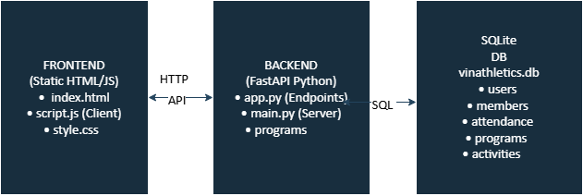

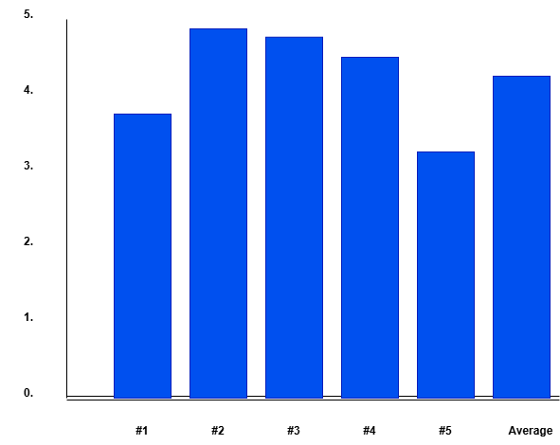

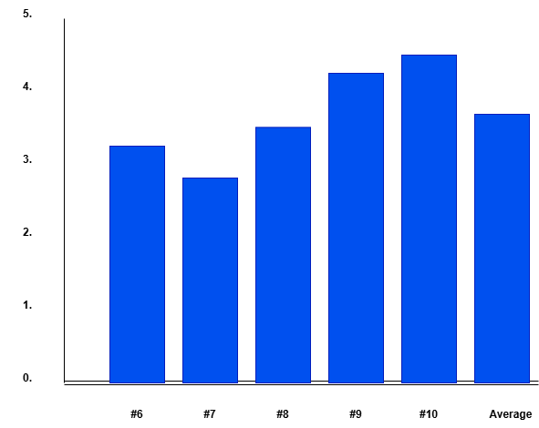

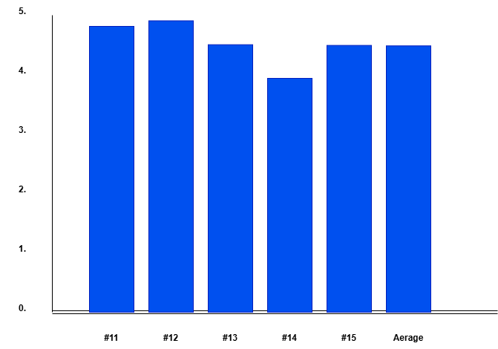

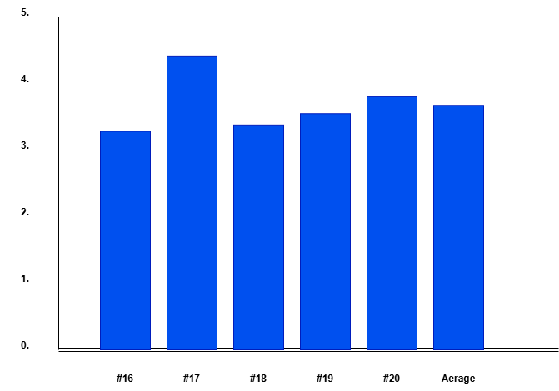

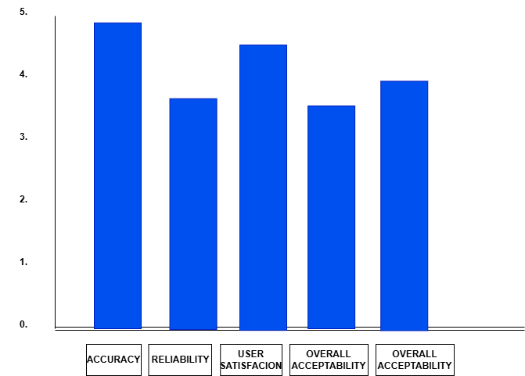

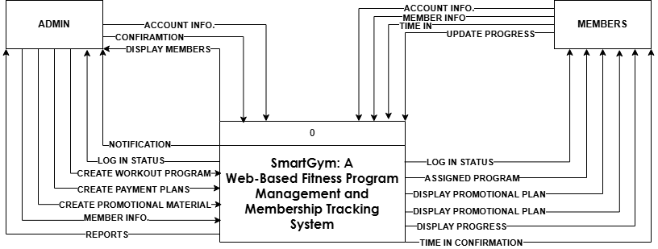

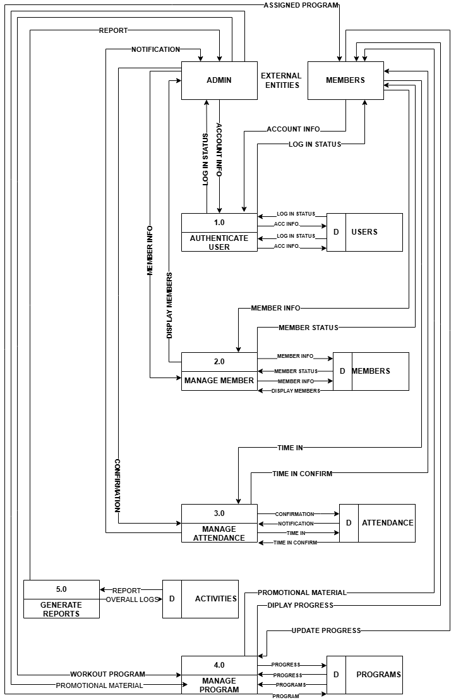

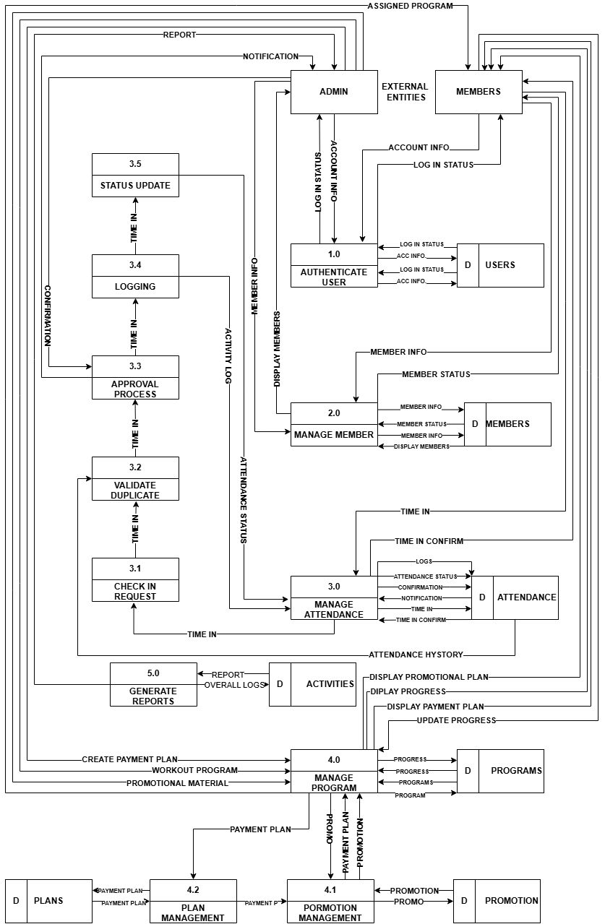

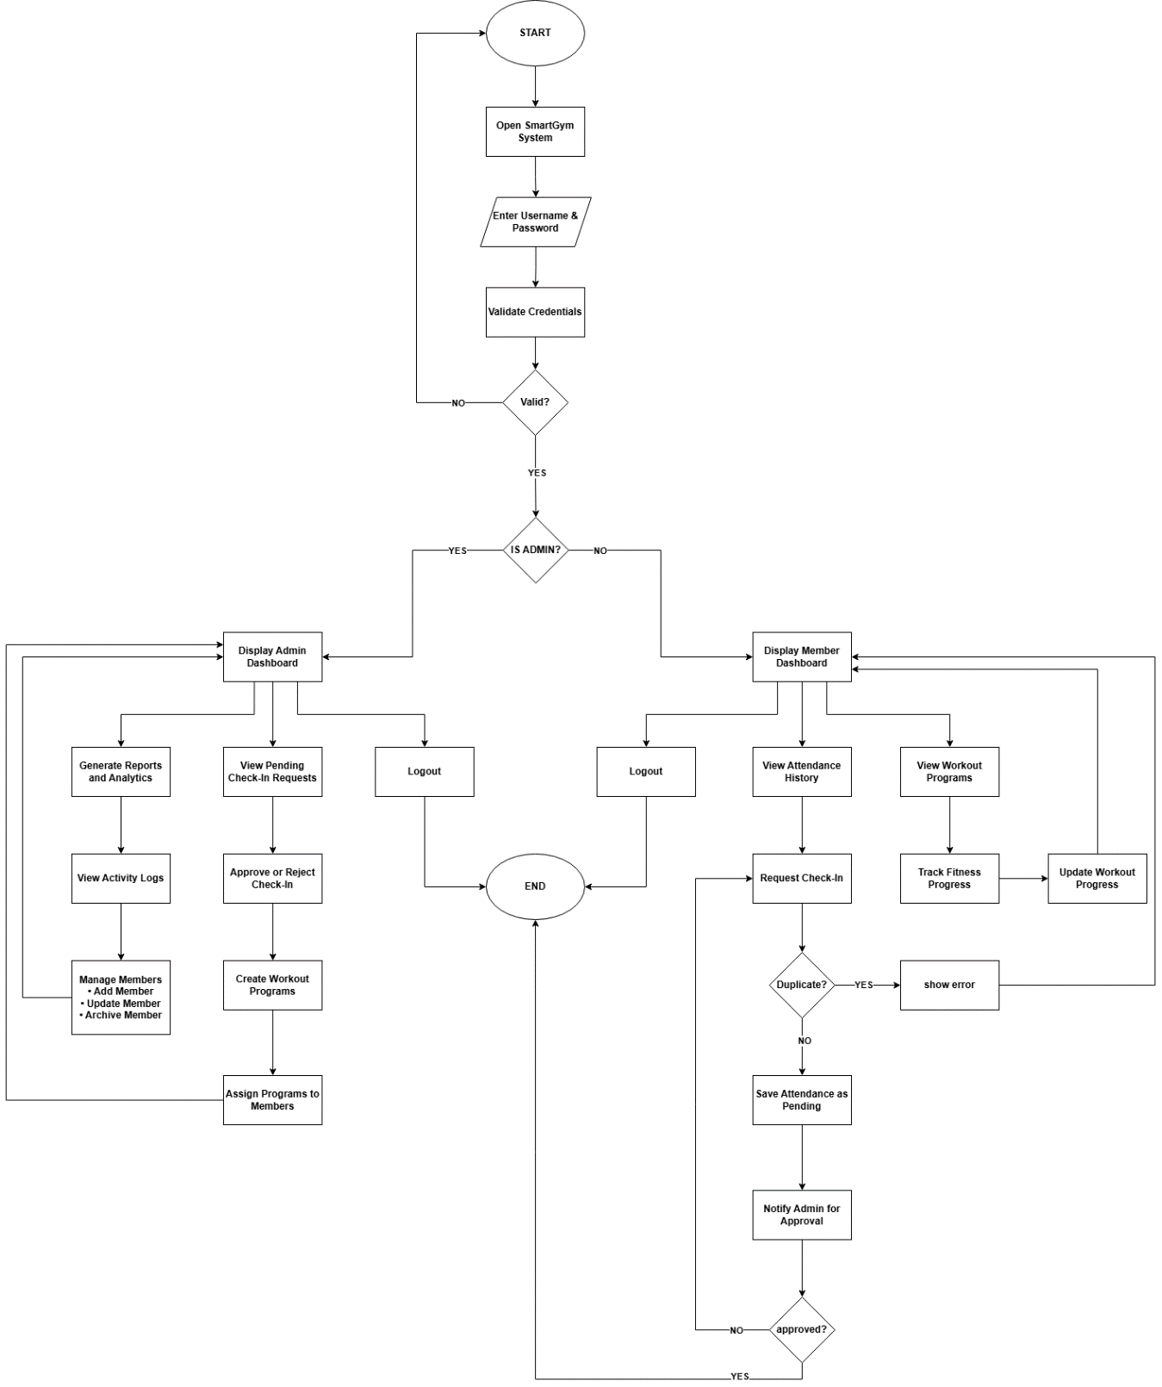

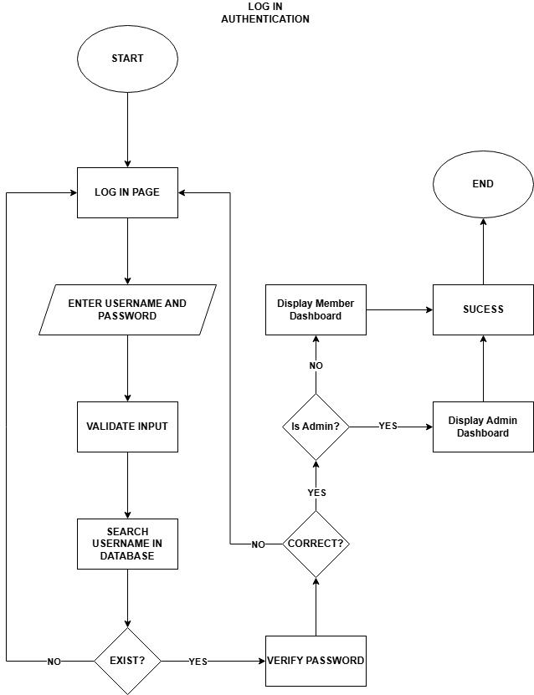

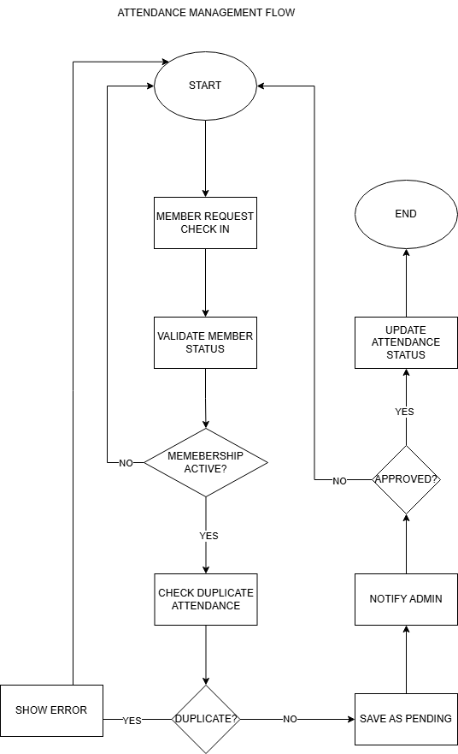

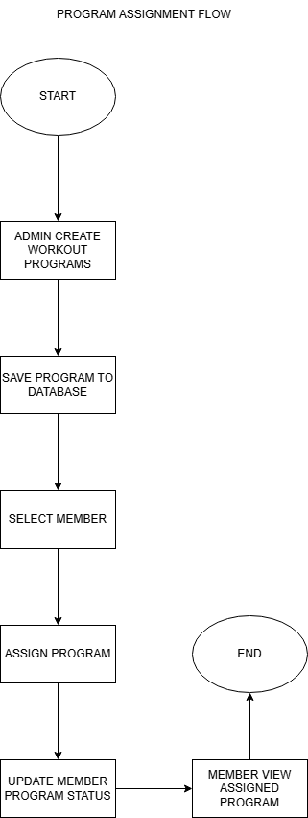
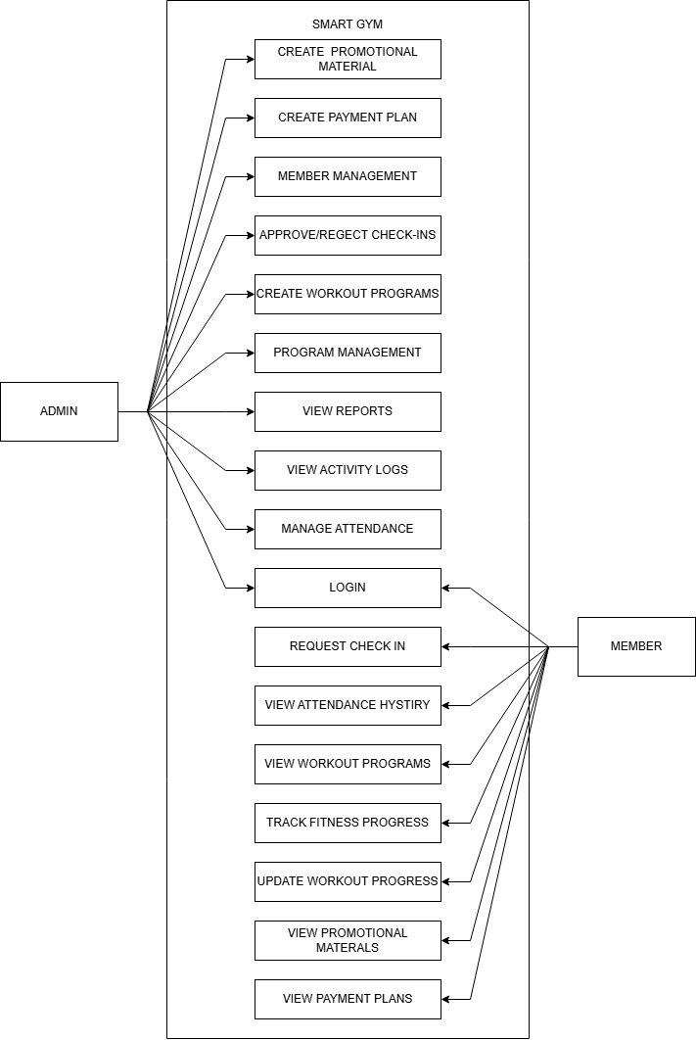

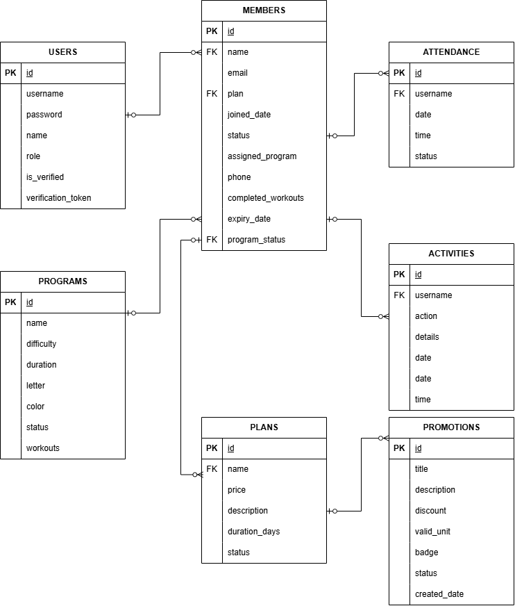

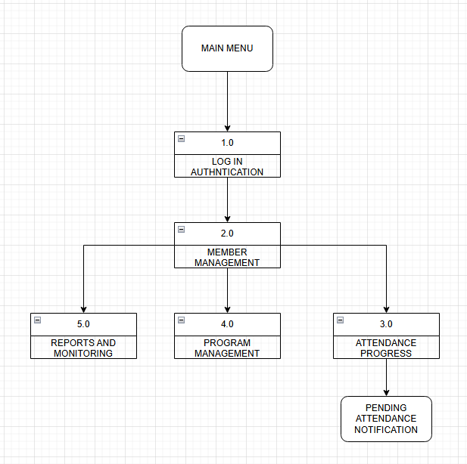

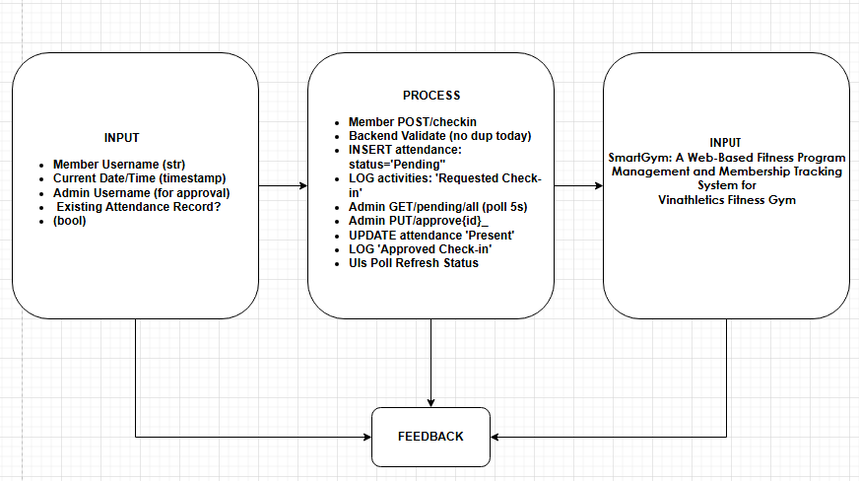

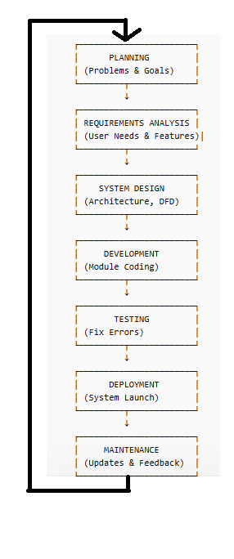

1. Introduction
The SmartGym System is a web-based application designed to manage gym membership, attendance tracking, workout programs, and user progress. It provides an efficient and user-friendly platform for administrators, trainers, and members of Vinathletics Fitness Gym.
This manual serves as a guide for users to understand how to operate the system effectively.
2. System Requirements
- Hardware Requirements
• Desktop or Laptop Computer
• Minimum 4GB RAM
• Stable Internet Connection
• Mobile Device (smartphone or tablet) capable of running a modern web browser
- Software Requirements
• Web Browser (e.g., Google Chrome, Microsoft Edge, or equivalent)
• Backend Server (FastAPI running locally or hosted)
3. Accessing the System
Step 1: Start the System
- Open terminal/command prompt
- Navigate to backend folder
- Run the command:
python main.py
- Open the frontend file (e.g., index.html or siadaw.html) in a browser
Step 2: Login
- Enter your Username
- Enter your Password
- Click “Login” or “Access Dashboard”
Default Admin Account:
Username: admin
Password: 123

4. User Roles and Access
The system has two primary user roles:
4.1 Administrator
- Manage members
- Approve/reject attendance
- Create workout programs
- View reports and logs
4.2 Member
- Request attendance check-in
- View workout programs
- Track progress and attendance history

5. Administrator Guide
5.1 Dashboard Overview
After logging in, the administrator will see:
- Member List
- Pending Check-ins
- Activity Logs
- Reports Section

5.2 Managing Members
Add Member
- Go to Members Tab
- Click “Add Member”
- Fill in required details:
  - Name
  - Email
  - Contact Number
  - Membership Plan
- Click Save

Update Member
- Select a member from the list
- Click Edit
- Update details
- Click Save

Archive Member
- Select member
- Click Archive
- Confirm action

5.3 Attendance Management
View Pending Requests
- Go to Dashboard
- Check Pending Check-ins Table
Approve Check-in
- Click Approve button
- Status changes to Present
Reject Check-in
- Click Reject button
- Status changes to Rejected

5.4 Program Management
Create Program
- Go to Programs Tab
- Click Add Program
- Enter:
  - Program Name
  - Difficulty Level
  - Duration
  - Workout Details
- Click Save
Assign Program to Member
- Go to Members Tab
- Select a member
- Assign a program
- Save changes

5.5 Viewing Reports
- Navigate to Reports Tab
- View:
  - Attendance statistics
  - Member activity
- Print or export if available
5.6 Activity Logs
- Go to Activity Tab
- View system logs:
  - Check-ins
  - Approvals
  - Updates

6. Member Guide
6.1 Dashboard Overview
Members can view:
- Attendance Status
- Workout Program
- Progress Tracking

6.2 Check-In Process
Request Check-In
- Click “Check In Now”
- Status becomes Pending Approval
After Approval
- Status changes to Present
- Button becomes disabled

6.3 Viewing Attendance
- View attendance history
- Check total days present
- See last visit

6.4 Viewing Workout Program
- Go to My Program Section
- View assigned exercises
- Track completed workouts

6.5 Updating Progress
- Mark completed workouts
- Save progress
- System updates automatically

7. System Features
- Automated attendance tracking
- Real-time check-in approval
- Membership management
- Workout program assignment
- Activity logging system
- Role-based access control

8. Troubleshooting Guide
Issue | Possible Solution
Cannot login | Check username/password
Button not working | Refresh the page
No pending check-ins | No requests submitted
Server not running | Run python main.py
Duplicate check-in error | Only one check-in per day allowed

9. Security Notes
- Do not share login credentials
- Logout after use
- Only administrators can modify data
- System logs track all activities

10. Summary
The SmartGym system provides a centralized and efficient platform for managing gym operations. By following this manual, users can easily navigate the system, perform tasks, and maximize its features for improved fitness management and administrative efficiency.
T-TEST ANALYSIS

Purpose of the T-Test
A T-test is a statistical method used to determine whether there is a significant difference between a sample mean and a known or hypothesized population mean.
In this study, the T-test is used to evaluate the system performance, specifically the response time of the SmartGym system, to determine if it meets the acceptable standard.

Hypotheses
- Null Hypothesis (H₀):
The system response time is greater than or equal to 2 seconds (μ ≥ 2.0) → Not acceptable
- Alternative Hypothesis (H₁):
The system response time is less than 2 seconds (μ < 2.0) → Acceptable

Formula Used
t=xˉ−μ0snt = \frac{\bar{x} - \mu_0}{\frac{s}{\sqrt{n}}}t=n​s​xˉ−μ0​​
Where:
- xˉ\bar{x}xˉ = sample mean
- μ0\mu_0μ0​ = hypothesized mean
- sss = standard deviation
- nnn = sample size

Given Data
- Sample Size (n) = 30
- Mean ( xˉ\bar{x}xˉ ) = 0.478 seconds
- Standard Deviation (s) = 0.078
- Hypothesized Mean (μ₀) = 2.0 seconds
- 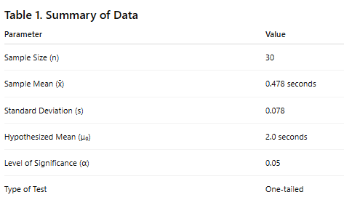

Solution
Substitute the values:
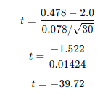
Critical Value
- Level of Significance: α = 0.05
- Degrees of Freedom: df = 29
- Critical t-value ≈ -1.699 (one-tailed test)
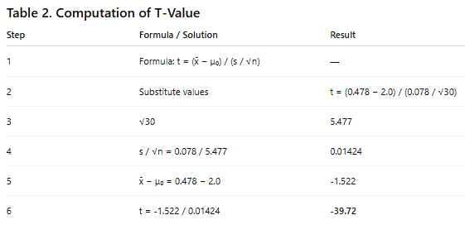

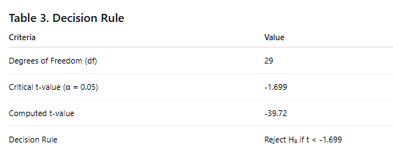Decision Rule
- If t < -1.699, reject H₀
- If t ≥ -1.699, accept H₀

Decision
Since:
t=−39.72<−1.699t = -39.72 < -1.699t=−39.72<−1.699
Reject the Null Hypothesis (H₀)

Basis | Result
Comparison | -39.72 < -1.699
Decision | Reject H₀

Interpretation
The result shows that the system’s response time is significantly less than 2 seconds. Therefore, the SmartGym system meets the required performance standard.

Conclusion
The T-test analysis confirms that the SmartGym system performs efficiently, with an average response time of 0.478 seconds, which is significantly faster than the acceptable threshold of 2 seconds. This indicates that the system provides a fast and responsive user experience.

COST BENEFIT ANALYSIS
Overview
This section presents the cost–benefit analysis of the SmartGym: Web-Based Fitness Program Management and Membership Tracking System. The analysis evaluates the financial feasibility of implementing the system at Vinathletics Fitness Gym, considering its defined scope and limitations.
The system focuses on membership management, attendance tracking, workout program management, and progress monitoring, without including advanced features such as online payments, biometric integration, or multi-branch deployment.

1. Development Costs (One-Time Cost)
Category | Cost (PHP) | Description
System Development | 25,000 | Estimated 50 hours of development (₱500/hour)
Testing and Evaluation | 5,000 | Includes system testing and user evaluation
Software Tools | 0 | Open-source tools (FastAPI, SQLite, HTML, CSS, JavaScript)
Total Development Cost | ₱30,000

2. Operational Costs (Annual)
Category | Cost (PHP) | Description
Hosting / Server | 6,000 | VPS hosting (₱500/month) or local hosting option
System Maintenance | 10,000 | Updates, bug fixes, and monitoring
Data Backup | 1,200 | Cloud storage for database backup
Total Operational Cost (Annual) | ₱17,200

3. Expected Benefits (Annual)
Since the system does not include payment processing, benefits are focused on operational efficiency and cost savings.
Benefit | Value (PHP) | Description
Labor Cost Savings | 240,000 | Reduced manual work (2 hrs/day × 300 days × ₱400/hr)
Error Reduction | 50,000 | Minimizes data loss, duplication, and manual errors
Improved Decision-Making | 30,000 | Accurate reports for attendance and member tracking
Total Benefits (Annual) | ₱320,000

4. Net Benefit Analysis

Item | Amount (PHP)
Total Annual Benefits | 320,000
Total Costs (Year 1) | 47,200
Net Benefit (Year 1) | ₱272,800

5. Return on Investment (ROI
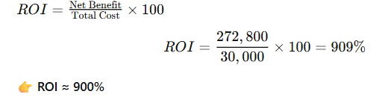
6. Payback Period
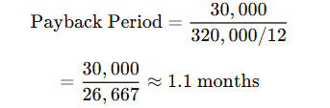
The system pays for itself in approximately 1 month
7. Consideration of Scope and Delimitations
The cost–benefit results are influenced by the system’s defined limitations:

Excluded Features
- No online payment system
- No biometric or IoT integration
- No mobile application
- Single-gym implementation only

Impact on Costs
- Lower development cost (no complex integrations)
- Reduced maintenance complexity
- Minimal infrastructure requirements

Impact on Benefits
- No direct revenue from payment automation
- Benefits mainly come from:
  - Efficiency improvements
  - Labor savings
  - Data accuracy
8. Sensitivity Analysis
Scenario | Members | Annual Benefit | Payback Period
Base Case | 100 | ₱320,000 | 1.1 months
Small Gym | 50 | ₱160,000 | 2.2 months
Expanded Use | 200 | ₱640,000 | < 1 month
9. Summary
The cost–benefit analysis demonstrates that the SmartGym system is financially viable and highly beneficial. Despite its limited scope, the system provides significant savings through improved efficiency and reduced manual workload.
With a high ROI of approximately 900% and a payback period of about one month, the implementation of the system is strongly justified.
Conclusion
The SmartGym system is a cost-effective solution for improving gym operations. Even without advanced features such as payment integration or multi-branch support, the system delivers substantial operational and financial benefits. Therefore, it is recommended for immediate implementation in Vinathletics Fitness Gym


Researcher / programmer

De Leon, Jarri A.

Phone number: 09852122307 Email: jarrideleon.scc@gmail.com Address: PH 7B, BLK 37, LOT 16, PKG 16, Bagong Silang Caloocan City.

Education
2024-PRESENT | ST. CLARE COLLEGE OF CALOOOCAN  BSCS
2016-1018 | ST. DOMINIC SAVIO COLLEGE  STEM
2012-2016 | TALA HIGH SCHOOL

Researcher


De la Peña, Adrian B

Phone number: 09563957714 Email: aidriandelapena.scc@gmail.com Address: #3081 A. Mabini St. Bagong Pag-Asa Camarin, Caloocan City.

Education

2022 – present

ST. CLARE COLLEGE OF CALOOOCAN

Bachelor of Science in Computer Science

2020 – 2022

ACCESS COMPUTER COLLEGE

General Academic Strand

2019 – 2020

SAMPAGUITA HIGH SCHOOL

Learner/Junior high school

2009 – 2016 SAMPAGUITA ELEMENTARY SCHOOL
Researcher / programmer

ESCALANTE, NATHANIEL R

Phone number: 09382494423 Email: nathanielescalante.scc@gmail.com Address: 092 Magnolia St. Bo. San Lazaro Brgy.187 T.C.C

Education

2022 – present

ST. CLARE COLLEGE OF CALOOOCAN

Bachelor of Science in Computer Science

2020 – 2022

SAMARIA SENIOR HIGH SCHOOL

General Academic Strand

2019 – 2020

ALTERNATIVE LEARNING SYSTEM

Learner/Junior high school

2009 – 2016

APOLINARIO MABINI ELEMENTARY SCHOOL


Researcher

JURANE, ADRIAN D.

Phone number:09956490960 Email: adrianjurane1.scc@gmail.com Address: BLK 18 LOT 22 LOT 22 Dao Street Camarin Road, Hillcrest Village Barangay 173, Caloocan City

Education
2024-PRESENT | ST. CLARE COLLEGE OF CALOOOCAN  BACHELOR OF SCIENCE IN COMPUTER SCIENCE
2021-2023 | AMA COMPUTER COLLEGE  BSIT
2019-2021 | BESTLINK COLLEGE OF THE PHILIPPINES  ICT

Researcher

SISON, JOHANN CARLO H

Phone number:09947836071 Email:johanncarlosison.scc@gmail.com Address: BLK 12 LOT 13 Ph2 Solar Urban Homes Bagumbong Caloocan City

Education
2023– present | ST. CLARE COLLEGE OF CALOOOCAN  Bachelor of Science in Computer Science
2020 – 2022 | ST. CLARE COLLEGE OF CALOOOCAN  ICT
2016 – 2020 | BAGUMBONG HIGH SCHOOL  Learner/Junior high school
2015– 2016 | RIDGEWOOD SCHOOL OF CALOOCAN
Researcher / programmer


RIVAS, IVAN GREG A.

Phone number: 09455800573 Email: ivangregrivas.scc@gmail.com Address: BLK 5 LOT 2 Maharlika Homes Brgy. 171 Saranay Bagumbong Caloocan City

Education
2023 - PRESENT | ST.CLARE COLLEGE OF CALOOCAN  Bachelor of Science in Computer Science
2021-2022 | ST. CLARE COLLEGE OF CALOOCAN  ICT
2016-2020 | BAGUMBONG HIGH SCHOOL


Researcher

TANAY, KARL CHARTON M.

Phone number: 09483529843 Email: karltanay.scc@gmail.com Address: blk 23 lot 19 D parnassus st. North Olympus Kaligayahan Quezon city

Education
2022 – present | ST. CLARE COLLEGE OF CALOOOCAN  Bachelor of Science in Computer Science
2020 – 2022 | ST. CLARE COLLEGE OF CALOOOCAN  ICT
2019 – 2020 | CIELITO ZAMORA JR HIGH SCHOOL  Learner/Junior high school

