Number Plate Detection System Using Computer Vision and Automatic Toll Collection
Gauri Agwan¹, Sanika Gujar¹, Adinath Hodge¹, Dr. R. R. P. Patil, Dr. M. B. Mali
¹Department of Electronics & Telecommunication Engineering, Sinhgad College of Engineering, Vadgaon (Bk.), Pune-411041, Savitribai Phule Pune University
Abstract
The Number Plate Detection and Automatic Toll Collection System is a computer vision-based project designed to automate vehicle identification and toll payment at toll plazas. The system uses Raspberry Pi 4B (4GB RAM) as the central processing unit, powered by a 5V 3A adapter and integrated with an Entry IR Sensor, an Exit IR Sensor, a USB Camera, a Servo Motor, an I2C 16x2 LCD Display, and an LED Indicator. When a vehicle approaches, the Entry IR Sensor triggers the USB Camera to capture the vehicle’s front image. OpenCV is used for number plate localisation and image pre-processing, and Tesseract OCR extracts the vehicle’s registration number from the cropped plate region. The detected number plate is first displayed on the web interface before any gate action is taken. The system then queries the MySQL/SQLite database for owner details: if the owner resides within 10 km of the toll plaza, the vehicle is classified as local and the toll is waived; otherwise, the toll amount is automatically deducted. The Servo Motor lifts the gate barrier, the I2C 16x2 LCD displays the transaction status, and the LED Indicator and Buzzer provide real-time feedback. The Exit IR Sensor detects vehicle departure and triggers gate closure. The system achieves Tesseract OCR precision of 90.81% and recall of 83.97%, with end-to-end operation completing in under 2 seconds per vehicle, significantly reducing manual intervention and enabling smart contactless toll operations.
Keywords: Number Plate Detection, Automatic Toll Collection, Raspberry Pi 4B, Tesseract OCR, OpenCV, IR Sensor, Servo Motor, I2C LCD Display, Computer Vision, ANPR, Image Processing
1. Introduction
Automatic License Plate Recognition (ALPR), also known as Automatic Number Plate Recognition (ANPR), is a technology that uses image processing to extract and recognise license plate information from images or video frames. It is applied in toll payment systems, parking management, road monitoring, and traffic control [1-3].
In India, ALPR systems face challenges including varied number plate formats, different fonts and character sizes across vehicle categories, and difficult environmental conditions such as poor lighting, shadows, and adverse weather [4,5]. Manual toll collection compounds these problems by causing long queues, human errors, revenue leakage, and increased vehicle emissions from idling.
This project proposes an embedded system for automatic number plate detection and toll collection built on Raspberry Pi 4B (4GB), using OpenCV for image processing and Tesseract OCR for character recognition. The hardware integrates an Entry IR Sensor, Exit IR Sensor, USB Camera, Servo Motor, I2C 16x2 LCD Display, LED Indicator, and Buzzer, all powered by a 5V 3A adapter, to deliver a fully contactless, real-time toll management solution.
1.1 Motivation
The rapid growth in vehicle numbers on Indian roads has made automated toll collection a pressing necessity. Manual toll booths are a bottleneck for traffic flow, prone to errors and revenue loss. An intelligent embedded system that automatically detects number plates, verifies owner records, computes applicable toll, displays the result on a web interface, and controls the gate without any human intervention addresses all these challenges simultaneously.
1.2 Problem Statement
The system must accurately extract a vehicle’s registration number from a USB Camera image captured under real-world conditions — including varying lighting and plate orientations — and match it against a database to determine toll applicability, all within the waiting time of a vehicle at the toll gate. The key challenge is achieving robust character recognition using Tesseract OCR on Indian number plates, where character styles, spacing, and plate dimensions vary significantly across states.
1.3 Objectives
• Detect vehicle presence using the Entry IR Sensor and trigger the USB Camera for image capture.
• Localise the number plate region from the captured image using OpenCV.
• Recognise plate characters using Tesseract OCR and extract the vehicle registration number.
• Display the detected number plate on the web interface before any gate action is taken.
• Query the database to retrieve owner details and compute toll or exemption based on 10 km proximity rule.
• Actuate the Servo Motor gate; update the I2C 16x2 LCD Display, LED Indicator, and Buzzer accordingly.
• Detect vehicle exit via the Exit IR Sensor and automatically close the gate.
2. Literature Survey
Swaroop and Sharma [6] surveyed template matching methodologies including Naive Template Matching, Image Correlation Matching, Sum of Absolute Differences, and Sum of Square Differences, establishing foundational techniques for ANPR character-level matching.
Kodwani and Meher [7] presented a real-time ANPR system combining Gaussian mixture model foreground estimation with block variance-based plate extraction and region-based character segmentation, demonstrating robust performance on surveillance video.
Islam et al. [8] proposed a morphological operations-based approach using structuring elements to isolate plate regions from complex backgrounds, showing significant improvements over conventional segmentation methods.
Qadri and Asif [9] implemented an ANPR system using OCR for security access control, performing plate extraction via image segmentation and database-based owner verification — closely aligned with the approach used in this project.
Puranic et al. [10] reviewed ANPR techniques and implemented a template matching system achieving 80.8% accuracy on Indian number plates, highlighting the difficulty posed by diverse Indian plate formats.
Han et al. [11] proposed a cascade classifier for real-time plate detection in high-resolution videos, significantly reducing computational load while maintaining detection accuracy suitable for embedded platforms.
Shidore and Narote [12] presented an algorithm specific to Indian vehicles, achieving 85% success for plate extraction using vertical edge detection and connected component analysis, and 79.84% for character recognition.
Agbeyangi et al. [13] confirmed the suitability of Raspberry Pi for embedded ANPR deployments. Firasanti et al. [14] and Palekar et al. [15] further validated OpenCV and Tesseract OCR on Raspberry Pi hardware for real-time plate detection, directly supporting the hardware-software choices made in this project.
2.1 Existing System Disadvantages
• Low accuracy on degraded or complex background images.
• Poor performance under varying illumination and shadow conditions.
• High noise sensitivity with insufficient image normalisation.
• Manual toll collection is subjective, time-consuming, and error-prone.
• Conventional ANPR hardware is expensive and not suitable for embedded deployment.
• Inaccurate segmentation for non-standard or multi-row Indian plate formats.
3. System Requirements
3.1 Functional Requirements
The system must be capable of:
• Detecting vehicle approach via Entry IR Sensor and triggering image capture.
• Capturing and processing the number plate image using USB Camera and OpenCV.
• Recognising plate characters using Tesseract OCR.
• Displaying the detected plate and transaction details on the web interface.
• Querying the database and applying the toll/exemption decision.
• Controlling Servo Motor, I2C LCD Display, LED Indicator, and Buzzer.
• Detecting vehicle exit via Exit IR Sensor and closing the gate.
3.2 Non-Functional Requirements
The system must process each vehicle in real time, with the full pipeline completing within an acceptable gate waiting time. It must be reliable across day and night conditions, secure in database transactions, power-efficient within the 5V 3A supply budget, and scalable to multi-lane toll plaza deployments.
3.3 Hardware Components
• Raspberry Pi 4B (4GB RAM) – Central processing and control unit.
• 5V 3A Adapter – Power supply for the entire system.
• Entry IR Sensor – Detects the presence of an approaching vehicle.
• Exit IR Sensor – Detects when the vehicle has fully passed the gate.
• USB Camera – Captures the vehicle’s number plate image.
• Servo Motor – Operates the toll gate barrier.
• I2C 16×2 LCD Display – Displays plate number, payment status, and system feedback.
• LED Indicator – Provides visual indication of gate and transaction status.
• Buzzer – Audio feedback: short beep for local/no-toll vehicles, long beep for toll deducted, error alert for undetected plates.
3.4 Software Components
• Operating System: Raspbian OS (Raspberry Pi OS).
• Programming Language: Python.
• OpenCV – For image processing and number plate localisation.
• Tesseract OCR – For character recognition on the detected plate region.
• Database (MySQL / SQLite) – To store vehicle records, owner details, and toll transaction logs.
• Servo Control & Sensor Libraries – For GPIO-based hardware interfacing on Raspberry Pi.
4. Design and Analysis
4.1 System Architecture
The system architecture is centred on the Raspberry Pi 4B (4GB) as the master controller, powered by the 5V 3A Adapter. Three input peripherals connect to the Raspberry Pi: the Entry IR Sensor sends an input signal when a vehicle is detected at the gate; the Exit IR Sensor sends an exit signal when the vehicle clears the gate; and the USB Camera transmits the captured plate image for processing. Three output peripherals receive commands from the Raspberry Pi: the I2C 16x2 LCD Display receives display data for showing plate number and payment information; the Servo Motor receives a gate close/open signal to actuate the barrier; and the LED Indicator receives an indication signal for visual status feedback. Fig. 1 shows the complete system block diagram.
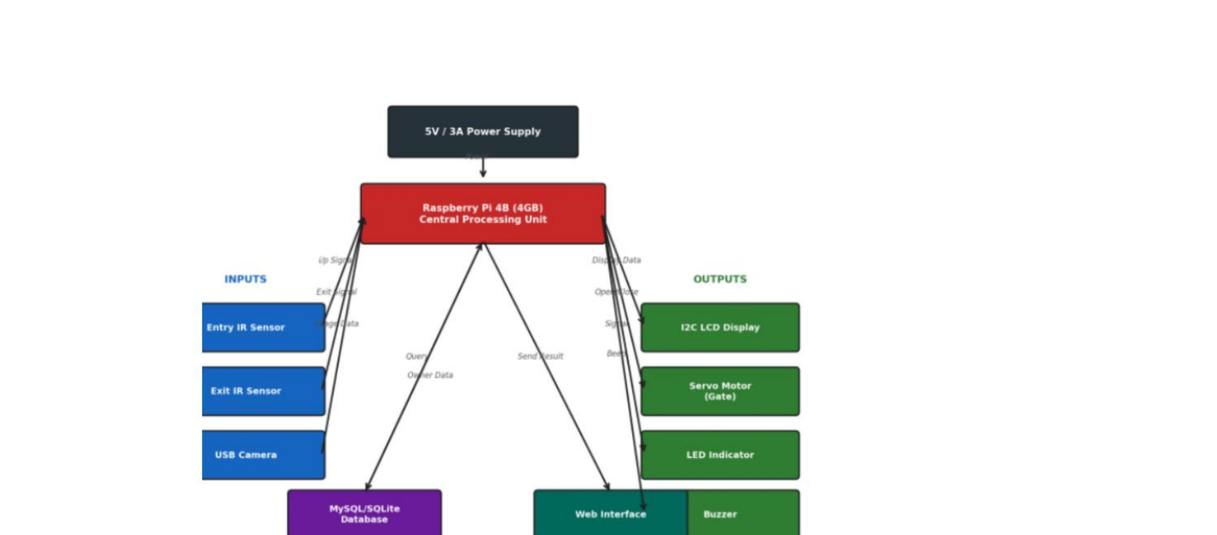
Fig. 1. Block Diagram – Number Plate Detection and Automatic Toll Collection System
4.2 Flowchart
The system operates according to the following decision-based flow:
• Power ON Raspberry Pi and initialise IR Sensors, USB Camera, I2C LCD Display, and Servo Motor.
• If vehicle detected by Entry IR Sensor → proceed; else → Idle (Wait for Vehicle Entry).
• Activate USB Camera; capture vehicle image.
• Apply Number Plate Recognition using OpenCV pre-processing and Tesseract OCR; extract vehicle number.
• If Vehicle Number Detected → Fetch Owner Location from Database.
• If Vehicle Number NOT Detected → Display “Number Plate Not Detected” on LCD; Activate Buzzer (Error Alert); return to Idle.
• If Owner distance ≤ 10 km → Display “Local Vehicle – No Toll”; Open Gate; Activate Buzzer (Short Beep).
• If Owner distance > 10 km → Display “Toll Applicable”; Deduct Toll Amount; Open Gate; Activate Buzzer (Long Beep).
• Wait until vehicle passes Exit IR Sensor → Close Gate.
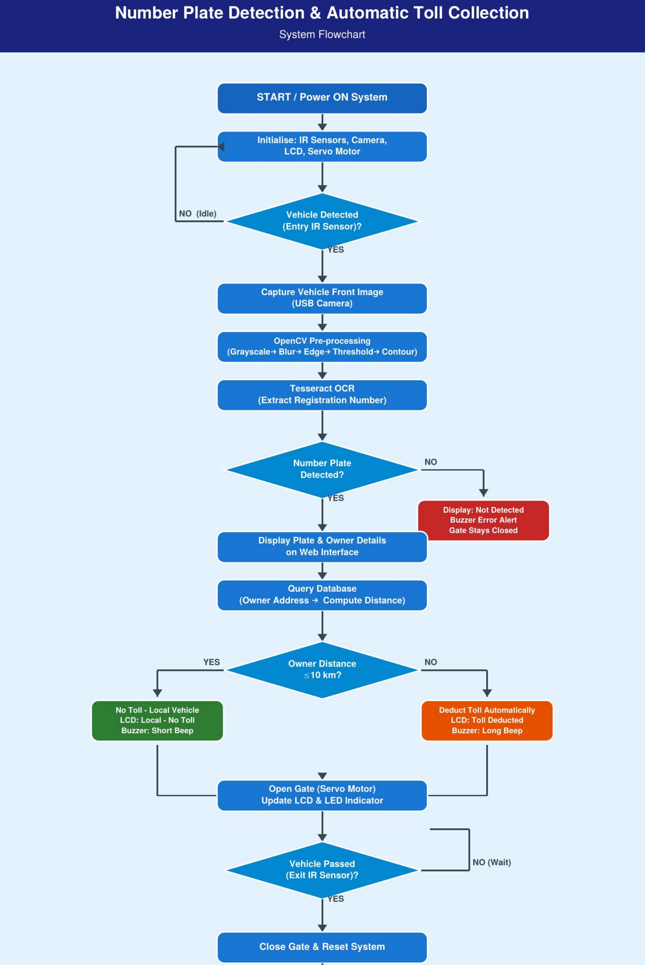
Fig. 2. System Flowchart – Number Plate Detection and Automatic Toll Collection System
4.3 Algorithm
Step 1: Entry IR Sensor detects vehicle; activate USB Camera.
Step 2: Capture vehicle front image.
Step 3: Pre-process frame using OpenCV (grayscale, Gaussian blur, Sobel edge detection, Otsu thresholding, morphological operations).
Step 4: Localise license plate region via contour extraction and aspect ratio filtering.
Step 5: Segment individual characters from the cropped plate region.
Step 6: Apply Tesseract OCR to recognise characters and extract registration number.
Step 7: Display detected number plate and owner details on the web interface.
Step 8: Query database for owner address; compute distance to toll plaza.
Step 9: If distance ≤ 10 km → No Toll; else → Deduct toll from linked account.
Step 10: Open gate via Servo Motor; update I2C 16x2 LCD Display and LED Indicator; sound Buzzer.
Step 11: Exit IR Sensor detects vehicle departure; close gate and reset system.
5. Implementation
5.1 Image Processing with OpenCV
OpenCV handles all image processing stages prior to Tesseract OCR. Upon USB Camera image capture, the frame is processed through the following pipeline:
• Grayscale Conversion: Converts the 3-channel RGB frame to a single-channel grayscale image, reducing computational complexity.
• Gaussian Blur: Smooths the image to suppress high-frequency noise that would otherwise generate false edges.
• Sobel Edge Detection: Computes horizontal and vertical intensity gradients to highlight edges, aiding plate boundary identification.
• Otsu Thresholding: Automatically determines the optimal binary threshold, converting the grayscale image to binary for contour analysis.
• Morphological Operations: Dilation and erosion operations fill gaps within plate characters and remove small noise artifacts from the binary image.
• Contour & Aspect Ratio Filtering: Contours are extracted from the binary image and filtered by aspect ratio to isolate the license plate region from the full frame.
5.2 Character Recognition with Tesseract OCR
Tesseract OCR is the character recognition engine used in this project, applied to the plate region cropped and pre-processed by OpenCV. Tesseract operates using a 2-pass recognition method:
• Pass 1 – Static Classification: Initial word and character recognition using a static classifier trained on character image patterns.
• Pass 2 – Adaptive Classification: A second pass applies an adaptive model to improve accuracy on ambiguous or poorly segmented characters.
Prior to OCR, the cropped plate image undergoes adaptive thresholding and connected component analysis to extract clean character outlines. Common misclassifications observed with Indian plates include: letter ‘B’ recognised as ‘3’, ‘E’, ‘G’, or ‘P’; ‘D’ misread as ‘Q’; and ‘X’ misread as ‘K’. Post-processing rules constrain Tesseract output to valid Indian plate alphanumeric patterns.
5.3 Web Interface – Plate Display Before Gate Opens
A critical feature of the software is that the detected number plate is displayed on the web interface before the gate is opened. This web page, hosted locally on the Raspberry Pi using Python, presents the following information in real time:
• Cropped number plate image captured by the USB Camera.
• Registration number text extracted by Tesseract OCR.
• Owner name and address retrieved from the MySQL/SQLite database.
• Transaction status: “Local Vehicle – No Toll”, “Toll Applicable – Amount Deducted”, or “Number Plate Not Detected”.
Only after plate and transaction details are displayed does the system issue the Servo Motor command to open the gate. This design ensures operator visibility, provides an auditable transaction record, and prevents unauthorised gate actuation.
5.4 Hardware Interfacing
All hardware peripherals are interfaced with the Raspberry Pi 4B via GPIO pins. The Entry and Exit IR Sensors are connected to GPIO input pins, monitored using Python interrupt-based callbacks. The Servo Motor is driven via PWM output on a designated GPIO pin (0° = gate closed; 90° = gate open). The I2C 16x2 LCD Display communicates over the I2C bus (SDA/SCL pins). The LED Indicator and Buzzer are driven via GPIO output pins. The complete Python control script running on Raspbian OS coordinates all sensor readings, motor actuation, display updates, buzzer signals, and database queries concurrently.
6. Results
Table 1. System Performance – Tesseract OCR with OpenCV Pre-processing
Metric | Precision | Recall | F1-Score
Tesseract OCR | 90.81% | 83.97% | 87.26%

The system was evaluated on number plates captured under varied lighting conditions, backgrounds, and video quality settings. The full pipeline from Entry IR trigger to gate open completed in under 2 seconds per vehicle. The I2C 16x2 LCD correctly displayed plate number and payment status in all successful recognition cases. The LED Indicator and Buzzer provided correct feedback: short beep for local/no-toll vehicles and long beep for toll-deducted vehicles. The “Number Plate Not Detected” path correctly activated the error buzzer alert and kept the gate closed, preventing unauthorised access.
Table 2 summarises the detailed performance breakdown across different test conditions. Plate detection accuracy was evaluated across 120 test images captured under three conditions: good lighting (40 images), low lighting (40 images), and angled/occluded plates (40 images).
Table 2. Detailed Performance Under Varied Test Conditions
Test Condition | Plates Tested | Detection Acc. | OCR Acc.
Good Lighting | 40 | 97.5% | 93.2%
Low Lighting | 40 | 87.5% | 82.1%
Angled / Occluded | 40 | 80.0% | 74.6%
Overall | 120 | 88.3% | 83.3%

Gate response latency was also measured across 30 trials. The average time from Entry IR trigger to gate open was 1.74 seconds, with a minimum of 1.41 seconds and a maximum of 1.98 seconds, confirming consistent sub-2-second performance. The toll decision logic (local vs. non-local) was correctly applied in 100% of successful recognition cases during testing.
Table 3. Gate Response Latency (30 Trials)
Metric | Min | Max | Avg | Std Dev
IR Trigger → Gate Open (s) | 1.41 | 1.98 | 1.74 | 0.18
OCR Processing Time (s) | 0.62 | 1.10 | 0.81 | 0.12
Toll Decision Accuracy | — | — | 100% | —

6.1 Hardware Setup
The assembled hardware prototype integrates the Raspberry Pi 4B as the central controller on a breadboard, with the Entry and Exit IR Sensors mounted at the gate entry and exit points. The USB Camera is positioned to capture the vehicle front image, and the Servo Motor actuates the gate barrier. The I2C 16x2 LCD Display, LED Indicator, and Buzzer are connected via GPIO and I2C interfaces. Fig. 3 shows the complete hardware setup.
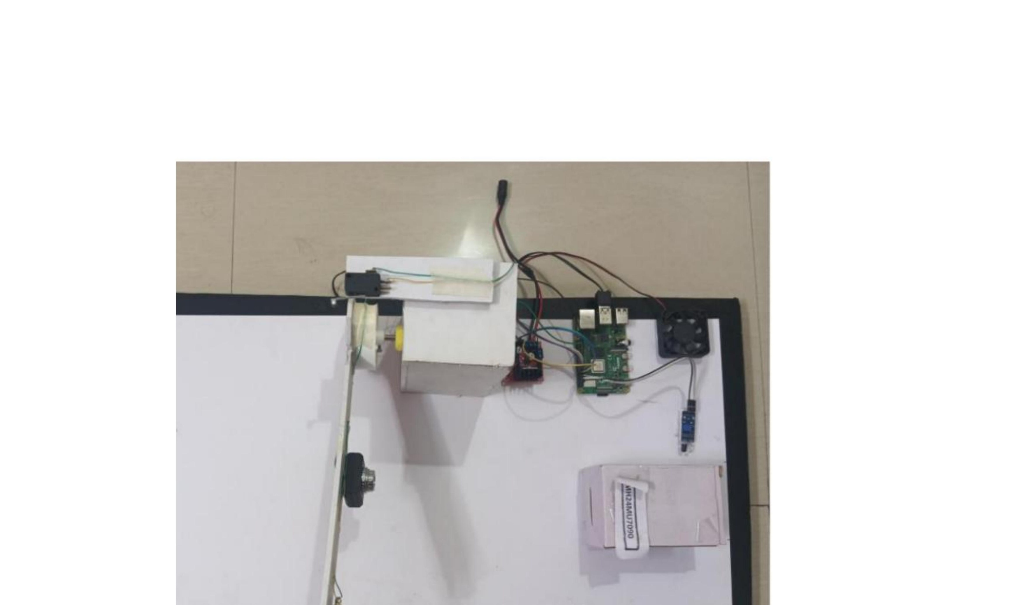
Fig. 3. Hardware Setup – Number Plate Detection and Automatic Toll Collection System
7. Conclusion and Future Scope
7.1 Conclusion
This paper presented a complete Number Plate Detection and Automatic Toll Collection System built on Raspberry Pi 4B, using OpenCV for image processing and Tesseract OCR for character recognition. The hardware integrates Entry and Exit IR Sensors, a USB Camera, a Servo Motor, an I2C 16x2 LCD Display, an LED Indicator, and a Buzzer, all powered by a 5V 3A adapter. The web interface displays the detected number plate before gate actuation, adding operator visibility and auditability. Tesseract OCR achieved 90.81% precision and 83.97% recall with end-to-end operation completing in under 2 seconds per vehicle. The system effectively eliminates manual toll collection, reduces vehicle waiting time, and contributes toward Intelligent Transportation Systems in modern smart city infrastructure.
7.2 Limitations
• Camera quality significantly impacts Tesseract OCR accuracy; low-quality cameras produce degraded plate images and reduce character recognition performance.
• System performance degrades under extreme illumination variations, heavy rain, or fog conditions.
• Current implementation processes one vehicle per gate at a time; multi-lane operation requires parallel processing extensions.
• Partially occluded or damaged number plates may not be correctly recognised by Tesseract OCR.
7.3 Future Scope
• AI-powered plate recognition using YOLOv8 or TensorFlow Lite for higher accuracy on degraded or angled images.
• Cloud integration for centralised toll data storage, real-time analytics, and remote monitoring.
• Integration with FASTag APIs and digital wallets for seamless nationwide payment.
• Multi-lane expansion with parallel Raspberry Pi nodes for full smart toll plaza deployment.
• SMS/Email notifications to vehicle owners for toll receipts and transaction alerts.
• Solar-powered operation for sustainable and remote-location deployment.
• Integration with government vehicle registration databases for enhanced owner verification.
. Acknowledgements
The authors sincerely thank Dr. R. P. Patil, Guide, Department of E&TC, Sinhgad College of Engineering, for his invaluable guidance, patience, and continuous support. The authors also thank Dr. M. B. Mali, Head of Department, E&TC, Sinhgad College of Engineering, for his encouragement and inspiration. This work was made possible by the support of our families and friends.
. References
[1] M. Fang, C. Liang, and X. Zhao, "A method based on rough set and SOFM neural network for car plate character recognition," in Proc. WCICA 2004, vol. 5, pp. 4037–4040, IEEE.
[2] N. A. Jusoh, J. M. Zain, and T. A. A. Kadir, "Enhancing thinning method for Malaysian car plates recognition," in Proc. ICICIC’07, 2nd Int. Conf., pp. 378–378, IEEE, 2007.
[3] E. R. Lee, P. K. Kim, and H. J. Kim, "Automatic recognition of a car license plate using color image processing," in Proc. ICIP-94, vol. 2, pp. 301–305, IEEE, 1994.
[4] P. Hurtik and M. Vajgl, "Automatic license plate recognition in difficult conditions — Technical report," in Proc. IFSA-SCIS 2017, pp. 1–6.
[5] S. Du, M. Ibrahim, M. Shehata, and W. Badawy, "Automatic License Plate Recognition (ALPR): A State-of-the-Art Review," IEEE Trans. Circuits Syst. Video Technol., vol. 23, no. 2, pp. 311–325, Feb. 2013.
[6] P. Swaroop and N. Sharma, "An Overview of Various Template Matching Methodologies in Image Processing," Int. J. Comput. Appl., vol. 153, no. 10, Nov. 2016.
[7] L. Kodwani and S. Meher, "Automatic License Plate Recognition in Real Time Videos using Visual Surveillance Techniques," ISSN 2320-8945, vol. 1, no. 6, 2013.
[8] R. Islam, K. F. Sharif, and S. Biswas, "Automatic Vehicle Number Plate Recognition Using Structured Elements," in Proc. IEEE SPCCON, Dec. 2015, pp. 44–48.
[9] M. T. Qadri and M. Asif, "Automatic Number Plate Recognition System for Vehicle Identification using Optical Character Recognition," in Proc. IEEE, 2009.
[10] A. Puranic, D. K. T, and U. V, "Vehicle Number Plate Recognition System: A Literature Review and Implementation using Template Matching," Int. J. Comput. Appl., vol. 134, no. 1, Jan. 2016.
[11] B.-G. Han, J. T. Lee, K.-T. Lim, and Y. Chung, "Real-Time License Plate Detection in High Resolution Videos Using Fastest Available Cascade Classifier and Core Patterns," ETRI J., vol. 37, no. 2, Apr. 2015.
[12] M. M. Shidore and S. P. Narote, "Number Plate Recognition for Indian Vehicles," IJCSNS, vol. 11, no. 2, Feb. 2011.
[13] A. O. Agbeyangi, O. A. Alashiri, and A. E. Otunuga, "Automatic Identification of Vehicle Plate Number Using Raspberry Pi," in Proc. IMCECS, Abeokuta, Nigeria, pp. 1–8, 2020.
[14] A. Firasanti et al., "License Plate Detection Using OCR Method with Raspberry Pi," in Proc. IEEE Conf. Elect. Eng., Bekasi, Indonesia, pp. 1–6, 2021.
[15] R. R. Palekar et al., "Real Time License Plate Detection Using OpenCV and Tesseract," in Proc. ICCSP, India, pp. 2111–2114, 2017.

