How to Reduce Plastic in Daily Life AND JOURNEY
Plastic pollution is one of the greatest environmental challenges of our time. Every year, 8 million tons of plastic waste ends up in the ocean, and around 91% of all plastic produced is not recycled. To tackle this crisis, it’s time to adopt the Plastic Diet, a simple yet effective strategy to reduce plastic consumption both in daily life and while traveling. This guide will help you implement the Plastic Diet by following practical steps that reduce plastic waste and make a positive impact on the environment.
By adopting these principles, you’ll not only reduce your plastic footprint but also contribute to a global movement for a cleaner planet.

Start by Calculating Your Plastic Footprint
Before diving into the Plastic Diet, calculate your current plastic footprint. By understanding how much plastic waste you generate, you can better target areas where you can make the most impactful changes. A Plastic Footprint Calculator can help you assess the amount of plastic you consume in your daily life and during travel.

6 Plastic Diet Principles for Travelers
Traveling often leads to an increase in plastic use, especially through single-use items. By being mindful of your choices, you can significantly reduce plastic waste while enjoying your adventures. Here are six practical steps you can take as part of your Plastic Diet while traveling:
- Bring Reusable Water Bottles, Utensils, and Bags
Carrying a reusable water bottle, metal or bamboo utensils, and cloth tote bags can drastically reduce your reliance on single-use plastics. Many tourist destinations are equipped with water refill stations, making it easy to avoid buying bottled water.
- Say No to Plastic-Wrapped Souvenirs and Plastic Cutlery
Plastic-wrapped souvenirs and single-use plastic cutlery are major contributors to plastic waste. Choose locally-made, plastic-free souvenirs and say no to plastic cutlery by bringing your own reusable set.

- Stay at Eco-Friendly Accommodations
Look for hotels or guesthouses that prioritize sustainability. Many eco-friendly accommodations offer refillable soap and shampoo dispensers, avoid plastic-packaged toiletries, and support sustainable practices that reduce plastic waste.
- Choose Plastic-Free Snacks
When you’re on the go, opt for snacks that aren’t wrapped in plastic. Buy fresh fruit, nuts, or unpackaged items from local markets, and carry your own container to avoid plastic-wrapped alternatives.
- Avoid Single-Use Toiletries in Hotels
Many hotels provide small plastic bottles of shampoo, conditioner, and soap, which contribute to single-use plastic waste. Instead, bring your own reusable toiletry containers or solid soap and shampoo bars to minimize your plastic consumption.
- Clean Up Plastic Waste During Your Travels
While exploring nature, be mindful of any plastic waste you come across. Participate in local clean-up initiatives or make it a personal mission to leave the places you visit cleaner than you found them.
- Share Your Journey with Others, Be an Influencer!
Use your travels to inspire others. Share your plastic-free journey on social media, showing others how easy and rewarding it is to travel sustainably. You can help spread awareness and encourage more people to join the Plastic Diet movement.

6 Plastic Diet Principles for Daily Life
Reducing plastic waste at home is just as important as cutting down on plastic use while traveling. Incorporating these principles into your daily routine will help lower your plastic footprint:
- Switch to Reusable Shopping Bags
Plastic shopping bags are a significant source of waste. By carrying reusable cloth or canvas bags, you can avoid single-use plastic bags entirely. Keep them in your car or purse so they’re always available.

- Ditch Plastic Water Bottles
Instead of buying bottled water, carry a reusable water bottle. Plastic water bottles are one of the most common items of plastic waste, with 1 million bottles purchased every minute globally. A reusable bottle is an easy switch that reduces waste and saves money.
- Buy in Bulk to Reduce Plastic Packaging
Buying items like grains, nuts, and pasta in bulk can significantly reduce the amount of plastic packaging you bring into your home. Use reusable containers or bags when purchasing bulk items from stores.
- Buy Fresh Ingredients in Paper or Your Own Packaging
Avoid plastic-wrapped produce by buying fresh fruits and vegetables at local markets or grocery stores where they are sold loose. Bring your own reusable produce bags or paper bags to store them.
- Buy Second-Hand or Sustainable Clothing
Fast fashion is a major contributor to plastic pollution, with many clothes made from synthetic fibers like polyester. Opt for second-hand clothing or support sustainable brands that use eco-friendly materials and plastic-free packaging.
- Avoid Single-Use Plastics Whenever Possible
From plastic straws to disposable cutlery and plates, single-use plastics are often unnecessary. Whenever possible, choose reusable alternatives or refuse single-use items altogether. Carry a reusable straw and utensils with you, and ask restaurants to skip the plastic cutlery when ordering takeout.

More Plastic Diet Tips for Daily Life
Here are a few more ways to reduce plastic use in your everyday life:
- Use Refillable Products: Choose refillable products like cleaning supplies, shampoo, and lotions to reduce plastic waste.
- Switch to Reusable Coffee Cups: Bring your own reusable coffee cup when grabbing a drink to go, helping to eliminate plastic and paper cup waste.
- Make Your Own Cleaning Products: DIY cleaning products using ingredients like vinegar, lemon juice, and baking soda can reduce your reliance on plastic-packaged products.
- Avoid Plastic Wrap: Use beeswax wraps, silicone lids, or glass containers for food storage instead of plastic wrap.
- Support Plastic-Free Stores: Shop at zero-waste stores that offer products without plastic packaging, where you can bring your own containers to refill items.


Key Facts About Plastic Pollution and Recycling
To fully grasp the importance of the Plastic Diet, it’s essential to understand the scale of the plastic problem:
- Plastic production: Humans produce nearly 400 million tons of plastic annually, much of which is designed for single-use items.
- Ocean pollution: 8 million tons of plastic waste enter the ocean every year, affecting marine life and ecosystems.
- Recycling reality: Despite global recycling efforts, only 9% of all plastic is actually recycled. The rest ends up in landfills or as pollution in the environment.
- Plastic in Asia: Over 60% of plastic waste in oceans comes from just five countries in Asia: China, Indonesia, the Philippines, Thailand, and Vietnam.
Plastic pollution has become a critical environmental issue, infiltrating our food, water, and air. Beyond harming ecosystems, it poses serious risks to human health. Microplastics and chemicals from plastic waste are increasingly found in everyday items, leading to concerns about their impact on our well-being. This article explores how plastic pollution affects human health and what we can do to mitigate these risks.

Understanding Plastic Pollution
Plastic pollution refers to the accumulation of plastic objects and particles—such as plastic bottles, bags, and microplastics—in the Earth’s environment, adversely affecting wildlife, habitats, and human populations. It is a growing problem due to the widespread use of plastic products in modern society, coupled with inadequate waste management systems.
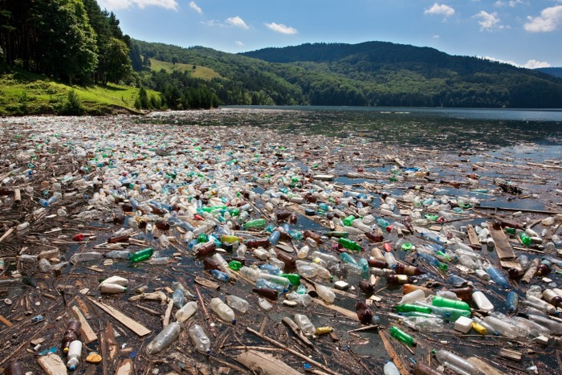

Definition of Plastic Pollution
Plastic pollution encompasses all types of plastic waste that end up in the environment, ranging from large items like discarded bottles and packaging to tiny particles known as microplastics. These microplastics, often less than 5 millimeters in size, are particularly problematic as they are difficult to remove and can easily enter food chains.

Sources of Plastic Pollution
This chart gives a clearer view of the relative contributions of each category to the total plastic pollution. Plastic pollution originates from various sources, including industrial waste, consumer products, and improper disposal practices. Common sources include:
- Single-use plastics: Approximately 40-50% of plastic pollution comes from single-use items like plastic bags, bottles, and packaging materials.These are the most common forms of plastic waste found in the environment due to their widespread use and short lifespan. (source: National Geographic Society)
- Improper waste disposal: Littering, inadequate landfill practices, and insufficient recycling efforts lead to plastic entering the environment. accounts for around 20-30% of plastic pollution.
- Industrial discharge: Industrial activities contribute 5-10% of plastic pollution, particularly through the release of plastics into waterways and air ​(source: UNEP – UN Environment Programme).
- Agricultural runoff: Agricultural uses of plastic, such as mulch films, contribute about 10-15% to overall plastic pollution ​(source: Ellen MacArthur Foundation)
- The remaining 5-10% of plastic pollution stems from a variety of sources such as textiles, cosmetics, and other consumer goods. These numbers can fluctuate based on regional policies, plastic usage, and waste management infrastructure.
Understanding these sources is crucial for addressing plastic pollution and mitigating its impact on human health.
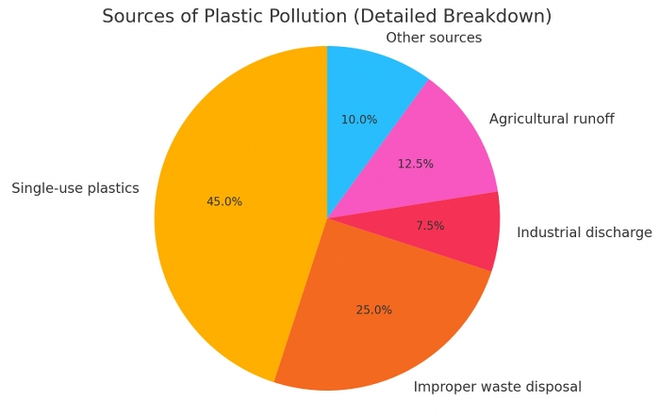

Pathways Through Which Plastic Pollution Affects Human Health
Plastic pollution impacts human health through various pathways, often in ways that are not immediately visible. As plastic waste breaks down, it releases harmful chemicals and microplastics into the environment, which can enter our bodies through food, water, air, and everyday products.

Contamination of Food and Water Supply
Microplastics and plastic-related chemicals have increasingly been found in the food we eat and the water we drink.
- Seafood Contamination: Marine life, particularly fish and shellfish, often ingest microplastics, which can then be passed on to humans through consumption. This introduces harmful chemicals, such as polychlorinated biphenyls (PCBs) and bisphenol A (BPA), into our diet, posing risks to our health.
- Agricultural Products: Plastics used in agricultural practices, such as mulching films, can degrade and contaminate crops. These plastics may then enter the human food chain.
- Drinking Water: Studies have found microplastics in tap and bottled water, raising concerns about long-term health effects from continuous exposure to these particles.

Airborne Microplastics
Plastic pollution doesn’t just affect land and water; it also impacts the air we breathe.
- Inhalation Risks: Microplastics can become airborne, especially in urban environments where plastic waste is prevalent. These tiny particles can be inhaled, leading to respiratory issues such as asthma, inflammation, and potentially long-term damage to the lungs.

Exposure through Consumer Products
Everyday items made from plastic are another significant pathway for exposure to harmful chemicals.
- Personal Care Products: Many cosmetics, toothpaste, and exfoliants contain microbeads, tiny plastic particles that can be absorbed through the skin or ingested.
- Plastic Packaging and Containers: Food and beverages stored in plastic containers can absorb chemicals like BPA and phthalates, which can leach into the products and be consumed by humans.
- Children’s Toys: Some toys made from plastic contain harmful substances, which can be particularly dangerous for children who are more vulnerable to chemical exposure.
These pathways demonstrate the pervasive nature of plastic pollution and its ability to infiltrate various aspects of human life, leading to significant health risks.

Health Risks Associated with Plastic Pollution
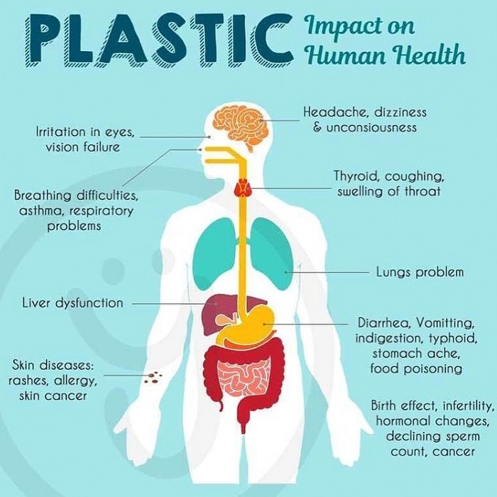
Plastic pollution poses various health risks due to harmful chemicals and microplastics entering the human body.

Chemical Toxicity
- Endocrine Disruptors: Chemicals like BPA and phthalates disrupt hormones, leading to issues like infertility and developmental disorders.
- Carcinogens: Some plastics release cancer-causing chemicals, increasing the risk of cancers like breast and colon cancer.

Respiratory Issues
- Asthma and Allergies: Inhaled microplastics can trigger respiratory problems, including asthma and lung inflammation.
- Lung Damage: Long-term exposure to airborne microplastics may lead to chronic lung diseases.

Impact on the Immune System
- Immune Suppression: Microplastics can weaken the immune system, making the body more vulnerable to diseases.
- Chronic Inflammation: Persistent exposure can cause inflammation, linked to autoimmune disorders and cardiovascular diseases.

Reproductive Health
- Fertility Issues: Chemicals in plastics disrupt reproductive health, affecting fertility and increasing risks of birth defects.
- Pregnancy Risks: Exposure during pregnancy can harm fetal development, leading to long-term health problems for the child.

Cancer Risk
- Carcinogenic Exposure: Prolonged exposure to plastic-related carcinogens raises the risk of developing various cancers.
These health risks highlight the urgent need to reduce plastic exposure and mitigate its harmful effects.


Vulnerable Populations
Certain groups are more vulnerable to the health risks of plastic pollution due to biological, socio-economic, or occupational factors.

Children and Infants
Children are particularly sensitive to plastic-related chemicals like BPA and phthalates, which can disrupt growth and development. Their behaviors, such as mouthing objects, increase exposure, leading to long-term health issues like asthma and reproductive disorders.

Pregnant Women
Exposure to plastic chemicals during pregnancy can affect fetal development, leading to birth defects and developmental delays. Hormonal disruptions from these chemicals also increase the risk of pregnancy complications.

Low-Income Communities
Low-income communities are often located near sources of plastic pollution, leading to higher exposure. Limited healthcare access and environmental injustice further exacerbate their health risks.

Occupational Exposure
Workers in plastic manufacturing, recycling, and healthcare are at greater risk of chronic exposure to harmful chemicals, leading to respiratory issues, skin conditions, and increased cancer risk.
Protecting these vulnerable populations is crucial in addressing the health impacts of plastic pollution.

Global and Regional Health Impacts
Plastic pollution affects health worldwide, with varying impacts depending on regional factors like plastic use, waste management, and socioeconomic conditions.
>> Read more: Drowning in Plastic: The Direct and Indirect Effects of Plastic Waste on Marginalized Communities

Case Studies
- Southeast Asia: High plastic pollution from poor waste management contaminates food and water, leading to increased health issues like gastrointestinal diseases and chemical exposure.
- United States: Despite better waste management, widespread plastic use has led to health concerns from endocrine-disrupting chemicals and microplastic contamination in water and food.
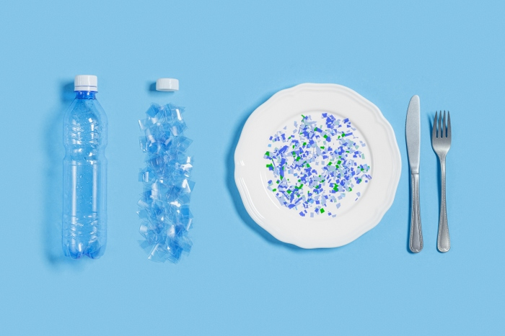

Comparative Analysis
- Developed vs. Developing Countries: Developed countries have better waste management but still face health risks from plastic consumption. Developing countries suffer more from inadequate waste disposal, leading to higher direct exposure.
- Urban vs. Rural Areas: Urban areas experience more plastic-related air and water pollution, while rural areas face localized contamination from poor waste practices.

Regional Responses
- Europe: Strong regulations, like bans on single-use plastics, are reducing health risks from plastic pollution.
- Asia-Pacific: While some policies are emerging, challenges remain due to rapid industrialization and high plastic use.

Global Impact
- Ocean Pollution: Plastic pollution in oceans affects global food chains, spreading health risks worldwide.
- Cross-Border Pollution: Exporting plastic waste to countries with poor waste management exacerbates health risks, particularly in developing nations.
Understanding these regional differences helps in creating targeted solutions to reduce the global health impacts of plastic pollution.

Measures to Mitigate Health Risks
Addressing the health risks posed by plastic pollution requires a multifaceted approach, involving individual actions, community efforts, and governmental policies. By implementing these measures, we can significantly reduce the exposure to harmful plastics and protect public health.

Reducing Plastic Use
Reducing plastic use is one of the most direct and effective strategies for mitigating the health risks of plastic pollution.
- Personal Choices: Individuals can make impactful changes by opting for reusable items like cloth bags, stainless steel water bottles, and glass food containers. Avoiding single-use plastics—such as straws, cutlery, and packaging—can significantly reduce plastic waste. By supporting brands that prioritize sustainability and plastic-free packaging, consumers can drive demand for more eco-friendly products.
- Product Alternatives: Choosing biodegradable and compostable materials, such as plant-based plastics and paper products, helps reduce the long-term environmental impact of plastic waste. Natural fibers in clothing and household items also minimize microplastic pollution. Plastic-free personal care products, like solid shampoos and refillable containers, further reduce exposure to harmful chemicals.
- Conscious Consumerism: Researching products and making informed choices about their environmental impact can help consumers avoid plastic-heavy options. DIY products and upcycling old items are also effective ways to reduce plastic consumption and waste. By advocating for change, individuals can influence broader community and legislative efforts to combat plastic pollution.
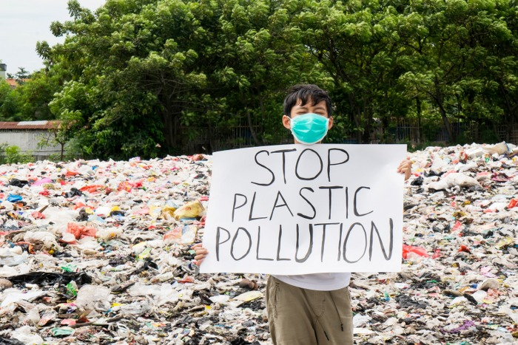

Improved Waste Management
- Recycling Programs: Effective recycling systems are crucial in managing plastic waste. Communities should enhance recycling infrastructure, making it easier for residents to dispose of plastics properly and ensuring that more plastic is reused rather than ending up in landfills or oceans.
- Composting and Biodegradable Solutions: Encouraging the use of compostable and biodegradable materials can reduce the burden on waste management systems. These materials break down more easily, reducing the long-term environmental impact.

Regulation and Policy
- Government Initiatives: Governments play a critical role in combating plastic pollution by enacting laws and regulations that limit plastic production and promote sustainable practices. Policies such as bans on single-use plastics, taxes on plastic bags, and incentives for companies to use alternative materials can significantly reduce plastic waste.
- International Agreements: Global cooperation is necessary to address plastic pollution effectively. International agreements, such as the Basel Convention, can help regulate the cross-border movement of plastic waste and encourage countries to adopt more sustainable practices.

Public Awareness and Education
- Community Education: Educating the public about the health risks associated with plastic pollution is vital for encouraging behavior change. Community programs and school curricula can raise awareness of the issue and teach practical ways to reduce plastic use.
- Media Campaigns: Media campaigns can amplify the message, reaching broader audiences and motivating people to take action. These campaigns can highlight the dangers of plastic pollution and promote sustainable alternatives.

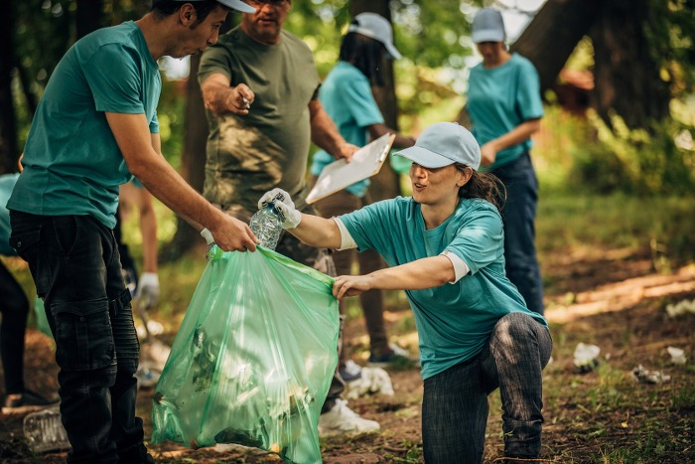

Innovation and Research
- Development of Alternatives: Continued research into alternative materials and technologies can reduce reliance on plastics. Innovations such as biodegradable plastics, plastic-free packaging, and advanced recycling techniques can help mitigate the environmental and health impacts of plastic pollution.
- Health Impact Studies: Ongoing research into the health effects of plastic pollution is essential for informing public policy and guiding future mitigation efforts. Understanding the specific risks associated with different types of plastic exposure will help tailor more effective solutions.
By taking these measures, we can work towards reducing plastic pollution and its associated health risks. A collective effort involving individuals, communities, governments, and businesses is necessary to protect public health and ensure a safer, more sustainable environment for future generations.
Every minute, the equivalent of one garbage truck full of plastic is dumped into our oceans. By the time you finish reading this paragraph, countless pieces of plastic will have joined the millions already threatening marine life and ecosystems. This isn’t just a distant environmental issue—it directly impacts you and your loved ones. The seafood on your plate may contain microplastics, and the beaches you enjoy are increasingly littered with debris. Plastic pollution is not just harming sea creatures; it’s entering our food chain and affecting our health.
The oceans are reaching a tipping point, and effective plastic waste management solutions are crucial. In this article, we’ll explore actionable strategies to reduce plastic pollution, safeguard marine ecosystems, and ensure a healthier planet for future generations.

Understanding the Impact of Plastic Waste on Marine Pollution
Plastic waste is a pervasive problem, affecting every corner of the ocean. To tackle this issue, it’s essential to understand the different types of plastic waste and their sources.
Plastic pollution has reached alarming levels, demanding immediate action. According to a 2020 study by The Pew Charitable Trusts and SYSTEMIQ, an estimated 11 million metric tons of plastic waste enter the ocean annually. If significant measures aren’t taken, this figure is projected to nearly triple to 29 million metric tons per year by 2040. This increase would be equivalent to dumping one garbage truck of plastic into the ocean every minute.
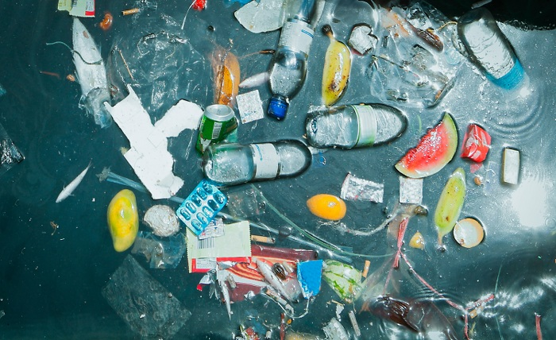

Types of Plastic Waste
- Microplastics: Tiny plastic particles less than 5mm in size, resulting from the breakdown of larger plastics or directly introduced through products like cosmetics.
- Single-Use Plastics: Items intended for one-time use, such as plastic bags, straws, and water bottles, which significantly contribute to pollution.
- Macroplastics: Larger plastic debris, including discarded fishing nets (often referred to as “ghost nets”), which pose direct threats to marine life through entanglement and ingestion.

Sources of Ocean Plastic Pollution
- Land-Based Sources: Improperly managed waste, industrial runoff, and littering contribute significantly to ocean pollution. Urban areas near coastlines are particularly impactful.
- Marine-Based Sources: Abandoned fishing gear, shipping activities, and offshore oil and gas platforms introduce large amounts of plastic into the ocean.

Impact on Marine Ecosystems
- Harm to Marine Life: Animals ingest or become entangled in plastic debris, leading to injuries, starvation, and death. For example, sea turtles often mistake plastic bags for jellyfish, a primary food source. Research shows that all seven species of sea turtles have been found with plastic in their digestive systems. Ingesting just 14 pieces of plastic can increase a sea turtle’s risk of death. (Source: Wilcox, C., Puckridge, M., Schuyler, Q. A., Townsend, K., & Hardesty, B. D. (2018). A quantitative analysis linking sea turtle mortality and plastic debris ingestion. Scientific Reports)
- Habitat Disruption: Plastic waste damages coral reefs and other critical habitats, reducing biodiversity and altering ecosystems. Plastic debris harms coral reefs by blocking sunlight and introducing pathogens. Corals in contact with plastic have an 89% likelihood of developing disease, compared to a 4% likelihood in those that are plastic-free.
- Human Health Risks: Microplastics enter the food chain, ultimately affecting human health through seafood consumption. Microplastics have been found in human organs, including the lungs, liver, and kidneys. While the full health implications are still being studied, there is concern over potential risks such as inflammation or exposure to toxic substances.

Economic Impact of Plastic Pollution
- Financial Costs: The United Nations estimates that plastic pollution costs the marine ecosystem up to $13 billion annually. This includes costs related to the impact on fisheries, tourism, and the cleaning of beaches.
- Industry Losses: The fishing industry suffers losses due to reduced fish populations and damaged equipment from plastic debris.
- Tourism Decline: Coastal communities experience economic downturns as polluted beaches deter tourists.
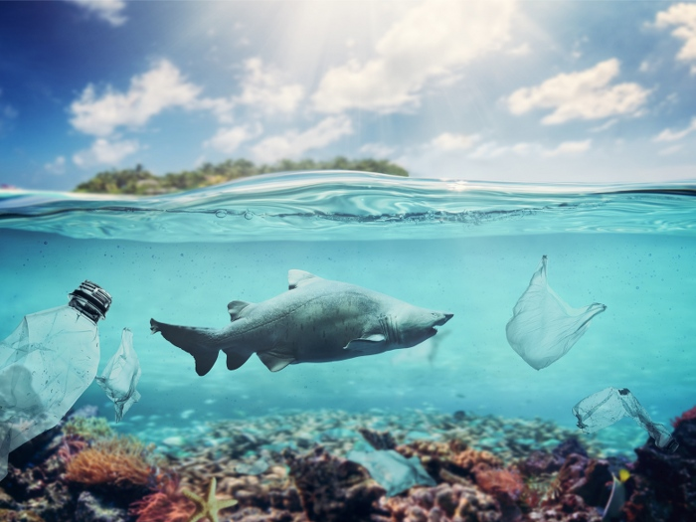

Key Strategies for Sustainable Plastic Waste Management
Effective plastic waste management requires a comprehensive approach, involving multiple strategies to address the issue at its source and reduce its impact on the ocean.

Reducing Plastic Production and Consumption
Reducing the amount of plastic produced and consumed is one of the most effective ways to combat plastic pollution. By minimizing single-use plastics and promoting sustainable alternatives, we can significantly decrease the volume of waste entering the ocean.
Minimizing single-use plastics involves implementing bans, regulations, and encouraging consumer behavior changes. Governments and organizations worldwide are taking steps to reduce single-use plastics by banning items like plastic bags and straws. At the same time, consumers are becoming more aware of the need to reduce plastic use in their daily lives.
Promoting sustainable alternatives is another crucial strategy. Biodegradable plastics, reusable materials, and innovative packaging solutions offer eco-friendly options that can replace traditional plastics. These alternatives help reduce the long-term impact of plastic waste on the environment.

Improving Waste Collection and Recycling Systems
An efficient waste management system is critical for keeping plastic waste out of the ocean. By improving waste collection infrastructure and advancing recycling technologies, we can ensure that more plastic is properly managed and less ends up in the ocean.
Enhancing waste collection infrastructure, especially in coastal regions, is essential for preventing plastic waste from reaching the ocean. Investing in better waste management systems ensures that waste is collected and processed effectively, reducing the likelihood of it being improperly disposed of.
Advancing recycling technologies plays a vital role in managing plastic waste. New technologies are being developed to increase recycling rates and process plastics that are currently difficult to recycle. By improving recycling capabilities, we can reduce the amount of plastic waste that needs to be managed.

Implementing Extended Producer Responsibility (EPR)
Shifting the responsibility of plastic waste management to producers is an effective way to reduce plastic pollution. Extended Producer Responsibility (EPR) programs hold manufacturers accountable for the entire lifecycle of their products, encouraging them to design more sustainable products and packaging.
EPR programs require producers to take back, recycle, or dispose of their products after use. This approach not only reduces the burden on waste management systems but also incentivizes companies to create products that are easier to recycle or have a lower environmental impact.
Successful EPR programs around the world have shown that this strategy can significantly reduce plastic waste. By making producers responsible for their products, we can encourage more sustainable production practices and reduce the overall volume of plastic waste.

Supporting Community-Led Initiatives
Community involvement is crucial in the fight against plastic pollution. Grassroots movements, beach cleanups, and local activism play a significant role in reducing plastic waste and raising awareness about the issue.
Beach cleanups and local activism bring communities together to remove plastic waste from coastlines and waterways. These efforts not only reduce the immediate impact of plastic pollution but also raise awareness about the importance of proper waste disposal and plastic reduction.
Education and awareness campaigns are also vital in supporting community-led initiatives. By educating the public about the dangers of plastic pollution and promoting responsible plastic use, we can empower individuals to take action and make a difference.
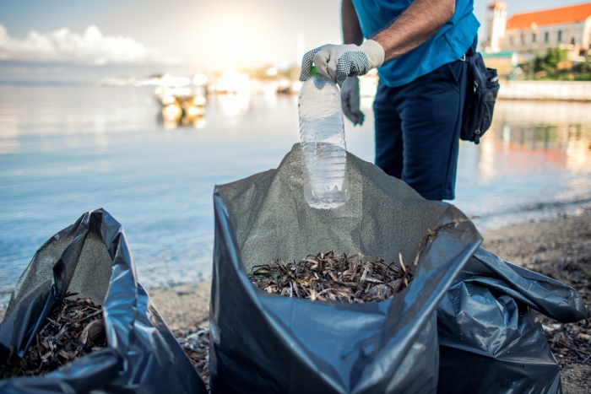

International Collaboration and Policies
Plastic pollution is a global issue that requires coordinated international efforts to address effectively. Global treaties, agreements, and the involvement of governments and NGOs are essential in the fight against plastic waste.
Global treaties and agreements, such as the Global Plastic Pact and the Basel Convention, provide frameworks for countries to work together to reduce plastic pollution. These agreements set targets for reducing plastic waste and encourage international cooperation in developing and implementing solutions.
Governments and NGOs also play a crucial role in addressing plastic pollution. By implementing policies, funding research, and supporting international agreements, these organizations contribute to the global effort to manage plastic waste and protect the oceans.

The Role of Innovation and Technology in Plastic Waste Management
Innovation and technology are critical in addressing plastic pollution. By developing new materials, advancing recycling methods, and implementing ocean cleanup technologies, we can make significant strides in managing plastic waste.

New Materials and Bioplastics
One promising area is the creation of new materials, such as bioplastics, made from renewable resources like corn starch or sugarcane. These materials are designed to be biodegradable and compostable, offering a sustainable alternative to traditional plastics. Beyond bioplastics, innovations like packaging made from algae, mushrooms, and seaweed are also being explored as eco-friendly options.

Advancing Recycling Technologies
Improving recycling is essential to managing existing plastic waste. Chemical recycling, which breaks down plastics at the molecular level to create new materials, offers a way to recycle mixed or contaminated plastics that traditional methods cannot handle. Additionally, advanced sorting technologies using AI are improving the efficiency of recycling facilities, allowing more plastic to be recycled and reducing waste.

Ocean Cleanup Technologies
To address the plastic already in the ocean, technologies like The Ocean Cleanup project are crucial. These systems collect plastic debris from the ocean using passive and active methods, preventing further harm to marine life. Smaller initiatives also focus on intercepting plastic waste in rivers and coastal areas before it reaches the ocean.
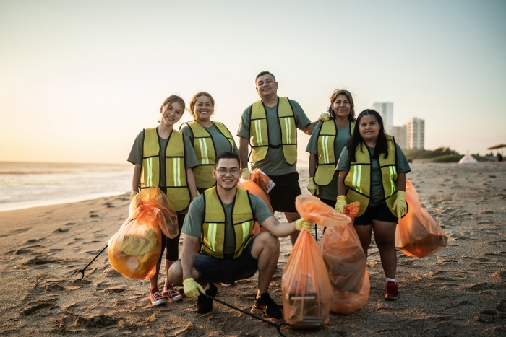

The Future of Innovation in Plastic Waste Management
The future will likely bring even more advancements in materials, recycling, and cleanup technologies. Collaboration between industries, governments, and researchers will be key to driving these innovations. By continuing to invest in and support these efforts, we can make meaningful progress in reducing plastic pollution and protecting our oceans.
In summary, innovation and technology are indispensable in the fight against plastic pollution. New materials, better recycling methods, and effective cleanup technologies offer hope for a future where plastic waste is effectively managed, and our oceans are restored.

Challenges and Future Directions
While progress is being made, significant challenges remain.

Challenges in Implementation
- Economic Barriers: High costs of new technologies and infrastructure improvements.
- Political Resistance: Lack of political will or conflicting interests can impede policy changes.
- Social Hurdles: Changing consumer behavior and societal norms takes time and education

