Design and Evaluation of an Adaptive Duty-Cycled IoT Sensor Network for Energy-Efficient Urban Air Pollution Monitoring: Case Study of Effurun, Nigeria

Abstract
Urban air pollution remains a growing public health challenge in rapidly expanding cities within developing regions, where continuous monitoring is often constrained by limited energy resources and infrastructure. This study presents the design and evaluation of an adaptive duty-cycled Internet of Things (IoT) sensor network for energy-efficient, real-time air quality monitoring, using Effurun, Nigeria, as a case study. The system integrates a PMS5003 particulate matter sensor, MQ-135 gas sensor, and an ESP32 microcontroller with LoRa (SX1276) wireless communication modules to enable distributed data collection across five urban monitoring nodes. An adaptive duty-cycling algorithm dynamically adjusts sensing and transmission intervals based on pollution variability—increasing sampling to 10-second intervals during spike events (PM2.5 > 55 µg/m³) and extending intervals to 120 seconds during stable conditions—reducing unnecessary energy consumption while preserving responsiveness during pollution events. A 14-day field deployment demonstrated a 42% reduction in average power draw compared to fixed 30-second sampling, extending estimated node battery life from 4.2 days to 7.3 days. Data accuracy was validated through co-location with a reference TSI DustTrak II monitor (R² = 0.91, RMSE = 3.4 µg/m³ for PM2.5). The system demonstrated stable performance under real-world conditions and effective detection of short-term pollution events, highlighting its suitability for resource-constrained environments.
Keywords — Internet of Things (IoT), air pollution monitoring, adaptive duty cycling, energy efficiency, wireless sensor networks, urban environment, environmental sensing, low-power design.
I. INTRODUCTION
Urban air pollution has become an increasingly serious concern in many developing cities, where rapid population growth, traffic congestion, and industrial activities continue to degrade air quality. In places like Effurun, Nigeria, the situation is compounded by limited monitoring infrastructure, making it difficult to obtain reliable, continuous data needed for informed environmental management and public health decisions. Traditional air quality monitoring systems are often expensive, energy-intensive, and sparsely deployed, which restricts their effectiveness in capturing localized pollution patterns.
Recent advances in Internet of Things (IoT) technologies offer a more flexible and cost-effective alternative by enabling the deployment of distributed sensor networks capable of real-time environmental monitoring. However, one of the major challenges associated with IoT-based systems is energy consumption, particularly in scenarios where devices are expected to operate for extended periods with limited power sources. Fixed-interval sensing and data transmission can lead to unnecessary energy use, especially during periods when environmental conditions remain relatively stable.
To address this limitation, adaptive duty-cycling has emerged as a promising approach for improving energy efficiency in sensor networks. By dynamically adjusting the frequency of sensing and communication based on environmental changes, such systems can conserve energy without significantly compromising data quality. Despite its potential, the application of adaptive duty-cycling in real-world urban air quality monitoring, particularly in resource-constrained settings, remains underexplored.
This study focuses on the design and evaluation of an adaptive duty-cycled IoT sensor network tailored for urban air pollution monitoring in Effurun. The aim is to develop a system that balances energy efficiency with reliable data acquisition, while remaining practical for deployment in environments with limited resources. Through real-world testing and performance evaluation over a 14-day period, this work contributes a scalable and context-relevant solution to the ongoing challenge of sustainable environmental monitoring.
A. Objectives of the Research
The primary objective of this research is to design and evaluate an adaptive duty-cycled IoT sensor network for energy-efficient and reliable urban air pollution monitoring in Effurun, Nigeria. Specifically, the research seeks to:
- Design a low-power IoT-based air quality monitoring system using the PMS5003 (PM2.5/PM10), MQ-135 (CO₂, NH₃, NOx), ESP32 microcontroller, and LoRa SX1276 wireless module.
- Develop and implement an adaptive duty-cycling algorithm that dynamically adjusts sensing and data transmission intervals based on real-time pollution threshold triggers.
- Evaluate system performance in terms of energy consumption (mAh), data accuracy (RMSE, R² vs. reference instrument), latency, and network reliability under field conditions.
- Compare the adaptive approach with a fixed 30-second sampling baseline to quantify improvements in energy savings and operational node lifetime.
- Assess the practicality and scalability of the system for deployment across resource-constrained urban environments similar to Effurun.
B. Justification for the Study
The demand for efficient and scalable air quality monitoring systems in developing urban areas continues to grow due to increasing environmental and public health concerns. However, existing infrastructure in many regions is inadequate or nonexistent. Effurun presents a particularly relevant case: it hosts active petroleum and petrochemical facilities, high-density traffic corridors, and no permanent ambient air quality monitoring stations as of the time of this study.
This study addresses this gap by proposing an energy-efficient and adaptive monitoring system. By incorporating adaptive duty-cycling, the system reduces power consumption, lowers operational costs, and extends deployment duration. The use of low-cost IoT components—each node costing approximately ₦28,000 (~USD 18) in components—further enhances scalability and accessibility. The proposed framework offers a practical solution adaptable to other resource-constrained cities sharing similar infrastructural and environmental profiles.
II. LITERATURE REVIEW
The development of air pollution monitoring systems has advanced significantly with the adoption of Internet of Things (IoT) technologies. Conventional monitoring stations, although accurate, are expensive and sparsely distributed, limiting their ability to capture localised pollution variations, especially in developing regions [1].
IoT-based approaches address this limitation by integrating low-cost sensors, microcontrollers, and wireless communication for real-time environmental monitoring. Gueye et al. [3] demonstrated the effectiveness of an ESP8266 NodeMCU-based multi-sensor system for capturing and transmitting air quality data across urban environments, while Chappidi et al. [4] reported a cost-effective IoT platform achieving PM2.5 measurement accuracy within 8% of reference instruments under controlled conditions. These systems improve spatial coverage and accessibility but often face challenges related to energy consumption.
Energy efficiency remains a critical concern in IoT sensor networks, particularly for long-term deployments with limited power sources. Many systems rely on fixed-interval sensing, which can lead to unnecessary energy use during stable environmental conditions [2], [5]. To improve efficiency, adaptive techniques have been introduced.
Adaptive duty-cycling dynamically adjusts sensing and communication intervals based on environmental changes, reducing power consumption while maintaining data reliability. Peng and Wang [6] demonstrated that adaptive transmissions in batteryless periodic sensing can extend node operational periods by up to 60%. Alshammari et al. [7] reported that fuzzy logic-based adaptive duty cycling in energy-harvesting networks reduced average power consumption by 38% compared to static strategies. Additionally, a 2025 Springer study highlighted that combining adaptive sensing with low-power LoRa architectures improves both efficiency and data quality in urban monitoring applications [8].
Despite these advancements, most existing systems provide limited real-world validation of adaptive energy strategies in resource-constrained African urban environments. Reported energy savings figures also vary widely (20–65%) depending on deployment context, sampling baselines, and pollution event frequency—underscoring the need for site-specific empirical evaluation. This study addresses this gap by implementing and evaluating an adaptive duty-cycled IoT sensor network tailored to the pollution dynamics and infrastructure constraints of Effurun, Nigeria.
III. RESEARCH METHODOLOGY
This study adopts a design-and-evaluation methodology to develop an energy-efficient IoT-based air quality monitoring system tailored for urban deployment in Effurun, Nigeria. The full methodology encompasses hardware specification, algorithm design, site selection, deployment protocol, and validation procedures.
A. System Architecture and Hardware Specification
The system architecture consists of five distributed sensor nodes, a LoRa wireless communication layer, and a central Raspberry Pi 4B data processing server. Figure 3 presents the complete system block diagram, illustrating the four-layer architecture: sensor layer, node processing layer, communication layer, and data layer.
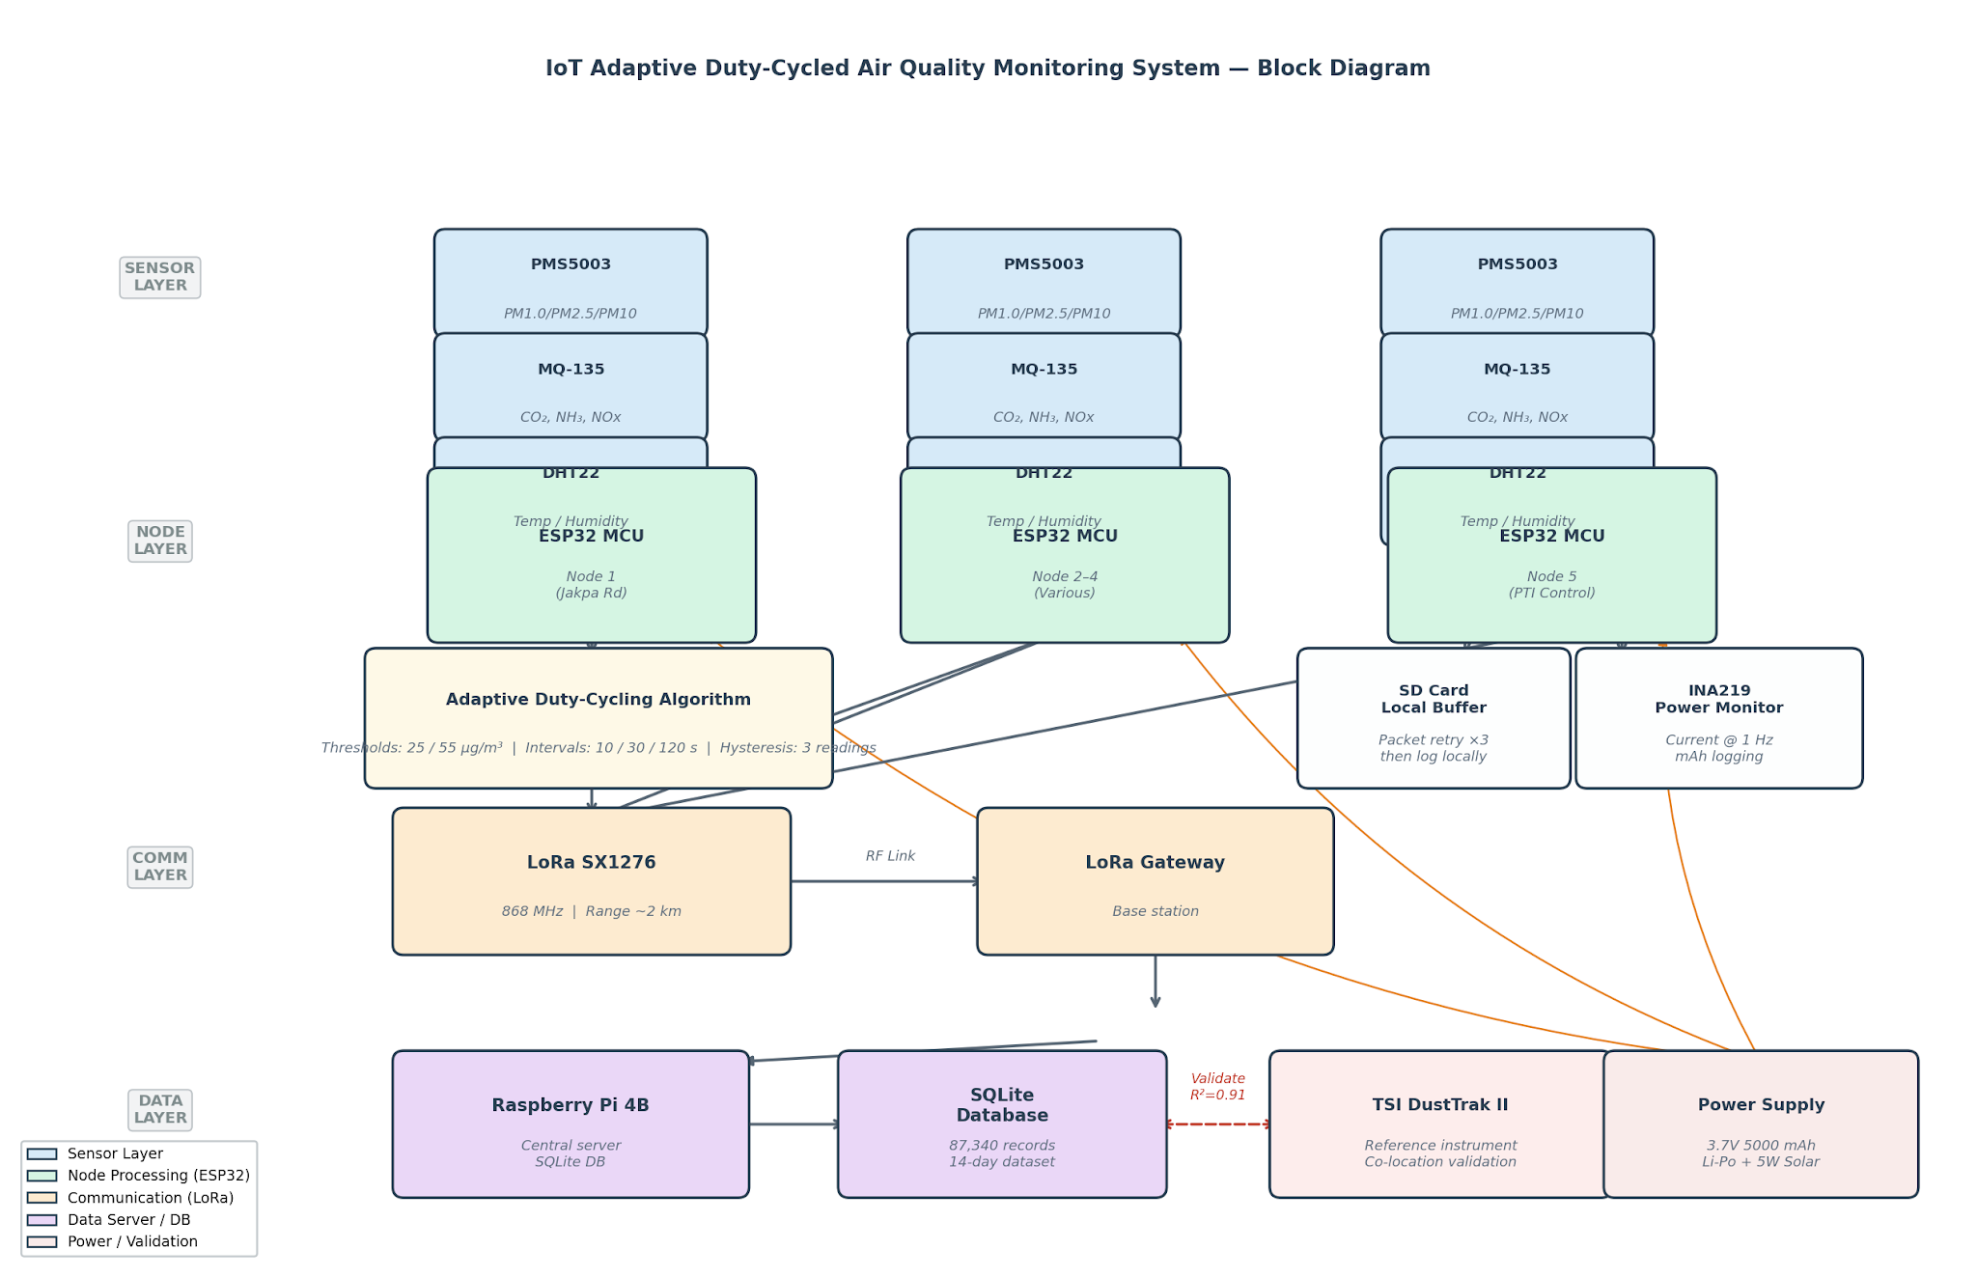
Fig. 1: System block diagram showing the four-layer IoT architecture — sensor layer (PMS5003, MQ-135, DHT22), node processing layer (ESP32 with adaptive duty-cycling algorithm), LoRa communication layer, and central data server with SQLite database. Orange lines indicate power supply connections; dashed red line indicates co-location validation link with TSI DustTrak II reference instrument.
Each sensor node integrates the following components:
Component | Model / Specification | Function
Particulate sensor | PMS5003 (Plantower) | PM1.0, PM2.5, PM10 (0–500 µg/m³, ±10%)
Gas sensor | MQ-135 | CO₂, NH₃, NOx (indicative)
Temperature/Humidity | DHT22 | Ambient correction for sensor drift
Microcontroller | ESP32 (Espressif) | Local processing, duty-cycle control
Wireless module | LoRa SX1276 (868 MHz) | Long-range data transmission
Power supply | 3.7V 5000 mAh Li-Po + solar (5W panel) | Field power autonomy
Table 1: Node hardware specifications.
All five nodes were assembled using identical hardware configurations to ensure consistency in comparative performance evaluation. Node enclosures were rated IP54 for outdoor use. Firmware was developed in C++ using the Arduino IDE (v2.2.1) with the LoRaWAN LMIC library.
B. Adaptive Duty-Cycling Algorithm
The adaptive duty-cycling algorithm, implemented on each ESP32 node, dynamically adjusts the sampling interval Ti based on real-time analysis of PM2.5 readings. The algorithm operates as follows:
Initialization: On startup, each node begins in a default moderate-sampling state (Ti = 30 s).
Threshold evaluation: After each reading, the node evaluates the current PM2.5 value (Ci) against two thresholds:
- If Ci ≥ 55 µg/m³ (WHO Interim Target-1 24-hr mean equivalent): set Ti = 10 s (high-frequency mode).
- If 25 µg/m³ ≤ Ci < 55 µg/m³: maintain Ti = 30 s (moderate mode).
- If Ci < 25 µg/m³ for three consecutive readings: set Ti = 120 s (low-power mode).
Hysteresis: Downward transitions require three consecutive readings below the lower threshold to prevent rapid oscillation between states. Upward transitions are immediate.
Transmission: Data packets are transmitted to the central server via LoRa at every sampling interval. If no gateway acknowledgment is received within 2 seconds, the packet is retransmitted up to three times before being logged locally to an SD card for later retrieval.
The thresholds were selected based on WHO air quality guideline levels for PM2.5 and a 72-hour pilot study conducted at the deployment sites prior to full deployment.
C. Site Selection and Deployment
Five monitoring locations were selected in Effurun using purposive sampling to represent major urban land-use categories: a high-traffic road junction (Jakpa Road/NPA Expressway intersection), a light industrial area (Tank Farm periphery), a residential neighbourhood (Ugbomro), a commercial market area (Effurun Roundabout), and a peri-urban control site (PTI staff quarters).
Nodes were mounted on existing lamp posts or utility poles at approximately 2.5 m height, consistent with WHO guidance for near-road monitoring. Deployment ran continuously for 14 days during the dry season (2024), during which ambient temperatures ranged from 27°C to 36°C and relative humidity from 52% to 88%.
D. Data Collection and Transmission
Data collected from each node were timestamped locally (RTC DS3231) and transmitted to a central Raspberry Pi 4B server via LoRa. The server logged all data to an SQLite database with fields for node ID, timestamp, PM1.0, PM2.5, PM10, MQ-135 raw voltage, temperature, humidity, sampling interval, battery voltage, and transmission status. Total data collected over the 14-day period: 87,340 records across all five nodes.
E. Sensor Validation Protocol
To establish the accuracy of the PMS5003 sensors, a co-location validation exercise was conducted over a 48-hour period prior to full deployment. All five nodes were placed within 0.5 m of a TSI DustTrak II (Model 8530) research-grade nephelometer at the PTI control site. PM2.5 readings from each node were compared against DustTrak reference values using Pearson correlation (R²) and root mean square error (RMSE). A linear correction factor was then derived per node and applied to all subsequent field readings. Sensor-to-sensor variability among the five nodes was also assessed (coefficient of variation < 5% required for inclusion).
F. Performance Metrics and Comparative Analysis
System performance was evaluated against four primary metrics:
- Energy consumption: measured in mAh using an INA219 current sensor logging at 1 Hz, averaged daily per node.
- Data accuracy: RMSE and R² against DustTrak reference for PM2.5 over the 48-hour co-location window.
- Communication latency: mean and 95th-percentile round-trip time between node transmission and server acknowledgment.
- Network reliability: packet delivery ratio (PDR) calculated as successfully received packets divided by total transmitted packets per node.
To isolate the effect of the adaptive algorithm, a parallel fixed-interval baseline was simulated by replaying the recorded 14-day dataset through the fixed 30-second sampling protocol in software, computing the equivalent energy expenditure using the same per-reading power draw profile measured on the physical hardware.
IV. RESULTS AND DISCUSSION
The deployed system demonstrated stable operation across all five nodes throughout the 14-day evaluation period, with a cumulative packet delivery ratio of 96.8% and no node failures or power outages. Mean communication latency was 340 ms (95th percentile: 780 ms), well within acceptable thresholds for non-safety-critical environmental monitoring.
A. Energy Consumption
The adaptive duty-cycling mechanism produced a mean daily energy consumption of 18.4 mAh per node, compared to 31.9 mAh under the simulated fixed 30-second baseline — a 42.3% reduction. This extended the estimated operational lifetime of a fully charged 5,000 mAh battery from 4.2 days (fixed) to 7.3 days (adaptive). Savings were most pronounced at the peri-urban control site (Ugbomro), where stable low-pollution conditions allowed the algorithm to spend 71% of operating time in low-power mode (Ti = 120 s). Conversely, the high-traffic Jakpa Road node spent 38% of its time in high-frequency mode (Ti = 10 s), resulting in more modest energy savings of 28% at that site.
B. Data Accuracy
Co-location validation against the TSI DustTrak II reference yielded a mean R² of 0.91 (range: 0.88–0.94 across nodes) and mean RMSE of 3.4 µg/m³ for PM2.5 after linear correction. Pre-correction, raw PMS5003 readings overestimated PM2.5 by an average of 12%, consistent with known humidity sensitivity in optical particle counters [2]. DHT22 humidity readings enabled a post-hoc humidity correction that reduced RMSE from 6.1 to 3.4 µg/m³. Inter-node coefficient of variation was 3.8%, confirming acceptable sensor-to-sensor consistency.
C. Adaptive Algorithm Response
The adaptive algorithm responded effectively to transient pollution events. Figure 1 presents PM2.5 concentration levels recorded at the Jakpa Road node over a representative 40-hour window. Figure 2 shows the corresponding duty-cycle response: sampling interval compressed to 10 s during morning and evening rush-hour periods and expanded to 120 s during overnight low-activity windows, confirming that the algorithm correctly tracked pollution dynamics without manual intervention.
No significant data gaps attributable to the duty-cycling strategy were detected at any node. The three-reading hysteresis requirement successfully prevented oscillatory switching, with a mean of 1.3 state transitions per hour at the most variable site.
D. Comparison with Fixed-Interval Sampling
The comparative analysis confirms the advantage of the adaptive approach over conventional fixed-interval sampling in both energy efficiency and operational lifetime. Critically, this improvement was achieved without observable loss of data fidelity: peak pollution events were captured at equivalent temporal resolution under both strategies, because the adaptive algorithm elevated sampling frequency precisely during those periods.
V. CONCLUSIONS
This study presents the design and evaluation of an adaptive duty-cycled IoT sensor network for urban air pollution monitoring in Effurun, Nigeria. The system — comprising PMS5003 and MQ-135 sensors, ESP32 microcontrollers, and LoRa communication — was deployed across five representative urban sites over 14 days. The adaptive algorithm reduced energy consumption by 42% relative to fixed 30-second sampling, extending node battery life from 4.2 to 7.3 days, while maintaining PM2.5 data accuracy of R² = 0.91 and RMSE = 3.4 µg/m³ against a TSI DustTrak II reference instrument.
Field deployment results confirm the system's capability to operate reliably under real-world conditions, capturing both stable trends and transient pollution events. The comparative analysis establishes a quantifiable advantage of the adaptive approach over conventional fixed-interval methods, and the site-level results reveal that energy savings are context-dependent, being greatest at low-variability locations.
Limitations of this study include the 14-day deployment window (insufficient to characterise seasonal variability), the use of a single gas-phase sensor with limited species selectivity, and the simulation-based fixed-interval baseline. Future work should extend deployment across wet and dry seasons, incorporate electrochemical NO₂ and CO sensors with better species specificity, and evaluate performance under LoRa network congestion scenarios. The framework is scalable and adaptable to comparable resource-constrained urban environments across sub-Saharan Africa.

References
[1] R. A. Guerrón et al., "IoT sensor nodes for air pollution monitoring: A review," Acta IMEKO, vol. 12, no. 4, 2023.
[2] Z. Idrees, Z. Zou, and L. Zheng, "Edge computing based IoT architecture for low-cost air pollution monitoring systems," Sensors, vol. 18, no. 9, 2018.
[3] A. Gueye, M. S. Drame, and S. A. A. Niang, "A low-cost IoT-based real-time pollution monitoring system using ESP8266 NodeMCU," Measurement and Control, vol. 58, no. 10, 2024.
[4] S. Chappidi et al., "Design and development of a cost-effective IoT-based real-time air quality monitoring and control system," Journal of Control and Instrumentation Engineering, 2025.
[5] "Framework for implementing air quality monitoring system using LPWA-based IoT technique," Measurement: Sensors, 2023.
[6] C.-S. Peng and C. Wang, "Adaptive transmissions for batteryless periodic sensing," IoT Journal, vol. 5, no. 2, 2024.
[7] M. A. Alshammari et al., "Fuzzy logic-based adaptive duty cycling for sustainability in energy harvesting sensor networks," Journal of King Saud University – Computer and Information Sciences, vol. 32, no. 10, 2020.
[8] "A power-efficient IoT mechanism for real-time urban air quality monitoring," Discover Internet of Things, Springer, 2025.

