Design and Development of a Smart Society Maintenance Management System

ABSTRACT
The Smart Society Management System is a comprehensive web-based application designed to address the growing needs and complexities of modern residential society management. Developed using Python and the Flask framework, the system seeks to overcome the limitations of traditional, manual processes that often result in inefficiencies, miscommunication, and lack of transparency in daily society operations.The principal aim of the project is to automate and streamline critical tasks such as maintenance billing and tracking, complaint registration and resolution, user management, and administrative communication. The application features robust, role-based modules: an Admin Module that empowers society managers to securely log in, generate and assign monthly maintenance bills, view payment statuses, manage user data, and publish important notices; and a User Module that enables residents to access their maintenance dues, view payment histories, download receipts, submit complaints, and receive instant updates from the administration. A key innovation is the real-time tracking dashboard, providing both admins and residents with up-to-the-minute information on payment status and outstanding balances. The integration of WhatsApp API for automated message delivery further enhances communication by allowing the administration to send payment receipts and critical notifications directly to residents' phones, minimizing information gaps and manual efforts. Security is prioritized through a custom login system with initial credentials managed by the admin and a password reset feature, ensuring data privacy and personal control for users.Initial testing with actual residents has yielded positive feedback, highlighting the application's user-friendly interface and practical utility. The use of an open-source SQLite3 database paired with cloud hosting delivers secure, reliable, and scalable storage of all transactions and user activities. By digitizing the entire workflow, the system eliminates paperwork, reduces errors, and supports transparency and accountability.
KEYWORDS
Web Application, Python, Flask, Smart Society, Maintenance, Automation
INTRODUCTION
The Smart Society Management System is a web-based application developed using Python and Flask to simplify and automate the management of residential society operations. This system addresses routine challenges such as maintenance billing, complaint tracking, payment management, and effective communication between members and administration. The project is built with two key modules: the Admin Module and the User Module. The Admin Module lets administrators securely log in, generate monthly bills, view resident details, and publish announcements. The User Module enables residents to register, access monthly dues, download receipts, and view notices instantly. This system brings transparency, efficiency, and convenience to housing society management. All payment, complaint, and resident data is stored securely in an integrated database, making day-to-day operations easier and more organized. Traditional residential society management processes are manual, time-consuming, and prone to errors. Most societies currently rely on physical registers or basic spreadsheets for tracking maintenance payments, recording complaints, and circulating notices.
This leads to several major challenges:
- Time-Consuming Manual Work – Society administrators spend excessive time preparing and distributing maintenance bills, keeping records, and addressing complaints individually.
- Lack of Transparency – Manual or offline records often lead to disputes over payment status, outstanding balances, and complaint resolutions.
- Inefficient Communication – Notices and updates are commonly circulated through word-of-mouth, printed copies, or basic messaging groups, which often fail to reach all residents effectively.
- Data Management Challenges – Maintaining historical records of payments, complaints, and announcements becomes difficult without a centralized digital system.
- Security Concerns – Without a secure and role-based system, sensitive data such as payment details and resident information is at risk of being misused or lost.
LITERATURE REVIEW
The increasing complexity of residential society management has led to a growing demand for digital solutions that improve efficiency, transparency, and communication. Traditional manual methods of record-keeping and billing are not only time-consuming but also prone to errors and disputes. As a result, researchers and developers have explored various approaches to digitize society operations, automate financial transactions, and enhance communication between administrators and residents.The concept of a Society Management System has evolved with the increasing need for digitization and automation in residential communities. Over the years, researchers and developers have explored various approaches to address problems such as billing, communication, data storage, and transparency in management. The following literature provides insights into existing works and technologies that form the foundation of this project:
- Automation and Digital Transformation in Society Management-Studies highlight the shift from manual record-keeping to automated platforms for society management. Digital systems ensure faster processing, reduce human error, and provide long-term sustainability in maintaining financial and complaint records. Automation also contributes to reducing conflicts between residents and administrators by ensuring accuracy and accountability in operations (Prakas, 2011).
- Web-Based Management Systems:-Several research papers emphasize the effectiveness of web applications in managing day-to-day activities. Web technologies allow remote access, platform independence, and scalability, which are essential for society management systems. The use of frameworks like Python Flask has proven successful in creating lightweight yet powerful applications that can handle both admin and user modules efficiently.
- Secure Authentication and Data Management:-Security has been a major focus in the development of digital management systems. Literature stresses the importance of role-based access control to prevent unauthorized access and protect sensitive information such as user identities and payment records. Custom login mechanisms, password reset features, and encrypted databases are recommended to ensure data privacy and confidentiality (Krebs & Denton, 1997).
- Communication and Notification Systems:-Effective communication is a recurring challenge in society management. Prior works suggest integrating automated messaging systems to keep residents updated about payments, complaints, and announcements. Recent developments, such as the use of API-driven notifications (e.g., WhatsApp APIs), enable instant communication and enhance user engagement.
- Transparency Through Dashboards:-Literature indicates that transparency in financial transactions can be achieved by implementing real-time dashboards. These dashboards provide both administrators and residents with instant visibility of dues, payments, and balances, reducing misunderstandings and building trust within the community (Payne & Gunhold, 1986).
- Digital Record Keeping for Accountability:-Maintaining digital records of all transactions, complaints, and communications has been emphasized by researchers as a critical component of accountability. Such systems not only streamline auditing but also provide historical data that helps in better decision-making (Milton & Robert, 2004).
- Integration of Innovative Technologies-:Recent studies explore the integration of modern APIs, cloud databases, and responsive web design to create user-friendly, scalable systems for society management. These approaches support multi-device accessibility and improve the efficiency of administrators in handling large amounts of resident data.
METHODOLOGY
The development of the Smart Society Management System (Nirmal Nagari Society Maintenance System) follows a structured software engineering methodology to ensure reliability, security, scalability, and user convenience. The system was designed and implemented through multiple phases including requirement analysis, system design, technology selection, module development, implementation, testing, and deployment.Initially, requirement analysis was conducted through discussions with society administrators and residents to identify the major operational challenges and required functionalities. Based on these interactions, two primary user roles were defined: Admin and Resident (User). The Admin is responsible for activities such as maintenance billing, communication management, complaint monitoring, and overall system administration, while Residents can view maintenance dues, download payment receipts, access announcements, and register complaints. Functional requirements including authentication, dashboard management, billing, and notifications were identified along with non-functional requirements such as security, usability, and scalability. Following requirement gathering, the system architecture was designed using flowcharts and block diagrams to represent module interactions and workflow. A structured database schema was developed to manage resident information, maintenance bills, complaint records, and announcements efficiently. Separate interfaces were designed for administrators and residents to provide role-based accessibility and improved user experience.
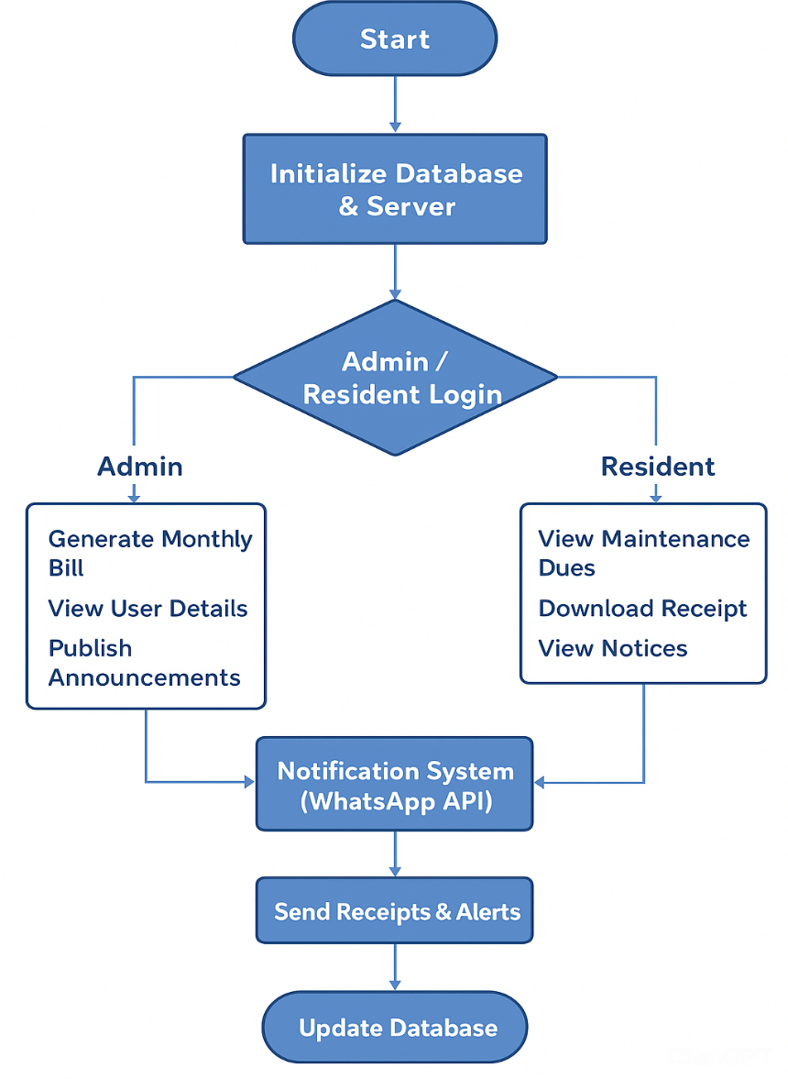
Fig 1. Block Diagram for Smart Society Maintenance System
For implementation, modern web technologies were selected to ensure flexibility and performance. The backend was developed using Python Flask due to its lightweight architecture and scalability, while HTML, CSS, and JavaScript were utilized to create an interactive and responsive user interface. MySQL/SQLite databases were integrated for data storage and management. Additionally, a WhatsApp API was incorporated to automate notifications, reminders, and receipt delivery. Security mechanisms such as role-based access control, encrypted password storage, and secure authentication were implemented to protect user information.
The development process was organized into modules including Login and Authentication, Admin Management, Resident Services, and Notification Management. The authentication module enabled secure login and password management, while the Admin module supported bill generation, payment tracking, announcements, and complaint monitoring. The Resident module provided facilities for bill viewing, receipt downloads, notice access, and complaint registration. The notification module ensured automated communication through WhatsApp integration.
Implementation was carried out incrementally by first developing core functionalities and then integrating frontend, backend, and database components for real-time operations. Comprehensive testing was performed to validate system functionality and performance. Unit testing verified individual modules, integration testing ensured proper communication between modules, user testing gathered usability feedback from residents, and security testing validated authentication and password recovery mechanisms.Finally, the system was prepared for deployment on local or cloud-based infrastructure with provisions for periodic maintenance, updates, and feature enhancements. The architecture was designed to support scalability, enabling future adaptation for larger residential societies and expanded management requirements.
RESULT AND DISCUSSION
The development of the Smart Society Management System (Nirmal Nagari Society Maintenance System) has successfully achieved significant milestones as per the planned objectives. The results obtained so far are summarized as follows:
- Login and Authentication Module
  - A secure login system has been implemented.
  - Admins can create first-time login credentials for residents.
  - Residents are able to log in and securely reset their passwords after initial access, ensuring both personalization and security.
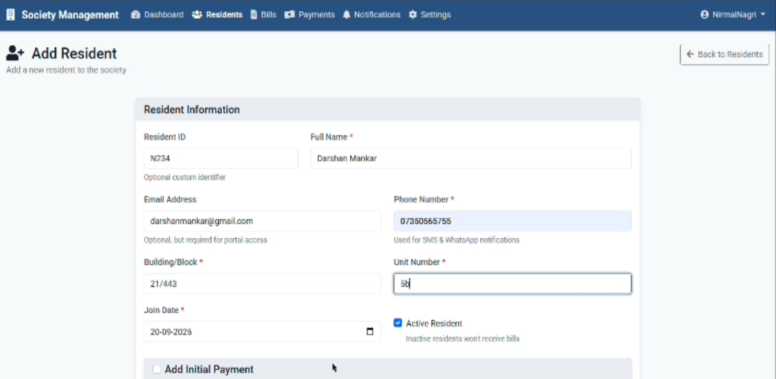
Fig 2. Adding New Resident
A form interface for adding a new resident’s details, including name, contact information, unit number, and initial payment.
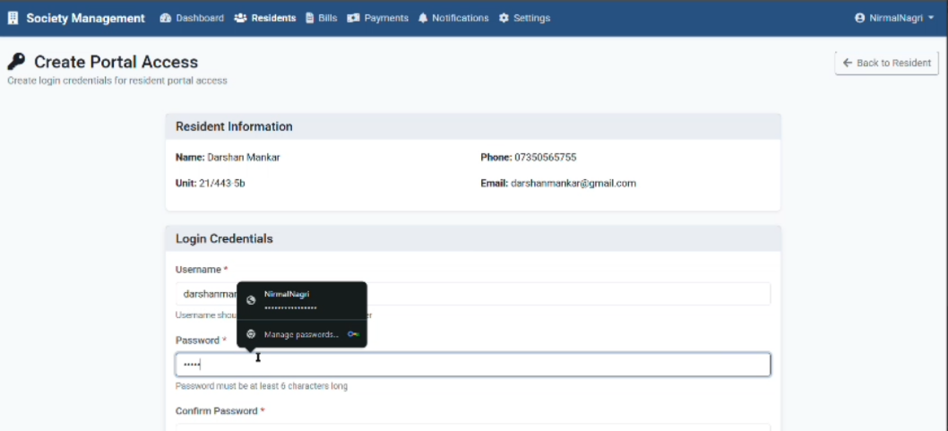
Fig 3. Creating Portal For Residents
A portal access creation page for a resident allowing entry of login credentials like username and password to enable account access.
- Resident Dashboard
  - Residents can now view their monthly maintenance status, including details of bills and outstanding balances.
  - The interface displays a clear and user-friendly overview, allowing residents to track their payment history.
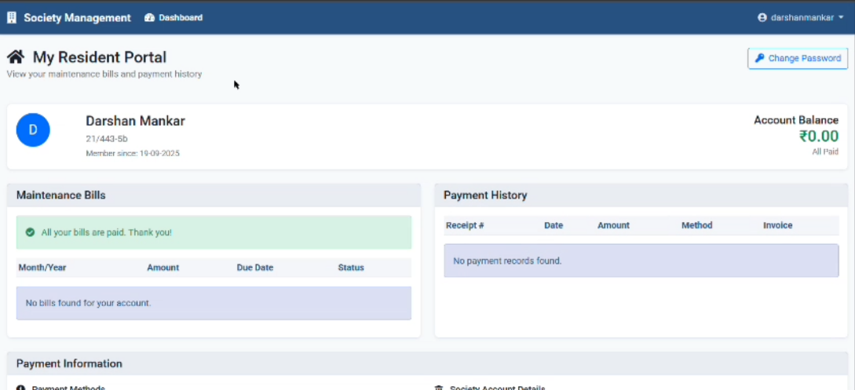
Fig 4. Resident Dashboard
A resident portal dashboard showing maintenance bill status, payment history, and current balance details
- Admin Dashboard
  - Admins can monitor total monthly collections through dashboard.
  - The system provides an overview of paid and unpaid residents, helping administrators manage records more effectively.
  - Complaint records submitted by residents are visible to the admin, ensuring systematic resolution.
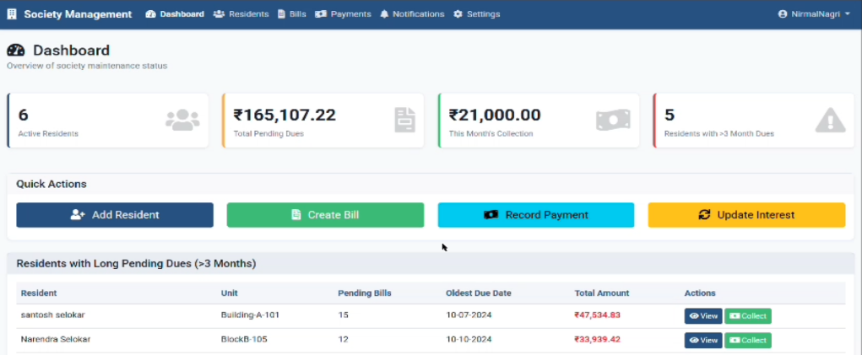
Fig 5. Admin Dashboard
A society management dashboard displaying active residents, pending dues, monthly collection, and residents with long-overdue payments.
- Database Integration
  - A fully functional database has been set up to store resident information, payments, receipts, and complaints.
  - All records are being stored and retrieved correctly during testing, proving the robustness of the backend.
- WhatsApp API Integration (Testing Phase)
  - The system successfully integrated WhatsApp messaging API.
  - Test messages for receipts and reminders have been sent successfully, confirming the feasibility of automated communication.
  - The feature is currently in the testing stage for live deployment.
- User Feedback
  - Initial testing with selected residents has provided positive feedback.
  - Users found the system to be simple, transparent, and practical in reducing manual efforts.
LIMITATION
While the Smart Society Management System (SSMS) has achieved its primary objectives and demonstrated strong potential, certain limitations were observed during development and testing:
- Limited Payment Integration-The current system allows for bill generation and tracking but does not include direct online payment gateways. Residents must still complete transactions manually.
- Dependency on Internet Connectivity-As a web-based application, the system requires a stable internet connection. Limited or unstable connectivity may affect accessibility and notification delivery.
- WhatsApp API Constraints-The WhatsApp API integration is in the testing phase and may face limitations in terms of message volume, delivery delays, or cost when scaled to large societies.
- Database Scalability-The initial implementation using SQLite3/MySQL is sufficient for small to medium-sized societies but may require migration to more robust databases (e.g., PostgreSQL, MongoDB) for larger communities.
- Limited Mobile Optimization-Although the system is web-based and responsive, it is not yet fully optimized as a standalone mobile application, which could restrict usability for residents preferring mobile-first access.
- Complaint Resolution Tracking-While complaints can be logged and updated, the system does not currently provide advanced analytics (e.g., average resolution time, complaint categorization).
- Security Enhancements-Basic encryption and role-based access have been implemented; however, stronger mechanisms such as two-factor authentication and HTTPS deployment are recommended for full-scale deployment.
- User Training Requirement-Some residents, particularly those less familiar with digital platforms, may require orientation or training to use the system effectively.
CONCLUSION
The Smart Society Management System (Nirmal Nagari Society Maintenance System) was successfully developed to address key challenges in residential society management, including maintenance billing, complaint handling, communication, and record management through a secure and efficient digital platform. By utilizing the Python Flask framework, database integration, and API-based communication, the system provides a user-friendly environment for both administrators and residents. The implementation of role-based access control, automated billing with digital receipts, real-time dashboards, complaint tracking, and WhatsApp-based notifications significantly improved operational efficiency, transparency, and user engagement. Testing and user feedback confirmed the reliability, practicality, and effectiveness of the system in simplifying society management processes while reducing manual effort and paperwork. Overall, the proposed system enhances communication, ensures secure data handling, and supports smart community management, with the flexibility to scale and adapt for deployment across residential societies of different sizes in the future.
REFERENCES
[1] Prakas, K. (2011). Feedback and optimal sensitivity: Model reference transformations, multiplicative seminorms, and approximate inverses. IEEE Transactions on Automatic Control, 26(2), 301–320.
[2] Myers, D. G. (2007). Psychology (1st Canadian ed.). Worth Publishers: New York.
[3 ]Payne, D. B., & Gunhold, H. G. (1986). Digital sundials and broadband technology. Proceedings of IOOC-ECOC 1986, pp. 557–998.
[4] Milton, M., & Robert, L. (2004). Atmospheric carbon emission through genetic algorithm. Environment and Technical Report No. 3. Indian Meteorological Department, New Delhi.
[5] Krebs, D. L., & Denton, K. (2006). Explanatory limitations of cognitive developmental approaches to morality. Psychological Review, 113(3), 672–675. doi:10.1037/0033-295X.113.3.672
[6] Vicki, G. T., Thomae, M., Cullen, A., & Fernandez, H. (2007). Modeling the hydrological impact on tropical forests. Forest Ecology, 13(10), 122–132. Retrieved from http://www.uiowa.edu/~grpproc/crisp/crisp.html
[7] Perilloux, C., & Buss, D. M. (2008). Human relationships: Costs experienced and coping strategies deployed. Evolutionary Psychology, 6(1), 164–181. Abstract retrieved from http://www.epjournal.net
[8] Patel, R., & Sharma, D. (2024). IoT-based Smart Society Management System for Residential Automation. International Journal of Advanced Computer Science and Applications (IJACSA), 15(3), 112–118.Describes an IoT-integrated approach to automate billing, security alerts, and complaint tracking in residential societies.
[9] Perfect, T. J., & Schwartz, B. L. (Eds.). (2002). Applied Metacognition. Retrieved from http://www.questia.com/read/107598848
[10] Krebs, D. L., & Denton, K. (1997). Social illusions and self-deception: The evolution of biases in person perception. In J. A. Simpson & D. T. Kenrick (Eds.), Evolutionary Social Psychology (pp. 21–48). Hillsdale, NJ: Erlbaum.
[11] Snyder, C. R., Higgins, R. L., & Stucky, R. J. (Eds.). (1983). Excuses: Masquerades in search of grace. New York: John Wiley & Sons.
[12] Kumar, A., & Singh, P. (2023). Enhancing Transparency in Residential Society Maintenance Using Cloud and Flask Framework. IEEE Xplore, pp. 1–6.Focuses on a cloud-hosted web solution using Python Flask to improve transparency in financial and administrative operations.
[13]Verma, N., & Yadav, S. (2024). AI-Powered Smart Housing and Society Management for Sustainable Communities. International Research Journal of Engineering and Technology (IRJET), 11(2), 530–535.Explores AI-driven maintenance prediction and data analytics to optimize resource usage and improve community satisfaction.

