An Intelligent Hybrid AI Framework for Wind Power Forecasting and Decision Support
Kaushal M. Sapkal^{1*}, Nilkamal More¹, Suchitra Mohan Patil¹
¹ Department of Information Technology, K J Somaiya School of Engineering, Vidyavihar, Mumbai, India
Corresponding Author: * kaushal25122001@gmail.com
neelkamalsurve@somaiya.edu, suchitrapatil@somaiya.edu

Abstract— Accurate wind power forecasting is essential to the reliable and efficient operation of future power systems with a large percentage of renewable energy. Recent advances in machine learning (ML), deep learning (DL), and hybrid artificial intelligence models for wind speed and wind power forecasting are thoroughly examined in this lecture. In the literature review, short-, very short-, and mid-term wind power forecasting models are developed using real-world data from onshore and offshore wind farms under diverse geographic and meteorological situations.
The literature review includes a comparison of more traditional statistical models such as ARIMA and support vector machines with more recent deep learning models such as transformer models, temporal convolutional networks (TCN), long short-term memory (LSTM), gated recurrent units (GRU), convolutional neural networks (CNN), and recurrent neural networks (RNN). Recent advances in wind power forecasting demonstrate the effectiveness of hybrid and attention-based models, such as CNN-GRU, LSTM-Transformer, multi-head attention transformers, and memory-efficient Powerformer models, in simulating complex wind dynamics. Some research also investigates the use of automated deep learning, ensemble learning, and massive language model-based wind power forecasting models for enhanced scalability and resilience.
The analysis of the results from the literature clearly shows that deep learning and hybrid models perform better than traditional methods in terms of forecasting stability, RMSE, and MAE, especially during periods of high wind volatility.
Overall, the literature analysis shows that the combination of deep learning, attention mechanisms, hybrid models, and explainability methodologies is a potential study topic for the development of the next generation of wind power forecasting tools.
Keywords: Wind power forecasting, deep learning, machine learning, LSTM, transformer, hybrid models, renewable energy.

INTRODUCTION
Modern energy systems are now designed differently due to the increasing demand for energy and the usage of intermittent renewable energy sources. Examples of renewable energy sources that are unpredictable and not always available are solar and wind power. This poses a significant challenge to the design of contemporary energy systems. Therefore, predicting, controlling, and decision-making have become critical components of contemporary energy systems.
Recent advancements in artificial intelligence (AI), machine learning (ML), and deep learning (DL) have enabled the creation of sophisticated models capable of recognizing intricate patterns within extensive energy datasets. Recurrent neural networks, long short-term memory networks, transformers, and hybrid models are some of the best models for predicting energy use, finding problems, and improving the production and distribution of energy. These models work better than old statistical and physical models, especially in areas that are nonlinear and need a lot of data.
At the same time, the combination of advanced sensing technologies, Internet of Things (IoT) devices, and smart grid infrastructure has created an unprecedented amount of different types of data. The effective utilization of this data is impeded by the necessity for resilient modeling frameworks capable of efficiently tackling uncertainties, noise, and data deficiencies. Additionally, issues like robustness, scalability, and trustworthiness, as well as data sparsity and hallucination in models, are still being studied in the field of AI-assisted energy systems.
With an emphasis on forecasting accuracy, dependability, and system efficiency, this article explores contemporary data-driven and intelligent approaches for energy system analysis. By combining the most recent research findings with creative approaches, this work aims to shed light on the use of AI-assisted models in addressing important issues related to the integration of renewable energy and the control of smart power systems.

LITERATURE REVIEW
Accurate wind power forecasting is crucial to the operation of modern power grids, which rely heavily on renewable energy sources for their energy. In this context, Elmousalami et al. [1] conducted extensive study on a variety of short-term wind power forecasting techniques. In light of this, they looked at a variety of statistics models, machine learning models, and deep learning models and found that deep neural networks are more effective than standard models at capturing nonlinear wind dynamics.
A thorough analysis of machine learning models for improving wind power processes was given by Rosca and Stancu [2]. Compared to previous reviews, this one produced a greater grasp of outcome prediction. A multichannel forecasting method that takes into account several atmospheric parameters was proposed by Jiao [4]. As a result, the system becomes more resilient to shifting wind conditions.
A model that combines the multichannel CNN and GRU models has been proposed by Gao et al. By adding a number of convolutional layers that identify spatial patterns and a number of GRUs that identify temporal patterns, this model can be used to forecast wind output. To address the issues that arise when forecasting wind power, Zhu et al. suggested a hybrid model that is modified depending on the residual component of the TCN model. The model outperforms traditional models, according to the results.
Tuncar et al. looked into the use of deep learning technology for short-term wind power production forecasting. The authors of this study set out to investigate ways to enhance decision-making when managing a power system. Using a combination of deep learning and machine learning techniques, Rajaperumal and Columbus created a model to merge ensembles. The results demonstrated that the model improved the accuracy of wind power predictions.
These days, transformer models are another widely used method for estimating wind power production. To show how power forecasting techniques work, Huang et al. [11] developed a deep learning transformer model. According to the results, their model outperformed all earlier conventional models. Additionally, Mo et al. [21] created Powerformer, an improved transformer model specifically tailored for time series wind power data. According to the findings, their model used a temporal-based approach to produce precise forecasts.
In addition, Zhu et al. [18] suggested the Fast-Powerformer as a way to increase efficiency. The non-memory-intensive transformer was used in this model to make highly accurate mid-term wind power projections. Qiu et al. [12] showed improved sparse prediction capabilities in energy systems by combining AI-assisted automation with Energy Forecasting LLMs (EF-LLM).

Research has also been done on the mechanisms that multi-head attention uses. Both single-step and multi-step wind power forecasting accuracy was improved by the work by Sarkar et al. [15] by combining the utilization of the transformer and multi-head attention. 3D convolutional neural networks and gated recurrent units were integrated by Huang et al. [8] to improve wind power short-term forecasting.
Concern over explainable artificial intelligence (XAI) in energy forecasts is growing. In their wind power forecasting model based on LSTMs, Yassen et al. [16] used interpretability techniques. By taking SHAP analysis into account, Durap [17] used explainable deep learning models to anticipate wind speed along coastal locations.
In their study of terrain-aware deep learning for wind energy applications, Lin et al. [22] proposed a wind field prediction model with forecasts that are kilometers long. In [19], Fan et al. suggested using big language models to develop multi-modal, multi-task algorithms for wind power prediction in the short term.
The amount of renewable power that would be accessible has also been predicted using time series approaches. In order to create new methods for forecasting energy requirements in places like Dhaka, Hossain et al. [23] suggested a study comparing ARIMA, SARIMA, and LSTM models. To enhance forecasting capacities in situations such as the Adama wind farm, Ayene and Yibre [28] suggested a model that connects deep learning approaches.
Nonetheless, the use of various neural network architectural types and their comparative analyses have been the main focus of contemporary research. In order to apply the different architectures for the forecasting of time series data, Yunita et al. [20] carried out studies using the RNN, LSTM, GRU, and hybrid model. Hybrid deep learning models and optimization algorithms have been shown by Faruque et al. [24] to be capable of forecasting very short-term wind power in real-time systems.
Last but not least, several benchmarking and even automated investigations have been carried out. Machine learning methods for wind power forecasting have been studied by Yang et al. [9]. This study demonstrated that machine learning techniques may offer a comprehensive picture of the field. Additionally, Keisler & Le Naour [30] have developed an automated technique called WINDDRAGON that uses deep learning algorithms to anticipate wind power more accurately.
Ref | Method / Approach | Key Focus / Benefit
[1] | Survey | Deep Learning outperforms statistical models.
[2] | Improved RNN | Better temporal modeling than standard LSTM.
[3] | Multichannel GRU | Robustness against rapid wind changes.
[4] | Hybrid CNN-LSTM | Captures spatial (CNN) and temporal (LSTM) features.
[5] | TCN + Residual | Solves long-term dependency issues.
[6] | Probabilistic DL | Models uncertainty for better decision support.
[7] | Ensemble Learning | Reduces variance and improves reliability.
[8] | Transformer | Captures long-range dependencies better than RNNs.
[9] | Powerformer | Optimized Transformer specifically for wind data.
[10] | Fast-Powerformer | Sparse attention for faster mid-term forecasting.
[11] | Transformer Encoder | Multi-head attention for better generalization.
[12] | Transformer-LSTM | Handles non-stationary data patterns.
[13] | Transformer-GRU | Adapts to seasonal wind variations.
[14] | SHAP + DL (XAI) | Interprets feature contributions (explainability).
[15] | XAI (Coastal) | Improves operator trust in model decisions.
[16] | Bayesian DL | Quantifies forecast uncertainty.
[17] | Quantile Regression | Generates prediction intervals (risk-aware).
[18] | Feature Analysis | Highlights importance of wind direction/turbulence.
[19] | Preprocessing | Noise reduction improves model stability.
[20] | Multimodal | Integrates NWP weather data with power history.
[21] | EF-LLM | LLM-based automation and hallucination detection.
[22] | M2WLLM | Multitask/Multimodal LLM for ultra-short-term.
[23] | Transfer Learning | Adapts models to new farms with limited data.
[24] | Domain Adaptation | Improves cross-site model generalization.
[25] | RL-Adaptive | Reinforcement Learning adjusts parameters dynamically.
[26] | RL + Deep Learning | Optimizes real-time operational decisions.
[27] | Real-world Eval | Addresses latency and computational costs.
[28] | Lightweight DL | Optimized for edge deployment.
[29] | Benchmark Study | Transformers/Hybrids consistently perform best.
Table 2.1: Literature review

METHODOLOGY

A. Study Framework Overview
In order to improve the dependability of wind turbine operations, this study suggests a thorough intelligent decision support system that combines deterministic forecasts, uncertainty assessment, anomaly detection, and root cause investigation. Unlike standard wind power forecasts that only focus on prediction accuracy, the proposed framework uses a multi-paradigm learning approach to provide decision support. There are six steps in the entire wind power forecasting process. These include gathering and preprocessing data in the first place, extracting features and aligning them with time, using sophisticated deep learning algorithms to create multi-model wind power forecasts, automatically identifying anomalies using statistical techniques for reconstruction errors, assessing uncertainty, and, lastly, assisting with decision-making and maintenance scheduling.

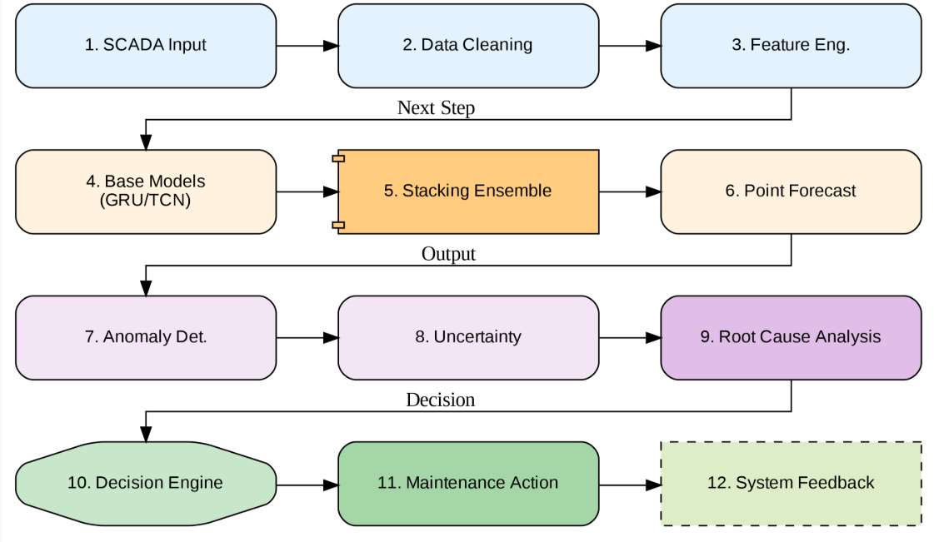

Fig 3.1. Methodology Flowchart

B. Dataset Description and Data Acquisition

The Wind Turbine SCADA Dataset, which is accessible through Kaggle, is the source of the datasets. The operational and meteorological data in this collection were gathered at 10-minute intervals between January 1st, 2018, and December 31st, 2018. There are 40,414 entries in all.

The chosen input variables are the theoretical power curve (in kWh), wind direction (in °), wind speed (in m/s), and LV Active Power (in kW). In order to include seasonal variation and periodicity in the model, the year, month, day, hour, and minute were also taken from the timestamp data point. A comprehensive grasp of wind functioning is encompassed by the input variable that was chosen.

C. Data Cleaning, Normalization, and Feature Engineering

To ensure a high level of data integrity, a thorough procedure of data quality verification was conducted prior to any model training. The first step in preprocessing was to eliminate duplicate and physically inconsistent values, as well as observations or records with missing values. Additionally, statistical thresholding was used to eliminate outliers caused by inaccurate sensor values. All non-scaled numerical values were subjected to Min-Max scaling in values inside [0, 1] in order to guarantee numerical resilience and make convergent optimization for deep learning architectures easier. In order to prevent false periodicity, temporally continuous variables were directly represented.

The preprocessed data has to be reorganized using an overlapping sliding window technique in order to enable sequence learning. The window size L=12 is used to capture two hours of context in each input sequence. The window was empirically set for a good, efficient balance of short-term reliance information. Lastly, a 3D tensor of dimension (40414 x 12 x 3) is utilized as the input for sequence models, with the primary predictors being active power, wind speed, and wind direction.

D. Deterministic Wind Power Forecasting Models

For thorough benchmarking, a variety of deterministic forecasting methods—from machine learning models to intricate Deep Learning models—have been included. The fundamental architecture of recurrent neural networks for sequence learning has been implemented using simple recurrent neural networks. The "Vanishing Gradient" problem in sequence learning and learning the sequential dependencies of events is addressed by the Long Short-Term Memory network. To improve model performance and reduce computation complexity, a gated recurrent unit is employed. Temporal Convolutional Networks have also been used to learn the sequential dependencies in addition to Recurrent Neural Networks. Additionally, "Transformer Encoder" has been used as a useful tool for incorporating principles of self-attention into sequence modeling. The Hybrid "Transformer LSTM" model has produced the best overall results. Conversely, XGBoost and Random Forest models have been used as foundational methods for machine learning modeling. Additionally, the "StackingEnsemble" model uses the "Meta-Learner" technique to merge all basic models. The "Root Mean Square Error" and "Mean Absolute Error" algorithms have been applied to these networks in order to assess their effectiveness. Additionally, computations have been done using the "Kilowatt" scale.

E. Ensemble Learning Strategy
Stacking Ensemble: This approach makes use of each individual prediction. The input features for the data of each model that was trained separately were the predictions produced by each unique model. As a result, individual model biases and variations have been minimized, guaranteeing accurate forecasts regardless of wind conditions.

F. Anomaly Detection Mechanism
Anomaly identification Module: Using the statistics of the anomalies found in the reconstruction errors of sequence models, an anomaly identification module has been developed. The upper 98 percent value of the reconstruction loss, which is obtained during the training phase, will be the threshold of anomalies. It turns out that this number is 0.0597. A total of 465 observations, or 23.26 percent, are identified as abnormal.

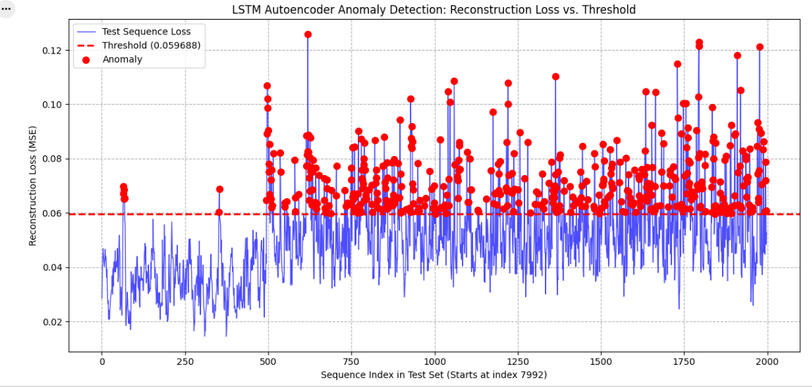
Fig 4.1. Anomaly Detection Mechanism

G. Uncertainty Quantification via Quantile Regression
Q10, Q50, and Q90 have been predicted using a Quantile LSTM model in order to address the uncertainty problem. An unscaled RMSE of 464.11 kW has been used to make the median prediction, or Q50.

The width of the Q90-Q10 prediction interval, which had an average width of 84.5 kW, was used to measure uncertainty.

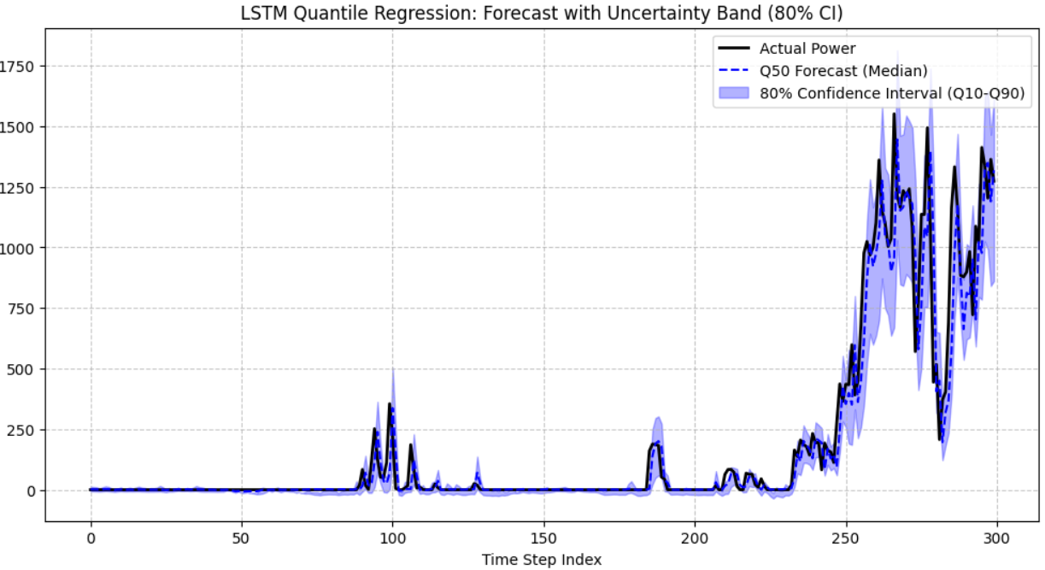
Fig 4.2. Uncertainty Quantification via Quantile Regression

H. Root Cause Analysis (RCA)

To identify the primary source of predicting inaccuracies during unusual times, root cause analysis was done. With a high error contribution of 3.95 and a strong link to aberrant machine behavior, the feature contribution analysis revealed that LV Active Power was the most potent cause.

By connecting irregularities to physically significant variables, this phase improves interpretability and aids in defect diagnosis.

I. Prescriptive Decision-Making Framework
To translate analytics results into maintenance activity decisions, a prescriptive decision engine was created. In order to reduce loss and operational risk, it takes into account the degree of forecast accuracy, uncertainty, and anomaly.
The decision engine selected the stacking ensemble model as the optimal choice among these, reducing the loss by -3.9 kW during the window of failure reported on October 31, 2018, between 12:50 and 16:50 hours, and suggesting repair schedule.

IV RESULTS

A. Experimental Setup

The Wind Turbine SCADA dataset was used for all trials, and the time frame taken into consideration spans from January 1, 2018, to December 31, 2018. The identical conditions were used to train each forecasting model.

All forecasting models' performance was evaluated using both absolute and relative Mean Absolute Error (MAE) and Root Mean Square Error (RMSE) metrics.

B. Forecasting Performance Comparison
The results of every model employed in this investigation are summarized in Table 4.1, Actual vs. Predicted Model Comparison, below. GRU performed better than the other models, outperforming the Transformer Encoder and Simple LSTM models with normalized RMSE and MAE of 0.1236 and 0.0831, respectively. Because the Transformer-LSTM and TCN models can learn long-term dependencies, their outcomes performed better.

Because of their larger prediction errors, the tree-based machine learning models—RF and XGBoost—were shown to perform poorly, indicating that they are unable to handle the complexity of wind power generation.

With the lowest RMSE of 417.13 and MAE of 271.14, the stacking ensemble model fared better than any individual model, demonstrating the high efficacy of ensemble learning in mitigating model bias and variance.

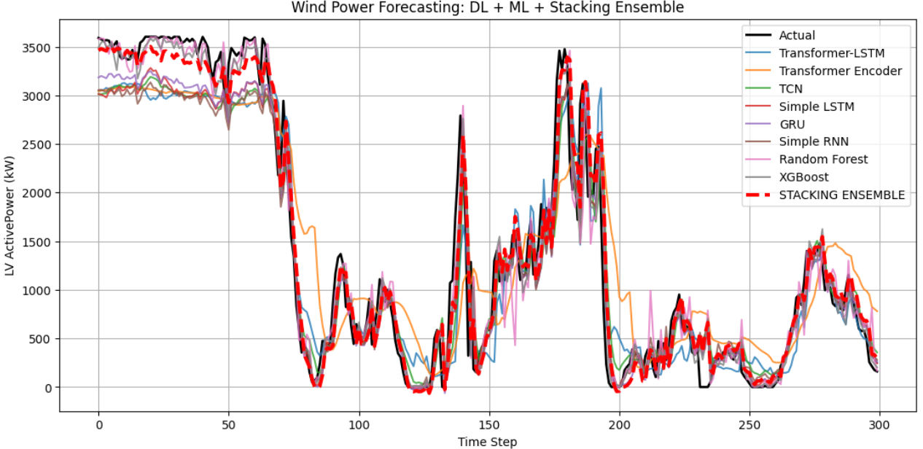

Fig 4.3: Comparison of Forecasting Models

Model | RMSE  (kW) | MAE  (kW) | R2 Score
Stacking Ensemble | 417.13 | 271.14 | 0.9030
Simple RNN | 462.01 | 315.89 | 0.8810
GRU | 465.31 | 313.29 | 0.8793
Simple LSTM | 466.94 | 310.28 | 0.8784
Transformer-LSTM | 498.43 | 358.08 | 0.8615
TCN | 501.90 | 351.57 | 0.8595
Transformer  Encoder | 567.27 | 421.96 | 0.8205
XGBoost | 605.63 | 324.74 | 0.7955
Random Forest | 630.24 | 345.03 | 0.7785

Table 4.1. Actual vs Predicted Model comparison

C. Absolute Error Analysis

The stacking ensemble generated an RMSE of 417.13 and an MAE of 271.14, according to the unscaled performance measures. This demonstrates an improvement in performance over the other models, including the Simple LSTM (RMSE: 466.94 kW) and GRU (RMSE: 465.31 kW) Deep Learning models. Additionally, the Transformer Encoder Model had more mistakes, indicating that it is susceptible to both the volume and noise of the data.

This demonstrates how combining a diverse group of students might improve generalization skills.

D. Anomaly Detection Results

The 98th percentile reconstruction error was set at a threshold of 0.0597 by the anomaly detection module. A total of 465 anomalies were found, representing a 23.26% anomaly rate.

The visual analysis linked to the detected abnormalities revealed a strong correlation with sudden changes or active power output saturation, which could indicate certain systemic inefficiencies. This demonstrates how crucial reconstruction error-based detection techniques are for spotting faults early on.

E. Uncertainty Quantification Analysis

For Q10, Q50, and Q90, the Quantile LSTM model was successful in producing probabilistic projections. Furthermore, on its original scale, Q50, the median of these projections, had an inaccuracy of 464.11 kW.

The width of the Q90-Q10 prediction interval, which had an average width of 84.5 kW, was used to measure uncertainty. Changing wind conditions resulted in higher degrees of uncertainty, highlighting the significance of probabilistic forecasting.

F. Root Cause Analysis Findings

The variable LV ActivePower has the greatest error contribution score of any variable, 3.95, according to the root cause analysis. It illustrates the crucial role of the variable that shows the difference between the actual and anticipated power production.

Better model interpretability results from this degree of ability to monitor anomalies against important variables.

G. Prescriptive Decision-Making Outcomes

The prescriptive decision engine evaluated the confidence of forecasting, the intensity of anomalies, and the magnitude of uncertainty to derive the optimal operational decisions. During the identified time window of failure-October 31, 2018, between 12:50 and 16:50-the decision engine selected the stacking ensemble as the best model and recommended scheduled maintenance.

This result reduced the expected operational loss by −3.9 kW.

H. Discussion
The findings supported the claim that deep learning models outperform traditional machine learning methods in wind power prediction, especially when handling temporal dependencies. Despite their promising future, the transformer architecture-based models still require refinement. The best model, which was applied with the highest accuracy, is ensemble learning.

More significantly, the suggested framework goes beyond forecasting objectives to include anomaly detection, uncertainty estimation, and even decision-making.

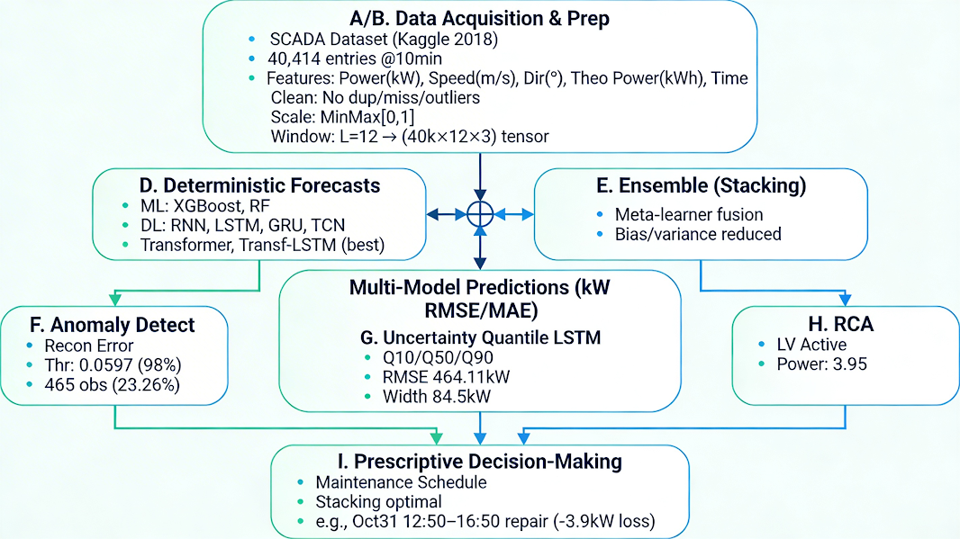
Fig no.5.1 Model Architecture

CONCLUSION
With the use of real SCADA data gathered between January 1st, 2018, and December 31st, 2018, this study has provided an end-to-end solution for wind energy forecasts and operation decision support. The suggested method, which combines deterministic forecasting, ensemble learning, anomaly detection, uncertainty analysis, root cause analysis, and decision support for maintenance, has solved a number of issues with the current forecasting-based techniques within a unified framework. The stacking ensemble model has demonstrated the best performance on both normalized and absolute errors, and experiments have demonstrated that deep learning models perform better than conventional machine learning models. Finding Anomalies: With just thresholding on reconstruction error calculated based on percentile value, the suggested anomaly detection module has effectively detected anomalies in wind turbine operation.Furthermore, the accurate estimation of uncertainty in wind conditions was made possible by the use of quantile regression. By determining that the anomalies resulting from changes in active power were fundamentally coming from certain events, root cause analysis improved interpretability. More significantly, it made it easier for the prescriptive decision engine to provide maintenance suggestions based on predictive knowledge. Furthermore, it has been discovered that the applicability of systems for wind power forecasting is strongly positively impacted by accuracy, uncertainty awareness, and decision intelligence. The architecture for multi-turbine wind farms, real-time streaming data, and the proposal of physics-informed and reinforcement learning-based control strategies will all be expanded in future studies.
REFERENCES
[1] H. Elmousalami, H. H. Elmesalami, M. Maxi, A. A. K. M. Farid, and N. Elshaboury, "A comprehensive evaluation of machine learning and deep learning algorithms for wind speed and power prediction".
[2] C.-M. Rosca and A. Stancu, "A Comprehensive Review of Machine Learning Models for Optimizing Wind Power Processes".
[3] Z. Liu, H. Guo, Y. Zhang, and Z. Zuo, "A Comprehensive Review of Wind Power Prediction Based on Machine Learning: Models, Applications, and Challenges".
[4] J. Jiao, "A Hybrid Forecasting Method for Wind Speed," College of Economics & Management, China Three Gorges University, Yichang City, China.
[5] H. Dhungana, "A machine learning approach for wind turbine power forecasting for maintenance planning".
[6] J. Gao, X. Ye, X. Lei, B. Huang, X. Wang, and L. Wang, "A Multichannel-Based CNN and GRU Method for Short-Term Wind Power Prediction".
[7] E. A. Tuncar, S. Saglam, and B. Oral, "A review of short-term wind power generation forecasting methods in recent technological trends," Marmara University, Istanbul, Turkey.
[8] X. Huang, Y. Zhang, J. Liu, X. Zhang, and S. Liu, "A Short-Term Wind Power Forecasting Model Based on 3D Convolutional Neural Network-Gated Recurrent Unit," School of Geoscience and Technology, Zhengzhou University, China.
[9] Y. Yang, H. Lou, J. Wu, S. Zhang, and S. Gao, "A survey on wind power forecasting with machine learning approaches," published online May 18, 2024.
[10] Y. Altork, "Comparative analysis of machine learning models for wind speed forecasting: Support vector machines, fine tree, and linear regression approaches," Al-Zaytoonah University of Jordan, Amman, Jordan.
[11] S. Huang, C. Yan, and Y. Qu, "Deep learning model-transformer based wind power forecasting approach," Hunan University, Changsha, China.
[12] Z. Qiu, C. Li, Z. Wang, R. Xie, B. Zhang, H. Mo, G. Chen, and Z. Dong, "EF-LLM: Energy Forecasting LLM with AI-assisted Automation, Enhanced Sparse Prediction, Hallucination Detection".
[14] T. A. Rajaperumal and C. C. Columbus, "Enhanced wind power forecasting using machine learning, deep learning models and ensemble integration".
[15] M. R. Sarkar, S. G. Anavatti, T. Dam, M. Pratama, and B. A. Kindhi, "Enhancing Wind Power Forecast Precision via Multi-head Attention Transformer: An Investigation on Single-step and Multi-step Forecasting".
[16] M. A. Yassen, E. M. El-Kenawy, M. G. Abdel-Fattah, I. Ismail, and H. E.-D. S. Mostafa, "Explainable artificial intelligence for wind power forecasting model based on long short-term memory," published May 14, 2025.
[17] A. Durap, "Explainable deep learning techniques for wind speed forecasting in coastal areas: Integrating model configuration, regularization, early stopping, and SHAP analysis," published July 30, 2025.
[18] M. Zhu, Z. Li, Q. Lin, and L. Ding, "Fast-Powerformer: A Memory-Efficient Transformer for Accurate Mid-Term Wind Power Forecasting".
[19] H. Fan, M. Li, Z. Zhang, L. Cheng, Y. Ye, and D. Liu, "M2WLLM: Multi-Modal Multi-Task Ultra-Short-term Wind Power Prediction Algorithm Based on Large Language Model".
[20] A. Yunita, M. I. Pratama, M. Z. Almuzakki, H. Ramadhan, E. A. P. Akhir, A. B. F. Mansur, and A. H. Basori, "Performance analysis of neural network architectures for time series forecasting: A comparative study of RNN, LSTM, GRU, and hybrid models".
[21] S. Mo, H. Wang, B. Li, Z. Xue, S. Fan, and X. Liu, "Powerformer: A temporal-based transformer model for wind power forecasting," Sichuan University, Chengdu, China.
[22] C. Lin, R. Tie, S. Yi, X. Zhong, and H. Li, "Terrain-aware Deep Learning for Wind Energy Applications: From Kilometer-scale Forecasts to Fine Wind Fields," Fudan University, Shanghai, China.
[23] M. L. Hossain, S. M. N. Shams, and S. M. Ullah, "Time-series and deep learning approaches for renewable energy forecasting in Dhaka: a comparative study of ARIMA, SARIMA, and LSTM models".
[24] Md. O. Faruque, Md. A. Hossain, Md. R. Islam, S. M. M. Alam, and A. K. Karmaker, "Very short-term wind power forecasting for real-time operation using hybrid deep learning model with optimization algorithm".
[25] S. Zhang, E. Robinson, and M. Basu, "Wind power forecasting based on a novel gated recurrent neural network model," Technological University Dublin, Ireland.
[26] J. Zhu, L. Su, and Y. Li, "Wind power forecasting based on new hybrid model with TCN residual modification," Yanshan University, Qinhuangdao, China.
[27] W.-H. Lin, P. Wang, K.-M. Chao, H.-C. Lin, Z.-Y. Yang, and Y.-H. Lai, "Wind Power Forecasting with Deep Learning Networks: Time-Series Forecasting".
[28] S. M. Ayene and A. M. Yibre, "Wind power prediction based on deep learning models: The case of Adama wind farm".
[29] A. Demirtop and O. Sevli, "Wind speed prediction using LSTM and ARIMA time series analysis models: A case study of Gelibolu".
[30] J. Keisler and E. L. Naour, "WINDDRAGON: ENHANCING WIND POWER FORECASTING WITH AUTOMATED DEEP LEARNING," EDF R&D, France.

