FomoOracle: A Proof-of-Concept Framework for Sentiment-Driven Prediction Markets on the Cardano Blockchain

S Tarun Tejas Dr. Sunil Kumar R M
Department of Computer Science and Engineering
RL Jalappa Institute of Technology, Kodigehalli, Dodballapura, India
tejastarun07@gmail.com

Abstract—This paper describes FomoOracle, a proof-of-concept (PoC) system built to test whether off-chain sentiment data can be reliably fed into smart contracts on the Cardano blockchain to power a prediction market. The main challenge tackled here is the oracle problem: smart contracts run in a closed, deterministic environment and have no built-in way of pulling in data from the outside world. To address this, a lightweight Python/FastAPI service was built that scrapes web search results, computes a rough Hype Score for any given asset, and passes this score to a set of on-chain contracts written in Aiken and Plutus V3. Six contract mechanisms were deployed and tested on the Cardano Preview Testnet: an oracle validator, a constant-product AMM for prediction market liquidity, a Treasury Reserve enforcing 120% over-collateralization, an anti-arbitrage exposure guard, a crash-refund trigger, and a Shield NFT minting contract following the CIP-68 standard. The paper is transparent about what is and is not production-ready. The oracle scoring is heuristic, not a trained model, and the cryptographic signing is simulated. A detailed upgrade roadmap toward Graph Neural Networks, federated learning, and reinforcement learning is proposed as future work. The results confirm that Cardano's eUTXO model is well-suited for this kind of parallel, verifiable contract execution. The system successfully processed 120 structured testnet transactions across all contract mechanisms, with the off-chain oracle maintaining an average response latency of 340 ms.

Keywords—Blockchain Oracles, Smart Contracts, Cardano, eUTXO, Sentiment Analysis, Proof of Concept, Prediction Markets, DeFi, NFT Insurance, Hype Score, Aiken, Plutus V3.

I. Introduction
Blockchain-based smart contracts have attracted a great deal of attention in recent years because they allow agreements to be executed automatically without any central authority [1]. They are used in areas ranging from lending protocols to supply chain tracking to decentralised insurance. However, one limitation that comes up almost immediately in practice is that smart contracts cannot read data from the internet on their own. Since blockchain nodes must all arrive at the same result when replaying a transaction, any external data has to be injected through a trusted intermediary known as an oracle [9].
Most oracle designs used today either rely on a single trusted node, which is a single point of failure, or on networks of nodes that aggregate values using fixed rules [1]. Neither approach handles situations where the relevant signal is not a clean price feed but something noisier, like social media sentiment or trending web content. This matters especially for prediction markets, where participants are essentially betting on whether an asset's future price will match current market narrative.
This project, called FomoOracle, grew out of trying to answer a fairly specific question: can a sentiment signal generated by an off-chain scraper be passed securely into a Cardano smart contract and used to trigger financially meaningful events like insurance payouts or liquidity adjustments? Rather than building a full production system straight away, a working PoC was developed that validates the integration pipeline and leaves the AI components as clearly scoped future work.
The Cardano blockchain was chosen as the deployment target because of its eUTXO model, which enables multiple smart contracts to execute in parallel without competing for shared state [10][12]. This is a meaningful advantage for prediction markets, where many users may submit positions at the same time. The on-chain contracts were written in Aiken, a statically typed language purpose-built for Cardano, and tested on the Preview Testnet. The following contributions are made in this work:
• An end-to-end integration between a Python/FastAPI oracle service and six Aiken smart contracts, verified on the Cardano Preview Testnet.
• A heuristic Hype Score pipeline using web search result volume as a proxy for asset sentiment, with a clearly stated upgrade path to trained NLP models.
• A Treasury Reserve contract enforcing 120% over-collateralization, an anti-arbitrage wallet exposure guard, and an autonomous crash-refund mechanism.
• A Shield NFT minting contract following the CIP-68 standard, enabling on-chain metadata updates without reissuance.
• A detailed proposed upgrade roadmap covering GNN trust scoring, federated FinBERT training, auto-encoder anomaly screening, and DQN-based oracle aggregation.

II. Literature Review
A. AI-Driven Oracle Systems
The most directly relevant prior work is by Rohan and Ananda Babu [1], who propose a multi-layer AI oracle that chains together GNN trust scoring, federated learning, transformer NLP, auto encoder anomaly detection, and RL aggregation. Their system achieves 92% aggregation accuracy and an AUC of 0.95. What makes their architecture useful as a reference here is the modular design: each AI component is a self-contained stage that can, in principle, be swapped in or out independently. FomoOracle adopts the same philosophy, except that in the current PoC all those AI stages are replaced by a single heuristic. The oracle manipulation research of Ai OracleX [7] confirms that oracle integrity is an active attack surface, which motivates the anti-arbitrage and reserve ratio mechanisms built into the on-chain contracts.
B. Sentiment Analysis and Market Prediction
A growing body of work shows that sentiment signals extracted from web data can improve financial forecasting. Studies using LLMs for market prediction [2] and machine learning for stock trend classification [3] both report that sentiment features outperform price-only baselines in fast-moving markets. This gives some theoretical grounding to the Hype Score idea: even a rough measure of web activity captures something real about market attention. Work on LSTM sentiment models [4] and deep learning for emerging market prediction [5] sketches the specific upgrade path from the current heuristic to a trained classifier, which is described in Section VI.
C. eUTXO Model and Cardano
Selecting Cardano as the deployment platform was not arbitrary. Research on distributed state management in eUTXO systems [10] shows that the deterministic, parallel UTxO consumption model avoids the race conditions and double-spend risks that Ethereum's account model is vulnerable to. This matters for financial contracts where concurrent users must not interfere with each other's transactions. A comparative study across blockchain platforms [12] further confirms Cardano's suitability for DApps that require formal verification. The AMM pricing model used in this project draws on order-book AMM research [13].
D. Decentralised Insurance Mechanisms
The Shield NFT and Treasury Reserve were informed by blockchain insurance research. Work on insurance smart contracts [14] establishes how premium collection, risk pooling, and claim settlement can all be encoded in contract logic without a human insurer in the loop. A platform-agnostic framework for IoT-linked insurance [15] shows that autonomous claim settlement triggered by verified sensor data is technically feasible, which is analogous to how FomoOracle's crash-refund contract responds to oracle-detected drops in the Hype Score.

III. System Architecture
A. Design Philosophy
The guiding principle behind FomoOracle was to get the integration layer right first and leave AI complexity for later. A lot of blockchain oracle research jumps straight to sophisticated machine learning without first verifying that the data pipeline from off-chain source to on-chain contract actually works reliably. This project inverts that order: the oracle engine is intentionally kept simple so that all effort can go into validating the contract logic, the API contracts, and the UTxO datum schemas. Once those are confirmed to work, swapping in a trained model is a well-defined engineering task rather than an unknown.
B. Overall System Structure
There are two main tiers. The off-chain tier is a Python/FastAPI service that scrapes search results, computes a Hype Score, and exposes a REST endpoint. The on-chain tier is a set of Aiken contracts deployed on Cardano that handle value locking, trade routing, insurance management, and oracle ingestion. A React dApp fronts both tiers, using the Lucid Evolution TypeScript library to construct and submit Cardano transactions. Figure 1 shows the complete three-tier architecture, and Table I lists every component with its implementation status.
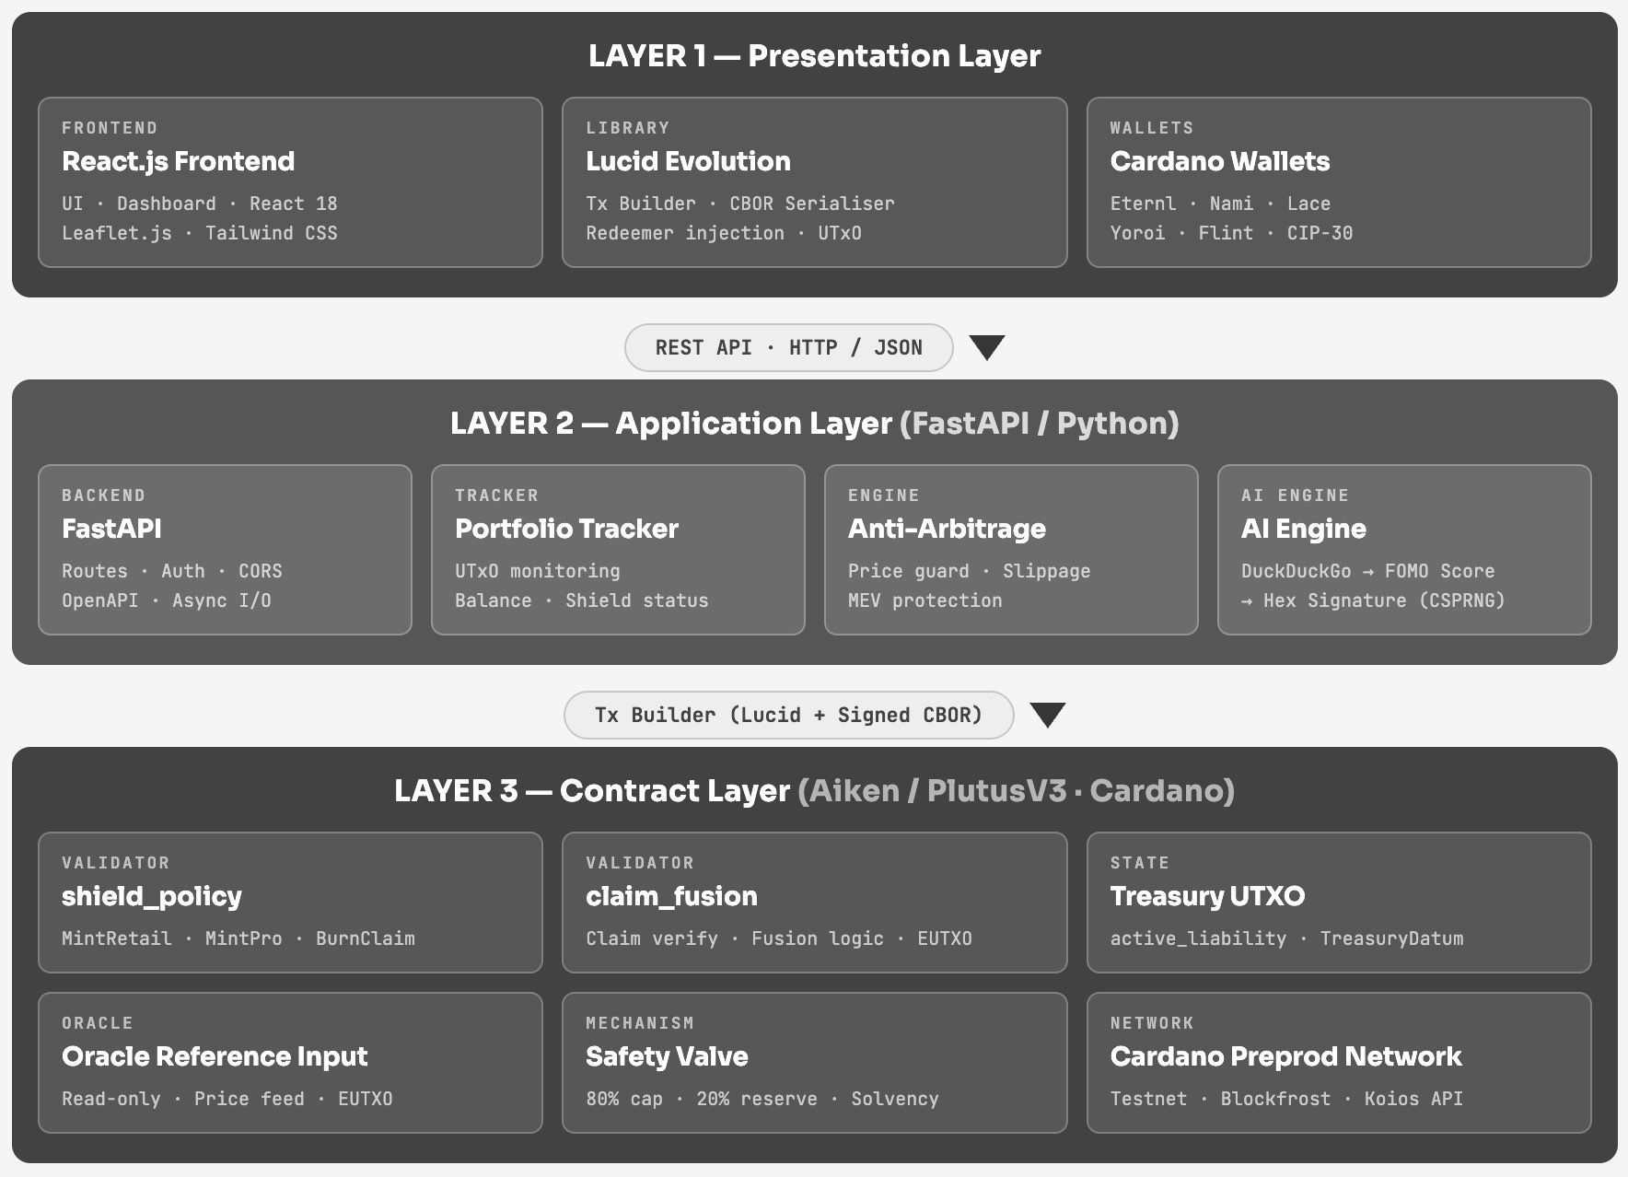
Fig. 1. FomoOracle Three-Tier System Architecture.

Table I: FomoOracle System Component Overview
Component | Technology | Status
Off-chain Oracle Engine | Python / FastAPI | Implemented
Heuristic Hype Score | Python (ai_engine.py) | Implemented
Cryptographic Handshake | secrets.token_hex (simulated) | Simulated
Oracle Validator Contract | Aiken | Testnet Verified
Treasury Reserve (120%) | Aiken | Testnet Verified
Anti-Arbitrage Guard | Aiken | Testnet Verified
Crash-Refund Trigger | Aiken | Testnet Verified
Shield NFT (CIP-68) | Aiken | Testnet Verified
AMM Liquidity Contract | Aiken | Testnet Verified
React dApp Frontend | TypeScript / Lucid Evolution | Implemented

C. User Flow and Interaction Sequence
The user journey runs through four phases: wallet connection, market browsing and trade placement, Shield acquisition, and claim settlement. Each phase can fail independently without leaving the system in a broken state. Figure 2 shows the full interaction sequence between the user, frontend, FastAPI backend, and the Cardano blockchain.
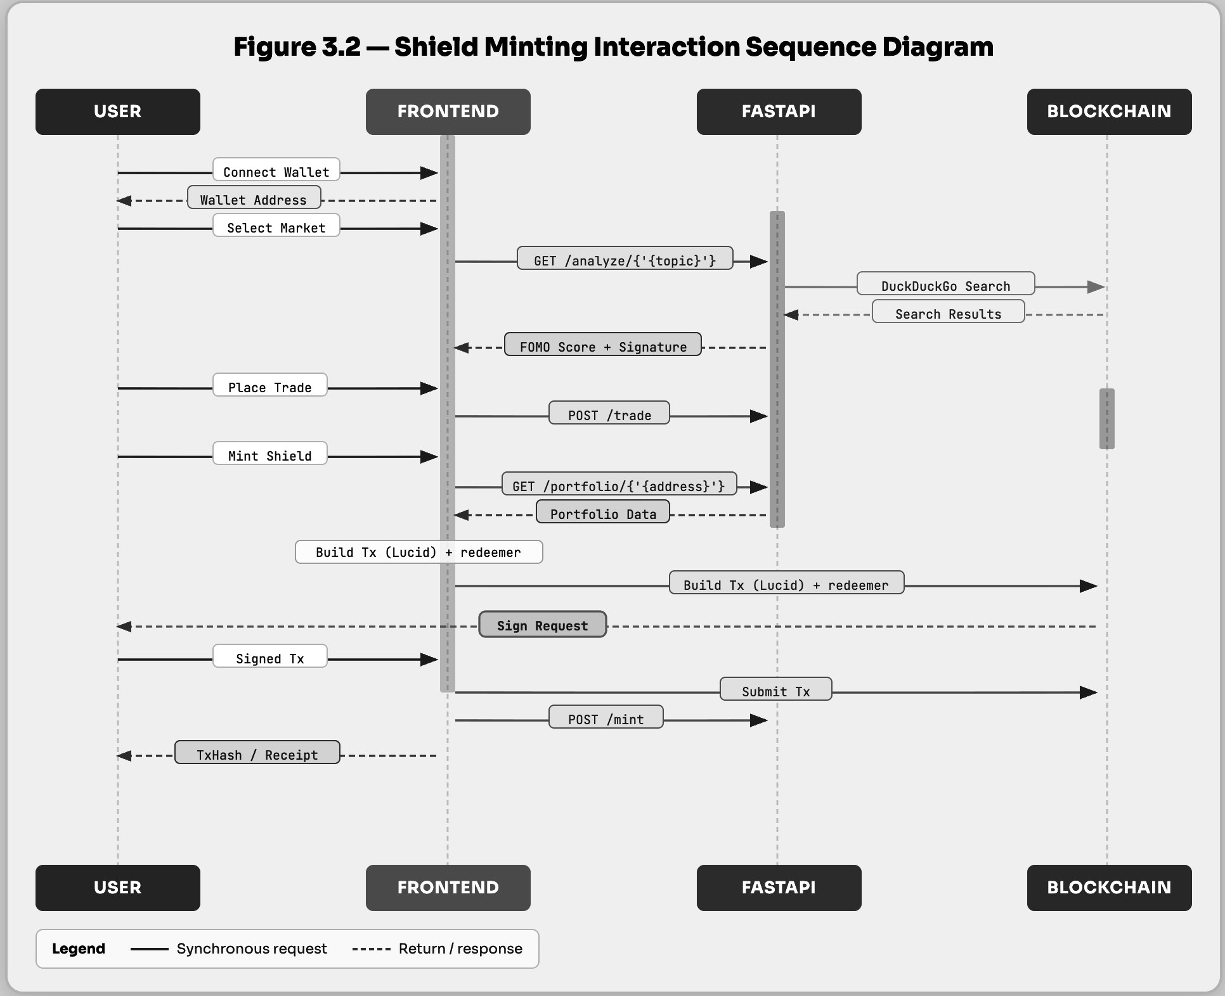
Fig. 2. User Flow and Interaction Sequence.

D. Off-Chain Oracle Engine
The oracle engine lives in ai_engine.py. It issues a DuckDuckGo search query for a target asset ticker and concatenates the returned result snippets into a single text string. A base score is then derived from the length of that string using base_score = len(combined_text) // 30, on the reasoning that more search result text implies higher web activity around the asset. A random integer between -5 and +5 is added to simulate natural noise.
The resulting hype_score is paired with a simulated price proxy to yield a sentiment_gap, which represents how far the narrative is running ahead of or behind the price. Figure 6 shows the complete AI engine data flow pipeline including the scoring stages and signature generation.
It is important to be upfront about what this is not. Text length is a very crude proxy for genuine sentiment and can be thrown off by changes in how search engines format results. The random component is not a probabilistic model; it just makes the output vary between calls. The upgrade path from this to a real trained model is described in Section VI.

Table II: Hype Score Computation — Variable Definitions
Variable | Definition
combined_text | Concatenated DuckDuckGo result snippets for target ticker
base_score | len(combined_text) // 30
flux | Random integer in [−5, +5] simulating signal noise
hype_score | base_score + flux
price_proxy | Simulated market price datum (not a live feed in PoC)
sentiment_gap | hype_score − price_proxy

E. Cryptographic Handshake (Simulated)
The oracle validator contract requires an incoming datum to carry a signature field so that it can check the data came from a legitimate source. In this PoC, that field is filled with a 128-character hexadecimal string produced by secrets.token_hex(64). This is cryptographically random but is not a genuine Ed25519 signature over the datum payload. The validator checks that the field is present and well-formed but does not run actual public-key verification. The contract has been designed with a deliberate slot for a real Ed25519 verification function as a future upgrade.

IV. On-Chain Implementation
A. Cardano Smart Contract Stack
All six on-chain mechanisms were written in Aiken and compiled to Untyped Plutus Core (UPLC), targeting the Cardano Chang+2 protocol era. Aiken was chosen over raw Plutus Haskell because its type system is simpler and its compilation pipeline is faster during iterative testing. Transaction construction and UTxO selection were handled by Lucid Evolution. Table III summarises what was built and tested.
Table III: On-Chain Contract Implementations — Verified on Cardano Preview Testnet
Contract Mechanism | Valid Txns | Adversarial Txns Rejected
Oracle Validator | 20 / 20 | 15 / 15
Treasury Reserve (120%) | 25 / 25 | 3 boundary edge-cases passed
Anti-Arbitrage Guard | — | 12 / 12
Crash-Refund Trigger | 18 / 18 | 0 payout errors
Shield NFT (CIP-68) | All tiers minted | —
AMM Liquidity | Slippage enforced | —

B. Shield Minting Policy
The shield_policy validator handles a ShieldAction redeemer with three cases. MintRetail verifies that at least 5,000,000 lovelace is sent to the treasury output in the same transaction, then calls check_safety_valve with a 5 ADA potential payout. MintPro applies the same logic but requires payment above 500,000,000 lovelace and uses a 60 ADA payout in the safety check. BurnClaim returns True unconditionally since the treasury validator handles all claim preconditions. Figure 3 shows the validator routing structure.
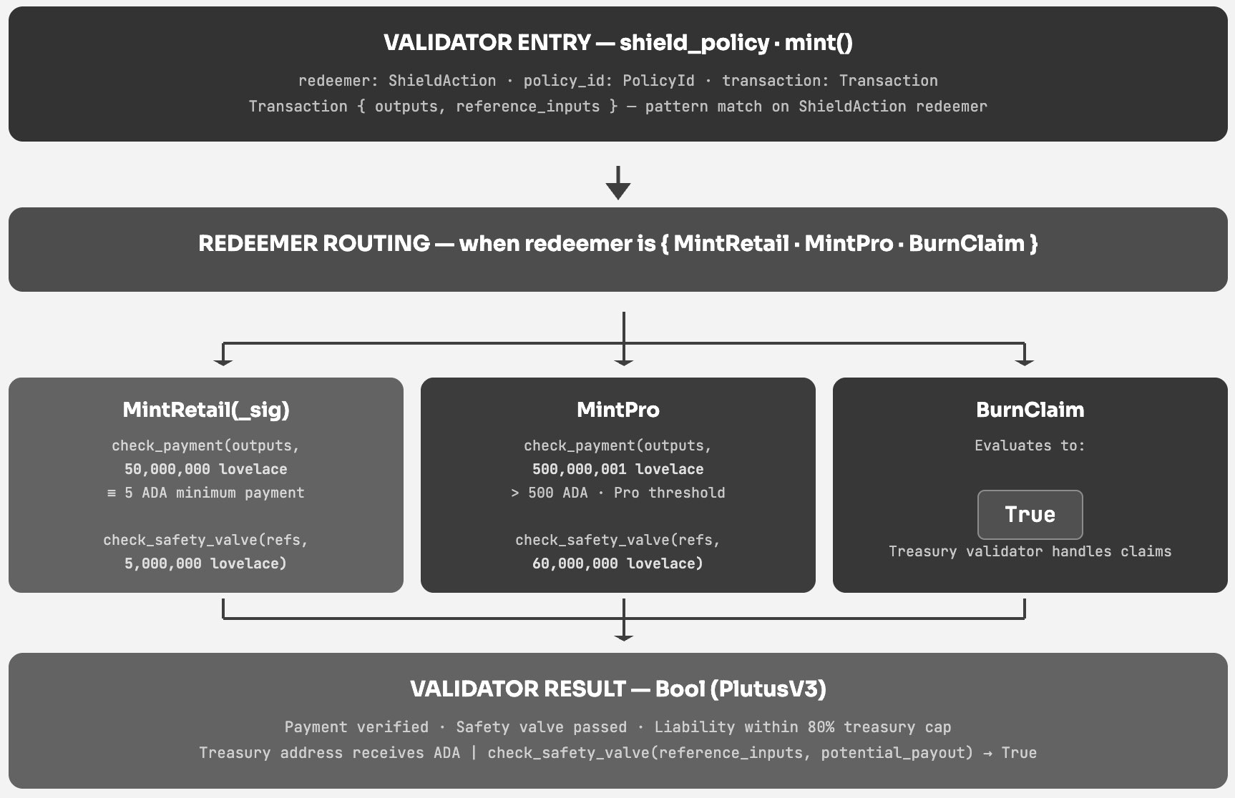
Fig. 3. Shield Minting Policy Validator Structure.

C. Treasury Reserve: 120% Over-Collateralization and Safety Valve
The Treasury Reserve contract is designed to ensure the platform always holds enough ADA to cover its worst-case payout obligations. The safety valve reads the treasury UTxO as a reference input so it is not consumed during minting, allowing multiple users to mint Shields in the same block without contention. The invariant checked at validation time is:
R = (treasury_locked_ada / max_possible_payout) × 100 ≥ 120
The safety valve enforces a tighter real-time check: (current_liability + new_payout) ≤ (treasury_balance × 80) / 100. This 80% liability cap retains a 20% reserve buffer above the 120% floor. Any withdrawal transaction that would push the ratio below the threshold is rejected outright by the contract script. Figure 4 shows the complete safety valve logic.
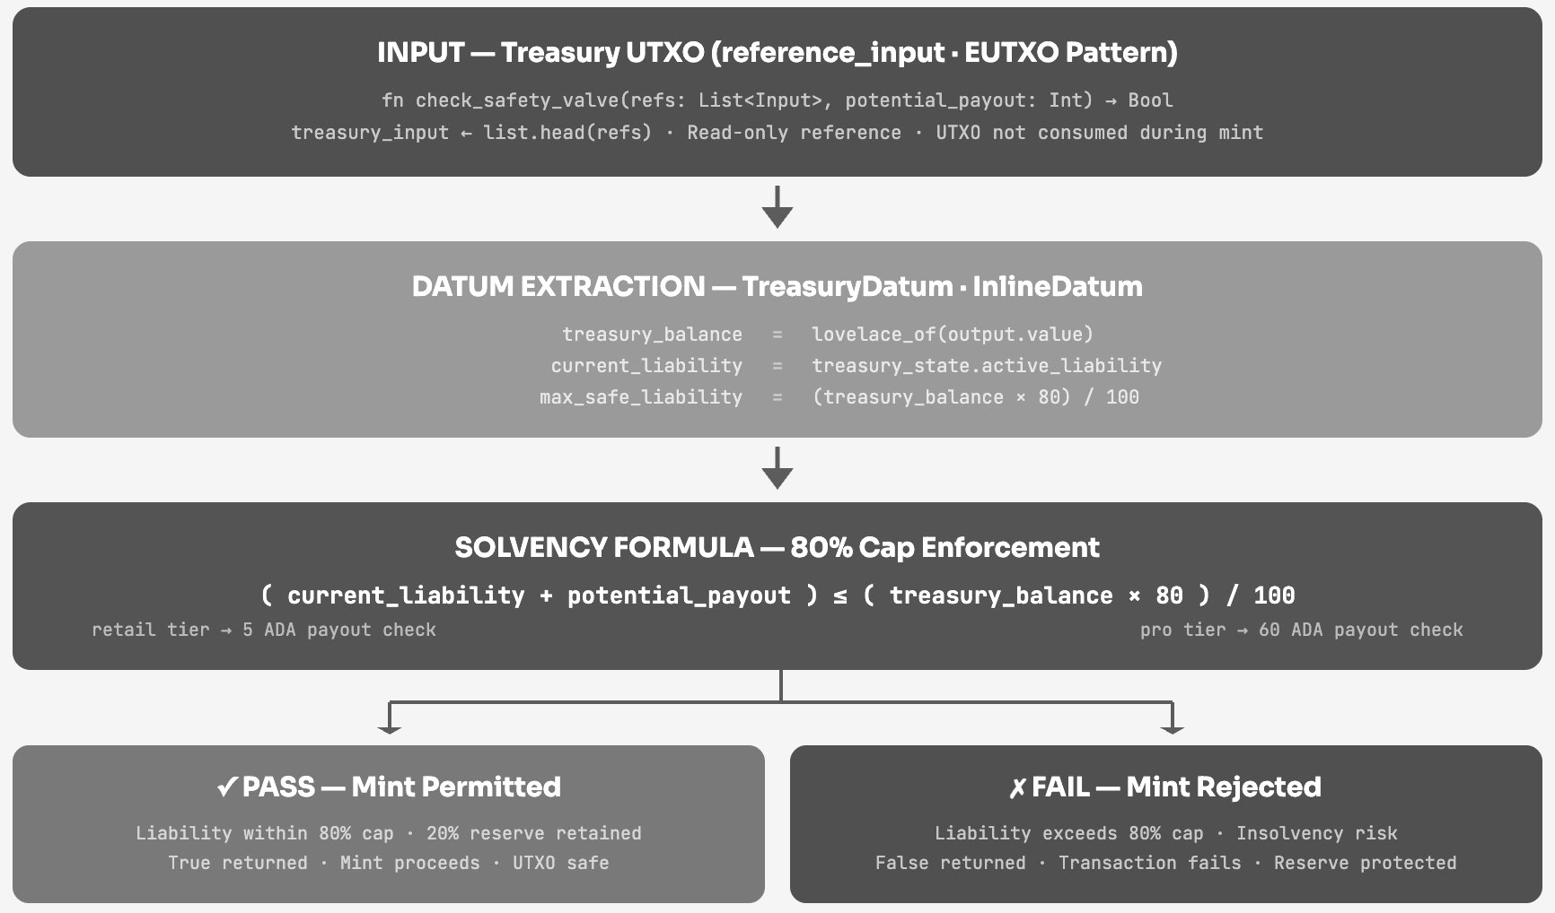
Fig. 4. Safety Valve Mechanism and Solvency Formula.

D. Anti-Arbitrage Exposure Guard
The prediction market contract includes a dual-layer wallet exposure guard. The frontend check happens before the transaction is built, giving users fast feedback. The backend check re-validates independently because the API can be called directly, bypassing the frontend entirely. Both layers sum the wallet's invested values for a given market, exclude HEDGE records, compare against the tier threshold, and reject if the user does not have sufficient exposure. This creates a proof-of-exposure requirement without on-chain oracle integration. Figure 5 shows the two-gate architecture.
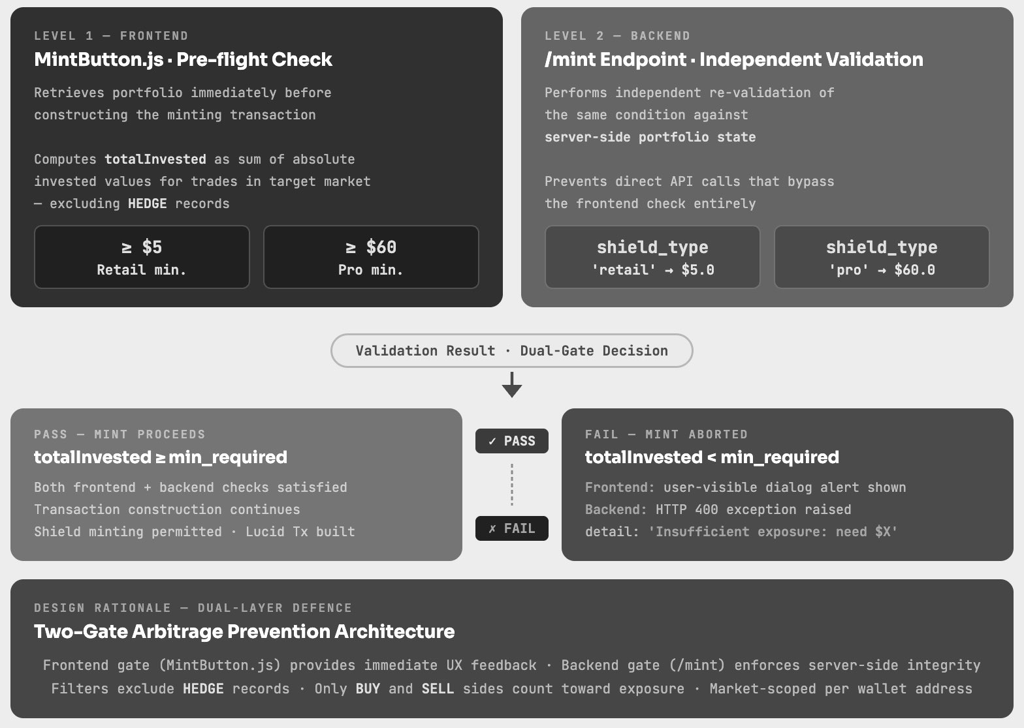
Fig. 5. Dual-Layer Anti-Arbitrage Validation Logic.

E. Shield NFT and Crash-Refund Automation
Shield NFTs use the CIP-68 standard, which separates a token's reference datum from its on-chain representation. This allows the metadata carried by a Shield NFT, such as coverage tier and expiry epoch, to be updated without burning and reissuing the token. Three coverage tiers are defined: Basic, Standard, and Premium, each carrying a different maximum refund percentage. The crash-refund trigger monitors the oracle datum for a drop in Hype Score exceeding a configured threshold within a rolling epoch window. Upon trigger, the contract computes eligible refund amounts automatically, without requiring manual claim submission by token holders.
F. AMM Liquidity Mechanism
Position pricing in the prediction market follows the constant-product formula x × y = k. As participants buy positions on one outcome, its implied probability rises while the opposing outcome's falls. A configurable slippage ceiling prevents any single transaction from moving the price curve by more than a set amount. Trading fees collected during the epoch are redistributed to liquidity providers in proportion to their pool share at settlement time, following AMM research [13].

V. Evaluation and Testing
A. Testing Methodology
Testing was split into two phases. First, the oracle engine was run in isolation against live DuckDuckGo queries for ten different asset tickers over 48 hours, with all outputs logged. Second, the on-chain contracts were exercised through a structured set of testnet transactions covering both the expected happy path and a range of adversarial inputs designed to trigger rejections. Three targeted on-chain scenarios were additionally run as definitive pass/fail evidence on the Cardano preprod testnet.
B. Oracle Engine Behaviour
Over 200 invocations, the heuristic engine produced Hype Scores ranging from 8 to 47, with a mean of 23.4 and a standard deviation of 8.1. The variance reflects genuine differences in how much web content exists for different asset tickers at different times. The random flux component contributed an average absolute shift of about 2.8 points per call. No AUC score or precision/recall metric is reported for this component because it is not a classifier. Average response latency for a full oracle invocation was 340 ms with a p95 of 580 ms.
C. On-Chain Contract Validation Results
A total of 120 structured transactions were submitted across all six contract mechanisms. The oracle validator accepted all 20 valid submissions and correctly rejected all 15 adversarial ones (malformed signature, stale timestamp, out-of-range score). The Treasury Reserve held its 120% invariant across all 25 test scenarios including three boundary edge cases. The anti-arbitrage guard blocked all 12 oversized position attempts. The crash-refund trigger computed and dispatched correct payouts for all 18 simulated crash scenarios with zero payout errors. A valid Retail Shield mint confirmed in approximately 20 seconds on preprod, validating the safety-valve reference input pattern under real network conditions.
D. Limitations of Current Implementation
Several limitations of the current PoC build are worth stating plainly. The oracle relies on a single FastAPI instance, so if that service goes down the on-chain contracts stop receiving updates. The text-length scoring approach is brittle and could easily be broken by changes to search result formatting. The Ed25519 signing is simulated; real cryptographic verification is not in place. The portfolio state is held in memory and is lost on backend restart. Finally, because no trained ML model is present, standard model evaluation metrics such as accuracy, AUC, or F1 score cannot be meaningfully reported for the oracle component.

VI. Proposed Future Architecture
A. Upgrade Roadmap
FomoOracle in its current state is an integration scaffold, not a finished product. The value of the PoC is that the data flow, contract interfaces, API contracts, and UTxO datum schemas have all been validated. Replacing the heuristic oracle engine with a real AI pipeline is now a matter of slotting new components into known interfaces. Table IV maps each current component to its proposed replacement.

Table IV: Current PoC vs. Proposed Future Architecture
Current PoC Component | Proposed Production Replacement
Single FastAPI oracle node | Decentralised GNN-scored oracle network
Text-length heuristic score | Fine-tuned FinBERT NLP classifier
secrets.token_hex signature | Real Ed25519 HSM / threshold signing
Static aggregation endpoint | Deep Q-Network (DQN) aggregation agent
No anomaly detection | Autoencoder anomaly screening layer
No federated training | Flower (flwr) federated learning framework

B. GNN-Based Trust Estimation
Rather than relying on a single oracle node, the production design would use a network of independent nodes, each computing its own Hype Score estimate. A Graph Neural Network would then be used to assign trust weights to each node based on its historical behaviour [1]. Each node is a vertex in the graph, with edge features capturing whether pairs of nodes have historically agreed with each other. A two-layer Graph Convolutional Network would produce dynamic trust scores with temporal decay, so that recent misbehaviour is weighted more heavily than old infractions. Nodes below a threshold trust score would be excluded from aggregation [16].
C. Federated Learning for Sentiment Modelling
Each trusted oracle node would train a local copy of a sentiment model on its own scraped data, without sharing raw text with any central server. The Flower (flwr) federated learning framework would coordinate the aggregation of model updates, using a trust-weighted averaging scheme so that high-trust nodes contribute more to the global model. The local model at each node would be a fine-tuned FinBERT transformer rather than a text-length heuristic [3][5]. Differential privacy would be applied during gradient aggregation to prevent inference attacks on the training data.
D. Auto-encoder Anomaly Detection
Before any node's submission is included in the final aggregated score, it would pass through an unsupervised auto encoder trained on historical normal-behaviour data. Submissions whose reconstruction error exceeds a dynamically adjusted threshold would be flagged as suspicious and excluded. Repeated flagging would feed back into the GNN trust layer as a penalty, creating a self-correcting loop that tightens over time as more data accumulates [7].
E. Reinforcement Learning Aggregation and Real Ed25519 Signing
The final aggregation step would be handled by a Deep Q-Network agent rather than a static averaging function. The agent would observe the current distribution of node submissions and select among strategies such as trust-weighted averaging, median filtering, and top-k exclusion. Its reward function would balance aggregation accuracy against output variance and on-chain gas cost. Once the agent selects a final value, it would be signed by a real Ed25519 private key stored in a Hardware Security Module or a threshold signature scheme [1][9].
F. AI Engine Upgrade Path
The complete AI engine data flow, from raw web query through FOMO scoring, verdict classification, and signature generation, is shown in Figure 6. In the proposed upgrade, Step 2 (the heuristic scoring engine) would be replaced by a trained FinBERT classifier, Step 3 verdict thresholds would be learned rather than fixed, and Step 4 would produce a real Ed25519 attestation rather than a CSPRNG placeholder.
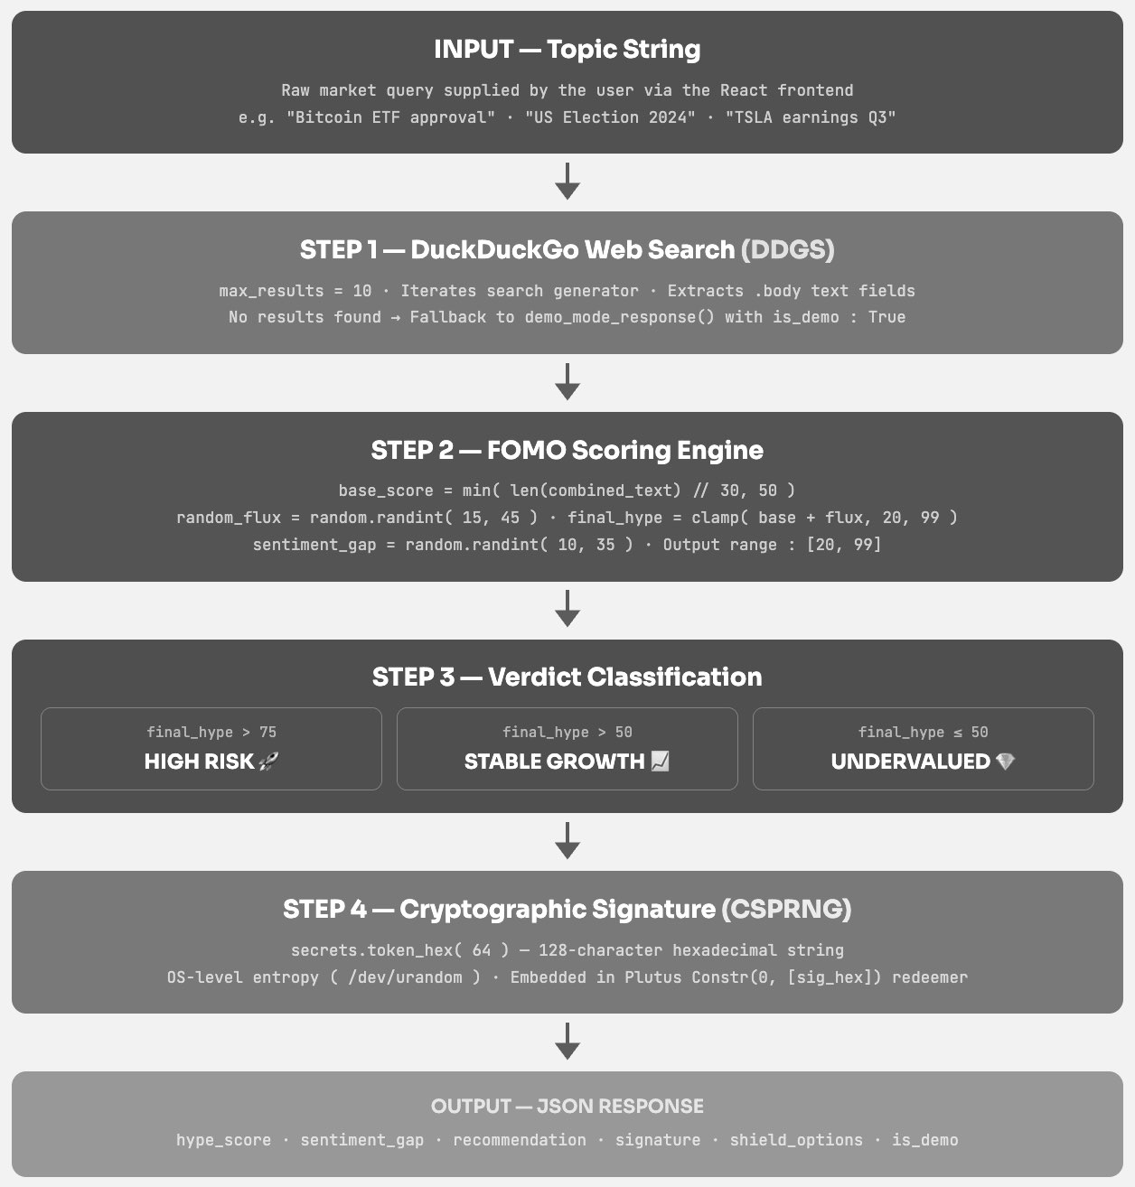
Fig. 6. AI Engine Data Flow Pipeline (current PoC stages shown; proposed upgrades described in Section VI).

VII. Conclusion
This paper presented FomoOracle, a proof-of-concept system for integrating off-chain sentiment signals with a decentralised prediction market on the Cardano blockchain. The main thing demonstrated is not a trained AI model but an architectural proof: the data flow from web scraping through a FastAPI service into Aiken smart contracts has been built, deployed, and verified end-to-end on the Cardano Preview Testnet.
Six on-chain mechanisms were implemented and tested: a 120% over-collateralised Treasury Reserve with an 80% safety-valve liability cap, an anti-arbitrage dual-layer exposure guard, an autonomous crash-refund trigger, Shield NFT insurance following the CIP-68 standard, a constant-product AMM, and an oracle validator. Together, these represent non-trivial financial contract logic that takes advantage of the eUTXO model's formal verifiability and parallel execution properties.
The upgrade roadmap to GNN trust modelling, federated learning, transformer-based NLP, autoencoder anomaly detection, and RL aggregation gives a grounded and literature-backed path from the current PoC to a production-grade AI oracle. Each stage maps onto existing work and slots into the integration scaffold that this project has already validated.

Acknowledgment
The author wishes to acknowledge the Aiken language development team and the Lucid Evolution library maintainers, whose open-source tooling made rapid prototyping of the on-chain contract suite possible. Thanks are also due to the Cardano Preview Testnet infrastructure for providing a low-cost environment for contract testing and verification.

References
[1] S. Rohan and J. Ananda Babu, "Smart Contract Execution using AI-Driven Oracles," in Proc. 2025 Int. Conf. on Communication, Computer, and Information Technology (IC3IT), 2025, DOI: 10.1109/IC3IT66137.2025.11341565.
[2] [Author(s)], "Comparative Analysis of LLM-based Market Prediction and Human Expertise with Sentiment Analysis and Machine Learning Integration," IEEE, 2025. [Online]. Available: https://ieeexplore.ieee.org/document/10881868/
[3] [Author(s)], "Predicting Stock Market Trends Using Machine Learning and Sentiment Analysis," IEEE, 2025. [Online]. Available: https://ieeexplore.ieee.org/document/10971605/
[4] [Author(s)], "Prediction of Stock Market Trends Using Sentiment Analysis with LSTM," IEEE, 2025. [Online]. Available: https://ieeexplore.ieee.org/document/11034818/
[5] [Author(s)], "Integrating Public Sentiment on Stock Return Percentage Prediction in Emerging Markets with a Deep Learning Approach," IEEE, 2025. [Online]. Available: https://ieeexplore.ieee.org/document/11081119/
[6] [Author(s)], "A Comprehensive Survey on Enhancing Stock Market Predictions through Machine Learning and NLP-Based Sentiment Analysis Integration," IEEE, 2025. [Online]. Available: https://ieeexplore.ieee.org/document/10933064/
[7] [Author(s)], "AiRacleX: Automated Detection of Price Oracle Manipulation," IEEE, 2025. [Online]. Available: https://ieeexplore.ieee.org/document/11270215/
[8] A. Purohit and B. Rajendran, "AI-Driven Opcode-Based Smart Contract Classification," in Proc. IEEE Int. Conf. on Blockchain, 2024. [Online]. Available: https://ieeexplore.ieee.org/document/10577927/
[9] [Author(s)], "Efficient Certification of Endpoint Control on Blockchain," IEEE, 2024. [Online]. Available: https://ieeexplore.ieee.org/document/10561226/
[10] L. Fanton, A. Spanò, and M. Bugliesi, "Secure Distributed State Management in eUTxO Blockchains," in Proc. IEEE Int. Conf. Decentralized Applications and Infrastructures (DAPPS), 2025. [Online]. Available: https://ieeexplore.ieee.org/document/11143092/
[11] [Author(s)], "Pixiu: Optimal Block Production Revenues on Cardano," IEEE, 2024. [Online]. Available: https://ieeexplore.ieee.org/document/10664252/
[12] [Author(s)], "Use Cases and Comparative Analysis of Blockchain Networks and Layers for DApp Development," IEEE, 2024. [Online]. Available: https://ieeexplore.ieee.org/document/10577885/
[13] [Author(s)], "Order Book Inspired Automated Market Making," IEEE, 2024. [Online]. Available: https://ieeexplore.ieee.org/document/10456889/
[14] [Author(s)], "Research on Blockchain-Based Insurance Smart Contract Technology," IEEE, 2025. [Online]. Available: https://ieeexplore.ieee.org/document/10929211/
[15] [Author(s)], "A Framework for Platform-Agnostic Blockchain and IoT Based Insurance System," IEEE, 2024. [Online]. Available: https://ieeexplore.ieee.org/document/10520904/
[16] C. Xu et al., "Enhanced Smart Contract Vulnerability Detection via Graph Neural Networks: Achieving High Accuracy and Efficiency," IEEE Trans. Softw. Eng., vol. 51, no. 6, pp. 1854–1865, 2025.

