BankeroBay: A Web-based Platform for Promoting and Selling Products of the Bankero and Fisherman Association
Julius Q. Ballares¹, John Paul P. Dela Cruz², Rogelio Angelo V. Duque³, Niela Belle B. Importante⁴, Mark Leslie D. Melendez⁵
¹²³⁴⁵Department of Information Technology, Pangasinan State University-Alaminos City Campus, Philippines
¹gonsz100@gmail.com, ²delacruzjohnpaul390@gmail.com, ³rogelioangeloduque@gmail.com, ⁴importantenielabelle02@gmail.com, ⁵mlmelendez.alaminos@psu.edu.ph
*corresponding author: Niela Belle B. Importante⁴
⁴importantenielabelle02@gmail.com

ABSTRACT
BankeroBay is a web-based platform developed to support the Bankero and Fishermen Association in promoting and selling seafood products through an accessible and efficient online marketplace. The study employed descriptive and developmental research approaches to thoroughly examine existing marketing and distribution practices and to guide the systematic design and development of the platform. Data were collected through an in-depth interview with the association chairman to identify operational processes, challenges, and the essential system requirements needed to address existing limitations in traditional selling methods. Based on the findings, the platform was carefully designed to enhance both user experience and overall operational efficiency by incorporating core features such as a landing page, secure account access, role-based user management, comprehensive product listings, and an order tracking system with assigned riders and third-party couriers to ensure timely delivery. In addition, the system supports multiple payment options to improve transaction accessibility and customer convenience. Additional functions including product requests, customer reviews, automated email notifications, chat support, Progressive Web App integration, and QR code verification for order confirmation were also implemented to strengthen usability, transparency, and reliability. Administrative tools were further integrated to allow efficient management of products, categories, orders, returns, site settings, and customer communication. The platform follows a structured three tier architecture and was developed using the Agile methodology to enable continuous improvement based on stakeholder feedback and evolving user needs. Evaluation using ISO 25010 software quality standards yielded high ratings in functionality, usability, reliability, performance efficiency, security, maintainability, and portability. The results indicate that BankeroBay significantly improves product visibility, streamlines transaction processes, and strengthens direct connections between fishermen and customers, thereby providing a practical and sustainable digital solution that enhances business operations and supports long-term livelihood development for small scale fishermen.
Keywords: Web-based Platform, Online Marketplace, Fishermen Association, Olongapo City, Zambales

INTRODUCTION
Fishing remains one of the most significant sources of livelihood in coastal communities, as it provides food, employment, and economic opportunities while supporting food security and sustaining local economies through both traditional and modern practices. In recent years, however, the rapid advancement of technology has encouraged businesses to adopt digital platforms to connect with customers, promote products, and improve transaction efficiency. Studies indicate that digital marketing is an effective strategy for increasing sales, as it enables wider market reach and more systematic operations (Sulkiah, 2023). Similarly, digital transformation allows organizations to adapt their business models and enhance customer engagement through technology-driven solutions (Casenave & Klarmann, 2020). In this context, the development of dedicated online platforms has further supported small-scale industries, including fisheries, by facilitating seafood listings, enabling transactions between buyers and sellers, and improving logistical coordination to maintain product quality (Bauer, 2021). These platforms also provide essential e-commerce features such as product catalogs, online ordering, and integrated payment systems, which contribute to more organized sales processes and broader market access (Wahyuni, Akbar, Khaliq, & Akbar, 2023). Furthermore, digital platforms have been shown to significantly improve small enterprise competitiveness by enhancing visibility and customer interaction (Verhoef, et al., 2021).
Despite these technological advancements, many local fishermen continue to rely on traditional selling methods such as walk-in transactions, phone calls, and social media messaging. While these approaches allow direct communication with customers, they remain limited in terms of reach and operational efficiency. In contrast, the use of digital tools has been proven to significantly enhance efficiency and help small-scale producers achieve their sales objectives (Gainau, Kilay, Ruban, Pattiasina, & Gomies, 2024). Furthermore, web-based systems offer advantages such as transparent pricing, real-time updates on product availability, and multiple payment options, all of which contribute to improved customer experience and increased revenue potential (Pasco, et al., 2024). In addition, the adoption of e-commerce platforms enables small businesses to expand beyond local markets and maintain business continuity during disruptions, thereby strengthening overall resilience (Wang, Padmanabhan, & Huang, 2022). Correspondingly, integrating digital marketplaces into traditional industries reduces transaction costs and improves supply chain coordination (Kumar & Ayedee, 2021).
In Olongapo City, fishing and seafood processing remain as primary sources of income for many residents, particularly within the Bankero and Fishermen Association in Barangay Barretto. Established in 2009 through the collective efforts of local boatmen and fishermen, the association aims to promote unity and improve livelihoods. From an initial membership of over 150 individuals, it currently maintains around 70 active members under the leadership of Mr. Noli Boy T. Cocjin. Over time, the association has diversified its activities to include seaweed farming and value-added product development through training in fish processing techniques such as smoking and bottling. As a result, members now produce a wide range of seafood products, including smoked fish, bottled sardines, squid, milkfish, mackerel scad, fish tocino, fish longganiza, and seaweed-based products. The association operates at Driftwood Beach Resort along the National Highway in Barangay Barretto, where it serves walk-in buyers, tourists, and regular customers, with deliveries managed locally and payments commonly conducted through GCash. Supporting this, research shows that value-added processing combined with digital exposure can significantly increase income opportunities for small-scale fisheries (Alhassan, Nmakatun, Cynthia, Chinedu, & Zakari, 2025).
However, despite these developments, the association’s marketing and distribution processes remain largely manual. Orders are primarily coordinated through phone calls and messaging applications, which often result in delays and inefficiencies. Moreover, reliance on physical selling limits their ability to reach a wider market and exposes their income to environmental and seasonal challenges. These limitations highlight the need for a more efficient and scalable system to support their operations and improve overall productivity. Consistent with this, studies indicate that the lack of digital adoption remains a major barrier for rural entrepreneurs in maximizing their market potential (Yelfiarita, Darwant, Waluyati, & Masyhuri, 2025).
In response to these challenges, this study proposes the development of BankeroBay, a web-based platform designed to promote and sell the products of the Bankero and Fishermen Association. The platform aims to enhance market accessibility, streamline transactions, and improve operational efficiency by integrating digital tools into existing business processes. Through this approach, the system is expected to strengthen customer engagement, support informed decision-making, and contribute to the long-term sustainability and growth of the association. Furthermore, digital platforms are increasingly recognized as essential tools in improving inclusivity and economic participation among small producers (Nambisan, 2024).

METHODOLOGY
The development of BankeroBay adopted the Agile methodology as its main framework, integrating descriptive and developmental research approaches to guide the system development process. The descriptive approach was used to understand the existing practices of the Bankero and Fishermen Association in promoting and selling seafood products. Interviews and observations were conducted to identify operational challenges, assess current workflows, and gather stakeholder requirements. The developmental approach supported iterative refinement of the system based on continuous feedback during development.
Agile methodology was selected due to its flexibility, collaborative nature, and ability to deliver functional outputs in incremental stages, ensuring continuous alignment of the system with user needs throughout the development process as shown in Figure 1.
Figure 1. Agile Methodology

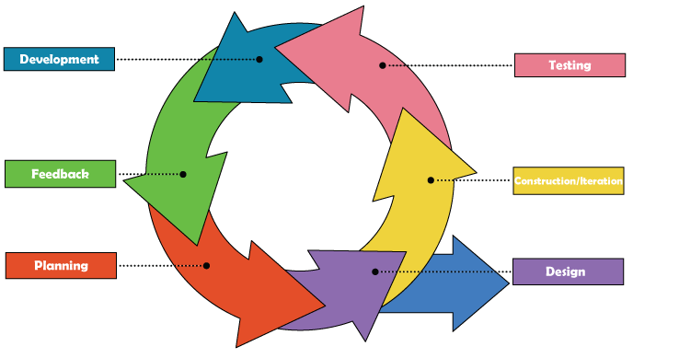
Requirements were gathered through coordination with the chairman and members of the Bankero and Fishermen Association. A formal letter of intent was sent prior to data collection. Interviews were conducted via Messenger and video calls to understand operational processes, challenges, and system expectations. Observations were also conducted to document the preparation, processing, and marketing of seafood products such as fish tocino, fish tacos, and seaweed crackers. Secondary sources related to digital marketplaces and fisheries operations were reviewed to support system requirements.
Based on the gathered information, the system design was developed to define the structure and interaction of BankeroBay. Flowcharts were created to map existing processes and identify areas for improvement, while a Business Model Canvas was prepared to align the platform with the association’s operations. Wireframes were developed using Figma to visualize the interface and user experience. An Entity Relationship Diagram was created to define relationships among users, products, and transactions. Third-party logistics integration was also considered to support delivery and tracking of orders.
The system was developed using HTML, CSS, JavaScript, PHP, and Laravel with Visual Studio Code as the development environment. It followed an iterative approach, allowing continuous improvement based on stakeholder feedback. Each feature was implemented in accordance with functional and usability requirements. System testing was conducted using black box testing and manual scenario testing with both valid and invalid test cases to identify errors and verify system behavior, ensuring system stability, security, and usability.
After testing, the system was deployed through hosting and domain configuration, followed by final checks to ensure proper functionality and security. System evaluation focused on usability, performance, and reliability, with feedback gathered from members of the Bankero and Fishermen Association and an Information Technology expert. The system architecture follows a three-tier structure to ensure organized data flow, efficient processing, and centralized data management, as illustrated in Figure 2.

Figure 2. Three Tier Architecture of BankeroBay

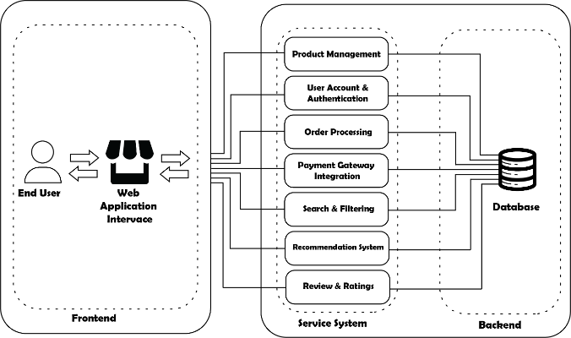
The study also involved both primary and secondary data sources. The Bankero and Fishermen Association consists of 70 active members, including officers and general members. The respondents of the study included the chairman, vice secretary, auditor, members of the association, buyers, and an IT expert, totaling 76 respondents as presented in Table 1.

Table 1. Respondents of the Study
Respondents | Number of Respondents
Chairman | 1
Vice Secretary | 1
Auditor | 1
Members of the Association | 67
Buyers | 5
IT Expert | 1
Total Respondents | 76

RESULTS AND DISCUSSION
The existing seafood trading system of the Bankero and Fishermen Association is primarily based on traditional, manual processes involving face-to-face transactions. Products are prepared by association members and sold directly at a beachfront stall, where customers purchase items after direct negotiation and payment through online. Marketing activities are largely dependent on word-of-mouth and limited community exposure, while delivery is conducted manually using tricycles for nearby areas and cargo services for distant locations.
This manual setup presents several operational limitations, including restricted market reach, inefficient transaction flow, and reliance on physical presence for both buyers and sellers. The absence of a centralized system also contributes to challenges in order tracking, communication, and overall coordination of transactions, particularly during peak demand periods.
To address these challenges, the BankeroBay system was developed as a centralized digital marketplace designed to streamline seafood trading operations. The platform provides online product listing, ordering, payment processing, real-time order tracking, and delivery management, along with communication and administrative features. These functionalities aim to improve operational efficiency, enhance accessibility, and support more organized and scalable seafood trading processes.
Existing Marketing and Distribution Processes of the Bankero and Fishermen Association
The Bankero and Fishermen Association operates through a traditional and community-based system in marketing and distributing its seafood products. Based on the interview with the Chairman, Mr. Noli Boy T. Cocjin, seafood trading starts with the preparation of products by association members, particularly the wives of fishermen, who handle cleaning, sorting, and organizing the catch before selling. The products are then displayed at a beachfront stall where customers can directly purchase them. Transactions are conducted face-to-face, where sellers assist buyers, negotiate prices, and release products immediately after payment through cash or GCash, allowing for personal interaction but limiting sales to walk-in customers only.
For promotion, the association mainly relies on word-of-mouth, personal networks, and repeat customers within the local community. Although they occasionally participate in events organized by the Bureau of Fisheries and Aquatic Resources, these opportunities are limited, resulting in mostly localized exposure and minimal reach to broader markets.
In terms of delivery, orders are received through SMS or chat applications. Members assess the delivery location to determine the appropriate transport method. Nearby deliveries are handled using tricycles, while distant deliveries are sent through cargo services such as Victory Liner Cargo, with customers typically picking up their orders at designated terminals.
Essential Features for an Effective Digital Marketplace or E-Commerce for Seafood Products
The system was designed to enhance the promotion, sale, and distribution of seafood products within the Bankero and Fishermen Association by introducing a centralized digital marketplace. It integrates e-commerce, logistics, and administrative functions to address the limitations of traditional marketing and distribution practices identified during the interview with the association chairman.
User access is secured through registration, login, email verification, and password recovery features, ensuring that only verified users can access the platform while maintaining account security, as shown in Figure 3.

Figure 3. Login and Registration Interface
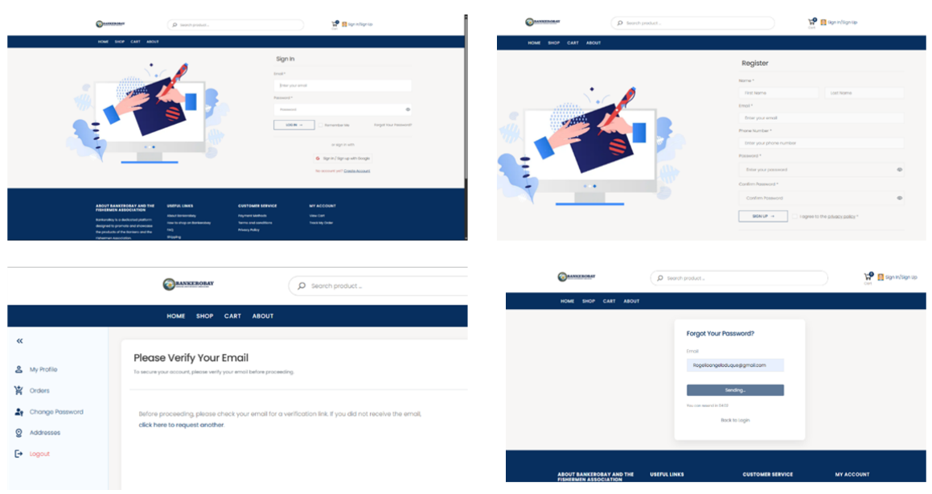
The marketplace allows users to browse seafood products through a structured listing page displaying images, prices, availability, and categories. Each product includes a detailed view with complete descriptions and additional images. A review system enables verified buyers to provide ratings and feedback, while a product request feature allows users to request unavailable items, helping administrators monitor demand, as presented in Figure 4.

Figure 4. Product Listing and Product Details Interface
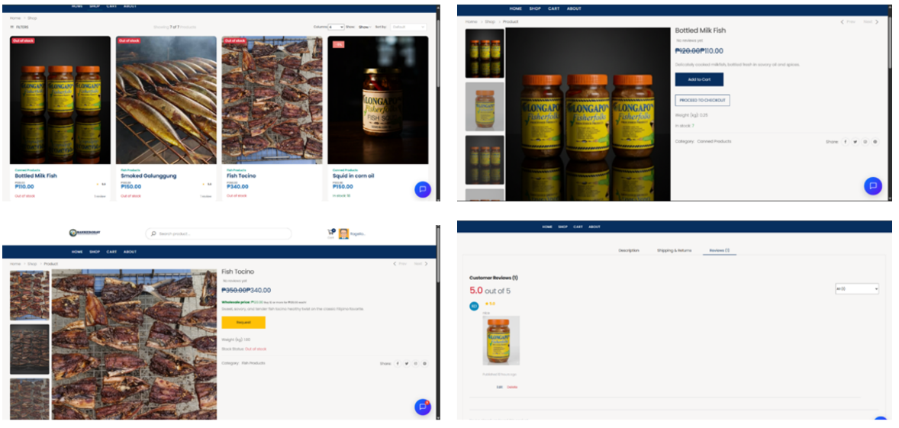
The ordering system includes cart management, checkout, and payment processing using credit or debit cards and e-wallet options, followed by real-time order tracking from processing to delivery to ensure transparency throughout the transaction, as presented in Figure 5 and Figure 6. Delivery operations are supported through rider-based delivery and third-party courier integration, where riders are equipped with live location tracking, route mapping, buyer information access, and delivery confirmation through proof-of-delivery photos and QR code verification, while courier tracking provides shipment updates and status monitoring for long-distance deliveries, as illustrated in Figure 6.

Figure 5. Order and Payment Interface
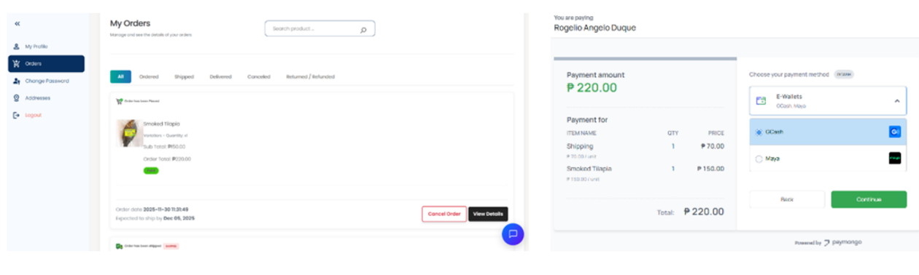

Figure 6. User Order Tracking Interface
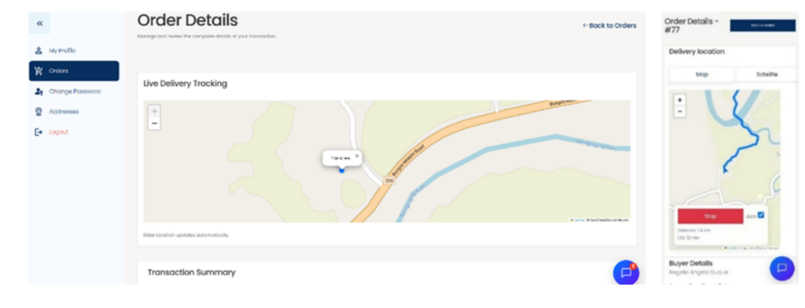

The administrative module provides a dashboard that presents user activity, order statistics, and revenue summaries. It supports product management, order monitoring, user account control, product request handling, return request processing, shipping fee configuration, and content management, as shown in Figure 7.
Figure 7. Admin Dashboard and Management System
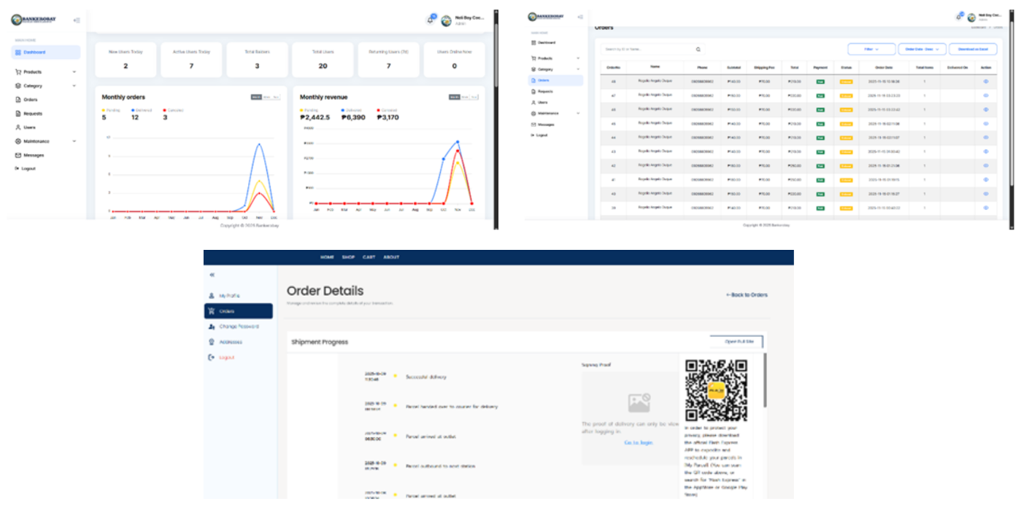

Communication features include chat support with automated responses and direct administrator interaction. Email notifications provide updates on orders, account verification, product availability, and password resets, ensuring timely communication between the system and users, as illustrated in Figure 8.

Figure 8. Communication and Notification System
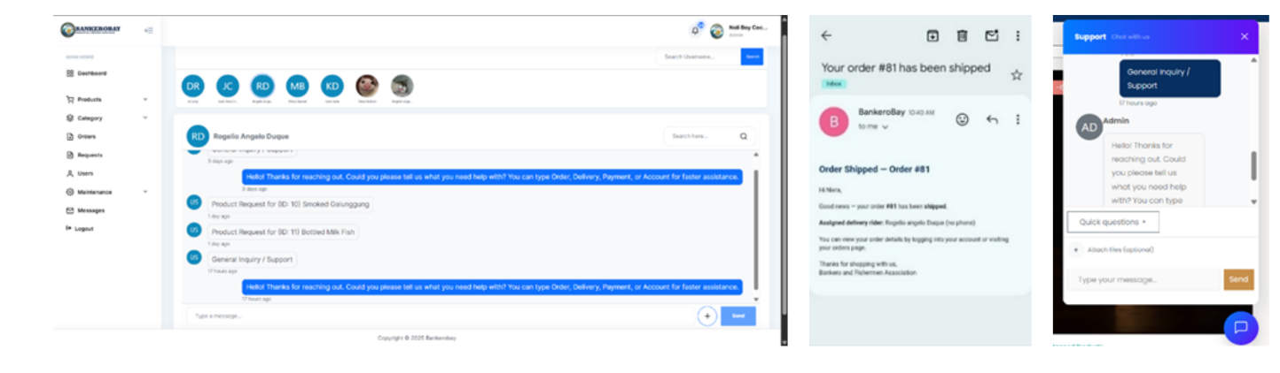
Assessment of Software Quality and User Acceptability of E-Commerce Platforms for Seafood Trading
The system was evaluated based on key software quality characteristics to determine its performance and usability. The results show that the platform consistently obtained high ratings across all indicators, including functionality sustainability, performance efficiency, usability, reliability, security, maintainability, and portability. These outcomes indicate that the system performs well in terms of accuracy, efficiency, stability, and user experience, while also ensuring data protection and adaptability across different environments.
Overall acceptability was assessed using the combined evaluation of all software quality attributes. The system obtained an average weighted mean of 4.57, interpreted as “Strongly Agree,” as shown in Table 2. This result reflects that users perceive the platform as efficient, reliable, secure, and user-friendly. The consistent high ratings further confirm that the system effectively supports improved seafood trading operations through a digital approach.
Table 2. The Scale of Measurement for Acceptance Test
Acceptability | WM | Description
Functionality Sustainability | 4.57 | Strongly Agree
Performance Efficiency | 4.49 | Strongly Agree
Compatibility | 4.57 | Strongly Agree
Usability | 4.56 | Strongly Agree
Reliability | 4.63 | Strongly Agree
Security | 4.53 | Strongly Agree
Maintainability | 4.57 | Strongly Agree
Portability | 4.60 | Strongly Agree
Average Weighted Mean | 4.57 | Strongly Agree

CONCLUSION
The BankeroBay platform offers an innovative solution to the challenges faced by the Bankero and Fishermen Association in promoting, selling, and delivering seafood products. By providing a centralized digital platform, it expands market reach, improves product visibility, and enhances the efficiency of sales and delivery operations. This transition from traditional methods to a digital system allows the Association to better respond to modern market demands.
Through the integration of user-friendly interfaces, secure payment processing, and real-time order tracking, the system effectively meets the needs of both sellers and buyers. Customers are able to browse products, view detailed information, place orders, and monitor deliveries with ease, while administrators can manage products, monitor transactions, assign riders, and communicate with users efficiently. In addition, coordination with delivery partners such as Flash Express supports timely and reliable order fulfillment.
The development of the system using the Agile methodology enabled continuous improvement through iterative development and user feedback, ensuring alignment with the practical needs of the stakeholders. Evaluation based on the ISO 25010 standard confirmed that BankeroBay performs well in terms of functionality, usability, reliability, efficiency, security, maintainability, and portability. The results indicate that users perceive the system as dependable, intuitive, and suitable for practical implementation, demonstrating its effectiveness in addressing the limitations of traditional seafood trading and supporting a more organized and customer-focused digital commerce system.

REFERENCES
- Alhassan, A., Nmakatun, M., Cynthia, N., Chinedu, N., & Zakari, Y. (2025). Digital Transformation for SmallScale Fisheries: An Integrated. International Journal of Science and Business.
- Bauer, E. (2021). Building a New, Online Marketplace for Sustainable Seafood in the Philippines. Resonance Global.
- Casenave, E., & Klarmann, M. (2020). The accountability paradox: How holding marketers accountable hinders alignment with short-term marketing goals. Journal of Business Research.
- Gainau, P., Kilay, T., Ruban, A., Pattiasina, G., & Gomies, N. (2024). Assistance in using Sipikan Website to increase sales of fishermen in Seri Village Sub-District Nusaniwe. Abdimas: Jurnal Pengabdian Masyarakat Universitas Merdeka Malang, 1003 - 1016.
- Kumar, A., & Ayedee, N. (2021). Technology Adoption: A Solution for SMEs to Overcome Problems during COVID-19.
- Nambisan, S. (2024). Digital innovation and international business.
- Pasco, J. T., Vicedor, C. D., Recena, J. D., Rodriguez, Y. T., Tomagos, G. N., & Serrano, E. A. (2024). SeaSavor:A Multivendor E-Commerce Website for the fishermen in the Philippines. IC4E '24: Proceedings of the 2024 15th International Conference on E-Education, E-Business, E-Management and E-Learning (pp. 304-309). Fukuoka-shi, Japan: Association for Computing Machinery.
- Sulkiah, S. (2023). Dampak Isi dan Keakuratan Seleksi Pemasaran Digital terhadap Penjualan Makanan Olahan Ikan Lombok Timur. Manazhim, 154 – 165.
- Verhoef, P. C., Broekhuizen, T., Bart, Y., Bhattacharya, A., Qi Dong, J., Fabian, N., & Haenlein, M. (2021). Digital transformation: A multidisciplinary reflection and research agenda. Journal of Business Research.
- Wahyuni, S., Akbar, A., Khaliq, A., & Akbar, A. (2023). WEB-BASED APPLICATION FOR SEA PRODUCTS TRADING TO INCREASE FISHERMEN'S INCOME IN SECANGGAN VILLAGE. Vol - 3.
- Wang, C.-H., Padmanabhan, P., & Huang, C.-H. (2022). The impacts of the 1997 Asian financial crisis and the 2008 global financial crisis on renewable energy consumption and carbon dioxide emissions for developed and developing countries. A Cell Press Journal.
- Yelfiarita, Y., Darwant, D., Waluyati, L., & Masyhuri, M. (2025). Determinants of digital marketing adoption among agroindustry SMEs: the case of the rendang sector.

