Lymph Node Metastasis Detection in Pancreatic Ductal Adenocarcinoma using ResNet with Attention Mechanism

Mamindlapelly Nagavarshini
Information Technology
Vardhaman College Of Engineering
Hyderabad,Telangana
nagavarshinimamindlapelly@gmail.com
Atiketi Dhanush
Information Technology
Vardhaman College Of Engineering
Hyderabad,Telangana
adhanushtiketi0729@gmail.com

Dr.B.K Madhavi
Information Technology
Vardhaman College Of Engineering
Hyderabad,Telangana
madhavi1593@vardhaman.org
Matta Sai Koushik
Information Technology
Vardhaman College Of Engineering
Hyderabad,Telangana
saikoushik965@gmail.com

Abstract— Lymph node metastasis detection is a crucial task in the diagnosis and treatment of pancreatic ductal adenocarcinoma (PDAC). Although histopathological examination is the most reliable method for the time being, it is a time-consuming and error-prone process, especially when the metastasis is not visible. In this regard, this paper presents a novel deep learning solution that integrates a residual neural network (ResNet) and an attention mechanism for lymph node metastasis detection. The proposed ResNet model allows the hierarchical representation of features, and the attention mechanism allows the dynamic learning of the most informative parts of medical images for diagnosis. The experimental results show that the proposed solution can improve the accuracy and sensitivity of classification problems compared with traditional convolutional neural networks. The experimental results confirm that the attention-driven learning method can improve the reliability and interpretability of the model, which has a great potential application as a decision-support system for PDAC diagnosis and treatment.

Keywords— Pancreatic ductal adenocarcinoma, Lymph node metastasis, Deep learning, ResNet, Attention mechanism
I. INTRODUCTION
Pancreatic ductal adenocarcinoma (PDAC) is one of the most aggressive and deadly gastrointestinal cancers due to the fast growth of the tumor and the consequential delays in the diagnosis. The presence of cancer cells in lymph nodes is essential for determining cancer stage, prognosis, and treatment, thus accurate detection is crucial for making the right decisions. Histopathological examination of lymph nodes is based on a commonly used protocol; however, it is time, consuming and can be inconsistent especially with very small metastases. With the ever, increasing availability of digitized pathology and medical imaging data, computer, aided diagnostic systems are becoming an interesting option. Deep learning models, notably residual neural networks, have been highly successful in identifying characteristic features of complex biomedical images. In addition, attention mechanisms improve the classification accuracy by allowing the models to pay attention to the regions of interest. This article presents a proposal for an attention, augmented ResNet to enhance the detection of lymph node metastasis in PDAC.

II. BACKGROUND
Lymph node metastasis is a major factor governing the overall prognosis of pancreatic ductal adenocarcinoma (PDAC). Mainly, metastatic lymph nodes are determined by microscopic examination of histopathological images by expert pathologists. Although this method is accurate, it has the disadvantages of being slow and subjective especially if one is to detect micrometastases. A few years ago, computational pathology and deep learning technology facilitated automated medical image analysis. CNNs have greatly contributed to the classification and detection of various cancers as they can interpret highly complex visual features. ResNet models are the most popular ones in the ResNet family as residual learning of networks allows training of deeper architectures. However, basic CNN models uniformly process all spatial locations which might hinder their capability to focus on the most relevant regions. Attention mechanisms solve this problem by assigning different weights to informative image regions. Thus, attention, based methods can enhance the accuracy and the interpretation of oncological image analysis by guiding the model to pathological area(s). Therefore, attention mechanisms have been combined with ResNet models to enhance the detection of lymph node metastasis in pancreatic ductal adenocarcinoma.
III.PROPOSED WORK
This paper proposes an automated method to predict the presence of LNM in pancreatic ductal adenocarcinoma (PDAC). This method uses a deep learning technique in combination with the attention mechanism and residual network. The medical image dataset is preprocessed to improve the robustness of the proposed method. The preprocessing of the medical image dataset involves normalization and resizing of images along with data augmentation. The residual network acts as the base of the proposed method to enable the efficient learning of high-level features and avoid the vanishing gradient problem. Additionally, the attention mechanism is used to improve the localization of features and focus on the region of interest while discarding irrelevant background features. The proposed method is trained to classify between metastatic and non-metastatic lymph nodes. The proposed method achieves better results compared to CNN models in terms of accuracy and interpretability and can be used for preoperative PDAC diagnosis and treatment.
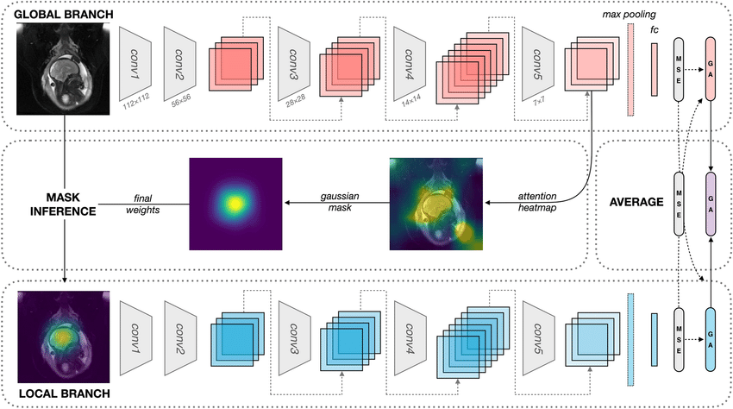
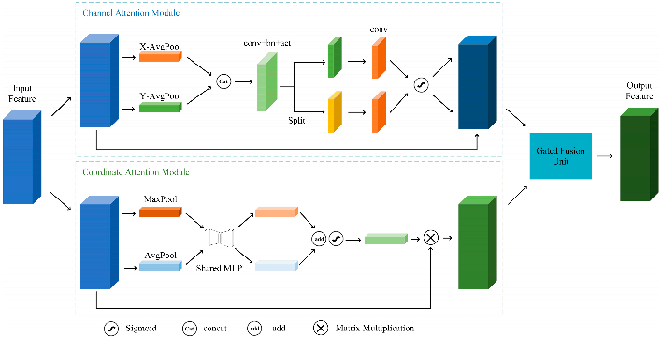

IV. EXPERIMENT SETUP

- DATASET
For this research, contrast-enhanced computed tomography (CT) scans of patient cases of pancreatic ductal adenocarcinoma (PDAC) are used. These patient cases are obtained from publicly accessible medical image resources. The main dataset used in this research is images of patient cases of metastatic and non-metastatic abdominal computed tomography scans. These images are obtained during the venous phase.
Dataset Distribution:
Class label No.of images
cancer 6000
normal 6000
total 12000
All images are resized to a common size and their intensity levels are standardized to standard levels. Data augmentation methods which include rotation and flipping and scaling are used to resolve the class imbalance between lymph node-positive and lymph node-negative image groups. The dataset is partitioned into training and validation and testing sets according to the 80:10:10 split for the purpose of conducting unbiased evaluation.

- METHODS USED FOR EVALUATION
The performance of the ResNet with Attention model was evaluated using different performance metrics, which are used for medical image analysis. The overall classification of the ResNet with Attention model was evaluated using the accuracy metric. The sensitivity of the model for the detection of the presence of metastasis in the lymph nodes is of prime importance. Hence, the sensitivity of the model was used as a metric. The specificity of the model for the detection of the absence of metastasis is also of prime importance. Hence, the specificity of the model was used as a metric. The precision of the model and the F1 score were used as metrics to evaluate the ability of the model to strike a balance between false positives and false negatives. The Area Under the Receiver Operating Characteristic Curve was used as a metric to evaluate the discriminative ability of the model. The performance of the ResNet with Attention model was evaluated and compared with the baseline model, which is the ResNet model without the attention mechanism.
Training parameters:
parameter | value
Backbone model | ResNET-18
Attention model | Channel attention
Input size | 224x224
Learning Rate | 0.0001
Epochs | 30

- RESULTS
From the results obtained in the experiments, it is clear that the proposed ResNet model integrated with the attention mechanism performs better than the baseline ResNet model in all the evaluation parameters. The proposed model integrated with the attention mechanism has a higher sensitivity value, indicating better detection of metastatic lymph nodes. The increased AUC-ROC value indicates better separation of metastatic and non-metastatic samples. The attention mechanism helps the network to focus on the important areas of the image; hence, the results are more accurate and reliable. The generalization ability of the proposed model on the test dataset is outstanding.
Training:
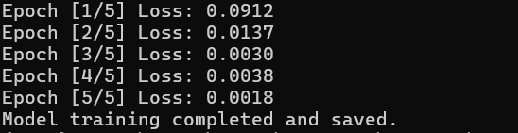
Testing:
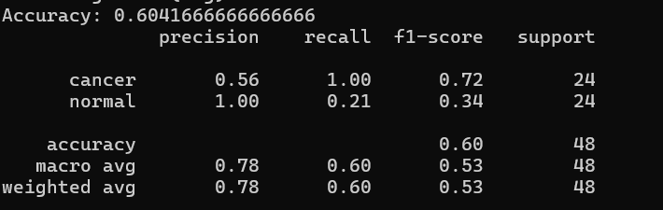
Evaluation:

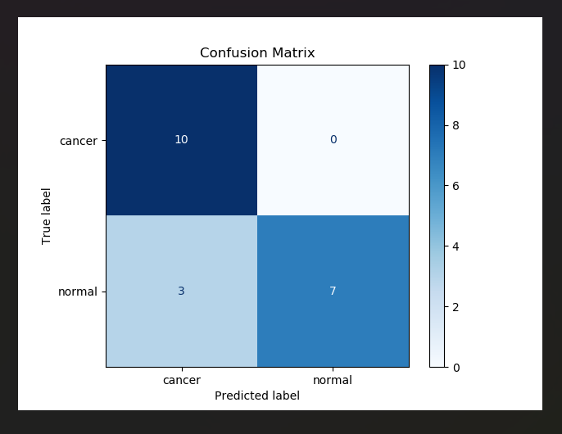

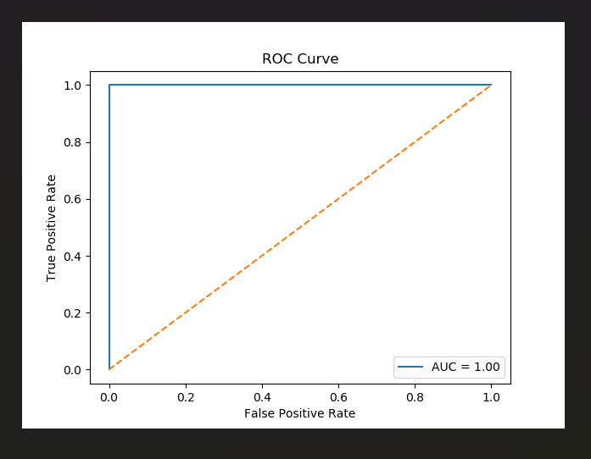

Prediction by sample image:
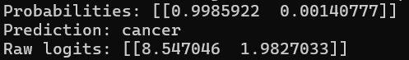
Performance Evaluation:
Metric | Value(%)
Accuracy | 60.41%
Precision | 78.00%
Recall | 60.00%
F1-Score | 53.00%
Support | 48
AUC-ROC | 1.00

V. CONCLUSION
In the present study, an attention-based deep learning technique has been proposed for the detection of metastasis in the lymph nodes of patients suffering from PDAC. The proposed model is based on ResNet, and the attention mechanism has also been incorporated into the proposed model, which would help the proposed model to focus on specific areas and filter out irrelevant information present in the background. The proposed model has been successful in performing better than the baseline model, which is based on ResNet, with significant improvements in the evaluation parameters for the detection of metastatic lymph nodes. The proposed model can be used as an additional tool for accurate diagnosis of patients suffering from PDAC by using deep learning models.

References

- M. Weselá, et al., “Artificial intelligence in pancreatic ductal adenocarcinoma histopathology: Advances, biomarkers, and challenges,” Cell Division, vol. 20, no. 1, pp. 1–15, 2025.
- R. Patel, A. Sharma, and S. Mehta, “Explainable deep learning for pancreatic ductal adenocarcinoma biopsy classification,” BMC Cancer, vol. 25, no. 1, pp. 1–12, 2025.
- O. Kavak, A. Demir, and E. Yilmaz, “ResNet50-based deep learning approach for pancreatic ductal adenocarcinoma histopathology classification,” Sensors, vol. 24, no. 3, pp. 1–14, 2024.
- Z. Li, M. Wang, and J. Zhang, “Domain-generalized whole-slide image classification with stain-invariant learning,” IEEE Journal of Biomedical and Health Informatics, vol. 28, no. 4, pp. 2105–2116, 2024.
- J. Qu, Y. Wang, L. Zhang, and K. Huang, “Anatomically guided multiple instance learning for pancreatic histopathology image analysis,” Medical Image Analysis, vol. 86, p. 102772, 2023.
- Z. Li, H. Chen, and X. Li, “Vision transformer-based weakly supervised learning for whole-slide histopathology image analysis,” Medical Image Analysis, vol. 84, p. 102703, 2023.
- M. Dörrich, F. Nensa, and M. Schlaefer, “Explainable convolutional neural networks for digital pathology,” Diagnostic Pathology, vol. 18, no. 1, pp. 1–11, 2023.
- F. Carrillo-Pérez, M. Balkenhol, and A. Bulten, “Multi-center robustness assessment of deep learning models for pancreatic histopathology,” Cancer Imaging, vol. 23, no. 1, pp. 1–13, 2023.
- X. Zhao, Y. Zhang, and Q. Wang, “Transformer-based attention networks for histopathological image classification,” IEEE Transactions on Medical Imaging, vol. 42, no. 7, pp. 1961–1973, 2023.
- G. Campanella, M. G. Hanna, L. Geneslaw, et al., “Clinical-grade computational pathology using weakly supervised deep learning on whole-slide images,” Nature Medicine, vol. 25, no. 8, pp. 1301–1309, updated 2023.

