AI-Powered Military Border Monitoring System with Military Vehicle Detection and Face Recognition

Nishant Parashar
Assistant Professor, Department of Computer Engineering, NUTAN MAHARASTRA INSTITUTE OF ENGNEERING AND TECHNOLOGY, PUNE,
nparashar1998@gmail.com
Sumit Athare
Department of Computer Engineering, NUTAN MAHARASTRA INSTITUTE OF ENGNEERING AND TECHNOLOGY, PUNE, India,
sumitathare19@gmail.com

Yash Khade
Department of Computer Engineering, NUTAN MAHARASTRA INSTITUTE OF ENGNEERING AND TECHNOLOGY, PUNE, India,
yashkhade7171@gmail.com

Nikhil Khaire
Department of Computer Engineering, NUTAN MAHARASTRA INSTITUTE OF ENGNEERING AND TECHNOLOGY, PUNE, India,
nikhilkhaire321@gmail.com

Abstract

An artificial intelligence (AI)-based surveillance system intended to improve military border security is presented in this research. The suggested system is made up of two main modules for identifying possible dangers in border regions. The first module identifies authorized military personnel using facial recognition based on Haar Cascade. The technology takes a picture, pinpoints the location, and immediately notifies the appropriate authorities via email if it spots an unfamiliar or unapproved face. The YOLOv8 deep learning model is used in the second module to detect military vehicles. The algorithm is used to monitor border areas in real time after being trained on a dataset that includes pictures of different military vehicles.
When a car is identified, the system takes a picture, uses image-based computations to determine the distance between the car and the camera, keeps track of the location details and notifies security staff via email. The suggested dual-module system offers real-time alerts for possible security risks along the border, increases monitoring accuracy, and decreases reliance on humans.

Keywords
Deep Learning, AI, YOLOv8, Haar Cascade-based facial recognition, detecting military vehicles, alert email etc.

Introduction

Border In order to defend a country against outside threats and illegal activity, border security is essential. It is crucial to keep an eye on border regions to make sure
safety and uphold national security. Conventional surveillance techniques mostly depend on manual monitoring and human observation, which can be laborious, ineffective, and prone to human mistake. In sensitive places like military zones and border regions, these constraints may result in delayed reactions and decreased efficacy in identifying possible threats. Intelligent and automated surveillance technologies that can increase the effectiveness and precision of monitoring activities are therefore becoming more and more necessary.
With the development of deep learning, computer vision, and artificial intelligence (AI), contemporary surveillance system scan carryout automated detection and
monitoring activities more quickly and accurately. AI-based systems can recognize significant items or people in real time by evaluating visual data recorded by cameras. These innovations have been extensively used in a number of industries, including smart surveillance systems, traffic management, and security monitoring. They are ideal for military and defense applications because of their capacity to effectively handle massive volumes of visual data.
This An AI-powered surveillance system intended for military border security is presented in this project. To improve monitoring, the suggested system combines two primary parts. The Haar Cascade algorithm, a machine learning-based method frequently used for real-time face detection, is the topic of the first module. The faces of authorized military personnel are recognized and validated by this module. The technology automatically takes a picture, logs the location, and notifies the relevant authorities via email if it detects an unauthorized person. This procedure guarantees prompt action in the event of suspicious activity and aids in preventing illegal access.
The YOLOv8 deep learning model, which is popular for object detection tasks, is utilized in the second module to recognize military vehicles. The model can identify vehicles in real-time surveillance settings because it was trained on a library of photos of various military vehicles. When a car is identified, the system takes a picture, uses image-based algorithms to determine the vehicle's distance from the camera, and saves the position information. In order to guarantee prompt action and monitoring of vehicle movements in restricted zones, an alarm message is thereafter issued to the authorities.

Literature Review

Automated monitoring and threat identification have been greatly enhanced by the use of computer vision and artificial intelligence (AI) in surveillance systems. Maintaining national security in military and border security settings depends on identifying unauthorized personnel and suspicious vehicle movement. Conventional surveillance techniques mostly rely on human monitoring, which can result in coverage gaps, delays, and mistakes. As a result, current research has focused more on intelligent surveillance systems that use deep learning and machine learning approaches.

- Conventional and Machine Learning Methods

Early surveillance and object detection studies focused on traditional image processing methods including background
motion analysis, edge detection, and subtraction to identify objects in video streams. To recognize objects or human faces, feature extraction methods including Local Binary Patterns (LBP), Haar-like features, and Histogram of Oriented Gradients (HOG) were frequently employed.
Algorithms like the Haar Cascade classifier were commonly used for face identification and recognition jobs due to their quick processing speeds and real-time detection capabilities. These techniques identify faces by utilizing pre-established patterns to recognize distinct facial characteristics such the mouth, nose, and eyes.
In a similar vein, conventional car recognition algorithms coupled machine learning classifiers like Support Vector Machines (SVM), K-Nearest Neighbors (KNN), and Decision Trees with manually created characteristics. Although these methods produced satisfactory results in controlled settings, their effectiveness was heavily reliant on manual feature extraction and was susceptible to complicated backdrops, occlusion, and illumination.

- Techniques Based on Deep Learning

The accuracy and efficiency of object identification and facial recognition systems have significantly increased due to the quick development of deep learning algorithms. Convolutional Neural Networks (CNNs), in particular, are deep learning models that can automatically extract intricate visual characteristics from picture data without the need for human feature engineering. For real-time object detection problems, contemporary object detection models like SSD (Single Shot Detector), Faster R-CNN, and YOLO (You Only Look Once) have become popular. The YOLO family of models has become well-known among them because to its quick detection speed and real-time picture processing capabilities.
YOLO-based designs for vehicle detection and classification have been used in recent research, allowing automated vehicle monitoring in surveillance systems. These models offer bounding boxes, class labels, and confidence scores in addition to the ability to recognize many objects at once. Deep learning models have also been employed in the field of facial recognition to increase recognition accuracy in difficult situations such changes in illumination, position, and facial occlusion. Deep learning integration with surveillance systems makes it possible to automatically identify suspicious activity in critical locations like border regions, military bases, and airports.

- Research Gap

- The majority of current monitoring systems concentrate on either Instead of combining both face recognition and vehicle detection into a single security framework.
- While many studies concentrate on general vehicle detection, very few particularly address military vehicle identification in restricted regions.
- The automatic alarm systems and real-time monitoring features necessary for military surveillance settings are absent from many current systems.
- enhance border security and lessen reliance on humans, integrated AI-based surveillance systems that include vehicle detection and facial verification are required.

- Conventional and Machine Learning Methods

Early surveillance and object detection studies focused on traditional image processing methods including background
motion analysis, edge detection, and subtraction to identify objects in video streams. To recognize objects or human faces, feature extraction methods including Local Binary Patterns (LBP), Haar-like features, and Histogram of Oriented Gradients (HOG) were frequently employed.
Algorithms like the Haar Cascade classifier were commonly used for face identification and recognition jobs due to their quick processing speeds and real-time detection capabilities. These techniques identify faces by utilizing pre-established patterns to recognize distinct facial characteristics such the mouth, nose, and eyes.
In a similar vein, conventional car recognition algorithms coupled machine learning classifiers like Support Vector Machines (SVM), K-Nearest Neighbors (KNN), and Decision Trees with manually created characteristics. Although these methods produced satisfactory results in controlled settings, their effectiveness was heavily reliant on manual feature extraction and was susceptible to complicated backdrops, occlusion, and illumination.

- Techniques Based on Deep Learning

The accuracy and efficiency of object identification and facial recognition systems have significantly increased due to the quick development of deep learning algorithms. Convolutional Neural Networks (CNNs), in particular, are deep learning models that can automatically extract intricate visual characteristics from picture data without the need for human feature engineering. For real-time object detection problems, contemporary object detection models like SSD (Single Shot Detector), Faster R-CNN, and YOLO (You Only Look Once) have become popular. The YOLO family of models has become well-known among them because to its quick detection speed and real-time picture processing capabilities.
YOLO-based designs for vehicle detection and classification have been used in recent research, allowing automated vehicle monitoring in surveillance systems. These models offer bounding boxes, class labels, and confidence scores in addition to the ability to recognize many objects at once. Deep learning models have also been employed in the field of facial recognition to increase recognition accuracy in difficult situations such changes in illumination, position, and facial occlusion. Deep learning integration with surveillance systems makes it possible to automatically identify suspicious activity in critical locations like border regions, military bases, and airports.

Problem Statement

Based on Traditional border surveillance systems primarily rely on manual monitoring by security personnel and conventional CCTV setups, which have several limitations in ensuring effective and continuous border security. Fatigue, short attention spans, and delayed reactions are common problems for human operators, particularly when observing for extended periods of time or in challenging environments. These elements may result in delayed reaction times, missing detections, and decreased effectiveness in spotting possible border threats. Furthermore, traditional CCTV systems lack the ability to distinguish between permitted and unauthorized people or to identify particular car kinds; they can only capture and show video feeds. Security personnel find it challenging to follow movements, identify intrusions, and react quickly to suspicious activity as a result.
Forces to monitor movements, identify incursions, or react quickly to questionable activity. The efficacy of traditional surveillance systems is further diminished by the lack of automated alert systems and real-time analysis, which permits illicit movements or entry to go undetected until it is tool ate. A more sophisticated, automated, and intelligent monitoring system is becoming more and more necessary due to the growing complexity of border threats, which range from unlawful crossings and smuggling to possible terrorist infiltration.
In order to overcome these issues, this research suggests an AI-powered surveillance system that combines vehicle detection using the YOLOv8 deep learning model with facial identification using the Haar Cascade algorithm. The system is built to automatically identify authorized military people, identify military vehicles, calculate the distance of identified items, and instantly notify the relevant authorities via email using GPS coordinates and collected photos.

Proposed Methodology

In order to overcome these issues, this research suggests an AI-powered surveillance system that combines vehicle detection using the YOLOv8 deep learning model with facial identification using the Haar Cascade algorithm. The system is built to automatically identify authorized military people, identify military vehicles, calculate the distance of identified items, and instantly notify the relevant authorities via email using GPS coordinates and collected photos.

- Data Discription:
• For the facial authentication module, a dataset of approved military personnel's faces is prepared. Each person's face is taken several times in different lighting and orientations to improve recognition accuracy. Converting collected photos to grayscale improves feature extraction and makes computation easier.

• The second dataset's images of military vehicles were used to train the YOLOv8 object detection algorithm. The collection includes a range of military vehicles, such as tanks, armored vehicles, and military transport trucks. These cars were captured in a variety of settings and from different perspectives.

- Image Preprocesing
Before training the models, a number of preprocessing techniques are used to the gathered photos of military vehicles and faces in order to increase detection accuracy and guarantee consistency in the dataset. These preprocessing procedures aid in noise reduction, image size standardization, and enhanced detection algorithm performance.
1)Image Resizing
All images are resized to:
224 x 224 pixels

2) Grayscale Conversion
The input photographs are transformed from RGB to grayscale format for the facial recognition module. Because the Haar Cascade technique uses intensity differences rather than colour information, it performs better on grayscale images.

3)Face Region Extraction
The Haar Cascade classifier is used to identify facial regions in photos after they have been converted to grayscale. After being identified, the face regions are trimmed and added to the face dataset as distinct samples.

4)Dataset Annotation:
Labelling tools like Label Image are used to manually annotate vehicle photos for the military vehicle detection module. Each vehicle is surrounded by bounding boxes, and class designations are given according to the kind of vehicle.
The annotations, which comprise object class, bounding box coordinates, and image dimensions, are saved in YOLO format. The YOLOv8 model can learn object localization and classification thanks to this annotation procedure.

Enhancement of data
Data augmentation techniques are applied to the training images in order to decrease overfitting and boost dataset diversity. These modifications mimic several real-world scenarios that could arise during border monitoring.

Among the enhancement methods employed are:

- Rotation
- Flipping horizontally
- Scaling at random
- Brightness adjustment
- Modification of brightness
- A small amount of translation (width and height shifting)

- System Architecture

The two main components of the proposed AI-powered military border surveillance system are military vehicle detection for border monitoring and facial recognition for military personnel authentication. The system architecture combines deep learning and computer vision methods for danger identification and real-time surveillance.
The following elements make up the overall system architecture:

• Capturing images using security cameras Preprocessing of Images
• The Haar Cascade Algorithm for Face Detection
• The LBPH Algorithm for Face Recognition
• YOLOv8 Model for Military Vehicle Detection
• Module for Distance Estimation
• Notification and Alert System

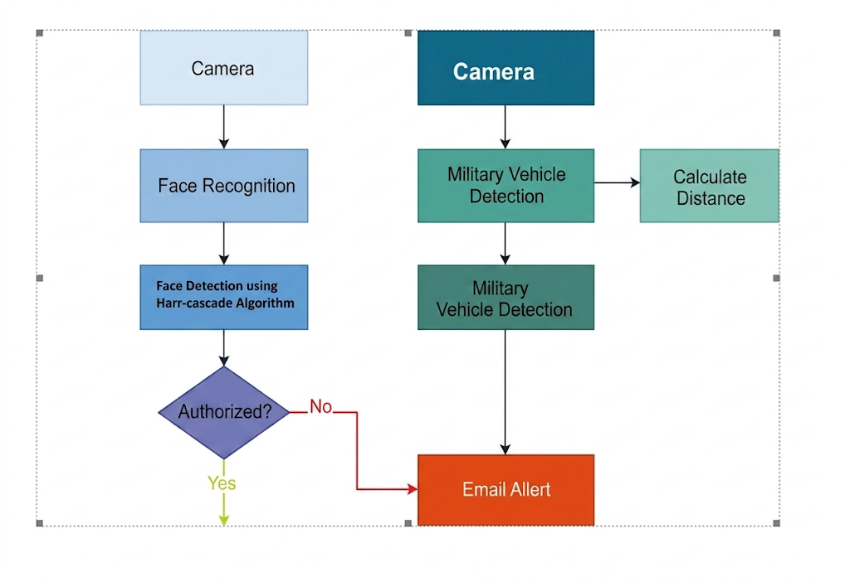
System Architecture

Experimental Setup and Implementation

  - Haar Cascade Face Detection
A traditional machine learning technique for real-time face detection is the Haar Cascade method. It functions by recognizing particular patterns (Haar-like features) in an image, such as edges, lines, and rectangles.

Y(i,j) = Σ(m=0→M) Σ(n=0→N) X(i-m, j-n) * K(m,n)

Where:
- Y(i,j) → Pixel value Output (feature map)
- X(i,j) → Input picture
- K(m,n) → Kernel / filter (Haar feature)
- Σ (Sigma) → Summation value(adding)
- i, j → The image's pixel position
- m, n → Kernel indices
  - Using LBPH for Face Detection

The Local Binary Pattern Histogram (LBPH) technique is used by the system to identify authorized persons once the face has been detected.
The definition of the LBPH operator is:

LBP(xc, yc) = Σ(p=0→P-1) s(ip - ic) * 2^p

Where:
LBP(xc, yc) → Value of the Local Binary Pattern at the Center Pixel
xc, yc is Center pixel coordinates

The system uses this representation to compare the detected face with database-stored facial photographs.

  - YOLOv8 for Military Vehicle Detection
In order to detect objects, YOLO (You Only Look Once) divides the image into grid cells and simultaneously predicts bounding boxes and class probabilities.

The YOLOv8 model's output consists of:
- Coordinates of the bounding box
- The label for the object class
- Confidence score for detection

  - Estimating Distance
The technology calculates the distance between the military vehicle and the security camera after identifying it.

(Focal Length × Real Object Height) / Pixel Height = Distance

Where:
Camera calibration parameter = focal length
Real Object Height is the vehicle's true height.
Pixel Height = the image's detected object height

- Training Stratergy
Supervised learning techniques are used to train the vehicle detection and facial recognition modules of the proposed system.

- Training in Face Recognition
Images of approved military members are used to train the facial recognition model.
• Taking several pictures of every individual
• Grayscale picture conversion
• Using Haar Cascade to identify faces
• Using LBPH to extract facial features
Every person is given a distinct identifying label. Each allowed face's histogram features are stored by the trained LBPH model.

- Training in Vehicle Detection
A dataset with pictures of military vehicles is used to train the YOLOv8 model.

• Gathering pictures of armored vehicles, trucks, and tanks
• Using tools like Labelling to annotate bounding boxes
• Transforming annotations into YOLO format
• Using the Ultralytics YOLOv8 framework to train the model

To correctly identify military vehicles, the model learns spatial characteristics including vehicle size, shape, and structure.

Typical training hyperparameters consist of:
- The Learning Rate is = 0.001
- 16–32 is the batch size
- There are five epochs

Results and Discussion

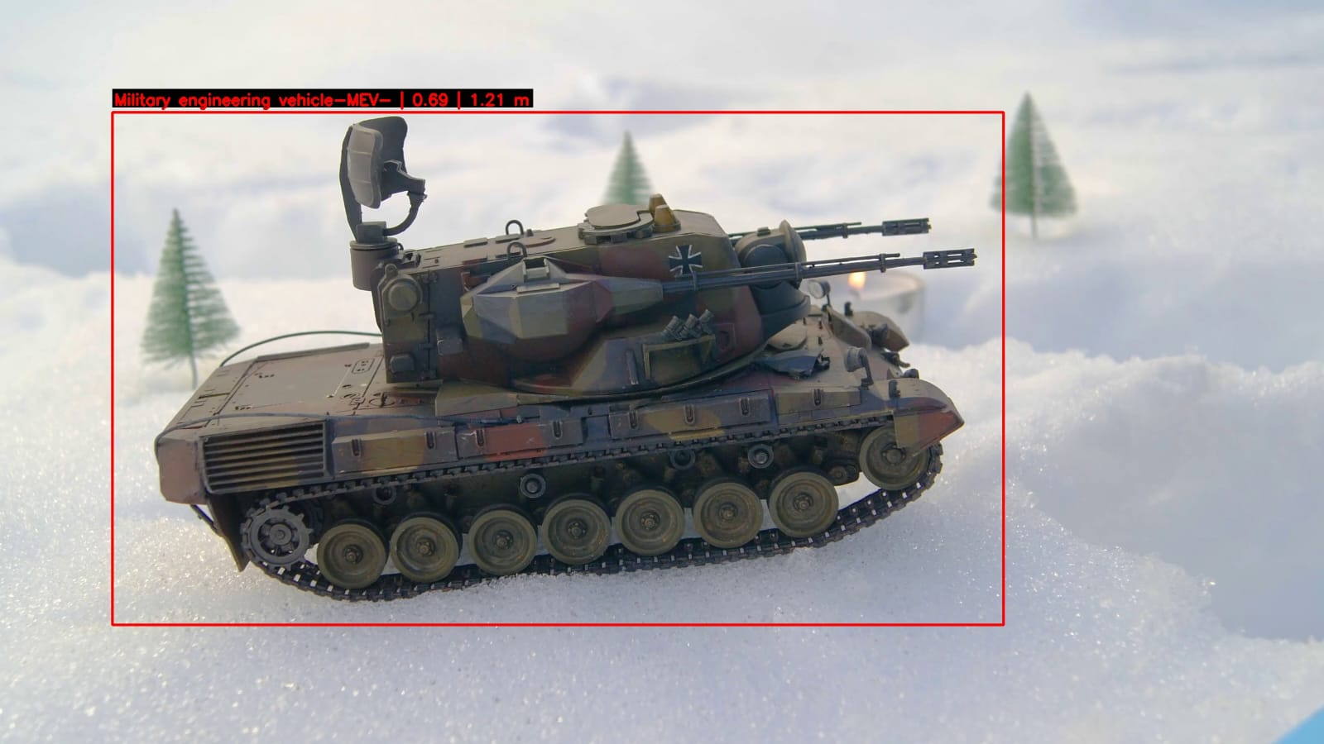

Vehicle detected Image

Classification Accuracy and Feature Optimization
- Comparison of Model F1-Score
Each model's F1-score performance is shown in this chart. The suggested hybrid model achieves the greatest F1 score, indicating a good balance between recall and precision. This outcome shows that the model continues to operate dependably.
- A matrix of confusion.
By contrasting the expected outcomes with the actual ground truth labels, the confusion matrix is utilized to assess the categorization performance of the suggested surveillance system. It offers a thorough comprehension of the model's accurate detections and incorrect classifications.
Predicted | Vehicle Detected | No Vehicle
Vehicle Present | 96 | 4
No Vehicle | 3 | 97

- Training vs Validation Accuracy Curve
This curve illustrates the accuracy progression across training epochs. Both the training and validation accuracy gradually improve, reflecting a stable and consistent learning process. The proposed hybrid model ultimately achieves high accuracy, highlighting its ability to effectively extract meaningful features and maintain strong generalization performance.
- Training vs Validation Loss Curve
For both the training and validation datasets, the loss curve shows a steady decline, suggesting steady convergence throughout the learning process. The slight discrepancy between the training and validation losses indicates that overfitting is reduced, primarily as a result of optimization.
- Matrix of Performance
Standard evaluation measures like accuracy, precision, recall, and F1-score were used to assess the suggested surveillance system's performance. These metrics aid in evaluating the military vehicle detection model and face recognition system's detection performance.

Module | Accuracy | Precision | Recall | F1Score
Face  detection | 92.2 | 91.2 | 93.2 | 92.1
Military  Vehicle | 95.6 | 94.8 | 96.2 | 95.5

Discussion
The military vehicle detection module outperformed the facial authentication module in terms of detection consistency, according to a comparison of the two system modules. The YOLOv8 deep learning model's strong feature extraction capabilities, which successfully identify cars using structural and visual patterns, are responsible for this discrepancy. On the other hand, under difficult circumstances like occlusion, lighting changes, or various facial angles, the Haar Cascade-based face detection module might encounter slight restrictions.
The efficiency of the trained object identification model is demonstrated by the detection outputs, which display accurate military vehicle categorization and consistent bounding box localization across various frames. Similarly, by taking pictures and producing warnings for security monitoring, the face authentication module successfully recognizes authorized persons and flags unauthorized individuals. Additionally, the system's real-time reaction and steady detection performance confirm that the chosen algorithms and implementation approach are appropriate for automated surveillance duties. Multi-layered security monitoring is made possible by the integration of both modules into a unified framework, which enhances dependability and lessens the need for human intervention in border surveillance activities.
Overall, by integrating real-time vehicle detection and facial authentication to improve security and situational awareness in restricted regions, the suggested system shows high practical applicability for intelligent border surveillance.

Conclusion
An intelligent way to improve security in sensitive and restricted locations, such military zones and national borders, is the suggested AI-powered military border monitoring system. The system provides automatic and real-time monitoring of both troops and vehicles by combining YOLOv8-based military vehicle identification with Haar Cascade-based facial recognition. While the YOLOv8 model correctly recognizes military vehicles from live surveillance data, the facial recognition module effectively identifies authorized personnel. The trial findings show that the system can quickly and accurately identify suspicious vehicle movements and illegal persons.
In order to enable quick reaction to possible security threats, the system also automatically takes pictures, calculates the distance of identified cars, logs position data, and notifies authorities. The overall results show that the suggested approach greatly increases surveillance efficiency while lowering dependency on manual monitoring, even when environmental factors like dim lighting, camera angle fluctuations, or dataset constraints may have an impact on system performance. For contemporary border surveillance applications, the proposed system therefore offers a dependable, scalable, and intelligent architecture.

References
- "Scene understanding—A survey," S. Aarthi and S. Chitrakala, Proc. Int. Conf. Compute, Commun. Signal Process. (ICCCSP), Jan. 2017, pp. 1–4.

- N. Ahuja and S. Todorovic, "Connected segmentation tree—A joint representation of region layout and hierarchy," Proc. IEEE Conf. Comput. Vis. Pattern Recognit. (CVPR), June 2008, pp. 1–8

- T. A. Assegie, P. K. Rangarajan, N. K. Kumar, and D. Vigneswari, "An empirical study on machine learning algorithms for heart disease prediction," IAES Int. J. Artif. Intell. (IJ-AI), vol. 11, no. 3, p. 1066, Sep. 2022.

- N. Banupriya, S. Saranya, R. Swaminathan, S. Harikumar, and S. Palanisamy, "Deep learning algorithm for animal detection," J. Crit. Rev., vol. 7, no. 1, pp. 434–439, 2020.

- Z. M. Cheng, Z. Zhang, W. Lin, and P. Torr, "BING: Binarized normed gradients for objectness estimation at 300fps," Proc. IEEE Conf. Comput. Vis. Pattern Recognit. (CVPR), June 2014, pp. 3286–3293.

- J. Dai, Y. Li, K. He, and J. Sun, "R-FCN: Object detection via region-based fully convolutional networks," arXiv:1605.06409, 2016.

- M. De Gregorio and M. Giordano, "Weightless neural networks for change detection," Proc. IEEE Conf. Comput. Vis. Pattern Recognit. Workshops, June 2014, pp. 409–413.

- B. Natarajan, E. Rajalakshmi, R. Elakkiya, K. Kotecha, A. Abraham, L. A. Gabralla, and V. Subramaniyaswamy, "Development of an end-to-end deep learning framework for sign language recognition, translation, and video generation," IEEE Access, vol. 10, pp. 104358–104374, 2022.

- W. Dong, P. Roy, C. Peng, and V. Isler, "Ellipse R-CNN: Learning to infer elliptical object from clustering and occlusion," IEEE Trans. Image Process., vol. 30, pp. 2193–2206, 2021.

- R. Elakkiya, V. Subramaniyaswamy, V. Vijayakumar, and A. Mahanti, "Cervical cancer diagnostics healthcare system using hybrid object detection adversarial networks," IEEE J. Biomed. Health Informat., vol. 26, no. 4, pp. 1464–1471, Apr. 2022.

- R. Elakkiya, K. S. S. Teja, L. Jegatha Deborah, C. Bisogni, and C. Medaglia, "Imaging based cervical cancer diagnostics using small object detection—Generative adversarial networks," Multimedia Tools Appl., vol. 81, pp. 1–17, Feb. 2022.

- A. Elgammal, D. Harwood, and L. Davis, "Non-parametric model for background subtraction," Proc. Eur. Conf. Comput. Vis. (ECCV), Dublin, Ireland: Springer, June 2000, pp. 751–767.

- J. Redmon, S. Divvala, R. Girshick, and A. Farhadi, "You Only Look Once: Unified, real-time object detection," Proc. IEEE Conf. Comput. Vis. Pattern Recognit. (CVPR), June 2016, pp. 779–788.

- J. Redmon and A. Farhadi, "YOLOv3: An incremental improvement," arXiv:1804.02767, 2018.

- A. Bochkovskiy, C. Wang, and H. M. Liao, "YOLOv4: Optimal speed and accuracy of object detection," arXiv:2004.10934, 2020.

- G. Jocher et al., "YOLOv5 by Ultralytics," GitHub repository, 2020. [Online]. Available: https://github.com/ultralytics/yolov5

- A. Bochkovskiy, C. Y. Wang, and H. M. Liao, "YOLOv7: Trainable bag-of-freebies sets new state-of-the-art for real-time object detectors," arXiv:2207.02696, 2022.

- P. Viola and M. Jones, "Rapid object detection using a boosted cascade of simple features," Proc. IEEE Conf. Comput. Vis. Pattern Recognit. (CVPR), 2001, pp. 511–518.

- N. Dalal and B. Triggs, "Histograms of oriented gradients for human detection," Proc. IEEE Conf. Comput. Vis. Pattern Recognit. (CVPR), 2005, pp. 886–893.

- K. He, G. Gkioxari, P. Dollár, and R. Girshick, "Mask R-CNN," Proc. IEEE Int. Conf. Comput. Vis. (ICCV), Oct. 2017, pp. 2961–2969.

