Adaptation and On-Farm Evaluation of Tractor-Operated Teff Thresher

Abstract
This study evaluates the performance of the BAERC model tractor PTO-operated teff thresher under varying operating conditions, specifically feed rate and threshing drum speed. The experiment was conducted using three levels of feed rate (22, 26, and 30 kg/min) and three drum speeds (700, 750, and 800 rpm). Key performance indicators, including threshing efficiency, cleaning efficiency, and seed loss percentage, were measured and analyzed using factorial ANOVA. Results indicated that both feed rate and drum speed had significant effects (p < 0.05) on threshing efficiency, while cleaning efficiency was significantly influenced by feed rate alone. The maximum threshing capacity of the machine was 553.57 kg/hr, which was obtained at maximum RPM (800) and 30 kg/min feed rate. The highest threshing efficiency (99.65%) was achieved at 800 rpm and 22 kg/min, while the cleaning efficiency decreased with increasing feed rate, particularly at lower drum speeds. Minimum seed losses were recorded at 750 rpm. The findings suggest that optimal machine performance can be achieved at moderate feed rates of 26 kg/min and drum speeds of 750 rpm, 458.4kg/hr. The grain straw ratio 1:1.26. This study concludes that the BAERC teff thresher is technically suitable for smallholder farming systems in Ethiopia, offering a balanced trade-off between grain quality, efficiency, and throughput.
Keywords: Capacity, Efficiency, Feeding rates, Throughput

Introduction
Teff (Eragrostis tef) is a staple cereal crop with high socio-economic and nutritional importance in Ethiopia. As an indigenous crop, it plays a central role in the country's food security and rural livelihoods. Teff grains are primarily used in making injera, a traditional pancake-like flatbread porridge, and various beverages such as tella, areki, and ferso. The straw is widely utilized for livestock feed, soil mulching, and construction purposes such as wall plastering and roof reinforcement. From a nutritional standpoint, teff is considered superior to other gluten-free grains such as rice, sorghum, and buckwheat, due to its high contents of iron, calcium, dietary fiber, and bioactive compounds (Gebru et al., 2020).
According to the latest report from the Central Statistical Agency (CSA 2023), teff was cultivated by over 6.9 million smallholder farmers across approximately 2.9 million hectares, producing over 5.2 million metric tons during the 2022/23 Meher season. Despite its importance, teff production faces major post-harvest challenges, particularly during threshing, a crucial step typically performed using labor-intensive and traditional methods. Manual beating or animal treading often leads to high levels of grain contamination with soil, chaff, and stones, and contributes to significant quantitative and qualitative losses (Tiguh et al. 2024)
To address these inefficiencies, efforts have been made by Oromia agricultural research institute to develop and disseminate mechanical threshers. Notably, the Jimma Agricultural Engineering Research Center (JAERC) developed a multi-crop thresher with a capacity of 100 kg/hr, and the Asella teff thresher with a 200 kg/hr capacity. However, many of these early models operated on small gasoline engines, which limited their capacity and adaptability in larger-scale operations.
In response to the need for more robust and adaptable technologies, the Bako Agricultural Engineering Research Center (BAERC) modified its earlier engine-operated teff thresher to function via tractor PTO power. The upgraded machine demonstrated promising results, including a threshing capacity of 572.13 kg/hr, a cleaning efficiency of 94.37%, and threshing loss as low as 2.62% at a drum speed of 750 rpm under controlled conditions( Gelgelo, 2021). These improvements are essential for reducing post-harvest losses and increasing the efficiency of teff processing in smallholder systems. Therefore, this study was undertaken to adapt and evaluate the performance of the Bako Agricultural Engineering Research Center (BAERC) tractor-operated teff thresher under the specific agro-ecological conditions of the study area.
Materials and methods
Materials
The materials used in the construction of the modified teff thresher included round shafts, pulleys, square pipes, sheet metal, angle iron, flat iron, anti-rust paint, bolts and nuts, electrodes, sieves, and a tractor PTO shaft.
Instruments
The instruments employed for data collection during performance testing comprised a tachometer for measuring drum speed, a digital balance for weighing grains, and a stopwatch for timing operational intervals with Tachometer (precision: 1 rpm), digital balance (precision: 0.01 g), and stopwatch (precision: 0.01 s). These tools facilitated accurate measurement of key performance parameters, including threshing capacity, cleaning efficiency, and threshing loss.
Methodology
Experimental site
The fabrication of the prototype were carried out at Jimma Agricultural Engineering Research Center. Preliminary tests were conducted at the center to verify its functionality. The performance of the machine was evaluated at Omo Nada district, Jimma zone based on the potential areas.
Machine Description
The threshing drum for teff crop is constructed from rolled and flat bar irons, mild steel sheet discs, and a centrally mounted steel shaft. To ensure efficient and gentle threshing of teff, the drum is designed with a length of 1200 mm and a diameter of 450 mm. A harmonized (balanced) drum type is employed to provide uniform operation, enabling effective grain separation while minimizing grain breakage and losses.

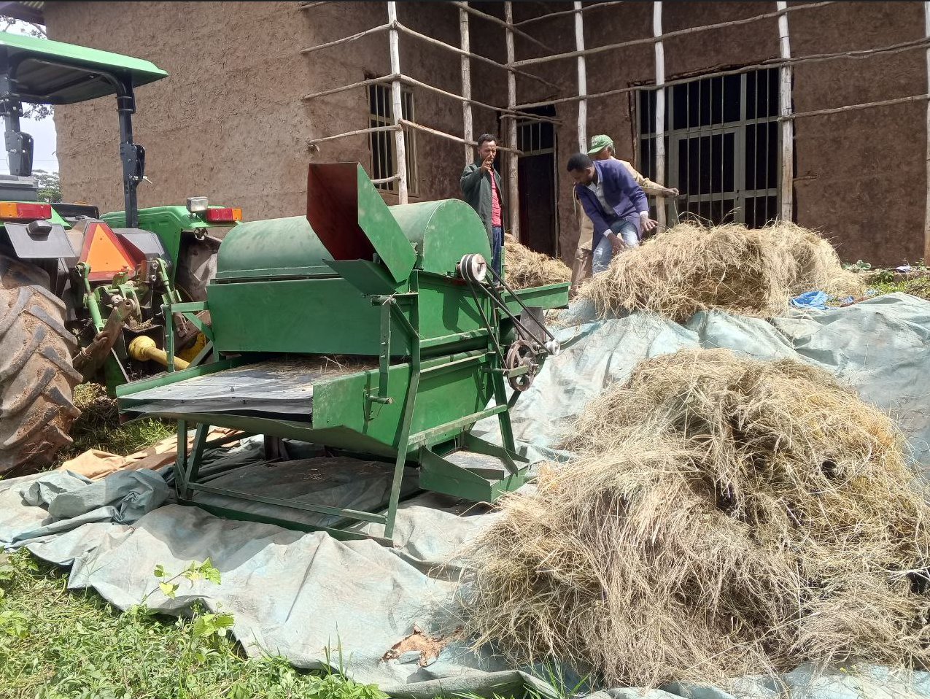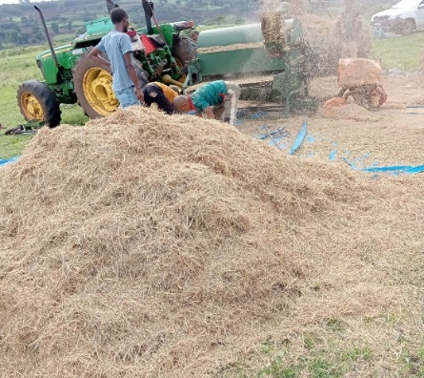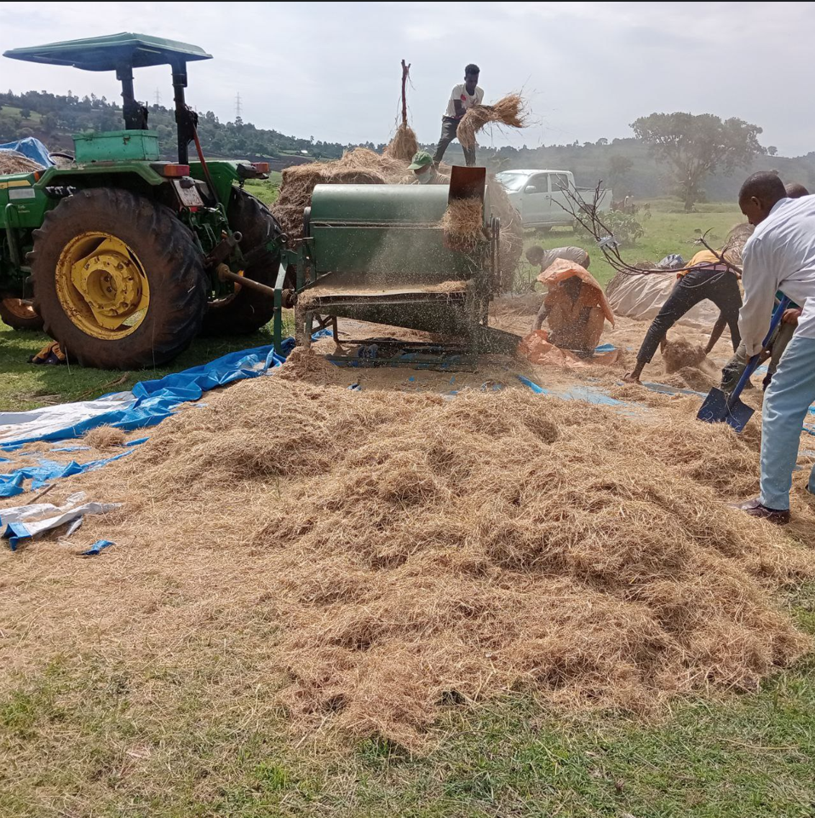
Figure 1: Photo taken during technology evaluation
Data collected
Total weight of the sample, weight of threshed grain, weight of unthreshed grain, and weight of the chaff
Performance Evaluation
Threshing efficiency
The threshing efficiency was determined using the relationship as determined by Ndirika (1994)
$TE=100-\frac{Q_{u}}{Q_{T}}×100$
Where, TE threshing efficiency in percentage,
QU = unthreshed quantity of grains in a sample in kg
QT = the total quantity of grains (kg) threshed and unthreshed in the Sample
Cleaning efficiency
The cleaning efficiency was determined using the relationship as determined by Ndirika (1994) and Gbabo, et al. (2014)
$C_{E}= \frac{(W_{t-}W_{c})}{W_{t}}×100$
Where: CE = Cleaning efficiency in percent
Wt = total weight at the outlet in kilograms and
W_{C} = chaff weight at the outlet in a kilogram
Threshing capacity
The thresher capacity was determined using the relationship as determined by Ndirika (1994) Ndirika (1994) and Gbabo, et al. (2014)
Tc = $\frac{Q_{s}}{T}$
Where: TC = threshing capacity expressed in kilograms per minute (kg /h)
QS =quantity of grains collected at the grain outlet in kilograms and
T = time taken to thresh in minutes
Shattering loss (SL): Shattering loss was determined using the relationship described by Ndirika (1994) Ndirika (1994) and Gbabo et al. (2013):
$$S_{L}=\frac{Q_{l}}{Q_{t}}×100$$
Where: S_{L} = Scatter loss expressed as a percentage,
Q_{l} =the number of grains scattered from the machine in kilograms, and
Q_{t} =total quantity of sample grains in kilograms.
Data analysis
The experiment was arranged in a split-plot experimental design with three replications, giving a total of 27 observations. Drum speed was assigned to the main plots, while feeding rate was allocated to the subplots. The data collected were subjected to analysis of variance (ANOVA) following procedures appropriate to the split-plot design, as described by Gomez and Gomez (1984) .Treatment means that differed significantly at the 5% level of significance (P ≤ 0.05) were separated using the least significant difference (LSD) test. All statistical analyses were performed using R-Stat statistical software.
Results and Discussion
The results obtained from the experimental trials were analyzed and are discussed in the following sections.
Threshing capacity
The maximum threshing capacity of the machine was 553.57 kg/hr, which was obtained at maximum RPM (800) and 30 kg/min feed rate. Conversely, the minimum threshing capacity recorded was 379.89 kg/hr, which occurred at a speed of 700 RPM and a feed rate of 22 kg/min. As shown in Table 1, there are significant differences in the threshing capacity of the machine based on both speed and feed rate, as well as their interaction. These findings align with the research conducted by (Amponsah et al., 2017), which demonstrated that an increase in both feed rate and threshing drum speed resulted in enhanced threshing capacity for paddy grain.
Similarly, (Faisal and Nasr, 2020) reported a comparable trend, where the machine's capacity improved with increased feed rates and higher drum speeds. For instance, they observed that at a feed rate of 20 kg/min and a drum speed of 1600 rpm, the machine's capacity reached 300 kg/hr, whereas it was only 150 kg/hr at a lower feed rate of 10 kg/min with a drum speed of 1400 rpm. This consistent pattern across different studies underscores the importance of optimizing both feed rate and drum speed to maximize the capacity of threshing operations.
Table 1. Effects of drum speed, feeding rate, and their interaction on threshing capacity
Feed rate x speed |  | Speed (rpm) |  |  | Speed (rpm) | Mean | Feed (kg/min) | Mean
 |  | 700 | 750 | 800
Feed rate (kg/min) | 22 | 379.89^{d} | 443.96^{d} | 455.13^{cd} | 700 | 449.13^{c} | 22 | 426.33^{c}
Feed rate (kg/min) | 26 | 455.17^{cd} | 458.41^{cd} | 492.87^{bc} | 750 | 476.35^{b} | 26 | 469.82^{b}
Feed rate (kg/min) | 30 | 512.33^{b} | 526.69^{ab} | 553.57ª | 800 | 500.52ª | 30 | 530.86ª
SE | 18.64 |  |  |  | 18.64
LSD | 39 .51 |  |  |  | 22.81
CV |  |  |  |  | 4.80

Cleaning Efficiency (%)
The maximum cleaning efficiency (96.38) was obtained at a 22 kg/min feeding rate and 800 rpm drum speed. The minimum cleaning efficiency (90.72) was obtained at a 30 kg/min feeding rate and 700 rpm drum speed. At a constant drum speed of 700 rpm, increasing the feed rate from 22 to 30 kg/min resulted in a decline in cleaning efficiency from 94.69% to 90.72%. A similar decreasing trend was observed at 750 and 800 rpm, although the impact was slightly mitigated due to improved aerodynamic separation at higher speeds. The ANOVA table showed that the cleaning efficiency of the thresher was significantly affected (p<0.05) by drum speed. Whereas the feed rate and their interaction had no significant effect (p>0.5) on cleaning efficiency. Similar findings were reported by (Ashebir, Woyessa, and Gabiso 2023)

Table 2. Effect of drum speed, feeding rate, and their interaction on cleaning efficiency
Feed rate x speed |  | Speed (rpm) |  |  | Speed (rpm) | Mean | Feed (kg/min) | Mean
 |  | 700 | 750 | 800
Feed rate (kg/min) | 22 | 94.69^{bc} | 95.68^{ab} | 96.38ª | 700 | 92.62^{b} | 22 | 95.58ª
Feed rate (kg/min) | 26 | 92.45de | 93.59^{cd} | 94.28^{bc} | 750 | 93.72ª | 26 | 94.89ª
Feed rate (kg/min) | 30 | 90.72^{f} | 91.90^{ef} | 92.48de | 800 | 94.38ª | 30 | 91.77ª
SE | 0.69 |  |  |  |  |  | 0.39
LSD | 1.45 |  |  |  |  |  | 0.84
CV |  |  |  |  | 0.90

Threshing efficiency
The threshing efficiency is influenced by various operating parameters, notably the feed rate and drum speed. According to ANOVA results, both feed rate and drum speed have a statistically significant effect on threshing efficiency. As presented in Table 3, increasing the drum speed from 700 to 800 rpm at a constant feed rate of 22 kg/min improved the threshing efficiency from 98.46% to 99.65%. Similarly, increasing the feed rate from 22 to 30 kg/min at a constant drum speed of 700 rpm resulted in a decrease in threshing efficiency, indicating that higher feeding rates may reduce the performance of the machine under lower drum speeds. This trend is supported by (Kidanmariam et al., 2023), who found that higher feed rates increased unthreshed grain and separation loss, especially at suboptimal drum speeds, in their evaluation of teff threshers under Ethiopian field conditions.
Table 3. Effect of drum speed, feeding rate and their interaction on the threshing efficiency
Feed rate x speed |  | Speed (rpm) |  |  | Speed (rpm) | Mean | Feed (kg/min) | Mean
 |  | 700 | 750 | 800
Feed rate (kg/min) | 22 | 98.46^{bcd} | 99.20^{ab} | 99.65ª | 700 | 99.12ª | 22 | 99.10ª
Feed rate (kg/min) | 26 | 97.72de | 98.66^{bc} | 99.1^{ab} | 750 | 98.56^{b} | 26 | 98.49^{b}
Feed rate (kg/min) | 30 | 96.84e | 97.83^{cd} | 98.6^{bcd} | 800 | 97.67^{c} | 30 | 97.76^{c}
SE | 0.44 |  |  |  |  |  | 0.25
LSD | 0.9189 |  |  |  |  |  | 0.53
CV |  |  |  |  | 0.54

Threshing loss (%)
Table 4. Effect of drum speed, feeding rate, and their interaction on threshing loss
Feed rate x speed |  | Speed (rpm) |  |  | Speed (rpm) | Mean | Feed (kg/min) | Mean
 |  | 700 | 750 | 800
Feed rate (kg/min) | 22 | 3.2^{bc} | 2.4.^{de} | 3.2^{bc} | 700 | 3.38^{b} | 22 | 3.49ª
Feed rate (kg/min) | 26 | 3.16^{c} | 2.20e | 3.30^{bc} | 750 | 2.46^{c} | 26 | 3.17ª
Feed rate (kg/min) | 30 | 3.76^{b} | 2.80^{cd} | 4.73ª | 800 | 3.74ª | 30 | 3.76ª
SE | 0.28 |  |  |  | 0.16
LSD | 0.58 |  |  |  | 0.34
CV |  |  |  |  | 10.64

The ANOVA analysis of threshing loss (%) showed that threshing loss was significantly (p < 0.05) influenced by both drum speed and the interaction between drum speed and feed rate. The minimum average threshing loss of approximately 2.20% was observed at a drum speed of 750 rpm with a feed rate of 26 kg. Higher threshing losses were recorded at 30 kg feed and 800 rpm speed, likely due to unthreshed and seed loss caused by the high feeding rate combined with fast drum rotation. This indicates that optimizing both feed rate and drum speed is critical to minimizing seed loss during teff threshing.
Conclusion and Recommendation
Conclusion
Adaptation of the tractor PTO operated teff thresher was done, and its performance evaluation was conducted in the farmers’ field. This study demonstrated that the adapted tractor PTO-operated teff thresher is significantly influenced by key operational parameters, particularly feed rate and drum speed. The results showed that optimal threshing efficiency, reaching up to 99.65%, was attained at a drum speed of 800 rpm and a feed rate of 22 kg/min. Conversely, increasing the feed rate beyond 30 kg/min negatively affected both threshing and cleaning efficiency, highlighting the importance of appropriate feed rate management.
Cleaning efficiency was more responsive to variations in feed rate than drum speed, and seed losses remained within acceptable ranges, with minimum losses observed at a drum speed of 750 rpm. Overall, the findings indicate that the machine performs optimally at drum speeds of 750 and feed rates of 26 kg/min. These operating conditions offer a practical balance between efficiency, throughput, and seed quality. Therefore, the BAERC teff thresher is technically suitable for deployment in Ethiopian agricultural systems, provided it is properly calibrated for varying field conditions and crop characteristics.

Recommendation
Based on the findings of this study, it is recommended that the teff thresher be operated at a drum speed of 750 rpm and a feed rate of 26 kg/min to achieve optimal performance.
To enhance performance at higher feed rates, improvements in the cleaning system, particularly the aerodynamic separation mechanisms, are advised. Training should also be provided to machine operators and farmers to ensure proper use and maintenance of the thresher, maximizing efficiency and machine life.
Finally, agricultural extension services and policymakers are encouraged to support the dissemination and adoption of this technology through awareness campaigns, demonstration trials, and subsidized distribution, contributing to improved post-harvest handling and food security in teff-growing areas.

Reference
Amponsah, Shadrack Kwadwo, Ahmad Addo, Komla Dzisi, Jean Moreira, And Sali Atanga Ndindeng. 2017. Comparative Evaluation of Mechanized and Manual Threshing Options for Amankwaa and Agra Rice Varieties in Ghana. Journal of Agricultural Engineering Xlviii. Doi:10.4081/Jae.2017.684.
Ashebir, Tsegaye, Degefa Woyessa, And Tamirat Gabiso. 2023. Performance Evaluation of CAAMs Teff Thresher. International Journal of Precision Farming 1(1): 25–30.
CSA, 2023. Central Statistical Agency Statistical Report On 2023. (July).
Faisal, And Nasr. 2020. The Performance Evaluation of Thresher Machine Attached to A Tractor. Journal Of Agriculture and Research 6(3): 7–16.
Gbabo, Agidi, Lukman Abdullahi, And A M Kuku. 2014. Design, Fabrication and Testing of Improved Traditional Rice Parboiler. J. Sci. Res. Rep, 30, 917–934
Gebru, Yoseph Asmelash, Desta Berhe Sbhatu, And Kwang-Pyo Kim. 2020.Nutritional Composition and Health Benefits of Teff (Eragrostis Tef (Zucc.) Trotter). Journal Of Food Quality 2020(1): 9595086.
Gomez, Kwanchai A, And Arturo A Gomez. 1984. Statistical Procedures for Agricultural Research. John Wiley and Sons.
Kibi, Gelgelo. 2021. Modification And Evaluation Bako teff Thresher to Tractor PTO Operation International Journal of Engineering Research-Online. 9(4). Doi:10.33329/Ijoer.9.4.1.
Kidanmariam, Geta, Daniel Tilahun, And Adamu Zegeye. 2023. Effect of Designed Threshing Unit on Performance of Teff [Eragrostistef (Zucc.) Trotter] Thresher. Agricultural Engineering International: Cigr Journal 25(3): 210–22.
Ndirika, V I O. 1994. Development And Performance Evaluation of a Millet Thresher. Journal Of Agricultural Engineering and Technology 2(1): 80–89.
Tiguh, Eniyew Eskezia, Mulugeta Admasu Delele, Addisu Negash Ali, Geta Kidanemariam, And Solomon Workneh Fanta. 2024. “Assessment of Harvest and Postharvest Losses Of Teff (Eragrostistef (Zucc.)) And Methods of Loss Reduction: A Review.” Heliyon 10(9).

