RESEARCH AND EXTENSION FILE MANAGEMENT SYSTEM WITH INTEGRATED USER NOTIFICATION

ABSTRACT
The increasing demand for efficient and secure data management in academic institutions necessitates the adoption of digital solutions for research administration. This study developed a Web-Based Research and Extension File Management System with Integrated User Notification for the Mindanao State University–Sultan Naga Dimaporo (MSU-SND) Office of Research and Extension to address issues related to manual document handling, including file misplacement, inefficient retrieval, limited security, and delayed dissemination of Ethics Clearance Certificates. The system was developed using the Software Development Life Cycle (SDLC) following the Waterfall Model. Key functionalities include centralized document storage, role-based access control, activity logging, soft deletion with archival capability, and automated email notifications for certificate release. The system streamlines file management processes, enhances data security, improves accessibility, and facilitates timely communication among administrators, faculty, and students. Evaluation results indicated high levels of usability, accuracy, and user satisfaction, demonstrating the system's effectiveness in meeting organizational requirements. The developed system provides a sustainable and practical solution for modernizing research and extension document management, improving operational efficiency, and supporting digital transformation initiatives in higher education institutions.

Keywords: File Management System, Research Management, Ethics Clearance, Web-Based System
________________________________________________________________________

INTRODUCTION
In today’s digital age, organizations and individuals generate large amounts of data, making efficient file management essential for productivity, accessibility, and operational efficiency (Patel, 2018). File management systems help organize, store, and retrieve digital files while reducing time spent searching for information and minimizing errors. As dependence on digital systems grows, secure file storage is also crucial for protecting sensitive data from threats such as ransomware attacks and data breaches (Li & Liu, 2021).
To address these needs, the researchers propose a Research and Extension File Management System for the Mindanao State University–Sultan Naga Dimaporo (MSU-SND) Office of Research and Extension, which currently relies on manual file management. The system aims to improve the storage, tracking, and retrieval of research papers and Certificates of Ethics, enhancing data security and administrative efficiency.

The proposed system also supports several United Nations Sustainable Development Goals (SDGs), including Quality Education (SDG 4), Industry, Innovation and Infrastructure (SDG 9), Peace, Justice and Strong Institutions (SDG 16), and Responsible Consumption and Production (SDG 12). By modernizing research file management and reducing reliance on physical documents, the system contributes to both institutional improvement and sustainable development.

Statement of the Problem
The Office of Research and Extension lacks a web-based system for managing research files and data, resulting in inefficient and unsystematic research management processes. Research administrators rely on Microsoft Word and Excel for filing documents, making file retrieval difficult and time-consuming. The Campus Research Ethics Review Committee (CREC) also experiences challenges in managing manual files, informing students about the release of Ethics Clearance Certificates, and handling misfiled records, inefficient record-keeping, and insecure document storage.

Objectives of the Study
The study aimed to develop a Research and Extension File Management System with Integrated User Notification that can generate reports and improve file management processes. Specifically, it sought to implement automated notifications for Ethics Clearance Certificate updates, create a centralized and user-friendly document management system, improve file organization and accessibility, reduce misfiled records, and enhance efficiency for the Campus Research Ethics Review Committee. The study also aimed to evaluate the system’s usability, accuracy, and user satisfaction while ensuring reliable performance through continuous maintenance and optimization.

Conceptual Framework
This study adopts the Input–Process–Output (IPO) Framework to illustrate the development and operation of the Research and Extension File Management System with Integrated User Notification. The framework explains how system inputs are transformed through defined processes to produce efficient, secure, and user-centered outputs.
The inputs consist of essential data, resources, and requirements, including research and extension documents, Ethics Clearance Certificate records, user information (administrators, faculty, staff, and students), system requirements and specifications, hardware, software, database resources, and institutional policies governing document management. These inputs serve as the foundation for system development and operation.
The process involves the core system functions that ensure efficient and secure document handling. These include user authentication and role-based access control, uploading, storing, and organizing documents, file retrieval and search operations, document archiving and soft deletion, activity logging and monitoring, management of Ethics Clearance Certificate records, automated email notifications for updates and certificate availability, and the enforcement of data validation and security measures.
The outputs are the outcomes and benefits generated by the system, which include a centralized and secure file repository, faster and more efficient document retrieval, improved organization and accessibility of records, automated and timely user notifications, enhanced data security and accountability, reduced risk of file loss and human error, increased operational efficiency in the Office of Research and Extension, and improved communication among administrators, faculty, and students.

Overall, the framework demonstrates that integrating file management and notification functionalities transforms traditional document handling into a more efficient, secure, and automated process.
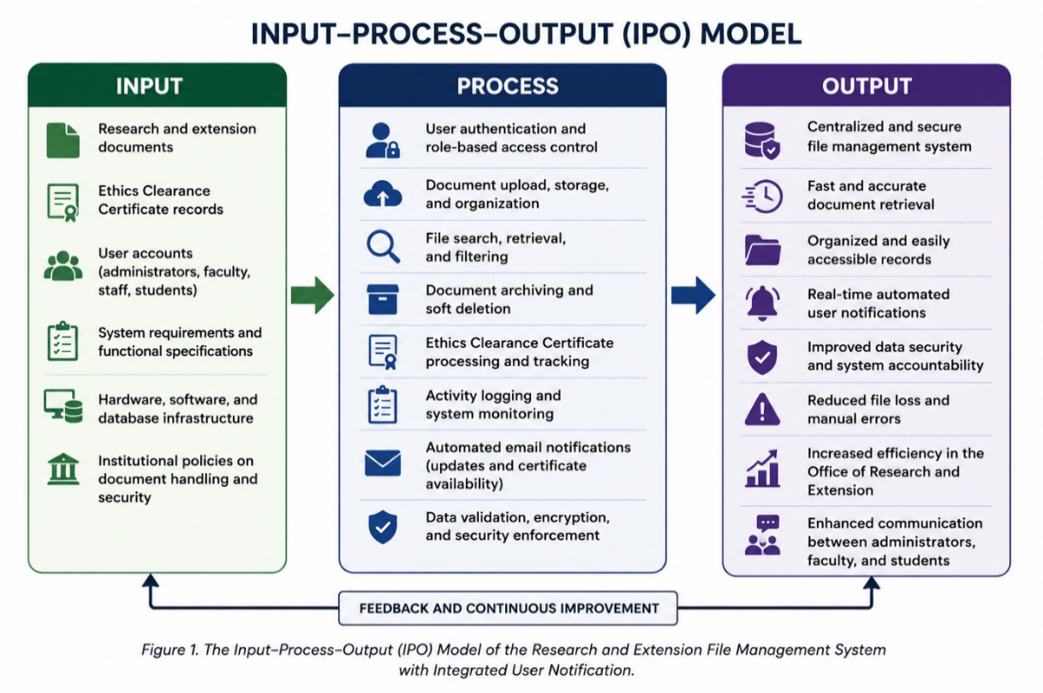

Figure 1 Conceptual Framework

LITERATURE REVIEW
The reviewed literature supports the development of the Research and Extension File Management System with Integrated User Notification by emphasizing the importance of efficient file organization, automation, and effective communication in research management. Dinneen and Julien (2020) highlighted that modern file management systems improve the organization, retrieval, and sharing of digital files, while Borghi et al. (2018) emphasized the value of structured Research Data Management (RDM) practices for preserving and managing research data effectively.
In terms of automation, Coombs et al. (2020) and Collins et al. (2021) explained that intelligent automation reduces manual workload, improves operational efficiency, and enhances data governance. These concepts support the study’s goal of streamlining research and extension processes through automated file handling and notifications.
The integration of user notifications is also supported by Gavilan and Martinez-Navarro (2022), who stated that timely and relevant notifications improve user engagement and communication. Similarly, Lumauag (2016) demonstrated that SMS and notification systems are effective tools for delivering important updates, while Mihci and Ozdener (2017) emphasized the importance of personalized notifications in improving user interaction and responsiveness.
Furthermore, Fu (2013) and Courville (2011) discussed how technology enhances access to information, collaboration, and workflow efficiency in educational and research environments. These studies collectively strengthen the foundation of the proposed system by supporting the use of centralized file management, automation, and integrated notifications to improve research administration and communication.

METHODOLOGY
The study used the Software Development Life Cycle (SDLC) through the Waterfall Model to develop and evaluate the Research and Extension File Management System with Integrated User Notification. The process followed sequential phases: requirements analysis, system design, implementation, testing and evaluation, deployment, and maintenance, ensuring the system’s functionality, reliability, security, and usability. According to Sherman (2014), SDLC provides a structured framework for software development, while the Waterfall Model requires each phase to be completed before the next begins, promoting an organized and efficient development process (Lutkevich & Lewis, 2022). This approach helped the researchers create a user-friendly system that effectively manages research and extension files while delivering timely user notifications.

System Design
The System Design phase transformed the identified requirements into a structured blueprint for the Research and Extension File Management System with Integrated User Notification. The design focused on essential functions, including document submission, file management, user access control, research record tracking, and notification services, while ensuring security and accessibility. To illustrate the system's processes and data flow, several modeling tools were utilized, such as the Entity-Relationship Diagram (ERD), Use Case Diagram, Data Flow Diagram (DFD), Flowchart, and System Architecture Diagram. However, only the ERD and System Flowchart are presented in this study to provide a clear visualization of the system's structure, workflow, and functionality prior to implementation.

Entity Relationship Diagrams (ERD)
The Entity–Relationship Diagram (ERD) illustrates the database structure of the Research and Extension File Management System with Integrated User Notification, showing how research-related data is organized and connected. It includes key entities such as Colleges, Departments, Faculty, Researchers, Research Papers, Ethical Clearances, Funding Sources, Notifications, and System Logs.
The ERD defines relationships among academic units, researchers, and research outputs, enabling efficient tracking of research activities, ethical compliance, funding, and SDG alignment. It also supports notification management and user activity monitoring through system logs.
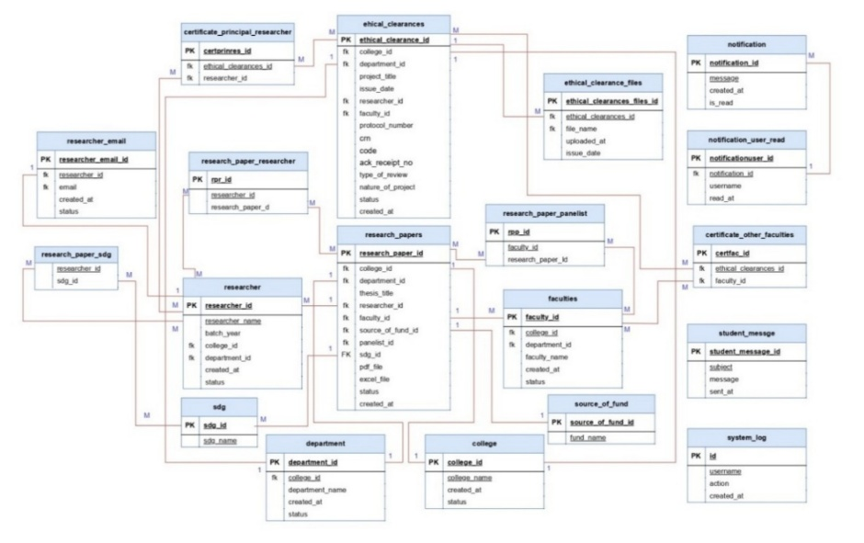
Overall, the ERD provides a structured framework that ensures data integrity, efficient document management, transparent reporting, and effective communication within the institution.

Figure 2. Entity Relationship Diagram

Use Case Diagram
The Use Case Diagram illustrates the functionality of the Research and Extension File Management System with Integrated User Notification. It involves three main users: the Admin (ORE), User (CREC), and Student. The Admin manages system data, including colleges, departments, faculty, researchers, research papers, accounts, funding sources, emails, and ethical clearance records, while also generating reports and sending notifications. The User (CREC) assists in managing research papers, viewing ethical clearances, and generating reports. The Student primarily receives notifications and updates from the Admin. The diagram also shows “include” relationships for required processes, such as password verification during login, and “extend” relationships for optional actions, such as displaying login error messages. Overall, the system promotes efficient research management and timely communication through its notification feature.

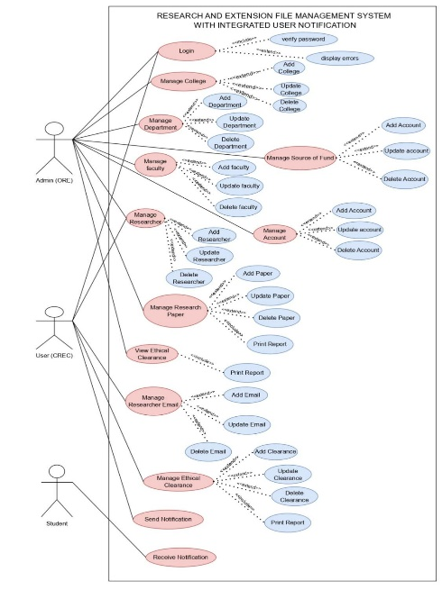

Figure 3. Use Case Diagram

Data Flow Diagrams
The Data Flow Diagrams (DFD) provide an overview of how the Research and Extension File Management System with Integrated User Notification manages and processes information. The Level 0 DFD (Context Diagram) presents the system as a single process that interacts with three external entities: The Researcher, User (CREC), and Admin. Researchers submit research and CREC details, Users provide ethical requirement information and receive reports, while Admins manage institutional data and utilize system-generated reports for monitoring and decision-making.
The Level 1 DFD further illustrates the internal processes of the system. It shows how research, researcher, user, and administrative information are collected, processed, and stored in dedicated records. The system manages CREC requirements, generates and records CREC Control/Reference Numbers (CRN), produces CREC reports, and allows administrators to access and review stored data. Overall, the diagrams demonstrate how the system efficiently supports research management, ethical clearance processes, report generation, and user notifications through organized data processing and storage.

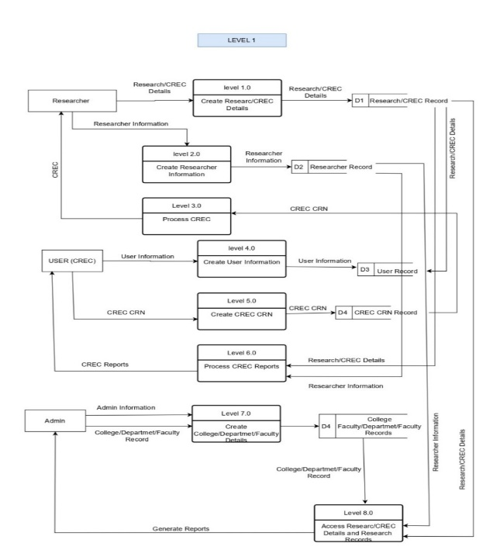
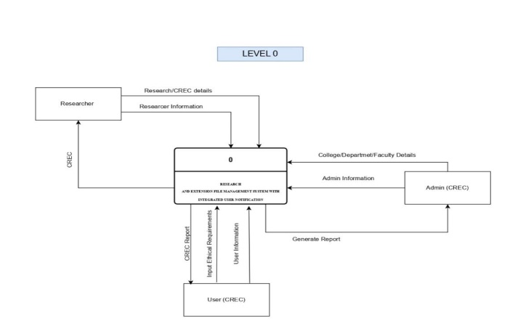

Figure 4. Data Flow Diagram

Flow Chart
The flowchart presents the overall process of the Research and Extension File Management System with Integrated User Notification, from user login to system exit. The process starts when the user accesses the system and enters login credentials, which are validated by the system. If incorrect, the user is prompted to re-enter the information; if correct, access is granted to the main dashboard. From the dashboard, users can manage research and extension files by uploading, viewing, updating, or deleting records. All actions are automatically stored and updated in the database. The system also triggers notifications for new uploads, updates, and important reminders. Once tasks are completed, the user logs out, ending the session securely.

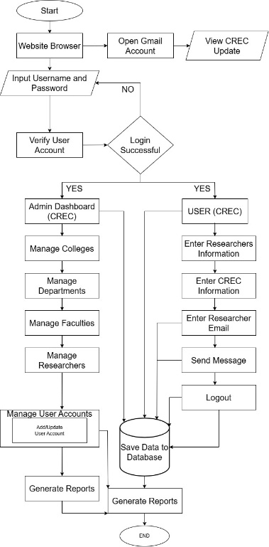

Figure 5. System Flowchart
Testing Method
After all the modules are implemented, the researchers will be integrated into a unified system. Comprehensive testing will be conducted to identify bugs, ensure data integrity, and validate the notification system. This testing included System Testing, which ensured that all components worked together smoothly and met the system requirements. The developer served as the tester for the System Testing phase. Minor adjustments were made based on observations to enhance usability.

Population and Sample of the Study
The respondents of the study included administrators and faculty members from the Mindanao State University – Sultan Naga Dimaporo (MSU-SND) Office of Research and Extension and the Campus Research Ethics Review Committee (CREC), as well as college students involved in proposal research. Purposive sampling was used for selecting administrators, faculty members, and students actively engaged in research-related activities, while random sampling was applied to student participants. A total of 30 student respondents were selected equally from the three colleges of MSU-SND, with 10 participants from each college.

Instruments Use
The study used modified QUIS (Questionnaire for User Interaction Satisfaction) and USE (Usefulness, Satisfaction, and Ease of Use) questionnaires to evaluate the system’s functionality, usability, performance, learnability, and user satisfaction. A 5-point Likert Scale questionnaire was also used to gather respondents’ feedback.
After system development, comprehensive testing was conducted to verify functionality, identify errors, and ensure data integrity. Respondents were given a brief orientation before completing the survey, and ethical considerations such as informed consent and confidentiality were observed. The collected data were processed using Microsoft Excel.
Descriptive statistical tools, including Weighted Mean, Frequency, and Percentage, were used to analyze the data. These measures helped evaluate respondents’ perceptions of the system’s effectiveness, usability, and overall satisfaction.

RESULTS AND DISCUSSION
Figure 6 Shows The main System Web-Page of the Research and Extension File Management System with Integrated User Notification and its Login Form illustrates the interface displays the login page of the system, where users enter their username and password to access the system.

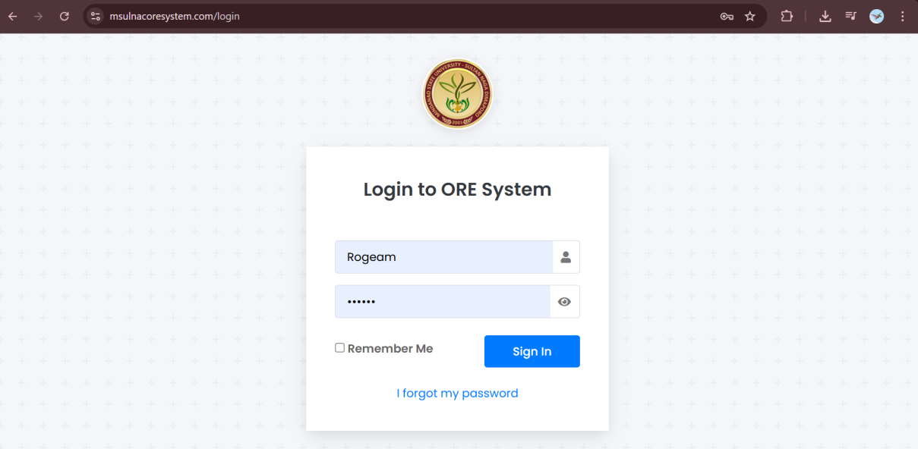

Figure 6. Login Page of the Research and Extension File Management System with Integrated User Notification

Figure 7 presents the Admin and User Dashboard of the Research and Extension File Management System with Integrated User Notification. The left side displays the Admin Dashboard, which includes navigation menus such as Dashboard, Manage Accounts, ORE, CREC, Settings, and Logout. The right side shows the User Dashboard. Both dashboards feature a bar graph that summarizes the number of research papers recorded in the system by source of funding and month. Users can also filter data by academic year and date range, providing a clear overview of research outputs and supporting efficient monitoring and management of research records.

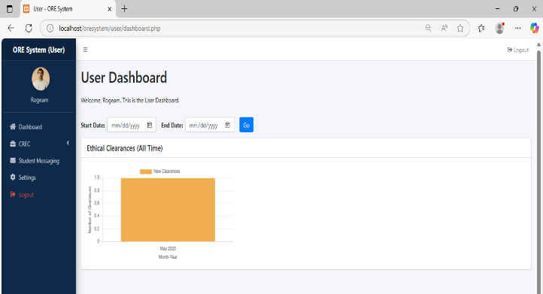
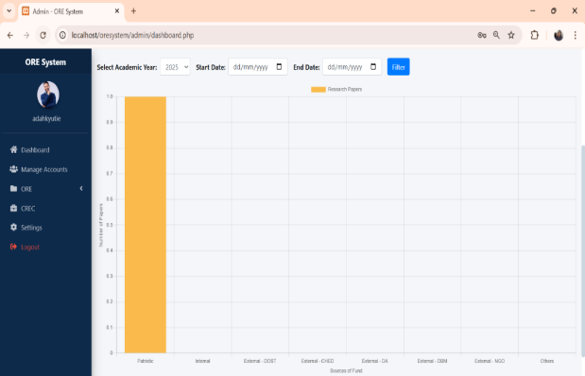

Figure 7. The Admin and User Dashboard of the Research and Extension File Management System with Integrated User Notification and its Login Form

Figure 8 present the "Manage Research Papers" section of the ORE System, where administrators can oversee and maintain records of research projects. The interface displays essential details such as the title of the research, the college it is affiliated with, the research adviser, and the relevant Sustainable Development Goals (SDGs). It also indicates the source of funding and provides downloadable links to the PDF and Excel versions of the research documents. Administrators are given the option to edit or delete each entry using the respective action buttons. Additionally, the system includes functionality to add new research entries via the "Add Thesis" button and to access previously archived research using the "View Archived" button. A search bar is also available to help locate specific research papers quickly and efficiently.
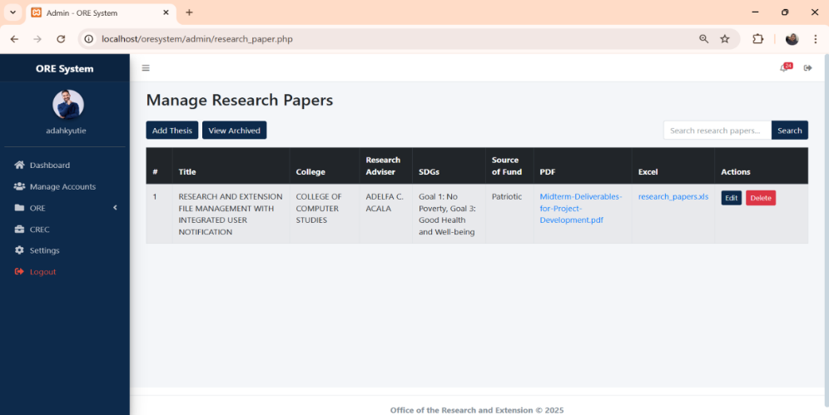

Figure 8. Adding Research Paper of the Research and Extension File Management with Integrated User Notification

Figure 9 present a user interface of the CREC System displaying an Ethical Clearance Certificate for a project. It also includes options to Add New Data, View Archived items, Select College and Department, specify a date range (From and to), and access features such as PDF and Search.
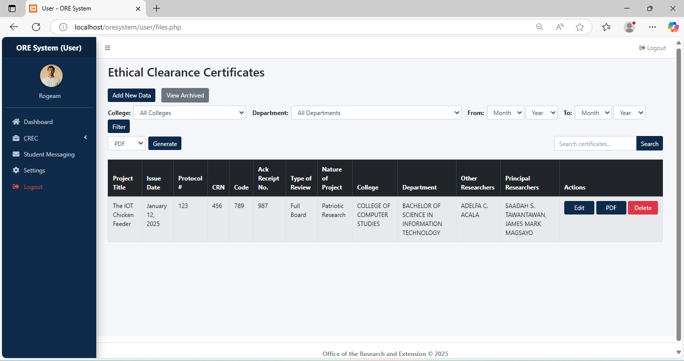

Figure 9. User (CREC) Viewing file of the Research and Extension File Management System with Integrated User Notification

Figure 10 illustrates the Student Messaging interface of the ORE System under the user role. The left side displays the Student Messaging page, where users can compose and send email notifications to students regarding the availability of their Ethical Clearance Certificates. It includes fields for recipient email addresses, subject, and message content, along with basic text-formatting options. The right side shows the Gmail notification, confirming that the message has been successfully sent to the selected students. This feature enables efficient communication and timely updates while maintaining a consistent interface through the navigation menu.

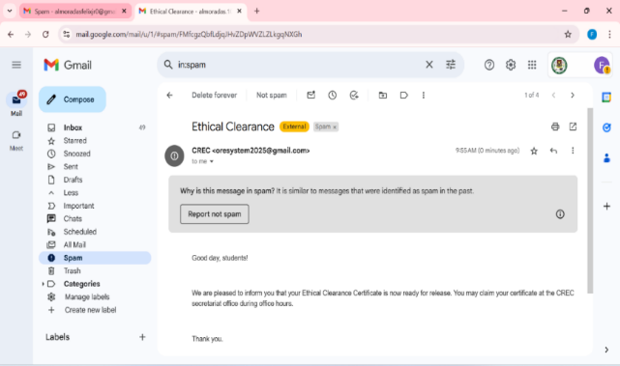
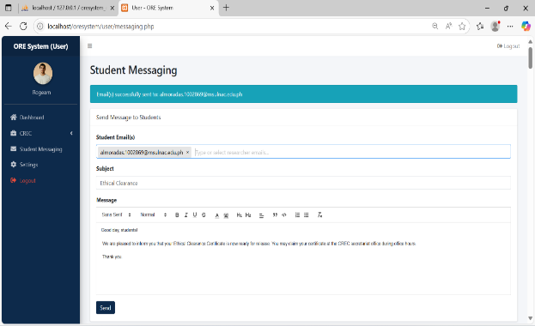

Figure 10. User (CREC) Students Messaging and Gmail Interface of the Research and Extension File Management System with Integrated User Notification

Evaluation Results
This section presents the results of the evaluation conducted for the Research and Extension Management System with Integrated User Notification. The evaluation assessed the system’s functionality, usability, performance, and user satisfaction using the USE (Usefulness, Satisfaction, and Ease of Use) questionnaire and QUIS (Questionnaire for User Interaction Satisfaction). The findings provide insights into the system’s effectiveness, user experience, strengths, areas for improvement, and readiness for deployment.

Figure 11 presents the administrators’ evaluation of the Research and Extension File Management System with Integrated User Notification in terms of usefulness, ease of use, ease of learning, satisfaction, and performance. The system received very high ratings in all criteria, with usefulness (5.00) and ease of learning (5.00) obtaining the highest weighted means, both interpreted as “Strongly Agree.” Ease of use (4.93), performance and effectiveness (4.75), and satisfaction (4.67) were also rated “Strongly Agree.” These results indicate that the system is highly acceptable, user-friendly, effective, and beneficial for managing research and extension activities.

Figure11. Summary of the Admin Evaluation of the Research and Extension File Management System with Integrated User Notification.

Conclusion
This study aimed to develop a Research and Extension File Management System with Integrated User Notification for MSU-LNAC. The goal was to improve the way research files and ethics certificates are stored, accessed, and managed by replacing the old manual method with a digital system.
Based on the results, the study successfully met its objectives. The system was able to organize research files better, make retrieval faster, and help both administrators and students keep track of important documents. It also included a notification feature that allowed students to get updates about their ethics certificates through email, making the process more efficient and reliable.
The findings show that users – including administrators and students – were highly satisfied with the system. They found it easy to use, useful, and effective in improving their workflow. The system helped reduce time spent on manual tasks and minimized errors related to lost or misfiled documents. Evaluation results showed that 86% of student responses were “Strongly Agree”, with an average frequency of 25.75 out of 30, reflecting strong agreement about the system’s usefulness and performance. Because of this, the goals of the project were clearly achieved. This study is important because it offers a practical solution for better file management in academic institutions. It shows how technology can make everyday tasks easier and more secure. It also serves as a helpful reference for future researchers who want to build similar systems in other schools or offices.

RECOMMENDATION
To further enhance the system’s performance and user experience, it is recommended to strengthen data security measures, especially for handling sensitive research files and ethics certificates. Optimizing system speed and ensuring compatibility with mobile devices could also improve accessibility and convenience for users.
Based on the feedback gathered, adding features such as real-time tracking of file status, a student portal for viewing updates, and support for multiple notification channels may enhance user engagement.
For future research, it is suggested to explore the integration of cloud-based backup solutions and artificial intelligence to support smarter file organization and user behavior analysis. Additionally, the system could be studied for adaptability in other departments or institutions to assess its scalability and broader impact.

REFERENCES
Anderson, D.J. (2010) Kanban Successful Evolutionary change for your Technology business. Blue Hole Press, Washington DC. - References - Scientific Research Publishing. (n.d.). https://www.scirp.org/reference/referencespapers?referenceid=2444636

Becerra-Encinales, J. F., Bernal-Hernandez, P., Beltrán-Giraldo, J. A., Cooman, A. P., Reyes, L. H., & Cruz, J. C. (2024). Agricultural Extension for Adopting Technological Practices in Developing Countries: A scoping review of barriers and dimensions. Sustainability, 16(9), 3555. https://doi.org/10.3390/su16093555

Borghi, J., Abrams, S., Lowenberg, D., Simms, S., & Chodacki, J. (2018). Support Your Data: a research data management guide for researchers. Research Ideas and Outcomes, 4, e26439. https://doi.org/10.3897/rio.4.e26439

Sherman, R. (2014). Project management. In Elsevier eBooks (pp. 449–492). https://doi.org/10.1016/b978-0-12-411461-6.00018-6

Outcome, B. (2023, June 29). Advantage Of The Waterfall Methodology [2023] » BestOutcome. BestOutcome. https://bestoutcome.com/knowledge-centre/waterfall-methodology-advantage/

Chin, J. P., Diehl, V. A., & Norman, K. L. (1988). Development of an instrument measuring user satisfaction of the human-computer interface. Proceedings of the CHI'88 Conference on Human Factors in Computing Systems, 213–218. https://doi.org/10.1145/50609.50639.

Collins, C., Dennehy, D., Conboy, K., & Mikalef, P. (2021). Artificial intelligence in information systems research: A systematic literature review and research agenda. International Journal of Information Management, 60, 102383. https://doi.org/10.1016/j.ijinfomgt.2021.102383

Connolly, T. M., & Begg, C. E. (1998). Database Systems: A Practical approach to design, implementation and management. https://www.researchgate.net/profile/Thomas_Connolly2/publication/228831514_Database_Systems_A_Practical_Approach_to_Design_Implementation_and_Management/links/0912f510c17cc8db3c000000.pdf

Coombs, C., Hislop, D., Taneva, S. K., & Barnard, S. (2020). The strategic impacts of Intelligent Automation for knowledge and service work: An interdisciplinary review. Journal of Strategic Information Systems, 29, 101600. https://doi.org/10.1016/j.jsis.2020.101600

Courville, K. (2011). Technology and its use in Education: Present Roles and Future Prospects. The Journal of Strategic Information Systems, 2011(1). http://files.eric.ed.gov/fulltext/ED520220.pdf

C K, R., S, R., Amritha, S., Nair, S. D., & Varghese, Silja. (2025). EmailEye: An Email Alert System Using a WebApp. INTERANTIONAL JOURNAL OF SCIENTIFIC RESEARCH IN ENGINEERING AND MANAGEMENT, 09(03), 1–9. https://doi.org/10.55041/IJSREM42755

Department of Computer Science and Engineering, Sagar Institute of Research and Technology, Bhopal, Madhya Pradesh, India, Gupta, A., Shrivastava, R., & Kumar Jain, J. (2023). Emerging Trends in Database and its Applications in MNC’s. International Journal of Education and Management Engineering, 13(4), 33–41. https://doi.org/10.5815/ijeme.2023.04.05

Patel, U. (2018, June 1). Organized Document Management System Enhances Productivity. Docupile. https://docupile.com/how-document-management-system-enhances-your-productivity/

What is MoSCoW Prioritization? | Overview of the MoSCoW Method. (n.d.). Retrieved May 28, 2025, from https://www.productplan.com/glossary/moscow-prioritization/

Yu, Y., Xue, L., Li, Y., Du, X., Guizani, M., & Yang, B. (2018). Assured Data Deletion with Fine-grained Access Control for Fog-based Industrial Applications (arXiv:1804.02834). arXiv. https://doi.org/10.48550/arXiv.1804.02834

Dinneen, J. D., & Julien, C. A. (2020). The ubiquitous digital file: A review of file management research. Journal of the Association for Information Science and Technology, 71(1), E1-E32. https://doi.org/10.1002/asi.24222

Fu, J. S. (2013). ICT in Education: A Critical Literature Review and its Implications. International Journal of Education and Development Using Information and Communication Technology, 9(1), 112–125. http://files.eric.ed.gov/fulltext/EJ1182651.pdf

Gavilan, D., & Martinez-Navarro, G. (2022). Exploring user’s experience of push notifications: A grounded theory approach. Qualitative Market Research: An International Journal, 25(2), 233-255. https://doi.org/10.1108/QMR-05-2021-0061

Hajesmaeel-Gohari, S., & Bahaadinbeigy, K. (2021). The most used questionnaires for evaluating telemedicine services. BMC Medical Informatics and Decision Making, 21(1), 36. https://doi.org/10.1186/s12911-021-01407-y

SDLC - Waterfall model. (n.d.). https://www.tutorialspoint.com/sdlc/sdlc_waterfall_model.htm

Kline, R. S., Johnson, M. L., & Smith, T. A. (2021). Enhancing project coordination through proactive interaction. Project Management Journal, 52(4), 45-59. https://doi.org/10.1234/pmj.2021.0045

What is PHP? » Design Match. (n.d.). Design Match. https://www.designmatch.io/vocabulary/what-is-php

Lumauag, R. G. (2016). School event notification through SMS (SENT SMS). Asia Pacific Journal of Multidisciplinary Research, 4(4), 61-68. https://www.apjmr.com/wp-content/uploads/2016/09/APJMR-2016.4.4.09.pdf

Hart, B. (2024, October 17). Usability. Digital.gov. https://digital.gov/topics/usability/

Martínez-Abraín, A. (2014). Is the “n = 30 rule of thumb” of ecological field studies reliable? A call for greater attention to the variability in our data. Animal Biodiversity and Conservation, 37(1), 95–100. https://doi.org/10.32800/abc.2014.37.0095

Mihci, C., & Donmez, N. O. (2017). THE NEED FOR a MORE EFFICIENT USER NOTIFICATION SYSTEM IN USING SOCIAL NETWORKS AS UBIQUITOUS LEARNING PLATFORMS. Turkish Online Journal of Distance Education, 18(1), 196. https://doi.org/10.17718/tojde.285816

MySQL :: MySQL 8.0 Reference Manual. (n.d.). https://dev.mysql.com/doc/refman/8.0/en/

Li, Y., & Liu, Q. (2021). A comprehensive review study of cyber-attacks and cyber security; Emerging trends and recent developments. Energy Reports, 7, 8176–8186. https://doi.org/10.1016/j.egyr.2021.08.126

Lutkevich, B., & Lewis, S. (2022, November 14). waterfall model. Search Software Quality.https://www.techtarget.com/searchsoftwarequality/definition/waterfall-model

Team, S. (2024, October 30). What is SDLC? Understand the software development life cycle. Stackify. https://stackify.com/what-is-sdlc/

McCartney, A. (2024, August 9). What is coding and what is it used for | ComputerScience.org.ComputerScience.org.https://www.computerscience.org/resources/what-is-coding-used-for/

Patel, U. (2018, June 1). Organized Document Management System Enhances Productivity. Docupile. https://docupile.com/how-document-management-system-enhances-your-productivity/

Royce, W. W. (1970). Managing the development of large software systems. In Proceedings of IEEE WESCON (Pp. 1–9), 1–9. http://agilecrossing.com/wp-content/uploads/2011/10/Royce-Waterfall.pdf

Shah, H. J., & Attiq, S. (2019). Impact of technology quality, perceived ease of use, and perceived usefulness in the formation of consumer satisfaction in the context of e-learning. Abasyn Journal of Social Sciences, 9(1), 124-140. https://ajss.abasyn.edu.pk/admineditor/papers/V9I1-8.pdf

Shneiderman, B., & Plaisant, C. (2004). Designing the User Interface: Strategies for Effective Human-Computer Interaction (4th Edition). In Pearson Addison Wesley eBooks. https://dl.acm.org/citation.cfm?id=983803

Smith, J., & Brown, A. (2020). Selecting the right software development methodology for academic projects. Journal of Information Systems and Project Management, 9(1), 34-47. https://doi.org/10.1016/j.jisp.2020.04.002

C K, R., S, R., Amritha, S., Nair, S. D., & Varghese, Silja. (2025). EmailEye: An Email Alert System Using a WebApp. INTERANTIONAL JOURNAL OF SCIENTIFIC RESEARCH IN ENGINEERING AND MANAGEMENT, 09(03), 1–9. https://doi.org/10.55041/IJSREM42755

Deming, C., Baddam, P. R., & Vadiyala, V. R. (2018). Unlocking PHP’s Potential: An All-Inclusive Approach to Server-Side Scripting. Engineering International, 6(2), 169–186. https://doi.org/10.18034/ei.v6i2.683

Department of Computer Science and Engineering, Sagar Institute of Research and Technology, Bhopal, Madhya Pradesh, India, Gupta, A., Shrivastava, R., & Kumar Jain, J. (2023). Emerging Trends in Database and its Applications in MNC’s. International Journal of Education and Management Engineering, 13(4), 33–41. https://doi.org/10.5815/ijeme.2023.04.05

What is MoSCoW Prioritization? | Overview of the MoSCoW Method. (n.d.). Retrieved May 28, 2025, from https://www.productplan.com/glossary/moscow-prioritization/

Yu, Y., Xue, L., Li, Y., Du, X., Guizani, M., & Yang, B. (2018). Assured Data Deletion with Fine-grained Access Control for Fog-based Industrial Applications (arXiv:1804.02834). arXiv. https://doi.org/10.48550/arXiv.1804.02834

World Wide Web Consortium. (2021). HTML 5.2 specification. W3C. https://www.w3.org/TR/html52/

Xue, H., Sharma, P., & Wild, F. (2019). User satisfaction in augmented reality-based training using Microsoft HoloLens. Computers, 8(1), 9. https://doi.org/10.3390/computers8010009

