Adaptive post- disaster shelter strategies in contemporary architecture in India.

ABSTRACT
The increasing frequency and intensity of natural and human-induced disasters have amplified the need for efficient, adaptable, and resilient post-disaster shelter solutions. This research investigates contemporary architectural approaches to temporary and rapid relief shelters, with a particular focus on their applicability within diverse and disaster-prone contexts such as India. Through a comprehensive review of literature and case-based analysis, the study examines various shelter typologies, including membrane, modular, compact, and traditional construction systems, highlighting their performance in terms of speed of deployment, adaptability, cost-efficiency, and user comfort.
The research further evaluates emerging design strategies that integrate prefabrication, local materials, and climate-responsive techniques to enhance resilience and sustainability. Emphasis is placed on the role of community participation, cultural sensitivity, and socio-spatial considerations in improving the effectiveness and acceptance of shelter solutions. Findings reveal that while modular and prefabricated systems offer significant advantages in scalability and rapid assembly, challenges related to affordability, logistical constraints, and long-term usability persist.
By synthesizing global practices and contextual insights, the study proposes a holistic framework for designing post-disaster shelters that balance technological innovation with local relevance. The research contributes to the discourse on disaster-responsive architecture by advocating for integrated, flexible, and human-centered shelter strategies that not only address immediate needs but also support long-term recovery and resilience.
Keywords: Resilience, Transitional Housing, Sustainability, Reconstruction, Adaptability
INTRODUCTION
Disasters, both natural and human-induced, pose significant disruptions to human settlements, often exceeding the capacity of communities to respond using their available resources. Over the past decades, the frequency and intensity of such events have increased substantially, leading to widespread destruction of infrastructure, loss of life, and large-scale displacement of populations. In contemporary times, this situation is further aggravated by ongoing global conflicts, including the war in Ukraine, prolonged instability in the Middle East, internal conflicts across parts of Africa, political unrest in Myanmar, and violence-driven crises in regions of the Americas. These conditions collectively contribute to an urgent and continuous demand for effective post-disaster and emergency shelter solutions.
Among the most immediate needs following a disaster is the provision of shelter, which serves not only as protection from environmental conditions but also as a space for safety, privacy, recovery, and basic human functioning. The challenge, however, lies in designing shelters that can be rapidly deployed while simultaneously addressing physical, psychological, and socio-cultural needs. Temporary shelters, therefore, occupy a critical position within disaster management frameworks, particularly in the emergency relief phase where timely intervention is essential for survival and stabilization.
Architectural responses to post-disaster sheltering have evolved significantly, ranging from traditional construction techniques to advanced modular, membrane-based, and compact systems. Each approach reflects different priorities such as speed of construction, cost efficiency, adaptability, and user comfort. Recent studies emphasize that construction systems play a decisive role in determining the performance and feasibility of shelter solutions, as they directly influence transportation, installation, durability, and environmental compatibility.
Despite numerous innovations, the design of temporary shelters remains a complex and often contradictory process. Shelters are expected to be lightweight yet durable, cost-effective yet comfortable, and temporary yet capable of supporting extended habitation. Additionally, they must respond to diverse climatic conditions and cultural contexts while being scalable for mass deployment. These competing demands highlight the need for a comprehensive evaluation of existing shelter typologies and design strategies.
In this context, the present research investigates contemporary post-disaster shelter systems through a comparative analysis of different construction typologies, including modular, membrane, compact, and traditional systems. By examining their strengths, limitations, and applicability in real-world scenarios, the study aims to identify effective design criteria and propose adaptable, resilient, and human-centered shelter solutions. Ultimately, the research seeks to contribute to the broader discourse on disaster-responsive architecture by addressing the critical gap between immediate emergency needs and long-term recovery strategies.

MATERIALS AND METHODS
Post-disaster response, supported by prior preparedness, is generally divided into three phases: emergency relief, early recovery, and reconstruction. The emergency phase is the most crucial, as it focuses on providing immediate shelter to help people cope with the initial impact of a disaster. This study examines recent innovations in temporary shelter design used during this stage. These shelters, selected for their practical feasibility and simple construction systems, represent diverse design approaches from countries such as Japan, the USA, and those used in India. They are categorized into four types—modular, compact, membrane, and traditional—and evaluated based on lifespan, safety, space adequacy, and potential for expansion.
Disaster management today combines both preventive and responsive strategies, including advancements in urban planning and construction technologies. Research highlights approaches such as data-driven planning for disaster-resilient smart cities, classification of shelters based on duration, and the use of computational design to improve spatial efficiency. Innovative materials like cardboard and fabric, prefabricated folding systems, and algorithm-based textile structures have also been explored. There is a growing shift toward using locally available materials due to their environmental benefits, along with increased focus on social, economic, and environmental sustainability. Additionally, newer concepts view shelters not just as physical structures but as evolving environments, while some studies explore integrating protective systems within buildings or using natural processes to reduce disaster risks. Overall, the research reviews both current and emerging strategies for shelter design in response to disasters such as floods, earthquakes, and tsunamis.

CASE STUDIES
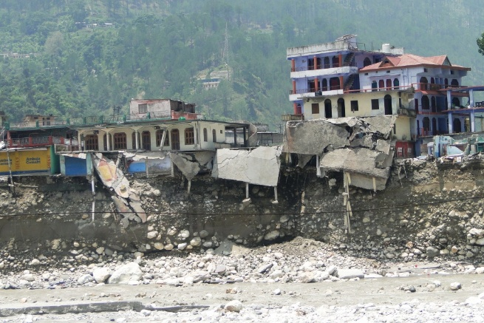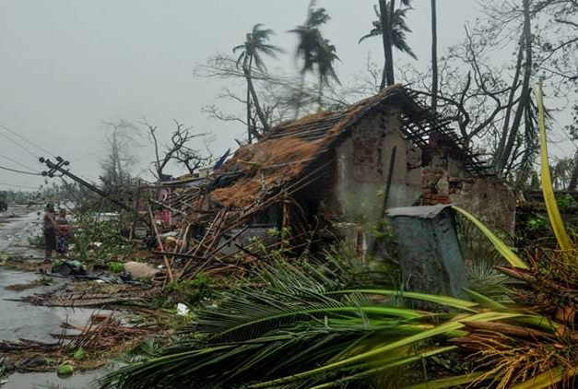
Uttarakhand Floods (2013) Cyclone Fani Odisha (2019)
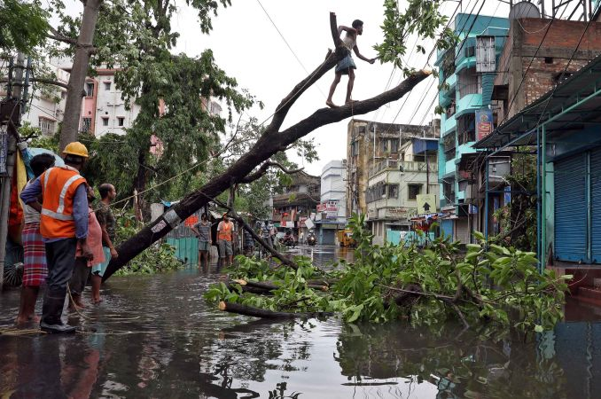
Cyclone Amphan (2020) Indian Red Cross Society
The 2013 floods in Uttarakhand caused widespread devastation, impacting 12 of the state’s 13 districts. The most severely affected areas were Rudraprayag, Chamoli, Uttarkashi, and Pithoragarh (Indian Red Cross Society, 2013). Over 4,000 villages were impacted, and about 3,320 homes were completely destroyed. The crisis intensified due to the concurrent Hindu pilgrimage and peak tourist season, which significantly increased the number of people in the region.
Intense flooding destroyed roads, bridges, and essential infrastructure, leaving thousands stranded. In response, the Indian Army, Air Force, and paramilitary forces were deployed to conduct large-scale rescue operations, successfully evacuating more than 110,000 individuals from the affected regions (The World Bank, 2014).
Relief efforts included the provision of temporary family tents, each designed to house up to eight people. Additionally, essential relief materials such as family kits—containing kitchen utensils, clothing, and buckets—along with stoves, lanterns, and tarpaulins, were distributed to support immediate survival needs (Indian Red Cross Society, 2013).
On 3 May, Cyclone Fani—a powerful Category 4 storm—made landfall across the Indian states of Odisha, Andhra Pradesh, and West Bengal, with Odisha experiencing the most severe impact. In Odisha alone, more than 15 million people were affected, including nearly 4.8 million children. The cyclone was notable for its rarity, as it occurred during the summer season, making it the first such event in 43 years and one of only three cyclones to strike Odisha in the past 150 years.
While large-scale loss of life was largely prevented, the storm significantly disrupted the lives and livelihoods of over 28 million people across the three states. To reduce casualties, authorities in Odisha, Andhra Pradesh, and West Bengal undertook extensive preparedness efforts, including the evacuation of residents from vulnerable low-lying areas to multipurpose cyclone shelters before landfall. In addition, emergency relief materials such as tarpaulin sheets, bamboo, and medical kits were distributed to meet immediate needs (IRFC, 2019).
On 20 May 2020, Tropical Cyclone Amphan hit India and Bangladesh, making landfall along the eastern coast in West Bengal and Odisha with wind speeds of up to 210 km/h. The cyclone affected nearly 60 million people in India, resulted in at least 95 fatalities, displaced hundreds of thousands into temporary shelters, and damaged or destroyed more than 2.9 million houses. It also caused extensive agricultural losses, destroying around 1.7 million hectares of cropland and aquaculture areas, and leading to the death of approximately 2.1 million livestock (Ober, 2020). The situation was further complicated as the disaster occurred during the COVID-19 pandemic, adding to the difficulties faced by affected communities (Mondal & Chowdhury, 2021).
States like Odisha and West Bengal, which frequently experience cyclones and flooding, have developed stronger disaster response systems over time. The Indian Red Cross Society (IRCS), along with its state branches, enhanced its preparedness through trained personnel, active volunteers, and well-equipped cyclone shelters, particularly in Odisha. In coordination with the Indian Meteorological Department and State Disaster Management Authorities, early warnings were issued, Social Emergency Response Volunteers (SERV) were mobilized, and essential supplies such as food, hygiene kits, and other relief materials were pre-positioned. At the same time, COVID-19 precautions, including social distancing measures, were maintained in shelters and safe zones (IRFC, 2021).
In partnership with government agencies, IRCS volunteers supported evacuation efforts in vulnerable areas, helping communities move to safer locations. Following the cyclone, they participated in damage assessments, distributed relief materials, provided first aid, and promoted hygiene practices. Immediate shelter support was also offered through the distribution of tarpaulins and mosquito nets to families who had lost their homes, ensuring basic protection in the aftermath of the disaster (IRFC, 2021).

TYPES OF DISASTER RELIEF SHELTERS
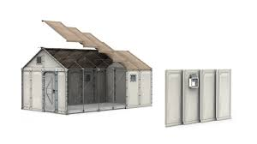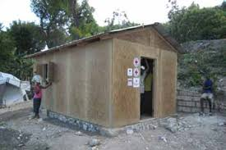
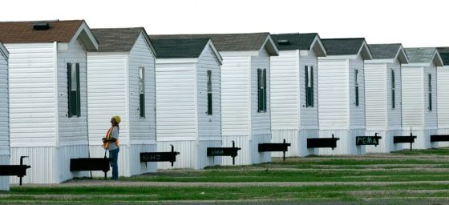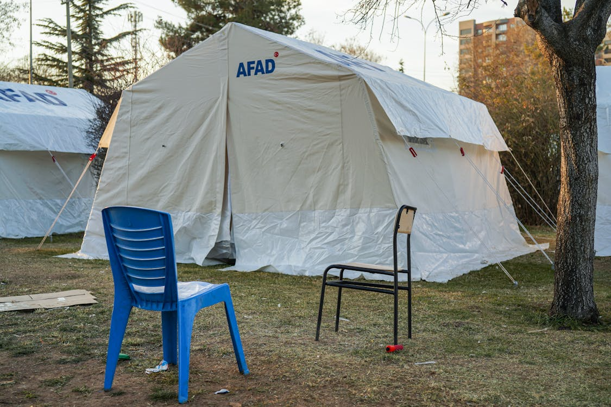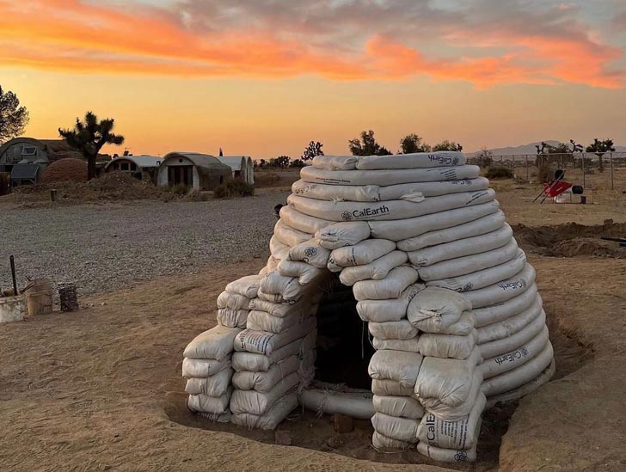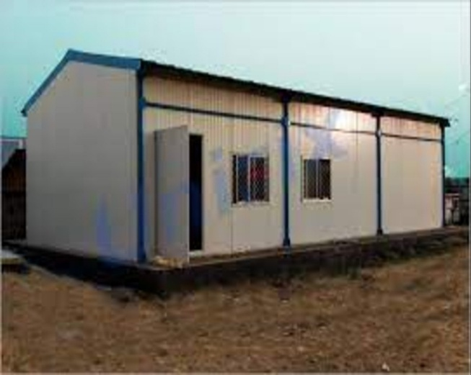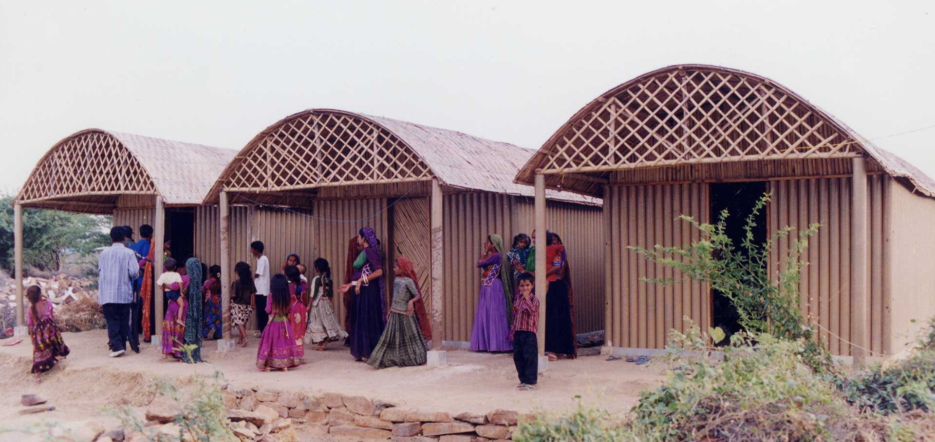
Better Shelter
Better Shelter units have been primarily implemented in Bangladesh and, to a smaller extent, in Nepal. A prominent example is their large-scale use in Rohingya refugee camps in Cox’s Bazar. Although they are not widely adopted within India, they remain relevant to the South Asian context due to their proximity and applicability. These shelters are designed as modular, flat-pack systems that can be quickly assembled on-site, offering improved durability, safety, and protection compared to conventional temporary tents.
Re-Build Housing (Pakistan Flood Reconstruction)
Re:Build Housing initiatives in Pakistan, particularly after the 2010 floods, focused on creating resilient and locally appropriate housing solutions. These efforts emphasized the use of regional materials and construction practices to ensure sustainability and long-term usability. Although implemented in Pakistan, this approach is highly relevant to India due to similar environmental conditions and socio-economic challenges, making it a valuable reference for disaster recovery strategies.
FEMA-Type Trailers (Conceptual Reference)
FEMA trailers are primarily used in the United States; however, their concept has influenced temporary housing approaches in India. While not directly adopted, similar prefabricated and portable housing units have been utilized in regions such as Jammu & Kashmir and Ladakh. These units are particularly useful in extreme climatic conditions and post-disaster situations, providing quick and movable shelter solutions.
AFAD-Type Shelters
AFAD shelters, commonly used in Turkey, are another example of modular, container-based housing systems. Although they are not directly used in India, comparable prefabricated shelters have been deployed in disaster-affected areas like Jammu & Kashmir and Ladakh. These shelters offer durability, structural strength, and the ability to be reused, making them suitable for challenging environments.
Sandbag Shelters
Sandbag shelters are frequently used in India and Nepal, especially in flood-prone regions such as Assam and Bihar. These structures are made using locally available materials and are simple to construct, making them ideal for emergency situations. They serve both as protective barriers against flooding and as temporary shelter solutions, offering a low-cost and practical response to recurring disasters.
Paper Log Houses
Paper Log Houses, developed by Shigeru Ban, have been used in Nepal after the 2015 earthquake and experimented with in India following the 2001 Gujarat earthquake. These shelters use paper tubes as structural elements, making them lightweight, environmentally friendly, and quick to assemble. They demonstrate an innovative and sustainable approach to post-disaster housing.
Transitional Shelters (Common Approach in India)
In India, transitional shelters are widely used as a medium-term solution after disasters. Built with materials such as bamboo, timber, CGI sheets, and tarpaulin, they provide improved protection and living conditions compared to emergency shelters. They have been implemented in events like the Uttarakhand floods (2013), Nepal earthquake (2015), and Pakistan floods (2010). Their ability to be upgraded into permanent housing makes them a practical and efficient option.
Bamboo and Tarpaulin Shelters
Bamboo and tarpaulin shelters are the most common immediate-response structures in India. These are quick to assemble, cost-effective, and require minimal technical skills. They are widely used in flood relief camps in Assam and Bihar, during the Uttarakhand floods, and in cyclone-affected regions such as Odisha and West Bengal. Despite being temporary, their reliance on local materials allows for rapid and large-scale deployment.
Prefabricated Modular Shelters
Prefabricated shelters represent a more advanced and modern approach to disaster housing. Manufactured off-site and assembled on location, these units use materials like steel frames and insulated panels to provide better durability and thermal comfort. They have been used in regions such as Jammu & Kashmir and Ladakh, as well as in emergency setups across India during events like the COVID-19 pandemic. Their speed of installation and reusability make them an efficient, though relatively expensive, option.
Community-Built Shelters Using Local Materials
Community-built shelters rely on traditional construction methods and locally sourced materials such as mud, bamboo, stone, and thatch. These shelters are often developed with support from NGOs or government agencies and reflect local cultural practices. They were prominently used during the reconstruction after the Gujarat earthquake (2001) and the Kerala floods (2018), as well as in rural housing programs across India. This approach promotes community participation, reduces costs, and supports local livelihoods while creating culturally appropriate and sustainable housing solutions.
3D-printed housing
It offers clear advantages for post-disaster situations, though it is not without limitations. Its main strength lies in speed of construction, allowing shelters to be built quickly with minimal material waste. The technology also enables design flexibility, making it possible to adapt structures to local climates, cultural needs, and site conditions. Additionally, it reduces reliance on manual labor and can produce structurally efficient forms.
However, its application is restricted by factors such as the need for specialized machinery, skilled operation, consistent power supply, and specific construction materials. These challenges can make it less practical in remote or severely affected areas, particularly in countries like India.
As a result, 3D-printed housing can be considered an adaptive strategy in contemporary post-disaster architecture, but mainly for transitional or permanent reconstruction rather than immediate relief. It is most effective when combined with traditional shelter methods as part of a phased recovery approach.
In Mexico, 3D printing has been used to create a residential community for economically weaker families in Tabasco through a collaboration between ICON and New Story. These houses were produced using large-scale printing technology, allowing relatively fast construction. Although the project was not developed in response to a specific disaster, it addresses the needs of populations living in high-risk and vulnerable conditions, making it relevant to post-disaster reconstruction and resilient housing approaches.
In the United States, especially in Texas, 3D-printed homes by ICON have been designed to perform well under extreme weather conditions, including floods, fires, and strong storms. While they are not typically used for immediate disaster relief, these projects demonstrate the potential of 3D printing in delivering strong, long-lasting, and disaster-resistant housing, particularly for long-term recovery and resilience planning.

CHALLENGES FACED
Post-disaster reconstruction and recovery involve multifaceted challenges that impact both governments and affected populations. In urban contexts, these challenges are particularly complex compared to rural areas, largely due to higher population densities and the urgent need to provide shelter for a greater number of households. Urban residents occupy a wide range of housing conditions, including apartment complexes, informal settlements, and rented accommodations. Individuals living in informal or rental housing are especially vulnerable, as assistance programs often rely on land or property ownership criteria, which can exclude them from receiving support.
Emergency shelters can be constructed rapidly—aligning with international guidelines such as those proposed by UNHCR—but they frequently fall short in terms of comfort, safety, accessibility, and environmental performance. On the other hand, permanent or durable shelters take longer to build yet offer improved protection, longevity, and living conditions. Transitional shelters serve as a middle ground; they perform better than emergency shelters in aspects like safety, privacy, and comfort, but still do not reach the overall effectiveness of permanent housing solutions.
Conventional construction practices are often inadequate in disaster scenarios due to their slow pace, high resource demands, and limited flexibility. These methods struggle to respond efficiently to urgent needs and diverse environmental conditions. In the Indian context, designing disaster relief shelters requires careful consideration of cultural practices and logistical constraints. Shelters must accommodate extended family systems and shared spaces, reflecting local lifestyles. Collaboration among government agencies, non-governmental organizations, and private stakeholders is essential to ensure funding, scalability, and effective implementation.
The development of disaster relief shelters presents significant opportunities for innovation among architects, construction professionals, and policymakers. In India, the National Disaster Management Authority (NDMA), established under the Disaster Management Act of 2005, plays a central role in shaping disaster response strategies. It sets guidelines, coordinates resources, and ensures that shelters meet basic standards of safety, dignity, and habitability while promoting fairness in resource distribution.
Architects contribute by designing flexible, modular, and culturally responsive shelter solutions that extend beyond mere protection. Their work can support social and psychological recovery by creating spaces that respect community identity and living patterns. Meanwhile, the construction sector can accelerate these efforts through modern technologies such as prefabrication, modular systems, and 3D printing, enabling faster and more efficient shelter deployment. The use of sustainable and locally available materials not only minimizes environmental impact but also encourages community participation and reduces costs.
The Disaster Management Act further strengthens these efforts by enabling financial support through mechanisms like the Disaster Response Fund (DRF) and Disaster Mitigation Fund (DMF). These funding structures facilitate partnerships between public institutions, private entities, and civil society, promoting coordinated and scalable solutions. Engaging local communities and artisans in the construction process enhances cultural relevance, fosters a sense of ownership, and contributes to local economic development through skill-building and employment opportunities.
In conclusion, a coordinated approach involving government bodies, architects, the construction industry, and local communities is essential for developing effective and resilient disaster relief shelters. Supported by a strong legal and institutional framework, such collaboration not only addresses immediate shelter needs but also contributes to long-term recovery, sustainability, and community resilience.

CONCLUSION
Contemporary shelter strategies have been organized based on current trends, providing a framework for further research into disaster-responsive architectural solutions. Future studies can focus on improving construction techniques and technical standards within these approaches.
In India, designing rapid relief shelters requires a balanced approach that addresses both immediate needs and long-term recovery. Urban areas pose greater challenges due to dense populations and informal settlements, while rural contexts differ in scale and resources. Architects must therefore create adaptable, sustainable, and culturally responsive designs using innovative materials and methods. Projects like the paper-based shelters by Shigeru Ban and earthbag construction demonstrate the effective use of local materials and community participation.
The National Disaster Management Authority (NDMA) plays a key role in coordinating disaster response and funding through initiatives like the Disaster Response Fund and Disaster Mitigation Fund, enabling collaboration across sectors.
Technological advancements such as prefabrication and modular construction have improved the speed, efficiency, and adaptability of shelter deployment. At the same time, involving local communities enhances cultural relevance, sustainability, and social recovery.
Overall, integrating technology, policy support, and community engagement can result in resilient, efficient, and sustainable disaster relief shelters that contribute to long-term recovery.

REFERENCES
- Biswas, A., & Puriya, A. (2019). Exploring Indian post-disaster temporary housing strategy through a comparative review. International Journal of Disaster Resilience in the Built Environment, 10(2/3), 140–155. https://doi.org/10.1108/IJDRBE-09-2018-0037
- Chang, Y., Wilkinson, S., Potangaroa, R., & Seville, E. (2017). A new model for effective post-disaster housing reconstruction: Lessons from Gujarat and Bihar in India. International Journal of Project Management, 35(2), 263–276. https://doi.org/10.1016/j.ijproman.2016.10.001
- Nair, A., & Ramanathan, R. (2021). An inquiry into success factors for post-disaster housing reconstruction projects: A case of Kerala, South India. International Journal of Disaster Risk Science, 12(1), 48–63. https://doi.org/10.1007/s13753-020-00309-3
- Patel, S., & Hastak, M. (2022). Learning from habitat reconstruction initiatives: A new approach for reducing vulnerability of rural housing in India. Sustainability, 14(7), 4359. https://doi.org/10.3390/su14074359
- Tauber, G. (2023). Architects and post-disaster housing: A comparative study in South India. transcript Verlag. https://doi.org/10.14361/9783839466615
- Johnson, C., Lizarralde, G., & Davidson, C. (2022). People-centered disaster recovery: A comparison of long-term outcomes of housing reconstruction in Thailand, India, and Japan. International Journal of Disaster Risk Reduction, 72, 102844. https://doi.org/10.1016/j.ijdrr.2022.102844
- Shinde, K. A. (2016). Disruption, resilience, and vernacular heritage in an Indian city: Pune after the 1961 floods. Urban Studies, 53(14), 3026–3042. https://doi.org/10.1177/0042098016652777
- United Nations Development Programme. (2012). Post-disaster recovery framework and housing reconstruction in India. UNDP India
- National Disaster Management Authority. (2010). National guidelines on management of earthquakes. Government of India. NDMA India
- United Nations Human Settlements Programme. (2015). Shelter after disaster: Strategies for transitional settlement and reconstruction. UN-Habitat

