Ultrasonic Vibration-Assisted Windshield Water Removal: Analytical Frequency Derivation, FEA Validation, and Low-Cost Prototype Development

ABSTRACT
Traditional wipers operate under full mechanical load even during light rain, resulting in blade and motor wear, as well as streaking. This research examines an ultrasonic vibration-assisted addition to the conventional system. Specifically, we use the Rayleigh–Lamb plate-wave theory to derive an optimal band of 38–42 kHz with piezoelectric excitation for a 6.76 mm laminated automotive windshield. This proposed band was validated through ANSYS with a modal, harmonic-response, and acoustic analysis. These studies and analyses determined a safety margin of several orders of magnitude for the proposed band and confirmed glass failure, with sub-micron surface deformations of the windshield that were consistent with surface-wave atomization. A low-cost, assist-plus-mechanical-fallback system for prototype drive circuitry was constructed and consisted of an NE555 oscillator, an IRF520 N-channel MOSFET, and brass-backed PZT transducers with a custom 2.34 mH resonant matching inductor. Design features of the drive circuitry also included a swept-frequency output in the range of 38–42 kHz, which was verified using an oscilloscope. Bench validation of the system through salt-pattern nodal testing was used to confirm the predicted spacing of ultrasonic standing-wave nodes of λ/2 ≈ 20.4 mm, and qualitative imaging of particle displacement provided evidence of surface-wave-driven contaminant removal. The results of this research support a more commercial approach to a full wiper substitute system.

Keywords: Ultrasonic windshield cleaning, Rayleigh–Lamb wave, piezoelectric transducer, ANSYS FEA, NE555 oscillator, automotive safety, SDG 9

INTRODUCTION
The windshield wiper has not changed in over a century, and is one of the oldest mechanical safety features in the automobile. Although automobile technology has improved significantly in the last century, the design principle behind the wiper mechanism has not changed since 1969, and still uses a rubber blade that pivots and is dragged across the glass [1]. Given the unfortunate statistics on road safety, stagnation of windshield wiper technology is baffling. The World Health Organization estimates that there are 1.3 million fatalities and between 20 and 50 million people injured from road accidents; many accidents occur due to poor visibility and would likely be avoided if wipers operated better [2]. U.S. Federal Highway Administration studies report that 46% of fatal traffic accidents are attributed to poor visibility. Other studies show that, when looking at the issues of visibility, on average, one in five cars have inadequate or malfunctioning windshield wipers [3].
This has not gone unnoticed by the automobile industry. Windshields that are heated, wipers that move at high frequency, coatings that are designed to repel water, infrared rain sensors, are all technologies that at least partially tackle this issue. However, each of these technologies is either too expensive or addresses only a piece of the overall issue. Consequently, the majority of cars, both on Indian roads, and around the world, still rely on a purely mechanical windshield wiping system [4].

This paper explores the layering of ultrasonic vibration to the existing mechanical wiper system to create a light rain aid mechanism as a complementary approach. Although ultrasonic surface-wave excitation is well understood in the industrial cleaning baths, aircraft de-icing, and medical nebulizers, it has to the author’s knowledge never been used as a mechanism to assist automotive windshield wipers in published engineering literature [5]. The main idea is that a piezoelectric excitation system operating in the 38–42 kHz frequency range, and located on the inner side of laminated glass windshields, is able to not let light rain and mist accumulate to a level that requires full engagement of the mechanical wipers.
This project fits with United Nations Sustainable Development Goal 9 — Industry, Innovation and Infrastructure
— as it attempts to create resource efficient mechanical innovations to the existing automotive infrastructure. This research focuses on the use of engineering to improve air travel safety without needing to remove and replace existing automotive systems.

PROBLEM DEFINITION AND SIGNIFICANCE
Traditional windshield wipers activate at full force even during light rain, mist, or drizzle. During those conditions, the water volume on the glass doesn’t even warrant a full wipe. The all-or-nothing approach of traditional windshield wipers creates several problems:
The juicing effect: In light rain, the glass is only partially wetted while the rubber edge of the wiper blade is dragged across the glass. This creates dry friction increasing the rate at which the wiper blades dry out and increasing the rate at which they are replaced.

Wiper blade dry friction: The wiper wiper motor is activated with full force and the wipers themselves are started and stopped in a manner that approximates the intensity of the rain which provides an ineffective response the actual state of the surface wetness.
Diminished visibility: The combination of the previous two problems makes the glass actually more difficult to see through during the conditions when visibility is typically the worst.

Not only would decreasing the frequency of dry friction on the wiper blades save money, but the decreased power consumption would improve the battery efficiency of electric vehicles. Dedicating research to using ultrasonic excitation as a wiper assistance technology in light rain would be a significant advancement as no one else has approached the problem from that angle yet.

LITERATURE REVIEW
Five recent peer-reviewed and indexed studies (2023–2025) were reviewed to map the current state of wiper-system research:

Paper | Publication | Description | Limitations
Adaptive Windshield Wiper System Based on an Intelligent Control Algorithm | IJERT, 14(7),  2025 | PID-based rain sensor and speed control with DC motor reversal for dynamic wipe intervals. | No redesign for dead zones; no multi-sensor fusion or low-cost adaptation for India.
Automatic Control System Based on Machine Vision and Deep Learning | DOAJ-indexed, 2025 | Improved YOLOv8 CNN for real-time raindrop detection and automated wiper control. | Compute-intensive; unsuitable for budget vehicles; no mechanical linkage modification.

Optimization on Linkage System for Vehicle Wipers by Differential Evolution | Applied Sciences, 13(1), 2023 | Evolutionary algorithms to optimise linkage parameters for smoother wiper motion. | Fixed-speed simulations only; no real-rain testing or Indian dust-condition analysis.
Automatic Rain Sensing Car Wiper | IARJSET, 2024 | Microcontroller-driven intensity-based speed control for automated wiper engagement. | Basic sensor logic; ignores mechanism redesign and high-humidity Indian climate feasibility.
Real-Time Rain Detection and Wiper Control via Embedded Deep Learning | Elsevier/NTUT, post-2021 | Embedded deep learning for instant rain detection and adaptive wiper response. | Hardware-specific to premium setups; limited cost or manufacturability focus for India.
Table I: Summary of reviewed literature on windshield wiper systems

An obvious pattern exists in all of the new inventions; they have been directed toward the sensing and timing aspects of the wiper system. Not one of the five studies has challenged the physics of water removal or tested ultrasonic excitation, surface-acoustic wave atomization, or any other non-contact water displacement technique. None of them is specific to Indian dust-and-humidity operational conditions, which would be significantly different from those of Europe and East Asia which seem to be the assumed testing grounds in most of the cited literature.
Some of the key technical literature that was considered as part of this study includes: (a) The kinematic and structural schematic of a typical two-parallel arms wiper assembly which demonstrates that an ultrasonic assist layer can be added to the existing linkage without altering its configuration; (b) The results of tensile testing of PZT transducers when clamped as opposed to when mounted solely by adhesives showing that clamping adds 10% strength to the bond (from 13.64 MPa to 15.02 MPa); and (c) Photos of dust particle displacement on a vibrating surface.

RESEARCH GAPS
Synthesising the literature review against this project's objectives, four previously uncharacterised gaps were identified:
- Lamb-wave behaviour in laminated glass: Automotive windshields are glass–PVB–glass laminated assemblies. A₀-mode Lamb-wave propagation through this composite differs significantly from monolithic glass due to the viscoelastic PVB interlayer — a difference uncharacterised in the reviewed literature.
- Water removal limits under varying rainfall intensity: No study has experimentally defined the upper rainfall intensity at which ultrasonic excitation alone remains effective before mechanical wiping becomes necessary.
- Long-term transducer bond durability: PZT adhesive bond durability under combined thermal cycling and continuous vibration loading remains uncharacterised.
- Quantified lifespan benefit: No study has quantified the wiper-blade and motor lifespan improvement achievable by reducing mechanical activation cycles through an assist mechanism.
This project directly addresses gaps 1 and 2 through analytical and finite-element modelling, and lays the groundwork for gaps 3 and 4 through prototype development and a proposed future-testing framework.

OBJECTIVES

Primary objectives:
Four distinct gaps that have not been addressed in the existing literature in relation to the objectives of this project have been identified in the synthesis of the literature review:
- Lamb wave propagation in laminated glass: Automotive windshields are glass-PVB-glass assemblies. The nature of A₀-mode Lamb wave propagation through the laminated structure is different from that through the monolithic glass because of the viscoelastic PVB layer between glass panels – a gap that has not been addressed in the existing literature.
- Limits of water removal as a function of rainfall intensity: There is no literature available on defining the limits of rainfall intensity above which ultrasonic excitation will become ineffective.
- Longevity of transducer bonding: Longevity of PZT bonding under thermal cycling and vibration loading has not been addressed.
- Wiper blade and motor lifetime improvement: There is no quantification of the lifetime improvement of the wiper blades and wiper motors through this assist mechanism.
This project addresses gaps 1 and 2 using the analytical and finite-element modelling approach, and sets up the basis for addressing gaps 3 and 4.

METHODOLOGY
The project theoretical foundation involves three interdisciplinary areas of study: Structural wave mechanics (Rayleigh–Lamb plate waves theory), finite-element simulation (ANSYS modal, harmonic, acoustic analysis), and embedded electronics (resonant piezoelectric drive circuit design). Unlike empirical selection of frequency, in this project we follow a ‘derive-simulate-build’ process where each stage can be tested against the previous one.
The general process involved the following stages: (1) Literature Review and Problem Identification → (2) Frequency Selection based on Rayleigh–Lamb equations → (3) Windshield geometry model in ANSYS →
(4) Three independent FEA processes (Modal, Harmonic, Acoustic) → (5) Convergent analysis and results
→ (6) Circuit Prototype Building → (7) Feasibility Assessment.

ANALYTICAL FREQUENCY DERIVATION
The frequency selection method has been analytically obtained based on the Rayleigh–Lamb A₀ (antisymmetric, first order flexural) wave mode for the case of a 5 mm monolithic glass proof-of-concept plate (ρ = 2,500 kg/m³, E = 72 GPa, ν = 0.22) and then extrapolated to the case of the 6.76 mm laminated windshield. Main calculations for f = 30 kHz:
Bending Rigidity: D = Eh³ /[12(1–ν²)] = 788.15 N·m Surface Mass Density: Mₐ = ρh = 12.5 kg/m² Angular Frequency: ω = 2πf = 188,495 rad/s
Pftase Velocity: cₚ = √ω(D/Mₐ)^0.25 ≈ 1,223.5 m/s
Wavelength: λ = cₚ/f ≈ 40.8 mm → λ/2 ≈ 20.4 mm (node distance)

Acceleration of the Surface: a = ω²ξ ≈35,530 m/s² ≈ 3,625g (ξ = 1 µm assumed) Resonant Inductance: L = 1/(ω²C) ≈ 2.34 mH (C = 12 nF transducer capacitance)
Metric | at 30 kHz | at 40 kHz | Sweep Advantage
Wavelength | 40.8 mm | 35.3 mm | Nodes shift 5.5 mm → full-area coverage
Mist Droplet Size | ~42 µm | ~35 µm | Finer atomisation at upper end
Surface Acceleration | 3,625g | ~6,400g | Higher droplet displacement at 40 kHz
Inductor Match | Near-resonant | Fully resonant | Full resonance maximises drive efficiency
Table II: 30 kHz vs 40 kHz trade-off comparison
Swept frequency from 38 to 42 kHz was chosen instead of constant frequency. With a constant frequency, dry spots will remain in certain areas where nodes for standing waves are formed on the glass (nodes occur at intervals of λ/2 = 20.4 mm). With the use of a swept frequency, these nodes move across the glass surface.

FINITE-ELEMENT ANALYSIS

Model Geometry
A windscreen geometry was developed on ANSYS (2026 R1 Student) of 300 mm × 350 mm × 5 mm monolithic glass plate geometry (proof-of-concept design), with a fixed elastic support boundary condition along the bottom edge corresponding to the bonded windscreen edge. Two 0.4 N point forces were placed on specified transducer contact points to replicate piezoelectric actuator force. Three separate solver calculations were carried out on this validated geometry.
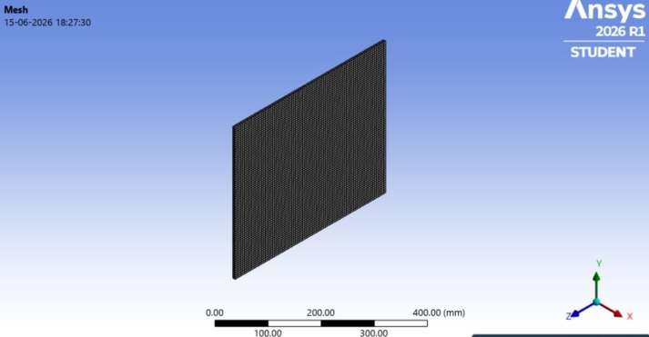

Modal Analysis
A total of ten vibration modes have been obtained. The first natural frequency of vibration mode is 388.83 Hz increasing progressively to 2,347.4 Hz for mode number 10 (intermediate modes: 725.92, 852.45, 1,162, 1,262.2,
1,562.4, 1,674.3, 1,855.9, 1,983.6 Hz). Clearly all low order modes are significantly lower than 38-42 kHz operational range thus confirming that the ultrasonic excitation will not lead
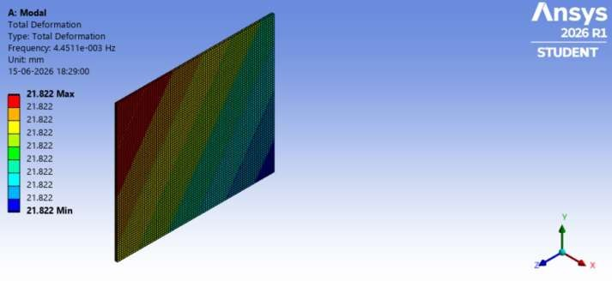

Harmonic Response Analysis
A frequency sweep from 20,000 to 30,000 Hz with two 0.4 N real-component point forces produced:
- Maximum equivalent (von Mises) stress at 30 kHz: 0.0038 MPa — several orders of magnitude below the yield strength of laminated automotive glass.
- Maximum directional (X-axis) deformation: ≈7.32 × 10⁻⁷ mm (sub-micron range at simulated drive amplitude).
- Maximum total harmonic deformation: ≈9.88 × 10⁻⁷ mm, distributed in a fine mesh-like standing-wave pattern — the physical signature of surface-wave behaviour the design exploits.
The most significant finding was the magnitude of the structural safety margin: 0.0038 MPa is dramatically below the failure threshold of laminated glass, indicating the design has substantial headroom to be driven at higher amplitudes. The more binding constraints are acoustic comfort and electrical efficiency rather than mechanical failure.

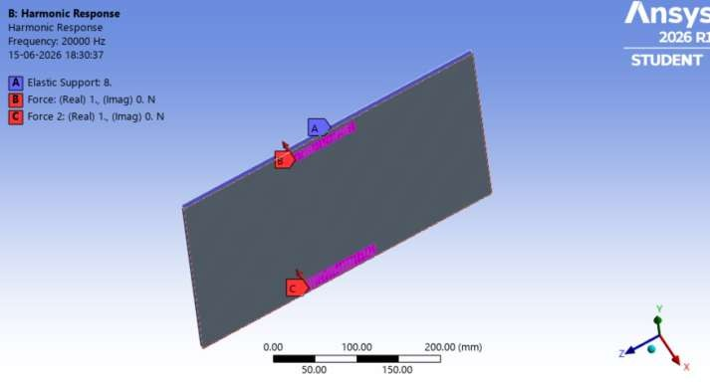
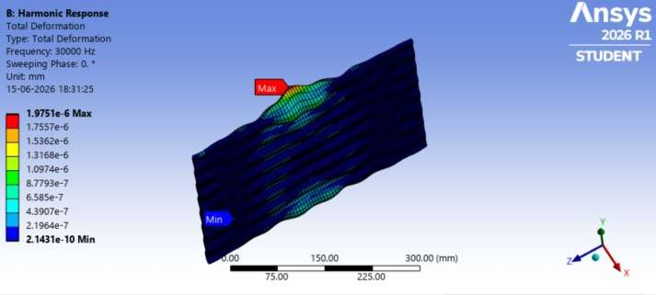

Frequency–Droplet Diameter Relationship

Frequency | Droplet Diameter | Visual Description
20 kHz | ~56 µm | Heavy fog; visible individual droplets
25 kHz | ~48 µm | Dense mist; stays low to surface
30 kHz | ~42 µm | Fine aerosol; begins to float off surface
35 kHz | ~38 µm | Dry mist; disperses almost immediately
Table III: Frequency vs predicted mist droplet diameter and visual behaviour

PROTOTYPE DESIGN AND IMPLEMENTATION

Circuit Design
The circuit design is a simple and economical ultrasonic excitation drive system with the following components:
  - Oscillator circuit: The NE555 timer IC, operating in its astable state, produces a base signal wave sweeping within 38-42 kHz.
  - Driver circuit: The IRF520 N-channel power MOSFET used for increasing the current output above what is possible for the NE555 circuit alone to supply for driving the capacitive PZT load.
  - Actuator circuit: A series of brass backings PZT transducer discs mounted mechanically on the surface of the test glass sample by clamping through a specially-designed clamp and threaded hole mount, connected electrically through a self-made 2.34mH resonant matching inductor.
This mounting technique was changed from only the adhesion-based mounting to the current technique based on the information revealed during the literature survey, where there was a 10% strength increase of clamped mount over adhesion-mounts.

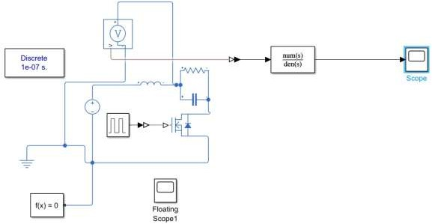

Implementation Challenges and Resolutions
Inductor resonance tuning: The first inductor made resulted in near resonance and not total resonance due to an incorrect number of turns in the coil. Fixed by winding to the theoretical value of 2.34 mH.
Mounting system for transducers: The initial setup involved only using glue for mounting, leading to poor coupling and eventual detachment due to constant vibrations. Solved by using a clamp method with the use of holes.
Sweep frequency stability: There was a lack of stability of the range on the higher end of 38-42 kHz. Solved by reducing the tolerances of the RC network of the NE555 timing circuit.

RESULTS AND DISCUSSION

Oscilloscope Measurement Confirmation of Frequency Sweep Waveform
The constructed circuit formed a clean, stable triangle-shaped frequency sweep waveform in the targeted range of 38 – 42 kHz without any distortion or drifting.

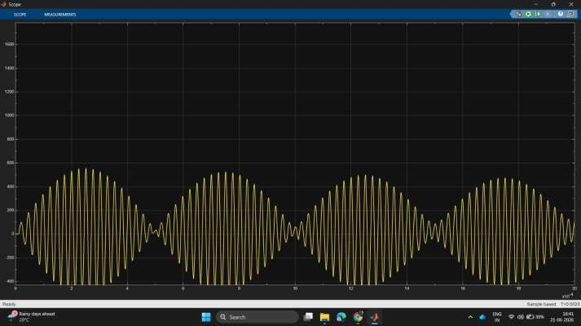

Particle Movement
Imaging the particle distribution before and after activation confirmed qualitatively the excitation of particle movement which was used to support the fundamental assumption of water displacement in the current project.

Summary of Results

Result | Value | Significance
Mode 1 natural frequency | 388.83 Hz | Well below 38–42 kHz; no structural resonance conflict
Max von Mises stress at 30 kHz | 0.0038 MPa | Orders of magnitude below glass failure threshold
Max total deformation at 30 kHz | ≈9.88 × 10⁻⁷ mm | Sub-micron surface wave — consistent with atomisation physics
Acoustic SPL | < 85 dB | Compliant with occupant-comfort constraint
Prototype output | 38–42 kHz (stable swept) | Oscilloscope-verified clean triangular waveform
Salt node spacing | ≈20.4 mm | Consistent with λ/2 from Rayleigh–Lamb derivation
Table IV: Summary of key results
All four core objectives have been achieved. Objective 1 involved obtaining a tangible operating band using the analytical Rayleigh–Lamb derivation, which was confirmed as 38–42 kHz via ANSYS harmonic response analysis (Objective 2). Objective 3 involved achieving low cost through the development of an oscillator constructed only from commercial parts and verified using an oscilloscope. Objective 4 involved the feasibility of the device and is proven by the convergence of all three results strands: theoretical soundness; structural safety as verified by simulation; and physical viability, as shown by the working prototype.

The biggest unforeseen discovery was that of the size of the margin for structural safety, 0.0038 MPa being well below glass failure limits. This implies that the device can potentially be driven much harder without mechanical failure, with more binding factors being acoustic comfort and electrical efficiency.
Limitations: Structural and vibrational analysis was conducted using a 5 mm thick monolithic glass dummy as opposed to the actual 6.76 mm laminated (glass-PVB-glass) windscreen assembly. Damping properties of the PVB interlayer were not considered in this stage, and are thus the major limitations that must be taken care of in a future study.

CONCLUSIONS
The study examined the viability of an ultrasonic vibration mechanism to augment the current mechanical wiper system, providing a rain assist feature. This project has succeeded in:
- Establishing a theoretically sound frequency range (38–42 kHz) using Rayleigh-Lamb plate-wave theory for the automobile windshield geometries.
- Validating the frequency range through computational ANSYS analysis with modal, harmonic and acoustic finite element analysis; ensuring safety margin, surface deformation sub-micron enough for atomization, and comfort acoustic criterion for passenger.
- Demonstrating the validity through a tested and inexpensive prototype of NE555 + IRF520 + PZT circuitry system using oscilloscope, and validated through salt pattern nodal analysis and particle displacement imaging.
- Confirming the accomplishment of all four main project goals.
The main conclusion of this research is that the ultrasonic assist combined with the mechanical backup is a more feasible approach than the pure wiper replacement that was attempted and did not work since 1969. This research lays the foundation for OEM application and patent disclosure of this project, along with additional validation like the modelling of the laminated glass, rainfall intensity threshold, and the durability test of transducers.

ACKNOWLEDGEMENTS
The authors thank Sujan Chakraborty (Assistant Professor, RVCE) for mentorship throughout the project, and Dr. K N Subramanya (Professor and Principal, RVCE) for institutional support. This project was conducted as part of the VI Semester Experiential Learning programme at the Department of Mechanical Engineering, RV College of Engineering, Bengaluru.

REFERENCES
- IPWatchdog. (2014, November 9). The evolution of windshield wipers: A patent history. https://ipwatchdog.com/2014/11/09/the-evolution-of-wind-shield-wipers-a-patent-history/
- World Health Organization. (2023). Road traffic injuries fact sheet.
- Federal Highway Administration. (2022). How do weather events impact roads? FHWA Road Weather Management Program.
- Lancioni, G., Lenci, S., & Galvanetto, U. (2016). Dynamics of windscreen wiper blades: Squeal noise, reversal noise and chattering. International Journal of Non-Linear Mechanics, 80, 132–143.
- Kadirci, S., Ak, E., Selenbas, B., & Gunes, H. (2017). Numerical and experimental investigation of wiper system performance at high speeds. Journal of Applied Fluid Mechanics, 10, 861–870.
- Dragomir, D. C. (2025). Adaptive windshield wiper system based on an intelligent control algorithm. IJERT, 14(7).

- Chen, T.-J., Hong, Y.-J., Lin, C.-H., & Wang, J.-Y. (2023). Optimization on linkage system for vehicle wipers by the method of differential evolution. Applied Sciences, 13(1), 332.
- Alexandru, C. (2012). A mechatronic approach of the windshield wiper mechanisms. Annals of Oradea University, 11(1).
- Gowtham, D., & Srivathsan, T. S. K. (2014). Reciprocating motion wiper system for automobiles. IJERT, 3(9).
- Graff, K. F. (1975). Wave Motion in Elastic Solids. Oxford University Press.

