Comparative Analysis of EdTech Readiness in Sierra Leone and Ghana: Temporal Alignment, Policy Trajectories, and System-Level Constraints.

Alimamy Kargbo^{1*}, Joshua Henry Amoh-Darko²
Faculty of Education, School of Educational Technology, Southwest University, Chongqing, China¹.
Department of Science, Mathematics and ICT, University of Cape Coast Ghana².
Email address: gjxy2024196@email.swu.edu.cn / kargboalimamys@gmail.com
Mobile number: +8613068332176

ABSTRACT
This paper offers a comparative analysis of EdTech readiness in Sierra Leone and Ghana through the World Bank’s EdTech Readiness Index (ETRI) framework. It addresses a key methodological challenge: Sierra Leone’s ETRI evidence derives from school and policy data collected in 2022 and published in 2025, while Ghana’s October 2025 report applies ETRI 2.0, which incorporates additional hybrid-learning indicators. Rather than treating the two country profiles as directly synchronous rankings, the study interprets them as snapshots of different stages in national EdTech development. Drawing on ETRI findings, national policy documents, and peer-reviewed literature on ICT integration, teacher capacity, and digital equity, the paper compares six overlapping pillars: school management, teachers, students, devices, connectivity, and digital educational resources. The analysis finds that Ghana demonstrates stronger readiness across most shared indicators, particularly in school leadership, teacher self-efficacy, curriculum integration, and digital resource use. By contrast, Sierra Leone’s 2022 baseline reveals limited school-level implementation, with persistent gaps in device availability, connectivity, teacher use, and student access. However, the temporal gap is central to interpretation. Ghana’s 2025 readiness reflects a longer policy trajectory shaped by its 2015 ICT in Education Policy and 2018–2030 Education Strategic Plan, whereas Sierra Leone’s baseline predates its 2025–2030 National Digital Learning Strategy. The paper argues that Sierra Leone should therefore be assessed not solely by its baseline position but by how effectively post-2025 reforms translate national digital learning ambitions into equitable, sustained, and measurable school-level practice.

Keywords: EdTech readiness, Sierra Leone, Ghana, ETRI, digital learning, policy implementation, teacher capacity, digital equity

INTRODUCTION
Educational technology has become a central element in global education reform, not because digital tools automatically improve learning, but because education systems increasingly rely on digital resources to expand access, support teachers, manage data, and sustain learning during disruptions. In low- and middle-income countries, however, the benefits of educational technology depend on system readiness: the availability of infrastructure, the capacity of teachers to integrate digital resources into pedagogy, the presence of coherent policy frameworks, and the ability of governments to address inequities in access and use (Ertmer, 1999; Hew & Brush, 2006; Tondeur et al., 2016).
The World Bank’s EdTech Readiness Index (ETRI) provides one of the most useful comparative frameworks for assessing readiness. ETRI measures enabling conditions across six pillars: school management, teachers, students, devices, connectivity, and digital educational resources. It also distinguishes between practice, de facto policy awareness, and de jure policy existence. This distinction is important because many education systems possess formal policies but lack corresponding school-level implementation. In this sense, readiness is not equivalent to policy ambition; it is the relationship between national strategy, institutional capacity, infrastructure, human capability, and routine practice (World Bank, 2025a, Lambert-Porter et al., 2025).
This paper compares Sierra Leone and Ghana, two English-speaking West African countries that ETRI assessed at different points. Sierra Leone’s ETRI assessment was conducted in 2022 through a school survey and a policy survey, and the technical note was published by the World Bank in 2025. Ghana’s ETRI report was published in October 2025 and uses ETRI 2.0, which expands the original framework by incorporating hybrid learning indicators and additional tools such as a student survey and a school checklist (World Bank, 2025a, Lambert-Porter et al., 2025).
The temporal difference between the two ETRI reports is not a minor technical issue. It affects how the evidence should be interpreted. Ghana’s 2025 data reflect a system with a longer history of ICT-in-education policy development, including the 2015 ICT in Education Policy and the Education Strategic Plan 2018–2030 (Ministry of Education, Ghana, 2015, 2019). Sierra Leone’s 2022 ETRI evidence, by contrast, reflects a baseline period that preceded the publication of its National Digital Learning Strategy 2025–2030 (World Bank, 2025a, 2025b). Therefore, this paper does not treat the two reports as a simple ranking exercise. Instead, it uses them to analyze readiness trajectories: Ghana as a case of more mature but still uneven implementation, and Sierra Leone as a system at an earlier baseline stage with a newly emerging digital learning strategy.
The study contributes to comparative EdTech scholarship in three ways. First, it provides a carefully bounded comparison using verifiable ETRI figures from both reports. Second, it addresses the methodological problem of comparing data collected and reported in different years. Third, it situates both countries within regional policy and equity debates, showing that higher readiness in one country does not eliminate structural constraints, especially where rural schools, learners with disabilities, and low-income communities remain underserved.

RESEARCH QUESTIONS
The paper is guided by the following research questions:
- How do Sierra Leone and Ghana compare across the overlapping ETRI pillars of school management, teachers, students, devices, connectivity, and digital educational resources?
- How does the difference in reporting years and ETRI versions affect the interpretation of the comparison?
- What does the comparison reveal about the role of policy continuity, infrastructure growth, teacher capacity, and digital equity in national EdTech readiness?
- What policy implications can be drawn for Sierra Leone and Ghana when the comparison is interpreted as a developmental trajectory rather than a strict cross-sectional ranking?

LITERATURE REVIEW AND CONCEPTUAL FRAMEWORK

Edtech Readiness as a System-Level Construct
EdTech readiness is best understood as a system-level construct rather than a count of devices or a measure of internet access alone. The presence of computers, tablets, or broadband does not guarantee meaningful learning if teachers are not trained, curriculum resources are not aligned, school leaders do not plan for integration, and students lack regular access. This argument is consistent with long-standing research on technology integration, which shows that first-order barriers such as devices, connectivity, and technical support interact with second-order barriers such as teacher beliefs, confidence, and pedagogical culture (Ertmer, 1999; Ertmer & Ottenbreit-Leftwich, 2010).
ETRI’s six-pillar model reflects this systemic view. It recognizes that digital learning readiness requires a chain of enabling conditions: school leaders must plan and prioritize technology use; teachers must be able and willing to use digital tools for planning, instruction, and assessment; students must have opportunities to use technology inside and beyond school; devices must exist and be functional; internet access must be available and sufficiently stable; and digital educational resources must be accessible, usable, high quality, curriculum-aligned, and inclusive (World Bank, 2025a, Lambert-Porter et al., 2025).
This systems perspective is especially important in Sub-Saharan African contexts, where policy ambition often exceeds implementation capacity. A country may have an ICT policy, a digital learning strategy, or a curriculum statement recommending digital skills, but the system may still lack functioning devices, technical support, connectivity, teacher training, and monitoring mechanisms. The distinction between de jure policy and de facto school-level implementation is therefore central to interpreting readiness (Kozma, 2008; World Bank, 2025a).

Policy Continuity and Implementation Capacity
The literature on educational technology policy emphasizes that implementation capacity is as important as policy design. Kozma (2008) argues that national ICT policies in education are most effective when they are aligned with broader education reforms, teacher development, curriculum standards, assessment systems, and infrastructure plans. In countries where ICT policies are not connected to financing, monitoring, or teacher support, the policy may function primarily as a statement of intention rather than a driver of classroom practice.
Ghana’s policy trajectory illustrates the importance of policy continuity. Ghana’s 2015 ICT in Education Policy aimed to make ICT a strategic tool for teaching, learning, education management, and national development. The policy was later situated within the Education Strategic Plan 2018–2030, which framed ICT as part of broader education transformation (Ministry of Education, Ghana, 2015, 2019). Therefore, we need to read Ghana’s 2025 ETRI results against a decade-long policy trajectory, not as an isolated measurement.
Sierra Leone’s trajectory differs. The Education Sector Plan 2022–2026 included goals related to data and technology, and the National Digital Learning Strategy 2025–2030 provides a more explicit strategic direction for EdTech activities implemented by the Ministry of Basic and Senior Secondary Education and the Teaching Service Commission (World Bank, 2025b). However, Sierra Leone’s ETRI data were collected in 2022, before the 2025–2030 strategy was published. Its low readiness profile is thus better understood as a baseline measurement that documents pre-strategy system conditions rather than a final judgment on the country’s future trajectory (World Bank, 2025a).

Teacher Capacity and Pedagogical Integration
Teacher capacity is one of the strongest predictors of effective technology use in schools. Research consistently shows that teachers need more than technical training; they need pedagogical models, ongoing support, confidence, and alignment between digital tools and curriculum goals (Ertmer & Ottenbreit-Leftwich, 2010; Tondeur et al., 2016). The difference between using technology for lesson preparation and using it during instruction is also important. Teachers may use digital devices to search for content, prepare presentations, or communicate with colleagues, while still rarely using technology to assess learning, facilitate student collaboration, or support student production of knowledge.
The Ghana ETRI report demonstrates this distinction clearly. Ghanaian teachers report relatively high self-efficacy and moderate use of ICT for planning, yet the score for ICT use during teaching remains lower than planning and self-efficacy. Sierra Leone’s ETRI report shows an even more fundamental challenge: teacher use of ICT during direct instruction was reported as 0% across multiple classroom-use indicators, and only 1% to 3% of teachers reported using digital devices for lesson planning activities such as searching for content or sharing educational materials (World Bank, 2025a, Lambert-Porter et al., 2025).
These findings align with the broader literature on technology integration, which shows that digital transformation requires sustained professional development and school-level support, not one-off training. Where teachers lack access to devices, connectivity, digital resources, and technical support, even well-designed training programs may fail to translate into classroom practice (Hew & Brush, 2006; Tondeur et al., 2016).

Digital Equity and the Risk of Unequal Readiness
Digital equity is not limited to whether schools have devices. It includes the distribution of access across urban and rural schools, public and private schools, boys and girls, students with disabilities, and households with different levels of income and connectivity. Warschauer and Matuchniak (2010) argue that digital inequality must be analyzed through access, use, and outcomes rather than access alone. A readiness framework that stops at infrastructure risks, ignoring whether learners meaningfully use digital tools and whether digital opportunities improve learning.
Both Sierra Leone and Ghana face digital equity challenges. However, the ETRI evidence suggests that Sierra Leone’s baseline gaps are more severe. Only 1% of Sierra Leonean schools in the report had internet access, and almost no devices were available to students and connected to the internet. Ghana’s 2025 report shows stronger but still incomplete readiness: 42.6% of principals reported that schools had internet access, but only 11% reported that devices available to students were connected to the internet, and only 3% reported a sufficient number of digital devices connected to the internet to support teaching and learning (World Bank, 2025a, Lambert-Porter et al., 2025).
The equity implication is clear: Ghana’s challenge is not simply to expand access but to improve quality, reliability, inclusiveness, and student-level availability. Sierra Leone’s challenge is more foundational: to move from very low baseline access toward basic availability, while ensuring that new investments do not reproduce rural-urban and disability-related inequities.

METHODOLOGY

Research design
This study uses a qualitative comparative desk-review design based on secondary data. It compares Sierra Leone and Ghana using overlapping ETRI pillars and selected policy documents. The approach is not a statistical meta-analysis and does not create a new official ETRI ranking. Instead, it uses the official ETRI reports to identify patterns, contrasts, and policy implications. This design is appropriate because the two reports differ in year, version, and some methodological features.
A strict score-by-score comparison would be methodologically problematic. Sierra Leone’s data were collected in 2022 and published in a 2025 technical note; Ghana’s report was published in October 2025 and uses ETRI 2.0, which adds hybrid-learning indicators and additional instruments. Therefore, this paper compares only the overlapping within-school ETRI pillars and interprets differences as directional evidence of system trajectories rather than as a synchronized league table (World Bank, 2025a, Lambert-Porter et al., 2025).

Data sources
The primary sources are the Sierra Leone ETRI technical note and the Ghana ETRI report. The Sierra Leone report states that data for ETRI were collected as part of the Global Education Policy Dashboard. Its school survey was conducted in May–June 2022 in 300 primary schools across the four provinces and Western Area using stratified random selection with probability proportional to school size, and its policy survey was conducted in September 2022 through a legislative review by a local consultant (World Bank, 2025a).
The Ghana report, published in October 2025, presents Ghana’s readiness to use technology in schools and uses ETRI 2.0. ETRI 2.0 includes additional practice and policy indicators focused on hybrid learning, a student survey, and a school checklist. The report states that ETRI is designed to evaluate countries’ readiness for integrating EdTech into education systems, while also emphasizing that it is not a full diagnostic tool (Lambert-Porter et al., 2025).
Supplemental policy sources include Sierra Leone’s Education Sector Plan 2022–2026 and National Digital Learning Strategy 2025–2030, Ghana’s ICT in Education Policy 2015, Ghana’s Education Strategic Plan 2018–2030, and Ghana’s draft EdTech strategy overview. These sources are used to interpret the ETRI results as part of broader national policy trajectories rather than isolated survey findings (MBSSE, 2022, 2025; Ministry of Education, Ghana, 2015, 2019; World Bank, 2025c).
Peer-reviewed sources were used to frame the analysis of technology integration barriers, teacher capacity, and digital equity. The paper draws especially on Ertmer’s (1999) distinction between first-order and second-order barriers, Hew and Brush’s (2007) review of technology integration barriers, Ertmer and Ottenbreit-Leftwich’s (2010) work on teacher technology change, Tondeur et al.’s (2017) systematic review of teacher beliefs and technology use, and Warschauer and Matuchniak’s (2010) framework for analyzing digital equity.

Temporal and Methodological Comparability
Because the reports differ in timing and ETRI version, the study uses a conservative comparative logic. Sierra Leone’s results are treated as a 2022 baseline that captures the state of readiness before the National Digital Learning Strategy 2025–2030. Ghana’s 2025 results are treated as evidence from a more mature policy environment, shaped by earlier ICT policy commitments beginning in 2015. This approach avoids overstating Ghana’s advantage as purely cross-sectional and avoids treating Sierra Leone’s 2022 baseline as a current post-strategy outcome.
The difference between ETRI 1.0 and ETRI 2.0 also matters. Ghana’s report includes hybrid-learning indicators, whereas Sierra Leone’s 2022 baseline focuses on the original within-school pillars. Therefore, this paper does not compare Ghana’s hybrid-learning scores with Sierra Leone’s. Instead, it compares overlapping indicators such as school strategy, teacher self-efficacy, teacher use for planning and teaching, student use inside and outside school, device access, connectivity, and digital educational resources.
Table 1: Temporal and methodological alignment of the two ETRI reports
Dimension | Sierra Leone ETRI | Ghana ETRI | Implication for comparison
Data/report period | School survey: May–June 2022; policy survey: September 2022; technical note published in 2025. | Report published in October 2025. | The comparison is temporally uneven and should be interpreted as developmental trajectory evidence.
ETRI version | The original ETRI framework focused on six pillars and policy/practice alignment. | ETRI 2.0 includes additional hybrid-learning indicators, a student survey, and a school checklist. | Only overlapping within-school indicators are compared.
Policy context at the time of evidence | ETRI data predate Sierra Leone’s National Digital Learning Strategy 2025–2030. | ETRI results follow a decade of policy activity after the ICT in Education Policy of 2015. | Sierra Leone is analyzed as a baseline-stage system, and Ghana as a more policy-mature system.
Analytical stance | Baseline readiness evidence. | Evidence of later-stage readiness and hybrid-learning monitoring. | The study avoids strict ranking and emphasizes trends, direction, and implementation pathways.
Note. Source data are drawn from the Sierra Leone and Ghana ETRI reports (World Bank, 2025a, Lambert-Porter et al., 2025), with policy context from (World Bank, 2025b). and the Ministry of Education, Ghana (2015, 2018).

Figure 1. Temporal positioning of policy and ETRI evidence
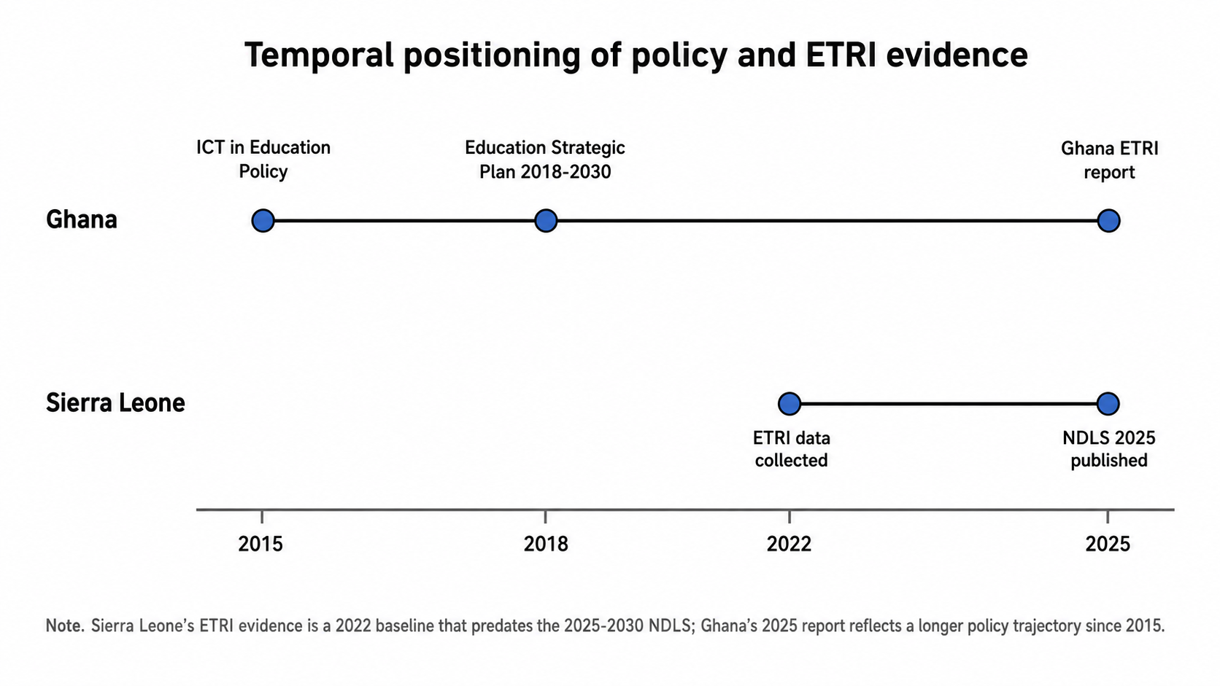

FINDINGS AND COMPARATIVE ANALYSIS

Overall Readiness Pattern: Low Baseline Versus More Mature but Uneven Readiness
The most important headline finding is that Ghana shows higher readiness across most overlapping ETRI domains, while Sierra Leone’s 2022 baseline indicates very low implementation across nearly all pillars. However, this finding must be interpreted carefully. Ghana’s higher readiness is not only a reflection of better conditions in 2025; it also reflects a longer policy accumulation process that began before 2015 and was strengthened through Ghana’s 2015 ICT in Education Policy and Education Strategic Plan 2018–2030 (Ministry of Education, Ghana, 2015, 2019). Sierra Leone’s baseline, by contrast, describes a system before its 2025–2030 National Digital Learning Strategy was in place (World Bank, 2025a; World Bank, 2025b).
The Sierra Leone report states that readiness was low across both practice and policy levels and across all six ETRI pillars. The report also identifies some limited entry points, particularly in school management, where some principals were aware of their responsibility to integrate ICT and digital resources into the curriculum. In these cases, policy awareness was somewhat better than actual classroom use (World Bank, 2025a). Ghana’s report, by contrast, describes school management practices and policies as closer to the midpoint; teacher practices as stronger in self-efficacy and planning than in classroom teaching; student practices as limited; and infrastructure pillars such as devices and connectivity as still weak despite better performance than Sierra Leone (Lambert-Porter et al., 2025).
Thus, the comparison does not support a simple conclusion that Ghana has solved EdTech readiness. Instead, it shows a difference in the level and nature of constraints. Sierra Leone’s constraints are foundational: basic access to devices, connectivity, teacher training, and student use are close to absent in many schools. Ghana’s constraints are more about depth of use, quality, reliability, support, and inclusion. In other words, Ghana’s system has moved further along the readiness pathway, but it has not yet reached broad, equitable, high-quality digital learning integration.

Figure 2. Snapshots from the ETRI reports showing headline readiness patterns

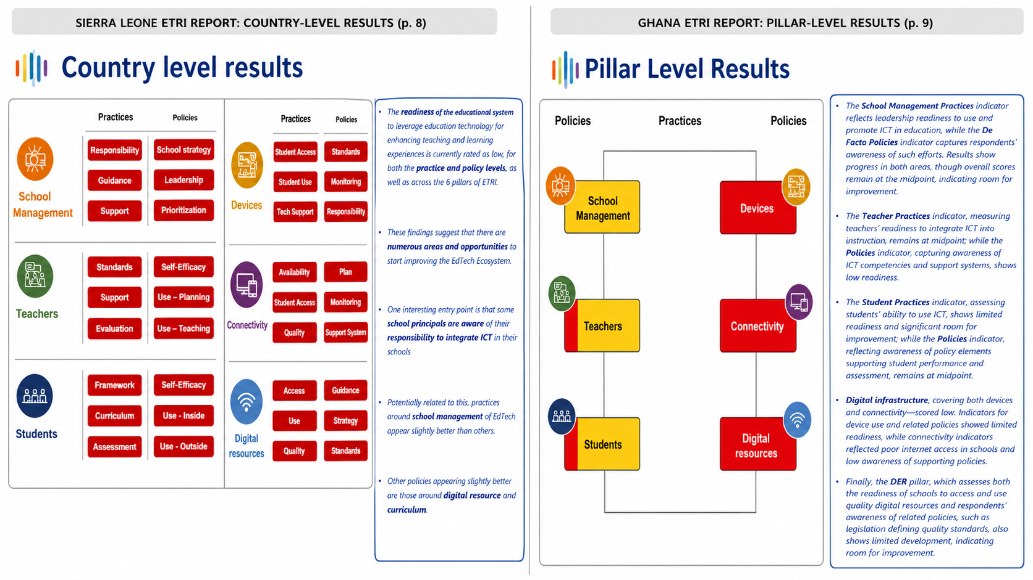
Note. The left panel reproduces the Sierra Leone report’s country-level results page; the right panel reproduces the Ghana report’s pillar-level results page. The snapshots are included to make the comparison traceable to the source reports.

School Management and Leadership
School management is the strongest comparative domain for Ghana and one of the few relatively promising entry points for Sierra Leone. Sierra Leone’s scores for school management practices were low: school strategy scored 2.1, leadership 2.0, and prioritization 2.4. Yet, compared with other pillars, school management had a slightly better policy awareness profile, especially responsibility, which scored 3.4. In practical terms, 25% of Sierra Leonean principals reported having a digital strategy or plan to incorporate ICT into teaching and administration, while 60% reported that responsibilities for integrating ICT into school strategic plans were assigned at some level (World Bank, 2025a).
Ghana’s school management readiness was considerably stronger. Ghana scored 3.46 on school ICT strategy, 3.77 on leadership, and 4.69 on prioritization of ICT for learning. The report shows that 75% of Ghanaian principals reported having a digital strategy or plan; 92% reported involving teachers in developing a plan to apply ICT; 91% reported supporting teachers in trying new ways of teaching with ICT; and 94% reported school-level discussions on the advantages and disadvantages of ICT for teaching and learning (Lambert-Porter et al., 2025).
The contrast suggests that Ghana’s policy trajectory has had stronger penetration into school leadership practice. However, the Ghana report also shows that support remains incomplete: only 43% of principals reported participating in ICT training during the previous 12 months, and only 34% reported that such training was required. This reveals an important point for comparative interpretation. Ghana’s relative advantage lies in leadership awareness and planning, not necessarily in fully institutionalized support for school leaders. Sierra Leone can learn from Ghana’s emphasis on school planning and leadership but must avoid assuming that plans alone will produce classroom-level integration.
The policy implication is that school leadership should be treated as a bridge between the national digital learning strategy and classroom practice. Sierra Leone’s 2025–2030 National Digital Learning Strategy provides an opportunity to improve principal training, communicate guidelines, and link digital planning to school improvement processes. Ghana’s next challenge is to move from leadership awareness toward stronger accountability for implementation quality, particularly in rural and under-resourced schools.

Teacher Capacity, Self-Efficacy, and Classroom Use
Teacher capacity is the domain where the distinction between self-efficacy, planning, and actual classroom integration becomes most visible. In Sierra Leone, the ETRI teacher practice results show extremely low ICT use. Teachers reported 0% use of ICT during direct class instruction across indicators such as searching for information during discussions, presenting information, using classroom management tools, asking students to search for information, asking students to present results using ICT, and using digital tools to assess learning. Lesson planning indicators were also close to absent: only 1% reported searching for content to use during class, 3% reported sharing educational content with other teachers, and 1% reported preparing presentations for teaching (World Bank, 2025a).
Sierra Leone’s teacher self-efficacy was also low. Only 4% of teachers reported confidence in contributing to online discussions, 5% in producing presentations, 7% in preparing lessons in which students use ICT, 7% in using spreadsheets, 5% in assessing learning with ICT, and 6% in collaborating with colleagues through shared resources. Teacher training indicators were similarly weak: 9% reported that initial training included learning to use ICT generally, and 4% reported that initial training included learning how to use ICT in teaching (World Bank, 2025a).
Ghana presents a different pattern. Teacher self-efficacy was high, with a score of 4.27. Ghanaian teachers reported 79% confidence in contributing to online discussions, 70% in producing presentations, 79% in preparing lessons in which students use ICT, 62% in using spreadsheets, 77% in assessing learning using ICT, and 63% in collaborating with colleagues through shared resources. Use for planning was also much higher than in Sierra Leone: 59% of teachers reported searching for content for class, 35% sharing educational content, 37% preparing presentations, and 63% expanding their knowledge about ICT. However, Ghana’s use for teaching scored only 1.87, meaning that direct classroom integration remains limited relative to teacher confidence and planning (Lambert-Porter et al., 2025).
This pattern aligns with technology integration research. Teacher confidence and training can facilitate adoption, but they do not guarantee pedagogical transformation. Teachers may feel capable of using technology for personal productivity while still using it minimally for learner-centered activities, formative assessment, collaboration, and knowledge creation (Ertmer & Ottenbreit-Leftwich, 2010; Tondeur et al., 2016). Ghana, therefore, illustrates an intermediate stage of readiness: digital confidence and planning have improved, but instructional integration remains uneven. Sierra Leone illustrates a foundational readiness challenge: teachers need access, training, confidence, and examples of pedagogically meaningful use.
For Sierra Leone, the policy priority is to design teacher professional development that begins with foundational digital literacy but quickly connects it to pedagogical practice. For Ghana, the priority is to deepen the instructional use of technology by linking teacher training to curriculum tasks, assessment, student production, and classroom routines. In both countries, teacher training should not be evaluated only by participation rates but also by evidence of classroom use.

Student Readiness and Digital Use
Teacher practice, device access, and connectivity strongly shape student readiness. Sierra Leone’s student practice indicators were almost nonexistent. Teachers reported 0% student use of digital devices during most or every lesson for searching information, communicating on projects, sharing assignment results, submitting work, evaluating information, and producing documents, presentations, or videos. Teachers also reported 0% student use outside school for browsing the internet for schoolwork, communicating with teachers, doing homework on a digital device, or using learning apps and websites. Student self-efficacy was also extremely low: only 3% of teachers believed at least half of students could open a new browser tab, 3% could save an online photo, 1% could find a previously visited website, and 2% could check whether online information was true (World Bank, 2025a).
Ghana’s student results show greater but still limited readiness. Student self-efficacy scored 2.31, use inside school 1.59, and use outside school 2.07. Teachers reported that students used digital devices in most or all lessons for searching information in 39% of cases, communicating on projects in 29%, sharing assignment results in 26%, submitting work for assessment in 19%, evaluating search information in 24%, and producing documents, presentations, or videos in 19%. Outside school, 51% reported that students used digital devices to browse the internet for schoolwork at least once a week, 46% for homework, and 37% for learning apps or websites (Lambert-Porter et al., 2025).
The policy side of student readiness also differs. In Sierra Leone, 24% of teachers believed the curriculum recommended ICT use in teaching, 23% reported a guiding document defining student digital competencies, and 11% reported that students’ digital competencies were formally assessed in the previous year. Ghanaian teachers reported much stronger policy awareness: 91% believed the curriculum recommended ICT use, 57% reported a guiding document defining student digital competencies, and 59% reported formal assessment of student digital competencies (World Bank, 2025a, Lambert-Porter et al., 2025).
The trend implication is important. Ghana appears to have embedded ICT expectations more strongly into curriculum and assessment discourse, even though student practice remains limited. Sierra Leone’s baseline suggests that both formal guidance and actual student opportunities require development. If Sierra Leone’s National Digital Learning Strategy is implemented effectively, one indicator of progress will be movement from policy creation to student-level exposure: not only schools having devices but also students using them for learning tasks, information evaluation, creativity, and assessment.

Devices and Technical Support
Device availability is a foundational readiness condition, but the ETRI reports show that device access must be interpreted through student availability, use frequency, technical support, and inclusion. Sierra Leone’s device pillar was fragile. Only 1% of schools had working digital devices available, and most of them were available to students for learning; 0% of principals reported that available devices were used in class at least once or twice a week; 5% agreed that there were enough digital devices for instruction; and 4% agreed that there was sufficient technical support to maintain ICT resources so that they were fully functional. Only 2% reported devices adapted for students with disabilities (World Bank, 2025a).
Ghana’s device access is better but still insufficient. The Ghana report states that the average number of devices per school was approximately 21, with about 15 working devices. Sixty-two percent of schools reported that more than half of working devices were available to students for learning, and 36% of principals reported that students used digital devices in class at least once or twice a week. However, only 2% of principals agreed that there were enough digital devices for instruction, 24% agreed that technical support was sufficient, and fewer than 6% reported devices adapted for students with disabilities (Lambert-Porter et al., 2025).
The comparison suggests that Ghana has moved from near-absence toward partial availability, whereas Sierra Leone’s baseline indicates that device access was not yet sufficient to support regular classroom integration. Yet Ghana’s data also show that device presence does not equal adequacy. A school may have some working devices, but not enough for meaningful instruction, especially if devices are shared across many students or unavailable in classrooms. Technical support is a further constraint in both countries. Without maintenance systems, device investments may deteriorate quickly, producing cycles of procurement without sustainable use (Hew & Brush, 2006).
From a policy perspective, Sierra Leone’s device strategy should avoid a narrow distribution model that counts devices but neglects maintenance, teacher integration, accessibility, and student use. Ghana’s experience shows that even where devices are more available, sufficiency, maintenance, and disability inclusion remain unresolved. Both countries need device policies that specify minimum access standards, maintenance responsibility, replacement cycles, accessibility requirements, and monitoring indicators.

Connectivity and Internet Quality
Connectivity is one of the clearest areas of difference between the two reports. Sierra Leone’s ETRI results show that only 1% of schools had internet access. No schools had digital devices available to students, most of which were connected to the internet, and only 5% of principals believed that there were a sufficient number of digital devices connected to the internet. Similarly, only 5% believed bandwidth or speed was sufficient, and 4% believed internet stability was sufficient. At the policy level, 22% of principals believed the government had a strategy or plan to provide or facilitate internet connectivity to all schools; while monitoring and support mechanisms were almost absent (World Bank, 2025a).
Ghana’s connectivity indicators are higher but still show substantial weakness. The Ghana report states that 42.6% of principals reported that schools had internet access. However, student access remains limited: only 11% reported that devices available to students were connected to the internet, and only 3% reported a sufficient number of internet-connected devices to support teaching and learning. Only 26% reported sufficient bandwidth, and 26% reported sufficient internet stability. On the policy side, 36% believed there was a government strategy or plan to provide or facilitate internet connectivity to all schools, 39% reported monitoring mechanisms for school internet availability, and 16% believed there was a support mechanism to resolve connectivity problems (Lambert-Porter et al., 2025).
The comparison suggests that Ghana has made progress in school-level access but still faces quality and student-access constraints. Sierra Leone’s baseline challenge is more basic: connectivity was almost absent in schools. Therefore, the two countries require different policy sequencing. Sierra Leone needs foundational school connectivity expansion, likely through phased rural connectivity, offline-first solutions, solar power, and low-bandwidth digital resources. Ghana needs to improve connection quality, student device connection, support mechanisms, and the instructional use of available connectivity.
The temporal difference matters here. Ghana’s 2025 connectivity results may reflect infrastructure growth over a longer period, while Sierra Leone’s 2022 baseline predates recent strategy development. If Sierra Leone’s 2025–2030 digital learning strategy succeeds, future ETRI reassessment should show improvements in school internet access, technical support, and the percentage of devices connected to the internet. Until then, comparisons should be treated as baseline-to-mature-system contrasts rather than as proof of permanent national difference.

Digital educational resources
Digital educational resources (DERs) are important because digital learning depends not only on hardware but also on usable, curriculum-aligned, contextually relevant content. Sierra Leone’s DER practice indicators were very low. Only 3% of principals agreed that their school had access to sufficient digital learning resources; 4% said available resources were of adequate quality; 7% said resources were aligned to curriculum needs; and 6% said resources were adapted to the local context. Teachers’ use of specific digital tools was nearly nonexistent: 1% reported use of computer-based information resources in most lessons, 1% reported use of digital resources linked with textbooks, and 0% reported use of digital learning games or collaborative software (World Bank, 2025a).
Ghana’s DER results are stronger but uneven. Teachers reported using computer-based information resources in some, most, or every lesson at 63%, digital resources linked with textbooks at 70%, word-processing software at 64%, presentation software at 40%, graphing or drawing software at 36%, digital learning games at 32%, and collaborative software at 26%. However, access and quality indicators remain weak: only 29% of principals agreed that their school had sufficient DERs, 27% agreed that available DERs were of adequate quality, 50% said resources were aligned to curriculum needs, and only 12% said resources were adapted to the local context. Only 8% reported sufficient DERs adapted for students with disabilities (Lambert-Porter et al., 2025).
This comparison shows that Ghana’s digital resource use is more active but not necessarily fully inclusive or high quality. Sierra Leone’s challenge is to build basic access and use, while Ghana’s challenge is to improve quality, local contextualization, disability inclusion, and sufficient availability. This aligns with digital equity literature, which warns that technology access can reproduce inequality when content is not culturally relevant, locally meaningful, linguistically accessible, or designed for diverse learners (Warschauer & Matuchniak, 2010).
For Sierra Leone, the National Digital Learning Strategy offers an opportunity to prioritize curriculum-aligned, low-bandwidth, offline-capable, and inclusive digital content. For Ghana, the policy challenge is to shift from general resource use toward quality assurance, accessibility standards, and stronger local content adaptation. Policymakers in both countries should link DER policy with curriculum development, teacher training, and assessment reform.
Table 2. Overlapping ETRI sub-indicator scores used for directional comparison
Pillar | Sub-indicator | Sierra Leone score | Ghana’s score | Analytical interpretation
School management | School strategy | 2.1 | 3.46 | Ghana shows stronger school-level planning.
School management | Leadership | 2.0 | 3.77 | Ghana shows stronger principal engagement.
School management | Prioritization | 2.4 | 4.69 | Ghana principals place a higher priority on ICT skills.
Teachers | Self-efficacy | 1.5 | 4.27 | The largest teacher-related gap is confidence.
Teachers | Use for planning | 1.1 | 3.27 | Ghanaian teachers use ICT more for preparation.
Teachers | Use for teaching | 1.0 | 1.87 | Teaching use is weak in both countries, especially in Sierra Leone.
Students | Self-efficacy | 1.1 | 2.31 | Student digital skill perceptions remain low in both, but are lower in Sierra Leone.
Students | Use inside the school | 1.0 | 1.59 | Classroom use is limited in both countries.
Students | Use outside school | 1.0 | 2.07 | Ghana shows more out-of-school use.
Devices | Student access | 1.3 | 2.49 | Ghana has more devices, but insufficiency remains.
Devices | Student use | 1.0 | 1.82 | Ghana shows partial use, while Sierra Leone shows near absence.
Devices | Technical support | 1.5 | 2.06 | Technical support is weak in both.
Connectivity | Availability | 1.0 | 2.70 | Ghana has more school internet access.
Connectivity | Student access | 1.3 | 1.49 | Both countries struggle to connect student devices.
Connectivity | Quality | 1.6 | 2.00 | Quality remains weak even where access exists.
Digital resources | Access | 1.5 | 1.92 | Access remains weak in both.
Digital resources | Use | 1.0 | 1.85 | Ghana shows more DER use.
Digital resources | Quality | 1.6 | 2.33 | Ghana reports stronger but still low DER quality.
Note. Scores are reported on the ETRI 1–5 scale. Values are drawn from the Sierra Leone and Ghana ETRI reports and compared only for overlapping within-school indicators (World Bank, 2025a, Lambert-Porter et al., 2025).

Figure 3. Average practice scores across overlapping ETRI pillars
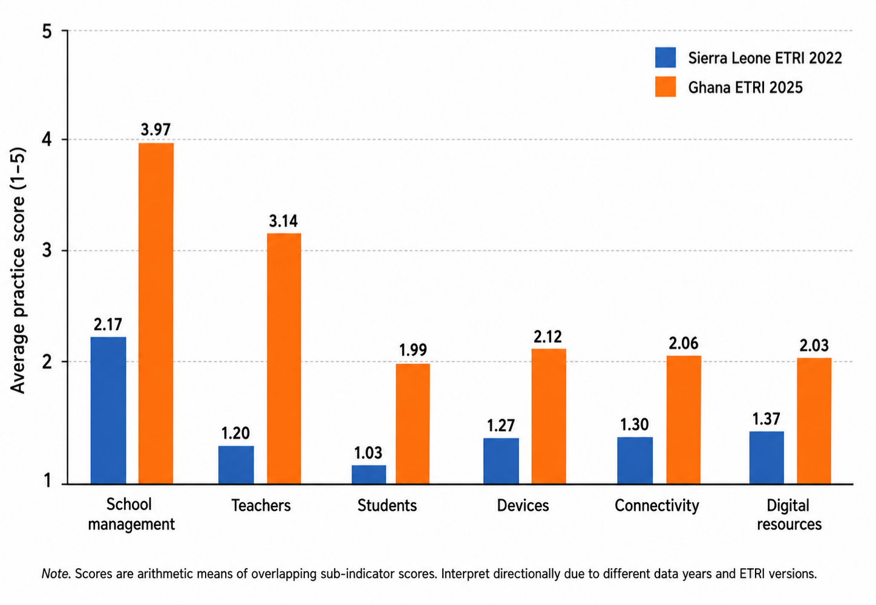

Figure 4. Average policy scores across overlapping ETRI pillars
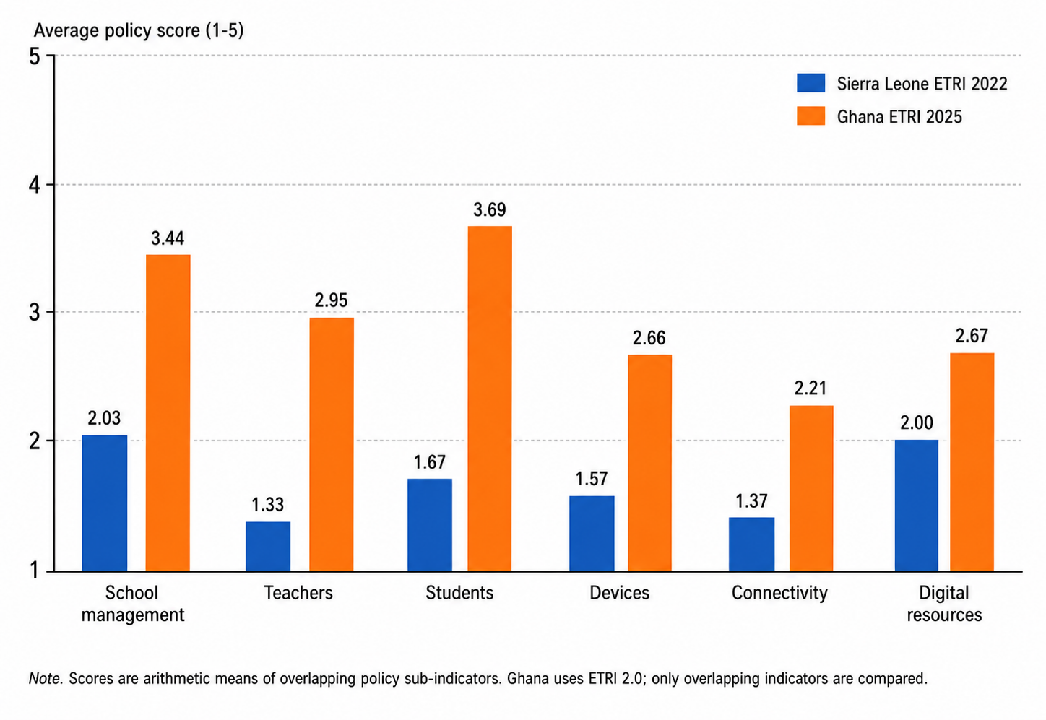
Note. Policy averages were calculated from comparable ETRI sub-indicator scores. Ghana’s higher policy scores must be interpreted in relation to its longer ICT-in-education policy trajectory.

Table 3. Selected directly reported ETRI percentages

Indicator | Sierra Leone | Ghana | Interpretation
Principals reporting a digital strategy or ICT plan | 25% | 75% | Ghana shows stronger school-level planning.
Principals involving teachers in ICT plan development | 13% | 92% | Ghana shows broader participatory leadership.
Principals are aware of ICT teaching guidelines | 7% | 52% | Policy communication is stronger in Ghana.
Teachers whose initial training included ICT use generally | 9% | 68% | Ghana has broader teacher exposure to ICT training.
Teachers whose initial training included ICT in teaching | 4% | 63% | Ghana has stronger pedagogical ICT training exposure.
Teachers using ICT to present information during instruction | 0% | 29% | Ghana has more classroom use, but it is still limited.
Teachers searching for digital content for class planning | 1% | 59% | Ghana’s planning use is far higher.
Schools with internet access | 1% | 42.6% | Connectivity is a foundational Sierra Leone constraint.
Principals reporting sufficient technical support for devices | 4% | 24% | Technical support remains weak in both.
Teachers using textbook-linked digital resources | 1% | 70% | Ghana has stronger DER use.
DERs adapted for students with disabilities | 7% | 8% | Both countries show weak disability inclusion in DERs.
Note. The table includes selected percentages reported in the ETRI slide reports. Differences should be read as directional evidence of readiness trajectories, not as synchronized cross-sectional estimates.
Figure 5. Selected comparable ETRI indicators from the two reports

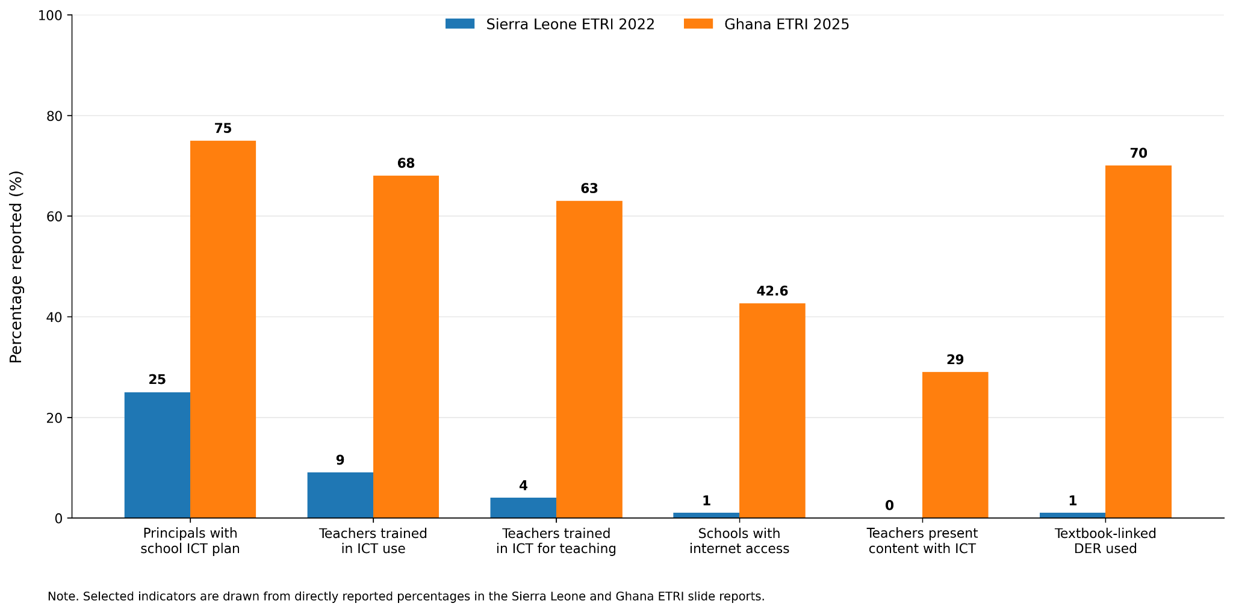

DISCUSSION

Why the Temporal Difference Matters
The difference in years between the two ETRI reports is a central interpretive issue. Sierra Leone’s school and policy data were collected in 2022, while Ghana’s report was published in 2025. In addition, the 2022 baseline preceded the publication of Sierra Leone’s National Digital Learning Strategy. This means that the Sierra Leone ETRI results should be understood as documenting the situation before the country’s more coherent digital learning strategy was available. A future reassessment may show whether the strategy improves policy communication, teacher training, infrastructure, and digital resource use.
Ghana’s 2025 results, by contrast, reflect a system that had already undergone a decade of policy development after the 2015 ICT in Education Policy. Ghana’s higher readiness, therefore, represents both current conditions and accumulated policy continuity. This makes Ghana a useful comparator, but not because it is identical to Sierra Leone. Rather, Ghana provides evidence of what a longer policy trajectory may produce: stronger school leadership awareness, higher teacher self-efficacy, stronger curriculum awareness, and more use of digital resources. At the same time, Ghana’s continuing weaknesses in device sufficiency, connectivity quality, technical support, and inclusion show that policy maturity does not eliminate implementation constraints.
Consequently, the paper’s core comparative claim is not that Ghana is simply better and Sierra Leone is simply weaker. The more analytically precise conclusion is that the two countries are at different points in an EdTech readiness pathway. Sierra Leone’s ETRI baseline is useful for identifying foundational gaps that the National Digital Learning Strategy must address. Ghana’s ETRI profile is useful for identifying the next-stage problems that emerge after policy awareness and basic teacher confidence improve quality, adequacy, technical support, inclusive design, and classroom-level use.

First-Order and Second-Order Barriers
Ertmer’s (1999) distinction between first-order and second-order barriers helps explain the comparison. First-order barriers are external constraints such as devices, internet access, technical support, and time. Second-order barriers include teachers’ beliefs, confidence, pedagogical assumptions, and willingness to change. Sierra Leone’s ETRI profile shows severe first-order barriers: devices, connectivity, technical support, and DER access are almost absent in many schools. It also shows second-order barriers, including very low teacher confidence and low awareness of guidelines. Ghana’s profile suggests that some first-order barriers have improved, but not enough to support universal use. Teacher confidence is comparatively high, yet classroom use remains limited, suggesting that second-order pedagogical transformation still requires support.
This distinction is important for policy sequencing. Sierra Leone cannot rely on teacher training alone if teachers do not have devices, connectivity, or digital resources. Ghana cannot rely on infrastructure alone if teachers primarily use ICT for planning and personal productivity rather than instructional transformation. Both countries need integrated strategies that connect infrastructure, training, curriculum, leadership, and monitoring.

Policy as Trajectory Rather Than Event
The comparison also suggests that we should understand national EdTech policy as a trajectory rather than a single event. Ghana’s ICT in Education Policy 2015 did not immediately produce full readiness, but it created a policy architecture that could be reinforced through subsequent planning, teacher development, and EdTech strategy formulation. Sierra Leone’s National Digital Learning Strategy 2025–2030 may play a similar role if it is accompanied by financing, monitoring, coordination, teacher professional development, and school-level implementation guidance (World Bank, 2025b).
The major risk for Sierra Leone is policy-performance decoupling: a situation in which policy documents improve while school-level practice remains low. The Sierra Leone ETRI baseline indicates that de jure policies can be stronger than de facto awareness or practice, especially where schools lack communication, capacity building, and implementation support (World Bank, 2025a). Ghana’s report also shows gaps between policy and practice, particularly in devices, connectivity, and DERs, although the gaps appear less foundational than Sierra Leone’s (Lambert-Porter et al., 2025).

Equity as the Central Test of Readiness
Equity is the central test of EdTech readiness. A country can improve its national averages while leaving rural schools, learners with disabilities, and low-income communities behind. Sierra Leone’s ETRI results show that the system has very low access and use, indicating that broad foundational investment is needed. Ghana’s results show more advanced readiness but persistent inclusion problems: fewer than 6% of principals reported devices adapted for students with disabilities, and only 8% reported sufficient DERs adapted for students with disabilities. This means that disability inclusion is weak in both countries (World Bank, 2025a, Lambert-Porter et al., 2025).
The implication is that digital inclusion should be built into national strategies from the beginning. Sierra Leone’s emerging implementation phase creates an opportunity to design inclusive systems before procurement and platform decisions become entrenched. Ghana’s more mature system needs to retrofit inclusion into existing digital infrastructure, resources, and teacher training. In both countries, readiness should be assessed not only by whether technology exists but also by who can use it, for what purposes, with what support, and with what learning consequences (Warschauer & Matuchniak, 2010).

POLICY IMPLICATIONS AND RECOMMENDATIONS

For Sierra Leone
First, Sierra Leone should use the 2022 ETRI evidence as a baseline for the implementation of the National Digital Learning Strategy 2025–2030. The strategy should identify measurable targets for each ETRI pillar, including principal training, teacher digital competence, device access, school connectivity, digital resource quality, and inclusion of learners with disabilities. A repeat ETRI or similar assessment should be planned within the strategy period so that progress can be measured against the 2022 baseline.
Second, Sierra Leone should prioritize foundational infrastructure while avoiding device-only reform. The ETRI results show that internet access, device availability, and technical support were almost absent in many schools. Infrastructure investment should therefore include electricity, connectivity, devices, maintenance, technical support, and offline-first content. Without these supporting systems, device distribution may not translate into student use.
Third, teacher professional development should combine basic digital skills with pedagogy. The baseline shows extremely low teacher self-efficacy and classroom use. Training should therefore begin with foundational skills but be organized around practical classroom tasks: searching and adapting content, presenting information, facilitating student research, assessing student work, and using digital resources aligned to the curriculum. Communities of practice and school-based coaching could help reduce the gap between training and classroom use.
Fourth, Sierra Leone should treat equity as a design principle. Implementation plans should include rural connectivity, disability-accessible devices, inclusive DERs, local language adaptation, and support for low-resource schools. If the strategy first focuses on more advantaged schools, the digital divide may widen even as national readiness improves.

For Ghana
First, Ghana should focus on moving from teacher confidence and planning toward deeper classroom integration. Ghanaian teachers report high self-efficacy and moderate ICT use for planning, but use during teaching remains weaker. Teacher development should therefore focus on learner-centered digital pedagogy, formative assessment, student collaboration, project-based learning, and critical evaluation of digital information.
Second, Ghana should strengthen technical support and device sufficiency. The report shows that although Ghana has more devices than Sierra Leone, only 2% of principals agreed that there were enough digital devices for instruction, and only 24% reported sufficient technical support. Sustainability should therefore be a major policy priority.
Third, Ghana should address inclusion gaps in disability-accessible devices and digital resources. The ETRI report shows very low availability of devices and resources adapted for students with disabilities. As Ghana’s EdTech ecosystem matures, inclusion should shift from policy recognition to enforceable standards, procurement criteria, and teacher training.
Fourth, Ghana should use ETRI 2.0 hybrid-learning indicators to build resilience. The inclusion of hybrid learning in the Ghana report provides an opportunity to plan for continuity during disruptions such as pandemics, floods, or school closures. However, hybrid learning should not be interpreted as online learning only; it should include low-bandwidth, offline, radio, and mobile-supported approaches that are realistic for underserved communities.

For Comparative and Regional edtech Research
This study demonstrates the importance of temporal alignment in comparative EdTech research. Future studies should avoid comparing readiness scores without considering the year of data collection, policy maturity, ETRI version, and implementation context. Where reports are from different years, researchers should frame comparisons in terms of trajectories and system maturity rather than synchronized performance.
Regional bodies and development partners could support more comparable ETRI cycles across West Africa. If countries use similar versions and similar timeframes for assessment, cross-national learning would become more robust. Until then, qualitative comparative analysis remains valuable, but it must be explicit about limitations.

LIMITATIONS
This study has several limitations. First, it relies on secondary data and does not include new interviews, classroom observations, or teacher surveys. Second, the ETRI reports from Sierra Leone and Ghana were produced in different years and utilize different versions of the ETRI framework. Third, the averages calculated in this paper are not official ETRI composite scores; they are arithmetic summaries of overlapping sub-indicators used to support directional comparison. Fourth, the analysis focuses on national-level findings and may understate subnational variation within each country. Finally, because Sierra Leone’s ETRI baseline predates the National Digital Learning Strategy 2025–2030, the results should not be treated as a current evaluation of that strategy.
Despite these limitations, the study provides a useful evidence-based comparison because it makes the temporal and methodological differences explicit rather than ignoring them. It also shows how ETRI data can be used responsibly to support policy learning across countries at different stages of digital education development.

CONCLUSION
This paper compared EdTech readiness in Sierra Leone and Ghana using the ETRI framework, while explicitly addressing the temporal and methodological differences between the two reports. Ghana’s 2025 ETRI profile shows higher readiness across most overlapping pillars, especially school management, teacher self-efficacy, curriculum integration, and digital resource use. Sierra Leone’s 2022 baseline shows very low readiness across devices, connectivity, teacher use, student access, and digital educational resources. However, this difference should not be interpreted as a static hierarchy. Ghana’s stronger profile reflects a longer policy trajectory, while Sierra Leone’s baseline captures a pre-NDLS stage of development.
The main contribution of the study is to shift the comparison from ranking to trajectory analysis. Ghana illustrates the opportunities and remaining limits of a more mature ICT-in-education policy environment. Sierra Leone illustrates the value of a baseline assessment that can guide implementation of a new national digital learning strategy. The most important policy lesson is that EdTech readiness requires more than devices or policy documents. It requires alignment among leadership, teacher capacity, student access, technical support, connectivity, digital resources, and equity. Future progress in both countries should be assessed by whether digital learning becomes routine, inclusive, pedagogically meaningful, and sustainable at the school level.

REFERENCES
- EdTech Hub. (2020). EdTech in Ghana: A rapid scan. EdTech Hub. https://docs.edtechhub.org/lib/4TKSDH2I
- Ertmer, P. A. (1999). Addressing first- and second-order barriers to change: Strategies for technology integration. Educational Technology Research and Development, 47(4), 47–61. https://doi.org/10.1007/bf02299597
- Ertmer, P. A., & Ottenbreit-Leftwich, A. T. (2010). Teacher technology change. Journal of Research on Technology in Education, 42(3), 255–284. https://doi.org/10.1080/15391523.2010.10782551
- Government of Sierra Leone. (2022, January 1). Sierra Leone Education Sector Plan: Transforming learning
- for all 2022-2026. Available at https://docs.edtechhub.org/lib/MYV4GHKW.
- Hew, K. F., & Brush, T. (2006). Integrating technology into K-12 teaching and learning: current knowledge gaps and recommendations for future research. Educational Technology Research and Development, 55(3), 223–252. https://doi.org/10.1007/s11423-006-9022-5
- Kozma, R. B. (2008). Comparative Analysis of Policies for ICT in Education. In Comparative analysis of policies for ICT in education (pp. 1083–1096). https://doi.org/10.1007/978-0-387-73315-9_68
- Lambert-Porter, E. C. M. H. (2025). Ghana - Examining Readiness to use Technology in Schools : ETRI results. World Bank. http://documents.worldbank.org/curated/en/099408504302618278
- Ministry of Education, Ghana. (2015, August 1). ICT in Education Policy - Ghana. Ministry of Education Ghana. Available at https://docs.edtechhub.org/lib/K24G4PWY.
- Ministry of Education. (2019, January 1). Education Strategic Plan 2018-2030. Government of Ghana.
- Available at https://docs.edtechhub.org/lib/NKY7MT7S.
- Taddese, A. (2020). EdTech in Ghana: A rapid scan. https://doi.org/10.53832/edtechhub.0030
- Tondeur, J., Van Braak, J., Ertmer, P. A., & Ottenbreit-Leftwich, A. (2016). Understanding the relationship between teachers’ pedagogical beliefs and technology use in education: a systematic review of qualitative evidence. Educational Technology Research and Development, 65(3), 555–575. https://doi.org/10.1007/s11423-016-9481-2
- Warschauer, M., & Matuchniak, T. (2010). New Technology and Digital Worlds: Analyzing evidence of equity in access, use, and Outcomes. Review of Research in Education, 34(1), 179–225. https://doi.org/10.3102/0091732x09349791
- World Bank. (2025a). Is Sierra Leone’s education sector ready for technology? Baseline technical note using EdTech Readiness Index (ETRI) 2022. World Bank. https://doi.org/10.1596/42881
- World Bank . (2025b). National Digital Learning Strategy for the Sierra Leone Ministry of Basic and Senior Secondary Education and Teaching Service Commission 2025-2030 (English). Washington, D.C. : World Bank Group. http://documents.worldbank.org/curated/en/099601408042527956
- World Bank. (2025c). EdTech Strategy Snapshot : An Overview of Ghana’s Draft National EdTech Strategy (English). Washington, D.C.: World Bank Group. http://documents.worldbank.org/curated/en/099846001142617472

