Comparative analysis of forecasting methods for 5G using real time mobile network data

- INTRODUCTION
Performance analysis is utmost important for driving the advancements of software and hardware systems. An in-depth investigation can discover system and architectural bottlenecks, provide crucial information for selecting frameworks and platforms, and lead to performance improvement. Performance analysis is a major step towards performance optimizations. Various methods of optimization exist in order to achieve better performance of various machine learning algorithms. In this paper, performance of proposed forecasting models is compared with various existing models. The performance of proposed models Enhanced Whale Optimization Based Forecasting Model (EWOFM) [1] and Adaptive Gradient Based Forecasting Model (AGBFM) [2] is compared after the final iteration of the forecasting models with LSSVM-PSO, LSSVM-ACO and LSSVM-WOA using the similar dataset scenarios.
In recent years, network traffic prediction has emerged as a critical topic in the telecommunications industry. The exponential growth in mobile device usage and data services has posed significant challenges in managing and optimizing network capacity [3]. Accurate prediction models enable network operators to efficiently manage resources, prevent congestion, and enhance service quality for end-users [4]. Traffic forecasting has become a cornerstone of telecommunication network management and optimization, particularly in the context of Long-Term Evolution (LTE), which underpins modern mobile data communications. Understanding traffic patterns and characteristics, such as seasonality, trends, and the continuous rise in mobile cellular traffic, is essential for effective resource allocation and ensuring quality of service for users [5]. The value of traffic forecasting lies in its ability to provide insights into future network demand, allowing operators to anticipate and adapt to traffic pattern changes. By analyzing historical data and identifying trends and seasonal variations, operators can make informed decisions regarding network expansion, capacity upgrades, and resource allocation. This proactive approach mitigates network congestion, minimizes service disruptions, and enhances the overall user experience.

The proposed forecasting models (AGBFM and EWOFM) are compared with three other models namely LSSVM-ACO, LSSVM-PSO and LSSVM-WOA. Although the meta-heuristic algorithms work really well in many domains of application, however, it is observed that LSSVM-ACO, LSSVM-PSO and LSSVM-WOA does not perform well as compared to the proposed ones, in forecasting traffic bursts. This is due to the fact that the first proposed model, adaptive gradient based optimizer (AGBO) can be directly integrated with proposed prediction model using parameter optimization (gamma and sigma). The second proposed model, IWOA enhances the exploration ability by using inertia weight factor whereas ACO and PSO cannot do optimization and proper exploration using LSSVM. Moreover, the search criteria of ACO and PSO include exploitation instead of inherent gradient based optimization in AGBFM. Also, the usage of input data for tuning of parameters makes the proposed algorithms (AGBFM and EWOFM) adaptive and efficient. The extra searches make the ACO and PSO loosely coupled optimizers. In case of PSO the convergence did happen faster, but it did not achieve good fitting cost.
Compared to ACO, the PSO achieved lower average fitting cost i.e. lower efficiency but not better than AGBFM and EWOFM.
The evaluation parameters, namely, MSE, accuracy, TPR, FPR, precision and F1-score are also calculated for all the existing and proposed forecasting models.

- RELATED WORK

Seasonality in traffic patterns refers to predictable, repetitive variations in traffic volume occurring at regular intervals, such as hourly, daily, weekly, or monthly [6]. Identifying and forecasting seasonal patterns optimize network resource utilization and enhance cost efficiency. Similarly, analyzing trends in traffic data is essential for long-term network planning [7]. Trends reflect the overall directional movement of traffic volume over time, capturing gradual changes driven by user behavior, technological advancements, or market dynamics. By recognizing and forecasting these trends, operators can anticipate future traffic demand, strategically plan network expansion, and implement upgrades to address evolving user needs. The continuous increase in mobile cellular traffic presents significant challenges for network operators. The proliferation of smartphones, IoT devices, and high-bandwidth applications has resulted in a consistent surge in data consumption, exerting immense pressure on existing network infrastructure [8]. Addressing this growing demand requires innovative forecasting methods and strategic planning to ensure sustainable and efficient network operations. Accurately forecasting mobile cellular traffic growth is critical to ensuring network scalability and maintaining quality of service. Advanced forecasting methods enable operators to predict future traffic levels and implement proactive measures to scale network capacity and optimize resource utilization. In the context of Base Station traffic, accurate forecasting is foundational for optimizing performance and resource allocation. As 5G technology continues to support high-speed data services and multimedia applications, the importance of precise traffic predictions becomes increasingly significant [9]. By anticipating traffic patterns and demand dynamics, operators can equip 5G Base Stations to provide seamless connectivity, high data rates, and low latency, meeting the growing demand for superior mobile broadband services. To identify the most effective prediction method for 5G network traffic, a comparative evaluation of AGBFM and EWOFM is essential. Each model offers distinct advantages in handling various data characteristics, and selecting the appropriate model can significantly enhance prediction accuracy and operational efficiency.

- RESEARCH METHODOLOGY

Figure 1 illustrates the processes involved in the methodology of this work. Traffic forecasting follows a structured approach to predict future traffic patterns based on historical data. The first step is to collect relevant historical traffic data, which is then pre-processed to ensure its quality and consistency. Next, a model is selected according to the characteristics of the data. For instance, if the data exhibits strong seasonal patterns, AGBFM may be the preferred model. Alternatively, if the data has a complex structure with many variables, EWOFM may be more suitable. Once the model is selected, it is trained using the historical data, with its parameters adjusted to best fit the data. The model is then evaluated using metrics such as Mean Absolute Percentage Error (MAPE), Root Mean Squared Error (RMSE), and Coefficient of Determination (R²) etc. which provide insights into the model's performance. These metrics help identify the most appropriate model for the task. After evaluation, the best model is selected to forecast future traffic patterns.

The forecasted values are then post-processed to ensure quality and consistency. Finally, the results are visualized to facilitate interpretation and decision-making. This structured approach ensures that the most accurate and reliable traffic forecasts are generated, supporting informed decisions regarding traffic management and infrastructure planning.

START
Dataset Description and Preparation

Model for traffic Forecasting

Performance Evaluation Metrics for Traffic Forecasting

END

Figure 1. Flowchart of the research methodology

3.1. Dataset Description and Preparation

The data which is used for network traffic forecasting is taken using two different scenarios: Scenario I: Raw data is generated by flooding various virtual machines with network traffic. The network traffic could be generated by running various commands at command prompt of the host machine. Here "ping command" and "apache server" 50 commands are run again and again to flood network with traffic. These bursts of data are captured by the host machine by using Wireshark [10]. The Wireshark capture engine captures live network data simultaneously from multiple network interfaces. The subset of captured traffic is shown in figure 2.

When capturing of data gets completed for a certain time interval, it is saved in .csv form. In the present study, firstly, normal data is captured without any traffic burst and plotted in a graph and then VMs (virtual machines) are flooded with data packets by running commands on prompt very frequently and these packets are captured. The normal and exponential bursts seen in captured traffic is shown in figure 3 and 4 respectively.

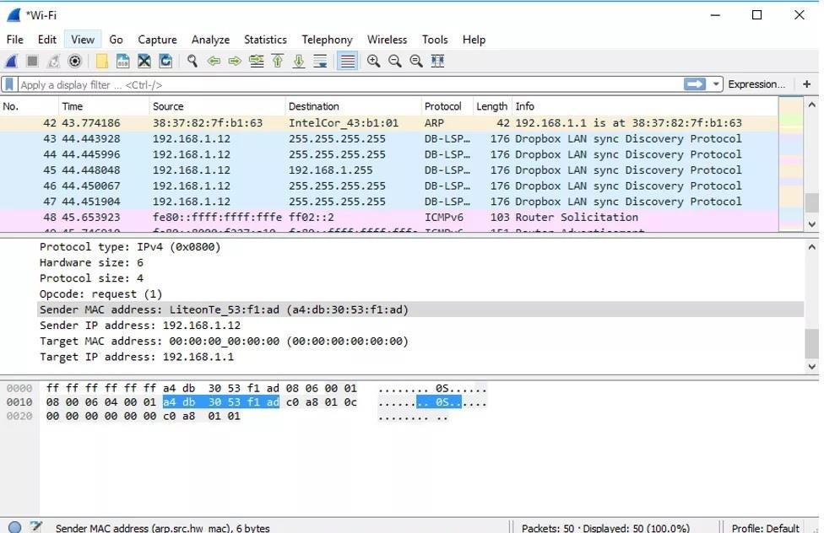
Figure 2. Wireshark engine running for network traffic capturing
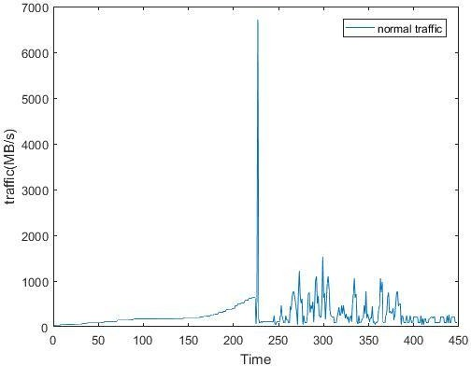
time(micro-seconds)

traffic(GB/micro-sec)

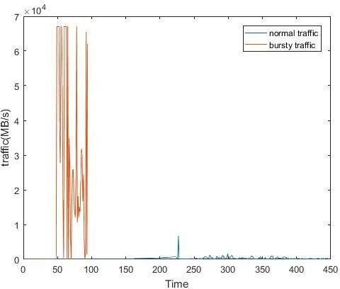
time(micro-seconds)

Figure3.Normal network traffic bursts data captured through Wireshark
traffic(GB/micro-sec)

Figure 3, 4. Exponential (bursty) network traffic laid over normal traffic data captured through Wireshark
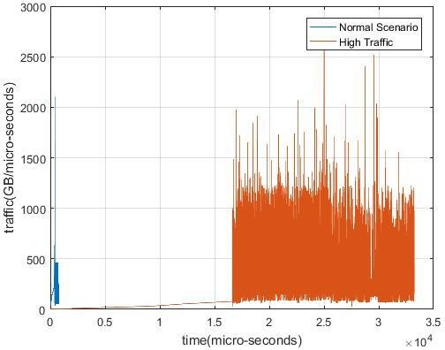
Scenario II: In this case, the data used to evaluate the present study is taken from CRAWDAD (Community Resource for Archiving Wireless Data) iitkdg/apptraffic datasets of a smartphone app collected using tcpdump. Tcpdump is a command-line interface-based data-network packet analyzer computer software. It allows the user to see TCP/IP and other packets that are being sent and received across a network to which the machine is connected. The desired traffic for evaluation came from Google Hangout of smartphone app. An application called google hangout traffic (GB/micro-sec) time (micro-seconds) traffic (GB/micro-sec) time (micro-seconds) 52 facilitates its users to do chats, carry out VoIP calls and video calls. Google hangout is not a completely peer-to-peer service platform, although it has features of a peer-topeer application as it permits two users to interconnect in real-time using a session server which is selected dynamically. In the form of .pcap files, data was collected with only the Google Hangouts app running in the foreground and only required system functions running in the background. A subset of dataset form google hangouts of smartphone app collected from CRAWDAD community.
Figure 5. Exponential (bursty) network traffic overlaid over normal traffic data
3.2. Models for Traffic Forecasting
Traffic forecasting in 5G base stations is crucial for efficient network management, resource allocation, and ensuring quality of service. Several models have been proposed and tested for this purpose, including traditional statistical models such as ARIMA, machine learning models using gradient methods like AGBFM, and techniques like EWOFM. This section presents a theoretical approach to traffic forecasting using these models, emphasizing their strengths and application scenarios.
3.3. Performance Evaluation Metrics for Traffic Forecasting
Various parameters are presented in literature which is considered for performance analysis in this study. Choice of an appropriate parameter is very important to do the comparative analysis of the proposed model with the existing ones. A number of metrics exist to express forecasting accuracy. A brief overview of the parameters explained by authors in their papers [11] is listed below:
- Confidence Intervals: It is considered as the most widely used parameter for network traffic forecasting. A confidence interval quantifies the uncertainty on an estimated traffic, such as the mean or standard deviation. Confidence intervals are most commonly used when forecasting with a regression model, where a quantity is being predicted. Confidence intervals tell how well the model have determined a parameter of interest, such as a mean or regression coefficient.
- Safe Zone: The safe zone, identified by the forecasting model can be effectively used as an alarm system by the network administrators. It can be defined as the network traffic zone in the normal ranges. There are no traffic bursts that might lead to network wide congestions and other related problems in safe zone. Therefore, it is used to identify exactly when the network peaked, so that appropriate actions can be taken to mitigate this problem.
- Mean Square Error (MSE): MSE is a popularly used performance parameter in forecasting. One of the primary performance measure of forecasting is the mean square error (MSE). The MSE is calculated as the average of the sum of the square of forecast errors
- Root Mean Square Error (RMSE): It is the standard deviation of the forecasting errors. Forecasting errors are a measure of how far are the data points from the regression line. It tells how concentrated the data is around the line of best fit. Mathematically, RMSE is defined as square root of MSE.
- Confusion Matrix: It is a metrics used to express predictive accuracy of forecasting model. A Confusion matrix is a 𝑁 × 𝑁 matrix used for evaluating the performance of a forecasting model, where N is the number of target classes. The matrix compares the actual target values with those predicted by the forecasting model. This gives a holistic view of how well the model is performing and what kinds of errors it is making. Figure 6 shows the confusion matrix consisting of the count of number of true positives, true negatives, false positives and false negatives. Equations to be used for evaluating the performance of forecasting model in terms of sensitivity or true positive rate, specificity, accuracy and precision is shown below.
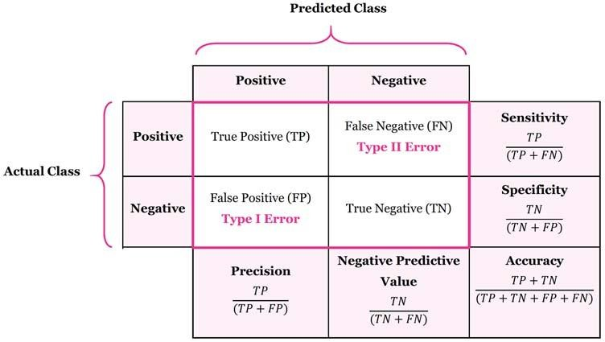
Figure 6. ConfusionMatrix

True Positive (TP) means the actual value was positive and the model predicted a positive value.
True Negative (TN) means the actual value was negative and the model predicted a negative value.
False Positive (FP) means the actual value was negative but the model predicted a positive value.
False Negative (FN) means the actual value was positive but the model predicted a negative value.
- True Positive Rate (TPR) or Sensitivity or Recall: This is another parameter to measure the performance of a forecasting model. It is defined as the ratio of total numbers of TP divided by total number of FP. TPR is the probability that an actual positive will test positive.
- False Positive Rate: It is calculated as the number of incorrect positive predictions divided by the total number of negatives.
- Accuracy: It is the primary measure to show the comparative performance of different models. It is defined as the percentage of correctly predicted instances.
- Precision: Precision is defined as the proportion of true positives declared by the proposed model out of the total positives.
- F1-Score: The weighted average of Precision and Recall is the F1 Score. As a result, this score considers both false positives and false negatives. F1 is more useful, especially when there is an unequal distribution of classes. When false positives and false negatives have equivalent costs, accuracy works well.
- Execution Time: The execution time is calculated using CPU cycles. It is equal to number of CPU cycles used to execute the model using dataset of size n.
- Computational Complexity: It is directly related to the amount of resources required to run an algorithm.

IV. RESULT AND DISCUSSION

4.1 Total Traffic Forecast
The comparison between actual total traffic data and the forecasting results generated by the proposed and existing models over the testing period is done using a number of parameters. The x-axis represents time in hours, and the y-axis indicates the traffic volume. Each model's forecast is plotted alongside the actual traffic data to visualize their performance. The graph highlights discrepancies between predicted and actual values, providing a clear visual representation of each model's accuracy. Forecasting models comprises of training and optimization algorithms. LSSVM (Least Square Support Vector Machine) [12] is used for training and ACO (Ant Colony Optimization) [13], PSO (Particle Swarm Optimization) [14], WOA (Whale Optimization Algorithm) [15], IWOA (Improved Whale Optimization), AGO (Adaptive Gradient Optimization) are used as optimization algorithms. Convergence curve for existing and proposed models is as shown in figure 7.

Iteration (#)
Figure 7. Convergence Curve using LSSVM-ACO
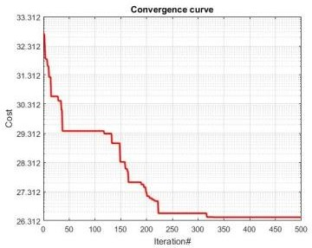
Figure 8. Convergence Curve using LSSVM-PSO
The best achievable optimization cost using ACO and PSO with LSSVM classifier is shown in figure 7 and 8. ACO Pareto optimization was not received even until 50 iterations. This makes LSSVM-ACO better in terms of optimization efficiency. This is because of the slower search criteria of ACO. The confusion matrix for LSSVM-ACO, LSSVM-PSO, LSSVM-WOA, AGBFM and EWOFM for scenario 1 and scenario 2 are shown in figure 9, 10, 11, 12 and figure 13 respectively.
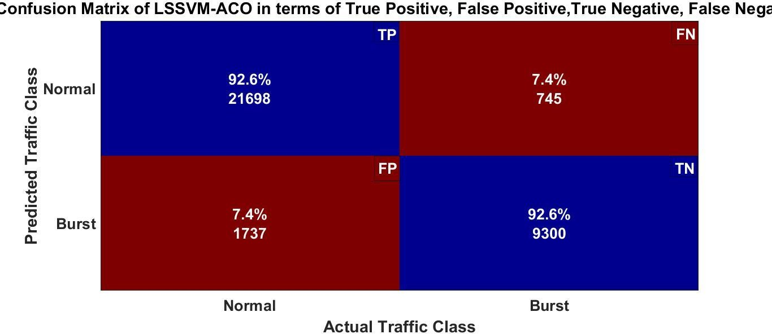  Confusion matrix in scenario1 | 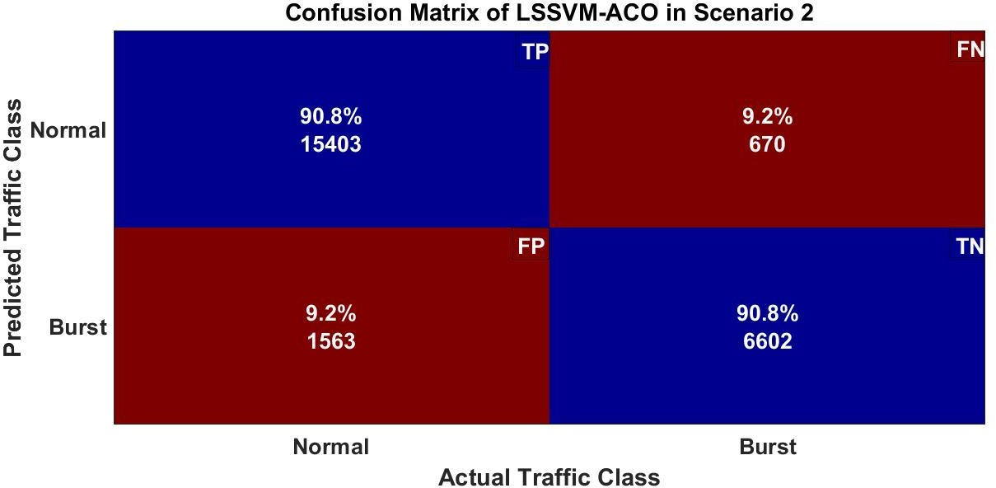
Figure 9: Confusion Matrix of LSSVM-ACO
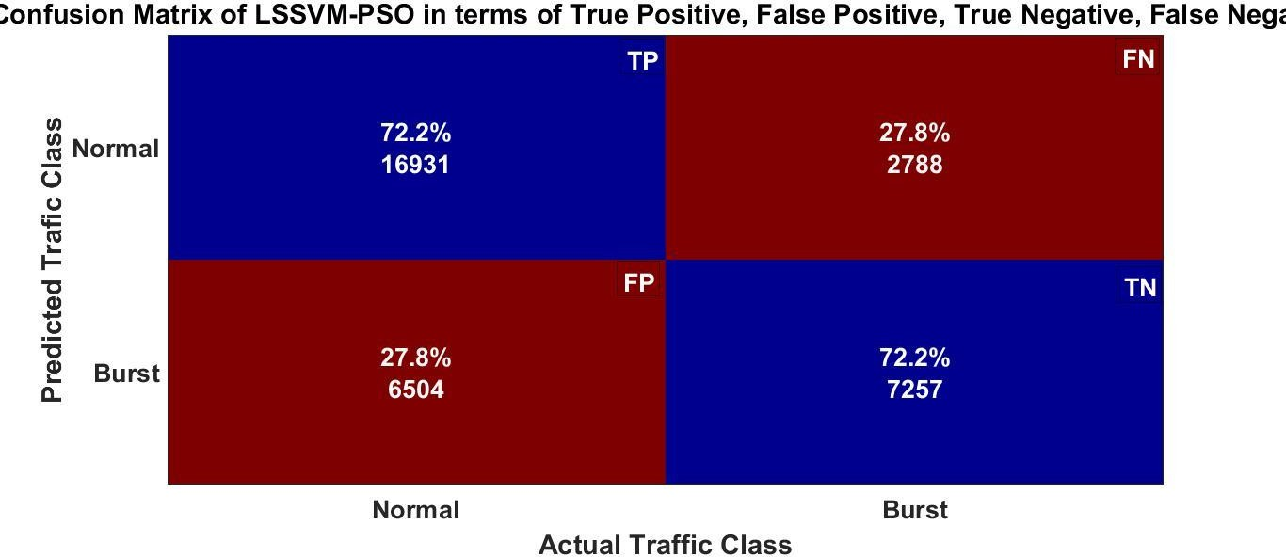  Confusion matrix for scenario1 |  | 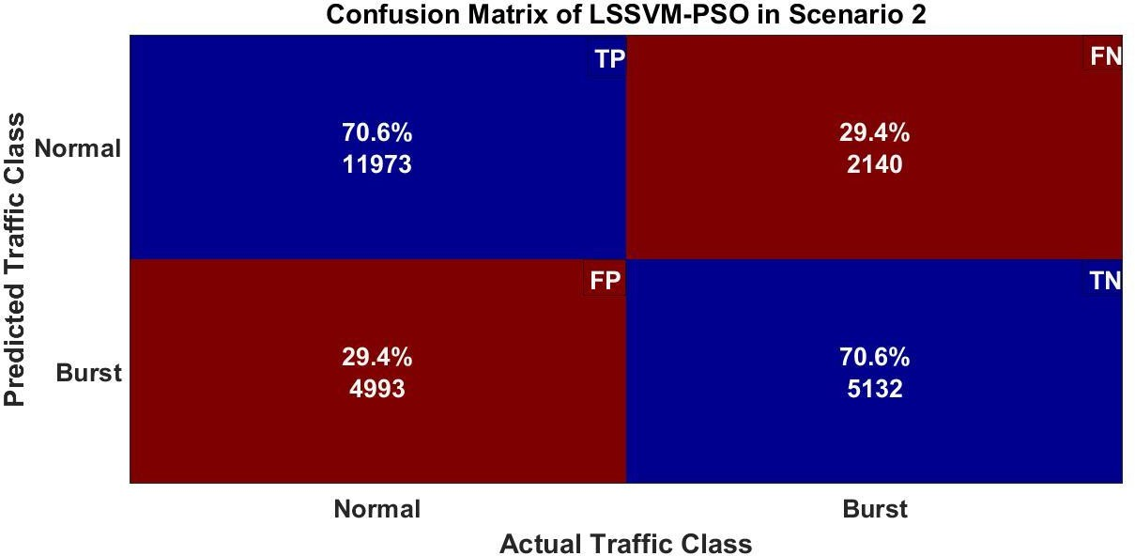
Figure 10: Confusion Matrix of LSSVM-PSO
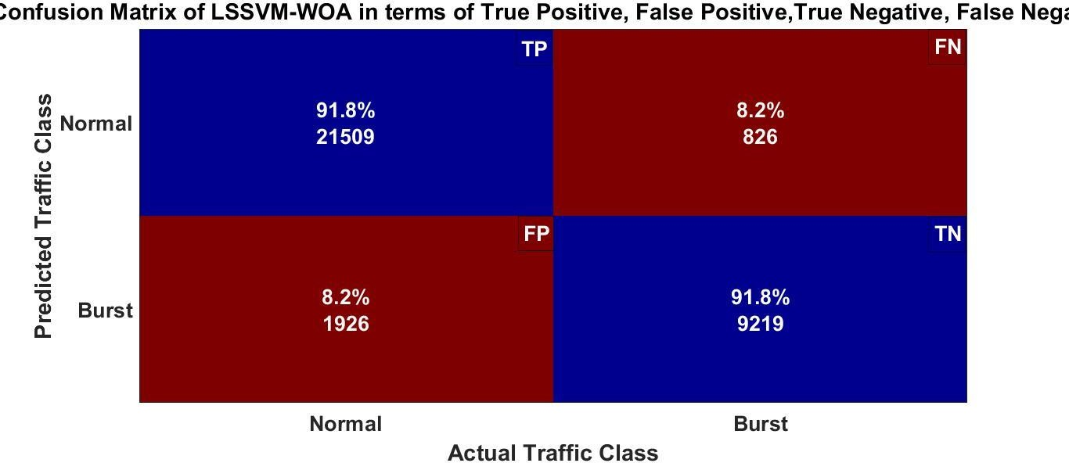  Confusion matrix for scenario1 |  |  | 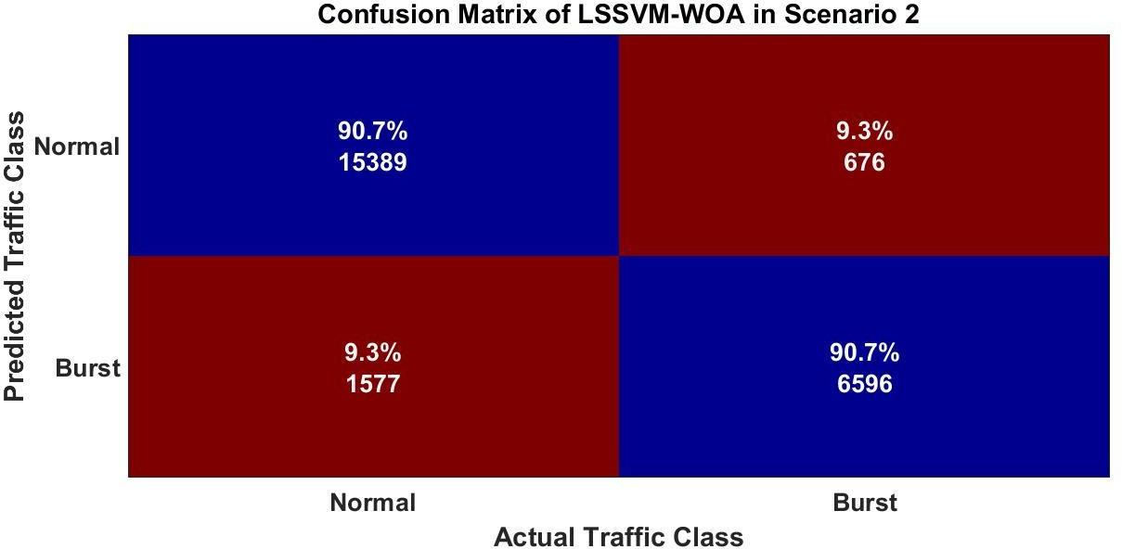
Figure 11: Confusion Matrix of LSSVM-WOA

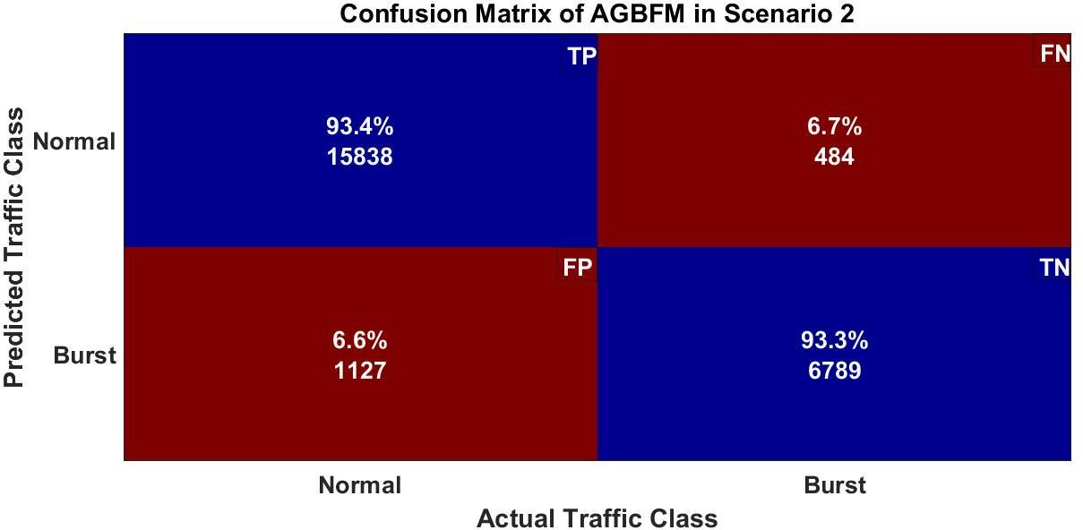 | 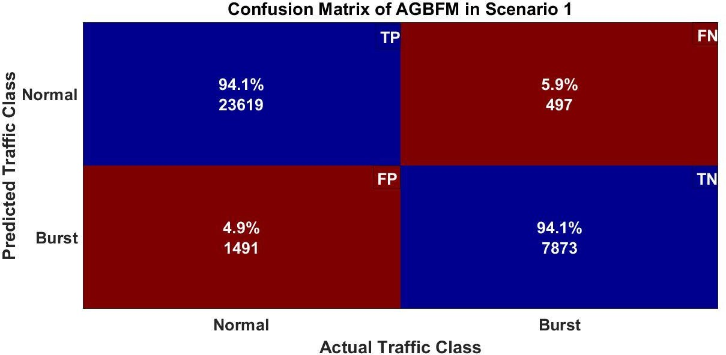
Figure 12: Confusion Matrix of AGBFM

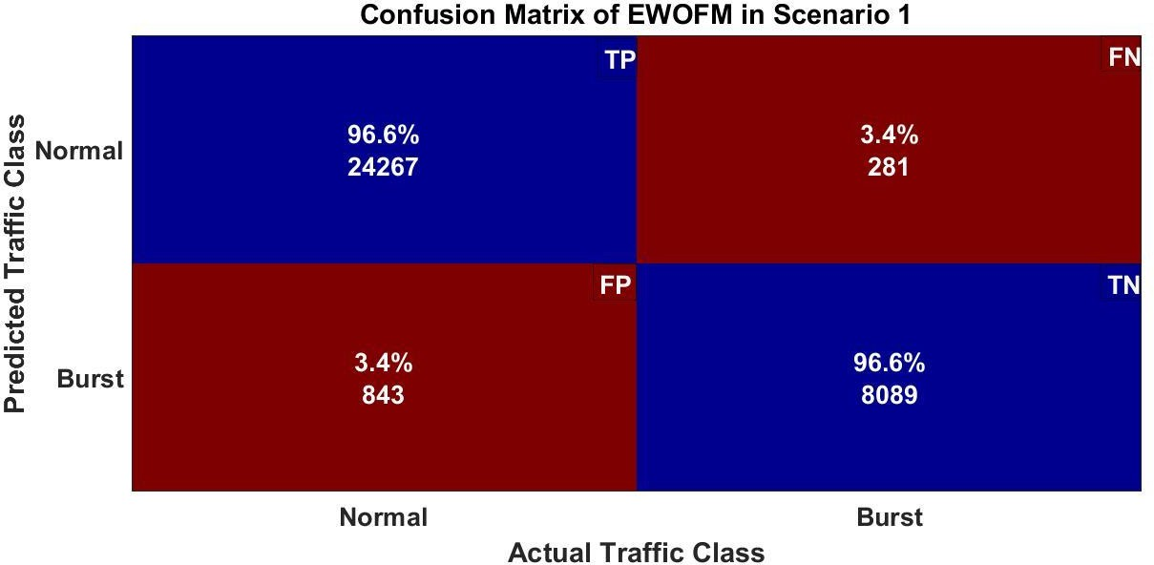 | 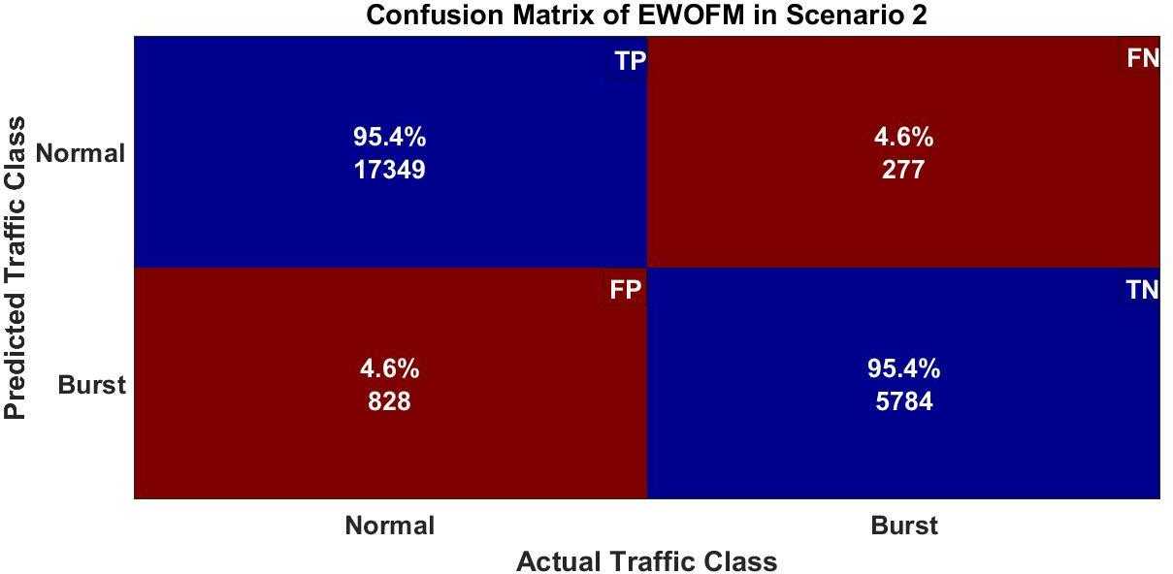
Figure 13: Confusion Matrix of EWOFM

4.2 Performance Analysis
The proposed forecasting models (AGBFM and EWOFM) are compared with three other models namely LSSVM-ACO, LSSVM-PSO and LSSVM-WOA. Although the meta-heuristic algorithms work really well in many domains of application, however, it is observed that LSSVM-ACO, LSSVM-PSO and LSSVM-WOA does not perform well as compared to the proposed ones, in forecasting traffic bursts. This is due to the fact that the first proposed model, adaptive gradient based optimizer (AGBO) can be directly integrated with proposed prediction model using parameter optimization (gamma and sigma). The second proposed model, EWOA enhances the exploration ability by using inertia weight factor whereas ACO and PSO cannot do optimization and proper exploration using LSSVM. Moreover, the search criteria of ACO and PSO include exploitation instead of inherent gradient based optimization in AGBFM. Also, the usage of input data for tuning of parameters makes the proposed algorithms (AGBFM and EWOFM) adaptive and efficient.

The extra searches make the ACO and PSO loosely coupled optimizers. In case of PSO the convergence did happen faster, but it did not achieve good fitting cost. Compared to ACO, the PSO achieved lower average fitting cost i.e. lower efficiency but not better than AGBFM and EWOFM. The evaluation parameters, namely, MSE, accuracy, TPR, FPR, precision and F1-score are also calculated for all the existing and proposed forecasting models.
4.2.1 Mean Square Error
The MSE is evaluated for the proposed and existing algorithms. The results for scenario 1 and scenario 2 are shown in figure 14. MSE is a technique for determining how close estimations or projections are to actual values. For regression models, this is employed as a model evaluation metric, with a lower value indicating a better fit. The EWOFM shows minimum MSE because this model uses enhanced whale optimization model to improve the hyper parameters of training model. IWOA optimizer can be tightly coupled with the LSSVM training algorithm as compared to other models which makes this model fit for forecasting.
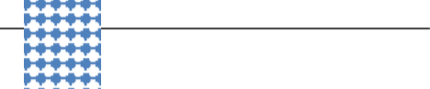          MSE FOR SCENARIO1  2.94%  3.16%  4.20%  7.40%  MSE of Different  Forecasting Models  27.90%  LSSVM-WOA  LSSVM-PSO  IWOPM  LSSVM-ACO  AGBFM |           MSE of Different  Forecasting Models  29.20%  8.10%  4.70%  3.42%  3.30%  MSE FOR SCENARIO2  LSSVM-ACO LSSVM-PSO LSSVM-WOA  AGBFM IWOPM
Figure14. MSE of forecasting models in scenario 1 and scenario 2

4.2.2. Accuracy
The accuracy is evaluated for the proposed and existing algorithms. The results are shown in figure 15 for scenario 1 and scenario 2. The EWOFM shows maximum accuracy because search criteria in this model used by search agents is three dimensional which enhances the capabilities in terms of exploration of the search space and hence overall accuracy in forecasting results increases.
Figure15. Accuracy of forecasting models in scenario 1 and scenario 2
4.2.3. True Positive Rate (TPR) or Sensitivity or Recall and False Positive Rate (FPR)
The true positive rate for the proposed and existing algorithms is shown in figure 16. The false positive rate for the proposed and existing algorithms is shown in figure 17. The TPR is maximum in case of EWOFM because the number of true alarms higher as the number of iterations increases. The higher TPR indicates confirmation. The FPR is lowest in case of EWOFM. The lower value of FPR is desirable, as FPR signify wrong forecasting.
Figure 16. TPR of forecasting models in scenario 1 and scenario 2

Figure 17. FPR of forecasting models in scenario 1 and scenario 2

4.2.4. F1-Score
F1-score of EWOFM is slightly better than the other models as this model is having best TPR (or recall) and precision. F1-score gives the harmonic mean of these two so the overall value is better than the other models. The F1-Score evaluated for the proposed and existing algorithms is shown in figure 18.
Figure 18. F1-Score of forecasting models in scenario 1 and scenario 2

The performance evaluation of EWOFM, AGBFM, LSSVM-PSO, LSSVM-ACO and LSSVM-WOA for both the scenarios of dataset is summarized in table 1 and table 2.
Table 1. Comparative analysis of existing and proposed forecasting models for scenario 1
Parameters  Forecasting Models | LSSVM-ACO | LSSVM-PSO | LSSVM-WOA | AGBFM | EWOFM
Mean Square Error | 7.4% | 27.9% | 4.2% | 3.16% | 2.94%
TP alarms | 21698 | 16931 | 21509 | 23619 | 24267
FP alarms | 1737 | 6504 | 1926 | 1491 | 843
TN alarms | 9300 | 7257 | 9219 | 7873 | 8089
FN alarms | 745 | 2788 | 826 | 497 | 281
Accuracy | 92.60% | 72.20% | 91.80% | 94.10% | 96.60%
TPR (Sensitivity) | 0.966805 | 0.858614 | 0.963018 | 0.979391 | 0.988553
FPR | 0.15738 | 0.47264 | 0.172813 | 0.159227 | 0.09438
Precision | 0.92588 | 0.722466 | 0.917815 | 0.940621 | 0.966428
F1-Score | 0.9459 | 0.784678 | 0.939873 | 0.959615 | 0.977365
Execution Time* | 56 | 81 | 49 | 45 | 41
Computational Complexity | $θ\left(n\log{n}\right) + \frac{θ\left(n^{2}\log{n}\right)}{ρ^{2}}$** | $$θ\left(n^{2}\log{n}\right)$$ | $$θ\left(nlog n\right)+θ(n^{3})$$ | $$θ\left(nlog n\right)+θ(n^{2})$$ | $$θ\left(nlog n\right)+θ(n^{3})$$

Table 2. Comparative analysis of existing and proposed forecasting models for scenario 2
Parameters  Forecasting Models | LSSVM-ACO | LSSVM-PSO | LSSVM-WOA | AGBFM | EWOFM
Mean Square Error | 8.1% | 29.2% | 4.7% | 3.42% | 3.30%
TP alarms | 15403 | 11973 | 15389 | 15838 | 17349
FP alarms | 1563 | 4993 | 1577 | 1127 | 828
TN alarms | 6602 | 5132 | 6596 | 6789 | 5784
FN alarms | 670 | 2140 | 676 | 484 | 277
Accuracy | 90.80% | 70.60% | 90.70% | 93.40% | 95.40%
TPR (Sensitivity) | 0.958315 | 0.848367 | 0.957921 | 0.970347 | 0.984285
FPR | 0.191427 | 0.493136 | 0.192952 | 0.14237 | 0.125227
Precision | 0.907875 | 0.705706 | 0.907049 | 0.933569 | 0.954448
F1-Score | 0.932413 | 0.770488 | 0.931791 | 0.951603 | 0.969137
Execution Time* | 60 | 85 | 53 | 51 | 46
Computational Complexity | $θ\left(n\log{n}\right) + \frac{θ\left(n^{2}\log{n}\right)}{ρ^{2}}$** | $$θ\left(n^{2}\log{n}\right)$$ | $$θ\left(nlog n\right)+θ(n^{3})$$ | $$θ\left(nlog n\right)+θ(n^{2})$$ | $$θ\left(nlog n\right)+θ(n^{3})$$

5. CONCLUSION AND FUTURE SCOPE

- A study of the various machine learning algorithms is performed in order to choose the suitable algorithm for training. LSSVM machine learning algorithm is considered for training using dataset. Various optimization schemes are also studied to optimize the parameters of machine learning algorithm for better performance.
- The proposed models have been compared on the evaluation parameters using confusion matrix namely MSE, TPR, FPR, accuracy, execution time and computational complexity precision, f1-score.
- The two proposed models are compared with the existing models to show the effectiveness of the proposed ones using the performances matrices. The proposed forecasting models are compared with three existing models namely LSSVM-ACO, LSSVM-PSO and LSSVM-WOA. Although the meta-heuristic algorithms work really well in many domains of application, however, it is observed that both LSSVM-ACO and LSSVM-PSO does not perform well as compared to deterministic AGBFM, in predicting traffic bursts. Also EWOFM perform best of the all models in forecasting as it focuses on near-optimal solution to the problem and whale based optimizers provides a high-level problem-independent framework.
In future, EWOFM and AGBFM models can also be extended further, so as to apply to different real world problems like image processing, data mining and feature selection.
REFERENCES
[1]. Singhrova, A. (2021). Enhanced whale optimization based traffic forecasting for SDMN based traffic. ICT Express, 7(2), 143-151.
[2]. Anupriya, & Singhrova, A. (2022). Mobile traffic flow prediction using intelligent whale optimization algorithm. Automated Software Engineering, 29(2), 48.
[3]. “Cisco Annual Internet Report - Cisco Annual Internet Report (2020–2025) White-Paper-Cisco.” https://www.cisco.com/c/en/us/solutions/collateral/ executive-perspectives/annual-internet-report/white-paper-c11-741490.html.
[4]. S. Djahel, R. Doolan, G.-M. Muntean, and J. Murphy, “A Communications-Oriented on Traffic Management Systems for Smart Cities: Challenges and Innovative Approaches,” Jan. 2015, vol. 17. doi: 10.1109/COMST.2014.2339817.
[5]. L.-V. Le, D. Sinh, B.-S. P. Lin, and L.-P. Tung, “Applying Big Data, Machine Learning, and SDN/NFV to 5G Traffic Clustering, Forecasting, and Management,” in 2018 4th IEEE Conference on Network Softwarization and Workshops (NetSoft), Jun. 2018, pp. 168–176. doi: 10.1109/NETSOFT.2018.8460129.
[6]. Van Splunder, J. (2015). Periodicity detection in network traffic. Technical Report, Mathematisch Instituut Universiteit Leiden.
[7]. Gijon, C., Toril, M., Luna-Ramírez, S., Marí-Altozano, M. L., & Ruiz-Avilés, J. M. (2021). Long-term data traffic forecasting for network dimensioning in LTE with short time series. Electronics, 10(10), 1151.
[8]. Haseeb, A., & Farooq, A. (2025). REVOLUTIONIZING TELECOMMUNICATIONS: THE IMPACT OF IOT. Spectrum of Engineering Sciences, 347-355.
[9]. Tedjopurnomo, D. A., Bao, Z., Zheng, B., Choudhury, F. M., & Qin, A. K. (2020). A survey on modern deep neural network for traffic prediction: Trends, methods and challenges. IEEE Transactions on Knowledge and Data Engineering, 34(4), 1544-1561.
[10]. Nath, A. (2015). Packet Analysis with Wireshark. Packt Publishing Ltd.
[11]. Yun, S. Y., Namkoong, S., Rho, J. H., Shin, S. W., & Choi, J. U. (1998). A performance evaluation of neural network models in traffic volume forecasting. Mathematical and Computer Modelling, 27(9-11), 293-310.
[12]. Mitra, V., Wang, C. J., & Banerjee, S. (2007). Text classification: A least square support vector machine approach. Applied soft computing, 7(3), 908-914.
[13]. Dorigo, M., Birattari, M., & Stutzle, T. (2006). Ant colony optimization. IEEE computational intelligence magazine, 1(4), 28-39.
[14]. Kennedy, J., & Eberhart, R. (1995, November). Particle swarm optimization. In Proceedings of ICNN'95-international conference on neural networks (Vol. 4, pp. 1942-1948). ieee.
[15]. Mirjalili, S., & Lewis, A. (2016). The whale optimization algorithm. Advances in engineering software, 95, 51-67.

