Revolutionizing Skin Cancer Diagnosis with AI: Integrating YOLO-Based Lesion Detection into a Telegram Chatbot

Lankapalli Mahitha Chopra¹, P S Latha Kalyampudi ²
¹MSc Artificial Intelligence and Data Science ,Central University of Andhra Pradesh
²Assistant Professor, Central Tribal University of Andhra Pradesh

ABSTRACT-- Skin cancer is one of the leading types of cancer globally and the early detection and treatment of skin lesions can drastically decrease mortality. Traditional diagnostic methods require specialized dermatological knowledge and facilities, which are inaccessible in remote and underserved areas. In this paper we develop an Artificial Intelligence-based skin cancer screening framework which is comprised of a YOLO-based object detection model integrated with a Telegram bot for real-time lesion analysis. Using the ISIC (International Skin Imaging Collaboration) dataset, we performed data labelling using Roboflow and developed a YOLO-based object detection model trained to detect nine classes of skin lesions namely: melanoma, basal cell carcinoma, squamous cell carcinoma, actinic keratosis, among others clinically relevant types of lesions. We then integrated our trained model into a Telegram bot which allows for the real-time assessment of uploaded lesion images. Through rigorous testing on the validation set, we report an mAP@50 of 66.4% and an accuracy of recall of 81.0%, precision of 52.5% and an F1 score of 63.7%. This work suggests a feasible approach in using Computer Vision and conversational AI for remote preliminary dermatological screening.
Keywords— Skin Cancer Detection, YOLO, Computer Vision, Deep Learning, Telegram Chatbot, Teledermatology, Roboflow, Artificial Intelligence.
I. INTRODUCTION
Skin cancer is one of the most commonly diagnosed cancers in the world and has a significant impact on public health. Statistics show millions of cases of melanoma and non-melanoma skin cancer worldwide per year. Although most skin cancers are responsive to treatment with early detection, advanced diagnoses result in disease progression and clinical compromise.
Recent progresses in the artificial intelligence, deep learning, computer vision domains led to the development of automated diagnostic systems that may support clinicians on medical image analysis. Deep neural networks are showing interesting results on detection of skin diseases from dermo-scopic images. Still, most of these solutions are not publicly available (due to hardware, complexity or clinical deployment issues).
This paper introduces a low-cost, and easy-to-use skin cancer screening system based on YOLO-based lesion detection[1], and the Telegram chatbot interface to overcomes these limitations. Users upload images directly on messaging interface, and getting an initial prediction of lesions within real time.
The major contributions of this work are:
- Development of a nine-class skin lesion detection model using the ISIC dataset.
- Application of a YOLO-based object detection framework for lesion localization and classification.
- Integration of the trained model with a Telegram chatbot for remote accessibility.
- Evaluation of detection performance using standard object detection metrics.
- Demonstration of a practical tele-dermatology support system for preliminary screening.
II. RELATED WORK
In the recent past, the contribution of AI toward the analysis of medical images has greatly increased. It has been reported that Esteva et al. Could achieve performance comparable to that of a dermatologist for skin lesion classification using CNNs that were trained using skin lesion datasets. Different architectures like ResNet, EfficientNet, DenseNet and Vision Transformers[4] were subsequently used for skin cancer classification[6,7].
Object detection methods have also gained interest for their unique capability to perform localization and classification at the same time. The YOLO based architecture has a good trade off in speed and accuracy for its use in real time applications for healthcare.
Yet most research is only interested in the accuracy achieved. The systems are rarely deployed for real-time diagnosis through a conversational user interface. The implementation of object detection systems over message-based applications is an emerging field.
III. METHODOLOGY
The methodology is organized into four main parts: preparing the dataset, annotating and pre-processing the images[2], training the model using YOLO, and deploying the model with the help of Telegram Bot. The methodology can be shown as follows:
ISIC Dataset → Annotation and Preprocessing → YOLO Training → Model Evaluation → Telegram Deployment → User Prediction
A. Dataset
The International Skin Imaging Collaboration (ISIC) dataset was used for model development. The dataset consisted of 2,494 dermoscopic images representing nine lesion categories:
- Actinic Keratosis
- Basal Cell Carcinoma
- Dermatofibroma
- Melanoma
- Pigmented Benign Keratosis
- Seborrheic Keratosis
- Squamous Cell Carcinoma
- Vascular Lesion
- Nevus
A. Dataset
We use the International Skin Imaging Collaboration (ISIC) dataset to build our model. The dataset contained 2,494 dermo-scopic images categorized into nine types of lesions:
- Actinic Keratosis
- Basal Cell Carcinoma
- Dermatofibroma
- Melanoma
- Pigmented Benign Keratosis
- Seborrheic Keratosis
- Squamous Cell Carcinoma
- Vascular Lesion
- Nevus
ISIC dataset was used as it is one of the widely recognized and most commonly used benchmarks for skin lesion classification[11,12] and contains clinically relevant dermo-scopic images of lesions which contain both types of cancerous (malignant) and non-cancerous (benign) lesions which would help in learning varied visual features corresponding to different skin lesions.
The data was split into train, validation, and test sets. The training set was utilized to learn model parameters while the validation set was used to tune hyper parameters and check model performance. Finally, the test set was kept aside for the final evaluation.
B. Data Annotation and Pre-processing
For object detection, precise annotation is very important since the model has to learn the lesion location as well as classify the lesion. All the images were uploaded in Roboflow and lesion areas were manually annotated with bounding box. Each bounding box was labelled as one of the nine lesion categories.
The pre-processing steps executed after annotation to make the models more robust and more generalizable are as follows:
1) Image Resizing
Images were rescaled to a constant size to match the YOLO input layer. This common input size not only optimizes processing time but also helps to guarantee the extracted features from all training images remain coherent[3].
2) Data Augmentation
To add more variability to our dataset and avoid overfitting we used the following augmentation methods:
- Horizontal flipping
- Vertical flipping
- Rotation
- Scaling
- Cropping
- Brightness adjustment
- Contrast enhancement
These transformations represent the types of variations encountered in natural image acquisition conditions and will improve robustness against variations in orientation, lighting and appearance of the lesion.
3) Normalization
Values of pixels were normalized in a common range prior to the training stage. Normalization increases the numerical stability of optimization, thus speeding up the neural network's convergence.
4) Dataset Splitting
The annotated dataset was split into training, validation and test sets to avoid data leakage, and so that models are tested on images they have never seen.
C. YOLO-Based Detection Model
The framework utilizes a YOLO based object detector. YOLO achieves object localization and classification within a single neural network pass, and real-time inference can be performed by YOLO.
In contrast to conventional two-stage detectors, YOLO makes predictions for both the bounding box and the class probabilities in the input image. This in turn reduces inference time and computational cost. This makes it extremely useful for deployment in the medical services and telemedicine applications
1) Model Architecture
Three major components of YOLO are:
a) Backbone Network
The backbone performs extraction of hierarchical visual features from dermoscopic images. The early layers learn the low-level features which represent the texture and edges, while the deeper layers learn high-level features, such as the lesion's structure and patterns.
b) Neck Network
Neck aggregates multi-scale feature maps from backbone. In this stage, by integrating features from different feature levels, detection performance of lesions with different sizes and shapes can be boosted.
c) Detection Head
The detection head predicts:
- Bounding box coordinates
- Object confidence scores
- Lesion class probabilities
The last output comprises of localized lesions and their diagnostic categories.
2) Training Procedure
The model was trained by means of supervised learning with annotated dermo-scopic images. In every iteration:
- Images were fed into the network.
- Predicted bounding boxes were generated.
- Predictions were compared with ground-truth annotations.
- Loss values were computed.
- Network weights were updated using backpropagation and gradient descent.
The training was stopped when convergence was obtained in the validation set.
3) Loss Function
The object detection objective is expressed as:
[L = L_{box} + L_{class} + L_{object}]
where:
- (L_{box}) represents localization loss,
- (L_{class}) denotes classification loss,
- (L_{object}) corresponds to objectness loss.
Localization loss - checks the accuracy of the predicted bounding boxes, classification loss - checks the classification of lesion category and objectness loss - check if there is a lesion inside the predicted box.
This joint optimization results in an excellent detection accuracy and a faster inference speed.
4) Evaluation Metrics
Model performance was assessed using standard object detection metrics:
Precision
[Precision = \frac{TP}{TP + FP}]
where TP represents true positives and FP represents false positives.
Recall
[Recall = \frac{TP}{TP + FN}]
where FN represents false negatives.
F1-Score
[F1 = \frac{2 \times Precision \times Recall}{Precision + Recall}]
Mean Average Precision (mAP)
Mean Average Precision: it measures the accuracy of detection across all lesion classes and is one of the most common primary benchmark metric for object detection systems.
D. Telegram Chatbot Deployment
For ease of access and usability, the trained model was incorporated into a Telegram bot with the use of Python and the Telegram Bot API.
The following is a high-level summary of the deployment workflow:
Image Upload → Preprocessing → YOLO Inference → Prediction Generation → Telegram Response
When a user uploads a skin lesion image:
- The chatbot receives the image through Telegram servers.
- The image is pre-processed and resized.
- The trained YOLO model performs lesion detection.
- Confidence scores are generated for each prediction.
- The most probable lesion category is selected.
- Results are returned to the user through the chatbot interface.
The chatbot offers an intuitive interaction interface that does not require medical specialized software to be used. A user can access to the screening service by any device that is able to run the telegram messenger which is suitable for remote and low-resource conditions[12].
E. System Workflow
The entire operation flow of the proposed system can be stated as follows:
- Collection of dermo-scopic images from the ISIC dataset.
- Annotation of lesion regions using Roboflow.
- Image preprocessing and augmentation.
- Training of the YOLO-based detection model.
- Validation and performance evaluation.
- Deployment of the trained model through a Telegram chatbot.
- Real-time lesion prediction from user-uploaded images.
This methodology provides the possibility to create a complete AI assisted skin cancer screening platform integrating both the identification of a lesion and easy tele-dermatology access.
IV. SYSTEM ARCHITECTURE
The system's architecture was conceived as an end-to-end pipeline, providing support for the detection of skin lesions from the point of image acquisition to the presentation of the prediction to the user. The architecture includes dataset handling, deep learning-based object detection, cloud-hosted inference, and a chat interface via Telegram.
The system architecture is a complex interconnected system consisting of four different modules, they are Dataset Preparation Module, Model Training Module, Inference Engine Module, User Interface Module. These modules have different functionalities but each of them communicate and collaborate with adjacent modules in order to have a perfectly working system.

A. Module 1: Dataset Preparation
The Dataset Preparation Module is the heart of the framework that is being proposed. The main goal of the Dataset Preparation Module is to collect, structure, annotate and preprocess the dermo-scopic images in order to be fed to the training module.
1) Data Acquisition
Images from the ISIC dataset (a dataset of clinically verified skin lesions, both benign and malignant) were utilized to train the dermoscopic classifier[9]. The diversity of lesion morphologies included in the dataset helped the model to learn discriminative visual representations.
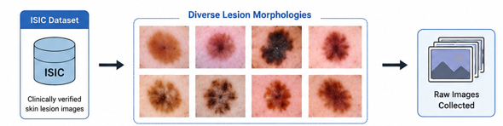
2) Annotation Process
Images were uploaded into Roboflow and then the region of each lesion was manually identified using a bounding box. The class each lesion was put into was selected from one of the nine classes. A key element of this process is correct annotation as it provides critical information regarding the location of the objects.
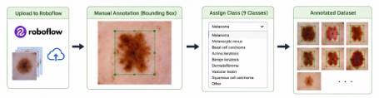
3) Data Augmentation and Preprocessing
In order to increase the generalizability of the model and to prevent over fitting, several preprocessing steps were taken: resize the images, normalize pixel values, rotation of the image, flipping horizontally and vertically, altering brightness and changing contrast. By performing such operations we are adding diversity to the dataset and it mimics real life scenarios in which images are captured.
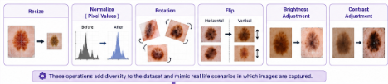
The output from this module is a properly structured and labelled data set, ready to be used for deep learning models.
B. Module 2: Model Training and Validation
The Model Training Module is used to learn the characteristics of the lesions from labelled images, and outputs the trained detection model.
1) Feature Extraction
The features from dermo-scopic image are extracted by YOLO[8] backbone network hierarchically. Low-level layers detect the edges, textures and colour changes in the dermos-copic image, while high-level layers extract the characteristics of the lesion including asymmetry, abnormal boundary and pigmentation characteristics.

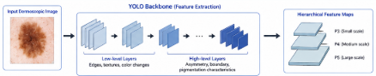

2) Multi-Scale Feature Fusion
Neck: This module aggregates feature maps from multiple depth levels of the network. Aggregation of features from multiple network depths enables detection of lesions that differ considerably in scale and form (e.g. Both small and large lesions could be identified).

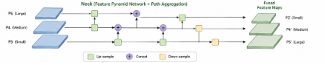

3) Lesion Detection and Classification
The detection head predicts:
- Bounding box coordinates
- Object confidence scores
- Lesion class labels
In training, prediction results are compared with the annotation information and model parameters are adjusted by back-propagation.

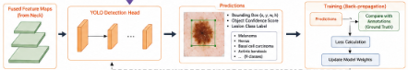

4) Validation and Performance Monitoring
The validation dataset is useful to check the training progression and to analyze the model performance. Various indicators as precision, recall, F1-score, mAP, etc, are being monitored in order to avoid the over-fitting, and the best model is selected accordingly.
The output from this module will be a trained YOLO model that can detect and classify skin lesions in novel images.
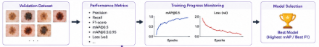
C. Module 3: Inference Engine
The Inference Engine is the central processing component of the implemented system. This component receives an input image submitted by the user and produces the lesion prediction on the fly[9].
1) Image Reception
When you upload an image via Telegram, it gets sent to the inference server. Image is stored temporarily by the server, and then readied for inference.
2) Image Preprocessing
The input image is first resized and normalized according to the input requirements of the trained YOLO.
3) Real-Time Detection
Image is processed by YOLO, in which regions of candidate lesions are found out. For every lesion detected by the model:
- Bounding box coordinates
- Confidence scores
- Predicted lesion category
4) Post-Processing
Remove multiple detection with Non-Maximum Suppression (NMS) and only kept the best prediction. Threshold the detections based on confidence, remove low confidence predictions
5) Result Generation
The prediction finally displays the type of lesion detected along with the confidence value. The output is formatted as a user- friendly reply which will then be sent back to the chat-interface.
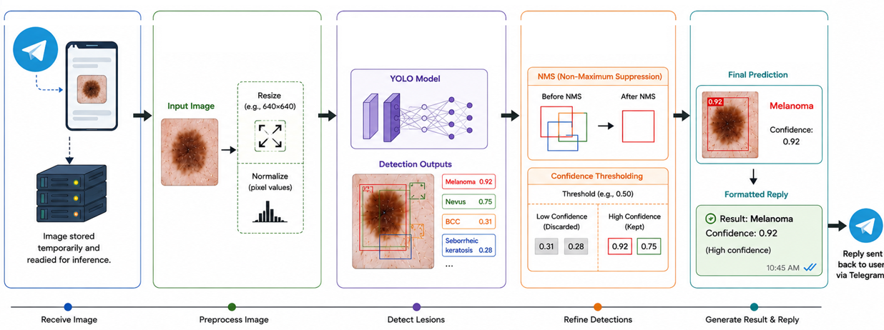
D. Module 4: User Interaction and Telegram Interface
The User Interaction Module allows a simple means of communication between the user and the AI.
1) Telegram Bot Interface
The front-end is the Telegram bot. When you send images through the Telegram interface[17]directly, you will be able to get some output from this front-end.
2) Request Handling
The chatbot receives the request from user, validates the image file formats, and sends image to inference engine.
3) Response Delivery
After inference is completed, the chatbot returns:
- Predicted lesion category
- Confidence score
- Detection summary
This process typically occurs within a few seconds, enabling near real-time screening.
4) Accessibility and Usability
Since Telegram is a common platform on most devices (phones, tablets and PCs) the users don't need a specific medical software installation on their device. This greatly facilitates usage in remote areas with limited or no access to medicalcare.
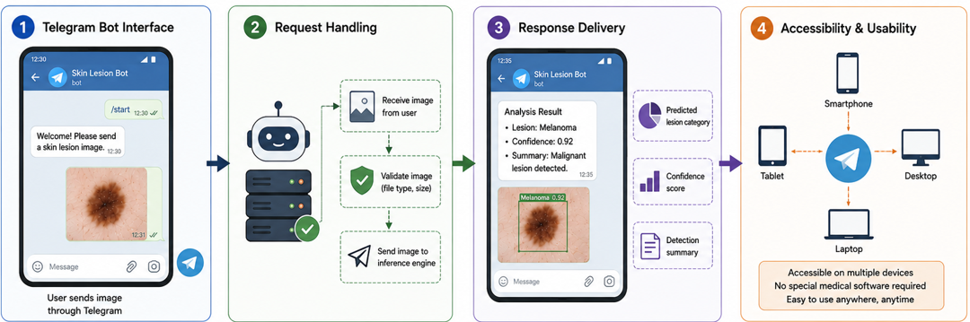
E. End-to-End Data Flow
The complete system workflow can be summarized as:
ISIC Dataset → Annotation and Augmentation → YOLO Training → Trained Model → Inference Engine → Telegram Bot → User Prediction
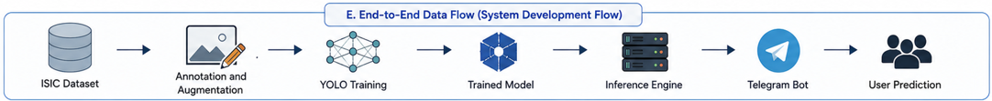
During deployment, the operational flow follows:
User Uploads Image → Telegram Bot Receives Image → Image Preprocessing → YOLO Inference → Confidence Evaluation → Prediction Generation → Result Returned to User
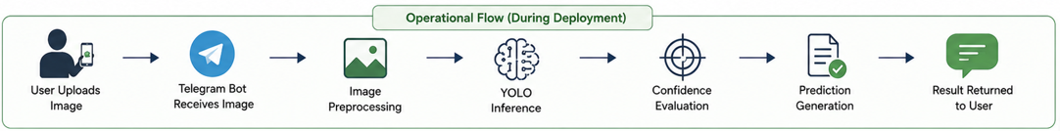
This architecture also makes deep learning, cloud-based inference and conversation AI conveniently usable as an accessible skin cancer screening solution. Its automated detection of a skin lesion within an intuitive messaging interface offers quick initial diagnosis, and makes the system scalable and user-friendly as an aid to tele-dermatology.
V. EXPERIMENTAL SETUP
Parameter | Value
Dataset | ISIC
Total Images | 2494
Number of Classes | 9
Framework | Roboflow
Detector | YOLO-Based Object Detection
Deployment Platform | Telegram
Task | Skin Lesion Detection

VI. RESULTS AND DISCUSSION
A. Overall Performance
Standard object detection metrics, including precision, recall, F1-score, and mean Average Precision (mAP@50) were calculated for the trained YOLO skin lesion detection model based on the validation results given in Table I.
Table I. Overall Validation Performance
Metric | Score
mAP@50 | 66.4%
Precision | 52.5%
Recall | 81.0%
F1-Score | 63.7%

The mAP@50 of the model is 66.4%. This result implies that the level of accuracy of the detection for all classes of lesions is quite acceptable. In order to further improve the model, there is space of improvement according to this metric, however, the result shows that our model is capable of learning effective representations of lesion types on a relatively small dataset consisting of nine different classes.
Another important measure is the recall score of 81.0%, which is much greater than the precision score of 52.5%. Recall measure is very important rather than precision for the medical screening application because the misdiagnosis that a malignant lesion is ignored may cause a very negative medical effect. The good recall obtained by proposed system implies that most instances of the lesion have been successfully detected. Thus, less number of misdiagnosed cases can be expected.
The low precision could mean that the model sometimes makes wrong positive detections, which is not unusual in a multi class dermatology dataset because there are many categories that are visually very similar (e.g. Malignant and benign skin lesions). The downside of having false positive detections is that it will increase unnecessary investigations, but compared to false negatives in the case of cancer detection, these are normally preferred.
F1-score: 63.7%, which means that precision and recall have been balanced and confirms that sensitivity and reliability of prediction remain within reasonable limits. It can be stated that the described framework has potential application as a support tool for decision making, not as an independent diagnostic system.
B. Analysis of Detection Performance
Precision and recall curves were analyzed in order to obtain a deeper insight into the model performance. The high values of recall shows that the model was able to learn effective lesion detection features and was capable of segmenting lesion regions despite the differences in color, texture, and shape.
Several factors contributed to the achieved performance:
- Data Augmentation: By using image transformations including rotation, flipping and brightness adjustment, more diversified datasets were obtained and the generalization of the model was improved.
- Detection at different scales: YOLO was good at detecting lesions of different scales due to feature fusion.
- Bounding box annotation: Precisely identifying the position of the lesions allows the model to capture spatial attributes for each type of lesion.
- Class Complexity: There are several lesion classes that exhibit visual similarities and, as a result, are more difficult to differentiate from each other and hence more prone to false positive classifications.
From the above, it can be seen that the model is biased towards sensitivity and less towards specificity. This is a desirable feature of a preliminary medical screening system.
C. Class-Wise Performance Evaluation
The class-wise mAP@50 results are presented in Table II.
Table II. Class-Wise Detection Performance
Class | mAP@50
Basal Cell Carcinoma | 92%
Pigmented Benign Keratosis | 79%
Melanoma | 65%
Dermatofibroma | 65%
Nevus | 70%
Squamous Cell Carcinoma | 62%
Actinic Keratosis | 56%
Vascular Lesion | 55%
Seborrheic Keratosis | 45%

Wide variation among the lesion types was seen. The sensitivity of detection was highest for Basal Cell Carcinoma.
VII. LIMITATIONS
The developed system has proven the possibility of implementing AI-assisted skin cancer screening through a Telegram chatbot. However, the system has certain limitations that need to be highlighted.
A. Limited Dataset Size
The model was trained using 2,494 dermoscopic images across 9 categories of lesions. Though this size may be adequate for building the concept model, it is considerably small compared to many medical imaging datasets and limited training samples could impair the model’s ability to generalize to different lesion presentations.
B. Class Imbalance
The different types of lesions were represented unevenly in the dataset. Therefore, there existed an imbalance in the training set. Perhaps this caused an inequality in the class-wise performance. In particular, Seborrheic Keratosis and Vascular Lesions class may have been affected.
C. Moderate Precision
While recall was excellent at 81.0% (see below) there appears to be issues with true positives (false positives are prevalent with 52.5% precision). Clinically, these false positives will undoubtedly generate anxiety in the patient and require further clinical investigations.
D. Dependence on Image Quality
Image quality strongly influences the system performance. Bad lighting, blurred images, low resolution images, incorrect focus or occlusion could lower detection performance and prediction reliability.
E. Lack of Clinical Validation
Proposed framework has been tested with available publicly dermoscopic images and hasn't been validated against clinical data, or patient records as diagnosed by a Dermatologist. As such this system should be treated as a decision-support system not as a replacement for the opinion of an expert Dermatologist.
F. Privacy and Security Concerns
Since the images will be sent over an internet messaging system, consideration for patient privacy, security, and regulation compliance is required before this system can be deployed on a large scale in a healthcare setting.
VIII. FUTURE SCOPE
There are a few areas in which the system could be improved for better performance, reliability and clinical application.
A. Expansion of Dataset
In the future work we can expand the skin lesion datasets by using more and various sources. Increasing datasets size and diversity helps improving generalization of classification models and minimizing bias of the model classification.
B. Advanced YOLO Architectures
In addition to this, it is possible to enhance the implementation by employing state of the art object detection models like YOLOv8, YOLOv9 or transformer-based object detection models to increase localization and classification accuracy.
C. Clinical Validation Studies
In future work it would be beneficial to work with dermatologists and health providers in order to test the system with actual patient data. Clinical validation will give further support as to the robustness and reliability of this framework.
D. Explainable Artificial Intelligence (XAI)
Explainable AI methods like Grad-CAM and attention visualization, would offer enhanced interpretability, by visually pointing out areas of the image that affect prediction. This would, therefore, raise users confidence and guide clinicians to their decision making.
E. Mobile Application Development
While Telegram's readily available deployment is beneficial, developing a stand-alone mobile healthcare application would ensure better functionality, user-friendliness, secure handling of data, and electronic health record system integration.
F. Multi-Modal Diagnostic Support
Future systems could possibly incorporate other patient data such as patient age, gender, history of lesion and clinical symptoms in addition to dermoscopic images. The combination of Multi-modal learning methods will potentially increase the diagnostic accuracy considerably.
G. Cloud-Based Teledermatology Platform
This chatbot can be developed into a complete teledermatology system allowing for remote appointments with dermatologists, scheduled appointments, review by dermatologists, and automated report generation.
IX. CONCLUSION
This paper demonstrates an affordable framework for skin cancer screening system. This proposed system is built by implementing a YOLO-based object detection model to perform a real-time analysis of lesions, through an interactive Telegram bot. 2,494 dermoscopic images collected from the ISIC dataset was used to train our model, in detecting and classifying 9 types of skin lesions, ranging from benign to malignant.
Evaluation by experiment achieved the whole mAP@50: 66.4%, precision: 52.5%, recall: 81.0%, and F1-score: 63.7%. The high recall value demonstrated by our model makes it efficient to pick up possibly suspicious lesions which is appropriate to pre-screening work where missed detection is the most important.
The trained model was deployed in conjunction with a Telegram chatbot as a feasible and accessible tool for distant skin lesion screening. In doing so, the suggested system utilizes an established and familiar interface, increasing the accessibility of AI based skin lesion screening in rural and undersupplied areas.
Although the system should not be considered as a replacement to professional medical diagnosis, it shows the feasibility of using deep learning, computer vision, and conversational AI to build systems for supporting tele-dermatology. Further improvements with bigger datasets, superior detection architectures, explainable AI algorithms and clinical validation studies are anticipated to enhance the performance of the system and medical use cases.
REFERENCES
[1] G. Jocher, A. Chaurasia, and J. Qiu, “YOLO by Ultralytics,” GitHub Repository, 2023. Available: https://github.com/ultralytics/ultralytics
[2] IEEE Access Editorial Board, “Recent Advances in Artificial Intelligence for Medical Image Analysis,” IEEE Access, vol. 10, pp. 45000–45025, 2022.
[3]Sarvamangala, D. and Kulkarni, R. V. (2022). Convolutional neural networks in medical image understanding: a survey. Evolutionary intelligence, 15(1):1–22.
[4]Rothman, D. and Gulli, A. (2022). Transformers for Natural Language Processing: Build, train, and fine-tune deep neural network architectures for NLP with Python, PyTorch, TensorFlow, BERT, and GPT-3. Packt Publishing Ltd.
[5] Gaafar, A. S., Dahr, J. M., and Hamoud, A. K. (2022). Comparative analysis of performance of deep learning classification approach based on lstm-rnn for textual and image datasets. Informatica,
[6] A. Dosovitskiy, L. Beyer, A. Kolesnikov, et al., “An Image is Worth 16×16 Words: Transformers for Image Recognition at Scale,” International Conference on Learning Representations (ICLR), 2021.
[7] M. Kavitha, P. V. V. S. Srinivas, P. S. L. Kalyampudi, C. S. F and S. Srinivasulu, "Machine Learning Techniques for Anomaly Detection in Smart Healthcare," 2021 Third International Conference on Inventive Research in Computing Applications (ICIRCA), Coimbatore, India, 2021, pp. 1350-1356,doi:0.1109/ICIRCA51532.2021.9544795
[8]Jiang, P., Ergu, D., Liu, F., Cai, Y., and Ma, B. (2022). Areview of yolo algorithm developments. Procedia Computer Science, 199:1066–1073.
[9] Rao, TV Madhusudhana, P. Srinivasa Rao, and PS Latha Kalyampudi. "Iridology based vital organs malfunctioning identification using machine learning techniques." International Journal of Advanced Science and Technology 29.5 (2020): 5544-5554.
[10] M. Tan and Q. Le, “EfficientNet: Rethinking Model Scaling for Convolutional Neural Networks,” Proceedings of the International Conference on Machine Learning (ICML), pp. 6105–6114, 2019
[11] N. C. F. Codella, D. Gutman, M. Celebi, et al., “Skin Lesion Analysis Toward Melanoma Detection: A Challenge at the International Symposium on Biomedical Imaging,” ISBI, pp. 168–172, 2018.
[12] P. Tschandl, C. Rosendahl, and H. Kittler, “The HAM10000 Dataset: A Large Collection of Multi-Source Dermatoscopic Images of Common Pigmented Skin Lesions,” Scientific Data, vol. 5, no. 180161, 2018.
[13] J. Redmon, S. Divvala, R. Girshick, and A. Farhadi, “You Only Look Once: Unified, Real-Time Object Detection,” Proceedings of the IEEE Conference on Computer Vision and Pattern Recognition (CVPR), pp. 779–788, 2016.
[14] A. Esteva, B. Kuprel, R. A. Novoa, et al., “Dermatologist-Level Classification of Skin Cancer with Deep Neural Networks,” Nature, vol. 542, no. 7639, pp. 115–118, 2017.
[15] International Skin Imaging Collaboration (ISIC), “ISIC Archive,” Available: https://www.isic-archive.com
[16] Roboflow Inc., “Roboflow Documentation,” Available: https://docs.roboflow.com
[17] Telegram, “Telegram Bot API Documentation,” Available: https://core.telegram.org/bots/api
[18] S. Ren, K. He, R. Girshick, and J. Sun, “Faster R-CNN: Towards Real-Time Object Detection with Region Proposal Networks,” IEEE Transactions on Pattern Analysis and Machine Intelligence, vol. 39, no. 6, pp. 1137–1149, 2017.
[19] K. He, X. Zhang, S. Ren, and J. Sun, “Deep Residual Learning for Image Recognition,” CVPR, pp. 770–778, 2016.
[20] G. Huang, Z. Liu, L. Van Der Maaten, and K. Weinberger, “Densely Connected Convolutional Networks,” CVPR, pp. 4700–4708, 2017.

