Environmentally Induced Behavior of the Superstructure of Highly Skewed Bridges

ABSTRACT

Aim: This study critically examines the environmentally induced behavior of highly skewed bridge superstructures, a structural vulnerability that has been dangerously under-addressed relative to its consequences. Particular emphasis is placed on how temperature variation, thermal gradients, seasonal thermal cycling, and differential solar exposure combine to threaten the structural response, serviceability, and long-term survivability of skewed bridges.
Study Design: The review adopts a comprehensive, critically focused analytical and literature-based approach, concentrating on studies published between 2021 and 2026 that address skew bridge mechanics, thermal loading effects, finite element modeling, and the deteriorating durability of bridge systems under sustained environmental attack.
Methodology: The study was conducted through a systematic review of scholarly publications obtained from databases such as Google Scholar, Scopus, ScienceDirect, and Environmental Science& Policy. Relevant peer-reviewed articles relating to thermal behavior, structural deformation, support restraint effects, and environmental loading in skewed bridges were critically examined.
Results: Findings from the reviewed studies indicate that environmental loading significantly influences the structural behavior of highly skewed bridge superstructures. Increasing skew angle was found to amplify thermally induced displacements, girder rotations, restraint forces, and support reactions, especially near acute and obtuse corners of the deck. Bridges with skew angles greater than approximately 45° exhibited pronounced three-dimensional deformation patterns that conventional simplified design approaches often fail to predict accurately. Differential solar heating and thermal gradients were also identified as major contributors to bearing distress, expansion joint deterioration, and uneven load transfer within the bridge system.
Conclusions: Environmental effects play a critical role in the structural performance and serviceability of highly skewed bridges. Existing simplified design assumptions are increasingly inadequate for bridges with large skew angles under realistic environmental conditions. Improved analytical modeling, advanced thermal assessment procedures, and enhanced detailing of bearings, expansion joints, and restraint systems are necessary to ensure the durability and resilience of skewed bridge infrastructure.

Keywords: Induced Behavior, Skewed Bridge, Temperature Variation, Thermal Gradient, Thermal Cycling.

1. INTRODUCTION

Bridges remain among the most critical components of transportation infrastructure, underpinning economic growth, mobility, trade, and regional integration [1]. Any compromise to their structural integrity carries consequences that extend far beyond the structure itself, disrupting supply chains, emergency response, and regional connectivity. The continuous expansion of urban road networks, railway crossings, waterways, and complex highway interchanges has driven an increasing reliance on bridge systems capable of fitting within constrained site conditions. As a direct consequence, skewed bridges have become increasingly common in modern bridge engineering practice, often without a proportional increase in scrutiny of the environmental risks they introduce. A skewed bridge is generally defined as a bridge whose supports are not perpendicular to the longitudinal centerline of the bridge deck. Instead, the supports intersect the deck at an oblique angle, creating what is referred to as a skew angle.

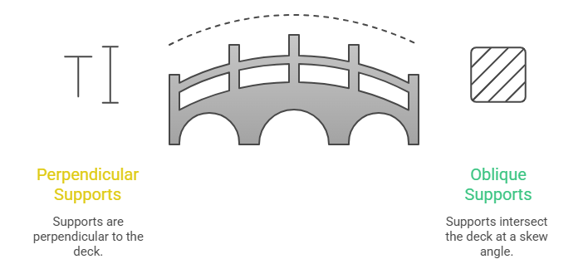

Figure 1: Understanding Skewed Bridge

Bridges with small skew angles may behave similarly to conventional straight bridges; however, highly skewed bridges exhibit critically different and far less forgiving structural responses due to their geometric irregularity [2, 3]. The presence of skewness fundamentally and dangerously changes the way loads are transferred through the bridge system. In conventional right-angle bridges, structural behavior is relatively predictable because loads are distributed symmetrically to supports. In contrast, skewed bridges generate complex three-dimensional responses characterized by torsion, uneven load transfer, stress concentration, differential support reactions, and rotational movements [4, 5]. These effects intensify sharply as the skew angle increases, and beyond a critical threshold they can no longer be treated as a secondary design consideration. Engineers and researchers have devoted considerable attention to understanding how skewness influences structural performance under vehicular live loads and seismic actions. Yet the environmentally induced behavior of highly skewed bridge superstructures has received disproportionately little attention despite being a critical, ongoing driver of bridge deterioration and long-term serviceability failure [6].

Environmental loading refers to external conditions such as temperature fluctuations, solar radiation, wind exposure, humidity, and seasonal climatic variation that act continuously on structures throughout their service life [7]. Among these factors, thermal loading stands out as the most critical for bridge systems, because bridges are relentlessly exposed to changing atmospheric conditions every day and across every season, with no reprieve from this cumulative environmental attack.

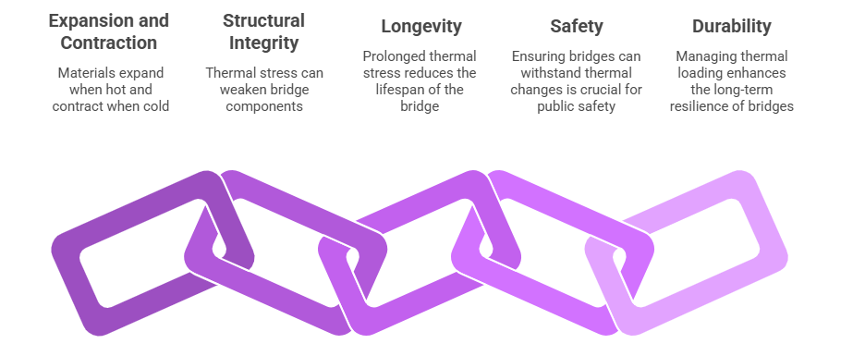

Figure 2: Impact of Thermal Loading on Bridges

Temperature variation causes expansion and contraction of bridge components, generating movements and stresses that critically affect structural integrity, support behavior, and maintenance performance. While all bridges are affected by temperature changes, highly skewed bridges exhibit markedly more severe and unpredictable responses because their geometry creates nonuniform deformation patterns and rotational effects that are absent or far less pronounced in straight bridges [8–10]. Thermal effects in bridge engineering are generally categorized into uniform temperature changes and thermal gradients.

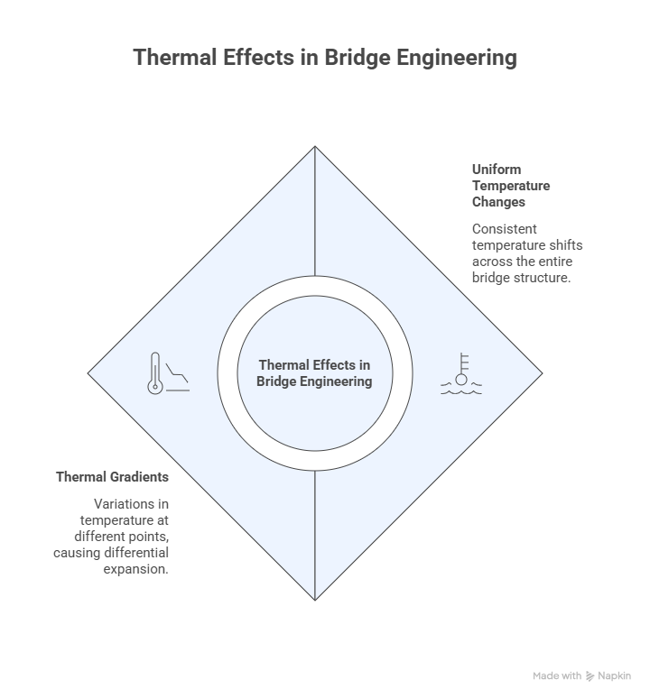

Figure 3: Thermal Effects in Bridge Engineering

Uniform temperature changes occur when the entire structure experiences approximately the same increase or decrease in temperature, causing the bridge deck and supporting components to expand or contract uniformly. Thermal gradients, by contrast, develop when temperature distribution across the bridge section is uneven, a condition that often results from solar radiation, shading effects, atmospheric conditions, and material properties. In concrete and steel bridge systems, differential heating between the top and bottom surfaces of the deck, or between exposed and shaded girders, can generate bending stresses, warping deformation, and restraint forces severe enough to threaten long-term serviceability [11, 12].

In highly skewed bridges, the influence of thermal loading becomes critically more severe due to the interaction between skew geometry and structural restraint conditions [13]. Unlike conventional bridges, where thermal expansion occurs predominantly along the longitudinal axis, skewed bridges experience coupled translational and rotational movement during temperature changes. As thermal expansion proceeds, the acute and obtuse corners of the bridge deck move differently, creating asymmetric displacement patterns that carry a heightened risk of localized failure. These movements often induce torsional rotations, dangerous localized stress concentration, and irregular support reactions. Studies confirm that skewness sharply amplifies thermal deformation near support regions, especially at large skew angles exceeding approximately 45° [14, 15].

One of the most critical consequences of thermal action in highly skewed bridges is the development of restraint forces. Bridge supports, bearings, diaphragms, and substructures often restrain free thermal movement to some extent. In straight bridges, these restraint forces may remain relatively manageable and predictable. In skewed bridges, however, restraint conditions become dangerously more complicated because the thermal movement path is no longer linear [9, 16]. The resulting restraint forces may generate excessive, potentially critical stresses in girders, deck slabs, bearings, and expansion joints. Beyond the structural risk, environmentally induced behavior carries serious economic consequences for bridge maintenance and lifecycle management. Premature deterioration caused by thermal stresses and environmental exposure escalates repair costs, traffic disruption, and long-term maintenance burdens [17, 18]. Transportation agencies worldwide already spend substantial financial resources annually on bridge rehabilitation and replacement programs, a burden that is set to grow more critical as skewed bridge inventories age [17].

Recent research has proposed several strategies for mitigating the environmental vulnerability of highly skewed bridges. These include optimized bearing layouts, improved expansion joint systems, use of thermal-resistant construction materials, incorporation of sliding and guided support mechanisms, and enhanced numerical simulation during the design phase [9, 19, 20]. Some researchers have gone further, recommending that excessive skew angles be limited where feasible, or that alternative geometric configurations be adopted to minimize torsional effects and restraint-induced stresses — a recognition that current practice may be permitting a critical design risk to persist unchecked [4]. Additionally, the integration of structural health monitoring systems has been proposed as a means of continuously evaluating thermal response and identifying early, otherwise invisible signs of environmental distress in bridge structures [21].

Despite these advancements, critical gaps remain in current understanding of the environmentally induced behavior of highly skewed bridge superstructures. Much of the available literature focuses primarily on live load behavior, seismic performance, or static structural response, while comparatively few studies comprehensively investigate environmental loading effects, leaving a dangerous blind spot in the evidence base. Existing research also tends to examine individual thermal factors in isolation rather than considering the combined and compounding influence of uniform temperature change, thermal gradients, seasonal cycling, and differential solar exposure under realistic service conditions. Furthermore, there remains limited integration between field monitoring data and advanced computational modeling, creating unacceptable uncertainty regarding the practical accuracy of analytical predictions; this study seeks to confront these gaps directly.

2. METHODOLOGY

This study adopted a systematic qualitative review approach to critically examine the environmentally induced behavior of highly skewed bridge superstructures. The methodology was designed to rigorously evaluate recent scholarly studies relating to the influence of environmental loading conditions — including uniform temperature changes, thermal gradients, seasonal thermal cycling, and differential solar exposure — on the structural response of highly skewed bridges. The review focused specifically on understanding how skew angle affects thermally induced displacements, support reactions, girder rotations, restraint forces, and long-term bridge performance under realistic and, at times, worst-case environmental conditions. The study relied primarily on secondary data obtained from peer-reviewed journal articles published between 2021 and 2026. This review period was selected to ensure that the study captured recent, critically relevant developments in bridge engineering, finite element modeling techniques, thermal loading analysis, and environmental performance assessment of bridge systems. Emphasis was placed on contemporary studies because the environmentally induced behavior of highly skewed bridges remains a relatively novel yet urgently developing area within structural and transportation engineering research.

The literature search strategy involved the use of four major academic and engineering databases, namely Google Scholar, Scopus, ScienceDirect, and Environmental Science & Policy. These databases were selected for their wide coverage of civil engineering, structural engineering, transportation infrastructure, and environmental engineering publications. Google Scholar provided broad multidisciplinary coverage and access to conference papers and engineering reports, while Scopus and ScienceDirect provided high-quality peer-reviewed journal articles relating to structural analysis, bridge mechanics, and thermal behavior. Environmental Science & Policy was included specifically to capture studies relating to environmental loading, climate effects, and infrastructure resilience — an increasingly critical dimension of this topic.

The literature search process involved carefully selected keywords and search combinations related to the study topic. Search terms included “highly skewed bridges,” “skew bridge superstructure,” “thermal effects in bridges,” “environmental loading in bridges,” “temperature-induced bridge behavior,” “thermal gradients in skew bridges,” “solar radiation effects on bridges,” “bridge thermal deformation,” “finite element analysis of skew bridges,” and “seasonal thermal cycling in bridge structures.” Boolean operators such as AND and OR were used to combine keywords and refine the search results. Additional manual searches were also conducted through the reference lists of selected articles to identify other critically relevant studies that may not have appeared during the initial database search.

The literature identification process initially produced 96 records from the selected databases. Google Scholar contributed 38 records, Scopus produced 27 records, ScienceDirect yielded 21 records, while Environmental Science & Policy contributed 10 records. After the removal of duplicate studies and repeated publications, 71 records remained for title and abstract screening. The screening process involved critically examining the relevance of each study to the environmentally induced behavior of highly skewed bridge superstructures. Studies that focused mainly on conventional straight bridges, unrelated structural systems, or general bridge maintenance without environmental analysis were excluded at this stage.

During the screening stage, 49 records were excluded for several reasons. Some studies focused primarily on seismic loading, vehicular live load distribution, or dynamic vibration analysis without considering environmental loading effects. Other studies examined bridge deterioration generally without specifically analyzing thermal behavior or skew-induced structural response. Following the screening stage, 22 full-text articles were assessed for eligibility and detailed, critical review. The full-text assessment focused on identifying studies that directly addressed the relationship between environmental loading and structural behavior in highly skewed bridge systems. Particular attention was given to studies involving finite element analysis, thermal loading simulations, field monitoring, solar radiation analysis, and structural response evaluation. After detailed assessment, 9 studies were considered sufficiently relevant, methodologically sound, and critically significant for inclusion in the qualitative analysis.

The selected studies were critically analyzed to identify common findings, methodological approaches, structural response patterns, and areas of disagreement within existing literature. The review examined how different skew angles influence thermal displacement, rotational movement, support reactions, and restraint effects. Comparisons were also made between analytical approaches used by different researchers, especially regarding finite element modeling techniques, thermal load assumptions, and environmental simulation methods. Furthermore, the review explored how environmental conditions such as differential solar exposure and seasonal thermal cycling contribute to long-term bridge deterioration and escalating maintenance challenges.

Despite the systematic nature of the review, several limitations must be critically acknowledged. First, the study relied solely on secondary data from published literature and therefore depended heavily on the quality, accuracy, and methodological consistency of the reviewed studies. Also, because the topic is relatively novel, the number of recent studies specifically focusing on environmentally induced behavior in highly skewed bridges remains limited, constraining the volume of available literature for comprehensive comparison and synthesis. Nonetheless, the adopted methodology provided a structured and reliable approach for identifying, reviewing, and synthesizing recent knowledge relating to the environmentally induced behavior of highly skewed bridge superstructures. The approach enabled the study to evaluate current research trends, identify key structural response patterns, assess methodological advancements, and highlight the critical gaps that require urgent further investigation in bridge engineering research.

3. RESULTS AND DISCUSSION

3.1 Thermally Induced Displacement and Three-Dimensional Deformation Patterns

The structural response of highly skewed bridge superstructures to environmental loading is fundamentally and critically distinct from that of straight or moderately skewed configurations. The reviewed literature consistently demonstrates that increasing skew angle sharply amplifies thermally induced displacements in both longitudinal and transverse directions, producing complex three-dimensional deformation fields that violate the fundamental assumptions of conventional planar analysis [3, 22, 23].

Field monitoring and finite element investigations reveal that bridges with skew angles exceeding approximately 45° exhibit severe spatial displacement patterns characterized by asymmetric corner movements, differential girder rotations, and non-uniform bearing translations [3]. Parametric studies indicate that transverse bearing displacements at acute corners increase sharply and nonlinearly with skew angle; for a 60° skew, acute corner transverse displacements increase by over 1100% relative to non-skewed configurations under identical thermal contraction, while obtuse corners remain comparatively restrained [19, 23]. This alarming asymmetry arises because thermal expansion vectors resolve into components both parallel and normal to skewed support lines, generating racking deformations that concentrate movement, and risk, at acute corners [19]. Longitudinal displacement components show only modest variation with skew angle — typically less than 10% difference between 0° and 60° configurations — indicating that the critical driver of vulnerability is not overall thermal expansion but the geometric amplification introduced by skew [22].

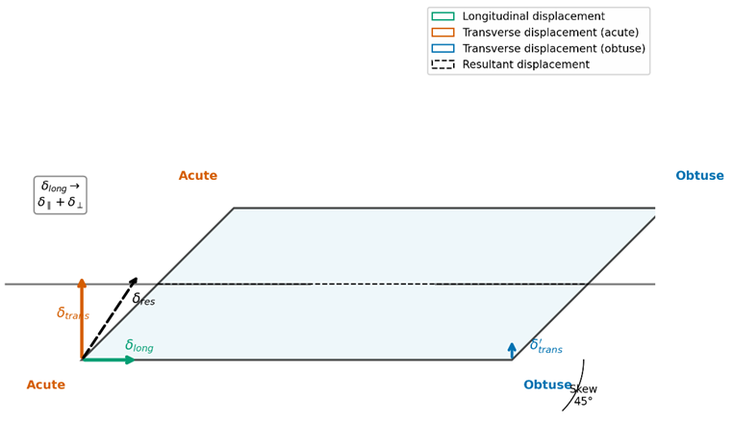

Figure 4: Schematic plan view of highly skewed bridge showing thermal displacement vector decomposition at acute and obtuse corners

The spatial complexity of thermal deformation manifests in coupled displacement fields that cannot be decomposed into independent orthogonal components, a critical limitation of simplified design tools. In monitored highly skewed deck girder bridges with skew angles approaching 64°, approximately 90% of longitudinal bearing displacement translates into parallel-to-expansion-joint motion, while roughly 40% contributes to normal-to-joint components [24]. This kinematic coupling generates multidirectional bearing demands and complex, critically difficult-to-predict expansion joint loading patterns. The strong positive correlation between bearing displacements and temperature (correlation coefficients exceeding 0.90) confirms thermal drivers as dominant, though correlation strength diminishes during warming compared to cooling periods, suggesting hysteretic or time-dependent material effects that add a further layer of critical uncertainty [9, 24, 25].

These displacement patterns carry serious implications for analytical modeling. The inherent three-dimensionality of skewed bridge thermal behavior — manifested in coupled displacement fields, multi-axial force distributions, and spatially varying stress states — demands sophisticated three-dimensional finite element approaches for accurate prediction. Simplified two-dimensional grillage or plane-frame models critically fail to capture these phenomena, and even three-dimensional models depend critically on element formulation, mesh refinement, boundary condition realism, and thermal load representation [24, 26].

In the context of accelerating global climate change, these findings assume even more critical significance. As regional temperature extremes become more pronounced, highly skewed bridges will experience amplified thermal excursions that exacerbate displacement asymmetries and push existing structures closer to their design limits. The nonlinear relationship between skew angle and transverse displacement implies that even modest increases in thermal range will produce disproportionately larger corner movements in bridges exceeding 45° skew, a critical warning sign that historical thermal design ranges may already be dangerously unconservative for future climate scenarios.

3.2 Support Restraint, Reaction Amplification, and Component Demands

The non-uniform thermal expansion and contraction across bridge superstructures generates differential support movements that induce critical restraint forces at bearings, substructure elements, and foundation components. These forces arise from incompatibility between free thermal deformation and structural boundary constraints, producing self-equilibrating stress systems that intensify, sometimes sharply, with increasing thermal effects [22, 28, 29].

Finite element investigations demonstrate that support restraint effects are highly and critically sensitive to boundary condition assumptions. Fixed pier connections substantially amplify thermal restraint moments compared to simply supported conditions, with skew geometry exacerbating force concentrations at acute corner supports [26]. Studies modeling global temperature changes of 20°C combined with vertical thermal gradients of 5°C reveal that skewed configurations develop significant biaxial bending at pier-girder connections, with skew-induced torsional components superimposing on primary flexural responses to produce dangerously complex multi-axial stress states [9, 16, 19].

For integral abutment configurations, skew introduces additional and critical complexity through superstructure-abutment-backfill interaction. Thermal expansion drives abutments toward backfill, with the obtuse side experiencing greater displacement than the acute side, generating non-uniform horizontal earth pressure distributions concentrated at obtuse corners [19, 30]. The resultant force system includes normal pressures perpendicular to the abutment face and shear stresses along the interface, creating coupled force-moment interactions that induce superstructure rotational tendencies. For skew angles exceeding 40°, shear keys at pile cap bases or battered pile orientations become critically necessary to prevent excessive transverse cap movements [25].

These amplified restraint forces translate directly into demands on mechanical components that critically exceed conventional design capacities. Bearings in highly skewed bridges must accommodate cyclic motions in multiple degrees of freedom — longitudinal translation, transverse translation, rotation about vertical axes, and rocking about horizontal axes. This multi-axial demand overwhelms the capacity of fixed bearings and guided expansion bearings configured for primarily unidirectional movement, generating fretting wear, localized yielding, and potential locking, all of which are critical precursors to bearing failure [22, 24]. Traditional bearing orientation schemes aligned parallel to the centerline or perpendicular to supports prove critically inadequate because they fail to accommodate coupled displacement vectors. Radial orientation schemes offer improved performance but require verification against transverse components [9]. Multi-directional expansion bearings, spherical bearings, or disc bearings provide enhanced capacity but must be selected based on three-dimensional displacement predictions rather than dangerously oversimplified planar estimates [26].

Expansion joints experience similarly severe demands. Joints oriented parallel to skewed abutments undergo opening-closing translation superimposed with in-plane rotation, accelerating seal degradation at a critical rate. Modular expansion joints with individual seal elements accommodate differential movements more effectively than single-strip seals, though current systems remain designed primarily for unidirectional applications, leaving a critical mismatch with actual skewed-bridge demand [24].

Progressive component deterioration creates dangerous system-level effects. Bearing distress alters effective support conditions, potentially transforming expansion supports into unintended fixed supports that redistribute thermal forces unpredictably and critically. This evolution induces secondary stresses not anticipated in original design, with particular vulnerability at acute corners where force concentrations are already elevated [26]. Expansion joint deterioration compromises thermal movement capacity, transferring demands to adjacent elements in a cascading, critical failure pathway. These degradation mechanisms are particularly insidious because complex three-dimensional behavior masks underlying deterioration until advanced, critical stages, substantially elevating remediation costs [24, 31].
From a lifecycle management perspective, bearings in highly skewed bridges require more frequent inspection and replacement cycles than straight bridge counterparts — a critical operational reality that is too often underfunded. Transportation agencies face escalating maintenance expenditures, with premature bearing replacement, expansion joint rehabilitation, and deck corner repair representing disproportionately large shares of lifecycle costs. Incorporating thermal cycling effects into lifecycle cost models is critically needed to improve budget forecasting and intervention prioritization for highly skewed bridge inventories before deterioration reaches a crisis point.

3.3 Thermal Gradients, Solar Exposure, and Seasonal Cycling Effects

Beyond uniform temperature changes, non-uniform thermal effects — encompassing vertical gradients through the cross-section, differential solar exposure across the deck, and repeated seasonal temperature cycling — constitute major and critically underappreciated environmental drivers that interact with skew geometry to produce severely amplified structural responses.

Thermal gradients through the superstructure depth induce curvature changes generating differential deflections across the bridge width. In skewed configurations, this manifests as complex warping rather than cylindrical bending, because skewed support geometry constrains natural thermal curvature patterns. The resulting deformation field includes vertical displacements and horizontal rotations of girder lines, with magnitudes increasing disproportionately, and critically, with skew angle [9, 25]. Finite element analyses incorporating nonlinear positive and negative deck temperature gradients demonstrate that gradient-induced displacements, while generally smaller than those from uniform temperature changes, produce significant secondary effects through interaction with support constraints. For composite steel-concrete systems, temperature differentials between steel girders and concrete decks induce additional internal forces that redistribute between components in ways that can critically compromise composite action [9, 19, 32].

Differential solar exposure creates planar thermal gradients that drive horizontal curvature and twisting deformations. In highly skewed bridges, non-rectangular deck geometry ensures that acute and obtuse corners experience systematically different thermal histories over diurnal and seasonal cycles, establishing temperature differentials between adjacent girders [31]. This differential heating generates internal forces that peak, critically, at acute corners where thermal and geometric stress concentrations converge. Infrared imaging and thermal monitoring systems have emerged as valuable tools for characterizing these patterns, enabling real-time identification of thermal hotspots and gradient-induced anomalies that may precede visible, and otherwise undetected, distress. Integration of thermal monitoring with finite element calibration offers particular promise for closing the critical gap left by simplified thermal load assumptions.

Seasonal thermal cycling imposes repeated stress and deformation demands that accumulate, critically, over service life. Field monitoring data reveal that abutment movements, pile bending moments, and pile axial loads fluctuate systematically with seasonal temperature variations, with skew geometry introducing phase shifts and amplitude variations between measurement locations [25]. The redistribution of dead loads among components induced by planar temperature gradients and earth pressure changes contributes to axial load fluctuations in piles, with critical implications for foundation fatigue. Even moderate thermal excursions, repeated over thousands of cycles, produce cumulative damage that can exceed the damage caused by rare extreme events — a critical finding that undermines design philosophies focused only on peak loading [25, 32].

The interaction between thermal gradients and seasonal cycling creates compound, critically dangerous degradation mechanisms. Gradient-induced daily curvature fluctuations superimpose on seasonal expansion-contraction cycles, generating multi-frequency stress spectra that accelerate fatigue damage in steel components and cumulative cracking in concrete. In highly skewed bridges, the asymmetric nature of both gradient and cyclic effects concentrates damage at acute corners, where daily solar heating differentials and seasonal racking deformations combine to produce the most severe demand spectra observed anywhere in the structure.

Climate change amplifies these effects substantially, turning a serious engineering concern into a critical one. As historical thermal design ranges may no longer bound expected future extremes, highly skewed bridges face growing and urgent vulnerability. The nonlinear sensitivity of large-skew configurations implies that climate-driven demand increases will disproportionately, and critically, affect this bridge class ahead of the broader bridge population.

3.4 Analytical Modeling and Validation Approaches

Accurate prediction of environmentally induced behavior in highly skewed bridges requires analytical approaches commensurate with their structural complexity; anything less represents a critical shortfall in engineering practice. Three-dimensional finite element models provide substantially improved accuracy over grillage or plane-frame analogues, though fidelity depends critically on element formulation, mesh density, boundary condition representation, and thermal load definition [26].

Element selection significantly influences predicted thermal response. Shell elements for girder modeling combined with solid elements for diaphragms and piers capture stress gradients at pier-girder connections and acute corner details, though mesh refinement requirements vary with skew angle. Contact and connection modeling between superstructure and substructure introduces additional complexity, with gap opening-closing behavior and nonlinear soil springs significantly, and at times critically, influencing predicted restraint forces [24, 26]. Bearing behavior representation presents particular challenges: simplified spring elements fail to capture multi-axial force-displacement relationships, while detailed bearing models require material properties that are frequently poorly characterized, introducing critical uncertainty into predictions relied upon for safety.

Thermal load representation constitutes a major source of inter-study variation and a critical vulnerability in current practice. Simplified approaches apply uniform temperature changes or linear gradients specified in design codes, while sophisticated methods employ transient heat transfer analyses with meteorological boundary conditions including solar radiation flux, convective coefficients, and effective sky temperatures [32]. Gradient magnitude and shape depend on geographic location, bridge orientation, surface absorptivity, and surrounding terrain shading — factors rarely captured in standardized provisions. Comparative analysis suggests that simplified thermal load assumptions dangerously underestimate acute corner stress demands by 15–30% in highly skewed configurations compared to detailed transient analyses, a critical margin of error for safety-relevant structures [22, 26].

Validation through field monitoring reveals persistent, and critically concerning, discrepancies between predictions and measured behavior. Measured bearing displacements and rotations exhibit scatter exceeding instrument uncertainty, suggesting omitted physical mechanisms [24]. Probable sources include time-dependent material effects, soil-structure interaction, nonlinear bearing behavior, and wind-modified convective coefficients. Long-term monitoring is particularly critical because short-term measurements cannot capture cumulative cyclic effects or seasonal stabilization phenomena that may only manifest after years of exposure.

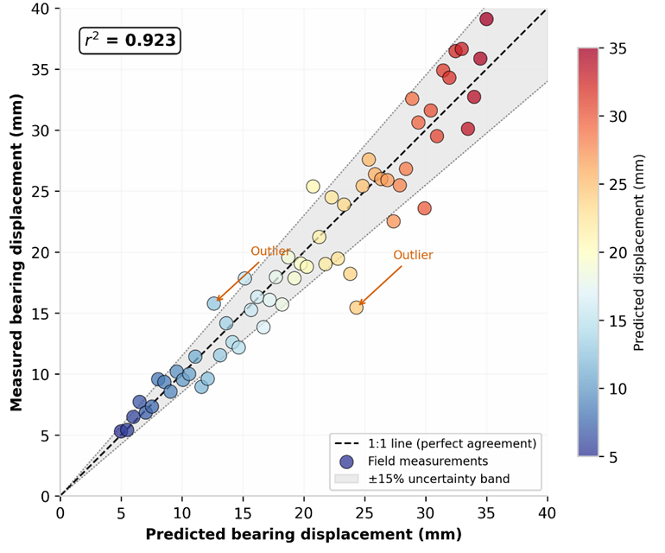

Figure 5: Comparison of predicted versus measured bearing displacements from field-monitored highly skewed bridges

Kim et al. [25] observed that pile moment response patterns shifted over multiple years as backfill compaction stabilized — a time-dependent effect not captured in initial analytical models, and a critical reminder that single-point-in-time validation is insufficient. Structural health monitoring systems offer a pathway to close this dangerous validation gap. Sensor networks continuously recording thermal response, displacement, and strain data enable data-driven calibration frameworks that refine finite element predictions. Fiber optic distributed temperature sensing, wireless strain monitoring, and satellite-based displacement measurement provide opportunities for comprehensive thermal response characterization. However, the spatial complexity of thermal behavior in highly skewed bridges requires dense sensor arrays capturing gradients across deck width, depth, and along skewed support lines, with acute and obtuse corners demanding independent, critical monitoring. Standardized monitoring protocols specifying minimum sensor densities, calibration procedures, and data quality metrics would facilitate cross-study comparison and accelerate model validation at a pace commensurate with the urgency of the problem [24, 25].

3.5 Design Implications, Knowledge Gaps, and Future Directions

The reviewed findings carry critical implications for the design, detailing, and maintenance of highly skewed bridge infrastructure. Current provisions developed for straight or moderately skewed bridges employ simplified thermal analysis procedures assuming planar behavior, uniform temperature distributions, and independent orthogonal displacement components. These assumptions become progressively, and eventually critically, invalid as skew angle increases, with bridges exceeding approximately 45° exhibiting behavioral modes that fundamentally violate underlying simplifications [14, 22, 27].

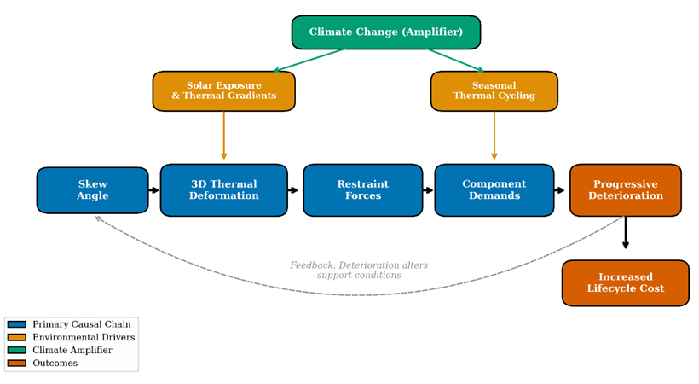

Figure 6: Conceptual framework of environmentally induced behavior in highly skewed bridge superstructures

The inadequacy of simplified approaches is most critically evident in bearing demand and expansion joint movement prediction. Conventional calculations based on uniform temperature change and bridge length dangerously underestimate acute corner displacement demands by factors increasing with skew angle, because they neglect transverse displacement components induced by geometric skew [24]. Restraint force predictions based on planar analysis similarly underestimate multi-axial force demands, particularly when thermal gradients and differential solar exposure are present. The reviewed studies recommend incorporating three-dimensional finite element analysis for thermal loading scenarios as a critical minimum standard, with careful attention to boundary condition realism and comprehensive load case definition [26].

Climate resilience represents an increasingly critical design dimension that can no longer be treated as an afterthought. As thermal design ranges based on historical baselines may no longer bound expected future extremes, highly skewed bridges face growing, urgent vulnerability. Climate-resilient design should incorporate projected temperature scenarios, with enhanced safety margins or adaptive capacity in critical components to address amplified corner displacement and restraint force effects characterizing large skew configurations.

Several critical knowledge gaps persist and demand urgent attention. The reviewed studies rely predominantly on numerical simulation rather than long-term field monitoring, creating dangerous uncertainty regarding real-world performance. Parametric studies employ idealized configurations that may not capture actual structural complexity. Environmental loading interactions with traffic, wind, and seismic effects remain insufficiently characterized, a critical omission given that these loads act simultaneously in practice. Long-term durability implications — including fatigue in steel components, cumulative cracking in concrete, and progressive degradation of bearings and joints — require further investigation to establish reliable service life predictions [25, 26].

Methodological diversity complicates synthesis and, in a field this critical, undermines confidence in cross-study comparability. Different finite element codes, element formulations, mesh densities, boundary conditions, and thermal load definitions limit direct comparability. The range of bridge configurations examined — varying in span length, girder type, deck system, support arrangement, and material composition — constrains transferability to the broad population of highly skewed bridges. Nevertheless, the consistency of major findings across diverse approaches provides confidence in fundamental conclusions regarding the critically amplified environmental sensitivity of this bridge class [22, 24].

Future research priorities, framed by the urgency of the findings above, include: (1) comprehensive multi-year field monitoring programs for bridges with skew exceeding 45° under varying climates; (2) development of simplified yet accurate design-oriented analytical methods capturing essential three-dimensional thermal behavior without requiring full finite element analysis for every design; (3) experimental and field evaluation of multi-directional bearings, modular joints, and flexible connections configured for multi-axial demands; (4) characterization of combined environmental-mechanical load effects and appropriate combination factors; and (5) long-term durability studies quantifying cumulative damage in bearings, joints, girders, and connections under cyclic thermal loading [24, 25, 32]. Addressing these needs is not merely desirable but critically essential for advancing highly skewed bridge infrastructure toward acceptable levels of durability and resilience. The integration of structural health monitoring systems, climate projection data, and adaptive computational modeling offers a promising pathway for closing identified gaps and ensuring reliable performance throughout intended service life, before deferred action allows a known critical vulnerability to become a structural failure.

4. CONCLUSION

This review critically examined the environmentally induced behavior of highly skewed bridge superstructures, with emphasis on temperature variation, thermal gradients, seasonal thermal cycling, and differential solar exposure and their effects on structural response and long-term performance. The findings indicate that increasing skew angle significantly and critically amplifies thermally induced displacements, with bridges exceeding 45° skew exhibiting severe three-dimensional deformation patterns that are not adequately captured by conventional simplified design approaches. Differential solar heating and thermal gradients were identified as major, critical causes of bearing distress, expansion joint deterioration, and uneven load distribution, with the most severe effects occurring at acute corner regions due to geometric–thermal interaction. In addition, seasonal thermal cycling produces cumulative, multi-directional damage in bearings and joints, leading to progressive deterioration that may not be apparent under single-event thermal analyses — a critical blind spot in conventional inspection regimes. Overall, current simplified design assumptions are critically inadequate for highly skewed bridge systems, underscoring the urgent need for improved analytical modeling, advanced thermal evaluation methods, and more robust detailing of bearings, expansion joints, and restraint systems. The integration of structural health monitoring systems, climate projection data, and adaptive computational modeling provides a promising and increasingly necessary framework for improving prediction accuracy and enhancing the long-term durability and resilience of highly skewed bridge systems. Given the critical nature of the vulnerabilities identified in this review, future research should prioritize advanced modeling approaches, improved detailing of critical components, and climate-informed design strategies to address evolving environmental demands before they translate into service failures.

REFERENCES

1. Varghese AM, Pradhan RP. Transportation infrastructure and economic growth: does there exist causality and spillover? A systematic review and research agenda. Transportation Research Procedia. 2025;82:2618-32.

2. Haseli B, Nouri G, Taromi MM, Bahari M, Adili E, Keyghobadi A. Effect of skew angle on seismic response of irregular concrete bridges with horizontal curve. KSCE Journal of Civil Engineering. 2024;28(6):2329-43.

3. Diaz Arancibia M, Rugar L, Okumus P. Role of skew on bridge performance. Transportation Research Record. 2020;2674(5):282-92.

4. Fathy E, Eraky A, Mustafa SA, Al-Sallami AA. Controlling seismic torsional behavior of skewed bridges to reduce the risk of unseating damage. Structures. 2025;80:109874.

5. Gupta T, Sandhu D. Seismic response of horizontally curved bridges in combination with skewed abutments. Structures. 2022;36:864-78.

6. Zhang G, Liu Y, Liu J, Lan S, Yang J. Causes and statistical characteristics of bridge failures: a review. Journal of Traffic and Transportation Engineering (English Edition). 2022;9(3):388-406.

7. Ramirez JA, Boroschek RL, Aguilar R, Ventura CE. Daily and seasonal effects of environmental temperature and humidity on the modal properties of structures. Bulletin of Earthquake Engineering. 2022;20(9):4533-59.

8. Rezaei H, Mohammadi Dehcheshmeh E, Tsompanakis Y. Impact of analysis method on the fragility curves of regular and irregular box-girder highway bridges. Structure and Infrastructure Engineering. 2025:1-21.

9. Li L, Chen B, Zhou L, Xia Q, Zhou Y, Zhou X, et al. Thermal behaviors of bridges—A literature review. Advances in Structural Engineering. 2023;26(6):985-1010.

10. Gong X, Song X, Li G, Xiong W, Cai CS. Deep learning based anomaly identification of temperature effects in bridge structural health monitoring data. Structures. 2024;69:107478.

11. Wang S, Zhang G, Li J, Wang Y, Chen B. Temperature response of double-layer steel truss bridge girders. Buildings. 2023;13(11):2889.

12. Lin Q, Li Y, Ge X, Li X, Dong Q. Study on solar-induced temperature field and thermal effects of double-layer steel truss girder bridge based on monitoring data. Case Studies in Thermal Engineering. 2026:108063.

13. Ma Z, Liu Y, Liu J, Lyu Y. Mitigation of thermal effects in bridges: a comprehensive review of control methodologies. Journal of Traffic and Transportation Engineering (English Edition). 2025;12(2):215-35.

14. Kiran MC. Assessment of porosity influence on thermo-mechanical stability characteristics of skew functionally graded plates using higher order shear deformation theory. Mechanics Based Design of Structures and Machines. 2024;52(7):3724-49.

15.Zhou S, Fahnestock LA, LaFave JM. Parametric study of skewed steel I-girder bridge truck live load response. Journal of Bridge Engineering. 2024;29(12):04024088.

16. Zhou S, Fahnestock LA, LaFave JM, Dorado R. Long-term field response of skewed steel I-girder bridge superstructures under thermal variation. Journal of Performance of Constructed Facilities. 2024;38(5):04024039.

17. Nasr A, Björnsson I, Honfi D, Larsson Ivanov O, Johansson J, Kjellström E. A review of the potential impacts of climate change on the safety and performance of bridges. Sustainable and Resilient Infrastructure. 2021;6(3-4):192-212.

18. Ganiev IG, Muradov Z. Global issue of ageing reinforced concrete bridge infrastructure. Technical Science Integrated Research. 2025;1(3):3-9.

19. Hussein HH, Khoury I, Lucas JS. Environment-induced performance of end concrete diaphragm in skewed semi-integral bridges. Buildings. 2022;12(11):1985.

20. Zhou GD, Yi TH. Thermal load in large-scale bridges: a state-of-the-art review. International Journal of Distributed Sensor Networks. 2013;9(12):217983.

21. Rizzo P, Enshaeian A. Challenges in bridge health monitoring: a review. Sensors. 2021;21(13):4336.

22. Nguyen K, Velarde C, Goicolea JM. Analytical and simplified models for dynamic analysis of short skew bridges under moving loads. Advances in Structural Engineering. 2019;22(9):2076-88.

23. Wu S, Jia J, Jiao C, Huang J, Li J. Study on the additional support length requirements of single-span bridges due to skew using a simplified method. Advances in Bridge Engineering. 2021;2(1):22.

24. LaFave JM, Brambila G, Kode U, Liu G, Fahnestock LA. Field behavior of integral abutment bridges under thermal loading. Journal of Bridge Engineering. 2021;26(4):04021013.

25. Zhu J, Wang Z, Zhang Y, Wang Y. A knowledge foundation and prospect review on thermal response of bridges. Advances in Structural Engineering. 2025;28(15):2871-92.

26. Kim W, Laman JA, Zareian F, Min G, Lee D. Influence of construction joint and bridge geometry on integral abutment bridges. Applied Sciences. 2021;11(11):5031.

27. Cui F, Zhang X, Li H, Elghazouli AY, Liu Y. Temperature field effects and thermal-induced response of curved steel box-girder bridges using field monitoring data and numerical assessments. Journal of Constructional Steel Research. 2026;237:110102.

28. Zhang J, Huang M, An Y, Zhu H. Analysis of three-dimensional temperature distribution characteristics and temperature-induced frequency variation for continuous rigid frame bridges. Advances in Structural Engineering. 2025;28(15):2835-54.

29. Tan G, Kong Q, He X, Liu H, Wang H. Effects of temperature on modal characteristics of non-uniform rigid-frame bridges. Advances in Structural Engineering. 2023;26(6):1011-26.

30. Quan L, Ke Y, Shen Y, Li C, Peng W. Field testing and numerical analysis of concrete multi-box girder bridges strengthened with H-shaped transverse steel connections. Structure and Infrastructure Engineering. 2026:1-20.

31. Liu H, Han J, Parsons RL. Integral bridge abutments in response to seasonal temperature changes: state of knowledge and recent advances. Frontiers in Built Environment. 2022;8:916782.

32. Nayeem MB, Billah AM. Effect of temperature distribution and thermal gradient on the thermal response of steel–concrete composite girders. Canadian Journal of Civil Engineering. 2025;52(11):2070-91.

