Analysis of The Emerging Trends in

ABSTRACT

Notwithstanding the growing interest in environmental management accounting over the last decade, a thorough overview of this field remains sparse in the literature. The demand for sustainable environmental management has increased dramatically, and green management has emerged as an essential instrument for businesses. These environmentally responsible activities cannot overlook the manufacturing sector. This study aims to investigate the trends in current research on environmental management accounting. Environmental management accounting is a novel approach to management accounting that employs tools to support a range of environmental decision-making factors in organisations. Management accounting must develop a system for energy management focused on decreasing energy expenses and controlling energy consumption, consequently reducing the company's environmental impact and improving its reputation. This study provides an in-depth analysis of EMA literature from 2017 to 2022. The data collection method is Publish or Perish (PoP), and VOS Viewer software is used to filter articles accordingly. Data were obtained from the Scopus journal. This study employs systematic analysis to identify the theories, variables, and methodologies in environmental management accounting. A total of 76 articles can be evaluated as a result. The findings suggest that sustainability and cost are extensively discussed subjects. Moreover, future research may concentrate on the following topics: executive commitment, institutional pressures, environmental strategies, and environmental uncertainty. The analysis of environmental management accounting literature demonstrates an extensive variety of theories adopted by renowned academics. These encompass institutional theory, contingency theory, the new resource-based view, stakeholder theory, resource slack theory, dynamic capacity theory, planned behaviour theory, and the traditional life cycle.
Keywords: Environmental Management Accounting, Literature Review, Publish or Perish

1. INTRODUCTION

The number of global concerns, such as climate catastrophe and environmental deterioration, is increasing. Climate change poses a significant risk to global peace and security. The effects of climate change intensify competition for resources such as land, food, and water, thereby exacerbating socioeconomic conflicts and increasingly causing mass migration (UN, 2021). Carbon and other greenhouse gas emissions are among the leading contributors to this overshoot, and the largest emitters are large corporations. Environmental management accounting (EMA) has gained prominence in recent decades as a method for assessing environmental impacts, such as carbon emissions (Christ & Burritt, 2013). The demand for sustainable environmental management has escalated rapidly, and green management has emerged as an essential tool for companies. These environmentally responsible initiatives cannot neglect the manufacturing sector (Baquero, 2024). Managers are more conscious of environmental concerns, including climate change, carbon emissions, waste disposal, landfill usage, land and water contamination, resource consumption, and recycling (Saeidi et al., 2018). As a consequence, the senior management teams have to set aside the resources that are required for EMA implementation (Hasan et al., 2024).
Moreover, environmental management accounting (EMA) is gaining importance as a field of study because it can assist businesses in locating and utilizing the data required to make better decisions regarding their environmental performance (Mohd Jama et al., 2018; Tashakor et al., 2019). EMA is essential for companies involved in environmental initiatives (Ilyas et al., 2020). Successful businesses in the 21st century consider the effective implementation of EMA as a crucial component, as it allows them to identify, assemble, and evaluate various types of information for final decision-making. EMA assists managers in making better decisions by informing them of the environmental implications of an organization beyond its borders. This encompasses both environmental and economic factors. EMA can identify environmental issues, improvements, and the effect they have on economic performance. The accounting literature has evolved to tackle climate change, emerging in new fields such as Environmental Management Accounting (EMA) and carbon accounting (Setiawan et al., 2023).
The focus on addressing climate change is growing among all parties. Nonetheless, prior studies have not thoroughly examined EMA research as a crucial tool for addressing climate change challenges. Existing EMA research is still limited because it focuses on control (Johnstone, 2018), and linkages between SMA at the organizational micro-level with meso- and macro-levels (Schaltegger, 2018). The necessity for a comprehensive analysis of the current state of EMA research indicates the importance of undertaking this investigation. This study incorporates research data from Scopus sources, which offer results from studies with a considerable degree of analysis. This study enhances the existing discourse by advancing the current state of EMA research. This research aimed to conduct a thorough review, utilizing bibliometric methodologies to consolidate the current state of knowledge. This study contributes to the literature in the following ways: The research extensively explores independent, dependent, mediating, and moderating variables. The study comprises an analysis of the theories and methodologies applied to EMA research trends.
This study's objective is to analyze the published literature on environmental management accounting, focusing on the theory employed, research variables, and research methods. The article comprises four sections: the introduction, outlining the topic's significance and the research's purpose; the methodology; the analysis results; and the conclusion.

LITERATURE REVIEW

The International Federation of Accountants (IFAC) (2005) defines EMA as the expansion of environmental management and overall economic performance through the development and implementation of environmental accounting systems and pertinent practices. EMA is one of the accounting disciplines whose operations seek to provide management with information about environmental management and its impact on production costs. Environmental management accounting is an innovative approach to management accounting that employs some tools to support a variety of environmental decision-making elements in businesses (Schaltegger, 2018). Management accounting must establish an energy management system that aims to reduce energy costs and control energy consumption, thereby lowering the company's environmental impact and enhancing its reputation (Christensen & Himme, 2017).
Environmental Management Accounting processes and utilizes two types of information: physical information about resources and financial information about expenses, revenues, savings, etc. Both types of information are equally useful for effective decision-making and improved environmental performance because they enable the organization to regulate environmental costs, obtain benefits, and improve environmental performance (Latan et al., 2018; Le et al., 2019). It indicates that the adoption of EMA has a significant impact on the environmental performance of an organization. However, the adoption of EMA within the organization is highly dependent on a variety of factors (Chaudhry et al., 2020). ﻿ Environmental awareness and concerns have made it vital to improve decision-making while considering the environment (Chaudhry et al., 2020).

METHODOLOGY

This literature review provides a systematic technique to map environmental management accounting themes from 2017 through 2022. This study employs the Publish or Perish (PoP) method to identify papers to be mapped. In addition, the literature review was undertaken using the criteria "environmental management accounting". These keywords are used to verify that the information that is sought is pertinent to the current topic. The observation period was from 2017 through 2022, as determined by the researchers. Furthermore, the investigation identifies the Scopus source of the article. The selected articles are written in English. The keyword "environmental management accounting" returns up to 146 articles in the preliminary search results. The 146 articles acquired 1,331 citations, equivalent to 266.20 citations each year. The study evaluation used criteria that required twice as many citations, therefore the final number of articles considered was 76, with a total of 1307 citations, or 261.4 per year. Table 1 shows the article's details.

Table 1. The difference in Metric Searching
 | Initial | Refinement
Years | 2017-2022 | 2017-2022
Papers | 146 | 76
Citations | 1331 | 1307
Cites/year | 266.2 | 261.40
Cites/paper | 9.12 | 1712
Authors/paper | 1 | 1
h-index | 22 | 22
g-index | 32 | 32

﻿The software VOS viewer was applied to analyze the final data to identify the distribution of data patterns. VOS viewer indicates that 1631 terms appear repetitively in the title and abstract. Then, the VOS viewer analyses the phrases that appear more frequently than five times in the titles and abstracts of the 76 papers and identifies 72 thresholds. Figure 1 shows network visualization, while Figure 2 depicts density visualization mapping, both compliments VOS Viewer. The yellow color symbolizes the largest quantity and highest element weights (e.g., sustainability and cost). The green color provides researchers the opportunity to conduct extensive research (e.g., top management commitment, institutional pressure, environmental strategy, and environmental uncertainty). Future research on topics based on these terms can be done in the green area of the density visualization mapping.
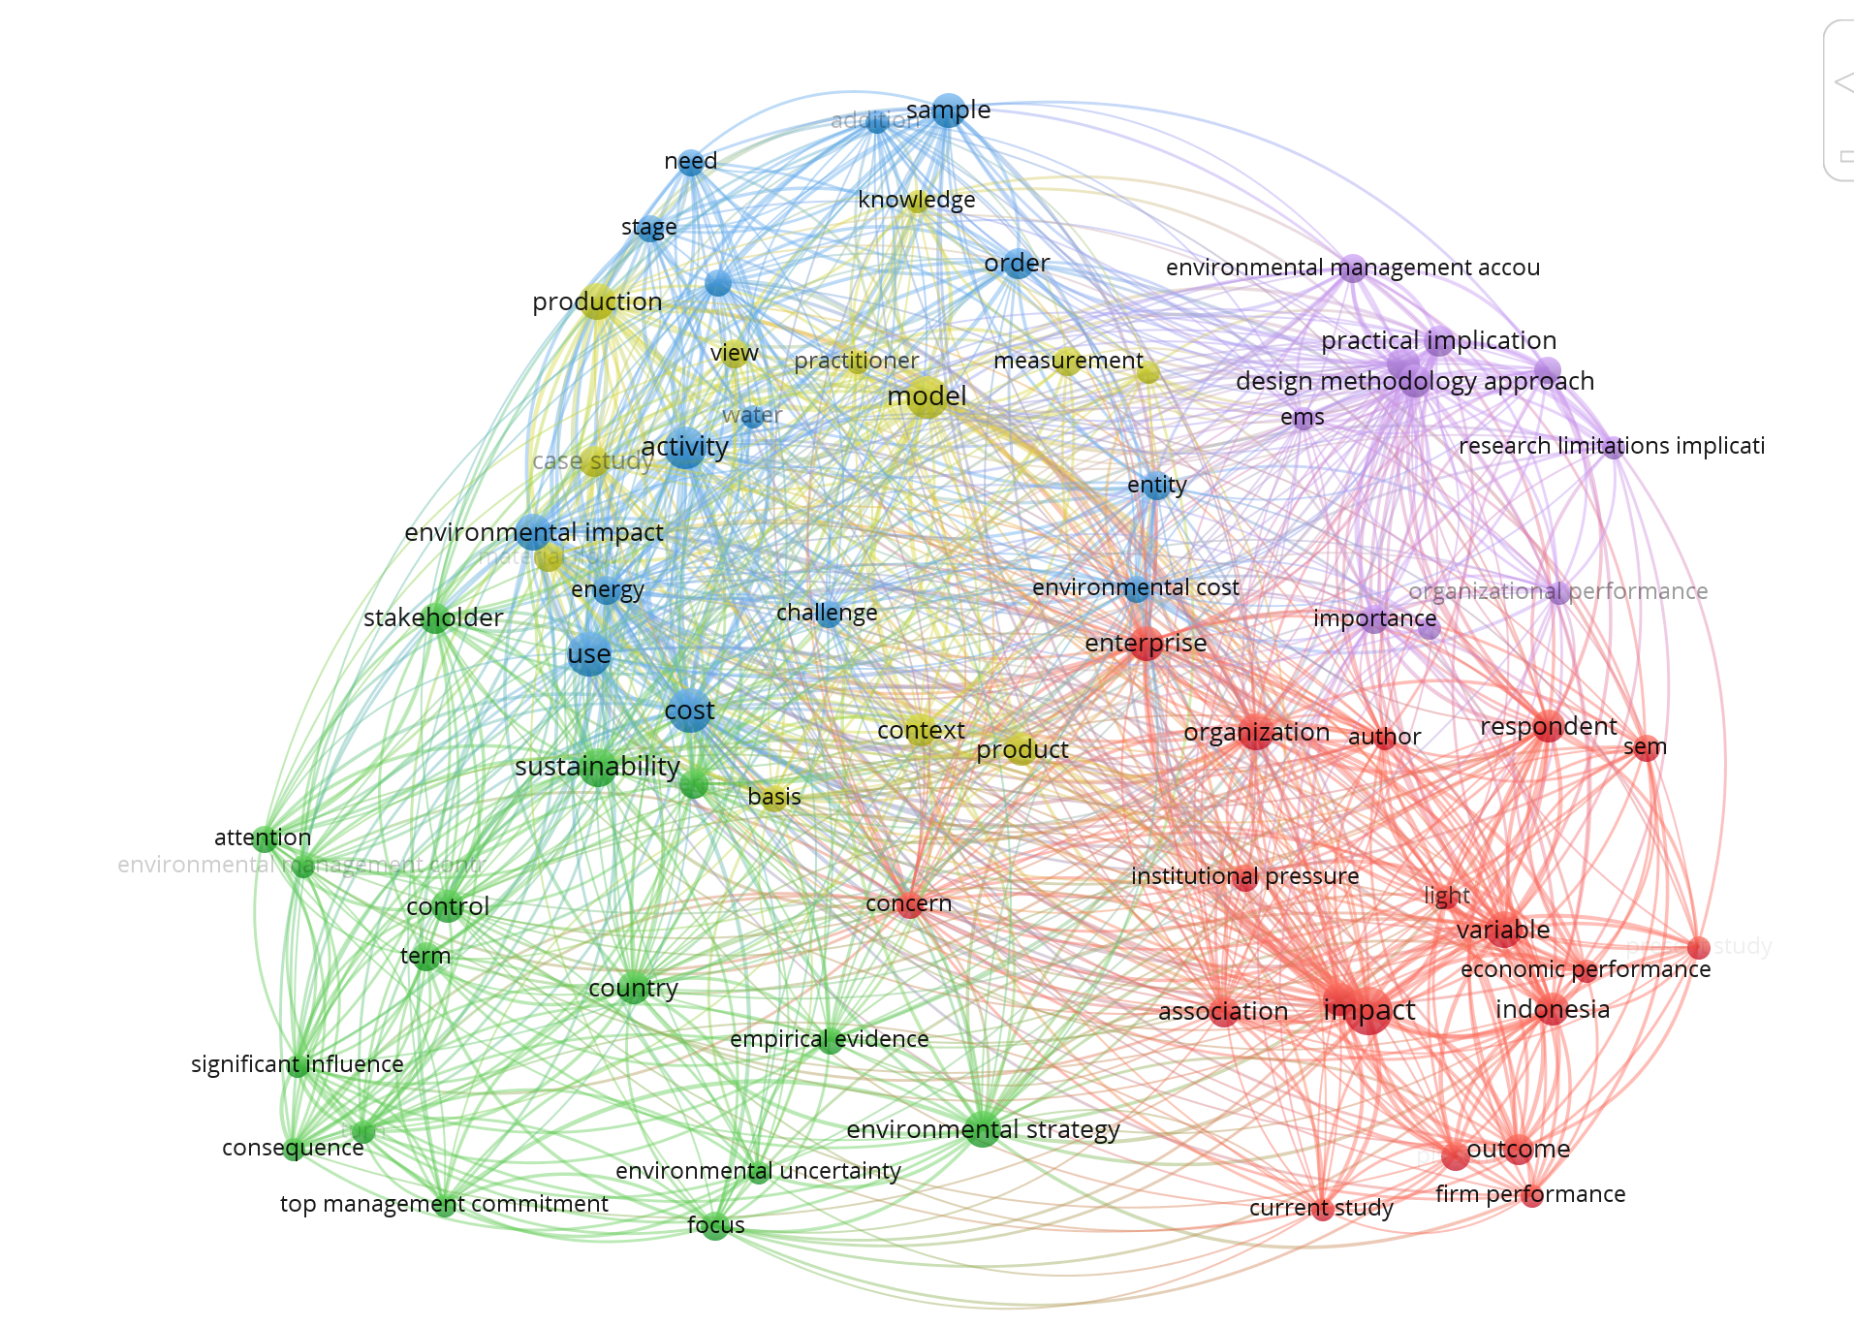
Figure 1. Network visualization
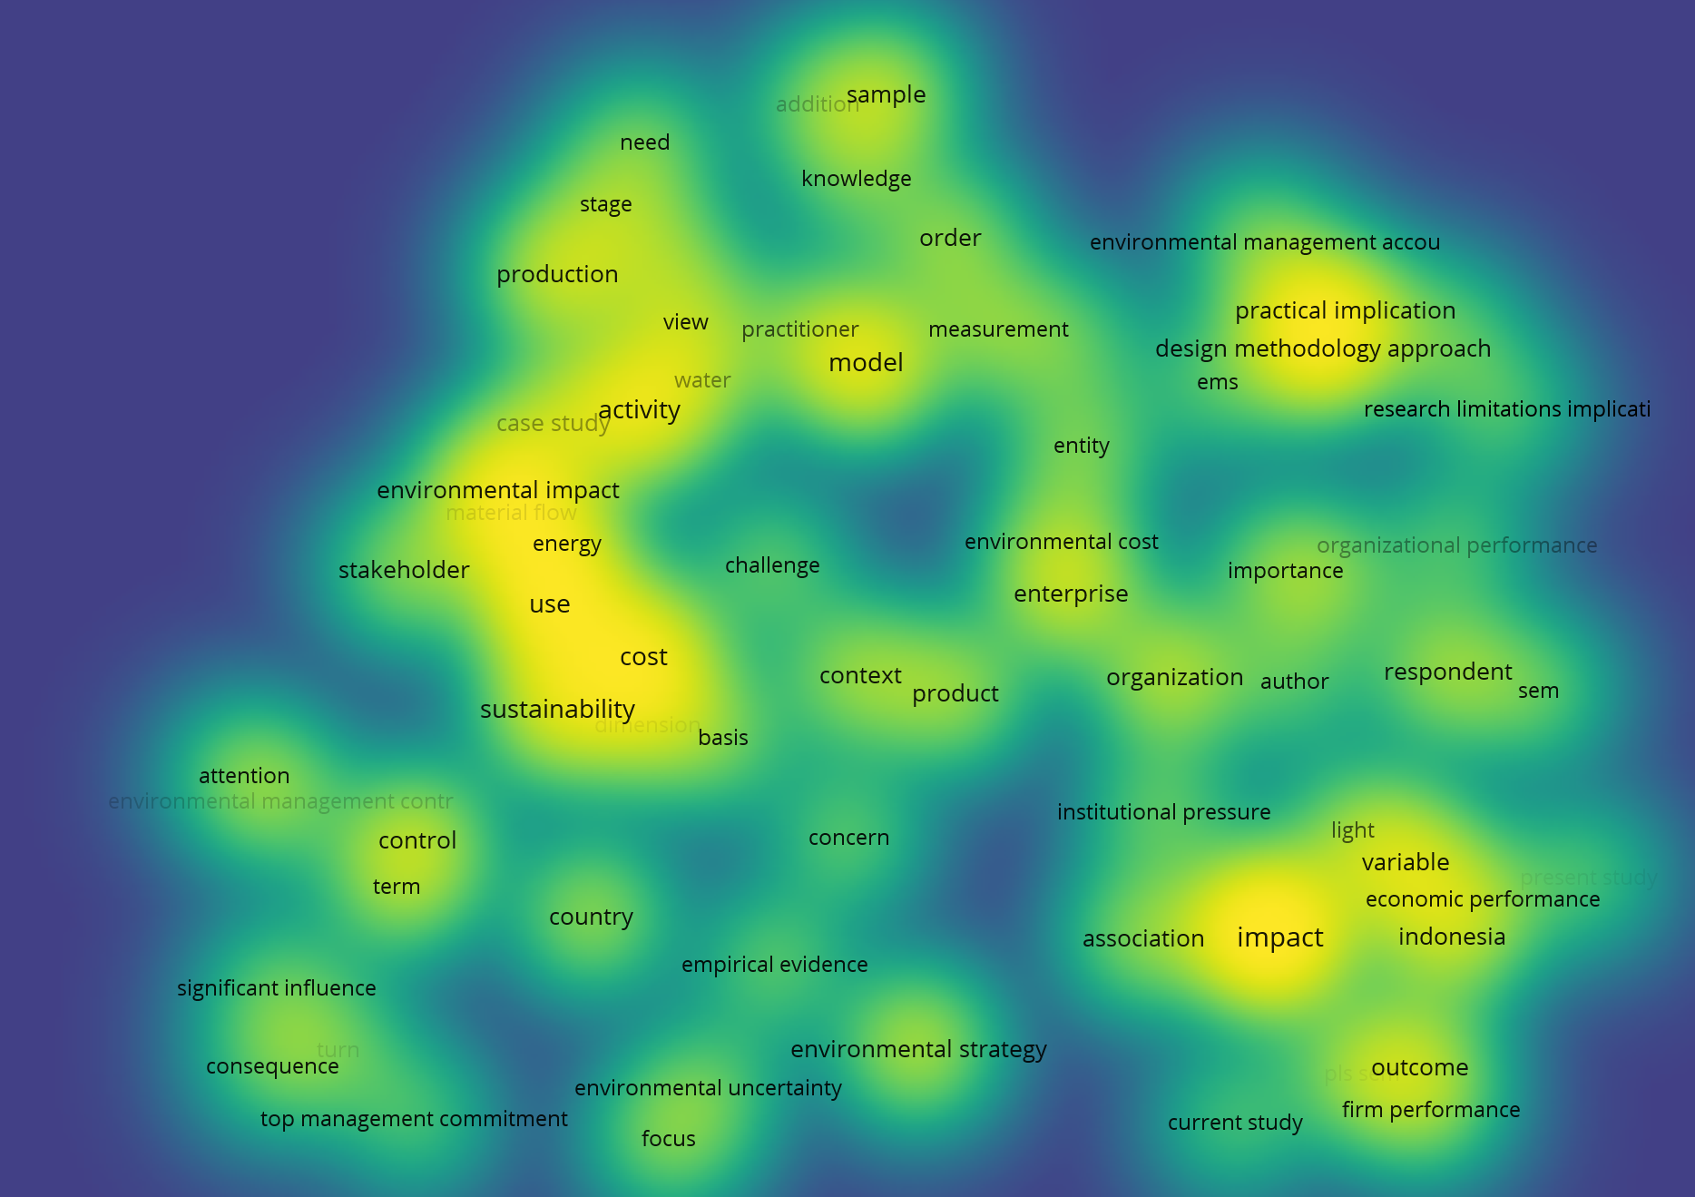
Figure 2. Density Visualization

RESULTS

This study's article search results were organized by publisher. Analysis shows that the Journal of Cleaner Production and the International Journal of Energy Economics and Policy publishes the greatest number of articles on environmental management accounting. The results of future investigations indicate that both Q1 and Q2 are reputable journals. The journal articles are shown in figure 3.

Figure 3. Journal Publications

DISCUSSION

The findings of research mapping in the field of environmental management accounting are analyzed in three separate sections. The first section explains the theories employed by the selected articles. The second section maps the variables that appear in the selected articles. The researcher performed a meta-analysis on the dependent, independent, mediating, and moderating factors identified in this section's selected studies. In the third section, the researcher identified the research methodologies employed in the selected papers. In addition, the researchers mapped both the research subject and the research setting.
Analysis 1: Theory of Environmental Management Accounting Study.
The analysis of environmental management accounting literature revealed a diversity of theories utilized by prominent scholars. These include institutional theory, contingency theory, new resource-based view, stakeholders’ theory, resource slack theory, dynamic capability theory, planned behavior theory, and traditional life cycle.
The Institutional Theory
According to DiMaggio & Powell (2000), organizations subjected to similar environmental conditions (such as organizations within the same industry) tend to systemically resemble one another or become 'isomorphic' due to similar social and environmental pressures exerted by influential stakeholder groups. In addition to technical efficiency, institutional pressures in corporate environmental management are the pressures governments, professions, or society apply to adopt environmental management approaches (Delmas & Toffel, 2004). In general, these pressures can be classified into three categories of mechanisms. They are coercive, imitative, and standard (DiMaggio & Powell, 2000). The adoption of sustainability management strategies, such as corporate environmental efforts, has been consistently postulated and empirically demonstrated to be influenced by a range of institutional elements (Gunarathne et al., 2021). Institutional pressure is an important part of the research since coercive, mimetic, and normative pressures can promote the implementation of EMA in an organization (Chaudhry & Amir, 2020). According to the mapping results, the institutional theory is the most prevalently used (Chaudhry & Amir, 2020; Iredele et al., 2020; Latif et al., 2020; Mashudu D. Mbedzi et al., 2018; Susanto & Meiryani, 2019; Wang et al., 2019; Zandi et al., 2019). Institutional isomorphism aims to explain why organizations with similar environmental conditions reflect one another.

Contingency Theory
Researchers have utilized contingency theory (Chapman, 1997). Management accounting systems are implemented to assist managers in achieving anticipated organizational goals or outcomes. (Haldma & Meiesaar, 2002). The implementation of contingency theory depends on the configuration of the management accounting systems (Chenhall, 2007; Otley, 1980). The idea of "fit" is the theory's core concept. Fit is the theory's fundamental concept. It argues that an organization's performance is enhanced when management accounting system information and organizational characteristics "fit" well. Since there is no universally applicable accounting system, the selection of an accounting system will depend on the organization's particular needs (Chang, 2007).
Researchers found that the reason an organization is structured and how it operates is contingent on the existence and impact of a few important internal and external environmental variables. Researchers sought to identify the optimal organizational structures and management techniques for various types of organizations (Parker, 1997). The management accounting-contingency theory is predicated on the notion that there is no single accounting system that can be utilized by all firms in all circumstances (Emmanuel et al., 1990). Instead, the idea states that the characteristics of a good accounting system will depend on the circumstances in which a business finds itself. Case-based studies employ several types of techniques (Christ & Burritt, 2013). According to Parker (1997) environmental accounting may depend on the significance of environmental management practices. In addition, Chenhall (2003) noted that contingency-based research indicates that specific tactics will be more effective for particular strategies, regardless of the strategic direction chosen. Researchers in the subject of environmental management accounting makes extensive use of contingency theory, according to the study's findings (Al-Mawali et al., 2018; N. Gunarathne & Lee, 2021; Nartey, 2018; San et al., 2018).

Stakeholder Theory
Organizations adhere to the government's mechanisms to exist and grow (Delmas & Toffel, 2004). Government enforcement can prompt organizations to alter their behavior. Enhancing or maintaining community relations influences the adoption of environmental management methods. If the pressure from the company's stakeholders is severe enough, integrating an EMA system into one's procedures could be a means of legitimizing a company's internal processes (Le, 2020). The results of the mapping demonstrate that stakeholder theory helps explain firms' environmental management accounting practices (Agustia et al., 2019; Chaudhry et al., 2020; Le, 2020; Mashudu David Mbedzi et al., 2020).

Natural Resource Based View (RBV)
Hart's proposed position is based on natural resources (1995). The NRBV argues that a competitive advantage can only be maintained if it can produce revenues from resources that are difficult for competitors to duplicate (Latan et al., 2018). NRBV is used to define the combination of various resources in enhancing the environmental performance of enterprises continually (Christ & Burritt, 2013; Journeault, 2016). Environmental management accounting research can be explained by RBV theory (Burritt & Christ, 2017; Jermsittiparsert et al., 2020; Latan et al., 2018; Portillo-Tarragona et al., 2018; Sari et al., 2020; Sidik et al., 2019; Solovida & Latan, 2017; Somjai et al., 2020; Susanto & Meiryani, 2019).

Theory of Dynamic Capacity
Within the theoretical framework of an RBV of the firm (Barney, 2001) and its extension to dynamic capabilities, it has been demonstrated that resources and capabilities are relevant to the success of the environmental strategy (Teece, 2007). In a framework for dynamic capabilities, a business can achieve management innovation success by building, growing, and modernizing its resource base. The research indicates a positive relationship between the circular stage of organizations, their environmental accounting practices, and their corporate social responsibility (CSR) and accountability levels (Scarpellini et al., 2020).

The Planned Behavior Theory (TPB)
According to the Theory of Planned Behavior(TPB), the intention to engage in a certain behavior is the primary predictor of that behavior (Ajzen, 2002). According to TPB, behavioral intentions are predicted by three belief-based variables: attitude, subjective norm, and perceived behavioral control (Ajzen, 1991). According to the theory of planned behavior, individuals who hold a good attitude toward a given behavior, believe they have normative support, and believe they can conduct the behavior develop stronger intentions to do the behavior. The greater the purpose to engage in the behavior, the higher the probability that it will be carried out.
The results of the mapping imply that the TPB theory can be used to explain environmental management accounting techniques employed by firms. Tashakor et al. (2019) examined the relationship between belief-based variables (attitudes, subjective norms, and perceived behavioral control and environmental management accounting practices. This study reveals that the subjective norm of subjective norms has a significant indirect effect on EMA practices via farmer attitudes and perceived behavioral control. In addition, the study discovered that the intention of farmers to be less environmentally conscious was mostly influenced by perceived behavioral control, whereas the intention of farmers to be more environmentally conscious was primarily influenced by views and subjective norms. Research must explain how individuals develop effective EMA behaviors.

Traditional Life Cycle
The concept of the "life cycle," which originates in ecology, comprises the full of an organism's life process, from birth to development, maturity, and decline. The life cycle theory, as applied to industrial ecology, refers to the metabolic activities of the industrial environment. The life cycle of a product comprises include raw materials, processing, manufacturing, transportation, consumption, disposal, and recycling. Moreover, life cycle cost (LCC) and life cycle assessment (LCA) are often utilized in sustainable development decision-making (Boxtel et al., 2015; Lim & Park, 2007). LCC focuses on the evaluation of economic implications (such as costs, revenues, and cash flows), whereas LCA identifies and quantifies the environmental impact of economic activity. The results of the study conducted by Zou et al., (2019) applying the traditional life cycle concept provide a benchmark for tracking and analyzing the environmental impact of material flows throughout the life cycle of a company, as well as determining the effectiveness of material flow targets.

Analysis 2: Variables of Environmental Management Accounting Research
Dependent Variable
According to the results of the analysis, the dependent variables that frequently appear in Environmental Management Accounting research are an application of environmental accounting, environmental performance, organizational performance, financial performance, carbon management, sustainability, environmental management systems, disclosure quality, sustainable supply chain management, cost savings, and efficiency (environmental and financial).
In addition, earlier research has identified environmental management accounting as the dependent variable whose purpose is to describe the scope of its application (Al-Mawali et al., 2018; Latan et al., 2018; Latif et al., 2020; Le, 2020; Tashakor et al., 2019; Wang et al., 2019; Zandi et al., 2019). Le (2019) explained that government enforcement and stakeholder concerns influence the implementation of the EMA. According to Latif et al., (2020), the use of EMA is influenced by the existence of coercive, normative, and mimetic forces. These results are consistent with this finding.
Furthermore, Wachiri & Wang'Ombe (2019) studied the use of management accounting in firms. According to Le et al (2019) government enforcement, stakeholder interests, good environmental strategies, community expectations, professional education networks, and monetary conditions influence the usage of environmental management accounting. However, government enforcement is the most important factor in the adoption of EMA by businesses. Moreover, the deployment of EMA in enterprises is driven by government regulations. In addition, they claimed that the acceptance of the EMA is also motivated by community expectations (Imtiaz Ferdous et al., 2019),
Latan et al. (2018) found that the organization's resources, such as its environmental strategy, senior management's commitment, and environmental uncertainty, impact the implementation of EMA. They discovered evidence that the establishment of an EMA will aid the achievement of environmental performance inside an organization. Moreover, the adoption of environmental management accounting and environmental performance positively correlate with green intellectual capital, which includes green human capital, green structural capital, and green relational capital (Asiaei et al., 2022).
EMA research can be decomposed further into the monetary and physical EMA (Phan et al., 2017). According to studies, companies that use more monetary EMA can achieve larger environmental performance improvements. They elaborated that the implementation of the EMA is bolstered by the rigor of environmental strategy management and the participation of high management. However, other research has shown that senior management participation can reduce the relationship between coercive and normative limitations on EMA implementation. In addition to coercive and normative pressures. Chaudhry and Amir (2020) found that mimetic factors influence businesses' usage of environmental management accounting.

Independent Variable
Based on the analysis, environmental management accounting, environmental strategy, green innovation, product innovation, process innovation, environmental uncertainty, material flow cost accounting, environmental costs, EPR, critical success factors, environmental management systems, and top management commitment control, financial performance, life cycle costing, environmental proactivity, institutional pressure, regulatory pressure, company scale, firm knowledge pressure, and management support are among the independent variables utilized by previous researchers. The implementation of EMA has numerous positive effects on businesses, including financial performance (Saeidi et al., 2018), firm value (Agustia et al., 2019) organizational performance (Al-Mawali et al., 2018; Appiah et al., 2020), and environmental performance (Asiaei et al., 2022; Latan et al., 2018; Qian et al., 2018).

Mediation Variable
The mapping analysis of the study found that the mediating variables were environmental management accounting, product innovation, process innovation, behavioral control, environmental management control systems, and corporate environmental strategies. A mapping study on environmental management accounting identified management accounting systems as a mediating variable in the link of pressure (coercive, mimetic, and normative) to the environmental performance (Chaudhry et al., 2020). Environmental management accounting can also moderate the relationship between product innovation and corporate performance (Chaudhry et al., 2020) However, innovation influences the association between environmental management accounting and firm success, according to Saeidi et al. (2017), innovation mediates the relationship between environmental management accounting and firm performance.
In addition, the mapping results indicate that attitudes and perceived behavioral control significantly influence farmers' intentions to adopt EMA practices and that subjective norms have a significant indirect effect on EMA practices via farmers' attitudes and PBC's perceived behavioral control. Accounting techniques for environmental management in relation to belief-based factors (attitudes, subjective norms, and perceived behavioral control EMA (Tashakor et al., 2019).

Moderating Variable
Analyzing the mapping of articles revealed that the emerging moderating variables included, among others, support from top management, environmental proactivity, environmental management accounting, and monetary variables. Mapping environmental management accounting studies indicated that management support moderates the relationship between institutional pressure and EMA implementation (Wang et al., 2019). Their research indicates that top management support and perceived advantages moderate positively the relationship between coercive pressure, normative pressure, and EMA application, while they moderate adversely the relationship between mimetic stress and EMA application. Environmental proactivity attenuated the connection between mimetic stress and environmental performance (Chaudhry and Amir 2020)

Analysis 3: Research Method of Environmental Management Accounting Research
The results of the article mapping analysis revealed that questionnaire-based surveys, secondary data, literature reviews, meta-analyses, case studies, and interviews were employed as research techniques. The most common research method is a survey based on a questionnaire. Participants/subjects identified by additional article mapping analysis include chief financial officers of public companies, accountants, management accountants, managers at middle and upper levels, as well as owners of manufacturing companies, general managers, operations managers, finance managers, environmental managers, and company stakeholders. coal, cotton farmers, and individuals in management positions in the manufacturing industry.
In addition, the mapping results revealed that the types of companies used as research samples included public companies, companies with ISO certificates, companies in the US, Australia, and Japan, manufacturing companies and consumer products in Iran, manufacturing companies in Malaysia, as well as a business entity in Sri Lanka, a multi-industry organization in Australia, a company with a significant environmental impact in Romania, and a manufacturing company, Universities in Indonesia, Vietnam, and the Philippines, local governments in New South Wales, Australia, Family farms in China, Construction companies in Vietnam, Manufacturing companies in the Yangtze River Delta, Manufacturing companies in Klang Valley Selangor, a local manufacturing company in Nairobi Kenya, non-financial companies in Saudi Arabia, the United Arab Emirates, Kuwait, Oman, Qatar, Bahrain, Jordan, and Egypt, and companies listed on UAE Stock Markets.

CONCLUSION

The purpose of this study is to map environmental management accounting research across the five-year period from 2017 to 2022. The results revealed that the ideas of legitimacy, contingency, stakeholders, and natural resources were the most prevalent. Based on the findings of the investigation, the application of dynamic capability theory, TPB, and traditional life cycle theory remains limited. This theory can be used in the future to explain and anticipate environmental management accounting phenomena. This study also concludes that there are dependent variables (such as the application of environmental accounting, environmental performance, organizational performance, financial performance, carbon management, sustainability, environmental management systems, disclosure quality, sustainable supply chain management, company cost savings, and performance efficiency (environmental and financial), as well as independent variables (environmental management accounting, environmental performance, organizational performance, financial performance, carbon management, sustainability, environmental management systems, and disclosure quality). The environmental management control system, financial performance, life cycle costing, environmental proactivity, institutional pressure, institutional pressure, regulatory pressure, firm size, firm knowledge pressure); moderating variables (support of top management, environmental proactivity, environmental management accounting); mediating variables (environmental management accounting, product innovation, process innovation, behavioral control, environmental management control system, corporate environmental strategy ). These factors can be used in future studies on the use of accounting in developing nations and the SME sector. Furthermore, the results of this study reveal that survey methodologies and secondary data predominate in the research (archival). Future studies could employ a combination of research methods, experimental research methods that can demonstrate causation between dependent and independent variables, and literature evaluation by comparing developed and emerging nations as well as large, medium, and small business enterprises. This study emphasizes advancing environmental protection objectives by encouraging the integration of EMA practices in manufacturing SMEs (Hasan et al., 2024). It is feasible for differences in methods and metrics to provide a clearer picture of the application of environmental management accounting.

REFERENCES

- Agustia, D., Sawarjuwono, T., & Dianawati, W. (2019). The mediating effect of environmental management accounting on green innovation - Firm value relationship. International Journal of Energy Economics and Policy, 9(2), 299–306. https://doi.org/10.32479/ijeep.7438
- Ajzen, I. (1991). The theory of planned behavior. Organizational Behavior and Human Decision Processes, 50(2), 179–211.
- Ajzen, I. (2002). Perceived Behavioral Control, Self- Efficacy, Locus of Control, and the Theory of Planned Behavior. Journal of Applied Psychology, 32(4), 665–683. https://doi.org/10.1111/j.1559-1816.2002.tb00236.x
- Al-Mawali, H., Al Sharif, A., Abu Rumman, G., & Kerzan, F. (2018). Environmental Strategy, Environmental Management Accounting and organizational performance: Evidence from the United Arab Emirates Market. Journal of Environmental Accounting and Management, 6(2), 105–114. https://doi.org/10.5890/JEAM.2018.06.002
- Appiah, B. K., Donghui, Z., Majumder, S. C., & Monaheng, M. P. (2020). Effects of environmental strategy, uncertainty and top management commitment on the environmental performance: Role of environmental management accounting and environmental management control system. In International Journal of Energy Economics and Policy (Vol. 10, Issue 1, pp. 360–370). zbw.eu. https://doi.org/10.32479/ijeep.8697
- Asiaei, K., Bontis, N., Alizadeh, R., & Yaghoubi, M. (2022). Green intellectual capital and environmental management accounting: Natural resource orchestration in favor of environmental performance. Business Strategy and the Environment, 31(1), 76–93. https://doi.org/10.1002/bse.2875
- Baquero, A. (2024). Linking green entrepreneurial orientation and ambidextrous green innovation to stimulate green performance: a moderated mediation approach. Business Process Management Journal, 30(8), 71–98. https://doi.org/10.1108/BPMJ-09-2023-0703
- Barney, J. B. (2001). Resource-based theories of competitive advantage: A ten-year retrospective on the resource-based view. Journal of Management, 27(6), 643–650. https://doi.org/10.1177/014920630102700602
- Boxtel, A. J. B. Van, Perez-lopez, P., Breitmayer, E., & Slegers, P. M. (2015). The potential of optimized process design to advance LCA performance of algae production systems. APPLIED ENERGY, 1–6. https://doi.org/10.1016/j.apenergy.2015.01.036
- Burritt, R. L., & Christ, K. L. (2017). The need for monetary information within corporate water accounting. In Journal of Environmental Management (Vol. 201, pp. 72–81). Academic Press. https://doi.org/10.1016/j.jenvman.2017.06.035
- Chang, H.-C. (2007). Environmental management accounting within universities: current state and future potential. RMIT University.
- Chapman, C. S. (1997). Reflections on a contingent view of accounting. Accounting, Organizations and Society, 22(2), 189–205.
- Chaudhry, N. I., & Amir, M. (2020). From institutional pressure to the sustainable development of firm: Role of environmental management accounting implementation and environmental proactivity. Business Strategy and the Environment, 29(8), 3542–3554. https://doi.org/10.1002/bse.2595
- Chaudhry, N. I., Asad, H., Ch, M. A., & Hussian, R. I. (2020). Environmental innovation and financial performance: Mediating role of environmental management accounting and firm’s environmental strategy. Pakistan Journal of Commerce and Social Science, 14(3), 715–737.
- Chenhall, R. H. (2003). Management control systems design within its organizational context: findings from contingency-based research and directions for the future. Accounting, Organizations and Society, 28(2–3), 127–168. https://doi.org/https://doi.org/10.1016/S0361-3682(01)00027-7
- Chenhall, R. H. (2007). The contingent design of performance measures. Contemporary Issues in Management Accounting, 28, 127–168. https://doi.org/10.1093/acprof:oso/9780199283361.003.0005
- Christ, K. L., & Burritt, R. L. (2013). Environmental management accounting: The significance of contingent variables for adoption. Journal of Cleaner Production, 41, 163–173. https://doi.org/10.1016/j.jclepro.2012.10.007
- Christensen, B., & Himme, A. (2017). Improving environmental management accounting: how to use statistics to better determine energy consumption. Journal of Management Control, 28(2), 227–243. https://doi.org/10.1007/s00187-016-0239-0
- Delmas, M., & Toffel, M. W. (2004). ENVIRONMENTAL MANAGEMENT PRACTICES : 222, 209–222.
- DiMaggio, P. J., & Powell, W. W. (2000). The iron cage revisited institutional isomorphism and collective rationality in organizational fields. Advances in Strategic Management, 17(2), 143–166. https://doi.org/10.1016/S0742-3322(00)17011-1
- Gunarathne, A. D. N., Lee, K. H., & Hitigala Kaluarachchilage, P. K. (2021). Institutional pressures, environmental management strategy, and organizational performance: The role of environmental management accounting. Business Strategy and the Environment, 30(2), 825–839. https://doi.org/10.1002/bse.2656
- Gunarathne, N., & Lee, K. H. (2021). Corporate cleaner production strategy development and environmental management accounting: A contingency theory perspective. Journal of Cleaner Production, 308. https://doi.org/10.1016/j.jclepro.2021.127402
- Haldma, T., & Meiesaar, K. (2002). Environmental Contingencies Of The Management Reform In The Estonian Health Care Institutions. Effect of Accession to the European Union on the Economic Policy of Estonia, 483-C496.
- Hart, S. L. (1995). A natural-resource-based view of the firm. Academy of Management Review, 20(4), 986–1014.
- Hasan, S. A. S., Waghule, S. N., & Hasan, M. B. (2024). Linking environmental management accounting to environmental performance: the role of top management support and institutional pressures. Cogent Business and Management, 11(1). https://doi.org/10.1080/23311975.2023.2296700
- IFAC, (2005). International guidance document: Environmental management accounting.
- Ilyas, S., Hu, Z., & Wiwattanakornwong, K. (2020). Unleashing the role of top management and government support in green supply chain management and sustainable development goals. Environmental Science and Pollution Research, 27(8), 8210–8223. https://doi.org/10.1007/s11356-019-07268-3
- Imtiaz Ferdous, M., Adams, C. A., & Boyce, G. (2019). Institutional drivers of environmental management accounting adoption in public sector water organisations. Accounting, Auditing and Accountability Journal, 32(4), 984–1012. https://doi.org/10.1108/AAAJ-09-2017-3145
- Iredele, O. O., Tankiso, M., & Adelowotan, M. O. (2020). The influence of institutional isomorphism and organisational factors on environmental management accounting practices of listed Nigerian and South African firms. In South African Journal of Accounting Research (Vol. 34, Issue 3, pp. 183–204). Taylor & Francis. https://doi.org/10.1080/10291954.2019.1675254
- Jermsittiparsert, K., Somjai, S., & Toopgajank, S. (2020). Factors affecting firm’s energy efficiency and environmental performance: The role of environmental management accounting, green innovation and environmental proactivity. International Journal of Energy Economics and Policy, 10(3), 325–331. https://doi.org/10.32479/ijeep.9220
- Johnstone, L. (2018). Environmental management decisions in CSR-based accounting research. Corporate Social Responsibility and Environmental Management, 25(6), 1212–1222. https://doi.org/10.1002/csr.1632
- Journeault, M. (2016). The influence of the eco-control package on environmental and economic performance: A natural resource-based. Journal of Management Accounting Research, 28(2), 149–178. https://doi.org/10.2308/jmar-51476
- Latan, H., Chiappetta Jabbour, C. J., Lopes de Sousa Jabbour, A. B., Wamba, S. F., & Shahbaz, M. (2018). Effects of environmental strategy, environmental uncertainty and top management’s commitment on corporate environmental performance: The role of environmental management accounting. In Journal of Cleaner Production (Vol. 180, pp. 297–306). https://doi.org/10.1016/j.jclepro.2018.01.106
- Latif, B., Mahmood, Z., San, O. T., Said, R. M., & Bakhsh, A. (2020). Coercive, normative and mimetic pressures as drivers of environmental management accounting adoption. Sustainability (Switzerland), 12(11). https://doi.org/10.3390/su12114506
- Le, T. T. (2020). Performance measures and metrics in a supply chain environment. Uncertain Supply Chain Management, 8(1), 93–104. https://doi.org/10.5267/j.uscm.2019.8.003
- Le, T. T., Nguyen, T. M. A., & Phan, T. T. H. (2019). Environmental management accounting and performance efficiency in the Vietnamese construction material industry-a managerial implication for sustainable development. Sustainability (Switzerland), 11(19). https://doi.org/10.3390/su11195152
- Lim, S., & Park, J. M. (2007). Environmental and economic analysis of a water network system using LCA and LCC. AIChE Journal, 53(12), 3253–3262.
- Mbedzi, Mashudu D., van der Poll, H. M., & van der Poll, J. A. (2018). An Information Framework for facilitating cost saving of environmental impacts in the coal mining industry in South Africa. Sustainability (Switzerland), 10(6). https://doi.org/10.3390/su10061690
- Mbedzi, Mashudu David, van der Poll, H. M., & van der Poll, J. A. (2020). Enhancing a decision-making framework to address environmental impacts of the south african coalmining industry. Energies, 13(18). https://doi.org/10.3390/en13184897
- Mohd Jama, N., Wui Kiet, W., Mohamed Saat, M., Othman, A., & Ramakrishnan, S. (2018). Green supply chain practices, environmental management accounting and performance of ISO 14001 certified organizations. In International Journal of Engineering & Technology (Vol. 7, pp. 169–172). eprints.utm.my. https://www.doe.gov.my/portalv1/wp-
- Nartey, E. (2018). Determinants of carbon management accounting adoption in Ghanaian firms. Meditari Accountancy Research, 26(1), 88–121. https://doi.org/10.1108/MEDAR-03-2017-0133
- Otley, D. T. (1980). The contingency theory of management accounting: achievement and prognosis. In Readings in accounting for management control (pp. 83–106). Springer.
- Parker, L. D. (1997). Accounting for environmental strategy: cost management, control and performance evaluation. Asia-Pacific Journal of Accounting, 4(2), 145–173.
- Phan, T. N., Baird, K., & Su, S. (2017). The use and effectiveness of environmental management accounting. Australasian Journal of Environmental Management, 24(4), 355–374. https://doi.org/10.1080/14486563.2017.1354235
- Portillo-Tarragona, P., Scarpellini, S., Moneva, J. M., Valero-Gil, J., & Aranda-Usón, A. (2018). Classification and measurement of the firms’ resources and capabilities applied to eco-innovation projects from a resource-based view perspective. Sustainability (Switzerland), 10(9). https://doi.org/10.3390/su10093161
- Qian, W., Burritt, R. L., & Monroe, G. S. (2018). Environmental management accounting in local government: Functional and institutional imperatives. Financial Accountability and Management, 34(2), 148–165. https://doi.org/10.1111/faam.12151
- Saeidi, S. P., Othman, M. S. H., Saeidi, P., & Saeidi, S. P. (2018). The moderating role of environmental management accounting between environmental innovation and firm financial performance. International Journal of Business Performance Management, 19(3), 326–348. https://doi.org/10.1504/IJBPM.2018.092759
- Saeidi, S. P., Shahwahid, M., & Othman, H. (2017). The mediating role of process and product innovation in the relationship between environmental management accounting and firm’s financial performance. In Int. J. Business Innovation and Research (Vol. 14, Issue 4).
- San, O. T., Heng, T. B., Selley, S., & Magsi, H. (2018). The relationship between contingent factors that influence the environmental management accounting and environmental performance among manufacturing companies in Klang Valley, Malaysia. In International Journal of Economics and Management (Vol. 12, Issue 1, pp. 205–232). ijem.upm.edu.my. http://www.ijem.upm.edu.my/vol12no1/11)The Relationship between Contingent Factors that Influence the Environmental Management Accounting.pdf
- Sari, R. N., Pratadina, A., Anugerah, R., Kamaliah, K., & Sanusi, Z. M. (2020). Effect of environmental management accounting practices on organizational performance: role of process innovation as a mediating variable. Business Process Management Journal, 27(4), 1296–1314. https://doi.org/10.1108/BPMJ-06-2020-0264
- Scarpellini, S., Marín-Vinuesa, L. M., Aranda-Usón, A., & Portillo-Tarragona, P. (2020). Dynamic capabilities and environmental accounting for the circular economy in businesses. Sustainability Accounting, Management and Policy Journal, 11(7), 1129–1158. https://doi.org/10.1108/SAMPJ-04-2019-0150
- Schaltegger, S. (2018). Linking Environmental Management Accounting: A Reflection on (Missing) Links to Sustainability and Planetary Boundaries. Social and Environmental Accountability Journal, 38(1), 19–29. https://doi.org/10.1080/0969160X.2017.1395351
- Setiawan, D., Rahmawati, I. P., & Santoso, A. (2023). A bibliometric analysis of evolving trends in climate change and accounting research. Cogent Business and Management, 10(3). https://doi.org/10.1080/23311975.2023.2267233
- Sidik, M. H. J., Yadiati, W., Lee, H., & Khalid, N. (2019). The dynamic association of energy, environmental management accounting and green intellectual capital with corporate environmental performance and competitive advantages. International Journal of Energy Economics and Policy, 9(5), 379–386. https://doi.org/10.32479/ijeep.8283
- Solovida, G. T., & Latan, H. (2017). Linking environmental strategy to environmental performance: Mediation role of environmental management accounting. Sustainability Accounting, Management and Policy Journal, 8(5), 595–619. https://doi.org/10.1108/SAMPJ-08-2016-0046
- Somjai, S., Fongtanakit, R., & Laosillapacharoen, K. (2020). Impact of environmental commitment, environmental management accounting and green innovation on firm performance: An empirical investigation. International Journal of Energy Economics and Policy, 10(3), 204–210. https://doi.org/10.32479/ijeep.9174
- Susanto, A., & Meiryani, M. (2019). Antecedents of environmental management accounting and environmental performance: Evidence from Indonesian small and medium enterprises. International Journal of Energy Economics and Policy, 9(6), 401–407. https://doi.org/10.32479/ijeep.8366
- Tashakor, S., Appuhami, R., & Munir, R. (2019). Environmental management accounting practices in Australian cotton farming: The use of the theory of planned behaviour. Accounting, Auditing and Accountability Journal, 32(4), 1175–1202. https://doi.org/10.1108/AAAJ-04-2018-3465
- Teece, D. J. (2007). Explicating dynamic capabilities: the nature and microfoundations of (sustainable) enterprise performance. Strategic Management Journal, 28(13), 1319–1350.
- Wachira, M. M., & Wang’Ombe, D. (2019). the Application of Environmental Management Accounting Techniques By Manufacturing Firms in Kenya. Advances in Environmental Accounting and Management, 8, 69–89. https://doi.org/10.1108/S1479-359820190000008004
- Wang, S., Wang, H., & Wang, J. (2019). Exploring the effects of institutional pressures on the implementation of environmental management accounting: Do top management support and perceived benefit work? Business Strategy and the Environment, 28(1), 233–243. https://doi.org/10.1002/bse.2252
- Zandi, G. R., Khalid, N., & Islam, D. M. Z. (2019). Nexus of knowledge transfer, green innovation and environmental performance: impact of environmental management accounting. International Journal of Energy Economics and Policy, 9(5), 387–393. https://doi.org/10.32479/ijeep.8285
- Zou, T., Zeng, H., Zhou, Z., & Xiao, X. (2019). A three-dimensional model featuring material flow, value flow and organization for environmental management accounting. Journal of Cleaner Production, 228, 619–633. https://doi.org/10.1016/j.jclepro.2019.04.309

