INTERNAL STAKEHOLDERS’ IMPLEMENTATION PRACTICES IN



ABSTRACT

Emactao, Lorena G. 2026. Internal Stakeholders' Implementation Practices of the School Improvement Plan (SIP).
Adviser: Nestle Joy R. Arguilla, PhD
The School Improvement Plan (SIP) serves as a strategic framework that guides schools in addressing priority needs and achieving continuous improvement through stakeholder participation and collaborative governance. Anchored on stakeholder theory and distributed leadership theory, this qualitative single case study explored the implementation practices and challenges of internal stakeholders in the School Improvement Plan (SIP) in selected public high schools in Maco North District, Davao de Oro. Data were gathered through semi-structured interviews with three school heads and three teachers who were directly involved in SIP implementation. The participating schools served as embedded sources of perspectives within the single bounded case of SIP implementation in public high schools in Maco North District. Thematic analysis revealed three major implementation practices: stakeholder shared ownership, collaborative communication dynamics, and collective empowerment practices. These practices fostered active participation, shared responsibility, collaborative decision-making, effective communication, accountability, transparency, and stakeholder empowerment in achieving school improvement goals. However, the findings also identified significant challenges, including workforce limitations affecting sip implementation, communication challenges affecting involvement, and stakeholder empowerment challenges. Specifically, insufficient manpower, limited resources, communication barriers, delayed dissemination of information, and limited stakeholder engagement affected the effective implementation of SIP programs and activities. Despite contextual differences among participating schools, internal stakeholders shared common experiences regarding collaboration, participation, accountability, and collective responsibility in implementing SIP initiatives. The study concludes that successful SIP implementation is strengthened through meaningful stakeholder engagement, collaborative leadership, effective communication, shared accountability, and stakeholder empowerment. It further recommends strengthening stakeholder-centered implementation frameworks, enhancing capacity-building initiatives, improving resource mobilization strategies, addressing manpower constraints, and promoting effective communication mechanisms to support sustainable and effective SIP implementation.

Keywords: School Improvement Plan, stakeholder participation, distributed leadership, stakeholder theory, school improvement.

ACKNOWLEDGEMENT

The successful completion of this study would not have been possible without the invaluable support, guidance, and encouragement of numerous individuals who contributed to its accomplishment.

Above all, I express my heartfelt gratitude to Almighty God, the Most High and Faithful God, for granting me wisdom, strength, and perseverance throughout this academic journey. His blessings and guidance have continually inspired me to overcome challenges and remain steadfast in achieving this endeavor. All honor and praise belong to Him.

I would also like to sincerely thank Dr. Nestle Joy R. Arguilla, my Thesis Adviser whose exceptional mentorship, scholarly insights, patience, and unwavering commitment to academic excellence. Her guidance significantly enriched the quality and rigor of this research

Sincere thanks are also conveyed to the members of the Thesis Advisory Committee—Dr. Marilou D. Junsay, the Chairperson, Dr. Leo D. Rayon, Jr., and Dr. Arnold M. Duping for their constructive critiques, insightful suggestions, and scholarly expertise that strengthened this thesis.

My deepest appreciation is extended to the participants of this study, especially the school principals and teachers from the selected public schools in Maco North District. Their willingness to share their experiences, perspectives, and insights greatly contributed to the success and significance of this study.

I am likewise grateful to the institution’s administration for providing the resources, assistance, and motivation necessary for conducting this research. I also extend my sincere thanks to my colleagues and friends whose encouragement, cooperation, and understanding helped me throughout the research process.

To my family, I dedicate my gratitude for their endless love, patience, and understanding. Their constant encouragement served as a source of strength and inspiration in completing this academic undertaking.

Finally, I extend my sincere appreciation to everyone who, in one way or another, contributed to the completion of this study. Your support and confidence in my pursuit of knowledge and professional development are deeply valued.

DEDICATION

To my beloved and supportive family,
This paper is lovingly dedicated to you for your unwavering support, endless encouragement, and steadfast belief in my dreams. Your sacrifices, understanding, and unconditional love have been my source of strength throughout this journey. This achievement is as much yours as it is mine.

With heartfelt gratitude and love,
TaoGodsgift Loreigne0216

TABLE OF CONTENTS

Page
TITLE PAGE i
DISCLAIMER ii
CERTIFICATE OF ORIGINAL AUTHORSHIP iii
CERTIFICATE OF PANEL APPROVAL iv
ABSTRACT v
ACKNOWLEDGEMENT vi
DEDICATION vii
TABLE OF CONTENTS viii
LIST OF TABLES x
LIST OF APPENDICES xi

CHAPTER
- INTRODUCTION

Background of the Study 1
Purpose Statement 5
Research Questions 5
Theoretical Lens 6
Significance of the Study 7
Scope and Limitations of the Study…………………………...7
Definition of Terms 8
- METHODOLOGY

Research Design 10
Research Locale 11
Research Participants 12
Research Instruments 14
Data Gathering Procedure 16
Data Analysis 17
Trustworthiness of the Study 19
Ethical Considerations 21
- RESULTS AND DISCUSSION

Internal Stakeholder’s Implementation
Practices of School Improvement
Plan 23

Internal Stakeholder’s Implementation
Challenges of School Improvement
Plan 41

- SUMMARY, CONCLUSIONS, AND IMPLICATIONS

Summary of Findings 64
Conclusions 65
Implications 66

REFERENCES 67

APPENDICES 70

BIONOTE 112

LIST OF TABLES

Table Page

- Distribution of Research Participants. 14

- Internal Stakeholders’ Implementation
Practices on School Improvement
Plan 24

- Internal Stakeholders’ Implementation
Challenges on School Improvement
Plan 42

LIST OF APPENDICES

Appendix Page

- Notice to Commence 75

- Request Letter to Conduct Study in
DepEd Davao de Oro 76

- Approval Letter from DepEd Davao
de Oro 77

- Request Letter to Conduct Study in
DepEd Public High Schools 78

- Sample Certificate of Consent 81

- Interview Guide Questions 82

- Validation Sheet for Qualitative
Research Instrument 83

- Sample Transcript Validation 85

- Certificate of Transcript Validation 88

- Audit Trail 91

- Grammarian Certificate 105

- Plagiarism Check Result 106

- Use of Artificial Intelligence
Declaration 107

- Evaluation Form Expedited Review 109

- Approval Letter to Study Protocol 110

- Ethical Clearance 111

Chapter 1
INTRODUCTION
Background of the Study
A School Improvement Plan (SIP) is a framework commonly used in education to improve school effectiveness through careful planning, implementation, monitoring, and evaluation. It supports evidence-based decision-making and encourages school stakeholders to address challenges and improve student outcomes. SIP is a collaborative, data-driven process aimed at strengthening accountability and promoting continuous school development (DepEd, 2015). As a strategic planning tool, the SIP enables schools to identify priorities, allocate resources, and implement interventions that support school improvement. According to Bantilan et al. (2023), strategic planning in educational institutions promotes organizational effectiveness by providing clear directions and aligning stakeholders toward common goals. However, the study also identified challenges, including limited stakeholder involvement, insufficient planning competencies, and weaknesses in the implementation process, which may affect the achievement of desired educational outcomes.
International studies have shown that SIP success depends largely on stakeholder engagement, leadership capacity, and resource availability. A study conducted by Bore and Triegaardt (2022) in Hawassa City Administration, Ethiopia, found that stakeholders' perceptions, practices, and challenges significantly influenced SIP implementation. Their findings revealed low participation among teachers, school leaders, and parents, as well as weaknesses in monitoring and evaluation systems, limited understanding of SIP procedures, and poor stakeholder coordination. Similarly, Shanko and Kabtyimer (2024) reported that SIP implementation in South Ethiopian schools was only moderate due to inadequate resources, limited stakeholder participation, weak monitoring and evaluation mechanisms, and insufficient leadership support. Likewise, Hunde and Desalegn (2020) found that secondary schools in Ilu Aba Bor Zone experienced challenges related to resource constraints, stakeholder involvement, and follow-up mechanisms, indicating a gap between policy expectations and actual implementation practices. Further research by Muhumed (2025) on stakeholder engagement in Jigjiga secondary schools emphasized that differences in stakeholder awareness and participation significantly influenced SIP implementation. Limited engagement, weak collaboration, and inconsistent communication were identified as major barriers to achieving school improvement goals.
In the Philippine context, the implementation of the SIP is fundamentally anchored on stakeholder participation and effective school leadership, both of which are critical in addressing persistent school-level challenges and improving educational outcomes. Stakeholder participation is recognized as a vital component of SIP processes because it fosters shared responsibility and collective action among teachers, parents, community members, and other relevant stakeholders. Their involvement strengthens collaboration in planning, implementation, monitoring, and evaluation, thereby making school improvement initiatives more responsive to local needs. However, despite its recognized importance, studies indicate that stakeholder engagement in SIP implementation remains uneven. Nicdao and Ancho (2020) emphasized the significance of stakeholder involvement across the Assess–Plan–Act cycle, while Guzman (2022) found that although participation positively influences school performance, implementation challenges still persist. Similarly, Bantilan et al. (2023) highlighted that low stakeholder involvement—often due to limited understanding of planning processes, insufficient collaboration, and inadequate orientation—continues to hinder meaningful participation in many schools.
Alongside stakeholder participation, effective leadership in the Philippine school system is crucial to ensuring the successful implementation of the SIP. School heads are tasked with leading the planning process, mobilizing stakeholders, managing resources, and monitoring progress to ensure that improvement goals are achieved. However, these responsibilities are often challenged by resource constraints, varying school performance, and complex management demands. Abalorio (2022) noted that school leaders frequently encounter difficulties in resource availability and school management during SIP implementation, while Balindong et al. (2024) underscored the need for strong governance and strategic leadership to sustain improvement initiatives. In addition, Bantilan et al. (2023) noted that many school leaders and personnel still face gaps in knowledge and skills in strategic planning, which affect the effectiveness of SIP implementation. These findings collectively highlight the need for continuous professional development, capacity-building programs, and strengthened leadership systems to ensure that SIPs are effectively implemented, sustained, and aligned with the broader goals of improving school performance and learner outcomes in the Philippine basic education system.
In the Davao Region, the SIP serves as a vital framework for addressing school needs, improving educational outcomes, and strengthening collaboration among stakeholders in the Philippine basic education system. This study highlights the experiences of internal stakeholders in SIP implementation, particularly in planning, coordination, and execution, revealing how collaboration, decision-making, and leadership practices influence school improvement efforts. Stakeholder participation is essential in fostering a supportive school environment, as partnerships among schools, families, and communities contribute to better educational outcomes (Epstein, 2018), while effective leadership ensures that goals are translated into sustained actions (Leithwood et al., 2020). Aligned with SDG 4: Quality Education and SDG 17: Partnerships for the Goals, the SIP underscores the importance of inclusive, equitable education and multi-stakeholder collaboration. The findings of this study may guide school leaders, teachers, and policymakers in strengthening SIP implementation and addressing real-world challenges such as limited resources, coordination issues, and workload constraints (DepEd, 2015; Bantilan et al., 2023), thereby providing evidence-based insights for improving school governance and informing future research on school planning and implementation in similar contexts.
Although several studies have examined the implementation of the SIP, there are still areas that need further exploration. Nicdao and Ancho (2020) emphasized the importance of stakeholder participation in SIP processes, while Guzman (2022) found that stakeholder involvement contributes positively to school performance. Likewise, Abalorio (2022) explored factors affecting SIP implementation, such as collaboration and resource management. While these studies provided valuable insights into stakeholder participation and the effectiveness of SIP implementation, they primarily focused on participation levels, implementation outcomes, and administrative perspectives. As a result, there is still a limited understanding of the actual experiences of internal stakeholders who are directly involved in carrying out SIP activities in schools. Miles (2017) highlighted the importance of qualitative research in understanding how individuals make sense of their experiences within specific contexts. Guided by this perspective, the present study addresses the gap by exploring the practices and challenges of internal stakeholders in implementing the SIP. Specifically, it seeks to provide a deeper understanding of their experiences within public schools in Davao de Oro, offering insights that may help strengthen school improvement efforts and stakeholder engagement in the future.
These studies indicated that while policies and structures for SIP implementation were in place, stakeholder participation, leadership practices, resource availability, and collaborative governance continue to influence implementation outcomes. However, limited research has explored how internal stakeholders implement SIP in public high schools within the Maco North District, Davao de Oro. Therefore, this study seeks to investigate the implementation practices and challenges experienced by school heads and teachers in implementing the School Improvement Plan in selected public high schools in the district.
Purpose Statement
This study aimed to explore the practices and challenges faced by internal stakeholders in the School Improvement Plan (SIP) at selected public high schools in the Maco North District of Davao de Oro Province, Davao Region, Philippines. It specifically looked at how internal stakeholders, including three school principals and three teachers, implement the SIP in their schools. The study used a single-case design, focusing on three public high schools as the source of inquiry. These schools illustrated the real-life context where internal stakeholders experience SIP implementation and its challenges. Through this approach, the study aimed to gain a deeper understanding of how internal stakeholders execute SIP implementation, how they view their roles, and what challenges they face during the process. The findings are expected to provide insights that may strengthen SIP practices and improve the school improvement plan in the selected setting.
Research Questions
This study specifically sought to answer the following questions.
  - How do internal stakeholders describe the implementation practices of the School Improvement Plan (SIP) in the selected public schools?
  - How do internal stakeholders perceive challenges in the implementation of the SIP in the selected public schools?

Theoretical Lens
This study is anchored on the Stakeholder Theory of R. Edward Freeman (1984) and the Distributed Leadership Theory of James P. Spillane (2006). These theories emphasize that organizational success is achieved when stakeholders actively participate in decision-making and share responsibility for accomplishing organizational goals. According to Stakeholder Theory, stakeholders are individuals or groups who can affect or be affected by an organization's achievement of its objectives. In the educational setting, internal stakeholders such as school heads and teachers play significant roles in the planning, implementation, monitoring, and evaluation of the School Improvement Plan (SIP).
Stakeholder Theory emphasizes collaboration, participation, and shared responsibility among stakeholders to achieve desired educational outcomes. It suggests that effective school improvement is more likely when stakeholders are actively engaged in decision-making and implementation. Through their involvement, stakeholders contribute valuable perspectives, resources, and support that strengthen school governance and organizational effectiveness.
Complementing this perspective, Spillane's Distributed Leadership Theory (2006) posits that leadership is not confined to a single individual but is distributed among various members of an organization. In schools, leadership responsibilities are shared among school heads, teachers, and other stakeholders who work collaboratively to achieve common goals. This theory emphasizes collective action, cooperation, and the use of diverse expertise to address school needs and implement improvement initiatives.
These theories provide a strong foundation for the present study by explaining how active engagement, collaboration, and shared leadership among internal stakeholders influence the implementation of the School Improvement Plan. Through their collective efforts, school heads and teachers contribute to effective SIP implementation, improved school performance, and the successful attainment of school improvement goals.
Significance of Study
Department of Education (DepEd). The study's findings aid DepEd in improving its policies on School-Based Management (SBM) and SIP implementation. Additionally, insights could help develop more flexible guidelines, monitoring systems, and training that encourage better stakeholder cooperation at the school level.
Teachers. School leaders might gain valuable insights into how to engage stakeholders and negotiate in a more inclusive manner. Evidence of how their participation aids in project execution and sustainability may also be helpful to teachers.
School Heads. They can strengthened school-based programs, enhance their collaboration techniques, and make better use of resources by understanding how their leadership and positions were perceived in SIP implementation.
Future Researchers. Future researchers benefited from this study since it adds to the corpus of information on SIP implementation in the Philippines and participatory governance. It provides a framework for other research into leadership, governance, and school-community partnerships by concentrating on the lived experiences of stakeholders
Scope and Limitations of the Study
This research examined the implementation phase of the School Improvement Plan (SIP) in designated public schools. It examined the school improvement plan's implementation practices and challenges from internal stakeholders. The study took place in three public schools in the Maco North District of the Division of Davao de Oro and used a single-case study design.
The study examined internal stakeholders' implementation of the School Improvement plan. It emphasized governance aspects, including stakeholder engagement, communication, collaboration, resource mobilization, and sustainability. Interviews are used to gather data and provide a complete picture of the instances.
Because this was a qualitative study, the results applied only to the schools studied and not to all schools in the Philippines. The study sought to offer comprehensive insights that could benefit schools in analogous settings.
The study was limited in scope because it examined only three schools and a few people involved with each. Officials from divisions and regions were not included. The researcher was the essential tool for methodologically gathering and making sense of the data.
Lastly, the study did not seek statistical generalization. Its aim is analytical generalization, connecting data to ideas like Stakeholder Theory and Distributed Leadership. The results were not meant to foretell what will happen in all schools, but to help people understand and do things better.
Definition of Terms
Internal Stakeholders. These refer to the school heads and teachers who play an active role in the planning, implementation, monitoring, and evaluation of the School Improvement Plan (SIP). As individuals directly involved in school improvement efforts, they contribute valuable insights based on their experiences, practices, and challenges in implementing the SIP. In this study, they served as the primary participants and sources of information regarding SIP implementation in public high schools.
SIP Implementation. It referred to the systematic process of implementing the strategies, activities, and interventions outlined in the School Improvement Plan to achieve targeted school goals and improve overall school performance.

Chapter 2
METHODOLOGY
Research Design
This study employed a qualitative research approach, using a single-case design, to explore the implementation practices of internal stakeholders in the SIP among public high schools in the Maco North District, Davao de Oro. Qualitative research is appropriate for exploring and understanding the meanings individuals or groups ascribe to social or human problems. According to Creswell and Poth (2018), qualitative research enables researchers to investigate phenomena in their natural settings and interpret them based on the meanings participants assign to their experiences. This approach was appropriate for the present study because it sought to examine how school heads and teachers implement the SIP and address the challenges encountered during its implementation.
Specifically, the study adopted a single-case study design. Yin (2018) defined a case study as an empirical inquiry that investigates a contemporary phenomenon within its real-life context, particularly when the boundaries between the phenomenon and context are not clear. The single case in this study was the implementation of the School Improvement Plan in public high schools within the Maco North District. The researcher explored this phenomenon through the experiences and perspectives of selected school heads and teachers who were directly involved in SIP implementation.
The case study design enabled the researcher to gain an in-depth understanding of participants’ experiences, practices, and challenges related to SIP implementation. Merriam and Tisdell (2016) emphasized that qualitative case studies are particularly useful for obtaining a comprehensive understanding of a bounded system through intensive, detailed data collection. In this study, the researcher examined key aspects of SIP implementation, including collaborative planning, stakeholder participation, resource management, program implementation, monitoring and evaluation, and alignment with school improvement goals.
The use of a single-case study design was appropriate because it allowed the researcher to investigate SIP implementation as a bounded system within a specific educational context. By focusing on public high schools in Maco North District, the study generated rich, detailed insights into the implementation practices and challenges faced by internal stakeholders. The findings may contribute to enhancing SIP implementation strategies and strengthening school governance and improvement efforts in public secondary schools.
Research Locale
The study was conducted in three selected public secondary schools within the Maco North District, Division of Davao de Oro. These schools were purposely chosen because they had implemented the School Improvement Plan (SIP) in accordance with DepEd Order No. 44, s. In 2015, I had stakeholders who were actively involved in implementing school improvement initiatives.
Geographically, Maco North District is situated in the southeastern part of Mindanao, Philippines, under the Division of Davao de Oro. The selected schools were suitable research sites due to their experience implementing SIP-related programs, projects, and activities to improve school performance and address identified school needs.
The study participants included school heads and teachers who were directly involved in implementing the SIP. Their experiences provided valuable insights into the implementation practices in their respective schools and the challenges encountered during the execution of SIP initiatives.
Selecting these three schools enabled the researcher to gain an in-depth understanding of stakeholders’ implementation practices and challenges in carrying out the School Improvement Plan, despite differences in school context. Through the experiences and perspectives shared by the participants, the study sought to examine how SIP activities were implemented, how stakeholders contributed to the process, and what factors facilitated or hindered the successful implementation of school improvement efforts. The findings were expected to provide insights that may help strengthen SIP implementation and support continuous school improvement in public secondary schools.
Research Participants
This study used purposive sampling to select participants with direct experience and substantial knowledge of School Improvement Plan (SIP) implementation in public high schools. Purposive sampling is appropriate in qualitative research because it enables researchers to intentionally select information-rich participants who can provide detailed insights into the phenomenon being studied (Creswell & Poth, 2018). Similarly, Patton (2015) emphasized that purposive sampling focuses on selecting participants who are knowledgeable and experienced regarding the research topic, thereby enhancing the depth and quality of the data obtained.
The study focused on the implementation practices and challenges faced by internal stakeholders in the School Improvement Plan (SIP) in public high schools in Maco North District, Davao de Oro, which served as the bounded case for the investigation. The participating schools provided the context through which the phenomenon was explored. The study did not seek to compare schools; rather, it aimed to understand SIP implementation as a single, context-bound educational phenomenon within the district. This approach is consistent with qualitative case study research, which seeks to generate an in-depth understanding of a bounded system within its real-life context (Merriam & Tisdell, 2016; Yin, 2018).
The primary participants in the study were three (3) school heads from selected public high schools in Maco North District. These school heads were purposively selected because of their direct involvement in the planning, implementation, monitoring, and evaluation of the School Improvement Plan. As primary informants, they provided central data and core perspectives regarding SIP implementation, leadership practices, stakeholder engagement, resource management, and school improvement initiatives.
To strengthen credibility, dependability, and the confirmability of the findings, additional supporting information was included for confirmatory triangulation. These participants consisted of three (3) teachers from each participating public high school. Their role was not to generate separate cases or new themes but rather to confirm, validate, and support the statements and experiences shared by the primary participants.
The study involved a total of six (6) participants. This number was considered sufficient because qualitative research emphasizes the richness and depth of information rather than statistical representation. Guest, et al. (2006) found that meaningful themes in focused qualitative studies can emerge with as few as six interviews. Since the participants had direct experience and substantial knowledge of SIP implementation, they were able to provide rich, relevant data to address the research questions and achieve the study's objectives. The teacher participants helped validate findings on the implementation of SIP activities, collaborative planning processes, communication practices, stakeholder participation, monitoring mechanisms, and the execution of school improvement initiatives. Their perspectives provided additional insights into how SIP implementation is experienced at the operational level and helped verify the consistency of the information provided by the school heads.
Furthermore, the responses of both the primary and supporting participants contributed significantly to addressing the research questions, particularly by examining the implementation practices of internal stakeholders, identifying challenges encountered during SIP implementation, and exploring strategies to address them. Their insights provided a deeper understanding of SIP implementation in public high schools and highlighted the realities, opportunities, and constraints that shape school improvement efforts in the Maco North District.
Table 1

Distribution of Research Participants

Number of School | Number of School Head | Code | Number of School SIP Coordinator (Teacher) | Code | Total Participants
1 | 1 | SH_01 | 1 | T_01 | 2
1 | 1 | SH_02 | 1 | T_02 | 2
1 | 1 | SH_03 | 1 | T_03 | 2
Total | 3 |  | 3 |  | 6

Research Instrument
The primary research instrument used in this study was a researcher-developed semi-structured interview guide designed to explore the implementation practices and challenges of internal stakeholders in the School Improvement Plan (SIP) in public high schools in Maco North District. The interview guide was developed to gather in-depth information from school heads and teachers regarding their experiences, roles, and involvement in the planning, implementation, monitoring, and evaluation of SIP initiatives.
According to Creswell and Poth (2018), qualitative interviews enable researchers to understand participants’ perspectives and experiences within their natural settings, making them appropriate for exploring complex educational phenomena.
The interview guide consisted of semi-structured questions that allowed participants to express their views and experiences while ensuring the discussion remained aligned with the study's objectives. This format enabled the researcher to delve deeper into relevant issues and to obtain detailed descriptions of SIP implementation practices and challenges. The questions focused on key areas such as stakeholder participation, leadership support, resource management, communication practices, monitoring and evaluation processes, and challenges encountered during SIP implementation. Merriam and Tisdell (2016) emphasized that semi-structured interviews allow researchers to obtain rich and detailed data while maintaining sufficient flexibility to explore emerging themes during the interview process.
The development of the interview guide was informed by the research questions, the conceptual framework, relevant literature, and Department of Education policies related to School Improvement Planning, particularly DepEd Order No. 44, s. 2015 and DepEd Order No. 26, s. 2022. The initial draft of the instrument was reviewed by the research adviser and three experts with backgrounds in educational leadership, school improvement planning, and qualitative research.
To ensure content validity and appropriateness, the interview guide was subjected to expert validation. The validators evaluated the instrument on clarity, relevance, coherence, and alignment with the study's objectives. Their comments, suggestions, and recommendations were incorporated into the final version of the instrument to improve its quality and effectiveness.
To further enhance the reliability and usability of the interview guide, a pilot test was conducted with participants from a public secondary school not included in the main study. Feedback obtained from the pilot testing was used to refine the wording, sequence, and clarity of the interview questions. This process helped ensure that the instrument was understandable, contextually appropriate, and capable of eliciting comprehensive and meaningful responses.
The use of a validated semi-structured interview guide within a qualitative single-case study framework enabled the collection of rich, contextually grounded data on SIP implementation. The responses gathered from participants were analyzed thematically to identify recurring patterns, generate meaningful insights, and develop recommendations to strengthen the implementation of the School Improvement Plan in public high schools.
Data Gathering Procedures
In this study, In-Depth Interviews (IDI) were used as the primary data gathering method. IDIs are a qualitative approach that allows researchers to explore participants’ experiences, perspectives, and meanings in detail through open-ended questions. This method was especially useful for understanding complex processes, such as School Improvement Plan (SIP) implementation, where rich, detailed responses from school stakeholders are needed (Boyce & Neale, 2006).
Asking for permission to Conduct the Study from the IAdS Dean. A letter requesting permission to conduct the study was submitted to the Dean of the Institute of Advanced Studies after the Dissertation Advisory Committee granted approval.
Asking for Permission to Conduct the Study from the DepEd Regional Office XI. Approval to conduct the study was sought from the Department of Education, Regional Office XI. Permission was also requested from various school heads and teachers in Region XI to participate in the research.
Designing a Research-Made Interview Questionnaire. An interview guide was developed and aligned with the study's research questions. The interview guide focused on the perspectives of internal stakeholders, particularly school heads and teachers.
Subjecting Research-Made Interview Guide to Validity and Pilot Testing. The interview guide was reviewed by experts to ensure alignment with the study's objectives. The guide was subsequently pilot-tested with individuals from the target population to identify potential issues and refine the interview questions. Through this process, the reliability and validity of the data collection instrument were enhanced (Yeong et al., 2018).
Seeking the Consent of Research Participants. A validated and pilot-tested interview guide was utilized, and informed consent forms were distributed to obtain participants’ consent, which constituted an essential ethical requirement of the study. One-on-one key informant interviews were scheduled and conducted only after signed consent was obtained from the participants and other relevant parties (Kadam, 2017).
Conducting In-Depth Interviews (IDI) with Research Participants. In-depth interviews (IDIs) were conducted with selected school principals and teachers across the Maco district to obtain detailed individual insights into their perspectives on the implementation of the School Improvement Plan. Participants were purposively selected based on their involvement in and familiarity with SIP implementation.
Data Analysis
In line with the qualitative single-case study design, this study used thematic analysis, following the framework of Braun and Clarke (2006), as the primary method for analyzing qualitative data. Thematic analysis enabled the systematic identification, organization, and interpretation of patterns within the data, providing a comprehensive understanding of the implementation practices and challenges of internal stakeholders in the School Improvement Plan (SIP) in public high schools in Maco North District.
The data analysis followed the six phases of thematic analysis proposed by Braun and Clarke (2006), as follows:
Data Organization and Preparation. All interview recordings were transcribed word-for-word to ensure that no details were missed. The transcripts, along with field notes and supporting documents, were carefully organized by participant. These were treated as part of a single, bounded case focusing on SIP implementation in the selected public high schools.
Familiarization with the Data. The data were read repeatedly to allow full immersion and understanding. Through this process, important statements, recurring ideas, and early observations related to SIP implementation were identified and noted.
Generating Initial Codes. Relevant portions of the data were identified and assigned initial codes that represented key ideas and concepts. An inductive approach was used, meaning the codes were developed directly from participants' shared material. A coding matrix was also used to help organize and track the codes throughout the process.
Searching for Themes. The codes were then grouped based on similarities and patterns. From these groupings, initial themes were formed that reflected the common practices and challenges of school heads and teachers in SIP implementation.
Reviewing and Defining Themes. These initial themes were carefully reviewed and refined to make sure they accurately reflected the data. Each theme was clearly defined based on its main idea and supported with relevant quotes from the interviews. Care was taken to ensure that the themes were clear, distinct, and aligned with the research questions.
Producing the Report. The findings were then organized into a clear and coherent narrative. The perspectives of school heads and teachers were integrated into a single case analysis. Direct quotations were included to support the findings and strengthen the study's credibility.
Triangulation and Validation. To ensure the trustworthiness of the findings, triangulation was used by including both school heads and teachers as participants. The responses from teachers were used to confirm, support, and enrich the data from school heads, helping ensure consistency across perspectives.
Presentation of Findings and Implications. The results were presented based on the emerging themes related to SIP implementation practices and challenges among internal stakeholders. These findings were then discussed in relation to existing literature and were used as the basis for conclusions and implications aimed at improving the implementation of the School Improvement Plan in public high schools in Maco North District.
Trustworthiness of the Study
To ensure rigor and trustworthiness, Lincoln and Guba’s (1985) four criteria of qualitative trustworthiness, credibility, dependability, confirmability, and transferability were applied in this study. These criteria served as the qualitative counterparts to the traditional concepts of internal validity, reliability, objectivity, and external validity. Through their application, the accuracy, consistency, and meaningfulness of the findings on the implementation of the School Improvement Plan (SIP) in public high schools in Maco North District were strengthened.
Credibility was ensured by accurately capturing and representing the perspectives of the participants, specifically the school heads and teachers. Methodological triangulation was applied by collecting data from both groups of participants to examine multiple perspectives on SIP implementation. Prolonged engagement during in-depth interviews was used to build rapport and deepen understanding of participants’ experiences. Member checking was also conducted, wherein interview transcripts and interpretations were returned to participants for validation. In addition, peer debriefing with academic colleagues was undertaken to minimize researcher bias and strengthen the consistency of interpretations (Darawsheh, 2014; Creswell & Poth, 2018).
To ensure dependability, a clear audit trail was maintained throughout the research process. All procedures, including participant selection, data collection, transcription, and data analysis, were systematically documented. This allowed the entire process to be traced and reviewed, ensuring that the findings were consistent and logically derived from the data.
Confirmability was ensured by grounding the findings in participants' actual responses rather than the researcher’s personal assumptions or biases. Reflexive journaling was maintained throughout the study to document decisions, observations, and possible sources of bias that could influence interpretation (Darawsheh, 2014). Through these measures, the objectivity of data interpretation was strengthened.
To enhance transferability, detailed descriptions of the research context, participants, and procedures were provided. Purposive sampling was used to select information-rich participants who had direct experience in SIP implementation. The study's detailed contextualization within public high schools in Maco North District, Davao de Oro, was presented to allow readers to assess the applicability of the findings to similar educational settings.

Ethical Considerations
The study was conducted in strict adherence to the ethical principles outlined in the Belmont Report (National Commission for the Protection of Human Subjects of Biomedical and Behavioral Research, 1979), ensuring that the rights, dignity, and welfare of all participants were fully protected throughout the research process.
Respect for Persons: Informed consent was obtained from all participants prior to data collection. The purpose, procedures, and nature of the study were clearly explained, and participants were informed of their right to voluntarily participate, refuse, or withdraw from the study at any time without any penalty. Interviews were conducted only after consent and approval had been secured, ensuring that participation was based on full understanding and free choice.
Beneficence. To minimize potential risks, strict confidentiality and privacy measures were put in place. All responses were anonymized and used solely for academic purposes. No data were disclosed for political, commercial, or non-research-related purposes. In addition, appropriate health and safety protocols were observed during face-to-face interviews, while online interviews were conducted when necessary to ensure participants' safety and convenience.
Justice. The principle of justice was upheld through fair and unbiased selection of participants. School heads and teachers were selected based on their relevance to the study, not on personal preference or discrimination. All participants were treated equally, ensuring that no group was unfairly burdened or excluded.

By applying these ethical principles, the study ensured respect for participants, minimized risks, and promoted fairness throughout the research process. This helped maintain the ethical integrity of the study while contributing to a responsible and credible understanding of School Improvement Plan (SIP) implementation in public high schools in Maco North District.

Chapter 3
RESULTS AND DISCUSSION
Internal Stakeholders’ Implementation Practices
School Improvement Plan

This chapter presents the study's findings on the implementation of the School Improvement Plan (SIP) as perceived by internal stakeholders in selected public schools. The analysis of the interview data revealed that SIP implementation was characterized by stakeholder shared ownership, collaborative communication dynamics, and stakeholder empowerment. Internal stakeholders emphasized active participation in identifying school priorities, implementing programs and projects, engaging in shared decision-making, supporting open communication, and fostering partnerships that advance school improvement goals. However, the findings also revealed challenges that affected SIP implementation, including workforce limitations, communication challenges, and stakeholder empowerment issues. Specifically, participants showed insufficient workforce, implementation delays, ineffective dissemination of information, communication barriers, limited feedback, inadequate capacity-building opportunities, and stakeholder dependence on school leaders as factors that hindered effective implementation. These findings provide a deeper understanding of the practices and challenges experienced by internal stakeholders and highlight the important role of participation, collaboration, and shared responsibility in the successful implementation of the School Improvement Plan.

Table 2
Internal Stakeholders’ Implementation Practices School Improvement Plan (SIP)
Core Ideas | Essential Themes
- Stakeholder Participation in Identifying Priority Needs  - Shared responsibility in achieving school improvement targets  - Active involvement in the implementation of school programs and projects  - Strengthened sense of ownership through shared involvement | Stakeholders Shared Ownership
- Regular communication among stakeholders  - Feedback exchange to improve implementation practices  - Collaborative decision-making through open communication | Collaborative Communication Dynamics
- Strengthened partnership through continuous engagement  - Empowerment through shared decision-making  - Enhanced stakeholder ownership of school initiatives | Collective Empowerment Practices

Table 2 presents the emergent themes derived from the participants’ responses concerning the implementation practices of internal stakeholders in the School Improvement Plan (SIP). The themes were identified through a systematic process of coding, categorizing, and analyzing the qualitative data, enabling the researcher to capture recurring patterns that reflect the participants' shared experiences and perspectives. The identified themes provide a comprehensive understanding of the implementation practices of internal stakeholders in the School Improvement Plan (SIP) in their school context. These themes illustrated the various strategies, processes, and collaborative efforts employed by school heads and teachers in implementing SIP initiatives, while also highlighting areas that may require further support and enhancement to strengthen school improvement efforts.
Moreover, the themes demonstrated the significant role of school heads and teachers in facilitating and sustaining the implementation of the School Improvement Plan (SIP). The findings revealed how internal stakeholders continuously adapt implementation practices in response to school needs, available resources, policy requirements, and contextual challenges. This highlights the importance of collaborative, responsive leadership; effective communication; accountability; transparency; and stakeholder empowerment to ensure SIP implementation remains relevant, effective, and aligned with the goals of continuous school improvement.
Furthermore, the implementation process was reinforced through active stakeholder participation, in which school heads, teachers, and other stakeholders share responsibilities in carrying out and supporting School Improvement Plan (SIP) initiatives. This collaborative approach promotes responsiveness to school needs and contextual realities, enabling implementation efforts to remain relevant, flexible, and effective. The findings further indicated that shared responsibility strengthens stakeholder commitment, accountability, and cooperation, thereby contributing to the successful achievement of school improvement goals.
Theme 1: Stakeholder Shared Ownership
The implementation of the School Improvement Plan was characterized by active stakeholder involvement in planning and decision-making. School heads emphasized that SIP implementation begins with identifying school needs and priorities through consultations with teachers, parents, community leaders, and other stakeholders. Decision-making was described as collaborative and consultative, ensuring that improvement initiatives reflect the collective aspirations and needs of the school community.
School heads highlighted the importance of identifying school priorities through a collaborative process involving various stakeholders. The participants emphasized that the School Improvement Plan must be carefully planned and based on the school's actual needs, given the budget's availability. The participants explained that;
^{[SH_01] “}The SIP should be carefully planned and based on the actual needs of the school. Budgeting should align with priorities an available resource”

^{[SH_03]} “So far, so good man amoang School Improvement Plan. Well planned man siya. Not only the school planning team but apil pd ang stakeholders nato sa gawas. So well presented sa ilaha, gi estoryahan, ghisgutan, then there was presentation kasama ang PTA officials of the school, Governing Council tapos subject for ratification until such time Nakita unsay mga top priorities na dapat tutukan sa school for five years mao toy ginahisgutan.”

^{[T_01]} “The SIP serves as the foundation for the improvement of the school. During the crafting process, we identified project titles and aligned them with the needs of the school. It also serves as a guide for utilization of the School Maintenance and Other Expenses (MOOE). The SIP ensures that requests and projects are prioritized properly based on the school’s needs.

^{[T_02]} “Another important strategy is collaborative and participatory planning. Teachers, school leaders, parents and community partners should take involved so that the SIP becomes inclusive and responsive to actual school needs.”

From the above results, stakeholders recognized the role of collaboration and need-based planning in making a well-planned SIP. It was pointed out by the participants that an SIP must be planned in line with the needs of the school, and there must be adequate allocation of the budget to meet the improvement goals set. The school heads also pointed out that participation from internal and external stakeholders, including teachers, parents, PTA officials, and SGC members, is necessary in the planning process. On the other hand, teachers also noted that the SIP is an essential tool, as it provides the necessary guidelines for planning activities that will improve schools while effectively utilizing resources. One consideration in planning and implementing projects and programs was aligning them with school needs. Teachers emphasized the importance of aligning SIP projects and interventions with the school's identified needs. They described how planning and implementation decisions were guided by priority concerns and available resources. Such alignment enabled schools to maximize limited resources while addressing areas that require immediate improvement. They may offer factual and innovative school projects and programs, as these perspectives involve teachers in the field. These teachers knew what was important and what was lacking in their part, especially in delivering instruction and service to students. One of the goals of the school improvement plan was to deliver effective instruction to students. The implementation of those programs and projects had an impact on the client's development, especially among the students. It was not only the school heads responsible for bringing these things to school, but also the people placed in the field of expertise, and those are the teachers. So, integrating stakeholders' perspectives was important for the implementation's success. The responses below strengthened these ideas;
This core idea of stakeholder participation in identifying priority needs emphasized that planning and decisions were guided by actual school needs and were determined through consultations, discussions, and consensus-building. This collaborative approach ensured that improvement initiatives addressed relevant concerns and reflected the shared interests of the school community. The finding suggested that collaborative identification of priorities ensures that SIP initiatives address actual school needs and promote stakeholder ownership of school improvement efforts. This supports Stakeholder Theory, which posits that organizational effectiveness is enhanced when stakeholders actively participate in decision-making.
Moreover, school heads described decision-making as an inclusive process that provides stakeholders with opportunities to express their views, share recommendations, and contribute to the development of school improvement initiatives. The participants highlighted that they involved stakeholders in consolidating school programs and projects through a thorough meeting. Stakeholders were part of the decision-making process. As the participants said;
^{[SH_01]} Before finalizing projects, we gather input from teachers. We used group chats and online forms to collect their needs and proposed projects. Teachers, especially project coordinators, submit their project titles and required resources. We also conduct meetings with department heads, School Governing Council members, PTA Officers, and student leaders. Internal Stakeholders like teachers are highly involved, and external stakeholders such as community members also participate in decision-making. Collaboration is strongly practiced in our SIP Implementation.

^{[SH_01]} During implementation, decisions are based on the approved projects in the SIP. For example, if the project is related to work immersion, the budget and activities are already identified. Teachers who proposed the project are aware of the requests and funding sources, especially those under MOOE. This helps ensure that priorities are followed and that implementation is aligned with the plan.

^{[SH_02]} “stakeholders such as teachers, parents, PTA officers, barangay officials, alumni, and community partners are also given opportunities to participate in school projects and decision-making.”

^{[SH_03]} They have chance to handle those projects because we have open forums and open discussions kung unsay nindut.”

^{[T_01]} The school head assigns specific responsibilities to teachers depende sa aming kakayahan, interest and committee memberships. Teachers led and implemented various SIP activities, monitor accomplishments, and submit progress reports while the other stakeholders support on financial assistance or other needed resources.

School Head (SH_01) highlighted that before putting everything, all the priorities, projects, and programs of the school in the School Improvement Plan, they were gathered first from the teachers and other stakeholders. There was a consolidation of data, decisions, and viewpoints regarding what to implement for a particular year. Teachers, such as subject and project coordinators, were being asked what priorities were needed in their field of expertise. Since the school programs and projects were not proposed by just one person. In these cases, stakeholder involvement was important. This was supported by the head of other schools. School Head (SH_02) added that stakeholders, such as teachers, were given opportunities to be involved in decision-making, which was a basic need for consolidating information and ideas. Teachers were experts in project and program identification because they are in the field. And these stakeholders were the first implementers. Same with school head (SH_03): added that stakeholders also had this chance to handle and implement projects. Open forums and discussions were held for them to express which projects and programs suited the school for the benefit of students.
The findings actively encouraged stakeholders to participate in discussions and decision-making regarding SIP implementation. The inclusion of stakeholders in decision-making promotes transparency, shared ownership, and stronger commitment to school improvement initiatives. Such practices align with Stakeholder Theory by recognizing stakeholders as valuable partners in organizational development.
This practice of school heads strengthened a sense of ownership through stakeholder involvement. School heads viewed SIP implementation as a collective leadership endeavor rather than a responsibility borne solely by school administrators. Leadership functions were distributed among teachers, coordinators, and stakeholders based on their expertise, committee assignments, and capacities. Through delegation and shared accountability, stakeholders contributed to planning, implementation, monitoring, and evaluation activities. This reflected the principles of distributed leadership theory, which emphasized the dispersion of leadership responsibilities across multiple individuals within an organization. The participants highlighted their responses below;
^{[SH_01]} During SIP implementation, leadership responsibilities are not handled by the principal alone. Everyone is designated with the different tasks according to their expertise and committee assignments.
Department heads and coordinators monitor specific programs and projects, while parents, community leaders, and partner organizations assist in activities that require resources and community participation.

^{[SH_02]} Leadership and responsibilities during the implementation of the School Improvement Plan are shared through the school planning team where there is always a consultative meeting.

^{[SH_03] ‘}Unang-una, dapat pag school head ka sa imoha jud na maggikan, dapat makita nila sa imoha giunsa pag manage properly ang team kasi dili mana pwede nga ako lang so mu- involve jud na sila tanan, and always tagaan nimo silag chance and opportunity by delegating them asa sila nindot nga committee assignments’

^{[T_02]} “Aside from that, I also took part in stakeholder consultations, especially through the School Governing Council. We engaged parents and community members to ensure that the plan reflected the actual needs and context of the school.”

The school head (SH_01) emphasized that everyone involved in implementing programs and projects was assigned different tasks based on their expertise and the committees to which they belonged. School heads designate teachers as Department Heads and coordinators; they monitor specific tasks for school programs. This was strengthened by the school head (SH_02), who stated that leadership and responsibilities during the implementation of the School Improvement Plan were shared through the School Planning Team (SPT), with a consultative meeting held at all times. School head (SH_03) supported the idea of delegating them to different projects and programs, giving them a chance to participate. Teacher (T_02) also emphasized the importance of participating in the stakeholders’ consultation. Delegation promoted efficiency and encouraged stakeholders to contribute meaningfully to the implementation of the school improvement plan. School heads distributed responsibilities among teachers, coordinators, and stakeholders according to their expertise and organizational roles. The distribution of tasks reflects Distributed Leadership Theory, in which leadership responsibilities are dispersed among organizational members rather than centralized in a single leader.
In any school, the success of projects and programs often hinges not just on the individual effort but on the shared responsibility of everyone involved. Collective accountability means that every member of the group takes ownership of their roles and works together towards common goals. This sense of unity fosters collaboration builds trust, and ultimately leads to more meaningful and effective outcomes. The responses below showed school heads' ideas on shared responsibilities;
^{[SH_01]} “We regularly conduct meetings to discuss progress, identify concerns, and decide on necessary actions. And because of this collaborative approach, stakeholders become accountable for their assigned responsibilities and actively contribute to the achievement of SIP goals.

^{[SH_02]} I involved everyone and ensured that all key players (teachers, parents & community leaders) are part of the planning and implementation process with clear delegation and shared responsibility

^{[SH_03]} E encourage pud nimo, that’s the way giunsa nimo sila pag encourage kay puros man ta leader unya di man nako Makaya. Kailangan nato ang matag-usa sa atoa aron mu success ta. So, need jud ang collaboration.”

^{[T_01}] “Stakeholders such as the PTA and alumni are actively involved. For example, PTA members help in school activities and income generating projects. Recently, alumni contributed to improving the school’s sound system. Overall, the school has a good relationship with its stakeholders.

^{[T_02]} “Another important strategy is collaborative and participatory planning. Teachers, school leaders, parents and community partners should take involved so that the SIP becomes inclusive and responsive to actual school needs.”

^{[T_03]} “Amoang gibuhat ato before mi nag craft is nagpatawag jud mig meeting together with the teachers with the PTA nga involve ana ma’am nga nag collaborate mi ma’am kung unsa ang pwede namo ma implement for five years sa school.”

The excerpts emphasized the core idea about shared responsibility in achieving school improvement targets. Beyond delegation, school heads highlighted the importance of accountability. One participant stated that stakeholders became accountable for their assigned tasks and actively contributed to achieving SIP goals (SH_01). Another emphasized the importance of involving all key players in planning and implementation with “clear delegation and shared responsibility” (SH_02). The school head also added that implementation would not succeed without collaboration from others. Teacher (T_01) highlighted that stakeholders, such as the PTA and alumni, showed their support through active involvement in school activities. Teacher (T_02) emphasized that teachers, school leaders, parents, and community partners should be involved to ensure that school programs and projects are inclusive and responsive to school needs. Teacher (T_03) stated that the school held meetings with teachers and the PTA to discuss school initiatives. These statements indicated that SIP implementation was understood as a collective endeavor in which leadership and accountability were shared among multiple actors. School heads emphasized collective accountability, with stakeholders sharing responsibility for implementing SIP activities and achieving goals. Shared accountability strengthens ownership and commitment among stakeholders, reinforcing the distributed nature of leadership in SIP implementation.
Theme 2: Collaborative Communication Dynamics
School heads highlighted communication and monitoring as critical practices that facilitate transparency and stakeholder engagement. Through regular meetings, consultations, and reporting activities, stakeholders remained informed about school programs and contributed to monitoring implementation. Collaborative Communication Dynamics must be practiced in the school implementation of SIP. This may lead everyone to participate in understanding all the school's programs and projects. Without the help of these stakeholders, the implementation would not continue or fail. The responses below were stated by the school heads.
^{[SH_01]} We regularly conduct meetings to discuss progress, identify concerns and decide on necessary actions. And because of this collaborative approach, stakeholders become accountable for them assigned responsibilities and actively contribute to the achievement of SIP goals.
[^{SH_02]} “The information about the SIP is communicated through orientations, meetings, assemblies, and official announcements.”

^{[SH_03]} Yes ma’am, I always informed them even sa mga small projects nga pwede ra unta sa school pero amoa jud na silang ginareach out para naa silay kahibalo unsa nay nahitabo dria sa atong school.”

^{[T_01]} Stakeholders are encouraged to participate through meetings, consultations, and school programs where they can express their ideas and concerns. The school regularly communicates updates regarding SIP activities and explains how stakeholders can contribute. Parents and community members are given opportunities to volunteer, support projects, and collaborate with teachers in implementing school initiatives. Through guidance, encouragement, and continuous engagement, stakeholders become more involved and take ownership of the programs and activities included in the SIP.

The excerpts showed that regular communication among stakeholders was present throughout the implementation process of the School Improvement Plan. School heads described multiple communication channels. One participant explained that meetings were conducted regularly to discuss progress, identify concerns, and determine necessary actions (SH_01). Another noted that SIP information was communicated through orientations, assemblies, meetings, and official announcements (SH_02). A school head from New Visayas NHS emphasized that stakeholders were informed about even small projects so they would remain aware of what was happening in the school (SH_03).
Through these communication channels, feedback mechanisms for implementation concerns would be used to gather ideas from others about the implemented school projects and programs. These mechanisms were helpful because the entire process was monitored by the project's in-charge. School heads were the first to monitor the implementation and to communicate with others about it. The following responses were the school heads’ ideas on communication;

^{[SH01_RQ1_S9]} Monitoring and evaluation of the SIP is a shared responsibility among school personnel and stakeholders. Teachers will submit accomplishments reports and provide updates on the programs they manage….

^{[SH02_RQ1_S8]} I involved everyone and ensured that all key players (teachers, parents & community leaders) are part of the planning and implementation process with clear delegation and shared responsibility

^{[SH03_RQ1_S8]} Ang importante dili kuan, dili blind ang community, kabalo sila unsay nahitabo sa school dapat transparent jud ta in operating the school especially makita na dha sa planning sa SIP, ginatan-aw pud na,
gina-evaluate. Tinood ba ni, natuman bani, as ana ta, mao nay importante nga mabalance nato ba.

^{[T_01]} Stakeholders are encouraged to participate through meetings, consultations, and school programs where they can express their ideas and concerns. …

Feedback mechanisms, such as monitoring and evaluation, were also portrayed as shared practices. One participant stated that “Monitoring and evaluation of the SIP projects and programs was a shared responsibility among school personnel and stakeholders” (SH_01). Another school head emphasized that teachers, parents, and community leaders were all part of the planning and implementation process (SH_02). And another school head (SH_03) added that all the people involved in implementation were not blinded to the process, but rather were aware of the whole process. The teacher (T_01) supported stakeholders by encouraging them to participate in decision-making through meetings, allowing them to express their ideas. School heads viewed communication as an essential mechanism for ensuring stakeholders' awareness, participation, and coordination during SIP implementation. Open communication promotes transparency and facilitates collaboration among stakeholders, supporting both Stakeholder Theory and Distributed Leadership Theory.
Additional responses also showed participants highlighted the importance of stakeholder feedback in evaluating SIP implementation. School heads explained that stakeholders are provided opportunities to express their observations, concerns, and recommendations regarding school programs and projects.
^{[SH01_RQ1_S9]} Parents, community partners, and SGC members participate in review meetings were accomplishments, challenges, and areas for improvement is discussed. Feedback from stakeholders helps us assess whether the targets are being achieved and determine the necessary adjustments to improve implementation.

^{[SH03_RQ1_S8]} Ang importante dili kuan, dili blind ang community, kabalo sila unsay nahitabo sa school dapat transparent jud ta in operating the school especially makita na dha sa planning sa SIP, ginatan-aw pud na, gina-evaluate. Tinood ba ni, natuman bani, as ana ta, mao nay importante nga mabalance nato ba.

^{[T_01]} During meetings, we present updates and discuss challenges encountered in carrying out SIP programs. Through regular monitoring and evaluation sessions, stakeholders work together to identify strengths, address concerns, and ensure that the SIP targets are being met.

Feedback gathered from stakeholders serves as a valuable source of information for assessing implementation effectiveness and identifying necessary improvements (SH_01). Through this, they can track the school projects and programs being implemented and, by doing so, evaluate (SH_03). Teacher (T_01) added that during meetings, updates, and discussions of challenges in carrying out the SIP were held. School heads recognized stakeholder feedback and evaluation activities as an important mechanism for improving SIP implementation and ensuring accountability. This collaborative decision-making through open communication promotes transparency and continuous improvement by enabling stakeholders to contribute to assessing implementation outcomes and future planning.
Theme 3: Collective Empowerment Practices
School heads described stakeholder empowerment as an important practice for sustaining participation and support in SIP implementation. Stakeholders were encouraged to contribute ideas, participate in planning activities, and provide resources to support school programs and projects. Empowerment was achieved through involvement, encouragement, capacity building, and recognition of stakeholders’ contributions.
Finally, the school heads described efforts to empower stakeholders and mobilize community support for school improvement. Stakeholders were encouraged to participate in planning, contribute ideas, and provide resources that could support SIP projects. Empowerment was achieved through involvement, encouragement, capacity building, and recognition of stakeholders’ contributions. The core ideas within this theme were strengthened partnerships through continuous engagement, empowerment through shared decision-making, and mobilizing stakeholder resources for school improvement. The responses of the school heads regarding empowerment;
^{[SH01_RQ1_S10] “}We empower stakeholders by involving them in planning meetings, consultations, and school activities related to SIP. Stakeholders are informed about the school's goals, programs, and their specific roles through orientation and regular communication. We also provide opportunities for them to share suggestions and participate in decision-making processes. Parents, community partners, and local organizations are encouraged to contribute resources, expertise, and services that support school projects”

^{[SH02_RQ1_S9]} As the school head, it is my duty to empower and encourage them to participate in the implementation of the SIP by giving them not just the responsibility, but also the authority, skills and confidence to perform.”

^{[SH03_RQ1_S9]} E encourage pud nimo, that’s the way giunsa nimo sila pag Encourage kay puros man ta leader unya di man nako Makaya. Kailangan nato ang matag-usa sa atoa aron mu success ta. So, need jud ang collaboration.”

^{[T01_RQ1_S9]} Stakeholders are encouraged to participate through meetings, consultations, and school programs where they can express their ideas and concerns. The school regularly communicates updates regarding SIP activities and explain how stakeholders can contribute. Parents and community members
are given opportunities to volunteer, support projects, and collaborate with teachers in implementing school initiatives. Through guidance and encouragement, and continuous engagement, stakeholders become more involved and take ownership of the programs and activities included in the SIP.

The excerpts showed that school heads intentionally created opportunities for stakeholders to participate in planning, implementation, and decision-making activities. One participant explained that stakeholders were empowered through involvement in planning meetings, consultations, and school activities (SH_01). Another school head stated that it was their duty to give stakeholders not only responsibilities but also the authority, skills, and confidence to participate actively (SH_02). The school head from another school emphasized that collaboration was necessary because no single leader could accomplish school improvement alone (SH_03). Teacher (T_01) added that stakeholders are encouraged to participate through meetings, consultations, and school programs where they can express their ideas and concerns. Stakeholder empowerment promotes ownership and sustains engagement in school improvement efforts, which aligns with Stakeholder Theory.
To strengthen partnerships through continuous engagement, resource support was also needed. The core idea refers to the process of building and maintaining strong relationships among school stakeholders through regular communication, collaboration, and participation in school improvement activities.
In the context of the SIP, this means that school heads, teachers, parents, PTA officers, School Governing Council members, and other community stakeholders continuously interact through meetings, consultations, planning sessions, presentations, and decision-making processes. These ongoing engagements foster trust, mutual understanding, shared responsibility, and commitment to school goals. The responses below were from the school head’s point of view;
^{[SH01_RQ1_S6]} Based on my experience, collaboration differs depending on the school context. In smaller or remote schools, it is harder to access resources, so, we rely more on direct communication and fundraising. In this school, we are fortunate because many stakeholders are willing to help. Through the School Governing Council an PTA, we connect with external partners. Even if support is not always financial, they contribute in many ways. We also receive assistance from local government units and other community partners, which helps in project implementation.

^{[SH01_RQ1_S10]} ‘Parents, community partners, and local organizations are encouraged to contribute resources, expertise, and services that support school projects’

^{[SH03_RQ1_S10]} “A small school, one challenge is low enrolment. Currently, we have around 49 learners and 11 teaching staff. Limited resources are also challenge, so support from stakeholders is very important.”

^{[T01_RQ1_S5]} “Stakeholders such as the PTA and alumni are actively involved. For example, PTA members help in school activities and income generating projects. Recently, alumni contributed to improving the school’s sound system. Overall, the school has a good relationship with its stakeholders.

^{[T_02]} We were fortunate because our PTA President was very active in every school activity. Because of that, many parents were encouraged to support the school.”

^{[T03_RQ1_S5]} “Amoang gibuhat ato before mi nag craft is nagpatawag jud mig meeting together with the teachers with the PTA nga involve ana ma’am nga nag collaborate mi ma’am kung unsa ang pwede namo ma implement for five years sa school.”

The excerpts emphasized that school heads connect with the other stakeholders in the implementation plan. School Heads (SH_01) said that through the School Governing Council, they connected with the external stakeholders. The parents and local organizations were encouraged to contribute resources, expertise, and services. This means their cooperation was highly needed for the plan's realization. Added by the school head (SH_03) that stakeholders were important. Teacher (T_01) highlighted that stakeholders, including the PTA and alumni, are actively involved. For example, PTA members help with school activities and income-generating projects. Recently, alumni contributed to improving the school’s sound system. Overall, the school has a good relationship with its stakeholders. Teacher (T_02) also added another important strategy: collaborative, participatory planning. Teachers, school leaders, parents, and community partners should be involved so that the SIP becomes inclusive and responsive to actual school needs.” And the teacher (T_03) stated that the school head, together with the teachers, called meetings before crafting the SIP. The active involvement of stakeholders in SIP-related activities fosters a stronger sense of ownership toward school programs and projects. Through participation in planning, implementation, and decision-making processes, stakeholders develop a deeper commitment to achieving school goals and become more willing to contribute their time, effort, and resources. This shared involvement encourages collective responsibility and mobilizes stakeholder resources for school improvement.
The findings revealed that stakeholder empowerment fostered a stronger sense of ownership toward the implementation of School Improvement Plan (SIP) initiatives. As stakeholders were continuously engaged in school activities, consultations, and implementation processes, they became more committed to supporting and sustaining school programs. Participants emphasized that when stakeholders were provided opportunities to contribute their ideas, resources, expertise, and services, they developed a greater sense of responsibility for the success of school improvement efforts. This sense of ownership was manifested through their active participation in project implementation, provision of support, and willingness to collaborate with the school in achieving its goals.
^{SH_01} "Parents, community partners, and local organizations are encouraged to contribute resources, expertise, and services that support school projects."

^{SH_02} "I involved everyone and ensured that all key players are part of the planning and implementation process with clear delegation and shared responsibility.”

^{T_01} Through guidance, encouragement, and continuous engagement, stakeholders become more involved and take ownership of the programs and activities included in the SIP."
School Head (SH_01) highlighted that stakeholders were encouraged to contribute resources, expertise, and services that supported school projects, demonstrating their commitment to school development. Likewise, School Head (SH_02_ shared that all key players, including teachers, parents, and community leaders, were involved in the planning and implementation process through clear delegation of responsibilities, allowing them to take an active role in school initiatives. Teacher (T_01) further emphasized that through guidance, encouragement, and continuous engagement, stakeholders became more involved and eventually took ownership of the programs and activities included in the SIP. These responses indicate that stakeholder empowerment not only increased participation but also cultivated a sense of accountability and shared responsibility for the successful implementation of school improvement initiatives.

Internal Stakeholders’ Implementation Challenges
of School Improvement Plan

This chapter presented the findings on the implementation challenges of the School Improvement Plan (SIP) as perceived by internal stakeholders in selected public schools. Analysis of the interview data revealed that SIP implementation was shaped by stakeholders' shared ownership, collaborative communication, and stakeholder empowerment, which facilitated the achievement of school improvement goals. Internal stakeholders demonstrated active involvement in planning, decision-making, program implementation, and partnership-building, reflecting the principles of participatory governance and shared responsibility.
Despite these positive practices, several challenges were identified that affected SIP implementation effectiveness. Workforce limitations emerged as a significant concern, as school personnel faced increasing workload demands and multiple responsibilities that constrained implementation efforts. Communication challenges, including ineffective dissemination of information, coordination barriers, and limited stakeholder feedback, affected stakeholder awareness, engagement, and collaboration. Furthermore, stakeholder empowerment challenges, such as limited participation in decision-making, inadequate capacity-building opportunities, and dependence on school leaders, reduced stakeholders' initiative and ability to contribute fully to SIP implementation.
Overall, the findings suggest that while collaboration, communication, and stakeholder participation remain fundamental strengths of SIP implementation, addressing workforce constraints, strengthening communication mechanisms, and enhancing stakeholder empowerment are essential to sustaining meaningful participation and improving the effectiveness of school improvement initiatives.
Table 3
Internal Stakeholders’ Implementation Challenges of the School Improvement Plan
Core Ideas | Essential Themes
- Insufficient personnel to carry out SIP activities  - implementation delays due to insufficient manpower | Workforce Limitations Affecting SIP Implementation
- Ineffective dissemination of timely Information  - Communication Barriers Affecting Coordination  - Limited Feedback challenges engagement | Communication Challenges affects Involvement
- Limited Participation in decision-making  - Inadequate capacity-building opportunities affected stakeholders' ability to effectively  - Reliance on school leadership limited stakeholder initiative | Stakeholder Empowerment Challenges

Table 3 shows the challenges encountered by people trying to implement the School Improvement Plan. Two major themes emerged from the analysis. One was workforce limitations affecting how the SIP gets implemented. The other was about resource availability problems in school development efforts.
It seems that not having enough staff meant activities were held up and projects took longer than planned. That limited manpower really slowed things down when it came to following through on what was supposed to happen.
Resources were another issue, as limited supplies and budget shortfalls also caused delays. Not enough funding affected many of the activities that had been mapped out in advance. I think these constraints with staff and materials are the main things holding back how well the plans work overall.
Some of the delays might be connected in ways that are not totally clear yet, but they do seem to impact whether the improvements can stick around long term.
Theme 1: Workforce Limitations Affecting SIP Implementation
A short staff made SIP implementation tough from the start. Internal people kept saying there just weren’t enough hands, the budget was too tight, and resources always felt stretched. So, if there weren’t enough staff or if supply costs spiked, the project timeline went out the window. Goals slipped, deadlines slid. It’s simple—if you don’t have what you need, these SIP projects get stuck.
School heads saw it up close. Too few people meant teachers had to balance their classes with SIP tasks, which quickly burned them out. Every day, things like paperwork, purchasing, or just keeping projects moving started piling up, because everyone was already maxed out. Teaching alone is a lot, and adding extra work just made everything harder to manage. The responses below highlighted this;

^{[SH_01]} One major challenge is the lack of manpower, particularly non-teaching personnel. Teachers are focused on instructions, assigning them additional responsibilities for projects can be difficult.

^{[SH_03]} “Normally, ang ma encounter jud nato is kaning expectation jud nato coming from external.
Siyempre, dili man jud nato kaya e funded tanang mga projects kay dinagko mana sa atong eskwelahan. Usahay naa tay timeline nga dili nato matuman.”

^{[T_03]} The challenges we encountered were the consolidation of data from different sources and analysis, limited resources, and limited manpower tungod niana aduna jud delay sa pag implement sa mga projects, madugay man tuod pero maimplement man gihapon.”

The excerpt emphasized the need for manpower to continue the work without disturbing others in the implementation. School head [SH_01] said that “One major challenge is the lack of manpower, particularly non-teaching personnel, because teachers were focused on instructions, assigning them additional responsibilities for projects. Another school head added that [SH_03] it was normal to expect help from external stakeholders because the school alone can’t meet the manpower and resource needs. Teacher [T_03] added that one of the challenges they encountered was limited manpower, and it’s hard for the school to sustain the implementation if there are not enough personnel to carry out the school project and program. The findings suggested that resource availability is sufficient to sustain implementation, but it’s not enough to continue the processes if manpower shortages are a challenge.
The school's biggest challenge in implementing its proposed projects is probably delays due to a lack of adequate staff, since most of its tasks were delayed or completed only because there were simply inadequate human resources.
Despite having the necessary funds for implementation, the projects will continue to encounter delays due to inadequate staff and limited operational support. The following responses are shown below;
^{[SH_01]} Even if funds are available, delays occur because of insufficient manpower. ^{[SH_03]} “Normally, ang ma encounter jud nato is kaning expectation jud nato coming from external. Siyempre, dili man jud nato kaya e funded tanang mga projects kay dinagko mana sa atong eskwelahan. Usahay naa tay timeline nga dili nato matuman.”

^{[T_03]} The challenges we encountered was the consolidation of data from different sources and analysis, limited resources, and limited manpower tungod niana aduna jud delay sa pag implement sa mga projects, madugay man tuod pero maimplement man gihapon”

The excerpt indicated that manpower availability can sustain the implementation process because the people involved are always available. School head (SH_01) emphasized that delays occurred due to insufficient manpower, while school head (SH_03) also supported this, highlighting that, because of these challenges, the timeline for implementing school projects and programs will be delayed. Teacher [T_03] also stated that another challenge they encountered was limited manpower, which led to a delay in implementation.
Theme 2: Communication Challenges Affects Involvement
Communication challenges significantly affected stakeholder involvement in the implementation of the School Improvement Plan. Difficulties in disseminating timely information, communication barriers that hindered coordination, and limited stakeholder feedback reduced opportunities for active participation and collaboration. These challenges affected stakeholders' awareness, engagement, and ability to contribute effectively to SIP implementation. Consequently, strengthening communication mechanisms and encouraging open stakeholder participation are essential to enhance involvement and support the successful implementation of the School Improvement Plan. The responses were provided below;
^{[SH_01]} One challenge we experienced was ensuring that SIP information reached all stakeholders promptly. Due to the number of people involved, some stakeholders received updates later than expected."

^{[SH_02]} "Although meetings were conducted regularly, there were occasions when important information was not fully communicated to all stakeholders, resulting in varying levels of awareness."

^{[T_02]} “Not all parents received updates because some could not attend meetings or access communication platforms regularly."

The excerpts revealed that difficulties in disseminating timely information affected stakeholders' awareness and participation in SIP implementation. School Head (SH_01) shared that ensuring SIP information reached all stakeholders promptly was challenging due to the large number of stakeholders involved, resulting in delayed updates for some. Similarly, School Head (SH_02) noted that although meetings were regularly held, important information was not always fully communicated, resulting in varying levels of awareness among stakeholders. Teacher (T_02) further explained that not all parents received updates because some were unable to attend meetings or regularly access communication platforms. These findings indicated that gaps in information dissemination limited stakeholders' access to important SIP-related information, thereby affecting their involvement in implementation activities. The responses were shown;
^{[SH_02]} "There were instances when misunderstandings occurred because instructions were interpreted differently by stakeholders."

^{[SH_03]} "Communication became challenging when stakeholders were not able to immediately respond to school concerns and requests."

^{[T_01]} "Different interpretations of assigned tasks occasionally affected the implementation of SIP activities."

The excerpts showed that communication barriers created coordination difficulties among stakeholders during SIP implementation. School Head (SH_02) reported that misunderstandings sometimes occurred because stakeholders interpreted instructions differently. Likewise, School Head (SH_03) explained that communication became challenging when stakeholders were unable to immediately respond to school concerns and requests. Supporting these observations, Teacher (T_01) stated that different interpretations of assigned tasks occasionally affected the implementation of SIP activities. These findings suggest that communication barriers hindered effective coordination among stakeholders, resulting in implementation challenges and affecting the smooth execution of SIP programs and activities. Additional responses were provided below;
^{SH_01]} "Some stakeholders attended meetings but rarely shared their opinions regarding SIP implementation."

^{[SH_03]} "Although communication channels were available, but dili jud tanan nagahatag sa ilahang feedback, that’s why lisod sa amoa mag communicate."

^{[T_03]} "Not all stakeholders felt comfortable expressing concerns or suggestions related to SIP implementation."

The excerpt revealed that limited stakeholder feedback affected engagement and collaborative communication in SIP implementation. School Head (SH_01) observed that some stakeholders attended meetings but rarely shared their opinions regarding SIP implementation. Similarly, School Head (SH_03) explained that although communication channels were available, not all stakeholders provided feedback, making communication and collaboration more difficult. Teacher (T_03) likewise noted that some stakeholders were not comfortable expressing concerns or suggestions related to SIP implementation.
These findings indicated that limited feedback reduced opportunities for meaningful stakeholder engagement and collaborative decision-making, thereby affecting active participation in SIP implementation.
Theme 3: Stakeholder Empowerment Challenges

The themes revealed that challenges to stakeholder empowerment affected the implementation of the School Improvement Plan across different school contexts. Limited participation in decision-making reduced opportunities for meaningful stakeholder involvement and shared ownership of SIP initiatives. Furthermore, insufficient capacity-building opportunities constrained stakeholders' understanding of SIP processes and limited their ability to contribute effectively. The findings also showed that reliance on school leadership discouraged stakeholder initiative and fostered dependence on administrators for guidance and direction. Collectively, these challenges affected stakeholder engagement, responsibility, and participation in SIP implementation, highlighting the need for stronger empowerment strategies through inclusive decision-making, continuous capacity-building, and shared leadership practices. The responses are shown below;
^{[SH_01]} "Some stakeholders preferred that school leaders make decisions rather than actively participate in planning."

^{[SH_02]"}While stakeholders were invited to planning sessions, only a few consistently shared their ideas."

^{[T_01]} "Some teachers felt that decisions were already established before consultations took place."

^{[T_03]} "Naay panahon nga uban lang ang naga-involve, ang uban passive lang pd though they were already encouraging to participate and that’s reality”

The excerpts revealed that stakeholder participation in decision-making remained limited despite efforts to encourage involvement in SIP planning and implementation. School Head (SH_01) shared that some stakeholders preferred that school leaders make decisions rather than actively participate in planning activities. Similarly, School Head (SH_02) noted that although stakeholders were invited to planning sessions, only a few consistently contributed their ideas and suggestions. Supporting these observations, Teacher (T_01) stated that some teachers perceived decisions as already established before consultations took place, while Teacher (T_03) observed that although stakeholders were encouraged to participate, some remained passive, allowing only a few individuals to become actively involved. These findings indicated that limited participation in decision-making reduced opportunities for collaborative planning and shared ownership of SIP implementation. The passive involvement of some stakeholders constrained the development of a more inclusive and participatory decision-making process. Other responses showed that;
^{[SH_01]} "Additional training must be reinforced so that it would help stakeholders contribute more effectively to implementation activities."

^{[SH_03]} "There were stakeholders who needed further guidance regarding SIP objectives and procedures."

^{[T_03]} "Capacity-building activities should have strengthened stakeholder involvement and commitment kay if naa man gud tanan stakeholders ani, they really have a full idea regarding the SIP”

The excerpts showed that inadequate capacity-building opportunities hindered stakeholders' ability to contribute effectively to SIP implementation. School Head (SH_01) emphasized the need for additional training to help stakeholders contribute more meaningfully to implementation activities. Likewise, School Head (SH_03) explained that some stakeholders required further guidance regarding SIP objectives and procedures to better understand their roles and responsibilities. Teacher 3 further stressed that capacity-building activities could strengthen stakeholder involvement and commitment by fostering a deeper understanding of the SIP and its significance. These findings suggest that limited training, orientation, and guidance hindered stakeholders' capacity to actively support SIP implementation. Strengthening capacity-building initiatives may enhance stakeholder competence, confidence, and commitment toward achieving SIP goals. Additionally, the responses below emphasized;
^{[SH_01]} "Many stakeholders looked to school leaders for direction before taking action."

^{[SH_02]} "Some stakeholders hesitated to initiate activities unless instructions were provided by administrators."

^{[T_01]} "Stakeholders often waited for guidance rather than independently contributing ideas and solutions."

^{[T_03]} "Supportive man ang mga stakeholders sa implementation, pero daghan japon magsalig jud sa school head bago mu participate”

The excerpts revealed that stakeholders often depended on school leaders for direction and guidance before acting. School Head (SH_01) observed that many stakeholders sought guidance from school leaders before participating in SIP-related activities. Similarly, School Head (SH_02) noted that some stakeholders hesitated to initiate activities unless administrators first provided directions. Teacher (T_01) likewise shared that stakeholders frequently waited for guidance rather than offering ideas and solutions independently. Supporting this observation, Teacher 3 stated that while stakeholders were generally supportive of SIP implementation, many still relied heavily on the school head before becoming actively involved.
These findings indicated that reliance on school leadership limited stakeholder initiative and proactive engagement. Such dependence may reduce opportunities for shared leadership and collective responsibility, which are important elements in sustaining stakeholder participation and effective SIP implementation.

Discussion
Stakeholders’ Implementation Practices of School
Improvement Plan in the lens of School Heads

The implementation of the School Improvement Plan (SIP) is strengthened when internal stakeholders actively work together toward achieving school goals. Through shared ownership, stakeholders develop a sense of responsibility and commitment in identifying school needs and carrying out improvement initiatives. This collective effort is supported by collaborative communication, where regular discussions, feedback, and open exchanges of ideas help stakeholders make informed decisions and address challenges effectively. Moreover, continuous engagement in planning and implementation fosters collective empowerment, enabling stakeholders to participate confidently in decision-making and contribute meaningfully to school improvement efforts. Together, these practices create a collaborative and supportive environment that promotes the successful implementation of the SIP.
Stakeholder shared ownership. The internal stakeholders show a strong sense of shared ownership in the implementation of the SIP anchored on collaborative and needs-based planning. Stakeholders emphasized that planning and budgeting processes are guided by the actual needs of the school, aligned with identified priorities, and constrained by available resources. The SIP serves as a strategic framework that directs the identification of projects, allocation of resources, and execution of improvement initiatives. These results suggest that school improvement efforts become more effective when planning processes are grounded in contextual needs and supported by active stakeholder participation. Through collaborative planning, stakeholders develop a shared understanding of school priorities, which strengthens their commitment to achieving school improvement goals.
This practice in SIP implementation is supported by Philippine-based studies emphasizing that SIP implementation is strengthened through active stakeholder engagement and participatory planning processes. Nicdao and Ancho (2020) found that stakeholder involvement in the School Improvement Plan is evident across the planning and implementation phases, where collaborative practices promote participation, shared decision-making, and collective ownership of school improvement initiatives. Their study highlights that meaningful engagement of stakeholders enhances the effectiveness of SIP processes by ensuring that school priorities are properly identified and addressed. Similarly, Balindong et al. (2024) emphasized that SIP implementation among school principals is a collaborative process that requires coordination, shared responsibility, and active stakeholder participation in addressing school needs and priorities. These findings reinforce the present study’s result that collaborative planning fosters ownership and strengthens SIP implementation. The findings further reveal that stakeholders actively participate in identifying school needs, planning interventions, and implementing school improvement initiatives. This aligns with Biñas, et. al (2023), who emphasized that participatory decision-making in Philippine public schools strengthens collaboration and ensures that school actions are responsive to contextual needs and institutional priorities. Their study highlights that when stakeholders are actively involved in planning and implementation, school-based initiatives become more effective and sustainable.
From a theoretical perspective, the findings are consistent with Freeman’s Stakeholder Theory (1984), which posits that organizational effectiveness improves when stakeholders actively participate in decision-making and planning processes. In education, this implies that school improvement outcomes are strengthened when school heads, teachers, and other stakeholders collaboratively contribute to planning and implementation.
The Department of Education (DepEd) Order No. 44, s. 2015, emphasizes that School Improvement Planning must be participatory, evidence-based, and responsive to actual school needs. The policy requires stakeholder involvement in finding priorities, planning interventions, and allocating resources. In addition, Republic Act No. 9155 (Governance of Basic Education Act of 2001) reinforces decentralized school governance, promoting stakeholder participation in decision-making processes.
Shared ownership serves as the foundation of effective School Improvement Plan (SIP) implementation. When stakeholders are genuinely involved in identifying school needs, setting priorities, and making decisions, they develop a stronger sense of accountability, responsibility, and commitment toward achieving school improvement goals. This active participation fosters collaboration, trust, and collective responsibility, enabling stakeholders to work together in addressing school concerns and implementing improvement initiatives. Moreover, shared ownership promotes sustainability because stakeholders become more invested in the success of programs and are more willing to contribute their time, effort, and resources. Therefore, effective SIP implementation is not merely a compliance-driven process but a collaborative endeavor that thrives on meaningful stakeholder engagement and shared commitment to continuous school improvement.
Collaborative Communication Dynamics. Another practice highlighted by the internal stakeholders is the importance of communication in the implementation of the SIP. It demonstrated that regular communication, consultations, and feedback exchanges played an important role in facilitating SIP implementation. Effective communication allowed stakeholders to clarify responsibilities, coordinate implementation activities, and address emerging concerns during the execution of school improvement initiatives.
Nicdao and Ancho (2020) supported this finding who found that stakeholder involvement in SIP formulation is strengthened through continuous communication and participatory engagement, where consultation and dialogue foster shared decision-making and collective ownership of school improvement efforts. Their study emphasizes that communication is essential in ensuring meaningful stakeholder participation during SIP processes. Similarly, Daca and Pacadaljen (2020) emphasized that SIP implementation in Philippine schools is strengthened through school-community partnership, where collaborative engagement among stakeholders contributes to the successful execution of school plans and activities. Their findings highlight that leadership coordination and stakeholder collaboration are key factors in ensuring effective SIP implementation and improved school performance outcomes. In addition, Decir and Paglinawan (2024) found that communication competence among school heads significantly enhances organizational commitment and stakeholder engagement in SIP implementation. Their study revealed that effective leadership communication promotes collaboration, strengthens trust, and improves the overall implementation of school improvement initiatives. These findings highlight the importance of leadership support in establishing clear communication systems that guide SIP execution.
This is also consistent with Freeman’s Stakeholder Theory (1984), which recognizes communication as a fundamental mechanism for building stakeholder relationships and encouraging stakeholder participation. Through continuous communication, organizations can address stakeholder concerns, strengthen collaboration, and promote shared commitment toward organizational objectives.
The findings are consistent with Republic Act No. 9155 (Governance of Basic Education Act of 2001), which identifies school heads as instructional leaders responsible for establishing effective communication systems, managing resources, and promoting stakeholder participation. Furthermore, the Philippine Professional Standards for School Heads (PPSSH) under DepEd Order No. 24, s. 2020 highlighted stakeholder engagement, communication, and collaborative leadership as key domains of effective school leadership. The standards emphasized that school leaders should foster partnerships, maintain transparent communication, and mobilize stakeholders to support school improvement initiatives. These policies reinforced the importance of leadership support and communication in strengthening SIP implementation and stakeholder engagement.
Communication is the driving force that transforms plans into meaningful action. The findings suggest that regular consultations, transparent information sharing, and continuous feedback strengthen coordination, build trust, and ensure stakeholder alignment toward common goals. Effective communication minimizes misunderstandings, promotes collaborative problem-solving, and sustains stakeholder engagement. Therefore, the success of SIP implementation depends not only on the quality of the plan but also on the effectiveness of the communication processes that support it. Leadership support also plays a key role because it sets the direction and tone for collaboration. When school leaders actively guide and support teachers, it builds trust and encourages participation, making stakeholders more willing to engage in school improvement efforts. In this sense, the study argues that SIP success is largely dependent on how leaders communicate and how well stakeholders are engaged in the process. Without these, even well-designed plans may fail to be fully implemented. Strong communication and leadership therefore serve as the foundation for building collaboration, transparency, and sustainable school improvement.
Collective Empowerment Practices. Another practice highlighted by the internal stakeholders through participation, communication, consultations, and opportunities to contribute resources, expertise, and services to support SIP implementation. Continuous engagement encourages stakeholders to become active partners in school improvement efforts and strengthens their sense of ownership toward school programs. These findings suggest that stakeholder empowerment promotes commitment, participation, and collective responsibility in achieving school improvement goals.
The findings revealed that stakeholders became more empowered when they were involved in planning, decision-making, and implementation activities. This supports the work of Nguyen, Harris, and Ng (2021), who found that distributed leadership practices encourage participation and build leadership capacity among school stakeholders. Similarly, Sebastian, et al. (2021) reported that teacher leadership and stakeholder empowerment contribute significantly to school improvement efforts by fostering ownership and accountability. Tian and Huber (2022) also emphasized that empowering stakeholders through shared leadership opportunities strengthens commitment and sustainability of school improvement initiatives. These findings support the present study's assertion that empowerment contributes to active participation and stronger stakeholder ownership. Recent studies on stakeholder engagement further revealed that active participation strengthens stakeholder ownership and commitment to educational programs. When stakeholders are provided opportunities to contribute meaningfully, they develop stronger connections to school goals and become more invested in implementation success.
This is consistent with Freeman’s Stakeholder Theory (1984), which recognizes stakeholders as valuable partners in achieving organizational objectives. The theory suggests that organizations perform more effectively when stakeholders are empowered to participate in organizational processes and contribute to decision-making and implementation activities.
This is supported by DepEd Order No. 26, s. 2022 or the Implementing Guidelines on School Governance Operations, which emphasizes participatory governance and stakeholder engagement in school management and improvement processes. Similarly, Republic Act No. 8525, also known as the Adopt-A-School Act of 1998, encourages partnerships between schools and community stakeholders to support educational development through resource sharing, volunteerism, and collaborative initiatives. In addition, the school-Based Management Framework promoted stakeholder participation in planning, implementation, monitoring, and evaluation activities. These policies affirm that empowering stakeholders through meaningful involvement enhances ownership, accountability, and commitment toward achieving school improvement goals.
Stakeholder empowerment and engagement strengthen SIP implementation by fostering ownership, collaboration, and commitment among stakeholders. Through active participation and meaningful involvement, stakeholders become important contributors to the successful implementation and sustainability of school improvement initiatives. This suggests that SIP implementation becomes more effective when stakeholders are not just involved but genuinely empowered to take part in the process. When teachers and other school personnel are given opportunities to share their ideas, contribute to decisions, and take part in planning, they begin to feel that the SIP is also their responsibility, not just something handed down to them. This sense of ownership naturally leads to stronger collaboration and commitment. Instead of simply following instructions, stakeholders become active contributors who are more willing to support and sustain school improvement efforts. In this way, the study argues that SIP success is closely tied to how empowered and engaged stakeholders feel. When participation is meaningful, it strengthens not only implementation but also the long-term sustainability of school improvement initiatives.
Stakeholders’ Implementation Challenges of
School Improvement Plan

While internal stakeholders demonstrated active participation in implementing the School Improvement Plan (SIP), they also encountered several challenges that affected the implementation process. The findings revealed difficulties related to workforce limitations, communication challenges, and stakeholder-related concerns. These challenges influenced how stakeholders carried out their responsibilities, coordinated with one another, and sustained their involvement in school improvement initiatives. Despite these obstacles, stakeholders continued to find ways to support the implementation of the SIP and work toward achieving the school's goals.
Workforce Limitation affecting SIP Implementation. The findings revealed that workforce limitations significantly affected the implementation of the School Improvement Plan. Participants described how insufficient personnel, multiple responsibilities, and increasing workloads constrained their ability to carry out planned programs and activities effectively. School heads and teachers often managed several tasks simultaneously, which limited the time and resources available for SIP implementation. As a result, some activities experienced delays or required additional support from stakeholders to ensure completion.
This finding is consistent with the study of Abalorio (2021), which identified manpower constraints and increasing workload demands as major challenges encountered during SIP implementation. The study emphasized that school personnel often struggle to balance instructional responsibilities with administrative and implementation tasks, thereby affecting the efficiency of school improvement efforts. Similarly, Dabesa and Cheramlak (2021) found that inadequate human resources and limited personnel hindered the effective implementation of school improvement initiatives. Their findings highlighted that workforce shortages often reduce stakeholders’ capacity to perform assigned roles and responsibilities effectively. Likewise, Balindong et al. (2024) reported that school leaders experienced difficulties in implementing SIP activities due to staffing limitations, resource constraints, and organizational demands. These challenges affected the timely execution of programs and required greater collaboration among stakeholders to address implementation gaps. Supporting these findings, Meyers and VanGronigen (2025) identified workforce limitations as one of the most frequently reported barriers in school improvement planning and implementation across different educational settings. Their systematic review noted that limited human resources often restrict schools’ capacity to execute planned interventions and sustain improvement initiatives over time. The findings suggest that adequate staffing and workforce support are essential for the successful implementation of SIP activities. Strengthening stakeholder participation, improving task delegation, and providing additional personnel support may help schools address workforce-related challenges and enhance implementation effectiveness.
This is consistent with Distributed Leadership Theory (Spillane, 2006), which suggests that leadership responsibilities should be distributed among organizational members to improve implementation effectiveness and reduce excessive dependence on individual leaders. Through shared leadership practices, schools can maximize available human resources and strengthen implementation capacity.
This is further supported by Republic Act No. 4670, otherwise known as the Magna Carta for Public School Teachers, which recognizes the need to provide teachers with reasonable working conditions and manageable workloads to enable them to perform their duties effectively. Likewise, the Philippine Professional Standards for School Heads (PPSSH) under DepEd Order No. 24, s. 2020 emphasized the importance of distributed leadership, human resource management, and collaborative practices in addressing organizational challenges. The policy highlighted the responsibility of school leaders to effectively delegate tasks, build collaborative teams, and maximize available human resources to improve school performance and implementation outcomes. These policies reinforce the importance of adequate staffing, workload management, and shared leadership in sustaining effective SIP implementation.
Workforce limitations pose a significant challenge to the effective implementation of the School Improvement Plan. The increasing workload and limited personnel often place additional pressure on school heads and teachers, affecting their ability to carry out SIP activities efficiently. While stakeholders remain committed to school improvement, insufficient human resources may lead to delays and implementation gaps. The study suggests that effective delegation, shared leadership, and stakeholder support are necessary to address these challenges. Strengthening workforce capacity can help ensure that planned initiatives are implemented successfully and sustained over time.
Communication Challenges affect Involvement. The findings revealed that communication challenges occasionally affected stakeholder participation and involvement in SIP implementation. Participants reported instances of delayed information dissemination, limited consultation opportunities, and communication gaps that reduced stakeholder awareness and participation in certain school improvement activities. These challenges sometimes created misunderstandings regarding responsibilities, schedules, and implementation priorities.
This finding aligns with the study of Dabesa and Cheramlak (2021), which found that ineffective communication and weak stakeholder coordination were among the major obstacles affecting school improvement plan implementation. The authors emphasized that communication barriers often limit stakeholder engagement and reduce the effectiveness of collaborative implementation efforts. Similarly, Khanam et al. (2023) reported that communication-related issues hinder stakeholder participation in school development planning, particularly when information is not disseminated consistently or when stakeholders are not adequately consulted during implementation. Furthermore, Carvalho et al. (2023) found that insufficient communication among stakeholders may weaken participation and reduce commitment to school improvement initiatives. Their study highlighted that effective communication promotes transparency, strengthens collaboration, and encourages active stakeholder involvement in planning and implementation processes. Likewise, Meyers and VanGronigen (2025) identified communication challenges as a recurring issue in school improvement planning across various educational contexts. Their review emphasized that schools with ineffective communication mechanisms often experience difficulties in maintaining stakeholder engagement and sustaining implementation efforts. These findings suggest that strengthening communication systems is crucial for improving stakeholder participation and involvement in SIP implementation. Schools may benefit from establishing more systematic communication channels, increasing consultation opportunities, and ensuring timely dissemination of information to all stakeholders.
This is supported by Freeman's Stakeholder Theory (1984), which emphasizes that stakeholders must be adequately informed and actively engaged to contribute effectively to organizational goals. The findings also align with Participatory Governance Theory, which highlights communication, collaboration, and stakeholder involvement as essential components of effective governance and decision-making.
Consistently supported with the studies of Epstein (2018), who emphasized that effective communication strengthens stakeholder participation and school-community partnerships, and Fullan (2016), who noted that successful school improvement depends on strong communication systems that promote collaboration and shared understanding. Similarly, OECD (2023) reported that transparent communication and stakeholder engagement contribute to more effective educational reforms and school improvement initiatives.
Moreover, the findings support the provisions of DepEd Order No. 44, s. 2015 (School Improvement Planning Guidebook), which emphasizes stakeholder participation through transparent communication and information sharing. The findings are likewise aligned with DepEd Order No. 83, s. 2012 on School-Based Management and Republic Act No. 9155, which promote shared governance, stakeholder engagement, and collaborative school management.
Communication challenges can hinder stakeholder participation and weaken collaboration during SIP implementation. Delays in information dissemination and limited opportunities for consultation may reduce stakeholder awareness and engagement in school improvement activities. As a result, misunderstandings and coordination issues may arise, affecting the implementation process. The study highlights the importance of establishing clear and consistent communication channels to promote transparency and shared understanding. Effective communication remains essential in ensuring that stakeholders work collectively toward achieving school goals.
Stakeholder Empowerment Challenge. The findings further revealed that some stakeholders experienced challenges related to empowerment and meaningful participation in SIP implementation. Participants noted that limited awareness of SIP processes, insufficient understanding of their roles, and varying levels of confidence affected the extent of stakeholder involvement. These challenges sometimes resulted in passive participation and reduced opportunities for stakeholders to contribute fully to school improvement efforts.
This finding is supported by Nicdao and Ancho (2020), who found that stakeholders’ knowledge and understanding of SIP processes significantly influence their level of participation in school improvement initiatives. The authors emphasized that stakeholders who are adequately informed and involved are more likely to contribute meaningfully to planning and implementation activities. Similarly, Guzman (2022) reported that stakeholder participation is strengthened when schools provide opportunities for engagement, consultation, and capacity-building activities that enhance stakeholders’ understanding of school improvement initiatives. Moreover, Carvalho et al. (2023) found that insufficient preparation, limited participation opportunities, and lack of confidence may constrain stakeholders’ involvement in school improvement planning and implementation. Their findings suggest that empowerment requires not only participation opportunities but also adequate support and preparation to enable stakeholders to perform their roles effectively. Supporting these findings, Meyers and VanGronigen (2025) noted that stakeholder capacity remains a critical factor influencing the success of school improvement efforts. Their review highlighted that meaningful participation is often hindered when stakeholders lack the necessary knowledge, skills, or confidence to engage actively in implementation processes. The findings indicate that schools should strengthen stakeholder orientation, capacity-building programs, and participatory mechanisms to enhance stakeholder empowerment. Providing stakeholders with adequate knowledge and opportunities for involvement may increase their confidence and enable them to contribute more effectively to SIP implementation.
This is further reinforced by DepEd Order No. 44, s. 2015, DepEd Order No. 83, s. 2012, and Republic Act No. 9155, all of which advocate participatory governance, stakeholder empowerment, shared responsibility, and collaborative decision-making in school management. These policies recognize that school improvement is most effective when stakeholders are actively involved and given opportunities to contribute to important school decisions. They also highlight the importance of equipping stakeholders with the knowledge and skills needed to fulfill their roles effectively. By fostering a culture of collaboration and shared leadership, these policies encourage stakeholders to work together in supporting school programs and achieving common goals for continuous school improvement.
Stakeholder participation becomes ineffective when individuals lack the knowledge, confidence, and capacity to contribute meaningfully to implementation processes. The findings indicate that limited awareness of SIP procedures and insufficient capacity-building opportunities restrict stakeholder engagement and reinforce dependence on school leaders. Therefore, schools must move beyond simply encouraging participation and focus on empowering stakeholders through continuous training, mentorship, and shared leadership opportunities. For stakeholder engagement to be meaningful, knowledge of the School Improvement Plan must be widely shared and understood by those involved in its implementation. Genuine empowerment enables stakeholders to become active partners in achieving sustainable school improvement.

Chapter 4
SUMMARY, CONCLUSIONS, AND IMPLICATIONS
Summary of Findings
The findings revealed that internal stakeholders view the implementation of the School Improvement Plan (SIP) as effective when there is a strong sense of shared ownership, open communication, and empowerment among those involved. Teachers and school personnel felt more committed to the implementation process when they were given opportunities to participate in planning, decision-making, and school improvement activities. Their active involvement helped create a sense of responsibility and accountability toward achieving the school’s goals.
The study also showed that collaborative communication played an important role in ensuring that stakeholders remained informed, connected, and aligned with the objectives of the SIP. When communication was open and transparent, stakeholders were able to work together more effectively and address concerns as they arose. Likewise, stakeholder empowerment encouraged individuals to take initiative, contribute ideas, and become active partners in school improvement efforts. These practices fostered a culture of teamwork and collective responsibility, which strengthened the implementation of the SIP.
Despite the positive practices identified, internal stakeholders also encountered several challenges during SIP implementation. One of the most common difficulties was the limited availability of personnel to carry out various school improvement activities. Many stakeholders shared that balancing SIP-related tasks with their regular responsibilities often became overwhelming, affecting the timely completion of activities.
Communication challenges also emerged as a concern. Some stakeholders experienced delays in receiving important information, while others felt that opportunities to provide feedback and express their views were limited. These situations sometimes led to misunderstandings and reduced participation in implementation activities.
In addition, the findings revealed concerns related to stakeholder empowerment. While stakeholders recognized the importance of their role in SIP implementation, some felt they lacked sufficient training, guidance, and opportunities to develop the skills needed to contribute more effectively. Others tended to rely heavily on school leaders for direction and decision-making. These challenges highlight the need for greater support and capacity-building to encourage more active and meaningful stakeholder participation.
Conclusions
The findings conclude that the effective implementation of the School Improvement Plan is largely influenced by the active involvement of internal stakeholders. A strong sense of shared ownership, collaborative communication, and stakeholder empowerment encourages greater commitment, accountability, and participation among teachers and school personnel. When stakeholders are provided opportunities to contribute to planning, decision-making, and implementation activities, they become more engaged in achieving school goals. Furthermore, open communication and empowerment foster teamwork, strengthen professional relationships, and promote collective responsibility, ultimately contributing to the successful implementation of the School Improvement Plan.
The findings conclude that internal stakeholders face several challenges that affect the effective implementation of the School Improvement Plan. Limited personnel and increasing workloads make it difficult for stakeholders to balance SIP-related responsibilities with their regular duties, which may delay the completion of planned activities. Communication barriers, including delays in information dissemination and limited opportunities for feedback, can also hinder coordination and stakeholder participation. Furthermore, insufficient training, guidance, and capacity-building opportunities reduce stakeholders’ confidence and ability to contribute effectively, resulting in greater dependence on school leaders. These findings suggest that strengthening human resource support, improving communication mechanisms, and providing continuous professional development are essential to enhancing stakeholder engagement and ensuring the successful implementation of the School Improvement Plan.
Implications
The findings suggest that schools should continue nurturing a culture of participation and collaboration among internal stakeholders. School leaders may strengthen stakeholder engagement by creating more opportunities for teachers and personnel to take part in planning, decision-making, and evaluation processes. When stakeholders feel that their voices are heard and their contributions are valued, they become more motivated to support school improvement initiatives.
The study also underscores the importance of maintaining open and consistent communication within the school community. Encouraging regular dialogue and information sharing can help strengthen relationships, build trust, and improve coordination among stakeholders. Furthermore, empowering stakeholders through leadership opportunities and shared responsibilities can foster a stronger sense of ownership and commitment toward achieving the goals of the SIP.
The challenges identified in the study point to the need for schools to provide stronger support systems for internal stakeholders. School administrators may consider strategies to address workload concerns and ensure that responsibilities are distributed fairly among personnel. Such efforts can help reduce pressure on stakeholders and improve the implementation of SIP activities.
The findings also highlight the need to strengthen communication practices within the school. Establishing clear communication channels and providing regular opportunities for feedback can help ensure that stakeholders remain informed, engaged, and involved throughout the implementation process.
Lastly, schools may invest in continuous capacity-building programs that enhance stakeholders’ knowledge, skills, and confidence in carrying out SIP-related responsibilities. Providing training, mentoring, and leadership development opportunities can empower stakeholders to become more proactive and independent contributors to school improvement efforts. Through these initiatives, schools can foster greater stakeholder engagement and improve the overall effectiveness of SIP implementation.

REFERENCES

Abalorio, B. E. (2022). Assessment of the school improvement plan implementation in the Muslim areas of Lanao del Norte Division: A mixed methods study (Doctoral dissertation, La Salle University).

Abalorio, R. (2021). Challenges in the implementation of school improvement plan in public schools. (Unpublished study).

Balindong, M., et al. (2024). School improvement plan implementation among public school principals: Collaborative practices and challenges. (Journal article).

Balindong, N. A., Naga, M. S. M., Guimba, W. D., & Daguisonan, L. B. (2024). The experiences of the school principals on the implementation of the school improvement plan (SIP) in Lanao Del Sur, Philippines. Education Quarterly Reviews, 7(1), 163–180.

Bantilan, J. C., Deguito, P. O., Otero, A. S., Regidor, A. R., & Junsay, M. D. (2023). Strategic planning in education: A systematic review. Asian Journal of Education and Social Studies, 45(1), 40–54. https://doi.org/10.9734/AJESS/2023/v45i1976

Biñas, J. P., Siason, N., & Paulino, R. (2023). Quality micro-decision-making at selected Philippine public secondary schools: An iterative process of planning and implementing the curriculum. Journal of Humanities and Social Sciences Studies, 5(5), 44–54. https://doi.org/10.32996/jhsss.2023.5.5.6

Bore, Y. H., & Triegaardt, P. K. (2022). Perception, practices and problems of school improvement program implementation: The case of selected secondary schools in Hawassa City Administration, Ethiopia. International Center for Research and Resources Development, 3(3). https://doi.org/10.53272/icrrd.v3i3.7

Boyce, C., & Neale, P. (2006). Conducting in-depth interviews: A guide for designing and conducting in-depth interviews for evaluation input. Pathfinder International. https://www.pathfinder.org/publications/

Braun, V., & Clarke, V. (2006). Using thematic analysis in psychology. Qualitative Research in Psychology, 3(2), 77–101. https://doi.org/10.1191/1478088706qp063oa

Carvalho, A., et al. (2023). Stakeholder participation and communication in school improvement processes. (Journal article).

Carvalho, M., Cabral, I., Verdasca, J., & Alves, J. (2023). Teachers’ perspectives on planning for school improvement: Processes, critical factors, and perceived outcomes. Revista Portuguesa de Educação, 36(2), e23029.

Creswell, J. W., & Poth, C. N. (2018). Qualitative inquiry and research design: Choosing among five approaches (4th ed.). SAGE Publications.

Dabesa, D., & Cheramlak, D. (2021). Challenges of school improvement plan implementation in public schools. (Journal article).

Dabesa, F., & Cheramlak, S. F. (2021). Practices, opportunities, and challenges of SIP in primary schools of Ilu Gelan Woreda, West Shoa Zone, Oromia Regional State. Middle Eastern Journal of Research in Education and Social Sciences, 2(2), 58–84.

Daca, M. A. D., & Pacadaljen, L. M. (2020). Implementation of School Improvement Plan in Samar and Catbalogan City Divisions. Psychology and Education Journal, 57(9), 2554–2564. https://doi.org/10.17762/pae.v57i9.2554

Darawsheh, W. (2014). Reflexivity in research: Promoting rigour, reliability and validity in qualitative research. International Journal of Therapy and Rehabilitation, 21(12), 560–568. https://doi.org/10.12968/ijtr.2014.21.12.560

Decir, J. L., & Paglinawan, E. G. B., (2024). Communication competence and organizational commitment on school improvement plan implementation of school heads. International Journal of Scientific and Management Research, 7(11), 1–12. https://doi.org/10.37502/IJSMR.2024.71122

Department of Education. (2015). DepEd Order No. 44, s. 2015: Guidelines on the enhanced school improvement planning (SIP) process and the school report card (SRC). Department of Education.

DepEd Order No. 24, s. 2020. Philippine professional standards for school heads. Department of Education, Philippines. https://www.deped.gov.ph

DepEd Order No. 26, s. 2022. Policy guidelines on the establishment and implementation of the School Governance Council Department of Education.

DepEd Order No. 44, s. 2015. Guidelines on the enhanced school improvement planning process. Department of Education, Philippines. https://www.deped.gov.ph

DepEd Order No. 83, s. 2012. Revised school-based management (SBM) framework, assessment process and tool (APAT). Department of Education, Philippines. https://www.deped.gov.ph

Epstein, J. L. (2018). School, family, and community partnerships: Preparing educators and improving schools (3rd ed.). Routledge.

Freeman, R. E. (1984). Strategic management: A stakeholder approach. Pitman Publishing.

Fullan, M. (2016). The new meaning of educational change (5th ed.). Teachers College Press.

Guba, E. G., & Lincoln, Y. S. (1985). Naturalistic inquiry. SAGE Publications.

Guest, G., Bunce, A., & Johnson, L. (2006). How many interviews are enough? An experiment with data saturation and variability. Field Methods, 18(1), 59–82. https://doi.org/10.1177/1525822X05279903

Guzman, J. (2022). Stakeholders' participation in School Improvement Plan and school performance of secondary schools. International Journal of Arts, Sciences and Education, 3(July Special Issue), 51–66.

Guzman, R. (2022). Stakeholder engagement and participation in school improvement initiatives. (Journal article).

Hunde, A., & Desalegn, G. (2020). Practices and challenges of school improvement program (SIP) in secondary schools of Ilu Aba Bor Zone. The Ethiopian Journal of Social Sciences and Language Studies, 6(2), 65–85. https://ejhs.ju.edu.et/index.php/ejssls/article/view/629

Kadam, R. A. (2017). Informed consent process: A step further towards making it meaningful! Perspectives in Clinical Research, 8(3), 107–112. https://doi.org/10.4103/picr.PICR_147_16

Khanam, M., et al. (2023). Communication barriers in school development planning. (Journal article).

Leithwood, K., Harris, A., & Hopkins, D. (2020). Seven strong claims about successful school leadership revisited. School Leadership & Management, 40(1), 5–22. https://doi.org/10.1080/13632434.2019.1596077

Lincoln, Y. S., & Guba, E. G. (1985). Naturalistic inquiry. Sage Publications.

Merriam, S. B., & Tisdell, E. J. (2016). Qualitative research: A guide to design and implementation (4th ed.). Jossey-Bass.

Meyers, C. V., & Van Gronigen, B. A. (2025). A systematic literature review on the development and implementation of school improvement plans (SIPs) around the world. Education Sciences, 15(12), 1708. https://www.mdpi.com/2227-7102/15/12/1708

Meyers, C. V., Aaron, T., Hitt, D. H., & Van Gronigen, B. A. (2025). Promises and pitfalls: Principals using short-cycle school improvement plans to optimize organizational change. International Journal of Educational Management, 37(4), 846–862.

Miles, D. A. (2017). A Taxonomy of Research Gaps: Identifying and Defining the Seven Research Gaps. Doctoral Student Workshop: Finding Research Gaps—Research Methods and Strategies, Dallas, Texas.

Muhumed, D. M. (2025). Stakeholder engagement and challenges in implementing the school improvement program in Jigjiga secondary schools. International Journal of Innovative Studies, 3(1). https://ijois.com/index.php/ijoisjournal/article/view/240

National Commission for the Protection of Human Subjects of Biomedical and Behavioral Research. (1979). The Belmont report: Ethical principles and guidelines for the protection of human subjects of research. U.S. Department of Health, Education, and Welfare. https://www.hhs.gov/ohrp/regulations-and-policy/belmont-report/

Nguyen, D., Harris, A., & Ng, D. (2021). Distributed leadership and school improvement. (Journal article).

Nicdao, M. F., & Ancho, I. V. (2020a). Practices of stakeholders’ involvement in the formulation of the School Improvement Plan. Humanities, Arts and Social Sciences Studies, 20(1), 219–246. https://doi.org/10.14456/hasss.2020.9

Nicdao, M., & Ancho, I. (2020b). Stakeholder participation in school improvement planning in Philippine public schools. Humanities, Arts and Social Sciences Studies. 20(2), 225–248 https://doi.org/10.13457/hasss.2020.10

OECD. (2023). Education policy outlook 2023: Shaping responsive and resilient education systems. https://www.oecd.org/education/

Patton, M. Q. (2015). Qualitative research & evaluation methods (4th ed.). SAGE Publications.

Republic Act No. 4670. (1966). Magna Carta for Public School Teachers. https://www.officialgazette.gov.ph

Republic Act No. 8525. (1998). Adopt-a-School Act of 1998. https://www.officialgazette.gov.ph

Republic Act No. 9155. (2001). Governance of Basic Education Act of 2001. Official Gazette of the Republic of the Philippines. https://www.officialgazette.gov.ph

Sebastian, J., Allensworth, E., & Huang, H. (2021). Leadership and school improvement. (Journal article).

Shanko, S. S., & Kabtyimer, M. T. (2024). Examining the status of school improvement program implementation in primary schools: A case study in South Ethiopia Region. Frontiers in Education, 9. https://doi.org/10.3389/feduc.2024.1394637

Spillane, J. P. (2006). Distributed leadership. Jossey-Bass.

Tian, M., & Huber, S. (2022). Teacher empowerment and school improvement sustainability. (Journal article).

Yeong, M. L., Ismail, R., Ismail, N. H., & Hamzah, M. I. (2018). Interview protocol refinement: Fine-tuning qualitative research interview questions for multi-racial populations in Malaysia. The Qualitative Report, 23(11), 2700–2713. https://doi.org/10.46743/2160-3715/2018.3412

Yin, R. K. (2018). Case study research and applications: Design and methods (6th ed.). SAGE Publications.

APPENDICES

APPENDIX A
Notice to Commence the Study


APPENDIX B
Request Letter to Conduct Study in DepEd Davao de Oro
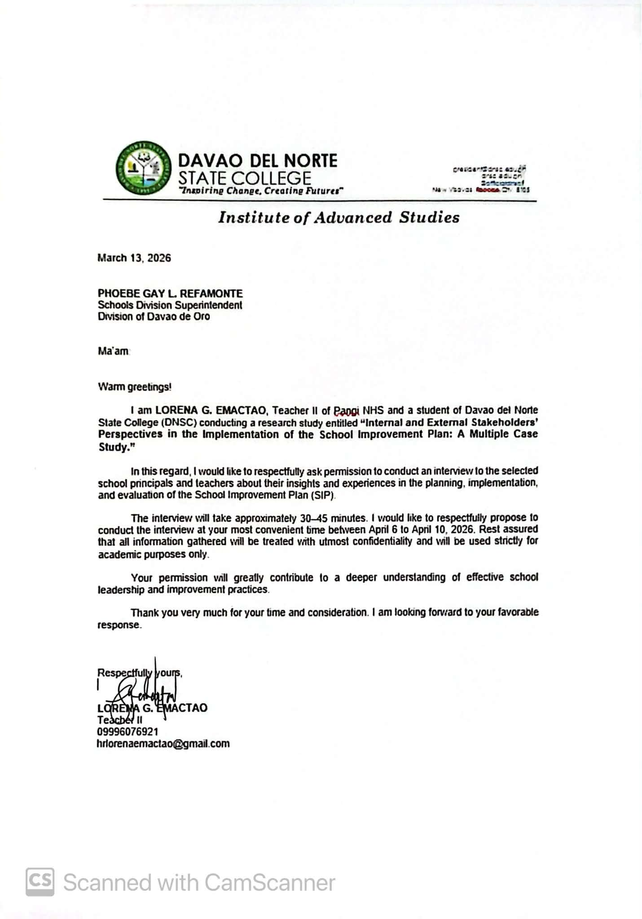

APPENDIX C
Approval Letter from DepEd Davao de Oro

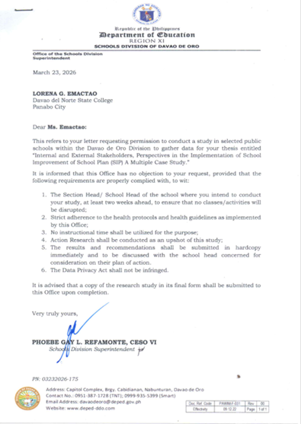

APPENDIX D
Request Letter to Conduct Study in DepEd Public High School


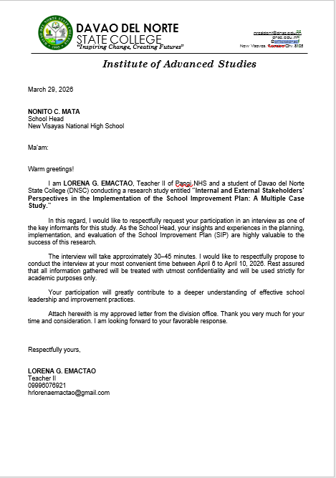

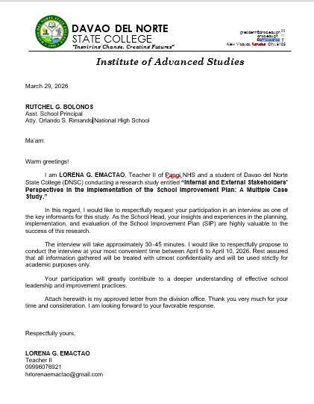

APPENDIX E
Sample Certificate of Consent


APPENDIX F

Interview Guide Questions

Research Questions | Interview Questions
RQ1. How do internal stakeholders describe the implementation practices of the School Improvement Plan in selected public schools? | How do you describe your involvement in developing and understanding the goals of the SIP?
 | How your decisions made during the implementation of the SIP?
 | How are leadership roles and responsibilities shared among stakeholders during SIP implementation?
 | How do stakeholders work together in implementing the SIP?
 | How is information about SIP communicated among stakeholders?
 | How do stakeholders share responsibility in monitoring and evaluating the SIP?
 | How are stakeholders supported or empowered to participate in SIP implementation?
RQ2. How do internal stakeholders perceive challenges in the implementation of the School Improvement Plan (SIP) in selected school cases? | 2.1 What challenges have you perceived in the implementation of the SIP?
 | 2.2 What challenges affect the timely implementation of SIP activities?
 | 2.3 What communication challenges have you experienced during SIP implementation?
 | 2.4 Have communication issues affected stakeholder coordination?
 | 2.5 How actively do stakeholders participate in SIP decision-making?
 | - What support is needed to strengthen stakeholder participation?
 | - How independent are stakeholders during implementation?

APPENDIX G
Validation Sheet for Qualitative Research Instrument




APPENDIX H
Sample Transcript Validation
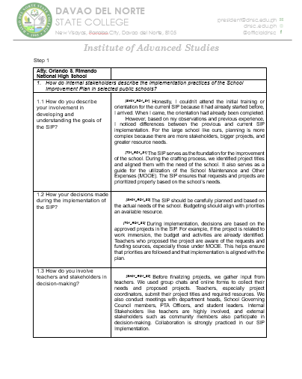

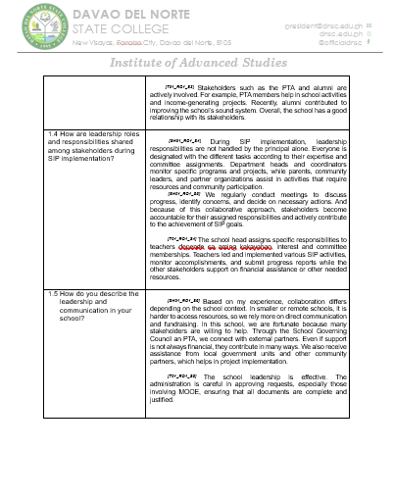

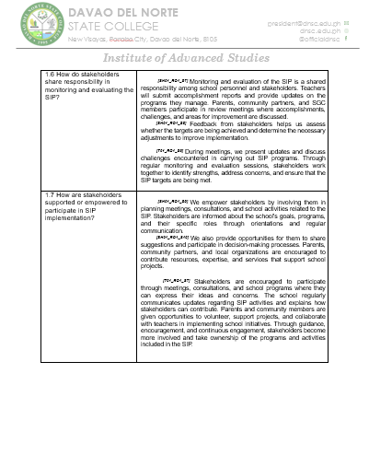

APPENDIX I
Certificate of Transcript Validation




APPENDIX J
Audit Trail
Internal Stakeholders’ Implementation Practices In
School Improvement Plan (SIP)
Code | Responses | Core Ideas | Themes
SH_01 | [SH_01] “The SIP should be carefully planned and based on the  actual needs of the school. Budgeting should align with priorities an  available resource” | - Stakeholder Participation in Identifying Priority Needs | Stakeholders Shared Ownership
SH_03 | [SH_03] “So far, so good man amoang School Improvement Plan.  Well planned man siya. Not only the school planning team but apil pd  ang stakeholders nato sa gawas. So well presented sa ilaha, gi estoryahan, ghisgutan, then there was presentation kasama ang PTA officials of the school, Governing Council tapos subject for ratification until such time Nakita unsay mga top priorities na dapat tutukan sa school for five years mao toy ginahisgutan.” | - Stakeholder Participation in Identifying Priority Needs | Stakeholders Shared Ownership
T_01 | [T_01] “The SIP serves as the foundation for the improvement of  the school. During the crafting process, we identified project titles  and aligned them with the needs of the school. It also serves as a guide for utilization of the School Maintenance and Other Expenses (MOOE). The SIP ensures that requests and projects are prioritized properly based on the school’s needs. | - Stakeholder Participation in Identifying Priority Needs | Stakeholders Shared Ownership
T_02 | [T_02] “Another important strategy is collaborative and participatory  planning. Teachers, school leaders, parents and community partners  should take involved so that the SIP becomes inclusive and responsive  to actual school needs.” | - Stakeholder Participation in Identifying Priority Needs | Stakeholders Shared Ownership
SH_01 | [SH_01] “We regularly conduct meetings to discuss progress, identify  concerns, and decide on necessary actions. And because of this collaborative approach, stakeholders become accountable for their assigned responsibilities and actively contribute to the achievement of SIP goals. | - Shared responsibility in achieving school improvement targets | Stakeholders Shared Ownership
SH_02 | [SH_02] I involved everyone and ensured that all key players  (teachers, parents & community leaders) are part of the planning and  implementation process with clear delegation and shared responsibility |  | Stakeholders Shared Ownership
SH_03 | [SH_03] E encourage pud nimo, that’s the way giunsa nimo sila pag  encourage kay puros man ta leader unya di man nako Makaya. Kailangan nato ang matag-usa sa atoa aron mu success ta. So, need jud ang collaboration.” |  | Stakeholders Shared Ownership
T_01 | [T_01] The school head assigns specific responsibilities to teachers depende sa aming kakayahan, interest and committee memberships. Teachers led and implemented various SIP activities, monitor accomplishments, and submit progress reports while the other stakeholders support on financial assistance or other needed resources. |  | Stakeholders Shared Ownership
SH_01 | [SH_01] Before finalizing projects, we gather input from  teachers. We used group chats and online forms to collect  their needs and proposed projects. Teachers, especially project  coordinators, submit their project titles and required resources.  We also conduct meetings with department heads, School  Governing Council members, PTA Officers, and student leaders.  Internal Stakeholders like teachers are highly involved, and external  stakeholders such as community members also participate in  decision-making. Collaboration is strongly practiced in our SIP  Implementation. | - Active involvement in the implementation of school programs and projects | Stakeholders Shared Ownership
SH_02 | [SH02_RQ1_S3] “stakeholders such as teachers, parents, PTA  officers, barangay officials, alumni, and community partners  are also given opportunities to participate in school projects and  decision-making.” |  | Stakeholders Shared Ownership
SH_03 | [SH03_RQ1_S3] They have chance to handle those projects because  we have open forums and open discussions kung unsay nindut.” |  | Stakeholders Shared Ownership
T_01 | [T_01] “Stakeholders such as the PTA and alumni are actively  involved. For example, PTA members help in school activities and income  generating projects. Recently, alumni contributed to improving the school’s  sound system. Overall, the school has a good relationship with its stakeholders. |  | Stakeholders Shared Ownership
T_02 | [T_02] “Another important strategy is collaborative and  participatory planning. Teachers, school leaders, parents  and community partners should take involved so that the  SIP becomes inclusive and responsive to actual school needs.” |  | Stakeholders Shared Ownership
T_03 | [T_03] “Amoang gibuhat ato before mi nag craft is nagpatawag  jud mig meeting together with the teachers with the PTA nga involve  ana ma’am nga nag collaborate mi ma’am kung unsa ang pwede namo  ma implement for five years sa school.” |  | Stakeholders Shared Ownership
SH_01 | [SH_01] During SIP implementation, leadership responsibilities are not handled by the principal alone. Everyone is designated with the  different tasks according to their expertise and committee assignments. Department heads and coordinators monitor specific programs and projects, while parents, community leaders, and partner organizations assist in activities that require resources and community participation. | Strengthened sense of ownership through shared involvement | Stakeholders Shared Ownership
SH_02 | [SH_02] Leadership and responsibilities during the implementation  of the School Improvement Plan are shared through the school  planning team where there is always a consultative meeting. | Strengthened sense of ownership through shared involvement | Stakeholders Shared Ownership
SH_03 | [SH_03] ‘Unang-una, dapat pag school head ka sa imoha jud  na maggikan, dapat makita nila sa imoha giunsa pag manage properly  ang team kasi dili mana pwede nga ako lang so mu- involve jud na sila tanan, and always tagaan nimo silag chance and opportunity by  delegating them asa sila nindot nga committee assignments’ | Strengthened sense of ownership through shared involvement | Stakeholders Shared Ownership
T_02 | [T_02] “Aside from that, I also took part in stakeholder  consultations, especially through the School Governing  Council. We engaged parents and community members  to ensure that the plan reflected the actual needs and context  of the school.” | Strengthened sense of ownership through shared involvement | Stakeholders Shared Ownership
SH_01 | [SH_01] We regularly conduct meetings to discuss progress,  identify concerns and decide on necessary actions. And because  of this collaborative approach, stakeholders become accountable for them  assigned responsibilities and actively contribute to the achievement of SIP  goals. | • Regular communication among stakeholders | Collaborative Communication Dynamics
SH_02 | [SH_02] “The information about the SIP is communicated through  orientations, meetings, assemblies, and official announcements.” | • Regular communication among stakeholders | Collaborative Communication Dynamics
SH_03 | [SH_03] Yes ma’am, I always informed them even sa mga small projects nga pwede ra unta sa school pero amoa jud na silang ginareach out para naa silay kahibalo unsa nay nahitabo dria sa atong school.” | • Regular communication among stakeholders | Collaborative Communication Dynamics
T_01 | [T_01] Stakeholders are encouraged to participate through meetings,  consultations, and school programs where they can express their ideas and concerns. The school regularly communicates updates regarding SIP activities and explains how stakeholders can contribute. Parents and community members are given opportunities to volunteer, support projects, and collaborate with teachers in implementing school initiatives. Through guidance, encouragement, and continuous engagement, stakeholders become more involved and take ownership of the programs and activities included in the SIP. | • Regular communication among stakeholders | Collaborative Communication Dynamics
SH_01 | [SH_01] Monitoring and evaluation of the SIP is a shared  responsibility among school personnel and stakeholders.  Teachers will submit accomplishments reports and provide updates  on the programs they manage. Parents, community partners, and  SGC members participate in review meetings were accomplishments,  challenges, and areas for improvement are discussed. Feedback from  stakeholders help us assess whether the targets are being achieved and determine the necessary adjustments to improve implementation. | • Feedback mechanisms for implementation concerns | Collaborative Communication Dynamics
SH_03 | [SH_03] Ang importante dili kuan, dili blind ang community, kabalo  sila unsay nahitabo sa school dapat transparent jud ta in operating the  school especially makita na dha sa planning sa SIP, ginatan-aw pud na, gina-evaluate. Tinood ba ni, natuman bani, as ana ta, mao nay importante nga mabalance nato ba. | • Feedback mechanisms for implementation concerns | Collaborative Communication Dynamics
T_01 | [T_01] Stakeholders are encouraged to participate through meetings,  consultations, and school programs where they can express their ideas and concerns. The school regularly communicates updates regarding SIP activities and explains how stakeholders can contribute. Parents and community members are given opportunities to volunteer, support projects, and collaborate with teachers in implementing school initiatives. Through guidance, encouragement, and continuous engagement, stakeholders become more involved and take ownership of the programs and activities included in the SIP. | • Feedback mechanisms for implementation concerns | Collaborative Communication Dynamics
SH_01 | [SH_01] Parents, community partners, and SGC members participate  review meetings were accomplishments, challenges, and areas for  improvement is discussed. Feedback from stakeholders help us  assess whether the targets are being achieved and determine  the necessary adjustments to improve implementation. | • Collaborative decision-making through open communication | Collaborative Communication Dynamics
SH_03 | [SH_03] Ang importante dili kuan, dili blind ang community, kabalo  sila unsay nahitabo sa school dapat transparent jud ta in operating the  school especially makita na dha sa planning sa SIP, ginatan-aw pud na,  gina-evaluate. Tinood ba ni, natuman bani, asa na ta, mao nay importante nga mabalance nato ba. | • Collaborative decision-making through open communication | Collaborative Communication Dynamics
T_01 | [T_01] During meetings, we present updates and discuss challenges encountered in carrying out SIP programs. Through regular monitoring and evaluation sessions, stakeholders work together to identify strengths, address concerns, and ensure that the SIP targets are being met. | • Collaborative decision-making through open communication | Collaborative Communication Dynamics
SH_01 | [SH_01] “We empower stakeholders by involving them in planning  meetings, consultations, and school activities related to SIP. Stakeholders are informed about the school's goals, programs, and their specific roles through orientation and regular communication. We also provide opportunities for them to share suggestions and participate in decision-making processes. Parents, community partners, and local organizations are encouraged to contribute resources, expertise, and services that support school projects” | • Empowerment through shared decision-making | Collaborative Communication Dynamics
SH_02 | [SH_02] As the school head, it is my duty to empower and encourage  them to participate in the implementation of the SIP by giving them not just the responsibility, but also the authority, skills and confidence to perform.” | • Empowerment through shared decision-making | Collaborative Communication Dynamics
SH_03 | [SH_03] E encourage pud nimo, that’s the way giunsa nimo sila pag encourage kay puros man ta leader unya di man nako Makaya. Kailangan nato ang matag-usa sa atoa aron mu success ta. So, need jud ang collaboration” | • Empowerment through shared decision-making | Collaborative Communication Dynamics
T_01 | [T_01] Stakeholders are encouraged to participate through meetings,  consultations, and school programs where they can express their ideas and concerns. The school regularly communicates updates regarding SIP activities and explains how stakeholders can contribute. Parents and community members are given opportunities to volunteer, support projects, and collaborate with teachers in implementing school initiatives. Through guidance, encouragement, and continuous engagement, stakeholders become more involved and take ownership of the programs and activities included in the SIP. | • Empowerment through shared decision-making | Collaborative Communication Dynamics
SH_01 | [SH_01] Based on my experience, collaboration differs depending on the  school context. In smaller or remote schools, it is harder to access resources, so, we rely more on direct communication and fundraising. In this school, we are fortunate because many stakeholders are willing to help. Through the School Governing Council an PTA, we connect with external partners. Even if support is not always financial, they contribute in many ways. We also receive assistance from local government units and other community partners, which helps in project implementation. | • Strengthened partnership through continuous engagement | Collaborative Communication Dynamics
SH_01 | [SH_01] ‘Parents, community partners, and local organizations are  encouraged to contribute resources, expertise, and services that support school projects’ | • Strengthened partnership through continuous engagement | Collaborative Communication Dynamics
SH_02 | [SH_02] I involved everyone and ensured that all key players (teachers, parents & community leaders) are part of the planning and implementation process with clear delegation and shared responsibility | • Strengthened partnership through continuous engagement | Collaborative Communication Dynamics
T_01 | [T_01] “Stakeholders such as the PTA and alumni are actively  involved. For example, PTA members help in school activities and income generating projects. Recently, alumni contributed to improving the school’s sound system. Overall, the school has a good relationship with its stakeholders. | • Strengthened partnership through continuous engagement | Collaborative Communication Dynamics
T_02 | [T_02] We were fortunate because our PTA President was very active in every school activity. Because of that, many parents were encouraged to support the school.” | • Strengthened partnership through continuous engagement
T_03 | [T_03] “Amoang gibuhat ato before mi nag craft is nagpatawag  jud mig meeting together with the teachers with the PTA nga involve  ana ma’am nga nag collaborate mi ma’am kung unsa ang pwede namo  ma implement for five years sa school.” | • Strengthened partnership through continuous engagement
SH_01 | SH_01 "Parents, community partners, and local organizations  are encouraged to contribute resources, expertise, and services  that support school projects."
SH_02 | SH_02 "I involved everyone and ensured that all key players  are part of the planning and implementation process with clear  delegation and shared responsibility.”
T_01 | T_01 Through guidance, encouragement, and continuous  engagement, stakeholders become more involved and take  ownership of the programs and activities included in the SIP."
SH_01 | [SH_01] One major challenge is the lack of manpower,  particularly non-teaching personnel. Teachers are focused  on instructions, assigning them additional responsibilities  for projects can be difficult. | Insufficient personnel to carry out SIP Activities | Workforce Limitations Affecting SIP Implementation
SH_03 | [SH_03] “Normally, ang ma encounter jud nato is kaning expectation jud nato coming from external. Siyempre, dili man jud nato kaya e funded tanang mga projects kay dinagko mana sa atong eskwelahan.  Usahay naa tay timeline nga dili nato matuman.” | Insufficient personnel to carry out SIP Activities | Workforce Limitations Affecting SIP Implementation
T_03 | [T_03] The challenges we encountered was the consolidation of data from different sources and analysis, limited resources, and limited manpower tungod niana aduna jud delay sa pag implement sa mga projects, madugay man tuod pero maimplement man gihapon .” | Insufficient personnel to carry out SIP Activities | Workforce Limitations Affecting SIP Implementation
SH_01 | [SH_01] Even if funds are available, delays occur because of insufficient manpower. | Implementation delays due to insufficient manpower | Workforce Limitations Affecting SIP Implementation
SH_03 | [SH_03] “Normally, ang ma encounter jud nato is kaning expectation jud nato coming from external. Siyempre, dili man jud nato kaya e funded tanang mga projects kay dinagko mana sa atong eskwelahan. Usahay naa tay timeline nga dili nato matuman.” | Implementation delays due to insufficient manpower | Workforce Limitations Affecting SIP Implementation
T_03 | [T_03] The challenges we encountered was the consolidation of data from different sources and analysis, limited resources, and limited manpower tungod niana aduna jud delay sa pag implement sa mga projects, madugay man tuod pero maimplement man gihapon .” | Implementation delays due to insufficient manpower | Workforce Limitations Affecting SIP Implementation
SH_01 | [SH_01] One challenge we experienced was ensuring that SIP information reached all stakeholders promptly. Due to the number of people involved, some stakeholders received updates later than expected." | Ineffective dissemination of timely Information | Communication Challenges affects Involvement
SH_02 | [SH_02] "Although meetings were conducted regularly, there were occasions when important information was not fully communicated to all stakeholders, resulting in varying levels of awareness." | Ineffective dissemination of timely Information | Communication Challenges affects Involvement
SH_03 | [SH_03] "Some stakeholders were unable to attend meetings, making it difficult to keep everyone informed about SIP activities and developments." | Ineffective dissemination of timely Information | Communication Challenges affects Involvement
T_02 | [T_02] “Not all parents received updates because some could not attend meetings or access communication platforms regularly." | Ineffective dissemination of timely Information | Communication Challenges affects Involvement
SH_02 | [SH_02] "There were instances when misunderstandings occurred because instructions were interpreted differently by stakeholders." | Communication Barriers Affecting Coordination | Communication Challenges affects Involvement
SH_03 | [SH_03] "Communication became challenging when stakeholders were not able to immediately respond to school concerns and requests." | Communication Barriers Affecting Coordination | Communication Challenges affects Involvement
T_01 | [T_01] "Different interpretations of assigned tasks occasionally affected the implementation of SIP activities." | Communication Barriers Affecting Coordination | Communication Challenges affects Involvement
SH_01 | [SH_01] "Some stakeholders attended meetings but rarely shared their opinions regarding SIP implementation." | Limited Feedback challenges engagement | Communication Challenges affects Involvement
SH_03 | [SH_03] "Although communication channels were available, but dili jud tanan nagahatag sa ilahang feedback, that’s why lisod sa amoa mag communicate." | Limited Feedback challenges engagement | Communication Challenges affects Involvement
T_03 | [T_03] "Not all stakeholders felt comfortable expressing concerns or suggestions related to SIP implementation." | Limited Feedback challenges engagement | Communication Challenges affects Involvement
SH_01 | [SH_01] "Some stakeholders preferred that school leaders make decisions rather than actively participate in planning." | Limited Participation in decision-making | Stakeholder Empowerment Challenges
SH_02 | [SH_02]"While stakeholders were invited to planning sessions, only a few consistently shared their ideas." | Limited Participation in decision-making | Stakeholder Empowerment Challenges
T_01 | [T_01] "Some teachers felt that decisions were already established before consultations took place." | Limited Participation in decision-making | Stakeholder Empowerment Challenges
T_03 | [T_03] "Naay panahon nga uban lang ang naga-involve, ang uban passive lang pd though they were already encouraging to participate and that’s reality” | Limited Participation in decision-making | Stakeholder Empowerment Challenges
SH_01 | [SH_01] "Additional training must be reinforced so that it would help stakeholders contribute more effectively to implementation activities." | Inadequate capacity-building opportunities affected stakeholders' ability to effectively | Stakeholder Empowerment Challenges
SH_03 | [SH_03] "There were stakeholders who needed further guidance regarding SIP objectives and procedures." |  | Stakeholder Empowerment Challenges
T_03 | [T_03] "Capacity-building activities should have strengthened stakeholder involvement and commitment kay if naa man gud tanan stakeholders’ ani, they really have a full idea regarding the SIP” |  | Stakeholder Empowerment Challenges
SH_01 | [SH_01] "Many stakeholders looked to school leaders for direction before taking action." | Reliance on school leadership limited stakeholder initiative | Stakeholder Empowerment Challenges
SH_02 | [SH_02] "Some stakeholders hesitated to initiate activities unless instructions were provided by administrators." | Reliance on school leadership limited stakeholder initiative | Stakeholder Empowerment Challenges
T_01 | [T_01] "Stakeholders often waited for guidance rather than independently contributing ideas and solutions." | Reliance on school leadership limited stakeholder initiative | Stakeholder Empowerment Challenges
T_03 | [T_03] "Supportive man ang mga stakeholders sa implementation, pero daghan japon magsalig jud sa school head bago mu participate” | Reliance on school leadership limited stakeholder initiative | Stakeholder Empowerment Challenges

APPENDIX K

Grammarian Certificate
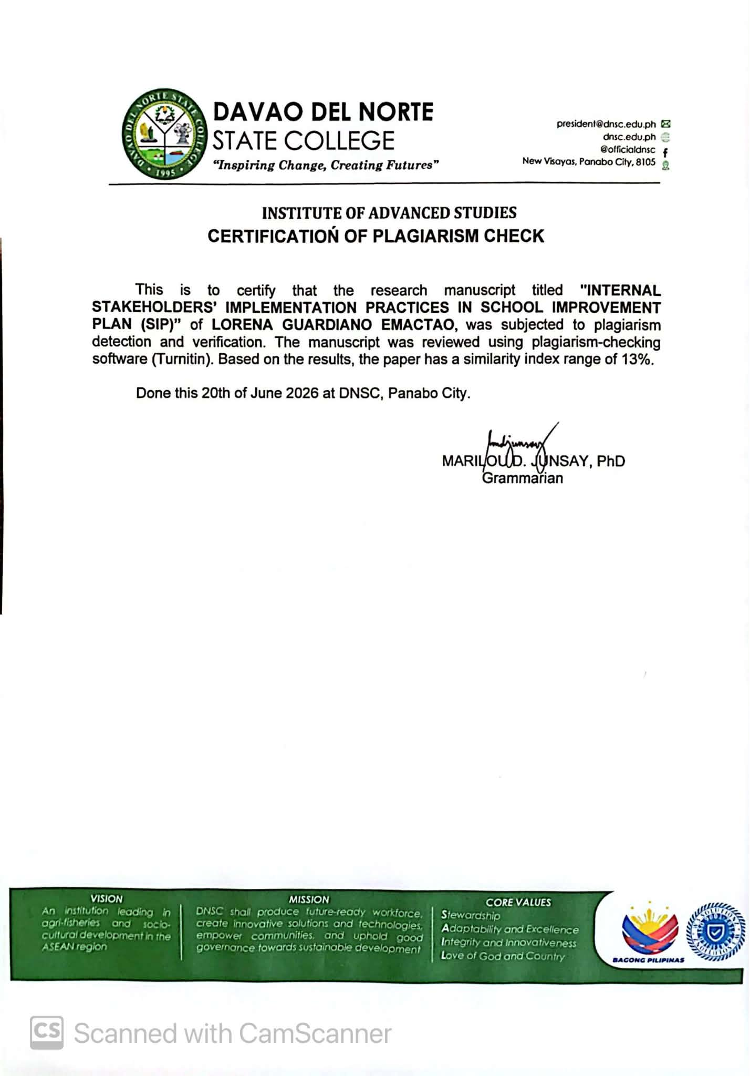

APPENDIX L

Plagiarism Check Result

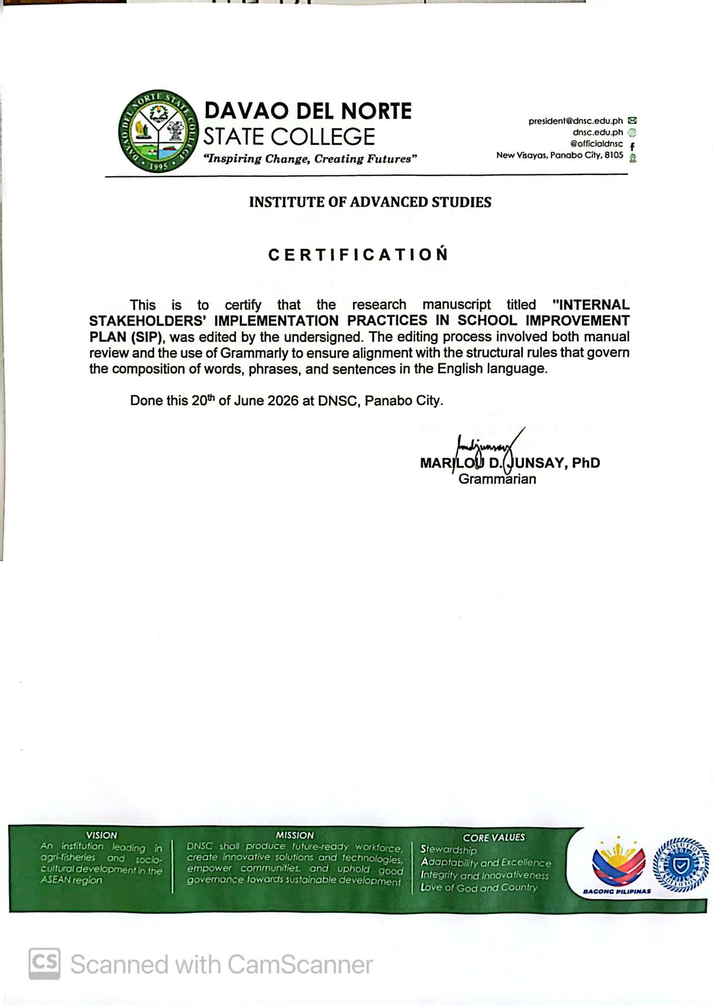

APPENDIX M
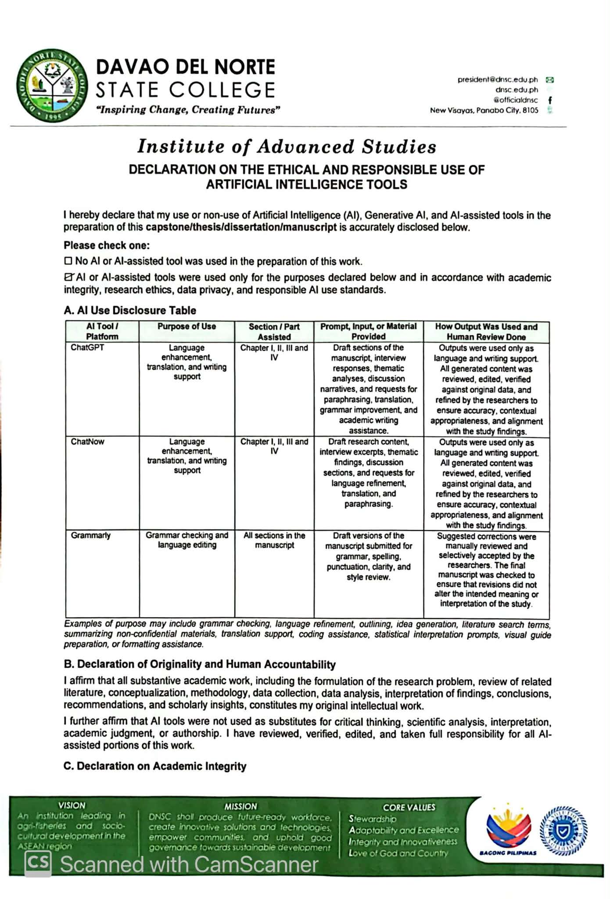
Use of Artificial Intelligence Declaration



APPENDIX N
Evaluation Form Expedited Review
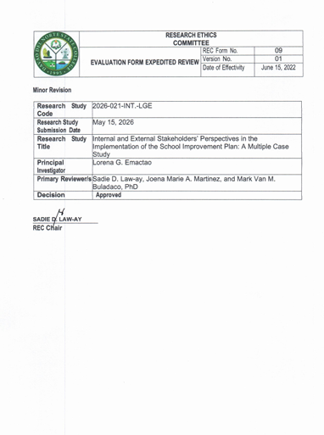

APPENDIX O
Approval Letter to the Study Protocol
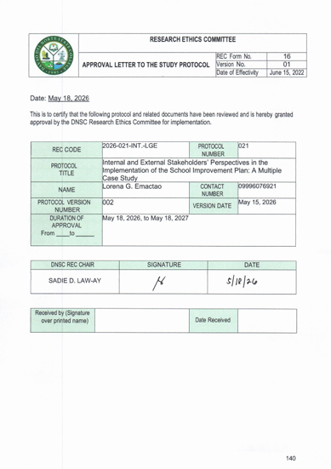

APPENDIX M
Ethical Clearance
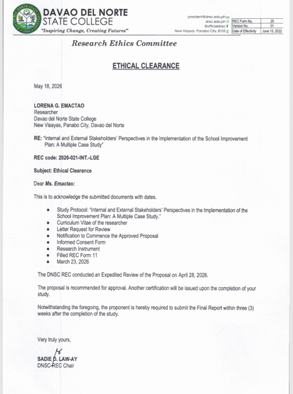

BIONOTE


Lorena G. Emactao is a dedicated and aspiring educator pursuing a Bachelor of Secondary Education degree. Throughout her academic journey, she has demonstrated commitment to excellence, leadership, and continuous professional growth. Her passion for education has inspired her to actively participate in academic and community-based activities that contribute to the development of learners and the improvement of educational practices. As a researcher, she developed a strong interest in educational leadership, stakeholder engagement, and school development initiatives. Her undergraduate research focused on the implementation of the School Improvement Plan (SIP), particularly examining the practices and challenges experienced by internal stakeholders in selected public secondary schools. Through this study, she gained valuable insights into the importance of collaboration, shared responsibility, and effective communication in achieving school improvement goals.

