Development of an Integrated Slotting Mechanism for Internal Keyway Machining on a Conventional Lathe

Thach Ngoc Phuc^{1,*}, Huynh Thanh Banh¹

¹School of Mechanical Engineering, College of Engineering and Technology, Tra Vinh University, Hoa Thuan Ward, Vinh Long Province, Viet Nam

*Corresponding author: thachngocphuc1976@gmail.com

ABSTRACT

Conventional lathes, while versatile, lack the capability to machine internal keyways, necessitating dedicated and costly equipment, a significant limitation for small- and medium-sized workshops. This study addresses this gap by developing a novel, mechanically integrated slotting attachment for conventional lathes. The research encompasses the systematic design, force-power analysis, fabrication, and experimental validation of the mechanism. The attachment, mounted on the lathe tool post, utilizes a crank-slider system driven by a stepper motor via an Arduino-based controller to generate a reciprocating cutting motion. Finite element analysis confirms the structural sufficiency of the critical ram shaft under operational loads. Machining experiments on aluminum and carbon steel C35 specimens demonstrate the attachment's practical efficacy, producing internal keyways with high dimensional accuracy (deviations within 0.03 mm for width and 0.05 mm for depth). The results prove that the proposed integration successfully extends lathe functionality, offering a cost-effective, space-saving, and precise solution for internal keyway machining. This work provides a validated design framework for enhancing the versatility of traditional machine tools in resource-constrained manufacturing environments.

Keywwords: Keyway machining, Internal keyway, Lathe attachment, Precision manufacturing, conventional lathe

1. INTRODUCTION
Mechanical engineering plays a pivotal role in industrial development, particularly in rapidly developing countries such as Vietnam, where manufacturing industries are expanding to meet increasing domestic and export demands. In this context, small- and medium-sized enterprises form the backbone of the manufacturing sector, and their productivity largely depends on the availability of affordable, reliable, and versatile machine tools. Despite the global transition toward CNC machining centers, a considerable number of workshops in Vietnam and other developing economies continue to rely on conventional machine tools due to constraints related to investment cost, maintenance capability, and workforce skill levels.
Among conventional machine tools, the lathe is widely recognized as the “mother of machine tools” owing to its versatility, robustness, and widespread availability. Conventional lathes are commonly employed for turning, facing, drilling, and threading operations. However, their functional limitations become apparent when components require additional machining features such as keyways, slots, or flat surfaces, which are essential in power transmission systems. Keyways are widely used to provide positive torque transmission between shafts and mating components such as gears, pulleys, and couplings, making them indispensable elements in mechanical assemblies.
Traditionally, keyway machining is carried out using specialized machine tools such as slotting machines, shaping machines, milling machines, or broaching machines. Broaching and slotting processes are particularly valued for their ability to produce accurate and repeatable internal and external keyways with good surface integrity; however, these methods typically require dedicated equipment and specialized tooling, resulting in high initial investment and limited flexibility for low-volume or customized production environments [1–3]. Consequently, such machines are often economically unjustifiable for SMEs and job-shop manufacturers.
To overcome these limitations, researchers and practitioners have increasingly focused on enhancing the functional capabilities of conventional lathes through the development of auxiliary attachments. Various studies have demonstrated that integrating additional machining operations into a single lathe platform can significantly reduce setup time, machine investment cost, and workpiece handling while maintaining acceptable dimensional accuracy. Grinding attachments mounted on lathes have been shown to improve surface finish without transferring the workpiece to a separate machine [4, 5]. Similarly, multi-operation and special-purpose attachments enable milling, drilling, and slotting operations to be performed on conventional lathes, thereby improving productivity and space utilization in small workshops [6].
In particular, slotting and keyway machining attachments for lathes have attracted growing attention due to their practical relevance. Several studies have proposed internal and external keyway attachments that allow keyway machining to be performed directly on a lathe without the need for milling or broaching machines. These solutions are especially suitable for maintenance work, batch production, and non-standard components commonly encountered in SMEs [7–10]. By maintaining the same workpiece setup, such attachments help reduce cumulative positioning errors and overall machining time while increasing the operational flexibility of conventional lathes.
From an engineering design perspective, the successful integration of a keyway slotting mechanism into a lathe requires careful consideration of kinematic motion conversion, structural rigidity, cutting force transmission, and ease of installation. While existing studies confirm the feasibility of lathe-based keyway machining, many of them focus primarily on fabrication or conceptual demonstration, with limited emphasis on systematic mechanical design and integration potential for machine tool manufacturers. As a result, there remains a need for a well-structured design approach that balances simplicity, robustness, and machining performance while being suitable for widespread industrial adoption.
This need is particularly evident in Vietnam, where domestic manufacturers continue to produce conventional lathes for the local and regional markets. Integrating a keyway slotting mechanism directly into the design of traditional lathes would significantly enhance their functional value, enabling manufacturers to offer multifunctional machines without substantial increases in cost. For end-users, such integration would expand machining capabilities, reduce dependency on multiple machine tools, and improve overall production efficiency.
Therefore, this study aims to design and develop a keyway slotting mechanism that can be effectively integrated with a conventional lathe. The proposed mechanism is intended to be structurally simple, easy to install and operate, and suitable for small- and medium-scale manufacturing environments. By addressing both practical industrial needs and mechanical design considerations, this research contributes to the advancement of multifunctional machine tool design and supports the sustainable development of mechanical manufacturing in developing economies.

2. CUTTING PARAMETERS AND MOTOR POWER DETERMINATION
2.1. Cutting parameters
The cutting parameters for the keyway slotting operation were selected based on surface finish requirements, machine rigidity, and practical machining conditions. The cutting depth was chosen following conventional slotting recommendations. For a target surface roughness of R_{a} = 3.2 μm, the cutting depth typically ranges from 0.5 to 2 mm. To ensure stable cutting and reduce tool loading, the cutting depth was set to t = 0.5 mm.
The feed rate was selected according to slot width and workpiece material (steel). For slot widths between 6 and 10 mm, the recommended feed rate ranges from 0.18 to 0.26 mm per double stroke. Considering the maximum slot width of 10 mm, the feed rate was chosen as S = 0.26 mm/double stroke. The cutting speed was determined from the kinematic characteristics of the quick-return slotting mechanism. With a stroke length of 80 mm and 16 double strokes per minute, the average cutting speed was calculated using standard slotting speed relations.
2.2. Cutting force estimation
In slotting operations, the main cutting force component P_{z} governs power consumption and mechanical loading. The cutting force was estimated using an empirical cutting force model:
P_{z} = 10.C_{p}.t^{x}.S^{y}.k_{p} (1)
For machining steel under the selected cutting conditions, the coefficients were taken as C_{p} = 247, x = 1, y = 1, while k_{p} represents the correction factor accounting for tool material and cutting conditions.
2.3. Power requirement and motor selection
To obtain a realistic power requirement, friction forces acting on the sliding guide of the slotting mechanism were included. The friction force was calculated as:
F = μ(P_{y} + G) (2)
where μ is the friction coefficient, P_{y} is the radial force component, and G is the weight of the reciprocating ram.
The cutting power was calculated as:
$N=\frac{P.V_{c}}{60.{10}^{3}}$ (3)
Mechanical transmission losses were considered by incorporating the efficiencies of rolling bearings (η_{ol} = 0.98) and spur gears (η_{br} = 0.995). The required motor power was calculated as:
$N_{motor_req} = \frac{N}{η_{bearing}.η_{gear}}$ (4)
The resulting motor power requirement was approximately 0.15 kW. Based on this value, a stepper motor with a rated torque of 14 Nm was selected, confirming stable and reliable operation of the proposed keyway slotting mechanism.
$M_{x}=\frac{9,55.{10}^{6}.N_{motor}}{n}$ (5)
$N_{motor} = \frac{M_{x}.n}{9,55.{10}^{6}}=\frac{14000.230}{9,55.{10}^{6}}=0,337 kW$ (6)
Since the rated motor power exceeds the required power ${(N}_{motor} > N_{motor_req})$, the selected motor satisfies the operational criterion.
3. DESIGN AND FABRICATION OF THE INTEGRATED SLOTTING MECHANISM
The integrated slotting mechanism is designed as an auxiliary attachment mounted directly on the tool post of a conventional lathe, enabling internal keyway machining without the need for dedicated slotting or broaching machines as shown in Fig. 1. The system consists of a rigid base plate (2) interfacing with the lathe tool post (1), a drive unit comprising an electric motor and reduction gearbox (3), a crank mechanism (4), a slotting ram (5), an adjustment mechanism (6), and a cutting tool (7). The compact and modular design allows easy installation, alignment, and removal, making it suitable for small- and medium-scale workshops. After fixing the mounting base (2) onto the lathe tool post (1), the mechanism is aligned and calibrated using the adjustment mechanism (6) to ensure accurate positioning of the cutting tool relative to the workpiece. When the system is activated, the electric motor transmits rotational motion through the reduction gearbox to the main drive shaft (3). This rotary motion is then converted into circular motion by the crank mechanism (4). The crank drives the slotting mechanism (5), transforming the rotary motion into a reciprocating linear motion with a double-stroke cycle. As a result, the cutting tool (7) moves linearly along the slotting direction, performing the internal keyway cutting operation during the forward stroke while retracting during the return stroke. This kinematic arrangement ensures stable cutting action, controlled stroke length, and compatibility with conventional lathe operations.
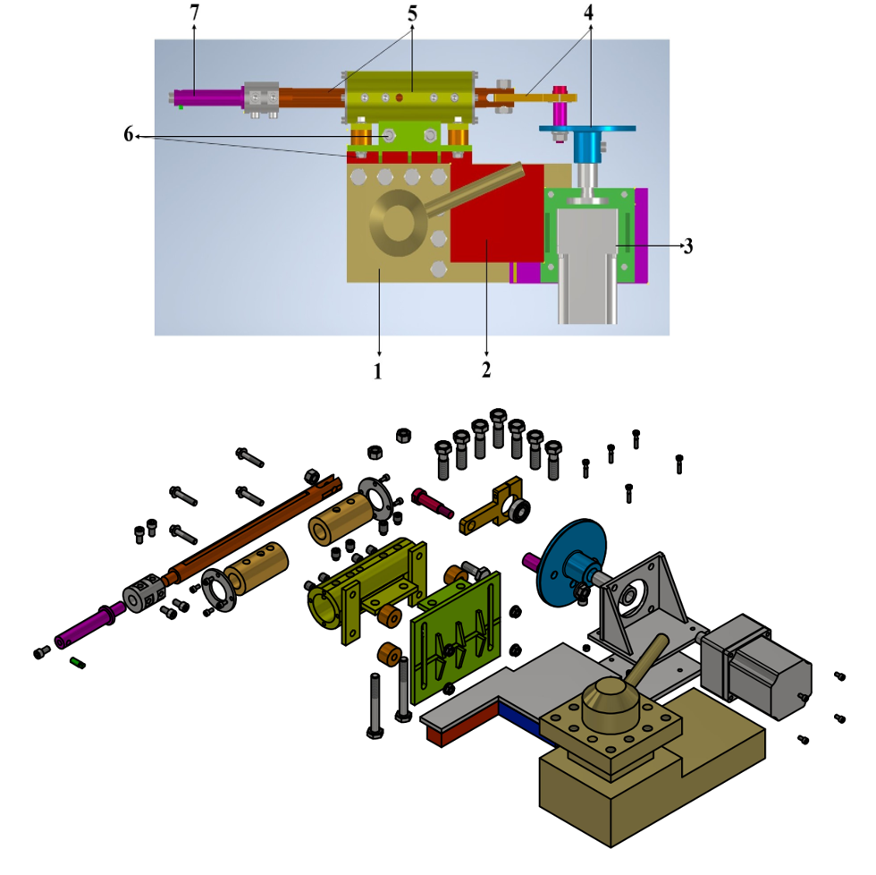
Fig. 1. Three-dimensional model of the lathe-integrated keyway slotting mechanism
The slotting ram shaft is selected for strength verification as it is the primary load-bearing component directly subjected to cutting forces during operation, and its structural integrity plays a critical role in system stiffness and machining accuracy. Therefore, finite element stress analysis is conducted on this component. As shown in Fig. 2, the maximum von Mises stress reaches 38.91 MPa, which is significantly lower than the allowable stress of the shaft material (σ__{ch} = 300 MPa). This result confirms that the slotting ram shaft satisfies strength and rigidity requirements, ensuring stable operation and reliable internal keyway machining accuracy.
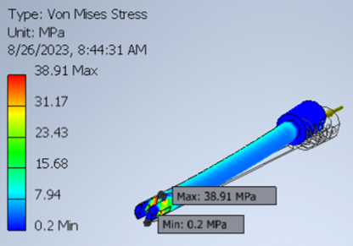
Fig. 2. Finite element stress analysis of the slotting ram shaft
The electrical control system of the integrated slotting mechanism is designed to ensure safe operation, reliable motion control, and effective thermal management as illustrated in Fig 3. The system mainly consists of a power supply, two control switches, an Arduino-based control unit, a 5-phase stepper motor driver (RKD514H-C), a 5-phase stepper motor, and a cooling fan.
When the main power supply is connected, electrical power is delivered to the primary switch; however, at this stage, the circuit remains in a standby state and the stepper motor does not operate. Upon switching on the second power switch (K2), electrical power is supplied to the stepper motor driver. Simultaneously, the cooling fan is activated to provide continuous forced-air cooling for the driver, ensuring thermal stability during operation.
When the first power switch (K1) is turned on, the Arduino control circuit is energized. The Arduino then generates continuous pulse (PUL) and direction (DIR) signals, which are transmitted to the input terminals of the 5-phase stepper motor driver. Upon receiving these control signals, the driver converts the low-level pulse commands into appropriate phase currents and supplies them to the 5-phase stepper motor. As a result, the stepper motor rotates according to the programmed pulse frequency and direction, thereby driving the mechanical transmission of the slotting mechanism.
This control architecture allows independent activation of the power stage and the control stage, improving operational safety and system reliability. In addition, the integration of an active cooling fan helps maintain stable driver performance and prevents overheating during continuous slotting operations.
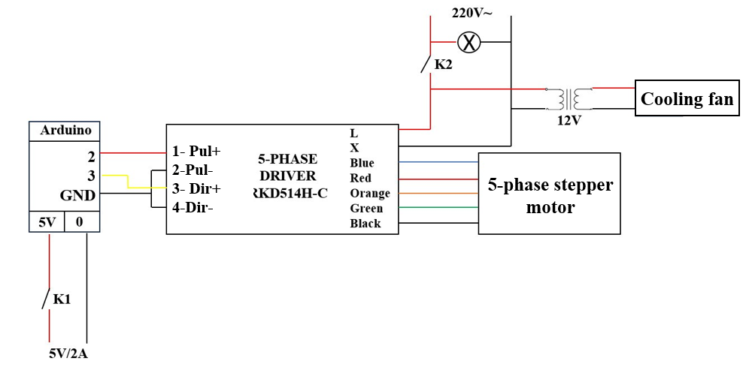
Fig. 3. Schematic of the electrical control system for the integrated slotting mechanism.
The integrated slotting mechanism was successfully fabricated and assembled according to the proposed 3D design, and subsequently mounted on a conventional lathe as depicted in Fig. 4. The manufactured components show good conformity with the design specifications and are rigidly connected to the lathe tool post through the mounting base. The compact structure allows convenient installation without interfering with standard lathe operations. The adjustment mechanism enables accurate alignment of the cutting tool relative to the workpiece, while the crank–slider assembly is correctly integrated to ensure smooth reciprocating motion. Overall, the fabrication and assembly results confirm the feasibility of mechanically integrating the slotting mechanism with a conventional lathe.
In addition, Fig. 5 shows the electrical control system was successfully fabricated and assembled in accordance with the designed control circuit. All key components, including the Arduino controller, 5-phase stepper motor driver, power supply, switches, and cooling fan, are properly integrated inside a compact control cabinet. The wiring layout is clear and secure, ensuring reliable power distribution and signal transmission for the integrated slotting mechanism.
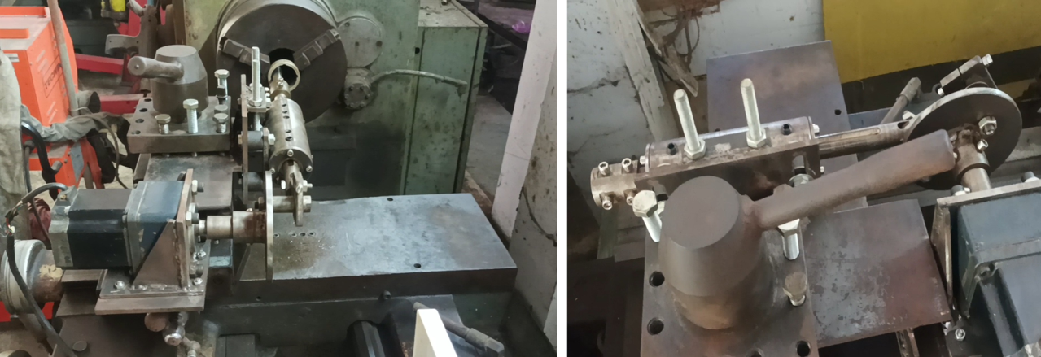
Fig. 4. Fabricated and assembled integrated slotting mechanism mounted on a conventional lathe.
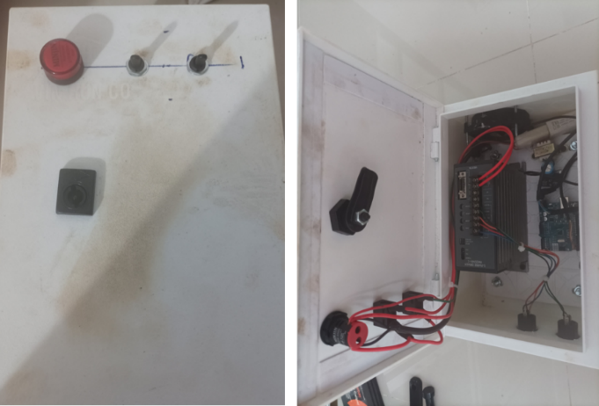
Fig. 5. Assembled electrical control cabinet for the integrated slotting mechanism
4. EXPERIMENTAL EVALUATION
The experimental design was established to evaluate the machining performance and dimensional accuracy of the integrated slotting mechanism for internal keyway machining. For aluminum specimens, the axial length of the keyway was fixed at 20 mm, and three keyway widths of 4 mm, 5 mm, and 6 mm were selected, with corresponding target depths of 1.8 mm, 2.2 mm, and 1.8 mm, respectively. For carbon steel C35 specimens, the axial keyway length was set to 40 mm, and a keyway width of 4 mm with a target depth of 1.7 mm was employed. Fig. 6 shows the internal keyway specimens machined using the integrated slotting mechanism to evaluate its machining capability. Fig. 6(a) presents the aluminum sample, while Fig. 6(b) illustrates the carbon steel C35 specimen, demonstrating the applicability of the proposed mechanism to different workpiece materials.
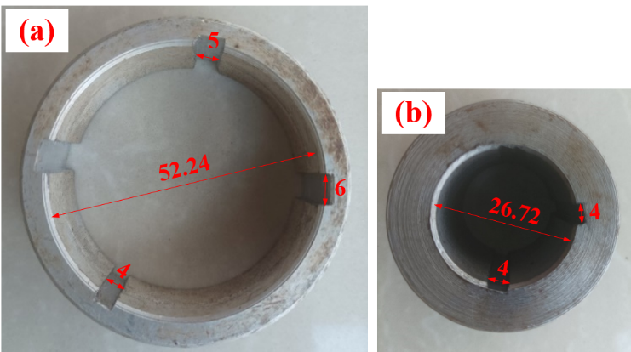
Fig. 6. Internal keyway specimens after machining using the integrated slotting mechanism: (a) Aluminum; (b) Carbon steel C35.
Figure 7 presents the experimental results of internal keyway machining using the integrated slotting mechanism for two different materials: aluminum and carbon steel C35. As shown in Fig. 7(a), the aluminum specimens exhibit very small deviations from the target keyway width and depth values, indicating stable cutting conditions and good dimensional controllability across different keyway sizes. For carbon steel C35 (Fig. 7(b)), although slightly higher cutting resistance is expected due to the material’s greater strength, the measured dimensions still show only minor deviations from the nominal values. Overall, the results demonstrate that the integrated slotting mechanism can achieve consistent and accurate internal keyway machining for both materials, confirming its reliability and applicability under varying material conditions.
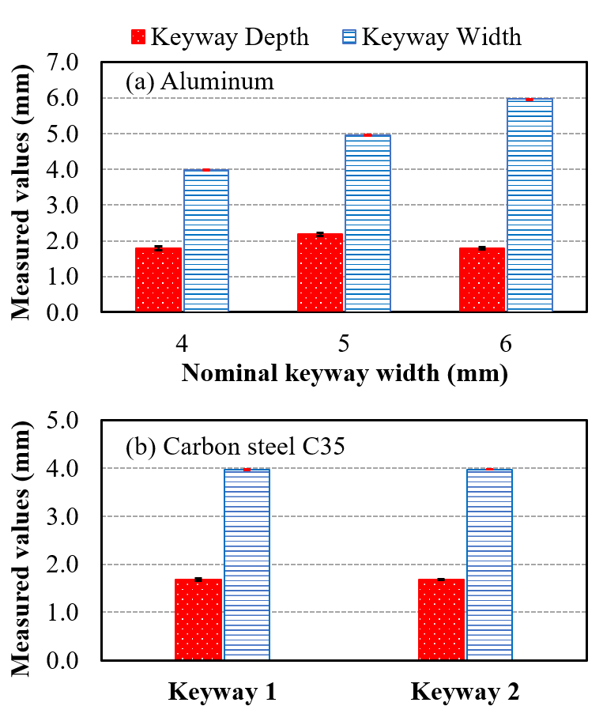
Fig. 7. Experimental results of internal keyway machining accuracy for (a) aluminum and (b) carbon steel C35
5. CONCLUSION
This study presents the successful design, fabrication, and evaluation of an integrated slotting mechanism for internal keyway machining on a conventional lathe, with the aim of enhancing the functionality of traditional machine tools widely used in small and medium-sized workshops. The proposed mechanism is compactly mounted on the lathe tool post and employs a crank–slider system to convert rotary motion into stable reciprocating motion for slotting operations.
The fabrication and assembly results confirm good structural rigidity and effective mechanical integration with the conventional lathe. Finite element stress analysis was conducted on the slotting ram shaft, identified as the primary load-bearing component. The maximum von Mises stress was found to be significantly lower than the allowable stress of the shaft material, indicating sufficient strength and stiffness to ensure stable operation and maintain machining accuracy.
Experimental results obtained from aluminum and carbon steel C35 specimens demonstrate that the integrated slotting mechanism can produce internal keyways with very small deviations from the target width and depth values. The machining performance remains consistent across different keyway dimensions and materials, although slightly larger deviations are observed for carbon steel due to higher cutting resistance. Nevertheless, all measured values fall within acceptable tolerance limits. Future research will focus on improving vibration control, optimizing cutting parameters, and extending the mechanism to accommodate harder materials and larger keyway dimensions.

ACKNOWLEDGMENT
We acknowledge the support of time and facilities from Tra Vinh University (TVU) for this study.
REFERENCES
[1] Darshan, A., Anand, C., Swanand, B. & Rohan, D., (2016). Design and Fabrication of Grinding Wheel Attachment on Lathe Machine. International Journal of Mechanical Engineering and Technology (IJMET), Volume 7, Issue 4, pp.281–288.
[2] Sachin, B., Sagar, R., Swapnil, V., & Sandeep, R. (2017). Design and Manufacturing of Lathe Tool Post Grinding Attachment. International Research Journal of Engineering and Technology (IRJET), Volume 04, Issue 03, pp. 2388 – 2390.
[3] Ying, S. S., Fu, F.T., Zhang, S. Q., & Lin, L. G. (2022). Numerical and Experimental investigations on cutting force of broaching internal spline holes. The International Journal of Advanced Manufacturing Technology, Volume 120, pp. 2803–2814.
[4] Abhishek. A., Sakhare, Amol C. K., Akshay V. J., Ashwin R. B., Ankush M. S., & Arun P. K. (2018). Design and Fabrication of Multiple Tool Attachment for Lathe Machine. International Journal for Research in Applied Science & Engineering Technology (IJRASET), Volume 6 Issue III, pp. 2425-2431.
[5] SenthilKumar, S., OmKumar, S., MohammedYazin, R., & MohanaKrishnan D. (2020). Special Attachment in Centre Lathe for Milling Operations. International Journal of Research and Analytical Reviews (IJRAR), Volume 7, Issue 2, pp. 132-143.
[6] Agash P. (2019). Design and Fabrication of Slotting Attachment in Drilling Machine. International Journal for Research in Applied Science & Engineering Technology (IJRASET), Volume 7 Issue XII, pp. 911-919.
[7] Muhammad Aziq Aznil, A., & Kamarul Adnan A. A. (2020). Design and Fabrication of Milling Vise Attachment on Lathe Machine. International Journal of Synergy in Engineering and Technology Vol.1 No.2, pp. 107-115.
[8] Shakeel A. S., Atul A. Y., & Amar S. B. (2017). Development of Internal Key Way Attachment for Lathe Machine”, International Journal of Engineering Research and Technology, Volume 10, Number 1.
[9] Indrajeet, B. S., & Amar, S. B. (2017). Design and Development of Keyway Milling Attachmentfor Lathe Machine. International Journal of Engineering Research and Technology, Volume 10, Number 1.
[10] Sivasankaran, P. (2017). Slotting/Milling Attachment to Enhance Features of Lathe. International Journal of Engineering Innovation & Research, Volume 6, Issue 4, pp. 179-184.

Ethical Approval: The authors confirm that this work is original, has not been published previously, and is not under consideration for publication elsewhere. All authors have read and approved the final manuscript and agree with its submission to International Journal of Research and Scientific Innovation (IJRSI).

Conflict of Interest: The authors declare that they have no known competing financial interests or personal relationships that could have appeared to influence the work reported in this paper.
Data Availability Statement: The data supporting this study’s findings are available from the corresponding author upon reasonable request.

