Dhruvaṁ Janma Mṛitasya Cha
Dr. Cheenepalli Ravi Shankara, Scientist-D (Retired), Central Silk Board, Ministry of Textiles, Government of India, Bangalore residing in House No. 34/11-45-A5,
Revenue Ward No. 34, New Kranti Nagar, Bommalasatram, Nandyal - 518 502
Nandyal district, Andhra Pradesh, INDIA
Mobile and Whatsapp Number: 9347531460, Email: ravishankara9@rediffmail.com
Key words: Bhavavad gita, reincarnation, soul, transmigration, rebirth, samsara, birth-death cycle.
ABSTRACT: It is attempted to explain reincarnation from the view of the Bhagavad Gita and compared the information with some of the views of modern reincarnation researchers. It is opined that studying of Bhagavad Gita by the modern reincarnation researchers may probably answer the question and mechanism of reincarnation.

Introduction: The Bhagavad Gita is one among the most important religious sacred texts of Hinduism and easily the best known. The Gita is the dialogue between the warrior-prince Arjuna and the God Krishna who served as his charioteer at the Battle of Kurukshetra fought between the Pandavas, the Kauravas and their allies. In the Bhagavadgita, Krishna teaches that one can kill only the body while the soul in it is immortal. At death, the soul is reborn in another body, or, for those who have fully grasped the true teachings, the soul achieves moksha or Nirvana i.e., freedom from the wheel of birth and death. Gita advocates that life and death are cyclic. Lord Krishna speaks about death, rather strongly and says that death in this material world is inevitable. So, we should not feel sorry for those who are dying. Everyone who is born in this world will die one day. No matter who you are you will die one day. Lord adds that both Arjuna and Krishna have had many births. While Arjun forgot them but Krishna remembers them all. Those who relinquish the body while remembering Lord Krishna at the moment of death will undoubtedly go to God’s abode. Whatever one remembers at the time of death attains that state being always absorbed in such contemplation. Further He adds, which type of death leads to liberation from Samsara or the birth death cycle or rebirth. Death may come due to senescence or aging and other causes like diseases, accidents etc. The agents of death can knock at our door at any moment and we cannot do anything. By living a pious life and eventually achieving this divine purity, individual soul eventually supersedes reincarnation altogether and gets liberated from any material body and moves entirely outside the cycle of death and rebirth to join Lord Krishna in an “imperishable place” beyond life and death. Lord emphatically states जातस्य हि ध्रुवो मृत्युर्ध्रुवं जन्म मृतस्य च (jātasya hi dhruvo mṛityur dhruvaṁ janma mṛitasya cha) in the Slokam 27 of the Chapter 2 (Saankhya Yoga) and the meaning is self explanatory.
On the other hand, Science defines life as any system capable of eating, excreting, breathing, moving, growing, reproducing, and responding to external stimuli and death as the end of life; the irreversible cessation of all biological functions that sustain a living organism. The remains of a dead organism normally begin to decompose shortly after death. Death eventually and inevitably occurs in all organisms. The difference between life and death is not as simple as it might seem, and defining these two simple terms has thwarted many excellent scientists. Our definitions of life and death have changed radically over the years, from the loss of a heartbeat to the absence of brain activity. Even now, we struggle a lot with what death is. Some organisms like Hydra and Jellyfish, (Turritopsis dohrnii), are biologically immortal, which means their mortality due to their chronological aging is decoupled from death or they remain ever young.
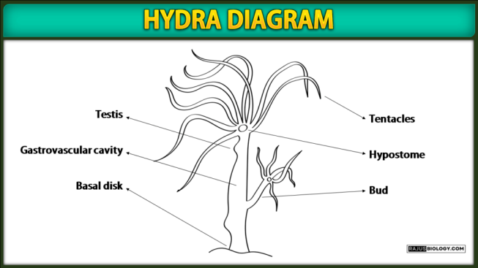 | 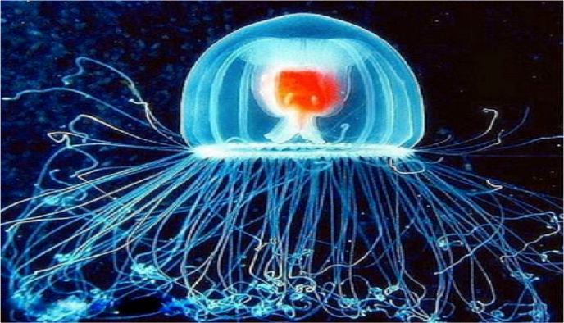
Hydra is found in the temperate and tropical regions of the world. When the animal has a part severed, it will regenerate. Biologists are especially interested in Hydra because of their regenerative ability. They do not appear to die of old age or not to age at all. | The immortal Jellyfish is found worldwide in temperate to tropic waters. It is capable of reverting completely to a sexually immature colonial stage after reaching sexual mature solitary individual.
However they can still die from means other than aging. Organisms showing only asexual reproduction like bacteria, amoeba and unicellular organisms with sexual reproduction like the algae Pandorina and Chlamydomonas are "immortal" to some extent, dying only due to external hazards, like being eaten or meeting with a fatal accident. However, in multicellular organisms with a division of labor between mortal body cells and "immortal" germ cells, death becomes an essential part of life, at least for the body cells. In the field of modern medicine, Forensic science is the application of scientific principles and methods to support legal decision-making in matters of crime and civil law. In Psychology, Thanatology deals with the scientific study of death and the losses brought about as a result of it. It investigates the bodily changes that accompany death and the postmortem period, as well as psychological and social aspects related to death. In this article, it is attempted to view the aspects of death, rebirth or reincarnation from the view of Gita and Science and compared to see whether any meaningful conclusion or correlation may be arrived about them. I humbly submit to the learned readers that it is an attempt to glorify the greatness of Bhagavad Gita scientifically. Bhagavad gita slokas from the internet version of Swamy Mukundananda. First let us list out the verses chapter-wise with their meanings.

Chapter 02: Saankhya Yoga; Verses 13, 20, 22 and 27
देहिनोऽस्मिन्यथा देहे कौमारं यौवनं जरा |
तथा देहान्तरप्राप्तिर्धीरस्तत्र न मुह्यति || 13||
"Sri Krishna said: O Arjuna, Just as boyhood, youth & old age are attributed to the soul & the embodied soul continuously passes through these cycles, similarly the embodied soul passes into another body at death. The wise man does not get deluded & bewildered with such a change."
न जायते म्रियते वा कदाचि
नायं भूत्वा भविता वा न भूय: |
अजो नित्य: शाश्वतोऽयं पुराणो
न हन्यते हन्यमाने शरीरे || 20||
"Sri Krishna said: O Arjuna, The soul is never born nor dies at any time. Soul has not come into being, does not come into being, and will not come into being. Soul is unborn, eternal, ever-existing and primeval. Soul is not slain when the body is slain."
वासांसि जीर्णानि यथा विहाय
नवानि गृह्णाति नरोऽपराणि |
तथा शरीराणि विहाय जीर्णा
न्यन्यानि संयाति नवानि देही || 22||
As a person sheds worn-out garments and wears new ones, likewise, at the time of death, the soul casts off its worn-out body and enters a new one.
नैनं छिन्दन्ति शस्त्राणि नैनं दहति पावक: |
न चैनं क्लेदयन्त्यापो न शोषयति मारुत: || 23||
Weapons cannot shred the soul, nor can fire burn it. Water cannot wet it, nor can the wind dry it.
जातस्य हि ध्रुवो मृत्युर्ध्रुवं जन्म मृतस्य च |
तस्मादपरिहार्येऽर्थे न त्वं शोचितुमर्हसि || 27||
Death is certain for one who has been born, and rebirth is inevitable for one who has died. Therefore, you should not lament over the inevitable.
Chapter 04: Jñāna Karm Sanyās Yog; Verse 5
श्रीभगवानुवाच |
बहूनि मे व्यतीतानि जन्मानि तव चार्जुन |
तान्यहं वेद सर्वाणि न त्वं वेत्थ परन्तप || 5||
The Supreme Lord said: Both you and I have had many births, O Arjun. You have forgotten them, while I remember them all, O Parantapa.

Chapter 08: Akshara parabrahma yoga; Verses 5, 6 and 23 to 26
अन्तकाले च मामेव स्मरन्मुक्त्वा कलेवरम् |
य: प्रयाति स मद्भावं याति नास्त्यत्र संशय: || 5||
Those who relinquish the body while remembering Me at the moment of death will come to Me. There is certainly no doubt about this.
यं यं वापि स्मरन्भावं त्यजत्यन्ते कलेवरम् |
तं तमेवैति कौन्तेय सदा तद्भावभावित: || 6||
Whatever one remembers upon giving up the body at the time of death, O son of Kunti, one attains that state, being always absorbed in such contemplation.
आब्रह्मभुवनाल्लोका: पुनरावर्तिनोऽर्जुन |
मामुपेत्य तु कौन्तेय पुनर्जन्म न विद्यते || 16||
In all the worlds of this material creation, up to the highest abode of Brahma, you will be subject to rebirth, O Arjun. But on attaining My Abode, O son of Kunti, there is no further rebirth.
यत्र काले त्वनावृत्तिमावृत्तिं चैव योगिन: |
प्रयाता यान्ति तं कालं वक्ष्यामि भरतर्षभ || 23||
अग्निर्ज्योतिरह: शुक्ल: षण्मासा उत्तरायणम् |
तत्र प्रयाता गच्छन्ति ब्रह्म ब्रह्मविदो जना: || 24||
धूमो रात्रिस्तथा कृष्ण: षण्मासा दक्षिणायनम् |
तत्र चान्द्रमसं ज्योतिर्योगी प्राप्य निवर्तते || 25||
शुक्लकृष्णे गती ह्येते जगत: शाश्वते मते |
एकया यात्यनावृत्तिमन्ययावर्तते पुन: || 26||
I shall now describe to you the different paths of passing away from this world, O best of the Bharatas, one of which leads to liberation and the other leads to rebirth. Those who know the Supreme Brahman and who depart from this world, during the six months of the sun’s northern course, the bright fortnight of the moon, and the bright part of the day, attain the supreme destination. The practitioners of Vedic rituals, who pass away during the six months of the sun’s southern course, the dark fortnight of the moon, the time of smoke, the night, attain the celestial abodes. After enjoying celestial pleasures, they again return to the earth. These two, bright and dark paths, always exist in this world. The way of light leads to liberation and the way of darkness leads to rebirth.
Comment:- Cambridge dictionary defines reincarnation as the belief of some people that the spirit of a dead person returns to life in another body or form, or a person or thing believed to have returned or been brought back in this way The word reincarnation is derived from a Latin term that literally means 'entering the flesh again'. In reincarnation, the soul upon death of the individual transmigrates into a newborn baby or an animal to continue its immortality (Gita 2:20). Available evidence suggests that reincarnation might be real while it can’t be quantified by the scientific method. By the early 20th century, interest in reincarnation had been introduced into Psychology, by William James, who raised aspects of the Philosophy of mind, comparative religion, the Psychology of religious experience and the empiricism (the theory which states that all knowledge is based on experience derived from the senses). In 1885, James founded the American Society for Psychical Research (ASPR) in New York City leading to systematic, critical investigation of paranormal phenomena.
Belief in reincarnation in some form of life after death is widespread throughout history in different cultures, and it has become central component in many religious systems. Public opinion polls have found the belief in reincarnation to have increased both in Europe and America in recent decades. Demographic survey data from 1999 to 2002 shows that 22% Europeans and 20% Americans believe in the existence of life before birth and after death. Belief in reincarnation is particularly high in Lithuania (44% of Europe), while the lowest figure is in East Germany (12%). A quarter of U.S. Christians, embrace the idea. Worldwide surveys done during 1999 showed that most of world`s population believe in afterlife For example, Mexicans (76%), South Africans (73%), Canadians (72%), Indians (65%), Iranians (98%), Japanese (51%), and 46% to 60% population with no religious affiliation also.
Origin of belief in Reincarnation:- Death in worldly parlance is merely the soul discarding its old dysfunctional body, and birth is the soul taking on a new body elsewhere (Gita 2:22). Most Oriental philosophies accept this concept of reincarnation. The most common view among scholars is that it was first conceived in India. Some ancient human civilization people thought it entered Greece from Egypt, and from Egypt travelled to India. Some others have proposed that it originated with the common ancestors of the Greeks, Indians, Celts (group of peoples inhabiting much of Europe and Asia Minor in pre-Roman times), and Germans. Another suggestion is that the belief arose in Tibet and Mongolia, from where it found its way independently to Greece, India, and North America.
Reported cases of reincarnation:-
The Return of Rawat Sukharam (Early 1700s):- At the end of the seventeenth century, the Mughal Emperor Aurangzeb (1618-1707), then ruling India, heard about a child with past-life memories. Aurangzeb summoned the child to his court and personally interviewed him, making this the first known case to be investigated by outside parties. The story was told in the Persian chronicle, Khulusat-ut-Tawarikh, composed during Aurangzeb’s reign. It was translated for Stevenson in 2001 from an eighteenth century book written in Urdu. The story goes like this. In 1699, there was a village headman named Rawat Sukharam in Bhakar village. He had an old enmity with another person, who after overpowering wounded him in the back and in the root of his ear and Rawat Sukharam died due to those injuries. A few months later a son was born to Rawat Sukharam’s son-in-law named Ramdas. This boy had a mark at the back as well as the root of his ear. News spread that Rawat Sukharam had reincarnated and was born again (Gita 8:6). This boy said that he was Rawat Sukharam, when he was able to communicate. He gave the correct address and other information which were verified and found correct. When the emperor heard about this strange incident, he called the child to his court and personally satisfied himself about these facts.

Helene Smith, Switzerland:- Théodore Flournoy, Swiss professor of Psychology at the University of Geneva was among the first to study a claim of past-life recall. Flournoy’s study was based on research he conducted on a 30-year-old woman whom he called Helene Smith. Smith was a woman with a regular job and had sound health and mind. She was well known in the community for her spiritual practices. She had practiced her abilities for three years before Flournoy began his research on her. All who knew her would say that she was an honest woman. This is important to know because of the nature of her claims. She was a medium who relayed supernatural information through a trance. Once Flournoy got into contact with her, he copied down everything the woman said while in a trance for the next five years. From what he observed came his most popular book, From India to Planet Mars published in 1900. In the course of his investigation he defined the possibility of Cryptomnesia [Forgotten memory returns] (Gita 8:6) in such accounts. Carl Gustav Jung, Swiss psychiatrist, emulated Flournoy in his thesis based on a study of Cryptomnesia in psychism. Later Jung emphasized the importance of the persistence of memory and ego in psychological study of reincarnation (Gita 8:6). This concept of rebirth necessarily implies the continuity of personality to remember that one has lived through previous existences.
Reincarnation case of Shanti Devi, India:- Rebirth and reincarnation didn’t have any base until the most famous case of Shanti Devi (11 December 1926 – 27 December 1987) in India in 1926. Shanti Devi claimed herself to be Lugdhi Devi, (18 January 1902 – 4 October 1925) the dead first wife of affluent businessman in Mathura and who died after giving birth to her son. Later from the statements of Shanti Devi, Lugdhi’s family was identified. Subsequently Shanti Devi was able to lead the way to Lugdhi’s house, where she recognized Lugdhi’s relations and displayed accurate knowledge about intimate facts relating to Lugdhi’s life. The case drew the attention of Mahatma Ghandi and was extensively investigated. A commission set up by Mahatma Gandhi supported her claim, while another report by researcher Bal Chand Nahata disputed it. Further, several other researchers interviewed Shanti Devi and published articles and books about her.
 | 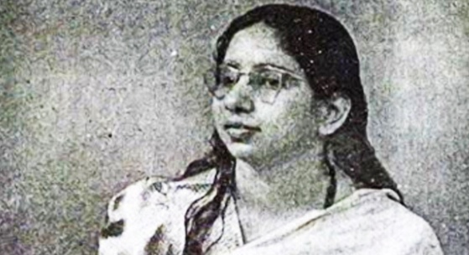
 | Shanti Devi adult

Reincarnation case of Sumitra Singh, India:- Sumitra Singh of Etawah District, UP in India appeared to die and then revived, having apparently lost all awareness of her former personality but rather showing the knowledge, behaviour and personality traits of a quite different woman, Shiva Tripathi, who had lived in the same district but had died suddenly by being crushed by a railway train two months earlier (Gita 2:22). On visiting Shiva’s family, Sumitra made accurate recognitions of family members, relating to each person in the appropriate customary manner. Conversely, Sumitra was no longer able to recognize people in her own family: her husband, her nine-month-old son, her in-laws, her father when he visited, the cousin she had lived with for eight years, and the cousin’s husband. Sumitra’s family members in Sharifpur all reported that Sumitra remained ‘Shiva’ to the end of her life that is for a period of thirteen years. The Tripathi family accepted Sumitra as Shiva in a different body, and she retained the new identity for the rest of her life. This highly unusual case was investigated by multiple researchers and has been interpreted variously as one of reincarnation, possession, or both. Reincarnation researcher James Matlock coined the term ‘Replacement Reincarnation’ for cases in which one spirit replaces another permanently without the body dying, such as Sumitra’s. Matlock notes that the replacement usually happens often after severe illness. Only two age ranges up to age three (most common) and rarely in the teen years have been observed in reincarnation cases.
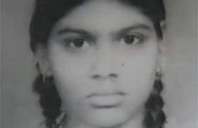  Sumitra Singh born in 1968 | 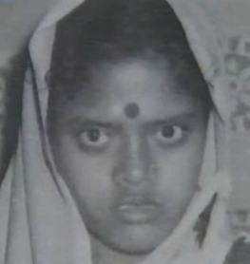  Shiva Tripathi born in 1962
James Leininger, America:- James Leininger is the subject of a well-known American child reincarnation case. In early childhood, James had frequent nightmares of being trapped in a burning plane that was crashing. In further statements to his parents he said he had been shot down in a plane near Iwo Jima, from a ship named Natoma and had a friend named Jack Larsen. These and other details were found to match closely with the life of James Huston Junior, an American pilot killed in action in March 1945. James’s parents wrote a best-selling book about their investigation, and the case received widespread media attention (Gita 8:6).
-   - James Leininger, the child | - 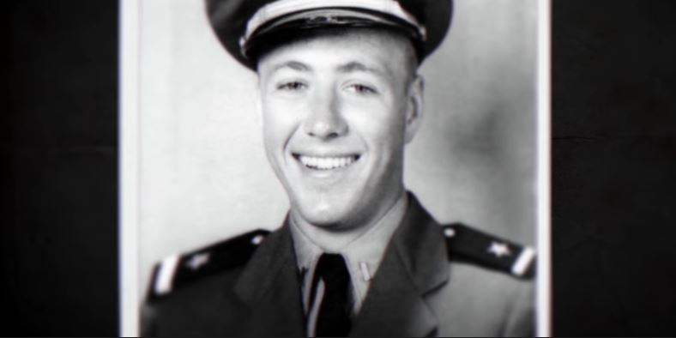  - James Huston Junior, American pilot

Pollock twins, England:- The extraordinary case of the Pollock twins reincarnation mystery intrigued England for over six decades. On May 5th, 1957, two sisters, the Pollock twins, and a friend were tragically killed in a car accident. Just one year later, twin girls were born with an eerie resemblance and strange familiarity to the deceased sisters' lives. Florence, their mother gave birth to identical twin girls on October 4th, 1958, named Gillian and Jennifer. From their birth, their parents John and Florence, noticed a resemblance between their new daughters and their deceased ones. The first thing they noticed was a birthmark on Jennifer's left hip. Jacqueline had the same birthmark. Moreover, a birthmark on Jennifer's forehead matched a scar Jacqueline had gotten from falling off a bucket. As the twins got older, the similarities only became more undeniable. John Pollock, their father a firm believer of reincarnation, was stunned by Jennifer’s birthmarks thinking that his prayers had been answered. Florence remained skeptical, but she noticed that Jennifer had a second birthmark on her waist that was eerily like one Jacqueline had in the same location. The Pollock twins seemed oddly familiar with a place they had never known. The twins were also able to identify their late sisters' toys by name. Jennifer and Gillian were incredibly frightened by cars (Gita 8:6). They pointed out locations that had been of interest to their sisters in their previous birth and identified the school they attended and the playground where they played in their previous birth correctly. Decades after the birth of Gillian and Jennifer Pollock, parents cling to the hope that scientific advances may someday solve the mystery of their daughters’ inexplicable connection to their late sisters. Their story is a poignant testament to the enduring quest for understanding in the face of the unexplained. Dr. Tucker, the thoughtful researcher, pondered over these implications further, saying, “The Pollock Twins’ case compels us to reevaluate conventional wisdom and delve deeper into the mysteries of human consciousness (Gita 2:20). It serves as a tantalizing glimpse into the unknown, beckoning us to explore its depths.”
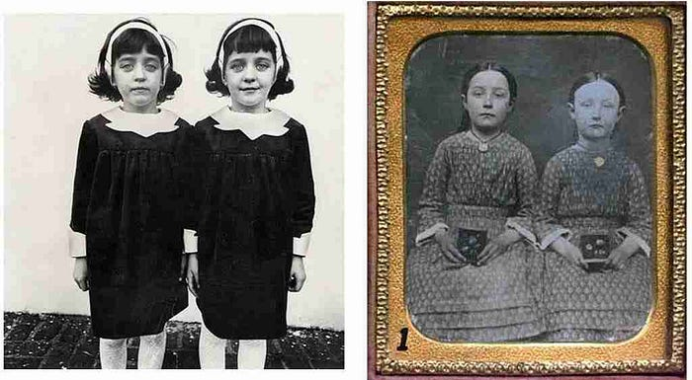

Most of the reincarnation cases have been recorded to be with people of young age, who died a violent death or died early. Kids all around the world recalled such memories of the same gender and most of them were males. The thing that makes Shanti Devi and James Leininger’s case different is that, Shanti Devi recalled absolutely everything and remembered it till her death. However, Leininger’s memories were fleeting and were gone till he reached adulthood. Thirty-six cases of rebirth in India whose subjects were born before 1936 were compared with fifty-six cases whose subjects were born in 1965 or later. Fifty-four data features or parameters of the cases were analyzed. The only scientific explanations to these happenings were rebirth and these cases still seem to be recorded till today, even in India.

Researchers in Reincarnation:-
Ian Stevenson, Psychiatrist,:- Ian Stevenson, Psychiatrist, University of Virginia School of Medicine is an authority in the scientific research on reincarnation and produced many reports of young children who claimed to remember a past life. He conducted more than 2,500 case studies over a period of 40 years and published 12 books, including Twenty Cases Suggestive of Reincarnation and “Where Reincarnation and Biology Intersect? In Reincarnation and Biology book, Stevenson methodically documented statements, identified the deceased person the child identified with, and verified the facts of the deceased person's life that matched the child's memory. He also matched birthmarks, birth defects, wounds, scars etc., on the deceased and verified with medical records like autopsy photographs of the deceased persons. Stevenson searched for alternative explanations for the reports, and believed that his strict methods ruled out all possible “normal” explanations for the child's memories except reincarnation and published a book European Cases of the Reincarnation Type. Stevenson performed an analysis of 42 pairs of twins, of which he and his colleagues investigated forty. The majority were from Burma and the others from India, Sri Lanka, Nigeria, Lebanon, Italy and England. Of the 42 pairs in Stevenson’s study, the previous persons of both twins had been identified in 31 cases, based on statements made by one or both twins in early childhood. Of every one of these 31 pairs, the previous persons had known each other in some way. Five pairs had been married to each other, eleven had been siblings – two of them twins – six had been relatives of other kinds and nine had been friends, acquaintances or business associates. Such cases hold implications for understanding the factors involved in personality development and behaviour, suggesting that REINCARNATION plays a role in addition to heredity and environment.

Jim B. Tucker:- Jim B. Tucker is a child psychiatrist and Bonner-Lowry Professor of Psychiatry and Neurobehavioral Sciences at the University Of Virginia School Of Medicine. His main research interests are documenting stories of children who he claims remember previous lives, and natal and prenatal memories. He is the author of the popular reincarnation book “Life Before Life: A Scientific Investigation of Children’s Memories of Previous Lives”, which presents an overview of over four decades of reincarnation research at the Division of Perceptual Studies. Tucker worked for several years on this issue with Ian Stevenson before taking over upon Stevenson's retirement in 2002. Tucker reports that in about 70% of the cases of children claiming to remember past lives, the deceased died from an unnatural cause, suggesting that traumatic death may be linked to the hypothesized survival of self (Gita 2:23; 8:6). He further indicates that the time between death and apparent rebirth is, on average, sixteen months, and that unusual birth-marks might match fatal wounds suffered by the deceased. Tucker has developed and evaluated cases of reincarnation based on four aspects. They are:
- Whether reincarnation involves birthmarks/defects that correspond to the supposed previous life?
- The strength of the statements made about the previous life.
- The relevant behaviors of persons as they relate to the previous life and
- Evaluation of the possibility of a connection between the child reporting a previous life and the supposed previous life.
Tucker investigated claims made by children for nearly 15 years who say they’ve had past lives. Usually the ages of those children are between 2 and 6 years. The children are sometimes able to provide enough details about those lives that their stories can be traced back to actual persons rarely famous and often entirely unknown to the family, who died years before. Tucker’s observations are:
- Roughly 70 percent of the children say they died violent or unexpected deaths in their previous life (Gita 2:23; 8:6). Males account for close to 75% of those deaths, which is almost precisely the same ratio of males who die of unnatural causes in the general population.
- More cases are reported in countries where reincarnation is part of the religious culture. But there is no correlation between how strong a case is deemed and that of family’s religious beliefs in reincarnation.
- In cases where a child’s story has been traced to another individual, the time between the death of that person and the child’s birth or reincarnation is about 16 months.
- Nearly 20 percent of the children studied have scar like birthmarks or even unusual deformities that closely match marks or injuries the person whose life the child recalls received at or near his or her death (Gita 2:23; 8:6).
- Most children’s claims generally subside around age of six, which roughly coincides with the time children’s brains get ready themselves for a new stage of development.
- Despite the otherworldly nature of their reincarnation stories, almost none of the children exhibited signs of being particularly enlightened. Children are just like typical kids except that a few make philosophical statements about life.
However, his critics have argued there is no material explanation for the survival of self, but Tucker suggests that quantum mechanics may offer a mechanism by which memories and emotions could be carried over from one life to another (Gita 2:20). Tucker thinks that the physical universe at quantum mechanics level is different from what it seems to be because the quantum world depends on the observer rather than the event itself. So the message is that consciousness is not just a by-product of a physical brain but is actually a separate entity in the universe that has a big impact on things in the universe. Consciousness is going to continue after the brain dies (Gita 2: 13 & 20).

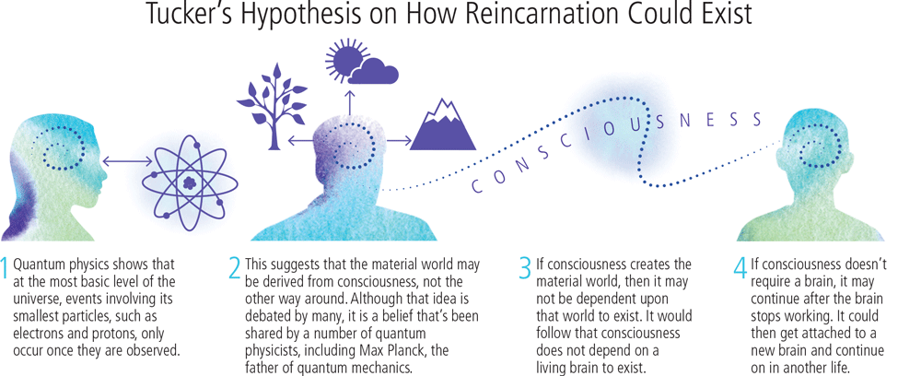
Tucker's Hypothesis on How Reincarnation Could Exist?
- Quantum physics shows that at the most basic level of the universe, events involving its smallest particles, such as electrons and protons, only occur once they are observed. | - This suggests that the material world may be derived from consciousness, not the other way around. Although that idea is debated by many, it is a belief that's been shared by a number of quantum physicists, including Max Planck, the father of quantum mechanics. | - If consciousness creates the material world, then it may not be dependent upon that world to exist. It would follow that consciousness does not depend on a living brain to exist. | - If consciousness doesn't require a brain, it may continue after the brain stops working. It could then get attached to a new brain and continue on in another life.
3. Hypnotic regression studies of Michael Newton:- Michael Newton, an American psychotherapist used hypnotic regression in his reincarnation works. Regression hypnosis is the process by which the hypnotist guides client back through time to particular events that need to be examined. It is relatively simple; you are suggested to travel back through the years to recall specific memories. Michael Newton uses hypnotherapy to help his clients to remember their lives as immortal souls in the spirit world (Gita 2:23). Thus he maps out the soul’s journey from the moment of death until rebirth. He begins by taking subjects to through the death scene of their most recent past life. Under hypnosis, clients remember their past lives and are able to recognize the important souls who agree to incarnate together lifetime after lifetime. He wrote a book “Journey of Souls” after hearing to tales of thousands of patients who recalled life between lives and described the common elements told by his patients. All patients told that our actual home is the spirit world and that we are here on the earth to learn (Gita 2:27). Using meticulous research methods, Michael explored the afterlife through the eyes of his clients. Michael Newton first shared his work with the world, having researched and assembled a model of the spiritual realm 7000 clients, spanning over 35 years. His journey towards these discoveries is further outlined in his best-selling books Journey of Souls and Destiny of Souls.
- Alexander Moreira-Almeida, Marianna de Abreu Costa & Humberto Schubert Coelho, Brazil:- Alexander Moreira-Almeida, Marianna de Abreu Costa & Humberto Schubert Coelho (2022) from Brazil in their book Science of Life After Death reported thousands of cases of very young children spontaneously making accurate statements about alleged previous lives, exhibiting behavior, emotional reactions, skills, and birth defects in accordance with the alleged personality (often unknown to them) strengthen the hypothesis of survival of consciousness after death (Gita 2:13 & 20).
- Satwant Pasricha, India:- In India Satwant Pasricha is the head of Department of Clinical Psychology at NIMHANS, National Institute of Mental Health and Neurosciences at Bangalore. She also worked for some time at the University Of Virginia School Of Medicine in the USA. Pasricha investigates reincarnation and near-death experiences. Pasricha co-authored the 2011 book “Making sense of near-death experiences”, which was Highly Commended in the Psychiatry category at the 2012 British Medical Association Book Awards. She worked as an assistant to Ian Stevenson and documented the child's statements, identified the deceased person the child remembers being, and verified the facts of the deceased person's life that match the child's memory. She has even correlated the birthmarks of the child with the physical trauma or deformity present in the deceased person of the past life the child has remembered, by verifying his medical records (Gita 8:6). She presented cases of “Xenoglossy” (Ancient Greek xenos means foreigner and glōssa means "tongue" or language) or the ability to speak a different language without having learned it normally and “Spirit Possession” (In which case the spirit possessed actually existed but in a different location wherein both the families never knew each other). Following her retirement from from NIMHANS, Bangalore in 2010, she worked at the Himalayan Institute of Medical Sciences in Dehradun, Uttarakhand, India. Currently she is a senior honorary Clinical Psychology consultant at the Psychological and Counseling Services Clinic in Dehradun.
Mind-Blowing Facts reported by Reincarnation Scientists:- Reputable medical, academic professionals and researchers from the University Of Virginia School Of Medicine have investigated thousands of stories of people about reincarnation for over 50 years since 1967 and reported the following 12 staggering facts.
- 33% of Americans believe in reincarnation and women were 1.4 times more likely to hold this belief than men.
- 65% more people believe in reincarnation now compared to 20 years ago.
- 36% of Catholics believe in reincarnation.
- 70% of people, who remember a past life, remember dying a violent or unnatural death (Gita 8:6).
- 9% of people who remember a past life exhibit an unusual skill related to that former life (Gita 8:6).
- 35% of people, who remember dying accidentally in a past life, have an extreme fear of dying the same way again (Gita 8:6).
- 26% of people who remember a past life demonstrate some other form of Extra Sensory Perception [ESP] (Gita 8:6).
- 20% of people who remember a past life believe they lived as a deceased family member. Psychologists documented many instances of supposed reincarnation within the same family. Dr. Brian Weiss, American Psychiatrist hypothesized that we may have a soul family OR a cluster of spirits that we are drawn to, life after life.
- 58% of people who remember drowning in a past life have an extreme fear of water (Gita 8:6).
- 23% of people who remember a past life believe they once lived as a different gender.
- 20% of people who remember a past life also remember something from the time between death and rebirth (Gita 8:6).
- 2% of people who remember a past life can accurately describe their previous funeral (Gita 8:6).

Hypotheses of reincarnation:-
Currently, neither there is strong objective evidence nor specific research method that can discover the actual process or mechanism of reincarnation scientifically. Again, if reincarnation is to be examined from scientific point of view, it is necessary to find a way of bypassing the religion factor because each religion and each spiritual teacher differs in their view of mechanism of rebirths. It appears that the “Truth” is beyond the reach of our mind. In general, human mind's weakness is to make concepts that fit into its belief and such beliefs led to the origin of religions. Reincarnation is a key belief within many religions, more specifically in Hinduism. According to Hinduism, all life goes through birth, life, death and rebirth called the cycle of samsara. Reincarnation theory was presented first in Bhagvad Gita 5,000 years ago. Accordingly, one can kill the material body only but not the soul carrying it. Soul drifts in the universe, and reincarnated in another body just like we change our old clothes with new ones. Lord emphasizes जातस्य हि ध्रुवो मृत्युर्ध्रुवं जन्म मृतस्य च (jātasya hi dhruvo mṛityur dhruvaṁ janma mṛitasya cha) [2:27] is the straight forward statement which has become very popular in Hinduism. This means that death is certain for one who has been born, and rebirth is inevitable for one who has died. When the soul is relieved from the cycle or birth and death, it attains moksha or nirvana. Lord Krishna mentions that, after letting go of regrets, pain, love, happiness, grief, anger, and by devoting the self to God one can one attain immortality and fuse with the the God. Thus Soul returns to God’s abode and stays there forever. To my knowledge there is no known scientific explanation behind this seemingly very simple and lucid theory and there is every need for the reincarnation researchers to focus on this hypothesis which may help in solving the riddle of reincarnation forever.
NASA DNA SAC HYPOTHESIS:- Scientists working at NASA (National Aeronautics and Space Administration) have proposed a hypothesis for rebirth or reincarnation. According per their opinion, DNA, the genetic material gets covered in a sac like structure after cremation or inhumation, funeral, burial etc. In case, the sac with DNA enters another embryo, it will show its effect and produces the characters in the organisms which the foreign DNA is possessing. This process of entering of DNA sac into the embryo is similar to the process of bacterium getting infected by a virus called Bacteriophage. In this process, phage virus (having foreign DNA) attaches itself to the bacterium (having local DNA), injects its DNA into it, and orders the bacterial DNA to produce viruses in the next generation. In a similar fashion, when encapsulated DNA or atma (?) enters from a Hindu person to Muslim or Christian, the boy or girl may sing Gita rather than Koran or Bible. This reminds me about the term Xenoglossy ie., speaking different language after reincarnation as proposed by Satwant Pasricha, India, India. Hindu religion advocates that Jeevaatma leaves the body after death and enters another body just as we change our clothes. But for scientists, the path is very long and tedious. Will a. Day come, when it will be `proved similar scientifically also.
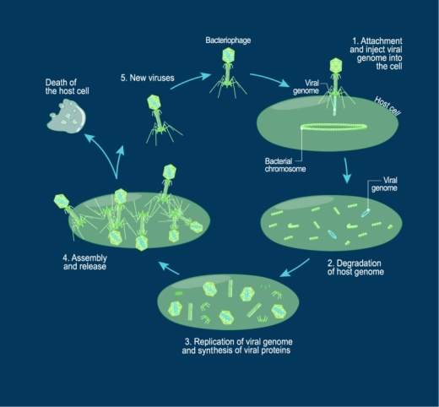

Quantum theory of consciousness of Max Planck:- Max Planck (1858-1947) Nobel Prize-winning German physicist and is the father of quantum theory. His work in the field of theoretical physics led the way to many advances throughout the 20th century. He viewed consciousness as fundamental and that matter was derived from it. We cannot get behind consciousness. Everything that we talk about, everything that we regard as existing, postulates consciousness.” It means that consciousness would not necessarily be dependent on a physical brain in order to survive, and could continue after the physical brain and the body dies. Here, it seems that after death, consciousness gets attached to a new brain, and exhibits past life memories (Gita 8:6). The human body has consciousness, because the soul resides within it, but when the soul leaves, the consciousness leave with it.
Life after Death – Micro-Genomic Particle Hypothesis:- Senarath Dayathilake of Sri Lanka hypothesized in 2017 that human consciousness may survive as micro-genomic particles when brain death occurs which lives again in a new brain (Gita 8:6). Micro-genomic particles will be transferred to a vacant zygote or early embryo in any universe(s) through some unknown natural phenomena. The micro-genomic particle might be near zero mass and can travel at infinite velocity to find a suitable vacant zygote or embryo to reincarnate. But further details on this issue are unclear due to unresolved problems in Physics, Psychology, Philosophy, and Neuroscience. He added that insights into the Buddhist Psychology and related empirical research findings might be helpful to get better insight or, at least, for a hypothesis on this matter.
Survival of consciousness after death through individual character and memory:- Alexander Moreira-Almeida, Marianna de Abreu Costa & Humberto Schubert Coelho from Brazil in their book Science of Life After Death (2022) viewed the continuity of individual character and memory in a new body in the case of reincarnation as the evidence for the survival of consciousness after death of a given person (Gita 8;6). Examples for memory are remembering facts, identifying people the claimed personality was acquainted with when alive. Examples for skills of the alleged personality are speaking or writing in a foreign language, handwriting, and artistic such as poetry, prose, and painting styles and personality traits are temperament, character, personal style etc. If this sort of evidence is consistently found by different investigators using different methods and investigating different phenomena, they would support survival of mind after bodily death (Gita 8:6). This conclusion is reached by the most qualified scientific and philosophical minds from diverse intellectual and geographical backgrounds that performed comprehensive analyses of the survival of the consciousness evidence.
Theory of Life and Afterlife as Shared Dreams, Jim B. Tucker:-, Reincarnation or rebirth is not just a concept. It could just as well be a truth but there’s no solid proof to prove it to be true. However, that doesn’t mean that they are completely wrong because they can’t be denied either. This coincides with the popular statement in Criminology “Absence of evidence is not the evidence for absence of the incident.” According to Tucker, mainstream science dismisses reincarnation as it does not fit in with a materialist view of the universe. But he hopes proof of reincarnation lies in quantum physics. He viewed the cases presented are not proofs but evidences of the possibility of reincarnation. We think of our minds existing in this world, but it’s actually the world that exists in our minds. We do not go to another place when we die. Instead, we will get into another dream. Quantam particles (electrons, protons, neutrons etc.,) are probably responsible for kids to recall such memories of the previous births because, quantam particles when attach themselves to a mind and body create such phenomenon (Gita 8:6). Quantum mechanics may one day prove that consciousness is a different entity separate from the functioning brain and from there; the possibility of consciousness transfer from one body to another becomes more feasible.
Hypothesis of Bhagavadgita about reincarnation:- Soul or Atma has no birth and death. Death is certain for one who has been born, and rebirth is inevitable for one who has died. Therefore, you should not lament over the inevitable. As a person sheds worn-out garments and wears new ones, likewise, at the time of death, the soul casts off its worn-out body and enters a new one.
How is reincarnation happening? Or what is the mechanism of reincarnation or rebirth?
No one has ever come close to suggesting a physical mechanism that would explain reincarnation. Reincarnation reiterates that soul or self is not bound by the physical brain and the reality is beyond our four-dimensional space-time world that we see and touch. The following are some of the hypothetical mechanisms proposed by modern scientists working in the field of Reincarnation research. Ted Christopher, USA (2023) attested Reincarnation researchers’ view that there is some kind of non-material continuity happening between sequential lives. Understanding those pre-modern beliefs in reincarnation could offer a number of specific explanations. So, serious consideration of the reincarnation from this perspective appears to be overdue. Perhaps the results of those simple observations can provide some helpful insights into life and its challenges.

Reincarnation is a fact of nature, Robert F. Almeder:- Samsara refers to the continuous cycle of birth, death, and rebirth. According to Hindu belief, all living beings go through this cycle until they achieve the so called Moksha (liberation). The soul undergoes through various physical forms and experiences as it moves through the cycle of birth, death, and rebirth (Samsara). Each life form is a temporary vessel, a form that the soul inhabits as it progresses towards eventual liberation (Moksha). The mechanics of reincarnation are complex. All the traditions seem to agree that actions (karma) from the past determine one’s present and future states. Since the influential research of Ian Stevenson, however, the evidential approach to the idea of reincarnation has prevailed, to the point that some philosophers like Robert F. Almeder, Emeritus Professor of Philosophy, Georgia State University to claim that it would be irrational to deny that the evidence leads to the conclusion that reincarnation is a fact of nature (Gita 2:27).
Reincarnation via a Subtle Body, the Psychophore:- Stevenson after studying nearly 2,500 cases of former-life remembrance in children, from all over the world from different cultures, concluded that something very unusual is going on in reincarnation, wherein some kind of non-physical mechanism operates that connects these children to their previous lives they describe so precisely and accurately. Stevenson (1997) proposed that memories, behaviors and form were conveyed from one life to another via a sort of subtle or astral body he called ‘Psychophore’, a term which means ‘soul-bearing’. Physical impressions carried on the Psychophore would help shape an embryo or fetus through a field effect when the Psychophore moved into ‘topical alignment’ with it, he thought. Memories, behaviors, and physical impressions were reduced in the Psychophore and passed on to the new body in a shrunken way, so that memories became fragmentary, skills became aptitudes, wounds no longer bled but might be replaced by birthmarks or other congenital abnormalities (Gita 8:6).
Replacement reincarnation of James Matlock:- James Matlock (2019), American anthropologist and leading reincarnation researcher has suggested an alternative hypothesis for reincarnation called replacement reincarnation. In replacement reincarnation, the incoming soul or spirit does displace reincarnating soul and remains in control of the body thereafter. Matlock calls this hypothetical process as replacement reincarnation. Replacement reincarnation may occur either before or after birth. If the possession is temporary, Matlock called it possession rather than replacement. The difference between whether a given case is one of possession or reincarnation is a matter of whether the possession is temporary or long-term.

Why is reincarnation reported only in some children? Why not everyone? Will Franks of France (2022) viewed that the vast majority of people undergo a sort of a partial or total loss of memory or “amnesia” before birth, where we forget our previous lives perhaps in order to focus all our energies on this current life (Gita 4:5). Or is it that knowingly or unknowingly, vast majority of population remembers or recalls God and His activities at the time of death and attained the so called Moaksha or Nirvana!? Interestingly, a high percentage of children who remembered their former life, remembered one in which the means of dying was either violent or sudden (Gita 8:6). The trauma left a deep imprint on their psyche that survived even through their next birth, allowing these children to access former-life memories. Nature may have found reincarnation as a way of preserving and carrying forward the life experience of the individual. Our individuality has emerged out of an ocean of time and it can continue to develop for as long again. Death is but a pause that punctuates the seasons of our life, nothing more.
Currently, there are few research groups currently investigating such reincarnation cases around the world, with the exceptions of the Division of Perceptual Studies at the University of Virginia (USA), Erlendur Haraldsson at the Psychology Department in the University of Iceland, Ohkado Masayuki at the Chubu University in Japan, and the Research Center in Spirituality and Health at the Federal University of Juiz de Fora - UFJF (Brazil). The International Centre for Reincarnation Research (ICRR), Ontario, Canada was founded in 2021 and incorporated in 2022 to provide increased funding for reincarnation research and unite researchers to create a coordinated program of systematic study.

Some objections for reincarnation from modern science are that
  - Evolution teaches that there was a time when humans did not yet exist. So reincarnation is inconsistent with modern science.
  - If there is reincarnation, then what is happening when the population increases?
  - If there is reincarnation, then why do so few, if any people, remember past lives?

While scientists cannot say with 100% certainty what happens after we die, by now, there is a significant body of evidence that suggests that reincarnation and rebirth are real phenomena. And, as with any scientific theory, the more evidence that supports it, the more probable it becomes. Thus the better conclusion that can be drawn from the article is that what was told in Bhagavadgita 5,000 years in a handful of slokas is indicated in the works of modern reincarnation researchers around the world. Terry Christopher Olesen, Reincarnation Researcher, Australian Institute of Parapsychological Research, Australia pointed in 2021 that at present only a handful of investigators in the world do reincarnation research. Despite this limitation, the field will advance more quickly and definitively as upcoming disparate groups start to set aside their prejudices and collaborate. Ian Stevenson viewed that currently reincarnation is not a substitute for present or future knowledge of genetics and environmental influences for hereditary characters. But it may emerge as a third factor contributing to the formation of human personality, some physical features and bodily abnormalities. However, reincarnation may serve as another useful tool for reincarnation investigating scientists to solve unsolved problems in Psychology and Medicine. Gita chapter 8, slokas 23-26 mentions that those who know the Supreme Brahman (Parabrahmam) and who depart from this world, during the six months of the sun’s northern course (Uttarayana - approximately 20 December - 20 June), the bright fortnight of the moon (Sukla Paksha), and the bright part of the day, attain the supreme destination. The practitioners of Vedic rituals, who pass away during the six months of the sun’s southern course (Dakshinayana - approximately 21 December- June 21), the dark fortnight of the moon (Krishna Paksha), the time of smoke, the night, attain the celestial abodes. After enjoying celestial pleasures, they again return to the earth. These two, bright and dark paths, always exist in this world. The way of light leads to liberation and the way of darkness leads to rebirth. These points may be verified by scientifically computing the reincarnation reports according to these Gita slokas. So there is every possibility that researching reincarnation by the modern reincarnation researchers on the lines indicated in Bhagavad gita may one day provide lucid, meaningful, scientific mechanism for reincarnation.
Date: 10-03-2025
(Dr. Cheenepalli Ravi Shankara)
Bank details: Bank: SBI; Branch: Nunepalli; S/B A/C No. 62004483152; IFSC Code: SBIN0003731

