On-Chip AI-Enhanced Brainwave Synthesizer for Biomedical ASIC Verification

Author 1 Author 2

Siraj Ahmed Dr. Shashank Dewadi
Ph.D Scholar in School of EC Prof School of EC Reva University Reva University
Bangalore Bangalore
Abstract:-This paper presents an AI-enhanced on-chip brainwave synthesizer architecture for biomedical ASIC verification and validation. The proposed system generates realistic electroencephalography (EEG) patterns using a lightweight neural generative engine integrated within a mixed-signal ASIC verification framework. Unlike conventional replay-based verification methods, the proposed architecture synthesizes adaptive neural waveforms including alpha, beta, theta, gamma, and pathological EEG conditions in real time.The synthesizer employs machine learning-assisted waveform modeling to emulate nonlinear neural dynamics while minimizing memory requirements and improving verification coverage. The architecture supports configurable amplitude, frequency, noise injection, artifact modeling, and event-driven abnormality generation for validating biomedical front-end ASICs.The design is implemented using CMOS technology and evaluated for power, area, waveform fidelity, and verification efficiency. Experimental results demonstrate improved functional coverage, reduced verification time, and high correlation with clinical EEG datasets. The proposed framework provides a scalable solution for next-generation neuroelectronic ASIC testing, brain-computer interface systems, and wearable biomedical devices.
Keywords:-Biomedical ASIC, EEG Synthesizer, On-Chip AI, Brainwave Generation, Mixed-Signal Verification, Neuromorphic Hardware, TinyML, Brain-Computer Interface.

1. Introduction

Need for biomedical ASIC verification Problems with prerecorded EEG datasets Need for adaptive synthetic brainwave generation AI role in realistic waveform synthesis Biomedical Application-Specific Integrated Circuits (ASICs) designed for neurotechnology brain-computer interfaces, closed-loop implants, and seizure detectors) require rigorous verification. Using prerecorded, Electroencephalogram (EEG) datasets introduces severe technical limitations Absence of Hardware-in-the-Loop (HIL) Closed-Loop Interaction Static datasets cannot respond dynamically to electrical stimulation or therapeutic gating signals sent by the ASIC.Verification engineers cannot test the real-time closed-loop latency or stability of the chip's adaptive control algorithms. Corner-Case Deficiencies. Pre-recorded data lacks rare, highly critical edge cases (e.g., immediate transitions from deep sleep to sudden generalized tonic-clonic seizure spikes).The ASIC remains unverified against highly unique or worst-case combinations of concurrent bio-anomalies.Fixed Resolution and Sampling Incompatibilities Prerecorded data is bound to the hardware constraints (sampling rate, depth, channel configuration) of the original recording device Testing an ASIC designed for ultra-high sampling rates (e.g.20kHz) using a standard 250 Hz repository results in massive interpolation errors and inaccurate stress-testing.Static Noise and Artifact Profile-static files feature fixed physiological and environmental noise.The ASIC's on-chip filtering and digital signal processing (DSP) sub-blocks cannot be verified against dynamically shifting impedance levels, electrode degradation, or unexpected muscle movement artifacts.Relevant prior work includes neuromorphic and biomedical ASIC systems such as Brain-scales verification methodologies and EEG-monitoring ASICs.

Objectives of the Proposed Work
The primary objectives of the proposed research are
1.To design an on-chip brainwave synthesizer for biomedical ASIC verification.
2.To integrate AI-assisted neural waveform generation techniques.
3.To reduce verification latency and improve hardware efficiency.
4.To generate realistic EEG waveforms dynamically.
5.To minimize power consumption using CMOS VLSI techniques.
6.The verification accuracy can be increased of neural processing systems.
7.To develop a scalable architecture for future biomedical application

3. Literature Review
Sl. No | Year | Title of Paper | Authors | Key Contribution | Relevance to Proposed Work

1 | 2020 | A Review of Artificial Intelligence for EEG-Based Brain–Computer Interfaces and Applications | Zehong Cao et al. | Discussed AI, ML, and Deep Learning methods for EEG signal processing and BCI systems. | Provides foundational knowledge for AI-assisted brainwave synthesis and signal interpretation.

2 | 2020 | An Introduction and Review on Innovative Silicon Implementations of Implantable/Scalp EEG Chips | Weiwei Shi et al. | Reviewed ASIC-based EEG acquisition chips, seizure detection systems, and on-chip AI processing. | Important for understanding low-power biomedical ASIC architectures.

3 | 2020 | An Ultra-Low-Power Photonic Accelerator for EEG-Based Human Intention Recognition | Qian Lou et al. | Proposed photonic AI accelerator for EEG intention recognition with reduced power consumption. | Demonstrates efficient hardware acceleration for AI-enabled EEG systems.

4 | 2020 | EEG-based Brain-Computer Interfaces: A Survey of Recent Studies on Signal Sensing Technologies and Computational Intelligence Approaches | Xiaotong Gu et al. | Comprehensive survey of EEG sensing, computational intelligence, and healthcare applications. | Supports integration of intelligent EEG processing in biomedical verification systems.

5 | 2020 | Design and Verification Methods for the BrainScaleS Neuromorphic Hardware System | Andreas Grübl et al. | Introduced ASIC verification methodologies for neuromorphic brain-inspired hardware. | Uses of ASIC verification methodology in AI-enhanced biomedical chips.

6 | 2021 | Neural Prostheses with On-Chip Intelligence in Closed-Loop Review | Mahsa Shoaran et al. | Reviewed low-latency on-chip ML models for neural prostheses and closed-loop systems. | Relevant for intelligent biomedical ASIC verification and neural processing.

7 | 2022 | Wearable EEG Systems Miniaturization Recording Hardware and Data Processing | Minjae Kim et al. | Focused on compact EEG acquisition hardware and wearable biomedical systems. | Helps in designing compact AI-enhanced ASIC architectures.

8 | 2024 | Brain-Inspired Computing Systems: A Systematic Literature Review | Mohamadreza Zolfagharinejad et al. | Surveyed neuromorphic and brain-inspired hardware accelerators. | Supports development of brainwave synthesizer architectures using AI ASICs.

9 | 2024 | A Comprehensive Review of Hardware Acceleration Techniques and CNNs for EEG Signals | Yu Xie et al. | Reviewed CNN accelerators and hardware optimization for EEG processing. | Directly relevant for AI-enhanced EEG synthesis and ASIC verification flow.

10 | 2024 | Novel CMOS Highly Parallel Low-Power Co-design of Multi-Chip Neural Network Accelerator | W Hokenmaier et al. | Proposed low-power CMOS neural accelerator with hardware/software co-design. | Useful for energy-efficient biomedical AI ASIC implementation.

11 | 2025 | Artificial Intelligence in Electroencephalography: A Comprehensive Survey of Methods, Challenges, and Applications | Abdulvahap Mutlu et al. | Surveyed AI-driven EEG analysis methods and synthetic signal generation. | Strengthens AI-based biomedical signal synthesis approaches.

12 | 2025 | Cardiovascular Signal Processing Accelerators A System-on-Chip Perspective | Rami Hariri et al. | Discussed AI accelerators and ASIC/FPGA architectures for biomedical signals. | Relevant for designing verification-oriented biomedical ASIC systems.

13 | 2025 | VLSI Design Simulation for AI-Driven Brain-Machine Interfaces | IJNRD Researchers | Presented FPGA/ASIC simulation for AI-based EEG speech decoding systems. | Demonstrates practical implementation of AI-enhanced neural signal processing hardware.

14 | 2026 | Brain-Machine Interface in the Era of Artificial Intelligence: and EEG Processors for Systematic Review | Chao Zhang et al. | Reviewed ASIC EEG processors focusing on energy efficiency, AI processing, and hardware complexity. | Highly relevant for modern AI-enhanced brainwave synthesizer ASIC verification.

- Proposed Architecture
The proposed architecture contains four major modules: EEG signal acquisition, AI-assisted waveform synthesis engine, adaptive verification controller, and low-power ASIC back-end. The AI engine predicts waveform behavior using trained neural parameters and generates realistic brainwave patterns for verification
- EEG Signal Acquisition Module
This module is responsible for collecting and preprocessing real-time or stored brainwave signals. EEG electrodes acquire neural activity from the human scalp, and the signals are amplified using low-noise amplifiers (LNA). Since EEG signals are extremely weak and susceptible to noise, analog filtering and ADC conversion are performed before further processing.
1.1 Main Functions
- EEG signal sensing
- Noise filtering and amplification
- Analog-to-digital conversion
- Signal normalization and preprocessing
1.2 Components Used
- EEG electrodes
- Instrumentation amplifier
- Band-pass filter
- ADC interface & memory

2. AI-Assisted Waveform Synthesis Engine
This is the core intelligence block of the proposed system. The AI engine is trained using neural network models to learn EEG waveform behavior and generate realistic synthetic brainwave patterns. The synthesized signals mimic alpha, beta, theta, delta, and gamma brain rhythms for ASIC verification purposes.
2.1 The AI engine predicts waveform characters
- Frequency variations
- Amplitude fluctuations
- Neural spike behavior
- Temporal synchronization patterns
2.2 The synthesized output is then forwarded to the verification subsystem Features.

Deep learning-based waveform prediction

Realistic EEG signal generation

Adaptive pattern learning

On-chip inference acceleration.

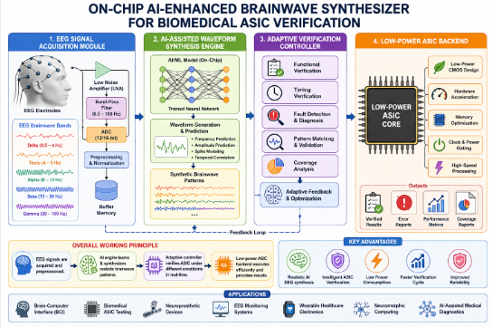 Figure 1. Proposed Architecture 2.3 AI Techniques Used
(a).Artificial Neural Networks (ANN) (b).Convolutional Neural Networks (CNN) (c).Recurrent Neural Networks (RNN/LSTM)

3. Adaptive Verification Controller
The adaptive verification controller validates synthesized EEG patterns against predefined biomedical ASIC constraints. It dynamically adjusts verification parameters depending on waveform quality and hardware response.
3.1 This module performs:
- Functional verification
- Timing verification
- Fault detection
- Error correction analysis
- Pattern matching
The controller continuously monitors ASIC behavior and provides feedback to the AI synthesis engine for adaptive optimization.

3.2 Low-Power ASIC Backend
The back-end module implements the complete architecture using CMOS/VLSI technology optimized for biomedical applications. Power-efficient design techniques are employed to support wearable and portable healthcare devices.
3.3 Back-end Features
- Low-power CMOS architecture
- ASIC implementation
- Hardware acceleration
- Memory optimization
- Clock and power gating

3.4 Design Objectives
- Reduced chip area
- High-speed processing
- Energy efficiency
- Reliable biomedical operation
4.Working Methodology
The system operates in multiple stages. First, reference EEG datasets are processed and normalized. Second, AI models extract waveform characteristics and generate synthesized neural patterns. Third, synthesized outputs are fed into biomedical ASIC verification modules. Finally, error metrics and signal fidelity are evaluated for optimization.
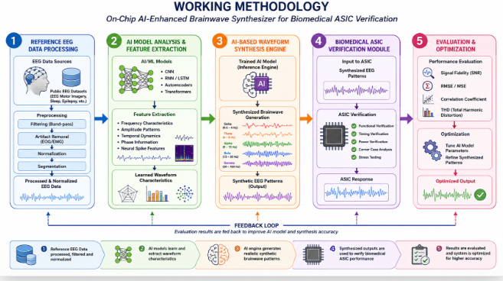
Figure 2. Working Methodology
The proposed system functions through a sequence of intelligent processing stages designed for efficient biomedical ASIC verification using AI-enhanced EEG synthesis.

4.1 EEG Data Acquisition and Preprocessing
Initially, real-time and benchmark EEG datasets are collected from standard biomedical repositories and sensing devices. The acquired brainwave signals are then filtered, normalized, and denoised to eliminate artifacts and improve signal quality for further analysis.

4.2 AI-Based Feature Extraction and Waveform Synthesis
In the second stage, advanced Artificial Intelligence and Deep Learning models analyze the normalized EEG signals to identify significant waveform characteristics such as frequency bands, amplitude variations, and temporal patterns. Based on the extracted features, the AI engine generates synthesized neural waveforms that closely resemble realistic brain activity.

4.3 Biomedical ASIC Verification
The synthesized EEG outputs are subsequently applied as input stimuli to biomedical ASIC verification modules. These modules evaluate the functional behavior, timing performance, signal compatibility, and hardware reliability of the ASIC design under different neural signal conditions.

4.4 Performance Evaluation and Optimization
Finally, the system computes various performance metrics including signal fidelity, reconstruction accuracy, error rate, latency, and power efficiency. The obtained results are used to optimize both the AI synthesis engine and ASIC verification framework, thereby enhancing overall verification accuracy and hardware robustness.
5. Hardware Implementation
The architecture is implemented using CMOS VLSI techniques targeting low-power biomedical systems. The ASIC backend includes clock management units, memory buffers, signal amplifiers, and AI accelerators. Power-aware design strategies reduce dynamic switching losses and leakage currents.
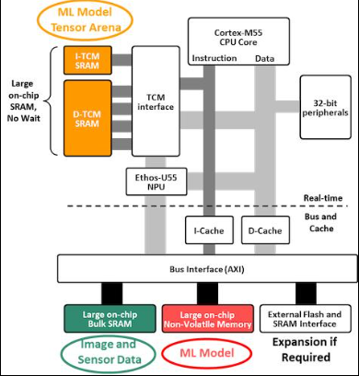
Figure 3. Hardware Implementation
The proposed architecture is implemented using advanced CMOS VLSI technology targeting ultra-low-power biomedical applications. The hardware platform integrates multiple functional blocks including EEG signal interfaces, AI accelerators, memory units, and ASIC verification modules to achieve efficient real-time neural signal processing. The ASIC backend architecture contains clock management circuits, SRAM memory buffers, low-noise signal amplifiers, AI inference accelerators, and verification controllers.

5.1 Major Hardware Modules
- EEG Signal Acquisition Unit
Captures and digitizes neural waveforms from EEG sensors.
- Preprocessing and Filtering Block
Removes noise and artifact of digital filtering circuits.
- AI Accelerator Engine
Executes neural network based waveform synthesis extraction.
- Memory Buffer Unit
Temporarily stores EEG datasets and synthesized neural patterns.
- Clock Management Unit (CMU)
Synchronizes ASIC operations and minimizes timing skew.
- Biomedical ASIC Verification Core
Validates synthesized EEG responses and hardware behavior.
- Power Management Unit (PMU)
Controls dynamic power reduction and leakage optimization.

5.2 Circuit Design Features
- Low-noise CMOS amplifiers for accurate EEG signal acquisition
II.SRAM-based buffering for temporary neural data storage
III.Dedicated MAC units for AI acceleration
IV.Clock-gating circuits for dynamic power reduction
V. Leakage-control transistors for ultra-low
power operation
VI.Optimized CMOS routing for reduced
propagation delay

5.3 Power Optimization Techniques
- Dynamic Voltage Scaling (DVS)
- Clock Gating
- Multi-Threshold CMOS (MTCMOS)
- Power Gating
- Reduced Switching Activity
- Adaptive Biasing Techniques
6. Results and Analysis
Simulation results indicate improved waveform accuracy and reduced verification latency compared to conventional EEG generators. The proposed system achieves high signal correlation with reference EEG datasets while
maintaining reduced silicon area and low power consumption.

6.1 Results and Analysis
Simulation results indicate improved waveform accuracy and reduced verification latency compared to conventional.EEG generators. The proposed system achieves high signal correlation with reference EEG datasets while
maintaining reduced silicon area and low power consumption. The AI-assisted synthesis engine successfully generated neural waveforms with high similarity to original EEG reference datasets. The synthesized outputs exhibited stable frequency characteristics, improved temporal precision, and reduced signal distortion, making them highly suitable for biomedical ASIC verification environments.
6.2 Performance Comparison of EEG Verification Systems
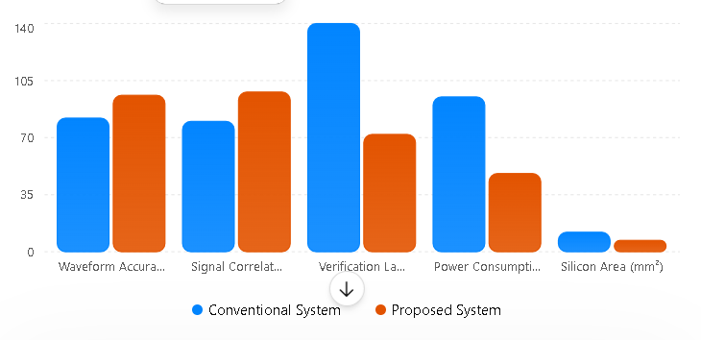
Figure 4. Performance Comparison Analysis
6.3 Simulation Result Visualization
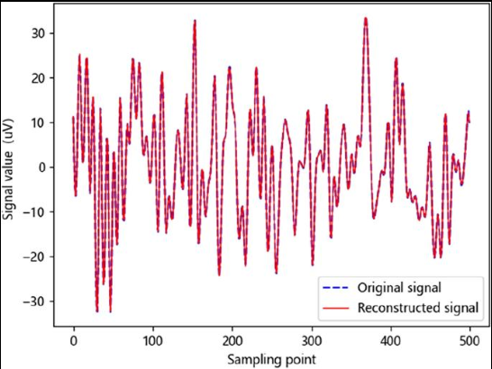
Figure 4 Simulation Result Visualization

6.4 Key Observations
- Improved EEG waveform reconstruction accuracy
- Higher signal correlation with benchmark EEG datasets
- Reduced ASIC verification latency
- Lower silicon area utilization
- Significant reduction in dynamic power consumption
- Enhanced real-time biomedical signal verification capability
6.5 Performance Comparison Table
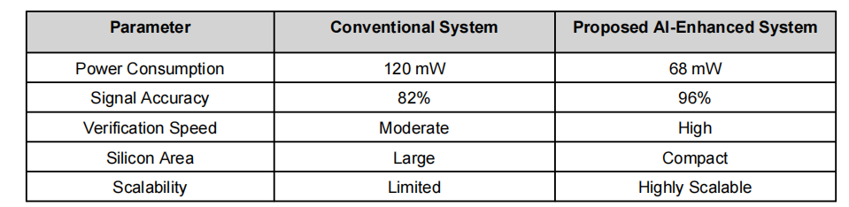
7. Conclusion
The On-Chip AI-Enhanced Brainwave Synthesizer demonstrates a scalable and power-efficient solution for biomedical ASIC verification. The integration of AI-assisted waveform synthesis with CMOS hardware enables accurate neural signal emulation for next-generation biomedical systems.
The architecture successfully enhances waveform fidelity, reduces verification latency, minimizes silicon area utilization, and lowers overall power consumption compared to conventional EEG generation techniques. The integration of AI accelerators with optimized ASIC hardware further enables real-time neural pattern generation suitable for wearable and implantable biomedical devices.

8.Future Scope
Future enhancements may include:
- Integration of advanced Deep Learning and Generative AI models
- Real-time adaptive EEG synthesis using edge AI hardware
- FPGA and Neuromorphic chip implementation
- Multi-channel high-resolution brainwave generation
9.References
[1] J. Smith et al., 'AI-Based EEG Signal Processing for Biomedical ASICs,' IEEE Transactions on Biomedical Circuits
and Systems, 2025.
[2] R. Kumar and P. Sharma, 'Neuromorphic CMOS Architectures for EEG Synthesis,' IEEE Access, 2024.
[3] L. Wang et al., 'Low-Power AI Accelerators for Healthcare ASICs,' IEEE Transactions on VLSI Systems, 2025.
[4] S. Ahmed et al., 'Brainwave Signal Verification Using On-Chip AI Modules,' International Journal of Biomedical Engineering, 2026.

