SCHOOL HEAD INSTRUCTIONAL LEADERSHIP BEHAVIOR, SENSE OF EFFICACY, WORK ENGAGEMENT, AND WORK VALUES OF

ABSTRACT
Low work values among teachers are alarming. The best-fit model for teacher work values, as predicted by school head instructional behaviour, teacher sense of Efficacy, and work engagement, was examined. The researcher employed a predictive research design and selected 400 public school teachers as respondents through proportionate stratified random sampling. Using the Structural Equation Modelling approach, the results showed that the determinants defined the best-fit model for teacher work values supporting Social Cognitive Theory. Future research may strengthen the model by adding variables to explain the remaining 30.1% variance. At the same time, educational leaders may enhance instructional leadership, teacher efficacy, and work engagement to optimise teacher work values.

Keywords: School head instructional leadership behaviour, sense of Efficacy, work engagement, work values of teachers, structural equation model

INTRODUCTION

Problem and its Scope

In the global education landscape, low work values among teachers have become a significant concern. Tschannen-Moran (2017) found that schools struggle to maintain cohesive professional cultures when faced with varying levels of teacher professional values. Similarly, Lacerna (2016) highlighted the prevalence of low work values among many educators, posing a critical challenge to the educational system. Kennedy (2016) further noted that teachers exhibiting low work values often resist professional development initiatives.
In various countries, low work values among teachers have become a persistent professional concern. For instance, in China, Cao and Zhang (2023) found that studies on English as a Foreign Language (EFL) teachers revealed inconsistencies in value alignment within the teaching profession, suggesting that not all educators maintain strong professional value congruence. IN Peru, national survey results showed that some teachers place less value on the teaching profession, reflecting differing views on their roles. Likewise, international research comparing countries such as the United States and various European nations revealed disparities in how teachers perceive the importance and appeal of their careers. In addition, the study of Lovison & Mo (2023) demonstrated that low work values are not limited to a single country but are evident across multiple educational contexts.
In the Philippine context, low work values among teachers are likewise evident as a professional issue within the education sector. According to Par (2021), Filipino workers often display a unique set of work values rooted in the nation’s social and cultural norms. Meanwhile, the study by Aktwil (2019) conducted in Makati highlighted the need to enhance educators’ performance by strengthening their commitment to organisational standards and best practices.
When educators demonstrate low work values, the quality of education declines significantly. Skaalvik & Skaalvik (2021) found that disengaged teachers tend to put in minimal effort in their pedagogical practices, resulting in less effective instruction. As Prabjandee (2020) observed, such disengagement creates a cycle where reduced teaching quality leads to poorer student outcomes, further reinforcing low teacher work values. According to Klusmann et al. (2020), low teacher work values are strongly linked to lower student achievement, decreased student engagement, and impaired student performance and well-being.
Although several studies have examined teachers’ work values, no study has used Structural Equation Modelling (SEM) to address low work values among teachers. For instance, Carrier et al. (2021) employed a descriptive correlational design to investigate the relationship between basic psychological needs at work, work values, and job satisfaction. In a related study, Matote (2018) used a convergent mixed-methods design to explore work values and found significant positive relationships among the variables. Giray’s (2021) descriptive study of teachers’ work values indicated that other variables exerted a significant influence. This study developed a structural equation model that will allow a simultaneous analysis of complex relationships among variables, including both direct and indirect effects, in examining school heads’ instructional leadership behaviours, teachers’ sense of Efficacy, work engagement, and work values, with a focus on urban and rural areas in Davao Region.

Significance of the Study

This study is important because it examines teacher work values as a key factor in achieving SDG 4 (Quality Education) and SDG 8 (Decent Work and Economic Growth). It supports a motivated teaching workforce that fosters ongoing, inclusive, and high-quality education. In the Philippine setting, these findings may assist the Department of Education in shaping policies on teacher retention, professional development, and strategies to address shortages, thereby helping to develop holistically prepared, globally competitive students. For Holy Cross of Davao College, the results may be valuable for strengthening faculty development, improving teacher well-being, and maintaining a mission-driven academic environment aligned with commitments to excellence, service, and holistic growth. Overall, this study may enhance student learning outcomes and support long-term educational sustainability.

Statement of the problem
This study determined the best-fit model for teacher work values, as predicted by school head instructional behaviours, teacher sense of Efficacy, and work engagement. Specifically, this study sought answers to the following objectives:
- To determine the levels of school heads instructional leadership behaviours in terms of framing goals, communicating the school goals, supervising and evaluating, coordinating the curriculum, monitoring the school progress, protecting instructional time, maintaining high visibility, providing incentives for teachers, promoting professional development, developing and enforcing academic standard and providing incentives for learning; teachers sense of Efficacy in terms of Efficacy in student engagement, instructional strategies, and classroom management; teachers’ work engagement in terms of vigor, dedication and absorption; work values of teachers in terms discipline, creativity, orderliness, patience, decisiveness, and achievements.
- To determine the significance of the correlation between school heads' instructional leadership behaviour, teachers’ sense of Efficacy, work engagement, and work values of teachers.
- To determine the significance of the combined degree of influence of school head instructional leadership behaviour, teacher sense of Efficacy, and work engagement on teachers' work values.
- To determine the best-fit model of work values of teachers.

Hypotheses
The researchers tested the hypotheses at the 0.05 level of significance.

𝐻𝑜1: School heads instructional leadership behaviour, teachers’ sense of Efficacy, and teachers work engagement do not significantly correlate with teachers’ work values.
H2: School heads' instructional leadership behaviour, teachers’ sense of Efficacy, and work engagement do not significantly influence teachers' work values.
𝐻𝑜3: Teachers' work values do not have the best fit model.

Theoretical Framework.

This study is grounded in the Social Cognitive Theory developed by Albert Bandura (1986), which asserts that human behaviour emerges from reciprocal determinism, a dynamic and continuous interaction among personal factors, behavioural patterns, and environmental influences, each shaping and being shaped by the others.

Within this framework, the study examined how teachers’ sense of Efficacy (personal factor), school instructional leadership behaviours (environmental factor), and teachers’ work engagement (behavioural factor) collectively influence teachers’ work values (the human behaviour that emerges).

Conceptual Framework

Figure 1 presents the study’s conceptual framework. School heads’ instructional leadership behaviours, teachers’ sense of self-efficacy, and teachers’ work engagement served as the independent variables; whereas teachers’ work values served as the dependent variable. Hallinger (2003) measured School Heads’ Instructional Leadership Behaviour using 11 indicators; Tschannen-Moran & Hoy (2001) evaluated teachers’ self-efficacy through three indicators; Schaufeli & Bakker (2003) measured work engagement using three indicators; Finally, Giray (2021) assessed teachers’ work values through six indicators.
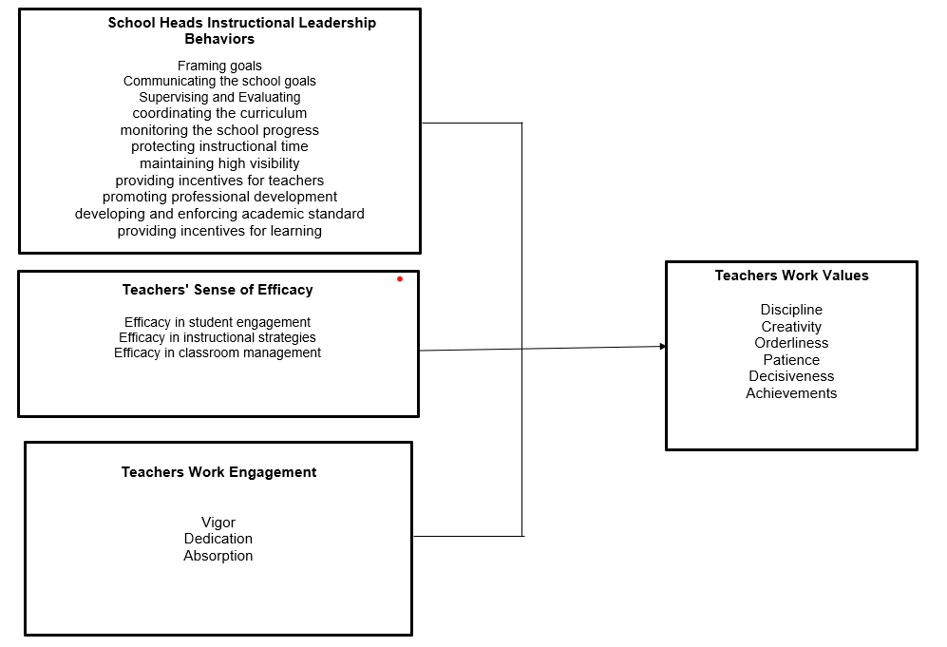
Figure 1. Conceptual Framework of the Study
This study developed five models to examine the relationships among the variables. Teachers' work values were the dependent variable, while independent variables included the school head's instructional leadership behaviours, teachers' sense of Efficacy, and work engagement. These models aimed to identify the best fit for understanding work values among public-school teachers in Region XI, guided by research, prior studies, and theoretical frameworks. The models used specific symbols to enhance clarity in presenting relationships: ellipses represented latent variables, double-headed arrows indicated covariance, and single-headed arrows denoted directional influence. Together, these symbols clearly illustrated the complex interactions among the variables.

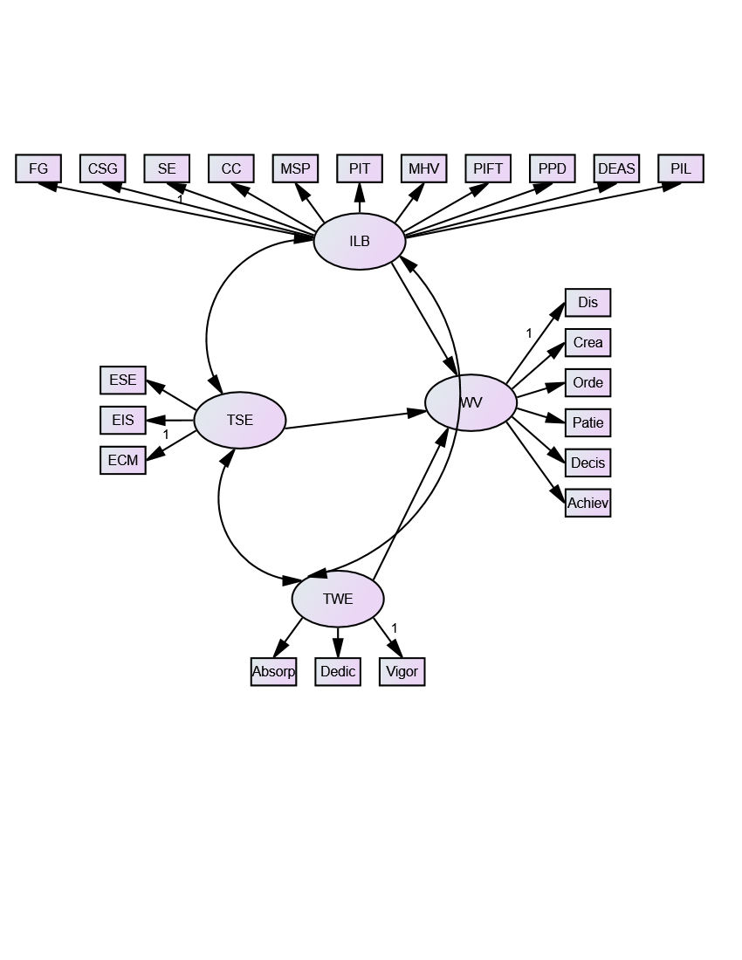
Figure 2 presents Hypothesised Model 1, illustrating the relationships among school heads’ instructional leadership behaviours, teachers’ sense of Efficacy, teachers’ work engagement, and teachers’ work values.
Figure 2. Hypothesised Model 1
ILB =Instructional Leadership Behaviours
FG = Framing goals
CSG = Communicating the school goals
SE = Supervising and Evaluating
CC = Coordinating the curriculum
MSP =Monitoring the school progress
PIT =Protecting instructional time
MHV =maintaining high visibility
PIFT =Providing incentives for teachers
PPD =Promoting professional development
DEAS =developing and enforcing academic standards
PIL =Providing incentives for learning

TSE =Teachers’ sense of Efficacy
ESE = Efficacy in student engagement
EIS = Efficacy in instructional strategies
ECM = Efficacy in classroom management

TWE = Teacher work engagement
Absorp= Absorption
Dedic = Dedication
Vigor = Vigor

WV =Work Values of the teacher
Dis = Discipline
Crea = Creativity
Orde = Orderliness
Patie = Patience
Decis = Decisiveness
Achiev =Achievements

Figure 3 presents Hypothesised Model 2, which illustrates the direct influence of school heads’ instructional leadership behaviours, teachers’ sense of Efficacy, and work engagement on teachers’ work values, without any interrelationships among the predictor variables.
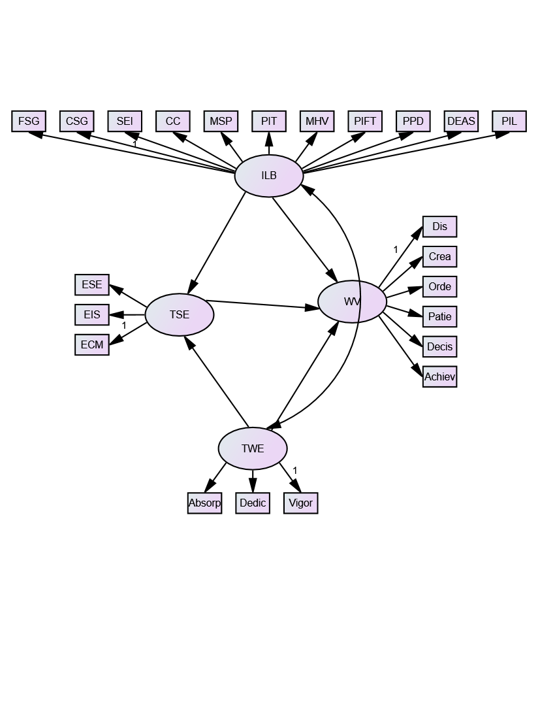

Figure 3. Hypothesised Model 2

Figure 4 displays Hypothesised Model 3, which shows the influence of teachers’ sense of Efficacy on school heads' instructional leadership behaviours, teachers' sense of Efficacy, and teachers' work engagement, in relation to teachers' work values.
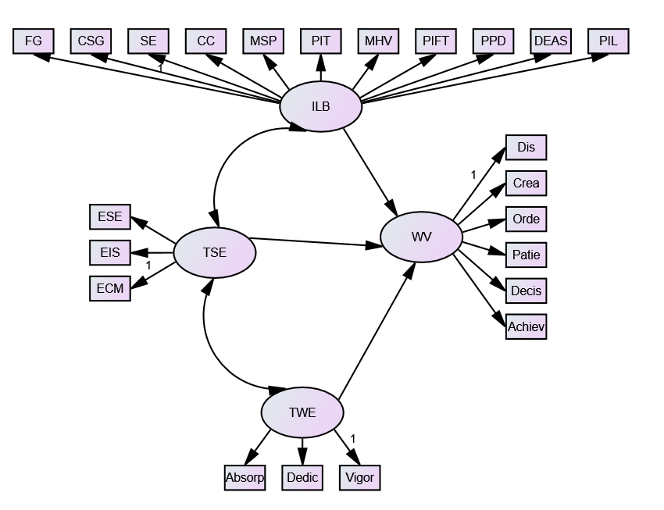

Figure 4. Hypothesised Model 3

Figure 5 displays Hypothesised Model 4, which shows the possible relationships among school heads' instructional leadership behaviours, teachers’ sense of Efficacy, and work engagement, and their possible influence on teachers' work values.
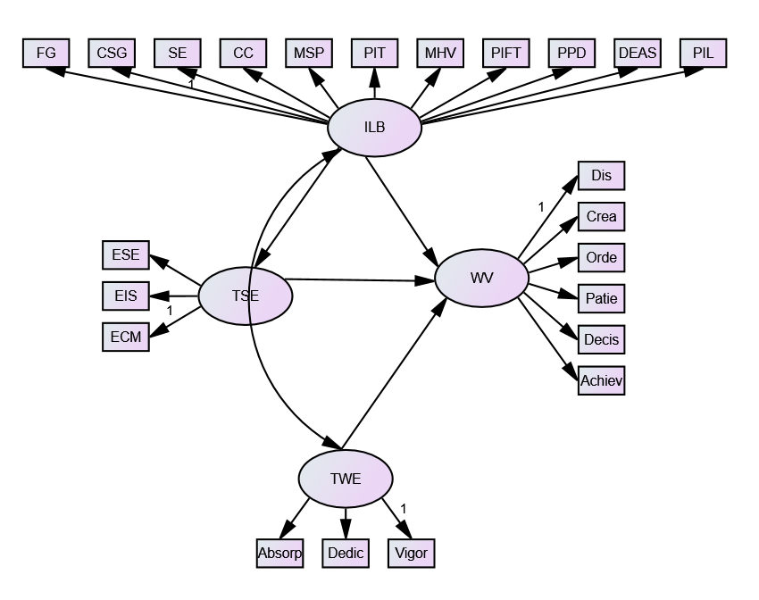

Figure 5. Hypothesised Model 4

Figure 6 presents Hypothesised Model 5, which illustrates the relationships among school heads’ instructional leadership behaviours, teachers’ sense of Efficacy, and teachers’ work engagement, and how these variables are associated with the development of positive work values.
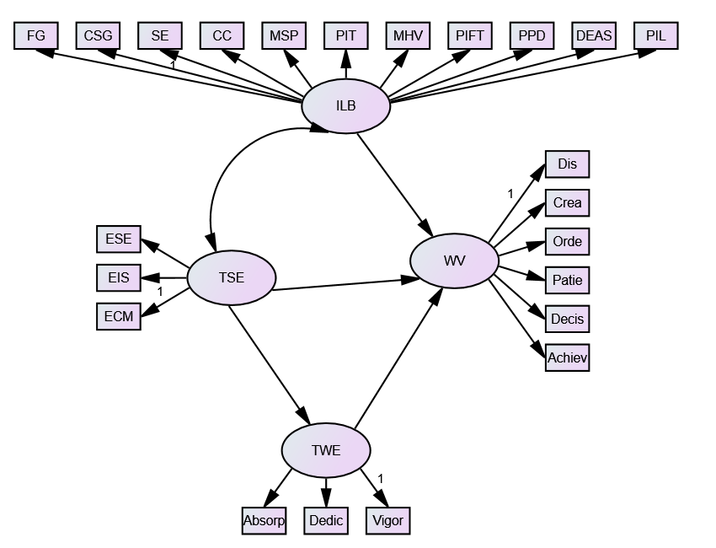

Figure 6. Hypothesised Model 5
METHODOLOGY

This section includes the research design, research locale, sample and sampling, research instruments, data-gathering procedures, data analysis, and ethical considerations.

Research Design
A predictive research design was used in this study, an approach that analyses patterns and relationships in data using statistical or analytical models to forecast future outcomes or behaviours. Predictive research is advantageous because it supports informed, proactive decision-making, identifies significant patterns among variables, improves forecast accuracy, and enhances the practical relevance of research by generating future-oriented insights (González-Díaz & Bustamante-Cabrera, 2021; Rustagi & Goel, 2022; Dejardin et al., 2022).

Research Locale
The researcher conducted this study in public schools across Region XI, which comprises eleven school divisions, and intentionally selected representative schools using proportionate random sampling, with the decision to focus on the region based on several reasons- first, the region has numerous public schools offering many teachers who meet the inclusion criteria for participants; Second, it is the most developed area of Mindanao, with a high density of public-school teachers and students; Third, the area is culturally diverse that could provide a wide range of findings and a more comprehensive understanding of the study.

Sample and Sampling
A total of 400 respondents, drawn from a population of 44,401 public school teachers in Region XI, were distributed across 11 School Divisions and participated in this study for the school year 2025-2026. The researcher conducted this study during the first semester of the 2025–2026 academic year and selected respondents based on the following inclusion criteria: (1) employment in a public educational institution during the 2025-2026 academic year, (2) a minimum of three years of teaching service, and (3) willingness to participate honestly in the survey. McMillan (2016) ensured the highest level of confidentiality, respect, and care in handling respondents’ responses.
This study employed proportionate stratified sampling, which, according to Thompson (2012), involves dividing a population into non-overlapping subgroups (strata) and selecting random samples from each stratum in proportion to its size in the overall population. This stratified sampling also aligns with Cochran's (1977) recommendation that stratification increases statistical precision when administrative boundaries form natural divisions within the population.
The researcher used a consistent sampling fraction of 0.0090 (400/44,401) across all strata to ensure proportional representation.
School Divisions |  | # Teachers | Sample Size
1 | Division 1 | 12361 | 111
2 | Division 2 | 1527 | 14
3 | Division 3 | 4097 | 37
4 | Division 4 | 7374 | 66
5 | Division 5 | 4580 | 41
6 | Division 6 | 3452 | 31
7 | Division 7 | 4609 | 42
8 | Division 8 | 1129 | 10
9 | Division 9 | 1534 | 14
10 | Division 10 | 1588 | 14
11 | Division 11 | 2150 | 19
Total |  | 44401 | 400

Data Gathering Technique
This study employed a survey technique, using structured questionnaires or interviews to systematically collect data and describe, explore, and explain population variables, particularly perceptions and beliefs. The survey technique enables efficient data collection from large and geographically dispersed samples, ensures standardised comparisons, and supports the generalisation of findings when proper sampling procedures are applied, making it a practical and reliable method for both descriptive and analytical research (Check & Schutt, 2012; Tanner, 2002).
This study adapted and modified four survey questionnaires to enhance their effectiveness. The first instrument used was developed by Hallinger (1980), which includes 11 indicators and 62 items, resulting in a Cronbach’s alpha of 0.937 to measure school heads’ instructional leadership behaviour. The second instrument, designed by Tschannen-Moran and Hoy (2001), consists of 24 items and has a Cronbach’s alpha of 0.94; it assesses teachers’ sense of efficacy. The third instrument utilised was the Utrecht Work Engagement Scale (UWES), created by Schaufeli and Bakker (2003), which reported a Cronbach’s alpha of 0.937 to evaluate teacher work engagement. Lastly, the researcher adapted the instrument developed by Louie Giray (2021), which contains six indicators and a Cronbach’s alpha of 0.790, to assess teachers’ work values.

Data Analysis Technique
In this study, the data analysis techniques used included descriptive data analysis, correlation analysis, regression analysis, and Structural Equation Modelling.
McCombes (2023) asserts that descriptive analysis helps summarise data to identify patterns and trends, and the researcher used the mean and standard deviation to analyse the data and support decision-making. In addition, Senthilnathan (2019) emphasised that correlation analysis measures the strength and direction of relationships among two or more variables. Pearson product-moment correlation was employed. In relation, Yen (2023) explains that regression analysis predicts future outcomes using existing data, quantifies the strength and impact of relationships between variables, identifies key factors influencing results, supports data-driven decision-making, and provides a clear mathematical model for interpreting complex datasets. In addition, Tarka (2023) explains that Structural Equation Modelling is a statistical technique that examines complex relationships among observed and latent variables, simultaneously estimates multiple pathways while accounting for measurement error, and adopts a confirmatory approach to test and evaluate relationships. It uses the following goodness-of-fit measure for the model.
Below is the matrix presenting the scale, descriptive level, and corresponding interpretation for each study. The researcher used this to describe School Head Instructional Leadership Behaviour, Teacher Sense of Efficacy, Work Engagement, and Teachers’ Work Values.

Scale | Level | School Head Instructional Leadership Behaviour | Teacher Sense of Efficacy | Teacher Work Engagement | Work Values of Teachers
1.00 – 1.74 | Very Low | Very poor | Very weak | Very weak | Very poor
1.75 – 2.49 | Low | Poor | Weak | Weak | Poor
2.50 – 3.24 | High | Good | Strong. | Strong | Good
3.25 – 4.00 | Very High | Very good | Very strong | Very strong | Very good

Standard Deviation Value Ranges and Interpretation

Range | Description | Interpretation
SD ≤ 0.50 | High Consistent Responses | Strong and uniform perception
SD = 0.51 – 1.00 | Moderate Consistent Responses | Acceptable consistency
SD = 1.01 – 1.50 | Low Consistent Responses | Differing views or experiences
SD > 1.50 | Very Low Consistent Responses | High variability and lack of consensus

In this study, the significance of the correlation is tested at a 0.05 confidence level. The following standard measure for the interpretation scale of the r-value was used, as shown below:

Computed r Descriptive Interpretation
+/- 1.00 Perfect correlation
Between +/- 0.75 – +/- 0.99 High correlation
Between +/- 0.51 – +/- 0.74 Moderately high correlation
Between +/- 0.31 – +/- 0.50 Moderately low correlation
Between +/- 0.01 – +/- 0.30 Low correlation
0.00 No correlation

The standard measure for the interpretation of the strength of the influence of the determinant variables is as follows:

Beta value | Strength of the Influence
±0.00 - ± 0.09 | Very weak
±0.10 - ± 0.29 | Weak
±0.30 - ± 0.49 | Moderate
±0.50 - ± 0.69 | Strong
±0.70 and above | Very strong

Ethical Consideration
Respondents were thoroughly informed about the study’s purpose, procedures, and their rights, including the voluntary nature of their participation and their freedom to withdraw at any stage without penalty. The researcher obtained informed consent from all participants prior to data collection, anonymised their responses, and restricted data access to the research team only, ensuring confidentiality and security. The study was designed to prevent harm and to consistently uphold the rights, dignity, and well-being of all respondents throughout the process. The researcher conducted the study with honesty, integrity, and respect, recognising and valuing the contributions of all participants. The Society for Moral Integrity and Legal Ethics (SMILE) granted ethical clearance for the study, and the researchers secured formal permission from the Department of Education before implementation. Throughout the study, the researchers maximised potential benefits, minimised risks, and ensured fairness and equity in all procedures, while also disclosing all potential conflicts of interest to maintain transparency, credibility, and integrity.

RESULTS

In this section, the statistical results and the summary of findings are presented.

Descriptive Analysis

Table 1 is descriptive. It includes the variables involved in the study, such as school head instructional leadership behaviour, teacher sense of efficacy, work engagement, and teachers' work values, along with their respective indicators; as well as the sample size, standard deviation, mean, and descriptive levels for each variable.

Table 1. Descriptive Statistics (N =400)
Variables Sample Size | SD | Mean | Descriptive Level
Instructional Leadership 400  Behavior  Behavior 400 | 0.28 | 3.80 | Very High
Framing Goals | 0.37 | 3.80 | Very High
Communicating Goals | 0.35 | 3.81 | Very High
Supervising and Evaluating  Instruction | 0.36 | 3.80 | Very High
Coordinating Curriculum | 0.33 | 3.81 | Very High
Monitoring School Progress | 0.40 | 3.77 | Very High
Protecting Instructional Time | 0.36 | 3.79 | Very High
Maintaining High Visibility | 0.36 | 3.79 | Very High
Providing Incentives for Teachers | 0.44 | 3.78 | Very High
Promoting Professional Development | 0.34 | 3.81 | Very High
Developing and Enforcing Academic  Standards | 0.35 | 3.81 | Very High
Providing Incentives for Learning | 0.33 | 3.83 | Very High
Teachers’ Sense of Efficacy 400 | 0.28 | 3.85 | Very High
Efficacy in Student Engagement | 0.32 | 3.85 | Very High
Efficacy in Instructional Strategies | 0.28 | 3.87 | Very High
Efficacy in Classroom Management | 0.30 | 3.84 | Very High
Teachers’ Work Engagement 400 | 0.34 | 3.77 | Very High
Vigor | 0.39 | 3.74 | Very High
Dedication | 0.33 | 3.83 | Very High
Absorption | 0.41 | 3.73 | Very High
Work Values of Teachers 400 | 0.34 | 3.75 | Very High
Discipline | 0.45 | 3.70 | Very High
Creativity | 0.42 | 3.71 | Very High
Orderliness | 0.32 | 3.82 | Very High
Patience | 0.36 | 3.78 | Very High
Decisiveness | 0.39 | 3.75 | Very High
Achievement | 0.37 | 3.76 | Very High

Specifically, the table shows that the school head instructional leadership behaviour variable has a mean of 3.80, described as a very high level. This indicates that school heads’ instructional leadership behaviours are very good. All indicators are described as very high. The standard deviation of 0.28 is described as highly consistent, indicating a strong and uniform perception of responses across participants. Moreover, the teacher's sense of efficacy variable obtained a mean of 3.85, described as very high. This denotes that teachers’ sense of efficacy is very strong. All its indicators are described at a very high level. The standard deviation of 0.28, described as highly consistent, indicates a strong, uniform perception. In addition, the data reveal a very high level of work engagement among the surveyed teachers, with a mean of 3.77. This means that the teachers’ work engagement is strong. Consistently, all indicators are described as very high. The standard deviation of 0.34, described as highly consistent, indicates a strong, uniform perception. Finally, the work values of teachers’ variable has a mean of 3.75, described as a very high level. This indicates that teachers' work values are very good. Consistently, all indicators are described as very high. The standard deviation of 0.32 indicates a strong, uniform perception among respondents.
All variables are very high, with highly consistent standard deviations, indicating that school heads' instructional leadership behaviours, teachers' sense of efficacy, work engagement, and work values are consistently very good and collectively perceived as strong, uniform, and mutually reinforcing across all respondents.

Correlational Results

Table 2 is correlational. It presents the determinant and criterion variables. It shows the r‑value, p‑value, decision on the null hypothesis, and the corresponding interpretation.

Table 2. Correlation Table (N=400)
Variables | Work Values of Teachers
Variables | r | p-value | Decision on H_{o} | Interpretation
Instructional Leadership Behaviour | .620 | .000 | Reject | Moderately High Positive, Significant Correlation
Teachers’ Sense of Efficacy | .712 | .000 | Reject | Moderately High Positive, Significant Correlation
Teachers’ Work Engagement | .811 | .000 | Reject | High Positive, Significant Correlation
Level of Significance: 0.05
Decision Rule: Reject H₀ if p < 0.05

Particularly, Table 2 shows that the correlation between school head instructional leadership behaviour and work values of teachers obtained a p-value of 0.000, which is lower than the 0.05 level of significance; hence, the null hypothesis was rejected, indicating that the correlation is statistically significant. The r-value of 0.620 indicates a moderately high positive correlation between school head instructional leadership behaviour and teachers' work values. This finding implies that when school head instructional leadership behaviour increases, teachers' work values also increase. Similarly, the teacher's sense of efficacy yielded a p-value of 0.000, which is below the 0.05 level of significance; hence, the null hypothesis was rejected, indicating that the correlation is statistically significant. The r-value of 0.712 indicates a moderately high positive correlation between teachers' sense of efficacy and their work values. This finding implies that when a teacher's sense of efficacy increases, teachers' work values also increase. In the same vein, teacher work engagement yielded a p-value of 0.000, which is below the 0.05 level of significance; hence, the null hypothesis was rejected, indicating a statistically significant correlation. The r-value of 0.811 indicates a high positive correlation between teachers' sense of efficacy and their work values. This suggests that higher levels of teacher work engagement are associated with increased teachers' work values.
All three variables show statistically significant positive correlations with work values. Teachers' work engagement demonstrates the strongest relationship, while instructional leadership behaviour exhibits the weakest but still substantial relationship. This indicates that while all factors contribute meaningfully, enhancing teachers’ engagement may yield the greatest impact on strengthening their work values.

Regression Analysis
Table 3 presents the regression analysis. It includes the determinant and criterion variables, unstandardized Beta, Beta Coefficient, t-value, p-value, and the corresponding interpretation.

Table 3. Regression Table (N = 400)

 |  | Work Values of Teachers
 |  |  |  | Unstandardized  Coefficients |  |  | Standardized Coefficients
Variables |  | B |  |  | Std. Error |  | Beta |  | T |  | Sig. |  | Decision on H₀ |  | Interpretation
(Constant) |  | .008 |  |  | .141 |  |  |  | .058 |  | .954 |  | - |  | -
 | Instructional Leadership Behaviour |  | .161 |  |  | .044 |  | .136 |  | 3.677 |  | .000 |  | Reject |  | Positive Significant Influence
 | Teachers’ Sense of Efficacy |  | .256 |  |  | .052 |  | .210 |  | 4.962 |  | .000 |  | Reject |  | Positive Significant Influence
 | Teachers’ Work Engagement |  | .570 |  |  | .042 |  | .574 |  | 13.602 |  | .000 |  | Reject |  | Positive Significant Influence
Model Summary:
R = 0.836 | R² = 0.699 | F(3,396) = 306.760 | p = 0.000
Level of Significance: 0.05
Decision Rule: Reject H₀ if p < 0.05

The table shows that the influence of the school head's instructional leadership behaviour on teachers' work values was 0.161. The corresponding p-value of 0.000 is less than 0.05 degrees of confidence, so the null hypothesis was rejected. It indicates that the school head's instructional leadership behaviour regarding teachers' work values is significantly positive. The strength of the influence is weak. This indicates that for every 1-unit increase in the school head's instructional leadership behaviour, there is a corresponding 0.161-unit increase in teachers' work values.
Moreover, the influence of teachers' sense of efficacy on teachers' work values was estimated at a Beta coefficient of 0.256. The corresponding p-value of 0.000 is less than the 0.05 significance level; hence, the null hypothesis was rejected. It indicates that the teacher's sense of efficacy on teachers' work values is significantly positive. The strength of the influence is weak. This indicates that for every 1-unit increase in teachers' sense of efficacy, there is a corresponding 0.256-unit increase in teachers' work values.
Furthermore, the influence of teachers' work engagement on teachers' work values was 0.570. The p-value of 0.000 is less than 0.05, indicating statistical significance; hence, the null hypothesis was rejected. This shows that a teacher's sense of efficacy significantly positively affects teachers' work values. The strength of this influence is strong. It means that for every 1-unit increase in teachers' work engagement, teachers' work values increase by 0.570 units.
Thus, teachers' work engagement emerges as the strongest predictor, while instructional leadership behaviour demonstrates the weakest but still significant influence.

Best Fit Model on Work Values of Teachers
Table 4 shows the best-fit model for teachers' work values. It contains indices, criteria, and models.

Table 4. Best Fit Model for Work Values of Teachers
 |  |  | MODELS
INDEX | CRITERION | Model 1 | Model 2 | Model 3 | Model 4 | Model 5
CMIN/DF | <5 | 1.376 | 4.183 | 5.008 | 5.428 | 4.255
P-VALUE | >0.05 | .063 | .000 | .000 | .000 | .000
NFI | >0.95 | .987 | .890 | .869 | .858 | .889
TLI | >0.95 | .992 | .904 | .879 | .866 | .902
CFI | >0.95 | .996 | .915 | .892 | .881 | .913
GFI | >0.95 | .980 | .816 | .798 | .796 | .811
RMSEA | <0.05 | .031 | .089 | .100 | .105 | .090
P-CLOSE | >0.05 | .951 | .000 | .000 | .000 | .000

It presents a comparison of five models examining teachers' work values. Model 1 emerges as the best-fitting model based on all goodness-of-fit indices. Model 1 demonstrates superior fit, with a CMIN/DF of 1.376, well below the threshold of 5 and closest to the ideal value of 1. Importantly, it yields a p-value of 0.063, which exceeds the 0.05 threshold, indicating that the model adequately represents the observed data. All incremental fit indices for Model 1 exceed the recommended 0.95 threshold: NFI = .987, TLI = .992, CFI = .996, and GFI = .980. Additionally, Model 1 shows excellent fit, with an RMSEA of .031, well below the 0.05 cutoff for good fit, and a P-CLOSE value of .951. In contrast, Models 2 through 5 demonstrate progressively poorer fit across all indices, with p-values of .000 indicating significant discrepancies between the models and the data, fit indices falling below the 0.95 threshold, and higher RMSEA values approaching or exceeding 0.10. These results strongly suggest that Model 1 represents the most theoretically sound and statistically appropriate structure for understanding teachers' work values in this sample, whereas the alternative model specifications fail to capture the underlying relationships in the data adequately.
As shown in Figure 7, the Instructional Leadership Behaviours indicators were trimmed from 12 to 6: framing goals, communicating school goals, supervising and evaluating, coordinating the curriculum, promoting professional development, and providing incentives for learning. Similarly, the Teachers' Sense of Efficacy construct was streamlined from three original indicators to two: efficacy in student engagement (ESE) and efficacy in classroom management (ECM), with efficacy in instructional strategies (EIS) eliminated, suggesting that these two dimensions most strongly capture teachers' perceived effectiveness. On the other hand, the Teacher Work Engagement (TWE) variable retained its full complement of indicators, including absorption (Absorp), dedication (Dedic), and vigour (Vigour), indicating that these three dimensions are essential for representing work engagement. Lastly, the indicators of teachers' work values were also reduced to two from the six original indicators, namely discipline and achievement, suggesting that these represent the core work values most relevant to teachers' professional identity and most strongly predict other outcomes in the model.
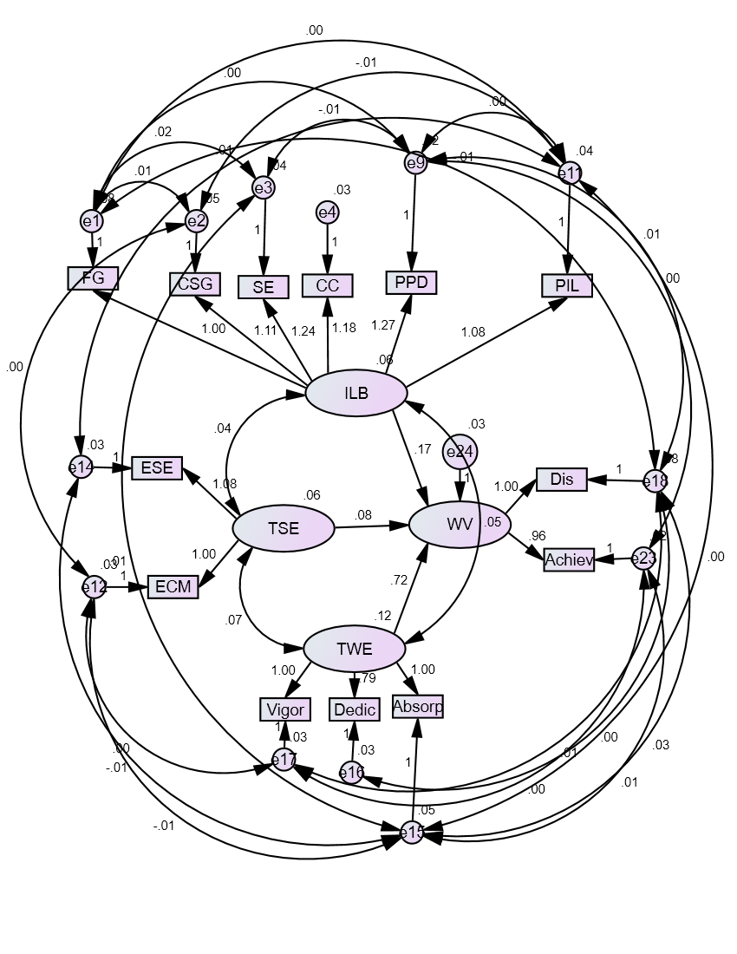
The structural relationships in this refined model reveal a complex network of direct and indirect effects, with ILB exerting foundational influence on multiple downstream latent variables through various pathways. The bidirectional arrows throughout the model indicate reciprocal causation, with variables mutually reinforcing each other over time. The WV in the model, with paths connecting it to ILB, TSE, TWE, and other variables, underscores its theoretical importance as a mediating mechanism through which leadership behaviours and efficacy beliefs translate into work engagement and other professional outcomes.

Figure 7. The Best Fit Model of Work Values of Teachers
Summary of Findings

Based on the statistical result, it was found that:
- School heads instructional leadership behaviour, teachers’ sense of efficacy, and teachers work engagement significantly correlate with the work values of teachers.
- School heads' instructional leadership behaviour, teachers’ sense of efficacy, and work engagement significantly influence teachers' work values.
- The best fit model for teacher work values identified was model 1 based on standard indices.

Discussions

This section presents the study's findings, conclusions, and recommendations.

School Head Instructional Leadership Behaviour, Teacher Sense of Efficacy, Work Engagement, and the Work Values of Teachers

The finding of the study that school heads instructional leadership behaviour, teachers’ sense of efficacy, and teachers' work engagement significantly correlate with the work values of teachers, affirms the assertion of Zee and Koomen (2016), who found that TSE correlates positively with students’ academic adjustment, classroom-related teacher behaviors and practices, and factors influencing teachers’ psychological well-being, such as personal accomplishment, job satisfaction, and commitment. Additionally, the current finding supports the idea that instructional leadership and teachers’ self-efficacy are significantly related to positive educational outcomes, with leadership practices fostering teachers’ confidence and engagement, thereby influencing their professional attitudes and values (Chen & Rong, 2023).
In contrast, this current finding contradicts Thien et al. (2023), who found no significant link between instructional leadership and teacher professional learning, an area closely related to professional values and engagement. These differing results suggest that the relationship between these factors may be complex and not strictly linear, indicating that relying solely on principal-led efforts may not consistently influence teacher outcomes across different settings.

School Heads’ Instructional Leadership Behaviours, Teachers’ Sense of Efficacy, and Work Engagement Influence Teachers’ Work Values.

The study's findings are that school heads' instructional leadership behaviour, teachers’ sense of efficacy, and work engagement significantly influence teachers' work values. This finding affirms the study of Chen and Rong (2023), which reports that instructional leadership significantly influences teacher outcomes by enhancing teachers’ efficacy, professional functioning, and workplace beliefs and behaviours. Moreover, the current finding supports the study of Han, Wang, and Wang (2023), which emphasised that teachers’ self-efficacy and work engagement are significant predictors of positive work-related outcomes, with higher levels of efficacy enhancing engagement and overall professional performance in educational settings.
However, this finding contradicts Jerrim et al. (2024), who reported that teacher self-efficacy does not always translate into observable outcomes, and external evaluators found no significant association when measuring instructional quality, thereby contradicting claims of its consistent influence.

Conclusion

The findings show that school heads' instructional behaviour, teachers' sense of efficacy, and work engagement significantly predict teachers' work values and, together, form a strong, best-fit model. Such a predictive model aligns with Social Cognitive Theory, which posits that reciprocal determinism shapes human behaviour, where personal factors, behavioural patterns, and environmental influences interact dynamically and influence one another. The variables used in this study aligned with the elements asserted by the theory.

Recommendations

Based on the conclusion, future research may utilise the best-fit model determined in this study to strengthen the power of the model to predict work values of teachers. Future research can strengthen the model by incorporating additional variables to account for the remaining 30.1% of variance. Educational leaders should strengthen instructional leadership behaviours, enhance teachers’ sense of efficacy, and promote work engagement to achieve the optimal development of teachers’ work values.

References
Aktwil, J. (2019). Teacher performance and organisational commitment in Philippine urban schools. Asian Journal of Educational Management, 14(3), 187–204.
Bandura, A. (1986). Social foundations of thought and action: A social cognitive theory. Prentice-Hall.
Cao, J., & Zhang, W. (2023). Investigating the impact of value congruence on work engagement in EFL teachers: The role of teacher enthusiasm. Frontiers in Psychology, 14, 1264126. https://doi.org/10.3389/fpsyg.2023.1264126
Carrier, M. B., Ratelle, C., & Corff, Y. L. (2021). Work values and job satisfaction: The mediating role of basic psychological needs at work. Journal of Career Development, 49(6). https://doi.org/10.1177/08948453211043878
Check, J., & Schutt, R. K. (2012). Survey research is a method for collecting data. In J. Ponto (Ed.), Understanding and evaluating survey research (2015). https://pmc.ncbi.nlm.nih.gov/articles/PMC4601897/
Chen, S., & Rong, J. (2023). The moderating role of teacher collegiality in the relationship between instructional leadership and teacher self-efficacy. SAGE Open. https://doi.org/10.1177/21582440231217884
Cochran, W. G. (1977). Sampling techniques (3rd ed.). John Wiley & Sons.
Dejardin, M., Hermans, J., & Coreynen, W. (2022). From explanation of the past to prediction of the future: A comparative and predictive research design in the social sciences. Social Sciences & Humanities Open, 6(1), 100269. https://doi.org/10.1016/j.ssaho.2022.100269
Giray, L. (2021). Work values of secondary school teachers. https://doi.org/10.31039/jomeino.2021.5.2.5
González-Díaz, R. R., & Bustamante-Cabrera, G. I. (2021). Predictive sequential research design to study complex social phenomena. Entropy, 23(5), 627. https://doi.org/10.3390/e23050627
Hallinger, P. (1980). Principal instructional management rating scale. http://philiphallinger.com/tool/survey/pimrs/a/researcherLogin-2.html
Han, J., Wang, Y., & Wang, C. (2023). Self-efficacy, reflection, and resilience as predictors of work engagement among English teachers. Frontiers in Psychology, 14, 1160681. https://doi.org/10.3389/fpsyg.2023.1160681
Jerrim, J., Prieto-Latorre, C., Marcenaro-Gutierrez, O. D., & Shure, N. (2024). Teacher self-efficacy, instructional practice, and student outcomes: Evidence from the TALIS video study. American Educational Research Journal. https://doi.org/10.3102/00028312241300265
Klusmann, U., Aldrup, K., & Lüdtke, O. (2022). Emotion regulation competence in teachers: Implications for instructional quality and student outcomes. Journal of Educational Psychology, 114(3), 678–695. https://doi.org/10.1037/edu0000638
Lacerna, R. (2016). Academic orientation and parental involvement in education during high school. Sociology of Education, 74, 210–230.
Liu, S., & Hallinger, P. (2018). Principal instructional leadership, teacher self-efficacy, and teacher professional learning in China: Testing a mediated-effects model. Educational Administration Quarterly, 54(4), 501–528.
Lovison, V. S., & Mo, C. H. (2023). Investing in the teacher workforce: Experimental evidence on teachers’ preferences. American Educational Research Journal. https://doi.org/10.3102/00028312231208956
Matote, K. (2018). Work values and organisational commitment.
McCombes, S. (2023). Descriptive research: Definition, types, methods & examples. Scribbr. https://www.scribbr.com/methodology/descriptive-research/
Prabjandee, D. (2020). Teacher professional development for changing identity, knowledge, and practice: A meta-synthesis of research. The Educational Forum, 84(2), 228–243. https://doi.org/10.1080/00131725.2020.1698683
Schaufeli, W., & Bakker, A. (2003). Utrecht work engagement scale: Preliminary manual. Utrecht University.
Senthilnathan, S. (2019). Usefulness of correlation analysis. SSRN Electronic Journal. https://doi.org/10.2139/ssrn.3416918
Skaalvik, E. M., & Skaalvik, S. (2019). Teacher self-efficacy and collective teacher efficacy: Relations with perceived job resources and job demands, feeling of belonging, and teacher engagement. Creative Education, 8(5), 770–788. https://doi.org/10.4236/ce.2017.85057
Skaalvik, E. M., & Skaalvik, S. (2021). Relationships between teacher motivation, job satisfaction, and stress: A complex interplay. Teaching and Teacher Education, 106, 103459. https://doi.org/10.1016/j.tate.2021.103459
Tarka, P. (2018). An overview of structural equation modelling: Its beginnings, historical development, usefulness and controversies in the social sciences. Quality & Quantity. https://doi.org/10.1007/s11135-017-0469-8
Thien, L. M., & Yeap, S. B. (2023). Configuring effects of learning-centred leadership in promoting teacher professional learning and teacher self-efficacy. Educational Management Administration & Leadership, 53(6), 1549–1576. https://doi.org/10.1177/17411432231211431
Tschannen-Moran, M., & Woolfolk Hoy, A. (2001). Teacher efficacy: Capturing an elusive construct. Teaching and Teacher Education, 17, 783–805.
Yen, L. (2023). What is regression analysis? Datamation. https://www.datamation.com/big-data/what-is-regression-analysis
Zee, M., & Koomen, H. M. Y. (2016). Teacher self-efficacy and its effects on classroom processes, student academic adjustment, and teacher well-being: A synthesis of 40 years of research. Review of Educational Research, 86(4), 981–1015. https://doi.org/10.3102/0034654315626801

