Bridging Technological and Governance Gaps in Tropical Forest Monitoring: A Hybrid Satellite–Community Model from Cameroon

Abstract
Effective environmental management requires monitoring systems that not only detect ecological change but also translate detection into governance action. While satellite-based forest alerts have significantly improved transparency in tropical forest monitoring, persistent uncertainties remain in driver attribution, spatial precision, and enforcement response. We evaluate a hybrid monitoring model integrating satellite alerts with structured community validation and local land-use governance mechanisms in the Yabassi Key Biodiversity Area (KBA), Cameroon. Using alerts from Global Forest Watch, combined with participatory field validation, GPS verification, and Community Land Use Planning (CLUP), we analyzed approximately 800 alerts over a five-month period, validating 172 events. Community validation refined disturbance classification, identifying selective logging (38.71%), agricultural expansion (25.81%), plantation development (25.81%), burning (4.84%), and charcoal production (1.61%) as dominant drivers. Embedding monitoring within CLUP governance structures institutionalized patrols and sanction mechanisms, thereby reducing the detection–response gap. The findings demonstrate that hybrid monitoring strengthens environmental management effectiveness by integrating adaptive governance, polycentric coordination, and knowledge co-production. This framework provides a scalable model for REDD+, biodiversity conservation, and decentralized forest governance across tropical forest landscapes.
Keywords: Hybrid monitoring; Environmental governance; Participatory validation; REDD+; Adaptive governance; Polycentric systems; Congo Basin
1. Introduction
Tropical forests are central to global carbon regulation, biodiversity conservation, and local livelihoods (FAO 2020). Advances in remote sensing have transformed forest monitoring, enabling near-real-time detection of canopy disturbance (Hansen et al. 2013). Platforms such as Global Forest Watch provide open-access alerts derived from Landsat and radar imagery, improving transparency and accountability.
However, three critical uncertainties persist with (i) attribution uncertainty where alerts detect canopy disturbance but do not reliably distinguish among logging, smallholder agriculture, plantation clearing, or fire (Curtis et al. 2018). (ii) Spatial uncertainty – with pixel-based resolution may not capture exact disturbance boundaries and (iii) Governance uncertainty where detection often fails to trigger timely enforcement or restoration (Cash et al. 2003).
These challenges highlight a broader institutional gap between technological detection systems and environmental governance.
This study develops and evaluates a hybrid satellite-community monitoring model in the Yabassi Key Biodiversity Area (KBA), Cameroon, addressing the following questions: (i) can structured community validation reduce uncertainty in satellite-based deforestation detection? (ii) does integration with local land-use governance improve environmental management outcomes? And (iii) Is such a hybrid model scalable within polycentric forest governance systems?
1.1 Theoretical Framework
Hybrid model operationalizes adaptive governance through a structured detection, validation, response loop, and empirically demonstrates polycentric coordination across scales. It uses:
(i) Adaptive governance emphasizes iterative learning, feedback loops, and institutional flexibility in managing complex socio-ecological systems (Folke et al. 2005). Monitoring systems lacking local feedback fail to adapt to evolving land-use dynamics. The hybrid model operationalizes adaptive governance by linking detection to validation and response.
(ii) Polycentric governance theory posits that multiple interacting decision centers improve environmental management outcomes (Ostrom 2010). Satellite platforms operate at global scales, national forest authorities operate at policy scales, and CLUP committees operate locally. Integrating these scales enhances accountability and responsiveness.
(iii) Environmental knowledge is most effective when scientific and local knowledge systems interact (Armitage et al. 2011). Satellite alerts provide spatial coverage; community validation provides contextual interpretation. The hybrid model institutionalizes co-production, improving legitimacy and compliance.
2. Study Area
The study was conducted in the Yabassi Key Biodiversity Area (KBA), Nkam Division, Littoral Region, Cameroon (4.49°N; 9.97°E). The landscape includes: Council forests (Yingui and Yabassi), logging concessions, community forests, and the proposed protected Ebo Forest (figure 1). The area supports high biodiversity and functions as an ecological corridor. Approximately 47 communities depend on forest resources for livelihoods (Cameroon forest Atlas, 2020).
In 1989, population in the villages was estimated around 12,000 people, rising to 15,000 in 2005 and over 17,000 in 2022. The current 2025 population around the classified forest is almost trice from 2022. They depend directly on the forest for their livelihood. As a KBA, its harbors a small population of gorillas located in Ebo Forest, and a range of primates and other animal subspecies in partial dance forest where logging concession is being expanding gradually with some key actor from the nearest Douala city. The KBA form a cross-boundary corridor between the Littoral and South-West region up to Nigeria. The non integration of local communities in the management of those affected forest is leading to decrease of the biodiversity of the landscape (All tree, 2022). The rhythm of land cover changes is alarming (GFW, 2022). The use of forest monitoring tools help understands the deforestation drivers and the areas affected.
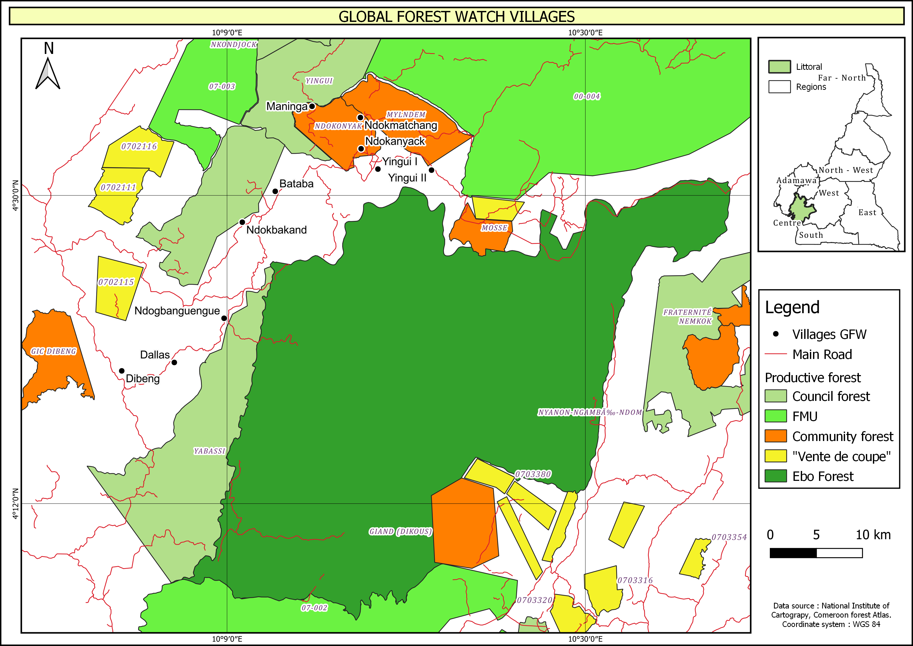
Figure 1: Location of the biodiversity hotspot in the Yabassi KBA
3. Methods
3.1 Satellite Alert Processing
Deforestation alerts were obtained from Global Forest Watch (GFW) platform, including GLAD and RADD alerts. Areas of Interest were delineated using national forest atlas shapefiles (Cameroon forest Atlas 2024). Alerts were downloaded and assigned to trained monitors via Forest Watcher where individual use the App to monitored its area. GFW is an online platform that provides data and tools for monitoring forests. By harnessing cutting-edge technology, GFW allows anyone to access near real-time information about where and how forests are changing around the world. The new data on GFW simplifies carbon monitoring by mapping all observed emissions and removals using a single model. In contrast, the GCP data only reports emissions related to human activity and estimates different components using different models. The combination of these datasets allows for detailed estimates about how each 30×30-meter piece of forest contributes to global emissions and removals. Deforestation occurs when forests are converted to non-forest uses, such as agriculture and road construction. Forest degradation occurs when forest ecosystems lose their capacity to provide important goods and services to people and nature. Approximately 800 alerts were detected during a five-month monitoring period.
Landcover classification was performed using supervised classification algorithms with ground-truth validation points collected during field surveys. Analysis of Landsat 8 satellite imagery for 2004, 2014 and 2024 contributed to oversee the landcover trends within a decade in the landscape.
3.2 Community Validation
Twenty-six participants (community forest committees, NGOs, forest managers) were trained in deforestation alert validation. Field validation included with the use of GPS verification, drone imagery, photographic documentation, semi-structured interviews and focus group discussions. Eighty-six alerts were validated through field missions. Figure 2 shows stakeholders during training on the use of Global Forest Wach application.
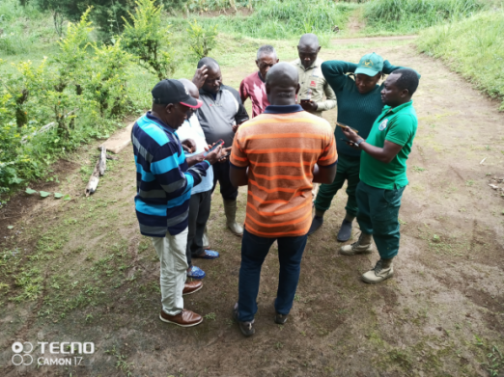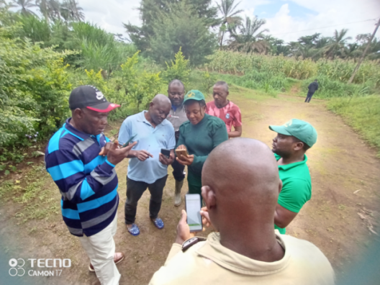
Figure 2: Training of participant for field validation of deforestation Alert using forest watcher and drone UAV, Ndjounguep, march 2024.
  - Governance Integration
Monitoring was embedded in Community Land Use Planning (CLUP), which established: Zoning rules, patrol schedules, traditional sanctions and degraded sites. This institutional integration ensured that validated alerts triggered management response.
3.4 Data Analysis
Driver categories were classified and quantified using descriptive statistics. Uncertainty reduction was assessed across: attribution clarity, spatial delineation and institutional response. Figure 3 indicate the hybrid monitoring conceptual framework that contribute in sustainable landscape governance.
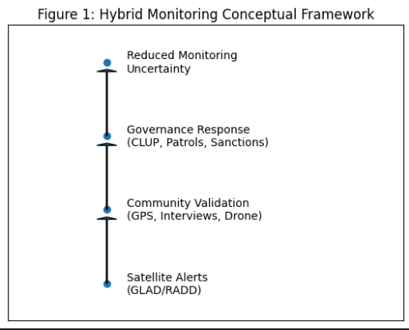
Figure 3: Hybrid monitoring conceptual framework
4. Results
4.1 Driver Attribution
Satellite alerts alone did not distinguish these categories prior to validation. Exchange with communities indicate that 97% agree to the fact that human activities such as logging, farming and build area are the main threats to deforestation within the landscape, while 3% of the responded confirmed that bush-fire and wind causes deforestation within the landscape.
Validated alerts documented about 84 deforestation alerts show more selective (38.71%) follow by clear cutting for agricultural activities (25.81%), agricultural plantation (25.81%), clear cutting/ open space (3.23%), burning / fires (4.84%) and charcoal production (1.61%). The driver of deforestation has an impact on tree covert lost evolution in the area of interest.
According to the communities, about 31.32% of this area need action, wile 57.61 are normal agricultural activities and 10.87% uncertain because they cannot appreciate the situation. Most of the areas that need actions are large scale farming (25%), large farm expansion (21.43%), expansion of agricultural land (17.8%), uncontrolled farming (10.71%) and bush fire (7.14%). They need the attention of the Chief of forestry (3.57%) to limit risk of expansion of illegal activities (3.57%). Figure 4 indicate the proportion of the deforestation drivers in the KBA (figure 4).

Figure 4: Description of deforestation drivers
The analyze the evolution of deforestation and degradation alerts (GLAD and RAD) with the GFW platform was carried out between 11th to 15th of March 2024 and 20th to 28th of March and between the 04th April to 25th July 2024 within the Yabassi Key Biodiversity landscape (communal forests (Yingui, Nkondjock and Yabassi), FMUs 002-004-07, Mt. Lonako Forest Reserve and the Ebo forest reserve). Figure 5 highlight past tree cover lost alert in the area of interested.

Figure 5: Evolution of tree covert lost in the Yabassi KBA 2001 to 2022 (GFW (2023).
From this figure, the tree cover lost become important as from 2013, gradually with a pick in 2017. The cause of this deforestation could be the influx of the CREFAT and the AZUR agro--industrial plantation in the area and also the deployment of logging company coming from the conflict area in the South west region of Cameroon. It is a period of oil palm extension within a primary forest and unplan forest logging with the release of several sale by standing volume by the Ministry of forestry and wildlife. Palm plantation needs clear cutting before planting. Beside that individuals and community’s plantation was created and other people are having interest in small holder plantation. The state of tree cover lost has damage the ecosystem and increase poaching with the creation of many accesses’ road. Figure 7 indicate the main deforestation drivers and communities’ perception on actions to be taken.

Figure 7: Communities perception on the need for action in the documented GLAD/ RADD alert GFW (2025).
From figure 8, the community perceptions on the other actions that are needed to to be ttaken ton reinforced the forest monitoring are highly not known (57.61%), 31,52% are known and 10.87% don’t know what to do.

Figure 8: Communities perception on further action should be taken in this area (%)
GFW (2025).
4.2 Reduction of Monitoring Uncertainty
4.2.1 Integrated deforestation alerts and Primary Forest loss in Yabassi KBA
The analysis from GFW platform show from 2001 to 2024, the Yabassi KBA registered 83,832 deforestation alerts between 27th of January 2023 and 29th of July 2024 where 89% were high confidence alerts detected by a single system and 2.4% were alerts detected by multiple systems lost 4.16 kha of humid primary forest, making up 90% of its total tree cover loss in the same time period. Total area of humid primary forest in Yabassi KBA decreased by 6.3% in this time period. These observations where also confirm by the analysis of satellite imagery indicating trend in landcover for the same period.
4.2.2 Landcover trend using Landsat data in the Yabassi landscape
From Landsat satellite images, analysis of landcover of the years 2004, 2014 and 2024 was made. Table 1 and 2 present the status and the changes in forest cover.
Table 1: Landcover status 2004 - 2024
Yabassi | Superficies (ha)
Yabassi | 2004 | 2014 | 2024
Settlement | 131.95 | 639.42 | 774.67
Secondary forest | 8972.53 | 59661.76 | 103974.22
Dense forest | 133740.76 | 83560.31 | 10174.51
Water body | 68.84 | 70.60 | 69.05
Mosaic forest | 821.60 | 2844.90 | 25094.15
Gallery forest | 4757.25 | 1715.54 | 4448.24
 | 148492.92 | 148492.52 | 144534.84

Table: 10: Landcover changes 2004 - 2024 in percentage
Yabassi | Area % |  |  | Evolution
Landcover (%) | 2004 | 2014 | 2024 | 2004-2014 | 2014-2024
Settlement | 0.09 | 0.43 | 0.54 | 0.34 | 0.11
Secondary forest | 6.04 | 40.18 | 71.94 | 34.14 | 31.76
Dense forest | 90.07 | 56.27 | 7.04 | -33.79 | -49.23
Water body | 0.05 | 0.05 | 0.05 | 0.00 | 0.00
Mosaic forest | 0.55 | 1.92 | 17.36 | 1.36 | 15.45
Gallery forest | 3.20 | 1.16 | 3.08 | -2.05 | 1.92
 | 100 | 100 | 100 | 0.00 | 0.00
Landcover changes show positive evolution in settlement areas, secondary forest and mosaic forest. Meanwhile, they have been deep regression of forest cover regarding the dense forest area. Figure 9 indicate the evolution of the tree cover land cover.

Figure 9: Landcover evolution in Yabassi from 2004 to 2024
The confusion matrix analysis shows an overall classification accuracy of approximately 80%, indicating substantial agreement between satellite-based detection and community validation. Accuracy was highest for selective logging and plantation activities, while agricultural expansion showed lower precision due to spectral similarities and mixed land-use patterns. These results confirm that community validation significantly improves attribution reliability, particularly in heterogeneous tropical landscapes where remote sensing alone struggles to distinguish overlapping disturbance signals as indicated in table 3.
Table 3 : Confusion Matrix Comparing Satellite-Based Classification and Community Validation
Satellite Classification | Selective Logging | Agriculture Expansion | Plantation | Fire/Burning | Other (Charcoal, Open) | Total (Predicted)
Selective Logging | 56 | 8 | 4 | 2 | 0 | 35
Agriculture Expansion | 6 | 36 | 6 | 2 | 2 | 26
Plantation | 4 | 6 | 30 | 0 | 0 | 20
Fire/Burning | 0 | 2 | 0 | 8 | 0 | 5
Other | 0 | 2 | 0 | 0 | 8 | 5
Total (Observed) | 33 | 27 | 20 | 6 | 5 | 172
Cohen’s Kappa Coefficient
To further assess the agreement between satellite-based classification and community validation, we computed Cohen’s Kappa coefficient (κ), 0.77, which accounts for agreement occurring by chance.
4.2.3. Community interviews clarified disturbance drivers and actors.
Analysis from communities to validate the validate deforestation drivers showed 97% are due to human activities such as logging, farming and build area are the main causes of deforestation within the landscape, while 3% of the responded confirmed that bushfire and wind causes deforestation within the landscape. This confirms the observation made with the analysis of GFW data as indicated in table 4.
Table 4: Causes of deforestation
Causes of deforestation | Number of persons | Percentages (%)
Human activities | 97 | 97
Bush fire | 1 | 1
Wind | 2 | 2
Total | 100 | 100

Figure 10 indicate the field documentation of deforestation alert using GPS, drone and smart phone.
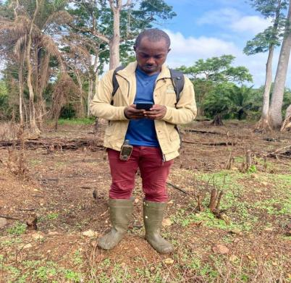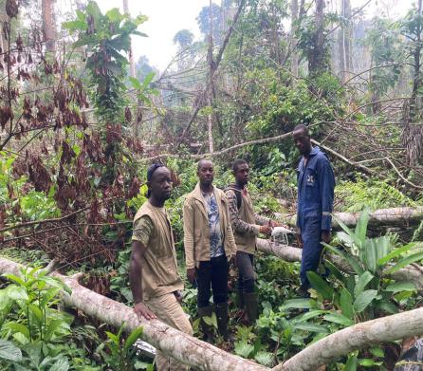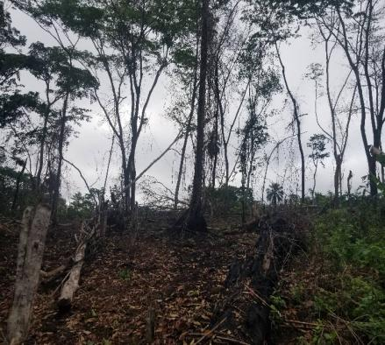
Data collection of validation deforestation alert (a) Taking deforestation alert, (b) Selective cutting of trees to open new farms, (c) burning of the forest to open new farms
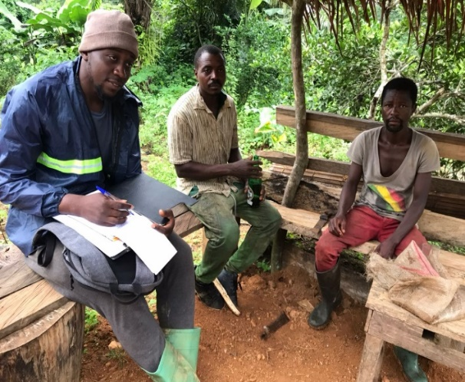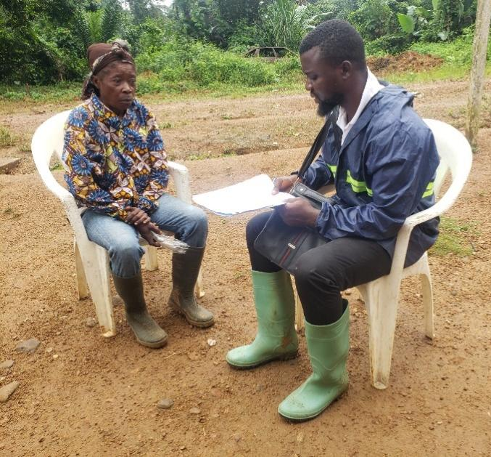
Figure 10: Collection of communities perception on deforestation drivers

4.2.4 Main drivers of deforestation identified within the KBA
- Slash and burn agriculture: This is the main cultivation method practiced in all villages with the opening of spaces that have been used for agriculture and set on fire after harvest. This plant prevents the appearance of secondary forest.
- Uncontrolled bush fires: Fire set after crop harvesting or before field preparation, with the aim of clearing the soil of weeds or giving it some fertility, often takes on dimensions that the farmers could not expect with direct effect on the forest.
- Uncontrolled cutting of trees: Though selective cutting of trees is taking place in the opening of some farms, most the forest is been cut down for creating space for land for agriculture.
- Land and resource use conflict: Land conflicts have pushed the vulnerable farmers to move right in to the primary forest to open their farms there by cutting down the forest
- Forest logging: Both conventional and illegal logging contribute to deforestation but illegal logging rates are higher than conventional logging since they felt a large portion of the forest just to take off their desired wood species and they lack the techniques and method of reduced logging impacts.
- Population increase: There has been rapid increase in population growth within the landscape which has cause high rates of deforestation as a result of increase in farm sizes and increase in build area.
From the survey, 64% responds that the forest belongs to the state and 32% states that it belongs to the village while 2% said it belongs to the chief and 2% it belongs nobody. From the analysis it shows that the forest will be under risk of deforestation because of different perceptions of ownership of the forest, table 5.
Figure 5: Forest ownership
Owner of the forest | Number of persons | Percentage (%)
Village | 32 | 32
Chief of the village | 2 | 2
State (council forest, logging concessions and forest reserves) | 64 | 64
Nobody | 2 | 2
Total | 100 | 100
3.3. Spatial Precision
3.3.1 GPS validation refined boundaries beyond pixel-level detection.
Field survey for the validation of landcover and deforestation alert indicate, there is also a rampant illegal logging within and around the council forest, communities forest and “sale by standing volume” where operators carry logs and some use engine saw to make plank to be sale in the neighboring town. There are logs without mark and some with counseled mark within, figure 11.
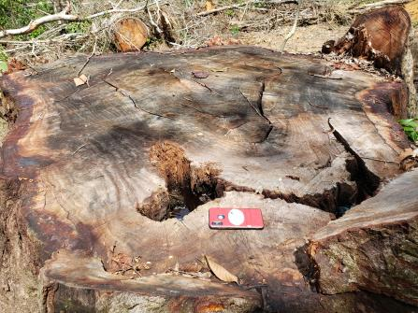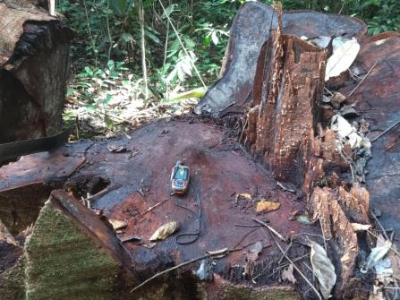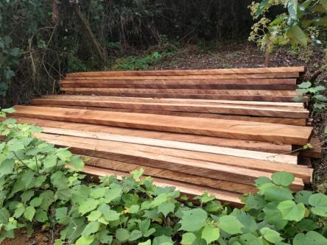
Figure 11: Zone illegal logging activities in the area of interest
The spatial evolution of deforestation drivers within a section of the area of interest indicate huge impact of human activities with large palm plantation, farmland with roads and in figure 12.
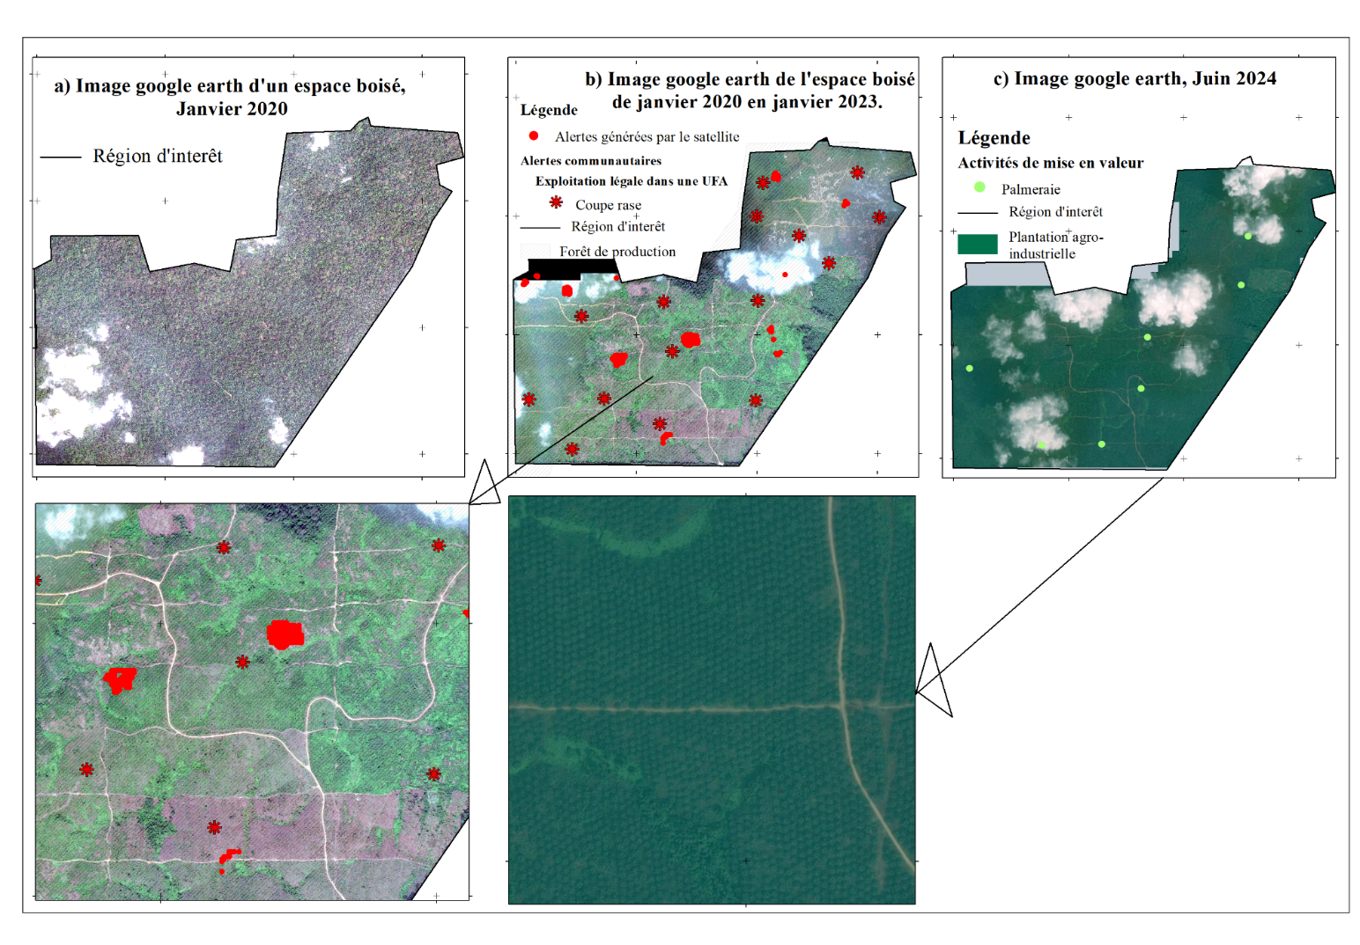
Figure 12: Evolution of deforestation drivers in Ndogbakand village
Dissemination of these activities detected by Realtime satellite monitoring with GFW platform indicate high intrusion in forest concession s classified as permanent forest zone. Alert verified show rampant logging with abandoned of logs, cocoa farming, large and small holder palm plantation. Figure 13 and 14 show the spatial representation of indicated deforestation alert and illegal activities within the study section in the KBA.
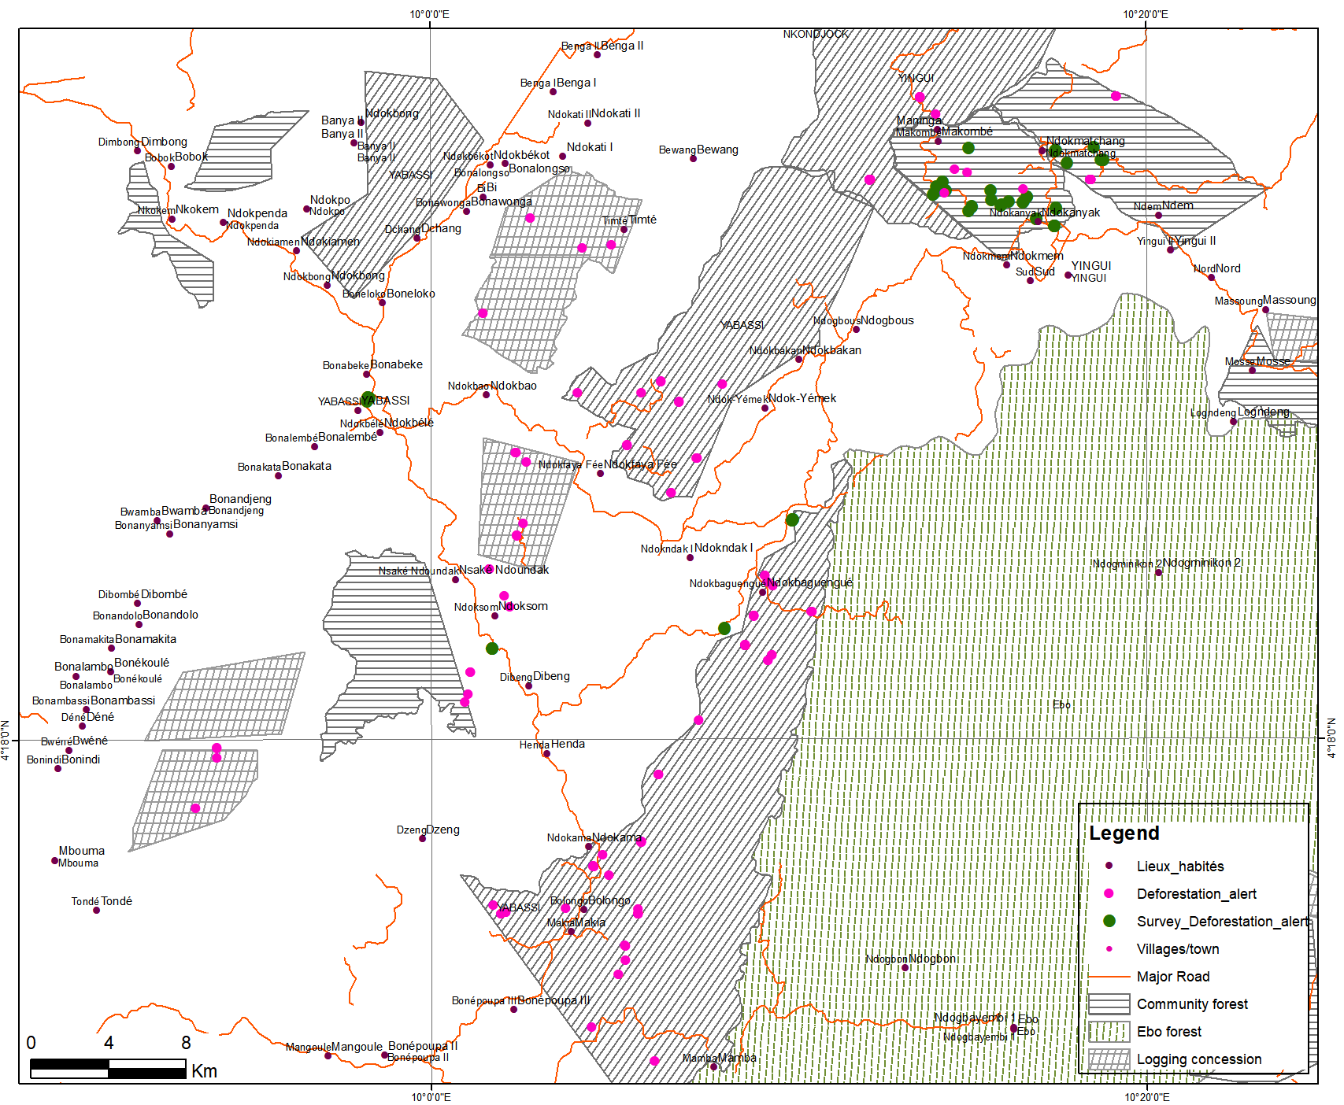
Figure 13: Spatial representation deforestation alert and survey alert of documented forest alert
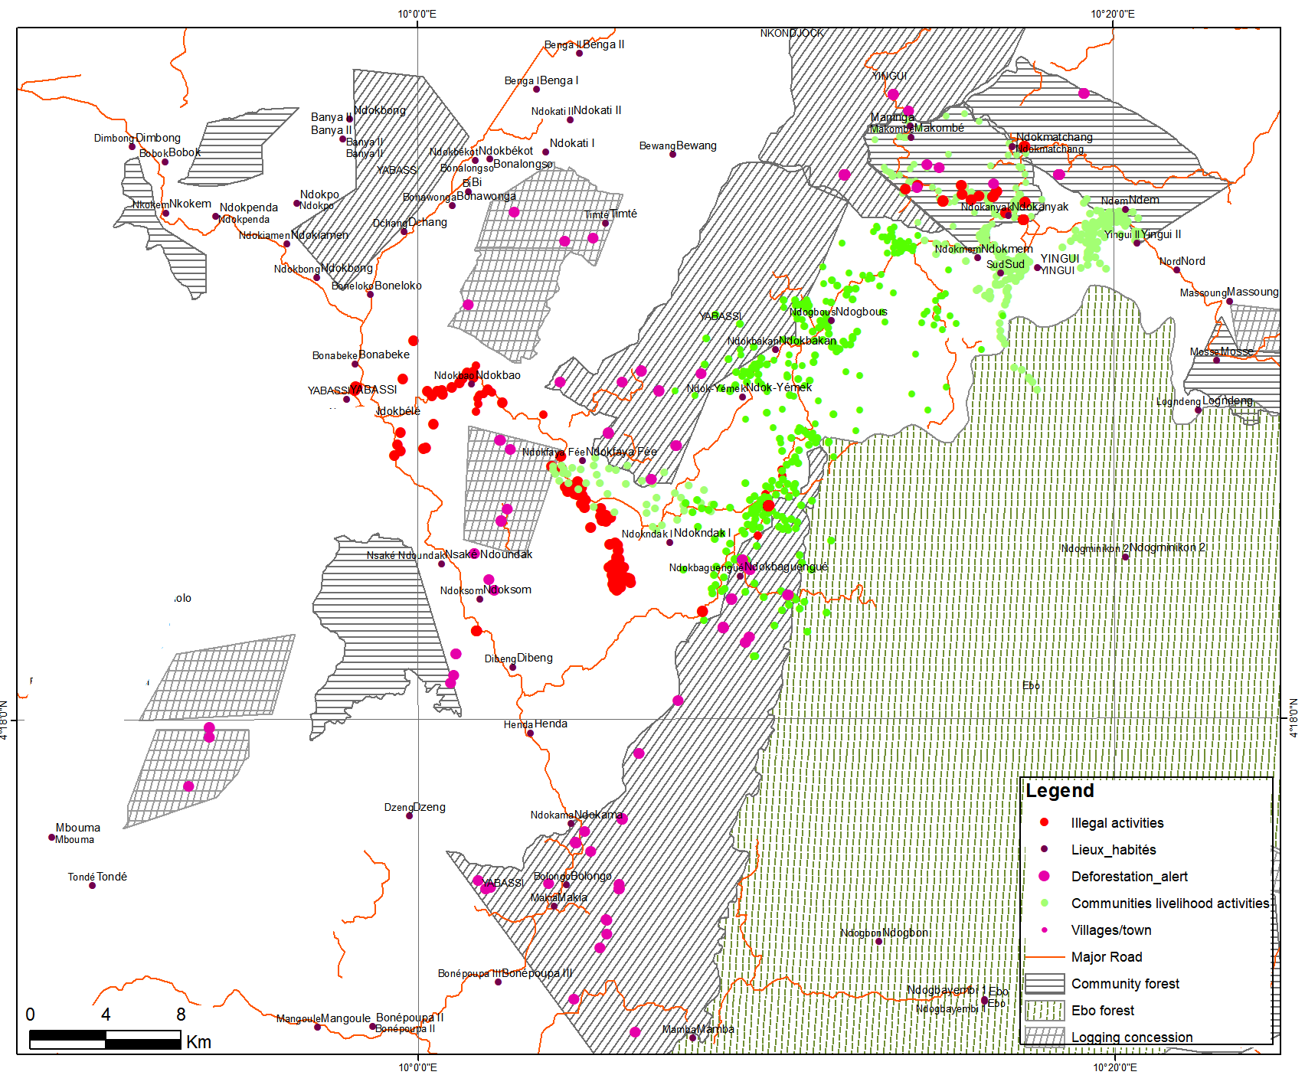
Figure 14: Spatial representation of illegal logging and community’s livelihood activities in the area of interest
3.4. Governance Response
Embedding monitoring in Community Land Use Plan (CLUP) institutionalized patrols and sanctions, closing the detection–response gap.
Of the validated alerts, 31.32% triggered governance responses including patrol deployment and sanctions, indicating a measurable reduction in the detection–response gap compared to baseline conditions where alerts were not operationalized.
Longterm deforestation monitoring for sustainable biodiversity management relies on governance structures from down to top level where communities are very important. With the rate of deforestation and drivers found in the Yabassi KBA, it was necessary to engage local communities with participatory diagnostic of deforestation causes and implementation of local landuse plan as bas for change of actions in the forest. the la land use plan come with role and responsibilities for actors to be implement in other to reduce/ stop deforestation through an elaboration of monitoring plant for the implementation by communities. CLUP committees conducted weekly patrols and applied traditional sanctions in cases of non-compliance, particularly in agricultural expansion zones. Divergent perceptions of forest ownership contribute to weak accountability and increased deforestation risk, underscoring the importance of tenure clarification in decentralized governance systems. Figure 6 indicate the monitoring plan establish by communities using landuse plan approh.
Table 6: Monitoring plan
Zone | Summary of strategic Directives | Who monitors, how, and how frequently | Next steps if rules are broken
Built Area | - lands in the area are not for sale | The CLUP committee does weekly monitoring when doing their activities | -Traditional sanction
Agriculture | - lands in the area not to be sold | The CLUP committee does weekly monitoring when doing their activities | -Traditional sanction
Forest (including Community Forest) | - lands in the area not to be sold  - No destruction of NTFPs | The CLUP committee does monthly monitoring. Once per month, field missions will be done. | -Traditional sanction

CLUP has help in the landscape to identify opportunities: (i) The creation of community forest for biodiversity preservation with 3 communities, (ii) the creation “ongoing” of 4 NTFP and forest nursery in 4 groups of communities, (iii) the initiative of community demonstration farm to trained on sustainable farming in 4 group of communities
These actions are managed by the CLUP committee put in place during CLUP process in each community. There are in charge of following the respect of activities and project agree during the process
5. Discussion
Hybrid model operationalizes adaptive governance through a structured detection, validation, response loop, and empirically demonstrates polycentric coordination across scales. While satellite-based platforms such as Global Forest Watch have significantly improved transparency and near-real-time detection of forest change, their effectiveness remains constrained by limited contextual interpretation and weak integration into governance systems (Cash et al. 2003; Curtis et al. 2018). The hybrid satellite–community monitoring model tested in the Yabassi KBA provides empirical evidence that bridging this gap enhances both monitoring accuracy and governance response.
The findings confirm that integrating community validation reduces key uncertainties in forest monitoring, particularly attribution, spatial precision, and response effectiveness. Attribution uncertainty, widely documented in global forest monitoring studies (Curtis et al. 2018), was significantly reduced through participatory validation, which enabled clear differentiation between selective logging, agricultural expansion, and plantation development. Similar findings have been reported by Danielsen et al. (2011), who demonstrate that community-based monitoring can generate data comparable in accuracy to professional scientific observations while providing richer contextual insights.
The Kappa coefficient of 0.71 demonstrates that the hybrid monitoring system achieves substantial agreement beyond chance, reinforcing its reliability for operational forest monitoring. This result aligns with findings from community-based monitoring studies (Danielsen et al. 2011), which report comparable accuracy levels when local knowledge is integrated with scientific data. Importantly, the remaining classification errors are concentrated in transitions between agricultural expansion and plantation development, highlighting persistent limitations of spectral-based detection in complex tropical landscapes.
Spatial uncertainty inherent in moderate-resolution satellite imagery was also mitigated through GPS-based field verification and drone observations. This aligns with the work of Pratihast et al. (2014), who argue that integrating local monitoring with remote sensing enhances spatial accuracy and improves the operational relevance of forest monitoring systems. The results therefore support a complementarity paradigm, were remote sensing and community knowledge function as mutually reinforcing systems.
However, the authors encountered practical challenges related to the timing of validation missions, logistical constraints, and resource limitations. Delays between alert detection and field verification sometimes reduced the reliability of driver identification, particularly in dynamic agricultural frontiers. These findings echo those of Ochieng et al. (2016), who highlight that the effectiveness of participatory monitoring depends heavily on timely data collection and sustained logistical support.
The hybrid model operationalizes adaptive governance, emphasizing iterative learning, feedback loops, and institutional flexibility (Folke et al. 2005). By linking detection (satellite alerts), validation (community engagement), and response (CLUP mechanisms), the system creates a dynamic feedback loop that enhances decision-making and supports adaptive land-use management.
This approach reflects the broader concept of knowledge co-production, where scientific and local knowledge systems are integrated to improve environmental governance (Armitage et al. 2011). Community involvement provided critical insights into local land-use dynamics, tenure systems, and socio-economic drivers that are often invisible in remote sensing datasets. As noted by Berkes (2009), such integration enhances both the legitimacy and effectiveness of environmental management systems.
Nevertheless, sustaining community participation presented challenges, including varying levels of engagement, capacity disparities, and competing livelihood priorities. These constraints are consistent with findings by Danielsen et al. (2014), who emphasize that long-term success of community-based monitoring depends on sustained incentives, institutional support, and capacity-building efforts.
The findings strongly support polycentric governance theory, which posits that multiple, interacting decision centers improve environmental management outcomes (Ostrom 2010). The hybrid model integrates global monitoring platforms, national policy frameworks, and local governance institutions, creating a multi-level system that enhances accountability and responsiveness.
However, the study also reveals important institutional challenges. While local CLUP committees effectively implemented monitoring and sanctions, integration with formal state enforcement mechanisms remained limited. Similar coordination gaps have been documented by Andersson and Ostrom (2008), who argue that decentralization alone does not guarantee effective governance unless supported by strong vertical linkages and clear institutional mandates.
These findings highlight the need for institutional bridging mechanisms that connect community-level monitoring systems with national enforcement agencies. Without such linkages, the potential of polycentric systems to improve environmental outcomes may not be fully realized.
The rapid decline in dense forest cover and expansion of secondary and mosaic forests reflect broader land-use transitions associated with agricultural intensification and agro-industrial development. Similar patterns have been observed across the Congo Basin, where infrastructure development and market integration are accelerating forest conversion (Tyukavina et al. 2018).
Importantly, the study also highlights the role of tenure ambiguity in shaping deforestation dynamics. Divergent perceptions of forest ownership among communities (state vs. local control) may reduce accountability and encourage resource exploitation. This supports findings by Robinson et al. (2014), who demonstrate that insecure or unclear tenure systems are associated with higher rates of deforestation.
Fieldwork also revealed socio-political sensitivities affecting data collection, particularly regarding illegal activities such as unauthorized logging. These challenges underscore the importance of trust-building and participatory approaches in community-based monitoring systems (Berkes 2009).
While the integration of GPS and drone technologies improved spatial precision, the authors encountered technical and infrastructural limitations, including equipment constraints, limited internet connectivity, and restricted access to high-resolution imagery. These challenges are consistent with broader findings on the digital divide in environmental monitoring systems in developing countries (Fritz et al. 2019).
Additionally, reliance on Landsat imagery for long-term analysis introduces limitations related to spatial resolution and cloud cover, potentially underestimating small-scale degradation processes. This reinforces the need for integrating higher-resolution datasets and emerging technologies such as radar and AI-based classification (Hansen et al. 2013; Tyukavina et al. 2018).

6. Conclusion
Integrating satellite alerts with structured community validation significantly reduces uncertainty in tropical deforestation detection. The hybrid monitoring model strengthens environmental management by linking technological detection with governance response. This approach provides a scalable pathway for improving tropical forest governance.
This study demonstrates that improving tropical forest monitoring requires integrating technological innovation with effective governance systems. While satellite-based platforms have enhanced the detection of forest disturbances, their impact remains limited when not connected to local validation and decision-making processes. The hybrid satellite–community monitoring model implemented in the Yabassi Key Biodiversity Area shows that combining remote sensing with participatory validation can significantly reduce uncertainties in driver attribution and spatial interpretation, while strengthening the link between detection and management response.
The findings highlight that deforestation in the study area is predominantly driven by agricultural expansion and logging, reflecting broader land-use pressures observed across tropical forest regions. By embedding monitoring within Community Land Use Planning (CLUP) structures, the model enabled locally grounded responses, including patrols, zoning enforcement, and the application of traditional sanctions. This integration demonstrates how monitoring systems can move beyond information provision to support actionable environmental management.
Consistent with the principles of adaptive and polycentric governance, the study shows that coordination across multiple institutional levels—global data platforms, national frameworks, and local governance bodies—enhances responsiveness and accountability. However, persistent challenges, including logistical constraints, uneven community participation, and limited integration with formal enforcement agencies, indicate that the effectiveness of such systems depends on sustained institutional support and capacity development.
From a management perspective, the results suggest that hybrid monitoring approaches can strengthen REDD+ Measurement, Reporting, and Verification (MRV) systems by improving data reliability and stakeholder engagement. They also provide a practical pathway for decentralizing forest governance while maintaining alignment with national and international conservation objectives.
Future efforts should prioritize scaling up hybrid monitoring systems through targeted investments in community capacity building, improved access to high-resolution data, and stronger institutional linkages between local monitoring initiatives and formal regulatory frameworks. Integrating socio-economic dimensions into monitoring systems will also be essential to address the underlying drivers of deforestation and ensure long-term sustainability.
finally, this study underscores that effective environmental management in tropical forest landscapes depends not only on the ability to detect change, but on the capacity to translate knowledge into coordinated and context-specific action.
7. Acknowledgement
The authors would like to express their sincere gratitude to the Global Forest Watch (GFW) Small Grants Fund, managed by the World Resources Institute (WRI), for providing the financial and technical support that made this research possible (2023–2024 cycle). We also thank the team at Ajemalebu Self Help (AJESH) for their coordination and the local community members of the Yabassi Key Biodiversity Area for their invaluable participation in field validation and data collection. Their commitment to sustainable forest management was essential to the success of this hybrid monitoring model.
8. Declarations
Funding: This paper is from GFW Small Grants funded by World Resource Institute in Cameroon between 2023 and 2024.
Conflict of Interest: None declared.
Ethical Approval: Community consent obtained.
Data Availability: Satellite alerts available via Global Forest Watch; validation data available upon request.

9. References
Andersson KP, Ostrom E (2008). Analyzing decentralized resource regimes. Policy Sci 41:71–93
Armitage D, Berkes F, Dale A et al (2011). Co-management and the co-production of knowledge. Glob Environ Change 21:995–1004
Berkes F (2009) Evolution of co-management. J Environ Manage 90:1692–1702
Cash DW, Clark WC, Alcock F et al (2003). Knowledge systems for sustainable development. Proc Natl Acad Sci USA 100:8086–8091
Curtis PG, Slay CM, Harris NL et al (2018). Classifying drivers of global forest loss. Science 361:1108–1111
Danielsen F et al (2014). A multicountry assessment of community monitoring. BioScience 64:236–251
Danielsen F, Burgess ND, Balmford A (2011). Monitoring matters. Conserv Biol 19:236–248
FAO (2020). Global Forest Resources Assessment 2020. FAO, Rome
Folke C et al (2005). Adaptive governance of social-ecological systems. Annu Rev Environ Resour 30:441–473
Fritz S et al (2019). Citizen science and the United Nations SDGs. Nat Sustain 2:922–930
Geist HJ, Lambin EF (2002). Proximate causes and underlying driving forces of tropical deforestation. Bioscience 52:143–150
Hansen MC, Potapov PV, Moore R et al (2013). High-resolution global maps of 21st-century forest cover change. Science 342:850–853
Herold M, Skutsch M (2011). Monitoring, reporting and verification for REDD+. Environ Res Lett 6:014002
Ochieng RM et al (2016). Motivation for participation in forest monitoring. Forest Policy Econ 65:69–77
Ostrom E (2010). Polycentric systems for coping with climate change. Glob Environ Change 20:550–557
Ostrom E (2010). Polycentric systems for coping with collective action and global environmental change. Glob Environ Change 20:550–557
Pratihast AK et al (2014). Community-based Forest monitoring. Forest Policy Econ 48:1–9
Robinson BE et al (2014) Does secure land tenure save forests? Glob Environ Change 29:281–293
Tyukavina A et al (2018). Types and rates of forest disturbance. Environ Res Lett 13:054028
World Resources Institute (2022) Global Forest Watch. Washington, DC

