Unilateral Congenital Eyelid Eversion - A Case Report

Abstract
Introduction:
Congenital Eyelid eversion is an uncommon ocular disorder that usually presents at birth with everted eyelids and prolapsed conjunctiva. Management is usually conservative though recalcitrant cases can be managed surgically.
Case Report:
6 hour old female neonate with congenital eversion of the left upper eyelid following an uneventful delivery. No other ocular or systemic anormalies were noted. Baby was treated conservatively with hypertonic saline soaked gauze and topical antibiotic ointment application. There was spontaneous resolution of the eversion after 1 week.
Conclusion
Unilateral congenital eyelid eversion is a rare condition that responds excellently to conservative management. Therefore early recognition and treatment would prevent complications and reduce the need for surgical intervention.
Key words- Unilateral, Congenital, Eyelid, Eversion

Introduction

Eyelid eversion in the newborn is a rare condition in which the upper eyelid is completely turned out with prolapse of the conjunctiva and chemosis.(1) Most times, it is present at birth but some cases of late presentation have been reported.(2–4) It is typically bilateral but unilateral presentations do occur sometimes.(5) Usually, Eyelid eversion of the Newborn resolves completely with no ocular sequelae but it could pose a threat to visual maturation by causing stimulus deprivation amblyopia if not managed promptly and appropriately(5). It could also be complicated by dessication of the prolapsed conjunctiva and infection.
This condition is frequently benign but stirs up undue anxiety in the parent, caregivers and primary care physicians who may not have had exposure to this entity.(6)
The exact aetiology is unknown however local or systemic causes leading to anterior lamellar shortening or posterior lamellar elongation or prolapse can predispose to eversion of the eyelid(7) Congenital eyelid eversion may be associated with birth trauma, prolonged or difficult labor or in systemic anomalies like Downs syndrome.(8,9)
Treatment may be conservative with antibiotics, hypertonic saline and pressure patching or surgically with temporary tarsorrhaphy.(10)
The aim of this report is to increase the awareness of this condition among pediatricians and primary care physicians and to highlight the importance of early recognition and prompt conservative management in achieving favourable outcomes.

Case Report
A 6hour old female neonate delivered via spontaneous vaginal delivery to a 30 year old woman after a full term pregnancy. Pregnancy, labour and delivery were uneventful. Birth weight- 3.8kg, she was said to have cried immediately after birth. She is the last of 3 children in a monogamous setting, no history of congenital anomalies in her other siblings. Baby was noticed to have reddish fleshy swelling over the left eyelid shortly after birth. She was admitted into the Neonatal intensive care unit and was thoroughly evaluated by the Paediatricians.
On examination, she was a healthy baby in no obvious distress. The upper lid of the left eye was everted with marked conjunctival chemosis. The right eye was normal. Attempts at repositioning the everted lid were unsuccessful. Further examination of the eyeball on the left also failed due to the marked chemosis. Hypertonic saline soaked gauze with Tobramycin ointment was placed over the everted lid . Hypertonic saline was prepared by the bedside by adding table salt to normal saline till the saturation point was reached and the salt no longer dissolved. This dressing was changed 3 times daily. One week after commencement of treatment, chemosis had resolved, the lid was properly positioned and baby could spontaneously open the eye. Further examination of the left eye revealed normal sized globe, conjunctiva was quiet, cornea was clear and the pupil was briskly reactive to light.
Baby was discharged from the hospital to be followed up on an outpatient basis. At follow up, 2weeks after discharge the eyelid remained in the normal position and there was ocular complication noted.

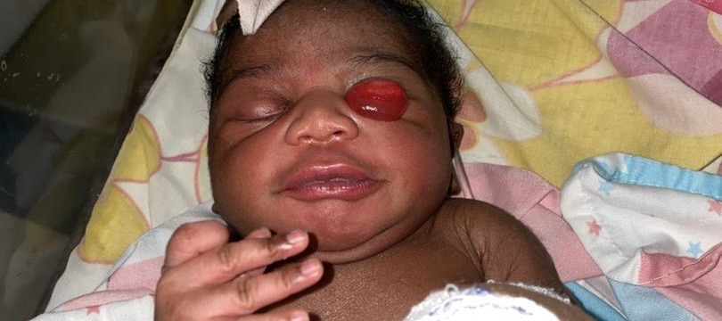 At presentation

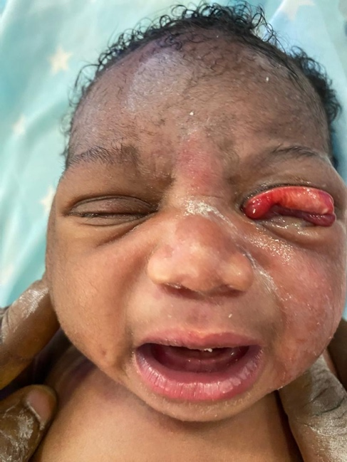 3days on conservative management

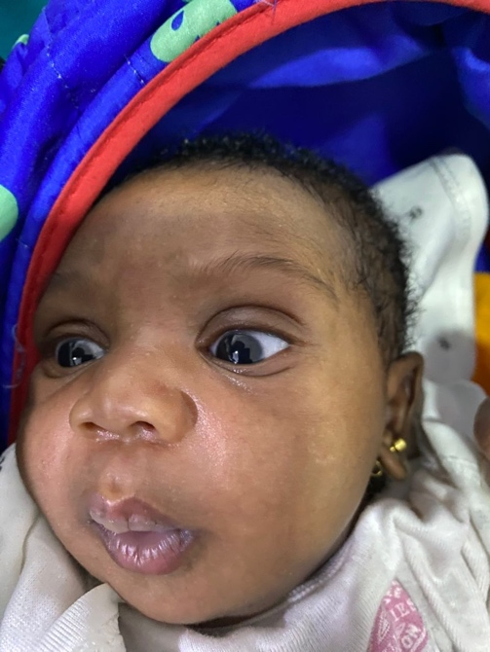 After 1 week

Discussion
Congenital lid eversion is an uncommon condition with unknown aetiology.it was first described by Adams in 1896. It more commonly presents bilaterally but some cases of unilateral presentation have been reported.(11,12) This is similar to the index case documented. Eyelid eversion in the Newborn has a higher prevalence in males and African populations though the index case was a female. (13). Most patients present soon after birth likely because of its rarity and it creates panic and undue anxiety to the parents and healthcare personnel. ml
The exact pathophysiology is unclear however some authors have implicated mode of delivery. Mechanical eversion and venous stasis during passage through the birth canal have been suggested as a cause.(8,14) This should however cause bilateral involvement as opposed to unilateral as seen in the index case. Some cases of congenital lid eversion have also been reported following caesarian delivery(13) Therefore, the role of mode of delivery is highly speculative .
Management of congenital lid eversion is mostly conservative though surgical management have been described for recalcitrant cases. Hypertonic saline soaked gauze is placed over the prolapsed conjunctiva. This helps to draw fluid out of the conjunctiva by osmosis due to the hypertonicity of the gauze. This has proven to be effective as reported in several studies and our patient responded favourably. This hypertonic saline can be easily prepared by the bedside of the patient using table salt and adding it to normal saline until it no longer dissolves. This method of treatment is easy, affordable and cost effective. It also does not require high level skill or technical know-how. Therefore, healthcare professionals that come in contact with newborns such as Obstetricians, neonatologists and primary care physicians should be aware of this condition and management .
Surgical management involves temporary tarsorhapy or the use of compression eyelid sutures.(15) This is usually reserved for cases that do not respond to conservative therapy.

Conclusion
Unilateral Congenital eyelid eversion is a rare condition that maybe encountered in neonatal and ophthalmic practice. Early recognition and conservative management with hypertonic saline is highly effective and reduces the need for unnecessary surgical intervention. Therefore, all healthcare personnel involved in the management and care of newborns should be aware of the condition as well as the appropriate management.

Ethical Consideration
This case report was made in accordance with the tenets of the Helsinki declaration.
Consent
Informed Consent was obtained from the parents of the patient before photographs were taken. The purpose and the benefits of the report were duely explained to the parents before consent were obtained.
Financial support- None
Conflict of interest- None to disclose

References

1. Bilateral Congenital Upper Eyelid Eversion (Ectropion): A Rare Presentation Responded Well to Conservative Treatment at Temeke Regional Referral Hospital-Tanzania [Internet]. [cited 2026 Jun 6]. Available from: https://www.scirp.org/journal/paperinformation?paperid=134251
2. Falilatou A, Chakiratou A, Soulé A, Lisette O, Ignace S, Sidonie T. Management of Four (4) Cases of Congenital Total Eversion of the Upper Lids using a Non-invasive Method in Northern Benin.
3. Adegbehingbe SA, Olubosede OA, Ibitoye BO. Case report of congenital bilateral ectropion of the upper eyelids in a 6 year old boy with Down Syndrome. West Niger J Med Sci [Internet]. 2024 Jun 30 [cited 2026 Jun 7];7(1):99–102. Available from: https://wnjms.com.ng/journal/index.php/wnjms/article/view/253
4. Sellar PW, Bryars JH, Archer DB. Late presentation of congenital ectropion of the eyelids in a child with Down syndrome: a case report and review of the literature. J Pediatr Ophthalmol Strabismus. 1992;29(1):64–7. doi:10.3928/0191-3913-19920101-13 PubMed PMID: 1533873.
5. Ibraheem WA. Bilateral congenital upper eyelid eversion: the clinical course and outcome of conservative management. Pan Afr Med J. 2014 Mar 18;17(215). doi:10.11604/pamj.2014.17.215.3967
6. Ne C, Vk O, A I, I J. Bilateral Congenital Upper Eyelid Eversion in a Newborn: A case Report. Ibom Med J. 2025 Jul 1;18(3):563–5. doi:10.61386/imj.v18i3.720
7. Hada M, Priyadarshini A, Upadhyay S. Congenital total eversion of the upper eyelid: report of two cases and review of literature. Indian J Clin Exp Ophthalmol. 2025 Jul 28;8(3):431–4. doi:10.18231/j.ijceo.2022.087
8. Awoyesuku EA, Pedro-Egbe CN, Sibeudu OA. Congenital upper lid eversion and severe chemosis in a new born. Niger J Clin Pract. 2014;17(2):248–50. doi:10.4103/1119-3077.127569 PubMed PMID: 24553040.
9. Sayadi J, Malek I, Abid Y, Gouider D, Mekni M, Chebbi A, et al. Case report: Severe presentation of a syndromic congenital bilateral upper eyelids eversion. Ann Med Surg. 2022 Feb 1;74:103279. doi:10.1016/j.amsu.2022.103279
10. Okonkwo SN, Nkanga ED, Etiowo NM, Iyam JE. Management of Bilateral Congenital Upper Eyelid Eversion in a Neonate. Niger J Med. 2022 Apr;31(2):229. doi:10.4103/NJM.NJM_205_21
11. Panshak T, V. Ramyil A, Maigida NB, Anyika PO, Wade P. Conservative Management of Congenital Unilateral Eyelid Ectropion in a 3-day-old Neonate in Jos North-Central Nigeria. J West Afr Coll Surg. 2022;12(1):104–6. doi:10.4103/jwas.jwas_67_22 PubMed PMID: 36203915; PubMed Central PMCID: PMC9531735.
12. Farhadi R, Farrokhfar A. Unilateral congenital upper eyelid eversion in a newborn: Conservative management and outcome. Clin Case Rep. 2022 Jan 18;10(1):e05295. doi:10.1002/ccr3.5295 PubMed PMID: 35079392; PubMed Central PMCID: PMC8766604.
13. Almajed F, Alsulaiman HM, AlMadhi N, Schellini SA, Sesma G. Congenital bilateral upper lid eversion. Saudi J Ophthalmol. 2021 Jul 29;34(4):324–7. doi:10.4103/1319-4534.322620 PubMed PMID: 34527884; PubMed Central PMCID: PMC8409351.
14. Adeoti CO, Ashaye AO, Isawumi MA, Raji RA. Non-Surgical Management of Congenital Eversion of the Eyelids. J Ophthalmic Vis Res. 2010 Jul;5(3):188–92. PubMed PMID: 22737355; PubMed Central PMCID: PMC3379910.
15. Fasina O. Management of Bilateral Congenital Upper Eyelid Eversion with Severe Chemosis. J Ophthalmic Vis Res. 2013 Apr;8(2):175–8. PubMed PMID: 23943693; PubMed Central PMCID: PMC3740470.

