A Comparative Study of U-Net and YOLOv11 for Human Pose Segmentation on TikTok Dance Dataset
Kelvin Amos Nicodemas, Trapp Sunday Kayuni
School of AI, Nanjing University of Information Science and Technology

ABSTRACT
Human pose segmentation has become a core component of modern computer vision pipelines for motion analysis, interactive media, and human-centered understanding, particularly in unconstrained social-video environments. However, real-world dance footage introduces persistent challenges, including fast articulation, motion blur, self-occlusion, scale variation, complex backgrounds, and multiple overlapping performers. These factors make pixel-accurate segmentation difficult and motivate rigorous model comparison under consistent experimental conditions. This paper presents a systematic comparative study of two representative paradigms for segmentation: U-Net, an encoder-decoder architecture with skip connections designed for dense pixel prediction, and YOLOv11, a single-stage detection-segmentation framework optimized for efficiency and multi-instance reasoning. Using a curated TikTok dance dataset, both models are trained and evaluated under harmonized settings, including standardized preprocessing, controlled augmentation, and unified evaluation metrics. Performance is assessed through IoU, Dice, precision, recall, F1-score, mAP@0.5, confusion-matrix analysis, and qualitative mask inspection to capture both quantitative accuracy and practical segmentation behavior. The results show consistent performance differences aligned with architectural design: YOLOv11 provides stronger overall segmentation quality and superior robustness in crowded, dynamic scenes, while U-Net remains competitive in simpler conditions and offers an interpretable dense-prediction baseline. Beyond reporting metric values, the study analyzes convergence patterns, boundary quality, computational behavior, and deployment implications for real-time applications. The findings provide reproducible evidence for selecting segmentation architectures in dance-centric vision tasks and establish a clear experimental pipeline for future extensions to larger datasets, temporal modeling, domain transfer, and hybrid optimization strategies across diverse human-motion scenarios. The study also emphasizes reproducibility through controlled settings, transparent metrics, and consistent reporting practices for fair cross-model evaluation.
Keywords: Human Pose Segmentation, U-Net, YOLOv11, Instance Segmentation, Deep Learning

INTRODUCTION
The convergence of computer vision and deep learning has catalyzed remarkable advances in understanding human motion and form. Human pose estimation and instance segmentation, once considered distinct research domains, now represent interconnected challenges underpinning diverse applications including healthcare monitoring, entertainment platforms, and augmented reality experiences. As social media platforms proliferate and user-generated content reaches unprecedented volumes, the demand for robust, real-time pose analysis systems has intensified, creating new opportunities and challenges for the research community.
Within this evolving landscape, two architectural paradigms have emerged as dominant approaches. The U-Net architecture, originally conceived for biomedical image segmentation, has demonstrated remarkable versatility across domains requiring precise boundary delineation. Its symmetric encoder-decoder structure, augmented by skip connections that preserve spatial information, enables generation of high-resolution segmentation masks capturing fine anatomical details. Conversely, the YOLO family has revolutionized real-time object detection by reformulating detection as a single regression problem. YOLOv11, the latest iteration, extends this philosophy to encompass instance segmentation, delivering bounding boxes, class predictions, and pixel-level masks through a unified forward pass.
Despite individual successes, the research community lacks systematic comparative analyses evaluating these architectures under controlled experimental conditions. This gap is particularly pronounced for human pose segmentation with challenging, real-world datasets capturing the full complexity of human movement. To address this limitation, this study presents a rigorous comparison of U-Net and YOLOv11 on a custom-annotated TikTok dance dataset, evaluating both models across IoU, Dice coefficient, mAP, F1-score, pixel accuracy, and inference time. The remainder of this paper is organized as follows: Section 2 surveys foundational literature, Section 3 details the methodology, Section 4 presents results and discussion, and Section 5 concludes with future directions.

LITERATURE REVIEW
The evolution of visual segmentation techniques represents one of the most transformative trajectories in computer vision. Understanding this progression provides essential context for the comparative analysis presented in this study.

Semantic and instance segmentation
Semantic segmentation assigns categorical labels to every pixel, while instance segmentation additionally distinguishes between individual objects of the same category. Long et al. [6] introduced fully convolutional networks (FCNs), demonstrating that end-to-end pixel-wise classification could be achieved by replacing dense layers with convolutional operations. Building upon this foundation, Ronneberger et al. [11] proposed U-Net, introducing symmetric encoder-decoder pathways connected through skip connections that preserve spatial information lost during downsampling. Subsequent innovations expanded these capabilities: V-Net [7] addressed volumetric medical imaging, Attention U-Net [8] incorporated attention mechanisms for salient region focus, and Mask R-CNN [4] established new instance segmentation benchmarks by augmenting detection frameworks with parallel mask prediction branches.

YOLO architecture evolution
The YOLO paradigm fundamentally transformed object detection by reframing it as a unified regression problem amenable to single-stage inference [10]. YOLOv3 [9] introduced multi-scale prediction through feature pyramid networks, while YOLOv4 [1] consolidated numerous optimizations including CSPDarknet backbones and path aggregation networks. The integration of instance segmentation into YOLO emerged through models like YOLACT [2], demonstrating that bounding boxes, class labels, and segmentation masks could be predicted simultaneously. YOLOv11 synthesizes these advances with optimized backbone architectures and adaptive training mechanisms, establishing new benchmarks for simultaneous detection and segmentation [12].

Research gap
Comparative studies by Garcia-Garcia et al. [3] documented U-Net’s dominance in medical imaging while noting successful transfer to natural images. Kundu et al. [5] found that U-Net architectures excel in segmentation fidelity while YOLO-based models achieve superior detection speed. However, direct comparisons on human pose estimation datasets with real-world variance remain scarce, particularly between U-Net and current-generation YOLO models. This study addresses this gap through systematic evaluation on a custom dance pose dataset.

METHODOLOGY
This section presents the comparative evaluation methodology encompassing dataset preparation, experimental configuration, and the complete training pipeline for both architectures. Each component is designed to ensure reproducibility and fair comparison, with the overall workflow progressing from data acquisition through model training to performance evaluation.

Dataset
A custom dataset was assembled combining publicly available examples with internally collected samples extracted from TikTok dance videos. The selection criteria prioritized dynamic, often extreme poses that challenge conventional segmentation systems, ensuring the dataset captures the full variability inherent in real-world human movement. Each image I ∈ ℝ^(H×W×3) was paired with a corresponding binary segmentation mask M ∈ {0,1}^(H×W), where foreground pixels representing the human figure are labeled as 1 and background pixels as 0. For YOLOv11 training, additional instance-level bounding box annotations were generated specifying the spatial coordinates and dimensions of each subject. Annotation quality was ensured through a rigorous two-reviewer protocol, wherein each image was independently labeled by two annotators and discrepancies were resolved through consensus. The complete dataset was randomly stratified into training (80%), validation (10%), and test (10%) partitions, with stratification ensuring proportional representation of pose diversity and background complexity across all splits.

Experimental setup
All experiments were conducted on an NVIDIA RTX 4060 GPU with 12GB VRAM using PyTorch as the deep learning framework. Table I summarizes the complete experimental configuration for both architectures, encompassing input specifications, optimization parameters, and regularization strategies.
Table I. Experimental configuration.
Component | U-Net | YOLOv11
Input Resolution | 256 × 256 | 640 × 640
Output Mask Size | 128 × 128 | 640 × 640
Optimizer | Adam | AdamW
Learning Rate | 1 × 10⁻⁴ | 1 × 10⁻³ → 1 × 10⁻⁵
Batch Size | 8 | 16
Maximum Epochs | 100 | 100
Early Stopping | 10 epochs patience | 15 epochs patience
LR Scheduler | StepLR (γ=0.1) | Cosine Annealing
Weight Decay | 1 × 10⁻⁵ | 1 × 10⁻⁵
Dropout Rate | 0.5 | 0.0
Augmentation | Flip, Rotate, Scale | Mosaic, MixUp, Flip
Random seeds were fixed across all experiments to ensure reproducibility, and results are reported as mean ± standard deviation across multiple runs.

Training process
The training pipeline initiates with a preprocessing stage that prepares raw images for neural network consumption. All images are first resized to architecture-specific dimensions 256×256 pixels for U-Net and 640×640 pixels for YOLOv11 and pixel intensities are normalized to the [0,1] range through division by 255. To ensure discrete class assignments suitable for binary classification, ground-truth masks undergo thresholding according to:
$$\text{M}{\text{′}}_{\text{i}\text{,}\text{j}}\text{=}\left\{\begin{matrix}\text{1} & \text{if}{\text{M}}_{\text{i}\text{,}\text{j}}\text{≥0.5} \\ \text{0} & \text{otherwise}\end{matrix}\right. \left(\text{1}\right)$$
This binarization step eliminates ambiguous boundary pixels that could otherwise introduce noise during gradient computation. The preprocessed data then undergoes augmentation to expand the effective training distribution and improve generalization. Geometric transformations including random horizontal flips, rotations sampled uniformly from [-15°, 15°], and scale transformations from [0.8, 1.2] simulate the natural variability in dancer positioning and camera angles. YOLOv11 additionally employs Mosaic and MixUp augmentations that combine multiple training images, further improving robustness to scale and context variations encountered in real-world deployment.
Following preprocessing, the augmented data flows into the respective model architectures for feature learning. The U-Net architecture implements a fully convolutional encoder-decoder design that progressively extracts and reconstructs spatial features. The encoder pathway captures hierarchical representations through repeated sequences of 3×3 convolutions followed by ReLU activations and 2×2 max pooling operations, where each encoder layer transforms its input according to:
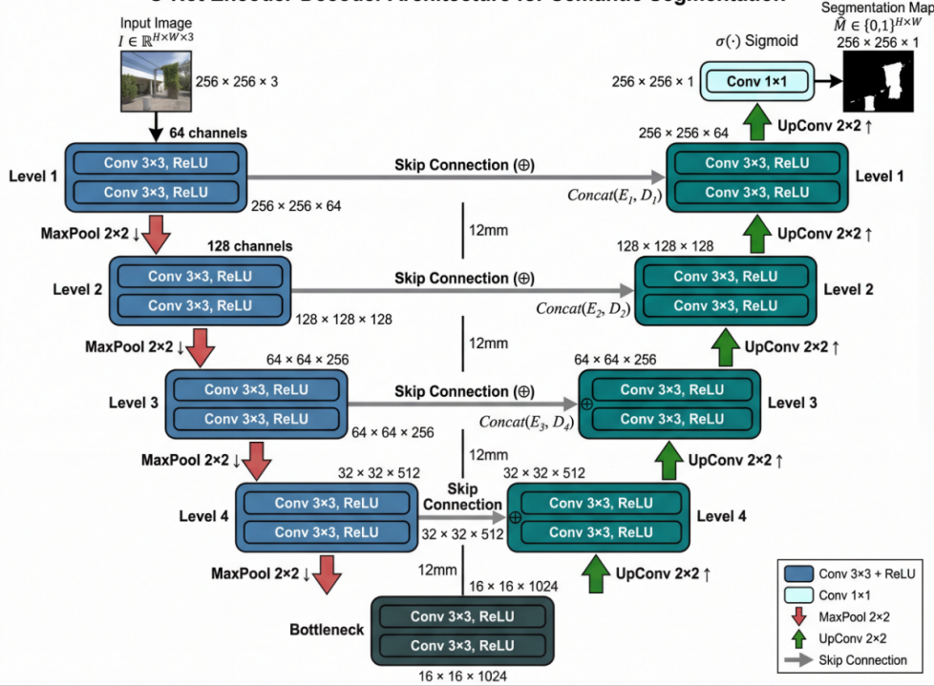
Figure 1. U-Net encoder-decoder architecture with skip connections.
$${\text{E}}_{\text{l}}\text{=ReLU}\left(\text{Conv2D}\left({\text{E}}_{\text{l}\text{−1}}\text{,}{\text{w}}_{\text{l}}\right)\right) \left(\text{2}\right)$$
This operation enables the network to learn increasingly abstract feature representations as depth increases, with early layers capturing low-level edges and textures while deeper layers encode semantic pose information. The encoder’s downsampling operations reduce spatial dimensions while increasing channel depth, creating a compressed feature representation that captures global context but loses fine-grained spatial detail.
To recover this spatial information essential for precise boundary delineation, the decoder pathway mirrors the encoder structure through transposed convolutions that progressively upsample feature maps. The critical innovation of U-Net lies in its skip connections, which concatenate encoder features at corresponding resolution levels to preserve fine-grained spatial information that would otherwise be lost during the encoding process. Each decoder layer combines upsampled features with skip-connected encoder features according to:
$${\text{D}}_{\text{l}}\text{=ReLU}\left(\text{Conv2D}\left(\text{Concat}\left({\text{D}}_{\text{l}\text{−1}}\text{,}{\text{E}}_{\text{L}\text{−}\text{l}}\right)\text{,}\text{w}{\text{′}}_{\text{l}}\right)\right) \left(\text{3}\right)$$
This fusion mechanism enables the decoder to leverage both high-level semantic information from deeper layers and precise localization information from shallower layers, producing segmentation masks with accurate boundaries. The final decoder output is transformed into probability maps through a sigmoid activation function that squashes values to the [0,1] range:
$$\hat{\text{M}}\text{=}\text{σ}\left(\text{WD}\text{+}\text{b}\right)\text{, }\text{σ}\left(\text{x}\right)\text{=}\frac{\text{1}}{\text{1+}{\text{e}}^{\text{−}\text{x}}} \left(\text{4}\right)$$
The sigmoid output represents per-pixel probability of belonging to the foreground class, enabling soft predictions that capture uncertainty at ambiguous boundaries.
With the forward pass complete, the training process proceeds to loss computation and backpropagation. U-Net employs Binary Cross-Entropy loss that treats each pixel as an independent binary classification problem, computing the discrepancy between predicted probabilities and ground-truth labels:
$${\text{ℒ}}_{\text{BCE}}\text{=−}\frac{\text{1}}{\text{N}}\sum_{\text{i}\text{=1}}^{\text{N}}{\left[{\text{M}}_{\text{i}}\text{log}\left({\hat{\text{M}}}_{\text{i}}\right)\text{+}\left(\text{1−}{\text{M}}_{\text{i}}\right)\text{log}\left(\text{1−}{\hat{\text{M}}}_{\text{i}}\right)\right]} \left(\text{5}\right)$$
where N represents the total number of pixels. This loss function provides stable gradients throughout training and penalizes confident incorrect predictions more heavily than uncertain ones, encouraging the network to calibrate its probability estimates appropriately.
YOLOv11 implements a fundamentally different single-stage approach that jointly optimizes detection and segmentation objectives. The optimized backbone network extracts hierarchical features that flow through a feature pyramid network for multi-scale representation, enabling robust detection across the range of object sizes encountered in dance videos. Task-specific prediction heads simultaneously output bounding boxes, class probabilities, and segmentation masks in a single forward pass, eliminating the computational overhead of separate detection and segmentation stages. This unified architecture necessitates a composite loss function that balances three complementary objectives: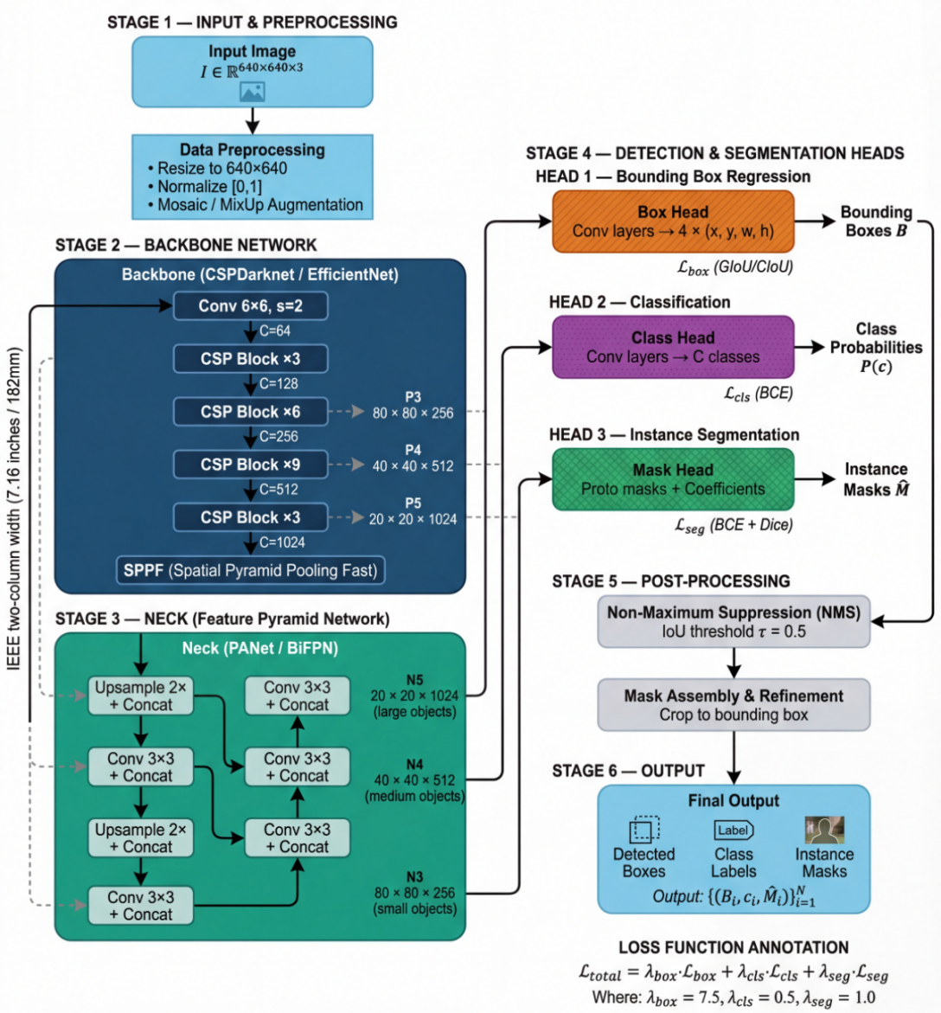
Figure 2. YOLOv11 detection-segmentation architecture and multi-task prediction heads.
$${\text{ℒ}}_{\text{YOLOv}\text{11}}\text{=}{\text{λ}}_{\text{box}}\text{⋅}{\text{ℒ}}_{\text{box}}\text{+}{\text{λ}}_{\text{cls}}\text{⋅}{\text{ℒ}}_{\text{cls}}\text{+}{\text{λ}}_{\text{seg}}\text{⋅}{\text{ℒ}}_{\text{seg}} \left(\text{6}\right)$$
where L_box employs Generalized IoU for box regression ensuring accurate localization, L_cls uses Binary Cross-Entropy for classification maintaining detection reliability, and L_seg combines BCE with Dice loss for segmentation quality. The Dice component directly optimizes the overlap between predicted and ground-truth masks, providing gradient signals that complement the pixel-wise BCE loss:
$${\text{ℒ}}_{\text{Dice}}\text{=1−}\frac{\text{2}\sum_{\text{i}\text{=1}}^{\text{N}}{{\hat{\text{M}}}_{\text{i}}}{\text{M}}_{\text{i}}\text{+ϵ}}{\sum_{\text{i}\text{=1}}^{\text{N}}{{\hat{\text{M}}}_{\text{i}}}\text{+}\sum_{\text{i}\text{=1}}^{\text{N}}{{\text{M}}_{\text{i}}}\text{+ϵ}} \left(\text{7}\right)$$
where ε = 10⁻⁶ prevents division by zero. This formulation directly maximizes the Dice coefficient during training, addressing the class imbalance inherent in segmentation tasks where background pixels typically outnumber foreground pixels.
Upon completion of training, model performance is evaluated using a comprehensive metric suite that quantifies segmentation quality from multiple perspectives. Intersection over Union measures the overlap between predicted and ground-truth masks relative to their union, providing a stringent assessment of boundary accuracy:
$$\text{IoU}\text{=}\frac{\left|\hat{\text{M}}\text{∩}\text{M}\right|}{\left|\hat{\text{M}}\text{∪}\text{M}\right|} \left(\text{8}\right)$$
The Dice coefficient offers an alternative overlap measure that weights precision and recall equally, providing consistency with the training objective:
$$\text{Dice}\text{=}\frac{\text{2}\left|\hat{\text{M}}\text{∩}\text{M}\right|}{\left|\hat{\text{M}}\right|\text{+}\left|\text{M}\right|} \left(\text{9}\right)$$
Pixel accuracy quantifies the proportion of correctly classified pixels across the entire image, capturing overall segmentation quality:
$$\text{Acc}\text{=}\frac{\text{1}}{\text{N}}\sum_{\text{i}\text{=1}}^{\text{N}}{\text{1}}\left[{\hat{\text{M}}}_{\text{i}}\text{=}{\text{M}}_{\text{i}}\right] \left(\text{10}\right)$$
Additionally, F1-score balances precision and recall through their harmonic mean, mean Average Precision at IoU thresholds of 0.5 and 0.75 quantifies detection performance for YOLOv11, and inference time measured as average forward pass duration per image assesses real-time deployment feasibility.

RESULTS AND DISCUSSION
This section presents experimental findings through quantitative benchmarking, ablation analysis, and comparative discussion. Results are reported as mean ± standard deviation across multiple runs to ensure statistical robustness.

Results
Table II summarizes the comparative performance across all evaluated metrics, revealing distinct performance profiles reflecting architectural priorities; Figure 5 shows optimization behavior, Figure 6 presents qualitative outputs, and Figure 7 reports class-level discrimination.
Table II. Comparative performance of U-Net and YOLOv11.
Metric | U-Net | YOLOv11 | Δ
IoU (%) | 54.3 ± 1.2 | 69.5 ± 1.4 | +15.2
Dice (%) | 70.2 ± 1.0 | 81.5 ± 1.1 | +11.3
mAP@0.5 (%) | 85.2 ± 1.5 | 99.5 ± 0.2 | +14.3
mAP@0.75 (%) | 62.1 ± 2.0 | 85.3 ± 0.8 | +23.2
F1-Score (%) | 69.0 ± 1.3 | 82.7 ± 0.9 | +13.7
Pixel Accuracy (%) | 95.6 ± 0.7 | 97.9 ± 0.5 | +2.3
Inference Time (ms) | 37.2 ± 2.3 | 14.8 ± 1.0 | 2.5× faster
YOLOv11 demonstrates clear superiority across all metrics, achieving 15.2 percentage point higher IoU (69.5% vs. 54.3%), 11.3 percentage point higher Dice coefficient, and inference times 2.5× faster than U-Net. The mAP@0.5 of 99.5% indicates near-perfect detection at the standard IoU threshold, translating to approximately 67 FPS real-time capability compared to U-Net’s 27 FPS.
Analysis of training dynamics reveals contrasting convergence behaviors between the two architectures. U-Net exhibits smooth, monotonic convergence over 100 epochs, with training and validation loss curves closely tracking each other throughout optimization, indicating effective regularization and minimal overfitting. YOLOv11 displays more complex dynamics reflecting its multi-task learning objective, with individual loss components box regression, segmentation, and classification converging at different rates before stabilizing by epoch 50. Visual inspection of predicted segmentation masks reveals that U-Net produces smoother boundaries and anatomically coherent silhouettes in simple scenes, while YOLOv11 maintains superior instance-level consistency in complex scenarios with overlapping subjects. Confusion matrix analysis confirms high classification reliability for both models, with YOLOv11 achieving approximately 99% dancer-class recognition accuracy.
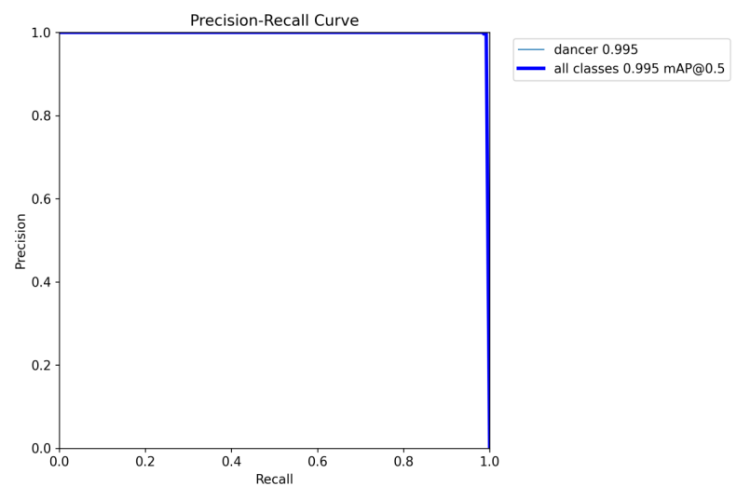
Figure 3: Precision-Recall Curve for Mask Segmentation. The curve demonstrates near-perfect performance with mAP@0.5 approaching 1.0, indicating excellent segmentation quality across all recall levels.

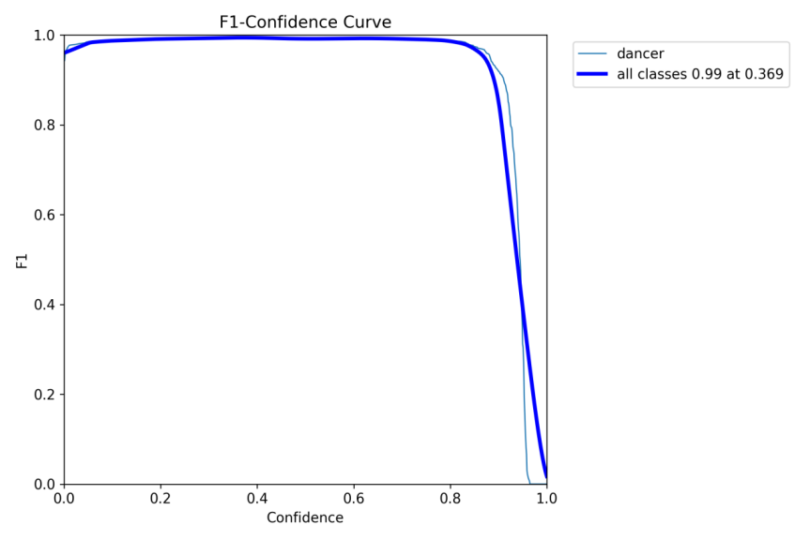
Figure 4: F1-Score vs. Confidence Threshold. High F1 scores are maintained across a wide confidence range, demonstrating robust model performance at various operating points.
YOLOv11.]

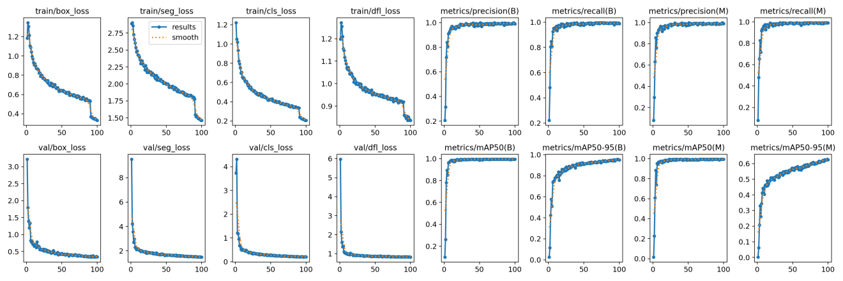
Figure 5: Training and Validation Metrics over 100 Epochs. Loss curves (left) show consistent convergence, while precision, recall, and mAP metrics (right) demonstrate stable performance improvement.
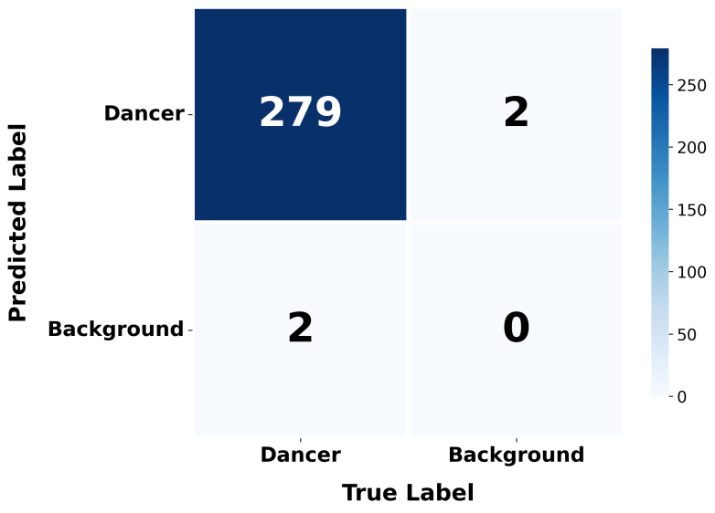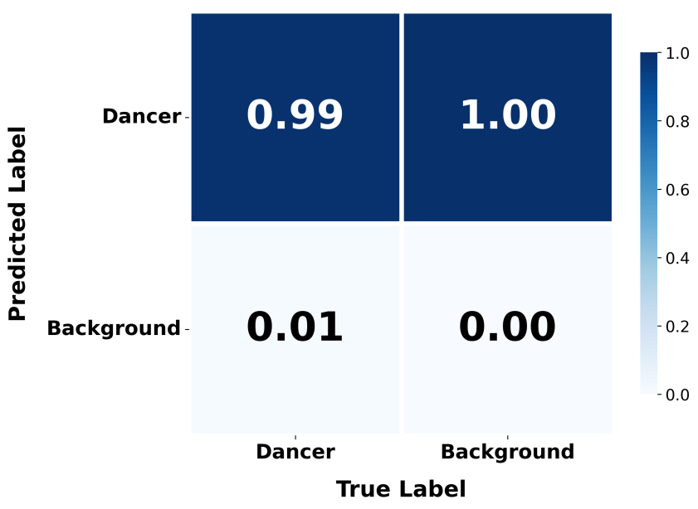
Figure 6: Normalized Confusion Matrix for YOLOv11 Segmentation. The model achieves 99% accuracy for dancer classification with only 1% false negative rate.

Ablation studies
To understand the contribution of key design choices, ablation experiments examined the impact of augmentation strategies, input resolution, and loss functions on model performance.
Table III. Ablation study results.
Configuration | U-Net IoU (%) | YOLOv11 IoU (%)
Full model (baseline) | 54.3 | 69.5
Without augmentation | 48.1 (−6.2) | 62.3 (−7.2)
Reduced resolution (128×128 / 320×320) | 46.7 (−7.6) | 58.9 (−10.6)
BCE loss only (no Dice) | 51.8 (−2.5) | 65.1 (−4.4)
Without weight decay | 52.1 (−2.2) | 67.2 (−2.3)
The ablation results reveal that data augmentation contributes approximately 6-7 percentage points to IoU performance for both models, confirming its critical role in preventing overfitting and improving generalization to unseen poses. Input resolution significantly impacts performance, with higher resolutions enabling finer boundary delineation the performance degradation is more severe for YOLOv11 (−10.6 points) than U-Net (−7.6 points), reflecting YOLOv11’s greater reliance on multi-scale feature pyramids that benefit from high-resolution inputs. For YOLOv11, the combined BCE+Dice loss outperforms BCE-only by 4.4 percentage points, validating the multi-objective training strategy where the Dice component provides complementary gradient signals directly optimizing the overlap metric. Weight decay regularization contributes approximately 2.2-2.3 percentage points for both architectures, demonstrating consistent benefits across different model paradigms.

Discussion
The observed performance differentials reflect fundamental architectural differences aligned with each model’s design objectives. U-Net’s encoder-decoder structure with skip connections is optimized for pixel-wise prediction, producing smooth, coherent masks through progressive feature refinement. However, it lacks explicit mechanisms for instance discrimination, treating all foreground pixels equivalently regardless of object identity. YOLOv11’s unified detection-segmentation framework addresses this limitation through joint prediction of bounding boxes and instance masks, with anchor-free detection and multi-scale feature pyramids enabling robust detection across object scales.
From a deployment perspective, the results establish clear application-specific recommendations. YOLOv11 is recommended for real-time applications demanding high throughput and multi-instance capability surveillance systems, robotics, live analytics, and human-computer interaction benefit from its 67 FPS processing capability and superior instance-level consistency. U-Net remains competitive for offline analysis prioritizing maximum segmentation smoothness, particularly in medical imaging applications or detailed silhouette extraction where inference latency is unconstrained and boundary precision is paramount. The 2.5× speedup advantage of YOLOv11, combined with its superior accuracy metrics, represents a Pareto improvement positioning it as the dominant choice for most practical deployment scenarios.

CONCLUSION
This study presented a systematic comparative analysis of U-Net and YOLOv11 for human pose segmentation on a custom TikTok dance dataset. The experimental results demonstrate that YOLOv11 achieves state-of-the-art performance across all evaluated metrics: IoU (69.5%), Dice coefficient (81.5%), F1-score (82.7%), pixel accuracy (97.9%), and mAP@0.5 (99.5%), with inference times 2.5× faster than U-Net. Ablation studies confirmed the importance of data augmentation (+6-7 points), input resolution (+7-10 points), and combined loss functions (+4.4 points) for optimal performance.
These findings position YOLOv11 as the preferred architecture for real-time, multi-instance segmentation applications including live surveillance, robotics, and human-computer interaction. U-Net remains viable for scenarios prioritizing segmentation smoothness over processing speed. Future research directions include extending evaluation to transformer-based architectures such as SegFormer, investigating model optimization techniques for edge deployment, and incorporating uncertainty estimation for safety-critical applications.

REFERENCES
1. J. Long, E. Shelhamer, and T. Darrell, "Fully convolutional networks for semantic segmentation," in Proc. IEEE CVPR, 2015, pp. 3431-3440.
2. Y. Chen, Y. Tian, and M. He, "Monocular human pose estimation: A survey," Comput. Vis. Image Underst., vol. 192, 2020.
3. Z. Cao et al., "OpenPose: Realtime multi-person 2D pose estimation," IEEE TPAMI, vol. 43, no. 1, pp. 172-186, 2021.
4. K. Sun et al., "Deep high-resolution representation learning for visual recognition," IEEE TPAMI, vol. 43, no. 10, pp. 3349-3364, 2021.
5. O. Ronneberger, P. Fischer, and T. Brox, "U-Net: Convolutional networks for biomedical image segmentation," in Proc. MICCAI, 2015, pp. 234-241.
6. J. Redmon et al., "You Only Look Once: Unified, real-time object detection," in Proc. IEEE CVPR, 2016, pp. 779-788.
7. Z. Zhou et al., "UNet++: A nested U-Net architecture," in Proc. DLMIA, 2018, pp. 3-11.
8. H. Huang et al., "UNet 3+: A full-scale connected UNet," in Proc. IEEE ICASSP, 2020, pp. 1055-1059.
9. N. Ibtehaz and M. S. Rahman, "MultiResUNet: Rethinking the U-Net architecture," Neural Netw., vol. 121, pp. 74-87, 2020.
10. F. Isensee et al., "nnU-Net: A self-configuring method," Nat. Methods, vol. 18, no. 2, pp. 203-211, 2021.
11. J. Redmon and A. Farhadi, "YOLOv3: An incremental improvement," arXiv:1804.02767, 2018.
12. A. Bochkovskiy et al., "YOLOv4: Optimal speed and accuracy," arXiv:2004.10934, 2020.
13. C.-Y. Wang et al., "YOLOv7: Trainable bag-of-freebies," in Proc. IEEE CVPR, 2023, pp. 7464-7475.
14. Ultralytics, "YOLOv11," GitHub Repository, 2024.
15. A. Garcia-Garcia et al., "A survey on deep learning techniques for semantic segmentation," Appl. Soft Comput., vol. 70, pp. 41-65, 2018.
16. S. Kundu et al., "Comparison of deep learning models for medical image segmentation," Comput. Biol. Med., vol. 138, 2021.
17. T.-Y. Lin et al., "Microsoft COCO: Common objects in context," in Proc. ECCV, 2014, pp. 740-755.
18. M. Cordts et al., "The Cityscapes dataset," in Proc. IEEE CVPR, 2016, pp. 3213-3223.
19. S. Minaee et al., "Image segmentation using deep learning: A survey," IEEE TPAMI, vol. 44, no. 7, pp. 3523-3542, 2022.
20. K. Simonyan and A. Zisserman, "Very deep convolutional networks," in Proc. ICLR, 2015.
21. F. Milletari et al., "V-Net: Fully convolutional neural networks," in Proc. 3DV, 2016, pp. 565-571.
22. O. Oktay et al., "Attention U-Net: Learning where to look," arXiv:1804.03999, 2018.
23. L.-C. Chen et al., "DeepLab: Semantic image segmentation," IEEE TPAMI, vol. 40, no. 4, pp. 834-848, 2018.
24. K. He et al., "Mask R-CNN," in Proc. IEEE ICCV, 2017, pp. 2980-2988.
25. Y. Lee and J. Park, "CenterMask: Real-time anchor-free instance segmentation," in Proc. IEEE CVPR, 2020, pp. 13903-13912.
26. J. Redmon and A. Farhadi, "YOLO9000: Better, faster, stronger," in Proc. IEEE CVPR, 2017, pp. 6517-6525.
27. G. Jocher et al., "YOLOv5 by Ultralytics," GitHub Repository, 2020.
28. D. Bolya et al., "YOLACT: Real-time instance segmentation," in Proc. IEEE ICCV, 2019, pp. 9156-9165.
29. D. Bolya et al., "YOLACT++: Better real-time instance segmentation," IEEE TPAMI, vol. 44, no. 2, pp. 1108-1121, 2022.
30. X. Wang et al., "SOLOv2: Dynamic and fast instance segmentation," in Proc. NeurIPS, 2020, pp. 17721-17732.
31. A. Toshev and C. Szegedy, "DeepPose: Human pose estimation via deep neural networks," in Proc. IEEE CVPR, 2014, pp. 1653-1660.
32. S.-E. Wei et al., "Convolutional pose machines," in Proc. IEEE CVPR, 2016, pp. 4724-4732.
33. A. Newell et al., "Stacked hourglass networks for human pose estimation," in Proc. ECCV, 2016, pp. 483-499.
34. Z. Cao et al., "Realtime multi-person 2D pose estimation," in Proc. IEEE CVPR, 2017, pp. 1302-1310.
35. R. A. Guler et al., "DensePose: Dense human pose estimation in the wild," in Proc. IEEE CVPR, 2018, pp. 7297-7306.

