SMART WATER QUALITY SURVEILLANCE SYSTEM USING IoT-BASED REMOTE-CONTROLLED BOAT

Anand S. Sawai¹, Shreyash P. Gawande², Abhishek N. Dhale³, Hassan Areeb Khan⁴, L. S. Kalkonde⁵
Electronics And Telecommunication,
Prof. Ram Meghe College Of Engineering And
Management
sawaianand225@gmail.com

Abstract— Water pollution has become a major environmental concern due to rapid industrialization, urbanization, and agricultural activities. Traditional water quality monitoring methods are time-consuming and lack real-time capabilities. This paper presents an IoT-based smart water quality surveillance system using a remotely controlled boat integrated with sensors and wireless communication. The system utilizes an ESP32 microcontroller to measure parameters such as pH, turbidity, total dissolved solids (TDS), and temperature. The collected data is transmitted in real time to the Blynk IoT platform for remote monitoring and analysis. The boat can be navigated using a mobile application, enabling monitoring in remote and hazardous locations. The proposed system provides a cost-effective, efficient, and scalable solution for continuous water quality monitoring and environmental protection.

Keywords— IoT, Water Quality Monitoring, ESP32, Smart Boat, pH Sensor, Turbidity, TDS, Blynk

- Introduction

Water is one of the most essential natural resources required for human survival, agriculture, industrial processes, and maintaining ecological balance. However, due to rapid industrialization, urbanization, and population growth, water quality has been significantly degraded. Industrial discharge containing toxic chemicals, agricultural runoff with fertilizers and pesticides, and untreated sewage from urban areas are major sources of water pollution. This contamination not only disturbs aquatic ecosystems but also poses serious health risks to humans by spreading waterborne diseases such as cholera, typhoid, and hepatitis. Therefore, maintaining and monitoring water quality has become a critical global concern.
Traditional water quality monitoring methods involve manual collection of samples followed by laboratory analysis. Although these methods provide accurate results, they are time-consuming, labor - intensive, and do not offer real-time monitoring. Additionally, these methods are limited to specific locations and cannot effectively capture rapid or dynamic changes in water conditions. Monitoring remote or hazardous water bodies such as deep lakes, polluted rivers, and reservoirs is also difficult and unsafe using conventional approaches. As a result, there is a need for a more efficient, automated, and real-time monitoring
system.
With the advancement of Internet of Things (IoT) technology, smart and continuous monitoring systems have become feasible. IoT enables the integration of sensors, microcontrollers, and cloud platforms to collect and transmit data in real time. In this paper, a smart water quality monitoring system using a remotely controlled boat is proposed. The system is capable of measuring important parameters such as pH, turbidity, total dissolved solids (TDS), and temperature. It also allows remote navigation and monitoring through a mobile application, improving accessibility and safety. This approach provides a cost-effective, scalable, and efficient solution for modern water quality management and environmental protection.

C. Title and Author Details
Several researchers have worked on water quality monitoring using IoT and embedded systems.
Lakshmikantha et al. proposed an IoT-based system for real-time monitoring using pH and turbidity sensors. Aslam and Hassan developed a remote-controlled boat system for water monitoring applications.
Shukla et al. introduced an autonomous water monitoring system for remote areas.
Metkari et al. designed an IoT-based pollution monitoring boat for real-time data collection.
Most existing systems either focus only on stationary monitoring or require complex infrastructure. The proposed system improves efficiency by integrating real-time monitoring, remote navigation, and IoT-based data visualization in a cost-effective and user-friendly solution.

II. PROPOSED SYSTEM
A. System Overview
The proposed system is an IoT-based smart water quality monitoring boat that collects real-time data from water bodies and transmits it to a cloud platform. It uses an ESP32 microcontroller integrated with multiple sensors to measure important parameters such as pH, turbidity, TDS, and temperature. The system also allows remote navigation of the boat using a smartphone application, making it suitable for monitoring remote and hazardous locations.

B. Methodology
The proposed system uses sensors such as pH, turbidity, TDS, and temperature to collect real-time water quality data. These sensors are interfaced with the ESP32 microcontroller, which processes and transmits the data via Wi-Fi to the Blynk IoT platform. The data is displayed on a mobile application for remote monitoring. The boat is controlled through a smartphone using an L298N motor driver, enabling movement across different locations. A threshold-based alert system is implemented to notify users when parameters exceed safe limits, ensuring efficient and reliable water quality monitoring.
C. Architecture
The system consists of four main layers:
- Input Layer: Sensors (pH, Turbidity, TDS, Temperature)
- Control Layer: ESP32 Microcontroller
- Processing Layer: IoT Platform (Blynk Cloud)
- Output Layer: Mobile Dashboard and Alerts

D. System Block Diagram
The system consists of sensors (pH, turbidity, TDS, temperature) connected to the ESP32 microcontroller for data collection and processing.
The processed data is transmitted via Wi-Fi to the Blynk IoT platform for real-time monitoring.
The L298N motor driver controls the DC motors, enabling remote navigation of the boat through a mobile application.
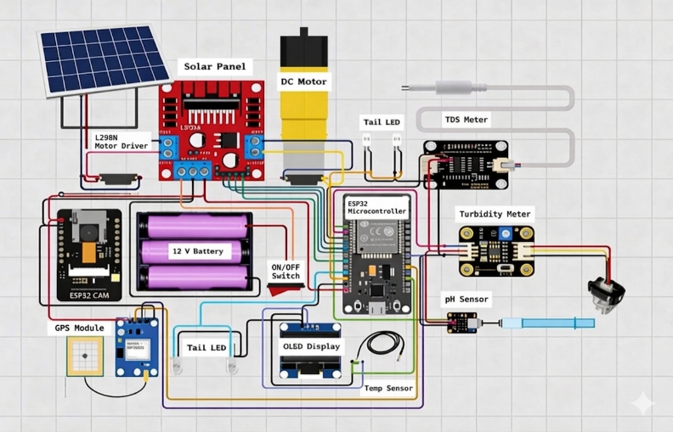

Block diagram of Smart Water Quality Surveilliance System
Boat

III. SYSTEM DEVELOPMENT
A. Hardware Components
The proposed system consists of the following hardware components:
- ESP32 Microcontroller
- pH Sensor
- Turbidity Sensor
- TDS Sensor
- DS18B20 Temperature Sensor
- L298N Motor Driver
- DC Motors with Propellers
- Battery and Solar Panel

B. Working Principle
The system operates using an ESP32 microcontroller, which acts as the central processing unit. It collects real-time data from sensors such as pH, turbidity, TDS, and temperature. The acquired data is processed and transmitted to the cloud platform via Wi-Fi for remote monitoring.
The user controls the movement of the boat through a mobile application. The control signals are received by the ESP32 and executed using the L298N motor driver, which drives the DC motors. This enables the boat to navigate in different directions across the water body.
The sensors continuously monitor water quality parameters, and the system generates alerts when any parameter exceeds predefined safe limits. This ensures efficient, real-time, and reliable water quality monitoring.

C. Flowchart Of the System

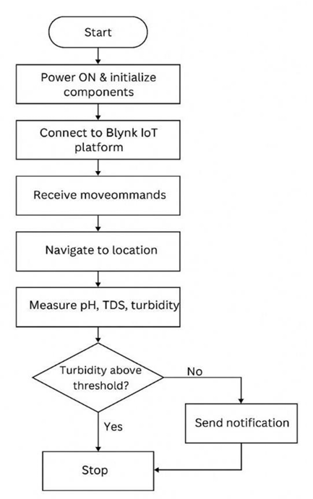

IV. RESULTS AND PERFORMANCE ANALYSIS
The proposed system was successfully implemented and tested under real-time conditions. The results demonstrate the effective integration of hardware components and IoT technology for water quality monitoring.
A. System Performance
The system exhibited reliable performance during testing. Real-time data transmission was achieved through the ESP32 microcontroller and Wi-Fi connectivity. The boat responded efficiently to remote control commands, enabling smooth navigation across the water body. Additionally, stable communication with the IoT platform ensured continuous monitoring without interruptions.

B. Data Analysis
The collected data was analyzed based on key water quality parameters. The pH value indicates the acidity or alkalinity of water, which is essential for determining its suitability. Turbidity reflects the clarity of water and helps identify the presence of suspended particles. Total Dissolved Solids (TDS) indicate the level of dissolved impurities and contamination. Temperature plays a significant role in affecting aquatic life and influences other chemical and biological processes in water.

V. ADVANTAGES AND UTILITY
The proposed IoT-integrated aquatic monitoring system offers several technical and operational improvements over traditional manual sampling methods:
- Real-Time Data Acquisition: Continuous monitoring allows for immediate detection of pollutant spikes, providing a high-resolution temporal dataset.
- Operational Safety: By utilizing a mobile-controlled robotic boat, human exposure to potentially contaminated or hazardous water bodies is eliminated.
- Sustainability: The integration of solar-harvesting modules ensures a reduced carbon footprint and extends the operational window without frequent manual charging.
- Economic Feasibility: The use of off-the-shelf sensors and open-source IoT architecture significantly reduces the Capital Expenditure (CAPEX) compared to industrial-grade static monitoring stations.
VI. LIMITATIONS AND CHALLENGES
Despite its efficacy, the current prototype is subject to certain technical constraints:
- Network Dependency: The system relies heavily on Wi-Fi/Internet availability. Data packets may be lost in remote areas with poor signal strength.
- Power Management: Although solar-supported, the peak power consumption of the propulsion motors limits the duration of continuous high-speed navigation.
- Sensor Drift: Chemical sensors require periodic recalibration to account for "bio-fouling" and drift to maintain data integrity.
VII. POTENTIAL APPLICATIONS
The versatility of the system allows for deployment across various sectors:
- Environmental Governance: Assisting municipal bodies in smart city initiatives to maintain urban water health.
- Aquaculture Management: Monitoring Dissolved Oxygen (DO) and pH levels to optimize conditions for fish farming.
- Industrial Compliance: Monitoring effluent discharge points to ensure adherence to environmental regulations.
- Crisis Response: Rapid deployment in flood-affected regions to check for water-borne pathogens or chemical leaks during disasters.

VIII. FUTURE RESEARCH DIRECTIONS
Future iterations of this research will focus on enhancing the autonomy and range of the system:
- Geospatial Mapping: Integrating GPS modules to correlate water quality data with precise geographical coordinates, enabling the creation of "pollution heat maps."
- Long-Range Communication: Implementation of LoRa WAN (Long Range Wide Area Network) or GSM to allow for operation in remote areas where Wi-Fi is unavailable.
- Predictive Analytics: Utilizing Machine Learning (ML) algorithms to predict future contamination trends based on historical sensor data.
- Swarm Robotics: Developing a multi-agent system where multiple boats coordinate to cover vast reservoirs simultaneously.
IX. CONCLUSION
This research presented the design and implementation of an IoT-based mobile water quality monitoring system. By synthesizing robotic navigation with multi-parametric sensing, the system effectively bridges the gap between manual sampling and expensive stationary stations.
The empirical data suggests that the system provides a reliable, cost-effective, and safe alternative for real-time environmental surveillance. While limitations regarding connectivity and battery life persist, the modular nature of the architecture allows for future upgrades in long-range communication and autonomous AI navigation. Ultimately, this technology serves as a scalable solution for the global challenge of water resource management.

REFERENCES

[1] V. Lakshmikantha, N. N. Mohanty and S. S. Patra, "IoT based smart water quality monitoring system," Cleaner Engineering and Technology, vol. 4, p. 100090, 2021. https://doi.org/10.1016/j.clet.2021.100090

[2] M. S. M. Aslam and H. Hassan, "Water Monitoring System Using Remote-Control Boat," Progress in Engineering Application and Technology, vol. 6, no. 2, pp. 132-140, 2025. https://doi.org/10.30880/peat.2025.06.02.015

[3] A. Shukla et al., "Autonomous water sampling and quality monitoring in remote locations: A novel approach using a remote-controlled boat." HardwareX, vol. 22, e00634, 2025.https://doi.org/10.1016/j.ohx.2025.e00634

[4] A. P. Adake and M. Dixit, “Water Quality Monitoring System using RC Boat with Wireless Sensor Network,” International Journal for Research in Applied Science & Engineering Technology (IJRASET), vol. 7, no. IV, Apr. 2019. https://doi.org/10.22214/ijraset.2019.4332

[5] Atharv L. Metkari et al., “IoT Based Water Pollution Monitoring RC Boat,” International Journal for Research in Applied Science & Engineering Technology (IJRASET), 2024. https://doi.org/10.22214/ijraset.2024.62135

[6] Pallavi V. Kukade et al., “IoT Based Water Pollution Monitoring RC Boat,” International Journal of Advanced Research in Science, Communication and Technology (IJARSCT), 2025. https://doi.org/10.48175/IJARSCT-25307

[7] V. L. Dsouza et al., “Remotely controlled boat for water quality monitoring and sampling,” Materials Today: Proceedings, vol. 47, Part 10, pp. 2391–2400, 2021. https://doi.org/10.1016/j.matpr.2021.04.354

[8] S. Singh and M. Nour, “IoT-Enabled Water Pollution Monitoring Remote Controlled Boat with a Debris Collection system in Aquatic Environments,” in 2024 IEEE Student Conference on Research and Development (SCOReD), 2025, pp. 716-721.
https://doi.org/10.1109/SCoRED64708.2024.10872740

[9] A. Prabhakara Rao et al., “Water Quality Monitoring Using Remote Control Boat,” in Cognitive Computing and Cyber Physical Systems, Lecture Notes of the Institute for Computer Sciences, Social Informatics and Telecommunications Engineering, Springer, 2023, pp. 201–212. https://doi.org/10.1007/978-3-031-28975-0_17

[10] J. H. Ryu et al., “Prototyping a low-cost open-source autonomous unmanned surface vehicle for real-time water quality monitoring and visualization,” HardwareX, vol. 12, e00333, 2022. https://doi.org/10.1016/j.ohx.2022.e00333

