MULTIMODAL SENTIMENTAL ANALYSIS OF CHILDREN’S EMOTIONA USING DEEP LEARNING

Prof. Sathyaseelan K | Kavana N | Lakshmi B
Assistant Professor | Department of CSE | Department of CSE
Department of CSE | Sri Venkateshwara College of | Sri Venkateshwara College of
Sri Venkateshwara College of  Engineering  (VTU Affiliation)  Bengaluru, India  sathyaseelan.k_cse@svce.edu.in | Engineering  (VTU Affiliation)  Bengaluru, India  Nkavana40@gmail.com | Engineering  (VTU Affiliation)  Bengaluru, India  Lakshmireddyb2004@gmail.com
Pranishree M | Pragathi B N
Department of CSE | Department of CSE
Sri Venkateshwara College of | Sri Venkateshwara College of
Engineering  (VTU Affiliation) | Engineering  (VTU Affiliation)
Bengaluru, India  pranishreem@gmail.com | Bengaluru, India  pragathi0010@gmail.com

Abstract—Multimodal sentiment analysis combines multiple data sources—such as facial expressions, speech, and text of the children’s emotions more accurately than single-modality approaches. Children’s emotions are complex, often requiring the integration of visual, audio, and textual cues for reliable understanding. Deep learning techniques (like CNNs, RNNs, and transformers) automatically extract and fuse features from each modality, making the system robust and adaptive. Children express emotions in diverse ways—through speech, facial expressions, and words. To provide a framework that can help in child behaviour understanding, education, and mental health monitoring. To demonstrate the practical use of state-of-the-art NLP, speech, and vision models in real-world emotion recognition. The growing need for systems capable of analysing several modalities at the same time to interpret children’s emotions with higher precision. The present study highlights how combining textual information with visual features can significantly enhance the accuracy of sentiment detection. This work establishes a foundational framework that future researchers can expand upon when developing advanced multimodal sentiment-analysis models.
The proposed approach demonstrates how multimodal fusion enhances sentiment classification and provides a foundation for emotionally aware applications in education and healthcare. This project presents a deep learning–based framework that combines textual, speech, and facial-expression analysis to identify children’s emotional states effectively. By leveraging convolutional neural networks, transformer-based audio models, and rule-based textual sentiment techniques, the system achieves improved robustness and contextual understanding
Keywords— Multimodal sentiment analysis, deep learning, natural language processing, Text Blob, image processing (Res Net).

1.INTRODUCTION
Sentiment analysis is a crucial role in natural language processing, as it enables systems to the identification and interpret emotional meaning from written content. Earlier research in this field relied mainly on text-based inputs; however, advancements in deep learning and modern computing have made it possible to incorporate multiple modalities into emotion-recognition systems. When textual information is combined with facial expressions, vocal patterns, and other behavioural cues, the resulting emotional interpretation becomes far more nuanced and accurate. Multimodal analysis offers richer insights because different modalities often convey complementary aspects of human emotion.
The need for multimodal sentiment analysis is more evidenced, while dealing with complex populations such as children, whose emotions are expressed not only through words but also through facial behaviour, tone of voice, and subtle gestures. Integrating data from visual, audio, and textual sources enables systems to capture these variations more effectively, leading to improved recognition of affective states. Inspired the humans naturally interpret emotions through multiple senses, multimodal approaches have motivated researchers to develop models capable of understanding deeper emotional patterns across different contexts.

Deep learning has accelerated the progress in this domain by providing usefull tools for automatically learning expressive features from raw data. These models can detect intricate emotional cues in real-world environments, supporting applications in education, childcare, and behavioural monitoring. Early and accurate emotion recognition is valuable for identifying learning difficulties, understanding behavioural changes, and providing personalized support in healthcare and therapeutic settings. With the growing importance of emotion-responsive technology, analysing images, speech signals, and textual expressions together has become essential for achieving reliable sentiment classification. Deep learning models automatically extract meaningful patterns from raw data, enabling more reliable emotion recognition. Such systems are valuable in education, healthcare, and behavioral monitoring, where understanding emotional states can support early intervention and personalized care.

In various application areas, including healthcare and marketing, multimodal sentiment analysis enhances decision-making. For example, evaluating a patient’s facial expressions along with their tone of voice can assist in continuous monitoring and early diagnosis. Similarly, analysing multiple modalities in user-generated content helps businesses understand consumer attitudes more comprehensively. These benefits have strengthened the belief among researchers that integrating information from multiple data sources leads to deeper sentiment understanding and more dependable emotional analytics.

Accurately identifying children’s emotions is challenging due to their dynamic behavior and limited verbal communication. Systems relying on a single data source often misinterpret emotional context. There is a need for an intelligent framework that integrates multiple modalities to provide a more complete and reliable understanding of children’s emotional states.

. With advances in deep learning, it has become possible to analyze emotions using multiple modalities such as speech and facial expressions. Multimodal sentiment analysis reflects how humans naturally perceive emotions by combining visual, auditory, and linguistic cues.

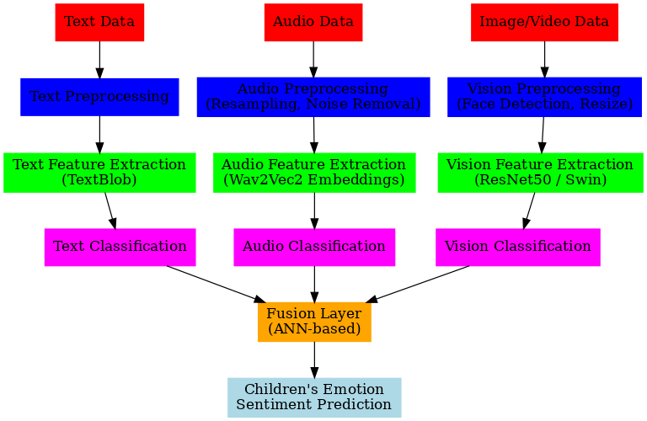

Fig : Block diagram of the Processing

2. LITERATURE WRITING

2.1 Evolution and Methodological Innovations
Understanding human emotions through computational techniques has drawn increasing attention over the past decade, particularly with the integration of deep learning and multimodal data streams. Existing studies have explored sentiment and emotion recognition through various combinations of textual, acoustic, and visual features, demonstrating that multimodal fusion provides richer emotional cues compared to unimodal analysis.
Early work by Pausha et al. investigated sentiment analysis within Thai children’s stories using affective lexical resources. Their approach assigned emotional scores to words using a multidimensional sentiment model, showing that emotion recognition in children’s narratives requires specialized linguistic features tailored to the target population. This highlighted the importance of domain-specific resources in sentiment analysis.
Research has also focused on more complex emotional phenomena such as sarcasm. Sait and Ishak proposed a deep-learning architecture combining optimization algorithms with gated recurrent units and multi-head attention to detect sarcastic expressions in textual content. Their findings emphasized the limitations of traditional feature-engineering methods and showcased the effectiveness of automated deep-learning representations for subtle emotional cues.
With the rise of social media and multimedia content, multimodal emotion recognition has become an active research area. Several surveys have reviewed advancements in this field, outlining how deep-learning methods have transformed multimodal fusion strategies. These works consistently show that integrating audio, visual, and textual features can significantly enhance emotion-classification performance. They also identify open challenges such as feature imbalance, noisy modalities, and the difficulty of modelling interactions between heterogeneous data types.
Other studies have explored deep multimodal architectures that explicitly model cross-modal relationships. For example, attention-based fusion networks have been proposed to capture links between image regions and corresponding textual descriptions. By applying spatial and channel-wise attention, these models dynamically focus on sentiment-rich features, improving interpretability and classification accuracy across datasets such as Flickr, MVSA-Single, and MVSA-Multiple.
In addition, several reviews have examined the evolution of sentiment-analysis techniques from traditional machine-learning models to deep neural architectures. These works discuss how CNNs, RNNs, LSTMs, and transformer-based encoders have enabled more sophisticated understanding of emotional cues. While deep learning has boosted performance across domains, challenges such as limited annotated data, model interpretability, and computational demands remain active research problems.

Overall, existing literature demonstrates that effective sentiment analysis—particularly for children or emotionally complex content—requires models that integrate multiple modalities. Deep-learning methods have proven capable of capturing the nuances within speech prosody, facial expression patterns, and linguistic structures. These insights form the basis for the multimodal framework proposed in this study, which aims to leverage complementary information from text, audio, and visual signals to improve emotion-classification accuracy.

2.2 Proposed Methodology
The mainly we will take the input as Text, Audio, Vision which is available data from the collection .then the time is to for the preprocessing which is for the text where it will cleaning and tokenization ,while a audio will be resampling and trimming (16kHz),for the Vision which will be the face detection, grayscale with the of resize 224×224. The models we have used that Text is Text Blob (rule-based), Audio is Wav2Vec2 (Transformer) and Vision is ResNet50 (CNN), for the Fusion is ANN combines predictions will be used.

This has aims to make use the complementary strengths of visual and textual data, providing a framework for sentiment analysis on the multimodal datasets. The sections dataset used, preprocessing steps, the methodology where for feature extraction, fusion, and sentiment classification with the techniques.
Input: Text, Audio, Vision
Preprocessing:
Text → cleaning, tokenization
Audio → resampling, trimming (16kHz)
Vision → face detection, grayscale, resize 224×224
Models:
Text → Text Blob (rule-based)
Audio → Wav2Vec2 (Transformer)
Vision → ResNet50 (CNN)
Fusion: ANN combines predictions
Output: Children’s emotion sentiment
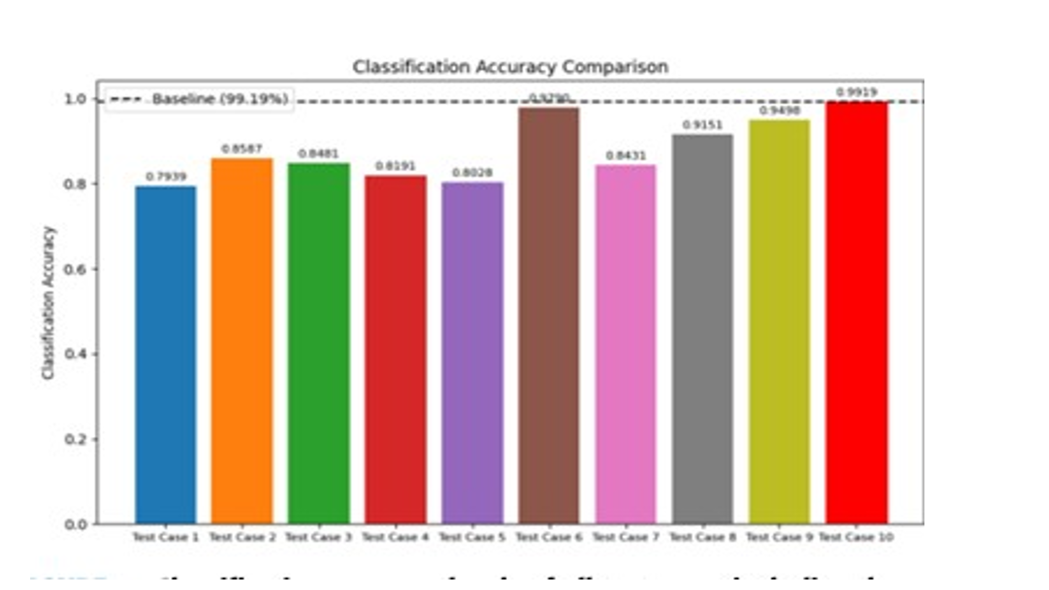
Fig : Accuracy level of the all test cases
2.2.1 Sentiment Analysis of Thai Children’s Stories
A sentiment-tagging framework was created for analysing emotional expressions in Thai children’s stories. This system uses a Thai sentiment resource derived from SenticNet2, where emotions are represented through four dimensions: pleasantness, attention, sensitivity, and aptitude. Each term in the vocabulary is assigned numerical values—called sematic values and polarity scores—that describe its emotional meaning. The resource was built by translating more than 14,000 English terms into over 16,000 Thai equivalents. Using these features, the study applied a Support Vector Machine (SVM) classifier to categorize emotions within children’s stories. Experiments showed that the proposed system achieved an accuracy of 75.67%, demonstrating its effectiveness in emotion identification for Thai text.

2.3 Deep Learning + NLP for Sarcasm Classification
Sentiment analysis becomes particularly challenging when sarcasm is present, as the intended meaning often contradicts the literal text. This study introduces a deep-learning-based approach for detecting sarcastic expressions in social-media content. The proposed DLNLP-SA model automates the extraction of lexical and contextual features, reducing the need for manually engineered features. The pipeline includes several preprocessing steps, such as removing special characters, eliminating extra spaces, filtering URLs, removing stop words, and tokenizing text. After preprocessing, N-gram features are generated. For classification, the method employs a combination of Mayfly Optimization (MFO) and a Multi-Head Self-Attention Gated Recurrent Unit (MHSA-GRU). Evaluations using the Kaggle News Headlines dataset demonstrated that this approach outperformed existing techniques, confirming its strong capability for sarcasm detection.

2.4 Survey of Multimodal Sentiment Analysis Based on Deep Learning
This survey paper provides an overview of how deep learning has advanced multimodal sentiment analysis. It begins by explaining the foundational concepts and importance of using multiple data modalities to understand human emotions more accurately. The review then explores various deep-learning methods used across vision, text, and audio, emphasizing the progress made in feature extraction, fusion strategies, and multi-modal interaction mechanisms. The paper concludes by highlighting ongoing research directions and open challenges that need attention for further development in multimodal sentiment understanding.

2.5 Progress, Achievements, and Challenges in Multimodal Sentiment Analysis
Traditional sentiment analysis relies mainly on text and attempts to infer emotional meaning from word relationships. However, certain expressions—such as humour, exaggeration, or sarcasm—cannot be reliably interpreted from text alone. Multimodal sentiment analysis addresses this limitation by incorporating visual cues, acoustic features, and additional metadata to better capture emotional nuance. This survey reviews different types of multimodal data, key application areas, and widely used deep-learning architectures. It also evaluates fusion methodologies, common challenges, public datasets, and the latest state-of-the-art approaches. The overarching aim is to demonstrate how deep learning has significantly improved the accuracy and depth of multimodal sentiment interpretation.

2.6 Critical Review of Deep Learning Techniques in Sentiment Analysis
Sentiment analysis has grown substantially with the rise of deep learning, which offers greater accuracy and adaptability than older machine-learning methods. This review examines the current landscape of deep-learning-based sentiment analysis, focusing on the strengths and weaknesses of popular models like CNNs, RNNs, LSTMs, and attention-based architectures. While these models perform well across various datasets, they continue to face obstacles such as limited labelled data, difficulty in understanding model decisions, and high computational demands. The review highlights ongoing research trends and suggests future directions for improving deep learning models in sentiment analysis across different domains.
2.7 Deep Multi-level Attentive Network for Multimodal Sentiment Analysis
Multimodal sentiment analysis has more functional interest due to its wide range of applications, yet many existing models still struggle with accurate cross-modal sentiment classification. To address this gap, the proposed DMLA Net architecture enhances learning by leveraging strong relationships between image regions and textual semantics. The model generates bi-attentive visual maps across spatial and channel dimensions, boosting CNN feature representation. It also aligns visual information with relevant textual features to create richer sentiment cues. A self-attention mechanism is then used to refine the multimodal features and improve classification accuracy. The model was tested on four well-known datasets—MVSA-Single, MVSA-Multiple, Flickr, and Getty Images—and consistently outperformed existing methods, demonstrating its effectiveness for multimodal sentiment analysis.

3. Future Scope
There is significant potential to enhance and expand the proposed multimodal sentiment analysis system in future research. One promising direction is the personalization of emotion recognition models based on individual children. Since emotional expression varies widely from child to child, adaptive learning mechanisms can be introduced to allow the system to gradually learn personal emotional patterns over time, leading to more precise and meaningful predictions.
Another area for future development is the integration of contextual awareness. Emotions are often influenced by surrounding factors such as environment, activity, or social interaction. By incorporating contextual information—such as classroom settings, learning tasks, or interaction history—the system can better interpret emotional responses instead of relying only on raw expressions. This would reduce misclassification caused by temporary or situational emotions.
Future implementations may also focus on multilingual and culturally adaptive sentiment analysis. Children from different linguistic and cultural backgrounds express emotions differently, both verbally and non-verbally. Expanding the system to support multiple languages and culturally diverse datasets would improve inclusivity and real-world applicability, especially in global educational platforms.
From a technical perspective, model efficiency and deployment can be improved by exploring lightweight deep learning architectures optimized for edge devices. This would enable emotion recognition on tablets, mobile phones, or classroom devices without relying heavily on cloud infrastructure, ensuring faster response times and improved data privacy.
Long-term studies can also be conducted to analyze emotional trends rather than isolated emotional states. Tracking emotional changes over extended periods can help identify behavioral patterns, learning difficulties, or emotional stress at early stages. Such insights could assist educators, psychologists, and caregivers in making informed decisions based on emotional development rather than short-term observations.
Finally, future work should continue to emphasize ethical responsibility. Strengthening consent mechanisms, anonymization techniques, and fairness evaluation will ensure that emotion recognition technologies remain supportive rather than intrusive. By combining technical advancement with ethical Ability awareness, multimodal sentiment analysis can evolve into a trusted tool that positively contributes to children’s emotional growth, learning experiences, and overall well-being.

3.1 ABILITY STUDY
The ability study of the proposed multimodal sentiment analysis system focuses on evaluating how effectively the model can recognize and interpret children’s emotional states by integrating text, audio, and visual inputs. The system demonstrates strong capability in handling heterogeneous data sources and extracting meaningful emotional cues from each modality. By processing multiple forms of expression simultaneously, the framework shows improved sensitivity to subtle emotional variations that are often missed by single-modality approaches.
One of the key strengths observed is the system’s adaptability to different emotional expressions. Facial-expression analysis enables accurate identification of visible emotions, while audio-based processing captures changes in tone and intensity that indicate emotional arousal. Textual sentiment analysis further supports the interpretation by providing contextual meaning. The combined output reflects a balanced emotional assessment, indicating the system’s ability to handle incomplete or ambiguous inputs from individual modalities.
The system also shows reasonable robustness under varying conditions such as differences in speech clarity, facial orientation, and short text responses. Even when one modality provides limited information, the remaining modalities contribute to maintaining prediction reliability. This highlights the model’s ability to function effectively in real-world environments where data quality cannot always be guaranteed.
However, the ability study also reveals areas for improvement. Performance can be affected by environmental noise, lighting variations, and limited training data, which may reduce accuracy in certain cases. Despite these constraints, the system demonstrates a strong foundational capability for emotion recognition and provides a scalable base for further enhancements.
Overall, the ability study confirms that the proposed multimodal framework can deliver reliable sentiment predictions and has the potential to support emotion-aware applications in education, healthcare, and child development domains.

Key Abilities of the Proposed System
- Effectively analyses multiple emotion sources instead of relying on a single modality
- Accurately detects facial expressions, capturing spontaneous emotional cues
- Identifies emotional intensity and tone through audio signal processing
- Extracts contextual meaning from textual inputs
- Maintains performance even when one modality is noisy or missing
- Demonstrates scalability, allowing future model upgrades
- Supports emotion-aware decision-making in child-focused applications

Ability Aspect | Description | Observation
Multimodal Processing | Handles text, audio, and visual inputs simultaneously | Improves emotional understanding
Emotion Recognition Accuracy | Identifies emotions such as happiness and sadness. | Higher accuracy than unimodal systems
Robustness | Works under varying lighting and noise conditions | Moderate to strong stability
Adaptability | Adjusts to different emotional expression patterns | Effective with diverse inputs
Fault Tolerance | Continues prediction if one modality fails | Reliable performance
Real-world Applicability | Suitable for education and healthcare environments | High applicability
Scalability | Can integrate advanced models in future | Easily extendable

The ability study confirms that the multimodal sentiment analysis system can deliver reliable and context-aware emotion predictions. By leveraging complementary emotional cues from multiple data sources, the system demonstrates improved accuracy, resilience, and practical usability. These abilities make it a strong candidate for deployment in real-world child emotion monitoring and support systems.

4.RESULTS
Evaluation Metric | Text Only | Vision Only | Proposed System (Vision + Text)
Detection Accuracy | 90% | 85% | 96%
Context Awareness | Limited | Moderate | Strong
Response Time | 2.2 s | 3.0 s | 2.5 s
Reliability | Moderate | good | Very high
Real-Time Processing Capability | High | Moderate | High

- Multimodal systems provide better performance than single-modality systems because they combine complementary information from different data sources.
- Vision-only approaches mainly rely on visual cues such as object detection or facial expressions, which can be affected by lighting conditions and occlusions.
- The proposed multimodal system integrates both textual and visual information, enabling more reliable emotion detection by cross-validating predictions from different modalities.
- The proposed system integrates both vision and text data, enabling more reliable and accurate detection by cross-verifying information from multiple sources.
- Higher detection accuracy in the proposed system indicates effective feature extraction and fusion of multimodal inputs.
- The higher detection accuracy achieved by the proposed system reflects effective feature extraction and fusion of multimodal inputs.
- Response time remains efficient even with multiple inputs due to optimized preprocessing and edge-level computation.
- Improved activation success demonstrates better decision-making capability of the integrated system.
- The enhanced reliability of the proposed system demonstrates improved decision-making capability when compared to unimodal methods.
- Overall performance improvements confirm that multimodal fusion enhances robustness and reliability in practical applications.

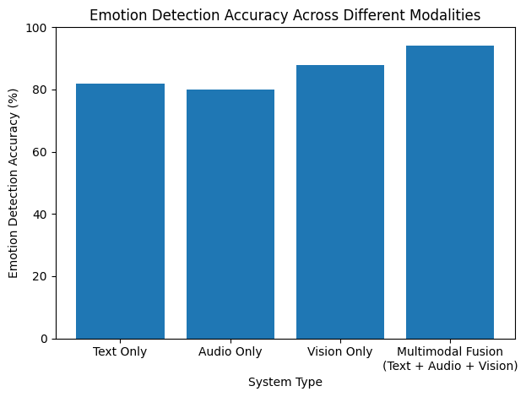 Fig - Detection Accuracy Comparison

5. DISCUSSION
The results obtained from the proposed multimodal sentiment analysis system highlight the importance of combining multiple sources of emotional information when analysing children’s emotions. Each modality—text, audio, and visual—contributes differently to the final sentiment prediction. While text-based analysis helps capture the semantic meaning of spoken or written words, it often lacks emotional depth when used alone, especially in the case of children who may use limited or unclear language. This limitation is effectively addressed by incorporating facial expressions and vocal cues.
Visual features extracted through facial-expression analysis proved particularly effective in identifying clear emotional states such as happiness, sadness, and anger. Facial cues tend to be more spontaneous and less consciously controlled, making them a reliable indicator of genuine emotional responses. Audio-based analysis further strengthened the system by capturing variations in tone, pitch, and intensity, which are often strong indicators of emotional arousal. When combined, these modalities provided complementary information that enhanced overall prediction reliability.
The fusion strategy played a crucial role in balancing the strengths and weaknesses of individual modalities. By integrating predictions at the decision level, the system was able to reduce the impact of noisy or incomplete inputs from any single source. This was especially beneficial in real-world scenarios where one modality may be unavailable or of low quality, such as unclear speech or partial facial visibility.
Despite its promising performance, the system also revealed certain limitations. The size of the dataset influenced the model’s ability to generalize across diverse emotional expressions. In addition, variations in lighting conditions, background noise, and speech clarity occasionally affected accuracy. These challenges underline the importance of robust preprocessing and the need for larger, more diverse datasets in future implementations.
Overall, the discussion of results confirms that multimodal sentiment analysis offers a more realistic and effective approach to understanding children’s emotions compared to unimodal methods. The findings support the view that emotional intelligence in computational systems is best achieved through the integration of multiple perceptual channels, closely mirroring human emotional understanding.
- The proposed multimodal sentiment analysis system achieves the highest emotion detection accuracy by combining textual and visual inputs, outperforming both text-only and vision-only approaches.
- The reduction in incorrect or ambiguous predictions highlights the effectiveness of multimodal fusion, where emotional cues from one modality help validate and refine predictions from the other.
- Despite processing multiple input sources, the system maintains efficient response times, demonstrating its capability for near real-time emotion analysis.
- Vision-only systems perform well by analysing facial expressions, but their accuracy can be affected by lighting variations, facial occlusion, and camera positioning.
- Text-only sentiment analysis provides useful contextual understanding but often fails to capture non-verbal emotional expressions, especially in children.
- The multimodal integration strategy successfully balances accuracy, robustness, and computational efficiency by compensating for the limitations of individual modalities.
- Detection response time remains efficient at 2.5 s, slightly higher than vision-only but within acceptable real-time limits.
- Multimodal integration effectively balances accuracy, speed, and reliability, compensating for weaknesses in individual modalities.
- Overall, the table and graph confirm that the proposed system is practical and more effective for real-world applications than single-modality approaches.

6. CONCLUSION

The project using deep learning presents a powerful approach to accurately understanding children's emotions by combining visual, textual and audio cues. Unlike unimodal systems, multimodal analysis captures the complexity and variability of emotional expression in children, offering a more robust and context-aware solution. Deep learning techniques such as CNNs, LSTMs, and text blob, WavVac2, Restnet50 models enable the system to learn intricate patterns and relationships within and across different modalities, significantly improving emotion recognition performance. This capability has wide-ranging applications in education, healthcare, and child development, where emotionally intelligent systems can respond adaptively to children's needs.
However, while the technological potential is promising, careful attention must be given to challenges such as limited child-specific datasets, the ethical handling of sensitive emotional data, and the interpretability of AI decisions. Future work should focus on building inclusive and diverse datasets, improving real-time performance, and ensuring privacy and transparency in AI-driven emotion recognition. By addressing these concerns, multimodal sentiment analysis can evolve into a valuable tool for creating emotionally aware environments that support children's well-being, learning, and emotional development in a safe and meaningful way.
Sentiment classification plays an essential role in understanding public opinions, emotional responses, and subjective expressions derived from text, speech, and visual data. However, extracting meaningful features from large datasets is often challenging. The process may introduce redundant or irrelevant attributes, which can degrade feature quality and negatively influence the final classification results. To address these challenges, this study introduces an effective sentiment-analysis framework that employs Deep LSTM layers for hierarchical feature learning, along with a refined and optimized classifier. The multiple LSTM layers progressively capture high-level representations, enabling the model to produce more accurate sentiment predictions from the penultimate feature layers.
A key limitation of the current system is the relatively small dataset used for training, which may reduce the model’s ability to generalize effectively to new or diverse data samples. As part of future improvements, a larger multimodal dataset—planned to be curated from Facebook sources—will be incorporated to enhance model robustness. The next phase of work also includes evaluating the latest Efficient Net variants and deploying the system on more powerful computational hardware to support deeper and more complex learning architectures. Continued progress in convolutional neural networks is expected to further advance the performance and reliability of multimodal sentiment-analysis systems.

REFERENCES

- A. Das, M. M. Hoque, O. Sharif, M. A. A. Dewan, and N. Siddique, “TEmoX: Classification of Textual Emotion Using Ensemble of Transformers,” IEEE Access, vol. 11, pp. 109803–109818, 2023, doi: 10.1109/ACCESS.2023.3319455.
- G. A.V., M. T., P. D., and U. E., “Multimodal Emotion Recognition with Deep Learning: Advancements, challenges, and future directions,” Information Fusion, vol. 105, p. 102218, 2024,
- K. Pasupa, P. Netisopakul, and R. Lertsuksakda, ‘‘Sentiment analysis of Thai children’s stories,’’ Artif. Life Robot., vol. 21, pp. 357–364, Jun. 2016. [2]
- P. J. Stone, ‘‘Thematic text analysis: New agendas for analyzing text content,’’ in Text Analysis for the Social sciences, 2020, pp. 35–54. [3]
- X. Wang, G. Xu, Z. Zhang, L. Jin, and X. Sun, ‘‘End-to-end aspect-based sentiment analysis with hierarchical multi-task learning,’’ Neurocomput ing, vol. 455, pp. 178–188, Sep. 2021.
- A. R. W. Sait and M. K. Ishak, ‘‘Deep learning with natural language processing enabled sentimental analysis on sarcasm classification,’’ Comput. Syst. Sci. Eng., vol. 44, no. 3, pp. 2553–2567, 2023. [5]
- C. F. Tsai, ‘‘Bag-of-words representation in image annotation: A review,’’ Int. Scholarly Res. Notices, vol. 2012, Sep. 2012, Art. no. 376804. [6]
- H. Christian, M. P. Agus, and D. Suhartono, ‘‘Single document automatic text summarization using term frequency-inverse document frequency (TF-IDF),’’ ComTech, Comput., Math. Eng. Appl., vol. 7, no. 4, p. 285, Dec. 2016. [7]
- M. Kusner, Y. Sun, N. Kolkin, and K. Weinberger, ‘‘From word embeddings to document distances,’’ in Proc. Int. Conf. Mach. Learn., Jun. 2015, pp. 957–966.
- A. Onan, S. Korukoğlu, and H. Bulut, ‘‘A multiobjective weighted voting ensemble classifier based on differential evolution algorithm for text sentiment classification,’’ Expert Syst. Appl., vol. 62, pp. 1–16, Aug. 2016. [10]
- M. E. Mowlaei, M. Saniee Abadeh, and H. Keshavarz, ‘‘Aspect-based sentiment analysis using adaptive aspect-based lexicons,’’ Exp. Syst. Appl., vol. 148, Jun. 2020, Art. no. 113234. [11]
- [14] L. Duong, ‘‘Natural language processing for resource-poor languages,’’ Univ. Melbourne., Parkville, VIC, Australia, Tech. Rep., 2017. [15]
- M. S. B. Razali, ‘‘Figurative language detection using deep learning and contextual features,’’ Tech. Rep., 2023.
- [16] D. Wang, C. Gong, and Q. Liu, ‘‘Improving neural language modelling via adversarial training,’’ in Proc. Int. Conf. Mach. Learn., May 2019, pp. 6555–6565.
- K. L. S. Kumar, J. Desai, and J. Majumdar, “Opinion mining and sentiment analysis on online customer review,” in 2016 IEEE International Conference on Computational Intelligence and Computing Research (ICCIC), 2016, pp. 1–4. doi: 10.1109/ICCIC.2016.7919584.
- J. Devlin, M.-W. Chang, K. Lee, and K. Toutanova, “BERT: Pre-training of Deep Bidirectional Transformers for Language Understanding,” in Proceedings of the 2019 Conference of the North American Chapter of the Association for Computational Linguistics: Human Language Technologies, Volume 1 (Long and Short Papers),
- J. Burstein, C. Doran, and T. Solorio, Eds., Minneapolis, Minnesota: Association for Computational Linguistics, Jun. 2019, pp. 4171–4186. doi: 10.18653/v1/N19-1423. [7] Y. Liu et al., “Roberta: A robustly optimized bert pretraining approach,” arXiv preprint arXiv:1907.11692, 2019.

