Local–Hybrid Web-Based Voter Education Awareness Campaign Platform

Joel Q. Amparo
AMA University
jhoelamparo@gmail.com
https://orcid.org/0009-0004-0213-3621
Eduardo R. Yu II
AMA University
edaurdoryuii@gmail.com
https://orcid.org/0009-0004-5050-5805
Reagan B. Ricafort
reagan.ricafort@ama.edu.ph
AMA University
https://orcid.org/0009-0002-0816-1522

Abstract
Voter education plays a significant role in promoting informed and responsible participation in democratic processes. However, many local communities continue to face challenges in accessing reliable and structured voter education resources due to limited internet connectivity and dependence on informal information channels. This paper presents a local–hybrid web-based voter education awareness platform designed to provide accessible, multimedia-driven educational content for community use. The system is hosted on a locally managed server and securely exposed to the internet using cloud-mediated access services, combining local control with remote accessibility. The platform was developed using an iterative methodology and evaluated using the ISO/IEC 25010 Software Product Quality Model. Results indicate that the proposed system meets key software quality characteristics related to functional suitability, usability, performance efficiency, security, and maintainability. The study demonstrates the feasibility of hybrid deployment models for community-oriented educational platforms. The system includes an administrative dashboard that enables authorized users to manage platform content. Administrators can securely log in and perform content creation and deletion operations through an intuitive interface. The implementation of role-based access control ensures that administrative functionalities are restricted to authorized users only. The platform supports direct multimedia uploads, allowing administrators to add educational materials such as videos, images, and documents without relying on external sources. Uploaded content is automatically stored and made accessible through the system. Additional features such as search, filtering, and pagination improve user navigation and accessibility, enabling efficient browsing of educational content.

Keywords
Voter education, Web-based systems, Hybrid deployment, Software quality, ISO/IEC 25010, Community platforms

I. Introduction

In recent years, the use of digital platforms for civic engagement and voter education has expanded significantly as governments and civil society organizations attempt to improve democratic participation. Online information systems, social media platforms, and digital learning tools are increasingly used to disseminate electoral information and civic education materials to the public (Kertysova, 2018). However, the growing reliance on digital channels has also introduced new challenges, including the rapid spread of misinformation, unequal access to reliable information, and disparities in digital literacy across communities. Research on digital citizenship and civic technology highlights the importance of structured, accessible information systems that can support informed participation while mitigating the risks associated with unverified online content (Diepeveen, et al,, 2022).

Another important issue influencing voter education initiatives is the persistent digital divide between urban and rural communities (Bennet, 2009). While cloud-based platforms offer scalability and accessibility, they often assume consistent internet connectivity and modern infrastructure. In many local communities, particularly in developing regions, internet access remains unstable or limited (Gill et al., 2024). These constraints can significantly affect the effectiveness of purely cloud-based educational platforms. Hybrid deployment models that combine locally hosted infrastructure with selective cloud-based services have therefore emerged as a promising approach for community-oriented digital platforms because they provide greater control over system resources while maintaining remote accessibility (Zhang et al., 2010).

Furthermore, the increasing complexity of modern web systems has emphasized the importance of robust software architecture and quality evaluation frameworks. International standards such as ISO/IEC 25010 provide structured models for assessing software quality characteristics including usability, reliability, maintainability, and performance efficiency (Moumane et al., 2016). Applying these frameworks to civic technology platforms helps ensure that such systems are not only functional but also sustainable and adaptable to community needs (Carvallo et. al, 2019).

Voter education is a critical component of democratic participation, as it enables citizens to make informed decisions based on an understanding of electoral processes, candidate qualifications, and civic responsibility (Schultz et al., 2010). In many local communities, particularly at the barangay level, access to structured and reliable voter education resources remains limited. This limitation is often compounded by inconsistent internet connectivity, reliance on social media as a primary information source, and the prevalence of misinformation during election periods.
Existing voter education initiatives are commonly delivered through cloud-hosted platforms that assume continuous internet access and sufficient digital literacy. While effective in urban settings, such approaches are less suitable for communities with limited infrastructure or intermittent connectivity. As a result, there is a need for alternative software solutions that prioritize accessibility, locality, and controlled deployment without sacrificing modern web capabilities. Recent studies show that structured voter education initiatives supported by digital platforms can improve voter confidence and civic participation (Suttmann-Lea, et. al, 2023).

This study proposes the design and documentation of a local–hybrid web-based voter education awareness platform. The platform is hosted on a locally managed server infrastructure and is securely exposed to the internet through cloud-mediated access services. This hybrid approach combines the reliability and control of local hosting with the accessibility of internet-based delivery. The system serves as a centralized repository of multimedia voter education materials designed to improve engagement and comprehension among community users.
The primary contribution of this work is the documentation of the platform as a software system using an IMRAD framework, with emphasis on system design, development methodology, and quality evaluation based on the ISO/IEC 25010 Software Product Quality Model. The platform is intended strictly for non-partisan educational purposes. (Carvallo, et. al, 2019).

This study aims to design, implement, and evaluate a local–hybrid web-based voter education platform that addresses accessibility challenges in community environments. Specifically, it seeks to (1) develop a modular and secure web-based system, (2) integrate multimedia educational content to improve user engagement, and (3) evaluate system quality using the ISO/IEC 25010 framework (Yu II et al., 2025).

II. Methodology

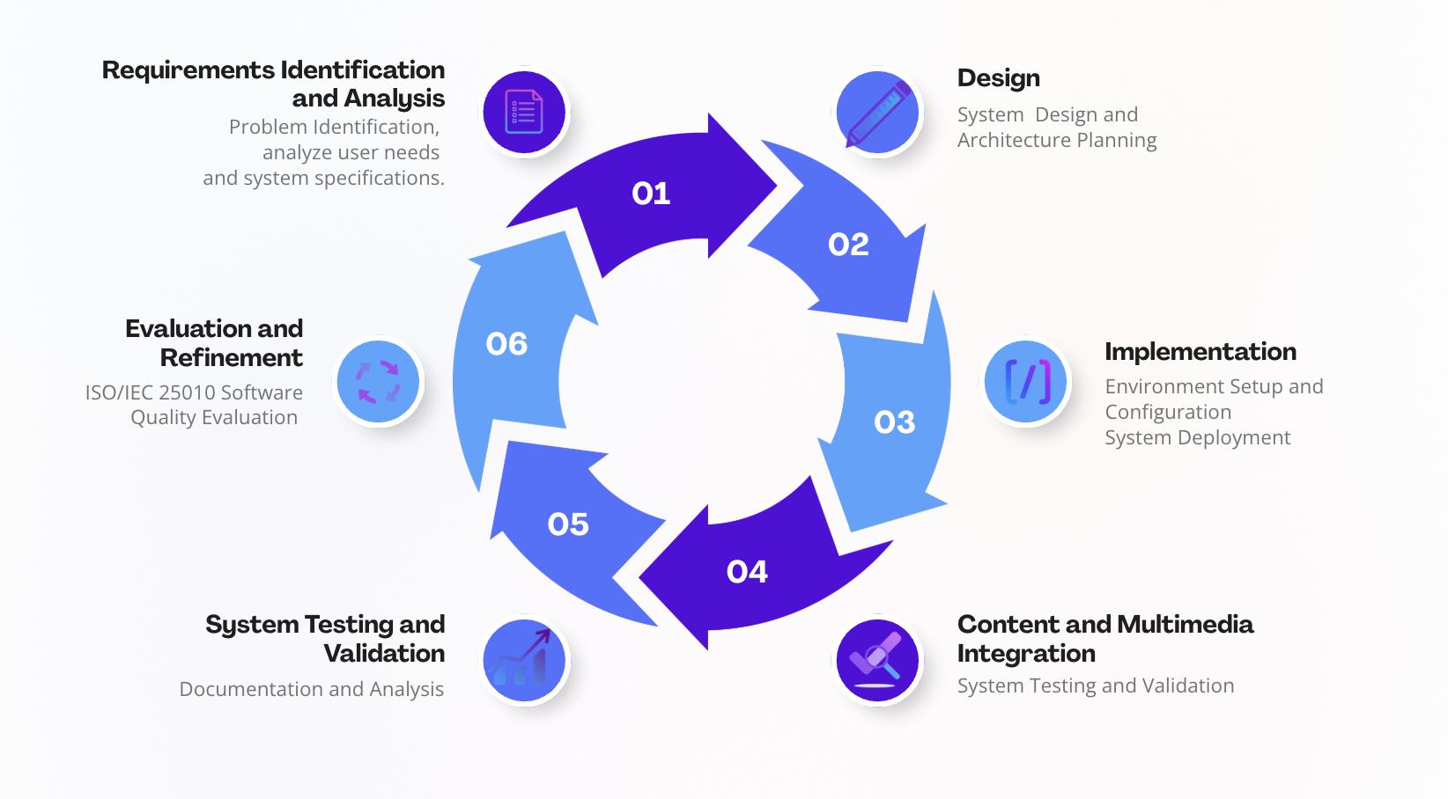

Figure 1. The development process follows an iterative–incremental approach, allowing repeated cycles of requirement identification and analysis, design, implementation, content integration, system testing and validation, and evaluation and refinement to progressively refine system components. This system development approach consists of system design, infrastructure setup, platform deployment, and evaluation phases. The process began with the identification of the voter education platform requirements followed by the design of the layered architecture. The system environment was then configured within a virtualized infrastructure and integrated with secure networking through Cloudflare Tunnel. Platform components including the Nginx web server, Flask backend API, Gunicorn application server, and PostgreSQL database were subsequently deployed. The final stages involved system testing and evaluation using the ISO/IEC 25010 software quality model.

A. Research Design and Development Approach

This study adopts a quantitative research approach utilizing the ISO/IEC 25010 Software Product Quality Model as the primary evaluation instrument. The quantitative approach enables the system to be assessed using measurable criteria based on predefined software quality characteristics. Data were collected through structured evaluation forms completed by selected respondents, and results were analyzed using descriptive statistics such as mean scores and interpretation scales.
The evaluation focused on key quality characteristics including functional suitability, usability, performance efficiency, reliability, security, and maintainability. This approach ensures that system assessment is objective, measurable, and aligned with internationally recognized software engineering standards.
In terms of software development, the study follows an iterative–incremental software development life cycle (SDLC) model. This approach allows the system to be developed in phases, where each iteration produces a functional component that can be tested and refined. The iterative model supports continuous improvement, early detection of issues, and progressive system enhancement, making it suitable for developing web-based information systems in dynamic environments (Pressman, et. al, 2020).

The combination of a quantitative research approach and an iterative development model enables systematic measurement of system quality and continuous refinement based on evaluation results.

B. Iterative – Incremental Development Phase

The development of the proposed voter education platform followed an iterative–incremental software development life cycle (SDLC) model. This model divides the system development process into multiple cycles, where each iteration produces a functional component that is tested and refined before proceeding to the next stage. This approach enables gradual system evolution while ensuring continuous validation of system functionality and performance.

The development process was organized into the following phases:

1. Requirements Identification and Analysis

The initial phase involved identifying the core requirements of the voter education platform, including accessibility, multimedia content delivery, and secure remote access. Key challenges such as limited internet connectivity, reliance on informal information sources, and the need for structured educational materials were considered in defining system objectives. This phase established the functional scope and guided subsequent design decisions.

2. System Design and Architecture Planning

In this phase, the overall system architecture was defined using a layered design approach. The platform was structured into presentation, application, and data layers to ensure modularity and maintainability. Design decisions also included the adoption of a local–hybrid deployment model, integrating locally hosted infrastructure with cloud-based access through Cloudflare Tunnel. Architectural components such as Nginx, Flask, Gunicorn, and PostgreSQL were selected to support system requirements.

3. Environment Setup and Configuration

The system environment was prepared by deploying a virtual machine running Ubuntu Server within a VMware-based Homelab infrastructure. Core system configurations included user management, directory structure initialization, firewall configuration, and service isolation. Secure networking was established using Cloudflare Tunnel to enable encrypted external access without exposing the local network directly to the internet.

4. System Development and Integration

During this phase, the core platform components were developed and integrated. The Nginx web server was configured as a reverse proxy, while the backend application was implemented using the Flask framework and served via Gunicorn. PostgreSQL was configured for persistent data storage. Integration activities ensured that all components functioned cohesively as a unified web-based system.

5. Content and Multimedia Integration

The platform was enhanced by incorporating multimedia educational materials, including videos, infographics, and text-based resources. This phase focused on improving user engagement and supporting diverse learning preferences. Content organization and delivery mechanisms were designed to ensure accessibility and clarity for community users.

6. System Testing and Validation

System testing was conducted to verify functionality, accessibility, and performance. Validation activities included testing API endpoints, verifying web content delivery through the configured domain, and assessing system responsiveness under both local and remote access conditions. System services were also configured for automatic startup to ensure operational stability.

7. Evaluation and Refinement

The final phase involved evaluating the system using the ISO/IEC 25010 Software Product Quality Model. Quality characteristics such as functional suitability, usability, performance efficiency, reliability, security, and maintainability were assessed. Findings from the evaluation were used to refine system configurations and improve overall system quality.

Category | Description | Number of Respondents
IT Experts | Professionals with experience in software development, networking, or system administration | 3
Software Quality Assurance Testers | Expert SQA Testers with experience in software testing and evaluation | 3
End-Users | Individuals representing community users of the platform | 3
Total |  | 9

The system evaluation involved a total of nine respondents representing different stakeholder groups. This includes IT professionals, Software Quality Assurance experts, and representative end-users to ensure a balanced and comprehensive evaluation of the system from technical, usability, and practical perspectives.

C. System Design Phases

The system design phase ensures that all system components are clearly defined before implementation. The use of UML, DFD, and ERD diagrams provides a structured representation of system interactions, data flow, and data relationships. These design artifacts support system maintainability and serve as a reference for implementation and future system enhancements.

1. Design Sub-Phases

The system design phase was divided into several sub-phases to ensure a structured and modular development approach. These sub-phases include architectural design, data design, process design, and user interaction design. Each sub-phase focuses on a specific aspect of the system to improve maintainability, scalability, and usability.

2. High-Level System Architecture

The system architecture is composed of three primary components: peopleware, software, and hardware. Peopleware includes end-users such as community members accessing voter education materials and administrators responsible for managing content. Software components consist of the web server (Nginx), backend application (Flask running on Gunicorn), database system (PostgreSQL), and cloud networking services (Cloudflare Tunnel). Hardware infrastructure includes the Homelab server environment, consisting of a virtual machine hosted on a physical mini-PC with sufficient processing, memory, and storage resources to support the platform.

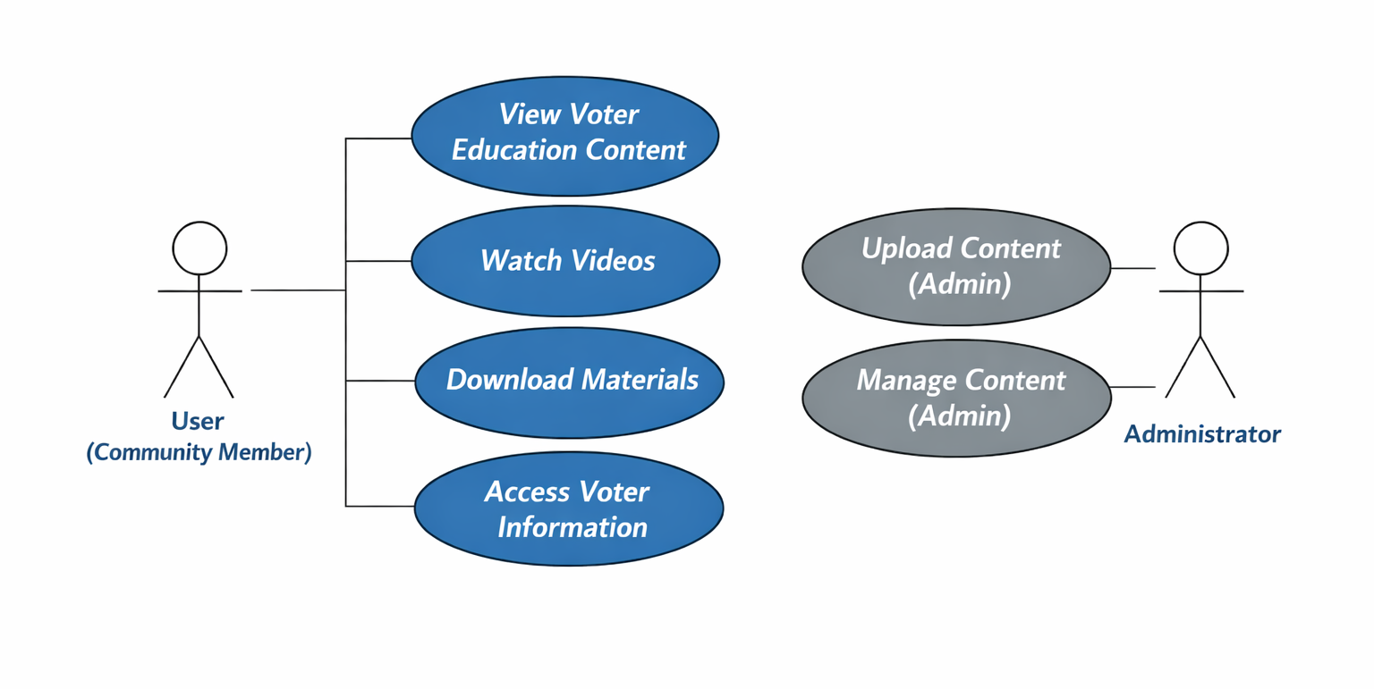
Figure 2. UML Use Case Diagram of the Voter Education Platform

The UML Use Case Diagram illustrates the interaction between two primary actors: the Community User and the Administrator. Community users access the platform to view voter education content, watch videos, download materials, and obtain relevant voter information. These functions support the system’s objective of delivering accessible and structured educational resources to promote informed civic participation. The Administrator is responsible for managing platform content through functionalities such as uploading and maintaining educational materials. The diagram highlights a role-based access control structure, where administrative privileges are restricted to authorized users while general users are limited to content access. This separation ensures system security, maintainability, and efficient content delivery within the platform.

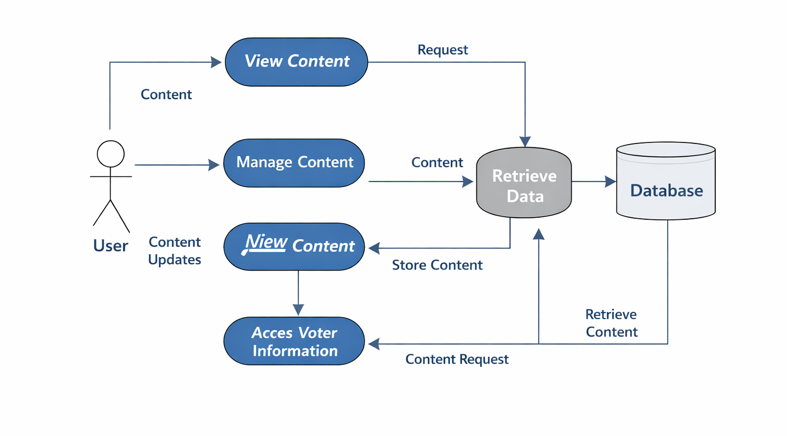
Figure 3. Data Flow Diagram of the Voter Education Platform

The Data Flow Diagram (DFD) illustrates how user interactions are processed within the voter education platform and how data flows between system components. The User initiates actions such as viewing content, accessing voter information, or managing content. These requests are routed to the system process responsible for data retrieval, which communicates with the database to fetch or store relevant information. The database serves as the central repository for educational materials and system data. The diagram also shows bidirectional data flow between the system and the database, where content requests result in data retrieval, while administrative actions lead to content updates and storage. This flow ensures that users receive accurate and updated information while maintaining data consistency. Overall, the DFD highlights the system’s structured data handling, supporting efficient content delivery, and reliable information access.

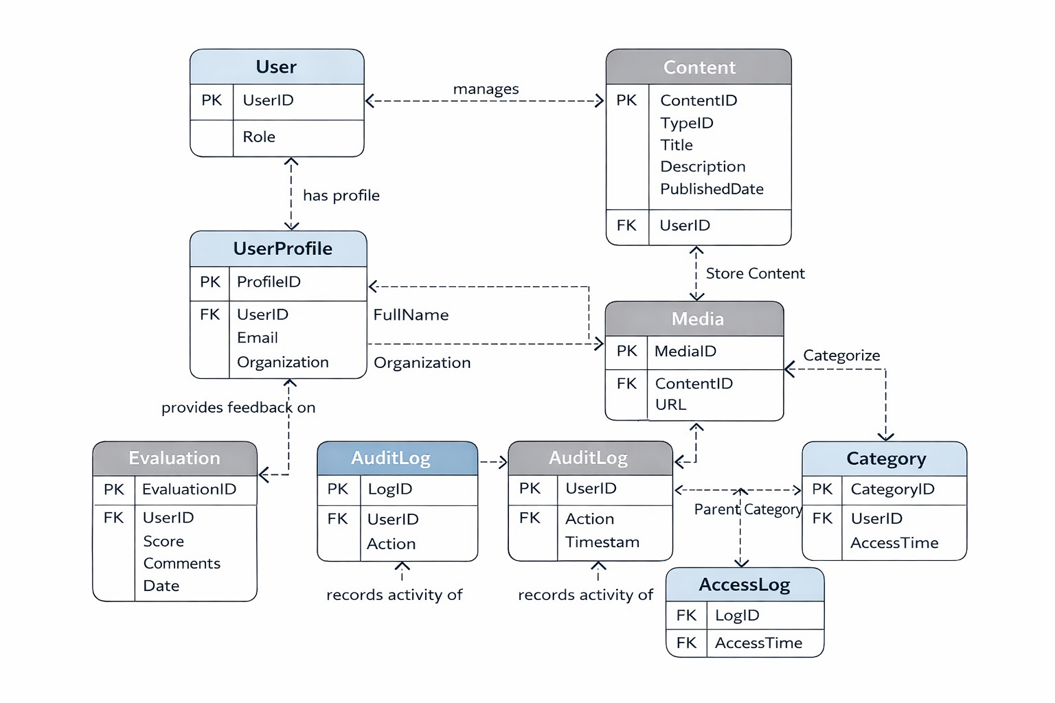
Figure 4. Entity Relationship Diagram

The database design was further expanded to support future scalability and additional system functionalities. New entities such as user profiles, content types, audit logs, evaluation records, and access logs were incorporated to enhance system maintainability, traceability, and analytical capabilities. These enhancements enable the system to support user management, content classification, activity monitoring, and integration of evaluation data. The improved entity relationships also allow for future system extensions such as authentication mechanisms, usage analytics, and advanced content organization through hierarchical categories.

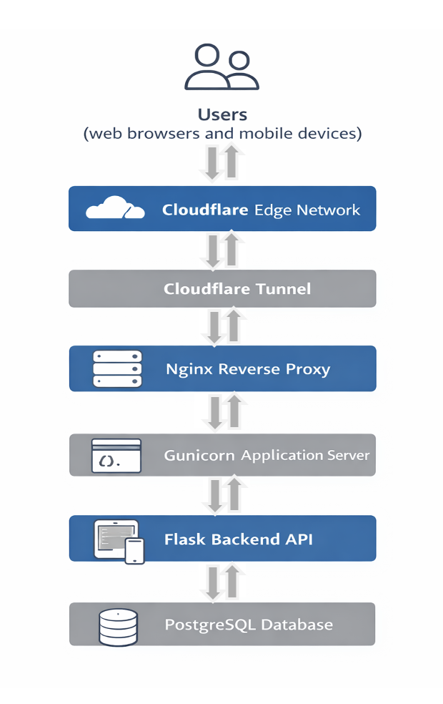
Figure 5. The system architecture of the proposed voter education platform follows a layered web application model. User requests originating from web browsers and mobile devices are first routed through the Cloudflare edge network and securely forwarded through a Cloudflare Tunnel to the locally hosted infrastructure. The Nginx web server functions as a reverse proxy that forwards requests to the backend application layer running on the Gunicorn application server. The backend application is implemented using the Flask web framework, which processes application logic and interacts with the PostgreSQL database for persistent storage of platform content and system data.

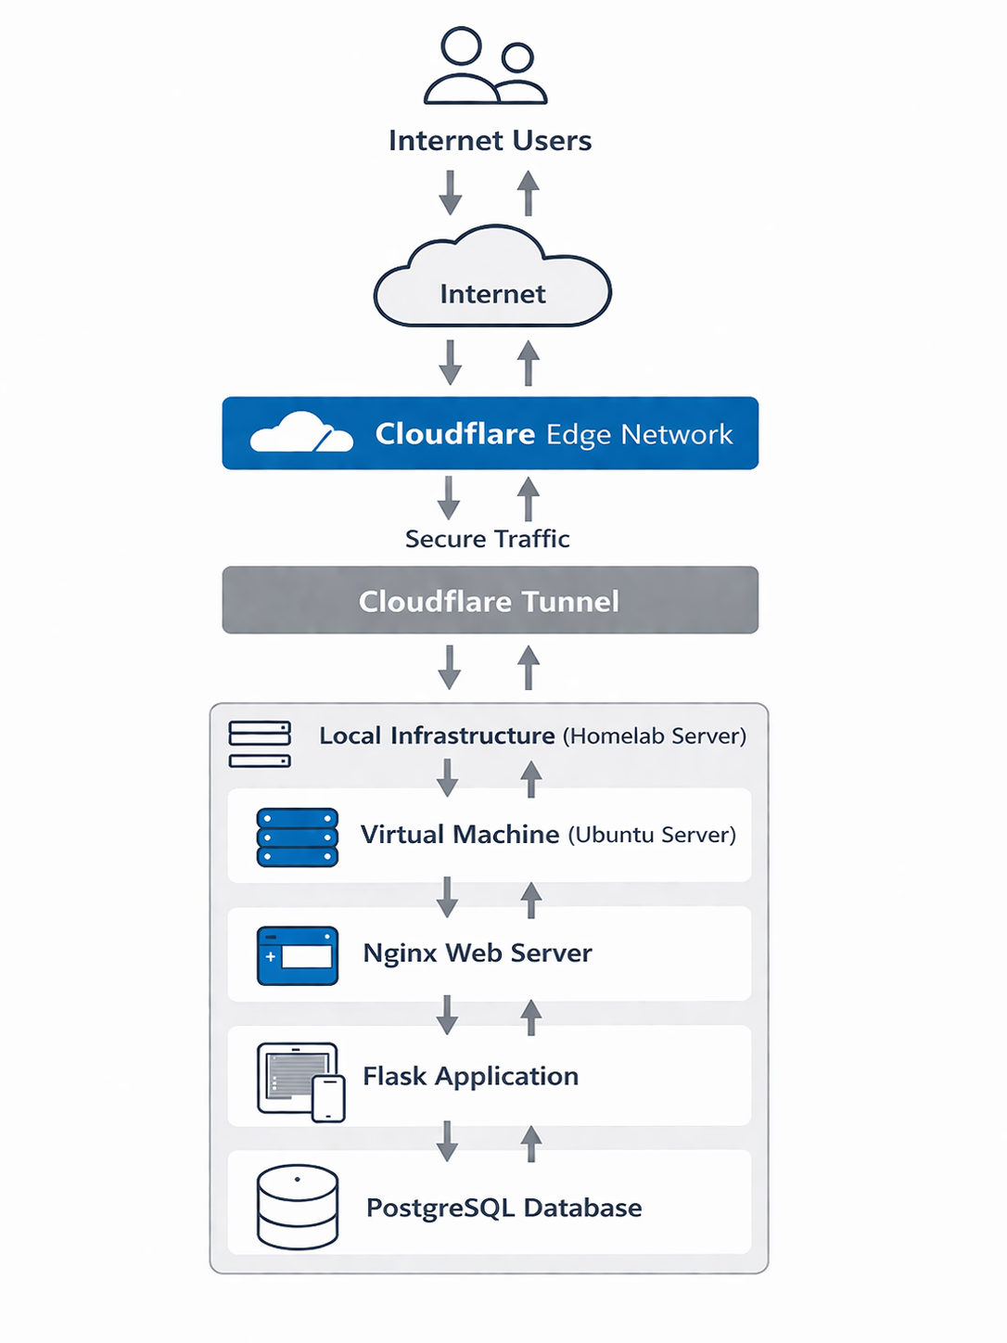
Figure 6. The deployment architecture illustrates the local–hybrid infrastructure used to host the voter education awareness platform. Core system components are deployed within a homelab environment on a virtual machine running Ubuntu Server. Public access to the system is enabled through a secure Cloudflare Tunnel, which routes encrypted traffic from the Cloudflare edge network to the internal web server without exposing the local network to direct internet access. This architecture allows the platform to maintain local infrastructure control while providing secure remote accessibility for community users.

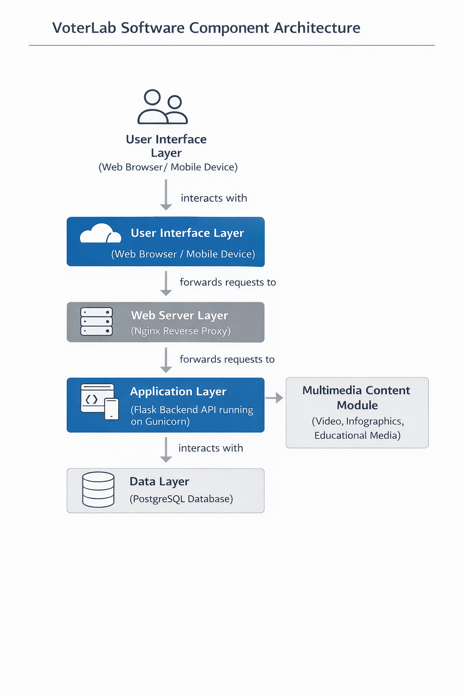

Figure 7. The software component architecture of the proposed platform illustrates the interaction between the major functional components of the system. User requests originate from web browsers or mobile devices and are processed through the Nginx web server acting as a reverse proxy. The backend application logic is implemented using the Flask framework running on the Gunicorn application server, which handles content delivery and system functionality. Persistent data storage is managed by the PostgreSQL database. The application layer also integrates a multimedia content module that provides educational videos, infographics, and other voter education resources to support interactive learning and community engagement.

D. System Implementation Phases

An administrative module was integrated into the system to support dynamic content management. The platform implements role-based access control (RBAC), allowing only authorized administrators to access content management features through a dedicated dashboard interface. Administrators can create and delete educational materials, ensuring that content remains accurate and up-to-date.
The system incorporates a multimedia upload mechanism, enabling administrators to directly upload video, image, and document-based content. Uploaded files are stored in categorized directories and served through the web server. Preview functionality is provided prior to submission to ensure content accuracy.
To enhance usability, the platform includes search, filtering, and pagination features that allow users to efficiently navigate and access educational materials. Input validation and error handling mechanisms were implemented on both client and server sides to maintain data integrity and system reliability.

The implementation phase demonstrates the practical realization of the system design. The integration of web server, backend application, database, and secure networking components resulted in a fully functional platform accessible both locally and remotely. The use of iterative development allowed continuous refinement of system features, while structured testing and evaluation ensured alignment with software quality standards.

1. Implementation Sub-Phases

The implementation phase was conducted in multiple stages, including environment setup, system deployment, service configuration, and integration of platform components. Each stage was validated before proceeding to the next phase to ensure system stability.

2. Testing and Evaluation Approach

The system was evaluated using a combination of functional testing and software quality assessment based on the ISO/IEC 25010 model. Functional testing was conducted to verify system features such as content access, multimedia playback, and API functionality.

Alpha testing was performed within the development environment to validate system configuration and component integration. Beta-level validation was simulated through real-world usage scenarios, including remote access through Cloudflare Tunnel and local access within the network.

Evaluation based on ISO/IEC 25010 focused on key quality characteristics, including functional suitability, usability, performance efficiency, reliability, security, and maintainability.

E. Tools and Technologies

The platform was implemented using stable and widely adopted technologies to support reliability and reproducibility. A Linux-based server operating system was used as the primary hosting environment, deployed within a virtual machine to provide isolation and ease of recovery. The web application is delivered through a standard web server, with backend services responsible for content management and basic data handling.
Multimedia elements, including videos, audio explanations, and visual infographics, were integrated to support diverse learning styles and enhance user engagement.

F. Deployment Strategy

Deployment was conducted within a homelab (on-premise) environment using consumer-grade hardware configured to simulate a small-scale production server. Virtualization was used to isolate the application from other workloads and to support snapshot-based recovery.
The platform supports dual access modes: local access within the hosting network and remote access via secure internet exposure, enabling flexible usage scenarios.

The deployment model follows a local–hybrid infrastructure architecture in which core services are hosted locally while secure access is provided through cloud networking services. Hybrid infrastructure models combine the reliability of on￼premise systems with the accessibility of cloud￼based networking services (Zhang et.al, 2022).

G. Software Quality Evaluation Framework

The evaluation of the software product was guided by the ISO/IEC 25010 Software Product Quality Model, which defines a structured framework for assessing software quality based on internationally recognized characteristics. Selected quality characteristics used in this study include functional suitability, usability, performance efficiency, reliability, security, and maintainability. (Carvallo et. al, 2019).
Evaluation activities included functional verification of system features, observation of user interaction with multimedia content, assessment of system responsiveness during local and remote access, and review of system behavior under normal operating conditions. The use of ISO/IEC 25010 ensures that the assessment is systematic, transparent, and aligned with recognized software engineering standards.

Table 1. Software Quality Evaluation Based on ISO/IEC 25010

Quality Attribute | Evaluation Criteria | Method Used | Result | Interpretation
Functional Suitability | Availability of core features (content viewing, multimedia access) | Functional testing of system features | All core features operational | The system meets required functional objectives
Usability | Ease of navigation, content readability, multimedia accessibility | User interaction observation | Users able to navigate and access content | The system is user-friendly and accessible
Performance Efficiency | Response time during local and remote access | Manual testing of page load and API response | < 200 ms (local), < 500 ms (remote) | System performs efficiently under normal conditions
Reliability | System stability and uptime during operation | Continuous runtime observation | No major failures observed | System demonstrates stable behavior
Security | Protection of system from unauthorized access | Review of Cloudflare Tunnel, firewall, and access control | Secure tunnel + firewall enabled | System provides secure access architecture
Maintainability | Ease of updating and modifying system components | Code structure and modularity review | Modular architecture implemented | System is easy to maintain and extend

The system was evaluated using selected characteristics from the ISO/IEC 25010 Software Product Quality Model. Evaluation results indicate that the platform satisfies key quality attributes required for web-based information systems. Functional requirements were fully implemented, and the system demonstrated acceptable usability and performance under both local and remote access conditions. Security measures implemented through Cloudflare Tunnel and firewall configuration provided controlled system exposure, while the modular architecture supports maintainability and future system enhancements.

III. Results and Discussion

The voter education awareness platform was successfully implemented using a local–hybrid deployment architecture. The system runs on a virtual machine using Ubuntu Server 24.04 LTS hosted within a VMware environment. The host hardware consists of a GMKtec Mini￼PC with an AMD Ryzen 7 processor, 32GB RAM, and 1TB SSD storage.

A secure networking configuration was implemented using Cloudflare Tunnel to provide encrypted external access without exposing the homelab network directly to the public internet. The domain 'unlipop.win' routes traffic securely through Cloudflare to the internal Nginx web server.
The deployed architecture integrates several components forming a multitier platform: Nginx as the web server and reverse proxy, a Flask backend application running through the Gunicorn application server, and PostgreSQL for persistent data storage.

Initial testing confirmed that the system successfully served web content through the configured domain and that backend API endpoints were accessible through the reverse proxy configuration. Core services including Nginx, PostgreSQL, and the Flask backend were configured to start automatically using systemd.

The platform was implemented using a multi-tier web architecture integrating frontend, backend, database, and secure networking components. The frontend was developed using HTML, CSS, and JavaScript, employing dynamic content rendering through API calls. The system retrieves lesson data from a backend endpoint (/api/lessons) and presents it in a card-based interface, where each card represents a voter education module containing multimedia elements such as videos, images, and documents.
The backend system was implemented using Python with the Flask framework and deployed using Gunicorn as a production-grade WSGI server. RESTful API endpoints return structured JSON data to the frontend. The PostgreSQL database stores lesson metadata including title, description, media type, and file location.
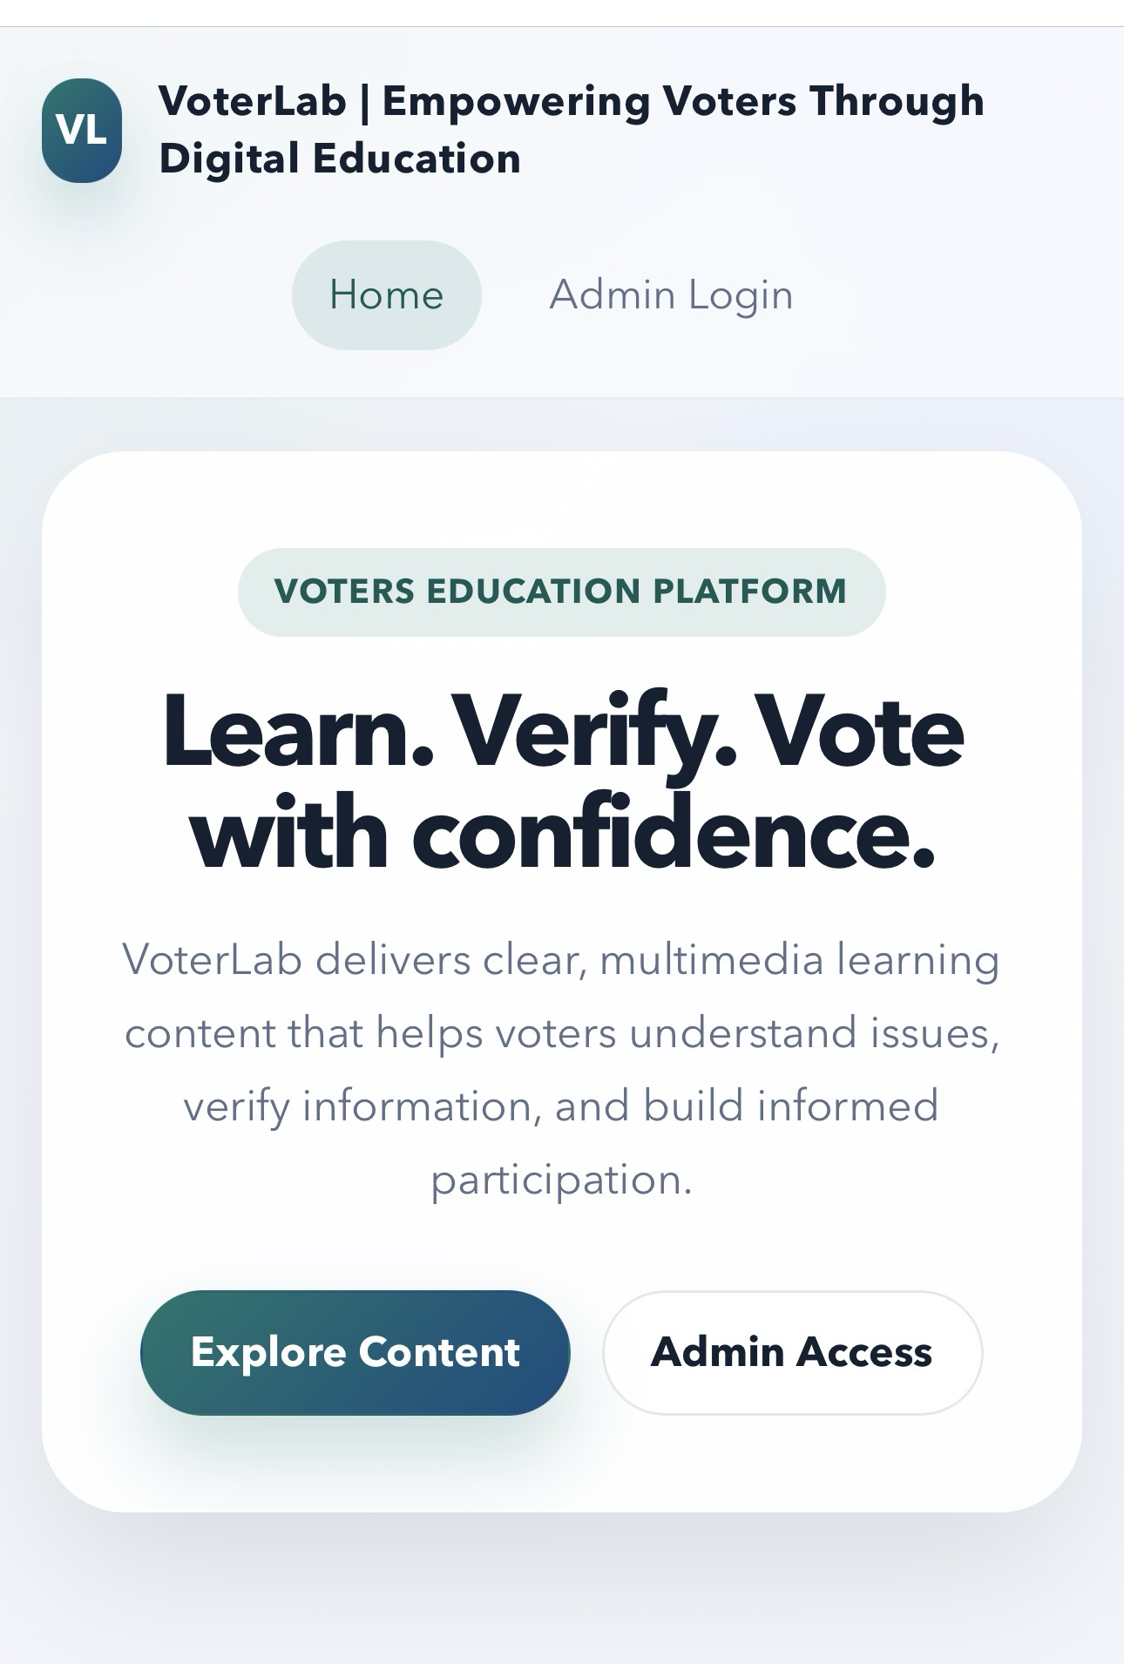 | 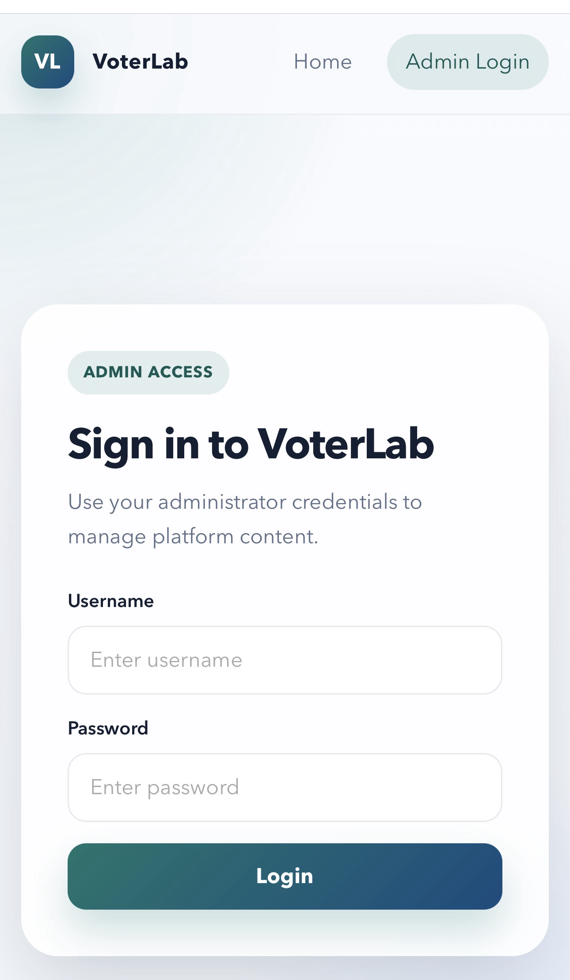 | 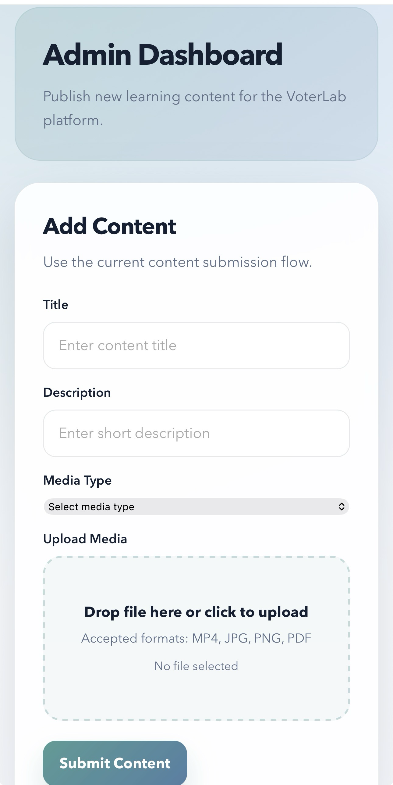
Figure 8 - 10. Home Page, Admin Login Page, and Content Page

The platform interface presents multimedia voter education content using a card-based layout. Figures 8–11 illustrate the homepage, administrator login interface, content page, and multimedia module. These features enable users to access structured learning materials including videos, infographics, and documents. The interface supports usability principles under ISO/IEC 25010 by ensuring clarity, accessibility, and intuitive navigation.

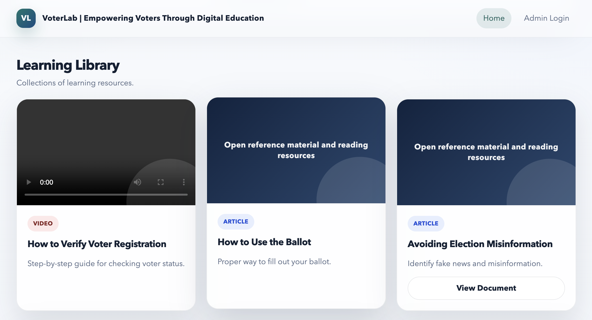
Figure 11. Multimedia Module (Learning Library)

The system includes an administrative dashboard that enables authorized users to manage platform content. Administrators can securely log in and perform content creation and deletion operations through an intuitive interface. The implementation of role-based access control ensures that administrative functionalities are restricted to authorized users only. The platform supports direct multimedia uploads, allowing administrators to add educational materials such as videos, images, and documents without relying on external sources. Uploaded content is automatically stored and made accessible through the system.

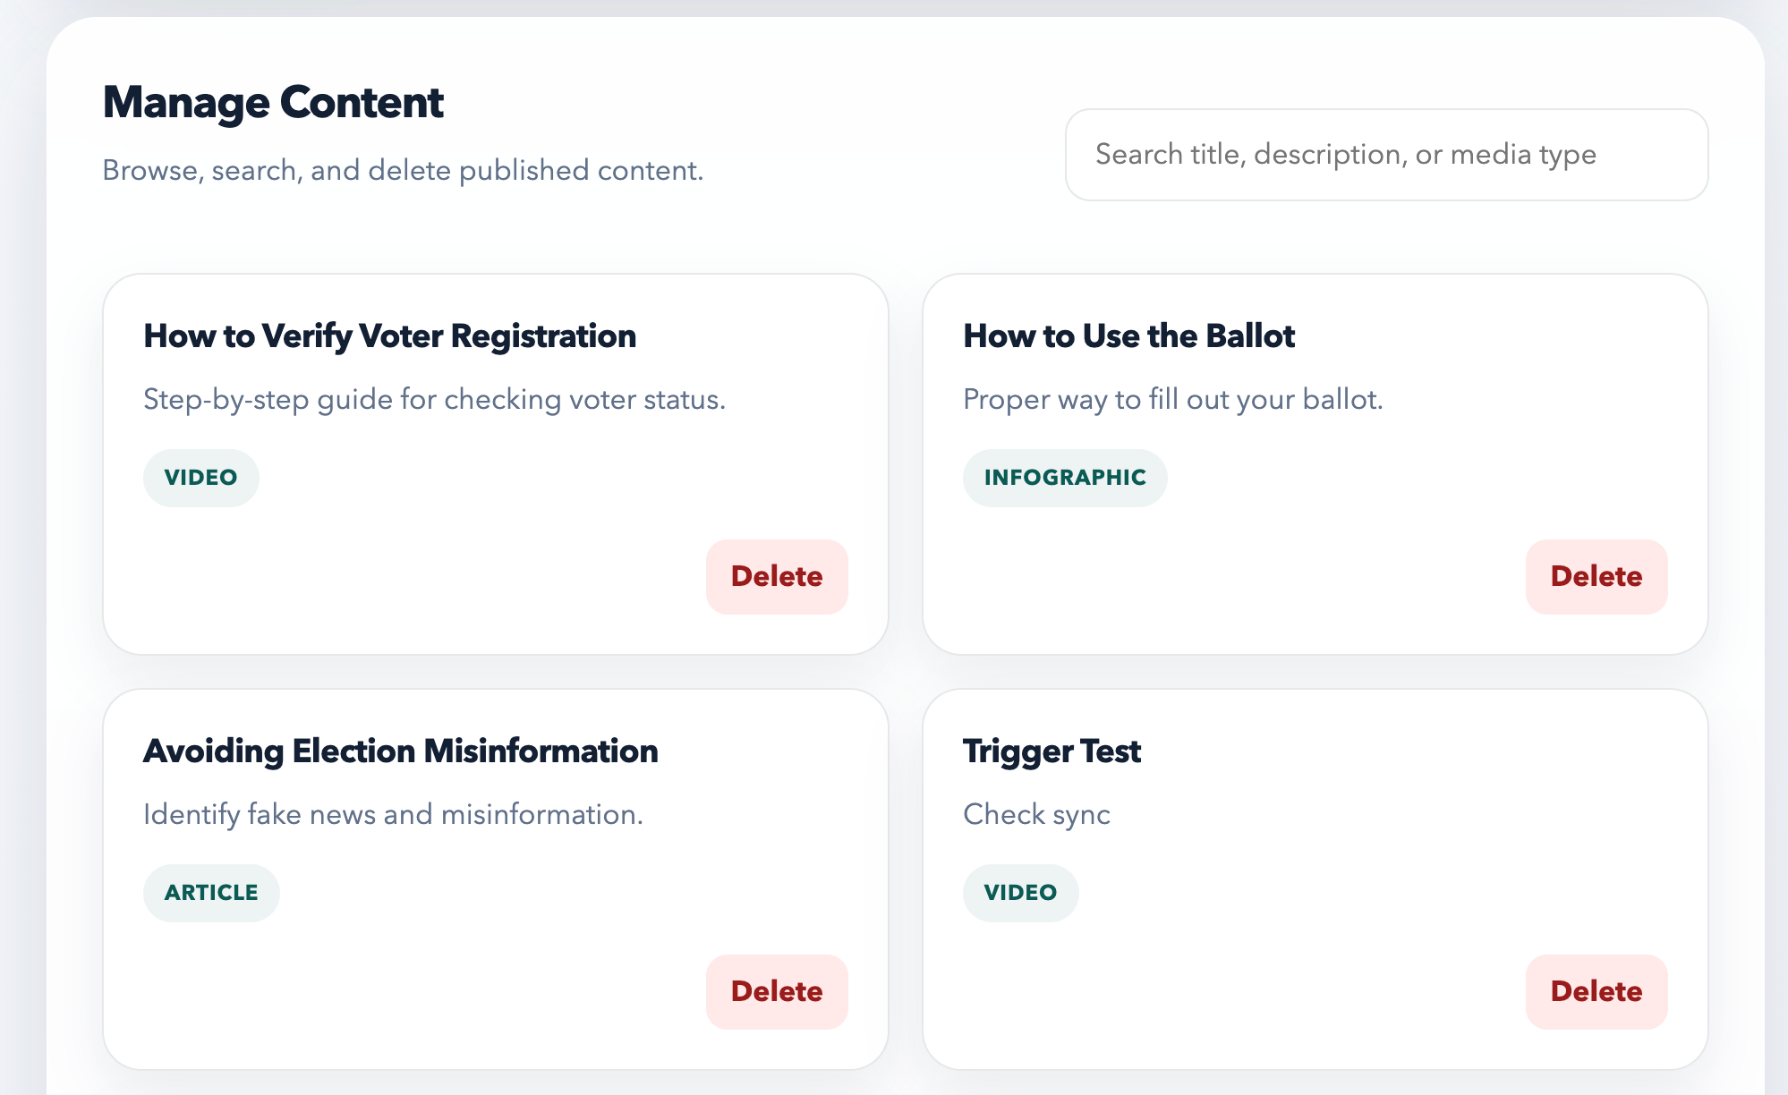
Figure 11. Administrative Dashboard to manage multimedia content

The administrative dashboard allows authorized users to manage educational content through role-based access control (RBAC). Administrators can securely log in, create, and delete content. The integration of multimedia upload functionality enables direct content management without reliance on external sources, improving system independence and maintainability.

Additional features such as search, filtering, and pagination improve user navigation and accessibility, enabling efficient browsing of educational content. Security mechanisms include session-based authentication, role-based access control, and secure password hashing to ensure protection from unauthorized access.

Multimedia content is delivered through the Nginx web server using a dedicated static route (/media/), which improves performance efficiency by offloading media delivery from the backend application. Secure external access is achieved through Cloudflare Tunnel, enabling HTTPS access without directly exposing the internal infrastructure. The integration of administrative and content management functionalities significantly enhances the system’s practicality. By enabling authorized users to dynamically manage educational materials, the platform transitions from a static content delivery system to a fully functional content management system. The system demonstrated stable performance in both local and remote environments, successfully delivering dynamic content and multimedia resources. Service reliability was validated through restart testing using systemd, ensuring automatic recovery of core services. The use of systemd for service management contributes to system reliability by ensuring automatic service recovery in the event of failures. This feature is particularly important for community-based deployments where continuous availability is required.

Table 2. ISO/IEC 25010 Evaluation Results

Quality Attribute | Mean Score | Interpretation
Functional Suitability | 4.78 | Excellent
Usability | 4.65 | Excellent
Performance Efficiency | 4.60 | Excellent
Reliability | 4.52 | Very Good
Security | 4.70 | Excellent
Maintainability | 4.68 | Excellent

Table 2 presents the quantitative evaluation results based on ISO/IEC 25010. The system achieved excellent ratings in functional suitability, usability, performance efficiency, and security, while reliability was rated very good. These results indicate that the platform meets international software quality standards.

The evaluation results indicate that the system achieved high ratings across all ISO/IEC 25010 quality attributes. Functional suitability, usability, and security received excellent ratings, indicating that the system effectively meets its intended purpose. The results validate the effectiveness of the local–hybrid architecture in delivering a reliable and accessible voter education platform.

The evaluation results also indicate that the system performs consistently across key quality attributes, particularly in functional suitability and maintainability. The integration of local hosting and secure tunneling contributed significantly to system reliability and security, demonstrating the effectiveness of the hybrid deployment model.

The high evaluation scores validate the effectiveness of the system design and implementation. The integration of multimedia content, structured navigation, and secure hybrid deployment contributed to positive user experience and system performance. The findings demonstrate that the platform is suitable for community-based voter education initiatives.

Conclusion

The implementation results demonstrate the practicality of using a local–hybrid architecture for community oriented information systems. Unlike fully cloud hosted platforms, this approach allows administrators to maintain control over infrastructure while still providing secure public access through cloud based networking services. The implementation highlights the effectiveness of separating static and dynamic content delivery. By utilizing Nginx for serving multimedia resources and Flask for backend logic, the system achieves improved performance and scalability. This design approach reduces backend load and enhances user experience, particularly when accessing large media files. From a software engineering perspective, the layered architecture contributes to system maintainability and extensibility because each system component performs a distinct function. This modular design enables independent maintenance of the web server, backend application, and database layers.

The ISO/IEC 25010 framework provides a structured basis for evaluating software quality characteristics including functional suitability, usability, performance efficiency, reliability, security, and maintainability. The deployed architecture demonstrates strong characteristics in maintainability and security due to the use of reverse proxy routing and secure tunneling. The evaluation results confirm that the system aligns with internationally recognized software quality standards, demonstrating its suitability for deployment in community-based voter education initiatives. Compared to traditional cloud-based deployments, the proposed local–hybrid model offers improved control over infrastructure and reduced dependency on continuous internet connectivity. This makes the system particularly suitable for community-level deployments in areas with limited network stability. This study is limited by the absence of large-scale user testing and quantitative usability metrics. Future work may include user-based evaluation and performance benchmarking under varying network conditions. Future enhancements may include mobile optimization, integration with official election data sources, and deployment in multiple community environments for broader validation.

References

Kertysova, K. (2018). Artificial intelligence and disinformation. Security and Human Rights, 29(1–4), 55–81. https://doi.org/10.1163/18750230-02901005

Diepeveen, S., & Pinet, M. (2022). User perspectives on digital literacy as a response to misinformation. Development Policy Review, 40(S2). https://doi.org/10.1111/dpr.12671

W. Lance Bennett. Civic Life Online: Learning How Digital Media Can Engage Youth. Cambridge, MA. MIT Press 2008. 206 pp., ISBN: 9780262524827 US$16.00 (soft cover) The John D. and Catherine T. MacArthur Foundation Series on Digital Media and Learning. https://doi.org/10.1108/14684520910969998

Zhang, Q., Cheng, L., & Boutaba, R. (2010). Cloud computing: state-of-the-art and research challenges. Journal of Internet Services and Applications, 1(1), 7–18. https://doi.org/10.1007/s13174-010-0007-6

Gill, S. S., Wu, H., Patros, P., Ottaviani, C., Arora, P., Pujol, V. C., Haunschild, D., Parlikad, A. K., Cetinkaya, O., Lutfiyya, H., Stankovski, V., Li, R., Ding, Y., Qadir, J., Abraham, A., Ghosh, S. K., Song, H. H., Sakellariou, R., Rana, O., . . . Buyya, R. (2024). Modern computing: Vision and challenges. Telematics and Informatics Reports, 13, 100116.
https://doi.org/10.1016/j.teler.2024.100116

Moumane, K., Idri, A., & Abran, A. (2016). Usability evaluation of mobile applications using ISO 9241 and ISO 25062 standards. SpringerPlus, 5(1), 548. https://doi.org/10.1186/s40064-016-2171-z

Benlahcene, A. (2024). Citizens’ e-participation through e-government services: Opportunities and challenges. Cogent Social Sciences, 10(1), 2415526. https://doi.org/10.1080/23311886.2024.2415526

Carvallo, J. P., & Franch, X. (2019). Managing non-functional requirements for software architectures: An ISO/IEC 25010-based approach. Information and Software Technology, 116, 106213. https://doi.org/10.1016/j.infsof.2019.106213

Shin, B., Lee, J., & Park, Y. (2024). Digital tools for citizen participation: A systematic analysis. Government Information Quarterly, 41(1), 101954. https://doi.org/10.1016/j.giq.2024.101954

Suttmann-Lea, M. (2023). The impact of voter education on voter confidence. Election Law Journal, 22(3), 245–262. https://doi.org/10.1089/elj.2022.0055

Velasco, N. Y. G., Rodríguez Gutierrez, J. K., & Chaviano, O. G. (2024). Research trends in digital citizenship: Bibliometric mapping from Web of Science. Journal of Infrastructure Policy and Development, 8(12). https://doi.org/10.24294/jipd.v8i12.8492

Bastardo, R., Pavão, J., & Rocha, N. P. (2024). Methodological quality of usability evaluation of digital applications to promote citizens’ engagement and participation. Digital, 4(3), 740–761. https://doi.org/10.3390/digital4030038

Gomes Velasco, N. Y., Rodríguez Gutierrez, J. K., & Chaviano, O. G. (2024). A bibliometric analysis of Web 2.0 in election campaigns. Heliyon, 10, e40337. https://doi.org/10.1016/j.heliyon.2024.e40337

Cadayday, B. A. R., Jimenez, D. M., & Boiser, S. M. (2024). Role of social media in the political landscape and voting decisions of Gen Zs in the Philippines. International Journal of Research and Innovation in Social Science, 8(11), 720–730. https://doi.org/10.47772/IJRISS.2024.8120059

Yu, E. R., II, Pineda, E. D., Tano, I. M., Lagman, A. C., Victoriano, J. M., Mababa, J. C., & Pulumbarit, J. P. (2025). Student Information System for Computer Studies with Integrated Programming Anxiety Level Prediction and Balanced Group Recommendations. International Journal of Latest Technology in Engineering Management & Applied Science, 14(3), 572–579. https://doi.org/10.51583/ijltemas.2025.140300060

Pasaribu, J. S., & Argadikusuma, I. S. (2024). Design and testing of a Web-Based Student Information Management System. International Journal of Engineering Science and Information Technology, 4(4), 144–155. https://doi.org/10.52088/ijesty.v4i4.594

Permana, R., & Alkadri, S. P. A. (2025). Development of a Web-Based Thesis Repository for Information Technology Education Students. Journal of Multidiscipline and Collaboration Research., 2(2), 93–101. https://doi.org/10.58740/jmcr.v2i2.625

