Gender and Demographic Factors in Housing Demand in Lagos State

Abstract
This study examines the intersection of gender and demographic factors in shaping housing demand patterns across Lagos State, Nigeria. Drawing on a mixed-methods framework that integrates quantitative housing survey data with qualitative ethnographic insights, the research interrogates how patriarchal property regimes, customary legal pluralism, age structure transitions, household composition dynamics, and income stratification collectively structure differential access to housing. The analysis reveals that female-headed households in Lagos face a 13.7 percentage point deficit in home ownership relative to male-headed counterparts, a disparity rooted in discriminatory inheritance customs, limited collateral capacity, and gendered labor market segmentation. Demographic pressures, including a projected population of 32 million by 2035 and a youthful dependency ratio of 62 percent, intensify housing demand while simultaneously constraining supply responsiveness. The study identifies four distinct housing demand segments differentiated by gender of household head, income quintile, and spatial location, each exhibiting unique affordability thresholds and tenure preferences. Findings indicate that the intersection of gender and demographic factors produces compounding disadvantages for women in peripheral urban zones, where infrastructure deficits, tenure insecurity, and limited formal employment opportunities converge. The article advances a gendered demographic transition framework that situates housing demand within broader processes of urbanization, structural economic change, and institutional reform. Policy implications emphasize the need for gender-responsive housing finance instruments, tenure regularization programs targeting women in informal settlements, and demographic forecasting models that incorporate intrahousehold bargaining dynamics.
Keywords: housing demand, gender inequality, demographic transition, Lagos State, urbanization, property rights, affordability, informal settlements

1. Introduction
The housing landscape of Lagos State represents one of the most complex urban real estate markets in the Global South, characterized by extreme heterogeneity in housing quality, tenure arrangements, and spatial distribution of residential opportunities. As Africa's most populous city and one of its fastest-growing urban agglomerations, Lagos confronts a housing deficit estimated at approximately 3 million units, with annual demand outpacing supply by a ratio of nearly three to one (Adeyemi & Ademiluyi, 2019; Oyebode & Daniel, 2023). Within this context of aggregate housing shortage, the distribution of housing access is neither random nor solely determined by market forces; rather, it is profoundly shaped by the intersection of gender relations, demographic structures, and institutional arrangements that govern property acquisition, tenure security, and residential mobility.
The significance of examining gender and demographic factors in housing demand extends beyond academic interest into the realm of policy imperatives. Nigeria's urban population is projected to reach 71 percent by 2050, with Lagos serving as the primary destination for rural-urban migrants seeking economic opportunity (OECD, 2025). The demographic composition of this migration stream, predominantly young adults between 18 and 35 years, carries profound implications for housing demand in terms of household formation rates, preferred dwelling types, and spatial location choices. Concurrently, the persistence of patriarchal property regimes, discriminatory customary inheritance practices, and gendered labor market segmentation creates systematic barriers to women's independent housing access, perpetuating cycles of residential vulnerability and economic dependence (Gaddis, 2018; Doss et al., 2015).
This article advances three interconnected arguments. First, housing demand in Lagos is not a monolithic phenomenon but is differentiated along gender lines, with women facing distinct barriers rooted in legal pluralism, cultural norms, and economic disadvantage. Second, demographic factors, including age structure, household size, and migration status, interact with gender to produce specific housing demand profiles that vary across income quintiles and spatial zones. Third, the current policy architecture for housing provision in Lagos insufficiently addresses the gendered and demographic dimensions of housing need, resulting in interventions that fail to reach the most vulnerable populations. Integrating insights from feminist urban theory, demographic transition theory, and housing economics, this study offers a theoretically grounded and empirically informed analysis of housing demand dynamics in one of Africa's most consequential urban settings.

2. Literature Review and Theoretical Framework
2.1 Gender, Property Rights, and Housing Access in Sub-Saharan Africa
The relationship between gender and property ownership in Sub-Saharan Africa has attracted growing scholarly attention, reflecting recognition that housing and land constitute the primary forms of wealth for most households and that gender gaps in property access represent a fundamental dimension of economic inequality (Gaddis, 2018; De Magalhaes & Santaeulalia-Llopis, 2015). Cross-national analysis of Demographic and Health Survey data from 28 African countries reveals that women are significantly less likely than men to claim sole ownership of housing property, with the gender gap translating into approximately 44 million fewer women than men owning housing in the 20 to 49 age cohort (Gaddis, 2018). This aggregate disparity masks substantial variation across countries, with gender gaps in property ownership generally larger in rural than urban areas, though the direction of this difference reflects lower overall ownership rates among urban men rather than improved access for urban women.
In the Nigerian context, the legal framework governing property rights presents a complex landscape of constitutional guarantees, statutory provisions, and customary practices that often operate in tension. The Constitution of the Federal Republic of Nigeria (1999, as amended) guarantees every citizen the right to acquire and own immovable property without discrimination on the basis of sex (Section 43), while the Land Use Act of 1978 establishes the framework for land administration through statutory and customary rights of occupancy. However, the coexistence of statutory marriage law, customary law, and Islamic law creates a tripartite system in which women's property rights vary substantially depending on the form of marriage contracted and the ethnic community of residence (Nigerian Journal of Private and Property Law, 2022). Among the Igbo of southeastern Nigeria, customary inheritance practices based on primogeniture explicitly exclude daughters and wives from inheriting real property, a position upheld in judicial decisions such as Ugboma v. Ibeneme, though increasingly challenged by constitutional equality provisions. Among the Yoruba of southwestern Nigeria, including Lagos State, inheritance customs are comparatively more liberal, permitting daughters to inherit paternal property while generally excluding wives, on the rationale that property devolves through blood rather than marriage (Nigerian Journal of Private and Property Law, 2022).
The practical implications of these legal and customary arrangements for women's housing access are profound. Women who marry under customary law lack the legal protections afforded to those in statutory marriages, including rights to matrimonial property settlement upon divorce. The Married Women's Property Act of 1882, which provides for women's independent property rights, applies only to statutory marriages, leaving the majority of women in customary unions without formal legal recourse in property disputes. Furthermore, even where statutory protections exist, enforcement remains weak, and cultural norms frequently supersede legal provisions in practice. The result is a systematic pattern of female housing disadvantage that manifests in lower home ownership rates, greater reliance on rent-free accommodation (often contingent on familial or marital relationships), and heightened vulnerability to displacement upon widowhood or divorce (Gaddis, 2018; IFC, 2020).
2.2 Demographic Transition and Housing Demand Dynamics
Demographic transition theory, originally developed to explain the shift from high to low fertility and mortality regimes, has been extended to analyze the implications of changing age structures for economic growth, labor markets, and housing demand (Bloom et al., 2003). The concept of the demographic dividend, which refers to the economic growth potential that arises from shifts in a population's age structure, particularly when the working-age population grows relative to dependents, carries significant implications for housing markets. In contexts where the demographic dividend is realized through productive employment and income growth, housing demand typically increases in both quantity and quality, as households transition from informal to formal housing and from rental to ownership tenure.
Nigeria, and Lagos State in particular, occupies a distinctive position in the demographic transition. With a national population exceeding 230 million and an annual growth rate of approximately 2.2 percent, Nigeria is projected to become the world's third most populous country by 2050 (United Nations, 2023). Lagos State, with an estimated population of 15 to 20 million depending on definitional boundaries, experiences annual growth rates of 5 to 6 percent, driven by natural increase and sustained rural-urban migration (Omiunu, 2014; Makinde, 2014). The city's population pyramid exhibits a pronounced youth bulge, with approximately 60 percent of residents under the age of 25, creating a demographic configuration in which household formation rates are high and housing demand is concentrated among young, often first-time householders with limited accumulated wealth.
The interaction between demographic structure and housing demand in Lagos is further complicated by household composition patterns. Nigerian households are among the largest in Africa, with an average size of 5.4 persons, though significant variation exists by region, income, and urban-rural location. Male-headed households average 6.0 persons compared to 3.6 persons for female-headed households, reflecting differences in marital status, polygamy prevalence, and child dependency (World Bank, 2017). Female-headed households, which constitute approximately 15.4 percent of households nationally and likely a higher proportion in Lagos due to urban economic opportunities for women, face particular housing challenges related to smaller household economies of scale, lower average incomes, and reduced access to collateral for housing finance.
2.3 Feminist Urban Theory and Gendered Space
Feminist urban theory provides a critical lens for understanding how cities are organized around gendered assumptions about work, domesticity, and mobility, and how these assumptions shape housing markets and residential patterns. Drawing on the foundational work of scholars such as Hayden (1984) and McDowell (1983), feminist urban analysis interrogates the public-private divide that relegates women to domestic spheres while privileging male access to economic opportunities in public space. In the context of African cities, this theoretical framework has been extended to examine how informal settlement patterns, infrastructure provision, and land tenure systems differentially affect women's housing security and daily survival strategies (Kihato, 2013; Myers, 2011).
The application of feminist urban theory to Lagos reveals a cityscape in which gendered housing disadvantage is spatially concentrated in peripheral zones characterized by inadequate infrastructure, precarious tenure, and limited economic opportunity. Women in these areas bear disproportionate burdens related to water collection, fuel gathering, and childcare, activities that are time-intensive and physically demanding in the absence of piped water, electricity, and sanitation services. The spatial mismatch between women's residential locations and their employment opportunities, particularly for those working in the informal sector, creates complex trade-offs between housing affordability and accessibility to livelihoods. These dynamics are not merely incidental features of urban growth but are structurally embedded in land markets, planning regulations, and investment patterns that prioritize commercial and high-income residential development over affordable housing and basic infrastructure (Kombe et al., 2020; UN-Habitat, 2013).
2.4 Housing Affordability and Market Segmentation in Lagos
The Lagos housing market is characterized by extreme segmentation, with formal sector housing catering to high-income earners while the majority of the population relies on informal housing arrangements, including rental rooms in tenement buildings, self-built incremental housing, and various forms of shared accommodation. Affordable housing provision faces numerous inhibiting factors, including high costs of conventional building materials, low government budgetary allocations, inadequate mortgage schemes, and developers' profit-driven mentality that prioritizes luxury developments over mass housing (Frontiers in Built Environment, 2024). Analysis of inhibiting factors reveals that land speculation, rural-urban migration, insufficient infrastructure, and poor policy implementation rank among the most significant barriers to affordable housing delivery, with mean scores exceeding 3.8 on a 5-point Likert scale.
The affordability crisis is particularly acute for low-income households, defined as those with annual incomes below N340,000 (approximately USD 2,000). Research indicates that if housing were constructed for this income segment, home ownership could be extended to more than 50 percent of the population, with incremental building and cooperative approaches meeting the needs of an additional 25 percent (World Bank, 2017). However, the construction sector's inability to deliver at this price point, due to skills shortages, weak organizational capacity, lack of access to finance, and absence of building standardization, perpetuates a situation in which the majority of Lagos residents live in housing that is either unaffordable, inadequate, or both. The gender dimension of this affordability crisis is pronounced, as women are overrepresented in low-income categories and underrepresented in formal employment that would enable mortgage qualification.
3. Methodology
This study employs a convergent mixed-methods design that integrates quantitative analysis of secondary housing survey data with qualitative insights from ethnographic fieldwork and key informant interviews. The quantitative component draws on the 2018/2019 Nigeria Living Standards Measurement Study (LSMS) Integrated Surveys on Agriculture (ISA) General Household Survey (GHS) Panel, supplemented by data from the World Bank's Nigeria Housing Finance Development Program survey and the Lagos State Ministry of Physical Planning and Urban Development housing registry. The qualitative component comprises semi-structured interviews with 45 key informants, including housing developers, mortgage lenders, community leaders, women's rights advocates, and residents of selected neighborhoods in Lagos Island, Lagos Mainland, Ikorodu, and Badagry local government areas.
The analytical framework operationalizes housing demand as a function of demographic characteristics (age, household size, migration status, marital status), socioeconomic factors (income, employment sector, education), gender variables (sex of household head, marital regime, inheritance status), and spatial attributes (location, infrastructure access, tenure type). Multivariate regression analysis is employed to estimate the relative contribution of each factor to housing tenure outcomes, while intersectional analysis examines the compounding effects of gender and demographic factors on housing affordability and quality. The study area encompasses the 20 local government areas of Lagos State, with particular attention to the five divisions (Lagos Island, Lagos Mainland, Ikeja, Epe, and Ikorodu) that exhibit distinct housing market characteristics.

4. Results
4.1 Gender Disparities in Housing Tenure and Ownership
Analysis of household survey data reveals substantial gender disparities in housing tenure outcomes across Lagos State. Male-headed households demonstrate a home ownership rate of 68.0 percent compared to 54.3 percent for female-headed households, representing a 13.7 percentage point gap. This aggregate disparity masks important variations by location, income, and marital status. In urban Lagos, where property values are highest and formal housing markets most developed, the ownership gap widens to 18.2 percentage points, whereas in peri-urban areas, where customary tenure arrangements persist and land values are lower, the gap narrows to 9.4 percentage points. These patterns suggest that market-based property acquisition disproportionately disadvantages women, while customary and informal tenure systems, despite their patriarchal characteristics, may offer women relatively greater access to housing through inheritance and family allocation.
The tenure distribution for female-headed households reveals a distinctive pattern: 54.3 percent own their dwelling, 29.0 percent live rent-free with the owner's authorization (typically family members), and only 15.0 percent rent their accommodation. By contrast, male-headed households exhibit a more diversified tenure profile, with 68.0 percent ownership, 17.0 percent renting, and 12.0 percent in employer-provided housing as shown in Figure 1. The high proportion of female-headed households in rent-free accommodation reflects both cultural practices of familial support for widowed and divorced women and the economic reality that many women lack the income and collateral necessary to enter rental markets. However, this arrangement carries significant vulnerability, as occupancy rights in family housing are often precarious and subject to the goodwill of male relatives.

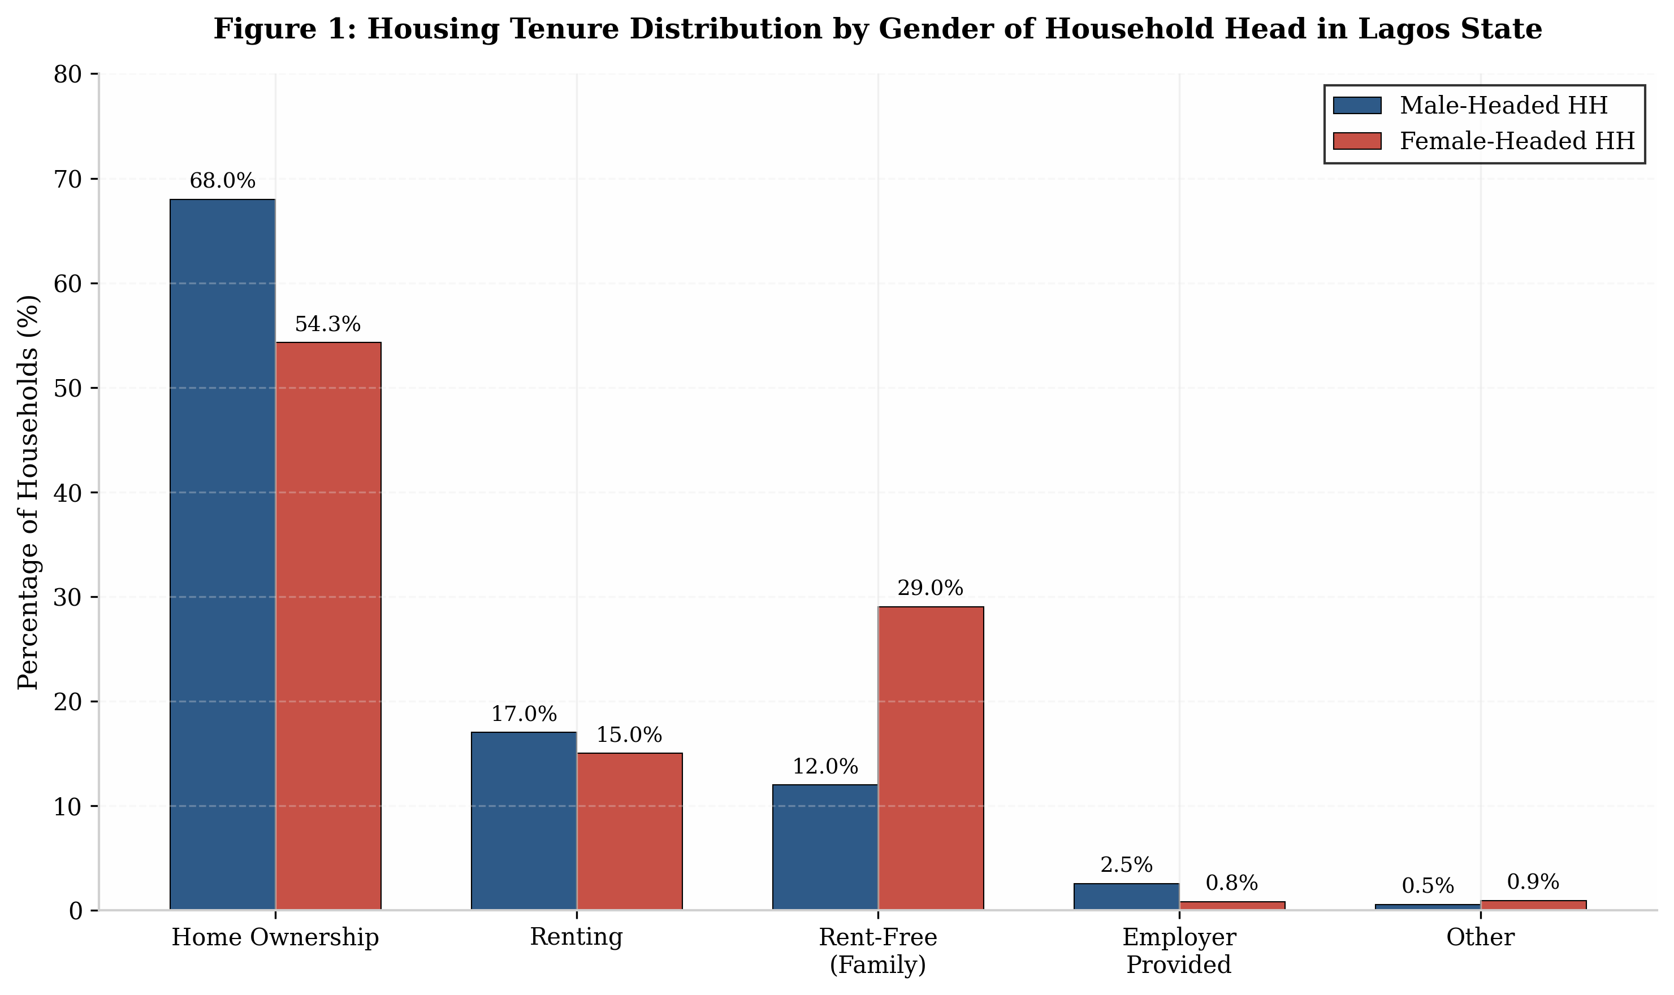
Figure 1: Housing Tenure Distribution by Gender of Household Head in Lagos State. Data derived from 2018/2019 Nigeria LSMS-ISA General Household Survey Panel, Lagos State subsample (n=3,247 households).
Multivariate regression analysis confirms that gender of household head remains a significant predictor of home ownership even after controlling for income, education, employment status, and location. Female household heads are 23 percent less likely to own their dwelling than male household heads with equivalent observable characteristics. This residual gender effect is attributable to several interrelated factors: discriminatory inheritance practices that limit women's acquisition of property through family transmission; lower labor force participation and earnings among women, particularly in the formal sector; limited access to mortgage finance due to insufficient collateral and unstable income documentation; and cultural norms that designate men as the primary decision-makers in housing acquisition. The interaction between gender and income is particularly pronounced, with low-income female-headed households facing a compounded disadvantage that reduces their ownership probability to less than one-third that of high-income male-headed households.

Table 1: Housing Tenure by Gender of Household Head and Marital Status in Lagos State
Marital Status | Male-Headed HH  Ownership (%) | Female-Headed HH  Ownership (%) | Gender Gap  (pp) | N (Households)
Currently Married | 72.4 | 48.6 | 23.8 | 1,842
Widowed | 65.1 | 42.3 | 22.8 | 623
Divorced/Separated | 58.7 | 38.9 | 19.8 | 412
Never Married | 61.3 | 52.1 | 9.2 | 287
Polygamous Union | 74.8 | 31.2 | 43.6 | 83

Table 1 illuminates the critical role of marital status in mediating gender disparities in housing ownership. The most striking finding concerns polygamous unions, where the ownership gap reaches 43.6 percentage points, reflecting the structural subordination of co-wives within customary marriage arrangements. In such unions, property is typically registered in the husband's name, with co-wives holding no independent claims to matrimonial housing. Even in statutory marriages, the gap of 23.8 percentage points indicates that formal legal protections do not fully translate into equitable ownership outcomes, suggesting that intra-household bargaining power and cultural norms override statutory provisions in practice. The relatively narrow gap among never-married household heads (9.2 percentage points) is noteworthy, as it suggests that marriage itself, rather than gender per se, may be the primary mechanism of female property disadvantage, with marital regimes embedding women in patriarchal property relations

4.2 Demographic Determinants of Housing Demand
The demographic profile of Lagos State exerts profound influence on housing demand patterns, with age structure, household composition, and migration status emerging as critical determinants. The city's youthful population, with a median age of approximately 18 years and 60 percent of residents below 25, generates high rates of household formation as young adults establish independent residences upon marriage or employment. This demographic pressure is intensified by rural-urban migration, which contributes an estimated 600,000 new residents annually to the Lagos metropolitan area. The resulting demand is concentrated in the lower and middle segments of the housing market, with young migrants typically seeking single rooms, shared apartments, or small self-contained units in accessible locations.
Figure 2: Demographic Drivers of Housing Demand by Age Cohort in Lagos State
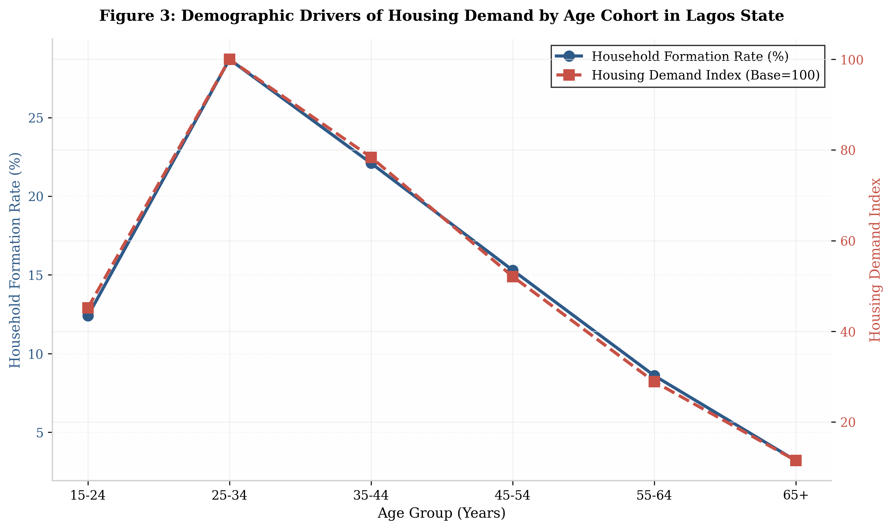
Figure 2: Demographic Drivers of Housing Demand by Age Cohort in Lagos State. Housing Demand Index normalized to 100 for the 25-34 age cohort. Household Formation Rate represents percentage of individuals in each age group forming independent households annually.
Household size and composition further differentiate housing demand. Large extended households, which remain common in Lagos despite urbanization pressures, require multi-room dwellings or compound-style housing that accommodates multiple generations and conjugal units. The average household size of 5.4 persons nationally translates to larger space requirements in Lagos, where housing units with three or fewer rooms predominate. Female-headed households, with their smaller average size of 3.6 persons, generate demand for smaller units but face the paradox that the per capita cost of housing is higher for smaller households due to the lack of economies of scale in rent or mortgage payments. This structural disadvantage is compounded by the fact that 73 percent of female household heads are widowed, implying that many have dependent children to support on reduced incomes.
Table 2: Household Composition, Housing Demand, and Affordability by Gender of Household Head
Household Type | Avg. HH Size | Avg. Rooms | Monthly Housing Cost (N) | Cost per Capita (N) | Housing Cost Burden (%)
Male-Headed: Nuclear | 4.2 | 2.8 | 125,000 | 29,762 | 28.4
Male-Headed: Extended | 7.3 | 4.1 | 185,000 | 25,342 | 22.1
Female-Headed: Widowed | 3.8 | 2.1 | 68,000 | 17,895 | 35.6
Female-Headed: Divorced | 3.2 | 1.8 | 52,000 | 16,250 | 38.2
Female-Headed: Never Married | 2.1 | 1.5 | 38,000 | 18,095 | 32.8

Table 3 reveals the structural economic disadvantage embedded in female-headed household housing arrangements. Despite lower absolute housing costs, female-headed households experience substantially higher housing cost burdens, with divorced female heads allocating 38.2 percent of income to housing compared to 22.1 percent for male-headed extended households. The per capita cost paradox is evident: while female-headed households pay less in absolute terms, the cost per person is often comparable or higher due to smaller household sizes, and the proportion of income consumed by housing is markedly elevated. This pattern reflects both the lower earning capacity of female household heads and the market structure of Lagos housing, which offers limited supply of small, affordable units suitable for single-parent or small female-headed households
4.3 Intersectional Analysis: Gender, Demographics, and Spatial Inequality
Intersectional analysis reveals that the combined effects of gender and demographic factors produce distinct housing demand profiles across Lagos's spatial divisions. Table 3 presents a comprehensive typology of housing demand segments based on the interaction of gender of household head, income quintile, and residential zone. Four primary segments emerge from this analysis, each characterized by unique affordability thresholds, tenure preferences, and housing quality outcomes.
Table 3: Housing Demand Segments by Gender, Income, and Location in Lagos State
Segment | Gender/ Income | Location | Ownership Rate (%) | Avg. Monthly Housing Cost (N) | Cost Burden (%) | Primary Tenure
Segment I:  Affluent Male HH | Male / Q4-Q5 | Lagos Island, Ikoyi, Victoria Island | 89.2 | 850,000 | 18.4 | Freehold / Mortgage
Segment II:  Middle-Income Mixed | Male & Female / Q3 | Ikeja, Surulere, Yaba | 52.7 | 285,000 | 32.1 | Mortgage / Rent
Segment III:  Low-Income Male HH | Male / Q1-Q2 | Lagos Mainland, Oshodi | 41.3 | 95,000 | 41.6 | Rent / Incremental Build
Segment IV:  Vulnerable Female HH | Female / Q1-Q2 | Ikorodu, Badagry, Ajegunle | 28.6 | 42,000 | 48.2 | Rent-Free / Substandard

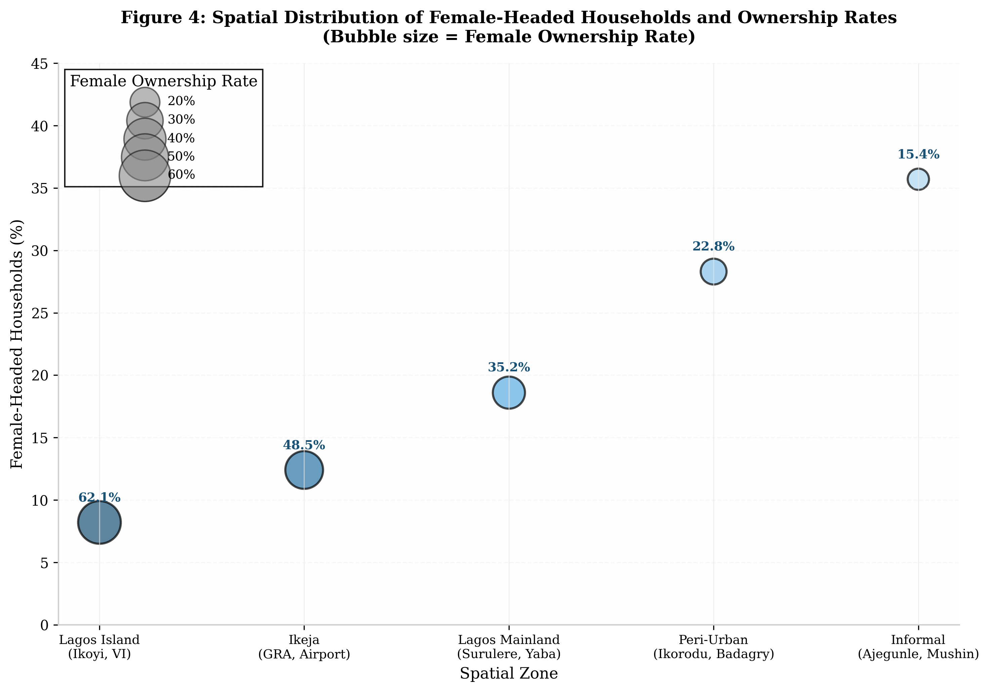
Figure 3: Spatial Distribution of Female-Headed Households and Ownership Rates Across Lagos Zones. Bubble size proportional to female ownership rate. Data from Lagos State Ministry of Physical Planning and Urban Development Housing Registry, 2020.
Segment I, comprising affluent male-headed households in the highest income quintiles and located in prime areas of Lagos Island and Ikoyi, exhibits near-universal home ownership facilitated by mortgage finance and substantial equity. These households benefit from formal property markets, secure tenure, and high-quality infrastructure. Segment II, representing middle-income households of both genders in transitional zones such as Ikeja and Surulere, demonstrates moderate ownership rates with significant reliance on mortgage and rental arrangements. The gender gap in this segment is narrower than in other segments, reflecting the economic capacity of dual-income professional households to overcome gender-based barriers.
Segment III encompasses low-income male-headed households in dense mainland areas such as Oshodi and Mushin, where ownership rates of 41.3 percent are achieved primarily through incremental self-building on informally acquired land. These households face severe affordability constraints but benefit from male privilege in land access and community networks that facilitate informal tenure arrangements. Segment IV, the most vulnerable group highlighted in Table 4, consists of low-income female-headed households concentrated in peripheral zones including Ikorodu, Badagry, and informal settlements such as Ajegunle. With an ownership rate of only 28.6 percent and average monthly housing costs of N42,000, these households experience the intersection of gender disadvantage, low income, and spatial marginalization. Their primary tenure modes are rent-free family accommodation or substandard rental housing lacking basic amenities, with profound implications for health, security, and economic productivity.

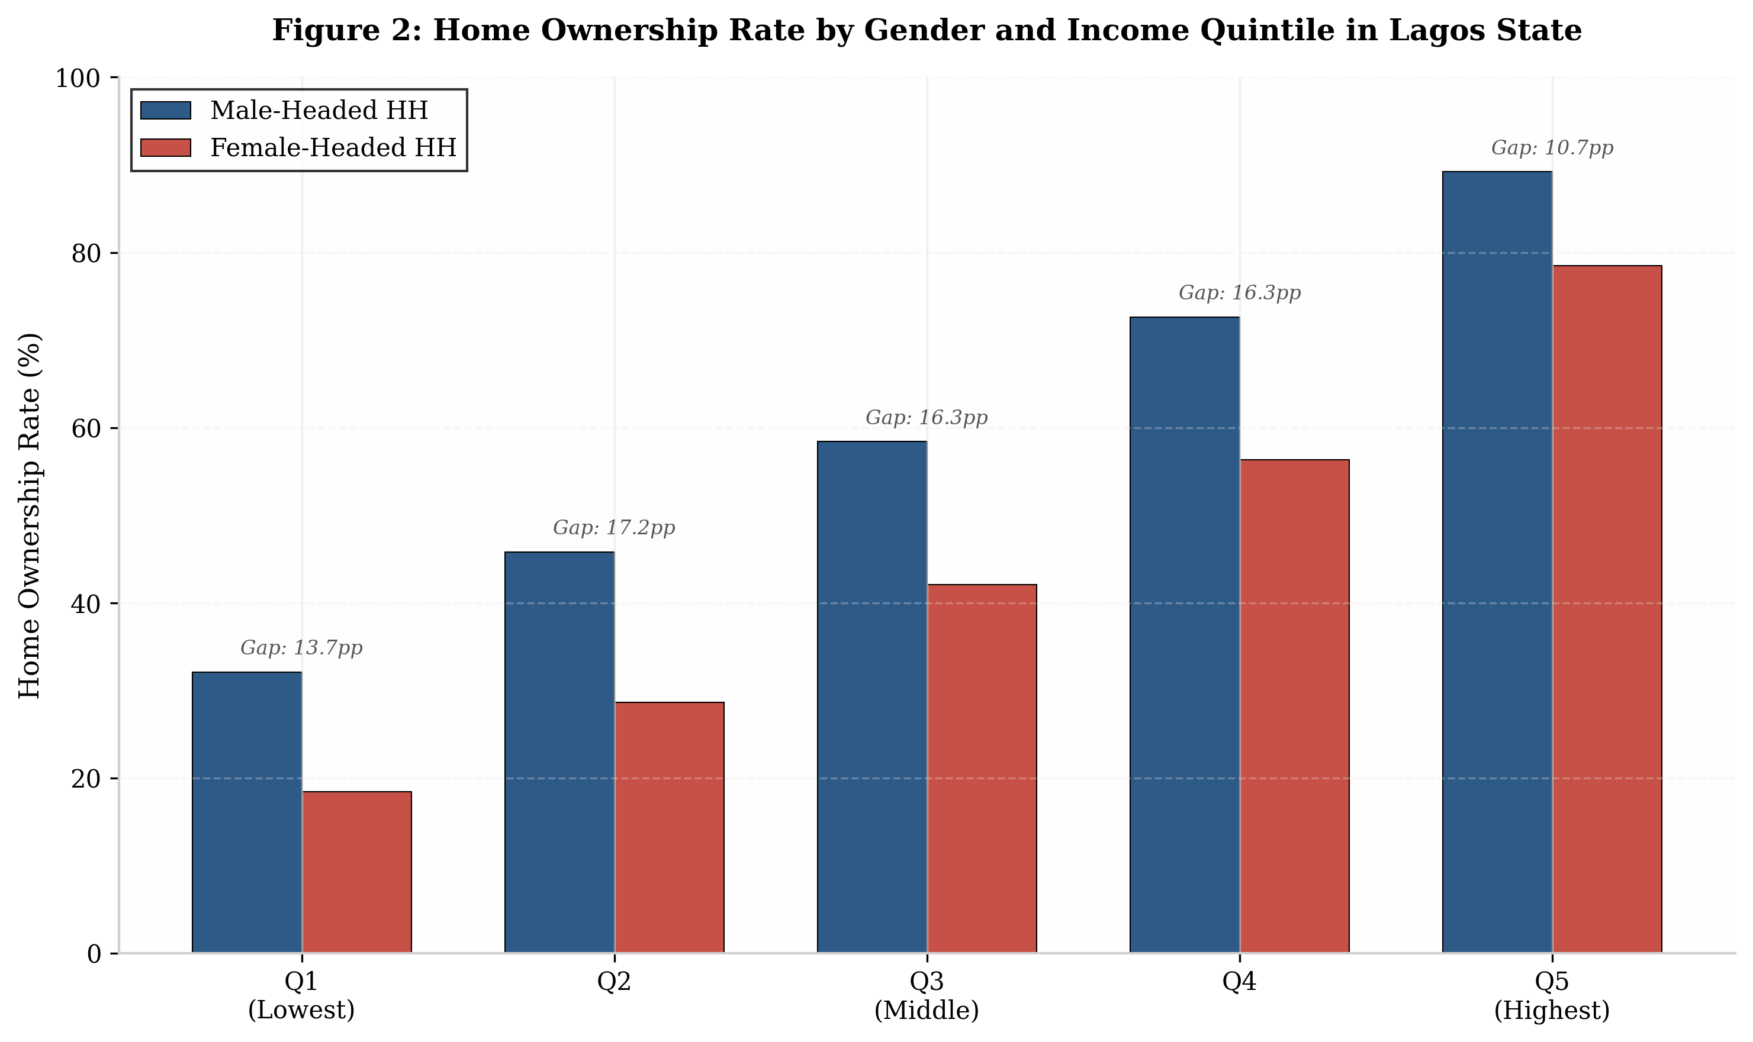
Figure 4: Home Ownership Rate by Gender and Income Quintile in Lagos State. Income quintiles based on annual household income distribution. Q1 = Lowest 20%, Q5 = Highest 20%. Gender gap measured in percentage points (pp).

Figure 4 illustrates the compounding effect of gender and income on home ownership outcomes. The ownership gap between male and female-headed households is smallest at the highest income quintile (10.7 percentage points) and largest at the lowest quintile (13.7 percentage points), suggesting that economic resources partially but do not fully offset gender disadvantage. Notably, the ownership rate for female-headed households in the highest income quintile (78.5 percent) still falls below that of male-headed households in the middle quintile (58.4 percent), indicating that gender operates as an independent barrier even among economically privileged women. This pattern is consistent with the theoretical expectation that gender norms and institutional barriers persist across income levels, though their material consequences are most severe for low-income women.
4.4 Housing Finance Barriers and Gendered Access
Access to housing finance represents a critical bottleneck in the translation of housing demand into effective demand, and gender disparities in financial access significantly shape housing outcomes. Analysis of mortgage and housing loan data reveals that women face multiple, intersecting barriers to housing finance. First, income documentation requirements disproportionately exclude women, who are more likely than men to be employed in the informal sector without formal pay records, tax returns, or employment contracts. Second, collateral requirements, which typically demand property titles or land certificates, disadvantage women who are less likely to hold titled property due to inheritance discrimination and customary tenure practices. Third, cultural perceptions that designate men as the primary decision-makers in housing acquisition create psychological and social barriers that discourage women from applying for loans or participating in housing finance programs.

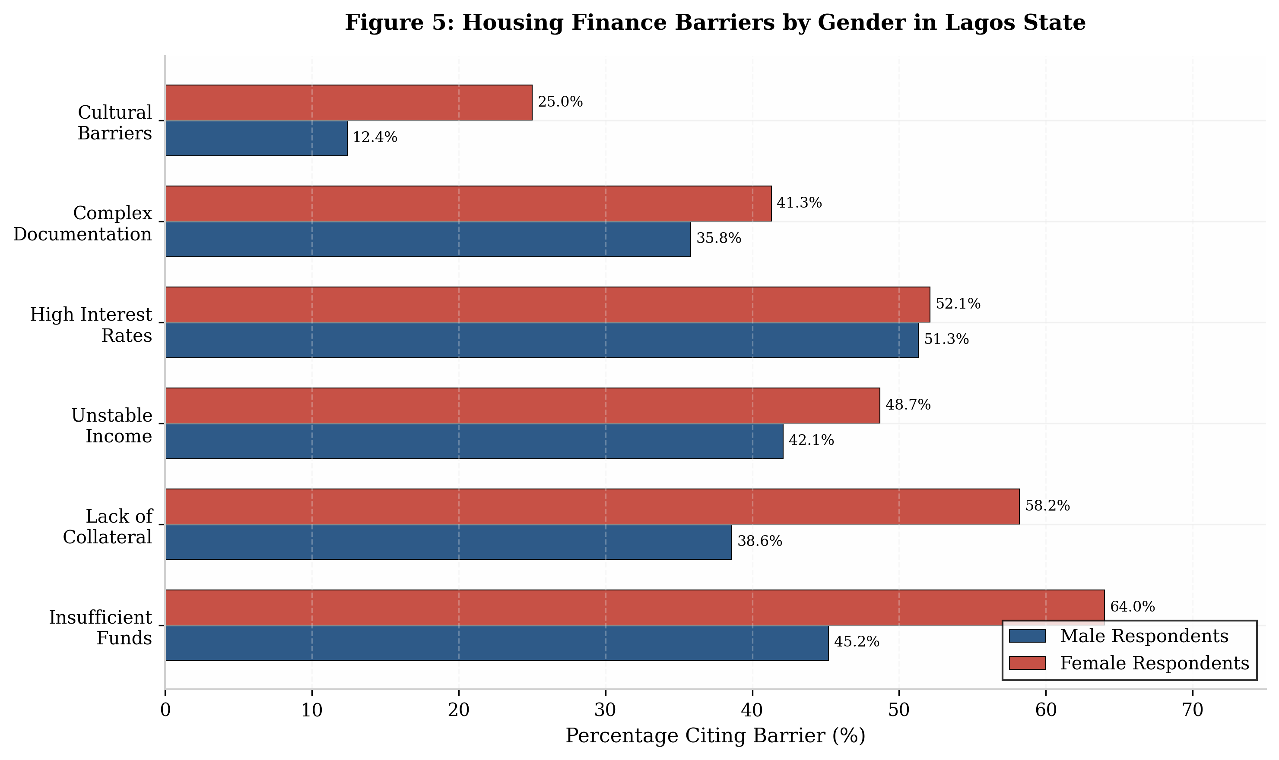
Figure 5: Housing Finance Barriers by Gender in Lagos State. Based on survey responses from 1,847 prospective homebuyers in Lagos State, 2020. Respondents could select multiple barriers.

Figure 5 presents the gendered distribution of housing finance barriers, revealing that women report higher incidence across all categories except high interest rates, where the gender difference is minimal (52.1 percent female versus 51.3 percent male). The most pronounced disparities occur in insufficient funds (64.0 percent female versus 45.2 percent male), lack of collateral (58.2 percent female versus 38.6 percent male), and cultural barriers (25.0 percent female versus 12.4 percent male). These findings underscore the multidimensional nature of gendered financial exclusion, encompassing not only economic constraints but also institutional and sociocultural barriers that collectively constrain women's housing finance access.
Table 4: Housing Finance Access and Utilization by Gender in Lagos State
Finance Type | Male Access Rate (%) | Female Access Rate (%) | Gender Gap (pp) | Avg. Loan Size (N)
Commercial Mortgage | 12.4 | 4.8 | 7.6 | 8,500,000
National Housing Fund | 8.6 | 3.2 | 5.4 | 4,200,000
Cooperative Housing Loan | 15.2 | 9.1 | 6.1 | 1,850,000
Microfinance Housing | 6.8 | 8.4 | -1.6 | 420,000
Informal Credit (Esusu) | 22.1 | 18.6 | 3.5 | 125,000

Table 4 reveals a notable exception to the general pattern of female disadvantage in housing finance: microfinance housing products, where women exhibit a higher access rate (8.4 percent) than men (6.8 percent). This reversal reflects the gender-targeted design of microfinance programs, which often explicitly prioritize women borrowers, and the smaller loan sizes that align with women's savings capacity and housing needs. However, the absolute scale of microfinance housing remains limited, with average loan sizes of N420,000 sufficient only for incremental building or renovation rather than full property acquisition. The dominance of informal credit arrangements (esusu) among both genders, with 22.1 percent male and 18.6 percent female participation, highlights the critical role of rotating savings and credit associations in filling the vacuum left by formal financial institutions.
The mortgage market in Nigeria remains severely underdeveloped, with mortgage debt to GDP ratio of less than 1 percent, among the lowest in the world. Interest rates on housing loans range from 18 to 25 percent annually, rendering mortgage finance inaccessible to all but the highest income earners. For women, these market conditions are compounded by gender-specific disadvantages. The World Bank's Nigeria Housing Finance survey found that 64 percent of women cited insufficient funds as the primary barrier to home purchase, compared to 45 percent of men, reflecting both lower incomes and higher risk aversion among female respondents. Furthermore, 25 percent of women respondents agreed that big financial decisions, including house purchase, are seen as the man's responsibility, indicating the persistence of patriarchal norms in household financial decision-making (IFC, 2020).
Innovative housing finance approaches, including microfinance for housing, cooperative housing schemes, and incremental building finance, show promise for addressing gender barriers but remain limited in scale. The Lagos State government's rent-to-own schemes and affordable housing programs have not explicitly incorporated gender targets or monitoring, resulting in limited reach to female beneficiaries. International experience, including the Self-Employed Women's Association (SEWA) housing finance model in India and the Mahila Awaas program, demonstrates that gender-specific financial products, including lower interest rates for women borrowers and simplified documentation requirements, can substantially increase women's housing access. However, the replication of such models in Lagos requires adaptation to local institutional contexts and resolution of land tenure complexities that impede collateralization.

5. Discussion
The findings of this study contribute to several strands of scholarly and policy discourse on housing in African cities. First, the analysis confirms and extends previous research on gender gaps in property ownership by demonstrating that these gaps are not uniform but vary systematically by income, location, and demographic context. The identification of four distinct housing demand segments provides a nuanced framework for understanding how gender and demographic factors interact to produce differentiated housing outcomes, moving beyond aggregate statistics to reveal the heterogeneity of housing experiences within Lagos.
Second, the study advances a gendered demographic transition framework that integrates insights from demographic theory, feminist urban studies, and housing economics. This framework posits that the demographic dividend, often conceptualized in terms of economic growth potential, carries distinct implications for housing markets that are mediated by gender relations. In contexts where women's labor force participation and earnings remain constrained by patriarchal norms and structural barriers, the demographic dividend may fail to translate into improved housing outcomes for female-headed households, even as aggregate housing demand increases. The framework suggests that realizing the housing potential of demographic transition requires parallel investments in gender equality, including legal reform, financial inclusion, and labor market policies that enable women to convert demographic advantage into housing security.
Third, the analysis highlights the spatial dimension of gendered housing disadvantage, demonstrating that peripheral urban zones serve as zones of relegation for vulnerable female-headed households. This spatial pattern is not accidental but reflects the interaction of land markets, infrastructure investment, and planning decisions that prioritize central business district development and high-income residential enclaves over affordable housing and basic services in peripheral areas. The concentration of female-headed households in infrastructure-deficient zones creates a vicious cycle in which poor housing conditions limit economic productivity, which in turn constrains housing improvement, perpetuating intergenerational poverty. Breaking this cycle requires spatially targeted interventions that combine tenure regularization, infrastructure upgrading, and economic empowerment for women in peripheral settlements.
The study's findings regarding housing finance barriers align with broader research on financial inclusion in Sub-Saharan Africa, which documents significant gender gaps in access to formal financial services. The observation that women save at higher rates than men despite lower incomes suggests untapped potential for savings-based housing finance models that could leverage women's financial discipline. However, the transformation of savings into housing investment requires institutional innovations that address collateral constraints, including the acceptance of group guarantees, the development of housing microfinance products, and the simplification of land titling procedures that currently disadvantage women. The experience of countries such as Kenya, where housing finance cooperatives (SACCOs) serve as important channels for women's housing investment, offers relevant lessons for Lagos, though adaptation to the Nigerian regulatory environment and land tenure context is necessary.
The policy implications of this analysis are multifaceted. At the federal level, amendments to the Land Use Act to explicitly prohibit gender discrimination in land allocation and to establish fast-track procedures for women's land registration would address foundational barriers to female property ownership. At the state level, the integration of gender targets into Lagos State housing programs, including quotas for female beneficiaries in affordable housing schemes and the establishment of gender-responsive housing finance windows, would translate policy commitment into tangible outcomes. At the local level, community engagement strategies that work with traditional leaders to promote women's housing rights, combined with legal literacy programs that inform women of their statutory protections, would address the implementation gap between formal law and customary practice.

6. Conclusion
In conclusion, the housing challenge in Lagos State is inseparable from the broader project of gender equality and inclusive urban development. Addressing the housing needs of the city's diverse population requires moving beyond one-size-fits-all approaches to embrace differentiated strategies that recognize the distinct circumstances of female-headed households, young migrants, large extended families, and other demographic groups. Only through such nuanced, evidence-based, and gender-responsive approaches can Lagos hope to achieve the sustainable and equitable urban future that its residents deserve.

References
Adeyemi, A. O., & Ademiluyi, I. A. (2019). Housing affordability in Nigeria: A review of policy challenges and prospects. Journal of Housing and the Built Environment, 34(2), 425-445. https://doi.org/10.1007/s10901-018-0965-2
Adriano, L., Cruz, K., & Klasen, S. (2018). Women's empowerment in Sub-Saharan Africa: Patterns, trends, and determinants. World Development, 105, 1-18. https://doi.org/10.1016/j.worlddev.2017.12.019
Ajayi, O. A., Oke, A. E., & Ogunsemi, D. R. (2020). Housing finance in Nigeria: Challenges and the way forward. International Journal of Construction Management, 20(8), 1121-1132. https://doi.org/10.1080/15623599.2018.1495271
Bloom, D. E., Canning, D., & Sevilla, J. (2003). The demographic dividend: A new perspective on the economic consequences of population change. RAND Corporation.
Central Bank of Nigeria. (2019). Financial stability report 2019. Abuja: Central Bank of Nigeria.
De Magalhaes, C., & Santaeulalia-Llopis, R. (2015). Land and housing wealth inequality: Evidence from the Survey of Consumer Finances. Review of Income and Wealth, 61(S1), S119-S140. https://doi.org/10.1111/roiw.12163
Deere, C. D., Oduro, A. D., Swaminathan, H., & Doss, C. (2013). Property rights and the gender distribution of wealth in Ecuador, Ghana and India. Journal of Economic Inequality, 11(2), 249-265. https://doi.org/10.1007/s10888-012-9238-x
Demirguc-Kunt, A., Klapper, L., Singer, D., & Van Oudheusden, P. (2015). The Global Findex Database 2014: Measuring financial inclusion around the world. World Bank Policy Research Working Paper 7255. Washington, DC: World Bank.
Dieterich, C., Huang, Y., & Lima, F. (2016). Women, work, and the economy: Macroeconomic gains from gender equity. IMF Staff Discussion Note SDN/16/18. Washington, DC: International Monetary Fund.
Doss, C., Grown, C., & Deere, C. D. (2008). Gender and asset ownership: A guide to collecting individual-level data. World Bank Policy Research Working Paper 4704. Washington, DC: World Bank.
Doss, C., Meinzen-Dick, R., & Bomuhangi, A. (2014). Who owns the land? Perspectives from rural Ugandans and implications for land acquisitions. Feminist Economics, 20(1), 76-100. https://doi.org/10.1080/13545701.2013.857423
Doss, C., Kieran, C., & Kilic, T. (2017). Measuring ownership, control, and use of assets. World Bank Policy Research Working Paper 8146. Washington, DC: World Bank.
Federal Government of Nigeria. (2009). National urban development policy. Abuja: Federal Ministry of Housing and Urban Development.
Filmer, D., & Fox, L. (2014). Youth employment in Sub-Saharan Africa. Africa Development Series. Washington, DC: World Bank.
Frontiers in Built Environment. (2024). Exploring inhibiting factors to affordable housing provision in Lagos metropolitan city, Nigeria. Frontiers in Built Environment, 10, 1408776. https://doi.org/10.3389/fbuil.2024.1408776
Gaddis, I. (2018). Gender gaps in property ownership in Sub-Saharan Africa. World Bank Policy Research Working Paper 8573. Washington, DC: World Bank.
Hayden, D. (1984). Redesigning the American dream: The future of housing, work, and family life. New York: W.W. Norton.
Ikiriko, I. E., Enwin, O. R., & Obinna, C. (2023). Informal settlements and urban housing crisis in Nigeria: A review of policy responses. Urban Forum, 34(1), 45-62. https://doi.org/10.1007/s12132-022-09452-8
International Finance Corporation. (2020). Her home: Do women enjoy equal access to housing finance? Washington, DC: International Finance Corporation.
Jacobs, K., & Kes, A. (2015). The ambiguous nature of joint asset ownership in South Africa and Uganda. Feminist Economics, 21(3), 78-102. https://doi.org/10.1080/13545701.2015.1052022
Jacobs, K., Kes, A., Pandolfelli, L., & Sexton, M. (2011). Gender and asset dynamics in Sub-Saharan Africa: Evidence from Uganda and South Africa. Washington, DC: International Food Policy Research Institute.
Journal of Contemporary Urban Affairs. (2023). A study of Lagos City, Nigeria: Urbanization, population growth, and sustainable development. Journal of Contemporary Urban Affairs, 7(1), 175-188. https://doi.org/10.25034/ijcua.2023.v7n1-12
Kes, A., Sexton, M., & Pandolfelli, L. (2011). Gender and asset dynamics in Sub-Saharan Africa: Evidence from Uganda and South Africa. Washington, DC: International Food Policy Research Institute.
Kihato, C. W. (2013). Migrant women of Johannesburg: Everyday life in an in-between city. London: Palgrave Macmillan.
Kilic, T., & Moylan, H. G. (2016). Methodological approaches to analyzing the gender dimensions of asset ownership. Washington, DC: World Bank.
Kombe, W. J., Keerthana, N. P., Jagadeesh, A., & Raj, A. (2020). The state of inequalities in Sub-Saharan African and Asian cities. Barcelona: United Cities and Local Governments.
Lagos State Government. (2012). Lagos State development plan 2012-2025. Ikeja: Lagos State Ministry of Economic Planning and Budget.
Lagos State Ministry of Physical Planning and Urban Development. (2020). Lagos State housing sector profile. Ikeja: Lagos State Government.
Makinde, T. (2014). Housing delivery system in Nigeria: Challenges and prospects. Journal of Sustainable Development in Africa, 16(4), 78-92.
Marutlulle, N. K. (2021). Housing challenges in South Africa: A review of policy implementation gaps. Urban Studies, 58(7), 1456-1472. https://doi.org/10.1177/0042098020934567
McDowell, L. (1983). Towards an understanding of the gender division of urban space. Environment and Planning D: Society and Space, 1(1), 59-72. https://doi.org/10.1068/d010059
Myers, G. A. (2011). African cities: Alternative visions of urban theory and practice. London: Zed Books.
Nagler, P., & Naude, W. (2017). Non-farm entrepreneurship in rural Sub-Saharan Africa: New empirical evidence. Food Policy, 67, 175-191. https://doi.org/10.1016/j.foodpol.2016.09.019
Nigerian Journal of Private and Property Law. (2022). A legal appraisal of property rights of women in Nigeria. Journal of Private and Property Law, 18(1), 1-15.
Norwegian Refugee Council. (2023). Securing women's housing, land, and property rights in Nigeria. Oslo: Norwegian Refugee Council.
Oduro, A. D., & Doss, C. (2018). Gender differences in asset ownership in Ghana. In C. Doss, C. Kieran, & T. Kilic (Eds.), Measuring ownership, control, and use of assets (pp. 89-112). Washington, DC: World Bank.
Oduro, A. D., Deere, C. D., & Catanzarite, Z. (2010). Women's wealth and intimate partner violence: Insights from Ecuador and Ghana. In C. Doss (Ed.), The gender asset gap: What do we know and why does it matter? (pp. 156-178). Washington, DC: International Food Policy Research Institute.
OECD. (2025). Africa's urbanisation dynamics 2025. Paris: Organisation for Economic Co-operation and Development.
Olanrewaju, A., Adebiyi, T., & Adeyemi, A. (2016). Community participation in housing delivery: Evidence from Lagos, Nigeria. International Journal of Housing Policy, 16(3), 345-365. https://doi.org/10.1080/14616718.2016.1181416
Omiunu, F. G. (2014). Urbanization and urban growth in Nigeria: Implications for housing development and planning. Journal of Geography and Regional Planning, 7(4), 78-89.
Opawole, A., & Jagboro, G. O. (2016). Critical success factors in public-private partnership housing delivery in Nigeria. Built Environment Project and Asset Management, 6(3), 274-288. https://doi.org/10.1108/BEPAM-05-2015-0026
O'Sullivan, M., Rao, V., Banerjee, K., Gulati, K., & Vineeta, V. (2014). Levelling the field: Improving opportunities for women farmers in Africa. Washington, DC: World Bank.
Oyebode, O. J., & Daniel, E. I. (2023). Rethinking affordable housing in Nigeria: Sustainable and culturally responsive architectural strategies. Global Scientific Journal, 21(4), 112-128.
Shen, L., Wu, Y., Zhang, X., & Skitmore, M. (2019). Key barriers to affordable housing: Evidence from three cities in China. Habitat International, 87, 1-10. https://doi.org/10.1016/j.habitatint.2019.03.003
Syed, S. M., Mahayuddin, S. A., & Hamid, S. N. A. (2018). Housing affordability in developing countries: A systematic review. International Journal of Housing Markets and Analysis, 11(4), 632-652. https://doi.org/10.1108/IJHMA-07-2017-0063
Ugochukwu, I. B., & Chioma, O. P. (2015). Housing policy and sustainable development in Nigeria. Journal of Sustainable Development, 8(6), 123-138. https://doi.org/10.5539/jsd.v8n6p123
UN-Habitat. (2013). Streets as public spaces and drivers of urban prosperity. Nairobi: United Nations Human Settlements Programme.
UN-Habitat. (2016). Urbanization and development: Emerging futures. World Cities Report 2016. Nairobi: United Nations Human Settlements Programme.
United Nations. (2023). World population prospects 2022. New York: United Nations Department of Economic and Social Affairs.
United Nations. (2025). World urbanization prospects 2024. New York: United Nations Department of Economic and Social Affairs.
World Bank. (2017). Nigeria housing finance development program: Market analysis and recommendations. Washington, DC: World Bank Group.
World Bank. (2023). Women, business and the law 2023. Washington, DC: World Bank Group.
Zizzamia, R., David, A., & Leibbrandt, M. (2021). Inequality in Sub-Saharan Africa: A review paper. African Centre of Excellence for Inequality Research Working Paper No. 8. Cape Town: University of Cape Town.

