Revitalizing Khadi Tales through Narrative Driven Design

Introduction
Khadi Tales is a thoughtful fashion and storytelling concept inspired by the timeless legacy of Khadi India’s iconic hand spun and handwoven fabric. Deeply rooted in the country’s cultural and historical identity, khadi gained national importance during the freedom struggle under the leadership of Mahatma Gandhi, who promoted it as a symbol of self-reliance, unity, and resistance against industrialized foreign goods. Today, khadi stands not only as a fabric but as a philosophy that blends sustainability, tradition, and ethical living. Khadi Tales builds upon this philosophy by transforming fabric into a medium of storytelling. Each garment or textile piece is seen as a “tale a narrative woven with threads of heritage, craftsmanship and human connection. From the spinning of yarn on a charkha to the weaving of fabric by skilled artisans, every stage reflects patience, dedication, and artistry. The concept aims to highlight these unseen processes and bring attention to the artisans whose skills have been passed down through generations.
At its core, Khadi Tales celebrates the beauty of imperfection and individuality. Unlike mass-produced fabrics, khadi carries unique textures and variations that make every piece distinct. This uniqueness is embraced as a mark of authenticity and craftsmanship. By combining traditional techniques with modern design sensibilities, Khadi Tales creates a bridge between the past and the present making heritage relevant for contemporary lifestyles. The concept strongly aligns with the principles of sustainable and slow fashion. In an era dominated by fast fashion, which often leads to environmental harm and overconsumption, Khadi Tales promotes mindful choices. Khadi is naturally ecofriendly, requiring minimal water and energy, and is biodegradable. By encouraging the use of such materials, the concept supports environmental conservation while also advocating for ethical production practices.
Another important aspect of Khadi Tales is its focus on social empowerment. The khadi industry provides livelihoods to thousands of rural artisans especially women. By supporting khadi-based products, the initiative contributes to economic stability in rural communities and helps preserve traditional skills that might otherwise disappear. It fosters a sense of pride and dignity among artisans by valuing their craft and giving them recognition in the modern market. Aesthetically, Khadi Tales emphasizes simplicity, elegance, and versatility. The designs often feature earthy tones, natural dyes, and minimalistic patterns that reflect a connection with nature. At the same time, innovative cuts, silhouettes, and styling techniques are incorporated to appeal to modern consumers. This fusion of tradition and innovation makes Khadi Tales suitable for both everyday wear and contemporary fashion statements. In essence, Khadi Tales is more than a fashion concept it is a movement that celebrates heritage, sustainability and storytelling. It invites people to reconnect with the origins of what they wear, to appreciate the hands that create it, and to make conscious choices that honor both culture and the environment. Through every thread and every design, Khadi Tales carries forward a legacy while shaping a more responsible and meaningful future for fashion.
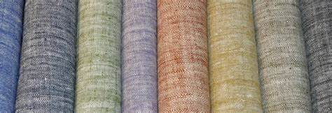
Image no1: mages/hd/khadi-handwoven-fabric-png
2. Review of The literature
Historical and Cultural Foundations of Khadi Scholarly literature consistently positions Khadi as a powerful symbol of India’s sociopolitical and cultural identity. During the independence movement, Mahatma Gandhi advocated khadi as a tool of economic self-reliance and resistance against colonial industrialization. Researchers highlight that khadi was not merely a fabric but a unifying ideology promoting rural employment and national pride. Post-independence studies show that khadi evolved from a political symbol into a cultural heritage textile. Literature emphasizes its continued relevance as a representation of authenticity, simplicity and ethical production, making it a significant subject in both historical and contemporary fashion discourse.
Craft, Artisanship, and Narrative Value Craft-based literature explores khadi as a product of skilled human labor, where each stage spinning, dyeing, and weaving contributes to its uniqueness. Scholars in design and anthropology argue that handmade textiles carry embedded narratives of the artisans their communities, and their traditions. The idea behind Khadi Tales aligns with this perspective, treating each fabric as a “story. Studies on craft storytelling suggest that consumers increasingly value products with cultural and emotional depth, rather than purely aesthetic appeal. This shift supports the relevance of narrative-driven fashion concepts.
Sustainability and Slow Fashion A major theme in recent literature is the role of khadi in promoting sustainable fashion. Researchers highlight that khadi production is environmentally friendly, requiring low energy consumption and minimal industrial processing. It is biodegradable and often produced using natural dyes, reducing ecological impact. Theories of slow fashion, introduced by scholars like Kate Fletcher, emphasize quality longevity and ethical production over mass consumption. Khadi fits naturally within this framework. Literature suggests that integrating khadi into modern fashion systems can help counter the negative effects of fast fashion such as waste generation and labor exploitation.
Socio Economic Impact and Rural Development Economic studies highlight the role of the khadi sector in supporting rural livelihoods. Institutions like the Khadi and Village Industries Commission have documented how khadi production generates employment, particularly for women and marginalized communities. Literature also points out challenges such as limited market access, competition from mechanized textiles, and lack of modernization. Concepts like Khadi Tales are seen as potential solutions, as they rebrand khadi for contemporary markets while preserving its traditional roots.
Design Innovation and Contemporary Adaptation Fashion and design research focuses on the adaptation of traditional textiles in modern contexts. Scholars argue that innovation in silhouettes, dyeing techniques and styling can make khadi appealing to younger consumers. Case studies in contemporary Indian fashion demonstrate how designers reinterpret khadi to suit global trends without losing its essence. The Khadi Tales concept reflects this approach by combining heritage craftsmanship with modern aesthetics, creating a dialogue between tradition and innovation.
Consumer Perception and Ethical Fashion Trends Recent literature in consumer behavior shows a growing awareness of ethical and sustainable fashion. Consumers are increasingly drawn to products that align with their values, including environmental responsibility and social justice. Studies indicate that storytelling plays a crucial role in influencing purchasing decisions. When consumers understand the origin and impact of a product, they are more likely to form an emotional connection with it. This reinforces the importance of narrative-based concepts like Khadi Tales.
3. Research Gap- Areas Lacking Comprehensive Study
3.1 Lack of Narrative Based Research in Khadi
  - Limited exploration of khadi as a medium for storytelling.
  - Insufficient study on how artisan narratives and cultural heritage can be integrated into fashion design.
  - Need for deeper analysis on how storytelling can enhance consumer engagement and brand identity.
3.2Limited Integration of Tradition with Contemporary Design
  - Lack of practical frameworks for merging traditional khadi techniques with modern aesthetics.
  - Limited exploration of innovative design strategies to make khadi competitive in global markets.
  - Need for understanding how to maintain khadi’s authenticity while evolving its design.
3.3 Insufficient Focus on Youth-Centric and Lifestyle Branding
  - Scarcity of in-depth analysis on positioning khadi as a lifestyle brand for younger generations.
  - Existing studies primarily focus on acceptance levels without providing aspirational strategies.
  - Lack of initiatives to promote khadi among design students and young consumers, indicating a need for increased awareness and creative engagement.
3.4 Weak Global Branding and Storytelling Strategies
  - Limited exploration of effective global branding for khadi compared to other sustainable fabrics.
  - Insufficient analysis of how storytelling can elevate khadi's visibility in international markets.
  - Need for consistent branding strategies that emphasize khadi's unique cultural and ethical value.
  - Gaps in Supply Chain Transparency and Quality Consistency
  - Fragmented production systems leading to variations in quality and consumer trust issues.
  - Insufficient focus on integrating transparency and traceability within the khadi supply chain.
  - Need for research on consumer demand for knowledge about product origins and journeys.
3.6 Limited Exploration of Khadi Beyond Apparel
  - Most research focuses on khadi in the context of clothing, neglecting its potential in other design fields.
  - Insufficient interdisciplinary exploration connecting khadi to lifestyle products, home décor, and experiential design.
  - Need for broader application of khadi in various design domains beyond fashion.
3.7Lack of Holistic Sustainability Assessment
  - Existing literature often focuses solely on production-level sustainability without considering the full lifecycle of khadi.
  - Insufficient analysis of social sustainability aspects, including artisan welfare and fair wages.
  - Gaps in understanding the true environmental impact of khadi within the context of circular fashion models.
3.8Perceptual Gap Between Heritage and Contemporary Expectations
  - Research indicates khadi is often viewed as traditional and outdated, limiting its contemporary appeal.
  - Lack of studies exploring how to reposition khadi as modern, luxurious, and usable in everyday fashion.
  - Need for strategies to transform consumer perception of khadi to align with modern lifestyles and aspirations.
4. Problem Statement
One of the central problems is the gap between traditional perception and modern consumer expectations. Khadi is often viewed as outdated, coarse, or suitable only for ethnic and ceremonial wear. This perception restricts its acceptance as a versatile and fashionable fabric for everyday use. The lack of contemporary design innovation, modern silhouettes, and appealing aesthetics further limits its integration into mainstream fashion.
5. Objectives of the Study
This paper can explore innovative design strategies that blend traditional khadi craftsmanship with modern aesthetics. It could evaluate how storytelling, branding, and consumer engagement can reposition khadi as a fashionable choice among younger consumers, thus promoting its use beyond traditional contexts.
6. Methodology: Standard methodology was used in below mention points.
6.1 Research Design: This study adopts a descriptive and exploratory research design to map the evolution of khadi, while simultaneously investigating its current status within the fashion industry and consumer perceptions.
6.2 Data Collection Methods: Basically used two type of data collected. Primary and secondary data represent the two fundamental pillars of research, distinguished primarily by their source and the intent behind their collection. Primary data is original information gathered firsthand by a researcher specifically to address a particular problem or hypothesis. This "raw" data is collected through direct methods such as laboratory experiments, field surveys, structured interviews, or direct observations. Because the researcher designs the collection process from scratch, primary data is highly tailored to the study's objectives and offers a high degree of control over accuracy and detail. However, this precision comes at a cost, as primary research is often resource-intensive, requiring significant time, funding, and specialized tools to execute.
In contrast, secondary data refers to information that already exists, having been collected by other individuals, organizations, or agencies for purposes other than the current study. This includes data from peer-reviewed journal articles, government census reports, historical archives, and internal institutional records. The primary advantage of secondary data is its accessibility and cost-effectiveness; it allows researchers to build upon established knowledge and identify trends over time without the need for large-scale field operations. While it is an essential tool for conducting literature reviews and framing a research gap, it may lack the specific nuance required for a specialized study or may be limited by the original collector's biases. In most advanced academic work, these two types are used in tandem: secondary data provides the context and theoretical foundation, while primary data provides the unique evidence necessary to contribute new knowledge to the field.
6.3 Sampling Technique: This research utilizes a purposive sampling technique, a type of non-probability sampling. Participants are chosen based on their relevance and significance to the research objectives, including artisans, designers, and consumers familiar with khadi.
6.4 Data Analysis: Qualitative Analysis: Thematic analysis will be applied to interpret interview responses and observational notes. This approach will help identify recurring patterns, themes, and insights related to khadi production and consumer perceptions.
6.5 Tools and Techniques: To facilitate comprehensive data collection and analysis, the research will employ a multifaceted toolkit designed to capture both quantitative and qualitative insights. Primary quantitative data will be gathered using questionnaires, which can be distributed efficiently via Google Forms for broader reach or in printed formats for on-site participants. To ensure the nuance of expert feedback is preserved, audio and video recording will be utilized during interview sessions, allowing for accurate transcription and behavioral analysis. Documentation of physical specimens, complex textile structures, and specific design processes will be achieved through high-resolution photography, providing a visual record that complements technical descriptions. Finally, all gathered information will be managed using spreadsheet software, which serves as the central hub for organizing, tabulating, and analyzing data to ensure the findings are both robust and reproducible.
7. Field Study and Documentation
7.1 Visit to State Museum: As part of the Khadi Tales project, a field visit was conducted to the State Museum in Bhopal to investigate the historical evolution and cultural significance of Khadi. The museum’s curated exhibits featured an extensive collection of traditional textiles, antique handlooms, and historical garments, all of which underscore the inherent simplicity and environmental sustainability of the craft. A central theme of the visit was the profound influence of Mahatma Gandhi, whose promotion of Khadi during the Indian freedom movement transformed the fabric into a powerful symbol of national self-reliance and grassroots empowerment.
To systematically capture these insights, the visit was documented using a combination of photography, detailed sketching, and descriptive note-taking. This experiential learning provided essential practical knowledge and design inspiration, fostering a deeper appreciation for Khadi’s heritage as a foundational element for contemporary sustainable design.

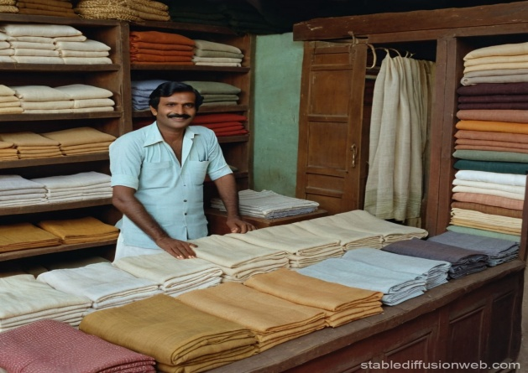
Image no 2: Visit State Museum in Bhopal
7.2 Khadi Tales Technique and Materials: Khadi is defined by its handmade process and natural composition. Both the technique and materials used in khadi production reflect simplicity, sustainability, and skilled craftsmanship.
The production of Khadi is a meticulous, multi-stage craft that prioritizes manual skill over industrial speed, resulting in a textile with deep cultural and ecological value. The journey begins with Hand Spinning (Charkha Process), where raw natural fibers are transformed into yarn using the traditional spinning wheel. This manual tensioning imparts the fabric’s signature "slub" or slightly uneven texture, a hallmark of authenticity that distinguishes it from the uniformity of machine-made threads.
Next, the Hand Weaving (Handloom Technique) involves artisans manually interlacing warp and weft threads. This deliberate, slow-paced process provides the weaver with superior control over the fabric’s structural integrity, producing a textile that is remarkably breathable, lightweight, and durable. To enhance its visual character, various Dyeing and Finishing Techniques are applied; the fabric is often treated with organic or eco-friendly pigments through traditional methods like vat dyeing, tie-dye (Bandhani), or intricate block printing. The final Finishing Process consisting of specialized washing, sun drying, and light starching refines the textile’s hand-feel and longevity while preserving its organic essence. Together, these steps ensure that every yard of Khadi remains a sustainable testament to human craftsmanship.
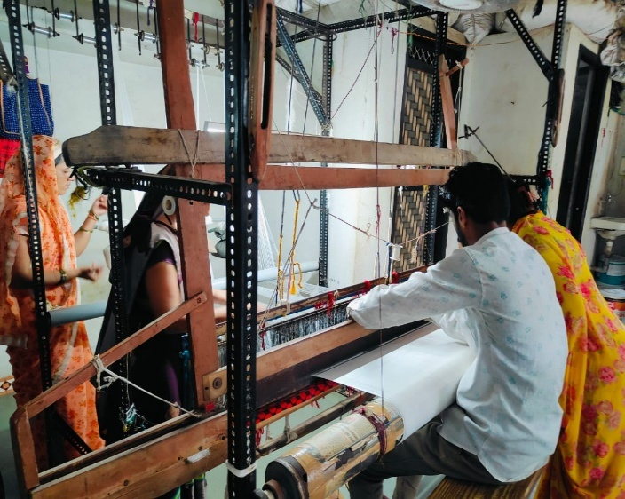
Image no-3,4 Khadi Tales Techniques
8. Materials Used in Khadi
8.1 Natural Fibers: The fundamental soul of Khadi lies in its use of purely natural fibers, which ensure the fabric remains biodegradable and skin friendly. Cotton remains the most widely utilized fiber due to its exceptional softness and breathability, making it a versatile choice for the diverse Indian climate. For more formal or luxury applications, Khadi Silk is produced by spinning silk filaments by hand, resulting in a sophisticated sheen and a rich, tactile texture that machine processed silk cannot replicate. Additionally, Khadi Woolen variants are crafted for colder regions, utilizing hand-spun wool to create garments that are remarkably warm, durable, and possess a characteristically coarse, rustic appeal.
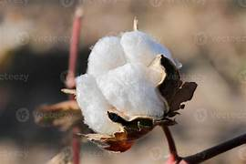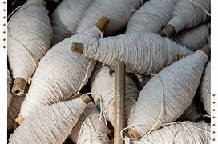
Image no 5,6: Natural Fibers
8.2 Natural Dyes: To maintain its status as an environmentally conscious textile, Khadi often utilizes plant based dyes derived from organic sources such as indigo, turmeric, pomegranate peel, and madder root. These natural pigments are preferred over synthetic alternatives because they are non-toxic, hypoallergenic, and significantly reduce the chemical footprint of the production process. The application of these dyes results in a distinctive palette of earthy, subtle tones that age gracefully over time, reflecting a deep connection to the natural landscape. This reliance on organic coloring agents ensures that the entire lifecycle of the fabric, from dyeing to disposal, remains in harmony with ecological preservation.
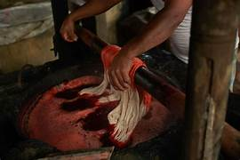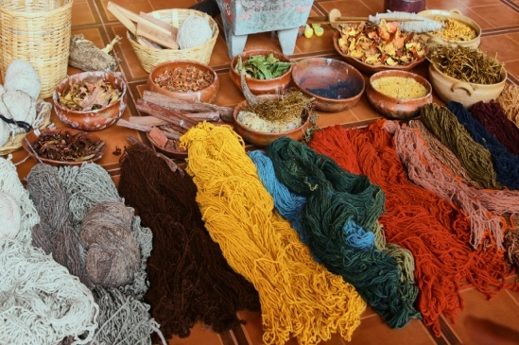
Image no 7,8:Natural Dye
8.3Supporting Materials: The production ecosystem of Khadi is supported by a range of traditional, low impact tools and organic substances that ensure the process remains decentralized and sustainable. Central to this are the wooden handlooms and spinning wheels (Charkhas), which are often maintained for generations and require no electricity to operate. During the final stages of production, organic starches frequently derived from rice or maize are used to provide the fabric with the necessary crispness and structural integrity without irritating the skin. Furthermore, artisans employ handmade wooden blocks for printing and specialized manual tools for dyeing, ensuring that every element used in the manufacturing chain supports local craftsmanship and ethical production standards.
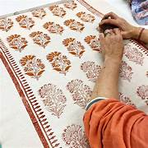
Image no 9:Suporting Material

9. Key Characteristics
Sustainability and Comfort: Khadi is globally recognized for its eco-friendly and biodegradable nature, as its production requires almost zero carbon footprints compared to mass produced synthetic textiles. The hand spun yarns create a unique porosity in the fabric, making it exceptionally breathable and comfortable; it possesses the rare quality of staying cool in the summer and providing warmth during the winter. Beyond its physical properties, the unique texture characterized by slight irregularities gives each piece a living quality that serves as a signature of the human hand. Ultimately, Khadi is more than just a material; it is a movement that promotes sustainable and ethical fashion, providing a viable alternative to the fast fashion industry while supporting the livelihoods of rural artisans.
10. Indian culture of Khadi: The culture of Khadi in India is not merely a history of a fabric, but a vibrant tapestry of regional identity, social empowerment, and sustainable living. Across the diverse landscape of the Indian subcontinent, Khadi serves as a common thread that binds different states, each adapting the material to suit their unique climates, indigenous crafts, and traditional occupations.

10.1 Regional Diversity and Craftsmanship
Every state in India has infused Khadi with its own cultural DNA, creating a diverse array of textiles that reflect local heritage. In West Bengal, the fine count of Khadi Muslin represents the pinnacle of hand spinning, often used in elegant sarees and dhotis. In contrast, Gujarat and Rajasthan utilize Khadi as a canvas for intricate block printing, Ajrakh, and Bandhani, where the fabric's absorbent nature perfectly holds natural plant-based dyes. Moving to the southern states like Andhra Pradesh and Tamil Nadu, Khadi is often characterized by its sturdy yet breathable weave, frequently adorned with temple-inspired borders that cater to traditional festive attire.
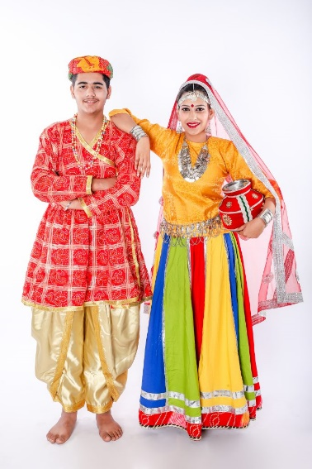
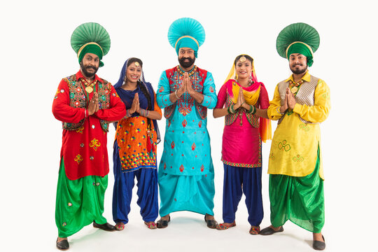
Image no 10,11: Rajasthan & Punjab
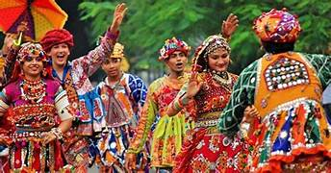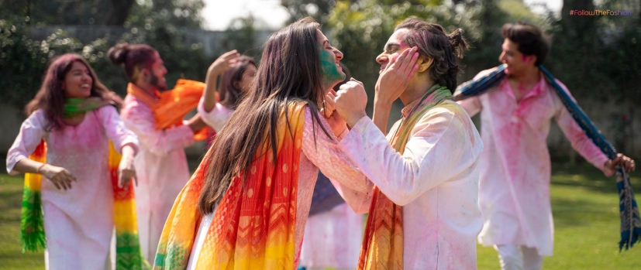
Image no 12,13: Gujarat & Madhya Pradesh

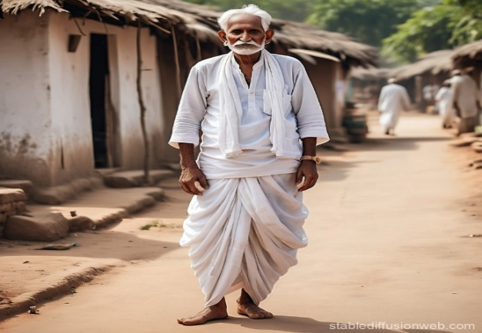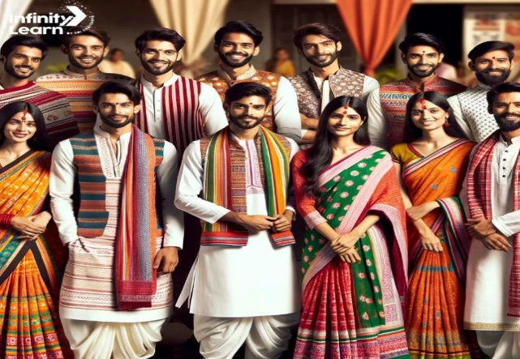
Image no 14,15: Uttar Pradesh & Bihar

Image no 16,17: Bengel & Tamil Nadu

10.2 Occupational and Functional Use
Historically and in the modern era, Khadi has been the garment of choice for a wide spectrum of Indian occupations, reflecting its versatility and durability. For the farming community, Khadi’s thick, hand spun cotton provides essential protection and breathability during long hours of manual labor under the sun. Conversely, in the political and academic spheres, the Khadi Kurta or Vasket (waistcoat) has become a uniform of integrity and intellectualism, symbolizing a commitment to Swadeshi (self-reliance) and grassroots development. Even in modern design sectors, Khadi is being reimagined as a sophisticated medium for contemporary office wear and interior furnishings, bridging the gap between rural production and urban professional life.
10.3 Khadi as a Symbol of Identity: Across India’s varied social strata, Khadi remains the ultimate "democratic" fabric, worn by both the common man and the elite. In many regions, specific Khadi garments are synonymous with cultural milestones; for instance, the Gandhi Topi and the Khadi Shawl are often used to honor guests or mark significant life events. This cultural deep-rooting ensures that Khadi is not viewed as an outdated relic, but as a living heritage. By integrating state-specific embroidery such as Kantha from Bengal, Phulkari from Punjab, or Chikankari from Uttar Pradesh onto Khadi base fabrics, the textile continues to represent a unified Indian identity that celebrates regional uniqueness through a shared medium of sustainable craftsmanship.
11. Conclusion and Design Intervention
The study of Khadi reveals a textile that is far more than a simple hand woven fabric; it is a profound symbol of India’s journey toward self-reliance and environmental consciousness. From the foundational spinning on the Charkha to the intricate handloom weaving processes, Khadi embodies a unique human centric production model that prioritizes quality and artisan well-being over industrial mass production. The field visits and material analysis conducted throughout this research underscore how Khadi’s distinctive texture and breathability are a direct result of manual skill, creating a product that is both functionally superior for various climates and culturally significant as a "fabric of freedom."
The environmental benefits of Khadi cannot be overstated in the context of today’s global climate crisis. By utilizing natural fibers like cotton, silk, and wool along with plant-based dyes such as indigo and madder, the Khadi industry offers a zero-carbon footprint alternative to synthetic, fast-fashion manufacturing. This research has demonstrated that Khadi is inherently sustainable, biodegradable, and supports a circular economy. Furthermore, the regional diversity ranging from the fine muslins of Bengal to the earthy tones of Rajasthani block prints proves that Khadi is a versatile medium capable of adapting to modern aesthetic demands while remaining rooted in ancient tradition.
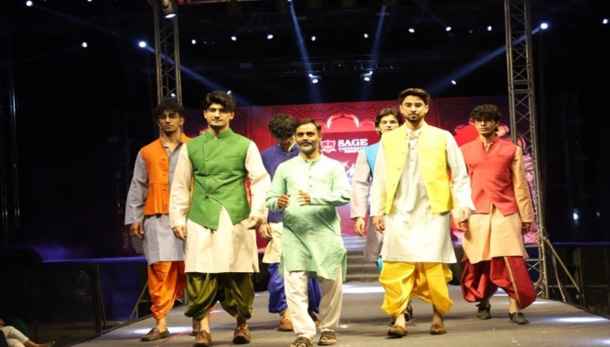
Image no 18: Khadi Collection for Male.
In conclusion, the future of Khadi lies in its ability to bridge the gap between rural craftsmanship and contemporary global fashion. While it remains a vital source of income for millions of rural artisans, particularly women, it also appeals to the modern ethical consumer seeking transparency and sustainability. To ensure its continued growth, it is essential to support the modernization of tools, such as the New Model Charkha, without compromising the hand crafted essence that defines the fabric. Ultimately, Khadi stands as a testament to the fact that the most sophisticated solutions for the future of the textile industry may very well be found in the wisdom of our traditional past. Key Summary of the work as mentioned below.
- Symbolism: Khadi remains a national symbol of integrity and Swadeshi.
- Eco-Impact: It is the most sustainable textile due to its low energy production.
- Socio Economic Value: It provides a vital livelihood for rural weaving communities.
- Modernization: The integration of technology can enhance production without losing the hand-made hallmark.
References:
[1] Aravind, V. (2022). Khadi textiles, women and rural development. Laxmi Publications.
[2] Arora, S. (2023). Khadi in shades of green: Sustainable approaches. Journal of Emerging Technologies and Innovative Research, 10(4), 112–119.
[3] Agarwal, S., & Raghav, P. K. (2021). Preference of the eco-friendly fabric from organic cotton and bamboo: A study. Research Gate. [This study highlights the shift toward sustainable fibers, supporting your research on PALF and organic blends].
[4] Agarwal, S., & Mehta, S. (2024). Fabric quality and properties consider for sports wear: Aesthetic and functional need. Shodh Kosh: Journal of Visual and Performing Arts, 5(4), 1136–1142. https://doi.org/10.29121/shodhkosh.v5.i4.2024.3834
[5] Agarwal, S. (2018). Effects of the new technology era on the economic growth of textile and fashion market. Trends in Textile Engineering & Fashion Technology, 3(4). DOI: 10.31031/TTEFT.2018.03.000569.
[6] Dasgupta, S., Ray, A., & Singh, S. (2019). Reviving khadi for sustainable fashion. International Journal of Home Science, 5(2), 143–148.
[7] Gonsalves, P. (2012). Khadi: Gandhi's mega symbol of subversion. SAGE Publications India.
[8] Mandal, R. K. (2007). Khadi and village industries in North East India. Mittal Publications.
[9] Parikh, G. (2020). History of khadi. National Book Trust. (Original work published 2011).
[10] Tarlo, E. (1991). The problem of what to wear: The politics of khadi in late colonial India [Doctoral dissertation, SOAS University of London]. SOAS Research Online.

