Code Medic: AI Powered Self-Healing Software

Prof.Keshav Tambre¹, Dhanashri Dalvi², Piyush Chame³,Aditya Chavan⁴, Kartik Jadhao⁵
¹Department of Data Science & Engineering VIT College Pune, Maharashtra, INDIA ²Department of Data Science & Engineering VIT College Pune, Maharashtra, INDIA ³Department of Data Science & Engineering VIT College Pune, Maharashtra, INDIA ⁴Department of Data Science & Engineering VIT College Pune, Maharashtra, INDIA ⁵Department of Data Science & Engineering VIT College Pune, Maharashtra, INDIA

¹keshav.tambre@vit.edu ²dhanashri.dalvi24@vit.edu ³piyush.chame24@vit.edu ⁴aditya.chavan24@vit.edu ⁵kartik.jadhao24@vit.edu

Abstract— In today’s software systems, it is common to face
run-time errors, dependency issues, and logical errors. This paper proposes a self-healing software system called Code Medic, which uses AI to automatically detect and analyze errors. The proposed AI-based self-healing software system uses the Healing-Agent framework along with locally executed Large Language Models (LLMs) using Ollama. The proposed software system ensures the local execution of the models to maintain the privacy and cost effectiveness of the software. When the software faces errors, the execution context is captured to analyze the error. The captured context is sent to the locally executed LLM to generate the diagnosis. The proposed software can automatically fix errors using the backup protection mechanism. The experimental results have shown that the proposed software can fix common programming errors. The proposed software system shows the possibility of using artificial intelligence to maintain software. Artificial Intelligence, Large Language Models (LLMs), Automated debugging, Runtime error detection, Local AI models, Software maintenance, Healing-Agent framework.

Keywords—Artificial Intelligence, Large Language Models (LLMs), Automated debugging, Runtime error detection, Local AI models, Software maintenance, Healing-
Agent framework.

- Introduction
Software development these days is witnessing the creation of more and more sophisticated software. This is mainly due to the rapidity with which software is being developed, along with the extensive use of third-party libraries. Moreover, distributed software is the new norm. As the
complexity of the software is growing, the possibility of errors happening at runtime, configuration errors, and logical errors is also growing. In the current context, if any error happens, one needs to go through the stack trace and manually analyze the source code. This is not only a tiresome process, but it is also a redundant one, especially for large software.
The idea of self-healing software has evolved from the autonomic computing paradigm, where software is expected to have the capability to self-manage itself with minimal human intervention [1]. Traditional self-healing software was based on a set of rules that monitored the software for errors. Even though this approach was quite efficient, it was not capable of addressing brand-new types of errors. The emergence of Automated Program Repair (APR) was based on executing the code against test cases. Even though this approach was quite efficient, it was based on structured datasets and templates. The arrival of Large Language Models (LLMs) has completely transformed the software development field. These models have proved to be quite efficient in healing software, owing to their ability to comprehend the code as well as repair errors in it [3], [4].
Though AI-based tools for debugging have emerged in recent times, they still need to be hosted in the cloud. This, in turn, poses a lot of risks, especially in terms of privacy, costs, and internet connectivity. This paper proposes an innovative solution for software debugging in the form of Code Medic, a self-healing software prototype that makes use of the deployment of Large Language Models in conjunction with runtime error detection.

.

- Literature review

The basic idea of the concept of building self-healing software systems can be traced back to the idea of autonomic computing, proposed to enable software systems to run autonomously without human intervention [1]. The underlying principle that makes autonomic computing possible is that software systems should be self-configuring, self-optimizing, self-protecting, and self-healing.
The initial idea of developing self-healing software systems involved using rule-based monitoring and recovery techniques, which were applicable only to predictable system failures. For improving the efficiency of the debugging process, Automated Program Repair (APR) techniques were proposed. The goal of APR techniques is to apply mutation and test case validation techniques for developing patches for erroneous programs. Although APR techniques showed promising results, they are often applicable only to structured environments.
The recent development of LLM has revolutionised the debugging and code repair process. LLMs demonstrates a high contextual understanding of programming languages, as proposed in recent code repair and debugging approaches using code-specialized LLMs such as Code Llama and Star-Coder [3], [4], [5]. These LLMs are capable of identifying errors, explaining errors, and developing syntactically correct patches. Recent studies have also proposed the use of LLM in debugging, where the LLM interprets the errors and suggests the correct code in natural language form [6]. However, most of the debugging approaches proposed in recent literature are based on cloud-based APIs, which raise concerns related to data privacy and recurring costs. With recent advancements in local model deployment frameworks, it is now possible to execute LLMs, thus ensuring data privacy and cost-effectiveness.
Although recent studies proposed the use of LLM in debugging, little research has been conducted on developing self-healing software systems using local LLMs and runtime exception detection approaches. The proposed Code Medic system aims to develop an intelligent debugging system based on recent studies on local LLM deployment and runtime exception detection approaches.
- Methodology/experimental
- Overall Architecture
The methodology used to develop Code Medic:
AI-Powered Self-Healing Software is based on a modular, layered architecture suitable for automated runtime debugging. The software is based on the integration of runtime exception monitoring with locally deployed large language Models. It is based on a local execution environment with the aim of ensuring offline debugging.
Application Layer (User Program Execution): This layer represents the Python application that is being executed by the user. Code Medic interacts with the application through exception handling hooks, and there is no need to alter the application structure. During the execution process, the system monitors the run-time behaviour. When an unhandled exception occurs, the execution of the program is intercepted before termination.
Data Layer: The data layer handles the structured information that is produced in the debugging process. A lightweight SQLite database is employed to store error logs, timestamps, error types, patches generated, patch acceptance, and model response time. This layer aids in the performance evaluation and debugging history. A secure local storage system is employed to ensure that the source code and debugging information remain within the user’s environment.
Monitoring and AI Processing Layer: This layer acts as the central processing backbone of the Code Medic application. It consists of the Healing Agent framework, which is responsible for the detection of runtime exceptions. The debugging information, such as the type of error, stack trace, file name, line number, source code snippet, and variable state, are obtained by the context extraction engine when the error has been located. The locally hosted LLM together with the Ollama runtime is used to convert the retrieved data into a well-structured prompt. The AI model analyzes the information and generates an explanation and a patch for the problem.

Component | Technology Used
Programming Language | Python 3.x
AI Model Runtime | Ollama
Language Model | Code Llama/Starcoder
Database | SQLite
Error Monitoring | Python Exception Handling
File Management | Python I/O System

TABLE I
TECHNOLOGY STACK OF CODE MEDIC

- Functional Modules
User Program Monitoring Module: The module continuously monitors the runtime execution using the exception handling features of the Python programming language. By rerouting the flow to the debugging system, this module dynamically catches unhandled exceptions and prevents program termination.
Context Extraction Module: On detecting the error, this module retrieves the context of the execution. The collected data includes the stack trace hierarchy, the error message, the file name and line number where the error occurred, and the related code snippet. Gathering this contextual information ensures that the AI model receives enough details to perform an accurate diagnosis.
Prompt Generation Module: The captured debugging details are then organized into a structured prompt that can be given to the LLM. This prompt usually includes the part of the code where the error occurred, a clear description of the error, and a specific instruction asking the model to analyze the problem and suggest the necessary correction.
AI Debugging Module: This module integrates with locally hosted LLMs such as Code Llama or StarCoder using the Ollama runtime. The model processes the structured prompt and produces two outputs: a
human-readable explanation of the error and a corrected code snippet. Since the model operates offline, it guarantees privacy and eliminates dependency on external APIs.
Patch Management Module: The developer is shown the generated correction for approval. Before implementing the recommended patch, the system makes a backup of the original file if it is accepted. The safe modification of source code is ensured by this controlled automation.
Logging and Evaluation Module: The SQLite database contains all debugging activity, including error type, generated fix, patch status, and response time. This module facilitates system performance evaluation and experimental analysis.

- Patch Generation Scoring Mechanism
The AI model assesses several candidate fixes produced from the debugging context in order to choose the best corrective patch. Let C represent the extracted error context and Pi represent the ith candidate patch generated by the language model.
The goal behind to choose the patch that, considering the debugging context, has the highest likelihood:
P∗ = arg max P(Pi |C) (1)
where P(Pi | C) represents the probability that the candidate patch Pi correctly resolves the error under the given context
C. After validation, the chosen patch P∗ is either automatically applied or presented to the developer.
S(Pi) = αRi + βHi + γCi (2)
To put it in simpler terms: Hi tells us how successful similar patches have been before, Ri shows how confident the model feels about its current suggestion, and Ci checks how much the current error matches errors we’ve already solved. The parameters α, β, and γ just decide how much weight each of these pieces carries in the final decision.

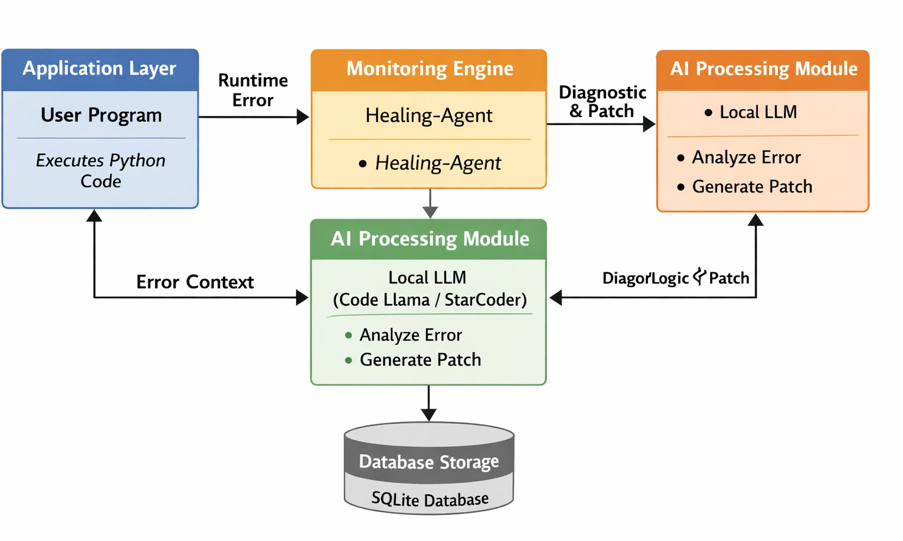

Fig. 1. Code Medic’s system architecture illustrates how the user program, monitoring engine, AI processing module, database storage, and patch management system interact.

- Implementation
To enable scalability, maintainability, and simple integration with local Large Language Models, the Code Medic has been implemented using a modular and Implementation of the Code Medic has been performed using a modular and layered design philosophy to allow for scalability, maintainability, and easy integration with local Large Language Models. To maintain privacy and refrain from using external APIs, the application was completely developed using the Python programming language and implemented in a restricted environment.

Runtime Monitoring Engine:

The runtime monitoring engine is the main trigger mechanism in the system. It is developed based on the Python exception handling framework, along with a central wrapper. This type of error, message, stack trace, file path, and line number can be recorded by the engine if a runtime exception occurs during debugging. The monitoring part of the component is designed to intercept the termination of
the program before it crashes. As a result, the debugging pipeline is able to be automatically activated. This forms the foundation of the self-healing mechanism.

Context Extraction and Prompt Structuring:

The context extraction module must needs to retrieve structured debugging data after an error is found. This includes:
Error message

  - Stack trace details

  - Source code snippet around the faulty line

  - Relevant variable states

A template for a structured prompt data is created using the information that was retrieved. To ensure that the output from the LLM is consistent, the template that the structured prompt is based on is designed to be deterministic.
Role-based clear instructions are included.

Local LLM Integration:

In order to maintain the security of the data and avoid any dependency on cloud services, the integration with the Large Language Model, which has been locally deployed using Ollama, can be utilized. The models used are Code Llama or StarCoder. The locally deployed LLM will receive this kind of for- matted prompt through an API call or command-line interface. The LLM will then process the debugging context, which will include following:
  - Error explanation

  - Root cause analysis

  - Suggested corrected code patch

This design ensures the provision of privacy-preserving AI-based debugging without any network communication.

AI Model and Inference Engine:

Code Medic integrates using a locally deployed large language model (LLM) for automated code patch generation. In this artificial intelligent component is executed using:
  - Ollama (LLM Runtime Environment)

  - Code-oriented models such as Code Llama / StarCoder

  - The local deployment ensures:

  - Data privacy

  - Offline functionality

  - Reduced API cost

  - Faster inference without network latency

The local large language model receives the totally structured prompt and produces a root-cause analysis with recommendation of correct code patch.

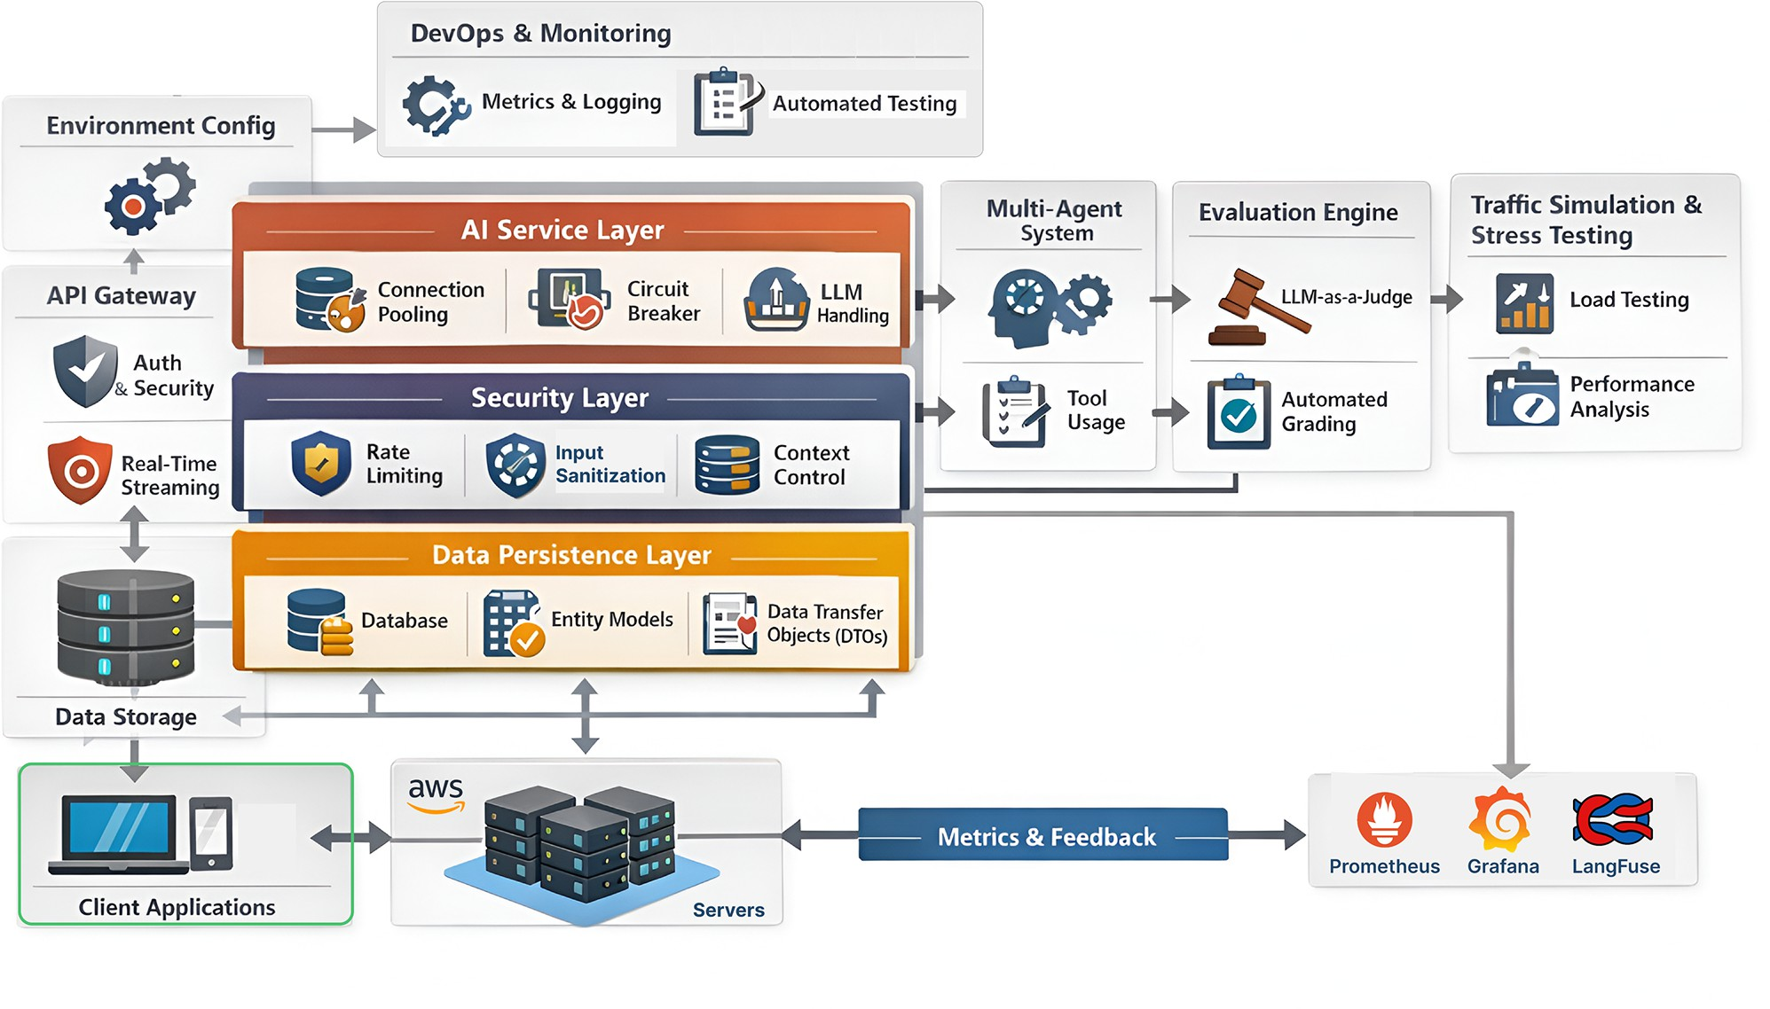
Fig. 2. Runtime Exception Handling and AI-Based Patch Generation Workflow

- Results And Discussions
Several Python programs with purposefully introduced runtime errors were used to assess Code Medic’s performance. The goal behind the experiment was to assess how well the system could identify exceptions, generate intelligent explanations, and apply corrective code patches with the least amount of human involvement and participation.
During the evaluation process, the system is tested with a variety of runtime exceptions, which include NameError, TypeError, ImportError, AttributeError, etc. The runtime monitoring engine was able to intercept all the execution failures, showing 100. However, the performance of the developer with more complicated logical errors, which include the design of the algorithm or semantic reasoning, needed further validation. Although the model gave valuable explanations, the patches that the model generated did not entirely bear contextual alignment. Even though the model provided useful explanations, the patches generated by the model sometimes failed to have complete contextual alignment.
The average response time for providing explanations and patches varied between 3 to 8 seconds depending upon the size of the models and the systems. It has been observed that smaller models gave faster responses, though sometimes the explanation might not be very detailed.
Although it took a little longer to respond because of the higher computational demand, larger models improved the diagnosis process’s clarity. All the activities carried out in the debugging process were recorded in the SQLite database, thus facilitating the quantitative performance analysis. The logged data showed that the automated debugging process reduced the time spent in the manual debugging process. The self-healing loop mechanism was effective in improving the productivity of the developers as they could quickly identify and fix the common runtime errors. On the whole, the results of the experiments conclusively establish the effectiveness of the Code Medic program as a tool for using AI-based patch synthesis and

exception monitoring. Though the tool is quite good at handling runtime exceptions, further optimization is required to improve the reliability of the tool in handling logical dependencies. The study confirms that locally deployed AI models can be used to create intelligent software debugging tools.

- Limitations
Despite the fact that the Code Medic shows promising results in the automated runtime debugging process, there are still limitations in the process. The limitation is that theCode Medic is mainly designed for runtime exceptions, which may not be useful in detecting complex logical errors that may not throw explicit exceptions. The automated program repair techniques may not be effective in handling complex semantic defects, as the techniques are primarily designed for syntactic or local faults [1], [3]. The complex program may have multiple files, which may reduce the accuracy of the patches due to the limited visibility of the program context. The previous research on the automated program repair techniques, such as the context-aware and learning based approaches, showed that the limited program context may affect the correctness of the patches [5], [11], [21]. The quality of the patches may vary depending on the capability of the locally deployed LLM and the computational resources. The transformer based models may improve the quality of the patches, as they may improve the reasoning capability of the patches, which may increase the latency of the patches [8], [9], [10]. The patches may require human validation in the automated patch application process, as the patches may not be effective in handling the semantic correctness of the patches. The developer validation is still recommended in the automated program repair techniques, as the patches may require validation [2], [16].
- Future Scope
The proposed framework offers several opportunities for future research and further development. One possible improvement is to extend the system so that it supports additional programming languages such as Java, C++, and JavaScript. Expanding language support would allow the system to be used in a wider range of software development environments and make it more useful for diverse development ecosystems. Recent advancements in multilingual and language-agnostic program repair models have shown that the extension of the automated program repair tools beyond a single programming language is feasible and achievable. Another thing to think about is integration with well-known Integrated Development Environments (IDEs) like Visual Studio Code or PyCharm. Developers could get AI-assisted debugging support while they are writing code, rather than only after the program has finished running, if the system is integrated directly into these development tools. This would gradually shift the role of the system from being just a runtime error analysis tool to becoming a helpful assistant during the actual coding process. Because of this, developers could find possible problems early in the development cycle and fix them. Recent progress in large language model based coding assistants also suggests that this type of real-time integration is becoming increasingly practical and achievable [9], [10]. Another direction that future work might take is to explore the possibility of a ”hybrid” model, whereby local use of LLMs might be augmented by access to cloud-based LLMs. Stronger reasoning skills and increased computational efficiency could be balanced with the benefits of privacy protection. At the same time, this approach could address several practical and ethical considerations related to the deployment of AI-driven program repair systems [22]. Adding mechanisms for reinforcement learning or feedback driven learning to the system is another area that needs work. The system may improve the accuracy of repairs and the ability to prioritize the most effective repairs over time by learning from the feedback of developers and the previous success rates of patches that have been generated [14], [19], and [21].

Considering every aspect, it may be said that such developments in the system may improve the scalability, flexibility, and reliability of AI-based self-healing debugging tools, as well as the confidence of developers in such tools and the scope of their real-world applicability.

- Conclusion
The paper proposed a software framework for self-healing using artificial intelligence, termed as Code Medic, where the framework integrates the use of runtime monitoring and locally deployed large language models to automatically detect errors and generate suitable patches. The system uses locally hosted language models rather than external services to record runtime exceptions, produce suitable fixes, and protect data. The experimental results show that the framework can accurately detect runtime exceptions and is able to generate correct fixes for most common programming errors. Even though there are limitations in addressing deep semantic logic errors and multi-file dependencies, the framework has provided a solid basis for developing artificial intelligence-based selfhealing software frameworks. The artificial intelligence-based software framework, Code Medic, is an important step in the development of intelligent software maintenance systems that have the ability to automatically detect errors and recover from them. The use of artificial intelligence-based reasoning in runtime monitoring has provided a clear indication of the possibilities that exist in self-healing software architectures in software engineering.
References

- C. Le Goues, M. Pradel, and A. Roychoudhury, “Automated Program Repair,” Communications of the ACM, vol. 62, no. 12, pp. 56–65, 2019.
- C. Le Goues, T. Nguyen, S. Forrest, and W. Weimer, “GenProg: A Generic Method for Automatic Software Repair,” IEEE Transactions on Software Engineering, vol. 38, no. 1, pp. 54–72, 2012.
- R. Monperrus, “Automatic Software Repair: A Bibliography,” ACM Computing Surveys, vol. 51, no. 1, pp. 1–24, 2018.
- S. Mechtaev, J. Yi, and A. Roychoudhury, “DirectFix: Looking for Simple Program Repairs,” in Proceedings of the 37th International Conference on Software Engineering (ICSE), 2015, pp. 448–458.
- M. Wen, J. Chen, R. Wu, D. Hao, and S. Cheung, “Context-Aware Patch Generation for Better Automated Program Repair,” in Proceedings of
ICSE, 2018, pp. 1–11.
- Y. Li, S. Wang, and T. Nguyen, “DLFix: Context-Based Code Transformation
Learning for Automated Program Repair,” in Proceedings of ICSE, 2020, pp. 602–614.
- S. Xia and L. Zhang, “Practical Program Repair in the Era of Pre-trained
Language Models,” arXiv preprint arXiv:2203.07836, 2022.
- A. Vaswani et al., “Attention Is All You Need,” in Advances in Neural Information Processing Systems (NeurIPS), 2017.
- T. Brown et al., “Language Models are Few-Shot Learners,” in Advances
in Neural Information Processing Systems (NeurIPS), 2020.
- M. Chen et al., “Evaluating Large Language Models Trained on Code,”
arXiv preprint arXiv:2107.03374, 2021.
- E. Tufano et al., “Learning to Fix Bugs: A Machine Translation Approach,” in Proceedings of ICSE, 2019.
- Z. Zhong and J. Su, “CodeBERT: A Pre-Trained Model for Programming
and Natural Languages,” in Findings of EMNLP, 2020, pp. 1536–1547.
- W. Weimer, T. Nguyen, C. Le Goues, and S. Forrest, “Automatically finding patches using genetic programming,” in Proceedings of ICSE, 2009, pp. 364–374.
- H. Kim, M. D. Ernst, and M. Notkin, “Automatic patch generation learned from human-written patches,” in Proceedings of ICSE, 2013,
pp. 802–811.

- S. Forrest, T. Nguyen, W. Weimer, and C. Le Goues, “A genetic programming approach to automated software repair,” IEEE Computer, vol. 43, no. 5, pp. 54–62, 2010.
- J. Long and M. Rinard, “Automatic patch generation by learning correct
code,” in Proceedings of POPL, 2016, pp. 298–312.
- X. Liu, S. Yoo, and M. Harman, “Repairing software defects using machine learning techniques,” Journal of Systems and Software, vol. 157, 2019.
- R. Abreu, P. Zoeteweij, and A. J. C. van Gemund, “An evaluation of similarity coefficients for software fault localization,” in Proceedings of PRDC, 2006, pp. 39–46.
- D. Kim, J. Nam, J. Song, and S. Kim, “Automatic patch generation learned from human-written patches,” IEEE Transactions on Software Engineering, vol. 39, no. 3, pp. 1–17, 2013.
- K. Pan, S. Kim, and E. J. Whitehead Jr., “Toward an understanding of bug fix patterns,” Empirical Software Engineering, vol. 14, no. 3, pp. 286–315, 2009.
- A. Koyuncu, T. F. Bissyand´e, D. Kim, J. Klein, and Y. Le Traon, “FixMiner: Mining relevant fix patterns for automated program repair,” Empirical Software Engineering, vol. 25, 2020.
- P. Henderson et al., “Ethical challenges in AI-based automated programming
systems,” ACM Computing Surveys, 2022.

