GEOPHYSICAL EVALUATION OF GROUNDWATER POTENTIALS USING ELECTRICAL RESISTIVITY METHOD AT UMUNEDE.

ABSTRACT
Understanding subsurface geo-electrical characteristics is essential for effective groundwater exploration and sustainable management. This study investigates the subsurface lithology and groundwater potential of Umunede using the Vertical Electrical Sounding (VES) technique with the Schlumberger array. Five VES stations were occupied within the study area, and the acquired data were subjected to quantitative interpretation through curve matching, using standard model curves, namely AA, KH, KH, and HKH. The data were further analyzed qualitatively using IP2Win software,the interpreted geoelectric sections revealed between four and six subsurface layers.The first geoelectric layer exhibited resistivity values ranging from 20.3 Ωm to 491 Ωm, with thicknesses varying between 0.5 m and 6.33 m. The second layer recorded resistivity values ranging from 111 Ωm to 1000 Ωm. Its thickness varied from 0.507 m to 9.53 m, while depths ranged from 1.01 m to 10.5 m. Based on the resistivity characteristics, the lithology of this layer was interpreted as clay, fine sand, and medium-to-coarse sand. The third layer consists of clay, fine sand, and medium-to-coarse sand. showed resistivity values ranging from 30.8 Ωm to 3485 Ωm with thicknesses ranging between 4.51 m and 55.2 m, while depths extended from 5.52 m to 65.7 m. Similarly, the fourth layer exhibited resistivity values ranging from 71.8 Ωm to 1247 Ωm, with thicknesses varying from 15.5 m to 98.6 m and depths ranging from 26 m to 164 m. The lithological units identified within this layer also comprise clay, fine sand, and medium-to-coarse sand. The fifth layer records resistivity values ranging from 184 Ωm to 10,763 Ωm. The thickness extends from 41 m about 120 m to infinite in some of the locations, while the depth to the layer ranges from 161 m to infinity. The layer with low resistivity is considered as potential aquifer zones while the higher resistivity is considered as coarse to gravel sediments without conductive fluids. The sixth geoelectric layer, identified only in VES 1 locations, exhibits resistivity values ranging from 254 Ωm. The lithological interpretation of layer five and six is fine to coarse sand with conductivity fluid potentials considered as aquifer zones. This aquifer zones of fine sand layer extends from approximately 43 m to 160 m depth which is in conformity and correlates with well log and lithological information obtained from nearby borehole records.
The results provide important information for groundwater development and sustainable water resource management in the area. Overall, the study presents a detailed geoelectrical and hydrogeological characterization of Umunede and offers valuable guidance for future groundwater exploration and exploitation.
Keywords: Potential aquifer, Schlumberger electrode configuration, resistivity, lithological characteristics.

INTRODUCTION
Groundwater is a vital part of the hydrological cycle and serves as one of the most important sources of freshwater for domestic, agricultural, and industrial activities across the world, particularly in areas where surface water resources are limited or unavailable (Todd, 1980; Fetter, 2001). In Nigeria, groundwater remains the primary and most dependable source of potable water for many rural and semi-urban populations. However, rapid population growth, fluctuating rainfall patterns, and increasing pollution of surface water sources have created a growing need for systematic and scientific investigations of groundwater resources to ensure their sustainable utilization and management (Atakpo and Ayolabi 2009). Likewise, Aweto and Ohwoghere (2018) Egheneji, et al (2023); Esi et al (2023); Esi and Akpoyibo (2023) utilized resistivity techniques to identify and map aquifer systems within the coastal plain sands of southeastern Nigeria.
As urbanization continues to expand and the population increases, the demand for water for domestic, agricultural, and industrial purposes rises correspondingly. The supply of potable water from harvested rainwater is often insufficient, especially during the dry season (Akpoyibo, 2025); Edet and Okereke (2001). Consequently, the development and management of water resources have become major concerns for planners and decision-makers, particularly in regions characterized by rapid population growth and water scarcity (Jawad et al., 2013 & Oyem et al., 2025).
The study area Umuneded, is located in Ika North-East Local Government Area of Delta State within the Niger Delta region and is known as an oil-producing community. Despite the presence of groundwater resources, accessing them can be challenging due to the area's relatively elevated topography (Akpoyibo, 2025).
As a result, groundwater cannot be effectively exploited without conducting detailed investigations to accurately determine the occurrence, depth, and extent of aquifer formations. Therefore, proper groundwater exploration and delineation are necessary to establish the precise depth to productive aquifers with a high degree of accuracy. The findings of this study will assist individuals, industries, and government agencies in estimating the cost of borehole drilling and development, thereby supporting sustainable groundwater exploitation and the provision of reliable potable water supplies.

LOCATION AND GEOLOGY OF THE STUDY AREA
The Umunede community is situated in Ika North-East Local Government Area, inhabited predominantly by the Ika ethnic group, in Delta State, Nigeria. Geographically, the area lies between latitudes 6°14'55"N and 6°16'20"N and longitudes 6°18'15"E and 6°19'35"E (Figure 1). It is bounded by the Namomah and Orogodo Rivers, while the neighbouring communities include Akumazi, Mbiri, Owa, and Emuhu. The drainage pattern is influenced by the rivers, which flow southwestward toward the coastal region. The area is also characterized by dense vegetation and forest reserves, which are distinctive features of its natural environment, (Oyem et al 2025).
The study area is located within the Niger Delta region, where the lithofacies of the Tertiary Niger Delta Basin gradually transition into those of the Cretaceous Anambra Basin (Nwakaji et al., 2025). The geology of the Umunede area has been extensively investigated by several researchers (Akpoyibo et al., 2022; Anomohanran et al., 2023; Akpoyibo and Vwavware, 2024; Akpoyibo et al., 2025). Geologically, the area records a series of transgressive and regressive depositional cycles that resulted in a stacked succession of sedimentary sequences, each reflecting variations in relative sea level and sediment supply through time (Reijers, 2011). The major lithostratigraphic units present in the area include the basal Imo Shale, the Ameki Formation, and the Ogwashi–Asaba Formation. At the subsurface level, the stratigraphic succession comprises the Akata Formation, characterized by marine transgressive shales; the Agbada Formation, consisting of alternating sand and shale deposits of paralic origin; and the continental Benin Formation, which forms the uppermost unit of the Niger Delta sedimentary sequence.
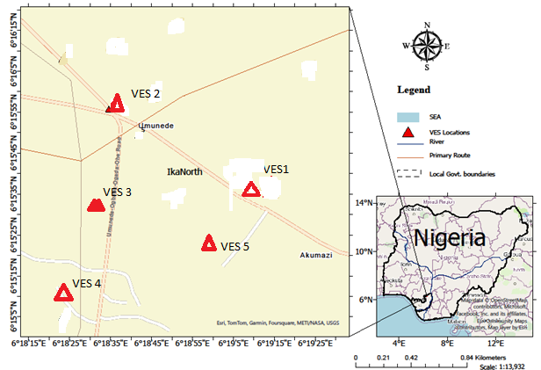Fig; 1: Map of the study area unveiling the VES locations
MATERIAL AND METHODS
This study employed the electrical resistivity method to determine subsurface depths and evaluate vertical variations in resistivity. Field data acquisition was carried out using a digital RHOMEGA EARTHRO Terrameter. The method was selected because of its effectiveness in investigating subsurface geological conditions and groundwater-bearing formations.
The Schlumberger Vertical Electrical Sounding (VES) technique was adopted for data collection due to its sensitivity to near-surface resistivity variations and its ability to achieve significant depths of investigation. According to Okolie and Akpoyibo (2012) and Afolabi et al. (2004), the Schlumberger array is particularly suitable for delineating subsurface structures by accurately determining the resistivity and thickness of underlying geological layers (Atakpo 2013). Its relatively deep penetration capability makes it an effective tool for groundwater exploration and geoelectrical investigations.

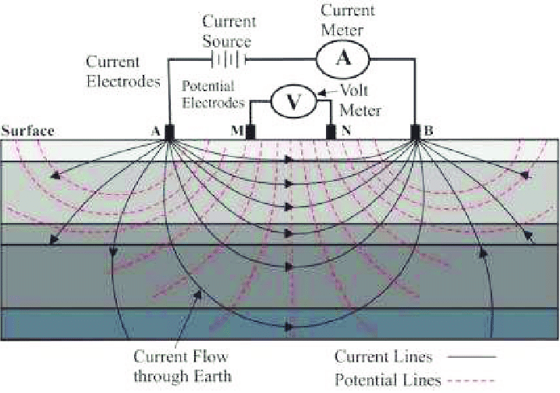
Figure 2. Schematic illustration of the basic measurements using electrical resistivity method (Modified after J.A. Clark et al., 2011).

The geometric factor (K) for Schlumberger Array is determined as follows:
$d_{1}=L-b$, $d_{2}=L+b$, $d_{3}=L+b$, $d_{4}=L-b$
K =$2π(\frac{1}{{\frac{1}{d}}_{1}-{\frac{1}{d}}_{2}-{\frac{1}{d}}_{3}+{\frac{1}{d}}_{4}})$ ……………………………… (1)
Simplifying equation (1), geometric factor K is given as
$K=(π\frac{l^{2}-b^{2}}{2b})$ ………………………………………..(2)
K is the geometric factor for Schlumberger array which depends on geometric arrangement.
When the ground is homogeneous, the resistivity measured with above equation would be constant and independent of both electrode spacing and surface location. When substance inhomogeneities exists however, the resistivity will vary with the relative positions of electrodes and any resistivity measured is regarded as apparent resistivity, $ρ_{a}$ = k$\left(\frac{V}{I}\right)$, ………………………. (3)
P_{a} = KR …………………………………………………………………………. (4)
Data Acquisition
The five VES data acquired from the field with GPS coordinate of the location and elevation as shown in table 1 below.
Table 1: VES Location of the Study area
VES | DESCRIPTION | EASTING | NORTHING | ELEVATION
VES 1 | Opposite sacred heart catholic church | 006⁰19’05.1’’ | 06⁰15’37.1’’ | 4 m
VES 2 | Mbiri road | 006⁰18’21.2’’ | 06⁰16’10.6’’ | 248m
VES 3 | Odum street | 006⁰18’28.4’’ | 06⁰15’05.1’’ | 206m
VES 4 | Odiakose street | 006⁰18’20.6’’ | 06⁰15’03.1’’ | 200m
VES 5 | Ugwubor street | 006⁰ 18’44.3’’ | 06⁰15’03.2’’ | 214m

Results and Discussion
The acquired Vertical Electrical Sounding (VES) data were subjected to both quantitative and qualitative analyses. Interpretation of the sounding curves was carried out through partial curve matching using appropriate master and auxiliary curves, followed by computer-assisted interpretation with the IP2Win software package.
The geoelectric parameters derived from the analysis, together with the interpreted lithological units of the study area, are summarized in Table 2. The interpreted resistivity sounding curves (Figure 2) reveal the presence of five to six distinct geoelectric layers beneath the surface, indicating variations in subsurface lithology and geological conditions across the study area.

Table 2: Geoelectric Layers Parameter Deduced from Iteration and Modeling of VES Field in Umunede
VES STATION | Numbers of Layers | Resistivity  ($Ω$m) | Thickness T(m) | Depth (m) | Inferred Lithology
VES 1 | 1 | 144 | 5 | 5 | Topsoil
VES 1 | 2 | 144 | 5.74 | 8.49 | Silty soil
VES 1 | 3 | 64.9 | 17.3 | 25.8 | Clay
VES 1 | 4 | 133 | 15.5 | 41.2 | Fine sand
VES 1 | 5 | 184.5 | 120 | 161 | Fine sand/water
VES 1 | 6 | 254 | - | - | -
VES 2 | 1 | 111 | 0.983 | 0.983 | Topsoil
VES 2 | 2 | 118 | 9.53 | 10.5 | Laterite
VES 2 | 3 | 1009 | 55.2 | 65.7 | Medium - Coarse sand
VES 2 | 4 | 291 | 98.6 | 164 | Fine sand
VES 2 | 5 | 78 | - | - | -
VES 3 | 1 | 79.2 | 6.33 | 6.33 | Topsoil
VES 3 | 2 | 517 | 3.8 | 10.1 | Medium sand
VES 3 | 3 | 292 | 40.3 | 50.4 | fine soil
VES 3 | 4 | 457 | - | - | Medium to fine
VES 4 | 1 | 491.5 | 3.5 | 3.5 | Medium to fine sand
VES 4 | 2 | 1000 | 5.24 | 8.74 | coarse sand
VES 4 | 3 | 3485 | 13.1 | 21.8 | Coarse gravel
VES 4 | 4 | 1247 | 17.1 | 38.9 | Coarse sand
VES 4 | 5 | 10763 | - | - | Gravel
VES 5 | 1 | 20.35 | 0.5 | 0.5 | Topsoil
VES 5 | 2 | 755 | 0.507 | 1.01 | Medium/coarse sand
VES 5 | 3 | 30.8 | 4.51 | 5.52 | Clay
VES 5 | 4 | 71.8 | 20.5 | 26.2 | Silty clay
VES 5 | 5 | 9410 | - | - | Coarse sand

The first geoelectric layer across the six VES stations exhibits resistivity values ranging from 20.3 Ωm at VES 5 to 491 Ωm at VES 4. The layer thickness varies between 0.5 m at VES 5 and 6.33 m at VES 3. Based on the resistivity characteristics, this layer is interpreted as fine sand, representing the topsoil and lateritic overburden of the area. The second layer is characterized by resistivity values ranging from 111 Ωm at VES 2 to 1000 Ωm at VES 4. Its thickness ranges from 0.507 m at VES 5 to 9.53 m at VES 2, while the depth to the base of the layer varies from 1.01 m at VES 5 to 10.5 m at VES 2. Lithologicaly, the layer is interpreted to consists of clay, fine sand, and medium- to coarse-grained sand which is line with (Nwakaji et al, 2025) who delineate the layer as clay/ kaolin mineralization zones
The third layer, resistivity values range from 30.8 Ωm at VES 5 to 3485 Ωm at VES 4. The thickness varies between 4.51 m at VES 5 and 55.2 m at VES 1, while the depth extends from 5.52 m at VES 5 to 65.7 m at VES 2. The lithological composition of this layer is inferred to comprise clay, fine sand, and medium- to coarse-grained sand deposits. The above assertion is tandem with the findings of (Ezeh and Ugwu, 2010), which states that subsurface materials have varying electrical resistivity values depending on their moisture content, porosity, mineral composition, and degree of saturation.
The fourth geoelectric layer exhibits resistivity values ranging from 71.8 Ωm at VES 5 to 1247 Ωm at VES 4. Its thickness varies from 15.5 m at VES 1 to 98.6 m at VES 2, while the depth ranges from 26 m at VES 5 to 164 m at VES 2. The interpreted lithology of this layer includes clay, fine sand, and medium- to coarse-grained sand materials. The fifth layer records resistivity values ranging from 184 Ωm at VES 5 to 10,763 Ωm at VES 4. The thickness extends from about 120 m at VES 1 to an infinite extent in some locations, while the depth to the layer ranges from 41 m to161 m at VES 1. Based on the resistivity distribution, this layer is interpreted as coarse sand to gravelly deposits, this layer constitutes a significant aquifer zone (Adesunloro et al, 2022). The sixth geoelectric layer, identified only in VES 1 locations, exhibits resistivity values from 254 Ωm and below. Both the thickness and depth of this layer extend beyond the maximum depth of investigation. The lithological characteristics are interpreted as fine sand deposits with water. This finding conforms with that of Nwachukwu et al, 2022), it clearly explains the fact that resistivity values, when correlated with borehole logs, provided accurate estimates of aquifer depth and thickness.

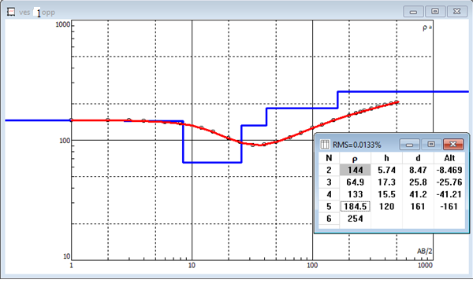 Figure 3: Iteration curve of VES 1 with six layers

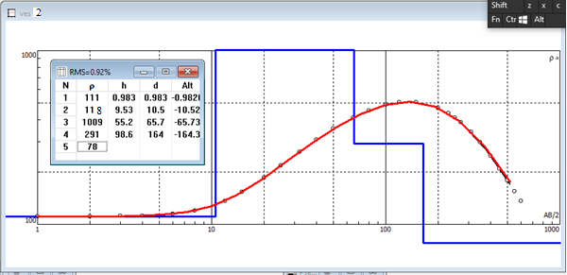
Figure 4. Iteration curve of VES 2 with five layers

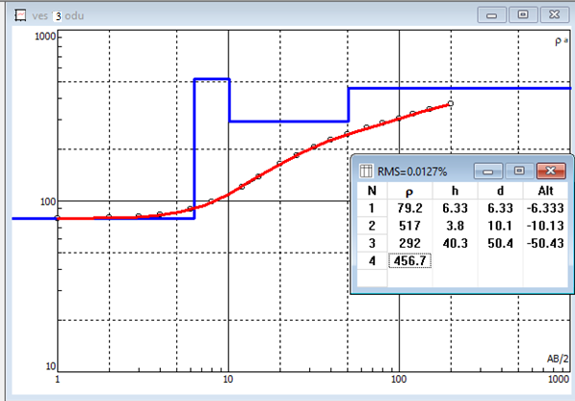
Figure 5. Iteration curve of VES 3 with four layers
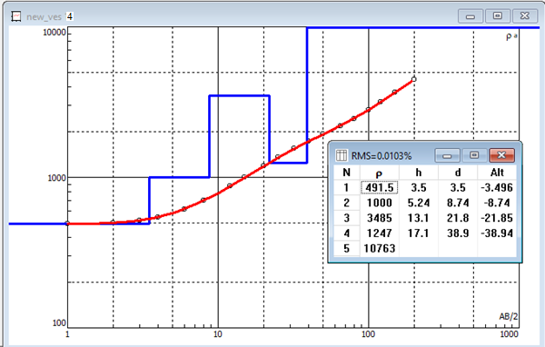
Figure 6. Iteration curve of VES 4 with five layers

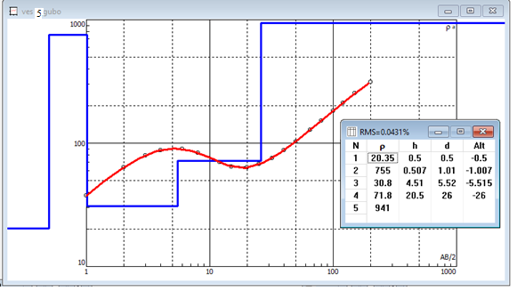
Figure 7. Iteration curve of VES 5 with five layers
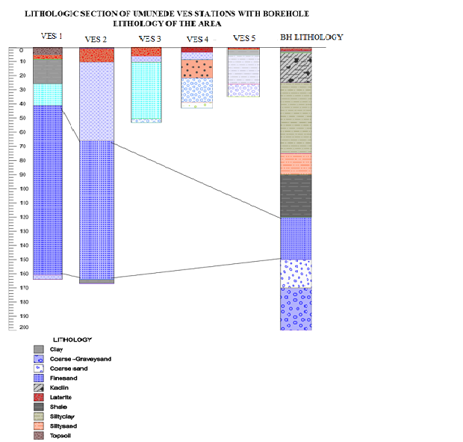
Figure 8: Lithological section of the VES station of Umunede study Area
CONCLUSION
The results of the geoelectrical investigation indicate that the fourth and fifth layers characterized by relatively low resistivity values, generally ranging between 100 and 200 Ωm. These resistivity values are indicative of fine sand formations saturated with groundwater, suggesting favourable aquifer conditions within the study area. The lithological interpretation presented in (Figure 3 -7) supports this inference and is consistent with information obtained from existing productive borehole logs in the area.
The study further reveals that the groundwater-bearing zones occur at considerable depths below the ground surface. Based on the interpreted geoelectric sections and borehole data correlation, the depth to a sustainable groundwater supply in the area is estimated to range from approximately 98 m to 160 m. This finding conforms with that of Nwachukwu et al, 2022), it clearly explains the fact that resistivity values, when correlated with borehole logs, provided accurate estimates of aquifer depth and thickness. These findings demonstrate the effectiveness of the electrical resistivity method in delineating potential aquifer zones and provide valuable information for groundwater exploration and borehole development within the study area.
RECOMMENDATIONS
Boreholes and wells should be located in zones exhibiting moderate to low resistivity values, which are indicative of fine sand formations and potential groundwater-bearing units as identified from the VES interpretation. Sitting water wells within these zones will enhance the probability of accessing productive and sustainable aquifers. Future groundwater exploration should adopt an integrated approach that combines electrical resistivity surveys, borehole log data, hydrological information, and data obtained from automated groundwater surveying equipment (PQWT). The integration of these complementary datasets will improve the accuracy, reliability, and effectiveness of groundwater potential evaluation and aquifer delineation.
REFERENCE

- Adesunloro, G. M, Olumodeji I. I. and Itakorode O. D., (2022), Geo-electrical investigation of ground water potential using vertical electrical sounding.World Journal of Advanced Research and Reviews, 2022, vol., 15(02), pp 322–329. DOI: https://doi.org/10.30574/wjarr.2022.15.2.0817
- Akpoyibo O. & Vwavware O.J. (2024). Assessing the Impact of Gas Flaring Activities in Ebedei, Southern Nigeria. Nigerian Journal of Physics (NJP), 33(2):137-145. DOI: https://doi.org/10.62292/njp.v33i2.2024.247
- Akpoyibo O., Abriku E.O., Ugbe F.C. & Anomohanran O. (2025). Geophysical and geotechnical assessment of Obiaruku-Agbor road failure in Western Niger-Delta, Nigeria, Journal of the Nigerian Society of Physical Sciences, 7 (1) 2328:1-9. https://doi.org/10.46481/jnsps.2025.2328
- Akpoyibo O., Abriku O.E., Ugbe F.C. & Anomohanran O. (2023). Engineering assessment of Lateritic soils of Obiaruku highway sections in South-southern, Nigeria. Nigerian Journal of Theoretical and Environmental Physics (NJTEP),1(1): 72-79. https://doi.org/10.62292/njtep.v1i1.2023.16
- Akpoyibo O., Anomohanran O. & Ossai C. (2022). Application of 2-D Imaging Survey for Ascertaining The Cause(s) of Road Failures Along Sapele/Agbor Road In Delta State, Nigeria, Scientia Africana, 21(3): 215-232. https://dx.doi.org/10.4314/sa.v21i3.17. ISSN 1118 – 1931.\ .
- Akpoyibo, Ogheneovo (2025); Assessment of aquifer protective capacity and soil corrosivity in Umunede, Delta State, using depth probing resistivity inversion, FUDMA Journal of Sciences, Vol 9 pp 102 – 113 DOI: https://doi.org/10.33003/fjs-2025-0907-3587\
- Anomohanran O., Nakireru O.F, Ofomola M.O, Anomohanran E.E. and Abrika E.O. (2023): Assessment of groundwater potential of Somebreiro-Warri Plain sand of Ughelli, Nigeria, Sustainable Water Resources Management 9(1):1-26. https://doi.org/10.1007/s40899-022-00797-9
- Atakpo E.A. & Ayolabi E.A. (2009). Evaluation of aquifer vulnerability and the protective capacity in some oil producing communities of western Niger Delta. Environmentalist, 29:310–317. https://doi.org/10.1007/s10669-008-9191-3
- Atakpo E.A. (2013). Aquifer Vulnerability Investigation Using Geoelectric Method in Parts of Sapele Local Government Area of Delta State, Nigeria. Nigerian Journal of Basic and Applied Science, 21(1): 11-19. http://dx.doi.org/10.4314/njbas.v21i1.2
- Aweto, K.E and Ohwoghere-Asuma, O. (2018). Assessment of aquifer pollution vulnerability index at Oke-Ila, Southwestern Nigeria using vertical electrical soundings. Journal of Geography, Environment and Earth Science International, 16(2):1 – 11
- Edet and Okereke (2001) A regional study of saltwater intrusion in southeastern Nigeria based on the analysis of geoelectrical and hydrochemical data. Environmental geology 40,1278-1289
- Egheneji, A., Molua, O. C., Vwavware, O. J., Osuhor, P., Akpoyibo, O. and Eseka, K. (2023): Investigation of Linear and Mass Attenuation Coefficient of Ozanogogo Kaolin, Agbor, Delta State. Open Journals of Environmental Research (OJER), 4(2): 1 – 11. http://dx.doi.org/10.52417/ojer.v4i2.540
- Esi E.O. & Akpoyibo O. (2023). Estimation of aquifer transmissivity for typical oil producing communities of western Niger Delta using electrical resistivity survey. COAST, Journal of the School of Science, 5 (2): 893 – 908. https://doi.org/10.61281/coastjss.v5i2.2
- Esi E.O., Akpoyibo O., Nwankwo R.C. & Vwavware J.O. (2023). Estimation of the variability of sand deposits in chosen communities in parts of Niger delta, Southern-Nigeria using geophysical techniques. Solid Earth Sciences, 8:267– 282. DOI: http://dx.doi.org/10.1016/j.sesci.2023.10.00
- Ezeh, C. C. and Ugwu, G. Z., (2010), Geoelectrical Sounding for Estimating Groundwater Potential in Nsukka Local Government Area, Enugu State, Nigeria. International Journal of Physical Science, vol 5: 415 - 420.search, 25 (3): 417 – 427.
- Jawad, T.Al-Bakri And Yahya, Y.Al-Jahmany (2013) Application of GIS and Remote Sensing to Groundwater Exploration in Al-Wala Basin in Jordan. Jour. Water Resource and Protection, v.5(10), pp.962-971. doi: 10.4236/jwarp.2013.510099.
- Nwachukwu, C. C, Ugbor, C. C., Ogboke, O. J., (2022) Electrical Resistivity Sounding for Groundwater Investigation around Enugu Metropolis and the Environs. International journals of Geosciences, Vol. 13 No. 1 Doi 10.4236/ijg.2022131004
- Nwakaji, K. N, Atoma, O. E. and Aweto, K. (2025) Preliminary investigation of kaolin mineralization zones within the Oligocene-Miocene sediments of the Niger Delta Basin using electrical resistivity, Nigerian Journal of Science and Environment, Vol. 23 (1) 50 – 60, https://doi.org/10.61448/njse231254
- Okolie E.C. & Akpoyibo O. (2012). Investigation of subsurface lithology and prolific Aquifer using VES in Edjekota, Delta State, Nigeria. International Journal of Research and Reviews in Applied Sciences, 12(3): 468 – 476. https://www.researchgate.net/publication/266165735
- Oyem, M. N., Meye, J., Oyem, H. H., Ogbijara, U. E., Okpo, S. O., & Rufus, A. (2025). Geospatial Analysis of Heavy Metal Intrusion in Groundwater Resources of Isoko North Local Government Area, Delta State, Nigeria: A GIS and AHP Approach. Journal of Pollution Monitoring, Evaluation Studies and Control. 4(1), 67–78. https://doi.org/10.54117/jpmesc.v4i1.13
- Reijers, T. J. A. (2011). Stratigraphy and sedimentology of the Niger Delta. Geologos, 17: 133 – 162.

